

**Vehicle Standard (Australian Design Rule 101/00—Light Emitting Diode (LED) Light Sources) 2025**

I, XXX XXX, Minister for XXX, determine this national road vehicle standard under section 12 of the *Road Vehicle Standards Act 2018*.

Dated

[DRAFT FOR CONSULTATION]

XXX

XXX

**CONTENTS**

1. LEGISLATIVE PROVISIONS 3

2. FUNCTION 3

3. APPLICABILITY 3

4. DEFINITIONS 3

5. REQUIREMENTS 3

6. EXEMPTIONS AND ALTERNATIVE PROCEDURES 4

7. ALTERNATIVE STANDARDS 5

APPENDIX A 6

1. LEGISLATIVE PROVISIONS
   1. Name of Standard
      1. This standard is the Vehicle Standard (Australian Design Rule 101/00 –Light Emitting Diode (LED) Light Sources) 2025.
      2. This standard may also be cited as Australian Design Rule 101/00 – LED Light Sources, the Australian Design Rule 101/00, or ADR 101/00.
   2. Commencement
      1. This standard commences on the day after it is registered.
2. FUNCTION
   1. The function of this standard is to prescribe dimensional, electrical and photometric requirements for replaceable LED light sources, to ensure interchangeability and correct functioning when installed in vehicle lamp units designed to illuminate the road or emit a light signal to other road users.
3. APPLICABILITY
   1. This standard applies to approved lamps that incorporate [replaceable] LED light sources, and are designed to illuminate the road or emit a light signal to other road users.
   2. The circumstances under which lamps are mandatory, optional, or prohibited are set out in either:

The Australian Design Rule 13/…[1] – Installation of Lighting and Light-signalling Devices on other than L-Group Vehicles;

The Australian Design Rule 19/…1 – Installation of Lighting and Light-Signalling Devices on L-Group Vehicles; or

The Australian Design Rule 67/…1 – Installation of Lighting and Light Signalling Devices on Three-Wheeled Vehicles.

1. DEFINITIONS
   1. For vehicle categories, definitions and meanings used in this standard refer to:
      1. Vehicle Standard (Australian Design Rule – Definitions and Vehicle Categories) 2005; and
      2. Definitions in Appendix A of this standard.
2. REQUIREMENTS
   1. LED light sources fitted to vehicle lamps designed to illuminate the road or emit a light signal to other road users must meet the requirements of:

Appendix A, as varied by clause 6 (Exemptions and Alternative Procedures); or

the alternative standard under clause 7 Alternative Standards.

* + 1. Appendix A Annex 1 Sheets for LEDlight sources, as incorporated into R.E.5 (ECE/TRANS/WP.29/1127), may be used to demonstrate compliance with the requirements of clause 5.1.

1. Exemptions AND Alternative Procedures
   1. Compliance with the following parts, paragraphs and annexes of Appendix A is not required for the purposes of this standard:

Paragraph 2.2 Application for approval

Paragraph 2.3 Inscriptions

Paragraph 2.4 Approval

Paragraph 4 Requirements to the packaging of LED substitute light sources

Paragraph 5 Conformity of production

Paragraph 6 Penalties for non-conformity of production

Paragraph 7 Production definitively discontinued

Paragraph 8 Names and addresses of Technical Services responsible for conducting approval tests, and of Type Approval Authorities

**Annexes**

Annex 2 Communication

Annex 3 Example of the arrangement of the approval mark

Annex 5 Minimum requirements for quality procedures by the manufacturer

Annex 6 Sampling and compliance levels for manufacturer test records

Annex 7 Minimum requirements for spot checks by the Type Approval Authority

Annex 8 Compliance approved by spot check

* 1. In paragraph 3.7.1. of Appendix A, omit “The definitions of the colour of the light emitted given in Regulation No. 48 and its series of amendments in force at the time of application for type approval shall apply to this regulation”, substitute “The definitions of the colour of the light emitted given in the Australian Design Rule 13/… – Installation of Lighting and Light-signalling Devices on other than L-Group Vehicles shall apply”.
  2. In paragraph 3.12.5 of Appendix A, omit “technical service”, substitute “Testing Facility”.

1. ALTERNATIVE STANDARDS
   1. The technical requirements of United Nations Regulation No. 128 - UNIFORM PROVISIONS CONCERNING THE APPROVAL OF LIGHT EMITTING DIODE (LED) LIGHT SOURCES FOR USE IN APPROVED LAMP UNITS OF POWER-DRIVEN VEHICLES AND THEIR TRAILERS, incorporating the original version of the regulation (00 series of amendments).

**APPENDIX A**

**Agreement**

**Concerning the Adoption of Harmonized Technical United Nations Regulations for Wheeled Vehicles, Equipment and Parts which can be Fitted and/or be Used on Wheeled Vehicles and the Conditions for Reciprocal Recognition of Approvals Granted on the Basis of these United Nations Regulations[2]*[3]\***

(Revision 3, including the amendments which entered into force on 14 September 2017)

_________

**Addendum 127: Regulation No. 128**

**Incorporating by the Department of Infrastructure, Transport, Regional Development, Communications, Sport and the Arts, all valid text up to:**

Date of entry into force: 17 November 2012

Supplement 1 to the original version of the Regulation

Date of entry into force: 3 November 2013

Supplement 2 to the original version of the Regulation

Date of entry into force: 10 June 2014

Supplement 3 to the original version of the Regulation

Date of entry into force: 15 June 2015

Supplement 4 to the original version of the Regulation

Date of entry into force: 8 October 2015

Supplement 5 to the original version of the Regulation

Date of entry into force: 8 October 2016

Supplement 6 to the original version of the Regulation

Date of entry into force: 22 June 2017

Supplement 7 to the original version of the Regulation

Date of entry into force: 16 October 2018

Corrigendum 1 to Supplement 7 to the original version of the Regulation

Date of entry into force: 16 October 2018

Supplement 8 to the original version of the Regulation

Date of entry into force: 28 May 2019

Supplement 9 to 00 series of amendments

Date of entry into force: 15 October 2019

Supplement 10 to the original version of the Regulation

Date of entry into force: 25 September 2020

**Uniform provisions concerning the approval of light emitting diode (LED) light sources for use in approved lamp units on power-driven vehicles and their trailers**



**UNITED NATIONS**

**Regulation No. 128**

**Uniform provisions concerning the approval of Light Emitting Diode (LED) light sources for use in approved lamps on power-driven vehicles and their trailers**

Contents

*Page*

1. Scope 9

2. Administrative provisions 9

3. Technical requirements 11

4. Requirements to the packaging of LED substitute light sources 15

5. Conformity of production 16

6. Penalties for non-conformity of production 17

7. Production definitively discontinued 18

8. Names and addresses of Technical Services responsible for conducting approval tests,   
and of Type Approval Authorities 18

Annexes

1 Sheets for LED light sources 19

2 Communication 49

3 Example of the arrangement of the approval mark 51

4 Method of measurement of electrical and photometrical characteristics 52

5 Minimum requirements for quality procedures by the manufacturer 55

6 Sampling and compliance levels for manufacturer test records 56

7 Minimum requirements for spot checks by the Type Approval Authority 60

8 Compliance approved by spot check 61

9 Method for the measurement of luminance contrast and luminance uniformity of the light

emitting area 62

**1. Scope**

This Regulation applies to LED light sources shown in Annex 1 and intended for use in approved lamps of power-driven vehicles and of their trailers.

**2. Administrative provisions**

2.1. Definitions

2.1.1. Definition of *"category"*

The term *"category"* is used in this Regulation to describe different basic design of standardised LED light sources. Each category has a specific designation as for example: "LW1", "LY2", "LR2".

2.1.2. Definition of *"type"*

LED light sources of different *"types"* are LED light sources within the same category which differ in such essential respects as:

2.1.2.1. Trade name or mark;

LED light sources bearing the same trade name or mark but produced by different manufacturers are considered as being of different types. LED light sources produced by the same manufacturer differing only by the trade name or mark may be considered to be of the same type.

2.1.2.2. Light source design, in so far as these differences affect the optical results;

2.1.2.3. Rated voltage.

2.2. Application for approval

2.2.1. Application for approval shall be submitted by the owner of the trade name or mark, or by his duly accredited representative.

2.2.2. Every application for approval shall be accompanied (see also paragraph 2.4.2.) by:

2.2.2.1. Drawings in triplicate, sufficiently detailed to permit identification of the type;

2.2.2.2. A brief technical description;

2.2.2.3. Five samples;

2.2.2.4. Documents, in case of LED substitute light sources, showing:

(a) The information to be displayed on; and

(b) The instructions to be contained by the packaging of LED substitute light sources.

2.2.3. In the case of a type of LED light sources differing only by the trade name or mark from a type that has already been approved it shall be sufficient to submit:

2.2.3.1. A declaration by the manufacturer that the type submitted

1. (a) Is identical with (except in the trade name or mark), and
2. (b) Has been produced by the same manufacturer as the type already approved, the latter being identified by its approval code.

2.2.3.2. Two samples bearing the new trade name or mark.

2.2.4. The competent authority shall verify the existence of satisfactory arrangements for ensuring effective control of the conformity of production before type approval is granted.

2.3. Inscriptions

2.3.1. LED light sources submitted for approval shall bear on the cap:

2.3.1.1. The trade name or mark of the applicant;

2.3.1.2. The rated voltage;

2.3.1.3. The designation of the relevant category;

2.3.1.4. A space of sufficient size to accommodate the approval mark.

2.3.1.5. In the case of LED substitute light sources, the following symbol[4]:



2.3.2. The space mentioned in paragraph 2.3.1.4. above shall be indicated in the drawings accompanying the application for approval.

2.3.3. Inscriptions other than those covered by paragraphs 2.3.1. and 2.4.4. may be affixed, on the condition that they do not adversely affect the luminous characteristics.

2.4. Approval

2.4.1. If all samples of a type of LED light source which are submitted in pursuance of paragraphs 2.2.2.3. or 2.2.3.2. above meet the requirements of this Regulation, approval shall be granted.

2.4.2. An approval code shall be assigned to each type approved.

This approval code shall consist of Section 3 of the approval number.*

The same Contracting Party may not assign the same code to another type of LED light sources.

2.4.3. Notice of approval or of extension or refusal or withdrawal of approval or production definitely discontinued of a type of LED light sources pursuant to this Regulation shall be communicated to the Parties of the Agreement which apply this Regulation by means of a form conforming to the model in Annex 2 to this Regulation and of a drawing, supplied by the applicant for approval in a format not exceeding A4 (210 x 297 mm) and on a scale of at least 2 : 1.

2.4.4. To every LED light source conforming to a type approved under this Regulation there shall be affixed in the space referred to in paragraph 2.3.1.4., in addition to the inscriptions required under paragraph 2.3.1., an international approval mark consisting of:

2.4.4.1. A truncated circle surrounding the letter "E" followed by the distinguishing number of the country which has granted approval[5];

2.4.4.2. The approval code, placed close to the truncated circle.

2.4.5. If the applicant has obtained the same approval number (and the same correlating approval code) for several trade names or marks, one or more of them will suffice to meet the requirements of paragraph 2.3.1.1.

2.4.6. The marks and inscriptions specified in paragraphs 2.3.1. and 2.4.4. shall be clearly legible and be indelible.

2.4.7. Annex 3 to this Regulation gives an example of arrangement of the approval mark.

**3. Technical requirements**

3.1. Definitions

The definitions given in Resolution R.E.5 or its subsequent revisions, applicable at the time of application for type-approval, shall apply.

3.2. General specifications

3.2.1. Each sample submitted shall conform to the relevant specifications of this Regulation.

3.2.2. LED light sources shall be so designed as to be and to remain in good working order when in normal use. They shall moreover exhibit no fault in design or manufacture.

3.2.3. LED light sources shall exhibit no scores or spots on their optical surfaces which might impair their efficiency and their optical performance. This shall be verified when commencing approval testing and when required in the respective paragraphs in this Regulation.

3.2.4. LED light sources shall be equipped with standard caps complying with the cap data sheets of IEC Publication 60061 as specified on the individual data sheets of Annex 1.

3.2.5. The cap shall be strong and firmly secured to the rest of the LED light source.

3.2.6. To ascertain whether LED light sources conform to the requirements of paragraphs 3.2.3. to 3.2.5. above, a visual inspection, a dimension check and, where necessary, a trial fitting into the holder as specified in IEC publication 60061 shall be carried out.

3.2.7. The solid state junction(s) and possibly one or more elements for fluorescence-based conversion shall be the only element(s) of the LED light source that generate(s) and emit(s) light when energized.

3.3. Tests

3.3.1. LED light sources shall first be aged at their test voltage for at least forty-eight hours. For multi-function LED light sources, each function shall be aged separately.

3.3.2. Unless otherwise specified, electrical and photometric measurements shall be carried out at the relevant test voltage(s).

3.3.3. Electrical measurements as specified in Annex 4 shall be carried out with instruments of at least class 0.2 (0.2 per cent full scale accuracy).

3.4. Position and dimensions of light emitting area

3.4.1. The position and dimensions of the light emitting area shall conform to the requirements as given on the relevant data sheet of Annex 1.

3.4.2. The measurement shall be made after ageing the LED light source according to paragraph 3.3.1.

3.5. Luminous flux

3.5.1. When measured according to the conditions specified in Annex 4, the luminous flux shall be within the limits given on the relevant data sheet of Annex 1.

3.5.2. The measurement shall be made after ageing the LED light source according to 3.3.1.

3.6. Normalized luminous intensity distribution / cumulative luminous flux distribution

3.6.1. When measured according to the test conditions specified in Annex 4 to this Regulation, the normalized luminous intensity distribution and/or cumulative luminous flux distribution shall be within the limits given on the relevant data sheet of Annex 1.

3.6.2. The measurement shall be made after ageing the LED light source according to paragraph 3.3.1.

3.7. Colour

3.7.1. The colour of the light emitted by the LED light sources shall be specified on the relevant data sheet. The definitions of the colour of the light emitted given in Regulation No. 48 and its series of amendments in force at the time of application for type approval shall apply to this regulation.

3.7.2. The colour of the light emitted shall be measured by the method specified in Annex 4. The measured integral value of the chromaticity coordinates shall lie within the required chromaticity area.

3.7.2.1. Moreover, in the case of LED light sources emitting white light and for use in forward lighting devices, the colour shall be measured in the same directions as where the luminous intensity distribution is specified in the relevant data sheet, but only where the specified minimum luminous intensity is exceeding 50 cd/klm. Each measured value of the chromaticity coordinates shall lie within a tolerance area of 0.025 units in the x direction and 0.050 units in the y direction, containing the measured integral value. The measured value in the direction of maximum luminous intensity and all measured values for a standard (étalon) LED light source shall also lie within the required chromaticity area for white light.

3.7.3. Moreover, in the case of LED light sources emitting white light, the minimum red content of the light shall be such that:



where:

Ee(λ) (unit: W) is the spectral distribution of the irradiance;

V(λ) (unit: 1) is the spectral luminous efficiency;

λ (unit: nm) is the wavelength.

This value shall be calculated using intervals of one nanometer.

3.8. UV-radiation

The UV-radiation of the LED light source shall be such that the LED light source is of the low UV type complying with:

**

where:

S(λ)(unit: 1) is the spectral weighting function;

km = 683 lm/W is the maximum value of the luminous efficacy of radiation.

(For definitions of the other symbols see paragraph 3.7.3. above).

This value shall be calculated using intervals of one nanometer. The UV-radiation shall be weighted according to the values as indicated in the Table below:

|  |  |  |  |  |  |  |  |
| --- | --- | --- | --- | --- | --- | --- | --- |
| λ | S(λ) |  | λ | S(λ) |  | λ | S(λ) |
| 250 | 0.430 |  | 305 | 0.060 |  | 355 | 0.000 16 |
| 255 | 0.520 |  | 310 | 0.015 |  | 360 | 0.000 13 |
| 260 | 0.650 |  | 315 | 0.003 |  | 365 | 0.000 11 |
| 265 | 0.810 |  | 320 | 0.001 |  | 370 | 0.000 09 |
| 270 | 1.000 |  | 325 | 0.000 50 |  | 375 | 0.000 077 |
| 275 | 0.960 |  | 330 | 0.000 41 |  | 380 | 0.000 064 |
| 280 | 0.880 |  | 335 | 0.000 34 |  | 385 | 0.000 053 |
| 285 | 0.770 |  | 340 | 0.000 28 |  | 390 | 0.000 044 |
| 290 | 0.640 |  | 345 | 0.000 24 |  | 395 | 0.000 036 |
| 295 | 0.540 |  | 350 | 0.000 20 |  | 400 | 0.000 030 |
| 300 | 0.300 |  |  |  |  |  |  |

*Note*: Values according to "IRPA/INIRC Guidelines on limits of exposure to ultraviolet radiation". Wavelengths (in nanometers) chosen are representative; other values should be interpolated.

3.9. Standard LED light sources

Additional requirements for standard (étalon) LED light sources are given on the relevant data sheets of Annex 1.

3.10. Maximum test temperature

In case a maximum test temperature is specified in the relevant data sheet of Annex 1, the following requirements shall apply:

3.10.1. When measured according to the conditions specified in Annex 4, paragraph 5:

(a) The luminous flux values at elevated temperatures shall be within the limits given in the relevant data sheet of Annex 1; and

(b) The colour variation shall not exceed 0.010.

3.10.2. After completion of the measurement procedure as prescribed in paragraph 3.10.1., the LED light source shall be continuously operated during 1000 h at the relevant test voltage(s); and

(a) In case of an integrated heatsink at an ambient temperature corresponding to the maximum test temperature as specified in the relevant data sheet of Annex I;

(b) In case of a specified Tb-point at a Tb-value corresponding to the maximum test temperature as specified in the relevant data sheet of Annex I.

3.10.3. After completion of the procedure as prescribed in paragraph 3.10.2., when measured according to the conditions specified in Annex 4, paragraph 5:

(a) The luminous flux values at elevated temperatures shall not deviate by more than ± 10 per cent from the corresponding values of the individual sample measured according to paragraph 3.10.1.; and

(b) The colour variation shall not deviate from the corresponding values of the individual sample measured according to paragraph 3.10.1. by more than ± 0.010.

3.10.4. After completion of the measurement procedure as prescribed by paragraph 3.10.3., the requirements in 3.2.3. shall be verified again.

3.11. LED light sources without general restrictions

3.11.1. Light emitting area characteristics

The size and position of the nominal emitter box as well as the side(s) of the light emitting area capable to generate the cut-off are specified in the relevant data sheet of Annex 1.

The values of the following characteristics shall be determined by using the method described in Annex 9:

(a) Luminance contrast;

(b) Size and position of zone 1a and zone 1b;

(c) Surface ratio R0.1 and R0.7

(d) Value of maximum deviation ΔL.

3.11.2. Luminance contrast of the light emitting area

3.11.2.1. The value(s) of luminance contrast of the light emitting area shall be within the limits given on the relevant data sheet of Annex 1.

3.11.2.2. In case in the relevant data sheet only one side of the light emitting area is specified as to generate the cut-off, at least one of the following provisions shall apply:

(a) The value of the maximum luminance gradient G50µm,max, determined according to Annex L of IEC Publication 60809, edition 4, shall not be less than the value given in the relevant category sheet, if any; or

(b) Zone 1b shall have a position closer to the corresponding side of zone 1a than to the opposite side.

3.11.3. Luminance uniformity of the light emitting area

3.11.3.1. The area of zone 1a (light emitting area) shall be within the nominal emitter box as specified in the relevant data sheet of Annex 1, and the size of the light emitting area shall be within the limits given on the relevant data sheet of Annex 1.

3.11.3.2. The value of R0.1 shall be within the limits given on the relevant data sheet of Annex 1.

3.11.3.3. The value of R0.7 shall be within the limits given on the relevant data sheet of Annex 1.

3.11.3.4. The deviation of the luminance ΔL shall not exceed ± 20 per cent.

3.12. LED substitute light sources - additional requirements

3.12.1. The electrical current of the LED substitute light source shall be measured at ambient temperature of (23 ± 2) °C in still air after 1 minute and after 30 minutes of operation at test voltage.

Measured values of the electrical current shall be within the limits as specified in the relevant data sheet of Annex 1.

3.12.2. The LED substitute light source shall comply with the technical requirements to an electrical/electronic sub-assembly (ESA) as specified by Regulation No. 10 and its series of amendments in force at the time of application for type approval.

3.12.3. The LED substitute light source shall not emit light when activated for 2 milliseconds or shorter.

3.12.4. The correlated colour temperature[6] of LED substitute light sources emitting white light shall be no more than 3000 K, unless an appropriate keying is defined in the relevant data sheet of Annex 1 for light sources with a specified higher correlated colour temperature.

3.12.5. An LED substitute light source shall be equipped with a cap to prevent misuse in service, meeting the requirements as defined in the relevant data sheet of Annex 1. This shall be verified by the technical service.

4. Requirements to the packaging of LED substitute light sources

4.1. Each package shall display the following information:

4.1.1. The trade name or mark of the manufacturer;

4.1.2. The rated voltage;

4.1.3. The designation of the LED substitute light source category;

4.1.4. The approval code;

4.1.5. The following symbol1:



4.2. Each package shall contain instructions in an official language of the 1958 Agreement (i.e. English, French or Russian), supplemented by the corresponding text in the language of the country where it is sold:

4.2.1. Stating that this LED substitute light source is suitable for fitment in lamps on vehicle models if both the lamp and the vehicle in which it is to be installed are approved for the use of this LED substitute light source;

4.2.2. Providing (a) website address(es) where the LED light source manufacturer shall publish up-to-date listing(s) of light signalling functions installed on vehicle models, specified by at least brand, type, model, and manufacturing period of the vehicle, approved for the use of the LED substitute light source;

4.2.3. Referring to the lamp markings and instructions provided with the vehicle;

4.2.4. Referring to professional maintenance or repair shops, if the applicability of the LED substitute light source is unclear;

4.2.5. Warning, clearly legible, that if this LED substitute light source is not used in accordance with the instructions with its package and with the instructions provided with the vehicle, this LED substitute light source may cause a fault in the vehicle’s electrical system and/or pose an operational and/or traffic safety risk.

4.3. The manufacturer shall provide the instructions, as referred to in paragraph 4.2, for displaying purposes at the point of sales without opening the package.

**5. Conformity of production**

5.1. LED light sources approved to this Regulation shall be so manufactured as to conform to the type approved by meeting the inscriptions and technical requirements set forth in paragraph 3. and Annexes 1, 4 and 5 to this Regulation.

In addition, the information on the packages and the instructions of LED substitute light sources contained by the packages shall conform to the requirements as set forth in paragraph 4.

5.2. In order to verify that the requirements of paragraph 5.1. are met, suitable controls of the production shall be carried out.

5.3. The holder of the approval shall in particular:

5.3.1. Ensure existence of procedures for the effective control of the quality of products,

5.3.2. Have access to the control equipment necessary for checking the conformity to each approved type,

5.3.3. Ensure that data of test results are recorded and that related documents shall remain available for a period to be determined in accordance with the Type Approval Authority,

5.3.4. Analyse the results of each type of test, applying criteria of Annex 6, in order to verify and ensure the stability of the product characteristics making allowance for variation of an industrial production,

5.3.5. Ensure that for each type of LED light source, at least the tests prescribed in Annex 5 to this Regulation are carried out,

5.3.6. Ensure that any collecting of samples giving evidence of non-conformity with the type of test considered shall give rise to another sampling and another test. All the necessary steps shall be taken to re-establish the conformity of the corresponding production.

5.3.7. Keep record of the listings, including the modifications and modification dates, published on its websites as described in paragraph 4.2.2.

5.4. The competent authority which has granted type-approval may at any time verify the conformity control methods applicable to each production unit.

5.4.1. In every inspection, the test books and production survey records shall be presented to the visiting inspector.

5.4.2. The inspector may take samples at random which will be tested in the manufacturer's laboratory. The minimum number of samples may be determined according to the results of the manufacturer's own verification.

5.4.3. When the quality level appears unsatisfactory or when it seems necessary to verify the validity of the tests carried out in application of paragraph 5.4.2. above, the inspector shall select samples, to be sent to the technical service which has conducted the type approval tests.

5.4.4. The competent authority may carry out any tests prescribed in this Regulation. Where the competent authority decides to carry out spot checks, criteria of Annexes 7 and 8 to this Regulation shall be applied.

5.4.5. The normal frequency of inspection authorised by the competent authority shall be one every two years. In the case where negative results are recorded during one of these visits, the competent authority shall ensure that all necessary steps are taken to re-establish the conformity of production as rapidly as possible.

**6. Penalties for non-conformity of production**

6.1. The approval granted in respect of a LED light source pursuant to this Regulation may be withdrawn if the requirements are not met or if a LED light source bearing the approval mark does not conform to the type approved.

6.2. If a Contracting Party to the Agreement applying this Regulation withdraws an approval it has previously granted, it shall forthwith so notify the other Contracting Parties applying this Regulation, by means of a communication form conforming to the model in Annex 2 to this Regulation.

**7. Production definitively discontinued**

If the holder of the approval completely ceases to manufacture a type of LED light source approved in accordance with this Regulation, he shall so inform the Type Approval Authority which has granted the approval. Upon receiving the relevant communication, that Authority shall inform thereof the other Parties to the 1958 Agreement applying this Regulation by means of a communication form conforming to the model in Annex 2 to this Regulation.

**8. Names and addresses of the Technical Services responsible for conducting approval tests, and of Type Approval Authorities**

The Parties to the 1958 Agreement which apply this Regulation shall communicate to the United Nations secretariat the names and addresses of the Technical Services responsible for conducting approval tests and of the Type Approval Authorities which grant approval and to which forms certifying approval or extension or refusal or withdrawal of approval, or production definitively discontinued issued in other countries, are to be sent.

**Annex 1**

**Sheets[7]* for led light sources**

List of categories of LED light sources and their sheet numbers:

|  | *Category* |  | *Sheet number(s)* |  |
| --- | --- | --- | --- | --- |
|  | LR1  LW2  LR3A  LR3B  LW3A  LW3B  LY3A  LY3B  LR4A  LR4B  LR5A  LR5B  LW5A  LW5B  LY5A  LY5B |  | LR1/1 to 5  LW2/1 to 5  L3/1 to 6  L3/1 to 6  L3/1 to 6  L3/1 to 6  L3/1 to 6  L3/1 to 6  LR4/1 to 5  LR4/1 to 5  L5/1 to 6  L5/1 to 6  L5/1 to 6  L5/1 to 6  L5/1 to 6  L5/1 to 6 |  |
|  |  |  |  |  |
|  |  |  |  |  |
|  |  |  |  |  |

List of sheets for LED light sources and their sequence in this annex:

|  | *Sheet number(s)* |  |
| --- | --- | --- |
|  | LR1/1 to 5  LW2/1 to 5  L3/1 to 6  LR4/1 to 5  L5/1 to 6 |  |
|  |  |  |
|  |  |  |
|  |  |  |
|  |  |  |

**Category LR1 Sheet LR1/1**

The drawings are intended only to illustrate the essential dimensions (in mm) of the LED light source

Figure 1

**Main drawing**

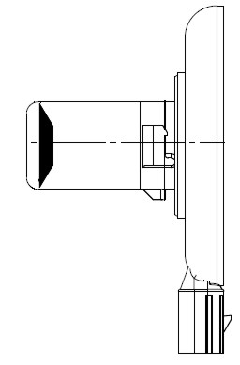

**e**

**35 max**

**Ø 22 max**

**14**

**Ø 67 max**

**min. free air space  
for convection**

**Reference plane 1/**

**Reference axis 2/**

**3/**

**28**

**5**

**Connector**

Figure 2

**Connector detail**



Not connected 4/

Major Function

Ground

Minor Function

___________________

1/ The reference plane is the plane defined by the contact points of the cap-holder fit.

2/ The reference axis is perpendicular to the reference plane and passing through the centre of the bayonet core.

3/ Light emitting area: to be checked by means of the box system in Figure 3.

4/ Optional pin.

**Category LR1 Sheet LR1/2**

Table 1

**Essential electrical and photometric characteristics**

|  |  |  |  |  |  |  |
| --- | --- | --- | --- | --- | --- | --- |
| Dimensions in mm | | | Tolerance | | | |
| LED light sources of normal production | | Standard LED light source | |
| e 3/ | 24.0 | | 0.2 | | 0.1 | |
| LR1 Cap PGJ21t-1 | | in accordance with IEC Publication 60061 (sheet 7004-165-1) | | | | |
| Electrical and photometric characteristics 5/ | | | | | | |
| Rated values |  | | Minor function | Major function | Minor function | Major function |
| Volts | | 12 | | 12 | |
| Objective  Values 6/ | Watts at test voltage  of 13.5 V DC | | 0.75 max. | 3.5 max. 1.4 min. | 0.75 max. | 3.5 max. 1.4 min. |
| Luminous flux  (in lm at 13.5V DC) | |  |  | 3.5 ± 10% | 47 ± 10% |
| Luminous flux in lm  (10-16 V DC) | | 3.5 ± 20% | 47 ± 20% |  |  |

5/ The emitted light shall be red.

6/ Continuous on for 30 minutes at 23 ± 2.5° C.

Failure condition behaviour

In case of LED light source failure (no light emitted) the maximum current draw – when operated within the input voltage range in major function mode – operation shall be less than 20 mA (open circuit condition).

Screen projection requirements

The following test is intended to define the requirements for the apparent light emitting area of the LED light source and to determine whether the light emitting area is correctly positioned relative to the reference axis and reference plane in order to check compliance with the requirements.

The position of the light emitting area is checked by the box system defined in Figure 3, which shows the projections when viewing along direction γ=90º in the planes C90 and C180 (C, γ as defined in Figure 4). At least 95 per cent of the luminous flux emitted into the viewing direction has to come from the trapezoidal area defined by d1, d2 and c. Less than 70 per cent of the luminous flux shall be emitted from the rectangular area defined by d3 and c.

**Category LR1 Sheet LR1/3**

Figure 3

**Box definition of the light emitting area**

**d2**

**d1**

**c**

**f**

**d3**

Table 2

**Dimensions of the box system in Figure 3**

|  |  |  |  |  |  |
| --- | --- | --- | --- | --- | --- |
| *Dimensions in mm* | *f* | *c* | *d1* | *d2* | *d3* |
| LED light sources of normal production | E + 0.2 | 3.6 | 21.0 | 15.0 | 7.0 |
| Standard (etalon) LED light sources | E + 0.1 | 3.4 | 21.0 | 15.0 | 7.0 |

Normalized luminous intensity distribution

The following test is intended to determine the normalized luminous intensity distribution of the light source in an arbitrary plane containing the reference axis. The intersection of the reference axis and the upper edge of the box is used as the coordinate system origin.

The light source is mounted on a flat plate with the corresponding mounting lug features. The plate is mounted to the goniometer table by a bracket, so that the reference axis of the light source lines up with one of the rotating axis of the goniometer. The corresponding measurement set-up is described in Figure 4.

**Category LR1 Sheet LR1/4**

The drawings are intended only to illustrate the essential set-up for measurement of the LED light source

Figure 4

**Set-up to measure the luminous intensity distribution**

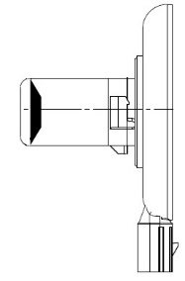

**γ**

**e**

**Photo-Detector of Goniometer**

**Reference Plane**

**Reference Axis**

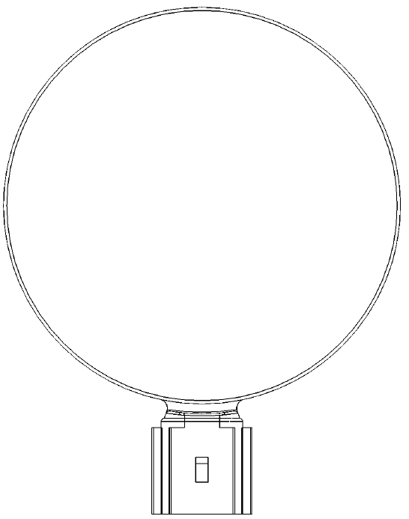

**C**

**Any C-plane between C30 and C330**

Luminous intensity data is recorded for the major function with a standard photo-goniometer. The measurement distance should be chosen appropriately, to make sure that the detector is located in the far field of the light distribution.

The measurements shall be performed in 3 C-planes, which contain the reference axis of the light source. The 3 C-planes shall be within C30 and C330 to avoid the connector shadows and they have to be at least 30º apart from each other. The test points for each plane for multiple polar angles γ are specified in Table 3.

After measurement the data shall be normalized to 1000 lm according to paragraph 3.1.11 using the luminous flux of the individual light source under test. The data shall comply with the tolerance band as defined in Table 3.

C-planes: see CIE publication 70-1987, "The measurement of absolute intensity distributions".

**Category LR1 Sheet LR1/5**

Table 3

**Test point values of normalized intensity for the major function of normal production and standard light sources, respectively.**

|  |  |  |  |  |
| --- | --- | --- | --- | --- |
|  | *LED light source of normal production* | | *Standard LED light source* | |
| *γ* | *Minimum intensity  in cd /1000 lm* | *Maximum intensity  in cd/1000 lm* | *Minimum intensity  in cd /1000 lm* | *Maximum intensity in cd/1000 lm* |
| 0° | 0 | 30 | 0 | 20 |
| 15° | 0 | 30 | 0 | 20 |
| 30° | 0 | 70 | 0 | 40 |
| 45° | 20 | 100 | 20 | 60 |
| 60° | 35 | 120 | 35 | 80 |
| 75° | 50 | 140 | 50 | 100 |
| 90° | 70 | 160 | 70 | 120 |
| 105° | 90 | 180 | 90 | 140 |
| 120° | 110 | 200 | 110 | 160 |
| 135° | 110 | 200 | 110 | 160 |
| 150° | 90 | 180 | 90 | 140 |

The luminous intensity distribution as described in Table 3 shall be substantially uniform, i.e. in between two adjacent grid points the relative luminous intensity requirement is calculated by linear interpolation using the two adjacent grid points.

**Category LW2 Sheet LW2/1**

The drawings are intended only to illustrate the essential dimensions (in mm) of the LED light source

Figure 1

Light emitting area 3/

Reference axis 2/

Reference plane 1/

**Main Drawing – front and side view**



Figure 2 – Connector Detail

Major function

Ground

Not connected 4/

Minor function



Table 1

**Essential electrical and photometric characteristics**

|  |  |  |  |  |  |  |  |
| --- | --- | --- | --- | --- | --- | --- | --- |
| *Dimensions in mm* | | *Tolerances* | | | | | |
| *LED light sources of normal production* | | *Standard LED light sources* | | | |
| e | 26.4 | 0.2 | | 0.1 | | | |
| Cap PGJY50 in accordance with IEC Publication 60061 (sheet 7004-182-1) | | | | | | | |
| Electrical and photometric characteristics 5/ | | | | | | | |
| Rated values |  | *Minor function* | *Major function* | | *Minor function* | *Major function* | |
| Volts | 12 | | | 12 | | |
| Objective  Values 6/ 7/ | Watts  (at 13.5 V DC) | 1 max. | 12 max. 4 min. | | 1 max. | | 12 max. 4 min. |
| Luminous flux  (in lm at 13.5V DC) |  |  | | 50 ± 10% | | 725 ± 10% |
| Luminous flux  (in lm at 10-16 V DC) | 50 ± 15% | 725 ± 15% | |  | |  |
| Corresponding base temperature Tb in °C | | 30 ± 2 | 55 ± 2 | | 30 ± 0.5 | | 55 ± 0.5 |

1/ The reference plane is given by the thermal transfer area on the backside of the light source.

2/ The reference axis is perpendicular to the reference plane and passing through the centre of the light source as defined by three notches on the outer perimeter.

3/ Light emitting area: to be checked by means of the box system in Figure 3.

4/ Optional pin.

5/ The emitted light shall be white.

6/ Continuous operation for 30 minutes with base temperature Tb stabilized as specified above.

7/ Luminous flux from the light emitting area shall be determined within a solid angle of ­ 40° < α < + 40° and ­ 40° < β < +40° using either integral methods or the procedure described on sheets LW2/3 and LW2/4.

**Category LW2 Sheet LW2/2**

Screen projection requirements

This test is intended to determine whether the light emitting area of the LED light source is correctly positioned relative to the reference axis and reference plane.

Compliance of position and dimension as defined in Table 2 is checked by the box system shown in Figure 3. The left drawing displays the projection when viewing along the reference axis with an aperture acceptance angle of ±40° while the right drawing defines the position of the reference plane and axis.

Size determination shall be done with suitable means.

Figure 3

**Box definition of light emitting area**

Light emitting area 3/

Reference plane 1/

Reference axis 2/

Light Emission



Table 2

**Dimensions of the light emitting area in Figure 3**

|  |  |  |  |  |
| --- | --- | --- | --- | --- |
| *Dimensions in mm* | *e* | *a* | *b* | *c* |
| LED light sources of normal production | 26.4 ± 0.2 | 14.5 +0/ -2.5 | 10.1 +0/ -1.5 | Ø 50.00 + 0.10/ -0 |
| Standard (Etalon) LED light sources | 26.4 ± 0.1 | 14.5 +0/ -2.5 | 10.1 +0/ -1.5 | Ø 50.05 + 0.05/ -0 |

**Category LW2 Sheet LW2/3**

Cumulative luminous flux distribution

Measurement set-up

This test is intended to determine the cumulative luminous flux within defined solid angles of the luminous intensity distribution.

Goniophotometers of type I or II according to CIE publication No. 70 -1987 with the capability of turning the light source around two axes perpendicular to the axis of light emission can be used. The intersection of the reference axis and the parallel plane to the reference plane in distance e is used as the coordinate system origin.

Figure 4

**Set-up to measure the luminous intensity distribution using a type I photogoniometer**



Photometer  
of Goniometer

Photometer

Reference Axis

Reference Plane

The light source is mounted on a flat plate with the corresponding mounting lug features. The plate is mounted to the goniometer table by a bracket in such way, that the reference axis of the light source lines up with the measurement axis of the goniometer. The corresponding measurement set-up is described in Figure 4.

**Category LW2 Sheet LW2/4**

Cumulative luminous flux distribution

Measurement and calculation procedure

Data shall be recorded for the specified base temperature Tb from Table 1 at the location shown in Fig. 5.

Luminous intensity distribution data shall be recorded within a solid angle of -40° < α < +40° and -40° < β < +40°. The measurement distance shall be chosen in such manner that the detector is located in the far field of the light distribution. An angular step size of 1° or less is required.

After the measurement, the cumulative luminous flux distribution shall be calculated from the recorded data for various solid angles as specified in Table 3 according to CIE publication 84-1989, section 4.3. Subsequently, the distribution shall be normalized to the total luminous flux determined for -40° < α < +40° and -40° < β < +40. The data shall comply with the tolerance band defined in Table 3.

In order to secure a symmetrical distribution within each solid angle in Table 3 the luminous flux determination shall be done independently for all 4 quadrants and flux values shall not differ by more than 15%.

Table 3

**Test point values of normalized cumulative luminous flux for both normal production and standard lamps**

|  |  |  |
| --- | --- | --- |
| *Angle α, β* | *Min. normalized flux in %* | *Max. normalized flux in %* |
| -5° < α, β < +5° | 8 | 14 |
| -10° < α, β < +10° | 31 | 37 |
| -15° < α, β < +15° | 54 | 59 |
| -20° < α, β < +20° | 75 | 81 |
| -25° < α, β < +25° | 91 | 95 |
| -30° < α, β < +30° | 97 | 100 |
| -35° < α, β < +35° | 98 | 100 |
| -40° < α, β < +40° | 100 (by definition) | |

The cumulative luminous flux distribution of the minor function may be verified by measuring the ratio of major and minor function under a fixed angle and multiplication of this factor with the luminous flux of the major function.

In case of doubt that cumulative luminous flux distributions of major and minor function differ, the procedure as described above for the major function shall be repeated for the minor function.

Thermal interface geometry

The LW2 thermal interface is located within the reference plane (shaded area in Figure 5) and described in detail in IEC Publication 60061 as indicated in Table 1 on sheet LW2/1. It shall be attached to an appropriate heat sink or thermal management system.

The luminous flux given in Table 1 shall be achieved once the base temperature Tb measured at the location shown in Figure 5 is stabilized.

**Category LW2 Sheet LW2/5**

Figure 5

**Rear-view: thermal contact area and location of Tb-point on the vertical   
symmetry axis, at a distance f from the center**



|  |  |
| --- | --- |
| *Dimensions in mm* | |
| c | 50.0 |
| d | 34.5 |
| f | 13.0 |
| g | 10.0 |

Failure condition behaviour

In case of LED light source failure (no light emitted) the maximum current draw – when operated within the input voltage range in major function mode – shall be less than 20 mA (open circuit condition).

**Categories LR3A, LR3B, LW3A, LW3B, LY3A and LY3B Sheet L3/1**

The drawings are intended only to illustrate the essential dimensions of the LED light source.

Figure 1*

**Main Drawing**

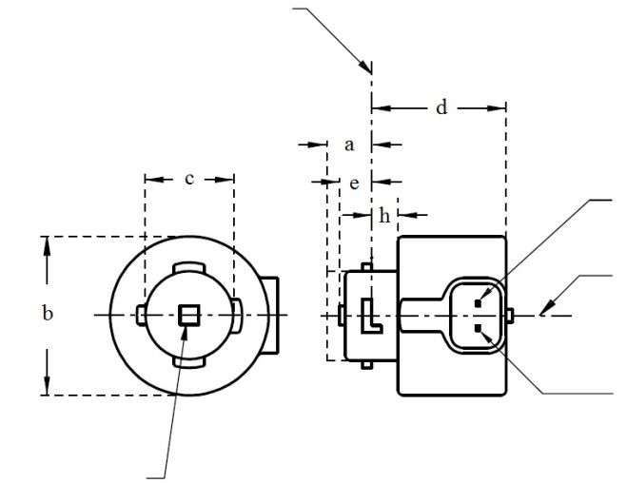

V+

Light emitting area 3

Reference axis 2

Ground

4

**LR3A, LW3A, LY3A**

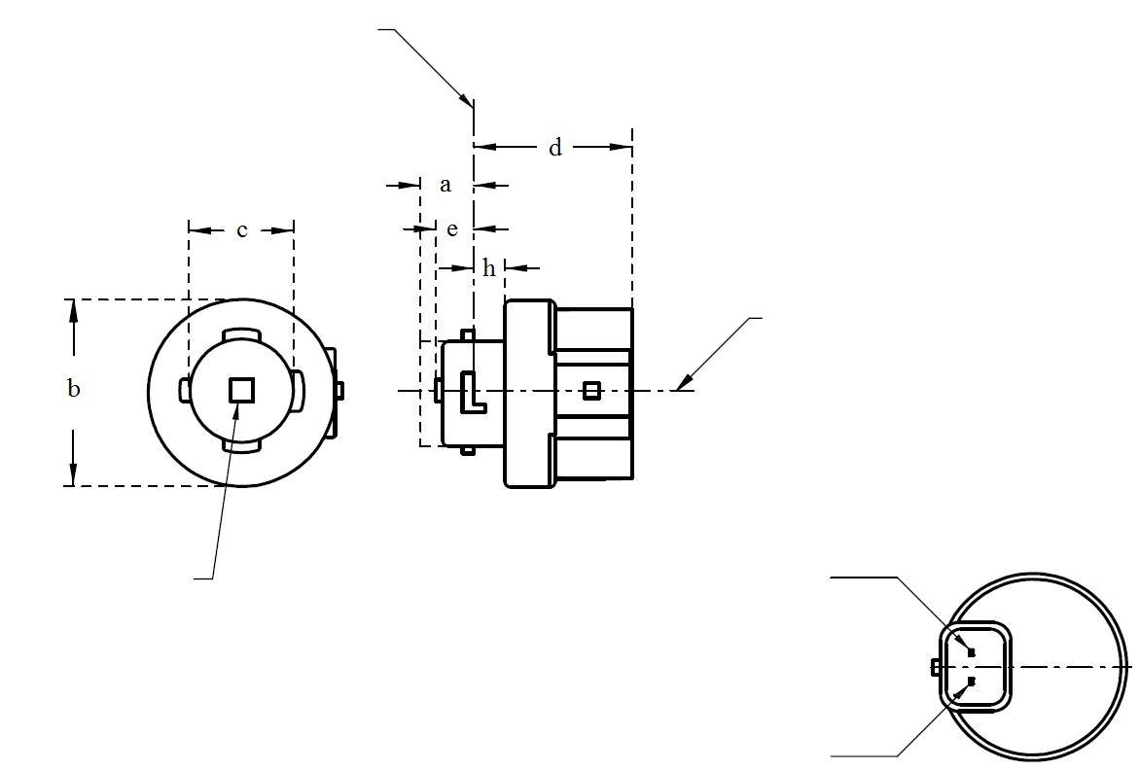

V+

Light emitting area 3

Reference axis 2

Ground

Reference plane 1

4

**LR3B, LW3B, LY3B**

For the notes see sheet L3/2.

* Projection method:

**Categories LR3A, LR3B, LW3A, LW3B, LY3A and LY3B Sheet L3/2**

Table 1

**Essential dimensional, electrical and photometric characteristics of the LED light source**

|  |  |  |  |  |  |  |  |
| --- | --- | --- | --- | --- | --- | --- | --- |
| *Dimensions* | | | | | | *Production LED light sources* | *Standard LED light sources* |
| a | | | | | mm | 6.0 max. | |
| b | | | | | mm | c + 10.0 min.  38.0 max. | |
| c | | | | | mm | 18.5 ± 0.1 | |
| d | | | | | mm | 28.0 max. | |
| e | | | | | mm | 3.0 ± 0.30 | 3.0 ± 0.15 |
| h | | | | | mm | 5.5 + 0.0/ – 0.1 | |
| Cap | LR3A, LR3B  LW3A, LW3B  LY3A, LY3B | | PGJ18**.**5d-1  PGJ18.5d-24 PGJ18.5d-15 | | in accordance with IEC Publication 60061 (sheet 7004-185-1) | | |
| *Electrical and photometric characteristics* | | | | | | | |
| Rated values | | Volts | |  | | 12 | |
| Watts | |  | LR3A, LR3B | 3 | |
|  | LW3A, LW3B  LY3A, LY3B | 4 | |
| Objective Values8 | | Watts  (at 13.5 V DC) | |  | LR3A, LR3B | 3.5 max. | |
|  | LW3A, LW3B | 5 max. | |
| 12 | LY3A, LY3B |
| Luminous flux  (in lm at 13.5 V DC) | | 5 | LR3A, LR3B | 80 ± 20%9 | 80 ± 10%10 |
| 6 | LW3A, LW3B | 250 ± 20% | 250 ± 10%11 |
| 7, 12 | LY3A, LY3B | 150 ± 20%9 | 150 ± 10%10 |
| Luminous flux  (in lm at 9 V DC) | | 5 | LR3A, LR3B | 19 min |  |
| 6 | LW3A, LW3B | 50 min. |  |
| 7, 12 | LY3A, LY3B | 30 min |  |

1 The reference plane is the plane defined by the contact points of the cap-holder fit.

2 The reference axis is perpendicular to the reference plane and passing through the centre of the bayonet core.

3 Light emitting area: to be checked by means of the box system in Figure 2.

4 A minimum free air space of 5mm around the light source shall be respected for convection.

5 The emitted light shall be red.

6 The emitted light shall be white.

7 The emitted light shall be amber.

8 After continuous operation for 30 minutes at 23 ± 2.5° C.

9 The measured value shall be in between 100 per cent and 70 per cent of the value measured after 1 minute.

10 The measured value shall be in between 85 per cent and 75 per cent of the value measured after 1 minute.

11 The measured value shall be in between 100 per cent and 90 per cent of the value measured after 1 minute.

12 Operated in flashing mode for 30 minutes (frequency = 1.5 Hz, duty cycle 50 per cent ON, 50 per cent OFF). Measured in the ON-state of flashing mode after 30 minutes of operation.

Electrical characteristics

In case of LED light source failure (no light emitted) the max. electrical current draw, when operated between 12 V and 14 V, shall be less than 20 mA (open circuit condition).

**Categories LR3A, LR3B, LW3A, LW3B, LY3A and LY3B Sheet L3/3**

Screen projection requirements

The following test is intended to define the requirements for the apparent light emitting area of the LED light source and to determine whether the light emitting area is correctly positioned relative to the reference axis and reference plane in order to check compliance with the requirements.

The position of the light emitting area is checked by the box system defined in Figure 2, which is aligned to the planes C90 and C180 and shows the projection when viewing along direction γ=0º (C, γ as defined in Figure 3).

The proportion of the total luminous flux emitted into the viewing direction shall be as described in table 3.

Figure 2

**Box definition of the light emitting area with dimensions as specified in table 2**

f/3

Reference axis

perpendicular in the

centre of the light-

emitting area

f/3

f/3

f/3

f/3

f/3

A

B

B

B

B

C

C

C

C

f/2

f/2

Table 2

**Dimensions of the box system in Figure 2**

|  |  |  |
| --- | --- | --- |
| *Dimensions in mm* | *f* | |
| LR3A, LR3B | LW3A, LW3B LY3A, LY3B |
| LED light sources of normal production | 3.0 | 4.5 |
| Standard LED light sources | 3.0 | 4.5 |

**Categories LR3A, LR3B, LW3A, LW3B, LY3A and LY3B Sheet L3/4**

Table 3

**Proportion of the total luminous flux emitted into the viewing direction from the areas specified in figure 2**

|  |  |  |  |
| --- | --- | --- | --- |
| *Category* | *Area(s)* | *LED light sources of normal production* | *Standard LED light sources* |
| LR3A  LR3B | A | ≤ 25% | ≤ 10% |
| Each B individually | ≥ 15% | ≥ 20% |
| Each C individually | - | ≤ 10% |
| A, all B and all C together | ≥ 90% | ≥ 90% |
| LW3A  LW3B  LY3A  LY3B | Each A,B individually | ≥ 6% | ≥ 8% |
| Each A, B individually | < 40% | < 30% |
| All A, B together | ≥ 55% | ≥ 60% |
| Each C individually | < 15% | < 10% |
| All A, B and C together | ≥ 90% | ≥ 90% |

**Categories LR3A, LR3B, LW3A, LW3B, LY3A and LY3B Sheet L3/5**

Normalized luminous intensity distribution

The following test is intended to determine the normalized luminous intensity distribution of the light source in an arbitrary plane containing the reference axis. The intersection of the reference axis and the parallel plane to the reference plane in distance e is used as the coordinate system origin.

The light source is mounted on a flat plate with the corresponding mounting lug features. The plate is mounted to the goniometer table by a bracket, so that the reference axis of the light source lines up with one of the rotating axis of the goniometer. The corresponding measurement set-up is described in Figure 3.

Luminous intensity data is recorded with a standard photo-goniometer. The measurement distance should be chosen appropriately, to make sure that the detector is located in the far field of the light distribution.

The measurements shall be performed in C-planes C0 (C180) and C90 (C270), which contain the reference axis of the light source. The test points for each plane for multiple polar angles γ are specified in Tables 4a and 4b.

The measured luminous intensity values, normalised to the measured luminous flux of the individual light source under test, shall be converted to normalised luminous intensity values of a 1,000 lm light source. The data shall comply with the tolerance band as defined in Tables 4a and 4b.

The drawings are intended only to illustrate the essential set-up for measurement of the LED light source.

Figure 3

**Set-up to measure the luminous intensity distribution**

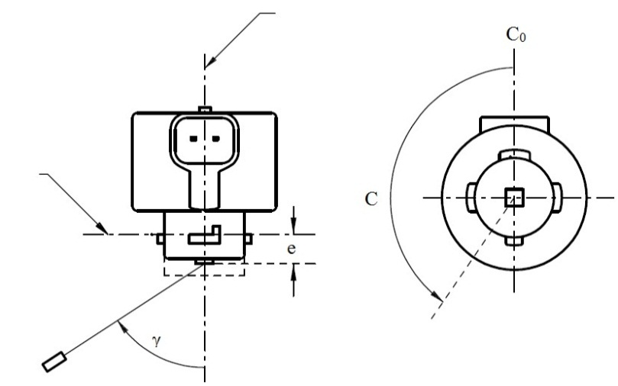

Reference axis

Reference plane

C-plane definition

Viewing direction along reference axis

Photo-Detector of Goniometer

**LR3A, LW3A, LY3A**

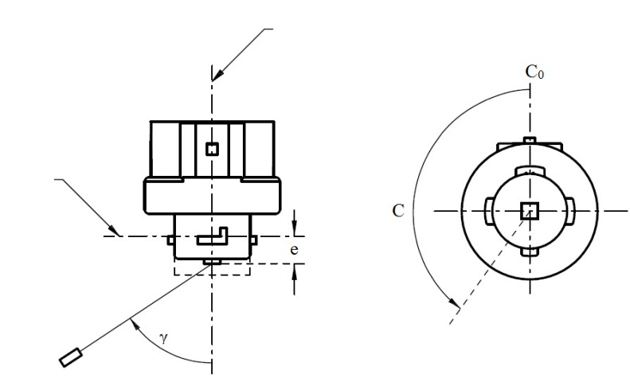

Reference axis

Reference plane

Photo-Detector of Goniometer

C-plane definition

Viewing direction along reference axis

**LR3B, LW3B, LY3B**

**Categories LR3A, LR3B, LW3A, LW3B, LY3A and LY3B Sheet L3/6**

The light pattern as described in Tables 4a and 4b shall be substantially uniform, i.e. in between two adjacent grid points the relative luminous intensity requirement is calculated by linear interpolation using the two adjacent grid points. In case of doubt this may be checked in addition to verification of the grid points given in Tables 4a and 4b.

Table 4a

**Test point values of normalized intensities for categories LR3A and LR3B**

|  |  |  |  |  |
| --- | --- | --- | --- | --- |
|  | *LED light sources of normal production* | | *Standard LED light sources* | |
| *Angle γ* | *Minimum Intensity  in cd /1000 lm* | *Maximum Intensity  in cd/1000 lm* | *Minimum Intensity  in cd /1000 lm* | *Maximum Intensity in cd /1000 lm* |
| -90° | 0 | 38 | 0 | 25 |
| -75° | 0 | 160 | 0 | 140 |
| -60° | 98 | 246 | 127 | 220 |
| -45° | 142 | 305 | 181 | 275 |
| -30° | 169 | 352 | 213 | 315 |
| -15° | 192 | 389 | 239 | 340 |
| 0° | 200 | 401 | 248 | 352 |
| 15° | 192 | 389 | 239 | 340 |
| 30° | 169 | 352 | 213 | 315 |
| 45° | 142 | 305 | 181 | 275 |
| 60° | 98 | 246 | 127 | 220 |
| 75° | 0 | 160 | 0 | 140 |
| 90° | 0 | 38 | 0 | 25 |

Table 4b

**Test point values of normalized intensities for categories LW3A, LW3B, LY3A and LY3B**

|  |  |  |  |  |
| --- | --- | --- | --- | --- |
|  | *LED light sources of normal production* | | *Standard LED light sources* | |
| *Angle γ* | *Minimum Intensity  in cd /1000 lm* | *Maximum Intensity  in cd/1000 lm* | *Minimum Intensity  in cd /1000 lm* | *Maximum Intensity in cd /1000 lm* |
| -90° | 0 | 70 | 0 | 65 |
| -75° | 0 | 160 | 0 | 150 |
| -60° | 85 | 245 | 105 | 220 |
| -45° | 145 | 310 | 180 | 275 |
| -30° | 170 | 380 | 220 | 335 |
| -15° | 190 | 415 | 240 | 370 |
| 0° | 200 | 425 | 250 | 390 |
| 15° | 190 | 415 | 240 | 370 |
| 30° | 170 | 380 | 220 | 335 |
| 45° | 145 | 310 | 180 | 275 |
| 60° | 85 | 245 | 105 | 220 |
| 75° | 0 | 160 | 0 | 150 |
| 90° | 0 | 70 | 0 | 65 |

**Categories LR4A and LR4B Sheet LR4/1**

The drawings are intended only to illustrate the essential dimensions of the LED light source.

Figure 1*

**Main Drawing**

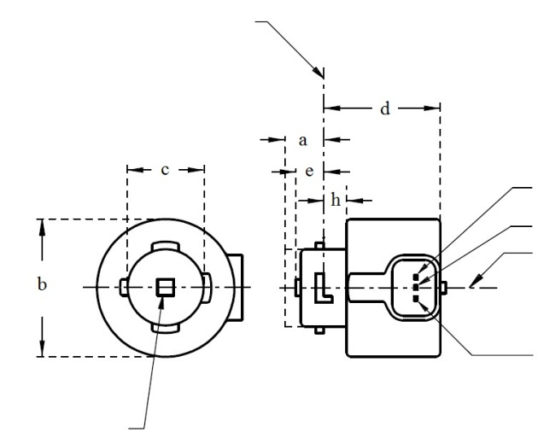

Reference plane 1

Major Function

Light emitting area 3

Reference axis 2

Ground

Minor Function

**LR4A**

4

* Projection method:

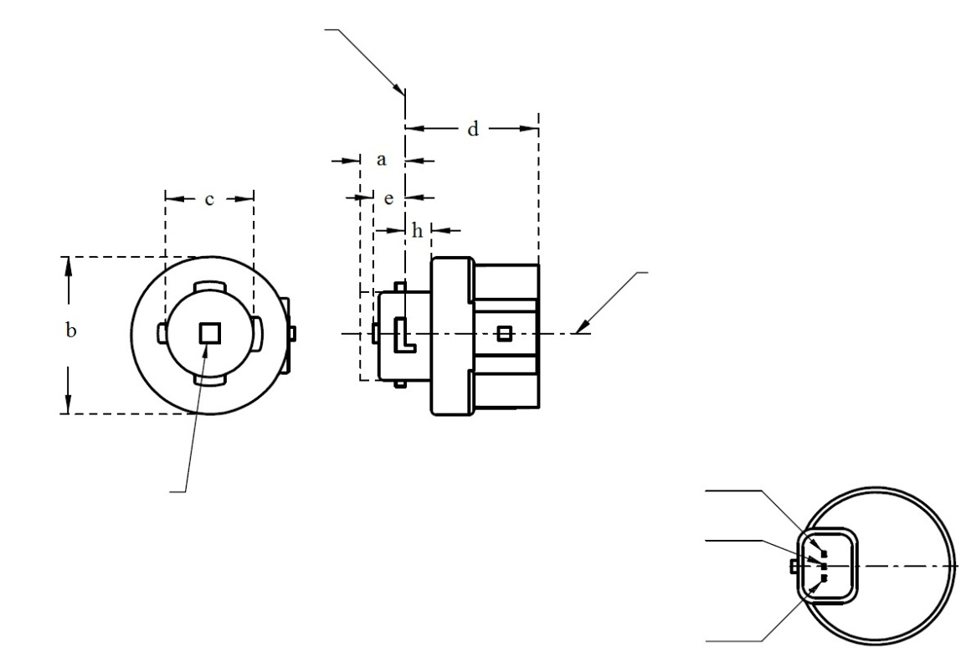

**LR4B**

Major Function

Light emitting area 3

Reference axis 2

Ground

Minor Function

Reference plane 1

4

For the notes see sheet LR4/2.

4

**Categories LR4A and LR4B Sheet LR4/2**

Table 1

**Essential electrical and photometric characteristics of the LED light source**

|  |  |  |  |  |  |  |
| --- | --- | --- | --- | --- | --- | --- |
| *Dimensions* | |  | *Production LED light sources* | | *Standard LED light sources* | |
| a | | mm | 6.0 max. | | | |
| b | | mm | c + 10.0 min.  38.0 max. | | | |
| c | | mm | 18.5 ± 0.1 | | | |
| d | | mm | 28.0 max. | | | |
| e | | mm | 3.0 ± 0.30 | | 3.0 ± 0.15 | |
| h | | mm | 5.5 + 0.0/ – 0.1 | | | |
| Cap PGJ18.5t-5 in accordance with IEC Publication 60061 (sheet 7004-185-1) | | | | | | |
| Electrical and photometric characteristics 5 | | | | | | |
| Rated values |  | | *Minor function* | *Major function* | *Minor function* | *Major function* |
| Volts | | 12 | | 12 | |
| Watts | | 0.75 | 3 | 0.75 | 3 |
| Objective  Values 6 | Watts  (at 13.5 V DC) | | 1.0 max. | 3.5 max. | 1.0 max. | 3.5 max. |
| Luminous flux  (in lm at 13.5 V DC) | | 6 ± 20% | 80 ± 20% 7 | 6 ± 10% | 80 ± 10% 8 |
| Luminous flux  (in lm at 9 V DC) | | 1.5 min. | 19 min. |  |  |

1 The reference plane is the plane defined by the contact points of the cap-holder fit.

2 The reference axis is perpendicular to the reference plane and passing through the centre of the Bayonet core.

3 Light emitting area: to be checked by means of the box system in Figure 2

4 A minimum free air space of 5mm around the light source shall be respected for convection.

5 The emitted light shall be red.

6 After continuous operation for 30 minutes at 23 ± 2.5° C.

7 The measured value shall be in between 100 per cent and 70 per cent of the value measured after 1 minute.

8 The measured value shall be in between 85 per cent and 75 per cent of the value measured after 1 minute.

Electrical characteristics

In case of LED light source failure (no light emitted) the max. electrical current draw, when operated between 12 V and 14 V, shall be less than 20 mA (open circuit condition).

The major and the minor function shall be operated by separate electrical circuits.

**Categories LR4A and LR4B Sheet LR4/3**

Screen projection requirements

The following test is intended to define the requirements for the apparent light emitting area of the LED light source and to determine whether the light emitting area is correctly positioned relative to the reference axis and reference plane in order to check compliance with the requirements.

The position of the light emitting area is checked by the box system defined in Figure 2, which is aligned to the planes C90 and C180 and shows the projection when viewing along direction γ=0º (C, γ as defined in Figure 3).

The proportion of the total luminous flux emitted into the viewing direction shall be as described in table 3.

f/3

Reference axis

perpendicular in the

centre of the light-

emitting area

f/3

f/3

f/3

f/3

f/3

AA

BB

BB

BB

BB

CC

CC

CC

CC

f/2

f/2

Figure 2

**Box definition of the light emitting area with dimensions as specified in table 2**

Table 2

**Dimensions of the box system in Figure 2**

|  |  |
| --- | --- |
| Dimensions in mm | f |
| LED light sources of normal production | 4.5 |
| Standard LED light sources | 4.5 |

Table 3

**Proportion of the total luminous flux emitted into the viewing direction from the areas specified in figure 2**

|  |  |  |  |
| --- | --- | --- | --- |
| *Function* | *Area(s)* | *LED light sources of normal production* | *Standard LED light sources* |
| *Minor* | A | ≥ 75% | ≥ 80% |
| *Major* | A | ≤ 25% | ≤ 10% |
| Each B individually | ≥ 15% | ≥ 20% |
| Each C individually | - | ≤ 10% |
| A, all B and all C together | ≥ 90% | ≥ 90% |

**Categories LR4A and LR4B Sheet LR4/4**

Normalized luminous intensity distribution

The following test is intended to determine the normalized luminous intensity distribution of the light source in an arbitrary plane containing the reference axis. The intersection of the reference axis and the parallel plane to the reference plane in distance e is used as the coordinate system origin.

The light source is mounted on a flat plate with the corresponding mounting lug features. The plate is mounted to the goniometer table by a bracket, so that the reference axis of the light source lines up with one of the rotating axis of the goniometer. The corresponding measurement set-up is described in Figure 3.

Luminous intensity data is recorded with a standard photo-goniometer. The measurement distance should be chosen appropriately, to make sure that the detector is located in the far field of the light distribution.

The measurements shall be performed in C-planes C0 (C180) and C90 (C270), which contain the reference axis of the light source. The test points for each plane for multiple polar angles γ are specified in Table 4.

After measurement the data shall be normalized to 1,000 lm according to paragraph 3.1.11 using the luminous flux of the individual light source under test. The data shall comply with the tolerance band as defined in Table 4.

The drawings are intended only to illustrate the essential set-up for measurement of the LED light source.

Figure 3*

**Set-up to measure the luminous intensity distribution**

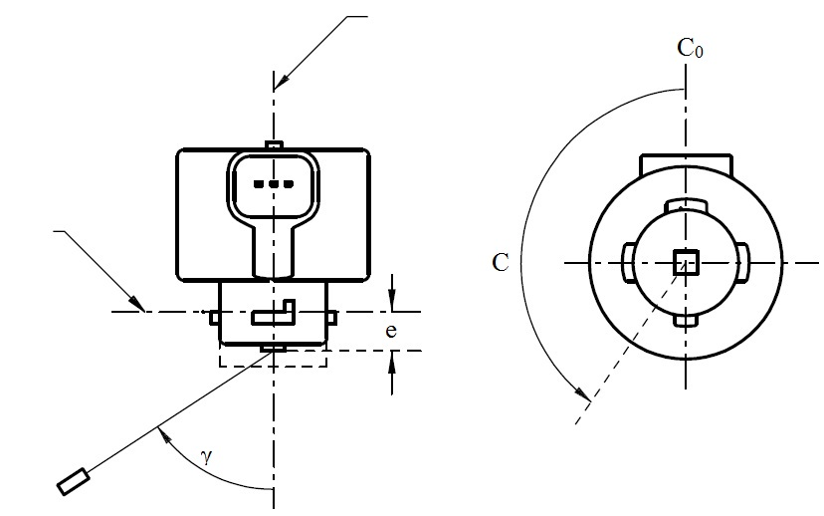

Reference axis

Reference plane

Photo-Detector of Goniometer

C-plane definition

Viewing direction along reference axis

**LR4A**

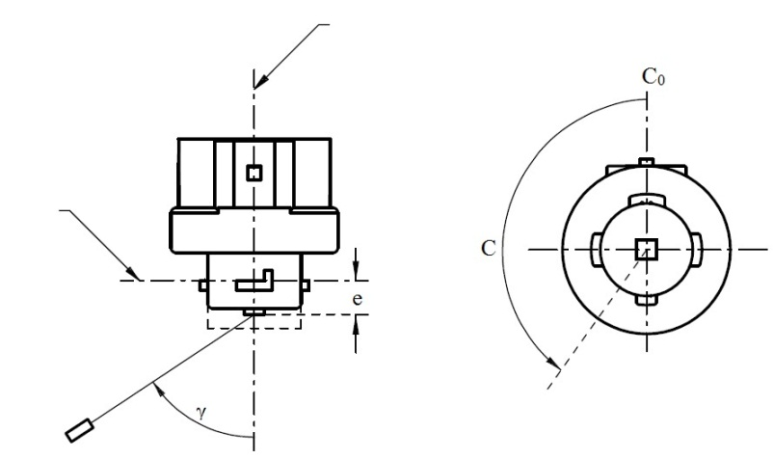

Reference axis

Reference plane

Photo-Detector of Goniometer

C-plane definition

Viewing direction along reference axis

**LR4B**

**Categories LR4A and LR4B Sheet LR4/5**

The light pattern as described in Table 4 shall be substantially uniform, i.e. in between two adjacent grid points the relative luminous intensity requirement is calculated by linear interpolation using the two adjacent grid points. In case of doubt this may be checked in addition to verification of the grid points given in Table 4.

Table 4

**Test point values of normalized intensities of normal production and standard lamps, respectively.   
Requirements apply to both, major and minor function.**

|  |  |  |  |  |
| --- | --- | --- | --- | --- |
|  | *LED lamps of normal production* | | *Standard LED lamps* | |
| *Angle γ* | *Minimum Intensity  in cd /1000lm* | *Maximum Intensity  in cd/1000lm* | *Minimum Intensity  in cd /1000lm* | *Maximum Intensity in cd/1000lm* |
| -90° | 0 | 38 | 0 | 25 |
| -75° | 0 | 160 | 0 | 140 |
| -60° | 98 | 246 | 127 | 220 |
| -45° | 142 | 305 | 181 | 275 |
| -30° | 169 | 352 | 213 | 315 |
| -15° | 192 | 389 | 239 | 340 |
| 0° | 200 | 401 | 248 | 352 |
| 15° | 192 | 389 | 239 | 340 |
| 30° | 169 | 352 | 213 | 315 |
| 45° | 142 | 305 | 181 | 275 |
| 60° | 98 | 246 | 127 | 220 |
| 75° | 0 | 160 | 0 | 140 |
| 90° | 0 | 38 | 0 | 25 |

**Categories LR5A, LR5B, LW5A, LW5B, LY5A, LY5B Sheet L5/1**

The drawings are intended only to illustrate the essential dimensions of the LED light source.

Figure 1*

**Main Drawing**

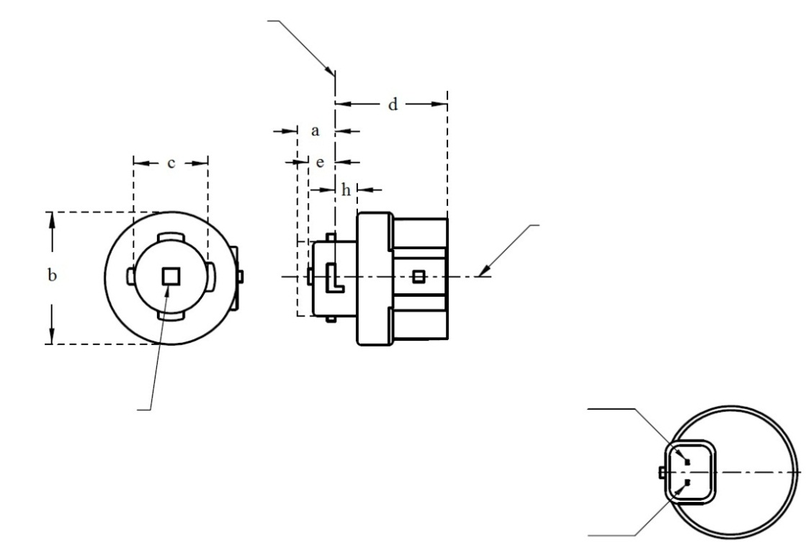

Ground

Reference plane 1

Light emitting area 3

Reference axis 2

4

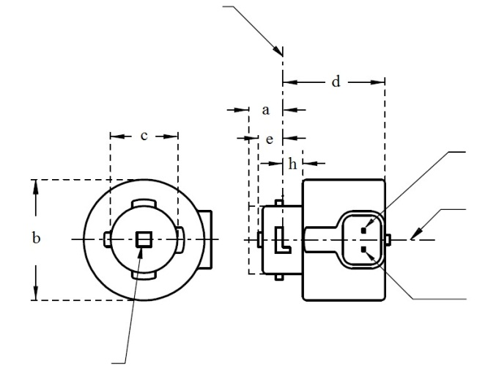

Reference plane 1

V+

Ground

4

Light emitting area 3

Reference axis 2

**LR5A, LW5A, LY5A**

**LR5B, LW5B, LY5B**

* Projection method:

For the notes see sheet L5/2

**Categories LR5A, LR5B, LW5A, LW5B, LY5A, LY5B Sheet L5/2**

Table 1

**Essential dimensional, electrical and photometric characteristics of the LED light source**

|  |  |  |  |  |  |  |  |
| --- | --- | --- | --- | --- | --- | --- | --- |
| *Dimensions* | | | | | | *Production LED light sources* | *Standard LED light sources* |
| a | | | | | mm | 6.0 max. | |
| b | | | | | mm | c + 10.0 min.  38.0 max. | |
| c | | | | | mm | 18.5 ± 0.1 | |
| d | | | | | mm | 28.0 max. | |
| e | | | | | mm | 3.0 ± 0.30 | 3.0 ± 0.15 |
| h | | | | | mm | 5.5 + 0.0/ – 0.1 | |
| Cap | LR5A, LR5B  LW5A, LW5B  LY5A, LY5B | | PGJ18.5d-10  PGJ18.5d-28  PGJ18.5d-19 | | in accordance with IEC Publication 60061 (sheet 7004-185-1) | | |
| *Electrical and photometric characteristics* | | | | | | | |
| Rated values | | Volts | |  | | 12 | |
| Watts | |  | LR5A, LR5B | 3 | |
|  | LW5A, LW5B  LY5A, LY5B | 6 | |
| Objective Values8 | | Watts  (at 13.5 V DC) | |  | LR5A, LR5B | 3.5 max. | |
|  | LW5A, LW5B | 8 max. | |
| 10 | LY5A, LY5B |
| Luminous flux  (in lm at 13.5 V DC) | | 5 | LR5A, LR5B | 120 ± 15% | 120 ± 5% 9 |
| 6 | LW5A, LW5B | 350 ± 20% | 350 ± 10% 9 |
| 7, 10 | LY5A, LY5B | 280 ± 20% | 280 ± 10% 9 |
| Luminous flux  (in lm at 9 V DC) | | 5 | LR5A, LR5B | 28 min. |  |
| 6 | LW5A, LW5B | 65 min. |  |
| 7, 10 | LY5A, LY5B | 55 min. |  |

1 The reference plane is the plane defined by the contact points of the cap-holder fit.

2 The reference axis is perpendicular to the reference plane and passing through the centre of the bayonet core.

3 Light emitting area: to be checked by means of the box system in Figure 2

4 A minimum free air space of 5mm around the light source shall be respected for convection.

5 The emitted light shall be red.

6 The emitted light shall be white.

7 The emitted light shall be amber.

8 After continuous operation for 30 minutes at 23 ± 2.5° C.

9 The measured value shall be in between 100 per cent and 90 per cent of the value measured after 1 minute.

10 Operated in flashing mode for 30 minutes (frequency = 1.5 Hz, duty cycle 50 per cent ON, 50 per cent OFF). Measured in the ON-state of flashing mode after 30 minutes of operation.

Electrical characteristics

In case of LED light source failure (no light emitted) the max. electrical current draw, when operated between 12 V and 14 V, shall be less than 20 mA (open circuit condition).

**Categories LR5A, LR5B, LW5A, LW5B, LY5A, LY5B Sheet L5/3**

Screen projection requirements

The following test is intended to define the requirements for the apparent light emitting area of the LED light source and to determine whether the light emitting area is correctly positioned relative to the reference axis and reference plane in order to check compliance with the requirements.

The position of the light emitting area is checked by the box system defined in Figure 2, which is aligned to the planes C90 and C180 and shows the projection when viewing along direction γ=0º (C, γ as defined in Figure 3).

The proportion of the total luminous flux emitted into the viewing direction shall be as described in table 3.

Figure 2

**Box definition of the light emitting area with dimensions as specified in table 2**

f/3

Reference axis

perpendicular in the

centre of the light-

emitting area

f/3

f/3

f/3

f/3

f/3

A

B

B

B

B

C

C

C

C

f/2

f/2

Table 2

**Dimensions of the box system in Figure 2**

|  |  |
| --- | --- |
| *Dimensions in mm* | *f* |
| LED light sources of normal production | 4.5 |
| Standard LED light sources | 4.5 |

**Categories LR5A, LR5B, LW5A, LW5B, LY5A, LY5B Sheet L5/4**

Table 3

**Proportion of the total luminous flux emitted into the viewing direction from the areas specified in figure 2**

|  |  |  |  |
| --- | --- | --- | --- |
| *Category* | *Area(s)* | *LED light sources of normal production* | *Standard LED light sources* |
| LR5A  LR5B | Each B individually | ≥ 10% | ≥ 15% |
| Each A, B individually | < 40% | < 30% |
| All B together | ≥ 60% | ≥ 65% |
| Each C individually | - | < 10% |
| All A, B and C together | ≥ 90% | ≥ 90% |
| LW5A  LW5B  LY5A  LY5B | Each A,B individually | ≥ 6% | ≥ 8% |
| Each A, B individually | < 40% | < 30% |
| All A, B together | ≥ 55% | ≥ 60% |
| Each C individually | < 15% | < 10% |
| All A, B and C together | ≥ 90% | ≥ 90% |

**Categories LR5A, LR5B, LW5A, LW5B, LY5A, LY5B Sheet L5/5**

Normalized luminous intensity distribution

The following test is intended to determine the normalized luminous intensity distribution of the light source in an arbitrary plane containing the reference axis. The intersection of the reference axis and the parallel plane to the reference plane in distance e is used as the coordinate system origin.

The light source is mounted on a flat plate with the corresponding mounting lug features. The plate is mounted to the goniometer table by a bracket, so that the reference axis of the light source lines up with one of the rotating axis of the goniometer. The corresponding measurement set-up is described in Figure 3.

Luminous intensity data is recorded with a standard photo-goniometer. The measurement distance should be chosen appropriately, to make sure that the detector is located in the far field of the light distribution.

The measurements shall be performed in C-planes C0 (C180) and C90 (C270), which contain the reference axis of the light source. The test points for each plane for multiple polar angles γ are specified in Table 4.

The measured luminous intensity values, normalised to the measured luminous flux of the individual light source under test, shall be converted to normalised luminous intensity values of a 1,000 lm light source. The data shall comply with the tolerance band as defined in Table 4.

The drawings are intended only to illustrate the essential set-up for measurement of the LED light source.

Figure 3

**Set-up to measure the luminous intensity distribution**



Reference axis

Reference plane

Photo-Detector of Goniometer

C-plane definition

Viewing direction along reference axis

**LR5A, LW5A, LY5A**



Reference axis

Photo-Detector of Goniometer

Reference plane

C-plane definition

Viewing direction along reference axis

**LR5B, LW5B, LY5B**

**Categories LR5A, LR5B, LW5A, LW5B, LY5A, LY5B Sheet L5/6**

The light pattern as described in Table 4 shall be substantially uniform, i.e. in between two adjacent grid points the relative luminous intensity requirement is calculated by linear interpolation using the two adjacent grid points. In case of doubt this may be checked in addition to verification of the grid points given in Table 4.

Table 4

**Test point values of normalized intensities for categories LR5A, LR5B, LW5A, LW5B, LY5A and LY5B**

|  |  |  |  |  |
| --- | --- | --- | --- | --- |
|  | *LED light sources of normal production* | | *Standard LED light sources* | |
| *Angle γ* | *Minimum Intensity  in cd /1000 lm* | *Maximum Intensity  in cd/1000 lm* | *Minimum Intensity  in cd /1000 lm* | *Maximum Intensity in cd /1000 lm* |
| -90° | 0 | 70 | 0 | 65 |
| -75° | 0 | 160 | 0 | 150 |
| -60° | 85 | 245 | 105 | 220 |
| -45° | 145 | 310 | 180 | 275 |
| -30° | 170 | 380 | 220 | 335 |
| -15° | 190 | 415 | 240 | 370 |
| 0° | 200 | 425 | 250 | 390 |
| 15° | 190 | 415 | 240 | 370 |
| 30° | 170 | 380 | 220 | 335 |
| 45° | 145 | 310 | 180 | 275 |
| 60° | 85 | 245 | 105 | 220 |
| 75° | 0 | 160 | 0 | 150 |
| 90° | 0 | 70 | 0 | 65 |

**Annex 2**

**Communication**

(maximum format: A4 (210 x 297 mm))

issued by: Name of administration:

......................................

......................................

......................................



**1**

**1**

[8]

concerning[9]: Approval granted

**1**

Approval extended

Approval refused

Approval withdrawn

Production definitively discontinued

of a type of LED light source pursuant to Regulation No. 128

Approval No................................…. Extension No......................................….

Approval Code................................….

1. Trade name or mark of the LED light source:

2. Manufacturer's name for the type of LED light source:

3. Manufacturer's name and address:

4. If applicable, name and address of manufacturer's representative:

5. Submitted for approval on:

6. Technical Service responsible for conducting approval tests:

7. Date of report issued by that Service:

8. Number of report issued by that Service:

9. Concise description:

Category of LED light source:

Rated voltage:

Colour(s) of the light emitted: White/amber/red 2

10. Position of the approval mark:

11. Reason(s) for extension (if applicable):

12. Approval granted/refused/extended/withdrawn2:

13. Place:

14. Date:

15. Signature:

16. The following documents, bearing the approval mark shown above, are available on request:

**Annex 3**

Example of the arrangement of the approval mark

(See paragraph 2.4.4.)

**E**

**0001**

**a**

**3**

**a**

**2**

**2 a**

**3**

**a = 2.5 mm min.**

**a**

**11**

The above approval mark affixed to a LED light source indicates that the light source has been approved in the United Kingdom (E11) under the approval code 0001.

**Annex 4**

**Method of measurement of electrical and photometrical characteristics**

LED light sources of all categories with integrated heat sink shall be measured in still air at ambient temperature of (23 ± 2) °C, and at an additional ambient temperature if indicated in the relevant data sheet of Annex 1. For these measurements the minimum free air space as defined in the data sheets shall be maintained.

LED light sources of all categories with definition of a temperature Tb shall be measured by stabilising the Tb-point at the specific temperature defined on the category data sheet.

In case a maximum test temperature is specified in the relevant data sheet of Annex 1 additional measurements shall be carried out at elevated temperatures according to the method described in paragraph 5 of this annex.

1. Luminous flux

1.1. A luminous flux measurement using an integrating method shall be made

1. (a) In case of an integrated heatsink after 1 minute and after 30 minutes of operation

or

1. (b) After stabilisation of the temperature at the Tb point.

1.2. The luminous flux values, as measured after:

(a) 30 minutes; or

(b) Stabilisation of temperature Tb.

shall comply with the minimum and maximum requirements.

Additionally, in case of (a), unless otherwise specified on the data sheet~~,~~

1. Either the luminous flux value measured after 30 minutes shall be in between 100 per cent and 80 per cent of the luminous flux value measured after 1 minute; or
2. The luminous flux value measured after 1 minute shall comply with the minimum and maximum requirements, and in addition the luminous flux value measured after 30 minutes shall not deviate by more than ± 20 per cent from the luminous flux value measured after 1 minute.

1.3. Measurements have to be carried out at relevant test voltage and at the minimum and maximum values of the relevant voltage range. Unless specified more tightly on the data sheet the following deviation of the luminous flux at the tolerance interval limits shall not be exceeded.

|  |  |  |
| --- | --- | --- |
| *Rated voltage* | *Min voltage* | *Max voltage* |
| 6 | 6.0 | 7.0 |
| 12 | 12.0 | 14.0 |
| 24 | 24.0 | 28.0 |
| Corresponding luminous flux tolerance* | ±30% | ±15% |

* The maximum luminous flux deviation at the tolerance limits is calculated by using the measured flux at test voltage as reference. In between test voltage and voltage range limits the luminous flux behaviour shall be substantially uniform.

2. Normalized luminous intensity/ cumulative luminous flux

2.1. The luminous intensity measurements shall be started

(a) In case of an integrated heatsink after 30 minutes of operation; or

(b) In case of a Tb point, specified in the relevant data sheet, after stabilisation of the temperature at this Tb point.

2.2. Measurements have to be carried out at relevant test voltage.

2.3 Normalized luminous intensity of a test sample is calculated by dividing the luminous intensity distribution as measured under paragraph 2.1. and 2.2. of this annex by the luminous flux as determined under paragraph 1.2. of this annex.

2.4. Cumulative luminous flux of a test sample is calculated according to CIE publication 84-1989, section 4.3 by integrating the luminous intensity values as measured under 2.1 and 2.2 within a cone enclosing a solid angle.

3. Colour

The colour of the light emitted as measured under the same conditions as described paragraph in 1.1. of this annex shall both be within the required colour boundaries.

4. Power consumption

4.1 A power consumption measurement shall be made under the same conditions as described in paragraph 1.1 of this annex using the requirements of paragraph 3.3.3. of this Regulation.

4.2 Power consumption measurements shall be carried out at relevant test voltage.

4.3 Values obtained shall comply with the minimum and maximum requirements of the relevant data sheet.

5. Photometric measurements in case a maximum test temperature is specified

5.1. Temperature and temperature range

5.1.1. Photometric measurements as specified in paragraphs 5.3., 5.4. and 5.5. shall be carried out at elevated temperatures T in steps not larger than 25° C, while the LED light source is continuously operated.

5.1.1.1. In case of LED light sources of a category with integrated heatsink the temperature range is defined by the ambient temperature of (23 ± 2) °C elevated up to and including the maximum test temperature as specified in the relevant data sheet of Annex 1, whereas the minimum free air space as defined in the relevant data sheet shall be maintained and a period of 30 minutes of operation shall be awaited after each increase of the ambient temperature.

5.1.1.2. In case of LED light sources of a category, for which a temperature Tb is specified, the temperature range is defined by the temperature Tb specified in the relevant data sheet elevated up to and includingthe maximum test temperature as specified in the relevant data sheet of Annex 1, whereas the temperature at the Tb-point is stabilised before each measurement.

5.2. Voltage

Measurements shall be carried out at relevant test voltage.

5.3. Measurement direction of luminous intensity and colour coordinates

All the values of luminous intensity and the colour coordinates in the temperature range as specified by paragraph 5.1. may be measured in one and the same direction. This direction shall be such that the luminous intensity is exceeding 20 cd for all measurements.

5.4. Luminous flux values at elevated temperatures

The values of the luminous flux at elevated temperatures T in the range as specified by paragraph 5.1. may be calculated by correcting the value of the luminous flux as measured according to paragraph 1.2. of this annex, by the ratio of the luminous intensity values as described in paragraph 5.3. and the luminous intensity value measured at:

(a) 23° C, in case of an integrated heatsink;

(b) Tb, in case a temperature Tb is defined.

5.5. Colour variation

The colour variation is the maximum deviation of all colour points (given by the chromaticity coordinates x, y) at elevated temperatures T in the range as specified by paragraph 5.1., from the colour point (*x0*, *y0*) at:

1. 23° C, in case of an integrated heatsink:

$max⁡\{\sqrt{{\left(x\left(T\right)-x_{0}\left(23° ∙C\right)\right)}^{2} + {\left(y\left(T\right)-y_{o}\left(23°∙ C\right)\right)}^{2}} \}$;

(b) Tb, in case a temperature value Tb is defined:  
max{$\sqrt{{(x\left(T\right)-x_{0}\left(T_{b}\right))}^{2}+{(y\left(T\right)-y_{o}\left(T_{b}\right))}^{2}} \}$

**Annex 5**

**Minimum requirements for quality control procedures by the manufacturer**

1. General

The conformity requirements shall be considered satisfied from a photometric, geometrical, visual and electrical standpoint if the specified tolerances for production LED light sources in the relevant data sheet of Annex 1, the relevant data sheet for the caps and in the case of LED substitute light sources the additional requirements to LED substitute light sources in paragraph 3.12. are met.

2. Minimum requirements for verification of conformity by the manufacturer

For each type of LED light source the manufacturer or the holder of the approval mark shall carry out tests, in accordance with the provisions of this Regulation, at appropriate intervals.

2.1. Nature of tests

Tests of conformity of these specifications shall cover their photometric, geometrical and optical characteristics.

2.2. Methods used in tests

2.2.1. Tests shall generally be carried out in accordance with the methods set out in this Regulation.

2.2.2. The application of paragraph 2.2.1. of this annex requires regular calibration of test apparatus and its correlation with measurements made by a competent authority.

2.3. Nature of sampling

Samples of LED light sources shall be selected at random from the production of a uniform batch. A uniform batch means a set of LED light sources of the same type, defined according to the production methods of the manufacturer.

2.4. Inspected and recorded characteristics

The LED light sources shall be inspected and test results recorded following the grouping of characteristics as listed in Annex 6, Table 1.

2.5. Criteria governing acceptability

The manufacturer or the holder of approval is responsible for carrying out a statistical study of the test results in order to meet the specifications laid down for verification of conformity of production in paragraph 4.1. of this Regulation.

Compliance shall be assured if the level of acceptable non-compliance per grouping of characteristics given in Table 1 of Annex 6 is not exceeded. This means that the number of LED light sources not complying with the requirement for any grouping of characteristics of any LED light sources type does not exceed the qualifying limits in the relevant Tables 2, 3 or 4 of Annex 6.

*Note*: Each individual LED light source requirement shall be considered as a characteristic.

**Annex 6**

**Sampling and compliance levels for manufacturer test records**

Table 1

**Characteristics**

|  |  |  |  |
| --- | --- | --- | --- |
| *Grouping of characteristics* | *Grouping* of test records between LED light source types* | *Minimum 12 monthly sample per grouping\** | *Acceptable level of non-compliance per grouping of characteristics (%)* |
| Marking, legibility and durability | All types with the same external dimensions | 315 | 1 |
| External LED light sourcedimensions (excluding cap/base) | All types of the same category | 200 | 1 |
| Dimensions of caps and bases | All types of the same category | 200 | 6.5 |
| Dimensions related to light emitting surface and internal elements** | All LED light sources of one type | 200 | 6.5 |
| Initial readings, power, colour and luminous flux** | All LED light sources of one type | 200 | 1 |
| Normalised luminous intensity or cumulative luminous flux distribution | All LED light sources of one type | 20 | 6.5 |
| Electrical current*** | All LED light sources of one type | 20 | 1 |

* The assessment shall in general cover series production LED light sources from individual factories. A manufacturer may group together records concerning the same type from several factories, provided these operate under the same quality system and quality management.

** In case a LED light source has more than one light output function the grouping of characteristics (dimensions, power, colour and luminous flux) applies to each element separately.

*** LED substitute light sources only Qualifying limits for acceptance based on different numbers of test results for each grouping of characteristics are listed in Table 2 as maximum number of non-compliance. The limits are based on an acceptable level of 1 per cent of non-compliance, assuming an acceptance probability of at least 0.95.

Table 2

|  |  |
| --- | --- |
| *Number of test results of each characteristics* | *Qualifying limits for acceptance* |
| 20  21 - 50  51 - 80  81 - 125  126 - 200  201 - 260  261 - 315  316 - 370  371 - 435  436 - 500  501 - 570  571 - 645  646 - 720  721 - 800  801 - 860  861 - 920  921 - 990  991 - 1,060  1,061 - 1,125  1,126 - 1,190  1,191 - 1,249 | 0  1  2  3  5  6  7  8  9  10  11  12  13  14  15  16  17  18  19  20  21 |

Qualifying limits for acceptance based on different numbers of test results for each grouping of characteristics are listed in Table 3 given as maximum number of non-compliance. The limits are based on an acceptable level of 6.5 per cent of non-compliance, assuming an acceptance probability of at least 0.95.

Table 3

|  |  |  |  |  |  |
| --- | --- | --- | --- | --- | --- |
| *Number of LED light sources in records* | *Qualifying limit* | *Number of LED light sources in records* | *Qualifying limit* | *Number of LED light sources in records* | *Qualifying limit* |
| 20  21 – 32  33 – 50  51 – 80  81 – 125  126 – 200  201 - 213  214 - 227  228 - 240  241 - 254  255 - 268  269 - 281  282 - 295  296 - 308  309 - 322  323 - 336  337 - 349  350 - 363  364 - 376  377 - 390  391 - 404  405 - 417  418 - 431  432 - 444  445 - 458  459 - 472  473 - 485  486 - 499 | 3  5  7  10  14  21  22  23  24  25  26  27  28  29  30  31  32  33  34  35  36  37  38  39  40  41  42  43 | 500 - 512  513 - 526  527 - 540  541 - 553  554 - 567  568 - 580  581 - 594  595 - 608  609 - 621  622 - 635  636 - 648  649 - 662  663 - 676  677 - 689  690 - 703  704 - 716  717 - 730  731 - 744  745 - 757  758 - 771  772 - 784  785 - 798  799 - 812  813 - 825  826 - 839  840 - 852  853 - 866  867 - 880 | 44  45  46  47  48  49  50  51  52  53  54  55  56  57  58  59  60  61  62  63  64  65  66  67  68  69  70  71 | 881 - 893  894 - 907  908 - 920  921 - 934  935 - 948  949 - 961  962 - 975  976 - 988  989 - 1,002  1,003 -,1016  1,017 - 1,029  1,030 - 1,043  1,044 - 1,056  1,057 - 1,070  1,071 - 1,084  1,085 - 1,097  1,098 - 1,111  1,112 - 1,124  1,125 - 1,138  1,139 - 1,152  1,153 - 1,165  1,166 - 1,179  1,180 - 1,192  1,193 - 1,206  1,207 - 1,220  1,221 - 1,233  1,234 - 1,249 | 72  73  74  75  76  77  78  79  80  81  82  83  84  85  86  87  88  89  90  91  92  93  94  95  96  97  98 |

Qualifying limits for acceptance based on different numbers of test results for each grouping of characteristics are listed in Table 4 given as a percentage of the results, assuming an acceptance probability of at least 0.95.

Table 4

|  |  |  |
| --- | --- | --- |
| *Number of test results of each characteristic* | *Qualifying limits shown as a percentage of results.*  *Acceptable level of 1 % of non-compliance* | *Qualifying limits shown as a percentage of results.*  *Acceptable level of 6.5 % of non-compliance* |
| 1,250  2,000  4,000  6,000  8,000  10,000  20,000  40,000  80,000  100,000  1,000,000 | 1.68  1.52  1.37  1.30  1.26  1.23  1.16  1.12  1.09  1.08  1.02 | 7.91  7.61  7.29  7.15  7.06  7.00  6.85  6.75  6.68  6.65  6.55 |

**Annex 7**

**Minimum requirements for spot checks by the Type Approval Authority**

1. General

The conformity requirements shall be considered satisfied from a photometric, geometrical, visual and electrical standpoint if the specified tolerances for production LED light sources in the relevant data sheet of Annex 1 and the relevant data sheet for the caps are met.

2. The conformity of mass-produced LED light sources shall not be contested if the results are in agreement with Annex 8 to this Regulation.

3. Conformity shall be contested and the manufacturer requested to make the production meet the requirements if the results are not in agreement with Annex 8 to this Regulation.

4. If paragraph 3. of this annex is applied, a further sample of 250 LED light sources, selected at random from a recent production run, shall be taken within two months.

**Annex 8**

**Compliance approved by spot check**

Compliance approved or disapproved shall be decided according to the values in Table 1. For each grouping of characteristics LED light sources shall be either accepted or rejected according to the values in Table 1*.

Table 1

|  |  |  |  |  |
| --- | --- | --- | --- | --- |
|  | *1 %\*\** | | *6.5 %\*\** | |
|  | *Accept* | *Reject* | *Accept* | *Reject* |
| First sample size: 125  If the number of non-conforming units is greater than 2 (11) and less than 5 (16) take a second sample size of 125 and assess the 250 | 2  6 | 5  7 | 11  26 | 16  27 |

* The proposed scheme is designed to assess the compliance of LED light sources to an acceptance level of non-compliance of 1 per cent and 6.5 per cent respectively and is based on the Double Sampling Plan for Normal Inspection in IEC Publication 60410: Sampling Plans and Procedures for Inspection by Attributes.

** The LED light sources shall be inspected and test results recorded following the grouping of characteristics as listed in Annex 6, Table 1.

Annex 9

Method for the measurement of luminance contrast and luminance uniformity of the light emitting area

1. The luminance measurement equipment shall be capable to distinguish clearly whether the luminance contrast of the light emitting area is above or below the required level for the LED light source under test.

Further, this equipment shall have a resolution of 20 µm or smaller in an area that is larger than the light emitting area of the LED light source under test. In case this equipment has a resolution of less than 10 µm, adjacent luminance measurement values shall be arithmetically averaged so as to represent a luminance value of an area of between 10 µm and 20 µm.

2. The luminance measurements of an area shall be done in an equidistant grid in both directions.

3. Zone 1a and zone 1b shall be determined from luminance measurements of an area which consists of the nominal emitter box as specified in the relevant data sheet of Annex 1 and enlarged to all sides by 10 per cent of the corresponding box dimension (see figure 1). The value L98 is the 98th percentile of all values of these luminance measurements.

3.1. Zone 1a (light emitting area) shall be the smallest circumferential rectangle having the same orientation as the nominal emitter box and containing all luminance measurements with a value of 10 per cent or more of the value L98. The value L1 shall be the arithmetic average of the values of all luminance measurements in zone 1a (see figure 2). The value of R0.1 shall be the surface ratio of zone 1a where the luminance value is exceeding 10 per cent of the value L1. The value of R0.7 shall be the surface ratio of zone 1a where the luminance value is exceeding 70 per cent of the value L1.

3.2. Zone 1b shall be the smallest circumferential rectangle having the same orientation as the nominal emitter box and containing all luminance measurements with a value of 70 per cent or more of the value L98.

4. Zone 2 shall have in both directions 1,5 times the size of the nominal emitter box as specified in the relevant data sheet of Annex 1 and it shall be positioned symmetrically to the nominal emitter box at a distance of d0=0.2 mm to zone 1a, unless otherwise specified on the data sheet (see figure 3). The value L2 shall be the arithmetic average of 1 per cent of all measured luminance values in zone 2 which represent the highest values.

In case in the relevant data sheet more than one side of zone 1a (light emitting area) is specified as to generate the cut-off, for each of these sides a value L2 shall be determined as described above.

5. The luminance contrast value(s) shall be the ratio of the luminance value L1 of zone 1a and the luminance value L2 of zone(s) 2.

6. In case the nominal emitter box as specified in the relevant data sheet of Annex 1 is subdivided in n areas (e.g. n = 1 x 4), the same subdivision shall also apply to zone 1a.

6.1. For each of the n areas the value L1,i (i = 1, …, n) shall be the arithmetic average of the values of all luminance measurements in the corresponding area.

6.2. The value ΔL shall be the maximum relative deviation of all luminance values L1,i from the luminance value L1.

ΔL = Max { (L1,i – L1)/L1; i = 1, …, n}

Figure 1

**Enlargement of the nominal emitter box**

Reference axis

Nominal emitter box

(size and position defined in data sheet)

+10%

+10%

+10%

+10%

Area for luminance measurements

Reference plane

Figure 2

**Definition of zones 1a and 1b**

Zone 1a

(contains all values ≥ 10% of L98)

Zone 1b

(contains all values ≥ 70% of L98)

Reference axis

Reference plane

Figure 3

**Definition of zone 2**

*d0*

Zone 2

* 1,5x dimension of nominal emitter box
* distance *d0* from "cut-off" side of zone 1a

Reference axis

Reference plane

1. The ellipsis (…) indicates the version(s) of the ADR in force at the *‘Date of Manufacture’*.
2. * Former titles of the Agreement:

   Agreement concerning the Adoption of Uniform Conditions of Approval and Reciprocal Recognition of Approval for Motor Vehicle Equipment and Parts, done at Geneva on 20 March 1958 (original version);

   Agreement concerning the Adoption of Uniform Technical Prescriptions for Wheeled Vehicles, Equipment and Parts which can be Fitted and/or be Used on Wheeled Vehicles and the Conditions for Reciprocal Recognition of Approvals Granted on the Basis of these Prescriptions, done at Geneva on 5 October 1995 (Revision 2).
3.
4. ISO 7000, symbol 1641
5. As defined in the Consolidated Resolution on the Construction of Vehicles (R.E.3.), document ECE/TRANS/WP.29/78/Rev.2, para. 2

   * 1958 Agreement, Revision 3, Schedule 4 (E/ECE/TRANS/505/Rev.3)
6. CIE S 017/E: 2011: ILV: International Lighting Vocabulary, or [eILV](http://eilv.cie.co.at/term/258); term 17-258
7. * Tables, Electrical and Photometric characteristics:

   Voltage is expressed in V;  
   Wattage is expressed in W;  
   Luminous flux is expressed in lm;  
   Normalized luminous intensity is expressed in cd/1000 lm;

   Normalized luminous intensity is expressed in cd/1000 lm;  
   Normalized cumulative luminous flux is expressed in %"
8. Distinguishing number of the country which has granted/refused/withdrawn approval (see approval provisions in the Regulation).
9. Strike out what does not apply.