Download a decision notice for an advisory notice
  - ROVER guide
October 2026

This guides explains how to download a decision notice for an advisory notice that a thing is not a road vehicle.
An advisory notice is a formal notice issued under the Road Vehicle Standards Rules 2019, stating that a vehicle (or thing) is not a road vehicle and therefore does not require ‘permission’ to be imported into Australia.
Recommended browsers: Chrome, Firefox and Microsoft Edge.

Download a decision notice
To download an decision notice for an advisory notice, ensure you are signed in to ROVER (navigate to Welcome to ROVER and select the Sign in button) and complete the following steps.
- Select the Applications icon.
- Select Submitted Applications from the Filter Applications dropdown options.
- Open the relevant application by selecting the Application number link.
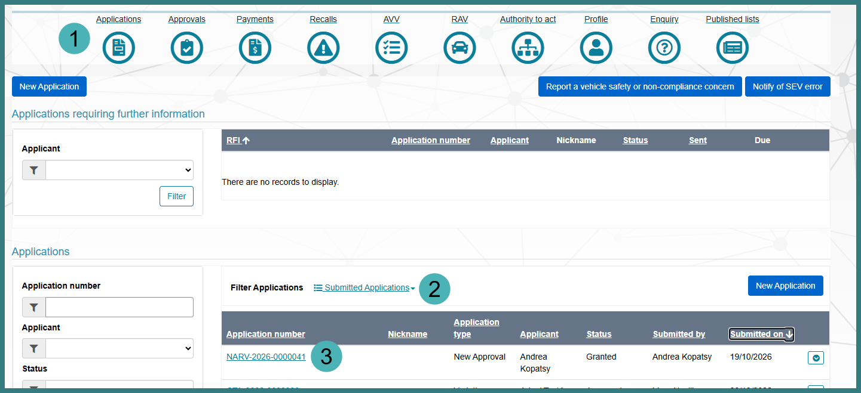
- Select the Download Decision Notice button.
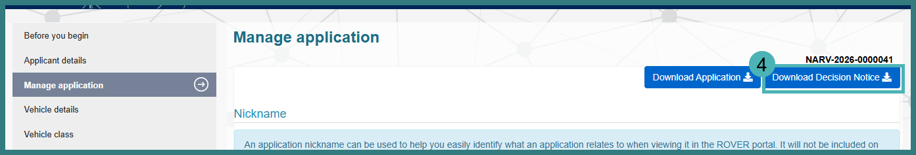

Further information
For further information, please visit Vehicles | Department’s website or submit an online enquiry via the Contact us—RVS | Department’s website page.

Quick links
- Welcome to ROVER
- RVS guides and resources | Department’s website
- RVS legislation glossary of terms | Department’s website

