Australian Government
Department of Infrastructure, Transport, Regional Development, Communications, Sport and the Arts

DRSNZ / BCARR / Communications arts & market analysis

Digital exclusion in Australia

Evidence from the Household, Income and Labour Dynamics in Australia (HILDA) survey

August 2025

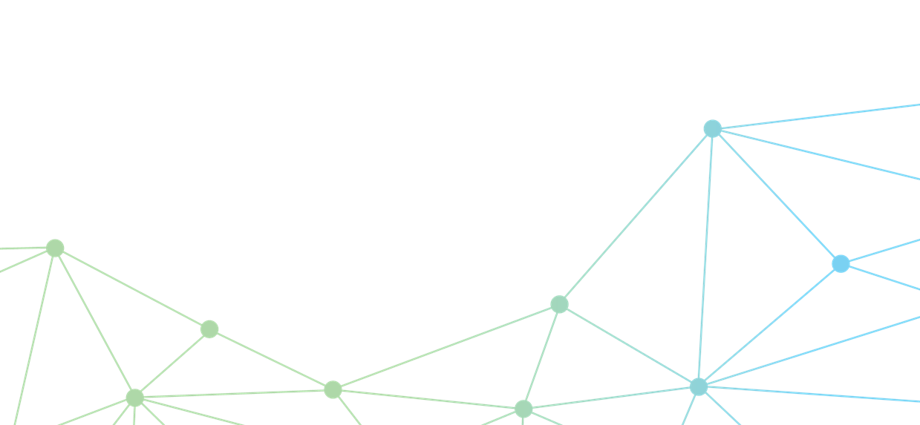

The Department of Infrastructure, Transport, Regional Development, Communications, Sport and the Arts acknowledges the Traditional Custodians of Country throughout Australia and their continuing connection to land, sea and community. We pay our respects to them, their cultures and to their Elders, past, present and emerging.

© Commonwealth of Australia 2025

ISBN 978-1-922879-82-0 BCARR reference: 2025-067

**Ownership of intellectual property rights in this publication**

Unless otherwise noted, copyright (and any other intellectual property rights, if any) in this publication is owned by the Commonwealth of Australia (referred to below as the Commonwealth).

**Disclaimer**

The material contained in this publication is made available on the understanding that the Commonwealth is not providing professional advice, and that users exercise their own skill and care with respect to its use, and seek independent advice if necessary.

The Commonwealth makes no representations or warranties as to the contents or accuracy of the information contained in this publication. To the extent permitted by law, the Commonwealth disclaims liability to any person or organisation in respect of anything done, or omitted to be done, in reliance upon information contained in this publication.

**Creative Commons licence**



With the exception of (a) the Coat of Arms; (b) the Department of Infrastructure, Transport, Regional Development, Communications, Sport and the Arts photos and graphics; (c) content supplied by third parties; (d) content otherwise labelled; copyright in this publication is licensed under a Creative Commons BY Attribution 4.0 International Licence.

**Use of the Coat of Arms**

The Department of the Prime Minister and Cabinet (PM&C) sets the terms under which the Coat of Arms is used. Please refer to the [Commonwealth Coat of Arms Information and Guidelines | PM&C](https://www.pmc.gov.au/resources/commonwealth-coat-arms-information-and-guidelines).

**Contact us**

This publication is available in PDF format and Word format. All other rights are reserved, including in relation to any departmental logos or trademarks which may exist. For enquiries regarding the licence and any use of this publication, please contact:

Director, Communications, Arts and Market Analysis, Bureau of Communications, Arts and Regional Research

Email: BCARR@infrastructure.gov.au

Website: https://www.infrastructure.gov.au/research-data/bureau-communications-arts-and-regional-research

Table of contents

Table of contents 3

Key findings 4

Introduction 4

Approach 5

Access to the internet is improving 5

The internet is increasingly viewed as an essential service 6

Most Australians are satisfied with their internet connection 7

Persistent barriers to connectivity remain for some Australians 7

Less digitally-connected groups 8

Older Australians 8

People with disability 10

Non-employed people 12

Aboriginal and/or Torres Strait Islander peoples 12

Rural Australians 14

Low income households and less advantaged areas 15

Australians with lower educational attainment 16

Conclusion 17

Acknowledgement 17

References 18

Attachment A - Data and sample 20

Attachment B - Logistic regression 23

Odds ratio estimates 23

Marginal effects estimates 25

Diagnostics and limitations 27

Attachment C - Duration modelling 28

Kaplan-Meier survival rates 28

Cox Proportional Hazard regression model 33

|  |
| --- |
| Key findings |
| * + **The share of Australians without the internet at home has decreased significantly over the past decade.** In 2024, only 2% of the Australian population did not have an internet connection at home, compared to 16% in 2010. However, the Household, Income and Labour Dynamics in Australia survey data underrepresent the Australian Aboriginal and/or Torres Strait Islander population as the survey does not sample remote and very remote areas, where 9.4 % of the Australian Aboriginal and/or Torres Strait Islander peoples live.   + **Australians increasingly view the internet as an essential service.** In 2022, three quarters of Australians reported internet access at home as being essential, and something that no household should have to go without. This is a significant increase from 2014 where only half of Australians viewed having the internet at home as essential.   + **Over 80% of Australians were satisfied with the speed and reliability of their internet connection at home in 2020**. However, internet satisfaction was lower in rural areas.   + **Some Australians report that cost barriers are keeping them offline.** Almost 40% of people who reported being unable to afford the internet at home in 2014, also reported being unable to afford an internet connection in 2022.   + **Groups experiencing higher rates of digital exclusion in Australia include:** * people aged 65 years and older * Aboriginal and/or Torres Strait Islander peoples * non-employed people * people with disability * rural Australians * low income households * people living in areas of socioeconomic disadvantage * Australians with lower educational attainment.   + **Importantly, as people can be in more than one of the groups listed above, the analysis also indicates that some Australians will face multiple barriers to digital inclusion**. For example, on average, people with disability tend to be older, less likely to be employed and have lower incomes than people without disability. |

# Introduction

Access to the internet has become increasingly necessary. From study and work to getting in touch with family and friends, internet access is integral to effectively participate in society. Internet access has become almost universal in Australia – with about 98% of Australian adults having access to the internet at home in 2024 (ACMA 2024).[1]

This paper examines the remaining 2% of Australians without home internet access. There may be several reasons for not having internet access – from personal choice to barriers such as cost, a lack of digital ability, or inadequate broadband coverage.

We use data from the Household, Income and Labour Dynamics in Australia (HILDA) survey to track people over time and consider the socioeconomic characteristics that influence both internet access and the duration of time a household spends without internet access. By identifying these characteristics, our research builds the evidence base on digitally‑excluded groups in Australia[2] and aims to better inform policies directed at improving digital connectedness.

## Approach

This paper identifies groups of Australians who experience lower levels of digital connectivity. While digital connectivity can be looked at in several ways, our analysis examines digital connectivity in terms of having a home-based internet connection.

Digital connectivity for different groups is examined using a range of statistical techniques, from descriptive statistics and logistic regression, to examining internet access over time using duration modelling.

Descriptive statistics measure the share of the population of a given group who did not have access to the internet over the period analysed, from 2010 to 2022.

Since a person can exhibit multiple characteristics which may affect their access to the internet, we also apply regression modelling. Logistic regression allows us to estimate the percentage change in the probability of having internet access if a given variable is changed by one unit of measure, while holding other observed characteristics constant. Details of this analysis are shown in *Attachment B - Logistic regression*.

Duration modelling was also used to examine whether a given characteristic had a more enduring influence on lack of internet access over time while holding other observed characteristics constant. Estimates from this analysis are presented in terms of the relative speed of gaining access to the internet for different groups, where a longer time spent without access to the internet indicates more persistent disadvantage. Details of this analysis are shown in *Attachment C - Duration modelling*.

# Access to the internet is improving

HILDA data show that over the past decade, the share of Australians[3] without the internet at home dropped significantly. By 2022, only 3% of the Australian population did not have an internet connection at home, down from 16% in 2010 (Figure 1).[4] During this period, there were significant changes to the telecommunications landscape, including: the rollout of the National Broadband Network (NBN), improved mobile and fixed broadband coverage – particularly in regional Australia, and further technological advances which have encouraged widespread adoption of smartphones and other internet-enabled devices. Amongst these changes, there were also sustained decreases in the prices of telecommunications services, leading to some connectivity offerings becoming more affordable (BCARR 2023).[5]

Figure : Internet access at home, 2010 to 2022

Source: The HILDA Survey, Release 22; BCARR calculations.

## The internet is increasingly viewed as an essential service

In 2022, 74% of Australians considered internet access at home as essential, and something that no household should have to go without. This is a significant increase from 2014, when only half of Australians viewed having the internet at home as essential (Figure 2).[6]

Perhaps unsurprisingly, HILDA data show that people who had a home-based internet connection were more likely to view the internet as an essential service (76%) than people who did not have the internet at home (39%) in 2022.

Figure : Share of people who considered internet access to be essential, 2014, 2018 and 2022

Source: The HILDA Survey, Release 22; BCARR calculations.

## Most Australians are satisfied with their internet connection

In 2020, 82% of Australians were either satisfied or very satisfied with the speed and reliability of their internet connection at home.[7] Conversely, only 9% of Australians reported being dissatisfied or very dissatisfied. A higher proportion of people in major cities were very satisfied with their connection (55%) compared to people in rural areas (41%) (Figure 3). This is consistent with findings from the *Regional Telecommunications Review* (2024) in which satisfaction with mobile connectivity was higher in major cities than in regional and remote areas.

Figure : Satisfaction with the internet connection at home by location, 2020

Source: The HILDA Survey, Release 22; BCARR calculations.

Notes: The question ‘How satisfied are you with the speed and reliability of your internet connection?’ was in the form of a 0 to 10-point Likert scale, where a value of 0 was totally dissatisfied and 10 was totally satisfied. Our analysis categorised values 0-2 as very dissatisfied, 3-4 as dissatisfied, 5 as neutral, values 6-7 as satisfied and 8-10 as very satisfied. The full Likert scale distribution of this variable is available in *Attachment A - Data and sample*.

## Persistent barriers to connectivity remain for some Australians

Despite growth in internet access, persistent barriers to digital inclusion remain. People who did not have internet access at home commonly reported affordability as a key barrier.

* HILDA data show that, in 2014, 1.7 million Australians did not have the internet at home (9% of Australians). Almost 300,000 of these people (17%) cited affordability as the barrier for not being connected. By 2022, the number of Australians who did not have the internet at home decreased significantly to 655,000 (3% of Australians). Roughly 114,000 of these people (17%) reported that they could not afford the internet at home. Interestingly, the percentage is unchanged over this time period despite the falling real costs of internet usage.
* In addition, almost 40% of the people who reported not being able to afford internet at home in 2014 also reported not being able to afford an internet connection in 2022 – indicating persistent affordability barriers may be keeping a significant group of Australians offline.

# Less digitally-connected groups

Internet access at home has varied widely for different groups since 2010 when this information was first collected in HILDA. While digital access has improved markedly for all groups since 2010, groups who were less digitally connected in 2010 tended to also be less digitally connected in 2022 (Figure 4). In what follows, we examine internet connectivity for the less connected groups described in Figure 4. We will present descriptive statistics about their internet usage. We will then discuss the results from the logistic regressions and duration analysis described inthe *Approach* section, above (with a detailed description in the attachments). The descriptive statistics will help us to understand patterns in the data. The statistical analysis will help us to determine whether particular characteristics which are associated with internet connectivity are the result of associations with other variables rather than direct determinants of internet connectivity.

Figure : Share of people without access to the internet by characteristic, 2010 and 2022

Source: The HILDA Survey, Release 22; BCARR calculations.

## Older Australians

The proportion of older Australians – those aged 65 years and older – who lack internet access reduced by 35 percentage points from 45% in 2010 to 10% in 2022. Despite this reduction, throughout the entire research period, this age group still had the highest percentage of individuals without access to the internet (Figure 5). In our regression modelling, where we hold other factors constant, we estimate that older Australians were, on average, 9% less likely to have the internet at home over the 2010–2022 period compared to people aged 21 to 30.

Figure : Share of people without access to the internet at home by age group, 2010 to 2022

Source: The HILDA Survey, Release 22; BCARR calculations.

Older Australians may have lower rates of internet access for a range of reasons. Digital ability is found to be lower in this group, meaning older Australians may lack the ability to connect and use the internet (Office of the eSafety Commissioner 2018). Age has also been found to play a role in confidence online. According to Good Things Australia, a digital advocacy group, 37% of people aged 65 years and older required help to keep up with technological changes and 1 in 4 felt anxious when unable to complete something online by themselves (Good Things Australia, 2024). Older people were also found to spend much less on telecommunications services and use those services less than people of working age (BCARR 2023; Kenny, Kenny, Gehan 2023). Notably, people aged 75 years and older had the lowest digital inclusion index score (49) among selected subgroups of Australians, which was 25 points lower than the national average (Thomas et al. 2023).

Older Australians also recorded much slower uptake of internet access in the last decade, compared to other age cohorts. Our duration modelling of HILDA data show that, compared to people aged 21 to 30 years, and keeping other characteristics constant, Australians aged 65 years and older took, on average, 55% longer to access the internet at home for the first time. This signals that older Australians have more persistent periods of digital exclusion than younger age groups.

According to Moxley, Sharit, and Czaja (2022), the willingness to adopt digital technologies,[8] particularly by older people, is mainly determined by 3 aspects: the perceived value of the technologies; the perceived improvement in quality of life attainable from the technologies; and confidence in being able to use the technologies. HILDA data show that people aged 65 years and older were less likely to view the internet as essential. In 2014, 47% of people aged 65 years and older viewed having the internet at home as being essential, compared to 51% of people aged 15 to 64. By 2022, while there remained a gap in the perceived importance of the internet across age groups, all respondents were more likely to view internet access at home as essential (Figure 6).

Figure : Share of people who view internet access at home as essential by age, 2014, 2018 and 2022

Source: The HILDA Survey, Release 22; BCARR calculations.

## People with disability

People with disability, impairment or long-term health condition (referred to hereafter as people with disability)[9] tend to have lower access to the internet than those without disability. HILDA descriptive statistics reveal that the percentage of respondents with disability who lack internet access has dropped from 29% in 2010 to 7% in 2022. However, as of 2022, it still stood 5 percentage points higher compared to those without any health conditions (Figure 7). This echoes similar research by Thomas et. al (2023) who found that the digital inclusion index score was 12 points lower for people with disability (61) than the national average (73) in 2022.

While Figure 7 shows that people with disability have lower access to the internet than people without disability, it does not account for the additional effect of belonging to more than one socioeconomic group. For example, people with disability tend to have other characteristics which are correlated with lower access to the internet. On average, this group is older, less likely to be employed and has lower incomes than people without disability. Our regression modelling confirms these additional influences. After controlling for other observable characteristics (such as age, employment status and income), the impact of having disability on the probability of getting internet access was relatively small. Having a disability reduced the likelihood of having internet access by only 2%.

While the impact of disability on the likelihood of having internet access was relatively small, its effect on the speed of gaining access was quite large. Our duration modelling of HILDA data show that, compared to people without disability, those with health conditions were 12% slower to gain internet access, other factors held constant. This shows that disability has a persistent influence on the length of time spent without internet access.

Figure : Share of people without internet access at home by health status, 2010 to 2022

Source: The HILDA Survey, Release 22; BCARR calculations.

The higher share of people with disability who did not have access to the internet could relate to their lower confidence online or digital ability. Good Things Australia found that in 2024 almost three quarters (73%) of people living with disability did not feel comfortable keeping up with changes in technology and internet, with 38% needing help to keep up with these changes (Good Things Australia 2024).

People with disability can also face affordability barriers. BCARR research found that, when controlling for other factors, people with disability spent less on telecommunications as a share of income than people without disability (BCARR 2023). Good Things Australia found that, in 2024, 26% of people living with disability reported struggling to afford their internet bills – considerably higher than the Australian average (14%). Further, 29% of people with disability stated having to make difficult choices between paying for their internet and phone bills and other essential expenses, such as food and housing (Good Things Australia 2024).

Lower internet access rates for people with disability could also be due to poor tailoring of digital technologies to their needs. Anwar, Areni, Fadilah, Indrabayu and Erika (2023) found that many forms of technology are insufficiently tailored for people with disability in terms of information needs, usability and accessibility. They found also a lack of content tailored for the needs of people with disability. This was also recognised by the Australian Digital Inclusion Alliance, who noted the importance of ensuring government websites are accessible to those living with disability in their Digital Inclusion Roadmap (2020).

HILDA data support these findings. People were more likely to rate the devices they use to access the internet as ‘excellent’ or ‘good’ if they did not have disability. In 2020, 90% of people without disability rated their internet-accessing devices as ‘excellent’ or ‘good’, compared to 85% of people with disability (Figure 8).

Figure : Satisfaction with the quality of devices used to access the internet by health status, 2020

Source: The HILDA Survey, Release 22; BCARR calculations.

## Non-employed people

The internet is a key means for accessing job opportunities. Research has shown that people with internet access have a job-finding advantage over those without (Denzer, Schank and Upward 2021). HILDA data show that from 2010 to 2022, the percentage of non-employed people without internet access declined significantly, but the proportion without internet access still remained higher among non-employed Australians compared to employed Australians – at 7% in 2022 (Figure 9).[10]

Figure : Share of people without internet access at home by employment status, 2010 to 2022

Source: The HILDA Survey, Release 22; BCARR calculations.

The logistic regression modelling, where we controlled for other characteristics of non-employed individuals (such as income, age and education), estimated that non-employed people were only 3% less likely to have access to the internet at home compared to those who were employed. Further, the duration modelling of HILDA data, showed that, keeping other characteristics constant, being non-employed did not have a statistically significant impact on the speed of getting access to the internet for the first time (*Attachment C - Duration modelling*). These modelling results indicate that other factors are more important determinants of access to the internet and the length of time spent without it.

Households with at least one non-employed member were also found to spend less on telecommunications than households where all members are employed (BCARR 2023). This indicates limited, or potentially insufficient, expenditure on telecommunications by this group.

## Aboriginal and/or Torres Strait Islander peoples

The HILDA survey is not fully representative of the entire Australian Aboriginal and/or Torres Strait Islander population as the survey does not sample very remote areas (where 9.4% of Aboriginal and/or Torres Strait Islander peoples live, and where internet access is more limited) (BCARR 2024). For Aboriginal and/or Torres Strait Islander peoples who are represented in HILDA data, internet access has improved significantly over the last decade, and the share of not connected people has declined from 33% in 2010 to 4% in 2022 (Figure 10).

Figure : Share of population without internet access at home by Aboriginal and/or Torres Strait Islander status, 2010 to 2022

Source: The HILDA Survey, Release 22; BCARR calculations.

Note: HILDA data are not nationally representative of the entire Australian Aboriginal and/or Torres Strait Islander population as it does not sample very remote areas and, therefore, overestimates connectivity.

While the gap in internet access between Aboriginal and/or Torres Strait Islander and non-Aboriginal and/or Torres Strait Islander peoples has significantly narrowed over the research period, in 2022, the proportion of Aboriginal or Torres Strait Islanders without internet access was still 1 percentage point higher than their non- Aboriginal or Torres Strait Islander peers. The higher share of Aboriginal and/or Torres Strait Islander peoples not having access to the internet observed in HILDA data over the entire research period aligns with other research pointing to lower average digital inclusion for Aboriginal and/or Torres Strait Islander peoples. The Australian Digital Inclusion Index shows that in 2022, the digital inclusion gap between Aboriginal and/or Torres Strait Islander peoples and other Australians was 7.5 points. This gap was particularly pronounced in remote (24.4 points) and very remote (25.3 points) parts of Australia (Thomas et al 2023).

The logistic regression analysis, where we control for other observable characteristics of Aboriginal and/or Torres Strait peoples, indicates that Aboriginal and/or Torres Strait Islander peoples were 7% less likely to have internet access at home.

The lower likelihood of accessing the internet for Aboriginal and/or Torres Strait Islander peoples may be for a range of factors. Good Things Australia (2024) found that, in 2024, 28% of surveyed Aboriginal and/or Torres Strait Islander peoples needed help keeping up with rapid changes in technology and 1 in 3 stated feeling anxious when unable to complete online tasks without assistance.

HILDA data show that being unable to afford the internet was the reason why almost 1 in 2 Aboriginal and/or Torres Strait Islander peoples did not have internet at home in 2022, compared to 1 in 5 non-Aboriginal and/or Torres Strait Islander peoples. Good Things Australia (2024) also identified affordability as a barrier to digital connectivity, with 36% of Aboriginal and/or Torres Strait Islander respondents stating that they struggled to afford their internet bill, and 44% saying that they had to choose between paying for the internet and/or phone bills and other essentials, such as food and housing.

However, the duration modelling of HILDA data showed that, keeping other factors constant, being Aboriginal and/or Torres Strait Islander did not have a statistically significant impact on the speed of getting access to the internet for the first time (*Attachment C - Duration modelling*). This may point to the digital disadvantage not being so persistent for this group and other factors being more important determinants of the length of time without access to the internet.

While every effort has been made to interpret the data within Aboriginal and/or Torres Strait Islander contexts, there may be instances in which a greater understanding of Aboriginal and/or Torres Strait Islander cultures might aid this interpretation.

## Rural Australians

Australians living in rural areas tended to have lower levels of connectivity and less satisfaction with their internet and internet-accessing devices.[11] While the proportion of rural Australians not having internet access has decreased significantly from 22% in 2010 to just 5% in 2022,[12] these Australians without internet access remained 2 percentage points higher than people living in urban areas (Figure 11). The higher share of rural Australians not having access to the internet could indicate lower digital connectivity of the rural areas compared to urban areas (Thomas at al 2023) and the cost of internet access being higher in these areas.[13]

Figure : Share of people without internet access at home by household location, 2010 to 2022.

Source: The HILDA Survey, Release 22; BCARR calculations.

However, when also considering other socioeconomic characteristics, living in rural areas resulted in only a 1% lower likelihood of having access to the internet. This suggests that factors other than location are more significant in explaining the lack of internet access.

In addition to being less satisfied with their internet connection, people in rural areas were also less positive about the quality of the devices that they use to connect to the internet. In 2020, only 82% of rural households ranked the devices they use to access the internet as ‘excellent’ or ‘good’, compared to 89% of urban households (Figure 12). HILDA data show that people in rural areas, have lower average median incomes than people living in urban centres. As a result, may be less able to afford upgrading their device to a new or more advanced model. However, any device could be considered ‘poor’ at meeting the users’ needs if a strong, stable internet connection cannot be accessed, which is more commonly experienced by people in rural areas.[14]

Figure : Satisfaction with the quality of devices used to access the internet by location, 2020

Source: The HILDA Survey, Release 22; BCARR calculations.

## Low income households and less advantaged areas

People living in low income households or in areas with a lower socioeconomic index (SEIFA) tend to be less digitally connected. Over the entire research period, the average income of a digitally disconnected household was much lower, less than half of the average disposable income of a household with internet connectivity. Similarly, the share of these households without access to the internet at home was higher in less advantaged areas (that is, areas with a lower SEIFA). Over the 2010–2022 period, the average SEIFA was around 4 for people who did not have access to the internet compared 6 for those who did have access (Figure 13).

Figure : Mean disposable household income and SEIFA index for those with and without access to the internet, 2010 to 2022

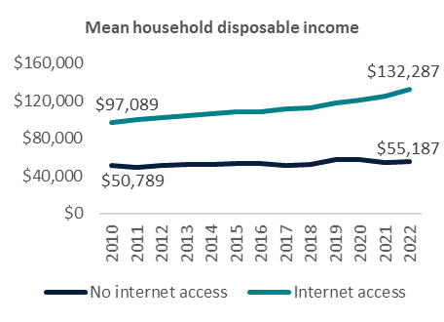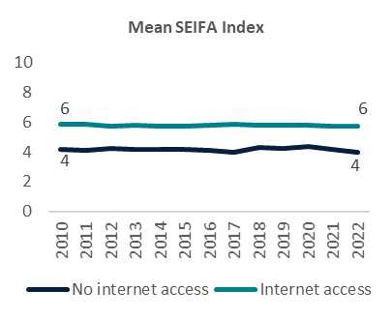

Source: The HILDA Survey, Release 22; BCARR calculations.

Notes: Socio-Economic Indexes for Areas (SEIFA) are area-based deciles, calculated by dividing the areas, ordered by disadvantage, into 10 equally-sized groups. Decile 1 contains the most disadvantaged areas, decile 10 contains the most advantaged areas.

Living in a household with lower disposable income was correlated with a lower probability of having access to the internet, when controlling for other factors. However, this impact was modest. A $10,000 decrease in household disposable income contributed to a 1% decline in the probability of having access to the internet, holding other characteristics constant. This small effect may, in part, reflect the role of telecommunications as an essential service, in which spending is less sensitive to changes in income. BCARR research showed that, in 2021, household spending on telecommunications was the fifth largest spending category as a share of disposable income, behind rent, groceries, health insurance and public transport (BCARR 2023). The logistic regression estimates also indicated that factors other than income, such as age, were a more significant driver for not having access to the internet at home.

When controlling for other factors, people living in less advantaged areas had a lower probability of having access to the internet, and were slower to gain access to the internet than people living in advantaged areas. These impacts were, however, minor. Modelling of HILDA data show, that, when controlling for other observable characteristics, being located in an area with a higher SEIFA index improved the likelihood of obtaining internet access and the speed of gaining internet access by only 1% (*Attachment B - Logistic regression*; *Attachment C - Duration modelling*).

## Australians with lower educational attainment

People with lower levels of educational attainment tended to be less digitally connected (Figure 14). Even though the share of Australians with a high school or lower qualification who lack internet access has been steadily declining since 2010, it still reached 6% in 2022. By comparison, only 3% of those who had completed a non-university qualification did not have home internet access in 2022. The share of Australians with a university qualification who did not have access to the internet was at 0% in 2022.

Figure : Share of population without access to the internet by educational attainment, 2010 to 2022

Source: The HILDA Survey, Release 22; BCARR calculations.

Our logistic regression modelling has shown that, when controlling for the other socioeconomic characteristics, people with a high school or lower qualification had the lowest likelihood of having internet access of all educational attainment groups. Compared to this group, people with a university degree were 8% more likely to have an internet connection at home and people with a non-university qualification were 4% more likely to have an internet connection.

Lower uptake of the internet for less educated groups could reflect their lower digital ability. In 2022, the digital ability component of the Australian Digital Inclusion Index score for people who did not complete secondary school (39) was 26 points lower than the national average (65) (Thomas et al 2023). Other factors held constant, people who had a high school or lower qualification were also found to spend less on telecommunciations compared to their counterparts with higher educational attainment (BCARR 2023).

# Conclusion

Our analysis has revealed that the share of Australians without the internet at home has decreased significantly over the past decade. HILDA data show that only 3% of the Australian population did not have an internet connection at home in 2022, compared to 16% in 2010. Australians also increasingly view the internet as an essential service. In 2022, 74% of Australians considered internet access at home as being essential, and something that no household should have to go without.

That said, persistent barriers to digital inclusion remain for some Australians. The less digitally connected groups include:

* people aged 65 years and older
* Aboriginal and/or Torres Strait Islander peoples
* non-employed people
* people with disability
* rural Australians
* low income households
* people living in areas of socioeconomic disadvantage
* Australians with lower educational attainment.

Our research contributes to the evidence on digitally‑excluded segments of the Australian population to help inform policies that target digital connectedness. Beyond descriptive statistics, our analysis examines the influence of particular characteristics, holding other observable factors constant. However, as people can be in more than one of the groups listed above, our analysis also indicates that some Australians will have multiple barriers to internet access – such as being older, not employed and in a low-income household.

Our analysis is limited by the data that was available to us. Our primary data source, the HILDA survey, collects information only on whether or not a respondent had access to the internet. It does not specify the frequency and intensity of internet use, the connection type, data allowances or the speed or type of devices used to access the internet. Having this additional information would allow more detailed and nuanced analysis of access to the internet.

We were not able to supplement our analysis with the digital connectivity data from other data sources. The Census of Population and Housing stopped collecting information on access to the internet in 2016. Other longitudinal surveys, such as the Longitudinal Study of Indigenous Children (LSIC) and the Longitudinal Study of Australian Children (LSAC) ceased collecting information on children’s use of digital technologies in 2019 and 2014, respectively. This makes the monitoring of groups without internet access much more difficult. While not free of limitations, the HILDA survey data and this study provide unique insights in this regard.

## Acknowledgement

We would like to acknowledge and thank Professor Robert Breunig for his advice and expertise in his peer review of this analysis.

# References

Office of the eSafety Commissioner. 2018. *Understanding the digital behaviours of older Australian. Summary of national survey and qualitative research.* https://www.esafety.gov.au/sites/default/files/2019-08/Understanding-digital-behaviours-older-Australians-summary-report-2018.pdf?v=1727666244154.

ACMA. 2024. *Communications and media in Australia: How we use internet.* https://www.acma.gov.au/sites/default/files/2024-12/How%20we%20use%20the%20internet%20-%20Executive%20summary%20and%20key%20findings.pdf.

Ali M.A., Alam K., Taylor B., Rafiq S. 2019. “Do income distribution and socio-economic inequality affect ICT affordability? Evidence from Australian household panel. Evidence from Australian household panel data.” *Economic Analysis and Policy* 317-328.

Anwar, M., I. S. Areni, N. Fadilah, Indrabayu, and K. A Erika. 2023. “Inclusive digital health: Empowering people with disabilities.” *Partnership for Australia-Indonesia Research (PAIR).*

Australian Digital Inclusion Alliance. 2020. “A National Digital Inclusion Roadmap.” https://www.digitalinclusion.org.au/wp-content/uploads/2020/10/ADIA-A-National-Digital-Inclusion-Roadmap.pdf.

BCARR. 2023. *Australian households and the affordability of telecommunications. Evidence from Household Income and Labour Dynamics in Australia (HILDA) data.* https://www.infrastructure.gov.au/sites/default/files/documents/australian-households_-affordability-telecommunications-evidence-household-income-labour-dynamics-australia-hilda-data-working-paper-november2023.pdf.

BCARR. 2024. “Telecommunications affordability and access for First Nations households: Learnings from the HILDA survey.” https://www.infrastructure.gov.au/sites/default/files/documents/telco-affordability-access-first-nations-households-june-2024-hilda.pdf.

Cleves M., Gould W., Marchenko Y. 2016. *An Introduction to Survival Analysis Using Stata, Revised Third Edition.* US: Stata Press.

Denzer, M., T. Schank, and R. Upward. 2021. “Does the internet increase the job finding rate? Evidence from a period of expansion in internet use.” doi:https://doi.org/10.1016/j.infoecopol.2020.100900.

Good Things Australia. 2024. “Australian attitudes to getting online 2024. Consumer research by Good Things Australia. October 2024.” https://goodthingsaustralia.org/wp-content/uploads/2024/10/Aus-Attitudes-to-Getting-Online-Report-2024-.pdf.

Kenny R., Kenny Ch., Gehan Z. 2023. “What Drives Broadband Traffic.” *Telecommunications Policy* Volume 47, Issue 9.

Moxley, J., J. Sharit, and S. J. Czaja. 2022. “The Factors Influencing Older Adults’ Decisions Surrounding Adoption of Technology: Quantitative Experimental Study.” doi:https://doi.org/10.2196%2F39890.

Nicole Watson, Mark Wooden. 2010. “THe HILDA Survey: Progress and Future Developments.” *Australian Economic Review* 326-336.

Regional Telecommunications Review. 2024. “2024 Regional Telecommunications Review.” doi:https://www.infrastructure.gov.au/sites/default/files/documents/2024-regional-telecommunications-review.pdf.

Summerfield M., Garrard B., Kamath R., Macalalad N., Nesa M., Watson N., Wilkins R., Wooden M. 2023. *HILDA User Manual – Release 22.* https://melbourneinstitute.unimelb.edu.au/__data/assets/pdf_file/0020/4815110/HILDA-User-Manual-Release-22.0.pdf.

Thomas J., McCosker, A., Parkinson, S. Hegarty, K., Featherstone, D., Kennedy, J. Holcombe-James, I., Ormond-Parker, L. , Ganley, L. 2023. *Measuring Australia's Digital Divide: Australian Digital Inclusion Index 2023.* https://www.digitalinclusionindex.org.au/.

Thomas, J., J. Barraket, S. Ewing, Ch. Wilson, E. Rennie, and J. MacDonald T. Tucker. 2017. “Measuring Australia’s Digital Divide: The Australian Digital Inclusion Index 2017.” doi:http://www.dx.doi.org/10.4225/50/596473db69505.



# Attachment A - Data and sample

Household, Income and Labour Dynamics in Australia (HILDA) is a longitudinal survey which follows the same people and households over an extended period and collects information about them and their activities each year (or ‘wave’). The survey started in 2001 and has been collected annually since this time.

The question on access to the internet (*_lsinthm*) was collected annually from 2010, through a self-completion questionnaire in the first year and through a continuing person questionnaire in subsequent years, allowing for 12 years of data to be analysed (Summerfield, Garrard, Kamath, Macalalad, Nesa, Watson, Wilkins, Wooden 2023). Missing values were higher in 2010 (Table 1) than in subsequent years as the self-completion questionnaire is completed and returned in the respondents’ own time, where the continuing person questionnaire is completed and collected at the time of interview. As our analysis excludes missing values, and the share of the respondents without internet aligned with subsequent years of the survey, we included 2010 in our descriptive analysis and logistic regression.

The HILDA sample was topped up in 2011 with an additional 4,009 individuals added. In 2022, the most recent year of HILDA data this study uses, the sample comprised of 15,954 individuals. See Watson and Wooden (2010) for an in-depth discussion of HILDA data.

Our key variable of interest – internet access at home (*_lsinthm*) – is a variable within the HILDA survey, which captures information on respondents’ access to the internet at home irrespective of the connection type or the digital device used (e.g., a computer, mobile phone or other device).

Table : Sample size and the number of respondents not having access to the internet

|  |  |  |  |  |  |  |  |
| --- | --- | --- | --- | --- | --- | --- | --- |
| Wave | Year | Total respondents (No) | No internet  access (No) | No internet  Access (%) | Internet  access (No) | Internet  Access (%) | Missing (No) |
| 10 | 2010 | 13,526 | 1,915 | 16% | 9,741 | 84% | 1,870 |
| 11 | 2011 | 17,612 | 2,604 | 15% | 14,997 | 85% | 11 |
| 12 | 2012 | 17,475 | 2,213 | 13% | 15,254 | 87% | 8 |
| 13 | 2013 | 17,500 | 2,015 | 12% | 15,480 | 88% | 5 |
| 14 | 2014 | 17,511 | 1,746 | 10% | 15,757 | 90% | 8 |
| 15 | 2015 | 17,605 | 1,741 | 10% | 15,860 | 90% | 4 |
| 16 | 2016 | 17,693 | 1,625 | 9% | 16,063 | 91% | 5 |
| 17 | 2017 | 17,570 | 1,434 | 8% | 16,127 | 92% | 9 |
| 18 | 2018 | 17,434 | 1,203 | 7% | 16,225 | 93% | 6 |
| 19 | 2019 | 17,462 | 1,028 | 6% | 16,432 | 94% | 2 |
| 20 | 2020 | 17,070 | 991 | 6% | 16,070 | 94% | 9 |
| 21 | 2021 | 16,549 | 675 | 4% | 15,869 | 96% | 5 |
| 22 | 2022 | 15,954 | 556 | 3% | 15,395 | 97% | 3 |
| Total |  | 220,961 | 19,746 |  | 199,270 |  | 1,945 |

Source: The HILDA Survey, Release 22; BCARR calculations.

In wave 2020, HILDA collected information on respondent’s satisfaction with the quality of internet connection. The answers to the question ‘How satisfied are you with the speed and reliability of your internet connection?’ were captured using a 0 to 10-point Likert scale, where a value of 0 was totally dissatisfied and 10 was totally satisfied. In our analysis in this paper we categorised values 0–2 as very dissatisfied, 3–4 as dissatisfied, 5 as neutral, 6–7 as satisfied and 8–10 as very satisfied. Below table shows the full Likert scale distribution of this variable.

Table : Satisfaction with the internet at home (detailed), 2020

|  |  |  |
| --- | --- | --- |
| Likert scale | Population | Share of total |
| 0 – Totally dissatisfied | 137,701 | 0.7% |
| 1 | 135,696 | 0.7% |
| 2 | 342,072 | 1.8% |
| 3 | 419,207 | 2.2% |
| 4 | 753,053 | 4.0% |
| 5 | 1,504,365 | 7.9% |
| 6 | 1,957,177 | 10.3% |
| 7 | 3,629,509 | 19.1% |
| 8 | 5,152,364 | 27.1% |
| 9 | 2,909,056 | 15.3% |
| 10 – Totally satisfied | 2,063,734 | 10.9% |
| Total | 19,003,934 | 100% |

Source: The HILDA Survey, Release 22; BCARR calculations.

When analysing all years of data from 2010 to 2022, internet access at home varied significantly across Australians (Figure 15).

Figure : The share of people without access to the internet at home by characteristic

Source: The HILDA Survey, Release 22; BCARR calculations.

Note: The low share of people without internet access in the Northern Territory (NT) should be considered as indicative only, as HILDA did not sample very remote areas.

While Figure 15 is helpful in identifying the characteristics of people more commonly associated with not having access to the internet, it does not account for the additional effect of having more than one of these characteristics. For example, respondents who are not employed may be more likely to be without access to the internet not because they do not work but because they live in a household with a lower disposable income.

The next section estimates a simple logistic regression model which examines the likelihood of internet access when controlling for the characteristics that we have considered above. Model estimates enable us to isolate the independent contribution of a given characteristic to respondents’ likelihood of having internet access, while controlling for other characteristics included in the regression model.

# Attachment B - Logistic regression

We estimate our model on 197,432 observations across waves 10 to 22 of HILDA data. As a longitudinal survey, HILDA collects information from the same people over time. In our analysis we used multiple responses from the same individuals who share unobserved fixed characteristics (such as personality, attitude, ability) resulting in highly correlated observations. To adjust our standard errors for this correlation we apply the ‘vce cluster’ function in STATA to our model.

The dependent variable used in our regression is coded 1 if a person had access to the internet, and 0 otherwise. With the exception of household disposable income and SEIFA deciles of economic advantage, which are continuous variables, all of the explanatory variables used in our models are grouped into categorical variables. Some of our categorical variables are binary. For example, the employment status of a person is captured by a binary variable coded 1 if a person was employed, and 0 otherwise. While in our regression model we test all of the explanatory variables described in *Attachment A - Data and sample* in our final model we include only the explanatory variables that were statistically significant.[15]

Our model includes two interaction terms which were found to be significant, household income and educational attainment, and household income and employment status.

## Odds ratio estimates

Table 3 reports the estimates of the logistic regression in the form of odds ratios, which is the ratio that quantifies the association between two events. For example, the odds ratio refers to the probability of accessing internet when exhibiting a characteristic, over the probability of having access to the internet when not exhibiting that same characteristic. An odds ratio greater than 1 means the respondent exhibiting the given characteristic is more likely to access the internet. An odds ratio less than 1 means the respondent exhibiting the given characteristic is less likely to access the internet. An odds ratio of 1 means that there is no association between the respondent’s characteristic and their likelihood of accessing the internet. So, for the variable to have a statistically significant effect on the likelihood of accessing the internet, its odds must be different from 1 and be statistically significant (that is, its p-values must be above 10%).[16]

The results for non-binary categorical variables are reported in comparison to the following reference categories:

* wave, relative to wave 10
* highest level of education, relative to high school or lower qualification
* age, relative to those aged 21 to 30 years.

For example, the odds of having the internet access for those aged 65+ years were 0.26 times the odds for those aged 21–30 years. In other words, the odds of having the internet access was 74% lower for those aged 65+ years compared to those aged 21–30 years, holding other variables constant. In contrast, those studying full-time had more than double the odds of accessing the internet compared to those who were not studying full-time. Household income has its odds equal to 1, which means that is does not have statistically significant impact on the respondents’ likelihood of owning internet.

Table : Logistic regression results

|  |  |  |
| --- | --- | --- |
| Does a person have access to the internet at home? |  |  |
| Variable | Odds Ratio | Robust Std Error |
| Wave (relative to wave 10) |  |  |
| wave 11 | 1.158*** | 0.034 |
| wave 12 | 1.416*** | 0.045 |
| wave 13 | 1.612*** | 0.054 |
| wave 14 | 1.953*** | 0.069 |
| wave 15 | 1.949*** | 0.072 |
| wave 16 | 2.142*** | 0.081 |
| wave 17 | 2.594*** | 0.102 |
| wave 18 | 3.103*** | 0.129 |
| wave 19 | 3.648*** | 0.158 |
| wave 20 | 3.561*** | 0.157 |
| wave 21 | 5.37*** | 0.259 |
| wave 22 | 6.638*** | 0.352 |
| Household disposable income |  |  |
| Household income | 1.000*** | 0.000 |
| Highest educational level (relative to high school or lower qualification) |  |  |
| Non-university qualification | 2.221*** | 0.212 |
| University qualification | 6.851*** | 1.366 |
| Interaction of highest educational level and household income |  |  |
| Non-university qualification* Household income | 1.000* | 0.000 |
| University qualification * Household income | 1.000*** | 0.000 |
| Presence of children in a household (relative to households with no children) |  |  |
| Child living in the household | 1.594*** | 0.070 |
| Aboriginal and/or Torres Strait Islander (relative on non- Aboriginal and/or Torres Strait Islander) |  |  |
| Aboriginal and/or Torres Strait Islander | 0.429*** | 0.037 |
| Age (relative to those aged 21–30) |  |  |
| Aged 31–64 | 0.675*** | 0.032 |
| Aged 65+ | 0.26*** | 0.015 |
| Immigrant status (relative to Australian-born) |  |  |
| Migrant | 1.158*** | 0.058 |
| Employment status (relative to employed or in the labour force) |  |  |
| Non-employed or not in the labour force | 0.508*** | 0.053 |
| Interaction of non-employed and household income |  |  |
| Non-employed or not in the labour force * Household income | 1.000** | 0.000 |
| Student status (relative to non-students) |  |  |
| Full-time student | 2.206*** | 0.204 |
| Health status (relative to no disability) |  |  |
| Disability | 0.703*** | 0.024 |
| Urban/ rural status (relative to urban) |  |  |
| Rural | 0.903* | 0.052 |
| SEIFA decile |  |  |
| SEIFA decile | 1.097*** | 0.009 |
| Constant | 1.724*** | 0.172 |
| Number of observations | **197432** |  |
| (Pseudo) R2 | **0.293** |  |
| Log (Pseudo) likelihood | **-43881** |  |
| AIC | **87820** |  |
| BIC | **88116** |  |

Source: The HILDA Survey, Release 22; BCARR calculations.

Notes: Standard errors adjusted for clustering at the level of the individual. *Significant at 10% level; **Significant at 5% level; ***Significant at 1% level

## Marginal effects estimates

Figure 16 reports the regression results in the form of marginal effects which refer to the percentage change in the probability of accessing internet if a given variable is changed by one unit of measure, holding other variables used in the regression model constant. For the binary variables, it measures the change in probability of having internet access when moving from zero to a one.

Figure : Predicted change in the probability of accessing the internet

Source: The HILDA Survey, Release 22; BCARR calculations.

Note: Marginal effects of household income refer to the percentage change in the response variable from a 1 unit change in household income level while holding constant the other control variables. Similarly, for SEIFA the marginal effect refers to the percentage change in the response variable if the SEIFA index increases by 1 decile. For other variables which are binary in nature, marginal effects refer to the percentage change in the response variable if a given variable changes from 0 to 1 while holding constant the other variables. Marginal effects for non-binary categorical variables are reported in comparison to the following reference categories: ‘high school or lower qualification’ for the highest level of education attained; ‘aged 21–30’ for the age variable and ‘urban’ for the location variable. They show us the percentage change in the response variable if a given categorical variable moves from the reference category to the category in question, holding other control variables constant.

## Diagnostics and limitations

The logistic regression estimates the likelihood of an outcome occurring, which in our model is the likelihood of an individual having access to the internet at home. This outcome is common, it occurs in 91% of all non-missing observations pooled across all the waves. The inverse of our outcome, an individual not having access to the internet at home is much less common and occurs in 9% of all non-missing observations. This makes it difficult for the model to predict the outcome not occurring, or people not having access to internet. We have taken this into account when running diagnostic tests on our model.

We conducted two diagnostic tests to assess the validity of our logistic regression model and to identify the proportion of observations correctly predicted and the sensitivity and specificity of the model. Sensitivity is the fraction of observations that are correctly classified predicting the outcome to occur, that is being 1. Specificity is the percentage of observations that are correctly classified as predicting the outcome not occurring, that is being equal to 0.

The results of the first two tests are summarised in Table 4. The proportion of correctly predicted outcomes is 89%. Using a cut-off point of 0.75 in the specificity and sensitivity analysis, we identified that our model is good at correctly predicting people who have access to the internet, or specificity, but not as good at correctly predicting people who do not have access to the internet, or sensitivity. To balance the sensitivity and specificity of our predictions and to minimise the total number of misclassifications we chose 0.75 as the cut-off point for our model.

Table : Diagnostics applied to the logistic regression model

|  |  |
| --- | --- |
| Diagnostic indicator | Percent |
| Specificity | 57% |
| Sensitivity | 92% |
| Correctly predicted | 89% |
| Correctly predicted cases | 95% |
| Correctly predicted non-cases | 44% |
| Defined cut-off point | 0.75 |

Source: The HILDA Survey, Release 22; BCARR calculations.

A limitation of the logistic regression modelling is that it treats the data as pooled cross-sectional, as opposed to longitudinal which means it does not fully utilise the potential of the collected longitudinal information. We do include time dummies which partially helps with this problem. Using HILDA data this way optimises the number of observations we can analyse. However, it does result in a lot of highly correlated observations since the responses come from the same individuals who have the same unobserved fixed traits such as personality, attitude, ability. As previously discussed, we adjust the reported standard errors for this correlation around individuals. In the subsequent section of the paper, we utilise the longitudinal nature of HILDA and describe our analysis of duration modelling for the time it took respondents to access the internet at home for the first time.

# Attachment C - Duration modelling

In this section we analyse the factors that affected the time it took respondents to first access the internet at home. A longer time spent without access to the internet may indicate more persistent disadvantage. Better understanding of the factors contributing to longer periods without access to the internet is critical for policy design aimed at improving digital inclusion.

We apply duration modelling to test if respondent’s socioeconomic characteristics have a statistically significant impact on the time it took them to obtain internet access, and if so, to what degree. We use STATA and its stset command to set up the essential variables – ‘failure’ and ‘time of failure’.[17] Failure is a binary variable set to 1 when a respondent gains access to the internet, and 0 otherwise (Cleves, Gould, Marchenko 2016). Failure in the dataset occurs when a respondent gains access to the internet (that is, the failure variable is 1) and censoring when the respondent does not gain access in our data window (the failure variable is 0 in all time periods). For simplicity, we model respondents’ first access to the internet.[18]

The time of failure variable specifies whenthe failure or censoring occurs by measuring the survival time until the moment of failure. In our analysis, this is the time it takes for a respondent to get access to the internet for the first time. The window for this analysis spans from 2011 to 2022. We chose to start our analysis in 2011 because this year saw HILDA sample topped up with over 4000 individuals (see: *Attachment A - Data and sample* for more details). The 2011 top up had a significant impact on the total number of people with and without access to internet that year and made a comparison to 2010 difficult. Starting in wave 11, 2011, our analysis excludes individuals that had internet access in this year and focuses on those who gained access after 2011.

## Kaplan-Meier survival rates

We start with 11,071 respondents, 1,478 of whom gain access to the internet – that is, fail, in the first year of our analysis. Kaplan-Meier (KM) estimates measure the fraction of respondents who survive an event for a certain amount of survival time t. In our case, the spell of interest is the period without access to the internet, that is, we are modelling the time it takes for respondents to access the internet at home for the first time from the moment they entered our analysis in wave 11. This variable can vary from 1 to 11 years (Table 5).

‘Net Lost’ in Table 5 refers to difference between the number of respondents without access to the internet who were censored and the number of respondents who entered our analysis in the subsequent year. The survivor function in Table 5 refers to the Kaplan-Meier (KM) probability of survival, or in other words, the probability of gaining access to the internet at a given time.

Table : Kaplan-Meier estimator of survivor function

|  |  |  |  |  |  |  |  |
| --- | --- | --- | --- | --- | --- | --- | --- |
| Time (in years) | Total | Failed | Net Lost | Survivor Function | Std Error | 95% | Conf. Int |
| 1 | 11,071 | 1,478 | 155 | 0.867 | 0.003 | 0.860 | 0.873 |
| 2 | 9,438 | 1,196 | 120 | 0.757 | 0.004 | 0.749 | 0.765 |
| 3 | 8,122 | 1,089 | 97 | 0.655 | 0.005 | 0.646 | 0.664 |
| 4 | 6,936 | 979 | 84 | 0.563 | 0.005 | 0.553 | 0.572 |
| 5 | 5,873 | 898 | 91 | 0.477 | 0.005 | 0.467 | 0.486 |
| 6 | 4,884 | 795 | 93 | 0.399 | 0.005 | 0.390 | 0.408 |
| 7 | 3,996 | 798 | 59 | 0.319 | 0.005 | 0.311 | 0.328 |
| 8 | 3,139 | 831 | 70 | 0.235 | 0.004 | 0.227 | 0.243 |
| 9 | 2,238 | 665 | 54 | 0.165 | 0.004 | 0.158 | 0.172 |
| 10 | 1,519 | 663 | 48 | 0.093 | 0.003 | 0.087 | 0.099 |
| 11 | 808 | 576 | 232 | 0.027 | 0.002 | 0.024 | 0.030 |

Source: The HILDA Survey, Release 22; BCARR calculations.

In what follows, we present estimates of the Kaplan-Meier (KM) survival probabilities for the total sample and the socioeconomic groups analysed. The y-axis in the graphs refers to the probabilities of surviving the spell of time without internet access, and the x-axis represents the years after entering HILDA sample in 2011. The survival curves are downward sloping step functions, where the rate of decrease is largest in the earliest period and gradually declines over time. They show that the likelihood of respondents getting access to the internet is much lower in the first years of our analysis. This is consistent with access to the internet being more prevalent in more recent waves of HILDA.

The aggregate survival probability estimates for the entire sample are illustrated in Figure 17. They show that a respondent entering our analysis (at time 1) has 87% chance of ‘surviving’ the spell of time without access to the internet in the first year following entering the HILDA dataset falling to 76% in the second year and then to 66% in the third year and so on.[19]

Figure 17 is a baseline hazard for our analysis of the survival probabilities by socioeconomic characteristic. In what follows we apply the same KM-based analysis, broken down by socioeconomic characteristics such as age, Aboriginal and/or Torres Strait Islander status, migrant status, employment status, health status, full-time student status, educational attainment, location, presence of children and SEIFA decile. We test the equality of all below described survivorship functions using long rank test in STATA.[20]

Figure : Survival probabilities for the entire sample

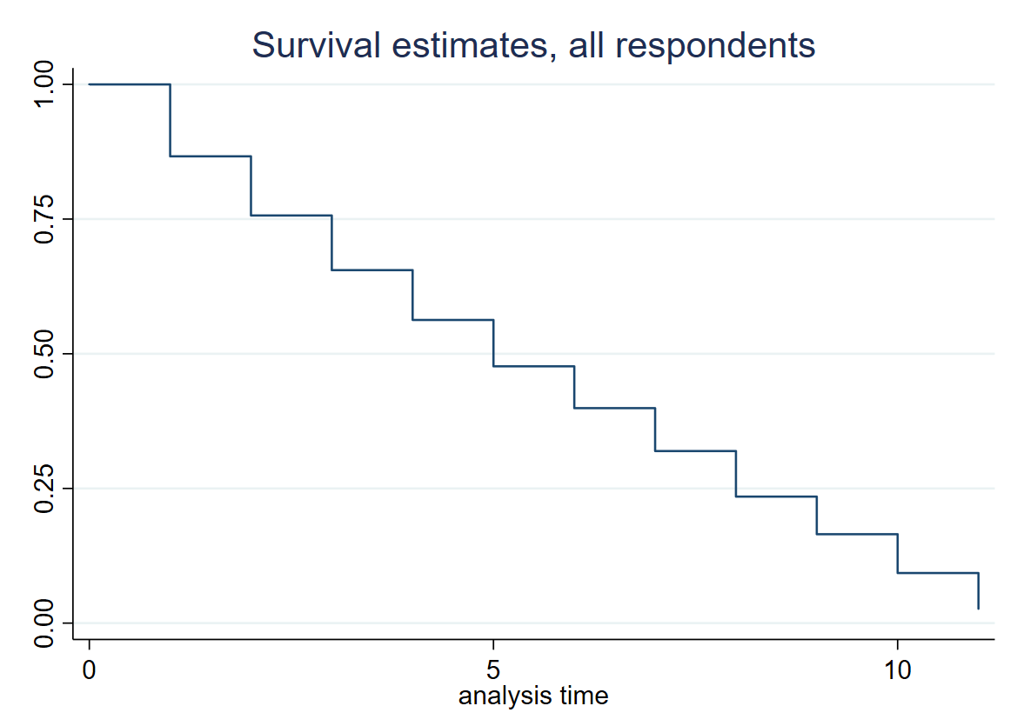

Source: The HILDA Survey, Release 22; BCARR calculations.

The KM-analysis outlined below, allows us to estimate survival probabilities and compare survival curves across various subgroups of the Australian population. However, it does not control for other characteristics which may be associated with these groups’ survival. To include these factors and evaluate their impact on these groups’ survival, we use the Cox proportional hazard regression which we explain in next section.

Figure 18 presents the KM survival curves for different age groups. It is evident that the curves for those aged 31 to 64 years and those aged 21 to 30 years sit well below the curve for those aged 65 years and older throughout the entire time period. This indicates that respondents in these age groups have lower ‘survival’ rates at each time point. In other words, prime working age respondents and those aged 21 to 30 years take significantly less time to get access to the internet compared to their older counterparts. The differences in the internet access probabilities between these age groups are large, statistically significant and are quite persistent throughout the entire research period.

Figure : Survival probabilities for particular age groups

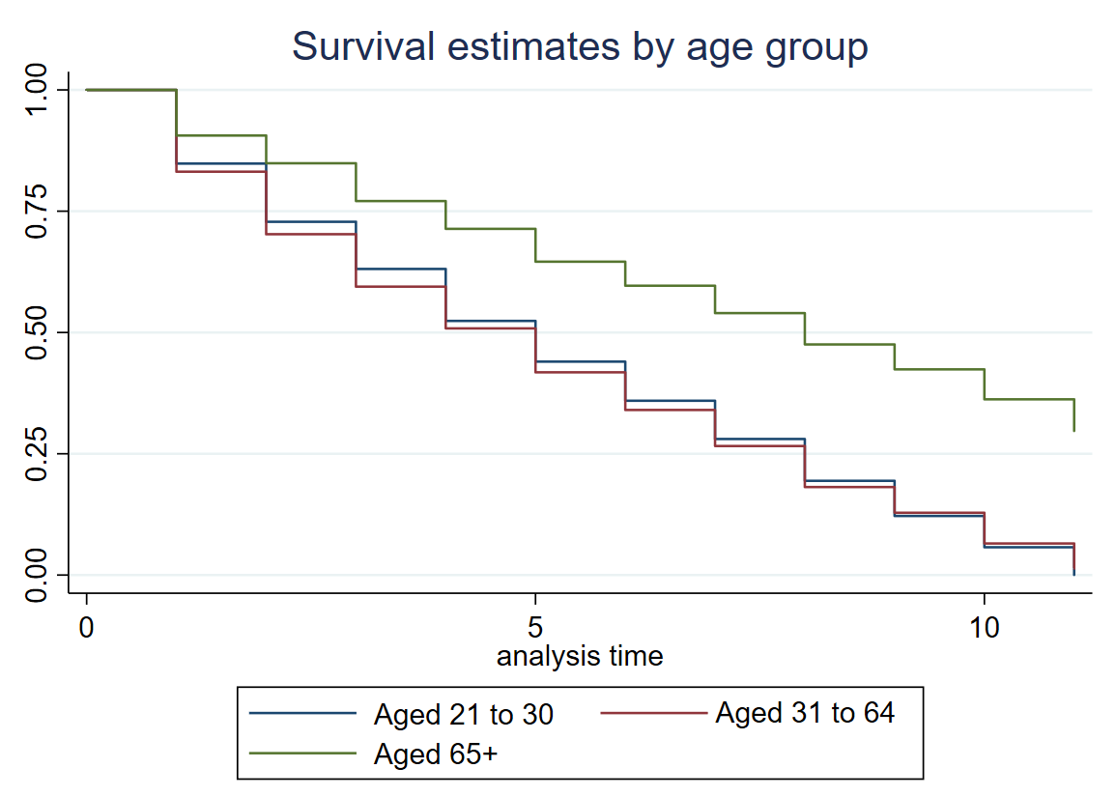

Source: The HILDA Survey, Release 22; BCARR calculations.

We find that Aboriginal and/or Torres Strait Islander status, employed status, full-time student status and health status are important characteristics in determining the time it takes for respondents to get access to the internet at home. Figure 19 shows that respondents who were Aboriginal and/or Torres Strait Islander, full-time students, not employed or had disability have much higher survival rates than other groups. Higher survival rates indicate that they took longer to access the internet at home compared to those who did not display these characteristics. Importantly, we find that, given time, internet access probabilities for Aboriginal and/or Torres Strait Islanders and students, but we find no similar convergence among respondents with varying employment levels with and without disability. The differences in survival rates were significant for all above groups with exception of full-time students.

Figure : Survival probabilities by health, employment, student and Aboriginal and/or Torres Strait Islander status

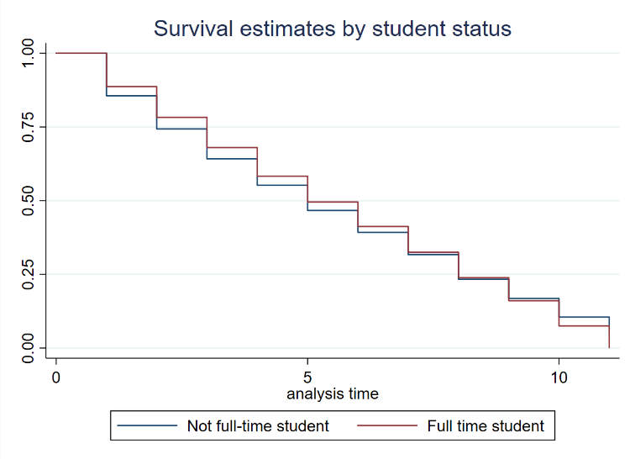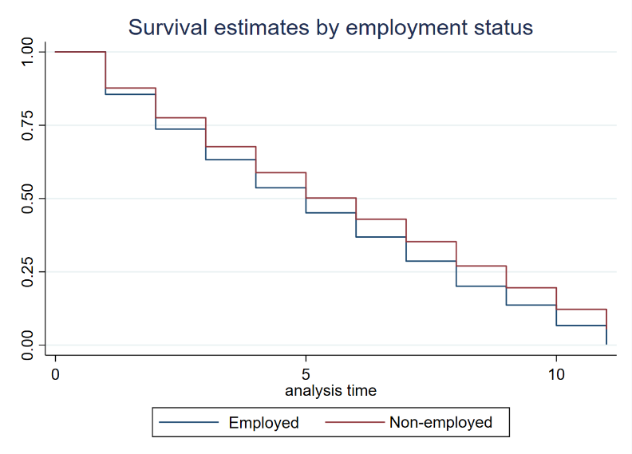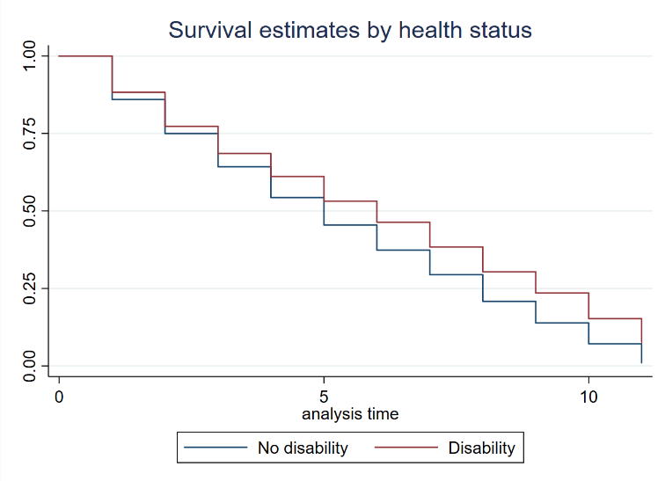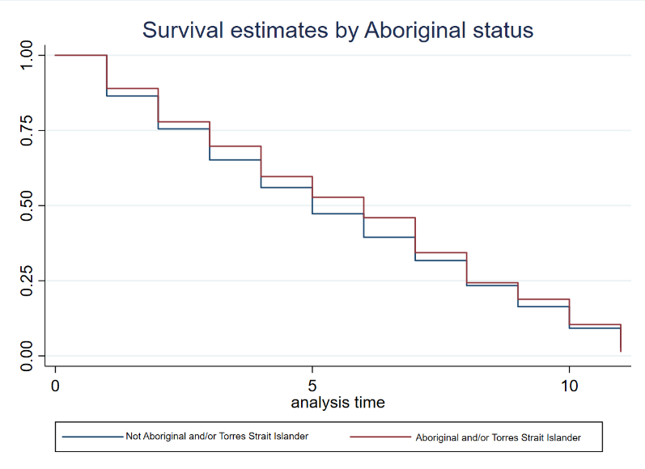

Source: The HILDA Survey, Release 22; BCARR calculations.

In contrast, respondents with a university qualification, those living with children and migrants appear to access the internet at home quicker than their counterparts with low educational attainment, without children and born in Australia (Figure 20). The gap in the survival probabilities of respondents with a university qualification and those with high school or lower qualification is statistically significant and seem to be quite persistent throughout the entire research period. Similarly, while small, the gap in the survival probabilities between those with and without children shows very little convergence and is statically significant. In contrast, the gap in survival probabilities between migrants and respondents born in Australia seems to converge over time and is not statistically significant.

Figure : Survival probabilities by highest educational attainment, migrant status and presence of children in the household

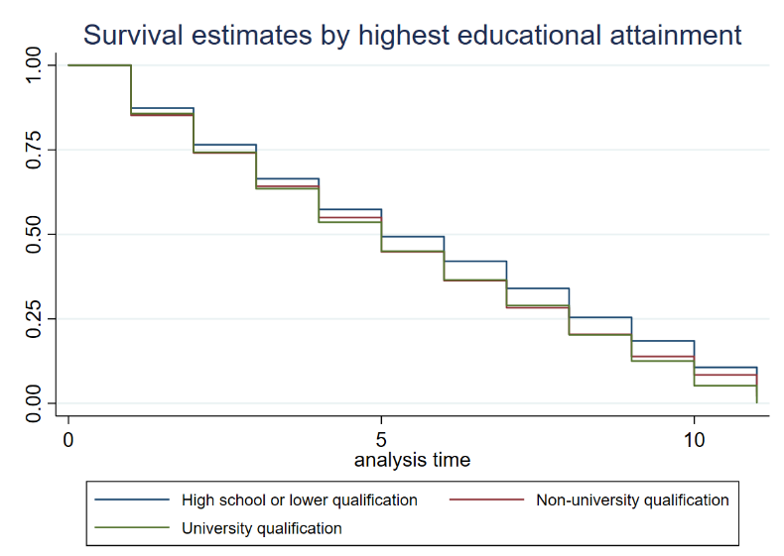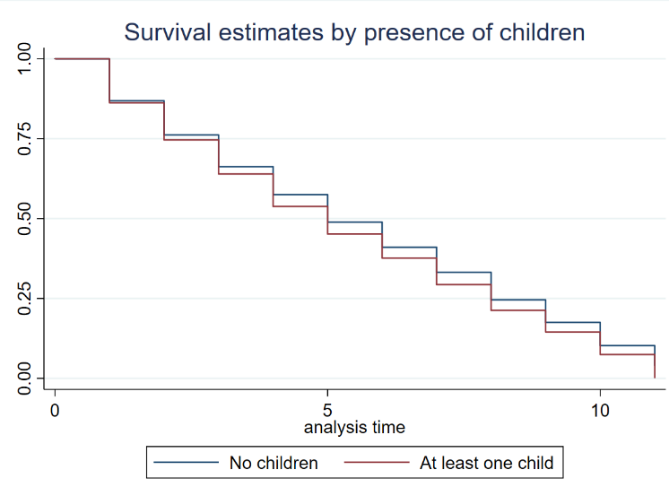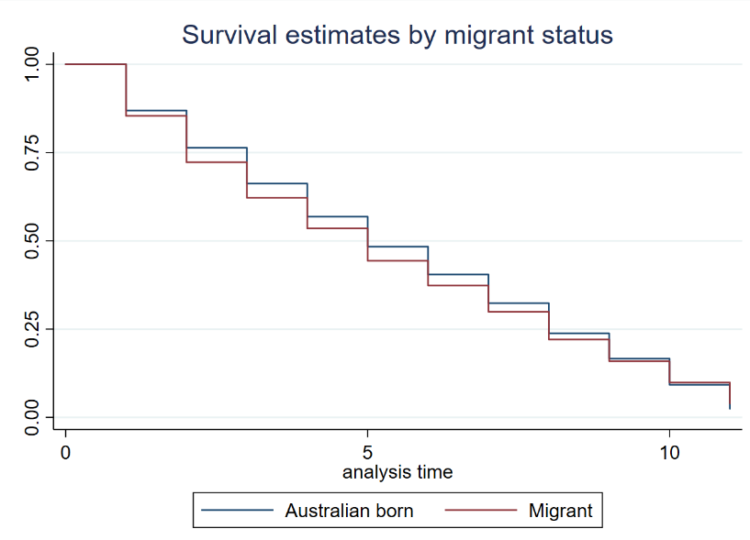

Source: The HILDA Survey, Release 22; BCARR calculations.

With regards to location, we find that respondents living in rural areas and lower SEIFA deciles take longer to get access to the internet (Figure 21). However, while statistically significant, these differences in survival probabilities are very small.

Figure : Survival probabilities by household location and SEIFA decile

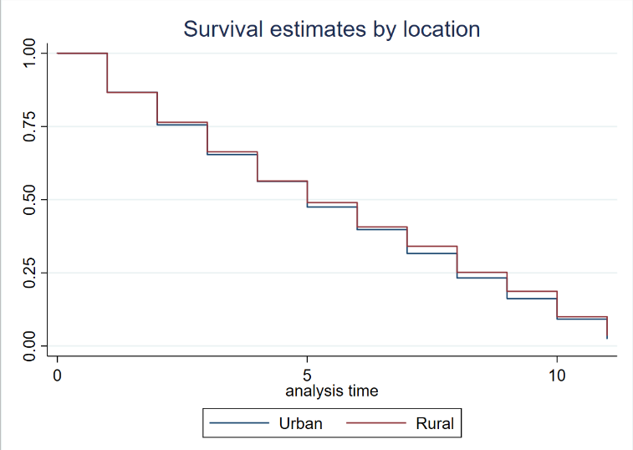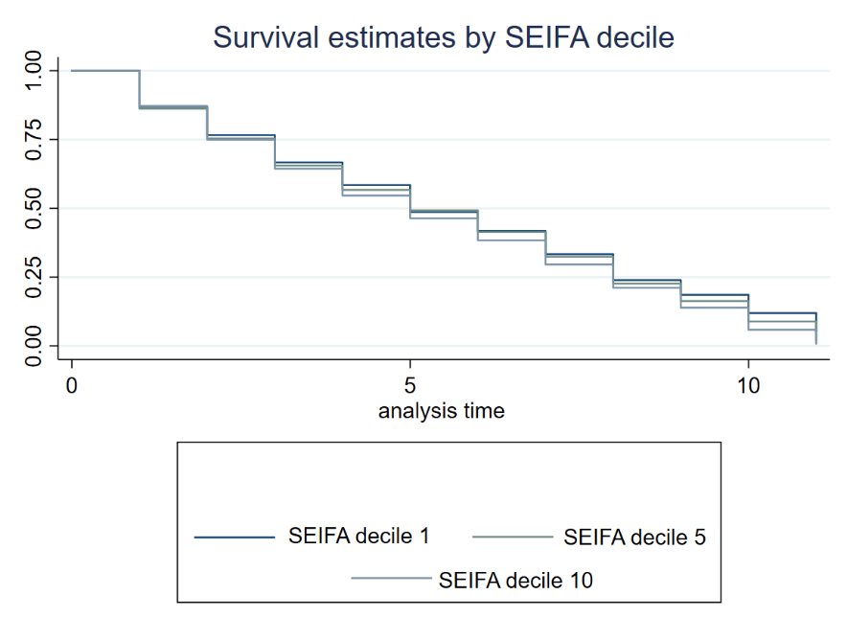

Source: The HILDA Survey, Release 22; BCARR calculations.

## Cox Proportional Hazard regression model

The KM analysis in the previous section indicated trends that strongly associate particular socioeconomic groups with the time it takes them to access the internet at home. While useful, the KM analysis is limited in its ability to determine causation and does not account for the additional effect of other variables on the survival times. For example, respondents studying full-time might have higher survival times, not because they are students, but because they are younger.

In this section, we discuss results from the survival analysis using the Cox Proportional Hazard (CPH) model which identifies the impact of a particular socioeconomic characteristic on the length of time it takes to get access to the internet while holding all the other characteristics constant. For example, we use CPH regression to estimate whether people with disability took longer to access internet holding constant other characteristics such as age, Aboriginal and/or Torres Strait Islander status, income and so on.

In our model, the duration spell we wish to analyse is the time it takes respondents to obtain access to the internet for the first time. Spell is our dependent variable and the regressors are the key socioeconomic factors described in more detail in the KM section of this paper such as respondents’ age, their highest educational attainment, Aboriginal status, presence of children in the household and so on.

Table 6 shows the CPH estimates in form of the hazard ratios which measure the relative speed of gaining access to the internet between the reference group and the group of interest. A ratio lower than 1 means that the group of interest has a lower hazard rate (and lower speed of gaining access to the internet) compared to the reference group. A ratio higher than 1 means that the group of interest has a higher valued hazard rate (and higher speed of gaining access to the internet) compared to the reference group. For example, compared to those aged 21 to 30, those aged 65+, access the internet on average 55% slower (that is, their hazard ratio is 0.45). Hazard ratio of 1 means that the variable has no significant impact on the speed of getting internet access.

Importantly, our CPH modelling assumes that the hazard ratios stay constant over time. For instance, the 0.45 hazard ratio for those aged 65 and older implies that older individuals tend remain without access internet 55% longer than their younger counterparts at any point throughout the research period.

Table 6 points to specific socioeconomic groups that are much slower in their take up of the internet. These are:

* people aged 65 + years who tend to remain without internet access 55% longer than their younger counterparts (aged 21 to 30)
* respondents with disability who are 12% slower in their internet take up compared to those without disability.

Long periods without access to the internet for the above listed groups might indicate persistent socioeconomic disadvantage, as they may prevent these groups from fully participating in the digital economy.

On the other hand, Table 6 shows that there are groups who on average, gain access to the internet much faster. These are:

* those living in a household with children who connect to the internet 19% quicker compared to those that live in households without children
* migrants to Australia are 8% faster in their take up the internet compared to the Australian-born respondents
* those living in areas with higher SEIFA deciles. With every increase in SEIFA decile the respondents tended to get access to the internet 1% faster.

The CPH results show that the association of household income with the respondent’s length of stay without access to the internet is minimal (hazard ratio of 1). This finding is in line with the logistic regression estimates (discussed in *Attachment B - Logistic regression*) which showed that income had a very small, positive impact on the likelihood of respondents gaining access to the internet. The modest impact of income on the probability of accessing the internet and the duration of time spent without it also indicates that other socioeconomic factors such as health status or age, which are correlated with income, have more significant influence of people’s digital connectivity.

Table : Cox proportional hazard regression estimates

|  |  |  |
| --- | --- | --- |
| Length of time it takes to get access to the internet for the first time |  |  |
| Variable | Hazard Ratio | Robust Std Error |
| Household disposable income |  |  |
| Household income | 1.000*** | 0.000 |
| Highest educational level (relative to high-school or lower qualification) |  |  |
| Non-university qualification | 1.017 | 0.028 |
| University qualification | 1.024 | 0.032 |
| Presence of children in a household (relative to households with no children) |  |  |
| Child living in the household | 1.185*** | 0.033 |
| Aboriginal status (relative to non-Aboriginal and/or Torres Strait Islander) |  |  |
| Aboriginal and/or Torres Strait Islander | 0.951 | 0.047 |
| Age (relative to those aged 21–30) |  |  |
| Aged 31–64 | 1.009 | 0.025 |
| Aged 65+ | 0.454*** | 0.021 |
| Immigrant status (relative to Australian-born) |  |  |
| Migrant | 1.079*** | 0.030 |
| Employment status (relative to employed or in the labour force) |  |  |
| Non-employed or not in the labour force | 0.965 | 0.027 |
| Student status (relative to non-student) |  |  |
| Full-time student | 0.949 | 0.037 |
| Health status (relative to no disability) |  |  |
| Disability | 0.879*** | 0.023 |
| Urban/ rural status (relative to urban) |  |  |
| Rural | 1.019 | 0.042 |
| SEIFA decile |  |  |
| SEIFA decile | 1.015*** | 0.004 |
| Number of observations | **14559** |  |
| Log (Pseudo) likelihood | **-49312** |  |
| AIC | **98649** |  |
| BIC | **98748** |  |

Source: The HILDA Survey, Release 22; BCARR calculations.

Notes: Standard errors adjusted for clustering at the level of individual. *Significant at 10% level; **Significant at 5% level; ***Significant at 1% level.

1. ACMA 2024 – ‘Overall, 98% had access to the internet at home, including via the 4G/5G mobile network.’
2. ADII (2023) and BCARR (2023).
3. The HILDA sample is representative of Australians aged 15 years and older in non-remote areas.
4. The difference in the share of the population without the internet at home between the HILDA survey (3%) and the ACMA data shown earlier (2%) is due to differences in the survey timing and data used. The HILDA survey is a nationally representative survey based on 15,954 panel respondents in 2022, while the ACMA figure is based on a nationally-representative survey of consumer take-up of communications services with a sample of 3,530 people in 2024.
5. Affordability is measured by looking at changes in the share of disposable income that households spend on telecommunications. Average household expenditure on telecommunications has declined from a high point of 4.1% of disposable income in 2008, down to 3% 2021, indicating telecommunications affordability has improved. For more information, refer to BCARR (2023).
6. COVID-19 and associated lockdowns and travel restrictions are likely to have influenced people’s perception of whether the internet is essential. During the pandemic, the internet became critical for work, entertainment, accessing services and staying in contact with others.
7. HILDA does not collect information on the types of internet access available at the home (for example, fixed-wireless, fixed line or mobile broadband), which may explain some of the variation in satisfaction across rural and urban areas.
8. Five technologies were presented in the study which included apps, an online portal and webpages.
9. Information on people with disability and those with long-term health conditions is collected together in the HILDA survey. Respondents were provided with a list of impairments and asked, ‘*Do you have any long-term health condition, impairment or disability (such as [those provided]) that restricts you in your everyday activities, and has lasted or is likely to last, for 6 months or more?’* Some example impairments included difficulty gripping things, hearing problems, chronic pain and difficulty breathing.
10. Non-employed people refers to anyone aged 15 years and older who is not in a job, such as unemployed Australians and those not in the labour force, including retirees, students, and those engaged in household duties.
11. HILDA survey does not sample very remote areas, so rural Australians living in these areas may be underrepresented.
12. The ASGC 2001 Section of State variable was used to categorise households as either urban or rural. Urban households are those located in major urban or other urban areas, and rural households are from areas of a bounded locality or rural balance.
13. Some parts of rural Australia are more likely to use satellite internet services which cost more than equivalent fixed-line broadband services available in urban areas. In rural Australia, there are fewer telecommunication providers, and therefore less competition.
14. HILDA data show a clear relationship between people’s satisfaction with their home internet connection, and the perceived quality of the device they use to access the internet. People using a poor-quality device are much more likely to be dissatisfied with their internet connection. This might be expected, as persons with lower incomes who cannot afford a new or high-quality device may also be on a low-speed internet plan. However, this relationship could also demonstrate how slow response times on an older or worn device are potentially mistaken for the slower speed or high latency of an internet connection, or vice versa.
15. In practice, this meant excluding the following variables from the final regression model: state or territory of household, number of residents in household, working from home status and English proficiency. Due to sample size issues, a geographic variable on household location was constructed using the ASGS 2021 section of state classification which grouped observations into urban (major city or other urban) and rural (bounded locality and rural balance) which represented 88% and 12% of the total sample, respectively.
16. For comparison, in the ordinary least square regression for the explanatory variable to have statistically significant effect on the dependent variable its coefficient must be different from 0 and be statistically significant.
17. Duration modelling, also known as ‘survival analysis’, is a branch of statistics used to analyse the expected duration until an event occurs. As the events studied in some scientific disciplines often have negative outcomes, such as death or mechanical failure, the terminology used for this modelling is also often negative. In contrast, for our study, ‘failure’ occurs when a respondent gains access to the internet, while ‘survival’ and ‘censored’ means that they do not gain access to the internet.
18. HILDA data capture respondents who gained and lost access to the internet multiple times. While STATA allows for the survival analysis of multiple occurrence events, this analysis is restricted to respondents who gained access to the internet for the first time in the period analysed.
19. In this study, a larger survival rate Pr(S) indicates a longer period without access to the internet, a negative event. It may be easier to interpret this number in terms of ‘failure’ rate Pr(F), which a positive event representing the probability of getting access to the internet such as Pr(F) = 1- Pr(S) where 0 <Pr(F)<1 and 0 <Pr(S)<1. If internet access is viewed as welfare-enhancing, a desired outcome in the analysis is for Pr(S) to be as low as possible and Pr(F) to be high as possible as this would indicate this group’s shorter time spent without access to the internet.
20. The differences in survival rates were considered to be statistically significant if the p-values of the long rank test for equality of survivorship functions was below 10%.