Logo: Australian Government, Department of Infrastructure, Transport, Regional Development and Communications.



www.infrastructure.gov.au
www.communications.gov.au 
www.arts.gov.au


# Designation of spectrum in the 3.4 GHz band for spectrum licensing—Consultation Paper

September 2020

© Commonwealth of Australia 2020  
September 2020 / INFRASTRUCTURE

Ownership of intellectual property rights in this publication

Unless otherwise noted, copyright (and any other intellectual property rights, if any) in this publication is owned by the Commonwealth of Australia (referred to below as the Commonwealth).

Disclaimer

The material contained in this publication is made available on the understanding that the Commonwealth is not providing professional advice, and that users exercise their own skill and care with respect to its use, and seek independent advice if necessary.

The Commonwealth makes no representations or warranties as to the contents or accuracy of the information contained in this publication. To the extent permitted by law, the Commonwealth disclaims liability to any person or organisation in respect of anything done, or omitted to be done, in reliance upon information contained in this publication.

Creative Commons licence

With the exception of (a) the Coat of Arms; (b) the Department of Infrastructure, Transport, Regional Development and Communications photos and graphics; and (c) [OTHER], copyright in this publication is licensed under a Creative Commons Attribution 4.0 Australia Licence.

Creative Commons Attribution 4.0 Australia Licence is a standard form licence agreement that allows you to copy, communicate and adapt this publication provided that you attribute the work to the Commonwealth and abide by the other licence terms.

Further information on the licence terms is available from <https://creativecommons.org/licenses/by/4.0/>.  
This publication should be attributed in the following way: © Commonwealth of Australia 2020.

Use of the Coat of Arms

The Department of the Prime Minister and Cabinet sets the terms under which the Coat of Arms is used. Please refer to the Commonwealth Coat of Arms — Information and Guidelines publication available at [www.pmc.gov.au](http://www.pmc.gov.au).

Contact us

This publication is available in hard copy or PDF format. All other rights are reserved, including in relation to any Departmental logos or trade marks which may exist. For enquiries regarding the licence and any use of this publication, please contact:

Director—Publishing and Communications  
Communication Branch  
Department of Infrastructure, Transport, Regional Development and Communications  
GPO Box 594  
Canberra ACT 2601  
Australia

Email: [publishing@communications.gov.au](mailto:publishing@communications.gov.au)

Websites: [www.infrastructure.gov.au](http://www.infrastructure.gov.au) | [www.communications.gov.au](http://www.communications.gov.au) | [www.arts.gov.au](http://www.arts.gov.au).

Contents

Executive summary 4

Background 5

NBN Co’s 3.4 GHz apparatus licences 5

Previous consultation on the 3.4 GHz band 6

Reform of the Radiocommunications Act 1992 6

Proposed designation 7

Assessment of proposed approach against relevant policy objectives 9

Efficient allocation and use of spectrum 9

Facilitate flexible spectrum management 9

Rollout of 5G technologies 10

Improving broadband access for all Australians 10

Consultation questions 12

Next steps 13

Feedback options 14

Publication of submissions 14

Privacy 14

Attachment A: HCIS description and images of designated areas 15

Attachment B: NBN Co’s PTS licence areas 24

Attachment C: Proposed urban excise areas 26

Tables / images

HCIS description and images of designated areas 15

3400–3425 MHz 21

3425–3442.5 MHz 21

3442.5–3475 MHz 22

3492.5–3510 MHz 22

3510–3542.5 MHz 23

NBN Co’s PTS licence areas 24

NBN Co’s PTS licence areas 25

Proposed urban excise areas 26

Adelaide 26

Brisbane 27

Canberra 27

Melbourne 27

Sydney 28

Perth 28

## Executive summary

The Minister for Communications, Cyber Safety and the Arts (the Minister) is considering exercising his power under section 36 of the Radiocommunications Act 1992 (the Act) to designate parts of the spectrum in the 3.4 GHz band (from 3400 MHz to 3575 MHz) for allocation by spectrum licences with respect to specified areas. To support the Minister’s consideration of this issue, the Department of Infrastructure, Transport, Regional Development and Communications (the Department) is seeking stakeholder views on a possible designation of part of the 3.4 GHz band for spectrum licensing.

The draft designation notice (the Notice) as drafted would designate for spectrum licensing the 3400–3425 MHz and 3492.5–3542.5 MHz portions of the band in metropolitan areas (the capital cities of Adelaide, Brisbane, Canberra, Melbourne, Perth and Sydney), 3400–3425 MHz in the major regional centres Albury, Ballarat and Bendigo, Cairns, Hobart, Launceston, Rockhampton, Toowoomba and Townsville, 3492.5–3510 MHz in Ballarat, Bendigo and Toowoomba, and in specified regional areas, 3400–3475 MHz and 3510–3542.5 MHz. Hierarchical Cell Identification Scheme (HCIS) identifiers of these geographic areas are provided along with images of the areas and frequencies proposed to be designated at Attachment A.

The Minister is considering making the Notice following the conclusion of the restack of regional apparatus licences in the band, as described in the Australian Communications and Media Authority’s (ACMA) paper Optimising arrangements for the 3400–3575 band—planning decisions and preliminary Views (the Decision Paper). The making of the Notice would require ACMA to take steps to, among other things, offer NBN Co spectrum licences to replace its existing apparatus licences which operate in those areas and frequencies specified in the Notice. Following the restack, NBN Co will be the only apparatus licensee operating in the frequencies and geographic areas specified in the Notice. For the regional spectrum covered by the Notice that will be vacant following the restack, ACMA would be required under section 39 of the Act to prepare a marketing plan for the allocation of spectrum licences in those areas and a subsequent allocation in accordance with procedures determined under section 60 of the Act.

In accordance with subsection 36(1) of the Act, the Minister has consulted with ACMA on the possible designation of these parts of the spectrum. In its advice to the Minister, ACMA noted that designating the frequencies and areas as proposed would align with ACMA’s proposed approach as described in the Decision Paper. In particular, ACMA noted this approach would include:

* conversion of NBN Co’s apparatus licences to spectrum licences in metropolitan and defined regional areas to facilitate the defragmenting of Optus and NBN Co’s 3.4 GHz spectrum holdings;
* excising urban areas of NBN Co’s 3.4 GHz licence holdings and investigating options to make them available for use by other wireless broadband operators; and
* allocating more of the band for spectrum licensing in regional areas, optimised for use by wide-area broadband deployments such as those by NBN Co and mobile network operators.

This paper assesses the Notice against identified policy objectives, in particular:

* supporting the efficient allocation and use of spectrum;
* facilitating flexible spectrum management;
* supporting the rollout of 5G technologies; and
* improving broadband access for all Australians.

The Department is seeking stakeholder views on this approach and the Notice. Feedback will inform advice to the Minister on how to proceed.

## Background

Current licensing arrangements in the 3.4 GHz band include a combination of apparatus and spectrum licences. These arrangements authorise a variety of services, including fixed and mobile wireless broadband, fixed satellite, radiolocation and amateur services. The current arrangements in the band limit the ability of some licensees to achieve contiguity and maximise the efficiency of their holdings in the band without regulatory intervention. Specifically, the mixture of spectrum and apparatus licensing arrangements has created various regulatory, commercial and technical barriers to trading in the band.

The broader 3.3–3.8 GHz band has been internationally identified as a pioneer band for next generation wireless broadband technologies. With the advent of 5G, use of the band by mobile operators is expected to considerably increase in coming years. However, the fragmented licensing arrangements in the 3400–3575 MHz part of this band in Australia are not conducive to the deployment of these services, which require wider contiguous bandwidths to operate effectively.

### NBN Co’s 3.4 GHz apparatus licences

NBN Co currently holds 10 public telecommunications services (PTS) apparatus licences for public mobile telecommunications services (PMTS) Class B services in 3400–3425 MHz and 3492.5–3542.5 MHz. NBN Co uses its apparatus licences to deliver its fixed-wireless (FW) services in outer-metropolitan areas of Adelaide, Brisbane, Canberra Melbourne, Perth and Sydney and surrounding regional areas. In practice, NBN Co’s PTS apparatus licences operate in a similar way to 3.4 GHz spectrum licences, as unlike most apparatus licences, they are area-based rather than site-based licences.

NBN Co’s FW network plays a pivotal role in providing high speed internet access to outer-metropolitan, regional and remote areas of Australia. Based on NBN Co’s 2020–23 Corporate Plan, the company will have invested $3.5 billion in NBN Co’s FW network by financial year 2023.

To date, NBN Co has not deployed services under its PTS licences within the inner-metropolitan areas of Adelaide, Brisbane, Canberra, Melbourne, Perth and Sydney. NBN Co’s 3.4 GHz spectrum in these areas could potentially be used to provide services such as 5G mobile broadband. Converting, and resuming, NBN Co’s licences would facilitate access to this spectrum for other operators and could result in greater utilisation of the band in urban areas.

The areas covered by NBN Co’s PTS apparatus licences are defined by the HCIS identifiers that are set out at Attachment B. The inner-metropolitan areas covered by these licences are set out at Attachment C. Maps of these areas are also provided. Following a conversion of NBN Co’s PTS apparatus licences and subsequent consolidation of their licence holdings, it is expected that the ACMA would resume, via section 89 of the Act, those parts of NBN Co’s spectrum licence(s) that cover these inner metropolitan areas.

### Previous consultation on the 3.4 GHz band

In April 2019, ACMA released the Optimising arrangements for the 3400–3575 MHz band: Options paper (the Options Paper) to consult on possible changes to arrangements in the 3.4 GHz band. ACMA’s preferred planning option, as described in the Options Paper, included designating portions of the 3.4 GHz band for spectrum licensing, to enable the defragmentation of spectrum licences and the allocation of additional spectrum for spectrum licensing. Eight submissions were received as part of the consultation, which were generally supportive of ACMA’s preferred approach to optimising the band.

ACMA finalised its planning decisions in November 2019 with the release of the Decision Paper. As stated in this paper, ACMA’s proposed approach for optimising arrangements in the 3.4 GHz band involves an ACMA-led restack of apparatus licences in the band, followed by the proposed designation of spectrum currently apparatus licensed to NBN Co and in regional areas that will be vacant following the restack. The Notice has been drafted to align with ACMA’s planning decisions and proposed way forward as set out in the Decision Paper.

### Reform of the Radiocommunications Act 1992

The Government is currently progressing targeted reforms of the Act and recently introduced the Radiocommunications Legislation Amendment (Reform and Modernisation) Bill (the Bill) into the Parliament. The proposed reforms in the Bill include repealing the current designation and conversion process, which would be partially replaced by giving ACMA the power to directly allocate spectrum licences under section 60 of the Act.

For the purposes of this consultation, it is assumed that the version of the Act as at 1 September 2020 will be in force at the time that the Minister makes a decision on designating this spectrum for spectrum licensing. The Department recognises that it is possible that the Bill may be passed and come into force before any designation notice for the 3.4 GHz band is made. If this does occur, feedback from this consultation may be taken into account by the ACMA in relation to decisions to allocate spectrum licences in the band under the reformed Act.

## Proposed designation

The Notice as drafted would designate the following parts of the spectrum, with respect to the following areas, to be allocated by issuing spectrum licences:

* 3400–3425 MHz: in metropolitan (the capital cities of Adelaide, Brisbane, Canberra, Melbourne, Perth and Sydney) and regional areas, including the major regional centres of Albury, Ballarat, Bendigo, Cairns, Hobart, Launceston, Rockhampton, Toowoomba and Townsville, that are not currently subject to spectrum licensing (excluding the earth station protection zones at Moree, Roma and Uralla);
* 3425–3442.5 MHz: in regional areas, excluding major regional centres, that are not currently subject to spectrum licensing (excluding the earth station protection zones at Moree, Roma and Uralla);
* 3442.5–3475 MHz: in regional areas where it is intended that NBN Co will hold PTS apparatus licences at the end of the current restack process being conducted by ACMA (with suitable buffer zones included to ensure the device boundary of existing NBN services are encompassed within the designated area);
* 3492.5–3510 MHz: in metropolitan areas and the major regional centres of Ballarat, Bendigo and Toowoomba where it is intended that NBN Co will hold PTS apparatus licences at the end of the current restack process; and
* 3510–3542.5 MHz: in metropolitan and regional areas, where it is intended that NBN Co will hold PTS apparatus licences at the end of the current restack process (with suitable buffer zones included to ensure the device boundary of existing NBN services are encompassed within the designated area).

Specific details of these areas, including HCIS code descriptions and images, are provided at Attachment A.

The making of the Notice will facilitate (subject to the terms of the Act) the conversion of NBN Co’s apparatus licences to spectrum licences, and also facilitate the allocation of additional spectrum for spectrum licensing in regional areas that will be vacant following a restack of apparatus licences currently being conducted by ACMA.

ACMA is working with NBN Co to restack some of its apparatus licence holdings into the 3400–3475 MHz frequency range. ACMA is also working with other incumbent apparatus licensees to restack them out of the areas and frequencies that may be designated for allocation by issuing spectrum licences. Alternative spectrum options have been identified for these services to move within the 3.4 GHz band, including continued use of apparatus licensing where appropriate.

The Department expects this restack to be complete by 30 November 2020. It is intended that the Notice would be made after the completion of the restack of apparatus licences in regional and remote areas.

If the Notice is made, in metropolitan areas the whole of the 3.4 GHz band would be subject to spectrum licensing, along with 125 MHz of the band in major regional centres and up to 140 MHz in some regional areas. Expanding the coverage of spectrum licensing in the band would enable spectrum licensees, such as NBN Co and Optus, to trade or vary their licences to increase contiguity of their spectrum holdings, improving the efficiency of spectrum allocation and use in the band. As stated in the Decision Paper, there is an intention for ACMA to resume NBN Co’s inner-metropolitan spectrum, by agreement with NBN Co, after conversion. The ACMA will engage with industry to develop interference management criteria for the use of spectrum in these areas. Based on the criteria developed, the ACMA will then investigate the utility of the spectrum to determine if and how it should be made available for allocation to other parties. Making this spectrum available for allocation a more efficient use is a key objective of the Notice, as discussed further in the next section.

In regional areas, the newly designated spectrum would be put to market by ACMA, potentially alongside any resumed metropolitan spectrum. The ACMA intends to optimise this spectrum or use by wide-area broadband deployments, such as those used by NBN Co or mobile network operators (MNOs).

Apparatus licensing will still be available in up to 65 MHz of spectrum in some regional areas and major regional centres. This will be available for fixed-satellite service (FSS) and amateur use as well as point-multipoint (PMP) licensing optimised for localised wireless broadband use. In addition to this the 3400–3442.5 MHz and 3475–3542.5 MHz frequency range will remain available for use by the FSS at the Moree, Roma and Uralla Earth station protection zones (ESPZs), while access to the 3475–3510 MHz frequency range will be maintained for the FSS at the Quirindi ESPZ.

## Assessment of proposed approach against relevant policy objectives

There is currently a combination of apparatus and spectrum licences in the 3.4 GHz band. A conversion of NBN Co’s PTS apparatus licences to spectrum licences via the Notice will advance the object of the Act, as set out in section 3 of the Act, and support the Government’s communications policy objectives as described below.

### Efficient allocation and use of spectrum

Part of the object of the Act is to maximise the overall public benefit derived from the use of radiofrequency spectrum by ensuring its efficient allocation and use. As mentioned above, the 3.4 GHz band is currently not optimally configured, with licensees such as Optus and NBN Co holding small segments of spectrum throughout the band. This spectral inefficiency cannot be fully rectified without the conversion of some existing apparatus licences to spectrum licences.

Fixed and mobile wireless broadband operators can gain greater efficiencies when spectrum is configured in large contiguous blocks. The Notice would provide licensees, such as Optus and NBN Co, with opportunities for commercial trading, or variations of their licence conditions, to achieve defragmentation of spectrum holdings in the band. This would reduce the need for licensees to deploy guard bands, or other interference management techniques, allowing the spectrum to be used more efficiently.

For example, a conversion of NBN Co’s apparatus licences to spectrum licences would provide a regulatory environment in which NBN Co can maximise the value to be gained from its spectrum holdings. NBN Co currently uses its 3.4 GHz spectrum to provide fixed wireless broadband. This is a valuable service in regional and outer-metropolitan areas, but is not required in inner-metropolitan areas. NBN Co is not fully utilising this inner-metropolitan spectrum, which could be used more efficiently by other operators, for example, by a mobile operator to provide 5G mobile coverage. Designating this spectrum for spectrum licensing would enable NBN Co to defragment its holdings, enabling it to improve service on its FW network in regional and outer-metropolitan areas, while its unused inner-metropolitan spectrum would be resumed and made available by ACMA to other users.

### Facilitate flexible spectrum management

The object of the Act also includes providing a responsive and flexible approach to meeting the needs of users of the spectrum. The Notice would achieve this by providing greater opportunities for licensees to trade or vary their licences as necessary, as licences are more likely to be traded amongst commercial entities where they are all the same type.

For example, NBN Co currently holds a 25 MHz and a 50 MHz block of apparatus-licensed holdings, separated by 67.5 MHz of spectrum-licensed spectrum, primarily held by Optus in metropolitan areas and NBN Co in regional areas. Optus and NBN Co also hold up to 32.5 MHz of spectrum from 3542.5 MHz–3575 MHz in some areas. Converting NBN Co’s apparatus-licensed holdings in the 3.4 GHz band to spectrum licences would enable NBN Co and Optus to trade, or vary with the assistance of ACMA, their spectrum licences to improve contiguity of their spectrum holdings.

Other spectrum licensees could also benefit from the conversion by optimising their own spectrum holdings through trades, or variations, with NBN Co, or through the increased opportunities for other third party access arrangements available under spectrum licensing. Pending an assessment of its utility, inner-metropolitan spectrum resumed from NBN Co could also be allocated by ACMA to meet the needs of other spectrum users.

### Rollout of 5G technologies

In its policy paper 5G–Enabling the Future Economy the Government indicated that it wants to facilitate the deployment of 5G technologies across Australia, so that Australians can seize the economic and social benefits 5G can provide. A key part of this is to make 5G suitable spectrum available in a timely manner. Spectrum in the 3.3–3.8 GHz band has been recognised internationally as a pioneer band for 5G technologies. Following the auction of the adjacent 3.6 GHz band in late 2018, operators have begun rolling out 5G networks in Australia.

Designating this spectrum would allow NBN Co and Optus to trade, or vary, their licences in the band. This would enable each to improve contiguity of their spectrum holdings. Larger channel bandwidths (made possible by larger blocks of contiguous spectrum) would allow Optus to deliver more of the benefits of 5G, including higher capacity networks and an improved user experience. Contiguous spectrum holdings will also result in reduced deployment costs. NBN Co’s FW network in regional and outer-metropolitan areas would similarly benefit, as discussed below.

Following a designation, ACMA will work with NBN Co on the conversion of its PTS apparatus licences and subsequent resumption of spectrum held in inner-metropolitan areas. Pending an assessment of the utility of the spectrum in these inner metropolitan areas, ACMA would then investigate options to make it available for use by other wireless broadband operators. It is likely this spectrum will be valuable for the provision of 5G services in metropolitan areas. The additional designated spectrum in regional areas and major regional centres is also likely to be valuable for the provision of 5G networks in regional areas.

### Improving broadband access for all Australians

The Government is committed to providing affordable, high-speed broadband access to all Australians and through its significant investment in the National Broadband Network (the NBN), has helped to connect previously underserved regions of Australia to the internet. NBN Co’s FW network is crucial to the connectivity of Australians in rural, regional and outer-metropolitan areas. To enable this network to operate effectively, NBN Co needs access to spectrum that is, or easily can be, configured for broadband access by large numbers of users.

A conversion of NBN Co’s PTS apparatus licences would help to address the current congestion on NBN Co’s FW network, support the Government’s substantial investment in the NBN and provide NBN Co with more flexibility in how it builds and operates its FW services. Improving the contiguity of its spectrum holdings in the 3.4 GHz band will provide NBN Co with adequate, contiguous spectrum through which to provide its public broadband services and is a key element of NBN Co’s strategy to aim to achieve minimum wholesale download speeds of 6 Mbps during the busy period across the FW network. This objective is additional to the requirement that NBN Co provide peak wholesale download speeds of at least 25 Mbps.

The Notice will also enable ACMA to allocate 42.5 MHz of spectrum for spectrum licensing in some regional areas, and 25 MHz in major regional centres. This spectrum will be optimised for wide area wireless broadband use and falls within the broad 3.3–3.8 GHz band that has been internationally identified as a pioneer band for 5G. Allocating this spectrum via spectrum licences in these regional areas will promote the long-term development and expansion of modern communications networks in regional Australia. For example, this spectrum could be used by an MNO to expand 5G coverage into regional areas.

## Consultation questions

1. Do you support the proposed approach to designate the specified geographic areas and frequency ranges for spectrum licensing? Why or why not?
2. Would the Notice as drafted affect you? If so, how?
3. Do you have any concerns about the Notice? If so, what are they?
4. Are there alternative options to a designation that could facilitate defragmentation of spectrum holdings and achieve greater uniformity of licence type that the Government should consider?

## Next steps

If the Minister decides to proceed with a designation, he would issue a designation notice covering the areas and frequencies as set out in the Notice (subject to any changes necessary following this consultation). The Department expects the Minister to be in a position to decide on whether or not to make such a notice in December 2020, upon receipt of advice from ACMA that the current restack process has been concluded.

Following the making of such a notice, ACMA would commence the conversion process for NBN Co’s apparatus licences, by preparing a conversion plan, consulting NBN Co on draft spectrum licences, and making a formal offer of spectrum licences to NBN Co. If NBN Co does not accept the spectrum licences offered by ACMA, ACMA would proceed to allocate the spectrum licences in accordance with procedures determined under section 60 of the Act.

In parallel with this consultation, the Government is separately considering whether to direct ACMA in relation to the fixing of a charge for spectrum licences to be offered to NBN Co and the terms of any such direction.

Once NBN Co’s apparatus licences are converted to spectrum licences it will be possible for NBN Co and Optus to trade, or vary with ACMA’s support, their licences to improve contiguity of their spectrum holdings. After this, ACMA may then proceed with the resumption of the inner-metropolitan spectrum held by NBN Co.

ACMA would then commence work on an allocation of the newly designated regional spectrum, which would involve ACMA issuing a marketing plan under s.39 of the Act and subsequently allocating licences in accordance with procedures determined by ACMA under s.60 of the Act. Pending an assessment on its utility, this would also include allocating the resumed inner-metropolitan spectrum.

## Feedback options

The Department invites responses to the questions posed above.

Email submissions can be made by sending a response to [spectrumaccessandmanagement@communications.gov.au](mailto:spectrumaccessandmanagement@communications.gov.au). Submissions in PDF, Microsoft Word or Rich Text Format are preferred.

Submissions by post can be sent to:

The Director  
Spectrum Access and Management  
Department of Infrastructure, Transport, Regional Development and Communications  
GPO Box 594  
Canberra ACT 2601

The closing date for submissions is **5pm AEST, Tuesday 20 October 2020**.

### Publication of submissions

The Department publishes submissions on our website, including personal information (such as names and contact details), except for information that you have claimed (and we have accepted) is confidential.

Confidential information will not be published or otherwise released unless required or authorised by law.

### Privacy

View information about our policy on the [publication of submissions](https://www.acma.gov.au/publication-submissions), including collection of personal information during consultation and how we handle that information.

Information on the Privacy Act 1988, how to access or correct personal information, how to make a privacy complaint and how we will deal with the complaint, is available in our [privacy policy](https://www.acma.gov.au/privacy-policy).

## Attachment A: HCIS description and images of designated areas

The HCIS in this and the following attachments can be converted into a Placemark file (viewable in Google Earth) through a facility on the [ACMA website](https://www.acma.gov.au/convert-hcis-area-description-placemark).

HCIS description and images of designated areas

| **Area name** | **HCIS description** |
| --- | --- |
| Adelaide A | IW3J, IW3K, IW3L, IW3N, IW3O, IW3P, IW6B, IW6C, IW6D, IW6F, IW6G, IW6H, IW3E5, IW3E6, IW3E8, IW3E9, IW3F4, IW3F5, IW3F6, IW3F7, IW3F8, IW3F9, IW3G4, IW3G5, IW3G6, IW3G7, IW3G8, IW3G9, IW3H4, IW3H5, IW3H6, IW3H7, IW3H8, IW3H9, IW3I2, IW3I3, IW3I5, IW3I6, IW3I8, IW3I9, IW3M2, IW3M3, IW3M5, IW3M6, IW3M8, IW3M9, IW6A2, IW6A3, IW6A5, IW6A6, IW6A8, IW6A9, IW6E2, IW6E3, IW6E5, IW6E6, IW6E8, IW6E9, JW1E4, JW1E7, JW1I1, JW1I4, JW1I7, JW1M1, JW1M4 |
| Adelaide B | IW2, IW3, IW5, IW6, IW7, IW8, IW9, JW1, JW4, IV8K, IV8L, IV8N, IV8O, IV8P, IV9F, IV9I, IV9J, IV9K, IV9L, IV9M, IV9N, IV9O, IV9P, IW1P, IW4D, IW4G, IW4H, IW4K, IW4L, IW4N, IW4O, IW4P, JV7M, JV7N, JV7O, JV7P, JV8M, JW2A, JW2B, JW2C, JW2E, JW2F, JW2G, JW2H, JW2I, JW2J, JW2K, JW2M, JW2N, JW2O, JW5A, JW5B, JW5C, JW5E, JW5F, JW5I, JW5J, JW5M, JW7A, JW7B, JW7C, JW7D, JW7E, JW7F, JW7G, JW7I, JW8A, IV8H9, IV8J8, IV8J9, IV9E3, IV9E4, IV9E5, IV9E6, IV9E7, IV9E8, IV9E9, IV9G1, IV9G2, IV9G4, IV9G5, IV9G6, IV9G7, IV9G8, IV9G9, IW1L6, IW1L9, JV7I7, JV7I8, JV7I9, JV7J7, JV7J8, JV7J9, JV7K7, JV7K8, JV7K9, JV7L7, JV7L8, JV7L9, JV8I7, JV8I8, JV8I9, JV8N1, JV8N4, JV8N5, JV8N6, JV8N7, JV8N8, JV8N9, JV8O7, JW2D1, JW2D2, JW2D4, JW2D5, JW2D6, JW2D7, JW2D8, JW2D9, JW2L1, JW2L2, JW2L3, JW2L4, JW2L5, JW2L6, JW3A7, JW3E1, JW5N1, JW5N2, JW5N4, JW5N5, JW5N7, JW5N8, JW8B1, JW8B2, JW8B4 |
| Albury | LW5P, LW6M, LW8D, LW8H, LW9A, LW9E, LW5O2, LW5O3, LW5O5, LW5O6, LW5O8, LW5O9, LW8C2, LW8C3, LW8C5, LW8C6, LW8C8, LW8C9, LW8G2, LW8G3, LW8G5, LW8G6, LW8G8, LW8G9 |
| Ballarat and Bendigo | KW9I, KW9J, KW9M, KW9N, KX2G, KX2H, KX2K, KX2L, KX3A, KX3B, KW8H6, KW8H9, KW8L3, KW8L6, KW8L9, KW8P3, KW8P6, KW8P9, KW9E4, KW9E5, KW9E6, KW9E7, KW9E8, KW9E9, KW9F4, KW9F5, KW9F6, KW9F7, KW9F8, KW9F9, KW9G4, KW9G5, KW9G7, KW9G8, KW9K1, KW9K2, KW9K4, KW9K5, KW9K7, KW9K8, KW9O1, KW9O2, KW9O4, KW9O5, KW9O7, KW9O8, KX2C7, KX2C8, KX2C9, KX2D3, KX2D6, KX2D7, KX2D8, KX2D9, KX2O1, KX2O2, KX2O3, KX2O4, KX2O5, KX2O6, KX2P1, KX2P2, KX2P3, KX2P4, KX2P5, KX2P6, KX3C1, KX3C2, KX3C4, KX3C5, KX3C7, KX3C8, KX3E1, KX3E2, KX3E3, KX3E4, KX3E5, KX3E6, KX3E7, KX3E8, KX3F1, KX3F2, KX3F3, KX3F4, KX3I1, KX3I2, KX3I4, KX3I5, KX3I7, KX3M1 |
| Brisbane A | NT9, NT8C, NT8D, NT8G, NT8H, NT8K, NT8L, NT8O, NT8P, NU3A, NU3B, NU3C, NU3D, NU3F, NU3G, NU3H, NT5O4, NT5O5, NT5O6, NT5O7, NT5O8, NT5O9, NT5P4, NT5P5, NT5P6, NT5P7, NT5P8, NT5P9, NT6M4, NT6M5, NT6M6, NT6M7, NT6M8, NT6M9, NT6N4, NT6N5, NT6N6, NT6N7, NT6N8, NT6N9, NT6O4, NT6O5, NT6O6, NT6O7, NT6O8, NT6O9, NT6P4, NT6P5, NT6P6, NT6P7, NT6P8, NT6P9, NU2C1, NU2C2, NU2C3, NU2D1, NU2D2, NU2D3, NU2D5, NU2D6, NU2D8, NU2D9, NU2H2, NU2H3, NU3E1, NU3E2, NU3E3, NU3E5, NU3E6, NU3E8, NU3E9, NU3I2, NU3I3, NU3J1, NU3J2, NU3J3, NU3K1, NU3K2, NU3K3, NU3L1, NU3L2, NU3L3 |
| Brisbane B | NT6, NT8, NT9, NU3, NT2P, NT3M, NT3N, NT3O, NT3P, NT4G, NT4H, NT4K, NT4L, NT4O, NT4P, NT5D, NT5E, NT5F, NT5G, NT5H, NT5I, NT5J, NT5K, NT5L, NT5M, NT5N, NT5O, NT5P, NT7C, NT7D, NT7F, NT7G, NT7H, NT7I, NT7J, NT7K, NT7L, NT7N, NT7O, NT7P, NU2A, NU2B, NU2C, NU2D, NU2E, NU2F, NU2G, NU2H, NU2L, NU2P, NU6A, NU6B, NU6C, NU6D, NT2O3, NT2O5, NT2O6, NT2O8, NT2O9, NT4C6, NT4C9, NT4D4, NT4D5, NT4D6, NT4D7, NT4D8, NT4D9, NT5A4, NT5A5, NT5A6, NT5A7, NT5A8, NT5A9, NT5B4, NT5B5, NT5B6, NT5B7, NT5B8, NT5B9, NT5C2, NT5C3, NT5C4, NT5C5, NT5C6, NT5C7, NT5C8, NT5C9, NT7A6, NT7A8, NT7A9, NT7B2, NT7B3, NT7B4, NT7B5, NT7B6, NT7B7, NT7B8, NT7B9, NT7E2, NT7E3, NT7E4, NT7E5, NT7E6, NT7E7, NT7E8, NT7E9, NT7M1, NT7M2, NT7M3, NT7M5, NT7M6, NT7M9, NU1B2, NU1B3, NU1B5, NU1B6, NU1C1, NU1C2, NU1C3, NU1C4, NU1C5, NU1C6, NU1D1, NU1D2, NU1D3, NU1D4, NU1D5, NU1D6, NU1D9, NU1H3, NU2J3, NU2K1, NU2K2, NU2K3, NU5D1, NU5D2, NU5D3, NU6E1, NU6E2, NU6E3, NU6E4, NU6E5, NU6E6, NU6F1, NU6F2, NU6F3, NU6F4, NU6F5, NU6F6, NU6G1, NU6G2, NU6G3, NU6G4, NU6G5, NU6G6, NU6H1, NU6H2, NU6H3, NU6H4, NU6H5, NU6H6 |
| Cairns | LQ1K, LQ1L, LQ1O, LQ1P, LQ1J2, LQ1J3, LQ1J5, LQ1J6, LQ1J8, LQ1J9, LQ1N2, LQ1N3, LQ1N5, LQ1N6, LQ1N8, LQ1N9, LQ4B2, LQ4B3, LQ4B5, LQ4B6, LQ4C1, LQ4C2, LQ4C3, LQ4C4, LQ4C5, LQ4C6, LQ4D1, LQ4D2, LQ4D3, LQ4D4, LQ4D5, LQ4D6 |
| Canberra A | MW4D, MW4H, MW4L, MW5A, MW5B, MW5E, MW5F, MW5I, MW5J, MW1P4, MW1P5, MW1P6, MW1P7, MW1P8, MW1P9, MW2M4, MW2M5, MW2M6, MW2M7, MW2M8, MW2M9, MW2N4, MW2N5, MW2N6, MW2N7, MW2N8, MW2N9, MW4P1, MW4P2, MW4P3, MW5M1, MW5M2, MW5M3, MW5N1, MW5N2, MW5N3 |
| Canberra/ Sydney | MW, MV6, MV9, NV4, NV5, NV7, NW1, MV2P, MV3D, MV3H, MV3L, MV3M, MV3N, MV3O, MV3P, MV5D, MV5H, MV5L, MV5P, MV7L, MV7O, MV7P, MV8D, MV8H, MV8I, MV8J, MV8K, MV8L, MV8M, MV8N, MV8O, MV8P, MX1C, MX1D, MX1H, MX2A, MX2B, MX2C, MX2D, MX2E, MX2F, MX2G, MX2H, MX3A, MX3B, MX3C, MX3D, MX3E, MX3F, MX3G, MX3H, NV1I, NV1J, NV1K, NV1L, NV1M, NV1N, NV1O, NV1P, NV2H, NV2I, NV2J, NV2K, NV2L, NV2M, NV2N, NV2O, NV2P, NV3E, NV3F, NV3G, NV3H, NV3I, NV3J, NV3K, NV3L, NV3M, NV3N, NV3O, NV3P, LW3L3, LW3L5, LW3L6, LW3L8, LW3L9, LW3P3, LW3P6, LW3P9, LW6D3, LW6D6, LW6D9, LW6H3, LW6H6, LW6H9, LW6L3, LW6L6, LW6L9, LW6P3, LW6P6, LW6P9, LW9D3, LW9D6, LW9D9, MV3G9, MV3K3, MV3K6, MV3K9, MV5G5, MV5G6, MV5G8, MV5G9, MV5K2, MV5K3, MV7K6, MV7K8, MV7K9, MV7N9, MV8E6, MV8E9, MV8F4, MV8F5, MV8F6, MV8F7, MV8F8, MV8F9, MV8G4, MV8G5, MV8G6, MV8G7, MV8G8, MV8G9, NV2D7, NV2D8, NV2D9 |
| Hobart | LY8L, LY8P, LY9I, LY9J, LY9K, LY9L, LY9M, LY9N, LY9O, LY9P, LZ2D, LZ2H, LZ3A, LZ3B, LZ3C, LZ3D, LZ3E, LZ3F, LZ3G, LZ3H, LY8H4, LY8H5, LY8H6, LY8H7, LY8H8, LY8H9, LY9E4, LY9E5, LY9E6, LY9E7, LY9E8, LY9E9, LY9F4, LY9F5, LY9F6, LY9F7, LY9F8, LY9F9, LY9G4, LY9G5, LY9G6, LY9G7, LY9G8, LY9G9, LY9H4, LY9H5, LY9H6, LY9H7, LY9H8, LY9H9, LZ2L1, LZ2L2, LZ2L3, LZ3I1, LZ3I2, LZ3I3, LZ3J1, LZ3J2, LZ3J3, LZ3K1, LZ3K2, LZ3K3, LZ3L1, LZ3L2, LZ3L3 |
| Launceston | LY5C, LY5D, LY5G, LY5H, LY6A, LY6B, LY6E, LY6F, LY5K1, LY5K2, LY5K3, LY5K4, LY5K5, LY5K6, LY5L1, LY5L2, LY5L3, LY5L4, LY5L5, LY5L6, LY6I1, LY6I2, LY6I3, LY6I4, LY6I5, LY6I6, LY6J1, LY6J2, LY6J3, LY6J4, LY6J5, LY6J6 |
| Melbourne A | KX3J, KX3K, KX3L, KX3N, KX3O, KX3P, KX6A, KX6B, KX6C, KX6D, KX6E, KX6F, KX6G, KX6H, KX6I, KX6J, KX6K, KX6L, LX1I, LX1M, LX1N, LX1O, LX4A, LX4B, LX4C, LX4E, LX4I, KX3E9, KX3F5, KX3F6, KX3F7, KX3F8, KX3F9, KX3G1, KX3G2, KX3G4, KX3G5, KX3G6, KX3G7, KX3G8, KX3G9, KX3H4, KX3H5, KX3H6, KX3H7, KX3H8, KX3H9, KX3I3, KX3I6, KX3I8, KX3I9, KX3M2, KX3M3, KX3M4, KX3M5, KX3M6, KX3M7, KX3M8, KX3M9, LX1E4, LX1E7, LX1E8, LX1E9, LX1J1, LX1J4, LX1J5, LX1J6, LX1J7, LX1J8, LX1J9, LX1K4, LX1K7, LX4F1, LX4F2, LX4F4, LX4F5, LX4F7, LX4F8, LX4J1, LX4J2, LX4J4, LX4J5, LX4J7, LX4J8 |
| Melbourne B | KW9, KX2, KX3, KX5, KX6, KX8, KX9, LX1, LX4, LX5, LX7, LX8, KW7L, KW7O, KW7P, KW8B, KW8C, KW8D, KW8E, KW8F, KW8G, KW8H, KW8I, KW8J, KW8K, KW8L, KW8M, KW8N, KW8O, KW8P, KX1C, KX1D, KX1G, KX1H, KX1K, KX1L, KX1O, KX1P, KX4C, KX4D, KX4G, KX4H, KX4J, KX4K, KX4L, KX4N, KX4O, KX4P, LW7A, LW7E, LW7F, LW7I, LW7J, LW7K, LW7M, LW7N, LW7O, LW7P, LX2A, LX2E, LX2I, LX2M, LX2N, LX2O, LX6A, LX6E, LX6I, LX6M, KW5P8, KW5P9, KW6M7, KW6M8, KW6M9, KW6N7, KW6N8, KW6N9, KW6O7, KW6O8, KW6O9, KW6P7, KW6P8, KW6P9, KW7D9, KW7H3, KW7H5, KW7H6, KW7H8, KW7H9, KW7K5, KW7K6, KW7K8, KW7K9, KW8A2, KW8A3, KW8A4, KW8A5, KW8A6, KW8A7, KW8A8, KW8A9, KX1J9, KX1N3, KX1N6, KX1N9, KX4B3, KX4B6, KX4B9, KX4F3, KX4F5, KX4F6, KX4F7, KX4F8, KX4F9, LW4M7, LW4M8, LW4M9, LW7B1, LW7B4, LW7B5, LW7B7, LW7B8, LW7B9, LW7C7, LW7C8, LW7G1, LW7G2, LW7G4, LW7G5, LW7G6, LW7G7, LW7G8, LW7G9, LW7H7, LW7L1, LW7L2, LW7L4, LW7L5, LW7L7, LW7L8, LW8M4, LW8M5, LW8M7, LW8M8, LW8M9, LX2P4, LX2P5, LX2P6, LX2P7, LX2P8, LX2P9, LX3M7, LX3M8, LX3M9, LX6B4, LX6B7, LX6F1, LX6F4, LX6F7, LX6J1, LX6J4, LX6J7, LX6N1, LX6N4 |
| Perth A | BV1I, BV1J, BV1K, BV1L, BV1M, BV1N, BV1O, BV1P, BV2I, BV2J, BV2M, BV2N, BV4A, BV4B, BV4C, BV4D, BV4E, BV4F, BV4G, BV4H, BV4I, BV4J, BV4K, BV4L, BV5A, BV5B, BV5E, BV5F, BV5I, BV5J, BV1E7, BV1E8, BV1E9, BV1F7, BV1F8, BV1F9, BV1G7, BV1G8, BV1G9, BV1H7, BV1H8, BV1H9, BV2E7, BV2E8, BV2E9, BV2F7, BV2F8, BV2F9, BV4M1, BV4M2, BV4M3, BV4N1, BV4N2, BV4N3, BV4O1, BV4O2, BV4O3, BV4P1, BV4P2, BV4P3, BV5M1, BV5M2, BV5M3, BV5N1, BV5N2, BV5N3 |
| Perth B | AV9, AW3, BV1, BV2, BV4, BV5, BV7, BV8, BW1, BW2, BW5, BV3A, BV3B, BV3E, BV3F, BV3I, BV3J, BV3M, BV3N, BV6A, BV6B, BV6E, BV6F, BV6I, BV6J, BV6M, BV6N, BV9A, BV9B, BV9E, BV9F, BV9I, BV9J, BV9M, BV9N, BW3A, BW6A, BW6E, BW6I, BW6M, BV3C1, BV3C2, BV3C4, BV3C5, BV3C7, BV3C8, BV3G1, BV3G2, BV3G4, BV3G5, BV9C1, BV9C2, BV9C4, BV9C5, BV9C7, BV9C8, BV9G1, BV9G2, BV9G4, BV9G5, BV9G7, BV9G8, BW3M4, BW3M7, BW3M8 |
| Regional A | CV, DV, IV, JV, KQ, KV, LV, AV9, AW3, BV3, BV6, BV7, BV8, BV9, BW1, BW2, BW3, BW5, BW6, CW1, CW2, CW3, CW4, DW1, DW2, DW3, EV1, EV2, EV3, EV4, EV5, EV6, EV7, FV1, FV2, FV3, FV4, FV5, GV1, GV2, GV3, GV6, HV1, HV2, HV3, HV4, HV5, HV6, HV8, HV9, HW3, HW6, IW1, IW2, IW4, IW5, IW7, IW8, IW9, JW2, JW3, JW4, JW5, JW6, JW7, JW8, JW9, JX1, JX2, JX3, JX5, JX6, KO1, KO4, KO5, KO7, KO8, KP1, KP2, KP4, KP5, KP6, KP7, KP8, KP9, KW1, KW2, KW3, KW4, KW5, KW6, KW7, KX1, KX4, KX5, KX8, KX9, KY2, KY3, KY6, LP4, LP7, LQ2, LQ5, LQ7, LR1, LR4, LR5, LR6, LR7, LR8, LR9, LW1, LW2, LW3, LW4, LW7, LX2, LX3, LX5, LX6, LX7, LX8, LX9, LY1, LY2, LY3, LY4, LY7, LZ1, MR1, MR4, MR5, MR7, MR8, MR9, MS1, MS2, MS3, MS4, MS5, MS7, MS8, MS9, MT1, MT2, MT3, MT6, MT7, MT8, MT9, MU1, MU2, MU3, MU4, MU7, MU8, MU9, MV1, MV2, MV3, MV4, MV5, MV6, MV7, MV8, MW6, MW7, MW8, MW9, MX1, MX2, MX3, MX4, MX7, MY1, MY4, MY7, MZ1, NS4, NS7, NS8, NS9, NT1, NT2, NT3, NT4, NU1, NU4, NU5, NU6, NU8, NU9, NV1, NV2, NV3, BV1A, BV1B, BV1C, BV1D, BV2A, BV2B, BV2C, BV2D, BV2G, BV2H, BV2K, BV2L, BV2O, BV2P, BV5C, BV5D, BV5G, BV5H, BV5K, BV5L, BV5O, BV5P, IW3A, IW3B, IW3C, IW3D, IW6I, IW6J, IW6K, IW6L, IW6M, IW6N, IW6O, IW6P, JW1A, JW1B, JW1C, JW1D, JW1F, JW1G, JW1H, JW1J, JW1K, JW1L, JW1N, JW1O, JW1P, KW8A, KW8B, KW8C, KW8D, KW8E, KW8F, KW8G, KW8I, KW8J, KW8K, KW8M, KW8N, KW8O, KW9A, KW9B, KW9C, KW9D, KW9H, KW9L, KW9P, KX2A, KX2B, KX2E, KX2F, KX2I, KX2J, KX2M, KX2N, KX3D, KX6M, KX6N, KX6O, KX6P, LQ1A, LQ1B, LQ1C, LQ1D, LQ1E, LQ1F, LQ1G, LQ1H, LQ1I, LQ1M, LQ4A, LQ4E, LQ4F, LQ4G, LQ4H, LQ4I, LQ4J, LQ4K, LQ4L, LQ4M, LQ4N, LQ4O, LQ4P, LQ8A, LQ8B, LQ8C, LQ8D, LQ8E, LQ8F, LQ8G, LQ8H, LQ8I, LQ8J, LQ8K, LQ8L, LQ8M, LR2A, LR2E, LR2I, LR2M, LR2N, LR2O, LR2P, LR3B, LR3C, LR3D, LR3F, LR3G, LR3H, LR3J, LR3K, LR3L, LR3M, LR3N, LR3O, LR3P, LW5A, LW5B, LW5C, LW5D, LW5E, LW5F, LW5G, LW5H, LW5I, LW5J, LW5K, LW5L, LW5M, LW5N, LW6A, LW6B, LW6C, LW6D, LW6E, LW6F, LW6G, LW6H, LW6I, LW6J, LW6K, LW6L, LW6N, LW6O, LW6P, LW8A, LW8B, LW8E, LW8F, LW8I, LW8J, LW8K, LW8L, LW8M, LW8N, LW8O, LW8P, LW9B, LW9C, LW9D, LW9F, LW9G, LW9H, LW9I, LW9J, LW9K, LW9L, LW9M, LW9N, LW9O, LW9P, LX1A, LX1B, LX1C, LX1D, LX1F, LX1G, LX1H, LX1L, LX1P, LX4D, LX4G, LX4H, LX4K, LX4L, LX4M, LX4N, LX4O, LX4P, LY5A, LY5B, LY5E, LY5F, LY5I, LY5J, LY5M, LY5N, LY5O, LY5P, LY6C, LY6D, LY6G, LY6H, LY6K, LY6L, LY6M, LY6N, LY6O, LY6P, LY8A, LY8B, LY8C, LY8D, LY8E, LY8F, LY8G, LY8I, LY8J, LY8K, LY8M, LY8N, LY8O, LY9A, LY9B, LY9C, LY9D, LZ2A, LZ2B, LZ2C, LZ2E, LZ2F, LZ2G, LZ2I, LZ2J, LZ2K, LZ2M, LZ2N, LZ2O, LZ2P, LZ3M, LZ3N, LZ3O, LZ3P, MS6M, MS6N, MS6O, MS6P, MT4A, MT4B, MT4C, MT4D, MT4E, MT4I, MT4M, MT4N, MT5A, MT5B, MT5C, MT5D, MT5F, MT5G, MT5H, MT5J, MT5K, MT5L, MT5N, MT5O, MT5P, MU5A, MU5B, MU5E, MU5F, MU5I, MU5J, MU5M, MU5N, MU5O, MU5P, MU6B, MU6C, MU6D, MU6F, MU6G, MU6H, MU6J, MU6K, MU6L, MU6M, MU6N, MU6O, MU6P, MV9A, MV9B, MV9C, MW1A, MW1B, MW1C, MW1D, MW1E, MW1F, MW1G, MW1H, MW1I, MW1J, MW1K, MW1L, MW1M, MW1N, MW1O, MW2A, MW2B, MW2C, MW2D, MW2E, MW2F, MW2G, MW2H, MW2I, MW2J, MW2K, MW2L, MW2O, MW2P, MW3A, MW3E, MW3I, MW3M, MW3N, MW4A, MW4B, MW4C, MW4E, MW4F, MW4G, MW4I, MW4J, MW4K, MW4M, MW4N, MW4O, MW5C, MW5D, MW5G, MW5H, MW5K, MW5L, MW5O, MW5P, NT5A, NT5B, NT5C, NT5D, NT5E, NT5F, NT5G, NT5H, NT5I, NT5J, NT5K, NT5L, NT5M, NT5N, NT6A, NT6B, NT6C, NT6D, NT6E, NT6F, NT6G, NT6H, NT6I, NT6J, NT6K, NT6L, NT7A, NT7B, NT7C, NT7D, NT7E, NT7F, NT7I, NT7J, NT7M, NT7N, NT8A, NT8B, NU2A, NU2B, NU2E, NU2F, NU2G, NU2I, NU2J, NU2K, NU2L, NU2M, NU2N, NU2O, NU2P, NU3M, NU3N, NU3O, NU3P, NU7A, NU7B, NU7C, NU7D, NU7E, NU7F, NU7G, NU7H, NU7I, NU7J, NU7L, NU7M, NU7N, NU7O, NU7P, NV4A, NV4B, NV4C, NV4D, NV4E, NV4F, NV4G, NV4H, NV5A, NV5B, NV5C, NV5D, NV5E, NV5F, NV5G, NV5H, BV1E1, BV1E2, BV1E3, BV1E4, BV1E5, BV1E6, BV1F1, BV1F2, BV1F3, BV1F4, BV1F5, BV1F6, BV1G1, BV1G2, BV1G3, BV1G4, BV1G5, BV1G6, BV1H1, BV1H2, BV1H3, BV1H4, BV1H5, BV1H6, BV2E1, BV2E2, BV2E3, BV2E4, BV2E5, BV2E6, BV2F1, BV2F2, BV2F3, BV2F4, BV2F5, BV2F6, BV4M4, BV4M5, BV4M6, BV4M7, BV4M8, BV4M9, BV4N4, BV4N5, BV4N6, BV4N7, BV4N8, BV4N9, BV4O4, BV4O5, BV4O6, BV4O7, BV4O8, BV4O9, BV4P4, BV4P5, BV4P6, BV4P7, BV4P8, BV4P9, BV5M4, BV5M5, BV5M6, BV5M7, BV5M8, BV5M9, BV5N4, BV5N5, BV5N6, BV5N7, BV5N8, BV5N9, IW3E1, IW3E2, IW3E3, IW3E4, IW3E7, IW3F1, IW3F2, IW3F3, IW3G1, IW3G2, IW3G3, IW3H1, IW3H2, IW3H3, IW3I1, IW3I4, IW3I7, IW3M1, IW3M4, IW3M7, IW6A1, IW6A4, IW6A7, IW6E1, IW6E4, IW6E7, JW1E1, JW1E2, JW1E3, JW1E5, JW1E6, JW1E8, JW1E9, JW1I2, JW1I3, JW1I5, JW1I6, JW1I8, JW1I9, JW1M2, JW1M3, JW1M5, JW1M6, JW1M7, JW1M8, JW1M9, KW8H1, KW8H2, KW8H3, KW8H4, KW8H5, KW8H7, KW8H8, KW8L1, KW8L2, KW8L4, KW8L5, KW8L7, KW8L8, KW8P1, KW8P2, KW8P4, KW8P5, KW8P7, KW8P8, KW9E1, KW9E2, KW9E3, KW9F1, KW9F2, KW9F3, KW9G1, KW9G2, KW9G3, KW9G6, KW9G9, KW9K3, KW9K6, KW9K9, KW9O3, KW9O6, KW9O9, KX2C1, KX2C2, KX2C3, KX2C4, KX2C5, KX2C6, KX2D1, KX2D2, KX2D4, KX2D5, KX2O7, KX2O8, KX2O9, KX2P7, KX2P8, KX2P9, KX3C3, KX3C6, KX3C9, KX3G3, KX3H1, KX3H2, KX3H3, LQ1J1, LQ1J4, LQ1J7, LQ1N1, LQ1N4, LQ1N7, LQ4B1, LQ4B4, LQ4B7, LQ4B8, LQ4B9, LQ4C7, LQ4C8, LQ4C9, LQ4D7, LQ4D8, LQ4D9, LQ8N1, LQ8N2, LQ8N3, LQ8N4, LQ8N5, LQ8N6, LQ8N7, LQ8O1, LQ8O2, LQ8O3, LQ8O4, LQ8O5, LQ8O6, LQ8P1, LQ8P2, LQ8P3, LQ8P4, LQ8P5, LQ8P6, LR2B1, LR2B4, LR2B7, LR2F1, LR2F4, LR2F7, LR2J1, LR2J4, LR2J7, LR2J8, LR2J9, LR2K7, LR2K8, LR2K9, LR2L7, LR2L8, LR2L9, LR3A3, LR3A6, LR3A9, LR3E3, LR3E6, LR3E9, LR3I3, LR3I6, LR3I7, LR3I8, LR3I9, LW5O1, LW5O4, LW5O7, LW8C1, LW8C4, LW8C7, LW8G1, LW8G4, LW8G7, LX1E1, LX1E2, LX1E3, LX1E5, LX1E6, LX1J2, LX1J3, LX1K1, LX1K2, LX1K3, LX1K5, LX1K6, LX1K8, LX1K9, LX4F3, LX4F6, LX4F9, LX4J3, LX4J6, LX4J9, LY5K7, LY5K8, LY5K9, LY5L7, LY5L8, LY5L9, LY6I7, LY6I8, LY6I9, LY6J7, LY6J8, LY6J9, LY8H1, LY8H2, LY8H3, LY9E1, LY9E2, LY9E3, LY9F1, LY9F2, LY9F3, LY9G1, LY9G2, LY9G3, LY9H1, LY9H2, LY9H3, LZ2L4, LZ2L5, LZ2L6, LZ2L7, LZ2L8, LZ2L9, LZ3I4, LZ3I5, LZ3I6, LZ3I7, LZ3I8, LZ3I9, LZ3J4, LZ3J5, LZ3J6, LZ3J7, LZ3J8, LZ3J9, LZ3K4, LZ3K5, LZ3K6, LZ3K7, LZ3K8, LZ3K9, LZ3L4, LZ3L5, LZ3L6, LZ3L7, LZ3L8, LZ3L9, MT4F1, MT4F2, MT4F3, MT4F4, MT4F5, MT4F6, MT4F7, MT4F8, MT4G1, MT4J1, MT4J2, MT4J4, MT4J5, MT4J7, MT4J8, MT4J9, MT4O4, MT4O5, MT4O7, MT4O8, MT4O9, MT4P6, MT4P7, MT4P8, MT4P9, MT5E1, MT5E2, MT5E3, MT5E5, MT5E6, MT5E8, MT5E9, MT5I3, MT5I6, MT5I8, MT5I9, MT5M2, MT5M3, MT5M4, MT5M5, MT5M6, MT5M7, MT5M8, MT5M9, MU5C1, MU5C2, MU5C3, MU5C4, MU5C5, MU5C6, MU5C7, MU5D1, MU5D2, MU5D3, MU5D4, MU5D5, MU5D6, MU5K7, MU6A1, MU6A2, MU6A3, MU6A4, MU6A5, MU6A6, MU6A8, MU6A9, MU6E3, MU6E6, MU6E9, MU6I3, MU6I6, MU6I8, MU6I9, MV9D1, MV9D2, MV9D3, MV9D4, MV9D5, MV9D7, MV9D8, MV9E1, MV9E2, MV9E3, MV9F1, MV9F2, MV9F3, MV9G1, MV9G2, MV9G3, MV9H1, MV9H2, MW1P1, MW1P2, MW1P3, MW2M1, MW2M2, MW2M3, MW2N1, MW2N2, MW2N3, MW3B1, MW3B4, MW3B7, MW3F1, MW3F4, MW3F7, MW3J1, MW3J4, MW3J5, MW3J6, MW3J7, MW3J8, MW3J9, MW3O4, MW3O5, MW3O6, MW3O7, MW3O8, MW3O9, MW3P4, MW3P5, MW3P6, MW3P7, MW3P8, MW3P9, MW4P4, MW4P5, MW4P6, MW4P7, MW4P8, MW4P9, MW5M4, MW5M5, MW5M6, MW5M7, MW5M8, MW5M9, MW5N4, MW5N5, MW5N6, MW5N7, MW5N8, MW5N9, NT5O1, NT5O2, NT5O3, NT5P1, NT5P2, NT5P3, NT6M1, NT6M2, NT6M3, NT6N1, NT6N2, NT6N3, NT6O1, NT6O2, NT6O3, NT6P1, NT6P2, NT6P3, NT7G1, NT7G4, NT7G7, NT7K1, NT7K4, NT7K7, NT7O1, NT7O4, NT7O7, NT7O8, NT7O9, NT7P7, NT7P8, NT7P9, NT8M7, NT8M8, NT8M9, NT8N7, NT8N8, NT8N9, NU2C4, NU2C5, NU2C6, NU2C7, NU2C8, NU2C9, NU2D4, NU2D7, NU2H1, NU2H4, NU2H5, NU2H6, NU2H7, NU2H8, NU2H9, NU3E4, NU3E7, NU3I1, NU3I4, NU3I5, NU3I6, NU3I7, NU3I8, NU3I9, NU3J4, NU3J5, NU3J6, NU3J7, NU3J8, NU3J9, NU3K4, NU3K5, NU3K6, NU3K7, NU3K8, NU3K9, NU3L4, NU3L5, NU3L6, NU3L7, NU3L8, NU3L9, NU7K1, NU7K2, NU7K3, NU7K5, NU7K6, NU7K7, NU7K8, NU7K9, NV4I1, NV4I2, NV4I3, NV4I4, NV4I7, NV4J1, NV4J2, NV4J3, NV4K1, NV4K2, NV4K3, NV4L1, NV4L2, NV4L3, NV4M1, NV4M4, NV4M7, NV5I1, NV5I2, NV5I3, NV5J1, NV5J2, NV5J3, NV5K1, NV5K2, NV5K3, NV5L1, NV5L2, NV5L3, NV7A1, NW1M4, NW1M5, NW1M6, NW1M7, NW1M8, NW1M9, NW1N4, NW1N5, NW1N6, NW1N7, NW1N8, NW1N9, NW1O4, NW1O5, NW1O6, NW1O7, NW1O8, NW1O9, NW1P4, NW1P5, NW1P6, NW1P7, NW1P8, NW1P9 |
| Regional B | AU6I, AU6J, AU6K, AU6L, AU6M, AU6N, AU6O, AU6P, AU9, BU4H, BU4I, BU4J, BU4K, BU4L, BU4M, BU4N, BU4O, BU4P, BU5E, BU5F, BU5G, BU5H, BU5I, BU5J, BU5K, BU5L, BU5M, BU5N, BU5O, BU5P, BU7, BU8, BU9A, BU9B, BU9E, BU9F, BU9I, BU9J, BU9M, BU9N |
| Rockhampton | MS6A, MS6B, MS6C, MS6D, MS6E, MS6F, MS6G, MS6H, MS6I, MS6J, MS6K, MS6L |
| Sydney A | MV9I, MV9J, MV9K, MV9L, MV9M, MV9N, MV9O, MV9P, MW3C, MW3D, MW3G, MW3H, MW3K, MW3L, NV4N, NV4O, NV4P, NV5M, NV5N, NV5O, NV5P, NV7B, NV7C, NV7D, NV7E, NV7F, NV7G, NV7H, NV7I, NV7J, NV7K, NV7L, NV7M, NV7N, NV7O, NV7P, NW1A, NW1B, NW1C, NW1D, NW1E, NW1F, NW1G, NW1H, NW1I, NW1J, NW1K, NW1L, MV9D6, MV9D9, MV9E4, MV9E5, MV9E6, MV9E7, MV9E8, MV9E9, MV9F4, MV9F5, MV9F6, MV9F7, MV9F8, MV9F9, MV9G4, MV9G5, MV9G6, MV9G7, MV9G8, MV9G9, MV9H3, MV9H4, MV9H5, MV9H6, MV9H7, MV9H8, MV9H9, MW3B2, MW3B3, MW3B5, MW3B6, MW3B8, MW3B9, MW3F2, MW3F3, MW3F5, MW3F6, MW3F8, MW3F9, MW3J2, MW3J3, MW3O1, MW3O2, MW3O3, MW3P1, MW3P2, MW3P3, NV4I5, NV4I6, NV4I8, NV4I9, NV4J4, NV4J5, NV4J6, NV4J7, NV4J8, NV4J9, NV4K4, NV4K5, NV4K6, NV4K7, NV4K8, NV4K9, NV4L4, NV4L5, NV4L6, NV4L7, NV4L8, NV4L9, NV4M2, NV4M3, NV4M5, NV4M6, NV4M8, NV4M9, NV5I4, NV5I5, NV5I6, NV5I7, NV5I8, NV5I9, NV5J4, NV5J5, NV5J6, NV5J7, NV5J8, NV5J9, NV5K4, NV5K5, NV5K6, NV5K7, NV5K8, NV5K9, NV5L4, NV5L5, NV5L6, NV5L7, NV5L8, NV5L9, NV7A2, NV7A3, NV7A4, NV7A5, NV7A6, NV7A7, NV7A8, NV7A9, NW1M1, NW1M2, NW1M3, NW1N1, NW1N2, NW1N3, NW1O1, NW1O2, NW1O3, NW1P1, NW1P2, NW1P3 |
| Toowoomba | NT7H, NT7L, NT8E, NT8F, NT8I, NT8J, NT7G2, NT7G3, NT7G5, NT7G6, NT7G8, NT7G9, NT7K2, NT7K3, NT7K5, NT7K6, NT7K8, NT7K9, NT7O2, NT7O3, NT7O5, NT7O6, NT7P1, NT7P2, NT7P3, NT7P4, NT7P5, NT7P6, NT8M1, NT8M2, NT8M3, NT8M4, NT8M5, NT8M6, NT8N1, NT8N1, NT8N2, NT8N3, NT8N4, NT8N5, NT8N6 |
| Townsville | LR2C, LR2D, LR2G, LR2H, LQ8N8, LQ8N9, LQ8O7, LQ8O8, LQ8O9, LQ8P7, LQ8P8, LQ8P9, LR2B2, LR2B3, LR2B5, LR2B6, LR2B8, LR2B9, LR2F2, LR2F3, LR2F5, LR2F6, LR2F8, LR2F9, LR2J2, LR2J3, LR2J5, LR2J6, LR2K1, LR2K2, LR2K3, LR2K4, LR2K5, LR2K6, LR2L1, LR2L2, LR2L3, LR2L4, LR2L5, LR2L6, LR3A1, LR3A2, LR3A4, LR3A5, LR3A7, LR3A8, LR3E1, LR3E2, LR3E4, LR3E5, LR3E7, LR3E8, LR3I1, LR3I2, LR3I4, LR3I5 |

3400–3425 MHz

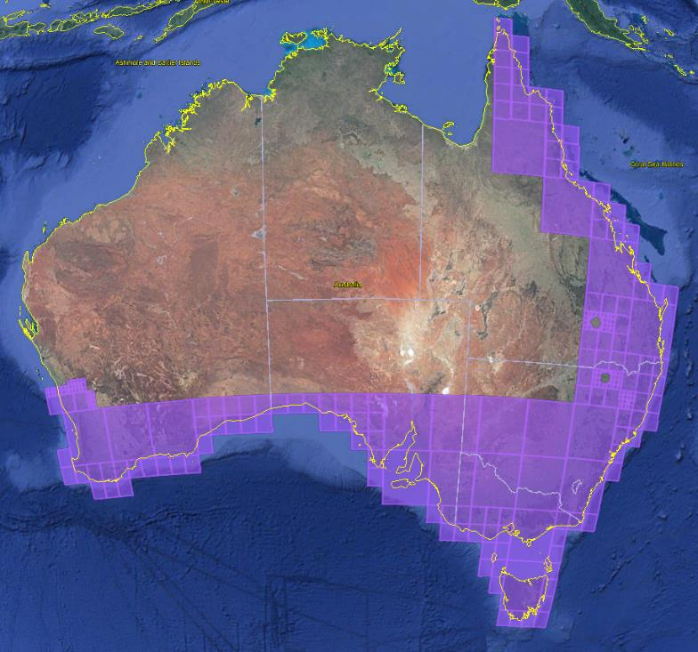

3425–3442.5 MHz

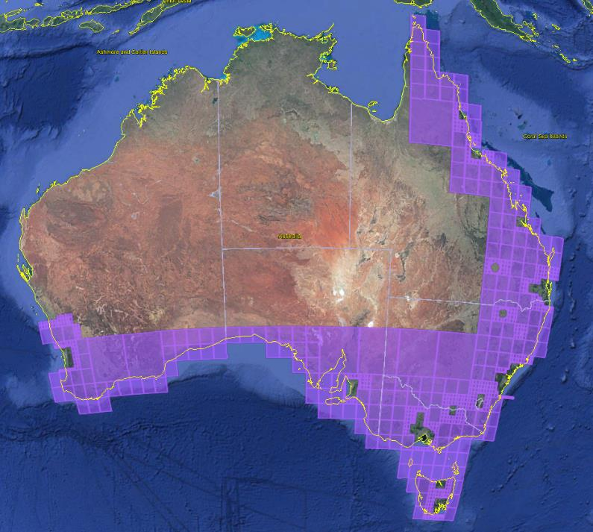

3442.5–3475 MHz

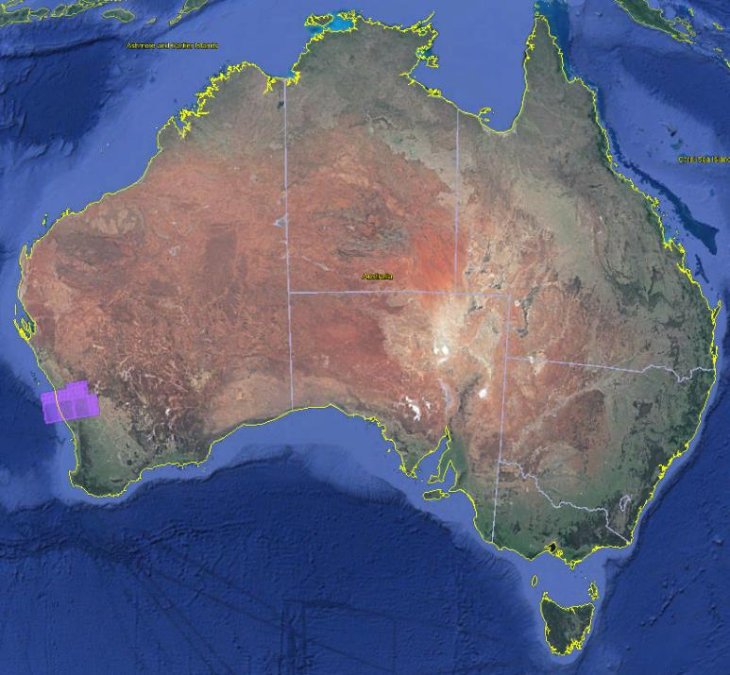

3492.5–3510 MHz

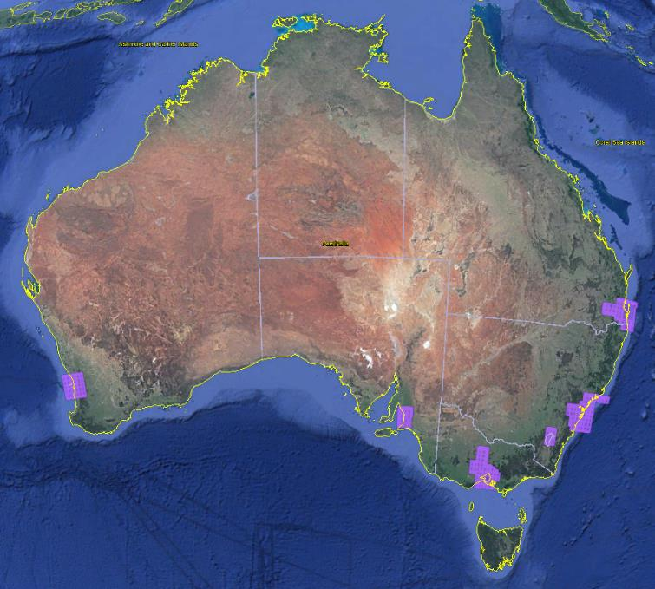

3510–3542.5 MHz

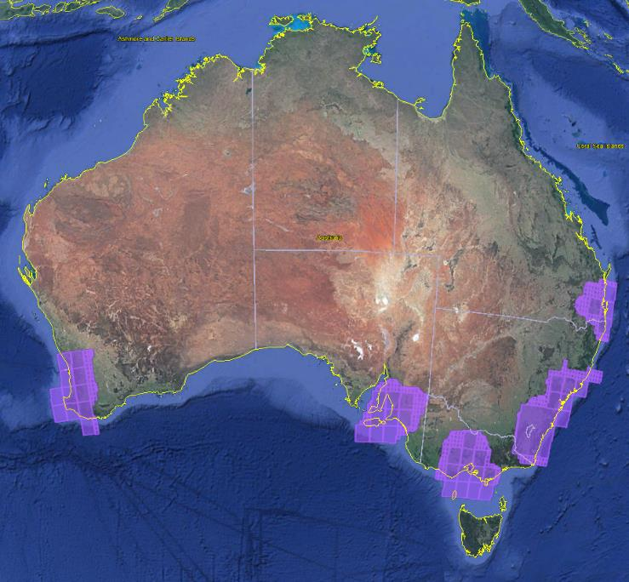

## Attachment B: NBN Co’s PTS licence areas

NBN Co’s PTS licence areas

| **Area name** | **HCIS description** |
| --- | --- |
| Adelaide | IV8K, IV8L, IV8N, IV8O, IV8P, IV9I, IV9J, IV9K, IV9L, IV9M, IV9N, IV9O, IV9P, IW1P, IW2, IW3, IW4D, IW4H, IW4K, IW4L, IW4N, IW4O, IW4P, IW5, IW6, IW7, IW8, IW9, JV7M, JV7N, JV7O, JV7P, JV8M, JW1, JW2A, JW2B, JW2E, JW2F, JW2G, JW2I, JW2J, JW2K, JW2M, JW2N, JW2O, JW4, JW5A, JW5B, JW5C, JW5E, JW5F, JW5I, JW5J, JW5M, JW7A, JW7B, JW7C, JW7D, JW7E, JW7F, JW7G, JW7I |
| Brisbane | NT4G, NT4H, NT4K, NT4L, NT4O, NT4P, NT5D, NT5E, NT5F, NT5G, NT5H, NT5I, NT5J, NT5K, NT5L, NT5M, NT5N, NT5O, NT5P, NT6, NT7C, NT7D, NT7G, NT7H, NT7K, NT7L, NT7O, NT7P, NT8, NT9, NU2B, NU2C, NU2D, NU2F, NU2G, NU2H, NU2L, NU3 |
| Canberra/ Sydney | MV2P, MV3L, MV3M, MV3N, MV3O, MV3P, MV5D, MV5H, MV5L, MV5P, MV6, MV8D, MV8H, MV8J, MV8K, MV8L, MV8N, MV8O, MV8P, MV9, MW, MX1C, MX1D, MX1H, MX2A, MX2B, MX2C, MX2D, MX2E, MX2F, MX2G, MX2H, MX3A, MX3B, MX3C, MX3D, MX3E, MX3F, MX3G, MX3H, NV1I, NV1J, NV1K, NV1L, NV1M, NV1N, NV1O, NV1P, NV2I, NV2J, NV2K, NV2L, NV2M, NV2N, NV2O, NV2P, NV3I, NV3J, NV3K, NV3L, NV3M, NV3N, NV3O, NV3P, NV4, NV5, NV7, NW1 |
| Melbourne | KW8H, KW8I, KW8J, KW8K, KW8L, KW8M, KW8N, KW8O, KW8P, KW9E, KW9F, KW9G, KW9H, KW9I, KW9J, KW9K, KW9L, KW9M, KW9N, KW9O, KW9P, KX1P, KX2, KX3, KX4D, KX4H, KX4L, KX4P, KX5, KX6, KX8, KX9, LW7I, LW7J, LW7M, LW7N, LW7O, LW7P, LX1, LX2E, LX2I, LX2M, LX2N, LX2O, LX4, LX5A, LX5B, LX5C, LX5D, LX5E, LX5F, LX5G, LX5H, LX5I, LX5J, LX5K, LX5L, LX5M, LX5N, LX5O, LX5P, LX7, LX8 |
| Perth | AU6I, AU6J, AU6K, AU6L, AU6M, AU6N, AU6O, AU6P, AU9, AV9, AW3, BU4H, BU4I, BU4J, BU4K, BU4L, BU4M, BU4N, BU4O, BU4P, BU5E, BU5F, BU5G, BU5H, BU5I, BU5J, BU5K, BU5L, BU5M, BU5N, BU5O, BU5P, BU7, BU8, BU9A, BU9B, BU9E, BU9F, BU9I, BU9J, BU9M, BU9N, BV1, BV2, BV3A, BV3B, BV3E, BV3F, BV3I, BV3J, BV3M, BV3N, BV4, BV5, BV6A, BV6B, BV6E, BV6F, BV6I, BV6J, BV6M, BV6N, BV7, BV8, BV9A, BV9B, BV9E, BV9F, BV9I, BV9J, BV9M, BV9N, BW1, BW2, BW3A, BW5 |

NBN Co’s PTS licence areas

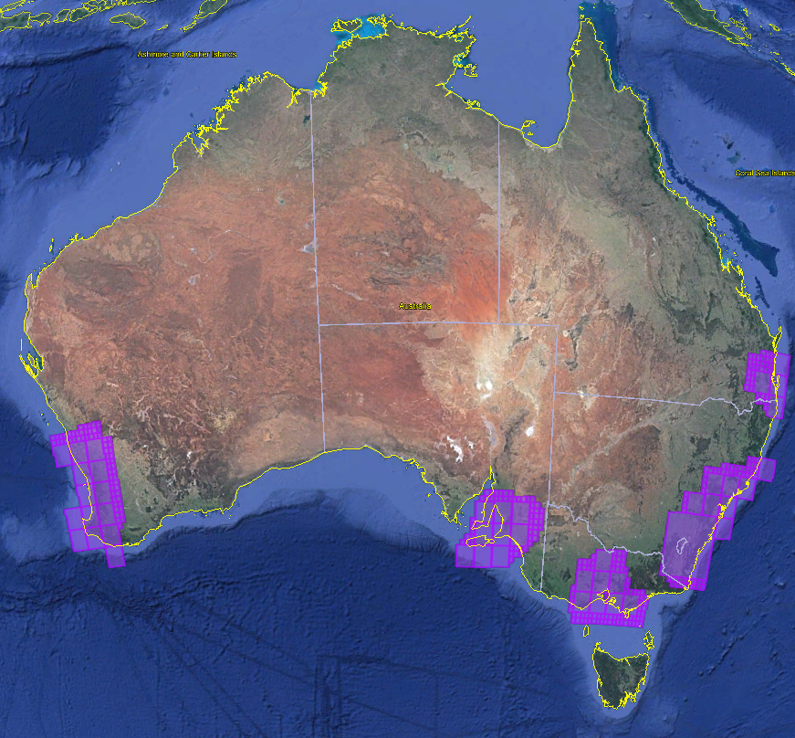

## Attachment C: Proposed urban excise areas

Proposed urban excise areas

| **Area name** | **HCIS description** |
| --- | --- |
| Adelaide | IW3N, IW3O4, IW3O5, IW3O7, IW3O8, IW6B1, IW6B2, IW6B3, IW6B5, IW6B6 |
| Brisbane | NT9B, NT9C, NT9D, NT9E, NT9F, NT9G, NT9H, NT9K, NT9L, NT8H3, NT8L2, NT8L3, NT8L5, NT8L6, NT8L8, NT8L9, NT9A6, NT9A7, NT9A8, NT9A9, NT9I1, NT9I2, NT9I3, NT9I4, NT9I5, NT9I6, NT9J1, NT9J2, NT9J3, NT9J4, NT9J5, NT9J6, NT9J9, NT9N5, NT9N6, NT9N8, NT9N9, NT9O4, NT9O7, NU3B2, NU3B3, NU3C1, NU3C4 |
| Canberra | MW4D, MW4H, MW5A, MW5B, MW5E, MW5F, MW2M5, MW2M6, MW2M7, MW2M8, MW2M9, MW2N4, MW2N5, MW2N7, MW2N8, MW2N9, MW4L1, MW4L2, MW4L3, MW4L5, MW4L6, MW5I1, MW5I2, MW5I3, MW5I4, MW5I5, MW5I6, MW5J1, MW5J2, MW5J4, MW5J5 |
| Melbourne | KX3P, KX3L6, KX3L7, KX3L8, KX3L9, KX6D1, KX6D2, KX6D3, KX6D5, KX6D6, LX1M, LX1I7, LX1N4, LX4A1, LX4A2, LX4A3, LX4A4, LX4A5, LX4B1 |
| Perth | BV1M, BV1N, BV1O, BV4A, BV4B, BV4C, BV1L5, BV1L8, BV1P1, BV1P2, BV1P4, BV1P5, BV1P7, BV1P8, BV4D1, BV4D2, BV4E1, BV4E2, BV4E3, BV4F1, BV4F2, BV4F3, BV4G1, BV4G2, BV1P9, BV4D3, BV4D4, BV4G3 |
| Sydney | NV7G, NV7H, NV7J, NV7K, NV7L, NV7M, NV7N, NV7O, NV7P, NW1A, NW1B, NW1C, NW1D, NW1E, NW1F, NW1G, NW1H, MV9P2, MV9P3, MV9P5, MV9P6, MV9P7, MV9P8, MV9P9, MW3D1, MW3D2, MW3D3, MW3D5, MW3D6, MW3D8, MW3D9, MW3H2, MW3H3, MW3H5, MW3H6, MW3H9, MW3L2, MW3L3, NV4O7, NV4O8, NV4O9, NV4P7, NV7F6, NV7F8, NV7F9, NV7I6, NV7I8, NV7I9, NW1I1, NW1I2, NW1I3, NW1J1, NW1J2, NW1J3, NW1K1, NW1K2, NW1K3, NW1L1, NW1L2, NW1L3 |

Adelaide

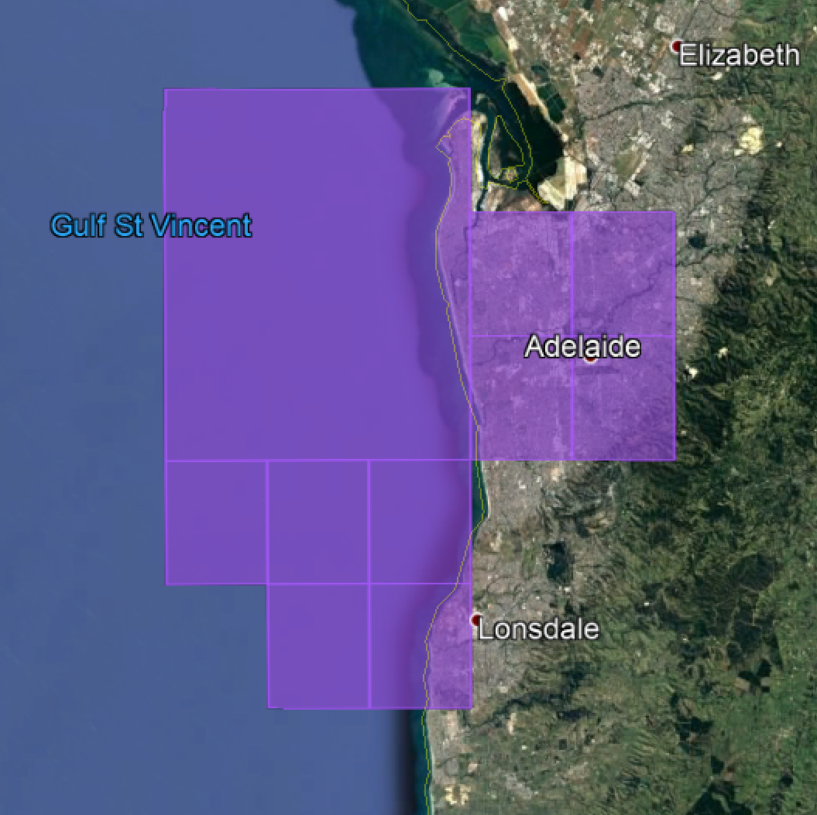

Brisbane

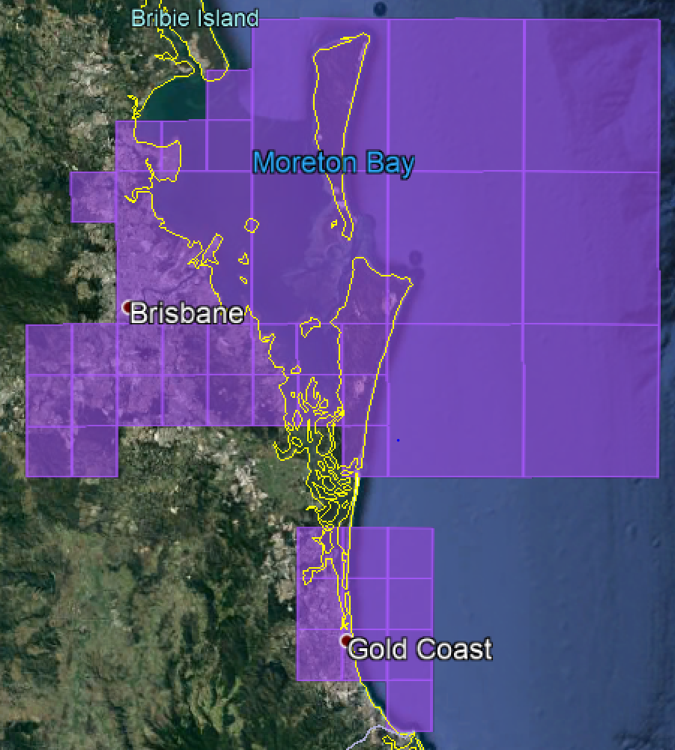

Canberra

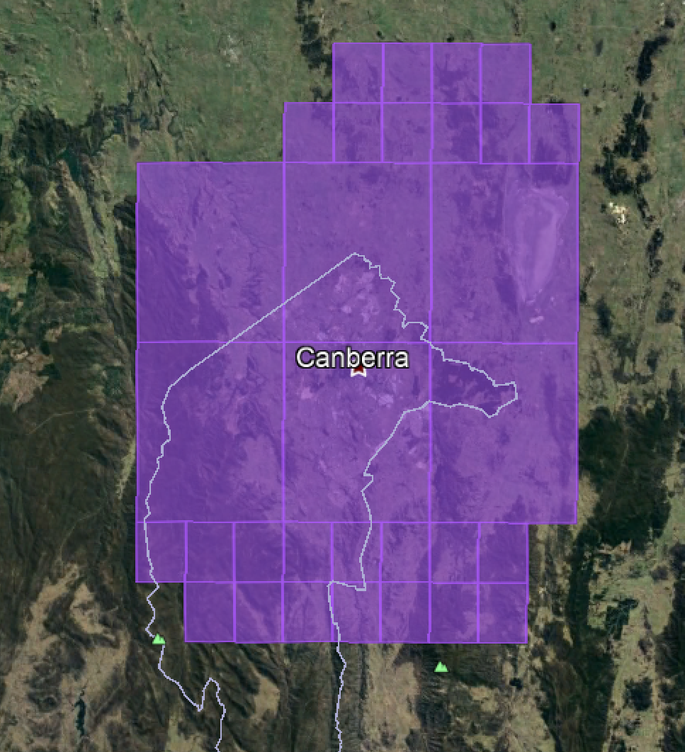

Melbourne

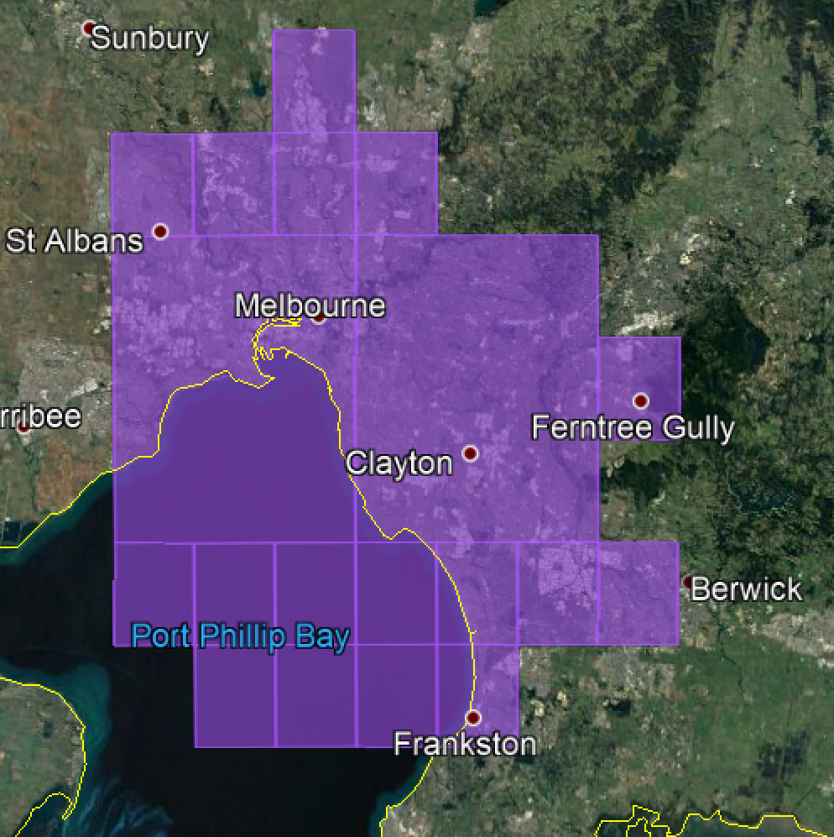

Sydney

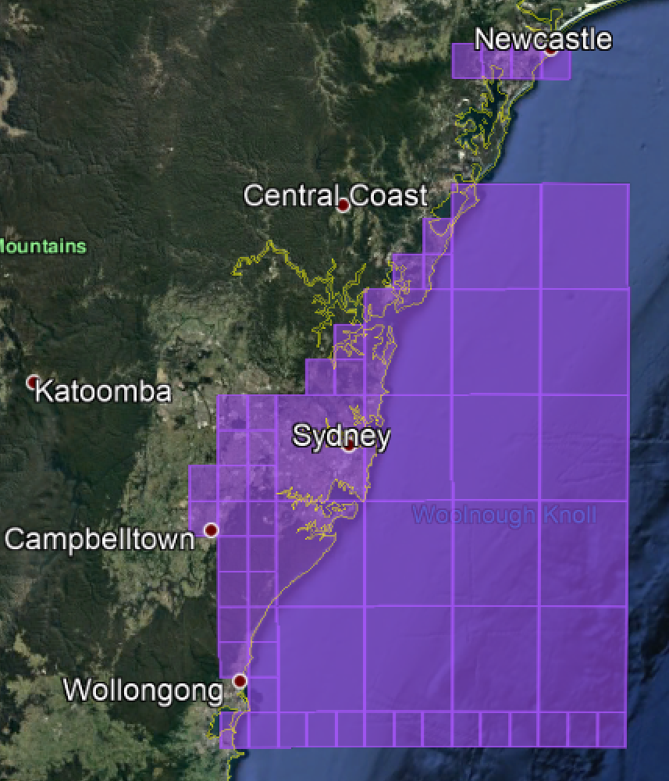

Perth

