BUREAU OF COMMUNICATIONS, ARTS AND REGIONAL RESEARCH

# Frequently Asked Questions: Cultural and Creative Activity in Australia, 2014–15 to 2023–24

**September 2025**

## Overview

### What is the purpose of this publication?

This publication quantifies the economic contribution of cultural and creative activity in Australia from 2014–15 to 2023–24. It provides an annual update to the Bureau of Communications, Arts and Regional Research (BCARR) statistical working paper [*Cultural and Creative Activity in Australia, 2008–09 to 2022–23 (Methodology Refresh)—Statistical Working Paper*](https://www.infrastructure.gov.au/department/media/publications/cultural-and-creative-activity-australia-2008-09-2022-23-methodology-refresh-statistical-working) released in December 2024. This update measures cultural and creative activity over a 10-year period.

The methodology refresh was an action listed in [*Revive: a place for every story, a story for every place—Australia's cultural policy for the next five years*](https://www.arts.gov.au/what-we-do/new-national-cultural-policy). The purpose of this refresh was to ensure that estimates of the cultural and creative sector remain fit-for-purpose in our changing economy. Subsequent consultation with stakeholders helped to refine the methodology refresh.

Major revisions were made to the methodology, and to the scope of activities considered to be cultural and creative based on a decision-making framework developed by the Department of Infrastructure, Transport, Regional Development, Communications, Sport and the Arts (the department). BCARR undertook consultation with stakeholders to develop and refine the approach for estimating cultural and creative activity.

This annual update follows the same approach taken in BCARR’s 2024 statistical working paper. Each table and figure corresponds to those used in the statistical working paper.

Unless otherwise noted, the 10-year period refers to 2014–15 to 2023–24. Data is subject to revisions by the Australian Bureau of Statistics (ABS) to the national accounts. Estimates in this updated release may vary from those published in 2024.

### What is cultural and creative activity?

Cultural and creative activity refers to the economic activity generated from the production and support of goods and services created by cultural and artistic means.

Cultural and creative activity is recognised as an important part of knowledge-based economies, and it makes a valuable contribution to Australia's economic and social wellbeing.

The economic value of cultural and creative activity is determined by how it is defined and identified. The Australian Bureau of Statistics first measured cultural and creative activity in Australia in 2014, and BCARR has been producing annual updates from 2018 to 2022. The original scope of the sector was broad, including not only the production and creation of cultural and creative services, but also activities related to their manufacture and distribution.

BCARR’s statistical working paper [*Cultural and Creative Activity in Australia, 2008–09 to 2022–23 (Methodology Refresh)—Statistical Working Paper*](https://www.infrastructure.gov.au/department/media/publications/cultural-and-creative-activity-australia-2008-09-2022-23-methodology-refresh-statistical-working) sets out the most recent approach for measuring the economic contribution of cultural and creative activity, including a revision to the scope of activities considered to be cultural and creative. The revised scope is narrower than the previous version, and better represents the sector. It also reflects accepted best practice in economic measurement and allows estimates to be updated by incorporating newly-available datasets with more granular data.

Several of the main sources of ‘creative only’ activity in estimates released prior to 2024, such as computer system design and clothing and footwear manufacturing, wholesaling and retailing, have now been removed from the industry scope.

### What is a ‘thematic account’?

A thematic account (also known as a ‘satellite account’) is used to measure the size of economic sectors that are not explicitly defined as industries in national accounts. A thematic account allows for an expansion of the national accounts for a selected area of interest while maintaining the concepts and structures of the core national accounts.[1]

## Key findings in this update

Cultural and creative activity plays an important role in Australia’s economy, growing to $67.4 billion in 2023–24, an increase of $20.9 billion (or 45.1%) over the last 10 years. To put this into context, cultural and creative activity is comparable in size to Australia’s Rental, Hiring and Real Estate Services industry.

Cultural and creative activity has grown in absolute terms, but growth has been slower than the pace of growth for the Australian economy overall. This largely reflects the continued strength in the Mining industry (buoyed by high commodity prices), and the Health Care and Social Assistance industry (supported by an ageing population). These industries fall almost entirely outside of the scope of cultural and creative activity.

As a share of total Australian GDP, cultural and creative activity declined from 2.9% in 2014–15 to 2.5% in 2023–24.

### Questions relating to domains

In the current scope, cultural and creative activities are grouped by 15 domains. The activities within the domains are grouped in terms of the input-output product classification (IOPC) codes, and the Australian and New Zealand Standard Industrial Classification 2006 (ANZSIC 06) class codes.

Thirteen of the 15 cultural and creative domains grew in nominal terms from 2014–15 to 2023–24. A substantial share of this growth occurred in domains which have large amounts of commercial activity, such as:

* Advertising and promotion grew strongly over the period (↑$7.2 billion).
* Print media and publishing (excl. internet) also grew over the 10-year period (↑$5.0 billion).
* Design and fashion (↑$2.4 billion) and Architecture services (↑$1.7 billion) both increased in nominal terms from 2014–15 to 2023–24.
* The only two domains that declined were film and television activities, and radio broadcasting which decreased by $496 million and $150 million respectively, driven by rising competition from online and cloud-based media platforms and falling demand from advertisers.

#### Which domain of cultural and creative activity experienced the largest increase?

Advertising and promotion experienced the largest increase from 2014–15 to 2023–24. This is the largest domain, accounting for 26.9% of cultural and creative activity in 2023–24. Cultural and creative activity GDP in this domain increased by $7.2 billion, from $10.9 billion in 2014–15 to $18.1 billion in 2023–24.

As a share of the overall economy, this domain increased slightly from 0.67% to 0.68% over the period. People are increasingly consuming content on internet-based platforms, which is bolstering demand for online advertising at the expense of print and broadcast advertising.

#### Which domain of cultural and creative activity experienced the strongest growth?

Digital games development has experienced the strongest growth from 2014–15 to 2023–24, with an average annual growth rate of 15.9% during the period. From its small base of initial activity, cultural and creative GDP in digital games development has increased significantly – from $92 million in 2014–15 to $336 million in 2023–24**.**

#### How are ‘events (arts)’ captured under the current methodology?

The current methodology provides an opportunity to better capture other activities such as events (arts) activity. Previously, such activity was excluded from pre-2024 estimates as it could not be identified directly from the latest ANZSIC classification. The current methodology resolves this issue by identifying events (arts) activity through the product details level.

Under the current methodology, the definition of events (arts) activity refers to activities that provide event management, promotion and ticketing services, as well as other events-related administration services. It also includes theatre and concert booking services. Events activity is apportioned to include arts-related events but excludes other type of event services, such as sports-related events services.

#### How can I find out more about the activity captured in each domain?

More information on the size of cultural and creative activity in Australia by industry division and by each domain is provided in BCARR’s *Visual Summary: Cultural and Creative Activity in Australia, 2014–15 to 2023–24*.

## Methodology

### How was cultural and creative activity measured under the current methodology?

This annual update follows the same refreshed methodology used by BCARR in its December 2024 release.

#### The framework

The current methodology follows a framework to capture cultural and creative activity within the production boundary of the national accounts (comprising activity of cultural and creative gross value added plus net taxes on their products), by re-identifying cultural and creative activity as three categories: specialised activity, embedded activity, and support activity.

Figure . Framework of cultural and creative activity, national accounts production boundary

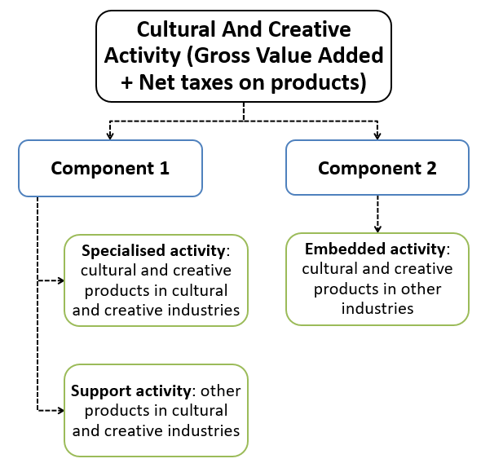

Source: BCARR.

This framework allows the economic value of all three types of cultural and creative activity to be captured wholly through the production side of the economy – by products and industries – and is now measured using a consistent approach. This differs from the previous framework that estimated cultural and creative activity through both the production and income sides of the economy.

#### Best-practice estimation process

The current methodology is a best-practice approach to produce estimates by quantifying the economic value of cultural and creative activities through a four-step approach.

Figure . Current estimation process to quantify the economic value of cultural and creative activity

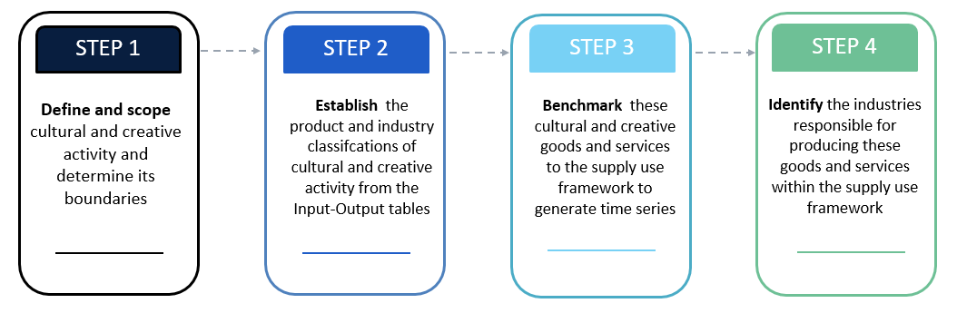

Source: BCARR.

#### Scope

In the current scope, cultural and creative activities are identified through both products and industries – as classified and defined by the Australian Input-Output Product Classifications (IOPCs) and Australian and New Zealand Standard Industrial Classification (ANZSIC).

#### Production-focused measures

Cultural and creative statistics are examined from the production side, which includes domestic output, gross value added (GVA) and gross domestic product (GDP). Estimates of compensation of employees for the cultural and creative workforce – which includes wages and salaries – are expected to be developed and released together with employment estimates in the next phase of this research.

Estimates of cultural and creative activity in this report are based solely on the national accounts production boundary, which excludes volunteering and non‑market-based production. This exclusion is due to their activity not being captured in the GDP calculations. The emphasis on the direct economic contribution broadly aligns with cultural/creative thematic accounts developed in other countries. While this initial methodology refresh does not examine potential or intangible values from cultural and creative activity, BCARR will consider exploring these topics in future research.

## More information on the new scope

### How was the current scope of cultural and creative activity decided?

The current scope is supported by a transparent decision-making framework. This framework is used to determine which industry and product lists were included in the cultural and creative activity account. This was a pragmatic approach created to make the scope consistent and transparent. It also supports a key aim of the methodology refresh, which was for the cultural and creative sector to see itself in the current measure.

The framework is underpinned by existing theoretical models of cultural and creative industries, combined with criteria on whether industries have engaged with domestic cultural policy through various mechanisms, including through submissions to various arts and cultural policy consultation activities and parliamentary inquiries in the period 2013 to 2023.

Figure . Decision-making framework to determine the scope of cultural and creative industry and products

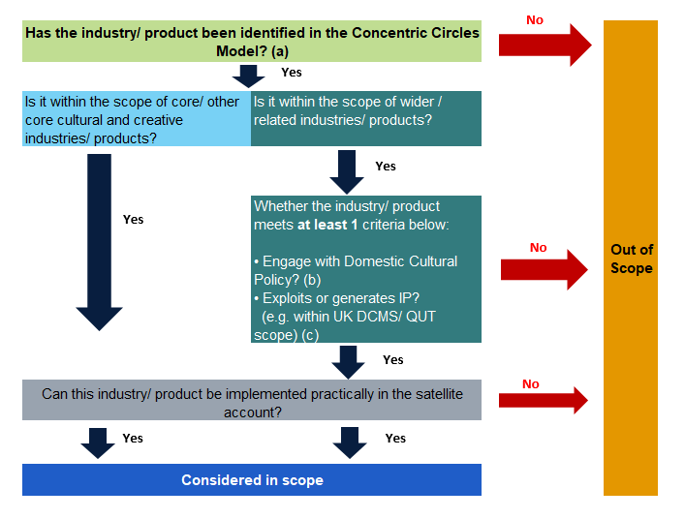

Source: Department of Infrastructure, Transport, Regional Development, Communications, Sport and the Arts.

Notes:

* + - * 1. The Concentric Circles Model of cultural industries developed by Professor David Throsby includes four layers: *Core creative arts* (incl. Literature, Music, Performing arts, and Visual arts); *Other core creative industries* (incl. Film, Museums, Galleries, Photography, and Libraries); *Wider cultural industries* (incl. Sound recording, Television and radio, Video and computer games, Heritage services, and Publishing and print media); and *Related industries* (incl. Design, Fashion, Advertising, and Architecture).
        2. This criterion refers to the engagement with domestic cultural policy from the period 2013 to 2023.
        3. The UK Department of Culture, Media and Sport (DCMS)/ Queensland University of Technology (QUT) model defines creative industries as ‘those industries which have their origin in individual creativity, skill and talent and which have a potential for wealth and job creation through the generation and exploitation of intellectual property.’

### Why do we use a decision-making framework?

There is no universally-accepted definition for cultural and creative activity to guide scope. As such a decision-making framework was developed to make the scope consistent and transparent. The Concentric Circles Model was the principal framework used in this decision-making framework to determine the activities in scope for cultural and creative activity. The cultural and creative areas in which the Australian Government makes substantial investments are considered by many to be the ‘core’ creative arts and cultural industries. This concept has been articulated by the Concentric Circles Model in examining the structure of the sector, while these core parts of the sector also enable broader cultural and creative production that reaches into the more commercial realms of the economy.

The decision-making framework contains a criterion of industry engagement with domestic cultural policy over the previous decade (including the recent national cultural policy, parliamentary inquiries, and with older cultural policies such as the 2013 *Creative Australia* policy). Engagement with domestic cultural policy was one of two further criteria used in the decision-making framework. The other criterion was whether the industry or product exploits intellectual property. Activities which exploit intellectual property is in line with the creative industry models developed by the UK Department of Culture, Media and Sport (DCMS) and Queensland University of Technology (QUT), and captures some creative activity that is not captured by the domestic cultural policy criterion.

### Why are current cultural and creative estimates smaller than BCARR pre-2024 releases?

The new scope’s exclusion of computer system design and related services, and clothing and footwear manufacturing, wholesaling and retailing industries is the main reason why the new estimates are much lower than the figures reported before 2024. Gross value added for these (now-excluded) industries was estimated at over $50 billion and represented 41.4% of total cultural and creative GDP in the 2019–20 estimates.

### How does this methodology compare to other nations, and across states and territories?

There is no universally-agreed definition of cultural and creative activity. Several government and non‑government organisations have reported on the economic impact of cultural and/or creative industries. However, a range of statistical definitions and approaches have been used. Due to the variety of definitions used to classify cultural and creative activity, international comparisons are difficult to make.

The data source and methodology used for the recent update is consistent with other thematic accounts frameworks such as the digital economy account, which has been broadly adopted by many countries including Australia. For example, the current methodology has estimated the cultural and creative activity GVA through an ‘output-associated’ approach – this approach was used by the US Bureau of Economic Analysis to measure the digital economy in 2018, and was further adopted in the Australian Bureau of Statistics’ *Australian digital activity satellite account* and BCARR’s *digitalisation satellite account for measuring the Internet of Things, Information and Communications Technology, and digital activities*. In addition, using the input‑output tables and supply-use tables as the main data sources in the refreshed cultural and creative activity methodology is also consistent with the Australian and international digital activity accounts. The department expects these consistencies will provide further opportunities to measure these emerging technologies within the cultural and creative sector in the future.

The cultural and creative economic contributions of states and territories have not been covered in either the current or previous estimates. The department proposes to develop a methodology on state and territory disaggregation after the release of new estimates at the national level. This would need to be examined after estimates of cultural and creative employment are developed.

1. Australian Bureau of Statistics (2021), Australian System of National Accounts: Concepts Sources and Methods, ABS Cat. no. 5216.0, p. 664.