BUREAU OF COMMUNICATIONS, ARTS AND REGIONAL RESEARCH

At a glance: Cultural and Creative Activity in Australia, 2014–15 to 2023–24
September 2025

Cultural and creative activity 2014–15 and 2023–24

Cultural and creative activity refers to the economic activity generated from the production and support of goods and services created by cultural and artistic means.  This updated release quantifies the economic contribution of cultural and creative activity in Australia from 2014–15 to 2023–24.  All data tables presented in the statistical report are also available in excel. Further information on these updates can be found in the FAQ: Cultural and Creative Activity in Australia, 2014–15 to 2023–24. | Key changes  Cultural and creative activity plays an important role in Australia’s economy, growing to $67.4 billion in 2023–24, an increase of $20.9 billion (or 45.1%) over the last 10 years.  Chart 1: Cultural and creative activity, 2014–15 and 2023–24  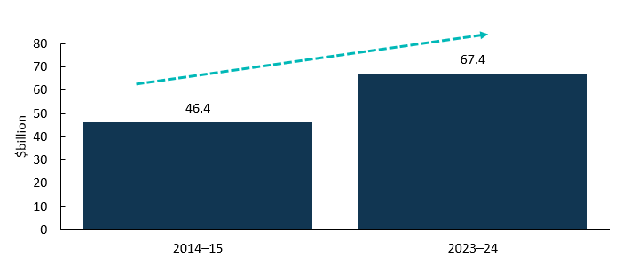  Source: ABS Australian System of National Accounts, Australian National Accounts: Input-Output Tables (Product Details); Australian National Accounts: Supply Use Tables; BCARR calculations.  Note: Estimates and their components in this document have been rounded and discrepancies may occur between sums of component items and totals. Analysis featured in this release is based on un-rounded data. Calculations based on rounded data may differ to those published.

Cultural and creative activity, GDP by domain
Most cultural and creative domains grew in nominal terms over the period from 2014–15 to 2023–24.  - Advertising and promotion activity grew strongly over the period (↑$7.2 billion).  - Print media and publishing activity (excl. internet) also grew over the 10-year period (↑$5.0 billion).  - The increase was mainly driven by software publishing activities that have experienced strong growth in recent years, but was offset by the decrease in newspaper, magazine and other periodic publishing activities.  - Architecture services (↑$1.7 billion) and Design and fashion (↑$2.4 billion) both increased in nominal terms from 2014–15 to 2023-24.  - Film and television activities were valued at $7.3 billion, with their share of total cultural and creative activity GDP dropping from 16.7% to 10.8% over the 10-year period. | Chart 2: Contribution to cultural and creative activity, GDP by domain,  2014–15 and 2023–24  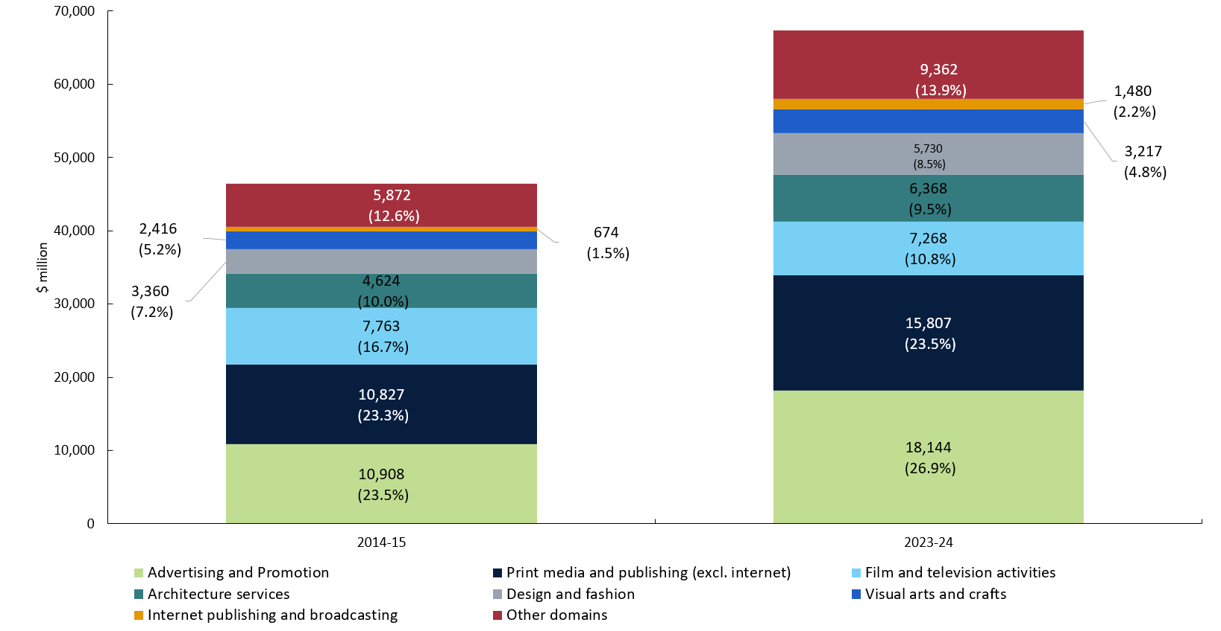  Source: ABS Australian System of National Accounts, Australian National Accounts: Input-Output Tables (Product Details); Australian National Accounts: Supply Use Tables; BCARR calculations.

Comparison with Australian industries
Cultural and creative activity accounted for 2.6% of gross value added (GVA) ¹ in the economy in 2023–24.  This is comparable to the size of the Rental, Hiring and Real Estate Services industry at 2.7%.  Note: Cultural and creative activity is not an industry division, but rather includes output produced by many industries across the economy, including output from the Arts and Recreation Services division as well as from other industries profiled in this chart.  ¹ GVA is a measure of the contribution to domestic production made by an individual producer, industry or sector. This is the value of output less the value of the goods and services used up in the process of production. By excluding net taxes, GVA provides a more accurate measure of economic activity by industry than gross domestic product (GDP). | Chart 3: Cultural and creative activity GVA and industry share of total economy, 2023–24  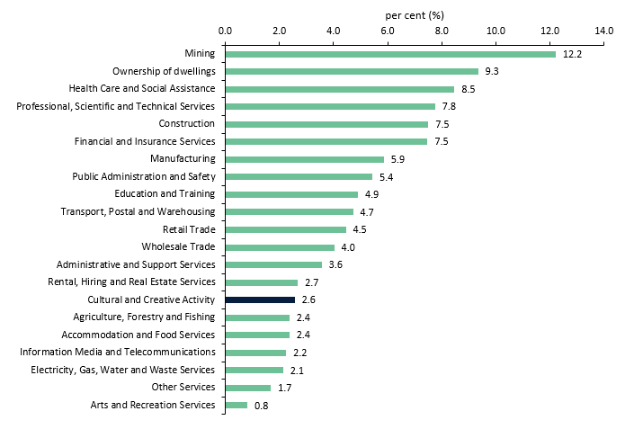  Source: ABS Australian System of National Accounts, Australian National Accounts: Input-Output Tables (Product Details); Australian National Accounts: Supply Use Tables; BCARR calculations.

GVA average annual growth rate by industry division, 2014–15 to 2023–24

The Australian economy has been supported by strong growth in Mining (buoyed by high commodity prices) and the Health Care and Social Assistance industry (supported by an ageing population).  From 2014–15 to 2023–24, the average annual GVA growth was 13.7% for Mining, 7.6% for Health Care and Social Assistance.  Average annual GVA growth was 5.8% for the overall economy, and 4.4% for cultural and creative activity. | Chart 4: GVA average annual growth rate by industry division, 2014–15 to 2023–24  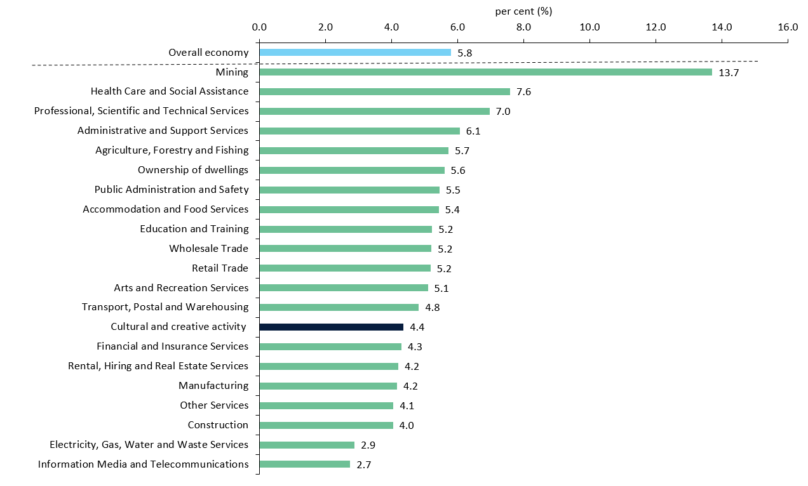  Source: ABS Australian System of National Accounts, Australian National Accounts: Input-Output Tables (Product Details); Australian National Accounts: Supply Use Tables; BCARR calculations.

Relative to nominal Gross Domestic Product (GDP)
Overall, the pace of growth in cultural and creative activity has been slower than the pace of growth for the Australian economy.  This largely reflects the continued strength in the mining and healthcare sectors, which fall almost entirely outside of cultural and creative activity.  As a share of GDP, cultural and creative activity declined from 2.9% in 2014–15 to 2.5% in 2023–24. | Chart 5: Relative to nominal Gross Domestic Product (GDP)  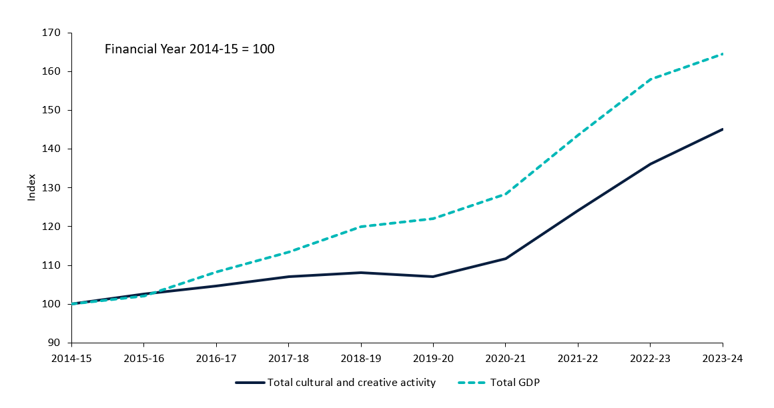  Source: ABS Australian System of National Accounts, Australian National Accounts: Input-Output Tables (Product Details); Australian National Accounts: Supply Use Tables; BCARR calculations.

About this document
The Bureau of Communications, Arts and Regional Research (BCARR) within the Department of Infrastructure, Transport, Regional Development, Communications, Sport and the Arts has estimated the economic contribution of Cultural and Creative Activity in Australia over a 10-year period, from 2014–15 to 2023–24.
This document outlines the key findings from the tables and figures shown in BCARR’s visual summary document: Cultural and Creative Activity in Australia, 2014–15 to 2023–24 and is presented alongside a document of Frequently Asked Questions. Further information on the methods used in this research can be found in BCARR’s statistical working paper: Cultural and Creative Activity in Australia, 2008–09 to 2022–23 (Methodology Refresh).

