Australian Government,
Department of Infrastructure, Transport, Regional Development, Communications and the Arts

# Applicable laws at Gold Coast Airport: Control of On-Airport Activities

Attachment B to *Sunsetting Airports Regulations Stage 2: Consultation Paper*

**September 2022**

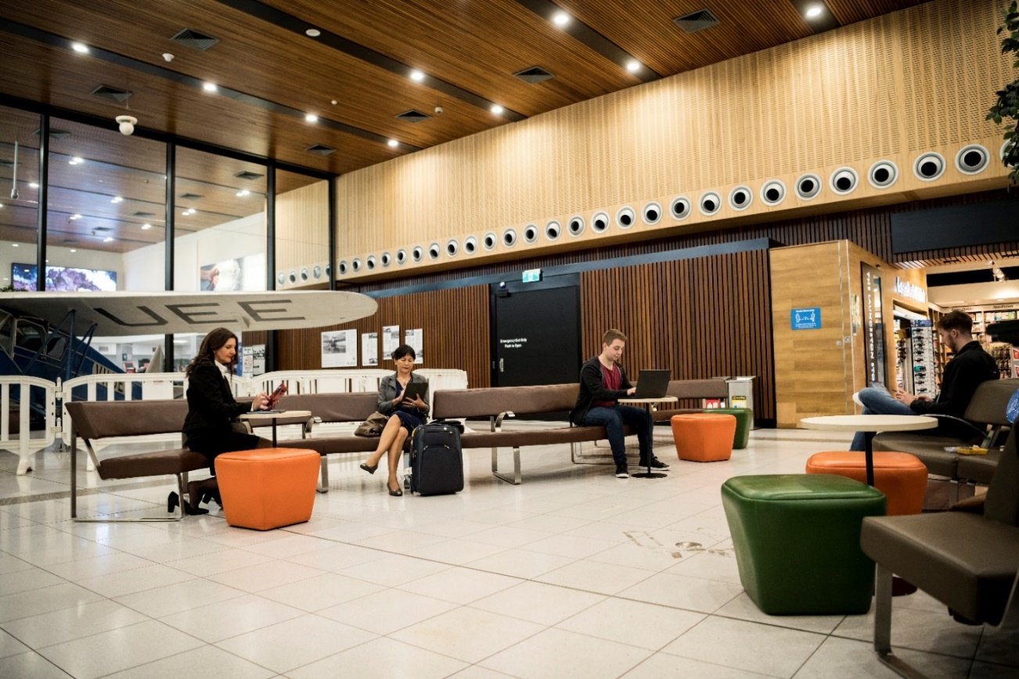

© Commonwealth of Australia 2022

September 2022 / INFRASTRUCTURE

Ownership of intellectual property rights in this publication

Unless otherwise noted, copyright (and any other intellectual property rights, if any) in this publication is owned by the Commonwealth of Australia (referred to below as the Commonwealth).

Disclaimer

The material contained in this publication is made available on the understanding that the Commonwealth is not providing professional advice, and that users exercise their own skill and care with respect to its use, and seek independent advice if necessary.

The Commonwealth makes no representations or warranties as to the contents or accuracy of the information contained in this publication. To the extent permitted by law, the Commonwealth disclaims liability to any person or organisation in respect of anything done, or omitted to be done, in reliance upon information contained in this publication.

Creative Commons licence

With the exception of (a) the Coat of Arms; (b) the department of Infrastructure, Transport, Regional Development and Communications photos and graphics; and (c) [OTHER], copyright in this publication is licensed under a Creative Commons Attribution 4.0 Australia Licence.

Creative Commons Attribution 4.0 Australia Licence is a standard form licence agreement that allows you to copy, communicate and adapt this publication provided that you attribute the work to the Commonwealth and abide by the other licence terms.

Further information on the licence terms is available from <https://creativecommons.org/licenses/by/4.0/>.

This publication should be attributed in the following way: © Commonwealth of Australia 2022.

Use of the Coat of Arms

The department of the Prime Minister and Cabinet sets the terms under which the Coat of Arms is used. Please refer to the Commonwealth Coat of Arms - Information and Guidelines publication available at [http://www.pmc.gov.au](http://www.pmc.gov.au/).

Contact us

This publication is available in hard copy or PDF format. All other rights are reserved, including in relation to any departmental logos or trade marks which may exist. For enquiries regarding the licence and any use of this publication, please contact:

Director – Creative Services

Communication Branch

Department of Infrastructure, Transport, Regional Development, Communications and the Arts

GPO Box 594

Canberra ACT 2601

Australia

Email: [publishing@infrastructure.gov.au](mailto:publishing@infrastructure.gov.au)

Website: [www.infrastructure.gov.au](http://www.infrastructure.gov.au/)

**Table of contents**

Introduction 4

Purpose of the paper 4

Consultation process 4

Applicable laws at Gold Coast Airport 5

Liquor 5

Consumer trading hours 5

Vehicles 6

Gambling 6

Smoking 7

Other matters 7

## Introduction

### Purpose of the paper

This paper supports the *Sunsetting Airports Regulations Stage 2: Control of On-Airport Activities* paper. It is required to capture community and local stakeholder concerns relating specifically to issues of the applicable state laws at Gold Coast Airport, the only leased federal airport located across two states, (Queensland (QLD)-New South Wales (NSW)).

Stage 2 of the Department of Infrastructure, Transport, Regional Development, Communications and the Arts’ (the Department) sunsetting review will evaluate the *Airports (Control of On-Airport Activities) Regulations 1997* (the Regulations) and consider if the Regulations remain fit-for-purpose, and what changes (if any) should be made. The current regulatory framework for on‑airport activities at Gold Coast Airport is:

|  |  |
| --- | --- |
| **Activity** | **Current regulation** |
| Liquor | QLD law applies to the terminal area with limited adjustments |
| Consumer trading hours | Direct Australian Government regulation - deregulated trading hours |
| Vehicles | Direct Australian Government regulation - Parking Infringement Notice Scheme (PINS) |
| Gambling | Direct Australian Government regulation - prohibition |
| Smoking | Direct Australian Government regulation – airport lessee company (ALC) determines prohibited smoking areas |

This is an opportunity to discuss the impacts (if any) of Gold Coast Airport’s location within both QLD and NSW, and the issues relating to laws that could apply under the current regulatory framework, or as a result of any reforms.

The options in this paper are not government policy – they are examples to support the consultation process, which will inform decisions about necessary reforms (if any). Conferring any functions on other regulators (such as state or territory regulators) would be subject to their agreement.

Stakeholders are encouraged to consider the stage 2 consultation paper prior to this paper to have a better understanding of the possible reforms in stage 2.

### Consultation process

Public consultation on the stage 2 consultation paper and this attachment will open on 16 September 2022 and will close on 19 October 2022. Please provide submissions to [aviationreform@infrastructure.gov.au](mailto:aviationreform@infrastructure.gov.au).

Written submissions made will be **publicly available** on the Department’s website unless the submission indicates clearly that all or part of the submission is to remain in confidence.

Any personal information respondents provide to the Department will be used in accordance with our privacy statement and the *Privacy Act 1988* (see Appendix B of the main stage 2 consultation paper).

Submissions made in relation to previous stages of the sunsetting review will be considered as part of the current stage, as far as they are relevant.

## Applicable laws at Gold Coast Airport

The Gold Coast Airport is located predominantly in QLD, but some airport land (largely runway and forestry) and terminal area crosses the border and is in NSW. The entire airport is a Commonwealth place, where generally state law is applied as Commonwealth law. Where state laws are applied, different laws could apply to the NSW and QLD sides of the airport.

The [Gold Coast Airport’s 2017 Master Plan](https://www.goldcoastairport.com.au/corporate/regulatory/gold-coast-airport-2017-master-plan) outlines the plan of the airport lessee company (ALC) to further develop the airport terminal into NSW to meet increased demand for aviation services in the Gold Coast region. The terminal extension into NSW opened in September 2022. This development has seen an increase in the on-airport activities covered by the Regulations being undertaken in NSW.

While increasing development at the Gold Coast Airport site draws attention to this matter, this is not a new issue. Gold Coast Airport has always been situated in QLD and NSW. The sunsetting process gives an opportunity to consider issues with the applicable laws at Gold Coast Airport that could arise under the current regulatory framework, or as a result of any reforms.

## Liquor

QLD law applies to the control of liquor in the entirety of the terminal area of Gold Coast Airport, with some adjustments, under the Regulations (Division 4 of Part 2, and Part 3 of Schedule 1). These adjustments set out transitional arrangements (including a 24-hour liquor licence for the ALC) and provide a role for the ALC in relation to the control of liquor. QLD laws will continue to apply to the expanded terminal area, even on the NSW side of the terminal.

Outside the terminal, the current laws would have NSW authorities responsible for regulating liquor in the NSW side of Gold Coast Airport, although in practice there is not yet a need for any liquor licences to be granted in this area. The application of NSW liquor laws on the NSW side of Gold Coast Airport, outside the terminal, would continue to see non-terminal airport land treated like the rest of the community in which it is situated, which is the current policy for Gold Coast Airport. The ALC and other licenced venues may have concerns about the impacts of needing to deal with two regulatory frameworks for liquor on the airport site in the future.

There is an opportunity to review these arrangements as part of the sunsetting process.

**Questions**:

1. What would the impacts be on the development and operations for Gold Coast Airport if NSW liquor laws applied to the NSW part of the airport outside the terminal? Why?
2. Is the current policy of applying QLD liquor laws to the whole of the airport terminal appropriate?
3. Should the whole airport site have the same liquor laws? For example, should the Regulations provide that QLD liquor laws apply to the NSW side of the airport, even outside the terminal? Why?

a. What would be the impacts of this for your operations, and the operations of other stakeholders within your knowledge?

## Consumer trading hours

Part 3 of the Regulations deals with consumer trading hours at leased federal airports. For some, the relevant state or territory law applies. For others (leased federal airports in NSW, QLD, and SA, and Melbourne and Perth Airports), the relevant state law is modified or not applied, to reduce restrictions on trading hours for these airports. This is in recognition that the nature of the service that these airports provide requires more flexible trading hours than were afforded in the relevant state regulations at the time that the airports were leased.

Complexities may compound as development of the airport continues, pushing further into the NSW side of the airport site. For example, the Regulations provide that QLD’s *Trading (Allowable Hours) Act 1990* does not apply to consumer trading at Gold Coast Airport. The relevant NSW law may still apply to the NSW side of the airport, potentially restricting trading hours for that area. This could lead to inconsistent trading hours both within terminal buildings and on the broader airport site.

There is an opportunity to review these arrangements as part of the sunsetting process.

**Questions**:

1. What would the impacts be on the development and operations for Gold Coast Airport if NSW laws in relation to trading hours applied to the NSW part of the airport? Why?
2. Should the whole airport terminal have the same rules for trading hours? For example, should the Regulations provide that QLD and NSW trading hours laws do not apply to the Gold Coast Airport terminal? Why?

a. What would be the impacts of applying this exemption to only the terminal (especially for customers, and businesses outside the terminal)?

1. Is there any need for the whole of the airport site to have the same rules for trading hours? For example, should the Regulations provide that QLD and NSW trading hours laws do not apply to the whole of the Gold Coast Airport? Why?

a. What would be the impacts of applying this exemption to the whole airport site (especially for regulated entities and businesses outside the airport site)?

## Vehicles

Part 4 of the Regulations currently provides a regulatory framework for the control of parking in the landside and airside areas of an airport and the control of the operation of vehicles in the airside area. Gold Coast airport is directly regulated by the Australian Government for the control of parking in the landside area, with the application of the Australian Road Rules and the Parking Infringement Notice Scheme (PINS). The Australian Government also directly regulates the control of vehicles in the airside area of all leased federal airports.

No issues relating to the applicable laws currently arise for parking and vehicle operations at Gold Coast Airport because the Australian Government regulates all vehicle controls.

If Gold Coast Airport ceased being a PINS airport the control of landside parking would be split between the QLD and NSW jurisdictions.

There is an opportunity to review these arrangements as part of the sunsetting process.

**Questions**:

1. What would be the impacts be, on airport operations and to other stakeholders within your knowledge, if Gold Coast Airport ceased being a PINS Airport?
2. What would the specific impacts be for local governments?
3. Should the whole airport site have the same rules for vehicle controls on landside? For example, should QLD law apply to the QLD and NSW sides of the airport? Why

## Gambling

Part 5 of the Regulations currently prohibits gambling at leased federal airports, with two exceptions based on grandfathering arrangements for existing gambling authorities (these are outside QLD).

No issues relating to the applicable laws currently arise for gambling at Gold Coast Airport because of the gambling prohibition. If gambling was liberalised on leased federal airports, by transfer of regulatory responsibility to state or territory regulators, which state laws would apply remains a question.

There is an opportunity to review these arrangements as part of the sunsetting process.

**Questions**:

*Note these matters would only be relevant if there was any liberalisation of gambling on leased federal airports. The question of whether there should be any liberalisation is considered under the main stage 2 paper.*

1. Should the whole terminal have the same rules for gambling? For example, should QLD’s laws apply to the whole terminal? Why?
2. Should the whole airport site have the same rules for gambling? Why?
3. What would be the impacts of the application of QLD’s gambling laws to the whole terminal, or whole airport, for your operations and the operations of other stakeholders within your knowledge?

## Smoking

Part 6 of the Regulations currently identifies Gold Coast Airport as a ‘regulated airport’ for the purposes of smoking control. This allows the ALC to decide that an area at the airport is to be a no-smoking area.

No issues relating to the applicable laws currently arise for smoking at Gold Coast Airport because the Australian Government regulates smoking through the ALC as a whole.

There is an opportunity to review these arrangements as part of the sunsetting process.

**Questions**:

*Note these matters would only be relevant if there was any transfer of regulatory responsibility for smoking to states. The question of whether there should be any transfer is considered under the main stage 2 paper.*

1. Should the whole terminal have the same rules for smoking? For example, should QLD’s laws apply to the whole terminal? Why?
2. Should the whole airport site have the same rules for smoking? Why?
3. What would be the impacts, for your operations, of the application of QLD’s smoking laws to the whole terminal, or whole airport?

## Other matters

Currently other NSW laws apply to the NSW side of the airport as Commonwealth law unless specifically excluded. For example, NSW daylight savings time, work health and safety laws and some environmental laws apply on the NSW side of the airport. These matters are not covered by the Regulations and not within the scope of matters that are expected to be addressed as part of the sunsetting review. Specifically, the interaction of NSW daylight savings time with the application of the curfew at Gold Coast Airport are not within scope.

Within the sunsetting timeframe (before 1 April 2024), the Department is considering changes to how on‑airport activities (liquor, gambling, smoking, consumer trading hours, and vehicles) are regulated. However, there is also a need to consider whether longer-term reforms for the application of other laws on the airport site are required, due to which laws apply on the airport.

**Questions**:

*Note this question, like others in this paper, relates specifically to issues that arise because of the different laws that may apply on different parts of the airport site. It is not about the substance of any particular law.*

1. Are there particular matters for which the Australian Government should modify the application of state law on Gold Coast Airport, because of the differences in laws that apply on the QLD and NSW parts of the airport? If so:

a. What is the law?

b. If QLD and NSW law applied to the respective sides of the Gold Coast Airport site, what would the impact be?

c. Should the Australian Government intervene? If so, how (e.g. by application of QLD law to the whole terminal, by application of QLD law to the whole airport site, or by bespoke regulation by the Australian Government)?

d. What would the impact of Australian Government intervention be?