Consideration of requests for Technical Capability Notices by the Minister for Communications
August 2022

© Commonwealth of Australia 2022
August 2022 / INFRASTRUCTURE

Ownership of intellectual property rights in this publication
Unless otherwise noted, copyright (and any other intellectual property rights, if any) in this publication is owned by the Commonwealth of Australia (referred to below as the Commonwealth).

Disclaimer
The material contained in this publication is made available on the understanding that the Commonwealth is not providing professional advice, and that users exercise their own skill and care with respect to its use, and seek independent advice if necessary.
The Commonwealth makes no representations or warranties as to the contents or accuracy of the information contained in this publication. To the extent permitted by law, the Commonwealth disclaims liability to any person or organisation in respect of anything done, or omitted to be done, in reliance upon information contained in this publication.

Creative Commons licence
With the exception of (a) the Coat of Arms; (b) the Department of Infrastructure, Transport, Regional Development, Communications and the Arts photos and graphics; and (c) [OTHER], copyright in this publication is licensed under a Creative Commons Attribution 4.0 Australia Licence.
Creative Commons Attribution 4.0 Australia Licence is a standard form licence agreement that allows you to copy, communicate and adapt this publication provided that you attribute the work to the Commonwealth and abide by the other licence terms.
Further information on the licence terms is available from https://creativecommons.org/licenses/by/4.0/.
This publication should be attributed in the following way: © Commonwealth of Australia 2022.

Use of the Coat of Arms
The Department of the Prime Minister and Cabinet sets the terms under which the Coat of Arms is used. Please refer to the Commonwealth Coat of Arms—Information and Guidelines publication available at www.pmc.gov.au.

Contact us
This publication is available in hard copy or PDF format. All other rights are reserved, including in relation to any Departmental logos or trade marks which may exist. For enquiries regarding the licence and any use of this publication, please contact:
Director—Publishing and Communications
Communication Branch
Department of Infrastructure, Transport, Regional Development, Communications and the Arts
GPO Box 594
Canberra ACT 2601
Australia
Email: publishing@communications.gov.au
Websites: www.infrastructure.gov.au | www.communications.gov.au | www.arts.gov.au.

Contents
Introduction 4
What is taken into account by the Minister in making a decision? 4
The objectives of the notice 4
Irrelevant considerations 5
The legitimate interests of the designated communications provider 5
The impact of the notice on the efficiency and international competitiveness of the Australian telecommunications industry 6
The impact on efficiency of the industry 7
The impact on the international competitiveness of the Australian telecommunications industry 7
The representation (if any) that was made under subsection 317TAAA(4) 8
Such other matters (if any) as the Minister considers relevant 8

Introduction
This paper sets out how the Department of Infrastructure, Transport, Regional Development, Communications and the Arts (the Department) proposes to interpret the matters specified in subsection 317TAAA(6) and 317XA(6) of the Telecommunications Act 1997 (the Act), being matters that the Minister for Communications (the Minister) must consider in determining whether to approve the giving of a technical capability notice by the Attorney-General.
This paper has been prepared for general guidance to the communications industry and is not a substitute for legal advice.

What is taken into account by the Minister in making a decision?
The Minister’s consideration process is triggered when the Attorney-General gives the Minister a written notice setting out the proposal to give a technical capability notice. This occurs following a request made by the Director-General of Security or the chief officer of an interception agency to the Attorney-General.
In considering whether to approve the giving of a technical capability notice by the Attorney-General, the Minister must consider each of the matters specified in subsection 317TAAA(6) of the Act:
- the objectives of the technical capability notice;
- the legitimate interests of the designated communications provider to whom the notice relates;
- the impact of the notice on the efficiency and international competitiveness of the Australian telecommunications industry;
- the representation (if any) that has been made by the Attorney-General; and
- such other matters (if any) as the Minister considers relevant.

The objectives of the notice
The Minister must have regard to the objectives of the technical capability notice. These objectives need to be within the scope of the requesting agency’s functions to give effect to ‘relevant objectives’ listed under subsection 317T(3) of the Act. The relevant objectives are:
- enforcing the criminal law, so far as it relates to serious Australian offences; or
- assisting the enforcement of the criminal laws in force in a foreign country, so far as those laws relate to serious foreign offences; or
- safeguarding national security.
The objectives of a proposed technical capability notice may be ascertainable on the face of the proposed notice, or may be set out in the written notice of the proposal or any representations given to the Minister by the Attorney-General. This may include the written request from an interception agency or ASIO to the Attorney-General being disclosed to the Minister.

Irrelevant considerations
Any objectives not stated, or other objectives of ASIO or interception agencies that are stated in other documents that come to the attention of the Minister will not be considered in place of any specifically stated objectives of a proposed notice (noting that the other objectives of ASIO or interception agencies may be a relevant consideration under subsection 317TAAA(6)(e) of the Act).
The general objectives of the Act, the Telecommunications (Interception and Access) Act 1979, or any other related legislation will also not be considered to be the objectives of a technical capability notice.

The legitimate interests of the designated communications provider
Assistance notices must be directed at a designated communications provider, and in the case of a corporate entity, cannot be directed at individual employees of a designated communications provider in their personal capacity.
Generally, the term ‘legitimate interests’ will be taken to mean the lawful commercial and other interests of the designated communications provider that may be impacted by the requirements imposed in a technical capability notice.
The Minister will have regard to the impact on the lawful commercial and other interests of the provider by the technical capability notice, and the provider’s ability to protect these interests in the event that the technical capability notice was given to the provider. Examples of interests that could be impacted include (but are not limited to):
- the security of a provider’s infrastructure and/or services and/or information;
- the goodwill of the business, loss of user trust or other reputational harm to the provider;
- the terms and conditions for providing help that have been agreed between the provider and an interception agency or ASIO;
- market share;
- confidential information held by the provider such as employee information, billing and customer information;
- potential loss of revenue and profits, as a result of having fewer resources to divert to revenue generating activities;
- the competitive impact the provider may face in contrast to the provider’s competitors and/or being comparatively less competitive in tender processes;
- the ability of the provider to study the impact of any new capability on its service before it is installed;
- the ability of the provider to maintain continuity of services to its customers;
- the ability of the provider to maintain supply chains and the impact on a provider’s supply partners;
- the impact on the provider’s workforce and available skills for the duration on a notice;
- operational impacts of maintaining a requested technical capability that is not core business for the provider and cannot be used to generate revenue, beyond the costs compensated for under agreed terms and conditions;
- impairing the ability of the provider to comply with other statutory obligations, such as discharging duties under applicable Work Health and Safety laws;
- potential conflicts of interests between a provider and/or employees and persons of interest.
Further guidance on agreeing terms and conditions and cost recovery is provided in ‘Industry assistance under Part 15 of the Telecommunications Act 1997’ published by the Minister for Home Affairs.

The impact of the notice on the efficiency and international competitiveness of the Australian telecommunications industry
This matter will be given a wide meaning, consistent with the main objects of the Act. This matter relates to the impact on the efficiency and international competiveness of the industry as a whole, rather than the impact only on the particular provider.
The definition of the telecommunications industry is intended to cover the broad range of telecommunications services provided to the public within Australia and to overseas destinations, including fixed and mobile telephony, value added carriage services, internet and other data services.
The ‘telecommunications industry’ is defined under section 7 of the Act, which is an industry that involves persons:
- carrying on business as a carrier; or
- carrying on business as a carriage service provider; or
- supplying goods or services for use in connection with the supply of a listed carriage service; or
- supplying a content service using a listed carriage service; or
- manufacturing or importing customer equipment or customer cabling; or
- installing, maintaining, operating or providing access to a:
- telecommunications network; or
- facility;
used to supply a listed carriage service.
Given Part 15 applies more broadly to the communications sector, the telecommunications industry will be considered to also include persons or entities described by the definition of a ‘designated communications provider’ in section 317C of the Act.

The impact on efficiency of the industry
The Minister is required to have regard to the impact of the notice on the efficiency and international competitiveness of the Australian telecommunications industry. The Department is of the view that each of the elements comprising this factor should be assessed separately.
The likely effects that giving a technical capability notice to a designated communications provider would have on the efficiency of the industry will be considered by the Minister. In the context of assessing how a proposed technical capability notice would impact this factor, the following issues may be relevant:
- the types of consumers and end users that may be affected;
- the types of communications networks and services that may be affected;
- the supply of new products and services;
- the ability to utilise and source equipment and devices;
- the number and type of service providers and vendors that may be affected in the communication supply chain; and
- potential risks of disruption and degradation to services.
In determining negative impacts on efficiency, the following concepts will be considered:
- Productive inefficiency – the extent to which the industry is unable to deliver communications services at least cost, and whether the costs involved in supplying, and charging for, services and devices are likely to become unreasonable.
- Allocative inefficiency – whether resources are likely to be allocated away from services and devices that are of highest value to consumers. For example, over-servicing of interception agencies and underservicing of businesses and consumers.
- Dynamic inefficiency – the extent resources are likely to be allocated away to focus on immediate needs to the detriment of investment in current and future technologies, innovation, and improvements in the performance, reliability, and quality of services over time.

The impact on the international competitiveness of the Australian telecommunications industry
The effect of the proposed technical capability notice in substantially reducing the international competitiveness of the Australian telecommunications industry (or the likelihood of the notice having such an impact) will be considered. The Department considers that the concept of international competitiveness refers to the ability of the industry to sell their products or services on a sustainable basis in a market, which is open to competition from all potential suppliers, including foreign ones.
The market position of the impacted designated communications provider should be examined, including:
- the provider’s position in both the domestic and international markets – what presence they have, and substitutes in the market;
- the types of communications services or products offered by the provider;
- the effect on a provider’s ability to deliver product innovation and increased quality of services to the market; and
- who the provider’s customers are, i.e. government, enterprise, public.
In determining the impact on the international competiveness of the industry, factors that may also be relevant, depending on the particular case being examined, include (without limitation):
- the extent resources are likely to be allocated away from investment in improved education and skills training;
- the extent resources are allocated away from the conduct of research and development;
- the extent the industry is unable to attract permanent and temporary skilled workers;
- if the requirements of a technical capability notice would dis-incentivise investment in the Australian telecommunications industry;
- whether the requirements of a technical capability notice will discourage entry of foreign providers into the Australian market;
- the impact that a technical capability notice may have on a provider’s ability to operate in foreign markets or enter into new foreign markets; and
- whether the technical capability notice would likely effect the way the industry operates and increase prices of services, as well as detract from product features and services in the market.
Impacts on the availability of or access to communications services that could not reasonably be foreseen by Government will not be taken into account.

The representation (if any) that was made under subsection 317TAAA(4)
The Minister is required to consider any representation made by the Attorney-General to the Minister about the proposal to give the technical capability notice under subsection 317TAAA(4). A representation may relate to the matters listed in section 317ZAA as well as any other matters the Attorney-General considers relevant.

Such other matters (if any) as the Minister considers relevant
In addition, the Minister must take into account any other matter as the Minister considers relevant to their consideration of whether to approve the giving of the technical capability notice.
It is not possible to be prescriptive on the kinds of matters that may come within this category. Any additional matters that may be relevant to the Minister’s decision will vary depending on the particular case of each proposed notice. As a general guide only, below are examples of matters that the Minister might consider relevant:
- any representations that may have been made by the affected provider to the Minister, or to other parties that come to the attention of the Minister, in relation to a proposed issuance or variation of a TCN;
- whether the Attorney-General made a determination to waive consultation with the affected provider regarding the technical capability notice as a matter of urgency; and if so,
- whether the Minister considers that the circumstances support the determination of urgency.
- the nature of the provider’s operations and business model, including maturity of the business, management capability and sophistication of the provider’s business and operation;
- whether the designated communications provider has requested the Attorney-General to authorise disclosures of technical capability notice information, and whether these have been approved;
- whether the requesting agency and/or the Attorney-General has demonstrated that the TCN is the least intrusive means for achieving the relevant objectives of the agency or the Attorney-General;
- the “systemic vulnerability” and ”systemic weakness” prohibition;
- whether other technical assistance notices and technical capability notices have been given to the provider, and if any are in force at the time of consideration;
- if an assessment was undertaken at the request of the provider in relation to the issuance or variation of a TCN, the assessment report;
- this may also include not making a determination as to whether to issue or vary a technical capability notice until the assessment report has been completed.
- the nature and impact of the terms and conditions for providing help that have been agreed between the provider and an interception agency or ASIO; including:
- whether the Attorney-General has made a declaration to exempt the provider’s ability to negotiate terms and conditions of compliance with a TCN on grounds of ‘public interest’; and,
- whether the proposed capability has been previously tested/trialled by agencies with that provider or other providers.

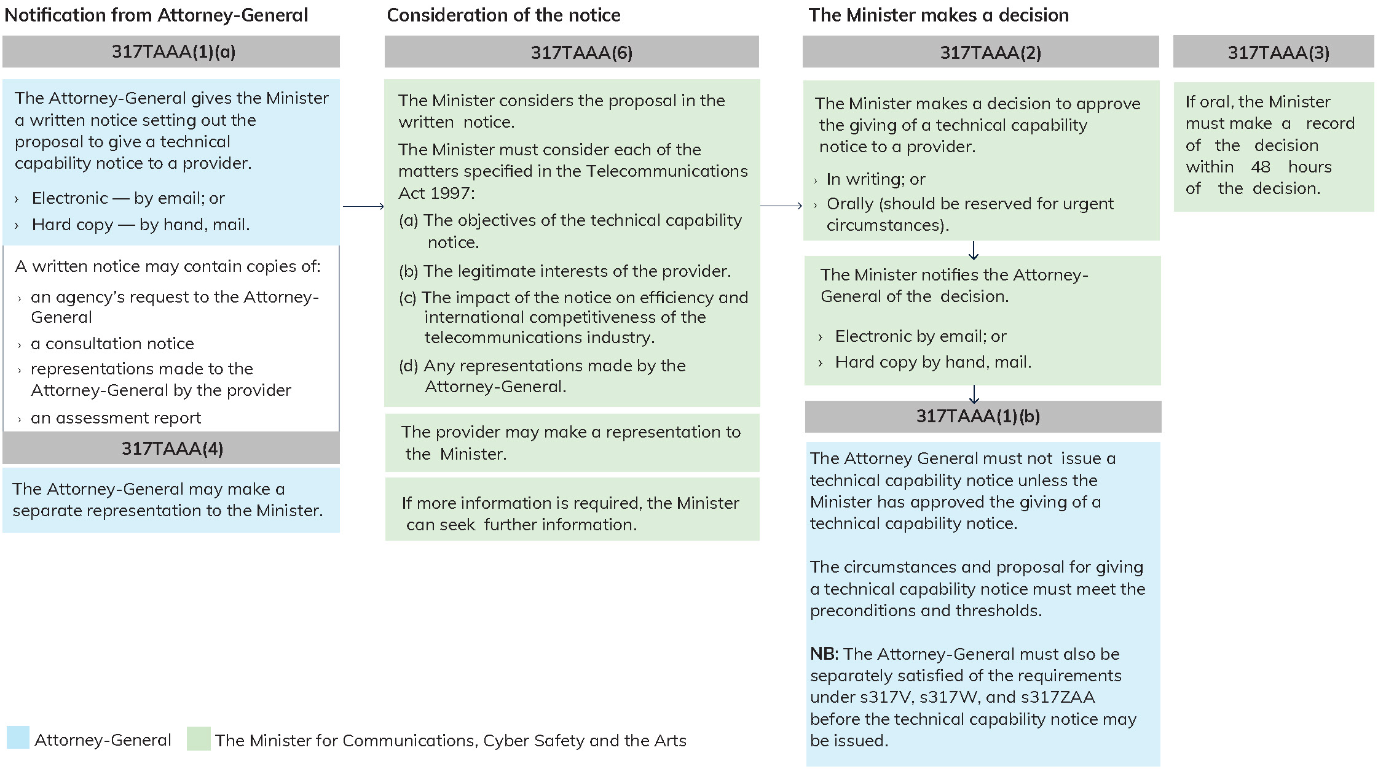

See paragraphs 317TAAA(6)(d) and (e) of the Act.
See paragraph 317TAAA(6)(e) of the Act.
See paragraph 317TAAA(1)(6)(b) of the Act.
See subsections 317W(3) and 317Y(3) of the Act.
See subsection 317ZF(16) of the Act.
See section 317ZG of the Act.
See sections 317WA and 317YA of the Act.
See section 317ZK of the Act.
See subsections 317ZK(3) and 317ZK(6A) of the Act.

