

road vehicle regulation division / vehicle safety operations branch

Compliance and Enforcement Strategy 2026–29
August 2026


© Commonwealth of Australia 2026

Ownership of intellectual property rights in this publication
Unless otherwise noted, copyright (and any other intellectual property rights, if any) in this publication is owned by the Commonwealth of Australia (referred to below as the Commonwealth).

Disclaimer
The material contained in this publication is made available on the understanding that the Commonwealth is not providing professional advice, and that users exercise their own skill and care with respect to its use, and seek independent advice if necessary.
The Commonwealth makes no representations or warranties as to the contents or accuracy of the information contained in this publication. To the extent permitted by law, the Commonwealth disclaims liability to any person or organisation in respect of anything done, or omitted to be done, in reliance upon information contained in this publication.

Creative Commons licence


With the exception of (a) the Coat of Arms; (b) the Department of Infrastructure, Transport, Regional Development, Communications, Sport and the Arts photos and graphics; (c) content supplied by third parties; (d) content otherwise labelled; copyright in this publication is licensed under a Creative Commons BY Attribution 4.0 International Licence.

Use of the Coat of Arms
The Department of the Prime Minister and Cabinet (PM&C) sets the terms under which the Coat of Arms is used. Please refer to the Commonwealth Coat of Arms Information and Guidelines | PM&C.

Contact us
This publication is available in PDF and Word format. All other rights are reserved, including in relation to any departmental logos or trademarks which may exist. For enquiries regarding the licence and any use of this publication, please contact:
Vehicle Safety Operations, Compliance and Enforcement Section
Email: vehiclecompliance@infrastructure.gov.au
Website: Compliance and enforcement under the RVSA | Department of Infrastructure, Transport, Regional Development, Communications, Sport and the Arts

Table of Contents
Document Control 3
Introduction 4
Our approach to compliance and enforcement 4
Our principles 4
Our regulatory approach 5
Previous compliance and enforcement strategies 5
Our operating environment 5
RVS and related legislation 5
Industry intelligence 5
Reports of alleged non-compliance 6
The evolving automotive industry and emerging technologies 6
Our priorities for 2026 to 2029 6
Risk and prioritisation 6
Compliance and enforcement focus areas 6
1. Strengthening accountability for repeated non-compliance 7
2. Responding to regulatory challenges from emerging vehicle technologies 8
3. Supporting approval holder understanding of quality systems and testing facility integrity 8
More information 9
The Regulatory Report 9
Reporting suspected non-compliance to us 9
Review and complaint mechanisms 9
Glossary 9
Use of generative AI compliance statement 10

Document Control
Refer to the following table for the approver and latest version of this document.
Version | Release date | Approver | Reason for update
1.0 | Jul 2026 | Amanda Milczarek, Assistant Secretary, Vehicle Safety Operations | Initial release of document.
1.1 | Aug 2026 | Drew Ward, Director, Compliance and Enforcement | Added an infographic on focus areas.

Introduction
The Road Vehicle Standards Act 2018 (RVSA) and associated subordinate legislation (together, the RVS legislation) provides the national framework for the design, manufacture, importation and first provision of road vehicles in Australia, as well as certain road vehicle components. This strategy outlines how the Department of Infrastructure, Transport, Regional Development, Communications, Sport and the Arts (the department) will conduct its compliance and enforcement activities for the 2026 to 2029 period.
The strategy informs the community, regulated entities, the automotive industry and other regulators about our compliance and enforcement approach, priorities and focus areas for the next 3 years. It is informed by our compliance model (including the 4 compliance types: voluntary, assisted, directed and enforced) and emerging risk themes.
The strategy is supported by operational impartiality. It will be reviewed as required to ensure it remains reflective of regulatory frameworks, is responsive to new or emerging issues, and any significant changes in our operating environment.
The objective of this strategy is to ensure the effective operation of the regulatory framework by delivering outcomes that:
- support vehicle safety
- reduce emissions
- prevent vehicle theft
- maintain consumer trust in the vehicle market.

Our approach to compliance and enforcement
We take an intelligence-led, risk-based approach when managing matters related to compliance with the RVS legislation. This ensures our compliance and enforcement activities are focused on regulated areas and regulated entities that pose the greatest risk.
Our approach is informed by:
- the principles set out in this document
- our road vehicle regulatory approach
- previous compliance and enforcement strategies
- our operating environment, including: the RVS legislation, industry intelligence, reports of alleged non-compliance and the evolving automotive industry (including emerging technologies).
Under this approach, we aim to:
- remain agile and consistent
- allocate resources effectively and proportionately to higher-risk matters
- deliver appropriate compliance and enforcement responses regarding identified non-compliance
- support voluntary compliance through clear guidance and engagement
- adapt to new and evolving risks (including technology and new market entrants)
- deploy regulatory treatments through new technologies and innovation.

Our principles
The following principles continue to inform our compliance and enforcement activities, including through a flexible, intelligence-led prioritisation approach that targets effort to the highest-risk cohorts and behaviours. Priorities are reviewed and adjusted as new intelligence, data and inspection findings emerge, with graduated responses aligned to our compliance model supported by clear, defensible decision-making.
- Voluntary compliance – we promote and encourage voluntary compliance through communication and education.
- Risk-based – our activities are risk-based, ensuring regulatory effort addresses the most serious and systemic risks.
- Intelligence-led and evidence-based – we use intelligence, data and trend analysis to inform our proactive activities and strategic focus areas.
- Proportionate – our responses are proportionate to the risks we are managing.
- Consistent – we act consistently and in accordance with documented procedures.
- Outcomes focused – we prioritise the greatest risks with a view to improving overall compliance in the regulated industry.
- Fair and transparent – we communicate clearly and make decisions in a fair and transparent manner.
- Responsive, agile and efficient – we respond to credible allegations, new information, trends and data, while minimising unnecessary burden.
- Professional – our staff act respectfully, courteously and with integrity.

Our regulatory approach
We acknowledge there are varying degrees of compliant and non-compliant behaviour. The compliance model sets out an escalating regulatory response to escalating risk and non-compliant behaviours and guides our compliance activities and enforcement responses while supporting industry, road vehicle regulation and the New Vehicle Efficiency Standard Act 2024 (NVES). Please reference the Road vehicle regulatory approach document.

Previous compliance and enforcement strategies
Previous strategies supported entity transition to the RVS regulatory framework, while also helping build broad understanding of RVS obligations.
Information from targeted desk top activities, compliance monitoring inspections and investigations continue to assist with our regulatory approach and, importantly, the focus areas detailed in this strategy.

Our operating environment

RVS and related legislation
The department administers the Road Vehicle Standards Act 2018 and associated subordinate legislation. Our compliance and enforcement activities are undertaken in accordance with the powers and tools available under the RVS legislation and related regulatory powers frameworks.

Industry intelligence
We receive information from multiple sources, both passively and proactively. This includes information from regulated entities, the public, external regulatory partners and related agencies, issues identified through application assessment processes, direct data analysis, compliance monitoring inspections and intelligence products. These intelligence channels help us identify current and emerging compliance risks and assist in targeting our regulatory effort appropriately.

Reports of alleged non-compliance
Reports of alleged non-compliance are a valuable intelligence source that can help identify underlying issues, emerging trends, and matters requiring immediate attention. We record and manage all reports in departmental systems and use them to inform compliance triage, prioritisation and, where appropriate, targeted compliance activities.

The evolving automotive industry and emerging technologies
The operating environment continues to evolve, shaped by new market entrants, complex global supply chains, and the rapid uptake of new vehicle technologies. Electric vehicles, advanced driver assistance systems (ADAS) and other emerging technologies can reach the Australian market rapidly, creating opportunities to strengthen regulatory understanding and compliance capability in step with innovation. These dynamics reinforce the need for an agile, intelligence-led and risk-based compliance approach, including appropriate post-approval compliance monitoring to control emerging risks quickly.

Our priorities for 2026 to 2029
During 2026 to 2029 we will continue to promote and enable voluntary RVS compliance through clear guidance and proactive engagement. Consistent with our compliance model, we will also increase emphasis on assisted, directed and enforced compliance where risk, behaviour or compliance history indicates this is necessary to protect the Australian public and the integrity of the regulatory framework.
We will apply a risk-based and flexible prioritisation framework, using intelligence, compliance data and inspection findings to help target effort where it delivers the greatest vehicle safety and compliance impact. This includes adjusting compliance activities as new risks emerge, while maintaining transparency about what the department can and cannot address at a given time.
The focus areas detailed in this strategy will be the cornerstone of our regulatory efforts over the next 3 years.

Risk and prioritisation
We adopt a risk-based approach to prioritising compliance and enforcement activities. This ensures resources are directed to the areas of greatest potential harm and impact. In assessing and triaging matters, priority is given to:
- serious safety risks, particularly those that may result in injury or harm
- widespread, systemic or repeated non-compliance
- impacts on vulnerable consumers, including where particular groups may be disproportionately affected
- emerging technologies or market developments, where uncertainty or information asymmetry increases risk
- deliberate or reckless behaviour indicating disregard for regulatory obligations.
Our response is proportionate to the level of risk and harm, and may range from education and engagement through to strong enforcement action.

Compliance and enforcement focus areas
We have identified 3 focus areas to guide proactive compliance and enforcement activity for the 2026 to 2029 period. These focus areas respond to observed systemic compliance risks, the evolution and implementation of technology and the need to target regulatory effort where it has the greatest benefit. Each focus area will be delivered using the full range of regulatory tools available in our compliance model, applied proportionately to both risk and behaviour.
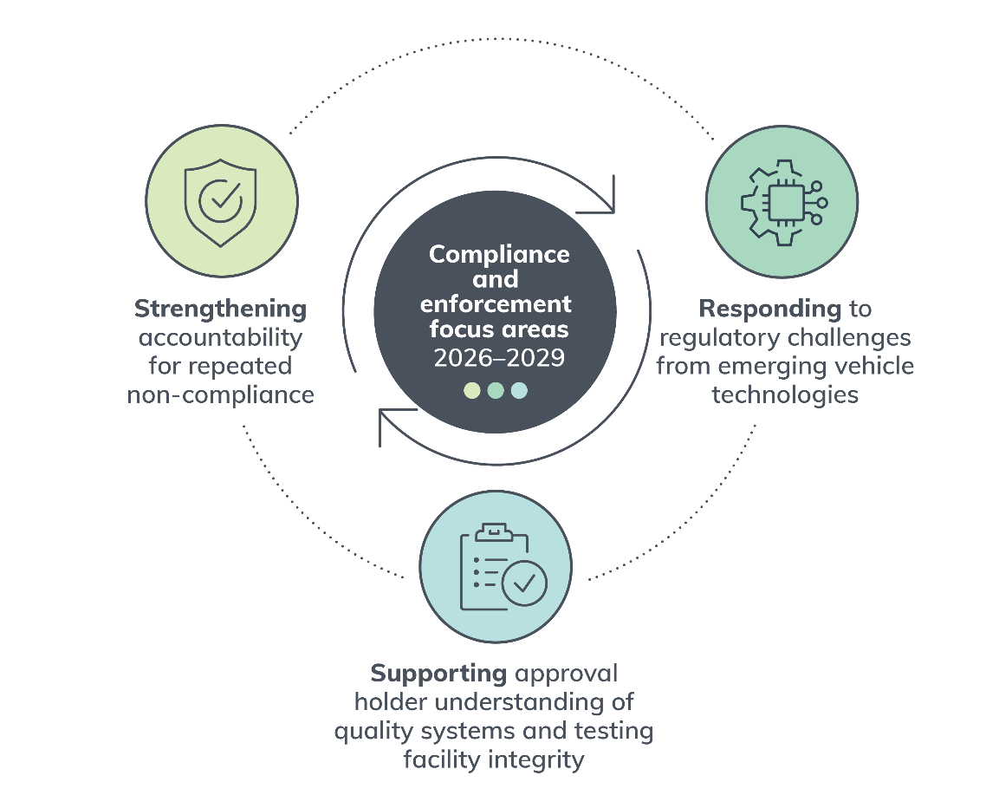

1. Strengthening accountability for repeated non-compliance
We will use the regulatory tools available under the RVS legislation to strengthen approval holder accountability where non-compliance is repeated, persistent or systemic.
This focus area addresses non-compliance by raising the baseline capability and accountability of RVS approval holders. We will use RVS approval levers and other regulatory tools (including discretionary approval conditions; compliance monitoring inspections; regulatory reviews and where necessary, approval suspension or revocation) to address recurring and high-risk non-compliance at its source. Our responses will be proportionate to the nature, seriousness and persistence of the non-compliance, escalating through voluntary, assisted, directed and enforced compliance where required.
- Objective / outcome: Improved approval holder capability and accountable compliance behaviours.
- Key initiatives / activities:
  - Targeted compliance monitoring inspection programs for higher-risk approval holders (including concessional and repeat non-compliant cohorts).
  - Use of approval conditions to strengthen governance, quality controls and evidence expectations.
  - Escalate enforcement responses quickly and in line with the compliance model where non-compliance persists.

2. Responding to regulatory challenges from emerging vehicle technologies
We will proactively identify and manage compliance risks arising from emerging vehicle technologies and new market entrants.
This focus area aims to identify, using intelligence and research, new risks associated with emerging vehicle types and technologies. This includes undertaking intelligence-led compliance monitoring of new RVS entrants and existing approval holders operating in high-growth vehicle categories, conducting targeted compliance monitoring inspections, providing clear and accessible guidance, and taking decisive enforcement action where road vehicles are being provided without a relevant RVS approval.
- Objective / outcome: Early identification and control of compliance risks linked to emerging technologies and new market entrants.
- Key initiatives / activities:
  - Develop and maintain intelligence triggers for emerging vehicle categories.
  - Targeted compliance monitoring inspections and compliance monitoring of new entrants and higher-growth categories.
  - Publish and maintain clear accessible guidance to support voluntary compliance and reduce ambiguity.
  - Take proportionate enforcement action for the importation and provision of road vehicles without relevant approvals.
  - Post-approval market surveillance and technical intelligence gathering for emerging technologies (including ADAS and other safety-related systems).
  - Targeted information requests and reviews where emerging risks are identified.

3. Supporting approval holder understanding of quality systems and testing facility integrity
We will support RVS approval holders to understand the importance of effective quality system documentation and reliable testing facility evidence. RVS approval holders remain responsible for developing, maintaining and applying their own quality systems.
This focus area recognises that poor or incomplete quality system documentation can be a root cause of non-compliance, particularly where RVS approval holders cannot demonstrate effective control over design, componentry, manufacturing changes, testing evidence or ongoing conformity. We will not design, strengthen or operate quality systems on behalf of RVS approval holders. Instead, we will set clear regulatory expectations, use compliance monitoring inspections, approval assessments, information requests, and approval conditions to help RVS approval holders understand their obligations, identify gaps early and take responsibility for durable improvements to their systems, procedures and records.
- Objective / outcome: RVS approval holders better understand the importance of effective quality system documentation, testing facility integrity and reliable compliance evidence, and take responsibility for maintaining systems that support ongoing compliance.
- Key initiatives / activities:
  - Use inspection findings, application assessment insights and intelligence to identify and communicate common weaknesses in quality system documentation and testing evidence.
  - Apply targeted information requests and approval conditions to clarify expectations for procedures, record keeping, change control and evidence traceability where risk warrants it.

  - Undertake targeted compliance monitoring of testing facility integrity, including the reliability, currency and relevance of ADR evidence relied on for approvals.
  - Use proportionate regulatory responses to enable RVS approval holder uplift, including education and engagement to support voluntary compliance, corrective action where weaknesses are identified, and stronger enforcement where systemic issues are not addressed.

More information
To support regulated entities in their commitment to voluntary compliance, we will continue to publish and maintain guidance and information about compliance and enforcement under the RVSA. More information is available on the department’s website: Compliance and Enforcement under the RVSA.

The Regulatory Report
We report on RVS regulatory activities conducted by the department through The Regulatory Report. These quarterly reports provide information on the number of vehicles on the Register of Approved Vehicles, application assessment timeframes, recalls, compliance and enforcement matters, and stakeholder engagement and enquiries. Refer to The Regulatory Report page on the department’s website.

Reporting suspected non-compliance to us
Information from the public, industry and other regulators helps identify emerging concerns and significant issues that may require immediate attention and informs future compliance planning. For information on reporting suspected non-compliance or safety concerns, refer to Reporting a vehicle safety or non-compliance issue.

Review and complaint mechanisms
If a regulated entity is not satisfied with our response or action in relation to a compliance matter, it can be raised with the relevant area handling the matter. A formal complaint can also be made by contacting us via the department’s website. Refer to the Complaints Fact Sheet.
In the case of certain decisions made under the RVS legislation, an applicant or approval holder may have review rights through the relevant review mechanism (for example, the Administrative Review Tribunal or successor arrangements as applicable). Reviewable decisions are set out in the Road Vehicle Standards Rules 2019.

Glossary
Term | Definition
Australian Design Rules (ADRs) | National road vehicle standards under the RVSA.
Compliance monitoring | A broad term referring to information collection or contact with a regulated entity to identify issues relating to compliance with the legislation and/or conditions of an approval.
Enforceable undertaking | A written, court-enforceable undertaking accepted by an authorised person about compliance with enforceable provisions.
Register of Approved Vehicles (RAV) | A publicly accessible online database of vehicles that comply (or substantially comply) with applicable national road vehicle standards or are otherwise permitted for use on public roads under a concessional scheme.
Quality System Documentation (QSD) | To meet the criteria under the RVS legislation, when you apply for vehicle type, low ATM trailer (via a vehicle type) and component type approvals, you need to have either:  - full control over all stages of the design, componentry and manufacturing process for the type of road vehicle or road vehicle component, or  - access to information, including information about any changes, relating to the design, componentry and manufacture of the type of road vehicle or road vehicle component that may affect its compliance with the applicable national road vehicle standards.  See link: Quality management system requirements
Advanced driver assistance systems (ADAS) | Are active safety systems that use sensors, cameras, and algorithms to assist drivers with steering, braking, and information, while still requiring the driver to remain responsible for the driving task.
Road Vehicle Standards Act 2018 (RVSA) | An Act to provide for the regulation of road vehicles and road vehicle components, to set national road vehicle standards, and for other purposes.
Regulated entity | An individual or organisation engaged in the import or provision of road vehicles or approved road vehicle components to the Australian market, as authorised through an approval granted in accordance with the RVS legislation.

Use of generative AI compliance statement
Generative AI technology was used to assist in the preparation of this document, including reviewing content for alignment with related departmental frameworks and supporting the drafting and consolidation of feedback. All substantive decisions, final wording and approvals were made by departmental officers.

