Australian Government
Department of Infrastructure, Transport, Regional Development, Communications and the Arts

# Community values on Christmas Island—summary report

**July 2022**

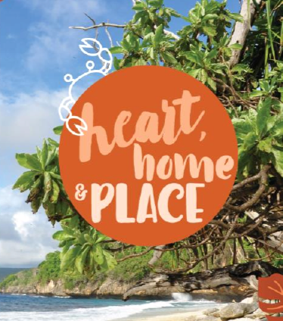

© Commonwealth of Australia 2022

July 2022 / INFRASTRUCTURE 2022

Ownership of intellectual property rights in this publication

Unless otherwise noted, copyright (and any other intellectual property rights, if any) in this publication is owned by the Commonwealth of Australia (referred to below as the Commonwealth).

Disclaimer

The material contained in this publication is made available on the understanding that the Commonwealth is not providing professional advice, and that users exercise their own skill and care with respect to its use, and seek independent advice if necessary.

The Commonwealth makes no representations or warranties as to the contents or accuracy of the information contained in this publication. To the extent permitted by law, the Commonwealth disclaims liability to any person or organisation in respect of anything done, or omitted to be done, in reliance upon information contained in this publication.

Use of the Coat of Arms

The Department of the Prime Minister and Cabinet sets the terms under which the Coat of Arms is used. Please refer to the Commonwealth Coat of Arms—Information and Guidelines publication available at [http://www.pmc.gov.au](http://www.pmc.gov.au/).

Use of the Coat of Arms

The Department of the Prime Minister and Cabinet sets the terms under which the Coat of Arms is used. Please refer to the Commonwealth Coat of Arms—Information and Guidelines publication available at [http://www.pmc.gov.au](http://www.pmc.gov.au/).

Contact us

This work is copyright. Apart from any use as permitted under the *Copyright Act 1968*, no part may be reproduced by any process without written permission from:

Department of Infrastructure, Transport, Regional Development, Communications and the Arts

GPO Box 594, Canberra ACT 2601

Telephone: 1800 075 001

Website: https://www.infrastructure.gov.au/territories-regions-cities/territories/indian-ocean-territories/christmas-island/strategic-assessment

Christmas Island strategic assessment enquiries

If you have an enquiry about the Christmas Island Strategic Assessment, please contact:

Director, Christmas Island Strategic Assessment

Department of Infrastructure, Transport, Regional Development, Communications and the Arts

Email: [cisa@infrastructure.gov.au](mailto:cisa@infrastructure.gov.au)

Table of contents

1. Purpose 5

2. Introduction 6

Streamlining heritage laws on Christmas Island 6

3. Engaging the community 7

4. Community priorities 8

Community Priorities 8

5. Key findings and insights 9

The community wants sustainable development 9

The community recognises the importance of economic diversification 10

There is a need for streamlined regulatory processes and governance arrangements. 11

The Island’s historical, social and cultural heritage values are important to the community. 12

Ongoing engagement will provide a foundation for a sustainable future. 12

6. Heritage values 13

Nationally important heritage places 13

Locally important heritage places 13

7. Next steps 15

Appendix A: Key heritage sites investigated 16

Appendix B: “Where should it go?”—suggested location of residential and commercial developments 17

Appendix C: “Where should it go?”—suggested location of tourism 18

Appendix D: “Where should it go?”—suggested location of industrial developments 19

Appendix E: “Where should it go?”—suggested location of rural activities 20

List of figures and tables

Table 1: Summary of consultation methods. 7

Figure 1: A word cloud of community perspectives on Christmas Island. 8

Figure 2: Key areas of importance for the Christmas Island community, as determined by the community values mapping project. 9

Figure 3: What are the three (3) most important environmental issues on Christmas Island? 10

Table 2: Community sentiment toward future industries. 11

Table 3: Ranking of heritage places for their National, Regional and Local values. 13

Table 4: Ranking of local heritage value. 14

## 1. Purpose

The values and aspirations of a community underpins strategic land-use planning processes. Community values mapping identifies important social, economic, environment and heritage values and how these relate to places.

The purpose of this Summary Report is to synthesise findings from a community values consultation process undertaken on Christmas Island from 22 February 2022 until 1 March 2022 by Creating Communities Australia on behalf of the Department of Infrastructure, Transport, Regional Development, Communications and the Arts (DITRDCA).

The results of these discussions will inform development of the Christmas Island Strategic Assessment (CISA) Program. Led by DITRDCA, the CISA Program will consider the cumulative social, economic and environmental impacts of proposed development activities to support sustainable development and economic diversification on Christmas Island over the next 30 years.

## 2. Introduction

Christmas Island is a remote island in the Indian Ocean, home to rare and endangered flora and fauna, some of which are not found anywhere else in the world. The Christmas Island National Park (CINP) covers 63% of the Island, and many species are protected under the Commonwealth *Environment Protection and Biodiversity Conservation Act 1999* (EPBC Act).

Small, isolated communities like Christmas Island rely on key industries and the natural environment to support its economy. Extensive and expensive approval processes have limited development opportunities on Christmas Island and resulted in a lack of diversification of economic prospects, basic resources and community driven initiatives.

The primary objective for the community values mapping project was to gather information on local values to inform the development of the CISA Program. It also provided an opportunity for community input on the application of WA heritage laws on Island. The DITRDCA commissioned this project to consult with the community, industry, business and the Shire of Christmas Island about local heritage values, social values, development opportunities, and conservation values. This included consultation on whether listed heritage places were considered important to the community at a local, regional or national level.

The information gained from the community values mapping project will be used to inform the development of CISA documents ahead of a formal EPBC Act public consultation period. Once finalised, the strategic assessment documents will be provided to the federal Minister for the Environment for formal consideration under the EPBC Act.

### Streamlining heritage laws on Christmas Island

Due to the status of Christmas Island as a Commonwealth Territory, developments that may have a significant impact on Commonwealth heritage values, including those properties that are privately owned, must be referred to the Environment Minister under the EPBC Act. This can include repairs or minor renovations on properties with heritage values. This process takes time, is costly and is inconsistent with heritage management practices for private freehold properties elsewhere in Australia.

Engagement with the community also informed the development of the Christmas Island Applied Laws Ordinance 1992, which applies the WA *Heritage Act 2018* to give effect to historic Commonwealth EPBC Act amendments on Christmas Island. The effect of this is that privately-owned heritage values would no longer be regulated under the EPBC Act.

Applying WA heritage laws on Christmas Island is consistent with the aims of the CISA Program to streamline regulation and facilitate sustainable development. It is also an important step in supporting the efficient implementation of the CISA.

## 3. Engaging the community

A range of community engagement methods were employed to gather community feedback and insights. Key stakeholders and community members from the Shire of Christmas Island (SoCI), business owners, Phosphate Resource Limited (PRL), Christmas Island Visitor Centre, Parks Australia and the Christmas Island District High School were engaged through the consultation processes.

A summary of consultation methods is provided below with further information outlined in Table 1.

22 one-on-one interviews with cross section of key stakeholders.

5 focus group workshops, 46 participants total.

91 surveys online and hard copy.

3 drop-in sessions and pop-ups.

Overall, the project engaged more than 10% of the island’s population. When compared to characteristics of the total population, males, young adults and the Malay and Chinese communities were under-represented in the engagement.

The engagement was broad; canvassing questions on governance, housing, economic development—including industry, mining and tourism—environment, social and cultural heritage, infrastructure and agricultural issues.

Table 1: Summary of consultation methods.

|  |  |
| --- | --- |
| Header row | Header row |
| Survey | A total of 91 people participated in the survey, with the majority (56%) answering every question. |
| Focus groups | Five focus groups were held, with a total of 46 participants. Each focus group targeted different cohorts:   1. Business and Industry 2. Community organisations 3. Residents 4. Christmas Island District High School 5. Poon Saan club |
| Pop-up stalls | Two pop-up hubs promoted the consultation and were located in high traffic areas including the Christmas Island Recreation Centre and Flying Fish Cove to encourage community input. |
| Community drop-in | The community drop-in enabled 20 community members to gather information and provide feedback on the CISA. Participants were able to indicate areas of value and express where they think certain types of development should (or should not) occur through mapping activities (Appendix A–E). |
| Interviews | Face-to-face and online interviews were conducted with a range of representation from 22 participants. The interviews were 60–90 minutes long and focused on:   * Strengths, challenges and opportunities of the environment, culture, heritage, development, social and governance aspects of Christmas Island * Thoughts on the seven proposed Classes of Action (proposed developments to be permitted under the CISA Program) * Places of heritage significance. |

## 4. Community priorities

The breadth of approaches employed engaged different Island stakeholders, resulting in a range of insights from various perspectives. For example, collation of *Which three words best describe Christmas Island and its community?* creates the following word cloud (Figure 1):

Figure 1: A word cloud of community perspectives on Christmas Island.

### Community Priorities

Survey respondents were asked to rank ten priority statements for the Island’s future:

* + - 1. Caring for the environment
      2. Improving food availability
      3. Increasing connection and accessibility to the Island
      4. Developing a sustainable and diversified economy
      5. Celebrating history and cultural heritage
      6. Supporting a strong community
      7. Developing tourism
      8. Celebrating and preserving environmental heritage
      9. Education and training opportunities
      10. Employment

## 5. Key findings and insights

The community values consultation identified three key areas of importance for the community of Christmas Island; sustainable development, economic diversification, and community values (Figure 2).

Figure 2: Key areas of importance for the Christmas Island community, as determined by the community values mapping project.

Economic diversification.
Streamlined regulatory processes and governance arrangements.
Sustainable development.
Ongoing engagement.
Importance of community values.

The consultation project also highlighted the value of streamlined regulatory processes and ongoing engagement with the community. These key findings are summarised below.

### The community wants sustainable development

Survey respondents emphasised the beaches, the ocean and the National Park as areas of high importance to the community. Respondents consider development should be balanced against protecting the natural environment and supporting conservation practices. There is strong community support for leveraging the natural assets of Christmas Island to promote economic diversification activities, such as growth in the tourism industry.

The community strongly values the unique natural environment of Christmas Island. The results of the surveys, focus groups and drop-in sessions demonstrated the community’s desire to protect the flora and fauna of the island, including restricting future development from encroaching on environmental assets (Figure 3).

Figure 3: What are the three (3) most important environmental issues on Christmas Island?

Waste management: 36%.
Nature conservation: 34%.
Maintenance service: 12%.
Mining: 8%.
Global warming: 6%.
Energy: 2%.
Food access: 2%.
Education: 1%..

Participants strongly advocated development, including tourism ventures, should not be at the expense of the natural environment, communicating a high level of support for improved conservation management, waste management and less ecologically damaging industries.

“The environment is the identity (character and spirit) of Christmas Island – without the environment it wouldn’t be Christmas Island.”—Interview participant

Waste management was rated highly by respondents (Figure 3), with suggestions to improve recycling, adding an organics collection service and building renewable energy options into future development plans. The Island’s history of phosphate mining and use of asbestos in building materials has created legacy issues for future development, requiring an informed response to managing environmental contaminants.

On the topic of future housing and urban development for the Island, participants of the interviews and focus groups indicated a desire to maintain large block sizes, while recognising the lack of available land for new housing. This contrasts with alternative suggestions by participants for future development to be consolidated into denser hubs. A primary concern around housing development is the cost of building (including freight, trade persons and materials).

Finally, the community raised land subsidence and rock fall as an issue. Currently DITRDCA is investing in a $29 million project to upgrade and replace landslide and rockfall infrastructure to ensure Christmas Island remains a safe destination to live, work and visit over the coming decades.

### The community recognises the importance of economic diversification

The community recognises the importance of economic diversification through:

* Supporting diversification of emerging industries including tourism, education and training
* Better planning of precinct areas to support the economy and concentrate development to consolidated retail and industrial ‘hubs’
* Building capacity for agricultural production appropriate for Island conditions.

While there is an appreciation of the role the current major industries have played in developing the Island, there is appetite for change. The community is seeking economic diversification of the Christmas Island economy. As shown in Table 2, there are conflicting ideas on which future industries are best suited with a preference for education and training, cultural industries, and health.

Stakeholders note barriers that exist to economic development including the high business and transport costs, limited accommodation for staff, unclear governance and approvals processes and lack of available space.

A specific challenge is developing fit-for-purpose agriculture capability for the current and future Island population and industries. Participants in focus groups and interviews agreed sustainable agriculture is important to reduce reliance on imported food and produce. Future opportunities may include hydroponics or modular systems capable of scalable production, limiting dependence on poor quality soils and exposure to pests and diseases, including the annual crab migration.

Table 2: Community sentiment toward future industries.

|  |  |  |  |
| --- | --- | --- | --- |
|  | Perceived Future Importance for the Island | Level of Support from the Community | Desirability for employment |
| Tourism | High | Moderate | High |
| Government services and facilities (e.g Detention Centre) | High | Low | Moderate |
| Mining | High | Low | Moderate |
| Education and Training | Moderate | High | High |
| Cultural industries | Moderate | High | Low |
| Health industries | Low | High | Moderate |

The current state of infrastructure is seen as an impediment to growth and development, particularly telecommunications (including internet), roads and the port. The community recognises the cost challenges of upgrading infrastructure and suggested exploring alternate financing models such as public-private partnerships or fee-for-service models.

Stakeholders also note the need for a clearly planned, systemic and considered approach to economic diversification, recognising opportunities for reinforcing growth in existing industrial areas of the Island.

### There is a need for streamlined regulatory processes and governance arrangements.

The community provided feedback that complicated approvals processes are a disincentive for individuals and businesses seeking to invest in ventures on Christmas Island. They considered development could be encouraged by improving and streamlining approvals processes, including the removal of ‘red and green tape’. The community also expressed support for the Shire’s planning scheme and the importance of this being supported by the Australian Government.

The desire for improvement in the governance of Christmas Island was a recurrent theme throughout the consultations. Current governance structures and processes are considered to be confusing, bureaucratic and disconnected.

When participants in the focus groups and interview were discussing urban development opportunities, they recognised needs for expediting government approvals to support development and for effective planning, specifically in precinct areas. This would help to address existing approval processes which are considered complex, slow and ineffective.

The community also suggested revisions to the Island’s land tenure system (where DITRDCA, as the owner of Crown land, owns the majority of the land on CI) by altering the lease period and implementing penalties for ‘land banking.’

### The Island’s historical, social and cultural heritage values are important to the community.

The community identified places with significant historical, social and cultural heritage values on Christmas Island, especially in the Malay Kampong area, the South Point Settlement remains and the Poon Saan area.

The community provided feedback that heritage on Christmas Island has not been appropriately maintained in the past due to costly and burdensome management approvals and processes, especially for private landholders. They also identified existing heritage list should be reviewed and places with local heritage values should be managed at a local level, with a focus on individual places rather than precincts. Feedback also identified that building the resilience of historic places from climate change and natural hazards will facilitate protection and future use.

Participants in the focus groups and interviews nominated the social and cultural strengths of cultural diversity and social capital, finding the Island to be cohesive, supportive, inclusive and safe.

Christmas Island has a long and interesting history, with many buildings still existing from the early days of settlement. This historical heritage was also highlighted by consultation participants: heritage connects the community.

### Ongoing engagement will provide a foundation for a sustainable future.

The community want improved communication on important changes and follow-up from on-island consultation processes.

The participants highlighted an increased commitment for communication between all parties, including reporting and feedback after consultation processes. Building local engagement capacity could also increase volunteering and management of community assets.

## 6. Heritage values

Understanding the Christmas Island community’s awareness and preferences for heritage protection was a specific focus of the community consultation process. The survey and focus groups asked participants about the ten Commonwealth Heritage Listed Places, seeking to understand their local heritage value (from the survey) and significance at a national, regional or local level in the focus groups.

### Nationally important heritage places

In the focus groups, participants were given stars and asked to place them across the ten sites to show prioritisation of the importance of each site. Participants were asked to place their allocated stars on the site that was most valued locally, regionally or nationally.

The Administrator’s House was rated the highest in terms of its importance, particularly at the national level. South Point Remains presents strong regional values, while the Malay Kampong Group and Poon Saan Group rate highly in overall importance and local value (Table 3).

Table 3: Ranking of heritage places for their National, Regional and Local values.

|  |  |  |  |
| --- | --- | --- | --- |
| Heritage site | National value | Regional value | Local value |
| Administrator’s House Precinct | 23 | 5 | 0 |
| South Point Remains | 7 | 11 | 7 |
| Malay Kampong Group (Community Precinct) | 1 | 1 | 12 |
| Poon Saan Group | 1 | 5 | 11 |
| Settlement | 1 | 4 | 7 |
| Industrial and Administrative Group | 2 | 7 | 1 |
| Malay Kampong (Residential) Precinct | 1 | 3 | 10 |
| Bungalow 702 | 0 | 1 | 6 |
| Phosphate Hill | 1 | 4 | 2 |
| Drumsite | 0 | 2 | 3 |

### Locally important heritage places

Survey respondents were asked their agreement with this statement: This place has Christmas Island local heritage value with (5) Strongly agree and (1) Strongly disagree, yielding the ranking below in Table 4.

While focus groups could discuss and locate heritage sites on maps, survey respondents had to rely on their individual knowledge of the Island’s history. It was clear from the focus groups that many participants were unaware of the existence of some heritage places, in particular, Bungalow 702.

Ongoing maintenance of heritage sites was highlighted as an issue by participants.

Table 4: Ranking of local heritage value[1].

|  |  |  |
| --- | --- | --- |
| Ranking | Place | Score (out of 5) [2] |
| 1 | Malay Kampong Group | 4.3 |
| 2 | South Point Settlement remains | 4.2 |
| 3 | Poon Saan Group | 4.1 |
| 4 | Drumsite Industrial Area | 4.1 |
| 5 | Phosphate Hill Historic Area | 4.0 |
| 6 | Settlement Precinct | 4.0 |
| 7 | Malay Kampong Residential | 4.0 |
| 8 | Bungalow 702 | 4.0 |
| 9 | Administrators’ House | 3.9 |
| 10 | Industrial & Administrative Group | 3.8 |

## 7. Next steps

From 1 July 2022, the *Heritage Act 2018 (WA)(CI*) will be applied on Christmas Island. DITRDCA will continue to work closely with the Shire of Christmas Island to undertake a local heritage survey and, in consultation with the community and affected landowners, develop a local heritage list.

DITRDCA will also work closely with the Department of Climate Change, Energy, the Environment and Water to remove private freehold properties from the Commonwealth Heritage List.

DITRDCA is leading the Christmas Island Strategic Assessment to remove barriers to economic diversification, support sustainable development and provide certainty for development on Christmas Island over the next 30 years. The Christmas Island Strategic Assessment will reduce the regulatory burden on environmental approvals and increase regulatory certainty for Government, business and the community.

The CISA Program will assess the impacts of future development on places that remain on the Commonwealth Heritage List and facilitate development in accordance with the Sustainable Development Plan, specifying commitments to developing EPBC Act Heritage Management Plans. The CISA will further streamline EPBC Act requirements for developments that impact heritage places, including properties that are leased from the Australian Government.

**Departmental officers in DITRDCA are carefully considering the contributions received during the consultation, and will continue to develop the Christmas Island Strategic Assessment documents ahead of a formal EPBC Actpublic consultation.**

To find out more about the Christmas Island Strategic Assessment, visit [our website](https://www.infrastructure.gov.au/territories-regions-cities/territories/indian-ocean-territories/christmas-island/strategic-assessment) or contact [cisa@infrastructure.gov.au](mailto:cisa@infrastructure.gov.au).

## Appendix A: Key heritage sites investigated

There are ten (10) Commonwealth Heritage Listed Places in Christmas Island which formed the basis for the community and stakeholder engagement into local heritage values. The areas of investigation and questions asked of stakeholders were the ten properties listed on the Commonwealth Heritage List, including:

* **Site 1: Administrators House Precinct**—A symbol of colonial rule on Christmas Island, when it was incorporated into the Straits Settlement of Singapore and has been the focus for official duties and functions. Most valued for its historical and aesthetic aspects.
* **Site 2: Bungalow 702**—This bungalow was used by the Japanese as a radio station during the Island's occupation in World War II. Valued for its history.
* **Site 3: Drumsite Industrial Area**—The incline railway, 1930s chute and winding gear sheds are historically and scientifically significant as evidence of previous phases of the mining industry on Christmas Island. Valued for its history.
* **Site 4: Industrial and Administrative Group**—This area includes evidence of each successive phase of settlement and mining on the Island. It includes some of the oldest structures on Island, many of which hold historical significance. Valued for social and historical aspects.
* **Site 5: Malay Kampong (Residential) Precinct**—Area of the original residential settlement on Christmas Island, valued for social, spiritual and historical aspects. Has been the residential area occupied by the Malay community since the beginning of phosphate mining on the Island.
* **Site 6: Malay Kampong Group (Community Precinct)**—The Kampong Area represents one of the main cultural groups on Christmas Island and their endeavours to maintain their religious laws and traditions in a remote setting. Valued for social, spiritual and historical aspects.
* **Site 7: Phosphate Hill Historic Area**—Location of first commercial phosphate mining and historic burial ground is significant reminder of the hardships endured by early labourers. Valued for its history.
* **Site 8: Poon Saan Group**—Symbolises Chinese presence on the Island and the conditions in which they lived. Valued for social and historical aspects.
* **Site 9: Settlement Precinct**—Residential area listed as a reminder of when the Island came under the control of the British Phosphate Commission. Valued for its social and historical aspects.
* **Site 10: South Point Remains**—Reminder of one of the Island's early major residential areas and focus of mining activity from 1914. Valued for spiritual and historical aspects.

## Appendix B: “Where should it go?”—suggested location of residential and commercial developments

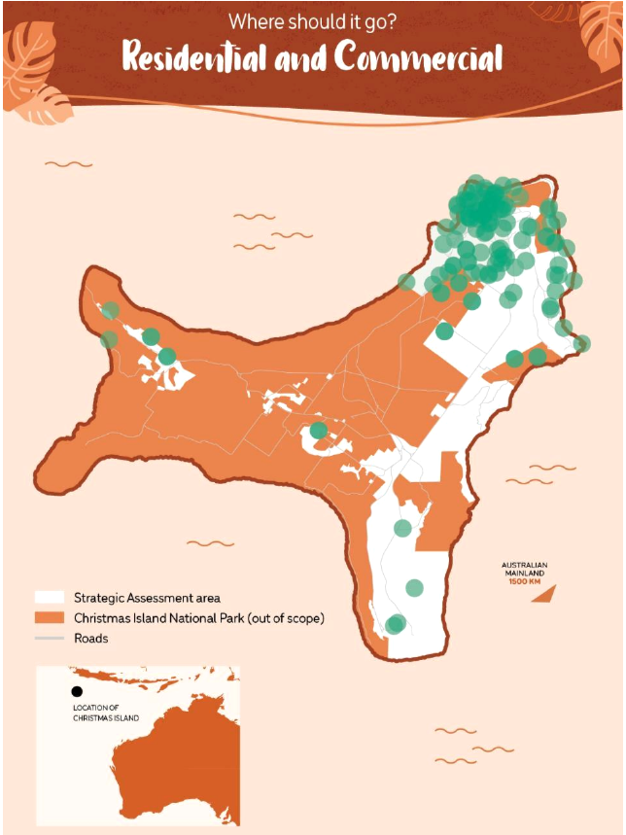

## Appendix C: “Where should it go?”—suggested location of tourism

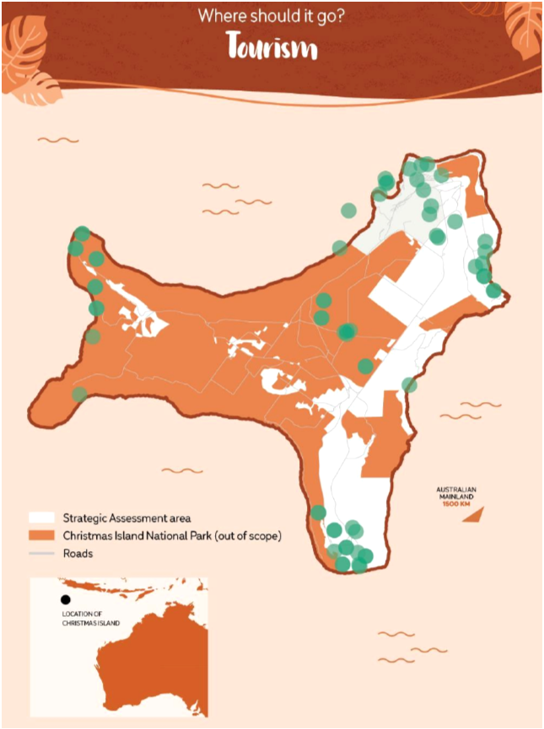

## Appendix D: “Where should it go?”—suggested location of industrial developments

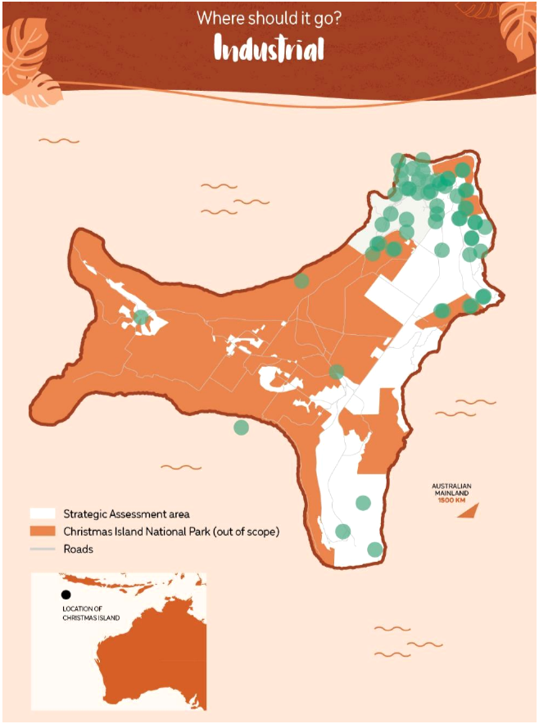

## Appendix E: “Where should it go?”—suggested location of rural activities

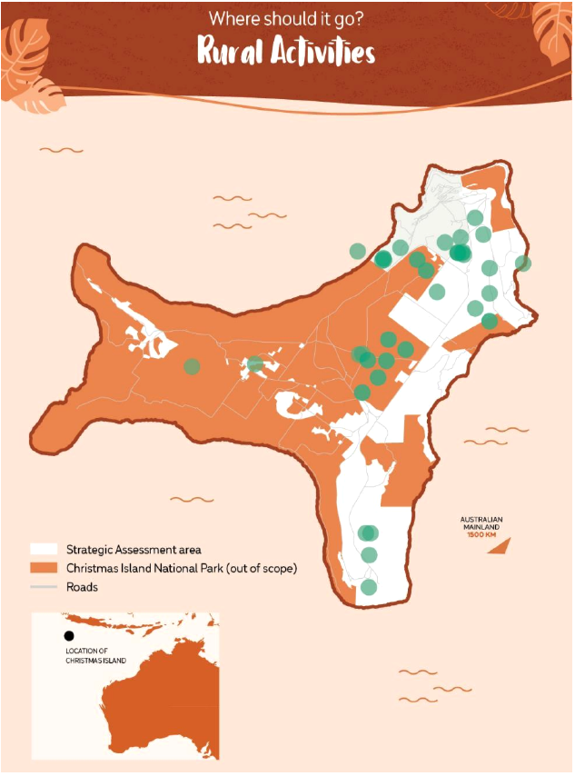

1. For a full listing and explanation of key Heritage Sites see Appendix 1
2. Score is based on (5) strongly agree to (1) strongly disagree: For each of the 10 Commonwealth Heritage Listed Places below select your level of agreement with this statement *This place has Christmas Island Local Heritage value.*