

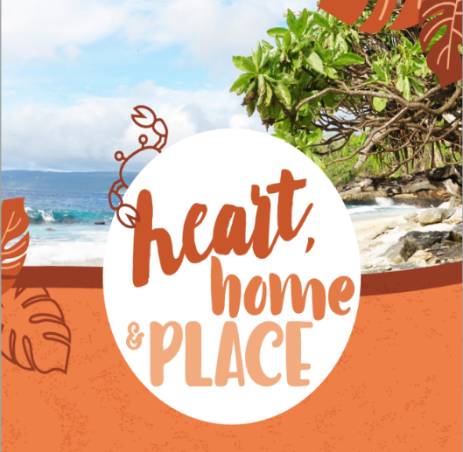

# Community values on Christmas Island—report on what we heard

**July 2022**

## Mapping community values

The values and aspirations of a community underpin strategic land-use planning processes. Community values mapping identifies important social, economic, environment and heritage values for the local community, and how these relate to places.

Through the recent community values mapping project, the Department of Infrastructure, Transport, Regional Development, Communications and the Arts (DITRDCA) consulted with the community, industry, business and the Shire of Christmas Island about local heritage values, social values, development opportunities, and conservation values. This included consultation on whether listed heritage places were considered important to the community at a local, regional or national level.

These discussions will inform the development of the Christmas Island Strategic Assessment (CISA), which will facilitate future sustainable economic development and environmental protection decisions for the Island.

## The conversation

From 22 February until 1 March 2022, we asked the community to map important values on Christmas Island.

We held conversations through focus groups, one-on-one interviews, and met with businesses and the community through drop-in information sessions and pop-up stalls. We also sought feedback through a 37-question community survey, which was accessible online and in hard-copy.

## Who engaged

The community, industry and business groups and government representatives all engaged through the consultation process.

22
One-on-one interviews 
with cross section of 
key stakeholders.



## Key insights from the consultation

The community wants sustainable development.

1. Survey respondents emphasised the beaches, the ocean and the National Park as areas of high importance to the community.
2. Development should be balanced against protecting the natural environment and supporting conservation practices.
3. There is strong community support for leveraging the natural assets of Christmas Island to promote economic diversification activities, such as growth in the eco-tourism industry.

The community recognises the importance of economic diversification through

1. Supporting diversification of emerging industries including tourism, research, education and training.
2. Better planning of precinct areas to support the economy and concentrate development to consolidated retail and industrial ‘hubs’.
3. Building capacity for agricultural production appropriate for Island conditions.

There is a need for streamlined regulatory processes and governance arrangements.

1. Complicated approvals processes are a disincentive for individuals and businesses seeking to invest in ventures on Christmas Island.
2. Development could be encouraged by improving and streamlining approvals processes, including the removal of ‘red and green tape’.
3. The community expressed support for the Shire’s planning scheme and the importance of this being supported by the Australian Government.

The Island’s historical, social and cultural heritage values are important to the community

1. The community identified places with significant historical, social and cultural heritage values on Christmas Island, especially in the Malay Kampong area, the South Point Settlement remains and the Poon Saan area.
2. Heritage on Christmas Island has not been appropriately maintained in the past due to costly and burdensome management approvals and processes, especially for private landholders.
3. The existing Commonwealth Heritage List should be reviewed and places with local heritage values should be managed at a local level, with a focus on individual places rather than precincts.
4. Building the resilience of historic places from climate change and natural hazards will facilitate protection and future use.

Ongoing engagement will provide a foundation for a sustainable future.

1. The community want improved communication from Government on important changes and follow-up from on-island consultation processes.

## What’s next?

We would like to thank the community for their engagement and feedback in this process.

Departmental officers are carefully considering the contributions received during the consultation period, and will continue to develop the Christmas Island Strategic Assessment documents ahead of a formal *Environment Protection and Biodiversity Conservation Act 1999* public consultation.

DITRDCA is leading the Christmas Island Strategic Assessment to remove barriers to economic diversification, support sustainable development and provide certainty for development on Christmas Island over the next 30 years. The Christmas Island Strategic Assessment will reduce the regulatory burden of environmental approvals and increase regulatory certainty for Government, business and the community.

To find out more about the Christmas Island Strategic Assessment, visit our [website](https://www.infrastructure.gov.au/territories-regions-cities/territories/indian-ocean-territories/christmas-island/strategic-assessment) or contact [cisa@infrastructure.gov.au](mailto:cisa@infrastructure.gov.au).

Thank you for your feedback.