# CIRCULAR 0-3-9

## PROVISION OF VEHICLE IDENTIFICATION NUMBERS

### BACKGROUND

ADR 61/02 Vehicle Marking requires the *Manufacturer[1]* to furnish a list of *Vehicle Identification Numbers* (VINs) to the *Administrator* or his designated nominee at agreed periodical intervals.

The *Administrator* has authorised Austroads Incorporated, responsible for the National Exchange of Vehicle and Driver Information System (NEVDIS), as his designated nominee.

Issues 2.2 and earlier of this Circular contained an arrangement to link the VINs submitted to the approvals to place plates (Identification Plate Approvals).

That part of the arrangements has been withdrawn.

Issue 2.3 and 2.4 provides updates to the NEVDIS accreditation forms, criminal history checks and NEVDIS address and location details.

### Arrangements for General Vehicles

To ensure that VINs are on record prior to registration and only those duly authorised are able to submit VIN data to NEVDIS the following arrangements shall apply:

1. VINs can only be submitted to NEVDIS by a submitter authorised under these arrangements (an authorised submitter). Becoming an authorised submitter requires the form at Attachment 5 to be completed and returned to NEVDIS. There will be no automatic recognition of those who submitted VINs to NEVDIS prior to these arrangements coming into force in 2005.
2. Only a *Manufacturer,* being an authorised submitter, or (in the case where the *Manufacturer* does not submit VINs directly) the *Manufacturer’s* nominated authorised submitter, is permitted to submit VINs to NEVDIS.
3. VINs must only be submitted for vehicles for which an approval is held by the *Manufacturer* under the provisions of section 10A or 14A of the *Motor Vehicle Standards Act 1989*.
4. VIN decode data for a particular make/model of vehicle must be submitted to NEVDIS at least 30 days prior to vehicles of that make/model being presented for original registration. (VINs cannot be processed onto NEVDIS unless the VIN decode information has already been loaded).
5. VINs should be submitted for processing at least 7 days prior to vehicles being presented for registration. Where VINs are received less than 3 clear business days prior to the vehicles being presented for registration, delays may be incurred.
6. VINs must be transmitted to NEVDIS in a manner acceptable to the *Administrator* (see Attachment 1).
7. The data structure and information content required when VINs or VIN decodes are transmitted to NEVDIS must be in a form specified by the *Administrator* (see Attachment 2).
8. Where it is found that a *Manufacturer* or the *Manufacturer’s* nominated authorised submitter has engaged in criminality or is in breach of VIN processing protocols the *Manufacturer* may be removed from the VIN lodgement system.

### Specific Arrangements for other vehicles

Individually Constructed Vehicles

State and Territory Registration Authorities (STRAs) issue VINs on a vehicle by vehicle basis for individually constructed vehicles. Lodgement of the VINs with NEVDIS for these vehicles will be undertaken by the responsible STRA.

Locally Manufactured Light Trailers that do not exceed 4.5 tonnes Aggregate Trailer Mass.

Manufacturers of light trailers who have been allocated world manufacturer identifier (WMI) require authorisation to lodge VINs with NEVDIS.

Imported Vehicles

The VINs of all imported used vehicles and imported new vehicles where a vehicle by vehicle import approval has been issued (i.e. not part of a “blanket” import approval) will be submitted to NEVDIS by the Administrator.

### Administrative Arrangements

VIN submitters must be authorised by NEVDIS using the form at Attachment 5. This authorisation replaces any previous arrangements (prior to December 2004). Authorised submitters will be identified using a three character code.

Acceptable methods of transmission of VINs are given in Attachment 1.

Data structure and information content requirements are given in Attachment 2.

Information regarding the criteria for authorised submitters is given in Attachment 3.

Questions regarding the application form for inclusion of an “authorised submitter” should be directed to the NEVDIS Administration Unit ([nevdis@nevdis.com.au](mailto:nevdis@nevdis.com.au)).

### Definitions

*“Administrator”* means the Administrator of Vehicle Standards, the person authorised under section 23 of the *Motor Vehicle Standards Act 1989*.

“*Manufacturer*” means the name of the person or company who accepts responsibility for compliance with the Australian Design Rules and to whom an “*Identification Plate*” (“Compliance Plate”) approval certificate has been issued (also known as the Licensee).

“*Vehicle Identification Number*” (VIN) means the number quoted on the “*Identification Plate*” (“Compliance Plate”) that uniquely identifies the vehicle and sets it apart from similar vehicles. This number shall correspond to the identification number of the vehicle that is permanently recorded elsewhere on the vehicle.

“*Identification Plate*” means a plate declaring the status of a road vehicle in relation to the national standards and approved to be placed on vehicles of that type or description under procedures and arrangements provided for in subsection 10(1) of the *Motor Vehicle Standards Act 1989*.

### ATTACHMENT 1

### ACCEPTABLE METHODS OF TRANSMISSION OF VINs TO NEVDIS

VINs may be transmitted by *Manufacturers* or “authorised submitters” to NEVDIS by the following method:

### Transmission using Email

VIN batches may be transmitted as a text file attachment to an email. The text file attachment must have a unique file name. That email is to be addressed to [nevdis@nevdis.com.au](mailto:nevdis@nevdis.com.au) VIN batch reports are returned the next business day.

### Provision of Details for Authorised Submitters

Manufacturers are required to submit details of “authorised submitters” to the designated nominee using the application form available from the Administrator or his nominee.

### ATTACHMENT 2

### DATA STRUCTURE AND INFORMATION CONTENT REQUIREMENTS FOR TRANSMITTING VINS TO NEVDIS

### Data Structure for Passenger and Light Goods Vehicles

The data required in the VIN file for all M and N category vehicles with a GVM less than or equal to 3.5 tonnes must include the VIN. Preferably it should also include the VFACTS (Vehicle Facts, the Federal Chamber of Automotive Industries retail reporting system) Marque, the VFACTS Model and the VFACTS Model ID fields in the “Extended VIN” format, which includes

*Header*

*Transaction Type*

*VIN*

*Alteration Code*

*Marque*

*Model*

*Model ID*

*Batch Control Information (not recorded on NEVDIS, but returned with error report if VIN rejected)*

*Trailer*

Where a *Manufacturer* does not participate in the VFACTS scheme the VFACTS Marque, the VFACTS Model and the VFACTS Model ID fields should preferably be populated with equivalent data. In this case the vehicle manufacturer must supply the VFACTS Marque, the VFACTS Model and the VFACTS Model ID fields to NEVDIS prior to submitting any VINs.

Where data is supplied in the VFACTS Marque, the VFACTS Model and the VFACTS Model ID fields it must exactly match that previously supplied to NEVDIS. Under no circumstances can data for the VFACTS Marque, the VFACTS Model and the VFACTS Model ID fields be accepted for vehicle model variants if those values have not already communicated to NEVDIS.

The detailed “extended VIN” file format may be obtained from the NEVDIS Administration Unit.

### Data Structure for Other Vehicles

The data for submission of VIN for vehicles not included above is to be in the “VIN” format:

*Header*

*Transaction Type*

*VIN*

*Alteration Code*

*Trailer*

The detailed “VIN” file format may be obtained from the NEVDIS Administration Unit.

### General Requirements

Manufacturers are advised that NEVDIS is unable to process VINs where:

The VIN decode does not already exist on NEVDIS, or

VFACTS information for the Marque, Model and Model ID is supplied with a VIN but has not already been communicated to NEVDIS for that model variant, or

The VIN has previously been loaded to NEVDIS, or

The file format does not comply with the above specifications.

### ATTACHMENT 3.

### Criteria for authorised submitters

All authorised submitters must be incorporated. If an authorised submitter is an overseas company, then it must appoint a sponsor that is incorporated in Australia, and will be the legal entity responsible for the activities of the authorised submitters under the *Motor Vehicle Standards Act 1989.*

The authorised submitters must have an established relationship with the *Manufacturer* to the extent that the authorised submitters are able to determine from the *Manufacturer* which vehicles are suitable to have VINs submitted for the purposes of registration in Australia and compliance with the requirements of the *Motor Vehicle Standards Act 1989* and to be able to confirm the selection of the data for the VFACTS Marque, the VFACTS Model and the VFACTS Model ID fields for each VIN.

### Fit and Proper Person

* The authorised submitter’s corporation must be a fit and proper person to be an authorised submitter. The fit and proper status of all directors and major shareholders, the company secretary, and the directors, company secretary and major shareholders of any company that has an interest (legal or beneficial) in the authorised submitter, and any partnership or natural person(s) that has an interest (legal or beneficial) in the authorised submitter, will be relevant considerations in assessing whether the authorised submitter’s corporation is a fit and proper person.
* The results from Australian Federal Police records checks and searches of the records of the Australian Securities and Investments Commission is required.

### Attachment 4

Removed in Issue 2.3

Austroads Logo

 Authorised Submitters Accreditation

A separate form must be supplied for each submitter.

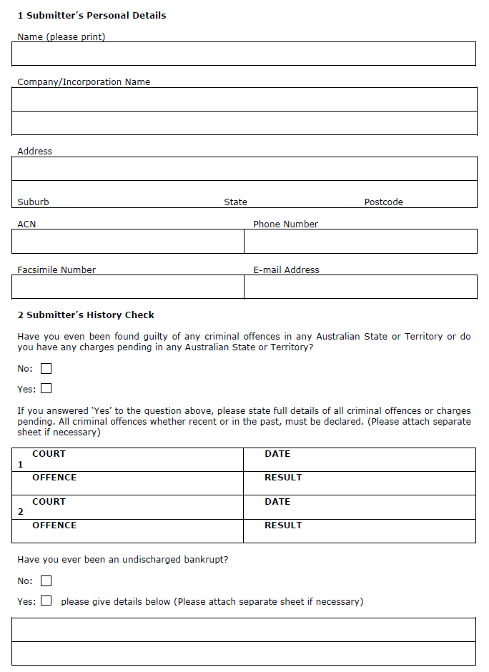

Have you ever been suspended or cancelled under the scheme, or a similar scheme previously operating in any Australian State or Territory?



**You are required to provide a National Criminal History Record Check with this application. Attach the original or a certified copy by Justice of the Peace to this application. The National Criminal History Record Check will be returned to you at the address quoted in Section 1 above, *Submitter’s Personal Details*.**

For more information on how to obtain a National Criminal History Record Check application, please refer to INSTRUCTIONS TO APPLICANTS located at the end of this application.

1. **Declaration by Submitter Applying for Accreditation**

***Please read carefully before you sign. If you do not tell the truth you can be fined***

I have read and understood the Commonwealth Department of Infrastructure and Regional Development Administrators Circular 0-3-9 and if authorised, agree to abide by all the conditions outlined in that document.

*Your personal information is collected and held by the NEVDIS Administration Unit, Level 9, 570 George Street, Sydney, NSW 2000 on behalf of Austroads.*

*I understand that my personal information is being collected for Accreditation to submit Authorised VINs. I must supply the information under the Commonwealth Motor Vehicle Standards Act 1989. Failure to supply full details and sign/confirm this declaration can result in accreditation not proceeding. My personal information held by Austroads may be disclosed within Australia to driver licensing and vehicle registration agencies, law enforcement agencies, and to verify the contents of this application, for the administration of driver licensing and vehicle registration legislation and law enforcement.*

*You have a right to access or correct your personal information in accordance with the provisions of the relevant privacy legislation.*

I declare that the details in this application are true and complete. I understand that if any information is found to be false or misleading, severe penalties may apply.

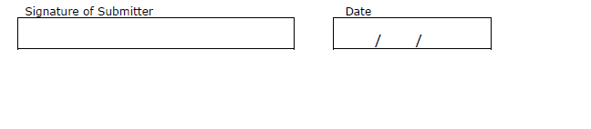 **Witness**

Your personal information is collected and held by the NEVDIS Administration Unit, Level 9, 570 George Street, Sydney, NSW 2000 on behalf of Austroads.

*I certify that the applicant, whose name and signature appears above, has signed in the signature box in my presence.*

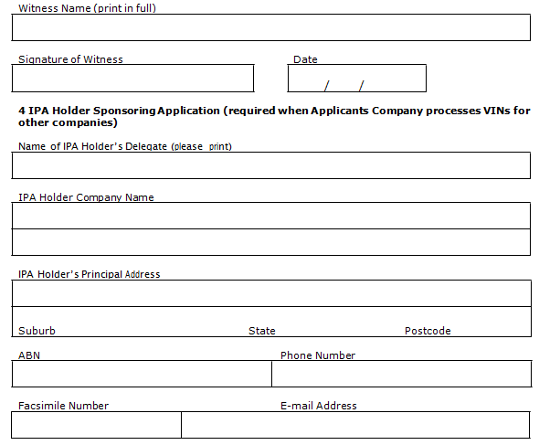

*I understand that my personal information is being collected for verification of the applicant's signature. My witnessing of the applicants' signature is voluntary. Failure to supply full details and sign this declaration can result in the transaction not proceeding. My personal information held by the Austroads may be disclosed within Australia to verify the contents of this application. You have a right to access or correct your personal information in accordance with the provisions of the relevant privacy legislation.*

1. **Declaration by IPA Holder’s Delegate**

I hereby sponsor the person whose name appears in Section 1 to be an Authorised Submitter of VINs.

Your personal information is collected and held by the NEVDIS Administration Unit, Level 9, 570 George Street, Sydney, NSW 2000 on behalf of Austroads.

*I understand that my personal information is being collected to facilitate the approval of my submitter for accreditation to submit authorised VINs. I must supply the information under the Commonwealth Motor Vehicle Standards Act 1989. Failure to supply full details and sign/confirm this declaration can result in accreditation not proceeding. My personal information held by Austroads may be disclosed within Australia to driver licensing and vehicle registration agencies, law enforcement agencies, and to verify the contents of this application, for the administration of driver licensing and vehicle registration legislation and law enforcement.*

*You have a right to access or correct your personal information in accordance with the provisions of the relevant privacy legislation.*

I declare that the details in this application are true and complete.

Form to collect delegate signature and date.

**OFFICE USE ONLY**

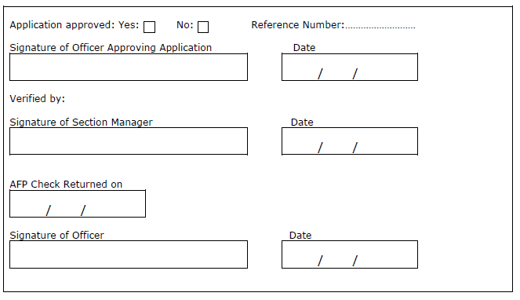

## Instructions to Applicants

1. A National Criminal History Record Check (Standard Disclosure) must support this application. This is available by contacting the Criminal Records Unit of the Police Service in your state:

ACT Police 131 444

[www.police.act.gov.au](http://www.police.act.gov.au/)

NSW Police 131 444

[www.police.nsw.gov.au](http://www.police.nsw.gov.au/)

TAS Police 131 444

[www.police.tas.gov.au](http://www.police.tas.gov.au/)

QLD Police 131 444

[www.police.qld.gov.au](http://www.police.qld.gov.au/)

WA Police 131 444

[www.police.wa.gov.au](http://www.police.wa.gov.au/)

SA Police 131 444

[www.police.sa.gov.au](http://www.police.sa.gov.au/)

NT Police 131 444

[www.pfes.nt.gov.au](http://www.pfes.nt.gov.au)

VIC Police (03) 92476666

[www.police.vic.gov.au](http://www.police.vic.gov.au/)

1. The completed application must be mailed to Manager, NEVDIS Administration Unit, Level 9, 570 George Street, Sydney, NSW 2000
2. The application may take up to 10 working days to process. A letter of Confirmation of Accreditation will be mailed directly to the authorised submitter.

*Please note that if you have any outstanding warrants or are waiting for a case to be heard in a Court, the application may be delayed until the outstanding matter/s has been resolved.*

### Guide to Assessing Eligibility for Accreditation

The Administrator’s designated nominee, currently the Manager, Austroads, NEVDIS Administration Unit, may consider a person suitable if the person:

1. Is of or above the age of eighteen years; and
2. Has not been found guilty of an offence involving theft, deception, fraud or dishonesty, other than a first degree of simple larceny that did not involve a motor vehicle or motor vehicle component; and
3. Has not been found guilty of any indictable offence; and
4. Has not been found guilty of any offence against any Australian Controlled Substances legislation involving a prohibited substance other than a simple possession offence; and
5. Has not been found guilty of any offence involving violence or threat of violence, other than a first offence of common assault; and
6. Has not been suspended or disqualified from practicing or carrying on an occupation, trade, or business under a law of a State or Territory of the Commonwealth; and
7. Is not an undischarged Bankrupt or subject to a composition or deed or scheme of arrangement with or for the benefit of creditors; and
8. Has not, during the period of five years preceding the Application for Accreditation, been a Director of a body corporate wound up for the benefits of creditors –
   1. When the body was being so wound up; or
   2. Within the period of six months preceding the commencement of the winding up; and
9. Has not been found guilty of any offence that would indicate the person is not a suitable person to be accredited to transmit VINs
10. Is not a suitable person for any other reason the Administrator’s designated nominee determines.

If you have been found guilty or found guilty without conviction of any of the above, you may not be entitled to be accredited to transmit VINs.

If the person is aggrieved by a decision of the Administrator’s designated nominee, he/she may within 14 days apply for a review of the decision. An appeal, in writing, of a decision may be lodged with the Administrator’s designated nominee.

Authorised Submitter Conditions

1. **New Application for Authorised Submitter of Vehicle Identification Numbers (VIN)**
   1. Accreditation will not be granted to a person unless the Administrator’s designated nominee is satisfied that the person is “suitable” to be so accredited. In considering the question, the Administrator’s designated nominee may have regard to any relevant fact that comes to the Administrator’s designated nominee’s attention regarding the applicant and, in particular, to any criminal convictions that the person has had for offences involving fraud, dishonesty, or other offences, which may indicate that, a person is not of sufficient probity. All applications will be considered on a case-by-case basis.
   2. An “Authorised Submitters Accreditation” application must be completed for each nominated Authorised VIN Submitter and accompanied by an Australian Federal Police (AFP) Criminal History check. To obtain and AFP check a person can either contact the AFP by phone on (02) 6140 6502 or refer to the AFP website [www.afp.gov.au/what-we-do/police-checks](http://www.afp.gov.au/what-we-do/police-checks.aspx)
   3. On approval of an application, the applicant will be issued with a Letter of Confirmation of Accreditation.
   4. The Administrator’s designated nominee may revoke an accreditation at any time.
2. **Refusal or Revocation of Accreditation**

Before the Administrator’s designated nominee refuses a person’s application for accreditation, or revokes any accreditation on the grounds that a person is not a “suitable” person, the Administrator’s designated nominee will give the person written notice of the proposed refusal or revocation and will provide a statement of the reasons for the proposed refusal or revocation. The person affected will then be given a reasonable opportunity, within 14 days after the issuing of the notice, to submit evidence and make submissions to the Administrator’s designated nominee. If after this period the application is refused or the accreditation is revoked, the Administrator’s designated nominee will notify the person affected, in writing, of that fact.

1. **Advice of Termination of Sponsorship by IPA Holder**

If an Authorised Submitter is no longer employed by or affiliated with a sponsoring IPA Holder, the Authorised Submitter must promptly advise the Administrator’s designated nominee of that fact.

1. **Failure to Comply with Administrator’s Circular 0-3-9 or the Authorised Submitter Conditions**

If an accredited submitter fails to comply with the Administrator’s Circular 0-3- 9 or with conditions contained in this document, the Administrator’s designated nominee may revoke the accreditation.

Definitions**:**

* 1. **0-3-9** – Administrators Circular issued by the Department of Infrastructure and Regional Development relating to the provision of vehicle identification numbers.
  2. **Accreditation** – Allowing official authorisation for the transmission and receiving of VINs data.
  3. **Administrator** – Administrator of Vehicle Standards, Department of Infrastructure and Regional Development.
  4. **Administrator’s Designated Nominee** - Austroads Incorporated, responsible for the National Exchange of Vehicle and Driver Information System (NEVDIS).
  5. **Manufacturer** – A person, firm or corporation under whose responsibility a vehicle has been assembled to form a unit, which is ready for operation.
  6. **IPA Holder** – a person or organisation who holds identification plate approval for any particular vehicle.
  7. **Authorised Submitter** – Person officially accredited to transmit VINs data.
  8. **VIN** – Vehicle Identification Number as required under Australian Design Rule 61/02.

1. Terms in Italics are defined at the end of this document