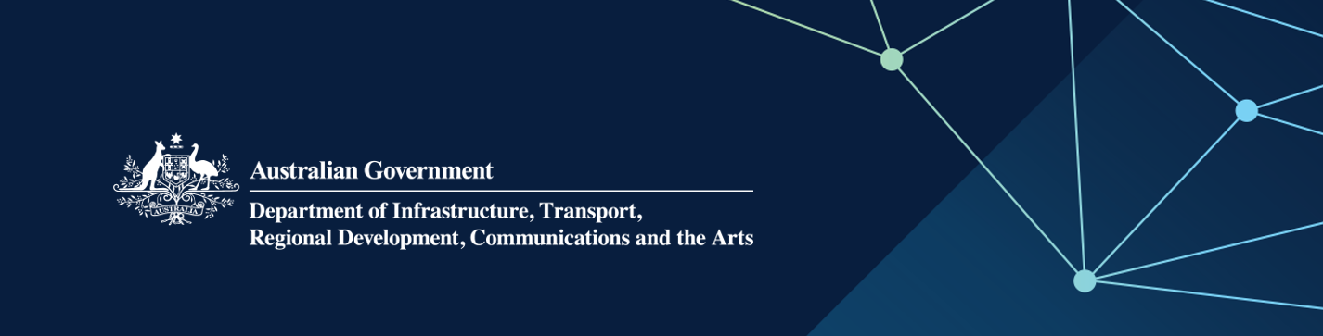

# Child Safety Statement 2022

Commonwealth Child Safe Framework

**October 2022**

The Department of Infrastructure, Transport, Regional Development, Communications and the Arts (the department) is committed to ensuring the safety and wellbeing of children and young people. The department is working to promote a culture where children and young people who may have contact with, or be affected by, the work of the department, are safe, protected and respected. This includes the implementation of the [Commonwealth Child Safe Framework](https://childsafety.pmc.gov.au/what-we-do/commonwealth-child-safe-framework) (the Framework).

As part of its commitment to child safety, the department commissioned an independent audit of our compliance with the Framework, which concluded in June 2022. The audit report found that while the department’s engagement with children is concentrated to specific areas and these areas have developed and implemented child safe practices, there remains work to be done to fully implement the Framework across the whole department.

## Our interaction with children

In accordance with Requirement 1 of the Framework, which specifies that Commonwealth entities must undertake annual risk assessments of their activities in relation to children, the department has put in place arrangements for an annual assessment of child-related activities and associated risks.

The 2022 assessment identified all departmental positions involving contact with children, the level of involvement each position has with children, and evaluated the risks to child safety posed by the department’s business activities.

The department’s operations for 2022 involve children and young people in limited settings with varying degrees of interaction:

* Community liaison and engagement programs across Australia, including in environments such as schools, and public events to engage with the community on major infrastructure projects.
* The administration of the Cocos (Keeling) Islands and Christmas Island (through the Indian Ocean Territories Administration), including the provision of health and education services. This includes roles such as nurses and education assistants, who have direct contact with children, in some cases without a guardian present. Education services are delivered in partnership with the Western Australian Government.
* The department also employs an exhibition attendant for the Tai Jin House museum in the Christmas Island National Park, whose role includes contact with child patrons of the museum.

Throughout the course of these activities we acknowledge there is a risk that harm to children and young people may occur, however the department has longstanding arrangements in place to mitigate risks in these specific areas. These include a Child Safety and Working with Children policy, Complaints Handling policy, and screening requirements for relevant staff.

## Risk Rating and Compliance with the Commonwealth Child Safe Framework

Similar to the findings of the independent audit, the risk assessment also identified areas in our child-safety infrastructure that can be strengthened. Areas of the department that have frequent interaction with children have processes in place, however, there are gaps in department-wide policy and process, as well as general staff awareness of their responsibilities in relation to child safety. These pose a moderate risk that is not accepted by the department and does not demonstrate full compliance with Requirements 2 and 3 of the Framework. The department is compliant with Requirements 1 and 4 of the Framework.

As such, the overarching risk rating for 2022 is found to be **moderate**.

## Child safety initiatives and measures

Work has already commenced to implement the recommendations from the independent audit and the risk assessment. Responsibility for the audit recommendations has been assigned to an Assistant Secretary, with a team focused on delivering a program of work to improve child safety arrangements.

Separate to this, grant and procurement guidance documents have also been reviewed and updated to include a focus on child safety and the Framework requirements in relation to funded third parties.

A project plan to implement the audit recommendations, and in turn strengthen our compliance with the Framework, outlines the following key bodies of work to be undertaken over the next 12 months:

* review of the department’s relevant policies and child safety guidance, including visibility of guidance to all staff
* investigation and implementation of appropriate child safety training, particularly for staff who either work directly with children and young people, or may have contact with them
* review of current recruitment processes and assessment of role requirements
* review of existing grants and procurement arrangements in relation to child safety clauses
* review of materials available to the public for accessibility to children and families

## Further information

For any questions relating to the department’s implementation and ongoing compliance with the Framework, please contact [integrity@infrastructure.gov.au](mailto:integrity@infrastructure.gov.au).

For information on how you can report your concerns or speak to a department staff member please visit our [Contact us](https://www.infrastructure.gov.au/contact-us#feedback) page.