

Stage 2 Reforms of the Disability Standards for Accessible Public Transport 2002

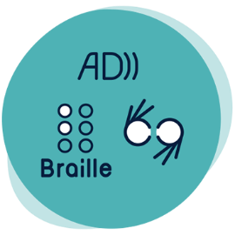

Signs, symbols, braille: Braille specifications

Currently, there is a lack of clarity on the standard of braille required for use in the provision of public transport information. This presents challenges to people with vision impairment who rely on braille to access key journey information. There is an opportunity to clearly specify the requirement for use of braille, raised lettering or symbols.

## Reform options

### Maintain current requirements in the Transport Standards

Transport Standards Section 17.6 *Raised lettering or symbols or use of braille*, would remain unchanged and no new additional requirements or guidance would be issued.

### Non-regulatory option

Guidance would be provided in the Transport Standards Guidelines and / or The Whole Journey Guide on good practice for the provision of information in braille formats.

Specific guidance may include:

* Expected standard of braille, including pre-prepared pamphlets and publications that should be available on demand
* Accessibly formatted electronic documents should be ready to distribute to enable at home printing

### Regulatory option

Transport Standards Section 17.6 would be amended to include the following (including any requirements retained or amended from the status quo):

* If information is presented to passengers in braille format, the braille must be Grade 1 Braille (uncontracted), in accordance with the criteria set out in The Rules of Unified English Braille by the Australian Braille Authority.
* If material is specifically requested in a grade of braille other than Grade 1 Braille (uncontracted) it must be supplied in the passenger's preferred grade in a timely manner.

These requirements would apply to conveyances, premises and infrastructure.

The Transport Standards Guidelines and / or The Whole Journey Guide may be updated to reflect new requirements for conveyances, premises and infrastructure.

## Have your say

Public consultation on the Stage 2 reform of the Transport Standards will open from 15 March to 9 August 2022.

For further information:

* **Website:** [https://www.infrastructure.gov.au](https://www.infrastructure.gov.au/infrastructure-transport-vehicles/transport-accessibility)
* **Call:** 1800 621 372
* **Email:** DisabilityTransport@infrastructure.gov.au
* **Survey:** <https://edm.infrastructure.gov.au/survey.php?sid=28665&name=braille-specifications>