

Stage 2 Reforms of the Disability Standards for Accessible Public Transport 2002

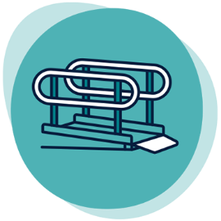

Accessible boarding points: Boarding ramp and removable gangway definitions

Vehicle boarding ramps are operated in a static onshore environment and removable gangways for vessels are operated in a dynamic marine environment, however they do not have distinct accessibility requirements in the Transport Standards. This is a risk for people with disability, as removable gangways may not be built fit for purpose. There is an opportunity to clearly differentiate between vehicle boarding ramps and removable gangways to reflect the distinction between these operating environments.

## Reform options

### Maintain current requirements in the Transport Standards

The Transport Standards would remain unchanged and no guidance material would be issued.

### Non-regulatory option

Guidance would be provided to include advice on the distinction between removable gangways and vehicle boarding ramps.

### Regulatory option

The Transport Standards would include new definitions for boarding ramps and removable gangways.

* Boarding ramps
  + Boarding ramps are deployable ramps of flat profile along the length of the access path that bridge the gap between static boarding points and vehicle entrances.
* Removable gangway
  + A gangway may be removable. Removable gangways are deployable ramps of convex profile along the length of the access path equipped with handrails that bridge the gap between pontoon boarding point and ferry decks. Removable gangways require a convex profile to maintain contact with both the vessel deck and pontoon while both may be in motion.

The Transport Standards Guidelines and / or The Whole Journey Guide would be updated to reflect new requirements.

## Have your say

Public consultation on the Stage 2 reform of the Transport Standards will open from 15 March to 9 August 2022.

For further information:

* **Website:** [https://www.infrastructure.gov.au](https://www.infrastructure.gov.au/infrastructure-transport-vehicles/transport-accessibility/people-with-disability-connected-automated-vehicles)
* **Call:** 1800 621 372
* **Email:** [DisabilityTransport@infrastructure.gov.au](mailto:DisabilityTransport@infrastructure.gov.au)
* **Survey:** <https://edm.infrastructure.gov.au/survey.php?sid=28662&name=boarding-ramp-and-removable-gangway-definitions>