Australian Government. Department of Infrastructure, Transport, Regional Development and Communications.

Bureau of Communications, Arts and Regional Research.



# Telecommunications Services and productivity

**March 2023**

Broadband has transformed the communications landscape and is generally thought to support positive productivity outcomes. To understand broadband’s relationship with productivity, it is useful to examine industries where supply and use of telecommunications is concentrated.

The Information, Media and Telecommunications (IMT) industry division, and in particular the Telecommunications Services subdivision,[1] provide a useful starting point to examine the relationship between the use of broadband and productivity outcomes. While not all businesses in IMT engage solely in telecommunications-related activity, this is where key telecommunications-related activities are captured, including wired, wireless and mobile telecommunications network operation.[2]

The Bureau of Communications, Arts and Regional Research (BCARR) has examined Multifactor Productivity (MFP) outcomes in the IMT industry division and Telecommunications Services subdivision to assess growth outcomes, with particular interest in the decade to 2019–20.

Multifactor productivity

Multifactor productivity (MFP) is output per unit of combined inputs, which generally include labour and capital – it is the residual element of GDP growth that is not explained by growth in capital or labour input. It is a useful measure of growth rates in particular – comparing changes in economic time series relative to a base period.[3]

## Performance overview

The productivity performance of IMT has been mixed since the start of the century. Growth was more subdued than the market sector more broadly up until around 2007–08. Since then, IMT has grown more strongly and has outperformed the market sector. This has been particularly noticeable since 2013, with IMT’s MFP growing around 3 times faster than the market average.

For the Telecommunications Services subdivision, BCARR has estimated MFP by assuming that movements in capital services at the IMT divisional level are a reasonable proxy for the subdivision level, given Telecommunications Services was by far the biggest contributor to capital services in IMT.[4]

The results show MFP increased noticeably from around 2013, growing four times faster than the market sector overall. Telecommunications Services drove the relatively strong IMT performance during this period; no other IMT subdivisions grew as strongly.

Figure : Multifactor Productivity Growth – comparison across sectors

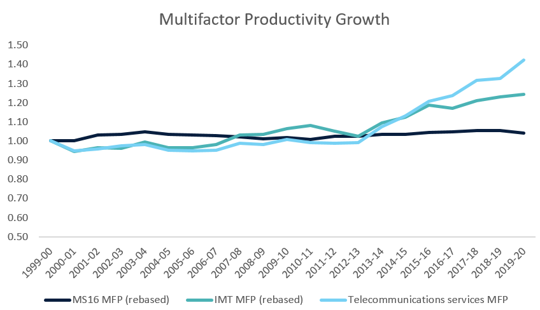

Index 1999–2000 = 1

Source: ABS, BCARR analysis

MS16 = 16 market sector industries as defined by the ABS

## Drivers of growth

While specific drivers of MFP growth from 2013 for the sectors remain unclear, it is likely that communications infrastructure and services played a role – particularly the growing use of the internet on business practices and the telecommunications networks that underpin internet access.

Using growth accounting techniques, we can look at the key components of growth more broadly to gain insights into the potential drivers. Figure 2 shows growth for component parts of IMT and Telecommunications Services, in comparison to the same components for the market sector more broadly.

Figure 2: Performance of IMT, Telecommunications Services and the market sector, 2010 - 2020

Figure 2: Performance of IMT, Telecommunications Services and the market sector, 2010 - 2020. 

Figure 2 compares the relative growth for the component parts of each of the IMT division, and the Telecommunications Services subdivision, relative to the market sector more broadly. The component parts are GVA growth - which has seen significantly higher growth than IMT or the market sector at 6 per cent - hours worked growth, capital services growth and MFP growth. Telecommunications Services in particular has performed more strongly than the market sector on all measures except hours worked growth, where the market sector more broadly is stronger. 

The results indicate above-average productivity growth over the past decade for IMT and Telecommunications Services was driven by strong value-added growth and average capital services growth.

Over the decade to 2019–20, at 4 per cent growth for the IMT division, value-added growth has been significantly stronger than the 2.3 per cent growth experienced across the broader market sector. BCARR has calculated that value-added growth for the Telecommunications Services subdivision was almost 6 per cent over this period,[5] and is likely to be a key driver of MFP growth in IMT.

## GDP impact

The results for individual MFP indicators show that firms operating in industries where telecommunications-related activity is significant have made a positive contribution to the economy more broadly over the previous decade. BCARR estimates that from 2009–10 to 2019–20, total MFP growth for the period was 3.3 percentage points, with IMT contributing around 0.6 percentage points, or 18 per cent of MFP growth over that time – about 2.2 per cent of GDP.

Over the same period, Telecommunications Services contributed an estimated 0.5 percentage points of economy-wide MFP growth, or around 14.7 per cent of total MFP growth. This is a strong contribution from a relatively small sector of the economy and these results should be considered indicative.[6]

A number of assumptions underpin these estimates. For example, the share of investment in Telecommunications Services as a proportion of IMT is assumed to remain fairly constant over the period analysed, while the capital income share is also assumed to remain relatively constant (e.g. most capital in the IMT division is in Telecommunications Services).

## Conclusion

Growth accounting techniques can elicit insights into linkages between broadband and productivity, including examining the performance of Telecommunications Services as the source of relevant goods and services.

Over the decade to 2019–20, the productivity performance of this subdivision has been stronger than other sectors and the broader economy. It indicates that, at least for industries where the production and supply of telecommunications including broadband is a key activity, productivity outcomes have been strong and positive

1. ## References and notes

   The ABS group activity into industry divisions, which in turn comprise multiple subdivisions, for the purposes of measuring economic activity in the national accounts and elsewhere.
2. Australian Bureau of Statistics (2013), Australian and New Zealand Standard Industrial Classification (ANZSIC), 580 Telecommunications Services, available online at [Group 580 Telecommunications Services | Australian Bureau of Statistics (abs.gov.au)](https://www.abs.gov.au/statistics/classifications/australian-and-new-zealand-standard-industrial-classification-anzsic/2006-revision-2-0/detailed-classification/j/58/580), last accessed 13 December 2022.
3. For a more detailed explainer see Reserve Bank of Australia, Productivity Explainer, available online at [Productivity (rba.gov.au)](https://www.rba.gov.au/education/resources/explainers/pdf/productivity.pdf?v=2&v-nocache=2022-12-13-10-37-31), last accessed 13 December 2022.
4. Australian Bureau of Statistics (2015), *8681.0 - Information Media and Telecommunications Services, Australia, 2013-14*, accessed 24 May 2022, available [www.abs.gov.au/ausstats/abs@.nsf/mf/8681.0](http://www.abs.gov.au/ausstats/abs@.nsf/mf/8681.0). The ABS reported in 2015 that ‘Of the $14.3 billion invested in total capital expenditure by the IMT industry in 2013-14, almost 85 per cent of this is attributed to the Telecommunications services subdivision.
5. The ABS does not disaggregate value added data to the Telecommunications Services subdivision level. BCARR calculated value added growth for the Telecommunication subdivision using chain volume measure data.
6. An industry’s contribution to productivity growth need not be positive. It is possible for a subdivision to make a contribution larger than the whole division of which it is a part, for a period where the rest of the division has made a negative contribution.