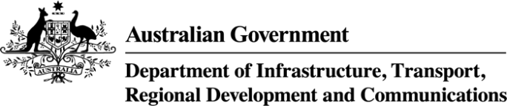

**Australia’s Broadband Performance**

**Update 2021**

|  |  |  |
| --- | --- | --- |
| Cartoon image of a house | **2nd**  Australia ranks | **100+ Mbps** |
| Australia is one of only five comparable countries where at least **99.9%** of households can access fixed broadband services. | **98.5%** of Australian premises have access to broadband speeds of at least **25 Mbps**, ranking Australia **2nd** out of 15 comparable countries. | Almost **75%** of Australian premises can access **100 Mbps** and above services. |

|  |  |
| --- | --- |
| The proportion of households with a fixed broadband connection increased to **90.2%**  (up from 88% as reported in the [2020 update](https://www.infrastructure.gov.au/department/media/publications/measuring-australias-fixed-broadband-performance-compendium))  ranking Australia **8th** out of 17 comparable countries. | Arrow showing an increase over time |

Broadband refers to broadband services at a fixed location, and includes satellite, fixed wireless and fixed-line broadband services.   
The summary findings above are intended to accompany the *Australia’s Broadband Performance Dashboard – Update 2021*   
released in March 2022 by the Bureau of Communications, Arts and Regional Research,   
within the Department of Infrastructure, Transport, Regional Development and Communications.

|  |  |  |
| --- | --- | --- |
| Cartoon map of Australia | Outline of download symbol with an arrow pointing down into a tray | Cartoon outline of a wi-fi router |
| Australia performs strongly against international peers for data consumption, with average yearly growth of more than **34%** between 2017 and 2019. | Between 2019 and 2021, Australia’s total data consumption has  nearly doubled to  **111.7 gigabytes**  per month per capita. | Around **75%** of NBN subscriptions are for speeds **50 Mbps** and above. |