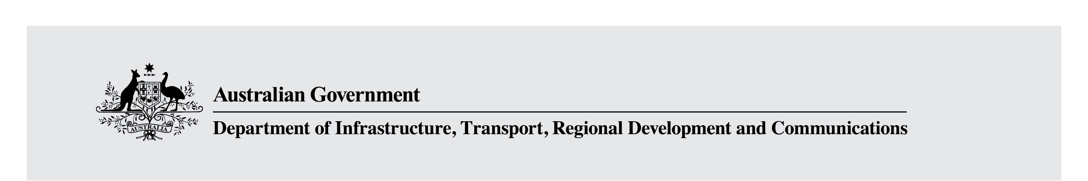

Australia’s new Online Safety Act
December 2020

Introduction
The internet has brought great social, educational and economic benefits. But just as a small proportion of human interactions go wrong offline, so too are there risks online. By establishing proper protections to help keep Australians safe online, we can in turn help Australians to realise the substantial benefits that come from using the internet.
Over the past two decades, Australia has been at the forefront of online safety policy and regulation. We have had laws to deal with harmful online content since 1999 and the establishment of an eSafety Commissioner in 2015 was a world first. Australia’s main legislative structures – the online content scheme contained in Schedules 5 and 7 of the Broadcasting Services Act 1992 and the Enhancing Online Safety Act 2015 – have served us well.
However, the rapid pace of technological change and the emergence of new platforms and services -including messaging apps, interactive games and live-streaming services – have given rise to new ways for users to interact online and created new risks.
That is why the Morrison Government committed to the development of a new Online Safety Act (the Act) to enhance the powers of the eSafety Commissioner, boost protections for Australians, and increase the responsibility on industry to keep their users safe online.
The Minister for Communications, Cyber Safety and the Arts, the Hon Paul Fletcher MP, consulted on a proposal for legislative reform from December 2019 until earlier this year. The Government has now released an exposure draft of the Online Safety Bill for public comment. Online safety is an important community issue and complex policy space so we want to hear from individuals, non-government organisations and industry on the draft legislation.

Key changes
The Online Safety Bill includes the following reforms:

Better protections for all Australians
All Australians should be able to engage online confidently, to work, communicate and be entertained, without fear of abuse or being subject to harmful content.
This is why the Government will create a world first cyber-abuse take down scheme for Australian adults. The scheme will empower the eSafety Commissioner to order the removal of seriously harmful online abuse – that meets thresholds consistent with those set out in the Criminal Code Act 1995 – when websites, social media and other online services do not remove it after a complaint is made.
An expanded cyber-bullying scheme for children will enable removal of material from the full range of online services where children are now spending time - such as games, websites, messaging and hosting services - and not just social media platforms.
Online service providers will be required to take action in a reduced time frame when they receive a notice from the eSafety Commissioner. Take down notices for image-based abuse, cyber-abuse, cyber-bullying, and seriously harmful online content will need to be actioned within 24 hours, rather than the current 48 hours.
If a website or app systemically ignores take down notices for class 1 material under the online content scheme such as child sexual abuse material the eSafety Commissioner can require search engines and app stores to remove access to that service.
These protections will be backed by civil penalties for service providers who fail to comply.
The eSafety Commissioner will also have a new rapid website blocking power to be used to block websites hosting abhorrent violent or terrorist material during an online crisis event.

Setting expectations for industry
Like other sectors, industry must make sure that Australians can use their digital products and services safely, which is why a set of Basic Online Safety Expectations will be set in law.
The Act will establish mandatory reporting requirements that will allow the eSafety Commissioner to require online services to provide specific information about online harms, such as their response to terrorism and abhorrent violent material, or volumetric attacks, where ‘digital lynch mobs’ seek to overwhelm a victim with abuse. Services will have to report on how they will uphold these expectations and they can be penalised if they fail to report.
The Government will also update Australia’s Online Content Scheme to better reflect the modern digital environment. This will mean that sections of the technology industry will need to create new and strengthened industry codes that meets the Government’s expectations to keep users safe.
Industry will be given six months to establish the new codes, with the eSafety Commissioner also having the power to create industry standards within 12 months.

Why is this needed?
It is the primary responsibility of the digital technology industry to create products and services that Australians can use safely. However, experience has shown that many platforms lack the built in safety features required, or fail to appropriately enforce their terms of service.
That is why the Government established the eSafety Commissioner in 2015 to act as a safety net for when platforms fail to keep their users safe.
The Government intends Australia to remain a world leader in online safety regulation. Reforming our existing online safety legislation will address new and emerging online harms and require the digital industry step up the ambition and pace of their online safety efforts.

How can I find out more?
The Government has released the draft Online Safety Bill so that interested individuals and organisations can all have their say.
The consultation will remain open until 5pm (AEDT) Sunday 14 February 2021. More information, including how to participate, is available at communications.gov.au/online-safety.

