OFFICIAL

Australian Government
Department of Infrastructure, Transport, Regional Development, Communications, Sport and the Arts

BUREAU OF COMMUNICATIONS, ARTS AND REGIONAL RESEARCH

Australian youth online

Findings from the Longitudinal Study of Australian Children (LSAC)

August 2025

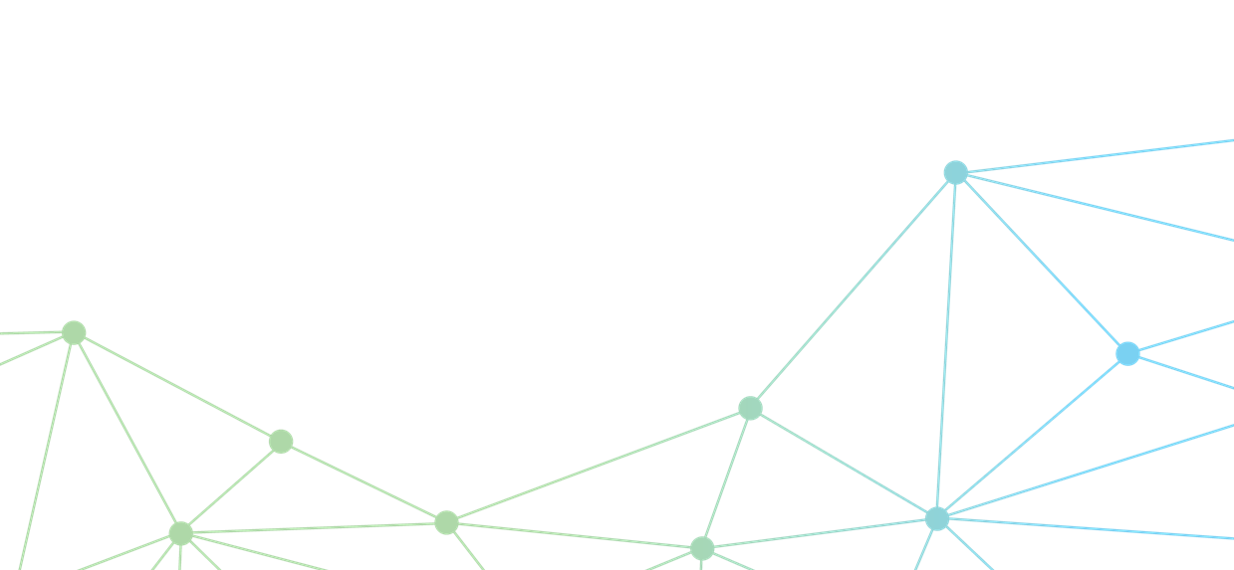

The Department of Infrastructure, Transport, Regional Development, Communications, Sport and the Arts acknowledges the Traditional Custodians of Country throughout Australia and their continuing connection to land, sea and community. We pay our respects to them, their cultures and to their Elders, past, present and emerging.

© Commonwealth of Australia 2025

ISBN: 978-1-922879-91-2

Bureaux reference: 2025-093

**Ownership of intellectual property rights in this publication**

Unless otherwise noted, copyright (and any other intellectual property rights, if any) in this publication is owned by the Commonwealth of Australia (referred to below as the Commonwealth).

**Disclaimer**

https://www.infrastructure.gov.au/disclaimer

The material contained in this publication is made available on the understanding that the Commonwealth is not providing professional advice, and that users exercise their own skill and care with respect to its use, and seek independent advice if necessary.

The Commonwealth makes no representations or warranties as to the contents or accuracy of the information contained in this publication. To the extent permitted by law, the Commonwealth disclaims liability to any person or organisation in respect of anything done, or omitted to be done, in reliance upon information contained in this publication.

**Creative Commons licence**



With the exception of (a) the Coat of Arms; (b) the Department of Infrastructure, Transport, Regional Development, Communications, Sport and the Arts photos and graphics; (c) content supplied by third parties; (d) content otherwise labelled; copyright in this publication is licensed under a Creative Commons BY Attribution 4.0 International Licence.

**Use of the Coat of Arms**

The Department of the Prime Minister and Cabinet sets the terms under which the Coat of Arms is used. Please refer to the Commonwealth Coat of Arms - Information and Guidelines publication available at [http://www.pmc.gov.au](http://www.pmc.gov.au/).

**Contact us**

This publication is available in Word format and PDF format. All other rights are reserved, including in relation to any departmental logos or trademarks which may exist. For enquiries regarding the licence and any use of this publication, please contact:

Director – Bureau of Communications, Arts and Regional Research

Email: [BCARR@infrastructure.gov.au](mailto:BCARR@infrastructure.gov.au)

Website: <https://www.infrastructure.gov.au/research-data/bureau-communications-arts-and-regional-research>

## Introduction

Access to digital technology has improved markedly over the last decade. However, research consistently identifies some groups of Australians experiencing disproportionally high rates of digital exclusion. These groups include older Australians, low income households, and Aboriginal and/or Torres Strait Islander peoples (BCARR, forthcoming).

This analysis uses data from the Longitudinal Study of Australian Children (LSAC) to understand the digital landscape for young people in Australia. This research considers children and young people’s access to digital technologies by different socio-economic groups, and their online safety experiences.

LSAC is a nationally-representative longitudinal survey of Australian youth which commenced in 2004 and has collected information from two cohorts of young people and their families every 1 to 2 years up until 2023 (Table 1).[1]

**Table 1: Sample sizes and age by wave and cohort**

|  |  |  |  |  |  |  |
| --- | --- | --- | --- | --- | --- | --- |
| Wave | Year | B- cohort |  | K- Cohort |  | Total |
|  |  | Sample | Age | Sample | Age |  |
| 1 | 2004 | 5,107 | 0-1 | 4,983 | 4-5 | 10,090 |
| 2 | 2006 | 4,606 | 2-3 | 4,464 | 6-7 | 9,070 |
| 3 | 2008 | 4,386 | 4-5 | 4,331 | 8-9 | 8,717 |
| 4 | 2010 | 4,242 | 6-7 | 4,169 | 10-11 | 8,411 |
| 5 | 2012 | 4,085 | 8-9 | 3,956 | 12-13 | 8,041 |
| 6 | 2014 | 3,764 | 10-11 | 3,537 | 14-15 | 7,301 |
| 7 | 2016 | 3,381 | 12-13 | 3,089 | 16-17 | 6,470 |
| 8 | 2018 | 3,127 | 14-15 | 3,037 | 18-19 | 6,164 |
| 9C1 | 2020 | 2,017 | 16-17 | 1,789 | 20-21 | 3,806 |
| 9C2 | 2021 | 2,688 | 17-18 | 2,463 | 21-22 | 5,151 |
| Total |  | 47,256 |  | 45,661 |  | 92,917 |

Source: Longitudinal Study of Australian Children User Guide.

**Important note:**

The children age throughout the survey. We refer to them as ‘children’ while they are under 18 years of age. The terms ‘youth’ or ‘young people’ are used when at least one of the cohorts being analysed has respondents aged 18 years or older.

Our analysis of children’s access to the internet, computers and mobile phones uses data from 2004 to 2018. Our analysis of online safety uses data from 2018 to 2021.

Understanding the social, economic and cultural factors that impact young people’s online experiences can inform decision-making on digital policies for the current generation of Australian children.

Why is this analysis important?

* Limited information is available on access to digital technology in Australia, and even less information is available for children and young people.
* Despite LSAC’s lack of recent questions on digital technology use, this survey offers unique insights about the experiences of technology use during a formative life stage for a group of young Australians. It can provide insights for future generations of children growing up in a connected world.
* LSAC also includes more recent information on young people’s online safety experiences – which is a key area of policy development.
* This analysis can also accompany previous BCARR research analysing the ‘*Use of digital technologies among first nations children’* which uses the Longitudinal survey of Indigenous Children (LSIC).

**A note on representativeness:**

LSAC samples only some remote areas and cannot provide representative insights for families living in these areas. Refer to Appendix A for further details.

LSAC does not represent young people of all ages at each time period. It represents two youth cohorts – ‘Baby’ (B: born March 2003–February 2004) and ‘Kinder’ (K: born March 1999–February 2000) – and tracks these cohorts over time as they grow older.

## Access to digital technologies

***Survey questions asked:***

***Do you have access to the internet[2] at home?*** ***Does child have the capacity in their bedroom to access*** ***the internet?*** Asked to primary caregivers of children from cohorts B and K in 2012 and 2014, and cohort B only in 2016.

***Does child have access to a mobile phone?*** Asked to primary caregivers of children from cohorts B and K in 2012 and 2014, and cohort B only in 2016 and 2018.

***What kind of plan is child's mobile phone on?*** Asked to primary caregivers of children from cohorts B and K in 2012 and 2014, and cohort B only in 2016.

***Does study child have access to a computer[3] at home?*** Asked to primary caregivers of children from cohort K in 2004 and 2006, and cohort B and K in 2008 and 2010.

Australian children are increasingly online. In 2014, over 97% of Australian children had access to the internet at home, and 78% had access to the internet in their bedrooms. This was up from 96% and 47%, respectively, when the children were two years younger in 2012 (Figure 1).[4]

In 2014, 59% of Australian children had access to a mobile phone, up from 46% in 2012 (Figure 1).[5] The ageing of children partially explains why access to mobile phones has increased over time, however even after controlling for age, mobile phone access was more common for children in later years of the survey (in 2014, 89% of children aged 14–15 years had access to a mobile phone, compared to 93% in 2018). This could also be due to mobile phones becoming more accessible or affordable over time, as well as social pressures which influence the age at which children start using mobile devices.

Figure : Children’s access to digital technologies, 2014

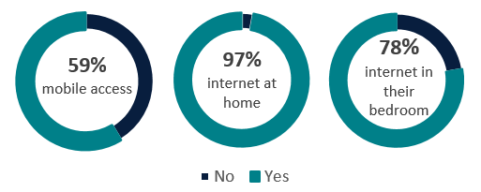

Source: LSAC Release 9.1 C2, BCARR analysis.

Prepaid mobile phone plans were more common among children than postpaid plans in 2014 (62% on prepaid and 38% on postpaid), however their popularity decreased as children got older (in 2012, 73% were on prepaid plans). Comparatively, only 29% of all mobile bill-payers had a prepaid service in 2014 (ACMA, 2014). Prepaid plans may be more attractive to teenage children compared to postpaid plans due to the lack of credit checks, contracts or longer-term commitment of funds, or the flexibility and pricing of these plans.

Prepaid plans were also more common among groups identified in previous studies to be less digitally connected (BCARR, forthcoming). Children in regional areas had higher rates of prepaid plans (75%) than children in major cities (61%), and prepaid plans were far more common for Aboriginal and/or Torres Strait Islander children (84%) than non-Aboriginal and/or Torres Strait Islander children (64%). This is also true for adults. In the First Nations Digital Inclusion Plan 2023–26 (2024), the National Indigenous Australians Agency (NIAA) notes:

‘First Nations people demonstrate a strong preference for pre-paid packages … [even though] … data costs associated with some pre-paid mobile packages tend to be more expensive than post-paid or home internet plans.’

Prepaid plans offer convenience but are generally more expensive than postpaid plans over the longer term. Consumer advocacy group ACCAN (2016) notes that this higher per unit cost of connectivity further entrenches:

‘… the economic and social exclusion experienced by many low-income Australians, specifically those experiencing homelessness and financial hardship.’

In response to this, Telstra (2024), the largest mobile network operator in Australia has introduced a higher-value entry level prepaid plan specifically for customers who live in remote communities.

## Some groups lack digital access

Socio-economic background influences digital connectivity (BCARR, 2024; BCARR, forthcoming). In this analysis, we examine how digital access differs for Australian children by socio-economic background. We use logistic regression modelling on LSAC data (pooled together across all years) to examine the impacts of different groups, while holding other demographic characteristics constant (refer to Appendix B for further details).

### Children in remote areas

**Note:** LSAC’s sample of children in remote areas is small and not representative.

Australians in remote or rural areas typically have lower digital connectivity than those in metropolitan areas (BCARR, forthcoming; ADII, 2023), and the same is true for children living in these areas.

Compared to children in major cities:

* children in regional areas were 74% less likely to have internet access at home, and 22% less likely to have access to a computer at home
* children in remote areas were 173%, or 1.73 times less likely to have internet access at home, and 85% less likely to have computer access (Figure 2).

Figure : Change in the likelihood of having internet or computer access for children by remoteness area

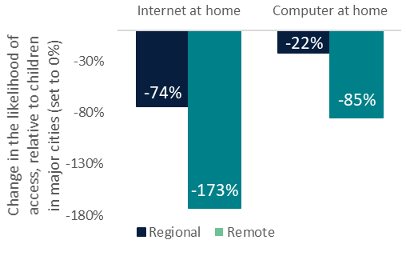

Source: LSAC Release 9.1 C2, BCARR analysis.

Notes: Years analysed are 2012–16 for internet access, and 2004–10 for computer access.

The gap in access to digital technology between children in major cities and children in remote areas has narrowed slightly over time.[6]

A combination of factors including limited internet availability, digital ability and affordability could lead to lower connectivity in remote areas (ADII, 2023).

Aboriginal and/or Torres Strait Islander children

**Notes:** LSAC’s sample of remote Aboriginal and/or Torres Strait Islander children is not representative of the population. Refer to Appendix C – for further details.

While every effort has been made to interpret the data within First Nations contexts, there may be instances in which a greater understanding of First Nations cultures might aid this interpretation.

Aboriginal and/or Torres Strait Islander children have lower rates of access to the internet and computers at home than non-Aboriginal and/or Torres Strait Islander children.

Compared to non-Aboriginal and/or Torres Strait Islander children, Aboriginal and/or Torres Strait Islander children were approximately:

* 200%, or 2 times less likely to have internet access at home, and
* 150%, or 1.5 times less likely to have access to a computer at home (Figure 3).

Figure 3: Change in the likelihood of access to the internet or a computer at home for children by Aboriginal and/or Torres Strait Islander status

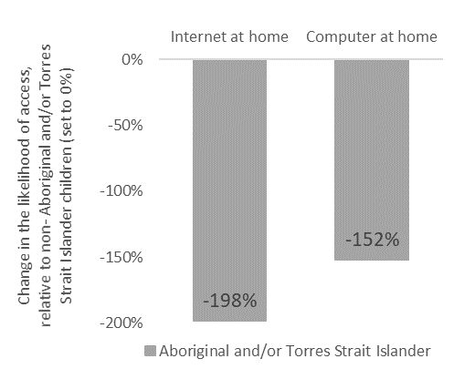

Source: LSAC Release 9.1 C2, BCARR analysis.

Notes: Years analysed 2012–16 for internet access, and 2004–10 for computer access.

The NIAA (2024) notes that, amongst factors such as housing mobility and internet availability, the limited availability of prepaid home internet data packages:

‘… mean that many First Nations people are not signing up to home internet plans, despite plans being more price efficient over the long term.’

The socio‑economic characteristics of Aboriginal and/or Torres Strait Islander children also influence their access to digital technologies. In a related BCARR study (BCARR, 2024) which uses data from the Longitudinal Survey of Indigenous Children (LSIC),[7] Aboriginal and/or Torres Strait Islander children were found more likely to access digital technologies if they lived in a metropolitan area, if their primary caregiver was employed, partnered, on a higher income or had higher educational attainment.

### Single parent households

Compared with other family types, single parent families[8] are considered to be at a higher risk of disadvantage, with respect to income, housing, employment and social participation (PHIDU, 2021). Children with single parents, as opposed to partnered parents, also face higher rates of digital exclusion. Children in single parent households were 219% or more than two times less likely to have access to the internet at home, and 149% or 1.49 times less likely to have access to a computer at home.

Other groups that lack digital access

Our analysis indicates households on low income or in areas of low socio-economic advantage also face lower digital access. The gap in digital access between low- and high-income households, and areas of low- and high- socio-economic advantage, are narrower than for the other groups previously discussed. See Appendix B – for more information.

## Mobile phones narrow the connectivity gap

Interestingly, mobile access is higher for children from a small number of digitally disadvantaged groups. When controlling for other demographic factors, mobile phone access was 35% higher for Aboriginal and/or Torres Strait Islander children than non-Aboriginal and/or Torres Strait Islander children, and 53% higher for children living with a single parent, when compared to a child living in a non-single parent household (Figure 4).[9], [10]

Figure : Increased likelihood of mobile access Aboriginal and/or Torres Strait Islander children and single parent households

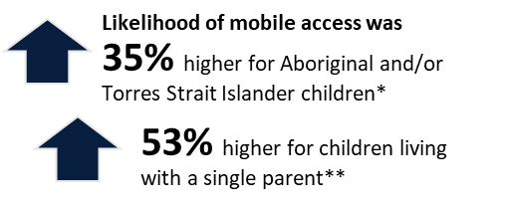

Source: LSAC Release 9.1 C2, BCARR analysis.

Notes: * Compared to non-Aboriginal and/or Torres Strait Islander children, ** Compared to a child living with two parents. Years analysed are 2012–18.

Mobile phones appear to provide a gateway to connectivity for children that are otherwise digitally disconnected. Over 43% of children who did not have internet access at home had access to a mobile phone.[11]3km

When analysing only households without internet, mobiles supported digital connectivity for half of the children in lone parent households, and one-third of Aboriginal and/or Torres Strait Islander children.

Importantly, mobile phone connectivity by itself is not sufficient to participate fully in the digital economy. Phones enable only a limited number of applications, particularly during the early years of this analysis (2012–14) where smartphones were only recently available. Mobile coverage was also more limited, particularly in some remote areas, and earlier mobile generations (2G) were still in operation and did not support the wider array of mobile applications that 4G and 5G do today.

The wider availability of prepaid plans for mobile, as opposed to largely post-paid home internet plans; or the lower upfront device costs for a mobile compared to a laptop or computer, could reduce the barriers to accessing mobile connectivity for those experiencing affordability pressures. It should be noted, however, that a slightly higher share of Aboriginal and/or Torres Strait Islander children had access to a mobile through someone else (i.e., they did not own the device themselves), and a slightly higher share of non-Aboriginal and/or Torres Strait Islander children had access to a mobile phone via their own device. Drawing on anecdotal information from Featherstone *et al.* (2024), this may be indicative of mobile-only households where one device is shared between residents.

Children with disability are one group that experience disproportionately lower mobile phone access. Compared to a child without disability, a child with disability or a medical condition lasting more than 6 months was 48% less likely to have access to a mobile phone.

## Young people’s experiences online

***Survey questions asked:***

***Have you ever done any of the following online? (e.g. un-tagged self from post, deleted posts about self, or deleted own social networking accounts)*** asked to children of cohort K in 2018.

***How often do you share/post on social media?*** Asked to children of cohorts B & K in 2020 and 2021.

***How about your relationship with social media and what you do on it?******(e.g. I use social media to forget my personal problems, I have tried to stop using social media without succeeding)***is asked to children and young people from cohorts B and K in 2020 and 2021.

***Do you have rules for study child about internet* use** is asked to primary caregivers of children from cohorts B and K in 2012 and 2014, and cohort B only in 2016 and 2018.

Children and young people engage with social media regularly. In 2020 and 2021, most young people engaged in posting or sharing on social media between once or a few times a month (56%). A smaller portion shared/posted to social media weekly or more frequently (30%), and the remainder either never posted (12%) or did not have social media (2%) (Table 2).

Table : Frequency of posting/sharing on social media

|  |  |
| --- | --- |
| Frequency | Share |
| Daily or more | 13% |
| Almost daily or once or twice a week | 17% |
| Between once or a few times a month | 56% |
| Never | 12% |
| Do not have social media | 2% |

Source: LSAC Release 9.1 C2, BCARR analysis.

Notes: Percentages are an average of years 2020 and 2021.

At the same time (2020–21), children and young people were asked questions relating to their relationship with social media (Figure 5):

* Most (65%) believed that using social media rarely had a negative impact on their work or study
* Most (80%) said they rarely became stressed or anxious if prohibited from using social media
* 62% rarely[12] felt they use it to forget about their personal problems
* 20% think about or plan to use social media often
* 10% reported they often try to stop using social media, but are unsuccessful.

Figure : Self-reported relationship with social media

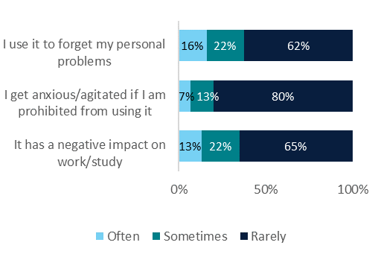

Source: LSAC Release 9.1 C2, BCARR analysis.

Notes: Percentages are an average of years 2020 and 2021.

Social media platforms have the potential to expose young people to a range of harms. However, in 2018, a large share of Australian youth had acted to protect themselves from online harm (65%). Common actions that children took to protect themselves online included un-tagging themselves from a post (44%), deleting a post about themselves (38%) or ceasing use of social media altogether (19%).

Social media has changed significantly in the last decade, however LSAC data suggests that, even in 2012 and 2014, most parents had rules in place about their children’s presence on social networking sites, and their general internet browsing. However, the share of parents with rules in place decreased slightly over this period (Figure 6).

An important distinction to make is that parents’ rules about their child’s internet activity reduce or relax with the ageing of their children, not time.[13]

Figure : Parents’ rules about their child’s internet activity

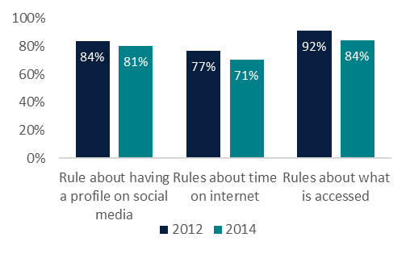

Source: LSAC Release 9.1 C2, BCARR analysis.

## Conclusion

**Australian children are increasingly online.** Over 97% of Australian children had access to the internet at home, and 78% had access to the internet in their bedrooms in 2014, up from 96% and 47%, respectively in 2012.

**Children’s digital connectivity differs by socio-economic background.** Generally, over the various periods of analysis spanning 2006–18, lower digital connectivity was experienced by children who:

* live in remote areas
* are Aboriginal and/or Torres Strait Islander
* live with a single parent
* reside in areas of low socio-economic advantage
* have a primary caregiver on a low income.

Importantly, as children can exhibit multiple characteristics, this can compound the impact of each characteristic on reducing digital connectivity.

**Mobile phones appear to facilitate digital connectivity** for children who belong to groups experiencing higher rates of digital exclusion, such as Aboriginal and/or Torres Strait Islander children or children living with a single parent. Prepaid plans appear to support children’s uptake of mobile phones more generally.

**A large share of Australian youth act to protect themselves from online harm.** In 2018 almost two-thirds of children and young people had taken steps to protect themselves from harm on social media platforms, most commonly by un-tagging themselves from posts, deleting posts about themselves or ceasing the use of social media altogether.

**The majority of parents had rules in place about their child’s internet activity in 2012 and 2014.** Parents’ rules about their child’s internet activity reduce or relax with the ageing of their children, not time.

While access to the internet is essential for full social and economic participation, exposure to harmful or inappropriate content has damaging implications, particularly for children. Continued research into the online experience of Australian youth is important to ensure measures are in place to keep online environments safe for all.

1. LSAC Data

This paper uses unit record data from Growing Up in Australia, the Longitudinal Study of Australian Children (LSAC). The study is conducted in partnership with the Department of Social Services (DSS), the Australian Institute of Family Studies (AIFS) and the Australian Bureau of Statistics (ABS). The findings and views reported in this paper are those of the author and should not be attributed to DSS, AIFS or the ABS.

LSAC investigates the effect of children’s social, economic and cultural environments on their wellbeing over time.[14] The study has collected information from participating families every 2 years since 2004. Information collected in the first year, 2004, belongs to wave 1, and information collected in each subsequent 2-year period has a sequential wave number. In 2005, 2007 and 2009 additional information was collected from families via in-between wave mailouts. This information forms wave 1.5, 2.5 and 3.5. Response rates for these waves were low and were not used for our analysis.

LSAC has a two-stage clustered sampling design:

1. Randomly selected 10% of all Australian postcodes, stratified by state and urban/rural
2. Selected two cohorts (‘Baby’ B cohort and ‘Kinder’ K cohort) of children within those postcodes.[15]

Except for some remote areas, the selected sample was chosen to be representative of all Australian children (citizens and permanent residents) in each of the two selected age cohorts. Differences exist between cohorts B and K (in addition to the age of the children), and include their location, sex, family type, ethnicity and migrant status. While wave 8B and wave 6K cohorts are comparable in terms of their age ranges, they are not perfectly comparable in their sample and response rates (Mohal, et al., 2023).

Our analysis uses questions related to children’s use of and access to digital technologies. Most questions analysed are from the ‘home education environment’ survey topic. The availability of questions relating to children’s access to digital technologies is provided in Table 3.

Table : Availability of questions relating to digital technologies in LSAC

|  |  |  |  |  |  |  |  |  |  |  |  |  |  |  |
| --- | --- | --- | --- | --- | --- | --- | --- | --- | --- | --- | --- | --- | --- | --- |
| Year | Respondent | 2004 | 2005 | 2006 | 2007 | 2008 | 2009 | 2010 | 2012 | 2014 | 2016 | 2018 | 2020 | 2021 |
| Wave |  | **1** | **1.5** | **2** | **2.5** | **3** | **3.5** | **4** | **5** | **6** | **7** | **8** | **9C1** | **9C2** |
| Does study child have access to a computer at home? | Parent 1 | K |  | K |  | B&K |  | B&K |  |  |  |  |  |  |
| Do you have internet access at home? | Parent 1 |  |  |  |  |  |  |  | B&K | B&K | B |  |  |  |
| Does study child own or use a mobile phone?   1. Yes, Own phone 2. Yes, Someone else's phone | Parent 1 |  |  |  |  |  |  |  | B&K | B&K | B | B |  |  |
| What type of internet access do you have at home?   1. Broadband connection (including ADSL, cable, wireless and satellite connections) 2. Dial-up connection (including analog modem and ISDN connections) 3. Other wireless (including access through hand-held devices such as smartphones, tablets, etc.) | Parent 1 |  |  |  |  |  |  |  | B&K | B&K |  |  |  |  |
| Do you have rules about…   1. what they are allowed to access on the internet at home or elsewhere? 2. how much time they can spend accessing the internet at home or elsewhere? 3. whether or not they can have a profile on a social networking site like Facebook or Myspace? | Parent 1 |  |  |  |  |  |  |  | B&K | B&K | B | B* |  |  |
| What kind of plan is child's mobile phone on? | Parent 1 |  |  |  |  |  |  |  | B&K | B&K | B |  |  |  |
| How about your relationship with social media and what you do on it…   1. I spend a lot of time thinking about social media or planning to use it 2. I feel I need to continually use more social media 3. I use social media to forget my personal problems 4. I have tried to stop using social media without succeeding 5. I become anxious or agitated if I am prohibited from using social media. 6. I use social media so much that my use has a negative impact on my work/study   (MCQ with values being 1 Very rarely; 2 Rarely; 3 Sometimes; 4 Often; 5 Very often) | Study Child |  |  |  |  |  |  |  |  |  |  |  | B&K | B&K |
| How often share/post on social network? | Study Child |  |  |  |  |  |  |  |  |  |  |  | B&K | B&K |
| Have you ever done any of the following online?   1. Un-tagged self from post 2. Deleted posts about myself 3. Reported posts about myself or request that administrators take them down 4. Request that someone else take them down 5. Stopped using my social networking account(s) 6. Deleted my social networking account(s) | Study Child |  |  |  |  |  |  |  |  |  |  | K |  |  |

Source: LSAC Release 9.1 C2 Data Dictionary, BCARR analysis.

*Only part c of the question was asked in this wave.

1. Analysis and results

Our analysis seeks to understand how children’s use of, and access to digital technologies has changed over time, and how the presence of certain household characteristics impacts digital connectivity. To model and test the statistical significance of these differences we conduct means tests of descriptive statistics[16] and followed the approach of BCARR (2024). Multilevel logistic regression modelling is used to account for the clustering of the LSAC sample around postcodes and the individuals being surveyed. To determine which regression model best fits this data, we compare the values of their log likelihoods, and the results of the Akaike Information Criteria (AIC) and Bayesian Information Criteria (BIC) tests. The log-likelihood value for a given model can range from negative to positive infinity. The higher the log-likelihood value, the better the model fit. AIC and BIC tests are designed to assist in selecting the best fitting model. The smaller the AIC or BIC, the better the model specification. Refer to Table 4 for the regression model output.

The dependent variables used in the regressions are coded 1 if the child had access to the internet/computer/mobile phone, and 0 otherwise. All explanatory variables used are grouped into categorical variables. Some of these categorical variables are binary – for example, cohort is coded 1 if the child is in the K cohort, and 0 otherwise. Similarly, income is set to 1 if the primary caregiver earns $1000+ p/w per week, and 0 if below this threshold.

For non-binary categorical variables, we set the following as reference categories:

* ‘Major cities’ for the remoteness area variable
* ‘Lowest 25% of SEIFA[17] deciles’ for the SEIFA variable.

Regression estimates for these categorical variables are reported in comparison to these reference categories. We chose to control for the cohort in our regression, as opposed to running separate regressions for each cohort.

Only significant variables were kept in the final models. Other variables that were tested but did not have a significant impact on children’s digital connectivity included migrant status of the child, and highest educational attainment of the parent(s). Some variables (disability, remoteness, sex) were significant only in some regression models. The limited availability of the SEIFA variable across waves precluded its use in the regression on computer access at home.

The regression results in the main body of this paper are reported as average marginal effects. Marginal effects refer to the percentage change in the probability of accessing the internet, a computer or a mobile phone, respectively, if a given variable is changed by one unit, holding all the other variables constant.

Table : Multilevel logistic regression results

|  |  |  |  |
| --- | --- | --- | --- |
| Variable | Internet | Computer | Mobile |
| Wave | (reference wave 5) | (reference wave 2) | (reference wave 5) |
| 3 |  | 1.743*** (0.154) |  |
| 4 |  | 6.737*** (0.711) |  |
| 6 | 1.518*** (0.205) |  | 2.948*** (0.162) |
| 7 | 1.729*** (0.323) |  | 66.995*** (6.303) |
| 8 |  |  | 386.168*** (50.646) |
| Income (relative to primary caregiver earning <$999 p/w) |  |  |  |
| Primary caregiver earns $1000+ p/w | 4.31*** (0.856) | 1.875*** (0.205) | 1.374*** (0.078) |
| Aboriginal and/or Torres Strait Islander (relative to a non-Aboriginal and/or Torres Strait Islander child) |  |  |  |
| Aboriginal and/or Torres Strait Islander | 0.138*** (0.038) | 0.219*** (0.04) | 1.421** (0.244) |
| Remoteness area (relative to a major city) |  |  |  |
| Regional | 0.479*** (0.077) | 0.799** (0.074) |  |
| Remote | 0.178*** (0.076) | 0.428*** (0.116) |  |
| Cohort (relative to B cohort) |  |  |  |
| K Cohort | 1.656*** (0.266) | 4.588*** (0.432) | 69.707*** (6.303) |
| Household type (relative to a non-single parent household) |  |  |  |
| Lone parent household | 0.112*** (0.019) | 0.226*** (0.022) | 1.697*** (0.127) |
| Sex (relative to female) |  |  |  |
| Male |  |  | 0.567*** (0.032) |
| SEIFA – relative to the lowest 25% of SEIFA deciles (least  advantaged) |  |  |  |
| Middle 50% of SEIFA deciles | 1.641*** (0.261) |  | 1.442*** (0.103) |
| Highest 25% of SEIFA deciles (most advantaged) | 3.531*** (0.998) |  | 2.181*** (0.202) |
| Disability (relative to a child that did not have disability/  medical condition in the previous 6 months) |  |  |  |
| Child has disability or medical condition that has lasted >6  months |  |  | 0.616*** (0.07) |
| Constant | 236.479*** (72.108) | 8.001*** (0.99) | 0.062*** (0.006) |
| Number of observations | 17291 | 20521 | 20030 |
| AIC | 3263.937 | 11687.890 | 17022.630 |
| BIC | 3364.791 | 11775.110 | 1133.305 |
| Log pseudo-likelihood | -1618.969 | -5832.943 | -8497.315 |

Source: LSAC, Release 9.1C2 BCARR calculations on pooled data.

Notes: *Significant at 10 per cent level; **Significant at 5 per cent level; ***Significant at 1 per cent level.

1. Interpreting LSIC and LSAC together

LSIC and LSAC have limitations which prevent a representative figure of the differences in connectivity between Aboriginal and/or Torres Strait Islander children and non-Aboriginal and/or Torres Strait Islander children.

## Measuring differences in access using LSAC

LSAC has a sample of Aboriginal and/or Torres Strait Islander children, albeit not a representative sample. There were 417 Aboriginal and/or Torres Strait Islander children sampled, representing 4.1% of the overall sample.[18] LSAC’s sample excludes 40% of areas classified as remote by the ABS (areas that typically have a higher share of First Nations peoples), and so the sample is not representative of Aboriginal and/or Torres Strait Islander children located in remote areas, whom are known to experience higher barriers to digital inclusion (BCARR, Forthcoming). Therefore, the differences in digital connectivity between Aboriginal and/or Torres Strait Islander children and non-Aboriginal and/or Torres Strait Islander children in LSAC is likely to be understated.

There is a substantial but shrinking difference or ‘gap’ in computer and internet access at home between Aboriginal and/or Torres Strait Islander children, and non-Aboriginal and/or Torres Strait Islander children in LSAC. The gap in mobile ownership between groups is significantly smaller, however this has increased slightly over the time period analysed (Figure 7).

Figure : Digital connectivity in LSAC, by Aboriginal and/or Torres Strait Islander status

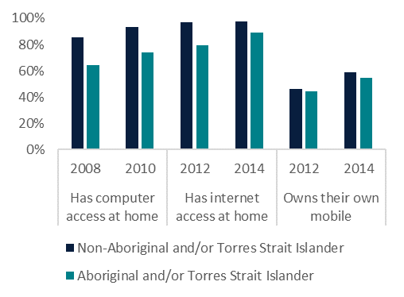

Source: LSAC, Release 9.1C2 BCARR calculations.

Notes: Only years where both cohorts were asked these question have been analysed.

## Measuring differences in access using LSAC and LSIC

LSAC and LSIC are similar in that they both follow and analyse the development of two cohorts of children over time. However, they are not directly comparable for several reasons, explained below.

### Limitations of a comparison

* LSAC’s sample is not representative of children in remote areas. This inflates LSAC’s estimates of digital connectivity for Australian children relative to LSIC, as digital connectivity is known to be lower in remote areas (BCARR, Forthcoming).
* LSIC is not a nationally representative survey, and any measure of access to digital technology represents the access of surveyed Aboriginal and/or Torres Strait Islander children only. LSIC also oversamples children in regional and remote locations.
* Children in LSAC are older than children in LSIC at any given point in time. This will inflate any visible ‘gaps’ in the use and access to digital technology between the surveys, as the uptake of digital technology increases with age (BCARR, 2024).
* The wording of questions on digital access in LSIC and LSAC are not identical. LSIC asks about use of digital technology, whereas LSAC asks about access and/or availability. While the responses to these questions will depend on the respondent’s interpretation of what is being asked, access should theoretically require the availability of digital infrastructure only, where use requires the availability of digital infrastructure, as well as other factors, such as being able to afford the technology, knowing how to use it, and for children, being permitted to use the technology. The broadness of questions in LSAC relative to LSIC will inflate the ‘gap’ in use and/or access to digital technologies between the surveys. Refer to Table 5 for more information on question wording.
* Questions on digital technology are asked in different years across LSIC and LSAC. LSAC also ceases asking questions on digital technology earlier than LSIC.

### Estimates of digital connectivity in LSAC and LSIC

Noting the limitations listed above, here we present the estimates of digital connectivity for Aboriginal and/or Torres Strait Islander children in LSIC, and for all Australian children from LSAC.

We present the estimates in two ways, first comparing comparable years of data between LSIC and LSAC (acknowledging the ages of children differ in these years) and the second comparing years where the ages of children are comparable (acknowledging the time periods of the analysis differ in this analysis).

Generally, digital connectivity in comparable years, or for children of comparable ages, is lower for Aboriginal and/or Torres Strait Islander children in LSIC, than Australian children overall. It is not clear just how much of the difference can be attributable to Aboriginal and/or Torres Strait Islander status, rather, the older age of LSAC children, the difference in years being analysed, the disparity of geographic samples between the two surveys or the broader questions being asked in LSAC relative to LSIC. All of these are likely to explain some of the difference that is being observed.

Analysis of comparable years

In LSIC (Figure 8):

* 47% of children used a computer at home in 2011.
* 42% of children used the internet at home in 2013
* 16% of children owned their own mobile phone in 2015

Figure : Digital connectivity in LSIC, by year

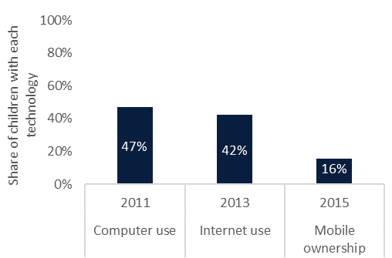

Source: LSIC Release 13, BCARR Analysis.

Comparatively, in LSAC (Figure 9):

* 93% of children had access to a computer at home in 2010
* 97% of children had access to the internet at home in 2014
* 53% of children owned their own mobile phone in 2014

Figure : Digital connectivity in LSAC, by year

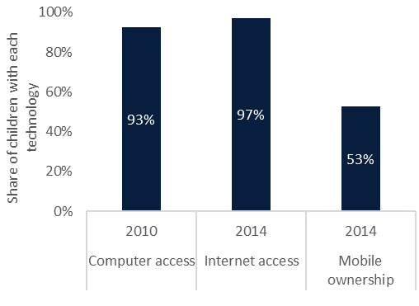

Source: LSAC Release 9.1 C2, BCARR Analysis.

analysis of comparable ages

In LSIC (Figure 10):

* 59% of children aged 10½–12 used a computer at home
* 82% of children aged 14½- 16 used the internet at home
* 84% of children aged 14½- 16 owned a mobile.

Figure : Digital connectivity in LSIC, by age

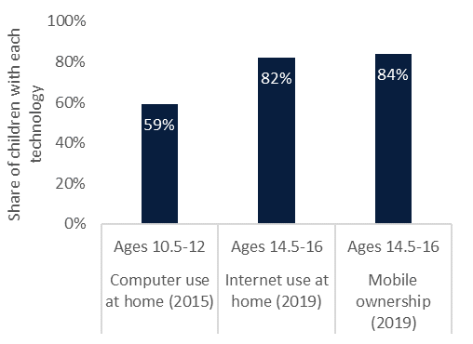

Source: LSIC Release 13, BCARR Analysis.

Comparatively, in LSAC (Figure 11):

* 95% of children aged 10-11 had access to a computer at home,
* 98% of children aged 14-15 had access to the internet at home, and
* 89% of children aged 14-15 owned their own phone.

Figure : Digital connectivity in LSAC, by age

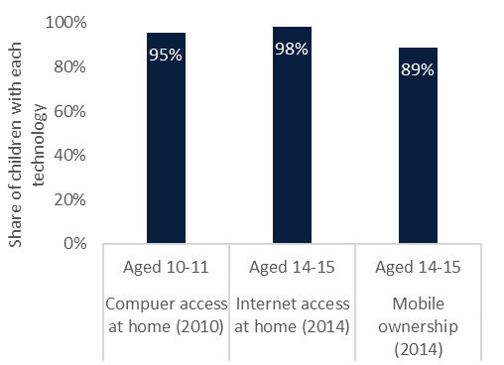

Source: LSAC Release 9.1 C2, BCARR Analysis.

Table : Summary of cohort ages and availability of dependent variables in LSIC and LSAC, by year

|  |  |  |  |  |  |  |  |  |  |  |  |  |  |  |  |  |  |  |
| --- | --- | --- | --- | --- | --- | --- | --- | --- | --- | --- | --- | --- | --- | --- | --- | --- | --- | --- |
|  | 2004 | 2005 | 2006 | 2007 | 2008 | 2009 | 2010 | 2011 | 2012 | 2013 | 2014 | 2015 | 2016 | 2017 | 2018 | 2019 | 2020 | 2021 |
| B Cohort Ages |  |  |  |  |  |  |  |  |  |  |  |  |  |  |  |  |  |  |
| LSIC |  |  |  |  | ½–2 | 1½–3 | 2½–4 | 3½–5 | 4½–6 | 5½–7 | 6½–8 | 7½–9 | 8½–10 | 9½-11 | 10½-12 | 11½-13 | 12½-14 |  |
| LSAC | 0-1 |  | 2-3 |  | 4-5 |  | 6-7 |  | 8-9 |  | 10-11 |  | 12-13 |  | 14-15 |  | 16-17 | 17-18 |
| K Cohort Ages |  |  |  |  |  |  |  |  |  |  |  |  |  |  |  |  |  |  |
| LSIC |  |  |  |  | 3½–5 | 4½–6 | 5½–7 | 6½–8 | 7½–9 | 8½– 10 | 9½– 11 | 10½–12 | 11½- 13 | 12½- 14 | 13½- 15 | 14½- 16 | 15½- 17 |  |
| LSAC | 4-5 |  | 6-7 |  | 8-9 |  | 10-11 |  | 12-13 |  | 14-15 |  | 16-17 |  | 18-19 |  | 20-21 | 21-22 |
| Computer |  |  |  |  |  |  |  |  |  |  |  |  |  |  |  |  |  |  |
| LSIC  Does the child use a computer at home? |  |  |  |  |  |  |  | B&K |  | B&K |  | B&K |  | B&K |  |  |  |  |
| LSAC  Does the child have access to a computer at home? | K |  | K |  | B&K |  | B&K |  |  |  |  |  |  |  |  |  |  |  |
| Internet |  |  |  |  |  |  |  |  |  |  |  |  |  |  |  |  |  |  |
| LSIC  Does the child use the internet at home? |  |  |  |  |  |  |  | B&K |  | B&K |  | B&K |  | B&K |  | B&K |  |  |
| LSAC  Do you (P1) have internet access at home? |  |  |  |  |  |  |  |  | B&K |  | B&K |  | B |  |  |  |  |  |
| Mobile phone |  |  |  |  |  |  |  |  |  |  |  |  |  |  |  |  |  |  |
| LSIC  Does the child own or use a mobile? Yes, their own |  |  |  |  |  |  |  |  |  |  |  | B&K |  | B&K |  | B&K |  |  |
| LSAC  Does the child own or use a mobile? Yes, their own |  |  |  |  |  |  |  |  | B&K |  | B&K |  | B |  | B |  |  |  |

Source: LSAC Data user Guide 2023, LSIC Data User Guide 2023, LSAC Release 9.1 C2 Data Dictionary, LSIC Data Dictionary Release 13.

1. Children online – other research

The ACMA, eSafety Commissioner and Telstra Foundation all provide relevant snapshots of Australian children online. Here we summarise some of their research, and the data that was used.

## eSafety Commissioner

Mind the gap (2022)

**About**

* Explores the opportunities and risks that the internet presents for children in Australia.

**Findings**

* Young people engage in a wide range of online activities and experience many benefits from using the internet. Many children have gone online for health information, emotional support from friends or mental health support services.
* Close to half of the children surveyed were treated in a hurtful or nasty way online in the past year.
* A quarter of the children had treated someone in a hurtful or nasty way online.
* One in ten children have been the target of hate speech online.
* Almost all children did something in response to a negative online experience – most commonly telling their parents.

**Data**

* Online survey of 3,590 children in Australia aged 8–17, conducted July–September 2021. Data relates to the period July 2020 to September 2021.

Children and social media (2024)

**About**

* Explores children’s experience with social media.

**Findings**

* 84% of children have used a social media or messaging service.
* 13% of children had at least one social media account shutdown for being under the age limit (13+).

**Data**

* A 2024 survey of 1,049 children aged 8 to 12 years.

How children use internet enabled devices (2024)

**About**

* Explores children’s ownership and uptake of internet enabled devices

**Findings**

* 50% of children had their own smartphone
* 58% of children had their own tablet
* 41% of children had their own laptop
* 39% of children had their own gaming console.

**Data**

* A 2024 survey of 1,504 children aged 8 to 15 years.

## ACMA

Kids and mobiles (2020)

About

* Analyses the use and ownership of mobile phones by Australian children aged 6 to 13 from 2015–20.

Findings

* In 2020, just under half (46%) of Australian children aged 6 to 13 used a mobile phone, up from 41% in 2015.
* In the 12 months to June 2020, 1 in 3 children (33%) aged 6 to 13 owned the mobile phone they use, unchanged for the last few years.
* Similar proportions of children living in capital cities (47%) and regional areas (45%) accessed a mobile phone in the 12 months to June 2020.

**Data**

* Roy Morgan Research’s Young Australians Survey. A survey of ~2,500 Australian children aged 6 to 13.
* Data relates to the period July 2014 to June 2020.

## Telstra Foundation

Australian Youth Digital Index (2024)

**About**

* Identifies and monitors the key drivers, issues, and opportunities that relate to young people’s relationships with digital technology.
* Funded by Telstra foundation, Telstra’s philanthropic arm and youth and technology unit.

**Findings**

* Of young people that had access to a smartphone in 2024, 90% had their own and 10% accessed a shared device.
* Approximately 94% of Australian youth had access to Wi-Fi at home in 2024. Around 68% had access to mobile data.
* Of the young people who had access to a smartphone, 94% used it to get online at least daily.
* Nearly all young people (94%) feel safe online.

**Data**

* The quantitative data is based on a nationally representative online survey of over 4,700 young people aged 8 to 25. Data relates to the period from 1 July to 1 August 2024.
* Qualitative fieldwork was also undertaken to get an understanding of the experiences of a diverse group of young people.

# References

ACCAN. (2016). Communications Affordability Policy. Retrieved from https://view.officeapps.live.com/op/view.aspx?src=https%3A%2F%2Faccan.org.au%2FACCAN%2520Affordable%2520Communications%2520Policy.docx&wdOrigin=BROWSELINK

ACCC. (2023). Regional Mobile Infrastructure Inquiry 2022-23. Retrieved from https://www.accc.gov.au/system/files/Regional%20Mobile%20Infrastructure%20Inquiry%20final%20report.pdf?ref=0&download=y

ACMA. (2014). Reconnecting the Customer - Tracking consumer outcomes. Retrieved from https://www.acma.gov.au/sites/default/files/2019-08/research-tracking-consumer-outcomes-2014.pdf

ACMA. (2020). *Kids and mobiles: How Australian children are using mobile phones.* Retrieved from https://www.acma.gov.au/publications/2020-12/report/kids-and-mobiles-how-australian-children-are-using-mobile-phones

ACMA. (2020). Mobile-only Australia: living without a fixed line at home. Retrieved from https://www.acma.gov.au/publications/2020-12/report/mobile-only-australia-living-without-fixed-line-home

ADII. (2023). Measuring Australia’s Digital Divide: Australian Digital Inclusion Index: 2023. doi:10.25916/528s-ny91

BCARR. (2024). Use of digital technologies among First Nations Children - Findings from the Longitudinal Study of Indigenous Children. Retrieved from https://www.infrastructure.gov.au/sites/default/files/documents/use-of-digital-technologies-among-first-nations-children-findings-from-the-longitudinal-study-of-indigenous-children-november2024.pdf

BCARR. (Forthcoming). Digital Exclusion in Australia - Evidence from the Household Income and Labour Dynamics in Australia (HILDA) survey.

eSafety Commissioner. (2022). *Mind the Gap: Parental awareness of children's exposure to risks online.* Retrieved from https://www.esafety.gov.au/sites/default/files/2022-02/Mind%20the%20Gap%20%20-%20Parental%20awareness%20of%20children%27s%20exposure%20to%20risks%20online%20-%20FINAL.pdf?v=1743720019807

eSafety Commissioner. (2024). *Children and social media.* Retrieved from https://www.esafety.gov.au/research/children-and-social-media/infographic

eSafety Commissioner. (2024). *How children use internet-enabled devices.* Retrieved from https://www.esafety.gov.au/research/children-and-social-media/internet-enabled-devices-infographic

Featherstone, D., Ormond-Parker, L., Parkinson, S., Hegarty, K., Hawkins, L., Thomas, J., . . . Ganley, L. (2024). Mapping the Digital Gap: 2024 Outcomes Report. Retrieved from https://apo.org.au/sites/default/files/resource-files/2024-12/apo-nid329174_1.pdf

*Mobile Telephony*. (n.d.). Retrieved from Old Australian Telephones: https://oldaustraliantelephones.weebly.com/mobile-telephony.html

Mohal, J., Lansangan, C., Gasser, C., Howell, L., Hockey, P., Duffy, J., . . . Mundy, L. (2023). Growing Up in Australia: The Longitudinal Study of Australian Children – Data User Guide, Release 9.1C2. doi:doi:10.26193/QR4L6Q

National Indigenous Australians Agency. (2024). First Nations Digital Inclusion Plan (2023-26). Retrieved from https://www.niaa.gov.au/sites/default/files/documents/publications/first-nations-digital-inclusion-plan-2023-2026_0.pdf

PHIDU. (2021). Single parent families with children aged less than 15 years, 2021. Retrieved from https://phidu.torrens.edu.au/notes-on-the-data/demographic-social/single-parent-families

Telstra. (2024). *Pre-paid community mobile plan*. Retrieved from Telstra: https://www.telstra.com.au/mobile-phones/prepaid-mobiles/prepaid-community-plan

Telstra Foundation. (2024). *Australian Youth Digital Index.* Retrieved from https://australianyouthdigitalindex.com/wp-content/uploads/2024/11/AYDI-Report_Landscape_T_FA.pdf

1. Information was collected in consecutive years (2020, 2021) to capture information on COVID-19. Refer to Appendix A for further details.
2. LSAC does not specify the type of internet connection accessed and could refer to any available technology type (e.g. mobile, fixed line, satellite).
3. LSAC does not specify the type of computer accessed.
4. These shares represent primary caregivers who indicated that there is internet access at home. Our analysis of internet access is therefore only indicative that a connection is present, whether children are allowed to use the internet at home is unknown.
5. This refers only to access to a mobile phone, not ownership of a mobile phone. In 2014, 53% of children owned their own phone.
6. In 2012, 97% of children in major cities had internet access, compared to 90% of remote children. In 2014, 98% of children in major cities had internet access compared to 92% of remote children.
7. LSIC is a longitudinal study of Aboriginal and/or Torres Strait Islander children in Australia from 2008 to 2020. It is not nationally representative; however, it has a large sample of regional and remotely located Aboriginal and/or Torres Strait Islander children.
8. Includes both a biological or non-biological parent.
9. This does not refer to children’s ownership of mobile phones, rather their access, be it to a parent, guardian, sibling, friends’ or their own device.
10. This analysis is not restricted to children without internet access at home. Sample size limitations would not permit the regression to be run on that group.
11. Average over years 2012 to 2016. This figure decreased over time but remains significant. Comparatively, 12% adult Australians were mobile-only in 2020 (ACMA, 2020).
12. ‘Rarely’ includes aggregated responses of ‘rarely’ and ‘very rarely’. Often includes responses of ‘often’ and ‘very often’.
13. When holding age constant (at 14–15 years), the share of parents with rules in place actually increased between 2012 and 2016. This indicates that the relaxation of rules around children’s internet activity has not happened as a result of time passing, rather the ageing of the sample.
14. Wave 10 of LSAC, collected in 2023, is available for use but has not been analysed in this report.
15. For more information on the LSAC study and sample visit: <https://aifs.gov.au/growing-australia/study/sample>
16. All shares and descriptive statistics provided in this paper are based on completed responses and exclude ‘missing’, ‘don’t know’ and ‘refused’ responses.
17. Socio-Economic Indexes for Areas (SEIFA) are area-based deciles, calculated by dividing the areas, ordered by disadvantage, into 10 equally sized groups. Decile 1 contains the most disadvantaged areas. Our analysis categorises the deciles into three groups, the lowest 25%, the middle 50% and highest 75%.
18. LSAC slightly oversamples Aboriginal and/or Torres Strait Islander children. In the 2021 Census 3.8% of the total Australian population were Aboriginal and/or Torres Strait Islander.