

Australian National Aviation Safety Plan Annual Report—Financial Year 2024–2025
April 2026


© Commonwealth of Australia 2026
ISBN 978-1-923111-14-1
April 2026 | INFRA7259

Ownership of intellectual property rights in this publication
Unless otherwise noted, copyright (and any other intellectual property rights, if any) in this publication is owned by the Commonwealth of Australia (referred to below as the Commonwealth).

Disclaimer
The material contained in this publication is made available on the understanding that the Commonwealth is not providing professional advice, and that users exercise their own skill and care with respect to its use, and seek independent advice if necessary.
The Commonwealth makes no representations or warranties as to the contents or accuracy of the information contained in this publication. To the extent permitted by law, the Commonwealth disclaims liability to any person or organisation in respect of anything done, or omitted to be done, in reliance upon information contained in this publication.
This document was edited with the assistance of Microsoft Copilot, a generative artificial intelligence tool, to improve clarity and readability. The final content has been reviewed and approved by the Department of Infrastructure, Transport, Regional Development, Communications, Sport and the Arts who remain responsible for its accuracy and completeness.

Creative Commons licence

The material in this publication is licensed under a Creative Commons Attribution 4.0 International licence, with the exception of (a) the Coat of Arms; (b) logos, photos and graphics; (c) content supplied by third parties; and (d) content otherwise labelled.
This publication (and any material sourced from it) should be attributed in the following way:
Australian National Aviation Safety Plan Annual Report—Financial Year 2024-2025 © Commonwealth of Australia 2026 licensed under CC BY 4.0. To view a copy of this licence, visit https://creativecommons.org/licenses/by/4.0/.

Use of the Coat of Arms
The Department of the Prime Minister and Cabinet sets the terms under which the Coat of Arms is used. Please refer to the Commonwealth Coat of Arms—Information and Guidelines publication available at www.pmc.gov.au.

Contact us
This publication is available in PDF and Word formats. All other rights are reserved, including in relation to any departmental logos or trademarks which may exist. For enquiries regarding the licence and any use of this publication, please contact:
Email: InternationalICAO@infrastructure.gov.au
Website: www.infrastructure.gov.au

Contributing Agencies
The National Aviation Safety Plan annual report is prepared by the Joint Aviation Agency Safety Analysis Coordination Group on behalf of the State Safety Programme—Cross-Agency Team (SSP-CAT), with performance data and information provided by:
- Department of Infrastructure, Transport, Regional Development, Communications, Sport and the Arts
- Civil Aviation Safety Authority
- Airservices Australia
- Australian Transport Safety Bureau
- Australian Maritime Safety Authority
- Bureau of Meteorology
- Department of Defence
- Department of Home Affairs.

Table of contents
Executive summary 6
1. Introduction 7
1.1 Australia’s safety goals and objectives 7
1.2 Analysis approach 10
Timeframes and limitations: 10
Remotely piloted aircraft (RPA): 11
2. Operational safety objectives 12
Goal 1: Improve the safety of Australian aviation operations across all sectors 12
Safety objective 1.1: Maintain a 3-year moving average decreasing trend of accidents 13
Safety objective 1.2: Maintain a 3-year moving average decreasing trend of serious incidents 13
Safety objective 1.3: Maintain a 3-year moving average decreasing trend of runway safety-related events 14
Safety objective 1.4: Maintain a 3-year moving average decreasing trend of mid-air collisions and airspace separation events 15
Safety objective 1.5: Maintain or increase Australia’s air navigation safety performance 15
3. Organisational safety objectives 17
Goal 2: Strengthen Australia’s safety oversight and investigation capabilities 17
Goal 3: Enhance the effectiveness of Australia’s State Safety Programme through safety intelligence. 20
Goal 4: Increase collaboration at global and regional levels to enhance aviation safety. 21
Goal 5: Enhance greater safety programme collaboration between Australian industry, industry associations and State agencies. 22
Goal 6: Ensure Australia has the appropriate aviation infrastructure to support safe operations 24
4. Conclusion 25
Appendix A—Operational Safety Performance Indicators 26
A.1—Safety Objective 1.1—Maintain a 3-year moving average decreasing trend of accidents 26
A.2—Safety Objective 1.2—Maintain a 3-year moving average decreasing trend of serious incidents 28
A.3—Safety Objective 1.3—Maintain a 3-year moving average decreasing trend of runway safety-related events 29
A.4—Safety Objective 1.4—Maintain a 3-year moving average decreasing trend of mid-air collisions (MAC) and airspace separation events 30
A.5—Safety Objective 1.5—Maintain or increase Australia’s air navigation safety performance 32
Appendix B—Accident analysis 34
Appendix C—Definitions and Abbreviations 37
C.1—Definitions 37
C.2—Abbreviations and Acronyms 39

List of figures and tables
Table 1—Australia’s safety goals and objectives 7
Table 2—Goal 1 performance outcomes for FY 2024–25 12
Figure 1—Number of accidents 13
Figure 2—Number of Serious Incidents 14
Figure 3—Runway safety-related events 14
Figure 4—Mid-air collisions and airspace separation accidents and serious incidents 15
Figure 5—Air navigation safety performance—Loss of Separation 16
Figure 6—Air navigation safety performance—Runway Incursions 16
Table 3—Goal 2 performance outcomes for FY 2024–25 17
Table 4—Goal 3 performance outcomes for FY 2024–25 20
Table 5—Goal 4 performance outcomes for FY 2024–25 21
Table 6—Goal 5 performance outcomes for FY 2024–25 22
Table 7—Goal 6 performance outcomes for FY 2024–25 24
Figure 7—Number of fatal accident and accident rates by sector 26
Figure 8—Number of serious incidents by sector 28
Figure 9—Number of runway safety-related events by aerodrome status 30
Figure 10—Mid-air collision and airspace separation events by sector 31
Figure 11— Air navigation safety performance—Loss of Separation 33
Figure 12—ATSB Accident occurrence category and sector (FY 2024–25) 34
Table 8—Commercial Air Transport accidents 34
Table 9—Commercial Aviation accidents 35
Table 10—Non-Commercial Aviation accidents 36

Executive summary
The National Aviation Safety Plan (NASP) annual report for 2024–25 outlines progress of aviation safety performance in the financial year towards improvements in safety management and risk reduction. The report supports the continuous monitoring and advancement of national safety objectives as outlined in the NASP.
Australia achieved a reduction in the three-year moving average of aviation accidents for commercial air transport. Regulatory oversight remains robust, with all relevant safety performance indicators (SPIs) meeting targets. Industry engagement and safety promotion initiatives have proven effective, supporting collaborative safety management. Air navigation and aerodrome infrastructure consistently comply with ICAO standards, and search and rescue systems provide full regional coverage for aircraft distress incidents. Global and regional collaboration has been strengthened, boosting Australia’s ability to identify and address aviation safety risks.
Operational safety objectives under the NASP target a downward three-year moving average, with performance targets for aviation accidents and air navigation safety met (accident rates declining, navigation safety stable). However, there has been no consistent downward trend for serious incidents, runway safety events, mid-air collisions, and separation occurrences. Commercial aviation—particularly aerial work and instructional flying—is contributing to the rise in mid-air collision trends. State Safety Programme (SSP) aviation agencies have responded with targeted surveillance, sector risk profiling, cross-agency and industry collaborative working groups, and expert reference groups to actively review risks and identify potential mitigations.
Against the NASP organisational safety objectives, 70% of SPIs have met targets, with all regulatory oversight SPIs on track. Safety promotion and industry engagement SPIs are achieving targets, supporting a solid framework for safety promotion activities. Despite ongoing challenges with unnecessary false alert activations, Australia's search and rescue system remains fully available, ensuring rapid detection and rescue in distress situations. Efforts to improve SSP effectiveness via safety intelligence remain below expectations, with only 37.5% of targets reached.
Several safety enhancement initiatives planned under the NASP are already underway to improve our organisational safety objectives over the three-year NASP period. The SSP governance structure is being reviewed to enhance cross-agency collaboration and raise awareness of the SSP and the NASP among all SSP agencies.
Results from the first year of the NASP confirm Australia’s strong dedication to improving aviation safety management and reducing operational risks, with SSP agencies at a mature stage in meeting safety objectives. Insights from this report will inform future NASP safety initiatives and will be shared with industry to ensure ongoing safety collaboration and learning.
A further indication of how safety initiatives in the NASP are impacting overall safety performance will become available in subsequent annual reports and in trend data over the three-year period of the NASP.

1. Introduction
Safety is always the primary consideration of Australian Government aviation agencies. The National Aviation Safety Plan (NASP) addresses key national safety risks and challenges and complements the Australian State Safety Programme (SSP).
The second edition of the NASP presents our ongoing national strategy and roadmap for continually enhancing aviation safety. While the NASP is based on Australia’s operating environment and safety risks, it is strategically aligned with the International Civil Aviation Organization’s (ICAO’s) Global Aviation Safety Plan (GASP) and the Asia Pacific Regional Aviation Safety Plan (AP-RASP), in recognition that aviation activities are interconnected and global in nature.
Accurately measuring and reporting on Australia’s safety performance is essential for evaluating the effectiveness of NASP strategies. The NASP annual report was developed in response to a safety enhancement initiative action to assist in cross-agency safety information sharing and performance monitoring.
This first annual report serves as a valuable source of SSP safety intelligence, guiding the planning of future safety promotion campaigns and identifying areas that may require further action, mitigation, or new safety initiatives. Additionally, the NASP annual report enables Australia to benchmark its commercial air transport operational safety performance against both regional and global trends through comparisons with ICAO's global and Asia Pacific regional annual safety reporting.

1.1 Australia’s safety goals and objectives
The NASP sets Australia’s overarching desired level of safety performance for civil aviation, being:
To continually improve aviation safety towards reducing aviation accidents and serious incidents across all aviation sectors, with no fatal accidents involving commercial air transport operations.
The NASP (2024-2027) includes six safety goals, each with supporting safety objectives that outline strategic outcomes. These objectives offer measurable ways to address safety risks and improve performance. Australia’s NASP 2024 goals and objectives are listed in Table 1.
Table 1—Australia’s safety goals and objectives
Table row/column heading | Table row/column heading—centred
Improve the safety of Australian aviation operations across all sectors. | Maintain a 3-year moving average decreasing trend of accidents
Improve the safety of Australian aviation operations across all sectors. | Maintain a 3-year moving average decreasing trend of serious incidents
Improve the safety of Australian aviation operations across all sectors. | Maintain a 3-year moving average decreasing trend of runway safety-related events.
Improve the safety of Australian aviation operations across all sectors. | Maintain a 3-year moving average decreasing trend of mid-air collisions (MAC) and airspace separation events
Improve the safety of Australian aviation operations across all sectors. | Maintain or increase Australia’s air navigation safety performance.
Strengthen Australia’s safety oversight and investigation capabilities. | Enhance Australia’s safety management oversight capabilities of Service Providers Safety Management Systems (SMS).
Strengthen Australia’s safety oversight and investigation capabilities. | Enhance and continue to maintain Australia’s regulatory oversight technical inspectors’ capabilities.
Strengthen Australia’s safety oversight and investigation capabilities. | Enhance and continue to maintain Australia’s aviation safety investigators technical capabilities.
Strengthen Australia’s safety oversight and investigation capabilities. | Improve the completion of ATSB investigations in a timely manner
Strengthen Australia’s safety oversight and investigation capabilities. | Improving CASAs oversight activities to monitor compliance and performance of Service Providers SMS.
Strengthen Australia’s safety oversight and investigation capabilities. | Maintain or improve the effectiveness of Australia’s aviation safety regime in accordance with ICAO SARPS
Strengthen Australia’s safety oversight and investigation capabilities. | Monitoring aviation service providers compliance with regulations.
Enhance the effectiveness of Australia’s State Safety Programme through safety intelligence. | Enhancing SSP performance through SEI actions being accomplished and implemented.
Enhance the effectiveness of Australia’s State Safety Programme through safety intelligence. | Enhancing ongoing state agency SSP collaboration through SSP governance meeting attendance.
Enhance the effectiveness of Australia’s State Safety Programme through safety intelligence. | Safety issues identified in ATSB investigations are addressed
Enhance the effectiveness of Australia’s State Safety Programme through safety intelligence. | Maintaining risk identification and analysis activities to inform the State risk intelligence and decision making.
Enhance the effectiveness of Australia’s State Safety Programme through safety intelligence. | Enhance and continue to maintain knowledge and awareness of the SSP and NASP across all SSP agencies.
Increase collaboration at global and regional levels to enhance aviation safety. | Improve the sharing of best practices in safety management, safety data and analyses, safety investigations, and search and rescue among global and regional platforms.
Increase collaboration at global and regional levels to enhance aviation safety. | Maintaining effective oversight activities of Foreign Aircraft operating into Australia.
Enhance greater safety programme collaboration between Australian industry, industry associations and State agencies. | Improve engagement with industry to support the continuous improvement of an efficient and effective aviation safety regulatory framework
Enhance greater safety programme collaboration between Australian industry, industry associations and State agencies. | Improving industry engagement with SSRPs to support the continuous identification and monitoring of sector related risks
Enhance greater safety programme collaboration between Australian industry, industry associations and State agencies. | Maintaining and ensuring industry engagement with SSP working groups
Enhance greater safety programme collaboration between Australian industry, industry associations and State agencies. | Promotion of safety education through improved collaboration between SSP agencies via the Interagency Aviation Safety Promotions Working Group (IASPWG).
Enhance greater safety programme collaboration between Australian industry, industry associations and State agencies. | Maintain or improve Airservices safety program maturity evaluation
Enhance greater safety programme collaboration between Australian industry, industry associations and State agencies. | Improving industry awareness, engagement and collaboration with key safety initiatives, campaigns, and outcomes
Ensure Australia has the appropriate aviation infrastructure to support safe operations. | Maintain or enhance SAR system effectiveness for the timely location and rescue of survivors of aircraft distress incidents.
Ensure Australia has the appropriate aviation infrastructure to support safe operations. | Reduce the unnecessary activation of the SAR system
Ensure Australia has the appropriate aviation infrastructure to support safe operations. | Maintain an increasing trend of air navigation and aerodrome infrastructure that meet relevant ICAO Standards.

1.2 Analysis approach
Performance of each NASP safety objective is measured against safety performance indicators (SPIs) that are aligned to, but expanded upon, those identified in the Global Aviation Safety Plan (GASP). Each SPI has a defined benchmark of either a safety performance target (SPT) or trended monitoring.
The NASP annual report utilises safety data and information from a variety of sources, including:
- ATSB National Aviation Occurrence Database
- National Drone Detection System (NDDS)
- CASA Commercial Drone Register
- Defence Aviation Safety Intelligence Portal
- ATS Occurrences—Corporate Integrated Reporting and Risk Information System (CIRRIS)
- Airservices’ Operational Data Analysis Suite (ODAS)
- Airservices Cognos (Movements).
The data was configured and analysed to enable safety performance monitoring against each safety objective and SPI. Mann-Kendall trend testing was performed against safety objectives 1.1 to 1.4 moving average data to identify if any trending 3-year moving averages were statistically significant. The Mann-Kendall test indicated a statistically significant negative trend for accidents (safety objective 1.1) however trends for safety objectives 1.2, 1.3 and 1.4 did not indicate statistical significance.
To enable a better understanding of the analysis results details regarding the data timeframes, assumptions, and limitations are provided below.

Timeframes and limitations:
- Trends over a ten-year timeframe have been included for most operational safety objectives to provide an adequate period to understand the nature of the trends. The ten-year period has been broken down by Financial Year (FY) to align with the NASP revisioning timeframe. The end date for all performance monitoring data within this report was 30 June 2025.
- Airspace events performance reporting excludes incident data and only contains accident and serious incidents results. This limitation is due to the aviation occurrence database reporting lag connected with incident level data. Incident level data is expected to be fully available for the next NASP annual reporting period ending 30 June 2026.
- To align with the ICAO safety reporting of the Commercial Air Transport (CAT) sector, rates are based on per million departures, with Australian CAT movements data sourced from Airservices movement dataset.
- Air navigation safety performance monitoring for Defence air traffic control (ATC) sites was available from FY 2018–19, and performance data included all civilian related events attributable to ATC or both ATC and pilots, regardless of instrument (IFR) or visual (VFR) flight rule status. Ratings for these metrics is based on aircraft movements rather than the number of IFR flights.
- ATSB national aviation occurrence data for trend monitoring of operational safety objective was obtained on 14 November 2025.

Remotely piloted aircraft (RPA):
- To align with the ATSB RPA sector reporting requirements, performance monitoring relating to this sector was restricted to RPAs with a take-off weight of greater than 2kg.
- CASA introduced mandatory commercial drone registration from the 28 January 2021. The Uncrewed (RPA) accident rate SPI is based on the number of registered commercial drones. This explains why this indicator has only been reported over a five-year period.
- Identification of RPAs within an aerodrome No-Fly Zone (NFZ) is connected to the National Drone Detection System (NDDS) data where drone detection equipment has been installed. This consists of 40 controlled aerodromes (29 civil and 11 Defence sites). The following should be considered when interpreting the results:
- The NDDS for all controlled aerodromes came into effect from 1 July 2020.
- Results were based on the number of distinct RPAs detected based on the unique Drone ID captured by the drone detection equipment.
- Micro RPAs (<250g) operating within three Nautical Miles (3NM) of the aerodrome, outside approach and departure paths, and below 45m altitudes are excluded, as this is considered compliant activity according to civil aviation regulations.
- RPAs operating in the outer runway splay of the NFZ below 90m altitudes are excluded as this is considered compliant activity according to civil aviation regulations.
- CASA can issue special approvals under the civil aviation regulations for the operations of RPAS within the NFZ boundaries of a controlled aerodrome. Due to data limitations, this approved activity is unable to be excluded from the analysis.

2. Operational safety objectives

Goal 1: Improve the safety of Australian aviation operations across all sectors
Goal 1 and its five safety objectives are designed to monitor performance in relation to operational safety risks with the first four objectives aiming for a performance outcome to maintain a decreasing 3-year moving average over the life cycle of the NASP. Performance is monitored against internationally recognised benchmarks for aviation accidents and serious incidents. Within NASP 2024 it was also identified that specific performance monitoring was warranted in relation to:
- runway safety related events
- mid-air collision and airspace separation events
- air navigation safety performance.
The operational safety objective analysis is supported by the operational SPI trend monitoring conducted at sector level. Detailed analysis for each of the safety performance indicators (SPIs) is outlined in Appendix A.
The performance outcomes for the operational safety objectives were measured against the trend of the
3-year moving average for the reporting period. Table 2 summarises the performance outcomes.
Table 2—Goal 1 performance outcomes for FY 2024–25
Goal 1 Safety Objectives | Performance Outcome
1.1—Maintain a 3-year moving average decreasing trend of accidents | Meeting target performance in first year of NASP.
1.2—Maintain a 3-year moving average decreasing trend of serious incidents | Improvement required for performance target to be achieved.
1.3—Maintain a 3-year moving average decreasing trend of runway safety-related events | Improvement required for performance target to be achieved.
1.4—Maintain a 3-year moving average decreasing trend of mid-air collisions and airspace separation events | Improvement required for performance target to be achieved.
1.5—Maintain or increase Australia’s air navigation safety performance | Meeting target performance in first year of NASP.
Further details and information for each of the operation safety objectives are provided below, including visual trending charts. For relevant sector impacts and any activities undertaken by SSP agencies to address adverse trends, refer to Appendix A.

Safety objective 1.1: Maintain a 3-year moving average decreasing trend of accidents
Over the last three years there has been a decreasing 3-year moving average trend in aviation accidents, consistent with a decreasing number of accidents trend over the last 10-year period. In FY 2024–25 Australia recorded 170 aviation accidents across all sectors, up from 136 accidents the previous year, but still below the 10-year annual average of 190. Over the last ten years, a total of 1,902 accidents occurred.
Figure 1 illustrates the accident trend over the 10-year period with the three-year moving average suggesting a decreasing trend in line with Australia’s desired level of safety performance.
Figure 1—Number of accidents
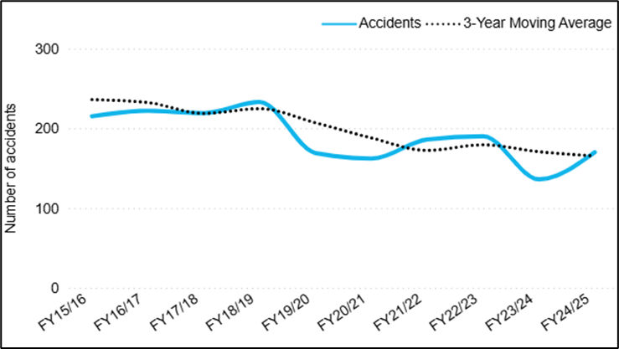
The accident performance monitoring is inclusive of fatal accidents. During FY 2024–25, there were 17 fatal accidents with 25 fatalities; one commercial air transport (CAT) non-scheduled accident caused three fatalities. Further details of fatal accidents are included in Appendix B of this report.
Refer to Appendix A.1 for detailed analysis of the nine sector-specific accident SPIs.

Safety objective 1.2: Maintain a 3-year moving average decreasing trend of serious incidents
In the last three years there has been an increase in the 3-year moving average for serious incidents, however, the serious incident trend has remained relatively stable (Figure 2). There were 200 serious incidents reported in FY 2024–25 which exceeded the 10-year average of 174.
Across the previous 10-years, a drop in incidents occurred from FY 2016–17 to FY 2019–20, after which numbers increased through the current reporting period. This may reflect post-pandemic recovery in flying activity and continued industry stressors.
Appendix A.2 provides further analysis of the three sector-specific SPIs that contribute to SO1.2, as well as actions being taken to further understand potential contributing factors for the increase.
These SPIs show that while CAT and non-commercial aviation (NCA) are stabilising, commercial aviation (CA)—including aerial work and instructional flying—continues to see a rise in serious incidents.
Figure 2—Number of Serious Incidents
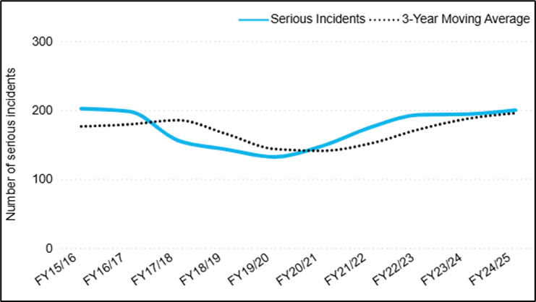

Safety objective 1.3: Maintain a 3-year moving average decreasing trend of runway safety-related events
The 3-year moving average for runway safety events rose slightly during FY 2024–25 (see Figure 3). Over the past decade, event numbers have only increased marginally. In FY 2024–25, 353 such events were reported across all sectors—down from 424 the previous year but just above the 10-year average of 343.
Appendix 1.3 provides further analysis of the two SPIs related to SO1.3—runway safety events at both controlled and non-controlled aerodromes—and details ongoing cross-agency and industry efforts addressing adverse trends.
Figure 3—Runway safety-related events
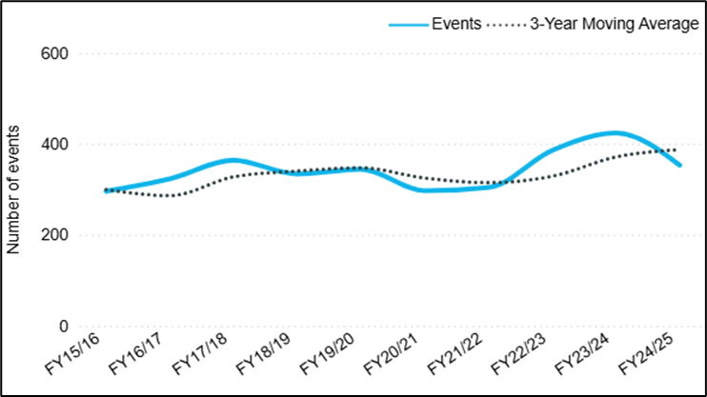

Safety objective 1.4: Maintain a 3-year moving average decreasing trend of mid-air collisions and airspace separation events
Mid-air collisions and airspace separation incidents have risen over the past three years (see Figure 4), but the number of incidents decreased by 18% from FY 2023–24 to FY 2024–25.
Figure 4—Mid-air collisions and airspace separation accidents and serious incidents
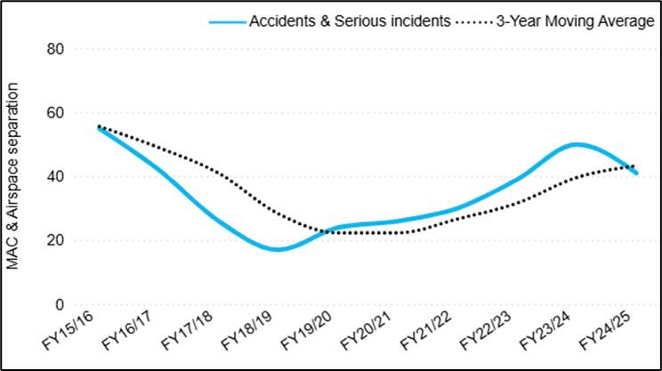
From FY 2015–16 to FY 2018–19, accidents and serious incidents related to MAC and airspace separation declined, but have risen since FY 2019–20, likely due to post-pandemic recovery and industry pressures. In FY 2024–25, there were 41 accidents and serious incidents, above the 10-year average of 35.

Safety objective 1.5: Maintain or increase Australia’s air navigation safety performance
Australia’s air navigation services are provided by both Airservices Australia and the Department of Defence. Due to this the safety objective connected to Australia’s air navigation safety performance has been divided based on the agency and aerodrome locations they control for air traffic service (ATS) attributable loss of separation and runway incursion events.
ATS attributable loss of separation rates within Airservices controlled airspace experienced a slight increase in the last two years however has broadly seen a long-term downward trend (Figure 5A). In Defence controlled airspace, rates involving civilian aircraft have fluctuated in recent years, with a marked decrease last year (Figure 5B).
ATS attributable runway incursion rates at Airservices controlled aerodromes experienced an increase over the last two years however has broadly achieved a long-term downward trend (Figure 6A). There were no runway incursions involving civilian aircraft at Defence controlled aerodromes in the last two years, and the long-term trend has remained stable (Figure 6B).

Figure 5—Air navigation safety performance—Loss of Separation
TS attributable loss of separation rate | TS attributable loss of separation rate
Airservices (Towers/Terminal/Enroute)  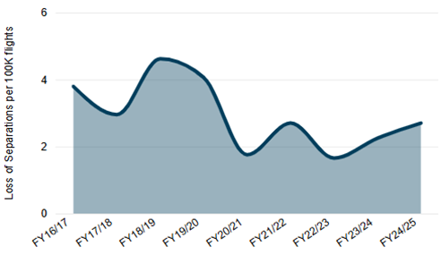 | Defence ATC sites  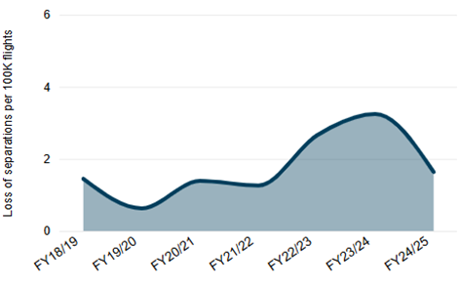
Figure 6—Air navigation safety performance—Runway Incursions
ATS attributable runway incursion rate
Airservices (Towers Only)  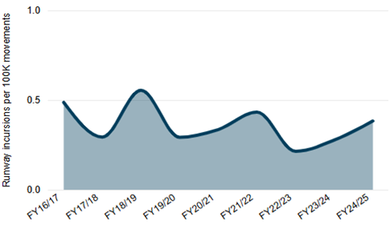 | Defence ATC sites  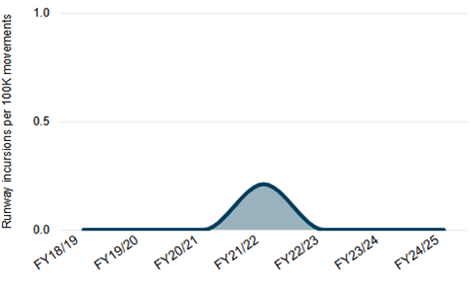

3. Organisational safety objectives
Goals 2 through 6 of the NASP, along with their 23 safety objectives, aim to assess how well Australia’s aviation safety agencies are performing and relate to the effectiveness of Australia’s SSP. They specifically address areas such as safety oversight and investigation capabilities, aviation infrastructure support, and both national and international safety collaboration. Most organisational safety objectives were met in the first year of the NASP, with 70% of the 40 indicators achieving their targets. However, performance monitoring has identified objectives relating to Goal 3 (enhance the effectiveness of Australia’s SSP through safety intelligence) is currently underperforming with only 37.5% of SPI targets being achieved. Performance against each of the organisational goals, their corresponding safety objectives and SPIs are outlined below within Tables 3 to 7 scorecards.

Goal 2: Strengthen Australia’s safety oversight and investigation capabilities
In the first year of the NASP, 83% of Goal 2 SPIs (10 out of 12) met performance targets (Table 3). All regulatory oversight SPIs achieved their targets, demonstrating a strong basis for oversight in line with the SSP. The two SPIs requiring improvements for performance targets to be achieved across the next two years of the NASP relate to timely publication of investigation reports and completion of corrective action plans (CAPs) within agreed timeframes. While these SPIs are not yet meeting targets, work is underway to ensure performance is improving towards the targets established in the NASP.
Performance relating to CAPs is indicative of the ambitious CAP timelines Australia originally set itself and recorded in the Universal Safety Oversight Audit Programme-Continuous Monitoring Approach (USOAP-CMA) online framework. During the FY 2024–25 reporting period, the first 16 of 52 of the CAPs stemming from the 2023 ICAO focused audit were completed. Further CAPs should be completed in 2025–26.
Table 3—Goal 2 performance outcomes for FY 2024–25
Safety Objectives (SO) | Safety Performance Indicators | Safety Performance Target or Trend | Performance Outcome  (as of 30 June 2025)
SO2.1: Enhance Australia’s safety management oversight capabilities of Service Providers Safety Management Systems (SMS). | a. Completion rates of SMS Assess and Approve training programs for all CASA SMS inspectors. | 95% of all active inspectors involved in SMS oversight to have completed and be current in SMS Assess and Approve training. | Meeting target performance in first year of NASP
SO2.1: Enhance Australia’s safety management oversight capabilities of Service Providers Safety Management Systems (SMS). | b. Completion rates of SMS introduction training for all CASA regulatory staff. | 95% of all CASA regulatory staff have completed and are current in SMS introduction training. | Meeting target performance in first year of NASP
SO2.1: Enhance Australia’s safety management oversight capabilities of Service Providers Safety Management Systems (SMS). | c. Completion rates for Human Performance in Safety Management training programs for CASA inspectors. | 95% of all active inspectors involved in SMS oversight to have completed required HP training (initial and recurrent). | Meeting target performance in first year of NASP
SO2.2: Enhance and continue to maintain Australia’s regulatory oversight technical inspectors’ capabilities. | a. Completion rates of mandatory technical training. | 95% of all inspectors have completed mandatory technical training relevant to their role. | Meeting target performance in first year of NASP
SO2.3: Enhance and continue to maintain Australia’s aviation safety investigators technical capabilities. | a. Completion rates of initial/induction mandatory technical training for accident and incident investigations | 100% of all mandatory technical initial/induction training completed within 12 months of commencement in role. | Meeting target performance in first year of NASP
SO2.3: Enhance and continue to maintain Australia’s aviation safety investigators technical capabilities. | b. Completion rates of recurrent/refresher mandatory technical training for accident and incident investigations | 95% of all active aviation safety investigators to have completed required recurrent/refresher mandatory technical training. | Meeting target performance in first year of NASP
SO2.4: Improve the completion of ATSB investigations in a timely manner. | a. ATSB investigation reports published, and safety issues relayed to safety owners. | Median time to complete short, Defined and Systemic investigations are within timeframes as detailed in the ATSB’s PBS. | Improvements required for performance target to be achieved
SO2.5: Improving CASAs oversight activities to monitor compliance and performance of Service Providers SMS. | a. Percentage of SMS oversight activities undertaken to evaluate compliance with SMS Part 119 and Part 138 requirements against planned surveillance. | 90% of planned SMS oversight activities completed. | Meeting target performance in first year of NASP
SO2.5: Improving CASAs oversight activities to monitor compliance and performance of Service Providers SMS. | b. Percentage of SMS Part 119/138 oversight activities resulting in non-compliance/non-conformance findings being issued. | Monitoring and trend reporting only to enhance safety intelligence with analysis provided to inform State for oversight surveillance undertaken | Trend monitoring achieved
SO2.6: Maintain or improve the effectiveness of Australia’s aviation safety regime in accordance with ICAO Standards and Recommended Practises (SARPS) | a. Percentage of corrective action plans (CAPs) completed. | 100% actioned within agreed acceptable timeframes. | Improvements required for performance target to be achieved
SO2.6: Maintain or improve the effectiveness of Australia’s aviation safety regime in accordance with ICAO Standards and Recommended Practises (SARPS) | b. Number of ICAO significant safety concerns. | Nil ICAO Significant Safety Concerns. | Meeting target performance in first year of NASP
SO2.7: Monitoring aviation service providers compliance with regulations. | a. NOP Planned Surveillance program: Percentage of planned surveillance activities undertaken within identified scheduled. | 90% of NOP planned surveillance activities completed within schedule. | Meeting target performance in first year of NASP

Goal 3: Enhance the effectiveness of Australia’s State Safety Programme through safety intelligence.
In the first year of the NASP (2024–2027), only 37.5% of Goal 3 SPIs (3 out of 8) have met their performance targets (Table 4). With performance relating to overall completion of NASP safety enhancement initiatives (SEIs) and sector safety risk profiles (SSRPs) meeting targets, this indicates functions aimed at enhancing SSP safety intelligence are being implemented but further work is required to ensure this goal is achievable.
Further SEIs are underway to revise the SSP governance arrangements, aiming to improve cross-agency collaboration and enhance SSP and NASP awareness among all SSP agencies. A review of the SSP/NASP awareness training aims to better understand training needs for aviation staff. These efforts are expected to help achieve safety objectives in collaboration and awareness performance targets.
Performance relating to the resolution of safety issues identified in aviation investigations was slightly below the target, with 63% achieved against the ATSB’s PBS benchmark of 65%. Preliminary indications suggest the target is likely to be met in the second year of the NASP.
Table 4—Goal 3 performance outcomes for FY 2024–25
Safety Objectives (SO) | Safety Performance Indicators | Safety Performance Target or Trend | Performance Outcome  (as of 30 June 2025)
SO3.1: Enhancing SSP performance through SEI actions being accomplished and implemented. | a. Percentage of SEI actions completed within defined timeline. | 90% of NASP SEI actions completed in accordance with defined timeline. | Meeting target performance in first year of NASP
SO3.1: Enhancing SSP performance through SEI actions being accomplished and implemented. | b. Number of SEI actions requiring adjusted delivery timelines. | Less than 5% of SEI actions requiring adjusted delivery timelines. | Meeting target performance in first year of NASP
SO3.2: Enhancing ongoing state agency SSP collaboration through SSP governance meeting attendance. | a. Percentage of SSP governance meetings held (based on annual planned schedule) | 90% of SSP governance meetings conducted (based on annual schedule). | Improvements required for performance target to be achieved
SO3.2: Enhancing ongoing state agency SSP collaboration through SSP governance meeting attendance. | b. Participation at each SSP governance meeting by SSP agencies. | All required agency members participating in each SSP governance meeting. | Improvements required for performance target to be achieved
SO3.3: Safety issues identified in ATSB investigations are addressed | a. Percentage of all safety issues identified in ATSB aviation investigations addressed. | In line with targets detailed in the ATSB’s PBS. | Improvements required for performance target to be achieved
SO3.4: Maintaining risk identification and analysis activities to inform the State risk intelligence and decision making. | a. Number of sector safety risk profiles (SSRP) workshops conducted against planned. | 100% completion of all planned SSRPs workshops. | Meeting target performance in first year of NASP
SO3.4: Maintaining risk identification and analysis activities to inform the State risk intelligence and decision making. | b. Timely publication of SSRPs | All SSRPs published within 2 months of workshop. | Improvements required for performance target to be achieved
SO3.5: Enhance and continue to maintain knowledge and awareness of the SSP and NASP across all SSP agencies. | a. Completion rates of SSP/NASP training programs for all SSP Agency staff. | 95% of all SSP agency aviation staff to have completed required SSP/NASP training. | Improvements required for performance target to be achieved

Goal 4: Increase collaboration at global and regional levels to enhance aviation safety.
During the first year of the NASP 75% of Goal 4 SPIs (3 out of 4) met their performance targets (Table 5). This demonstrates that Australia has not only maintained but also increased its collaboration on aviation safety both within the Asia Pacific region and globally. The Safety Assessment of Foreign Aircraft (SAFA) oversight programme has also further strengthened our overall oversight efforts under the SSP by ensuring foreign operators entering Australia continue to uphold safety standards.
Australian representation at safety-related ICAO forums was slightly below the target of 90% this reporting period with an achievement of 87%. The specific SPI is being reviewed and may be updated to reflect those collaborative forums that provide the most opportunities to enhance aviation safety.
Table 5—Goal 4 performance outcomes for FY 2024–25
Safety Objectives (SO) | Safety Performance Indicators | Safety Performance Target or Trend | Performance outcome  (as of 30 June 2025)
SO4.1: Improve the sharing of best practices in safety management, safety data and analyses, safety investigations, and search and rescue among global and regional platforms. | a. Australian representation at safety related ICAO meetings, panels and working groups. | At least ≥90% of meetings attended (defined by annual Strategic Review) | Improvements required for performance target to be achieved
SO4.1: Improve the sharing of best practices in safety management, safety data and analyses, safety investigations, and search and rescue among global and regional platforms. | b. Percentage of regional aviation safety capacity building requests received via regional platforms and undertaken by Australian SSP agencies. | Monitoring and trend reporting; with aim to maintain or increased level of support offered by Australian SSP agencies to region partners. | Meeting target performance in first year of NASP
SO4.2: Maintaining effective oversight activities of Foreign Aircraft operating into Australia. | a. Number of Safety Assessment of Foreign Aircraft (SAFA) oversight activities undertaken as part of European Union Ramp Inspection Programme. | 80% of planned activities conducted. | Meeting target performance in first year of NASP
SO4.2: Maintaining effective oversight activities of Foreign Aircraft operating into Australia. | b. Number of safety findings issued during Safety Assessment of Foreign Aircraft (SAFA) Ramp Inspection Programme. | Monitoring and trend reporting only to enhance safety intelligence with analysis provided to inform State for oversight surveillance undertaken. | Meeting target performance in first year of NASP

Goal 5: Enhance greater safety programme collaboration between Australian industry, industry associations and State agencies.
In the first year of the NASP, 90% of goal 5 SPIs (9 out of 10) met their performance targets (Table 6). All SPIs relating to external safety promotions and engagement with industry met performance targets, indicating a solid foundation for safety promotions performed in accordance with the SSP.
Performance regarding enhanced collaboration between SSP agencies through the Interagency Aviation Safety Promotions Working Group (IASPWG) was only marginally below the target for this reporting period, with three meetings held. During FY 2024–25, joint safety education initiatives conducted through the IASPWG concentrated on the Automatic Dependent Surveillance-Broadcast (ADS-B) rebate program and promotion of safety practices around non-controlled aerodromes.
Table 6—Goal 5 performance outcomes for FY 2024–25
Safety Objectives (SO) | Safety Performance Indicators | Safety Performance Target or Trend | Performance Outcome  (as of 30 June 2025)
SO5.1: Improve engagement with industry to support the continuous improvement of an efficient and effective aviation safety regulatory framework | a. Percentage of significant regulatory changes publicly consulted, and outcomes informed by industry feedback. | 100% of significant regulatory changes publicly consulted on. | Meeting target performance in first year of NASP
SO5.2: Improving industry engagement with SSRPs to support the continuous identification and monitoring of sector related risks | a. Percentage of SSRP workshops with industry participation. | 100% of workshops include industry representative attendance. | Meeting target performance in first year of NASP
SO5.3: Maintaining and ensuring industry engagement with SSP working groups | a. Percentage of SSP WG meetings with industry participation. | 100% industry participation in SSP WG meetings with required industry membership. | Meeting target performance in first year of NASP
SO5.4: Promotion of safety education through improved collaboration between SSP agencies via the Interagency Aviation Safety Promotions Working Group (IASPWG). | a. Number of joint agency safety education activities and initiatives completed per year. | i. Minimum of 4 IASPWG meetings held annually.  ii. 100% of planned and agreed joint safety education activities and initiatives delivered each year. | Improvements required for performance target to be achieved
SO5.5: Maintain or improve Airservices safety program maturity evaluation | a. Airservices Civil Air Navigation Services Organisation (CANSO) maturity assessment score. | To achieve CANSO maturity level D. | Meeting target performance in first year of NASP
SO5.6 Improving industry awareness, engagement and collaboration with key safety initiatives, campaigns, and outcomes | a. Attendance at industry association conferences and meetings, representation at annual safety conferences including AAA, RAAA, AAAA, AAUS, SafeSkies, and AHIA Rotortech conference. | CASA representation at 100% of major industry conferences. | Meeting target performance in first year of NASP
 | b. Participation of industry and industry associations in Aviation Safety seminars, webinars, and safety campaigns. | 90% of planned seminars and webinars conducted. | Meeting target performance in first year of NASP
 | c. Support industry to deliver key safety programs aligned with key safety priorities and identified risks. | Offer and provide scholarships aligned to key safety initiatives. Continue to offer and provide safety sponsorship opportunities for industry and encourage collaboration. | Meeting target performance in first year of NASP
 | d. Attendance at key industry airshows and other events. | CASA represented at a minimum of 5 events annually. | Meeting target performance in first year of NASP
 | e. Delivery of safety promotion and education to enhance awareness within industry of safety factors relating to Global High Risk Categories (G-HRC) and national safety risks. | Maintaining or increasing level of safety promotions and education campaigns to industry. | Meeting target performance in first year of NASP

Goal 6: Ensure Australia has the appropriate aviation infrastructure to support safe operations
In the first year of the NASP 50% of Goal 6 SPIs (3 out of 6) met their performance targets (Table 7), including air navigation and aerodrome infrastructure compliance with ICAO standards.
The search and rescue (SAR) system has consistently achieved its safety objectives of maintaining 100% availability of the COSPAS-Search and Rescue Satellite-Aided Tracking (SARSAT) satellite distress beacon system for the Australian flight information region (FIR). However, the objective to reduce unnecessary SAR system activations has not been met. While the rate of false alerts relating to emergency locator transmitters, SAR time search action required (SARTIME) and watch (SARWATCH) times have been above desired levels, in all cases appropriate SAR follow up was conducted and aircraft safety was confirmed. Ongoing initiatives, including safety promotions, aim to raise awareness of preventing unnecessary SAR system activations and continue to try to decrease the frequency of false alerts.
Table 7—Goal 6 performance outcomes for FY 2024–25
Safety Objectives (SO) | Safety Performance Indicators | Safety Performance Target or Trend | Performance Outcome  (as of 30 June 2025)
SO6.1: Maintain or enhance SAR system effectiveness for the timely location and rescue of survivors of aircraft distress incidents. | a. Percentage availability of the COSPAS-SARSAT satellite distress beacon system for the Australian Flight Information Region (FIR) | 100% availability for the Australian (FIR). | Meeting target performance in first year of NASP
SO6.2: Reduce the unnecessary activation of the SAR system. | a. Percentage of false Emergency Locator Transmitter (ELT) alerts. | Reduction in rate of false ELT alerts, including portable ELT alerts. | Improvements required for performance target to be achieved
SO6.2: Reduce the unnecessary activation of the SAR system. | b. Percentage of unnecessary emergency phases declared due to failure of pilots to report by SARTIME expiry. | Reduction in failure to cancel by SARTIME error rate. | Improvements required for performance target to be achieved
SO6.2: Reduce the unnecessary activation of the SAR system. | c. Percentage of unnecessary emergency phases declared due to failure of pilots to report by SARWATCH time. | Reduction in failure to report by SARWATCH error rate. | Improvements required for performance target to be achieved
SO6.3: Maintain an increasing trend of air navigation and aerodrome infrastructure that meet relevant ICAO Standards | a. Percentage of the 16 high priority Block 0 and 1 elements defined in the Australian Air Navigation Plan (NANP) implemented. | 100% of the elements implemented in alignment with APAC Air Navigation Plan defined milestone dates. | Meeting target performance in first year of NASP
SO6.3: Maintain an increasing trend of air navigation and aerodrome infrastructure that meet relevant ICAO Standards | b. Number of infrastructure-related air navigation deficiencies, against the GANP. | Zero air navigation deficiencies. | Meeting target performance in first year of NASP

4. Conclusion
The 2024-2025 NASP annual report notes that safety objective performance among SSP agencies is generally mature. SPI monitoring practices are generally well established and regularly reported by these agencies. This is the first performance review of the NASP and any insights or areas for improved performance will inform our future safety programmes to address operational risks and enhance organisational effectiveness. The performance outcomes against the safety goals in the first year of NASP demonstrate Australia’s ongoing commitment to improving aviation safety management and reducing operational aviation safety risks.
In the first year an important operational safety objective was achieved and that was SO1.1 Maintain a 3-year moving average decreasing trend of accidents. However, one CAT fatal accident was reported, which does not align with Australia’s overarching desired level of safety performance for civil aviation of having no fatal accidents involving commercial air transport operations.
Monitoring the other four operational safety objectives shows progress but also reveals some sectors need more attention. Notably, the CA instructional flying sector was identified as a predominant contributor for midair collisions (MAC) and aircraft separation accidents and serious incidents. Work has already commenced to better understand the risks associated with this sector, including safety risk analysis and industry consultation via an expert reference group and to determine if any additional measures can be identified and should be acted upon which could reduce these risks.
Safety enhancement initiatives (SEIs) scheduled for completed over the remaining duration of the NASP include several cross-agency initiatives to further analyse the contributors and precursors of G-HRCs. The results will support continued safety enhancements for industry across all sectors. The Inter-agency Safety Promotion Working Group (IASPWG), formed within the SSP governance framework, has already enhanced coordinated safety education efforts across agencies. The sectors identified as warranting extra focus, could be prioritised by this working group for targeted safety promotion campaigns.
Overall, most organisational safety objectives were met as intended. In particular, notable successes include strengthening oversight and investigation capabilities (Goal 2), collaboration at global and regional levels (Goal 4) and improved safety collaboration between industry, associations and among government agencies (Goal 5). While performances related to Goal 3 could be improved, several NASP SEIs aimed at SSP governance, intelligence frameworks and proactive risk modelling, are already underway to help strengthen performance of this goal.

Appendix A—Operational Safety Performance Indicators
Within the NASP Goal 1, safety objectives 1.1 to 1.5 are further broken down into aviation activities with associated Safety Performance Indicators (SPIs), to allow for greater identification of potential sector safety risks. Performance monitoring trending against these SPIs are outlined below.

A.1—Safety Objective 1.1—Maintain a 3-year moving average decreasing trend of accidents
The 3-year moving average for accidents as shown in Figure 1 decreased, and at a sector level the 10-year trends for each of the SPIs related to SO 1.1 are also favourable. There were 17 fatal accidents in the FY 2024–25 reporting period, which is comparable to the 10-year average, with 189 total fatal accidents across the 10 years. The fatal accident rate for commercial air transport (CAT) and non-commercial aviation (NCA) fatalities have fluctuated over the 10-year period but are overall indicative of a stable trend. Commercial aviation (CA) fatalities have stabilised over the last two years after increasing from the lowest number in FY 2022–23.
At a sector level commercial aviation (CA) and non-commercial aviation (NCA) accidents have steadily declined over the last 10 years. CAT has experienced a relative stable trend over the entire 10-year period and after a steady increase from the FY 2020–21 post pandemic, the trend has stabilised in the last two FYs.
The uncrewed RPA accident rate has increased over the last year and as of 30 June 2025 was the highest rate for the five-year reporting period. This may be attributed to the increasing use of commercial RPAs over the past 10 years in addition to the recent (2023) changes in ATSB mandatory reportable requirements for RPA operations becoming more understood and appropriately applied by industry participants. Consideration should be given to the context of the accidents as data indicates these were primarily linked with the RPA not responding to controls and colliding with terrain, mostly resulting in damage to the RPA but not to surrounding infrastructure or injury to people.
Figure 7—Number of fatal accident and accident rates by sector
Fatal accident rate—by sector | Accident rate—by sector
SPI 1.1.1—CAT Fatal Accident Rate  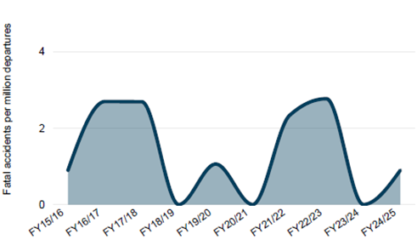 | SPI 1.1.2—CAT Accident Rate  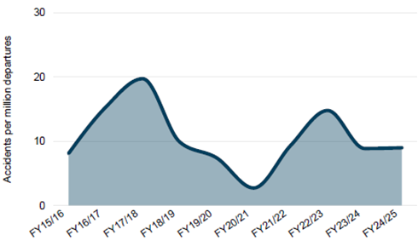
SPI 1.1.3—CA Fatalities  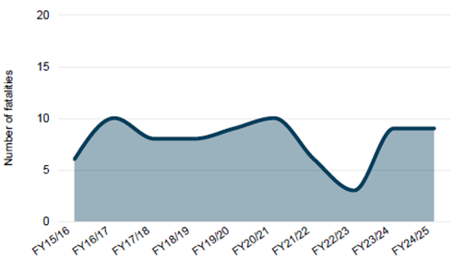 | SPI 1.1.4—CA Accidents  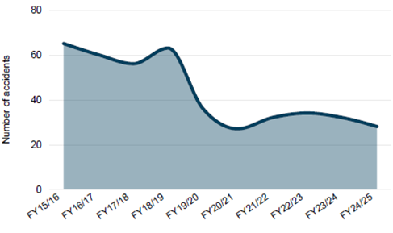
SPI 1.1.5—NCA Fatalities  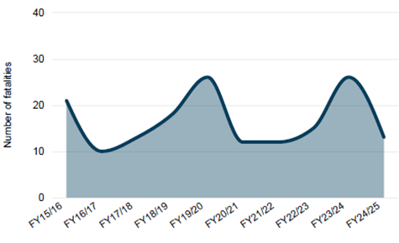 | SPI 1.1.6—NCA Accidents  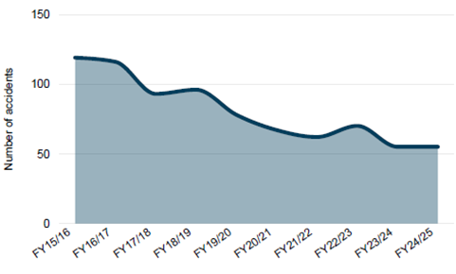
SPI 1.1.7—Number of Ground Fatalities  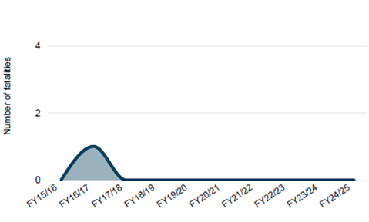 | SPI 1.1.8—Accident Rate per registered RPA  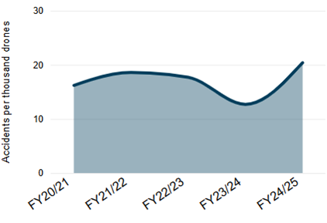
SPI 1.1.9—Uncrewed (RPAS) Fatal Accidents
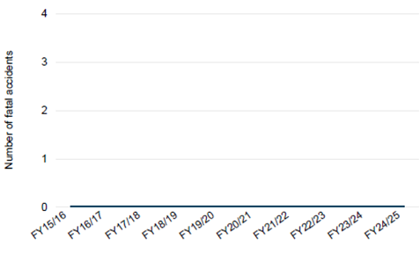

A.2—Safety Objective 1.2—Maintain a 3-year moving average decreasing trend of serious incidents
The increase connected with SO1.2 serious incidents (Figure 2) was primarily associated with the CA sector (SPI 1.2.2), with a 33% increase over the last 10 years (FY2015–16 compared to FY2024–25) and 20% increase over the last three years. The 10-year trend for CAT (SPI 1.2.1) is stable and NCA (SPI 1.2.3) decreasing.
CA encompasses aerial work and instructional flying activities. Instructional flying was the main contributor of serious incidents over the 10-year period. The notable increase commenced from FY2021-22 continued through to the end of the reporting period. The leading occurrence category over this period being aircraft separation. For aerial work, wire strikes during agricultural spreading and spraying activities may have also contributed to the rise.
In response, CASA undertook a targeted surveillance campaign focused on flight training organisations and a Sector Safety Risk Profile (SSRP) was also completed in August 2024 for this sector. Further in-depth analysis through the formation of an instructional flying Expert Reference Group (ERG) is currently underway based on a recommendation from the Aviation Safety Advisory Panel (ASAP). This will enable a more detailed review on instructional flying in collaboration with industry to reduce any potential sector risks. For aerial work and specifically agricultural activity, CASA has engaged with the agriculture sector including Farmsafe and State and Territory Work Health and Safety (WHS) agencies, with an Aerial Agriculture SSRP conducted in November 2024.
The CAT serious incident rate remained stable across the 10-year period but seen a gradual increase of approximately 10% over the last three years. Approximately 58% of CAT serious incidents involved non-scheduled air transport operations over the 10-years, increasing to 63% in the FY 2024–25. This sector is currently transitioning to mandatory civil aviation regulation Safety Management Systems (SMS) which introduces safety culture, safety reporting and safety risk assessment elements to these operators. It is anticipated this SMS transition will assist the sector to become better informed in relation to safety risks and potentially drive more proactive safety risk management.
The NCA sector experienced a decreasing trend in serious incidents across the first half of the 10-year period. Since the pandemic and the lowest number of serious incidents (53) in FY 2019–20 there has been a 40% increase in serious incidents to FY 2022–23 (74). Over the last three years the trend has remained stable.
Figure 8—Number of serious incidents by sector
Serious incident rate—by sector
SPI 1.2.1—CAT Serious Incident Rate  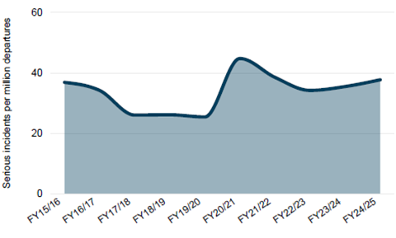 | SPI 1.2.2—CA Serious Incidents  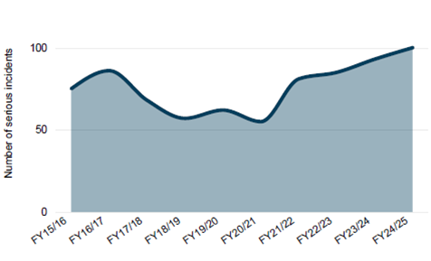
SPI 1.2.3—NCA Serious Incidents
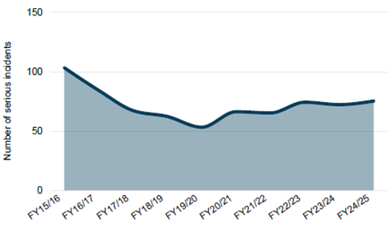

A.3—Safety Objective 1.3—Maintain a 3-year moving average decreasing trend of runway safety-related events
While the 3-year moving average of SO1.3 was indicative of an increasing trend (Figure 3), the number of events from FY 2023–24 to FY 2024–25 decreased by 17%. This was supported by a reduction in the controlled aerodromes runway safety-related event rate (SPI 1.3.1) and numbers of uncontrolled aerodrome runway safety-related events (SPI 1.3.2).
Runway safety-related events are closely monitored through the National Runway Safety Group (NRSG), a SSP operational working group that meets bi-annually. The NRSG reviews runway safety-related events at controlled aerodromes and where risks or emerging issues are identified a specific sub-working group may be formed. Over the last 12 months, the following specific sub-working groups have been active in reviewing risks connected with runway safety:
- displaced thresholds runway works
- pavement classification rating transition
- stop bars.
Through their collaboration, the NRSG also identified a downward trend in runway safety-related events connected with regional class D aerodromes but an increasing trend at metropolitan class D aerodromes. Runway incursions was a lead driver for the increase at metropolitan aerodromes and recommendations for enhanced safety education and awareness were made by the group. CASA’s pilot safety campaign in August 2024 focussed on these matters by raising safety messaging regarding departures, arrivals and landings at non-controlled aerodromes. CASA also conducted a SSRP for both controlled and uncontrolled aerodromes in early 2024 with the published outcomes released in FY 2024–25.
Figure 9—Number of runway safety-related events by aerodrome status
Runway safety-related event rates
SPI 1.3.1—Runway Safety-Related Events Rate (Controlled aerodromes)  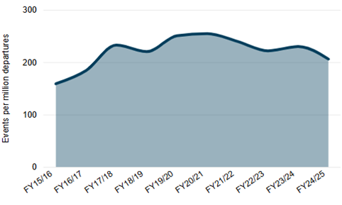 | SPI 1.3.2—Runway Safety-Related Events (Uncontrolled aerodromes)  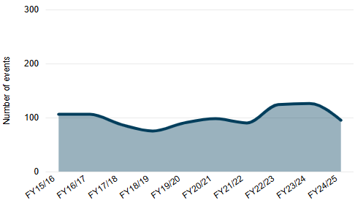

A.4—Safety Objective 1.4—Maintain a 3-year moving average decreasing trend of mid-air collisions (MAC) and airspace separation events
The number of accidents and serious incidents relating to mid-air collisions (MAC) and airspace separation decreased by 18% from FY 2023–24 to FY 2024–25, however the three-year moving average for this same period increased (Figure 4). All sectors (CA, NCA and Uncrewed (RPA)) contributed to this increase except for CAT.
There were three MACs in the reporting period, two of which were fatal. The first fatal accident involved two aerial work helicopters conducting agricultural mustering activities that collided after take-off and the other fatal collision involved an instructional flying (CA) aeroplane and a sport and pleasure (NCA) aeroplane. The third MAC involved two paragliders that were involved in instruction flying (CA) activities.
There has been a consistent increase in the number of CA MAC and airspace separations accidents and serious incidents since FY 2018–19. Instructional flying is the primary activity connected with the increase with near collisions in Class G airspace, being the lead occurrence category. This trend was discussed at the SSRP in August 2024 and may be a focus of the instructional flying ERG.
NCA airspace accidents and serious incidents was elevated in FY 2024–25 with sport and pleasure flying being the predominant activity type.
The number of RPA detected in aerodrome No-Fly Zones has increased to the highest number since the National Drone Detection System (NDDS—a joint initiative between CASA, Airservices and Defence) commenced around June 2020. There are several factors that may have influenced this increase, including:
- popularity in drone flying particularly in the recreational demographic
- newer and cheaper drone models entering the market (Micro <250g models)
- consistent connection across all locations of the NDDS network
An important consideration with this SPI is the context regarding the number of RPA detected in the aerodromes no-fly zones. Although the numbers seem elevated, around 80%-90% of detections are captured greater than 3km away from the aerodromes at an altitude below 120m. As these do not generate any significant potential MAC or loss of separation risks with other aircraft, they are considered a non-compliance matter rather than an aviation safety concern.
CASA monitors NDDS data for non-compliant and safety-concerning drone activity, analysing RPA detections in aerodrome no-fly zones to assess potential MAC or loss of separation risks. Mitigation and drone awareness strategies are implemented as needed. These currently include:
- bi-monthly drone detection airport reporting for civil sites (Commenced in June 2020)
- quarterly drone detection reporting for Defence sites
- CASA’s ‘Know your Drone’ branded safety campaigns
- targeted location specific drone safety education campaigns
- installation of drone safety signage where clusters of activity are identified.
Figure 10—Mid-air collision and airspace separation events by sector
Mid-air collision rate and airspace separation events by sector - by sector
SPI 1.4.1—CAT Mid-air Collision Rate  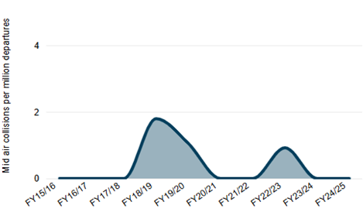 | SPI 1.4.2—CA Mid-air Collisions  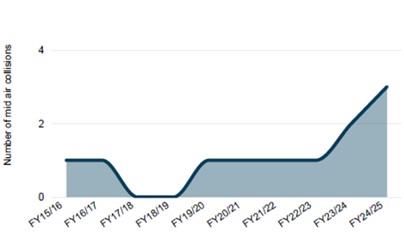
SPI 1.4.3—NCA Mid-air Collisions  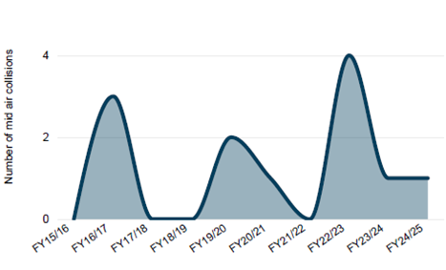 | SPI 1.4.4—CAT Airspace Accident & SI Rate  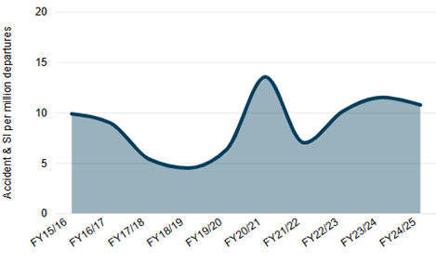
SPI 1.4.5—CA Airspace Accidents & Sis  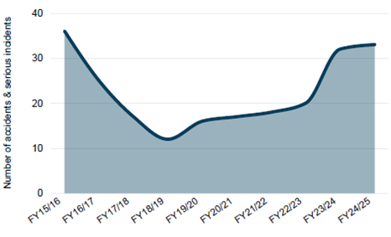 | SPI 1.4.6—NCA Airspace Accidents & Sis  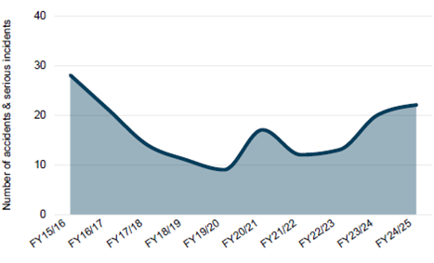
SPI 1.4.7—RPAS Detected in Aerodrome NFZ
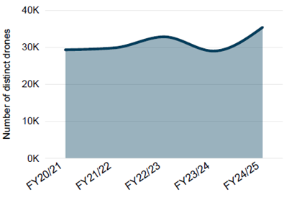

A.5—Safety Objective 1.5—Maintain or increase Australia’s air navigation safety performance
The FY 2024–25 increase in ATS attributable loss of separation (LOS) rates (SPI 1.5a i) within Airservices controlled airspace was driven by unrelated occurrences in Sydney. Airservices assurance processes continue to monitor these occurrences and adjust safety risk controls as required. Airservices has undertaken to better promote safety awareness in this area through safety initiatives including sharing of lessons learned from Australian and overseas events and related safety information directly with air traffic controllers.
In March 2025, Defence aligned the definition of LOS with the definition used by ATSB and Airservices Australia. Previously, Defence had reported LOS events that civilian air navigation services would not have determined as LOS, such as when an aircraft issued a level below lowest safe altitude. Defence is actively monitoring LOS events and targeting procedures, supervision, training and assessment, non-technical skills, immediate risk management, fatigue management and application of Compromised Separation Recovery Techniques (COMSERT).
The recent increase in runway incursion rates at Airservices controlled aerodromes (Figure SPI 1.5b i) has been driven by unrelated occurrences across regional and metropolitan Class D aerodrome tower locations. Airservices assurance processes continue to monitor these occurrences and adjust safety risk controls as required including direct engagement with airport users and safety promotions material on the Airservices Engage and Runway Safety webpages.
Airservices values engagement with communities and the aviation industry in support of making air navigation and overall aviation safer. Airservices Engage website provides an information sharing portal for proposed flight path changes and other major projects. In addition, the Engage Industry Hub webpage, provides a range of pilot safety information with a focus on metropolitan Class D environments. Information includes specific guidance and quarterly newsletters dedicated to keeping aerodrome users informed and safe on the ground and in the air.
SPI 1.5b ii illustrates that the trend for runway incursion event rate has remained primarily stable. The trend captures only civilian aircraft at Defence controlled aerodromes. There were no runway incursion events, involving civilian aircraft, at Defence controlled aerodromes except for in FY 2022–23.
Airservices and Defence are both members of the National Runway Safety Group (NRSG). With both agencies providing runway incursion data for the NRSG and actively participating in reviewing runway safety risks and supporting safety promotional and enhancement initiatives from NRSG sub-working groups.
Figure 11— Air navigation safety performance—Loss of Separation
ATS attributable loss of separation and runway incursion rates
SPI 1.5a (i) ATS attributable loss of separation rate—Airservices (Towers/Terminal/Enroute)  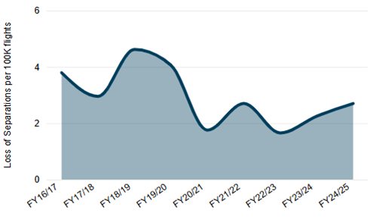 | SPI 1.5a (ii) ATS attributable loss of separation rate—Defence ATC sites  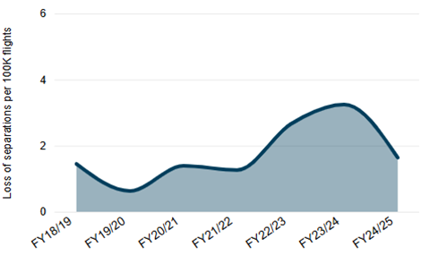
SPI 1.5b (i) ATS attributable runway incursion rate—Airservices (Towers Only)  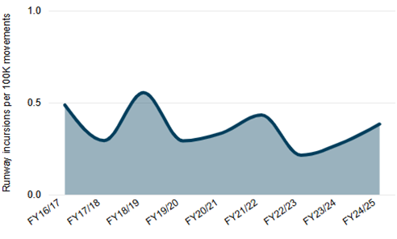 | SPI 1.5b (ii) ATS attributable runway incursion rate—Defence ATC sites  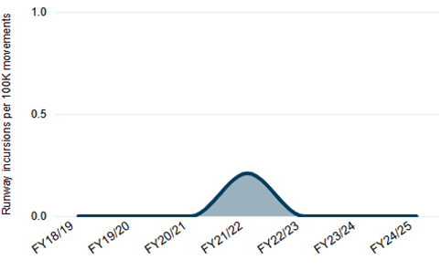

Appendix B—Accident analysis
Further analysis was conducted on the 170 accidents recorded in the current reporting period to provide more context regarding occurrence category and the associated sector involved.
Figure 7 provides a breakdown of accidents by ATSB occurrence category and sector. The data indicates that most accidents were categorised as terrain collisions, followed by aircraft control, powerplant/propulsion and systems. In terms of sector, the uncrewed RPA sector had the most accidents followed by NCA.
Figure 12—ATSB Accident occurrence category and sector (FY 2024–25)
ATSB occurrence breakdown | Sector breakdown
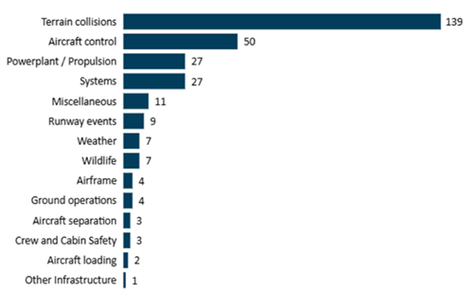 | 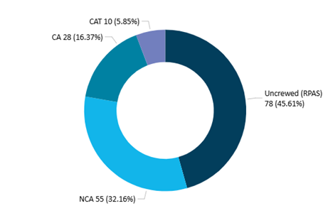
Note—An accident can be categorised against multiple occurrence categories. The occurrence category of Consequential Events has been excluded from the results. The sector breakdown was based on number of aircraft as there was one accident connected with multiple sectors.
Overall, there were 17 fatal accidents resulting in 25 fatalities in the current NASP reporting period. Details regarding fatal accidents, associated fatalities and a short description for each fatal accident have been provided by sector in the tables 8-10 below.
Table 8—Commercial Air Transport accidents
Accidents | Fatal Accidents | Fatalities | Fatal accident description
10 | 1 | 3 | Charter aeroplane collided with water with a pilot and six passengers onboard. The pilot and two passengers sustained fatal injuries.
Table 9—Commercial Aviation accidents
Accidents | Fatal Accidents | Fatalities | Fatal accident description
28 | 6 | 9 | - Aerial work agricultural spraying aeroplane struck a wire and subsequently collied with terrain, the pilot did not survive.  - Two aerial work mustering helicopters collided soon after take-off. Both pilots sustained fatal injuries.  - An instructional flying aircraft conducting a CPL test flight with a flight examiner collided inflight with a NCA aeroplane. The pilot of the NCA aeroplane, and the pilot and flight test examiner of the CA sustained fatal injuries.  - A helicopter conducting aerial work, agricultural spraying, collided with terrain and the pilot was seriously injured and shortly after succumbed to their injuries.  - An instructional flying ultralight aircraft collided with water resulting in fatal injuries to the two occupants onboard.  - An Australian registered aeroplane conducting aerial spraying in Papua New Guinea, collied with terrain and the pilot received fatal injuries.
Table 10—Non-Commercial Aviation accidents
Accidents | Fatal Accidents | Fatalities | Fatal accident description
55 | 11 | 13 | - General aviation helicopter collided with a building killing the pilot.  - Sport and pleasure aeroplane collided with terrain resulting in fatal injuries to the pilot  - During initial climb the sport and pleasure aeroplane lost control entering a veritable descent and collided with terrain. The pilot who was the sole occupant, sustained fatal injuries.  - A sport and pleasure aircraft (Jabiru) had completed a go-around at a non-controlled aerodrome. While joining the circuit to attempt to land again the Jabiru collided inflight with an instructional flying aircraft.  - General aviation aeroplane lost control and collided with terrain. The pilot and two passengers sustained fatal injuries.  - Helicopter conducting a ferry flight with one passenger collided with terrain after the pilot lost control inflight after an uncommanded yaw and inadvertently shutting down the number 2 engine. The passenger sustained fatal injuries.  - During initial climb, the sport and pleasure aircraft collided with terrain, and the pilot sustained fatal injuries, and the passenger sustained serious injuries.  - The sport and pleasure aeroplane collided with water and was subsequently destroyed. The pilot was fatally injured and the passenger sustained minor injuries.  - An aeroplane conducting a ferry flight collided with terrain. The pilot was the sole occupant and was fatally injured.  - A general aviation aeroplane collided with terrain. The pilot was fatally injured.  - A hang glider collided with terrain. The pilot sustained fatal injuries.

Appendix C—Definitions and Abbreviations

C.1—Definitions
Name | Definition
Accident | As per the Transport Safety Investigation Regulations 2021 means an aircraft is involved in an accident if:  - a person suffers a fatal aircraft‑related injury in relation to the operation of the aircraft; or  - a person suffers a serious aircraft‑related injury in relation to the operation of the aircraft; or  - the aircraft sustains damage or structural failure, or there are reasonable grounds for believing that the aircraft has sustained damage or structural failure, which:  - adversely affects the structural strength, performance, or flight characteristics of the aircraft; and  - would normally require major repair or replacement of the affected component; except for any of the following:  - engine failure;  - engine damage limited to a single engine (including damage to its cowlings or accessories);  - damage to propellers, wing tips, antennas, probes, vanes, tyres, brakes, wheels, fairings, panels, landing gear doors or windscreens;  - damage such as small dents or puncture holes to the aircraft skin;  - minor damage to main rotor blades, tail rotor blades or landing gear;  - minor damage resulting from hail or bird strike (including holes in the radome); or  - the aircraft is missing; or  - the aircraft is completely inaccessible.
Airspace events | In accordance with the NASP 2024, airspace events includes the ATSB occurrence category taxonomy of Airspace, including aircraft separation, airspace infringement, ANSP operational error, breakdown of coordination, operational non-commercial and encounter with RPA.
Commercial air transport (CAT) | From the Civil Aviation Safety Regulations 1998 means an air transport operation being a passenger transport operation, a cargo transport operation, or a medical transport operation, which is conducted for hire or reward; and is prescribed by an instrument issued under regulation 201.025.  Note: CAT does not include an aerial work operation.
Commercial aviation | In accordance with the NASP 2024, commercial aviation (CA) includes the aviation activities of aerial work and flight training excluding CAT activities.  Note: CA does not include uncrewed RPAS operations.
Incident | As per the Transport Safety Investigation Regulations 2021 means any occurrence that:  - is associated with the operation of an aircraft; and  - affects or could affect the safety of the operation of the aircraft.
Industry service provider | As per the ICAO Global Aviation Safety Plan 2023-25 means a non-governmental aviation organisation such as: aircraft operators; approved maintenance organisations; organisations responsible for the type design or manufacture of aircraft, engines, or propellers; approved training organisations; and operators of aerodromes, as well as other entities that form part of the aviation industry, as appropriate.
Non-commercial aviation | In accordance with the NASP 2024, non-commercial aviation (NCA) consists of sports and pleasure, recreational aviation, and other activities, excluding CAT activities.  Note: NCA does not include uncrewed RPAS operations.
Occurrence | Refers to any accident, serious incident or incident, associated with the operation of an aircraft which affects or could affect the safety of operation.
Operational safety objectives | In accordance with NASP 2024, are the objectives related to the continuous reduction of operational safety risks identified within global, regional and national plans, including risk management activities associated with ICAOs global high risk category occurrences (G-HRC).
Organisational safety objectives | In accordance with NASP 2024, are the objectives related to Australia’s safety oversight capabilities and the ongoing improvement of Australia’s SSP, including industry service provider’s SMS implementation and oversight.
Runway safety-related events | In accordance with NASP 2024, runway safety-related events are as per the ATSB occurrence category taxonomy of Runway Events, including the following: Runway excursions, Runway incursions, Depart/Approach/Land wrong runway, and Runway undershoot, and Runway events Other
Safety intelligence | As per ICAO Annex 19 means an outcome of the process of analysing safety data and safety information to support decision-making.
Safety objective | Safety objectives are the broad measurable outcomes to help achieve safety goals and drive safety performance against specific identified risks or challenges.
Safety performance indicator | Safety performance indicator (SPI) is a tactical parameter, relating to a safety objective, and provide a reference point to monitor safety data, safety performance and provide evidence on whether desired outcomes are being achieved.
SARTIME | SARTIME is an abbreviation for ‘time search action required’. A SARTIME is the time nominated by a pilot for the initiation of Search and Rescue (SAR) action. SAR action will commence at this time.
SARWATCH | SARWATCH is an abbreviation for ‘Search and Rescue Watch’. An aviation alerting service activated when a pilot fails to report position, arrival, or departure by a nominated time (SARTIME), or due to tracking/reporting requirements.
Serious incident | As per the Transport Safety Investigation Regulations 2021 means an incident involving circumstances indicating that there was a high probability of an aircraft accident.
Safety performance targets/trends | Safety performance targets or trends represent the level of performance considered to be acceptable for a specific safety performance indicator.
Uncrewed remotely piloted aircraft system (RPAS) | As per the RPAS and AAM Strategic Regulatory Roadmap 2024 refers to remotely piloted operations without people onboard and no plans for passenger transport in the near future. Remotely piloted aircraft systems (RPAS), also known as drones, differ from other aircraft in that they do not have a pilot or crew onboard.

C.2—Abbreviations and Acronyms
Abbreviation / acronym | Details
Airservices | Airservices Australia
AMSA | Australian Maritime Safety Authority
APAC | Asia Pacific
AP-RASP | Asia Pacific Regional Aviation Safety Plan
ARC | Abnormal Runway Contact
ATSB | Australian Transport Safety Bureau
BITRE | Bureau of Infrastructure, Transport and Regional Economics
BoM | Bureau of Meteorology
CASA | Civil Aviation Safety Authority
CA | Commercial aviation
CAT | Commercial Air Transport
CFIT | Controlled Flight into Terrain
CMA | Continuous Monitoring Approach
DASA | Defence Aviation Safety Authority
Defence | Department of Defence
DGCA | Director General Civil Aviation
EI | Effective Implementation
FIR | Flight Information Region
GASP | Global Aviation Safety Plan
G-HRC | Global high-risk category of occurrences
GNSS | Global Navigation Satellite System
Home Affairs | Department of Home Affairs
IATA | International Air Transport Association
ICAO | International Civil Aviation Organization
Infrastructure | Department of Infrastructure, Transport, Regional Development, Communications, Sport and the Arts
JAASACG | Joint Aviation Agency Safety Analysis Coordination Group
LOC-I | Loss of Control In-flight
MAC | Mid-Air Collision
NASP | National Aviation Safety Plan
NCP | National Compliance Plan
NDDS | National Drone Detection System (being Australia’s drone detection capability)
NFZ | No-Fly Zone
NOP | National Oversight Plan
NCA | Non-Commercial Aviation
PQ | Protocol Question
RE | Runway Excursion
RI | Runway Incursion
RPA | Remotely Piloted Aircraft
RPAS | Remotely Piloted Aircraft System
SAR | Search and rescue
SARPS | Standards and Recommended Practices
SEI | Safety Enhancement Initiative
SM ICG | Safety Management International Collaboration Group
SMS | Safety Management System
SPI | Safety Performance Indicator
SPT | Safety Performance Target
SSP | State Safety Programme
SSP-CAT | State Safety Programme Cross-Agency Team

The Mann-Kendall is a statistical trend test that is used to analyse data collected over time to determine any consistently decreasing or increasing trends. Statistical significance testing is used to determine whether observed data trends are unlikely to have occurred just by chance.
Part 101 (Unmanned Aircraft and Rockets) Manual of Standards 2019—Federal Register of Legislation
Runway safety-related events are as per the ATSB occurrence taxonomy of Runway Events. This includes the following: Runway excursions, Runway incursions, Depart/Approach/Land wrong runway, Runway undershoot and Runway events—Other.
Includes Australian VH registered, Australian non-VH registered crewed and uncrewed RPAs and foreign aircraft accidents in Australia.
The Uncrewed (RPA) accident rate SPI is based on the number of registered commercial drones.
One fatal accident in October 2024 involved two aircraft from both CA and NCA sectors. This fatal accident is only counted once for cumulative (total) reporting but is counted in each sector for the purpose of sector reporting.
One fatal accident in October 2024 involved two aircraft from both CA and NCA sectors. This fatal accident is only counted once for cumulative (total) reporting but is counted in each sector for the purpose of sector reporting.

