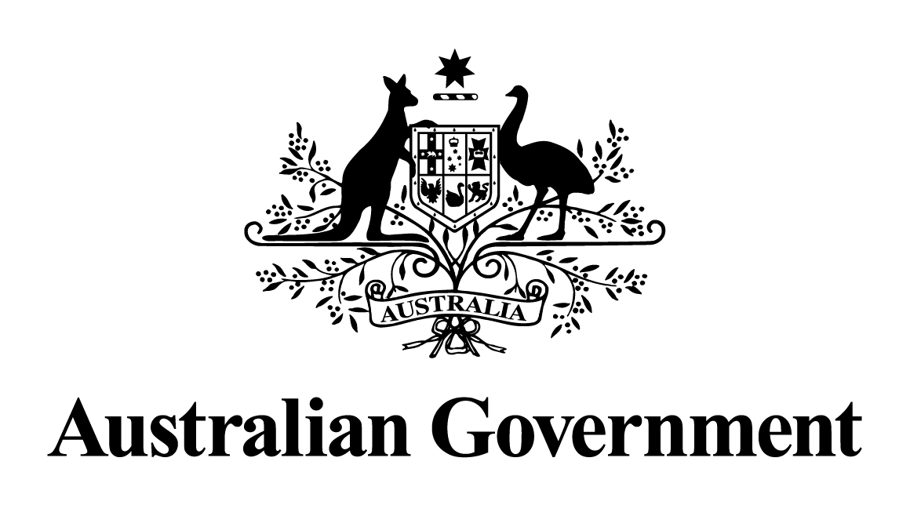

Australian Government response to the Select Committee on Commonwealth Bilateral Air Service Agreements report:
Commonwealth Bilateral Air Service Agreements
December 2025

The Australian Government notes the report by the Senate Select Committee into Commonwealth Bilateral Air Service Agreements.
International aviation is a key driver of Australia's economy, supporting the growth of tourism, business and trade.
The COVID-19 pandemic and border restrictions were the most devastating external shock to international aviation in its history, but the industry has bounced back. For the year ended 30 June 2025 the number of scheduled international flights to and from Australia increased to over 208,000 and the number of passengers over 43 million, both exceeding pre-COVID and 2023-24 traffic levels.
On 26 August 2024, the Government released the Aviation White Paper: Towards 2050, which sets out the long-term policies to guide the next generation of growth and innovation in the aviation sector. Initiatives include ensuring a competitive and efficient aviation sector, as well as continuing to keep bilateral air services capacity ahead of demand and considering open skies style agreements where it is in the national interest and can be bilaterally agreed.
Bilateral air services arrangements
Australia now has bilateral air services arrangements with 110 countries including open capacity access arrangements with our seven current biggest international arrival markets: New Zealand, China, US, UK, Japan (excluding Haneda), India and Singapore. These arrangements enable Australians wishing to travel internationally or visitors coming to Australia, to access around 2,000 international flights per week.
The Government has successfully negotiating updated air services arrangements with a number of countries including Hong Kong, Malaysia, Türkiye, Vietnam, Sri Lanka, Chile, and Canada and new air services arrangements with Latvia, Mongolia and Rwanda. These arrangements are consistent with our international aviation policy outlined in the Aviation White Paper, ensuring airlines have time to plan for additional future services and add new routes to their schedules, and helping Australia better access the Asia-Pacific, the fastest growing aviation region in the world.
The Department of Infrastructure, Transport, Regional Development, Communications, Sport and the Arts will continue to consult widely with Government agencies, including the ACCC, and industry stakeholders in providing analysis and advice to the Minister for Infrastructure, Transport, Regional Development and Local Government on proposed bilateral air services negotiations.
The outcomes of bilateral air services negotiations will continue to be advised to stakeholders and the level of available capacity for Australian and foreign airlines updated on the Department’s website.
Domestic aviation competition and consumer protections
All businesses operating in Australia, including airlines, are subject to the Competition and Consumer Act 2010 (the Act). The Act includes the Australian Consumer Law (ACL) which is enforced by the Australian Competition and Consumer Commission (ACCC) and state and territory ACL regulators.
The ACL contains many consumer protections, such as prohibitions on misleading or deceptive conduct, and the use of unfair contract terms in standard form contracts. The ACL also provides consumers with automatic consumer guarantee rights when they buy products and services. Consumers are entitled to a remedy if businesses do not meet these consumer guarantees.
The Government directed the ACCC to continue to monitor the prices, costs and profits of domestic airlines, to help ensure Australians see the benefits of a competitive airline sector. Enhanced ACCC monitoring will be conducted to increase transparency, enable greater public scrutiny of industry behaviour and determine whether large aviation businesses misuse their market power.
The ACCC plays a vital role in monitoring markets to protect and promote competition, and is already empowered and able to investigate anti-competitive business behaviour or practices that may be illegal under the Act across all sectors of the economy (including in the domestic aviation market). In instances where there has been a breach, the Act provides the ACCC with a range of enforcement remedies to address contraventions.
In addition to these protections, through the Aviation White Paper the Government announced that it will legislate for an Aviation Industry Ombuds Scheme, which will have the power to direct airlines and airports to provide remedies to consumers and investigate customer complaints about airlines’ and airports’ conduct, with penalties for non-compliance.
The Government also intends to establish a new Aviation Customer Rights Charter setting out the fair and appropriate treatment of customers by airlines and airports. The charter is intended to outline minimum customer service levels, give customers greater certainty about what they can expect when flights are cancelled and delayed, and when passenger journeys are disrupted, including in relation to the prompt payment of refunds, across all fare types.
The Department sought stakeholder views on the design and implementation of the new aviation consumer protections. This included the design of primary and subordinate legislation to establish a new aviation consumer protection framework.
Sydney Airport Demand Management
In February 2024, the Government announced a series of reforms to the Sydney Airport Demand Management Framework including legislative change, independent audits of slot use, and a competitive process for the appointment of the Slot Manager.
In December 2024 the Sydney Airport Demand Management Amendment Act 2024 received Royal Assent and is awaiting commencement to align with new Regulations and a new Scheme. The Amendment Act includes new provisions enhancing compliance and enforcement for slot misuse and implements Harris Review recommendations including:
- introducing a recovery period to support passenger services returning to schedule across the aviation network following a significant disruption at Sydney Airport;
- reforming the Compliance Committee to effectively inform compliance action, including a new requirement for an independent Chair; and
- permitting regulations that require greater transparency of slot usage.
The new Regulations and Scheme will also deliver on Harris Review recommendations including to make changes to slot allocation rules, amend the peak periods and align some provisions in the Scheme more closely with the Worldwide Airport Slots Guidelines.
The Government undertook a competitive open Request for Proposal process to select a Slot Manager for Sydney Airport. Subsequently the Minister for Infrastructure, Transport, Regional Development and Local Government (the Minister) appointed Airport Coordination Limited APAC (ACL APAC) as the Slot Manager for Sydney Airport, commencing 1 April 2025.
The Minister has issued ACL APAC a Statement of Expectations which includes an expectation that the Slot Manager is to take reasonable steps to address stakeholder concerns regarding potential perceived conflicts of interest, including by providing an annual declaration outlining operational independence as well as publishing its conflict of interest policy.

