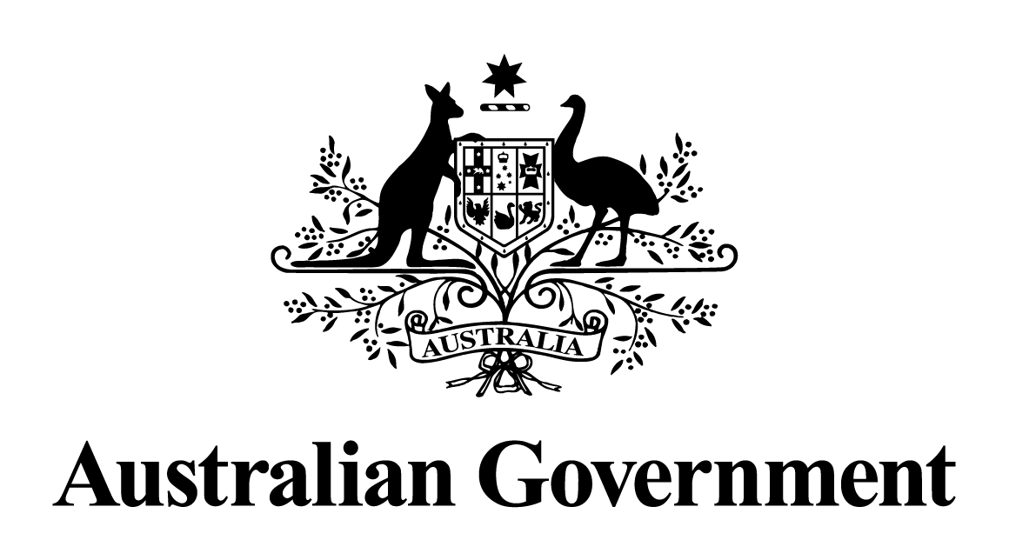
Australian Government response to the
Select Committee on PFAS (per and polyfluoroalkyl substances) report:
Interim Report
November 2025

Contents
Overview 3
Australian Government response 4
Recommendation 1: 4
Recommendation 2: 5
Recommendation 3: 7

Overview
On 22 August 2024, the Senate appointed the Select Committee on PFAS (per and polyfluoroalkyl substances) (the Committee). The Committee is currently inquiring into the extent, regulation and management of PFAS in Australia. On 14 March 2025, the Committee tabled its interim report, which has a particular focus on the community of Wreck Bay, Jervis Bay Territory (JBT).
The Australian Government welcomes the interim report and the opportunity to respond to its 3 recommendations, specifically regarding the Wreck Bay Aboriginal Community. The government acknowledges PFAS can affect communities because it is known to be highly persistent, can migrate long distances in the environment via surface and ground-water, bio-accumulate in animals and plants, and enter the food chain and drinking water.
The Department of Infrastructure, Transport, Regional Development, Communications, Sport and the Arts (DITRDCSA) and the Department of Defence (Defence) are working together to support the Wreck Bay community with improved signage, messaging and information in relation to PFAS contamination. Both government agencies, along with other stakeholders, also meet regularly to share information and discuss JBT governance and service delivery to ensure high quality service provision in the territory.
The government takes PFAS issues seriously given the potential impacts of PFAS contamination on humans, communities, and the environment. The government acknowledges PFAS is a significant environment, health and cultural concern for many communities across Australia, including the Wreck Bay community. The government recognises PFAS contamination is a complex and evolving subject, and is committed to evidence-based decision making and transparent community engagement. The government is establishing a National Coordinating Body (NCB) to improve management responses to PFAS from a whole of government perspective. Australian and state and territory ministers will oversee the NCB, to improve management responses to PFAS and guidance to meet the needs of individual communities.
Both Defence and DITRDCSA are administering Australian Government PFAS investigation programs, with Defence responsible for the PFAS Investigation and Management Program covering Defence bases and DITRDCSA investigating contamination at civilian airports through the PFAS Airports Investigation Program.
Airservices Australia, a portfolio agency of DITRDCSA, is also conducting investigative work, with a National PFAS Management Program covering its operational sites at civilian airports.
The government is aware that there will be more to do as PFAS investigations progress, and thanks the Committee for its diligence and thoroughness in inquiring into PFAS in Australia. The government also thanks those organisations, community groups and individuals that have made submissions to, or appeared at hearings for this inquiry.
This government response should be read alongside the following submissions to the Committee’s inquiry, which both discuss PFAS in the JBT:
- Defence; and
- DITRDCSA.

Australian Government response
The Australian Government’s response to interim report is set out in detail below.

Recommendation 1:
1.38 The committee recommends that the Senate reappoints the Select Committee on PFAS (per and polyfluoroalkyl substances) in the 48th Parliament, granting access to the evidence and documents collected during the 47th Parliament.
The Australian Government notes this recommendation and acknowledges this is a matter for the Senate.

Recommendation 2:
5.71 The committee recommends that the Department of Defence and the Department of Infrastructure, Transport, Regional Development, Communications and the Arts work with the Wreck Bay Aboriginal Community Council, and other relevant stakeholders, to improve signage, messaging and information provided to the community.
The Australian Government agrees to this recommendation.
The government recognises the testimonials and concerns of the Wreck Bay community reflected in the interim report. The government, through DITRDCSA and Defence, will consider ways to improve communication and will continue to work together and collaboratively with other stakeholders to support the Wreck Bay community to understand and manage the impacts of PFAS contamination.
Government agencies, including Defence, DITRDCSA, Wreck Bay Aboriginal Community Council (WBACC), the New South Wales Environment Protection Authority and the ACT Chief Minister, Treasury & Economic Development Directorate, regularly meet to coordinate the response to PFAS contamination at Jervis Bay. The government will continue to work with these groups to facilitate consistent, relevant and timely communications with the community regarding ways to minimise PFAS exposure.
Defence has First Nations staff who lead engagement with communities, including Wreck Bay, in a culturally appropriate way. Defence has held 10 community engagement sessions to discuss PFAS contamination on and around Jervis Bay Range Facility and HMAS Creswell. The last engagement was held on 13 February 2025, to discuss upcoming remediation works program at Jervis Bay Range Facility and the wider government response to PFAS contamination. Defence will continue to consult with the Wreck Bay community to keep them informed about remediation planning at Jervis Bay Range Facility and HMAS Creswell. The government and the Wreck Bay community are planning their next engagement for mid-2025. This engagement will focus on sharing findings from recent sampling events, and remediation work progress with community members.
Defence is also training local Wreck Bay community rangers to undertake PFAS sampling, to promote community involvement and transparency regarding monitoring for PFAS at off base locations. The first training occurred in May 2025.
The government is working with the Wreck Bay community to update all signs to improve community awareness and understanding at key locations across the JBT, including Summercloud Creek and Mary Creek. It is anticipated that co-designed signs will have greater community acceptance and will more successfully inform the community of the risks associated with PFAS.
The government is developing a community survey to receive updated information about how the community interacts with the environment, including their use or consumption of flora and fauna, and the community’s suggestions for additional sampling locations. This information and sampling data will inform updates to Defence’s Human Health Risk Assessment for PFAS contamination at Jervis Bay and will be considered in relation to precautionary advice and signage.
The government also provides a monthly community bulletin to the JBT residents, and publishes it on DITRDCSA’s website, to advise of PFAS levels in the drinking water, which is tested monthly. The level of PFAS in JBT’s drinking water is many times below the guideline level set by the current and proposed National Health and Medical Research Council’s Australian Drinking Water Guidelines 2011.

On 5 December 2024, the government released its response to the Independent Review of land uses around key Defence bases impacted by PFAS contamination. The government committed to providing clear and transparent advice on PFAS risks, along with clear English, location-specific information to help communities better understand how they can use their land.

Recommendation 3:
6.77 The committee recommends that Parliament considers referring an inquiry to the Joint Standing Committee on the National Capital and External Territories which examines governance, representation, and service provision in the Jervis Bay Territory (including the Wreck Bay Aboriginal community settlement).
The Australian Government notes this recommendation.
The Jervis Bay Territory Acceptance Act 1915 and Jervis Bay Territory Ordinances made by the Governor-General are administered by the Minister with responsibility for Territories.
The government facilitates state and local government-type services to JBT residents through agreements with the ACT and NSW governments, Shoalhaven City Council and non-government providers.
Under this remit, DITRDCSA, along with Defence, Australian Federal Police, National Indigenous Australians Agency (NIAA), and Parks Australia, regularly meet to share information and discuss JBT governance and service delivery issues, to ensure high quality service provision in JBT.
A new Wreck Bay Community Service Delivery Executive Committee has been established to ensure government service delivery responsibilities for the Wreck Bay community are being met and delivered in a coordinated approach. Membership will comprise representatives from the WBACC, the NIAA, DITRDCSA, Defence and the Australian Federal Police.
Members will work together to address any gaps identified in the delivery of government responsibilities to Wreck Bay Village, engaging with the relevant service providers and subject matter experts.
The government’s responsibilities to the Wreck Bay community are outlined below and are set out in the Memorandum of Understanding agreed in 1985 between the government and the Wreck Bay community:
- Essential Services
  - Water
  - Sewerage
  - Electricity
- Municipal Type Services
  - Domestic waste and recycling collection
  - Grass slashing in community areas
  - Litter collection
- Housing – construction and maintenance of houses
- Road Maintenance
- Maintenance of Summercloud Picnic Area
- Ongoing costs of WBACC to hold title and manage the land
- Enterprise funding.

