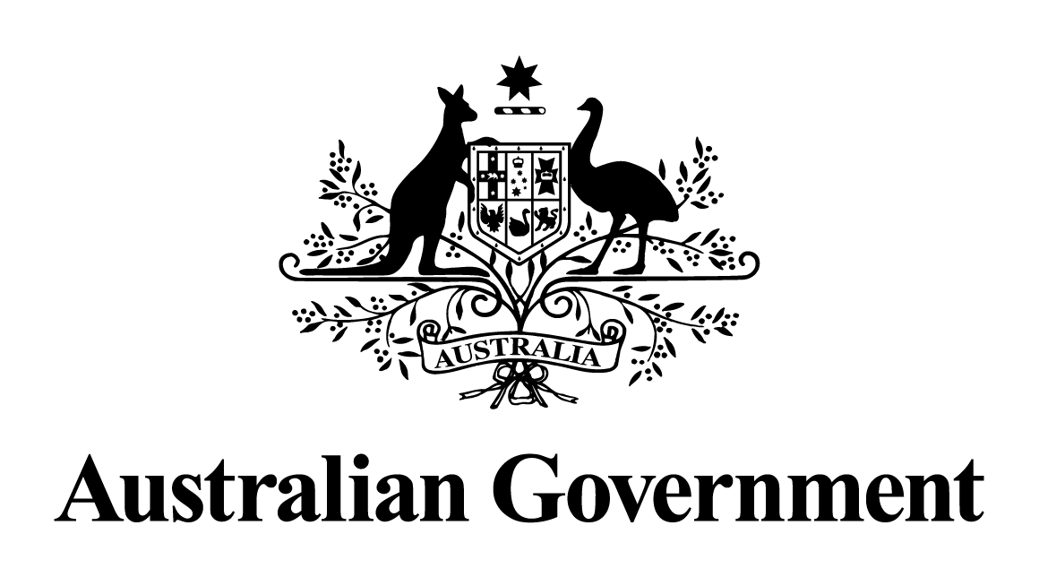

Australian Government response to the Senate Standing Committee on Environment and Communications report:
National Cultural Policy: Interim report
March 2026

Contents
Overview 3
Australian Government response 4
Recommendation 1: 4
Recommendation 2: 5
Recommendation 3: 6

Overview
The Australian Government notes the Senate Standing Committee on Environment and Communications’ Inquiry into National Cultural Policy: Interim report.
The development of the National Cultural Policy, Revive: a place for every story, a story for every place (Revive), was a 2022 election commitment and responded to a recommendation in the October 2021 House of Representatives Standing Committee on Environment and Report: Sculpting a National Cultural Plan: Igniting a post-COVID economy for the arts: Inquiry into Australia’s creative and cultural industries and institutions.
Launched in January 2023, Revive responds to the historical underfunding of the cultural and creative sector and challenges arising from the COVID-19 pandemic. Post-pandemic, recovery has been further affected by cost of living pressures, rising operational costs, extreme climatic events, and changed consumer and industry behaviours.

Australian Government response

Recommendation 1:
1.57 The Committee recommends the Australian Government consider, as a matter of priority, the provision of immediate funding support to the festivals sector.
The government notes this recommendation.
Engagement with stakeholders on the next National Cultural Policy is underway, and issues affecting the festivals sector are expected to be raised through public consultation.
Music Festivals – Revive Live
The Australian Government recognises the challenges faced by the live music industry, and the importance of a strategic approach to public investment in music festivals.
Since 2024-25, the Government has committed $25 million through Revive Live to support live music venues and festivals showcasing Australian artists.
Music Australia
Established under Revive, Music Australia was launched in 2023 within Creative Australia to support and invest in the Australian contemporary music industry. Revive includes dedicated funding for Music Australia of $69.4 million over 4 years. Music Australia’s remit includes the broad ecosystem of contemporary music, from creation and recording to live performance and market development.
Regional Festivals
As part of Revive, the Australian Government committed to the continuation of the Festivals Australia program. Festivals Australia was established in 1995 and funds arts and cultural projects in regional and remote communities for the benefit of participants and audiences.
In the 2024-25 financial year, Festivals Australia provided approximately $1.4 million in support to regional festivals and on-off community celebrations, and continues to contribute to the ongoing sustainability of arts and culture in regional and remote Australia.

Recommendation 2:
1.58 The Committee recommends the Australian Government lead coordination with the festivals sector and insurance industry to reduce premiums for festivals and investigate options for ensuring access to insurance is available to small and medium operators.
The government notes this recommendation.
Engagement with stakeholders on the next National Cultural Policy is underway. Issues affecting the festivals and the insurance industry are expected to be raised through public consultation.
Further, the Parliamentary Joint Committee on Corporations and Financial Services is undertaking an inquiry into the provision, regulation, and pricing of modern insurance products for small businesses and not-for-profit and community organisations. This includes consideration of the affordability and availability of insurance products in high-risk industries. The Committee is due to report by 27 October 2026.

Recommendation 3:
1.63 The Committee recommends the Australian Government prioritise the introduction of its legislative reforms for local content requirements for streaming services to the Australian Parliament.
The government has delivered this recommendation.
The passage of the Communications Legislation Amendment (Australian Content Requirement for Subscription Video on Demand (Streaming) Services) Act 2025 ensures Australians have guaranteed access to local stories across major streaming platforms and provide vital support for our domestic screen sector and arts workers.

