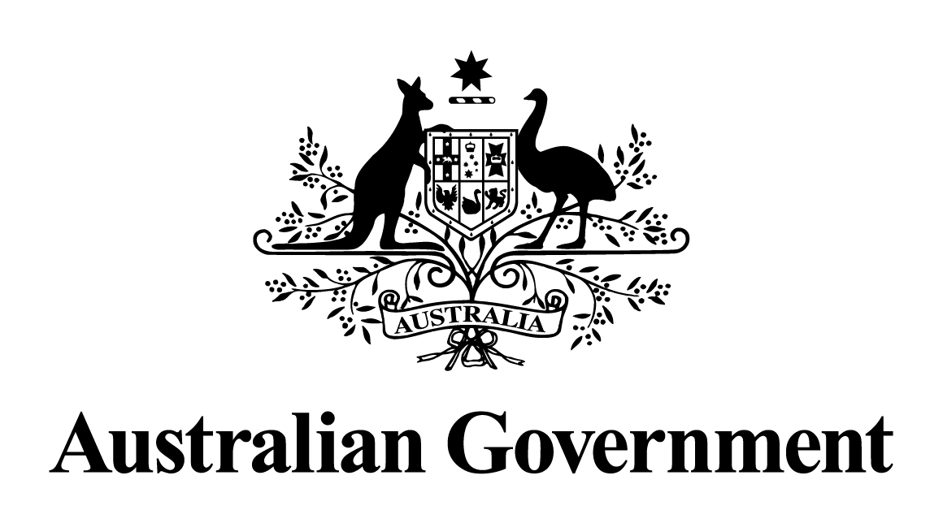

Australian Government response to the Senate Environment and Communications References Committee report:

Internet Search Engine Services Online Safety Code and under 16 social media ban
March 2026

Contents
Australian Government response 3
Recommendation 1: 3
Recommendation 2: 4
Recommendation 3: 5
Recommendation 4: 6

Australian Government response
The Australian Government’s response to the Report on ‘Internet Search Engine Services Online Safety Code and under 16 social media ban’ is set out below.

Recommendation 1:
3.47 The committee recommends that the implementation of the Social Media Minimum Age obligation be delayed until 10 June 2026 to allow time for the issues in implementation and compliance to be properly considered and an education campaign for young people affected to be rolled out.
The Government notes this recommendation.
The social media minimum age came into effect on 10 December 2025. A 12-month period between passage of the legislation and commencement of the obligation provided industry with time to implement appropriate age assurance systems to detect and remove under 16 accounts.
On 11 December 2025, the eSafety Commissioner gave information-gathering notices to 10 major age-restricted social media platforms, seeking information on their compliance with the social media minimum age obligation. Preliminary data shows about 4.7 million under-16 accounts on age-restricted social media platforms were removed or restricted within days of the obligation taking effect.
The eSafety Commissioner will continue to assess compliance with the law and expects platforms to continuously improve their efforts to detect and remove access to under-16 accounts.
The Government has been clear publicly, and with platforms, that there is no expectation that every user under 16 will be off age-restricted social media platforms. Instead, the onus is strictly on platforms to take reasonable steps to prevent age-restricted users having accounts on their platform.
To support the implementation of the obligation, the Government invested $20 million into the national public awareness campaign. That campaign launched on 19 October 2025 and will continue through to April 2026. The campaign supports parents, carers and young people under 16 prepare for, and navigate the changes, and directs them to the range of resources available on the eSafety Commissioner’s website.
There will also be an independent review of the legislation initiated within 2 years of effective commencement of the social media minimum age obligation.

Recommendation 2:
3.48 The committee recommends that the Australian Government legislate a digital duty of care to make online platforms safer for all users.
The Government agrees to this recommendation and has announced its intention to legislate a digital duty of care under the Online Safety Act.
A duty of care will require online services to take reasonable steps to prevent foreseeable harms and create a safer online environment.
Work is underway to develop a model appropriate to the Australian context and in line with community expectations. The Department of Infrastructure, Transport, Regional Development, Communications, Sport and the Arts has conducted a public survey and has engaged in a series of meetings with young people, with industry and with key community organisations to inform the design of a digital duty of care model.

Recommendation 3:
3.49 The committee recommends that the Australian Government legislate to prohibit platforms from harvesting and exploiting the data of minors and protect young people from targeted, unsolicited advertisements and algorithms as a matter of priority, with a view for this to apply to all users in the long-term to protect all Australians’ safety and privacy.
The Government agrees in principle with this recommendation.
The Government is acting to ensure young Australians are safe online and to uplift personal data protections for all Australians.
The Privacy and Other Legislation Amendment Act 2024 (Cth) (Privacy Amendment Act) represented the first stage of the Government’s commitment to uplifting Australia’s privacy laws. It contains the framework for the Australian Information Commissioner to develop a Children’s Online Privacy Code (Code), which must be registered by December 2026. The Code will specify how the Australian Privacy Principles must be met by social media and other online services (including websites, apps and online gaming services) likely to be accessed by children. The Government provided almost $3 million to support the Code’s development.
The Government is committed to ensuring the Privacy Act is fit for purpose in the digital age and is continuing work on a second tranche of privacy reform. Relevant reforms under consideration include requiring information handling to be fair and reasonable in the circumstances and clarifying obligations relating to direct marketing and targeting.
In parallel to updating Australia’s privacy framework, the Government is alert to ensuring that our criminal laws are fit-for-purpose to protect Australians’ online safety and that they remain responsive to new and emerging online harms.
The Government is also aware of the security risks stemming from the collection, aggregation and trade of data derived from Australians – including that which falls outside the scope of existing privacy regulation. This data is purchased via commercial data markets and used by digital marketers, and others, to build detailed profiles of individuals’ online habits and patterns of life. The Government is seeking to uplift industry practices and improve transparency to reduce potential harms via the 2023-2030 Australian Cyber Security Strategy.

Recommendation 4:
3.50 The committee recommends that the eSafety Commissioner roll out an education program, including through schools, that delivers clear information to young people about the platforms that are covered by the Social Media Minimum Age obligation and what the impacts on young people will be, as well as information about digital literacy and online safety
The Government agrees in principle to this recommendation.
The Government acknowledges that the social media minimum age is a significant change, which is why a range of resources have been developed to support children and young people, parents and carers, and educators with the changes.
On 19 October 2025, the national campaign ‘For the good of their wellbeing’ was launched to support parents, carers and young people under 16 prepare for and navigate the changes. The $20 million campaign consists of paid advertising, public relations, community and cultural outreach activities and will run until April 2026.
As part of the campaign, information kits have been distributed to secondary schools, youth peak bodies and organisations, youth services, public libraries, councils, and sporting networks nationally.
State and territory education sectors, school principals and frontline mental health organisations like headspace, ReachOut and Beyond Blue, have also received a digital information kit, which provides information about the social media minimum age, what it means for young people, and addressing some of the myths about the laws. The kit contains resources such as factsheets, flyers and presentations that can be printed and distributed directly by organisations to their networks.
Concurrently, the eSafety Commissioner launched a comprehensive online hub at www.esafety.gov.au/about-us/industry-regulation/social-media-age-restrictions-hub. The hub incorporates advice and support for educators, parents, carers and young people. It includes tailored FAQs explaining what is happening, a list of the platforms the eSafety Commissioner has assessed as age-restricted social media platforms and information on how to prepare for the change. The hub includes conversations starters, a digital literacy resource, get-ready guides, a video series for schools and parents and carers, downloadable action plans, health and wellbeing advice, and support for reporting online harms to eSafety if things go wrong. It also links to a series of webinars for parents, families and educators.
The hub adds to eSafety’s existing support for students, educators and families, and includes ongoing engagement with and support of the National Online Safety Education Council (NOSEC), Parent Advisory Group, eSafety Champions and Trusted eSafety Provider Program.
Government has also invested into broader efforts to improve digital literacy and online safety.
The eSafety Commissioner is Australia’s independent regulator and educator for online safety. Their primary purpose is to help safeguard Australians at risk of online harms and to promote safer, more positive online experiences. The eSafety Commissioner provides evidence-based, age-appropriate resources, training, and frameworks to educators, parents, and community members.
Under the National Strategy to Prevent and Respond to Child Sexual Abuse 2021-2030, the eSafety Commissioner received funding to deliver targeted online safety education that helps parents and families to recognise and prevent harmful behaviours online, focussing on issues related to online child sexual abuse and child safety.

The government has provided $12 million to the Alannah and Madeline Foundation (AMF) for delivery of its ‘Safe Kids are eSmart kids’ digital and media literacy education program in Australian schools. This program provides schools with free tools to teach kids how to be safe, smart and responsible in the digital world.
AMF have also developed new resources to support understanding and preparedness for young Australians, their families, and educators about the obligation. This includes family info sheets, teacher resources, and student worksheets available for free on their website. Additionally, a news post with information on affected platforms, digital literacy, online safety and impacts to young people was directly emailed to over 13,000 contacts and shared via social channels.
The government has committed $450,000 to SmackTalk to expand their program to better protect young Australians from online sextortion. It will broaden their reach and support development of free resources and education on risks, warning signs, and safety strategies for young Australians, parents, and community members. Funding will also support ongoing learning and strengthen collaboration with eSafety, law-enforcement agencies, schools, and community groups.
The Australian Federal Police (AFP), in partnership with state and territory police and industry partners, delivers the ThinkUKnow prevention and education program to students, parents, carers and educators. The program provides schools, community groups and organisations with free presentations addressing online child sexual exploitation including self-generated child abuse material, online grooming, and sexual extortion. It encourages help seeking behaviour and encourages reporting to the AFP-led Australian Centre to Counter Child Exploitation no matter the age or platform the abuse has taken place on.

