OFFICIAL

Apply for a low ATM trailer concessional RAV entry approval
  - ROVER Guide
August 2026

This guide steps you through a concessional RAV entry approval application for a low ATM trailer—a trailer with an aggregate trailer mass of 4.5 tonnes or less. It provides details on the information and documentation you will need to include in your application for either single or multiple (up to 4) trailers. This guide also includes how to check the status of your application.
Recommended browsers: Chrome, Firefox and Microsoft Edge.

Applying for a low ATM trailer concessional RAV entry approval
To apply for a low ATM trailer concessional RAV entry approval, ensure you are signed in to ROVER (navigate to Welcome to ROVER and select the Sign in button) and complete the following steps.
- Select the Applications icon.
- Select the New Application button.
- Select Single Road Vehicle approval from the dropdown options.
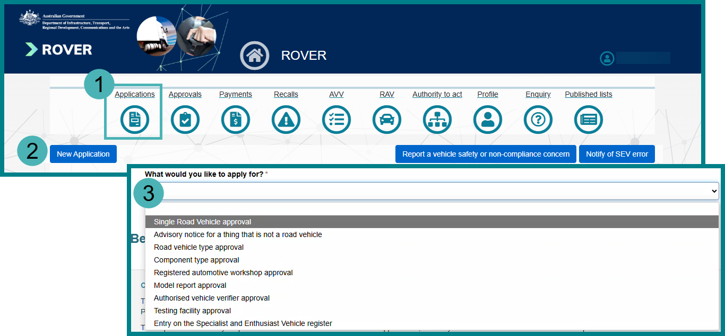
- Select No. This Vehicle is not on the RAV and does not have an MVSA plate from the dropdown options. If you are unsure you can read the text in the blue box.
- Select Yes from the dropdown options to confirm the vehicle is for road use.
- Read the Privacy Policy and select the checkbox to acknowledge you have read and understood the declaration.
- Select the Begin Application button.
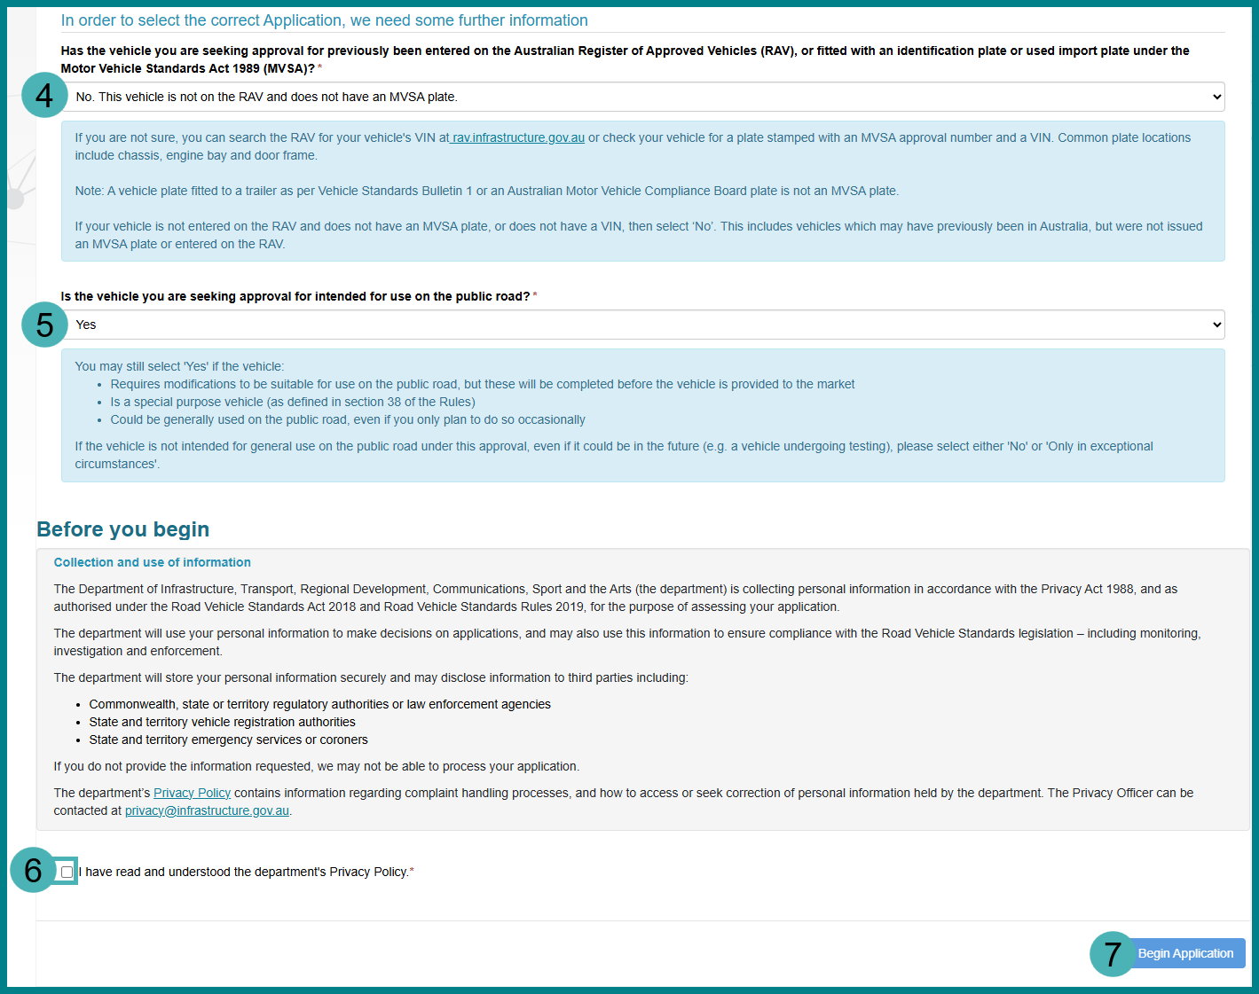
- Select the applicant from one of the following options:
  - Select the Someone else checkbox and the correct organisations or individuals from the dropdown options.
  - Select the Myself checkbox.
- Select the Save and Next button
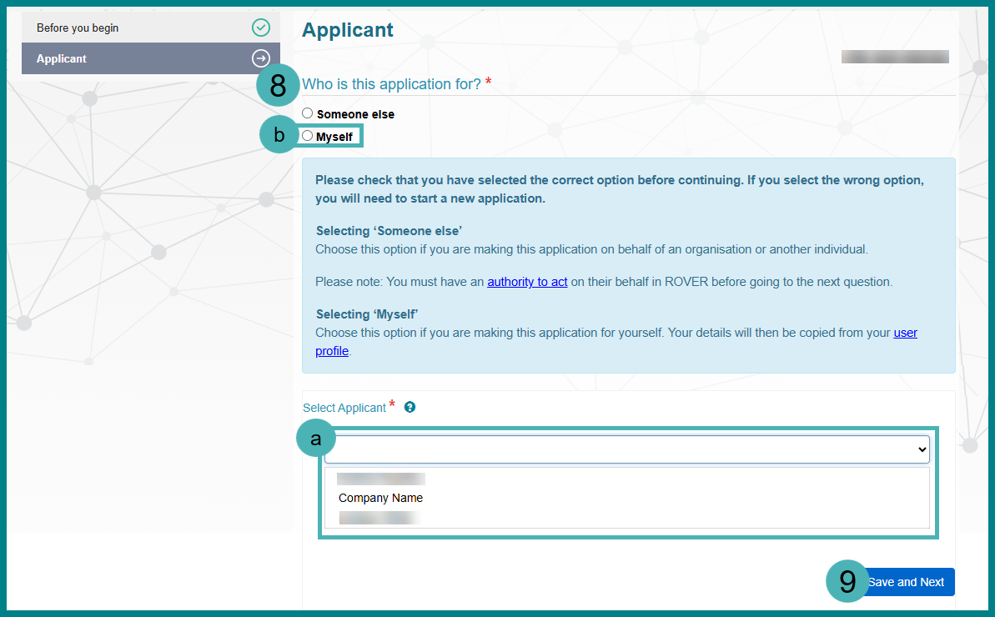
- Select Trailer (with an ATM less than or equal to 4,500 kg) from the dropdown options.
- Select the Single trailer checkbox.
- Select the New or Used checkbox.
- Select Yes or No to confirm whether the application will cover multiple identical vehicles.
- Select the relevant vehicle category from the dropdown options.
- Select the checkbox to confirm you are ready to proceed.
- Select the Save and Next button.
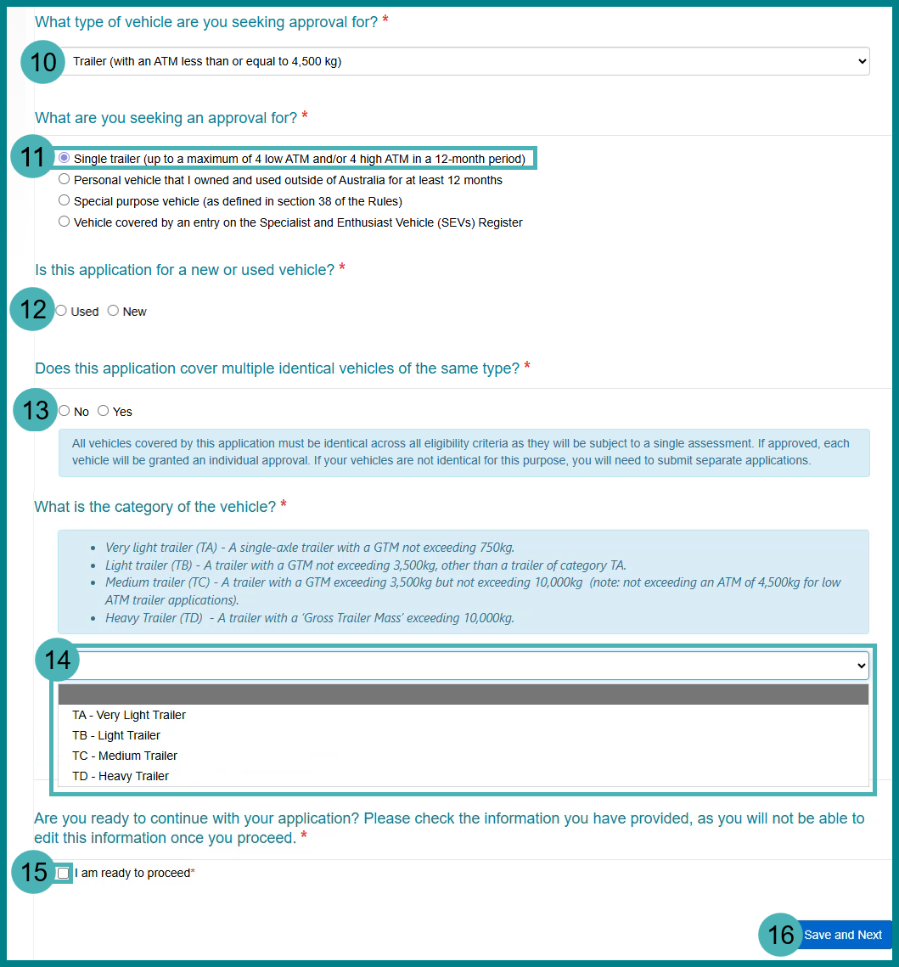

Add vehicle details
- Enter the Make. For example, you are unsure or the trailer is home-built, you can select Other and manually enter Concessional Trailer in the free text field.
- Enter the Model.
- Enter the Year.
- Enter the Month in numerical form. For example, enter 11 instead of November.
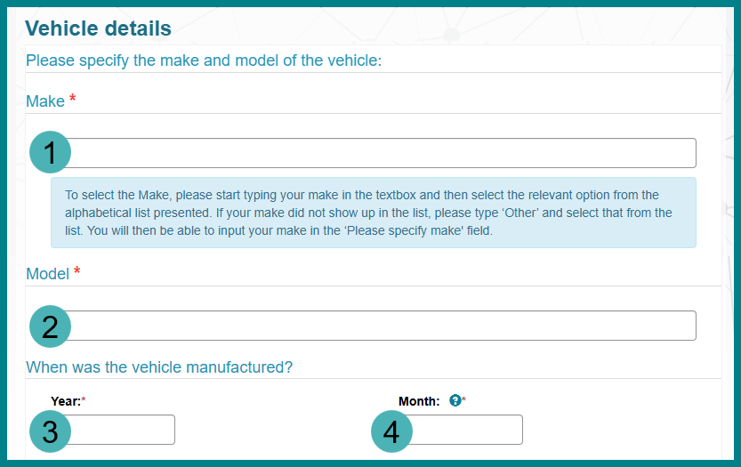
- Select either Yes or No from dropdown options to confirm if the vehicle has a VIN/Chassis.
  - If you selected Yes, enter the VIN and/or Chassis into the free text fields. When adding multiple trailers, you must provide the VIN/Chassis for each trailer.
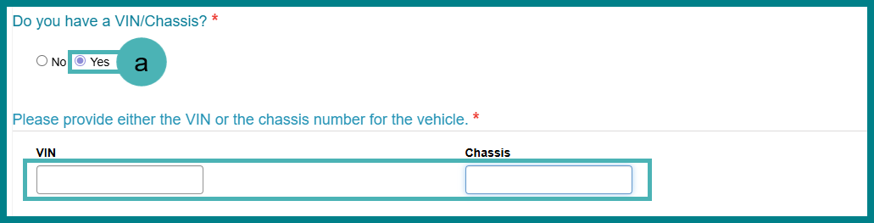
  - If you selected No, select the Yes checkbox to confirm you need a VIN. When adding multiple trailers, you must provide the build date for each trailer.
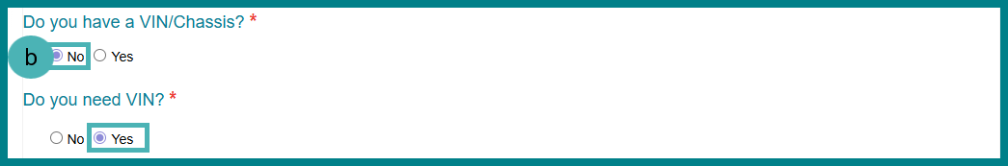
- Select the relevant checkbox to confirm the owner of the vehicle.
- Enter into the free text field to support your selected checkbox.
- Upload the relevant document:
  - Select the Upload New button.
  - Select the Choose File button.
  - Select a .jpg, .png, .pdf or .bmp file type from your device.
  - Select the Open button.
  - Select the Upload button.
- Select the Save and Next button.
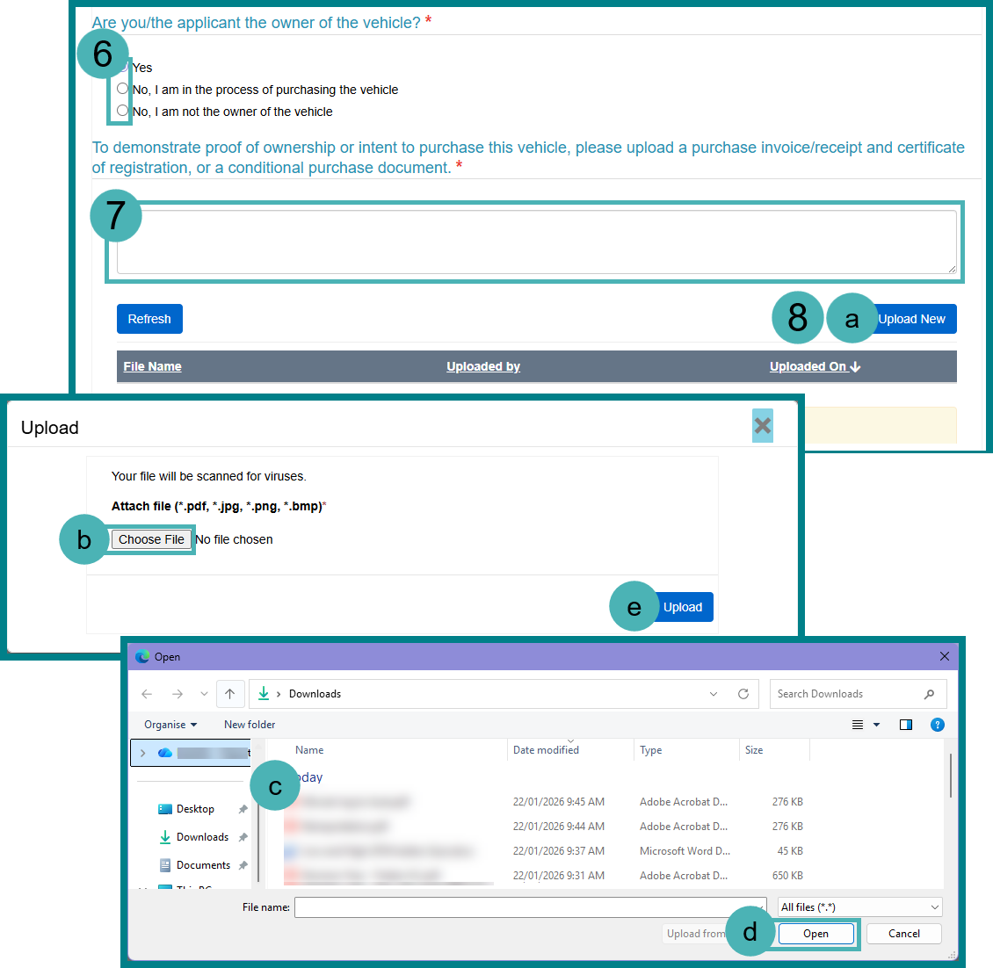

Supporting material for trailers
- Select the relevant Trailer Type from the dropdown options.
- Enter the Aggregate Trailer Mass.
- Enter the Gross Trailer Mass.
- Enter the Tare Mass.
- Upload the relevant supporting documents:
  - Select the Upload New button.
  - Select the Choose File button.
  - Select a .jpg, .png or .bmg file type from your device.
  - Select the Open button.
  - Select the Upload button.
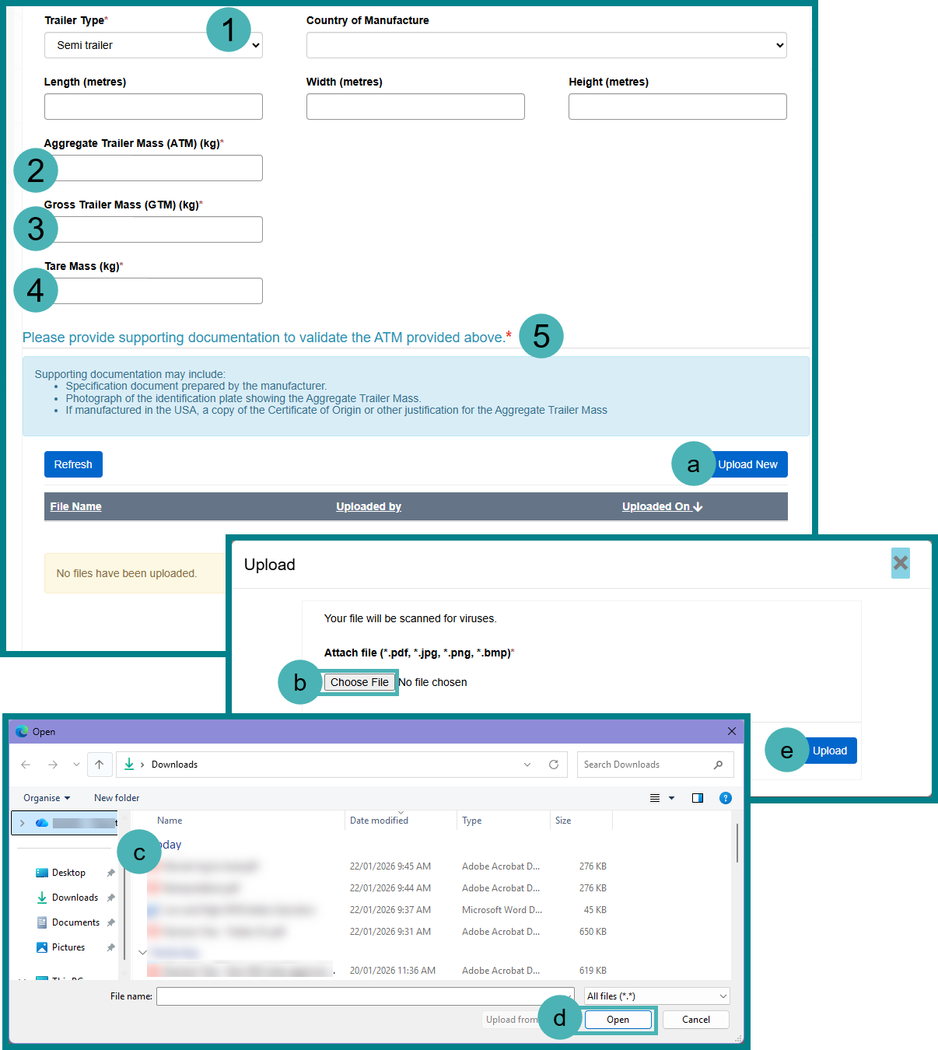
- Upload the relevant images:
  - Select the Upload New button.
  - Select the Choose File button.
  - Select a .jpg, .png or .bmg file type from your device.
  - Select the Open button.
  - Select the Upload button.
7. Select the Save and Next button.
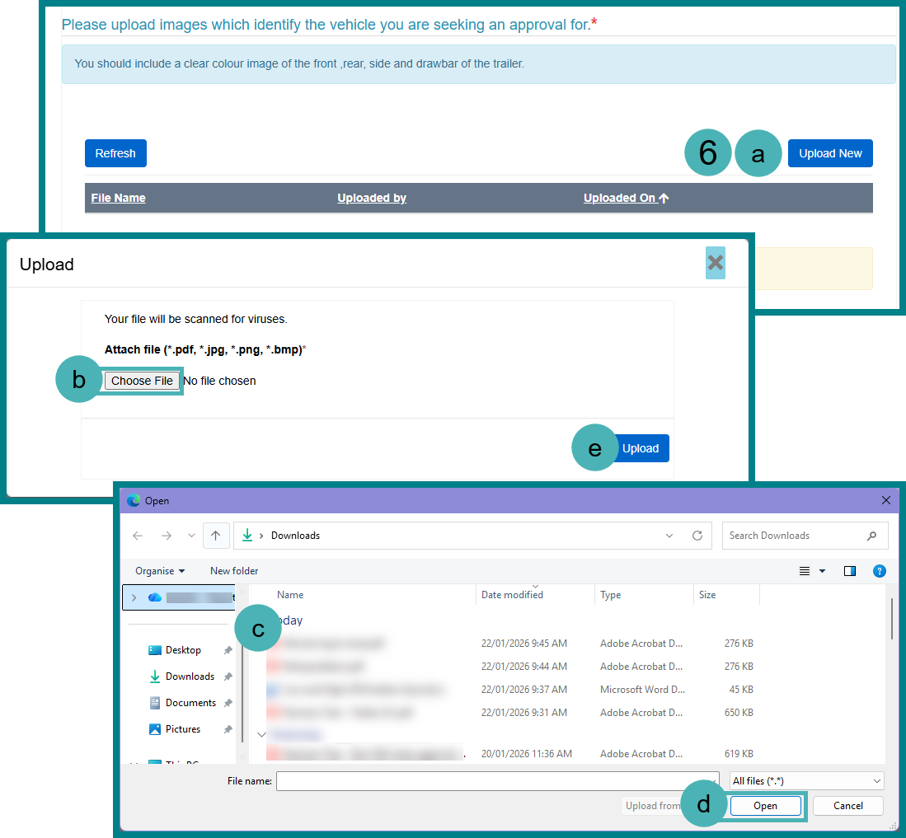

Extent of compliance
If your application is for a trailer that is not on the RAV and does not have an MVSA plate, you must indicate the trailers extent of compliance with the relevant Australian Design Rules (ADRs) and provide evidence demonstrating compliance. Upload any documents and comments for each ADR in the extent of compliance section and provide additional information in the Evidence of compliance section. Please note that you will have to provide evidence to submit your application. Read the Vehicle Standards Bulletin 1 (Revision 6)—Trailers with an aggregate trailer mass of 4.5 tonnes or less to understand which ADRs apply to trailers. If you are still unsure contact ROVERinfo@infrastructure.gov.au.
- Select the Extent of compliance for each applicable ADR.
- If you select anything except from fully compliant, provide information on intent of compliance in the free text field or select the Manage documents button. Complete the following steps for each ADR that is not fully compliant.
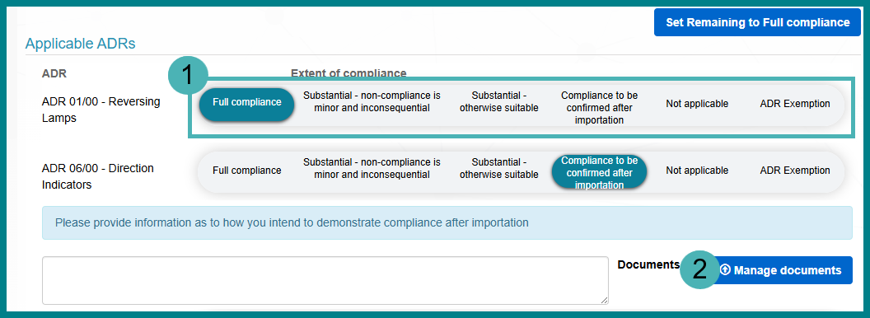
  - Select the Upload button.
  - Select the Choose File button.
  - Select a .jpg, .png or .bmg file type from your device.
  - Select the Open button.
  - Select the Upload button.
  - Select the Save and Close button.
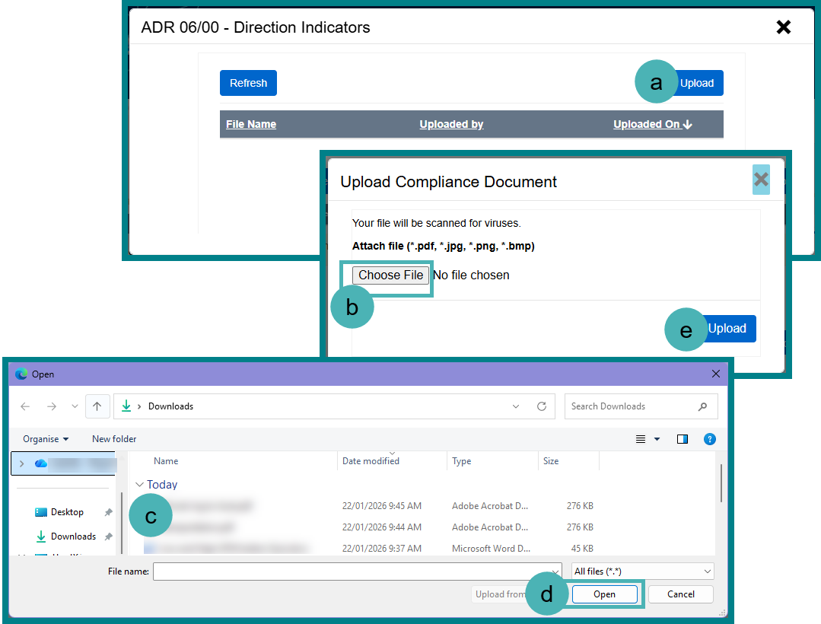
- Select the Add Evidence demonstrating Compliance page.
- Select the Add Evidence of Compliance button.
- Enter the Document reference number into the free text field to enable us to easily identify this evidence in your application. The document reference can be made up of letters and numbers of your choosing.
- Select the Add button.
- Select Save and Next button.
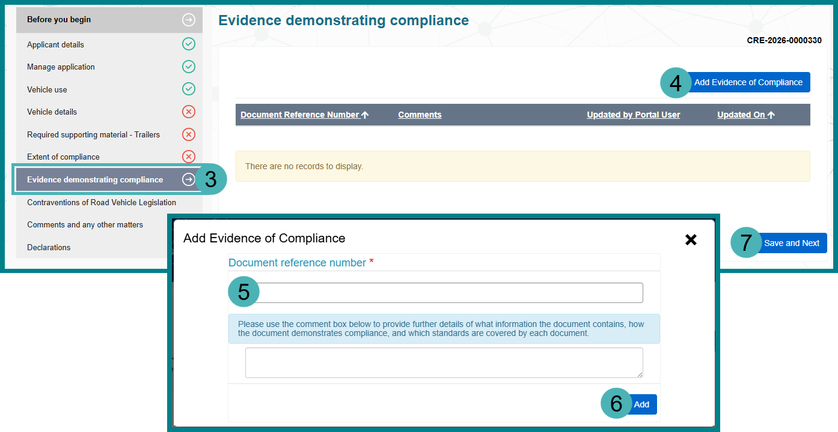

Contraventions of Legislation
- Select Yes or No checkbox.
  - If you selected Yes, provide further information in the free text box or upload documentation.
- Select the Save and Next button.
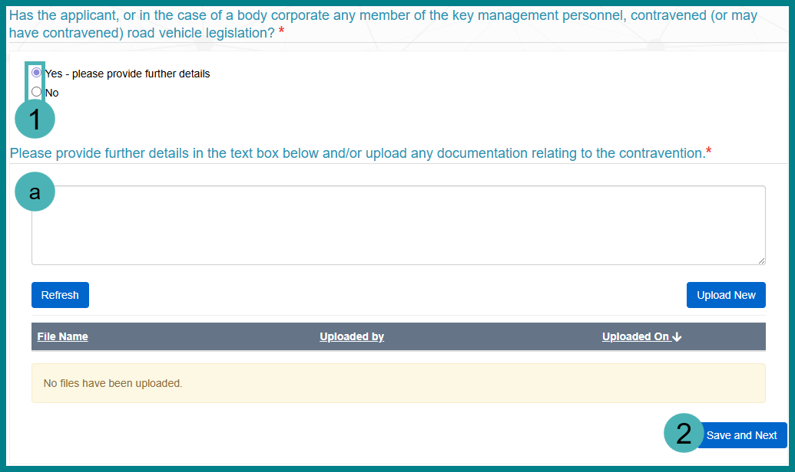

Complete the Declaration page
- Read the Declaration and select the checkbox to acknowledge you have read and understood the declaration.
- Select the Submit button.
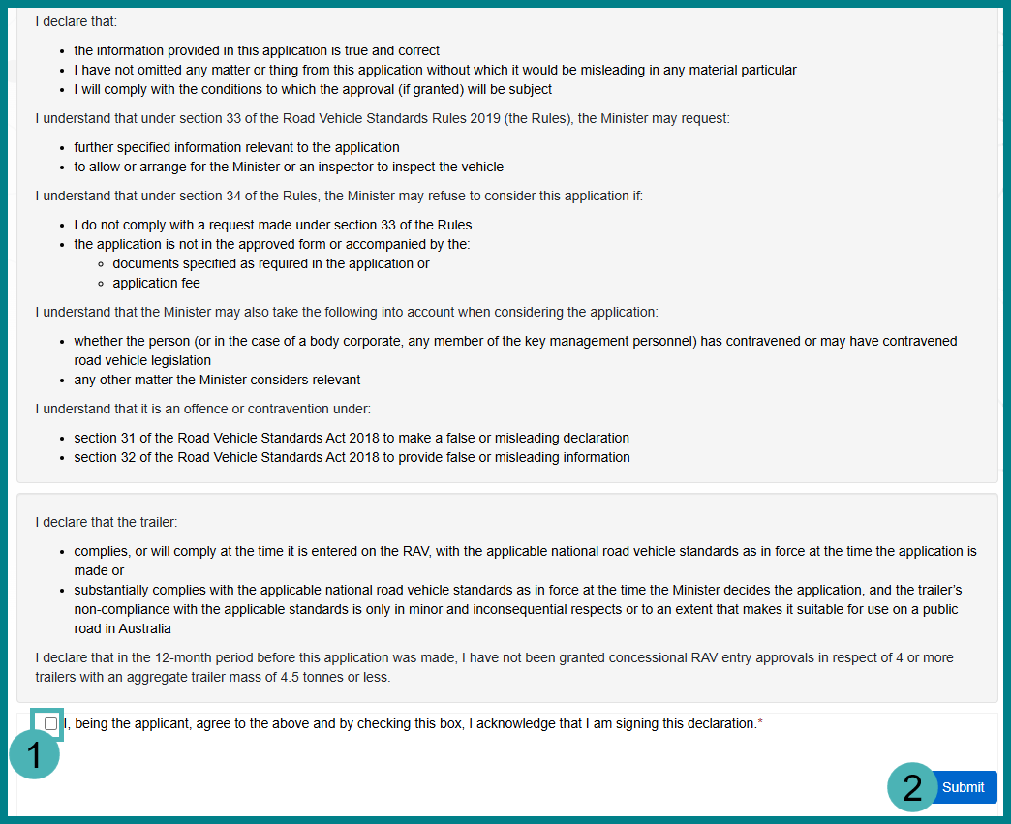

Check the application status
- Select the Application icon.
- Select the relevant application stage from the dropdown menu.
- View the Status column.
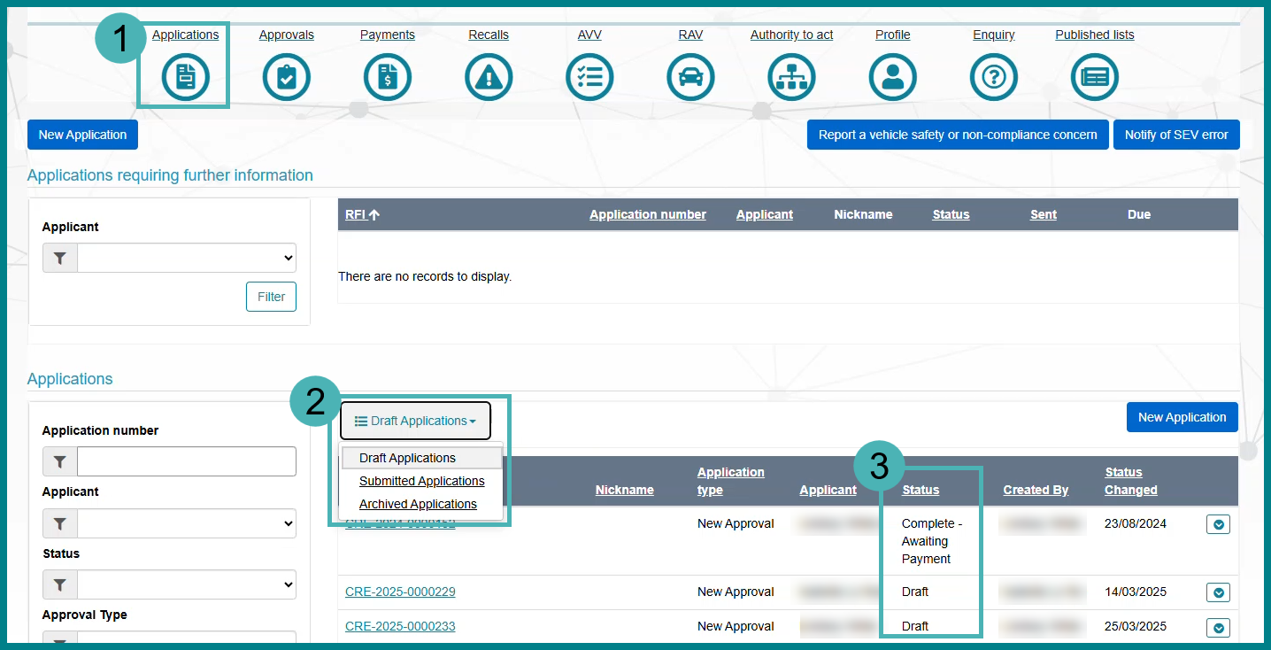

Further information
For further information, please visit Vehicles | Department’s website or submit an online enquiry via the Contact us—RVS | Department’s website page.

Quick links
- Welcome to ROVER
- ROVER application statuses and notifications
- RAV Public Search
- Road Vehicle Standards legislation | Department’s website
- RVS guides and resources | Department’s website
- RVS legislation glossary of terms | Department’s website
- Guide to concessional RAV entry approvals

