Australian Government,
Department of Infrastructure, Transport, Regional Development, Communications and the Arts

BUREAU OF COMMUNICATIONS, ARTS AND REGIONAL RESEARCH

# Analysis of the Cultural and Creative Sector

Revive: Sectoral Analysis

**December 2024**

The Department of Infrastructure, Transport, Regional Development, Communications and the Arts acknowledges the Traditional Custodians of Country throughout Australia and their continuing connection to land, sea and community. We pay our respects to them, their cultures and to their Elders, past, present and emerging.

© Commonwealth of Australia 2024

ISBN 978-1-922879-72-1 BCARR reference: 2024-1220

December 2024

Ownership of intellectual property rights in this publication

Unless otherwise noted, copyright (and any other intellectual property rights, if any) in this publication is owned by the Commonwealth of Australia (referred to below as the Commonwealth).

Disclaimer

The material contained in this publication is made available on the understanding that the Commonwealth is not providing professional advice, and that users exercise their own skill and care with respect to its use, and seek independent advice if necessary.

The Commonwealth makes no representations or warranties as to the contents or accuracy of the information contained in this publication. To the extent permitted by law, the Commonwealth disclaims liability to any person or organisation in respect of anything done, or omitted to be done, in reliance upon information contained in this publication.

*Unless otherwise noted, copyright (and any other intellectual property rights, if any) in this publication is owned by the Commonwealth of Australia (referred to below as the Commonwealth).*

Creative Commons licence



With the exception of (a) the Coat of Arms; (b) the Department of Infrastructure, Transport, Regional Development, Communications and the Arts photos and graphics; (c) content supplied by third parties; (d) content otherwise labelled; copyright in this publication is licensed under a Creative Commons BY Attribution 4.0 International Licence.

Use of the Coat of Arms

The Department of the Prime Minister and Cabinet sets the terms under which the Coat of Arms is used. For further information, please refer to the [Commonwealth Coat of Arms - Information and Guidelines](https://www.pmc.gov.au/resources/commonwealth-coat-arms-information-and-guidelines).

Contact us

This publication is available in PDF format. All other rights are reserved, including in relation to any departmental logos or trademarks which may exist. For enquiries regarding the licence and any use of this publication, please contact:

Email: [publishing@infrastructure.gov.au](mailto:publishing@infrastructure.gov.au)

Website: [www.infrastructure.gov.au](http://www.infrastructure.gov.au/)

Table of contents

Introduction 5

The post-COVID recovery has been challenged by cost of living pressures 7

Diverging trends are evident across the cultural and creative domains 12

Employment in traditional arts domains underperforms against national employment growth 14

Digital disruption continues to impact on business activity in media domains 15

Appendix A—Detailed analysis 16

A.1 Businesses in cultural and creative industries 16

Total businesses in cultural and creative industries 16

Businesses within cultural and creative domains 18

A.2 First Nations businesses in arts and heritage industries 22

A.3 Demographics of workers in cultural and creative industries 24

Employment in cultural and creative industries 24

Indicative employment trends in cultural and creative industries 25

Multiple job holders 26

Persons with a disability 27

A.4 Cultural and creative activities – attendance and participation 28

Attendance 29

Participation 30

Appendix B—Glossary 31

B.1 Domains 31

B.2 Businesses and employment within cultural and creative domains 32

B.3 Indicative employment within cultural and creative industries 33

References 35

Key Findings

**Cultural and creative activity plays an important role in Australia’s economy.** In 2022–23, businesses within the cultural and creative industries accounted for almost 4% of businesses (at over 95,700 businesses) and cultural and creative activities contributed 2.5% to Australia’s Gross Domestic Product (at $63.7 billion[1]). In 2021, employees within these industries comprised approximately 2.4% of total employment (at approximately 282,000 workers).[2]

**Many types of cultural and creative activities (known as ‘domains’) were more exposed to the challenges of the pandemic than other sectors of the economy, particularly those involving live performance and public exhibition.** Some of these domains are traditionally key contributors to total employment in cultural and creative industries.

**The arts and recreation services industry division could be considered inclusive.** Approximately 13.4% of workers in the arts and recreation services industry division had a form of disability in 2022, compared with 11.6% of Australia’s workforce.

**Cultural and creative activities (in aggregate) posted a recovery in employment, business counts and economic activity between 2021 and 2023, supported by the unwinding of COVID-related restrictions.** However, some domains within the cultural and creative sector experienced net reductions in businesses and employment, despite all domains expanding in terms of Gross Domestic Product over this timeframe.

**Cost of living pressures have intensified over 2024, and there are indications of pockets of instability within some domains.** Indicative employment in cultural and creative industries posted modest growth in the year to 2024. The arts and recreation services industry division (which can only be considered indicative of cultural and creative activities) has experienced an increase in underemployment and there has been a reduction in multiple job holding – though this work arrangement remains common at 8% of the arts and recreation services industry division workforce. Workers in the arts and recreation services industry division are also more likely to have changed industries than the average worker across all sectors of the economy.

**Attendance at cultural venues and events has fallen considerably from pre-COVID levels**. Between 2017–18 and 2021–22, the share of both adults and children who attended at least one cultural venue or event reduced significantly. In both instances, reduced attendance was particularly prominent for performing arts events and cinemas.

**Arts and heritage activities support a broad number of First Nations businesses across Australia.** In 2024, over 1,000 registered First Nations businesses were operating within arts and heritage industries, accounting for roughly 20% of all First Nations businesses.

## Introduction

Australia’s National Cultural Policy – [*Revive: a place for every story, a story for every place*](https://www.arts.gov.au/publications/national-cultural-policy-revive-place-every-story-story-every-place) – was released on 30 January 2023 and outlines a comprehensive framework for supporting the cultural and creative sector (Department of Infrastructure, Transport, Regional Development, Communications and the Arts, 2023).

An action listed in *Revive: a place for every story, a story for every place* was a refresh of the economic measure of cultural and creative activity. The purpose of this refresh was to ensure that estimates of the cultural and creative sector remain fit-for-purpose in our changing economy. The Bureau of Communications, Arts and Regional Research’s *Cultural and Creative Activity in Australia, 2008–09 to 2022–23 (Methodology Refresh)* working paper addresses this action. This Sectoral Analysis provides supporting guidance on metrics which are not reflected in the *Cultural and Creative Activity in Australia, 2008–09 to 2022–23 (Methodology Refresh)* working paper, such as businesses and employment, and adds some contextual analysis to the results.

This document is structured in two parts:

* The body of the report combines the key points from the datasets to describe the sector’s trajectory since 2021, with a key focus on the 2021 to 2023 period (with additional data provided for 2024 wherever available).
* A detailed analysis of the datasets is provided in *Appendix A—Detailed analysis**.*

Terminologies used in this paper

**Cultural and creative activity**

Cultural and creative activity refers to the economic activity generated from the production and support of goods and services created by cultural and artistic means. This activity is much larger than ‘the arts’ sector alone. It takes place across the economy and spans activities from architecture services to digital games development, from museums and galleries to design and fashion.

Cultural and creative activity is recognised as an important part of knowledge-based economies. In Australia, this activity makes a valuable contribution to our economic and social wellbeing. No universal definition of cultural and creative activity exists. Each country has different views on what they see as being cultural and creative, and each has a different way of measuring this activity.

Following a detailed review (refer to the *Cultural and Creative Activity in Australia, 2008–09 to 2022–23 (Methodology Refresh)* working paper), the approach to measuring this activity has changed and the scope is now narrower than it was previously. The methodology now captures cultural and creative activity based on detailed industries defined by the Australian and New Zealand Standard Industrial Classification and by products defined by the Input-Output Product Classifications. Where this definition of the sector has been applied, it has been referred to as ‘cultural and creative activity’.

The definition of the cultural and creative sector as applied in calculating cultural and creative activity is bespoke, and is not consistently replicable in published datasets from the Australian Bureau of Statistics. Many Australian Bureau of Statistics datasets are published by Australian and New Zealand Standard Industrial Classification industry only (excluding products), and even when produced by Australian and New Zealand Standard Industrial Classification, may not be available at a level detailed enough to replicate the industry component of cultural and creative activity.

In this report, we have applied a definition of the sector which best fits the granularity of data available for each metric. As a result, datasets presented within different sections of this report are not always consistent with each other. Care should be taken when comparing data across this report.

Future stages of the *Cultural and Creative Activity in Australia Methodology Refresh* may include other estimated metrics of cultural and creative activity (such as employment). In this instance, any estimates provided in this Sectoral Analysis would be considered less accurate than published estimates relating directly to cultural and creative activity.

**Cultural and creative industries**

This paper provides details on businesses and workers using industry-based data at varying levels of granularity from the Australian Bureau of Statistics. In these instances, the data reflects activities within cultural and creative industries only and has been referred to as ‘businesses/ workers in cultural and creative industries’.[3]

Employment data from the Australian *Census of Population and Housing* provides a better match for the cultural and creative industries than more regularly published data (such as the Australian Bureau of Statistics labour force data). In this report, data from the *Census of Population and Housing* has been used to provide an estimate of employment in cultural and creative sectors, and the less detailed labour force data has been used to provide an indication of trends since 2021. It is noted that some of Australia’s largest cities were in lockdown at the time of the 2021 *Census of Population and Housing* which may impact on the reported outcomes (Australian Bureau of Statistics, 2022a).

**Arts and recreation services industry division**

Where the industry-level data available is less detailed than required for data to be aligned with the cultural and creative industries, data relating to the arts and recreation services industry division has been applied. In these instances, the report’s findings should be considered indicative only.

**Cultural and creative activity domains**

Cultural and creative activity has been disaggregated into domains. These domains allow for analysis of trends within various types of cultural and creative activities, allowing for sectoral reporting.

In this report, we have aggregated some of the 15 domains provided in the *Cultural and Creative Activity in Australia, 2008–09 to 2022–23 (Methodology Refresh)* working paper to enable greater (but still imperfect) comparability of Gross Domestic Product and collected data on businesses and employment. In *Appendix A—Detailed analysis*, detailed domain information is presented for business counts and Census of Population and Housing employment, and less detailed domain information is presented for employment trends analysis.

For further details on definitions and correspondences applied in this paper, refer to *Appendix B—Glossary*.

## The post-COVID recovery has been challenged by cost of living pressures

The Australian economy was negatively impacted by the onset of COVID-19 and associated restrictions and health measures (Australian Bureau of Statistics, 2022b), resulting in a 5.8% decline[4] in employment in the financial year to June 2020, relatively low (1.8%) growth in Gross Domestic Product, and 2% growth in the number of businesses in operation (Australian Bureau of Statistics, 2023a; Australian Bureau of Statistics, 2024a).

Many cultural and creative activity domains were more exposed to the challenges of the pandemic than other sectors of the economy, especially those involving live performance and public exhibition.

Cultural and creative activities are also highly interconnected with the tourism sector (Creative Australia, 2018). Domestic visitors who undertake arts tourism on their visit[5] tend to stay longer and spend more than other visitors. In return, tourism is a key contributor to economic activity within the arts and recreation services industry division, contributing to approximately 17.2% of the arts and recreation services industry division’s Gross Domestic Product in 2022–23 (Australian Bureau of Statistics, 2023b). The closure of Australia’s borders (including state and territory borders) during the pandemic, and the resulting impact on tourism, flowed through to the arts and recreation services industry division. As a result, this industry recorded weaker economic outcomes than the national economy in this period.

As COVID response policies were unwound and borders opened, household spending recovered and business conditions improved, supporting an economic recovery (Australian Bureau of Statistics, 2022b). The economy posted strong employment and economic growth, as economic, tourism and social activities slowly returned to normal. Cultural and creative activity also benefited. In 2021, approximately 282,000 workers[6] were employed in cultural and creative industries (Australian Bureau of Statistics, 2022c). Trends from more recently published data (which reflect broader industries than the cultural and creative activities but may be indicative of trends in these industries) suggest the sector may have recorded 5% growth between 2021 and 2023 (Australian Bureau of Statistics, 2024a).

Over this timeframe, the number of businesses in cultural and creative industries increased by 8.9% to approximately 95,700 businesses (Australian Bureau of Statistics, 2023a), and, mirroring growth in the national economy, cultural and creative economic activity expanded by 22% to $63.7 billion (Figure 1) (in the period from 2020–21 to 2022–23).[7]

Figure 1. Change in cultural and creative metrics, 2021 to 2023

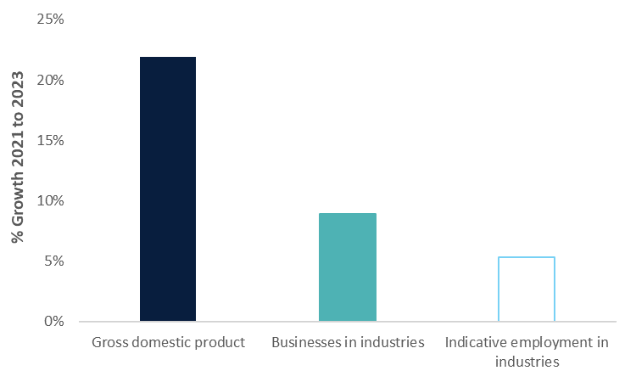

Note: The data published by industry for employment includes a range of activities beyond the cultural and creative scope. These estimates should therefore be considered as indicative only.

Source: Bureau of Communications, Arts and Regional Research, Australian Bureau of Statistics – Counts of Australian Businesses, including Entries and Exits, June 2019 to June 2023, Australian Bureau of Statistics – Labour Force, Australia, Detailed, August 2024.

Regularly published employment data is not a perfect match for the sector (and includes a number of activities which are beyond the scope of cultural and creative activities), but trends in this data may be considered as indicative of trends in employment in cultural and creative industries. This data suggests employment in the cultural and creative industries has historically been more volatile than total employment in Australia (see Figure 2). Cultural and creative activities which are typically unable to be conducted remotely (such as live performance and visual arts) experienced a sharp decline in employment in the very early months of COVID. Some of these activities, especially those involving live performance and public exhibition, have struggled to recover to pre-COVID levels (Australian Bureau of Statistics, 2024a).

Figure 2. Annual employment growth, indicative employment in cultural and creative industries and national employment, May 2014 to May 2024

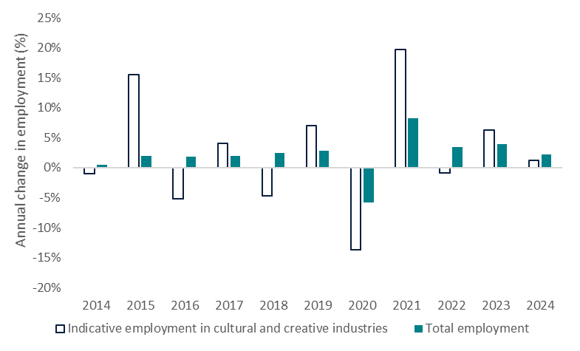

Note: All time periods presented are reported as of May in the year.

Source: Australian Bureau of Statistics – Labour Force, Australia, Detailed, November 2023.

There are signs of employment instability in some cultural and creative domains in 2024. Indicative employment in cultural and creative industries[8] posted modest growth of 1.2% in the year to 2024, underemployment in the arts and recreation services industry division has increased and multiple job holding in the sector has declined (Figure 3).

Figure 3. Change in selected arts and recreation services industry division metrics, May 2023 to May 2024

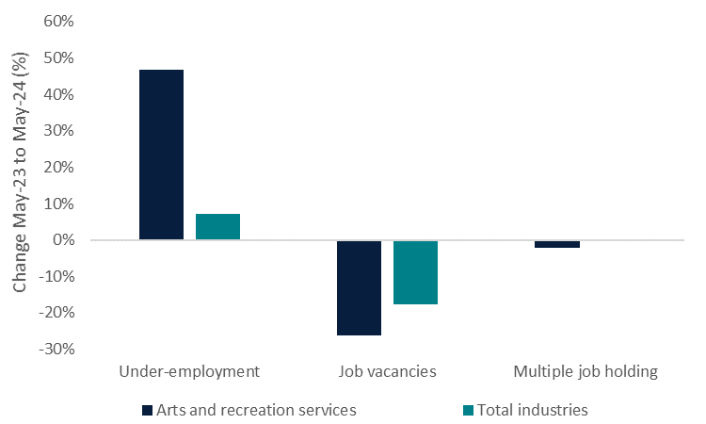

Source: Australian Bureau of Statistics – Multiple job-holders, June 2024, Australian Bureau of Statistics – Job mobility, February 2024, Australian Bureau of Statistics – Underemployed workers, July 2024.

Since 2022–23, the pace of national economic growth has been relatively slow, at 1.5%, reflecting subdued household demand (Australian Bureau of Statistics, 2024b). Cost of living pressures have impacted the purchasing power of households over the past year (Reserve Bank of Australia, 2024). Many cultural and creative outputs (such as theatre productions and music events and festivals) are considered as discretionary expenditure for households – and may be wound back in times of economic and financial uncertainty.

Recent surveys of Australians’ participation in cultural and creative activities indicate that Australians are attending arts and cultural events less frequently, despite wanting to attend more, primarily due to cost and location barriers (Creative Australia, 2023). Analysis of attendance at cultural venues and events indicates performing arts events and cinemas have experienced a marked drop in demand (Australian Bureau of Statistics, 2023c).

Spotlight on businesses in the cultural and creative industries[9]

In June 2023, businesses in the cultural and creative industries comprised approximately 3.7% of Australian businesses. Literature, creative and performing arts and visual arts and crafts was the most prominent domain within these industries (reflecting the prominence of self-employment within this domain), representing over 30% of cultural and creative businesses in the year, followed by the design and fashion domain which represented over 18% of businesses. Other domains comprising a prominent share of businesses, of over 10%, included architecture services, advertising and promotion and film and television activities (Figure 4).

Overall, businesses within the cultural and creative industries tend to be smaller in size than businesses in other industries. In June 2023, businesses within cultural and creative industries were more likely to record turnover of less than $200,000 per annum and be non-employing or have 1 to 4 employees than other businesses.

Figure 4. Cultural and creative domains share of businesses in cultural and creative industries, June 2023

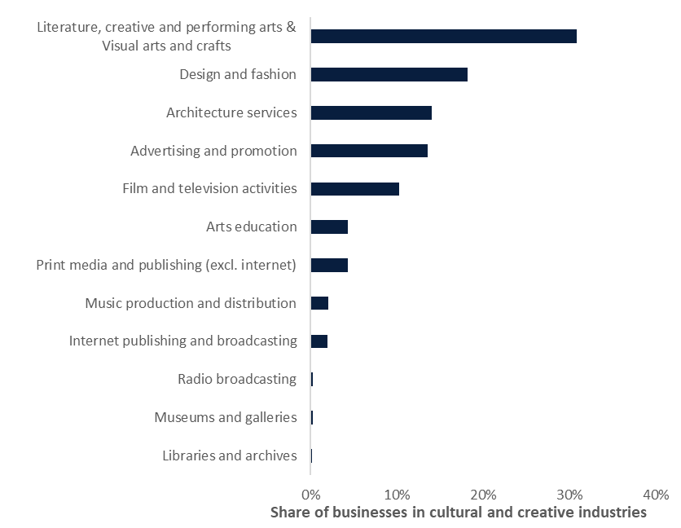

Source: Australian Bureau of Statistics – Counts of Australian Businesses, including Entries and Exits, June 2019 to June 2023.

Spotlight on First Nations Businesses

Approximately 20% of First Nations businesses[10] were in the arts and heritage industries in June 2024 (Office of the Registrar of Indigenous Corporations, 2024). These businesses are more likely to be defined (by a combination of employment, assets and income) as large or medium sized businesses than other First Nations businesses (representing 35% of these businesses, compared to 30% of all First Nations businesses). First Nations businesses in arts and heritage industries are more prominent as a share of total First Nations businesses in New South Wales, Queensland and Western Australia than other states.

Spotlight on employment in the cultural and creative industries[11]

In 2021, 281,986 workers were employed in cultural and creative industries (Australian Bureau of Statistics, 2022c). Between 2016 and 2021, the number of workers in these industries increased by 10.7%, slightly lower than the growth in national employment of 12.7%.

The most prominent domains contributing to total employment in cultural and creative industries in 2021 were literature, creative and performing arts and visual arts and crafts (17.1% of total), architecture services (16.7%) and advertising and promotion (14.9%).

Between 2016 and 2021, internet publishing and broadcasting posted the strongest employment growth of all the domains (at 34%) – lifting off a very small base (of less than 3,000 employees). Over this timeframe, the domains of advertising and promotion, and architecture services increased their share of total employment within cultural and creative industries by more than 1 percentage point each, whilst print media and publishing (excl. internet) reduced as a share of the total by approximately 2 percentage points (Figure 5) (driven by a 9.7% decline in employment).

Figure 5. Cultural and creative domains share of employment in cultural and creative industries, 2016 and 2021

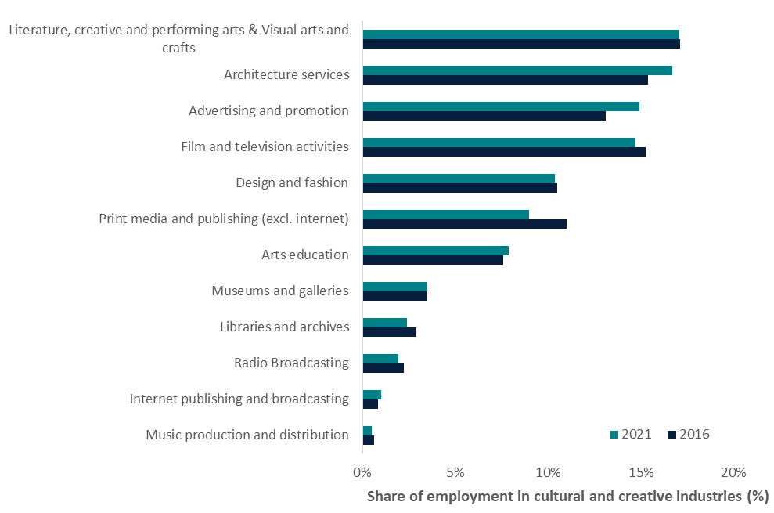

Source: Australian Bureau of Statistics – Census of Population and Housing (2016 and 2021).

Spotlight on indicative employment trends 2021 to 2023[12]

Data relating to indicative employment in the cultural and creative industries suggests domains such as museums and galleries, advertising and promotion and radio broadcasting all recorded strong rates of employment growth between 2021 and 2023. In contrast, internet publishing and broadcasting, music production and distribution, and literature, creative and performing arts and visual arts and crafts all recorded a reduction in employment over the period (Figure 6).

Figure 6. Indicative change in employment in cultural and creative domains, May 2021 to May 2023

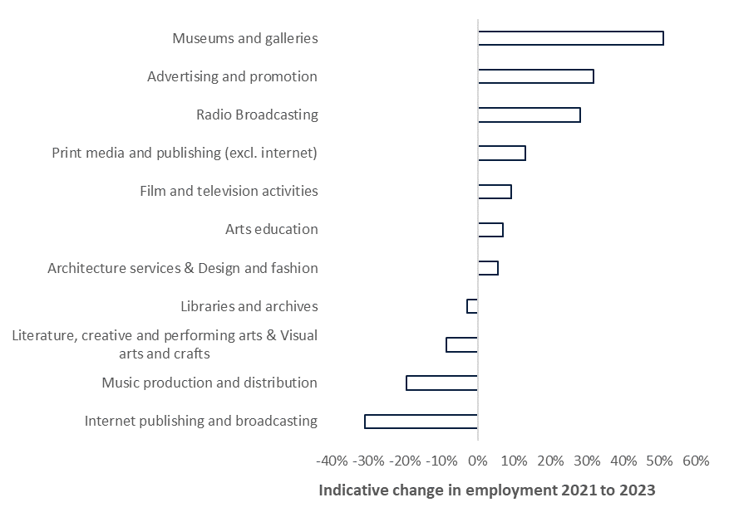

Source: Australian Bureau of Statistics – Labour Force, Australia, Detailed, August 2024.

## Diverging trends are evident across the cultural and creative domains

The following section compares each of the domains across the three metrics of Gross Domestic Product, business counts and indicative employment. These trends should be interpreted with caution, as employment trends referenced reflect broader industries than just those defined as cultural and creative industries. These figures should be considered as indicative only.

Cultural and creative activities are broad, and encapsulate a wide variety of activities (referred to as ‘domains’). These activities include:

* Traditional arts activities such as film and television activities, music production and distribution and literature, creative and performing arts and visual arts.
* Cultural services, including libraries and archives, and museums and galleries.
* Media activities, such as print media and publishing (excl. internet), radio broadcasting and internet publishing and broadcasting.
* Professional services, such as architecture services and design and fashion, and advertising and promotion.
* Provision of arts education.

Economic outcomes varied across the cultural and creative domains between 2021 and 2023.[13] Professional services and education activities tended to perform well on all measures, while outcomes were more mixed for domains relating to traditional arts, cultural services and media activities. Two of the most divergent trends are analysed in more detail below (Figure 7).

Figure 7. Gross Domestic Product, indicative employment and business counts, by domain, percentage change 2021 to 2023

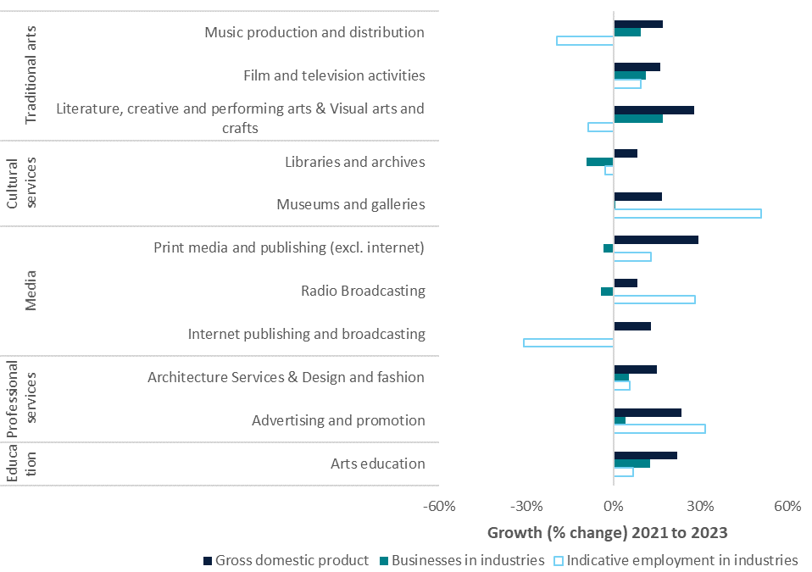

Source: Bureau of Communications, Arts and Regional Research, Australian Bureau of Statistics – Counts of Australian Businesses, including Entries and Exits, June 2019 to June 2023, Australian Bureau of Statistics – Labour Force, Australia, Detailed, August 2024.

## Employment in traditional arts domains underperforms against national employment growth

The traditional arts domains together supported approximately 20% of cultural and creative activity in 2022–23, 43% of businesses in June 2023 and 32% of employment in cultural and creative industries in 2021. Whilst most other domains recorded increased employment over the 2021 to 2023 period, there are indications traditional arts domains tended to record reductions in employment over this time period[14] (with the exception of film and television activities).

This decline is not evident in payroll jobs data[15] (Australian Bureau of Statistics, 2024c), in which payroll holders in the creative and performing arts activities industry subdivision (which can be used to approximate some traditional arts domains) increased by 25.7% between May 2021 and May 2023. This data typically reflects employees who are on an organisation’s payroll and would exclude persons who are self-employed. Approximately 75% of businesses in these domains (in total) are non-employing businesses, suggesting this data may capture only a small share of businesses (and their employees) in the domain.

Based on data for the arts and recreation services industry division (which is a broader and different definition to the traditional arts domains, but may approximate trends in the literature, creative and performing arts, and visual arts domain), the traditional arts domains may have experienced increased outward job mobility in recent years, impacting on total employment. On average, between February 2021 and February 2024,[16] workers in the arts and recreation services industry division were more likely than workers across all industries to have changed jobs in the last year, and they were more likely to have changed industries in the last year than other workers (Figure 8) (Australian Bureau of Statistics, 2024d). This may reflect rates of underemployment in the sector, which has reduced since 2020, but was still twice the national level, at 14.8%, in May 2024 (Australian Bureau of Statistics, 2024e).

Figure 8. Job mobility, arts and recreation services industry division, average February 2021 to February 2024

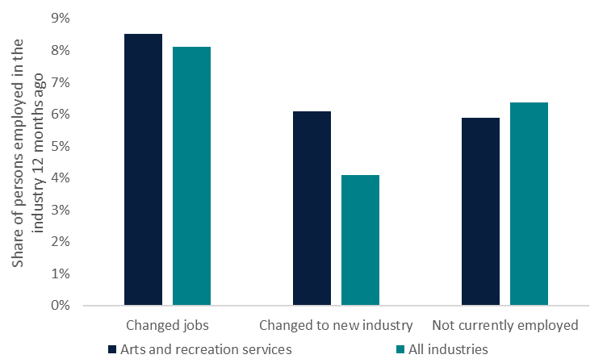

Source: Australian Bureau of Statistics – Job mobility, February 2024.

## Digital disruption continues to impact on business activity in media domains

The media domains provide a strong contribution to cultural and creative activity, representing over a quarter of cultural and creative Gross Domestic Product. In contrast, these domains represented over 6% of businesses (in 2022–23) and approximately 12% of employment within the cultural and creative industries (in 2021). This divergence between Gross Domestic Product and employment reflects the high value add nature of the media domains’ work.

Whilst Gross Domestic Product expanded for media-related domains in the period from 2020–21 to 2022–23, these domains generally reported declines in the number of businesses over the period (with the exception of internet publishing and broadcasting). Several macroeconomic factors are impacting the sector and have contracted economic activity for these domains in the years from 2015–16 to 2019–20.

The media domains include activities such as newspaper, magazine and book publishing which have all faced challenges, such as reduced circulation numbers and advertising revenue, amidst increased digitalisation of their sectors (Australian Competition and Consumer Commission, 2019). Increased competition from international retailers has further impacted on the book publishing sector. As a result of these revenue impacts, several Australian businesses have closed (see Figure 9). Overall, these industries have recorded net reductions in the number of businesses operating over the period analysed, and record lower entry rates than the Australian industry average. Media business closures have been more prominent from high turnover businesses (compared to the national all industry average). The loss of high turnover and high employing businesses can have significant ramifications for workers and economic activity within these domains.

Figure 9. Change in number of businesses, June 2021 to June 2023

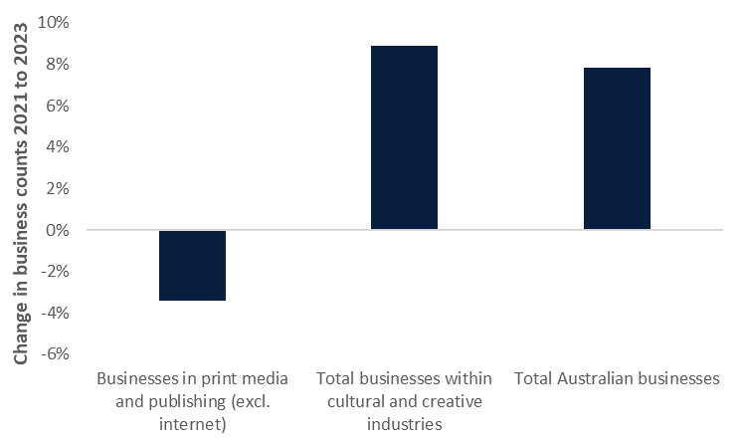

Source: Australian Bureau of Statistics – Counts of Australian Businesses, including Entries and Exits, June 2019 to June 2023.

## Appendix A—Detailed analysis

### A.1 Businesses in cultural and creative industries

In June 2023, there were approximately 95,753 businesses operating within the cultural and creative industries. Growth in the number of businesses operating within these industries has exceeded that of total businesses across Australia since June 2021.

A note on definitions used in this section

This section applies business counts by detailed (class/4-digit) Australian and New Zealand Standard Industrial Classification industries from the Australian Bureau of Statistics (Australian Bureau of Statistics, 2023a). This data captures information only on businesses within the cultural and creative industries, and excludes businesses associated with cultural and creative products. As such, the businesses profiled in this section are referred to as businesses within cultural and creative industries, and are not considered an exact match of cultural and creative activities.

#### Total businesses in cultural and creative industries

The number of businesses operating within cultural and creative industries increased 8.9% (or 7,835 businesses) between June 2021 and June 2023, to a total of 95,753 businesses (Figure 10). Consistent with the strong rate of growth in the cultural and creative economy in 2021–22, the number of businesses operating in the cultural and creative industries posted strong growth in 2021–22 (7.3%) outpacing the growth in the total number of Australian businesses (5.7%) in this year. As a result, the share of Australian businesses operating within these industries lifted very modestly, between June 2021 and June 2023. In 2022–23, the number of businesses within the cultural and creative sectors posted more modest growth, of 1.5%.

Figure 10. Businesses within cultural and creative industries, June 2021 to June 2023

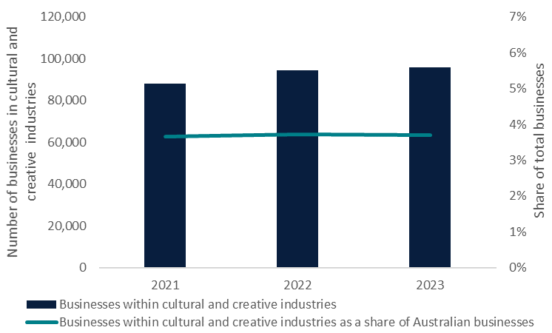

Source: Australian Bureau of Statistics – Counts of Australian Businesses, including Entries and Exits, June 2019 to June 2023.

Businesses within the cultural and creative industries tend to record lower levels of turnover than those of Australian businesses overall. Approximately 69% of businesses within the cultural and creative industries recorded annual turnover of less than $200,000 in June 2023, compared to 57% of all Australian businesses. Conversely, businesses in the cultural and creative industries were much less likely than Australian businesses overall to record turnover of between $200,000 and $2 million, but were modestly less likely to record higher turnover (Figure 11).

Figure 11. Businesses within cultural and creative industries, by annual turnover, June 2023

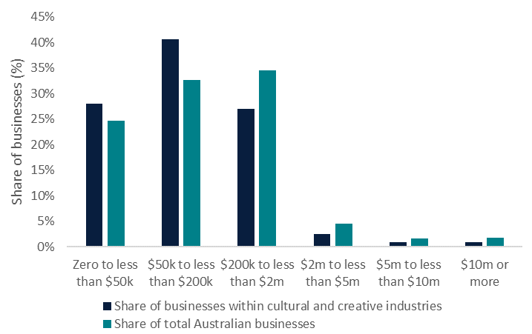

Source: Australian Bureau of Statistics – Counts of Australian Businesses, including Entries and Exits, June 2019 to June 2023.

Consistent with the generally lower annual turnover of businesses within cultural and creative industries by comparison to Australian businesses overall, businesses within these industries also tended to record lower levels of employment than other businesses (see Figure 12). Almost two-thirds of businesses within cultural and creative industries are non-employing businesses (which includes sole traders and partnerships), which is 4 percentage points higher than the share of non-employing businesses within the total business population. Businesses within these industries represented 4% of national non-employing businesses, higher than the overall representation of businesses within cultural and creative industries within the total business population. Businesses in these industries were particularly less likely to employ between 5 and 19 employees than Australian businesses overall.

Figure 12. Businesses within cultural and creative industries, by employment size, June 2023

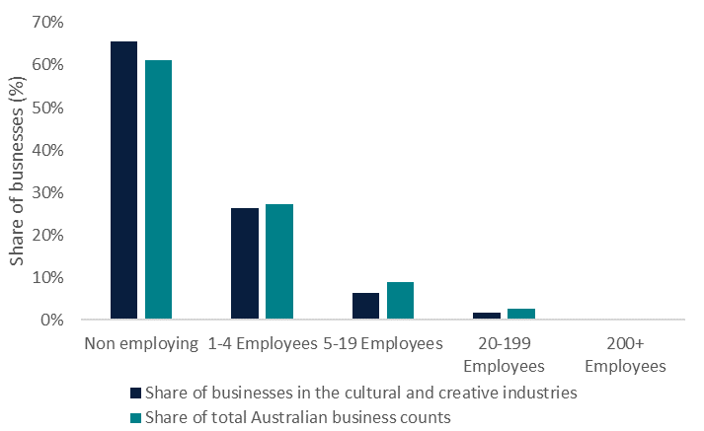

Source: Australian Bureau of Statistics – Counts of Australian Businesses, including Entries and Exits, June 2019 to June 2023.

In line with the population distribution across Australia, over 61% of Australia’s businesses were located in New South Wales and Victoria in June 2023. This trend was more prominent for businesses within cultural and creative industries, with over 67% of these businesses located across these two states (Figure 13).

Figure 13. Businesses within cultural and creative industries, by state and territory, June 2023

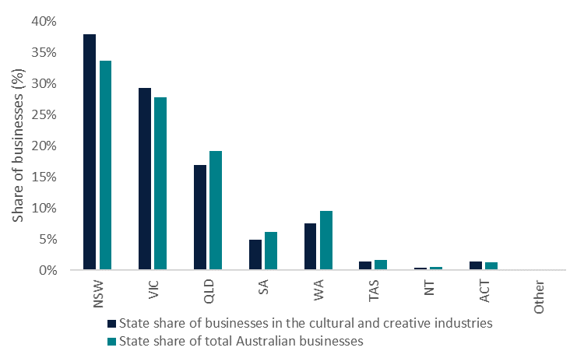

Note: Other refers to other territories, including Christmas Island, Cocos (Keeling) Islands, Jervis Bay and Norfolk Island.

Source: Australian Bureau of Statistics – Counts of Australian Businesses, including Entries and Exits, June 2019 to June 2023.

#### Businesses within cultural and creative domains

Business counts within cultural and creative industries were aggregated to cultural and creative domains to provide an indication of the composition of businesses within the sector. Not all domains can be replicated by industry-level data. A correspondence between the detailed cultural and creative industries and the pertinent domains is provided in *Appendix B—Glossary*.

Businesses within the cultural and creative industries are relatively concentrated within a few key cultural and creative domains (see Figure 14). In 2023, more than 60% of all businesses within the cultural and creative industries were within the most prominent 3 cultural and creative domains of literature, creative and performing arts, and visual arts and crafts, design and fashion, and architecture services. Further, the most prominent 6 domains represented over 90% of all businesses within the cultural and creative industries.

Figure 14. Share of businesses within cultural and creative industries, by domain, June 2023

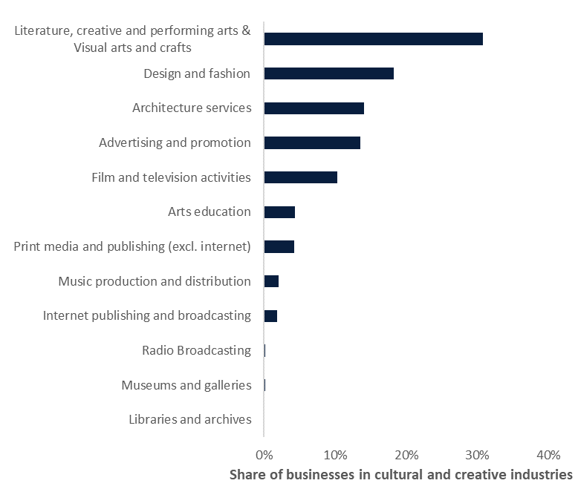

Source: Australian Bureau of Statistics – Counts of Australian Businesses, including Entries and Exits, June 2019 to June 2023.

Of the 7,835 net additional businesses within the cultural and creative industries between 2021 and 2023, over 80% were based within 3 of the cultural and creative domains of literature, creative and performing arts and visual arts and crafts, design and fashion, and film and television activities.

Over the same timeframe, 3 domains experienced a net reduction in businesses – print media and publishing (excl. internet), libraries and archives and radio broadcasting. Most of these reductions reflect a small number of business exits, with the exception of print media and publishing (excl. internet) which includes newspaper and magazine publishing and recorded a net reduction of more than 140 businesses (equating to a 3.4% decline in the number of businesses in this domain) (Figure 15). Newspaper and magazine publishing has been impacted by digital disruption, resulting in lower revenue generation. The sector is more likely to have large turnover businesses, suggesting a potentially large impact could result from individual business closures.

Figure 15. Net change in businesses within cultural and creative industries, by domain, June 2021 to June 2023

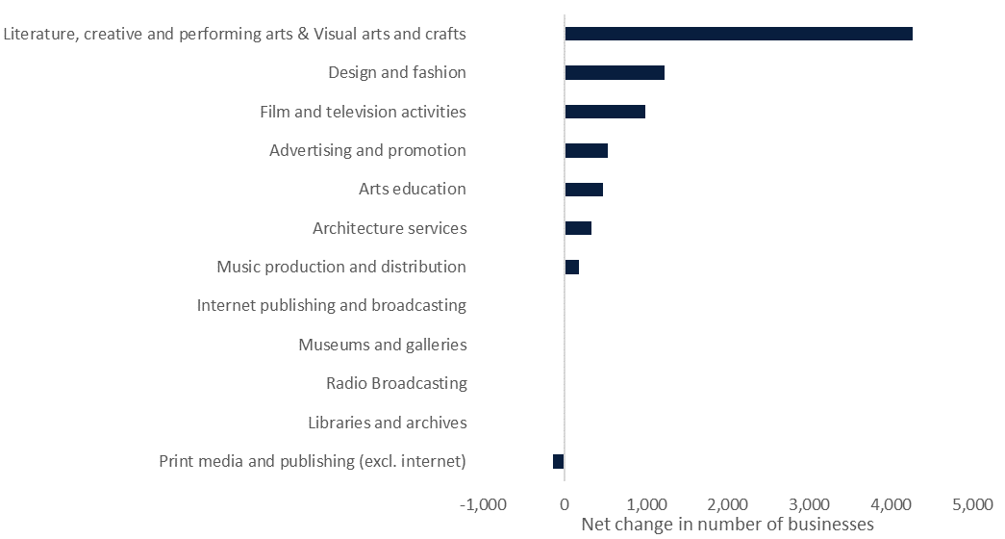

Source: Australian Bureau of Statistics – Counts of Australian Businesses, including Entries and Exits, June 2019 to June 2023.

All domains recorded high shares (above the share of total Australian businesses) of businesses with turnover of less than $200,000 per annum (see Table 1). The domains of literature, creative and performing arts and visual arts and crafts and music production and distribution, were particularly likely to record low levels of turnover, with over 70% of businesses within these domains recording turnover below this level. At the other end of the spectrum, businesses within the domains of print media and publishing (excl. internet), radio broadcasting, internet publishing and broadcasting, museums and galleries and advertising and promotion domains were more likely than other businesses to record higher shares (above the share of total Australian businesses) of businesses with turnover of over $5 million per annum.

Table 1. Share of businesses within cultural and creative industries, by domain and aggregated turnover categories, June 2023

|  |  |  |  |
| --- | --- | --- | --- |
| **Domain** | **Less than $200k** | **$200k to less than $5m** | **$5m and over** |
| Print media and publishing (excl. internet) | 63.1% | 32.3% | 4.6% |
| Film and television activities | 68.4% | 28.9% | 2.6% |
| Music production and distribution | 71.5% | 27.1% | 1.4% |
| Radio broadcasting | 48.5% | 41.2% | 10.3% |
| Internet publishing and broadcasting | 68.8% | 27.6% | 3.6% |
| Libraries and archives | 67.7% | 28.3% | 3.0% |
| Architecture services | 59.2% | 38.8% | 2.1% |
| Design and fashion | 68.5% | 30.5% | 1.0% |
| Advertising and promotion | 61.0% | 34.7% | 4.3% |
| Literature, creative and performing arts, and visual arts and crafts | 77.6% | 21.8% | 0.5% |
| Arts education | 65.2% | 34.7% | 0.1% |
| Museums and galleries | 63.2% | 31.4% | 5.4% |
| **Share of businesses within cultural and creative industries** | **68.6%** | **29.5%** | **1.8%** |
| **Share of total Australian businesses** | **57.3%** | **39.1%** | **3.5%** |

Note: Rows may not sum to 100% due to rounding.

Source: Australian Bureau of Statistics – Counts of Australian Businesses, including Entries and Exits, June 2019 to June 2023.

All domains were highly concentrated in New South Wales and Victoria. The domains of radio broadcasting, libraries and archives, film and television activities, and music production and distribution all recorded much higher shares of businesses located in these states, of above 70% (Table 2).

Table 2. Share of businesses within cultural and creative industries, by domain and state, June 2023

|  |  |  |  |  |  |  |  |  |  |
| --- | --- | --- | --- | --- | --- | --- | --- | --- | --- |
| **Domain** | **New South Wales** | **Victoria** | **Queensland** | **South Australia** | **Western Australia** | **Tasmania** | **Northern Territory** | **Australian Capital Territory** | **Other** |
| Print media and publishing (excl. internet) | 37.4% | 28.4% | 17.7% | 4.7% | 7.8% | 1.7% | 0.3% | 1.5% | 0.5% |
| Film and television activities | 43.2% | 28.7% | 14.1% | 4.6% | 5.7% | 1.0% | 0.6% | 1.9% | 0.1% |
| Music production and distribution | 39.8% | 31.5% | 15.8% | 3.4% | 6.6% | 1.9% | 0.3% | 0.6% | 0.0% |
| Radio Broadcasting | 55.7% | 17.5% | 12.4% | 2.6% | 8.8% | 0.0% | 1.5% | 0.0% | 1.5% |
| Internet publishing and broadcasting | 38.8% | 25.2% | 19.6% | 4.5% | 7.6% | 1.7% | 0.3% | 1.7% | 0.6% |
| Libraries and archives | 43.9% | 28.6% | 13.3% | 5.1% | 6.1% | 0.0% | 0.0% | 3.1% | 0.0% |
| Architecture services | 34.5% | 30.9% | 16.1% | 4.9% | 9.4% | 2.0% | 0.4% | 1.7% | 0.1% |
| Design and fashion | 38.5% | 28.8% | 17.0% | 5.2% | 7.4% | 1.4% | 0.4% | 1.2% | 0.0% |
| Advertising and promotion | 38.6% | 26.4% | 20.5% | 4.8% | 7.3% | 1.0% | 0.3% | 0.9% | 0.2% |
| Literature, creative and performing arts, and visual arts and crafts | 36.7% | 30.9% | 16.4% | 5.0% | 7.4% | 1.6% | 0.6% | 1.4% | 0.1% |
| Arts education | 37.8% | 26.3% | 17.6% | 5.5% | 9.0% | 1.3% | 0.5% | 1.9% | 0.1% |
| Museums and galleries | 26.2% | 35.5% | 18.0% | 3.3% | 9.8% | 5.5% | 0.0% | 1.6% | 0.0% |
| **Share of businesses within cultural and creative industries** | **37.9%** | **29.2%** | **16.9%** | **4.9%** | **7.6%** | **1.5%** | **0.5%** | **1.4%** | **0.1%** |
| **Share of total Australian businesses** | **33.6%** | **27.8%** | **19.2%** | **6.2%** | **9.5%** | **1.7%** | **0.6%** | **1.4%** | **0.1%** |

Notes: Rows may not sum to 100% due to rounding. Other refers to other territories, including Christmas Island, Cocos (Keeling) Islands, Jervis Bay and Norfolk Island.

Source: Australian Bureau of Statistics – Counts of Australian Businesses, including Entries and Exits, June 2019 to June 2023.

Consistent with the size distribution of Australian businesses overall, the vast majority of businesses within the cultural and creative domains were small businesses, employing up to 4 employees (see Table 3). Some domains were more likely to be small employers, particularly those in the literature, creative and performing arts and visual arts and crafts domain where 97% of businesses employed up to 4 employees (with the vast majority of these being non-employing). Conversely, businesses in the radio broadcasting, print media and publishing (excl. internet), and film and television activities domains were the most likely to employ 200 or more employees, representing 2.6% (of a small number of businesses), 0.7% and 0.5% of these businesses, respectively.

Table 3. Share of businesses within cultural and creative industries, by domain and employment size, June 2023

|  |  |  |  |  |  |
| --- | --- | --- | --- | --- | --- |
| **Domain** | **Non-employing** | **1–4 Employees** | **5–19 Employees** | **20–199 Employees** | **200+ Employees** |
| Print media and publishing (excl. internet) | 58.0% | 27.3% | 10.4% | 3.5% | 0.7% |
| Film and television activities | 62.9% | 27.6% | 6.1% | 2.8% | 0.5% |
| Music production and distribution | 66.8% | 27.3% | 4.5% | 1.3% | 0.2% |
| Radio broadcasting | 48.5% | 18.6% | 23.7% | 6.7% | 2.6% |
| Internet publishing and broadcasting | 65.6% | 23.2% | 8.4% | 2.4% | 0.3% |
| Libraries and archives | 62.6% | 24.2% | 9.1% | 4.0% | 0.0% |
| Architecture services | 50.2% | 38.6% | 9.2% | 2.0% | 0.1% |
| Design and fashion | 66.8% | 27.0% | 5.4% | 0.7% | 0.0% |
| Advertising and promotion | 58.1% | 31.1% | 7.8% | 2.8% | 0.2% |
| Literature, creative and performing arts, and Visual arts and crafts | 79.0% | 17.6% | 2.6% | 0.8% | 0.0% |
| Arts education | 53.7% | 28.2% | 16.6% | 1.6% | 0.0% |
| Museums and galleries | 64.1% | 22.8% | 7.6% | 5.4% | 0.0% |
| **Share of businesses within cultural and creative industries** | **65.6%** | **26.3%** | **6.3%** | **1.6%** | **0.1%** |
| **Share of total Australian businesses** | **61.2%** | **27.2%** | **8.9%** | **2.5%** | **0.2%** |

Notes: Rows may not sum to 100% due to rounding.

Source: Australian Bureau of Statistics – Counts of Australian Businesses, including Entries and Exits, June 2019 to June 2023.

### A.2 First Nations businesses in arts and heritage industries

In June 2024, there were approximately 1,057 registered First Nations businesses operating within the arts and heritage industries.

A note on definitions used in this section

This section applies business counts by broad (non-Australian and New Zealand Standard Industrial Classification) industry from the Office of Registrar of Indigenous Corporations (Office of the Registrar of Indigenous Corporations, 2024). With regards to cultural and creative activities, this data captures information only on businesses within the arts and heritage and culture industries (referred to together as arts and heritage businesses).

As such, the businesses profiled in this section are referred to as arts and heritage businesses, and do not capture the full scope of either the cultural and creative sector or the businesses in cultural and creative industries as outlined in the previous section.

The Office of the Registrar of Indigenous Corporations database allocates businesses to classifications of size (large, medium and small) based on each organisation’s income, assets and number of employees. This size classification differs from the employment and turnover analysis provided in the previous section.

In June 2024, approximately 5,285 First Nations businesses were registered in the Office of the Registrar of Indigenous Corporations database. Of these, approximately 1,057 (or 20%) were arts and heritage businesses. Arts and heritage businesses were more likely to be considered large- or medium-sized than First Nations businesses overall, with 35% of arts and heritage businesses in these classifications, compared to 30% of registered First Nations businesses (Figure 16).

Figure 16. First Nations businesses, arts and heritage businesses, by size classification, June 2024

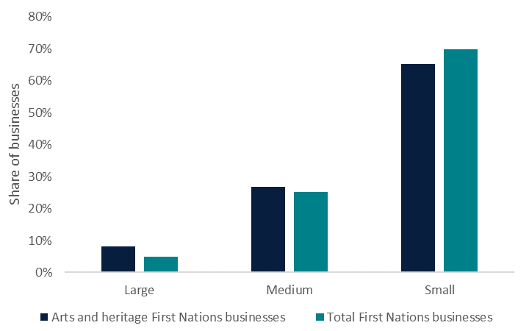

Source: Office of the Registrar of Indigenous Corporations – Aboriginal and Torres Strait Islander corporations.

In contrast to the geographical distribution of total Australian businesses, First Nations businesses were more likely to be based in Western Australia and Queensland than the other states and territories. Arts and heritage businesses were also more likely to be based in these states, particularly Queensland where these businesses comprised over a quarter of businesses in these industries (Figure 17).

Figure 17. First Nations businesses, arts and heritage businesses, by state and territory, June 2024

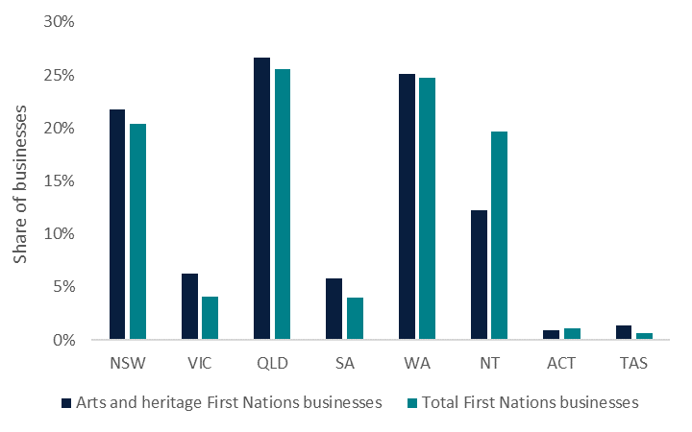

Source: Office of the Registrar of Indigenous Corporations – Aboriginal and Torres Strait Islander corporations.

### A.3 Demographics of workers in cultural and creative industries

#### Employment in cultural and creative industries

A note on definitions used in this section

This section applies employment information published by detailed level (class/4-digit) Australian and New Zealand Standard Industrial Classification industries from the Australian Bureau of Statistics (Australian Bureau of Statistics, 2022c). This data captures information only on employment within the cultural and creative industries, and excludes employment associated with cultural and creative products.

As such, the workers profiled in this section are referred to as employment within cultural and creative industries, and are not considered an exact match of cultural and creative activities. A correspondence between the detailed cultural and creative industries and the pertinent domains is provided in *Appendix B—Glossary*.

In 2021, approximately 11.9 million Australians indicated on their Census form that they were employed.[17] Approximately 281,986 of these Australians indicated they worked in a cultural and creative industry (representing 2.4% of the total). In 2021, the most prominent employing domains within the cultural and creative industries included literature, creative and performing arts and visual arts and crafts, architecture services and advertising and promotion, which together comprised almost half of all employment in the sector.

Between 2016 and 2021, national employment increased by 12.7% and employment in cultural and creative industries increased by 10.7%. The domains which contributed most significantly to the expansion of employment over the timeframe included advertising and promotion, architecture services and literature, creative and performing arts and visual arts and crafts (Figure 18).

Figure 18. Contribution to total growth in employment in cultural and creative industries, by domain, 2016 to 2021

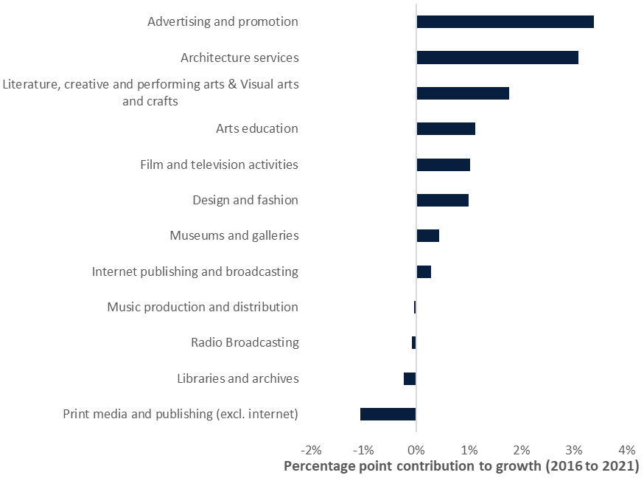

Source: Australian Bureau of Statistics – Census of Population and Housing (2016 and 2021).

#### Indicative employment trends in cultural and creative industries

A note on definitions used in this section

This section applies employment information published by semi-detailed level (group/3-digit) Australian and New Zealand Standard Industrial Classification industries from the Australian Bureau of Statistics (Australian Bureau of Statistics, 2024a). Due to the nature of the data published, this section of the report considers employment in creative and cultural industries, rather than cultural and creative employment (and differs from the definition of businesses in cultural and creative industries).

In some instances, the proportion of the group/3-digit Australian and New Zealand Standard Industrial Classification industries included may be small, overestimating the size of some domains (and employment in cultural and creative industries overall), and influencing the trends analysed. These estimates should be considered as indicative only. A correspondence between the semi-detailed cultural and creative industries and the pertinent domains is provided in *Appendix B—Glossary*.

Employment data published by the Australian Bureau of Statistics is published on a quarterly basis. To reduce the volatility of the data, employment data in this section is presented for May of each year (the closest month to the end of the financial year).

Between May 2021 and May 2024, indicative employment in the broad cultural and creative industries increased by 6.6%, following a strong year of growth to May 2021. Of the 6.6% increase in indicative employment, the literature, creative and performance arts and visual arts domain contributed 2.6 percentage points, the architecture services and design and fashion domain contributed approximately 2.2 percentage points and, the film and television activities sector, contributed 0.9 percentage points (see Figure 19). While the literature, creative and performing arts and visual arts, and film and television activities domains were hit hardest by the COVID pandemic, there are indications that these domains have rebounded since 2021. Detracting from growth over the period between 2021 and 2024 were the music production and distribution, print media and publishing (excl. internet), and libraries and archives domains.

Figure 19. Contribution to indicative growth in employment in cultural and creative industries, by domain, May 2021 to May 2024

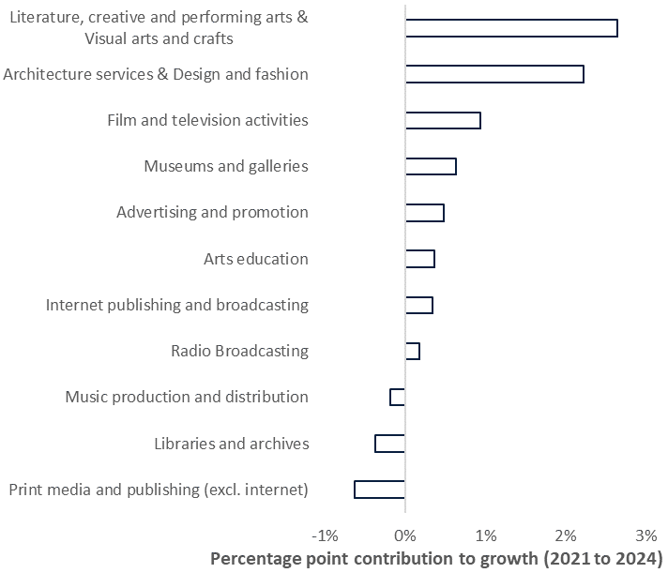

Notes: Some industries include activities outside the scope of the cultural and creative sector.

Source: Australian Bureau of Statistics – Labour Force, Australia, Detailed, August 2024.

#### Multiple job holders

A note on definitions used in this section

This section applies job holder information published by high-level (division/1-digit) Australian and New Zealand Standard Industrial Classification industries from the Australian Bureau of Statistics (Australian Bureau of Statistics, 2024f). Due to the high-level nature of the data published, this section of the report considers the arts and recreation services industry division. This industry includes a range of economic activities which are not included in the cultural and creative sector, including sports and recreational activities (such as gambling), repairs and maintenance activities (such as car repairs), and personal and other services (such as religious services). As such, the information presented should be considered as indicative only.

In June 2024, approximately 961,400 Australians were multiple job holders and approximately 23,300 of these (or 2.4%) were employed in the arts and recreation services industry division. Sectors such as health care and social assistance services, administrative and support services, and education and training are key contributors to the national total. The arts and recreation services industry division recorded a multiple job holding rate of 8.4% in June 2024. Between June 2021 and June 2024, the number of multiple job holders in the arts and recreation services industry division increased by 39%, faster than the growth in the total number of multiple job holders across all industries (17%) and the strongest growth of all industries presented in the period. This resulted in a 0.4 percentage point increase in the sector’s share of total multiple job holders. Whilst growth was recorded for both males and females in the sector, females continue to comprise more than 50% of multiple job holders (Figure 20).

Figure 20. Multiple job holders in the arts and recreation services industry division, by sex, 2019 to 2024

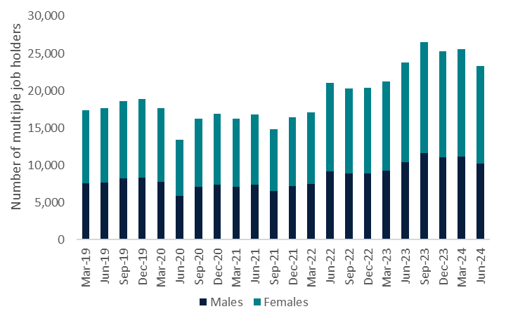

Source: Australian Bureau of Statistics – Multiple job-holders, June 2024.

#### Persons with a disability

A note on definitions used in this section

This section applies information published by high-level (division/1-digit) Australian and New Zealand Standard Industrial Classification industries from the Australian Bureau of Statistics relating to persons with a disability (Australian Bureau of Statistics, 2024g). Due to the high-level nature of the data published, this section of the report considers the arts and recreation services industry division. This sector includes a range of economic activities which are not included in the cultural and creative sector, including sports and recreational activities (such as gambling), repairs and maintenance activities (such as car repairs), and personal and other services (such as religious services). As such, the information presented should be considered as indicative only.

The arts and recreational services industry division may be considered as a more inclusive employer than other sectors of the economy. Approximately 11.6% of Australia’s workforce in 2022 had a form of disability. In the same year, approximately 13.4% of workers in the arts and recreation services industry division had a form of disability. Workers in the arts and recreation services industry division were less likely than the overall workforce to have specific limitations or restrictions,[18] but were more likely to have a profound or severe core activity limitation (Figure 21).[19]

Between 2018 and 2022, there was a significant increase in the prevalence of persons with a disability in Australia, from 17.7% of the population in 2018 to 21.4% in 2022. There are several factors which may have contributed to this increase, such as increased awareness of disability, increased prevalence of some long-term health conditions, the ageing of the Australian population and the use of an online self-completion questionnaire as part of the Survey of Disability, Ageing and Carers in 2022 (Australian Bureau of Statistics, 2024g).

In addition to the increased prevalence of disability between 2018 and 2022, there was also an increase in the labour force participation rate of persons with a disability over this timeframe – from 53.4% in 2018 to 60.5%. This increase was much stronger than that recorded for persons without a disability (which increased from 84.1% in 2018 to 84.9% in 2022).

The increased prevalence of disability coupled with the increased participation rate of persons with a disability contributed towards a strong 52% increase in the number of workers within the national workforce who had a disability between 2018 and 2022. By comparison, the arts and recreation services industry division (which was already employing a higher share of workers with a disability than the national average in 2018) recorded a 22.1% increase in employees with a form of disability.

Figure 21. Estimated share of workers, by level of reported disability, 2022

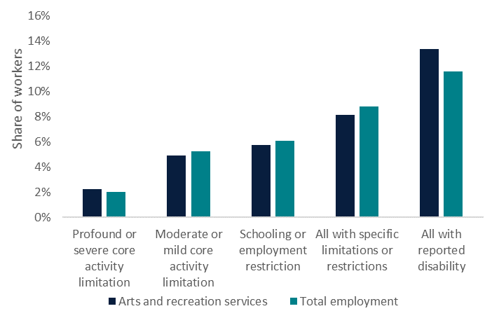

Source: Australian Bureau of Statistics – Disability, Ageing and Carers, Australia: Summary of Findings, 2022.

### A.4 Cultural and creative activities – attendance and participation

A note on definitions used in this section

This section applies information on participation in selected cultural activities and attendance at selected cultural venues and events as published by the Australian Bureau of Statistics (Australian Bureau of Statistics, 2023c). The cultural and creative activities in scope are consistent with cultural and creative activities, in particular those under the domains of literature, creative and performing arts, and visual arts and crafts, libraries and archives, museums and galleries, and music production and distribution.[20] However, this information is unable to be presented by cultural and creative domains.

#### Attendance

Recent years have been marked by a decline in the share of Australians attending cultural and creative venues or events, including dance performances, musicals and operas, and theatre performances. In particular there has been a noticeable decline from pre- to post-COVID, across both adults and children.

In 2021–22, 64% of adults[21] and 80% of children[22] attended at least one cultural venue or event (see Table 4). Both adults and children were more likely to attend either a cinema or performing arts event, by comparison to other venues or events in the year. Art galleries were the least attended cultural venue, of those provided, for both cohorts.

Between 2017–18 and 2021–22, the share of both adults and children who attended at least one cultural venue or event reduced significantly. In both instances, reduced attendance was particularly prominent (with attendance rates down more than 20 percentage points from 2017–18 levels) for performing arts events and cinemas.

Table 4. Attendance at cultural venues and events, 2021–22

|  |  |  |
| --- | --- | --- |
| **Venue** | Attendance rate  **2021–22** | Percentage point change  **2017–18 to 2021–22** |
| **Children** |  |  |
| Art galleries | 20% | -11% |
| Museums | 31% | -15% |
| Libraries or archives | 33% | -20% |
| Cinemas | 67% | -21% |
| Performing arts | 31% | -26% |
| **Attended at least one venue or event** | **80%** | **-14%** |
| **Adults** |  |  |
| Art galleries | 18% | -10% |
| Museums | 17% | -10% |
| Libraries or archives | 20% | -11% |
| Cinemas | 44% | -23% |
| Performing arts | 30% | -24% |
| **Attended at least one venue or event** | **64%** | **-19%** |

Note: Performing arts attendance is defined as attending at least one performing arts event.

Source: Australian Bureau of Statistics – Cultural and creative activities, 2021–22.

Diving further into the reduction in performing arts activities and events indicates adult attendance at live music concerts or performance has been the most impacted, with a decline of over 20 percentage points to 17.6% (Figure 22).

Figure 22. Adult attendance at selected cultural venues and events – performing arts

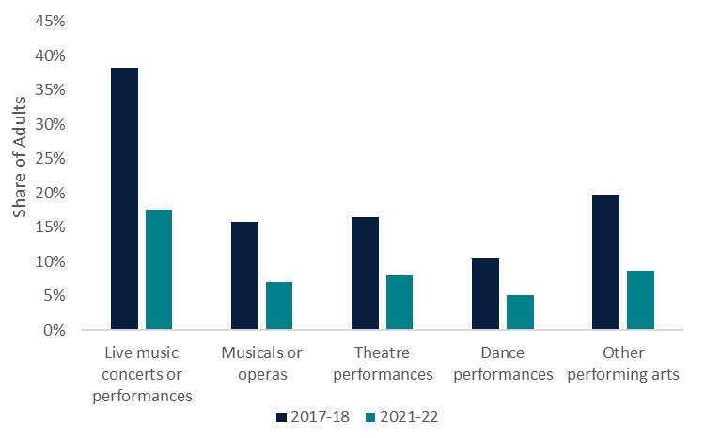

Source: Australian Bureau of Statistics – Cultural and creative activities, 2021–22.

#### Participation

Over the same period (2017–18 to 2021–22) there has also been a decline in children’s participation in cultural and creative activities, such as creative writing, drama activities, singing or playing a musical instrument, dancing and creating digital content (Figure 23). In 2021–22, around 6.2% of children did not participate in any cultural activities. Participation by girls was higher at 66.5% than boys at 52.3%. Screen-based activities recorded the highest level of participation, at around 90% each for girls and boys.

For adults, participation in cultural and creative activities remained more stable, increasing slightly from 31% in 2017–18 to almost one third of adults (32%) in 2021–22.

Figure 23. Participation in selected cultural activities – total children

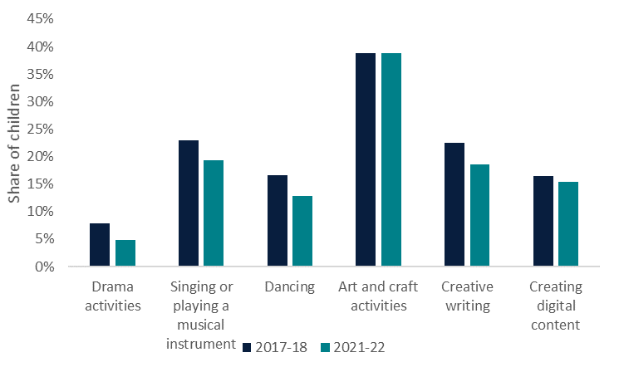

Source: Australian Bureau of Statistics – Cultural and creative activities, 2021–22.

## Appendix B—Glossary

### B.1 Domains

The following table outlines the alignment between 4-digit Australian and New Zealand Standard Industrial Classification industries and the cultural and creative domains, as per the *Cultural and Creative Activity in Australia, 2008–09 to 2022–23 (Methodology Refresh)* working paper (see Table 5)*.* The domains of Events (arts) and Digital games development are excluded from this list, as they are applicable only to products (and not industries).

Table 5. Detailed (4-digit Australian and New Zealand Standard Industrial Classification) industries alignment to cultural and creative domains

|  |  |  |
| --- | --- | --- |
| **Australian and New Zealand Standard Industrial Classification** | **Australian and New Zealand Standard Industrial Classification description** | **Domain name** |
| 1612 | Printing Support Services | Print media and publishing (excl. internet) |
| 5411 | Newspaper Publishing | Print media and publishing (excl. internet) |
| 5412 | Magazine and Other Periodical Publishing | Print media and publishing (excl. internet) |
| 5413 | Book Publishing | Print media and publishing (excl. internet) |
| 5419 | Other Publishing (except Software, Music and Internet) | Print media and publishing (excl. internet) |
| 5420 | Software Publishing | Print media and publishing (excl. internet) |
| 5511 | Motion Picture and Video Production | Film and television activities |
| 5512 | Motion Picture and Video Distribution | Film and television activities |
| 5513 | Motion Picture Exhibition | Film and television activities |
| 5514 | Post-production Services and Other Motion Picture and Video Activities | Film and television activities |
| 5521 | Music Publishing | Music production and distribution |
| 5522 | Music and Other Sound Recording Activities | Music production and distribution |
| 5610 | Radio Broadcasting | Radio Broadcasting |
| 5621 | Free-to-Air Television Broadcasting | Film and television activities |
| 5622 | Cable and Other Subscription Broadcasting | Film and television activities |
| 5700 | Internet Publishing and Broadcasting | Internet publishing and broadcasting |
| 6010 | Libraries and Archives | Libraries and archives |
| 6020 | Other Information Services | Print media and publishing (excl. internet) |
| 6921 | Architectural Services | Architecture services |
| 6924 | Other Specialised Design Services | Design and fashion |
| 6940 | Advertising Services | Advertising and promotion |
| 6991 | Professional Photographic Services | Visual arts and crafts |
| 8212 | Arts Education | Arts education |
| 8910 | Museum Operation | Museums and galleries |
| 9001 | Performing Arts Operation | Literature, creative and performing arts |
| 9002 | Creative Artists, Musicians, Writers and Performers | Literature, creative and performing arts; Visual arts and crafts |
| 9003 | Performing Arts Venue Operation | Literature, creative and performing arts |
| 9532 | Photographic Film Processing | Visual arts and crafts |

### B.2 Businesses and employment within cultural and creative domains

The following table provides guidance on the industries which have been captured to define businesses and employment in the cultural and creative sector (see Table 6). The key difference between this alignment and that presented above is the aggregation of Literature, creative and performing arts and Visual arts and crafts domains.

Table 6. Detailed (4-digit Australian and New Zealand Standard Industrial Classification) industries within cultural and creative industries (applied to Business Counts and Census employment estimates)

|  |  |  |
| --- | --- | --- |
| **Australian and New Zealand Standard Industrial Classification** | Australian and New Zealand Standard Industrial Classification description | Cultural and creative domains |
| 1612 | Printing Support Services | Print media and publishing (excl. internet) |
| 5411 | Newspaper Publishing | Print media and publishing (excl. internet) |
| 5412 | Magazine and Other Periodical Publishing | Print media and publishing (excl. internet) |
| 5413 | Book Publishing | Print media and publishing (excl. internet) |
| 5419 | Other Publishing (except Software, Music and Internet) | Print media and publishing (excl. internet) |
| 5420 | Software Publishing | Print media and publishing (excl. internet) |
| 5511 | Motion Picture and Video Production | Film and television activities |
| 5512 | Motion Picture and Video Distribution | Film and television activities |
| 5513 | Motion Picture Exhibition | Film and television activities |
| 5514 | Post-production Services and Other Motion Picture and Video Activities | Film and television activities |
| 5521 | Music Publishing | Music production and distribution |
| 5522 | Music and Other Sound Recording Activities | Music production and distribution |
| 5610 | Radio Broadcasting | Radio Broadcasting |
| 5621 | Free-to-Air Television Broadcasting | Film and television activities |
| 5622 | Cable and Other Subscription Broadcasting | Film and television activities |
| 5700 | Internet Publishing and Broadcasting | Internet publishing and broadcasting |
| 6010 | Libraries and Archives | Libraries and archives |
| 6020 | Other Information Services | Print media and publishing (excl. internet) |
| 6921 | Architectural Services | Architecture services |
| 6924 | Other Specialised Design Services | Design and fashion |
| 6940 | Advertising Services | Advertising and promotion |
| 6991 | Professional Photographic Services | Literature, creative and performing arts, and Visual arts and crafts |
| 8212 | Arts Education | Arts education |
| 8910 | Museum Operation | Museums and galleries |
| 9001 | Performing Arts Operation | Literature, creative and performing arts, and Visual arts and crafts |
| 9002 | Creative Artists, Musicians, Writers and Performers | Literature, creative and performing arts, and Visual arts and crafts |
| 9003 | Performing Arts Venue Operation | Literature, creative and performing arts, and Visual arts and crafts |
| 9532 | Photographic Film Processing | Literature, creative and performing arts, and Visual arts and crafts |

### B.3 Indicative employment within cultural and creative industries

The following table provides guidance on the industries which have been captured to indicatively define employment in the cultural and creative industries (see Table 7). The key differences between this version of the domains and those presented in *Cultural and Creative Activity in Australia from 2008–09 to 2022–23 (Methodology Refresh)* is the aggregation of:

* Literature, creative and performing arts, and Visual arts and crafts domains
* Architecture services, and Design and fashion domains.

Table 7. Detailed (3-digit Australian and New Zealand Standard Industrial Classification) industries within cultural and creative industries (applied to Australian Labour Force estimates of employment)

|  |  |  |
| --- | --- | --- |
| **Australian and New Zealand Standard Industrial Classification** | Australian and New Zealand Standard Industrial Classification description | Employment domain |
| 161 | Printing and Printing Support Services | Print media and publishing (excl. internet) |
| 541 | Newspaper, Periodical, Book and Directory Publishing | Print media and publishing (excl. internet) |
| 541 | Newspaper, Periodical, Book and Directory Publishing | Print media and publishing (excl. internet) |
| 541 | Newspaper, Periodical, Book and Directory Publishing | Print media and publishing (excl. internet) |
| 541 | Newspaper, Periodical, Book and Directory Publishing | Print media and publishing (excl. internet) |
| 542 | Software Publishing | Print media and publishing (excl. internet) |
| 551 | Motion Picture and Video Activities | Film and television activities |
| 551 | Motion Picture and Video Activities | Film and television activities |
| 551 | Motion Picture and Video Activities | Film and television activities |
| 551 | Motion Picture and Video Activities | Film and television activities |
| 552 | Sound Recording and Music Publishing | Music production and distribution |
| 552 | Sound Recording and Music Publishing | Music production and distribution |
| 561 | Radio Broadcasting | Radio Broadcasting |
| 562 | Television Broadcasting | Film and television activities |
| 562 | Television Broadcasting | Film and television activities |
| 570 | Internet Publishing and Broadcasting | Internet publishing and broadcasting |
| 601 | Libraries and Archives | Libraries and archives |
| 602 | Other Information Services | Print media and publishing (excl. internet) |
| 692 | Architectural, Engineering and Technical Services | Architecture services, and Design and fashion |
| 692 | Architectural, Engineering and Technical Services | Architecture services, and Design and fashion |
| 694 | Advertising Services | Advertising and promotion |
| 699 | Other Professional, Scientific and Technical Services | Literature, creative and performing arts, and visual arts and crafts |
| 821 | Adult, Community and Other Education | Arts education |
| 891 | Museum Operation | Museums and galleries |
| 900 | Creative and Performing Arts Activities | Literature, creative and performing arts, and visual arts and crafts |
| 900 | Creative and Performing Arts Activities | Literature, creative and performing arts, and visual arts and crafts |
| 900 | Creative and Performing Arts Activities | Literature, creative and performing arts, and visual arts and crafts |
| 953 | Other Personal Services | Literature, creative and performing arts, and visual arts and crafts |

## References

Australian Bureau of Statistics (2022a). *COVID-19 and the 2021 Census.* Retrieved from [4. COVID-19 and the 2021 Census | Australian Bureau of Statistics](https://www.abs.gov.au/census/about-census/census-statistical-independent-assurance-panel-report/4-covid-19-and-2021-census#:~:text=Leading%20up%20to%20Census%20night,restrictions%20lifted%20on%2010%20August.)

—— (2022b). *Economic gains and losses over the COVID-19 pandemic.* Retrieved from [Economic gains and losses over the COVID-19 pandemic | Australian Bureau of Statistics](https://www.abs.gov.au/articles/economic-gains-and-losses-over-covid-19-pandemic)

—— (2022c). *Census of Population and Housing* (accessed vis TableBuilder). Retrieved from [TableBuilder | Australian Bureau of Statistics](https://www.abs.gov.au/statistics/microdata-tablebuilder/tablebuilder)

—— (2023a). *Australian Bureau of Statistics* – *Counts of Australian Businesses, including Entries and Exits, June 2019 to June 2023.* Retrieved from: [Counts of Australian Businesses, including Entries and Exits, July 2020 - June 2024 | Australian Bureau of Statistics](https://www.abs.gov.au/statistics/economy/business-indicators/counts-australian-businesses-including-entries-and-exits/latest-release)

—— (2023b). *Australian National Accounts: Tourism Satellite Account, 2022-23.* Retrieved from [Australian National Accounts: Tourism Satellite Account, 2022-23 financial year | Australian Bureau of Statistics](https://www.abs.gov.au/statistics/economy/national-accounts/australian-national-accounts-tourism-satellite-account/latest-release#data-downloads)

—— (2023c). *Cultural and creative activities.* Retrieved from [Cultural and creative activities, 2021-22 financial year | Australian Bureau of Statistics](https://www.abs.gov.au/statistics/people/people-and-communities/cultural-and-creative-activities/latest-release)

—— (2024a). *Labour Force, Australia, Detailed, August 2024.* Retrieved from [Labour Force, Australia, Detailed, September 2024 | Australian Bureau of Statistics](https://www.abs.gov.au/statistics/labour/employment-and-unemployment/labour-force-australia-detailed/latest-release)

—— (2024b). *Australian National Accounts: National Income, Expenditure and Product.* Retrieved from [Australian National Accounts: National Income, Expenditure and Product, June 2024 | Australian Bureau of Statistics](https://www.abs.gov.au/statistics/economy/national-accounts/australian-national-accounts-national-income-expenditure-and-product/latest-release)

—— (2024c). *Weekly Payroll Jobs.* Retrieved from [Payroll Jobs, Revised estimates for week ending 15 June 2024 | Australian Bureau of Statistics](https://www.abs.gov.au/statistics/labour/jobs/payroll-jobs/latest-release)

—— (2024d). *Job mobility, February 2024.* Retrieved from [Job mobility, February 2024 | Australian Bureau of Statistics](https://www.abs.gov.au/statistics/labour/jobs/job-mobility/latest-release)

—— (2024e). *Job Vacancies, Australia.* Retrieved from [Job Vacancies, Australia, August 2024 | Australian Bureau of Statistics](https://www.abs.gov.au/statistics/labour/jobs/job-vacancies-australia/latest-release)

—— (2024f). *Multiple job-holders.* Retrieved from [Multiple job-holders, June 2024 | Australian Bureau of Statistics](https://www.abs.gov.au/statistics/labour/jobs/multiple-job-holders/latest-release)

—— (2024g). *Disability, Ageing and Carers, Australia: Summary of Findings.* Retrieved from [Disability, Ageing and Carers, Australia: Summary of Findings, 2022 | Australian Bureau of Statistics](https://www.abs.gov.au/statistics/health/disability/disability-ageing-and-carers-australia-summary-findings/latest-release)

Australian Competition and Consumer Commission (2019). *Digital Platforms Inquiry.* Retrieved from [Digital platforms inquiry - final report.pdf](https://www.accc.gov.au/system/files/Digital%20platforms%20inquiry%20-%20final%20report.pdf)

Creative Australia (2018). *Domestic Arts Tourism: Connecting the country.* Retrieved from [Domestic Arts Tourism: Connecting the country - Creative Australia](https://creative.gov.au/advocacy-and-research/domestic-arts-tourism-connecting-the-country/#:~:text=Domestic%20tourism%20provides%20an%20opportunity,niche%20opportunities%20across%20the%20country.)

—— (2023). *Creating Value: Results of the National Arts Participation Survey.* Retrieved from [Creating Value: Results of the National Arts Participation Survey - Creative Australia](https://creative.gov.au/advocacy-and-research/creating-value/)

Department of Infrastructure, Transport, Regional Development, Communications and the Arts (2023). *National Cultural Policy—Revive: a place for every story, a story for every place.* Retrieved from [National Cultural Policy—Revive: a place for every story, a story for every place | Office for the Arts](https://www.arts.gov.au/publications/national-cultural-policy-revive-place-every-story-story-every-place)

Office of the Registrar of Indigenous Corporations (2024). *Aboriginal and Torres Strait Islander corporations.* Retrieved from [Aboriginal and Torres Strait Islander corporations - Dataset - data.gov.au](https://data.gov.au/data/dataset/aboriginal-and-torres-strait-islander-corporations-oric)

Reserve Bank of Australia (2024). *Developments in Income and Consumption Across Household Groups.* Retrieved from [Developments in Income and Consumption Across Household Groups | Bulletin – January 2024 | RBA](https://www.rba.gov.au/publications/bulletin/2024/jan/developments-in-income-and-consumption-across-household-groups.html)

1. 11/09/2025: A typo in the December 2024 report was corrected from $63.7 ‘million’ to $63.7 ‘billion’.
2. Employment data published in the Census for 2021 is more granular and provides a better match for the cultural and creative industries, but does not provide an annual time series. Australian Bureau of Statistics’ Labour Force data, which is less granular but more frequent, is used to approximate change in employment for the cultural and creative industries over time. It is noted that some of Australia’s largest cities were in lockdown at the time of the 2021 Census.
3. A bespoke definition of cultural and creative employment, based on industries and occupations, has yet to be finalised.
4. From May 2019 to May 2020.
5. Including attending theatre, concerts of other performing arts, visiting museums or art galleries, visiting art or craft workshops or studios or attending festivals, fairs or cultural events, or experiencing First Nations art, craft and cultural displays during their visit.
6. Employment data published in the Census for 2021 is more granular and provides a better match for the cultural and creative industries, but does not provide an annual time series. Australian Bureau of Statistics labour force data, which is less granular but more frequent, is used to approximate change in employment for the cultural and creative industries over time. It is noted that some of Australia’s largest cities were in lockdown at the time of the 2021 Census.
7. Gross Domestic Product information is nominal and includes changes in prices.
8. Which is much broader than cultural and creative activities, but may be indicative of trends within the sector.
9. This section applies business counts by detailed (class/4-digit) Australian and New Zealand Standard Industrial Classification industries from the Australian Bureau of Statistics. This data captures information only on businesses within the cultural and creative industries. As such, the businesses profiled in this section are referred to as businesses within cultural and creative industries.
10. This section applies business counts by high-level industries from the Office of the Registrar of Indigenous Corporations. This data captures information only on businesses within the arts and heritage and culture industries. As such, the businesses profiled in this section are referred to as businesses within arts and heritage industries, and do not capture the full scope of either the cultural and creative sector or the businesses in cultural and creative industries as outlined in the previous section. The Office of the Registrar of Indigenous Corporations database allocates businesses to classifications of size (large, medium and small) based on each organisation’s income, assets and number of employees. This size classification differs from the employment and turnover analysis provided in other sections of this report.
11. This section applies employment information published by detailed level (group/4-digit) Australian and New Zealand Standard Industrial Classification industries from the Australian Bureau of Statistics. Due to the nature of the data published, this section of the report considers employment in creative and cultural industries.
12. This section applies employment information published by detailed level (group/3-digit) Australian and New Zealand Standard Industrial Classification industries from the Australian Bureau of Statistics. Due to the nature of the data published, this section of the report considers employment in creative and cultural industries. The estimates provided for the employment domains should be considered as indicative in nature, due to the inclusion of other activities beyond that of the cultural and creative sector due to the paucity of detailed data.
13. Gross Domestic Product information is nominal and includes changes in prices.
14. Due to the inclusion of other activities within each domain’s employment estimate, these trends should be considered indicative in nature.
15. Payroll data reports the number of payroll jobholders in the Single Touch Payroll system. As such, it does not capture all jobs in the Australian labour market.
16. Data is available for February of each year only. Data to February 2024 shows a similar trend and is included in *Appendix A—Detailed analysis*.
17. Census data is considered an undercount of the Australian population. In the month of August 2021, Australian Bureau of Statistics labour force estimates suggest there were 12.5 million Australian workers. On the night of the Australian Census, some of Australia’s largest cities were in lockdown, which may impact on these estimates.
18. To identify whether a person has a particular type of limitation or restriction, the survey collects information on their: (1) need for assistance, (2) difficulty experienced and (3) use of aids or equipment, to perform selected tasks.
19. A person with a profound core activity limitation is unable to do, or always needs help with a core activity task. A person with a severe core activity limitation sometimes needs help with a core activity task, and/or has difficulty understanding or being understood by family or friends, or can communicate more easily using sign language or other non-spoken forms of communication.
20. See [Cultural and creative activities methodology](https://www.abs.gov.au/methodologies/cultural-and-creative-activities-methodology/2021-22), 2023.
21. Defined as a person aged 15 years and over.
22. Aged between 5 and 14 years.