

Preparing for take-off
Surveying Australians’ air travel behaviour, experiences and attitudes
April 2026

Other uses
Enquiries regarding this license and any other use of this document are welcome at:
Managing Director
Behavioural Economics Team of the Australian Government
Department of the Prime Minister and Cabinet
1 National Circuit
Barton ACT 2600
Email: beta@pmc.gov.au
The views expressed in this paper are those of the authors and do not necessarily reflect those of the Department of the Prime Minister and Cabinet or the Australian Government.
Tell us how you are using this report


Research team
Current and former BETA staff who contributed to the report were: Riley Childs,
Lindsey Cuthbertson, Nicholas Hilderson, Haris Rao, Phi Vu and Loren Willis.

Acknowledgments
Thank you to the Interim Aviation Consumer Ombuds Scheme Team in the Department of Infrastructure, Transport, Regional Development, Communications, Sport and the Arts for their support and valuable contribution in making this project happen.

Who?

Who are we?
We are the Behavioural Economics Team of the Australian Government, or BETA. We are the Australian Government’s first central unit applying behavioural economics to improve public policy, programs and processes.
We use behavioural economics, science and psychology to improve policy outcomes. Our mission is to advance the wellbeing of Australians through the application and rigorous evaluation of behavioural insights to public policy and administration.

What is behavioural economics?
Economics has traditionally assumed people always make decisions in their best interests. Behavioural economics challenges this view by providing a more realistic model of human behaviour. It recognises we are systematically biased (for example, we tend to satisfy our present self rather than planning for the future) and can make decisions that conflict with our own interests.

What are behavioural insights and how are they useful for policy design?
Behavioural insights apply behavioural economics concepts to the real world by drawing on empirically-tested results. These new tools can inform the design of government interventions to improve the welfare of citizens.
Rather than expect citizens to be optimal decision makers, drawing on behavioural insights ensures policy makers will design policies that go with the grain of human behaviour. For example, citizens may struggle to make choices in their own best interests, such as saving more money. Policy makers can apply behavioural insights that preserve freedom, but encourage a different choice – by helping citizens to set a plan to save regularly.

Contents
Who? 2
Executive summary 4
Why 6
What we did 7
Results 8
Discussion and conclusion 41
References 43

Executive summary
The Australian Government’s Aviation White Paper – Towards 2050 (Aviation White Paper) contains 56 policy initiatives to support the Australian aviation industry into the future (Infrastructure, 2024). Two key initiatives are the establishment of an Aviation Consumer Ombuds Scheme (ACOS) and an Aviation Consumer Rights Charter (now referred to as an Aviation Consumer Protections Charter). These initiatives aim to improve outcomes for air travellers and to hold the aviation sector accountable for delivering on its obligations to customers.
BETA partnered with the Interim ACOS Team within the Department of Infrastructure, Transport, Regional Development, Communications, Sport and the Arts (DITRDCSA) to understand the attitudes and behaviours of Australians travelling by air, and their understanding of consumer rights.
BETA conducted an initial “screen-in” survey of over 7,600 people, followed by a more in-depth survey of a representative sample of 4,000 adult Australians who had travelled by air between 28 August 2024 and 27 August 2025.

Australians are regular air travellers
More than one in 2 (56%) Australian adults travelled by air in this 12-month period, and most flew more than once. Around one in 4 (24%) of these travellers identified as having a disability, medical condition or injury.​

Customer satisfaction with airlines operating in Australia is at 77%
Overall, customer satisfaction with air travel in Australia is comparable to that of other nations. Most travellers were satisfied with their departure airport(s) (78%) and the airline(s) (77%) they travelled with throughout this 12-month period.

Flight disruptions are common, and Australians are dissatisfied with their handling
One in 2 travellers experienced a flight disruption​ during this 12-month period, with delays of between 15 minutes and 3 hours the most common type of experienced disruption. Only 31% were satisfied with how their disruption was handled.
​Complaints are rare despite the level of experienced disruptions. Less than one in 10 (8%) travellers made a complaint. Only 2 out of 5 of people who made a complaint (39%) were satisfied with the outcome, and less than one out of 5 (17%) were satisfied with the complaint process overall.
An additional 3% intended to make a complaint about a disruption or issue in the last 12 months, but either did not start or complete the process.​ This group identified a lack of energy and time (52%) and a belief their complaint would not make a difference or be taken seriously (48%) as the key barriers to following through with a complaint. This suggests some Australians believe the complaints process will be too long or that it will often not result in the desired outcome.

Consumers’ understanding of their rights is low
Knowledge and understanding of consumer rights could also improve. Most Australians (79%) self-reported having a low level of or no understanding of their air travel consumer rights and the assistance available to them. More than half of travellers (57%) do not read their airline ticket terms and conditions during purchasing, and this information was identified as the hardest to understand.

People with disabilities, medical conditions or injuries experience barriers and are less satisfied with air travel
Two out of 5 Australians with a disability, medical condition or injury do not know how to access assistance services available to them (40%). Of those who sought information about available assistance, 39% found it ‘difficult’ or ‘very difficult’ to access this information. Overall, this group experiences additional barriers to air travel, reflected in their lower-than-average satisfaction with every stage in their most recent travel journey departing from an Australian airport.

Why

Policy context
Aviation is a key mode of transport for Australia given our geographical spread and global remoteness. Domestic and international airlines operating in Australia carried over 102 million passengers between July 2024 and June 2025, up from 97 million passengers in the previous year (BITRE, 2025). The industry is continuing to recover following the COVID-19 pandemic, with domestic passenger numbers in June 2025 approaching the June 2019 totals (ACCC, 2025).
The Australian Government released the Aviation White Paper in 2024, which proposes 56 new policy initiatives across 10 areas to ensure a safe, competitive, productive and sustainable sector into the future (Infrastructure, 2024). Two of these initiatives are the establishment of a new Aviation Consumer Ombuds Scheme (ACOS) to hold the sector accountable for delivering on its obligations to customers and the Aviation Consumer Protections Charter to set minimum expected standards of service for aviation customers (Infrastructure, 2024).
BETA partnered with the Interim ACOS Team in DITRDCSA to conduct research into the attitudes and behaviours of Australians travelling by air to inform the development of these initiatives.

What we did
We collaborated with the interim ACOS Team to develop a survey to capture the attitudes, behaviours, satisfaction and knowledge of Australians who travel by air.
We distributed the survey in two components via a probability-based survey panel provider. The first screener survey captured broad travel trends of the Australian population (n=7,631). The second survey focused on Australians who flew in the past 12 months (n=4,008) and captured:
- key traveller touchpoints with airlines and airports along their air travel journey, from booking a ticket to leaving the destination airport, including what is and isn’t working
- Australians' understanding of responsibilities, terms and conditions, and their rights in general throughout their aviation journey
- the air travel experience of Australians with a disability, medical condition or injury
- recent experiences with disruptions when travelling by air, such as delays and cancellations
- assistance provided during disruptions and/or when making a complaint
- an assessment of what education and communication passengers may want an airline to provide relating to their travel journey
- understanding barriers and enablers within the current complaint handling environment.
We then applied weighting to our survey responses to ensure our results are representative. Weights were applied so that wave 1 is representative of the Australian population, and wave 2 is representative of the Australian population who travelled by air in the last 12 months. The weighted percentages in this report are an estimate of the true value in the Australian population. For ease of reading, the range of credible values for these estimates (95% confidence intervals) are presented in tables in the supplementary Excel document, rather than included in the body of the report. Full details of our survey and its methodology is in Appendix A.

Results

Broad travel behaviour of Australians

Most Australians travelled by air in the last 12 months
One in two Australians (56%) had flown in the last 12 months. Travelling by air was the third most common transportation mode after private vehicle and train. Slightly more than half (58%) travelled domestically for their last flight, and almost 9 out of 10 travelled on an economy class ticket or equivalent (89%). Most people departed from a major east coast airport – Sydney, Melbourne or Brisbane – and travelled on one of Australia’s three major airlines by market share – Jetstar, Qantas or Virgin Australia (ACCC, 2025). Consistent with prior research, about 3 out of 4 (74%) Australians flew at least once in the past 3 years (Australian Airports Association, 2025).

No reason to travel, high costs and personal circumstances are key reasons for not travelling by air
Other than not having a reason to travel, cost was the main barrier to air travel, followed by personal circumstances (e.g. young children, carer responsibilities). Notably, having a disability and/or mobility challenges was the fourth most common reason for not travelling in the past 12 months. Other recent research has also identified financial reasons (flying costs, reduced income, and fear of cancellation/cost) as the main barriers to air travel (Australian Airports Association, 2025).
Figure 1. Australians’ departure locations when travelling by air in the last 12 months
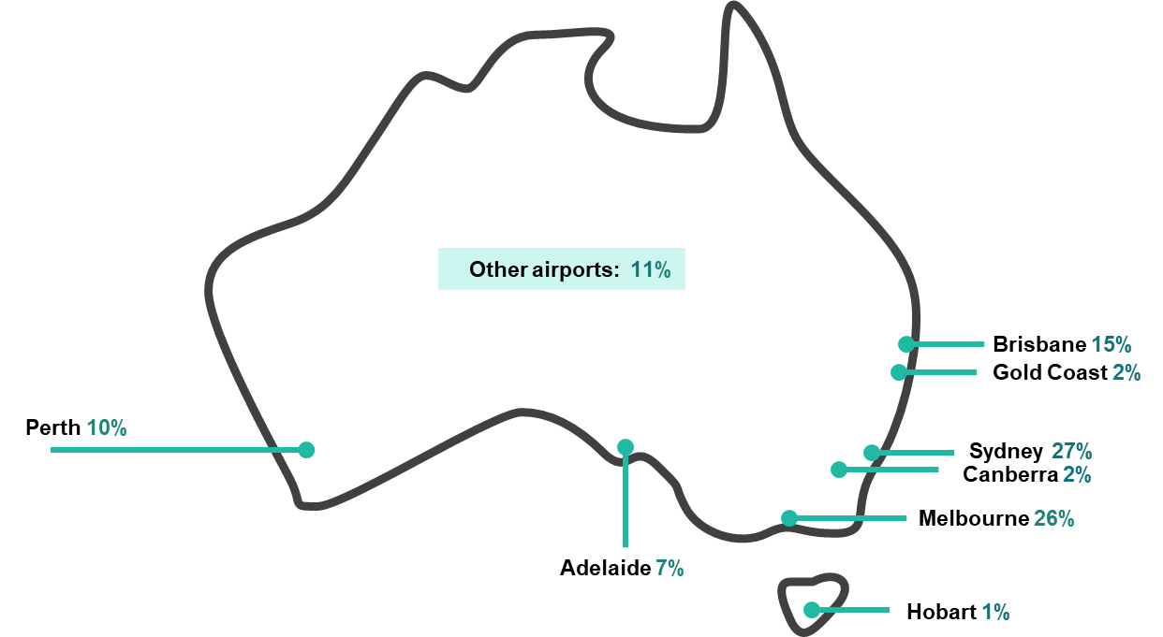Source: “Which Australian airport did you depart from?” (n=4,008 – weighted)

Satisfaction with air travel

Australians are generally satisfied with their air travel and airport experience
Around 3 in 4 Australians were satisfied with their airline’s performance on their most recent flight (77%), and any flight in the last 12 months (77%). Australians’ satisfaction with the departure airport on their most recent trip was also 77%, and only marginally higher for all airports in the prior 12 months (78%).
These results are generally comparable to other nations’ air travel satisfaction results:
- Canada – 75% (Canadian Transportation Authority, 2024)
- United Kingdom – 84% (Civil Aviation Authority, 2024)
- USA – 69-74% (Airlines for America 2025; American Consumer Satisfaction Index, 2025).
The International Air Transport Association’s (IATA) 2024 Global Passenger Survey provides a multi-national comparison, which found 82% of global passengers were satisfied with their air travel (IATA, 2024).

Australians with a disability, medical condition or injury may have lower levels of satisfaction
People with a disability, medical condition or injury reported lower levels of satisfaction with the airlines on their most recent flights (73%) compared to those without (78%). This cohort also reported lower satisfaction with their departure airports on their most recent flights (72%) compared to those without a disability, medical condition or injury (79%). Due to small sample sizes these estimates are not precise. The experiences of people with disability would benefit from more targeted investigation.

Airport satisfaction levels were related to an airport’s location and travellers’ disability status
Australians are generally more satisfied with smaller or regional airports, while the largest Australian airports (Sydney, Melbourne and Brisbane) were all in the bottom 5 for satisfaction. Due to small sample sizes estimates of satisfaction at some small airports are not precise.
Table 1. Australians’ satisfaction with the airport on their last flight
Airport | Satisfied
Canberra | 94%
Newcastle | 93%
Launceston | 92%
Adelaide | 92%
Townsville | 89%
Gold Coast | 85%
Sunshine Coast | 84%
Cairns | 84%
Darwin | 80%
Sydney | 78%
Hobart | 76%
Melbourne | 72%
Perth | 70%
Brisbane | 70%
Source: Which Australian airport did you depart from?”; “Overall, how satisfied or dissatisfied were you with [airport]” (n=4,008 – weighted, percentages refer to net satisfaction which is the proportion of respondents answering satisfied or very satisfied)
Responses regarding airport satisfaction from people with a disability, medical condition or injury were consistent with responses from the broader sample of travellers.
People who reported experiencing a disruption had low airport and airline satisfaction levels compared to other passengers.

Singapore Airlines, Emirates and Air New Zealand had the highest satisfaction ratings
Passengers who flew with Singapore Airlines, Emirates and Air New Zealand reported the highest levels of satisfaction compared to other airlines. Passengers who flew Jetstar had lower levels of airline satisfaction compared to other airlines.

Knowledge about aviation rights was associated with higher satisfaction levels
There was a relationship between self-reported knowledge of rights and both airline and airport satisfaction. Those who reported knowing more about their rights as an airline passenger reported higher satisfaction levels. However, satisfaction levels may drop or plateau once passengers reported they knew a moderate amount about their rights.
Table 2. Australians’ Net satisfaction with airport and airline by self-reported knowledge of rights
Knowledge of rights | Net satisfaction – airline | Net satisfaction - airport
No knowledge | 73% | 70%
I know a little bit | 78% | 76%
I know a moderate amount | 80% | 85%
I know a lot | 72% | 80%
Source: “All airline passengers have rights when they buy a plane ticket. Passenger rights include things like what you are entitled to if you flight is delayed or cancelled, or your baggage is lost. How much knowledge do you have about your rights as an airline passenger?”; “Overall, how satisfied or dissatisfied were you with [airport]”; “Overall, how satisfied or dissatisfied were you with [airline]” (n=4,008 – weighted). Percentages refer to net satisfaction which is the proportion of respondents answering satisfied or very satisfied.

Australians are generally satisfied with all stages of the air travel journey
Breaking a typical journey into steps, Australians are most satisfied with ‘booking their flights’ (88%), ‘navigating the airport’ (88%) and ‘boarding their flights’ (88%). Airline customer service or help (71%), and transfer and connection to another flight (74%) were the stages with the lowest satisfaction.
For all passengers, including people with a disability, medical condition or injury, the journey stage with the highest correlation to overall airport satisfaction is ‘access to the airport’ and ‘airport security screening processes’. The journey stage with the highest correlation to overall airline satisfaction is ‘in-flight experience’.
Table 3. Australians’ Net satisfaction scores for each stage of the air travel journey
Journey stage | Net satisfaction score
Booking your flight | 88%
Access to the airport | 78%
Check-in | 86%
Bag drop | 84%
Airport security screening | 79%
Navigating the airport | 88%
Flight communication | 83%
Airline customer service or help | 71%
Boarding your flight | 88%
In-flight experience | 79%
Disembarking | 84%
Transfer and connection to another flight | 74%
Bag collection | 82%
Source: “How satisfied or dissatisfied were you with the following aspects of your most recent flight experience (n=4,004 – weighted and removed “N/A” responses). Percentages refer to net satisfaction which is the proportion of respondents answering satisfied or very satisfied.

Australians with a disability, medical condition or injury reported lower satisfaction
Those with a disability, medical condition or injury have lower satisfaction levels across all stages of the air travel journey compared to the total figures shown in table 2. The biggest pain points for this group are:
- ‘airline customer service or help’ (satisfaction of 66%)
- ‘transfer and connection to another flight’ (satisfaction of 69%)
- ‘access to the airport’ (satisfaction of 73%).
There was higher satisfaction for ‘navigating the airport’ (81%), but it is still 5 percentage points lower than the overall population.

Australians whose main language spoken at home is not English reported mixed satisfaction results when compared to the overall population
Australians whose main language spoken at home is not English recorded a lower level of satisfaction for ‘airline customer service or help’ (64%). This group also recorded the equal-highest satisfaction score for ‘airport security screening’ (82%).

Ticket purchasing behaviour

Most Australians purchase their tickets direct from an airline website or app
More than 6 in 10 Australians purchased their ticket direct from an airline website or app, which is the most frequent purchasing method across all demographics. The 3 most common modes of ticket purchase (‘airline website or app’; ‘online booking platform’; ‘travel agency’) align with prior research on air traveller behaviour (Australian Airports Association, 2025).
Figure 2. Australians’ ticket class purchased for their most recent flight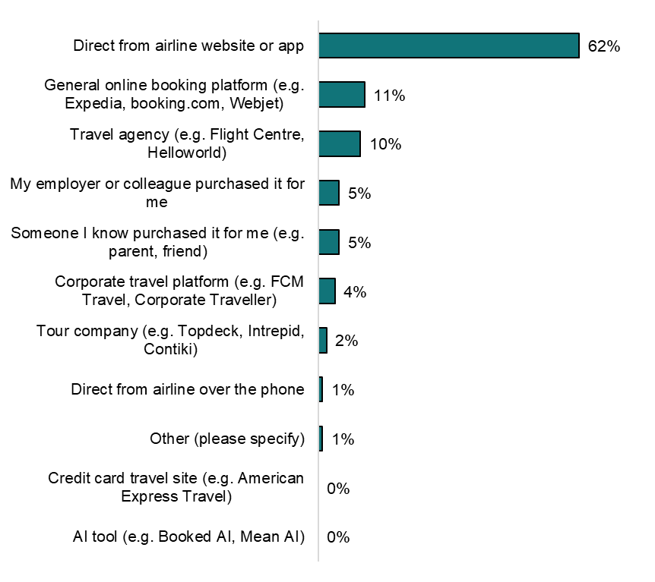Source: “How did you purchase your ticket?” (n=4,008 – weighted)
Excluding direct purchases from the airline’s website or app, some cohorts differed in their ticket purchasing behaviour:
- 58% of purchases from travel agents and 79% of purchases from a tour company are made by people 55 years and over.
- Australians whose main language at home was not English were more likely to purchase their tickets from booking platforms (22%) than those who speak English at home (9%).
- Australians with higher income (those earning above $150,000) were more likely to use a corporate travel platform to book their travel than people earning under $120,000.

Air travellers’ knowledge of their rights
Most Australians who travelled by air reported limited knowledge of their rights as airline passengers. More than half (56%) indicated they know only a little bit of knowledge, and almost a quarter (23%) reported possessing no knowledge. A fifth knew either a moderate amount (18%) or a lot (2%).
Older cohorts (65-75 years and 75+ years) were more likely to report higher knowledge of aviation consumer rights compared to younger cohorts.
Figure 3. Australians’ self-reported knowledge of airline rights by age group
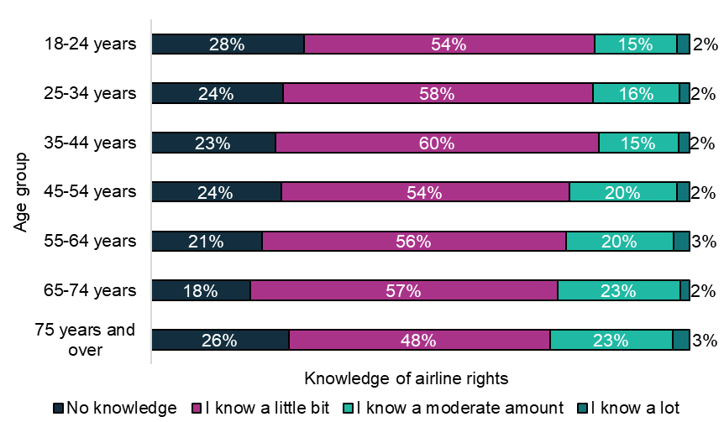
Source: “What is your age?”; “All airline passengers have rights when they buy a plane ticket. Passenger rights include things like what you are entitled to if you flight is delayed or cancelled, or your baggage is lost. How much knowledge do you have about your rights as an airline passenger?” (n=4,008 – weighted)
Australians with a disability, medical condition or injury also had slightly lower knowledge of their rights, with 28% reporting no knowledge compared to 21% without.

Figure 4. Australians’ self-reported knowledge of airline rights by disability status
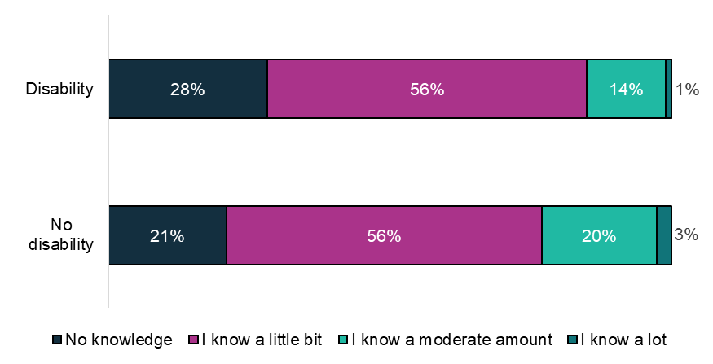
Source: “Do you have a disability, medical condition or injury that has lasted, or is likely to last, 6 months or more?”; “All airline passengers have rights when they buy a plane ticket. Passenger rights include things like what you are entitled to if you flight is delayed or cancelled, or your baggage is lost. How much knowledge do you have about your rights as an airline passenger?” (n=4,008 – weighted)
More than half of travellers (57%) report they do not read the airline terms and conditions during purchasing a ticket. A third (36%) read them partially, and 3% of responders read them in full. There is slightly more engagement when purchasing tickets through a booking platform with 8% reading the terms and conditions in full, 35% reading them partially and 54% not reading them at all.

Knowledge of rights is inconsistent across topics
We asked Australians to read 5 short statements about common air travel disruptions and answer whether they thought they were true or false. People could also respond “unsure/it depends” to each statement.

Table 4. Results of survey knowledge test on air travel rights
Knowledge statement | Correct answer | Percentage of correct answers | Percentage of incorrect answers | Percentage of 'depends/  unsure' answers
“I am entitled to a ticket refund or voucher when the cause of the flight cancellation is something the airline can control” | True | 75% | 4% | 21%
“If my flight is significantly delayed, I am entitled to a free meal or food voucher” | True | 56% | 9% | 35%
“If I have a disability or require assistance to navigate my journey, I can ask for this at the time of booking” | True | 88% | 3% | 10%
“The airline could deny me boarding if I have recently had surgery or I am injured” | True | 51% | 11% | 38%
“Airports are responsible for the management of baggage and handling baggage complaints” | False | 15% | 62% | 22%
Source: “Please select whether you think the following statements are true or false…” (n=4,008 – weighted)
We found Australians’ understanding of their rights was mostly correct. Areas of uncertainty were most noticeable in:
- baggage complaints – 3 out of 5 people (62%) incorrectly thought airports were responsible for the management of baggage and handling complaints. This is the airlines’ responsibility.
- denying of boarding – 2 out of 5 (38%) could not definitively answer whether airlines could deny boarding due to recent surgery or injury
- entitlements when experiencing a significant delay of 3 hours or more – almost 2 out of 5 (35%) could not definitively answer what their entitlements were in this situation.

Digital confidence is related to self-reported knowledge of rights
Those with high digital confidence reported greater knowledge regarding aviation consumer rights and performed better on the knowledge quiz. Those with no digital confidence had the greatest deviation in their knowledge from the overall population, with 63% of this group reporting no knowledge.

Figure 5. Australians’ self-reported knowledge of airline rights by digital confidence
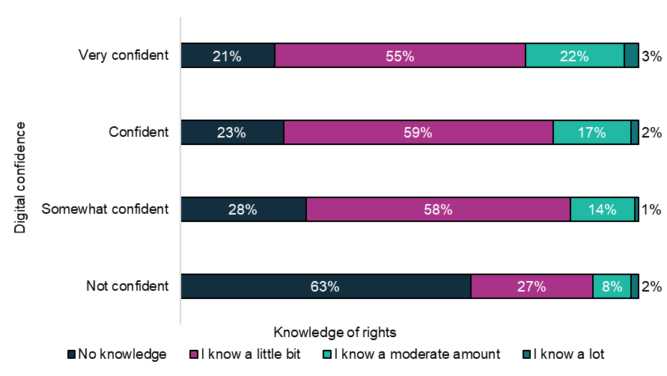
Source: “How would you describe your level of confidence with using computers, smartphones or other electronic devices to do what you need to online?”; “All airline passengers have rights when they buy a plane ticket. Passenger rights include things like what you are entitled to if you flight is delayed or cancelled, or your baggage is lost. How much knowledge do you have about your rights as an airline passenger?” (n=4,008 – weighted)

Australians on higher incomes were less likely to read ticket terms and conditions
The people least likely to read their ticket terms and conditions before booking were those on the highest income levels. This non-behaviour decreased in line with a person’s level of household income.
Table 5. Percentage of people who did not read their ticket terms and conditions before booking their most recent flight (by income bracket)
Household income bracket | Percentage who did not read ticket terms and conditions
$150,000 and over | 40%
$120,000 to $149,999 | 15%
$90,000 to $119,999 | 14%
$60,000 to $89,999 | 13%
$30,000 to $59,999 | 9%
Prefer not to say | 6%
Under $30,000 | 4%
Source: “Did you read the [relevant airline] terms and conditions for your ticket before booking your most recent flight from [departure airport]?” (n=4,008 – weighted)

Information on ticket terms and conditions is the hardest to understand
Australians identified information on terms and conditions as the most difficult to understand prior to travelling. On the other hand, Australians rated information on the overall flight itinerary as the easiest document to understand.
Figure 6. Australians’ perceptions of ease/difficulty for certain information prior to travelling by air
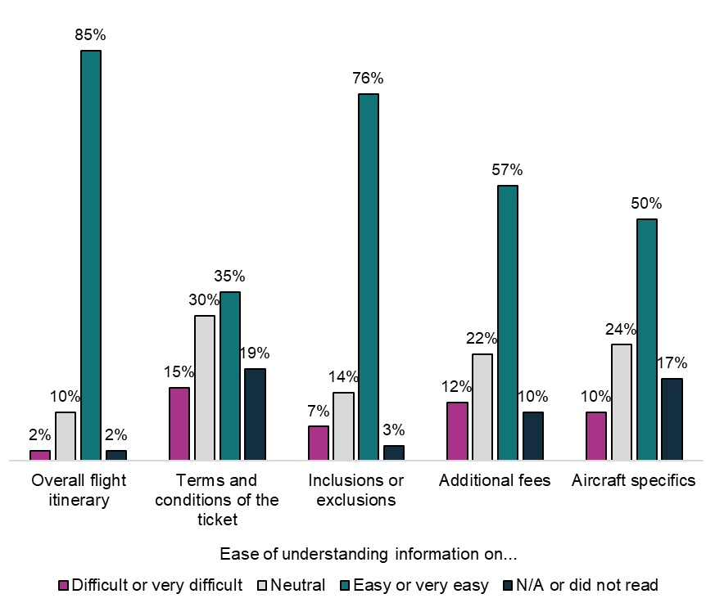
Source: Prior to your most recent flight…how easy or difficult to understand was the following information: (n=4,008 – weighted)

Airlines and online search engines are the first place people would go for more information on their rights
Most Australians would either go directly to the airline (34%) or an online search engine (33%) to find out more about their rights as an airline passenger. Government websites such as the ACCC and Smart Traveller were the third most popular option (14%).

People want more information relating to fees and ticket conditions for their next flight
Australians would most like information on additional fees and charges, entitlements, and terms and conditions to help inform future air travel.

Figure 7. Most helpful information to inform Australians’ future air travel bookings
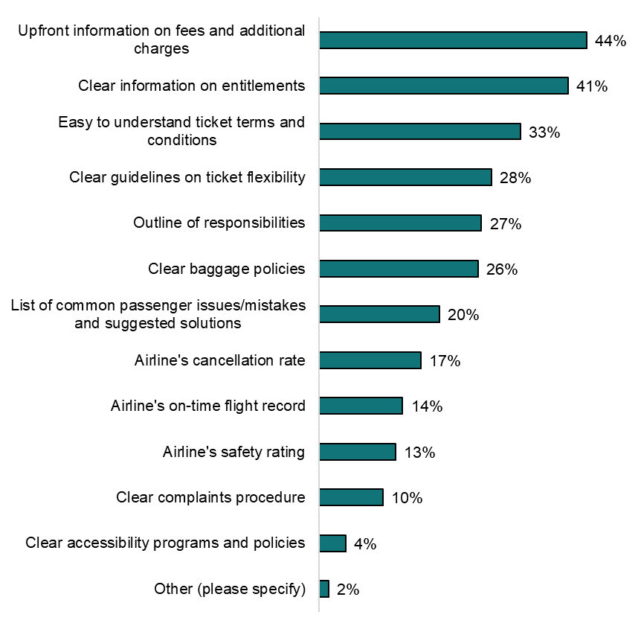
Source: “In your opinion, what information would be most helpful to inform your next air travel booking? Please select up to 3.” (n=4,008 – weighted. Questions where more than one response can be selected may not sum to 100%)
There were some preferential differences between different groups of Australians about what they would find most helpful to inform their next flight. People with a disability, medical condition or injury were 3 times more likely to prioritise clear accessibility programs and policies to help inform future air travel bookings than those without.
Australians living in a remote or very remote location, who are not digitally confident or have a lower level of household income were more likely to want an outline of responsibilities to inform their next air travel booking. Younger Australians between the ages of 18 and 44 were more likely to prioritise clear baggage policies.

Disruptions and associated communication

Over half of Australians experienced a disruption in the last 12 months
Fifty-five percent of Australians travelling by air experienced a disruption within the last 12 months. This included 37% who experienced a disruption on their most recent flight and 18% who experienced a disruption on any flight in the last 12 months (but not their most recent flight). The more flights people reported taking in the past 12 months, the higher the likelihood of experiencing a disruption.
Figure 8. Overview of disruptions and complaints for Australian travellers over the last 12 months
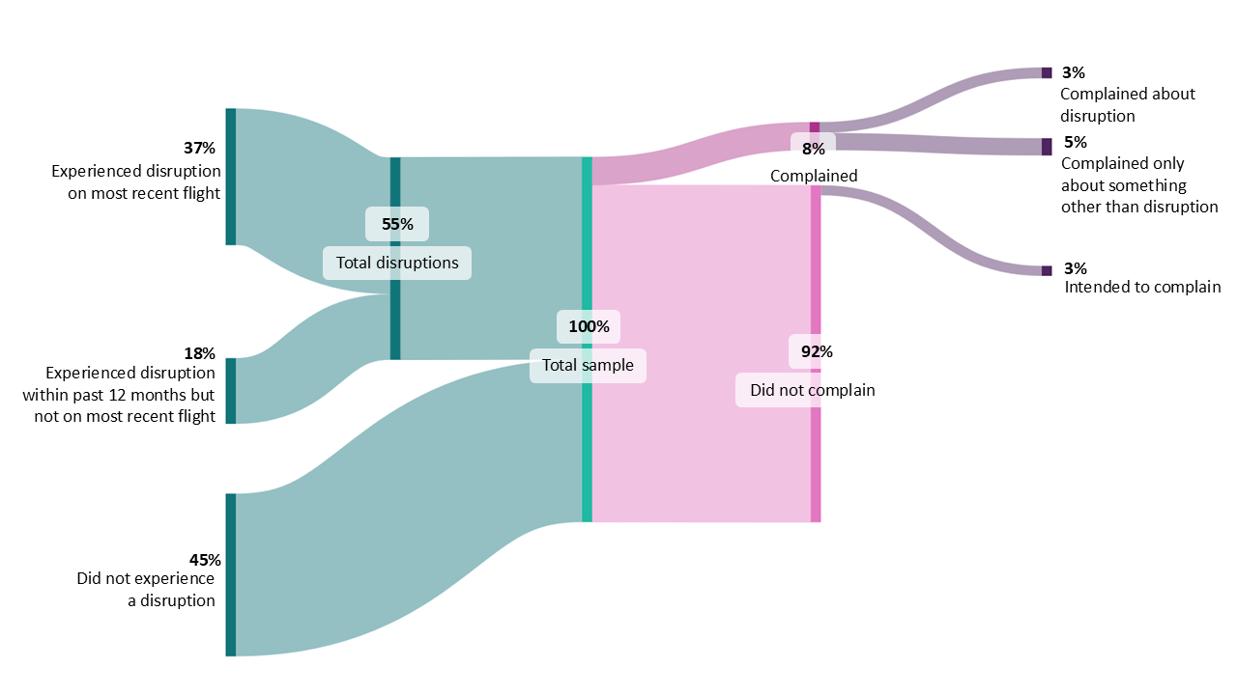
Note: Percentages are weighted and refer to percent of total sample, not the preceding branch
The most common disruption was a delay of between 15 minutes and 3 hours (43%), consistent with findings from previous research (CHOICE, 2023).

Figure 9. Australians’ experience with disruptions when flying based on their most recent flight or any flight in the last 12 months
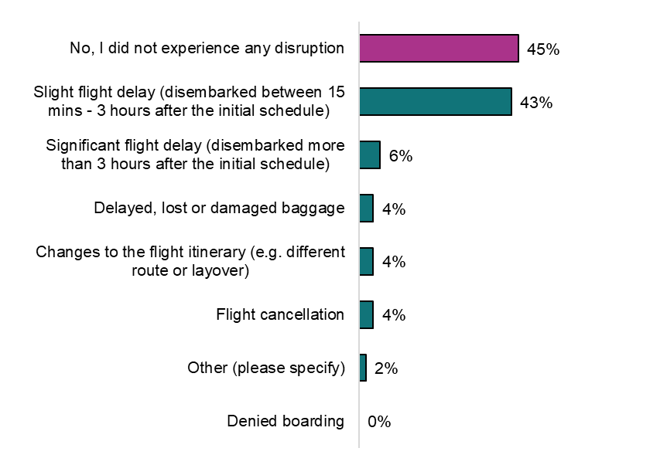
Source: “On your most recent flight…did you experience any of the following disruptions? Please select all that apply.” (n=4,008 – weighted); “On any of your flights from an Australian airport in the last 12 months, did you experience any of the following disruptions? Select all that apply.” (n=2,018 – weighted. ‘Select all’-type questions may not sum to 100%)

Communications about disruptions and complaints
People mostly learnt about the disruption via airport signage, loudspeaker or direct communication from the airline.

Figure 10. How Australians learnt about their most recent disruption
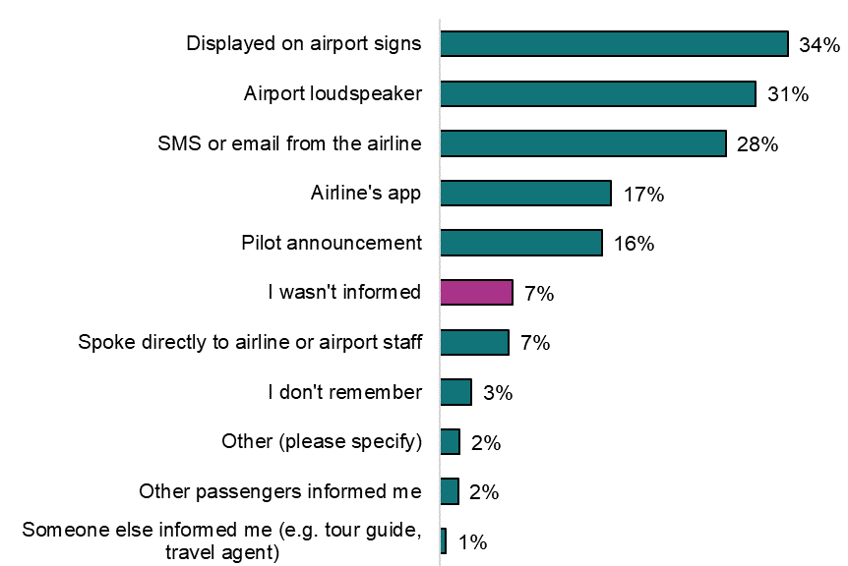
Source: “How were you informed of the disruption(s)? Please select all that apply” (n=2,228 – weighted. ‘Select all’-type questions may not sum to 100%)
Australians were most satisfied with the outcome of their disruption when they were told via a third party (e.g. tour guide, travel agent), a pilot announcement or directly by staff. Airports and airlines rarely informed Australians about the cause of the disruption (37%) or their rights as a passenger (7%) when experiencing a disruption.

Figure 11. Australians’ satisfaction with the handling of their disruption by how they were informed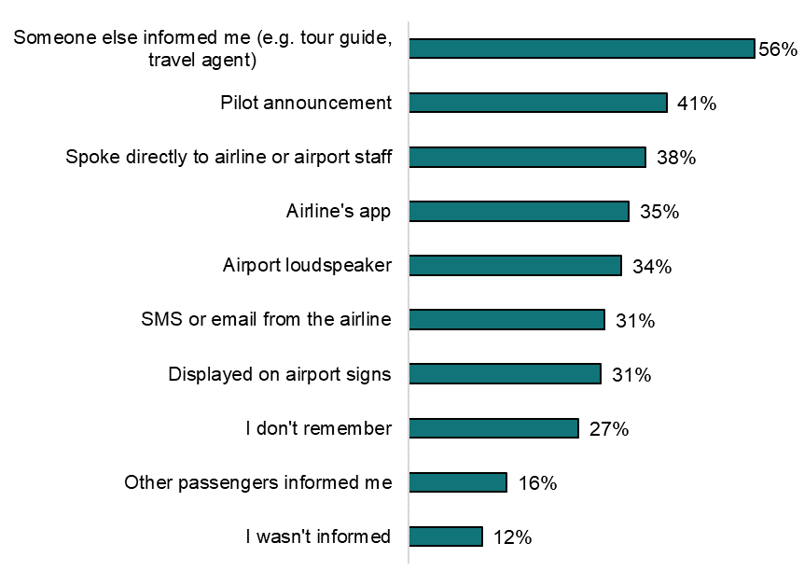Source: Overall, were you satisfied or dissatisfied with how the disruption(s) were handled?”; “How were you informed of the disruption(s)? Please select all that apply” (n=3,237 – weighted and merged. ‘Select all’-type questions may not sum to 100%)

Australians had mixed views about how disruptions were communicated
Only 42% of people were satisfied with the communication about their most recent disruption. Most people agreed the communications were clear and easy to find or hear. There was less agreement about communications being timely and practical. The clarity, timeliness, ease and practicality of disruption communications drove people’s overall satisfaction with disruption handling.
Table 6. Australians’ views on the communication about their experienced disruptions
‘The communication about the disruption was…’ | Disagree or strongly disagree | Neutral/don’t remember | Agree or strongly agree
Practical (e.g. outlined next steps) | 27% | 30% | 43%
Easy to find or hear | 24% | 23% | 53%
Timely | 28% | 25% | 47%
Clear | 21% | 23% | 57%
Source: “The communication about the disruption was…” (n=2,003 – weighted)

Most people did not receive a remedy to address their disruption and satisfaction with handling of the disruption was mixed
Only 18% of Australians received a remedy to address their flight disruption(s), which aligns with findings from prior research (CHOICE, 2023). The most common support was rebooking on another flight (9%) and food/drink (5%). Of those that received support, 49% found the process of receiving it to be easy or very easy.
Overall, only 31% of Australians who experienced a disruption were satisfied with the overall handling of their disruption, with 42% feeling neither satisfied nor dissatisfied.
Figure 12. Whether those who experienced a disruption received anything to address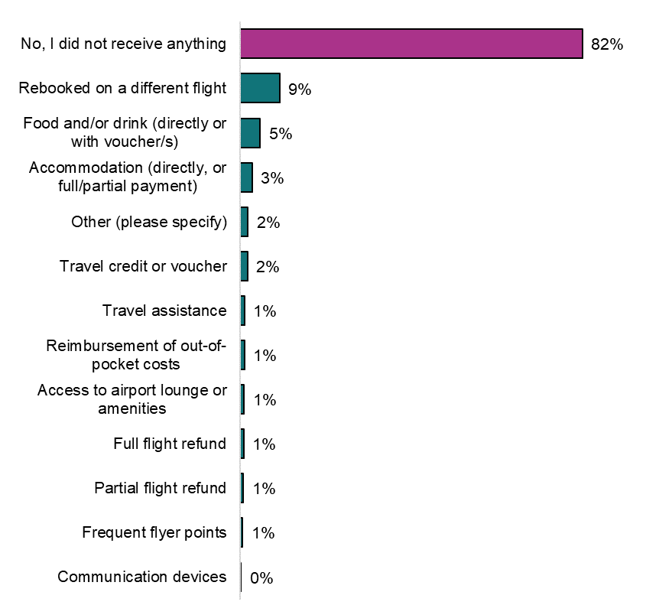Source: “Did you receive anything to address the disruption? Please select all that apply.” (n=2,228 – weighted. ‘Select all’-type questions may not sum to 100%)
Passengers who experienced a disruption but did not receive support were more likely to complain. People were also more likely to complain if they had a higher level of dissatisfaction with the overall handling of their disruption.
The method of communicating a disruption also affected the likelihood of lodging a complaint. Passengers were most likely to complain if there was no information (10%) or other passengers informed them (10%).
Figure 13. Whether Australians lodged a complaint about their disruption by how they were informed
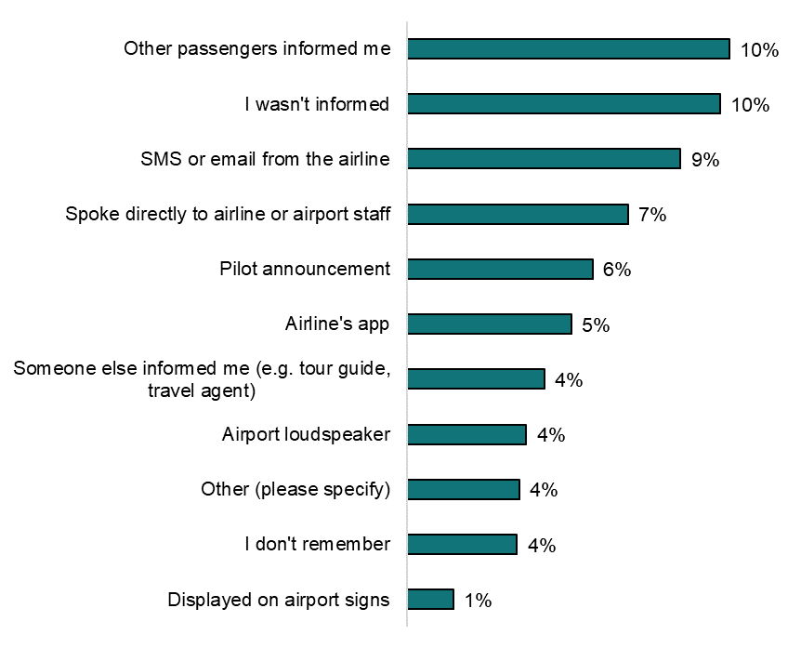
Source: “Did you make a complaint about the disruption(s)? A complaint is an expression of dissatisfaction made to or about an organisation, where a response or resolution is expected.”; “How were you informed of the disruption(s)? Please select all that apply” (n=2,228 – weighted. ‘Select all’-type questions may not sum to 100%)

People who experienced disruptions said they would like better communication and repayment of costs
Respondents provided free-text suggestions to improve the handling of disruptions. Below, these suggestions are grouped into 5 themes and presented in the order of how frequently they were mentioned.

Table 7. Australians’ suggestions to improve experience with disruptions
Suggestion theme | Summary
- Timely and clear communication | Respondents wanted more communication from airlines about the disruption. This included early, proactive, multi-channel (especially SMS/in-app) communications that clearly state the issue, passengers’ required actions and next steps. Respondents also wanted adequate numbers of staff available to assist at the time of disruption, especially when disruptions impact connections.  ‘Airlines should provide travellers with early indications of delays. Often I find that I can easily and accurately predict significant flight delays hours ahead using public data sources through apps like FlightAware that tell me that the operating aircraft for my flight is running behind on the inbound flight, yet airlines appear to be either unwilling or incapable of providing the same advance information to travellers’  Male, 55-64, NSW
- Repayment of cost caused by disruption | Respondents wanted proactive and timely compensation for disruptions. This included third party costs, e.g. missed connections, independently rebooking another flight, extending parking an extra day. Refunds were most preferred, but respondents also expected travel vouchers, food/drink, Wi-Fi and accommodation depending on the nature of the delay. Respondents also wanted more choice in the support offered, such as the rebooking of their flights.  ‘Offer SOMETHING when a flight is going to be delayed. Free wifi [sic], snacks, a $15 food voucher or uber voucher. Something usable. Not just a “we're going to be late, good luck.”’  Male, 25-34, ACT
- Transparency and accountability | Respondents wanted to know the reason for the disruption, and honest information regarding the cause and estimated impact. They also felt communications lacked accountability or empathy.  ‘Inform passengers as soon as possible with the true reason, not a made up one as was the case with my last flight’  Male, 65-74, QLD
- Communication of rights | Respondents wanted airlines to inform them of their rights and entitlements at the time of disruption, if not earlier at the time of booking.  ‘Link to information in rights would have been helpful, but airlines deliberately under-man assistance desks and during a disruption it's nearly impossible to get timely information’  Female, 35-44, QLD
- Airport announcements | Respondents noted difficulties regarding loudspeaker announcements of disruptions, such as inconsistent use, being difficult to hear or not broadcast to all areas of the airport.  ‘Better communication at gate lounges is badly needed – regarding boarding delays. Staff should speak slowly and clearly, as most messages are unable to be heard and understood, creating frustration for passengers needing updated information.’  Female, 65-74, QLD

Complaints and the complaint making process

People were unlikely to complain about a disruption or other issues
Overall, 8% of all air travellers made a complaint about an issue in the last 12 months. While 55% of travellers experienced a disruption in the last 12 months, only one in 20 (5%) of those complained about that disruption. The 3 main complaint issues were a flight delay, cancellation or changed itinerary (46%), baggage-related issues (22%) and poor customer service (19%).

Figure 14. The issues Australians’ complaints were about
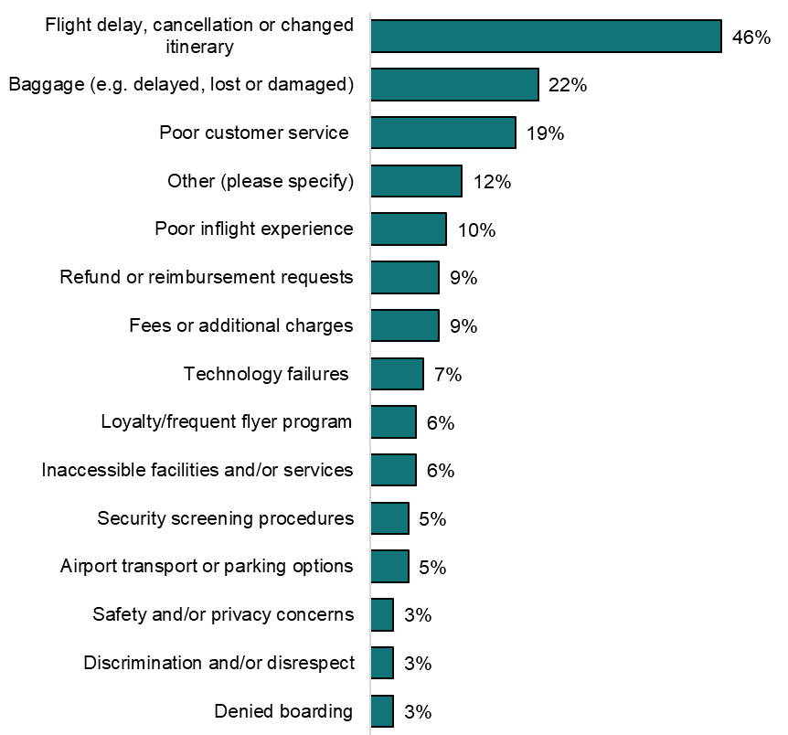
Source: “What issue/s were your complaint about? Please select all that apply” (n=313 – weighted and merged. ‘Select all’-type questions may not sum to 100%.)

Some cohorts were more likely to lodge complaints
Several cohorts appear more likely to complain:
- Males (9% versus 6% for females)
- Culturally and linguistically diverse individuals (11% versus 7% whose main language is English)
- Frequent flyers, especially those who flew more than 6 times in the last year (14% versus 6% for those who flew once in the last year).

Most Australians lodged their complaints directly with an airline
Seventy percent of Australians lodged their complaint with an airline. This reflects the types of issues travellers complained about, such as delays and baggage – often seen as the airline’s responsibility. The next most common recipient of complaints was ‘other’ (10%), which includes travel agents and insurance companies.
Figure 15. Where Australians lodged their complaints
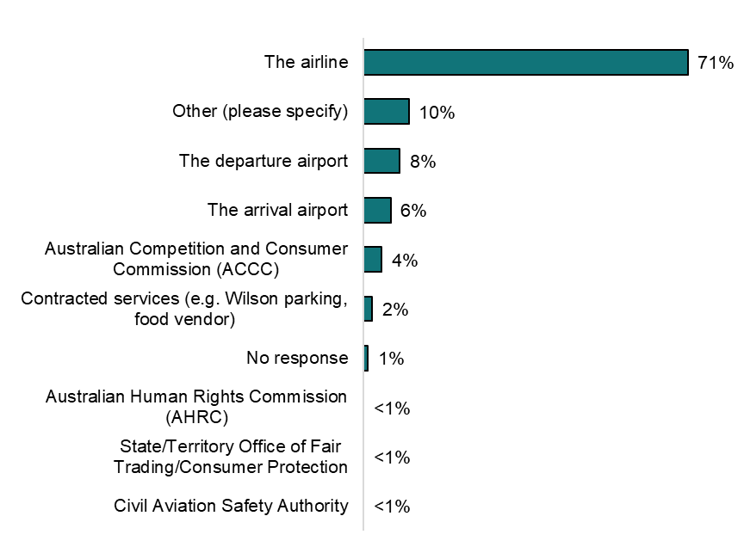
Source “Who did you initially lodge your complaint with?” (n=313 – weighted and merged)
Australians preferred lodging their complaints through digital channels (58%), through either a website (29%), email (18%), app (8%) or social media (3%).
Travellers mostly learnt how to lodge their complaint via search engines (24%), airline apps/websites (22%) or from airline/airport staff (18%). Fourteen percent learnt through word-of-mouth, such as other passengers, family or friends.

Most air travellers’ complaints were either responded to within 7 days, or not at all
Almost one in 3 Australians (31%) did not receive a response to their complaint at the time of the survey, while 41% were responded to either immediately or within 7 days.
Figure 16. How long it took Australians to receive a response to complaints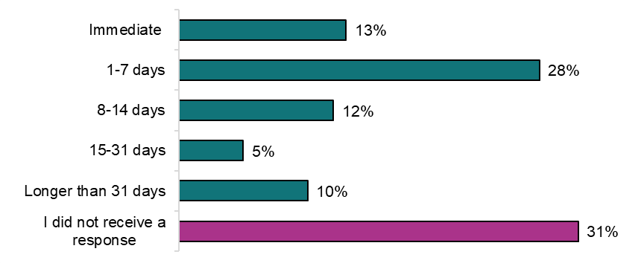
Source “How long did it take to receive a response to your initial complaint? (Not including auto-responses or chatbots)” (n=313 – weighted and merged)

2 out of 5 travellers’ complaints had not been resolved
Similarly, the number of Australians whose complaints had not been resolved at the time of the survey was 42%. This is higher compared to those whose complaint was either resolved immediately or within 10 days (26%). This number is also higher than recently reported by the Airline Customer Advocate, which indicated 33% of eligible complaints received in 2024 had not been resolved, while the Advocate’s average number of days taken to finalise a complaint was 10 (Airline Customer Advocate, 2025).
Figure 17. How long it took Australians’ complaints to be resolved
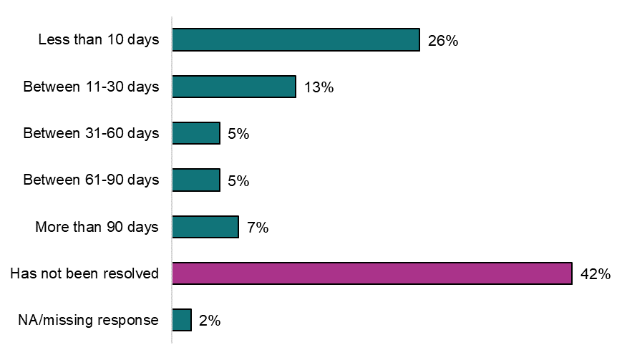
Source “How long do you estimate it took for your complaint to be resolved?” (n=313 – weighted and merged)
Lack of response or resolution relating to a complaint does not result in escalation. Most Australians (84%) did not escalate their complaint to another organisation.

Australians were generally dissatisfied with the aviation complaints process overall
Considering the steps in a typical complaints process, Australians were most satisfied with their complaint’s outcome (39%) and the time it took for the complaint to be resolved (31%), and were most dissatisfied with responses to their complaint (62%) and the complaint process overall (57%).
The percentage of Australians dissatisfied with the outcome of their complaint/s (37%) was lower than other contemporary research on Australians’ experience with airline complaints (67%) (CHOICE, 2023). It is worth noting we only asked Australians about the outcome or resolution of their complaint if they previously indicated it had been resolved, meaning this group may have inherently higher satisfaction.
Table 8. Australians’ satisfaction with stages of the complaints process
Stage of the complaint process | Net dissatisfied or very dissatisfied | Neutral/no response | Net satisfied or very satisfied
The process of initiating the complaint | 44% | 26% | 30%
The response(s) to the complaint | 62% | 23% | 15%
The communication throughout the process | 54% | 29% | 17%
How you were treated throughout the process | 49% | 28% | 23%
The complaint’s outcome | 37% | 24% | 39%
The time it took for the complaint to be resolved | 43% | 27% | 31%
The complaint process overall | 57% | 27% | 17%
Source “How satisfied or dissatisfied were you with…” (n=166-313 – weighted and merged). Percentages refer to net satisfaction which is the proportion of respondents answering satisfied or very satisfied.
The time it took to respond to complaints was the most predictive factor of whether someone was satisfied with the overall handling of their complaint.

Table 9. Australians’ satisfaction with the complaints process overall by time taken to receive response
Time taken to receive a response | Net dissatisfied or very dissatisfied | Neutral/no response | Net satisfied or very satisfied
Immediate | 31% | 25% | 44%
1-7 days | 39% | 41% | 19%
8-14 days | 59% | 14% | 27%
15-31 days | 65% | 11% | 24%
Longer than 31 days | 89% | 4% | 6%
I did not receive a response | 72% | 27% | 1%
Source “How satisfied or dissatisfied were you with the complaint process overall”; “How long did it take to receive a response to your initial complaint? (Not including auto-responses or chatbots)” (n=313 – weighted and merged)

People who intended to lodge a complaint but did not do so attributed this to lack of energy and time, and a belief that it would not make a difference
Three percent of Australians intended to make a complaint about a disruption or issue in the last 12 months, but either did not start or complete the process. This group identified flight delays, cancellations or changed itineraries (42%), poor in-flight experience (31%) and poor customer service (23%) as the main issues they intended to complain about. They also outlined a lack of energy and time (52%) and a belief their complaint would not make a difference or be taken seriously (48%) as the key barriers to lodging a complaint. This suggests Australians believe the process to be long and often does not result in the desired outcome.

People who lodged a complaint said a simpler and more responsive complaints process would improve their experience
Respondents provided free-text suggestions to improve the handling of complaints. Below, these suggestions are grouped into 6 themes and presented in the order of how frequently they were mentioned.

Table 10. Australians’ suggestions to improve experience with complaints
Suggestion theme | Summary
- Complaints process and response time | Respondents noted the lack of responses, slow responses and the need for frequent follow-ups as frustrating. Respondents also noted impersonal responses and inadequate handovers between departments contributed to poor customer experience.  ‘Force airlines to respond in a timely manner, don’t let them drag it out in the hopes the customer will drop their complaint’  Female, 25-34, QLD
- Lodgement channel | Respondents said it was unclear how to initiate a complaint. They wanted a clear list of options to lodge, including in person/at the airport, over the phone and online (via form or live chat, not with chatbots). Some believed the staff receiving their complaint lacked sufficient training or authority to deal with it effectively.  ‘There should be a way of establishing DIRECT contact with a PERSON, rather than robotic ineffectual processes during the period of enquire on the whereabouts of delayed baggage, particularly for passengers on their outbound flight who find themselves stranded in foreign countries. As it happens, the process is very painful and a shambles...’  Female, 65-74, SA
- Respectful and empathic communication | Respondents said there could be greater value, attention and respect applied to the complaint-making process.  ‘I am very, very angry about the whole process and profoundly distressed by it. I have disabilities that made their abuse and bullying a major trigger. I felt worthless, powerless, and dehumanised. I would never fly [with] them ever again if I could possibly avoid it. But there are very few options that I can afford now. So I'm living in dread of the next time I have to subject myself to that again.’  Male, 35-44, QLD
- Outcomes and compensation | Respondents noted the variability of outcomes, the need for proactive support and the perception that outcomes were not equal to impact.  ‘I was given 5,000 [airline loyalty] points for cancelled flight where I arrived home 18 hours later severely tired and stressed; I don't think they provided enough compensation relative to the harm’  Female, 35-44, VIC
- Accountability and regulation | Respondents expressed a desire for greater regulatory oversight, a central complaints body or harsher penalties for airlines.  ‘Strengthen the role of regulators or ombudsman services to ensure fair outcomes and reduce the perception of airlines’ [sic] marking their own homework.’  Male, 18-24, WA
- Information on rights | Respondents believed airlines should proactively inform them of their rights (note: this population [those that made complaints] are more likely to be already familiar with their rights).  ‘Remove ambiguity from your rights – made [sic] them clearer and less ambiguous / able to be debated by the airline. The industry would benefit from specific compensation rights, instead of the general provisions in Australian consumer law which are too vague and difficult to enforce.’  Male, 35-44, NSW
Source: “Do you have any suggestions to improve how aviation complaints are handled in the future?” (n=97 – themed)

The aviation experience for those with a disability, medical condition or injury
The Government’s Aviation White Paper clearly outlines that a better passenger experience includes making aviation accessible for people with a disability (Infrastructure, 2024). We were interested in better understanding the aviation experience of those with a disability through our survey. We also broadened our scope to include those with a medical condition or injury that has lasted, or is expected to last, 6 months or more, as these groups may also experience accessibility issues when travelling by air.

Demographics of those with disability, medical condition or injury
Almost a quarter of Australians who travelled by air in the last 12 months identified as having a disability, medical condition or injury (24%). Two out of 5 people in this cohort (40%) indicated their disability, medical condition or injury impacted their ability to access or use airports to some degree. Similarly, 38% reported their medical condition, disability or injury impacts their ability to travel on an aircraft.
Analysis of travel purpose revealed Australians with a disability, medical condition or injury were 3 times more likely to travel by air for medical purposes (2.6%) than those without (0.7%).

Figure 18. The impact that disability, medical condition or injury has on traveller’s ability to access or use airports
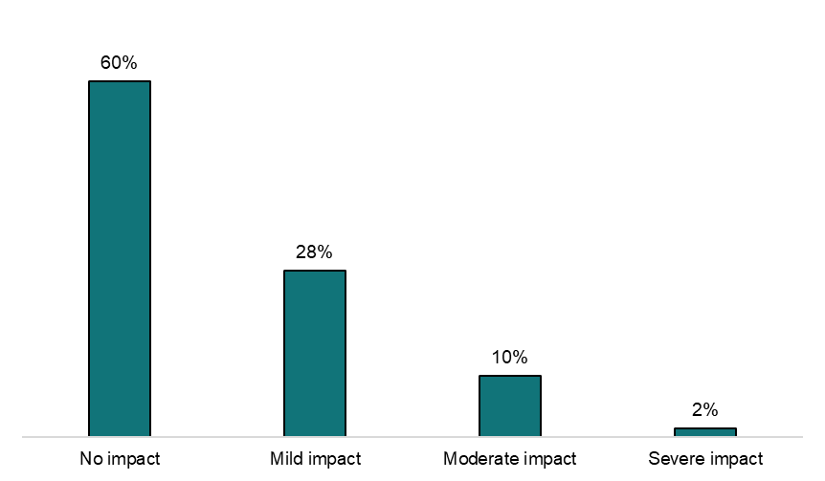
Source: How much does your disability, medical condition or injury impact your ability to access or use airports? (n=1,028 – weighted)
Figure 19. Percentage of Australians with a disability, medical condition or injury which impacts their ability to travel on an aircraft
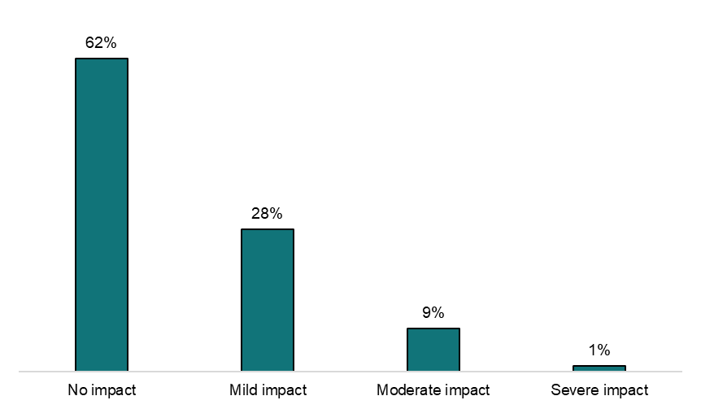
Source: How much does your disability, medical condition or injury impact your ability to travel on an aircraft? (n=1,028 – weighted)

Experience flying with a disability, medical condition or injury
The majority of Australians with a disability, medical or injury travelled by air without asking for or receiving assistance (84%), seeking information about available assistance (87%), or without a mobility aid (95%) or assistance animal (99%).
Figure 20. Travel behaviour of Australians with a disability, medical condition or injury on their most recent flight
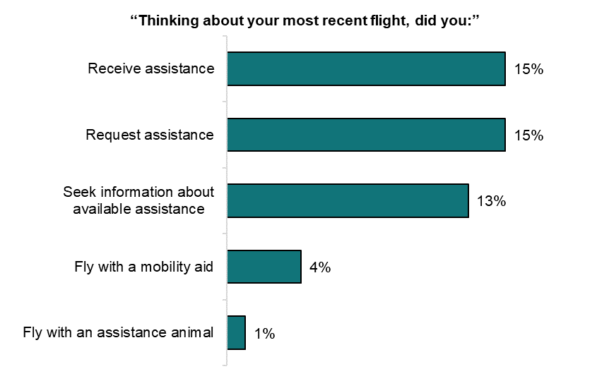
Source: As you indicated earlier that you have a disability, medical condition or injury, we would like to ask a few questions about your personal experience. Thinking about your most recent flight…did you: (n=1,027-1,028 – weighted)
While most Australians who flew with a mobility aid did not encounter any issues (56%), the main issues encountered were unclear directions for collection (18%) and limited space or storage (15%). Due to small sample sizes these estimates are not precise.
Those who did receive any kind of assistance were either satisfied (45%) or very satisfied (35%) with the assistance provided – mainly provided by airline staff (68%) – and most found the process of receiving it an easy experience (57%).

The ease of receiving assistance correlated with higher satisfaction levels
Of those with a disability, medical condition or injury who reported it was ‘very easy’ to access assistance, 100% were satisfied with the assistance they received. Of those who reported the process to receiving assistance as being ‘very difficult’, only 5% were satisfied.
Of those who sought information about available assistance, 39% found it ‘difficult’ or ‘very difficult’ to access this information.

‘Overall, the services are already helpful, but I think they could be made even better by adding more staff during peak travel times, offering clearer signage and digital guidance in multiple languages, and providing a smoother way to request real-time assistance through mobile apps.’
Male, 55-64, VIC

People with disabilities, medical conditions or injuries also have low knowledge of their rights in relation to available assistance from airlines and airports
One in 5 people (20%) with a disability, medical condition or injury indicated they have a moderate-to-high level of knowledge about the assistance available to them.
Table 11. Australians with a disability, medical condition or injury’s knowledge of assistance available to them when travelling by air
Australians with a disability, medical condition or injury’s knowledge level prior to their most recent flight regarding... | …Knowledge of the assistance available to them | …Knowledge of how to access assistance services
“No knowledge” | 29% | 40%
“I knew a little bit” | 52% | 45%
“I knew a moderate amount” | 16% | 11%
“I knew a lot” | 4% | 4%
Source: “Airports and airlines have assistance services available to support passengers with specific needs, to help them navigate the airport and aircraft safely and comfortably. Before booking your most recent flight…how much did you know about: the assistance available to you; how to access assistance services (n=1,027 – weighted)
Two out of 5 Australians (40%) with a disability, medical condition or injury had no knowledge about how to access services available to them.
Melbourne Airport launched a permanent network of mobility hubs during the running of our main survey (16 September 2025) to provide further assistance services after a successful 4-month trial (Melbourne Airport, 2025). Initiatives such as this, as well as the existing hidden disabilities programs (providing support for non-visible disabilities) offered through several Australian airports, may provide further support if Australians are aware they are available.

People with a disability, medical condition or injury see staffing and assistance, information on accessing support and mobility as key areas of improvement
Respondents provided free-text suggestions to improve airport and airline assistance services. Below, these suggestions are grouped into 9 themes and presented in the order of how frequently they were mentioned.

Table 12. Australians’ suggestions to improve airport and airline assistance services
Suggestion theme | Summary
- Staffing and assistance | Respondents wanted more staff available for assistance noting long waits or lack of access, even if the assistance was pre-booked. Respondents also said central information points/kiosks and specialised/trained staff would help.  ‘For persons with a chronic health condition that is variable, being able to access assistance while in the airport from staff positioned along the route from check-in through customs, security and to the boarding gate would be helpful.’  Female, 65-74, NSW
- Information on how to access support | Respondents believed the available assistance was poorly advertised both at the time of booking and at the airport.  ‘Perhaps making the support or assistance services with an airline part of the initial booking process rather than making it a service that needs to be added to a booking after the fact. That way people just opt in or opt out instead of having to add it afterwards by having to look up the contact details which aren't always easy to find and spend more time waiting for airline staff to be available to request adding the service to a booking.’  Female, 45-54, WA
- Mobility | Respondents described barriers to airport mobility including stairs for boarding and disembarking (especially when replacing aerobridges), lack of travelators, large distances to gate and long times on their feet with limited seating.  ‘My problem is difficulty in walking. I can however walk and would not normally need a wheelchair or other help. Its [sic] the distance one needs to walk which is a bother to me. Some airports have moving footways which help but none have these facilities once you leave the terminal. So for me the dragging of luggage across various obstacles to get to the private pick-up points are [sic] very distressing.’  Male, 65-74, NSW
- Baggage | Respondents wanted additional help with carrying/lifting baggage and noted weight limits may impact them disproportionately.  ‘Small luggage trolleys on other side of check-in /security, as often I can’t carry hand luggage & often have a long walk to depart gates.’  Female, over 75, VIC
- Wayfinding and announcements | Respondents said a lack of signage, including disability-specific signage, and unclear loudspeaker announcements were barriers.  ‘Announcements at gates could be captioned. Airlines could offer someone to explain important info personally to hearing impaired people. Captains and stewards making announcements could be trained in elocution.’  Female, over 75, ACT
- Boarding and disembarking | Respondents believe priority boarding is poorly handled and note the inconsistency of aerobridge versus stairs leads to access issues.  ‘I think you can ask if there is a lift, or to use level boarding but I only have a stiff leg that can make boarding and disembarking or up to arrivals level at airports a little difficult. Those ramps on and off planes at some airports are good. Stairs are tricky if you have even a minor disability or trouble with balance. I and others use rails for support and the ones that fold out from the plane can be disconcertingly wobbly. I would not like to be genuinely disabled on some.’  Male, 65-74, ACT
- Seating | Respondents noted uncomfortable or inadequate seating on aircraft or in the airport.  ‘We had to change plan[e]s before take-off. I had paid for an [a]isle row due to my condition. When getting on the back up plane I was no longer in an aisle which was required. Luckily the passenger next to me swapped.’  Female, 25-34, QLD
- Security | Respondents needed greater support from security staff including priority lines and accommodations for screening with medical devices/mobility aids.  ‘As mentioned earlier, clearer processes. I also think it would be better to minimise the wait between bag check and going through security specifically in the case that I have to put my cane in bag check and support myself with no assistance until I can go through and re-collect my cane.’  Female, 35-44, VIC
- Supporting infrastructure | Respondents noted the lack of public transport, long-term parking and accessible pick-up/drop-off at airports.  ‘The whole airport experience is exhausting. I park long term and it’s miles away so had to walk ages from overflow carpark to bus pick up. Then bus drop off is miles away from international so walking for ages again, then after check in have to walk miles to [airline] lounge for departure. The whole process feels like a journey in itself that I need a holiday from.’  Female, 45-54, VIC
Source: “Do you have any suggestions to improve the airport and airline assistance services in the future?” (n=961 – themed)

Discussion and conclusion

Survey outcomes and insights
We designed our survey to provide ACOS with a robust baseline of Australians’ attitudes, experiences and behaviours with the Australian aviation industry which will be measurable over time. We used a probability-based recruitment panel to reduce the likelihood of bias from our results, and weighting to ensure our survey was representative of the Australian adult population. Future surveys can apply these 2 elements of our methodology to accurately measure any changes to Australians’ knowledge of air travel rights, experiences and behaviour.

Addressing knowledge gaps on rights
There are knowledge gaps relating to Australians’ understanding of their rights when travelling by air, with 4 out of 5 reporting that they know either nothing or a small amount. This may be impacted by, or contribute to, the lack of reading of ticket terms and conditions. People finding terms and conditions difficult to understand prior to travel may also influence this knowledge gap. There is also a knowledge gap among those with a disability, medical condition or injury when it comes to understanding how to access assistance services available to them (40%), which may be a help-seeking barrier.

Increasing support for those experiencing disruptions
While over 4 out of 5 Australians do not receive any support when they experience a disruption, they were also not informed of their rights when these disruptions occur. Receiving this support also does not appear to be straightforward, with only 49% indicating it was an easy process. Just over 40% were satisfied with the communication of their disruption(s), and only 31% were satisfied with the handling of their disruption(s). This indicates an area of potential improvement for Australians’ air travel experience.
Potential actions to address this issue could be exploring how to best:
- Communicate air travellers’ rights when experiencing a disruption
- Make it easier for Australians to receive the support available to them when experiencing a disruption.

Addressing communication issues which impact the complaints process
Australians consistently identified communication as one of the most negative elements of the air travel complaints process, with 31% of complainants not receiving a response to their complaints.
This is evident through high levels of dissatisfaction towards complaint responses (62%) and communication through this process (39%), which may also impact dissatisfaction towards the complaints process overall (57%).
Exploring how best to encourage consistent communication throughout the complaints process (including consumer expectations), as well as reducing the time taken to process complaints, could be options to address this issue.

Reducing identified barriers to making complaints
There are 2 main barriers to people wanting to make complaints and not following through with this behaviour:
- It is a challenging process (or appears that way to many people)
- It is perceived to not lead to a meaningful outcome for the complainant.
Simplifying the complaints lodgement process and ensuring Australians clearly understand the value and seriousness of their complaints may address these barriers and improve air travellers’ experience of flying by air.

Evaluation

Using survey data as a baseline measure
We have designed this survey as an initial baseline measure for the ACOS as it begins its operations. Applying weighting to the survey results provides both a nationally representative sample and a method for future iterations of this survey to accurately measure progress against this baseline.

Measuring outcomes and outputs against baseline results
We recommend ACOS consider using specific baseline measures from this survey as an evaluation measure for its future work. For example, positive changes to the following survey questions may be evidence for the success of any awareness-raising initiatives on consumer air travel rights:
- How much knowledge Australians have about their rights as an airline passenger
- Knowledge test on air travel rights
- How easy or difficult it was for Australians to understand certain information prior to travelling on their most recent flight
- Knowledge on how to access assistance services available to passengers with a disability, medical condition or injury
- Overall satisfaction with their air travel experience, and satisfaction towards specific stages of the air travel journey for cohorts of the Australian population such as those with a disability, medical condition or injury.

References
Airline Customer Advocate (2025), Airline Customer Advocate Annual Report 2024, Airline Customer Advocate, accessed 10 November 2025
Airlines for America (2025), Air Travelers in America – Key Findings of a Survey Conducted by Ipsos, Airlines for America, accessed 27 October 2025
American Customer Satisfaction Index (2025), ACSI Travel Study 2025, ACSI, accessed 27 October 2025
Australian Airports Association (unpublished), Wave 12 Traveller Intentions Report, Zing! Insights on behalf of Australian Airports Association, accessed 20 November 2025
Behavioural Economics Team of the Australian Government (2021), Supporting consumer decision-making about add-on insurance, BETA, accessed 19 November 2025
Behavioural Economics Team of the Australian Government (2021), Helping people understand the outcomes of bankruptcy, BETA, accessed 19 November 2025
Bureau of Infrastructure and Transport Research Economics (2025), Airport traffic data, BITRE, accessed 19 September 2025
Bureau of Infrastructure and Transport Research Economics (2025), Airline On Time Performance, 2024-25 Financial Year, BITRE, accessed 27 October 2025
BIT (2019), Improving consumer understanding of contractual terms and privacy policies: evidence-based actions for businesses, BIT, accessed 7 November 2025
Canadian Transportation Agency (2024), CTA Air Passenger Satisfaction Survey, CTA, accessed 27 October 2025
CHOICE and the Consumers’ Federation of Australia (2023), Submission to the Department of Infrastructure, Transport, Regional Development, Communication and the Arts Aviation Green Paper, CHOICE and CFA, accessed 5 December 2025
Civil Aviation Authority (2024), Flying in 2024 and beyond – Research findings from Wave 13 of the CAA’s UK Aviation Consumer Survey, CAA, accessed 27 October 2025
Department of Infrastructure, Transport, Regional Development, Communications, Sport and the Arts (2025), Aviation Consumer Ombuds Scheme, Infrastructure, accessed 5 November 2025
Department of Infrastructure, Transport, Regional Development, Communications, Sport and the Arts (2025), Aviation Accessibility, Infrastructure, accessed 5 November 2025
Department of Infrastructure, Transport, Regional Development, Communications, Sport and the Arts (2024), Aviation White Paper, Infrastructure, accessed 8 December 2025
International Air Transport Association (2024), IATA Global Passenger Survey 2024 Highlights, IATA, accessed 10 November 2025
Melbourne Airport (2025), How to book Special Assistance, Melbourne Airport, accessed 27 October 2025

© Commonwealth of Australia 2025
ISBN 978-1-925365-82-5 Preparing for take-off – surveying Australians’ air travel behaviour, experiences and attitudes

Copyright Notice
With the exception of the Commonwealth Coat of Arms, this work is licensed under a Creative Commons Attribution 4.0 International license (CC BY 4.0) (https://creativecommons.org/licenses/by/4.0/)

Third party copyright
Wherever a third party holds copyright in this material, the copyright remains with that party. Their permission may be required to use the material. Please contact them directly.

Attribution
This publication should be attributed as follows:
© Commonwealth of Australia, Department of the Prime Minister and Cabinet, Preparing for take-off – surveying Australians’ air travel behaviour, experiences and attitudes

Use of the Coat of Arms
The terms under which the Coat of Arms can be used are detailed on the following website: https://pmc.gov.au/cca

Behavioural Economics Team
of the Australian Government
General enquiries beta@pmc.gov.au
Media enquiries media@pmc.gov.au
Find out more www.pmc.gov.au/beta

The screener survey ran between 22 August and 25 August 2025. Those who indicated they had travelled by air in the last 12 months in response to ““When did you last take a commercial flight that departed from an Australian airport?” were eligible to complete the main survey, which ran between 27 August and 8 September 2025.
The USA-based surveys are not nationally representative
Our survey defined a disruption as a “schedule change that prevented passengers from reaching their destination on time”.

