


July 2026

Australian Air Passenger Travel Guide
Your guide to flying in Australia. Book right, fly prepared and get help when things go wrong.



Introduction
This guide provides practical information for air travel in Australia. It explains key rights and responsibilities of travellers and can help passengers make informed choices before they travel. The guide follows the journey from planning and booking, through to arriving at your destination so you know what to expect. It also includes information on:
- baggage problems
- complaints
- travelling with disability
- where to find help if something goes wrong.
This guide is not:
- a substitute for airline terms and conditions
- airport policies
- insurance documents or legal advice.
Passengers should always check the details that apply to their flight, as airline policies, security settings and operational arrangements can be different.
Australia is developing a new aviation consumer protection framework. Proposed reforms include a consumer charter, an independent ombuds scheme and a body to oversee compliance. This guide reflects the current position at June 2026 and will be updated as reforms are introduced.

Contents
Introduction ii
- Plan smart 1
Travel insurance 2
Flying overseas 2
Make sure you’re fit to fly 2
Children and travel 3
- Book smart 4
Travel agents 5
- Before and at the airport 6
Pack right for a safe flight 6
Dangerous goods, prohibited items, medicines and medical devices 7
Lithium batteries 7
Travelling with medications and medical devices 8
Getting to the airport, check-in and screening 8
Border control 8
At the gate and during disruptions 9
- On the flight 10
- Arriving at your destination airport 11
Arriving from overseas 11

Delayed, lost or damaged baggage 12
Delayed and lost baggage 12
Damaged baggage 13
Damaged mobility equipment 13
- Making a complaint 14
- Travelling with a disability 16
Planning and notifying your airline 16
Accessibility resources and checking your reservation 17
At the airport, screening and boarding 17
On board and mobility aids 17
- Key contacts and resources 19



Plan smart
Good preparation starts well before you reach the airport. Doing your homework, booking smart, having the right documents, and being adequately insured can save time, money and stress. It pays to shop around for schedules, ticket prices and the airline that best suits your needs.
Book early where possible, and leave time for unforeseen events, especially if you’re travelling for a cruise, tour, family event or other important commitments.
Tips to help you plan:
- Compare fares, schedules, baggage allowances and airline policies – not just the headline price.
- Book early to improve your chances of better price and flight options.
- Consider travel insurance, including for domestic travel.
- If you’re flying overseas, check travel advice, entry requirements, passport validity and visas well before departure.
- If you have a medical condition or recently had surgery, check if you’re fit to fly and if your airline requires medical clearance.
- Plan early if you’re travelling with children, pets, medical needs or accessibility requirements. Check your airline’s requirements or contact them for more information before you book.

Travel insurance
Travel insurance isn’t mandatory, but it is strongly recommended. Without it, you may have to bear the full cost of medical emergencies, cancellations, lost baggage and other unexpected events.
Not all policies are the same, so read the product disclosure statement carefully and check what is covered. Common inclusions to check for include overseas medical expenses, trip cancellation, travel delay expenses, baggage and personal liability.
Also check exclusions, such as pre-existing medical conditions, high-risk activities, destinations subject to official ‘do not travel’ advice, and other limits.
Buy insurance as early as possible, ideally at the time of booking or soon after, so you’re covered if something goes wrong before your trip begins. For more information, visit the CHOICE travel insurance buying guide on the Smartraveller website.

Flying overseas
If you’re travelling overseas, check official travel advice for every destination and transit point, including entry rules, local laws and health information. Make sure your passport is valid for your whole trip, as many countries require at least 6 months validity beyond your planned departure date. Confirm whether visas or other travel documents are required and allow enough time
to obtain them. If you’re travelling with children, confirm identification, seating, baggage and supervision requirements with your airline. If you’re taking expensive items out of Australia and bringing them back, or carrying goods that must be declared, check Australian Border Force requirements before you leave.
Smartraveller provides travel advice, destination updates and information about health, safety, local laws and consular services. If your travel involves multiple countries, check all destinations and transit points. The Australian Government also provides 24-hour consular emergency assistance for Australians overseas, which may be relevant in serious emergencies such as medical crises, safety issues, lost passports, or other urgent situations.

Make sure you’re fit to fly
If you have a medical condition or have recently had surgery, you may require medical clearance to board your flight. This process will usually involve obtaining documentation from your airline that will then need to be completed by your doctor and submitted back to the airline for review before you are considered fit to fly. It is important that you complete this procedure with enough time to ensure that you are not denied boarding at the airport. Contact your airline to find out their specific medical clearance process.

Children and travel
It’s important to plan carefully when travelling with children. Make sure you understand identification requirements, baggage allowances and seating rules, as these can vary between airlines. Pack food, medicines and other essentials your child may need at the airport or on board. If your child has a medical condition, allergy or another need that may affect their travel, let the airline know before you fly. It’s also sensible to plan for common problems such as delays, no empty seats, limited changing facilities, unsuitable airline meals or delayed checked baggage. Be aware that all children are required to be security screened, even those who
are unaccompanied.
In Australia, an infant is generally a child under 2 years of age, although airline rules can differ, especially on overseas carriers. Infants may travel on a parent or guardian’s lap using an airline-provided supplementary loop belt, while children aged 2 years and over must occupy
their own seat. Some airlines offer bassinets on certain aircraft, and some allow approved child restraint systems such as an aircraft-approved car seat. Always check with the airline in advance whether the device is allowed and suitable for the seat. If a child is travelling alone, check the airline’s age limits, fees, forms, identification and collection arrangements carefully. Parents or guardians should also check if the adult dropping the child off must remain at the airport until the aircraft has departed, and whether any restrictions apply to connecting flights.

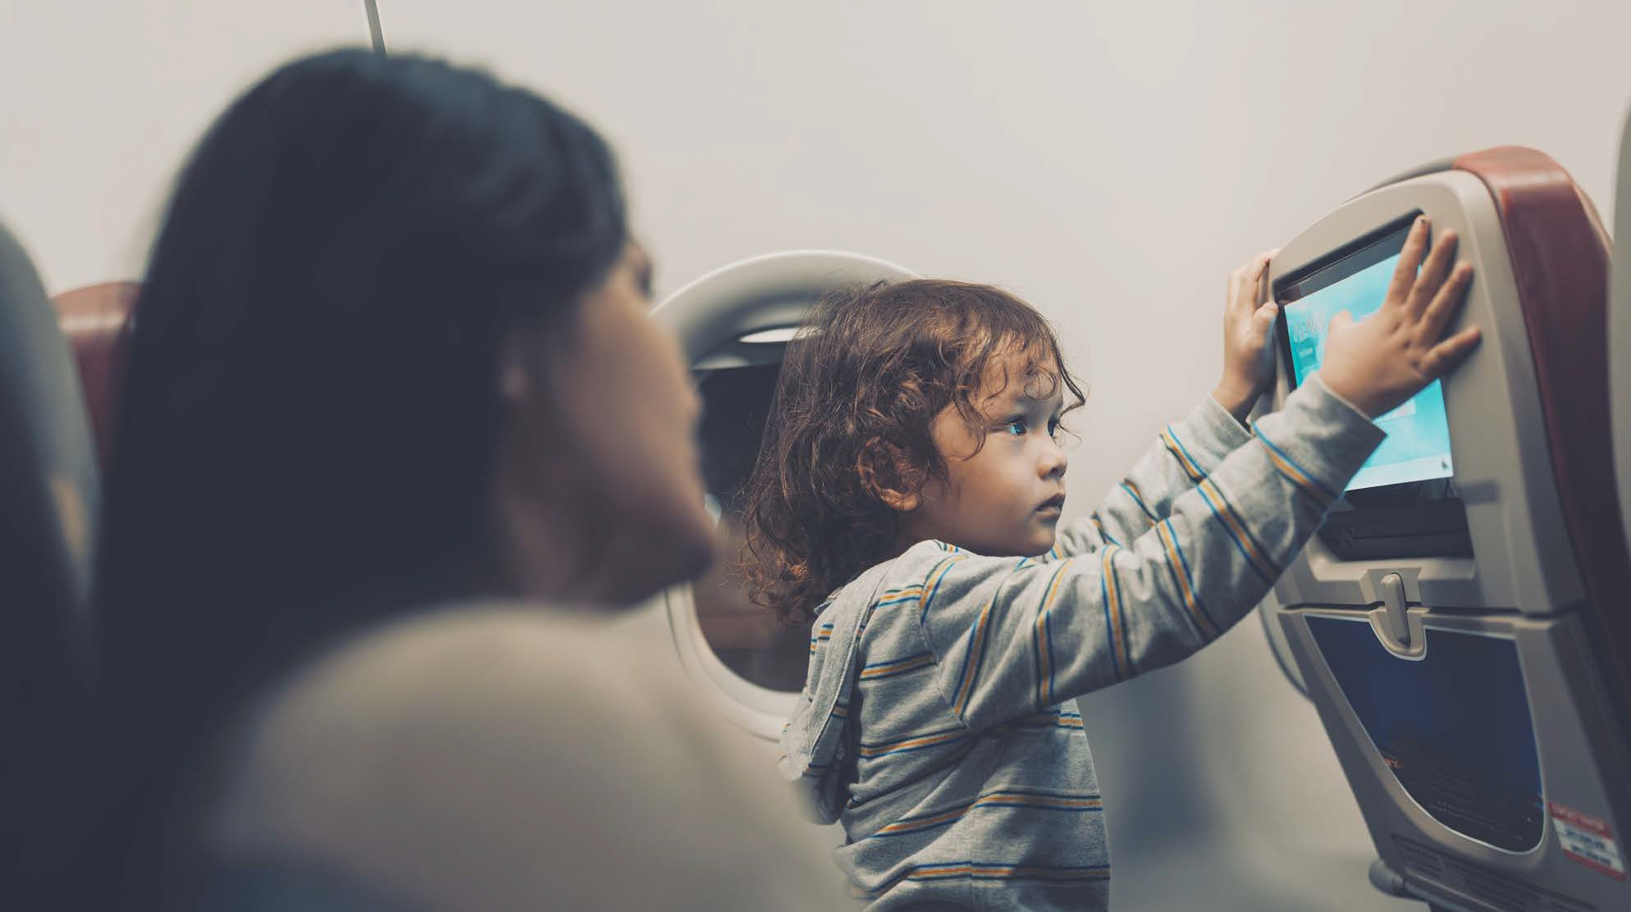

Book smart
Plan your booking carefully so you understand fare rules, inclusions and who is responsible if your travel plans change. Always book through official, reputable airlines, travel agents or travel sites. For useful links to airline and airport terms and conditions, visit the Department of Infrastructure’s website for Airline and Airport information.
  - Before you pay, read the airline’s terms and conditions and conditions of carriage carefully. These documents explain important matters such as changes, cancellations, refunds, baggage, special assistance and what the airline may do during disruptions.
  - If you book through a travel agent or booking platform, their terms also apply and may affect how changes and refunds are handled.
  - Check the fare class and ticket flexibility. Cheap fares may carry strict limits on refunds, changes and support during disruptions.
  - Check inclusions, such as checked baggage, seat selection, meals and in-flight services.
  - Confirm baggage size, weight and piece limits for every airline you’re flying with
(don’t assume the marketing or main airline baggage rules apply to all airlines on your itinerary). Extra baggage is usually cheaper if bought in advance.
  - Check rules for infants, children and unaccompanied minors, including identification and supervision requirements.
  - Allow enough time for flight connections, especially on separate bookings or mixed domestic and international itineraries.
  - Check the total price, including mandatory taxes, charges and optional extras.
  - Make sure names, dates, airports and contact details are correct before payment, especially if your name must match identification exactly.

Travel agents
Travel agents can be helpful, particularly for complex trips, and they add another layer between you and the airline. When you book through an agent, changes and refunds may need to
be handled through that agent rather than directly with the airline. This can affect timing, communication and fees. You may receive different information from the agent and the airline, especially during delays or cancellations, and support may be harder to obtain if your agent is in a different time zone or difficult to contact. If you use an agent, make sure you understand their fees and terms, how they can be contacted during disruptions, and whether your direct contact details have been added to the booking.
Travel agents are separate businesses, and their standards, fees and complaint processes can vary. Some agents may be based overseas, have limited local customer support or be difficult to contact quickly when things go wrong. In some cases, an agent may process a refund from the airline and then deduct fees before passing on the remainder to the passenger. Some agents may also choose to refund rather than rebook a disrupted trip, which can leave the traveller exposed to higher fares close to departure. Understanding the relationship between the airline and the agent can help you decide whether booking directly better suits your circumstances.
The Australian Travel Industry Association (ATIA) maintains a list of accredited travel agencies and tour operators on the ATIA Travel Tick website. Agents and operators who hold ATIA accreditation are required to conduct business in compliance with Australian Consumer Law and in accordance with their Accreditation Scheme Charter and Code of Conduct.

Quick tips:
- If where you sit matters, consider selecting a seat in advance.
- If you need more space or a particular seat type, check your options before travel.
- If you need a special meal, request it as early as possible.

Before and at the airport
Monitor your flight before you travel and while you’re at the airport. Flight details such as check-in time, departure time and gate can change. Check emails, text messages, airline apps and airport screens for updates. It is your responsibility to arrive on time, including allowing enough time for check-in, baggage drop, security screening, terminal transfers and getting to the gate.

Pack right for a safe flight
Pack safely to avoid delays, extra charges or missing your flight. Some everyday items may be restricted or banned. Other items may only be allowed in checked baggage or carry-on baggage. Check your airline’s baggage rules carefully, including size, weight and piece limits. Label your bags clearly, keep medicines and valuables in your carry-on where possible, and keep receipts for important items in case you later need to make a baggage claim.
- Pack your own bags and check size, weight and piece limits carefully.
- Choose durable luggage and avoid overpacking, which can cause damage.
- Label bags inside and out with your name and contact details.
- Keep essential medicines, valuables, keys, documents and fragile items in your carry-on baggage where possible.
- Take photos of baggage receipts and keep records for valuable items in case you need to make a claim.
- Consider using a luggage tracking device and make sure it’s charged before you travel.
For more information, visit the Civil Aviation Safety Authority’s (CASA) PackRight website.

Dangerous goods, prohibited items, medicines and medical devices
Dangerous goods can create serious safety risks on aircrafts. They might be flammable, explosive, toxic, or react dangerously with other substances. Common dangerous goods include spare batteries, vapes and e-cigarettes, aerosols, fuels, chemicals, cleaning products, lighters, fireworks and some petrol-powered items. Airports routinely screen both carry-on and checked baggage for dangerous goods. If undeclared prohibited items are found in checked
baggage, your bag may be removed and delayed, and you may miss your flight. Making a false or misleading declaration about dangerous goods can lead to serious penalties.
Everyday items may also be restricted or banned, including power banks, lithium batteries, aerosols, powders, gels, sharp items and chemicals. If you’re unsure whether an item can travel, check before you fly.
Some items are prohibited because they are a security risk. You cannot carry prohibited items beyond the security screening point or on board an aircraft. Prohibited items include weapons and some common household items and sporting goods that people can use as weapons or to cause harm to a person or an aircraft. This includes replicas or imitations of weapons. You may need to surrender prohibited items at the security screening check point. For more information on prohibited items, check TravelSECURE.
If you’re travelling with medicines, medical devices, mobility aids or needles, keep essential items with you and carry supporting documents, especially for overseas travel. Restrictions on liquids, aerosols, gels and powders differ between domestic and international travel, so confirm the rules that apply to your journey and terminal.

Lithium batteries
Lithium batteries power many everyday items such as phones, laptops and cameras, but they must be packed safely. Spare batteries and power banks must travel in the cabin and must never be packed in checked baggage. Devices with batteries fitted can usually travel in either checked or carry-on baggage, but they should be switched off completely, protected from accidental activation and packed to avoid damage. Airlines may also limit the number or size of spare batteries and power banks you can carry, and some airlines restrict their use on board.



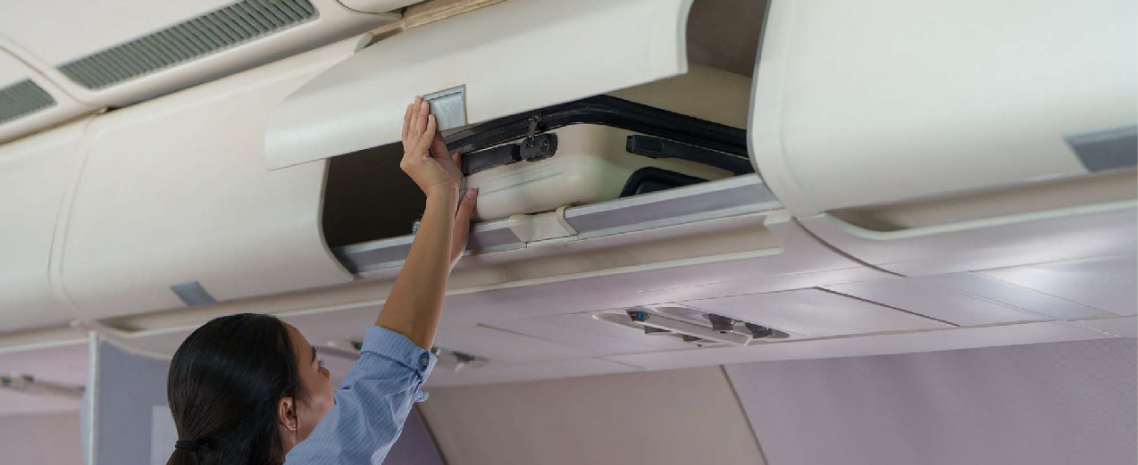

Travelling with medications and medical devices
If you’re travelling with medicines, medical devices or needles, carry enough for your trip in your carry-on baggage and keep prescriptions, a doctor’s letter or other supporting material with you, especially for international travel. Ask your doctor or the manufacturer whether medical equipment can safely go through body scanners or X-ray equipment. If an item cannot be screened in the usual way, tell the screening officer at the start of the process. Be aware that
restrictions on liquids, aerosols and gels can also differ if you’re departing a domestic flight from an international terminal.
For domestic travel within Australia, there are generally no limits on the amount of powders, liquids, aerosols and gels you can carry, unless you’re departing from an international terminal. For international travel, limits apply to liquids, aerosols, gels and certain powders, and individual containers are often restricted to 100 millilitres or 100 grams or less. Always check the
current rules for your departure point, especially if your itinerary involves both domestic and international sectors.

Getting to the airport, check-in and screening
Allow enough time for traffic, public transport delays, parking, terminal transfers and queues. Check your airport’s website for information about terminal layouts, services and any disruptions that may affect access. If you need accessibility support, confirm drop-off points and assistance arrangements in advance. Check in as early as your airline allows and remember that online check-in does not remove the need to meet bag drop and boarding deadlines. Security screening is compulsory and you are unable to select your method of screening. If you have special

circumstances, such as medical equipment, mobility aids, disability, cultural or religious needs, or an assistance animal, tell the screening officer at the start of the process and keep any supporting documents handy. Different screening methods or a private area may be used where appropriate. If you have questions or are uncomfortable during screening, ask to speak with
a supervisor.

Border control
If you’re travelling internationally, you’ll need to pass through border control. Make sure you have a valid passport or other required travel documents and allow extra time for departure and arrival formalities. Border processing can involve significant queues, especially during peak periods,
so factor this into your timing.

At the gate and during disruptions
Arrive at the gate well before boarding and listen for announcements, as gates and departure times can change with little notice. If you need assistance to board, contact the airline as early as possible and speak with staff at the gate. If your flight is delayed, disrupted or cancelled, check updates through the airline app, email, text message or airport screens, and speak with airline staff as soon as you can. If you booked through a travel agent or third-party platform, you may also need to contact them directly. Ask what options are available, including rebooking, refunds and any support such as meals, accommodation or transfers for significant delays. This support isn’t always offered automatically, so it’s worth asking. Keep receipts for reasonable expenses, as they may be relevant for airline reimbursement or travel insurance. If you still need to travel, think carefully before accepting a refund rather than rebooking, as replacement fares may be much higher at short notice. If you miss your flight, contact the airline immediately, especially if you’re on a multi-flight itinerary, because missing one flight may affect the rest of your booking.

Quick tips:
- Arrive when your airline says you should.
- Check in as early as possible.
- Pack safely and stay within your baggage allowance.
- Stay with your bags.
- Remain calm and polite, especially during delays.

On the flight
Your behaviour plays an important part in ensuring you and other passengers fly safely and comfortably. Follow all directions from cabin crew. Safety briefings, seatbelt requirements, baggage stowage rules and other instructions are important for your safety and the safety of others. You must behave appropriately on board. Disruptive, threatening or intoxicated behaviour can lead to refusal of carriage, removal from the aircraft, penalties or prosecution. If you’re travelling with children, supervise them throughout the flight.
Charge your devices before flying, as not all aircraft have charging ports and power bank usage may be restricted. If any carry-on items are damaged during the flight, tell cabin crew or ground staff as soon as possible.
Electronic devices may only be used in accordance with airline rules and crew instructions, including flight mode requirements.

Quick tips:
- Keep your seatbelt fastened whenever seated.
- Know where the nearest exit is.
- Stay hydrated.
- Tell cabin crew immediately if there is a medical issue or safety concern.
- Before leaving the aircraft, check that you have all your belongings.

Arriving at your destination airport
If you have checked baggage, collect it promptly and check the tag before leaving the carousel.


Arriving from overseas
If you’re arriving in Australia from overseas, follow border, customs and biosecurity requirements carefully and complete any required arrival documentation and declarations honestly. If you’re not an Australian citizen, make sure you hold a valid visa where required.
Border Force officers have legal powers to inspect baggage and ask questions, including about the contents of your baggage, prohibited goods and where you travelled from. If you have questions or concerns during the border control process, raise them with the relevant officer or supervisor at the time.

- Delayed, lost or damaged baggage
If your checked baggage is delayed, lost or damaged, report it to the airline as soon as possible, ideally before leaving the airport. Airports aren’t usually responsible for baggage claims. In most cases, the airline that operated your last flight is the airline you should contact. Time limits often apply, so act quickly and keep copies of any reports, claim numbers, baggage receipts and supporting documents. If you have travel insurance, check whether you must first make a claim with the airline before claiming on your policy.

Delayed and lost baggage
If your baggage does not arrive, contact airline staff immediately, ideally before leaving the baggage collection area. You’ll usually be asked to complete a report with your booking details, baggage receipt number and a description of the bag and its contents. Keep any reference number given to you. If your baggage is delayed while you’re away from home, some airlines may reimburse reasonable essential purchases such as toiletries, clothing, infant items or chargers, but make sure you keep the receipts. Baggage is often regarded as lost after a period of searching, and you may then need to submit a more detailed claim with proof of purchase
or value. Strict reporting time limits may apply, so check the airline’s requirements as soon as possible.

Damaged baggage
If your baggage is damaged, report it promptly to airline staff within the baggage claims area and follow the airline’s claim process. Time limits may apply. If your claim is accepted, the airline may repair the bag, replace it or offer a payment instead. Airlines often exclude certain kinds of damage, such as ordinary wear and tear, minor cuts or scratches, and damage caused by poor packing or overpacking, so check the relevant policy carefully.

Damaged mobility equipment
If your wheelchair or other mobility equipment is damaged during your journey, report it to the airline immediately, ideally before leaving the airport. Take photos of the damage as soon as possible and keep records of baggage tags, boarding passes, booking confirmations and any conversations with airline staff. Ask what immediate assistance can be provided, including temporary replacement equipment if needed while repairs or other arrangements are being considered. Prompt reporting and good records can be important if you later need to seek repair, replacement or reimbursement.

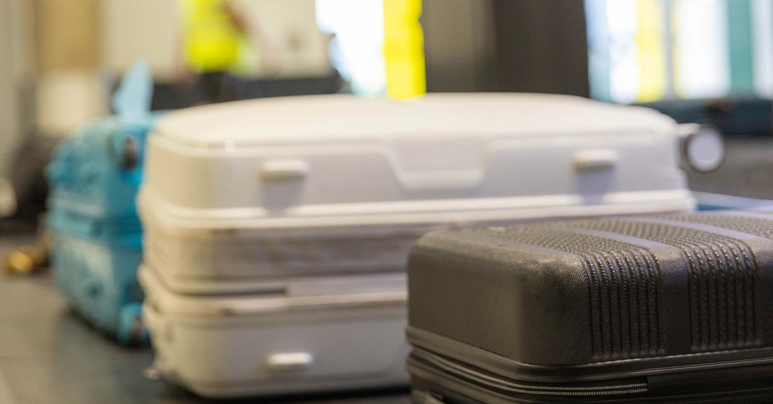

Making a complaint
Australia is establishing a new Aviation Consumer Ombuds Scheme. Until that scheme is in place, you should use existing complaint pathways.

If something goes wrong, always speak directly to the airline, airport or travel agent involved in the first instance. Follow their complaint process, keep copies of correspondence and ask for a reference number. Read the relevant terms and conditions so you understand the basis of your complaint and any timeframes that may apply. If you’re not satisfied, ask if there is an internal review or escalation process. If the matter remains unresolved, you may be able to contact an external body such as the Airline Customer Advocate, a state or territory consumer protection agency, the Australian Human Rights Commission for discrimination matters,
Department of Home Affairs for certain security screening concerns, or other appropriate bodies depending on the issue.
Court or tribunal action may be available as a last resort.

Quick tips:
- Keep all documents, emails and receipts.
- Know your airline(s) and agent’s terms and complaint policies.
- If your booking was a codeshare, check which airline operated the flight and direct the complaint to the appropriate carrier.
- Check response deadlines and act promptly.
- Be clear and concise in your complaint – include booking details and the resolution you seek.

Need more help? Visit the Australian Competition and Consumer Commission (ACCC), Department of Home Affairs and Australian Human Rights Commission websites for further resources.

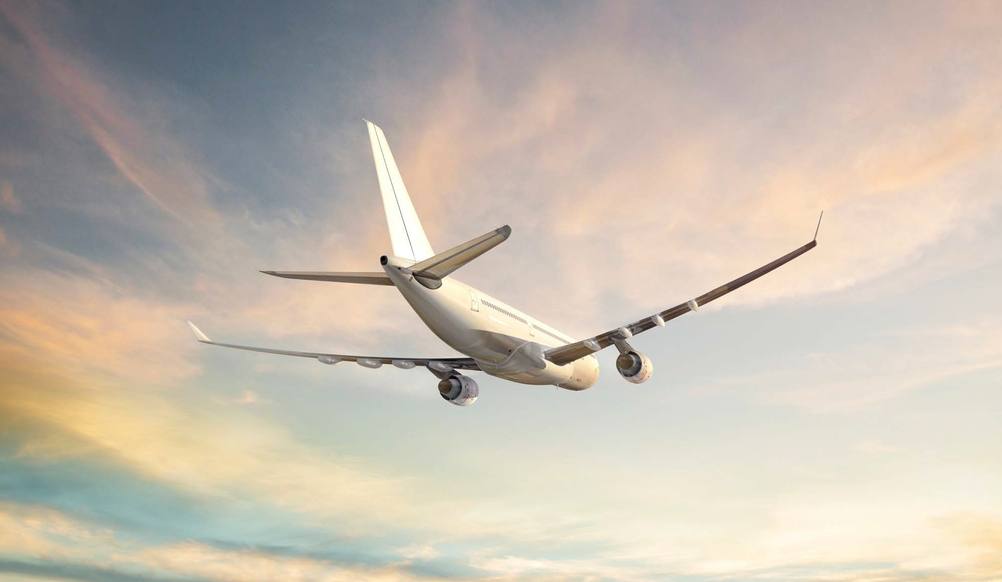



Travelling with a disability
Air travel can present physical, sensory, medical, communication and other barriers for people with disability. Planning ahead can improve the journey, as support and facilities may vary between airlines, airports, aircraft types and routes. People with disability have the right to travel safely and with dignity, and Australian law prohibits disability discrimination in many areas of public life, including air travel.
Rare Voices Australia has codesigned the Rare Disease Disability Toolkit alongside people
living with rare disease disability. The guide to Navigating Air Travel with Rare Disease Disability contains useful information. This section draws heavily from this resource.
This section provides an overview to help support your journey and should be read together with airline and airport accessibility information.

Planning and notifying your airline
Before booking, check if the airline’s accessibility policies and services meet your needs. You may wish to ask about assistance from check-in to boarding, the aircraft type, seating options, moveable armrests, aisle seats, mobility aid requirements, assistance animals, and what facilities are available at the airport and on board. After booking, confirm the services you’ve requested and notify the airline of your needs as early as possible, ideally at least 48 hours before travel, especially if you’re travelling with a battery-powered mobility aid or an assistance animal.
Contacting the airline well in advance will ensure any required checks and arrangements can be made.

Accessibility resources and checking your reservation
Many airlines and airports provide accessibility information to help you plan your journey, including maps, photographs, accessibility planners, mobility hubs and details of available facilities. After booking, double check your reservation and, where possible, get key arrangements in writing. Confirm the services you requested, the date and place of departure, check-in times, seat allocation, meals, stopovers and any mobility aid or assistance animal arrangements.
If you’re travelling independently, you may also wish to do a trial run to check parking, drop-off and transport arrangements.

At the airport, screening and boarding
Allow extra time at the airport. Assistance arrangements can differ and may not be available at every point of the journey unless arranged in advance. Airport maps, accessibility planners and mobility information can help you prepare, including information about accessible parking,
drop-off zones, quiet rooms and terminal navigation. Security screening rules still apply, although airports may use different methods where appropriate to assist people with specific needs.
If you’re travelling with medical equipment, mobility aids or other support items, tell the screening officer at the start of the process, carry supporting information if needed and ask how and when it may need to be handed over. This can differ between aircraft and airport facilities. If you’re travelling independently, think ahead about how your belongings and mobility needs will be managed during screening and boarding.

On board and mobility aids
Airline and cabin crew assistance may include help with boarding, reaching your seat, understanding safety information, opening meal packaging and handling some mobility aids carried on board, but the assistance available can vary and some personal care tasks may not be provided. For example, cabin crew may not be able to help you eat, use the toilet or provide medical assistance.
If you use a wheelchair or mobility aid, check the airline’s requirements well before travel, including battery, size and handling requirements where relevant. Photograph mobility equipment before handover where possible and report any damage immediately on arrival. If your mobility equipment is damaged in transit, raise it straight away and keep records for any follow-up claim.

Quick tips:
- Notify the airline of your needs early and reconfirm before departure.
- Arrive early.
- Keep key support information with you.
- Photograph mobility equipment before travel.
- If assistance is refused or unavailable, ask for the reason to be given to you clearly and record what happened.
For further information visit the Smartraveller advice for travellers with disability.

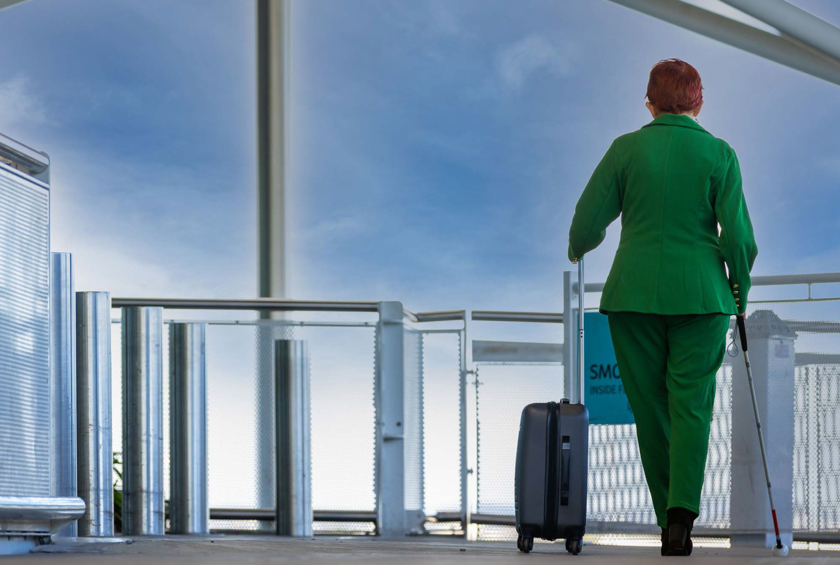



Key contacts and resources
For more information and to get in touch with any of the external organisations mentioned in this guide, visit the ACOS website for a comprehensive list of key contacts and resources.
Before you embark on your journey, consider bookmarking the contact information of the airlines, airports, consumer protection and support services that may be relevant to your trip.
For current information, use official Australian Government and airline resources.




INFRA7337
acos.gov.au

