


Australian Air Passenger Travel Guide in Easy Read
Your guide to flying in Australia. Book right, fly prepared and get help when things go wrong.

About Easy Read

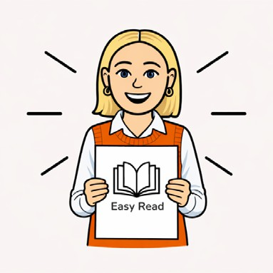
This is an Easy Read book.

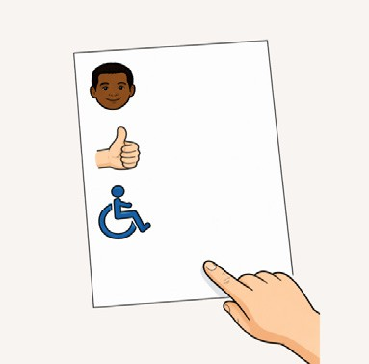
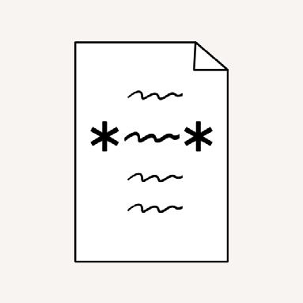
Easy Read uses simple words and pictures to explain ideas.

New words are *bold with stars*.

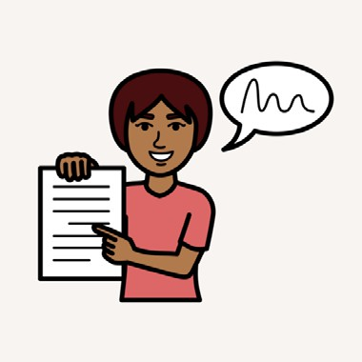
We explain what new words mean.


Easy Read is a summary. Links to more information are at the end of this book.

About this book

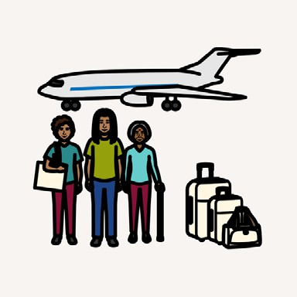
This is a guide to air travel.

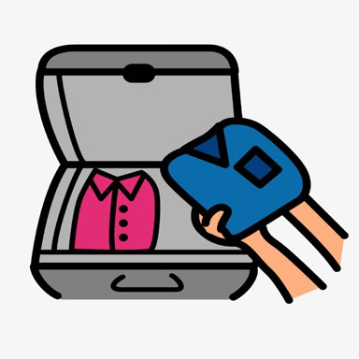
This guide can help you
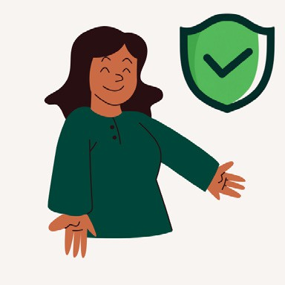
- get ready to travel

- fly safely


- know what to do if something goes wrong.

Plan smart

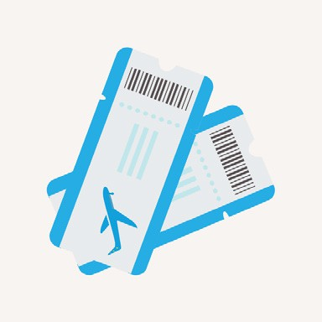
Planning can include
- booking flights early


- comparing prices and extra costs

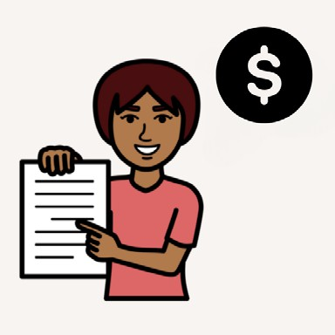
- buying travel *insurance*.


Insurance is money you pay
in case something goes wrong.

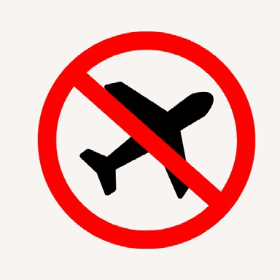
Travel insurance can pay costs for travel emergencies, like a cancelled flight.


If you travel to other countries, check
- safety advice for each country

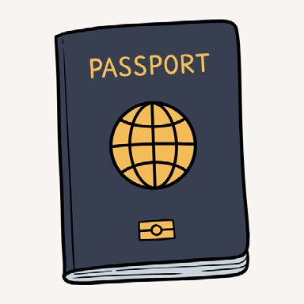
- your passport

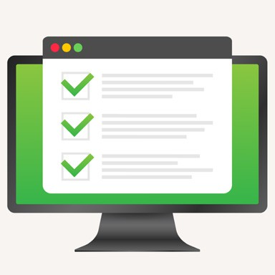
- rules for visiting each country and what you can have in your baggage.

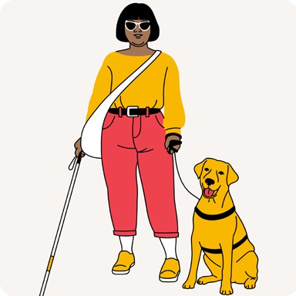
Allow extra travel planning for
  - pets or assistance animals

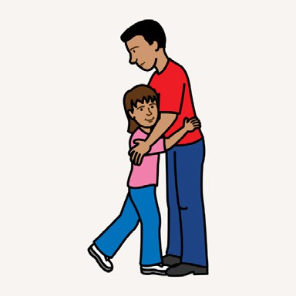
  - children.

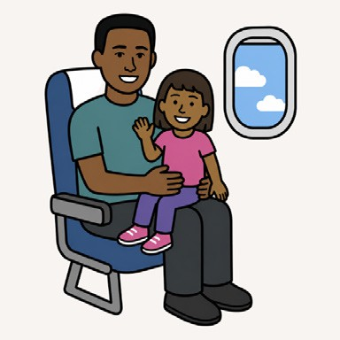
Airlines may have different rules about when children can
- sit on your lap to travel

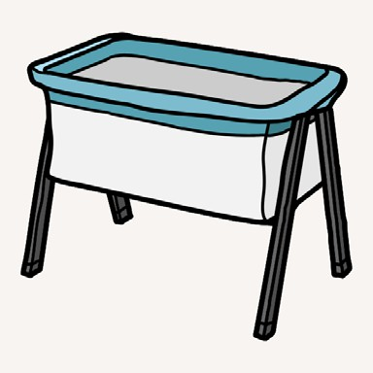
- use a car seat or bassinet in the aircraft


- travel on their own.

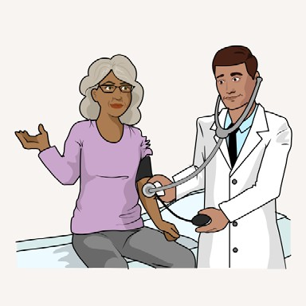
You might need *medical clearance* if you have a disability, health problem or had recent surgery.

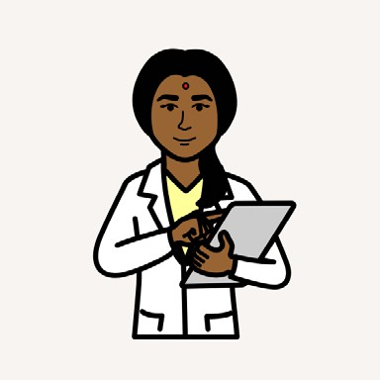
Medical clearance means your doctor says air travel is safe for you.

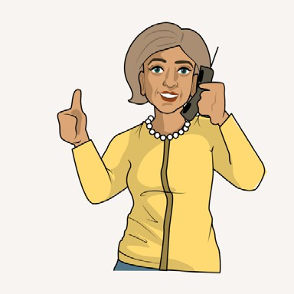
If you might need medical clearance, find out from your airline as soon as you can.

Book smart


Check all the booking details before you pay.

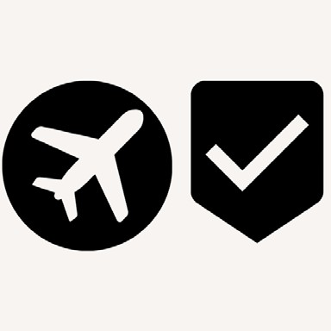
Make sure that you book travel with
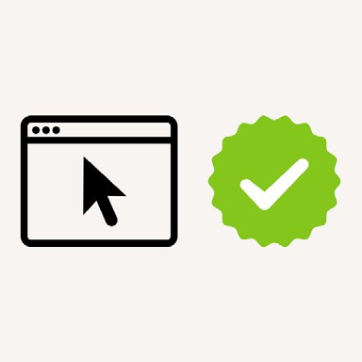
  - an official airline

  - an official travel website


  - a trusted travel agent.

Travel agents may charge extra money.

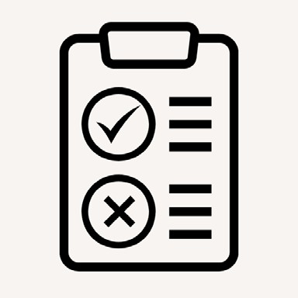
Travel agents may have different rules about bookings and refunds.

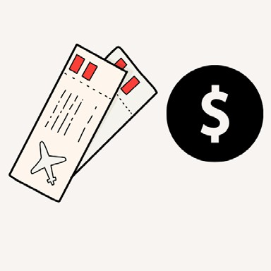
Check airline and travel agent rules for
  - ticket prices and what they cover

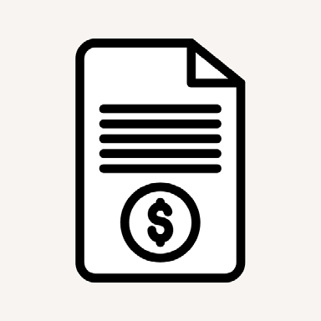
  - any extra charges


  - how much baggage you can take on every flight

  - what happens if your plans change.

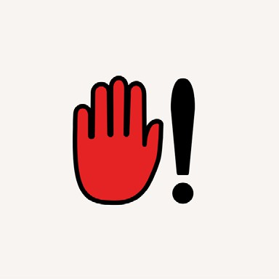
Your plans might change if
  - the airline cancels or changes your flight


  - you cancel or change your flight.

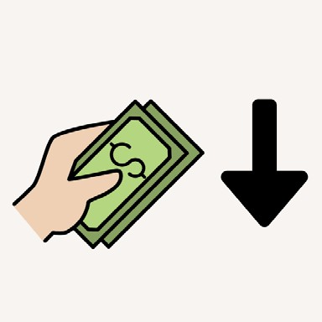
Cheaper flights may cost more later if you cancel or change your flight.


You may not get a refund if you book cheaper flights to start with.

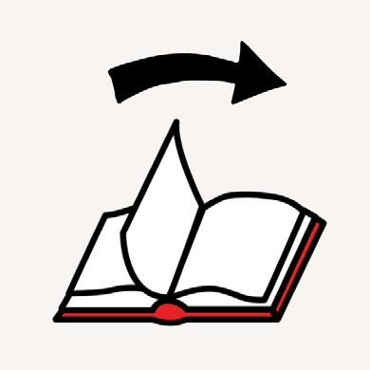
A link to trusted travel agents is at the end of this book.

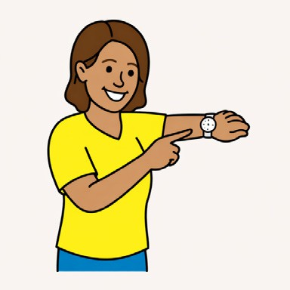
Make sure you have time to make travel connections on each step of your trip.

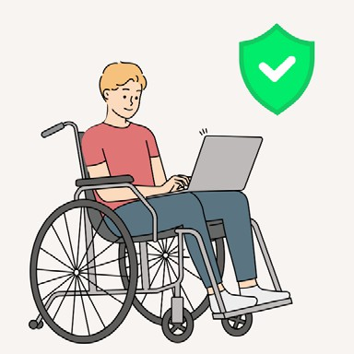
Before you pay, check booking information is right.

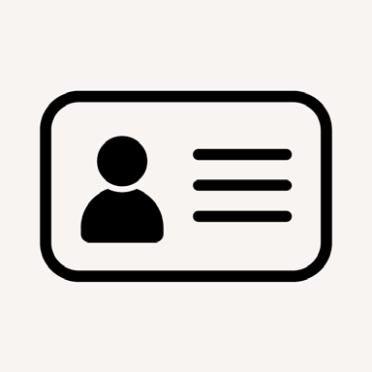
For example
  - your name and contact details

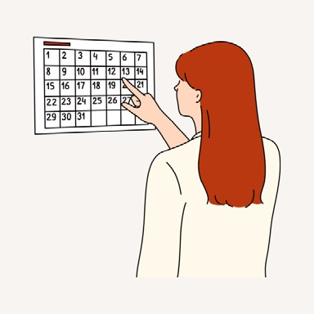
  - the date of flights


*sectors*.


A sector is 1 part of your trip.
For example, Sydney to Melbourne.

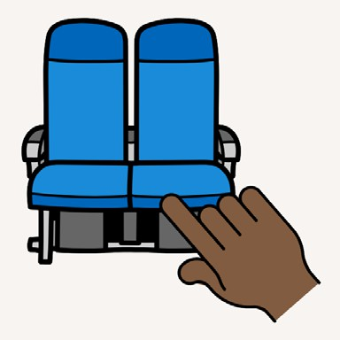
When booking you might choose
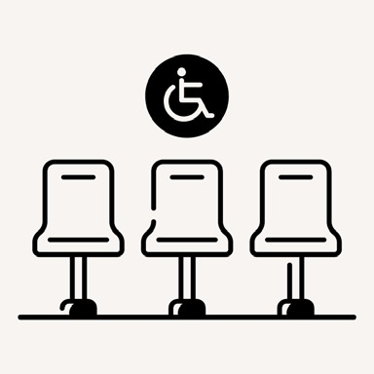
  - where you sit on the plane

  - extra space if you need it


  - your meal.


You may need to pay extra for these.

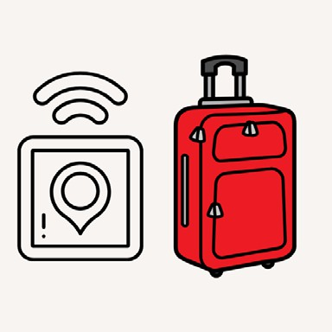
Pack right

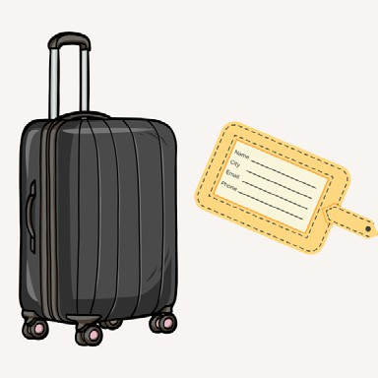
Check rules about packing different bags and put your name and number on all your bags.


Take a photo or write down your baggage number in case bags are lost.

Keep important things on you, like
  - your passport and wallet


  - medicines in their original pack

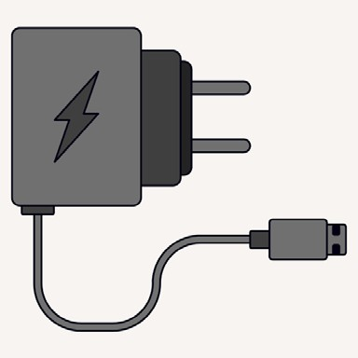
  - chargers and batteries that are safe

  - a bag tracker if you use one.


There are some things you cannot take on planes because they are dangerous.

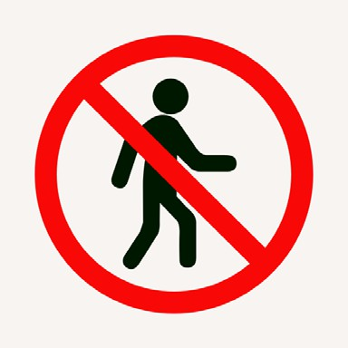
You might not be allowed on a plane if you have the wrong thing in your bag.


These can include
  - chemicals and some unsafe batteries

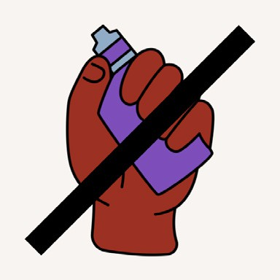
  - vapes, e-cigarettes and lighters

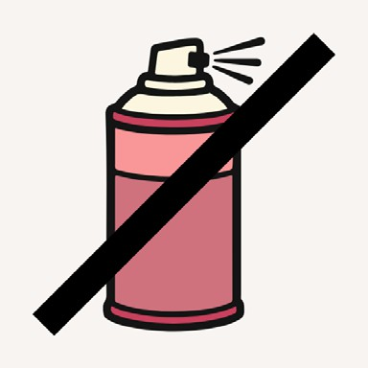
  - spray cans


  - sharp things.

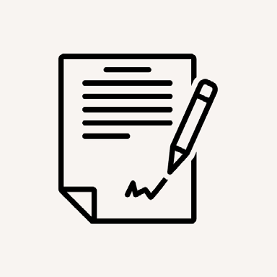
You might need special permission to pack
  - medicines or other chemicals

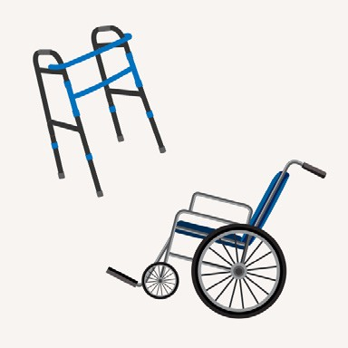
  - mobility aids or equipment.

Before and at the airport


Sometimes you can check in online before you go to the airport to save time.


Flight details can change up until take off.


You might find out about changes from
  - airline emails or text messages

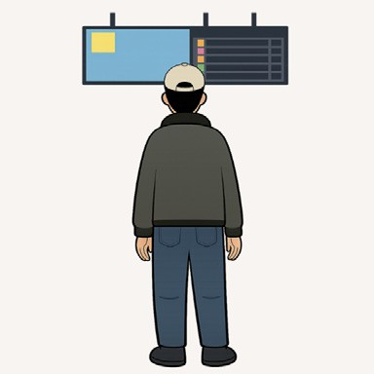
  - airport screens

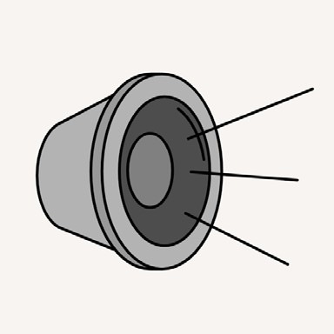
  - airport speaker announcements.

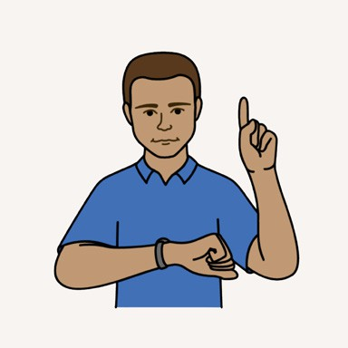
Airports are busy places and there can be long waiting times.

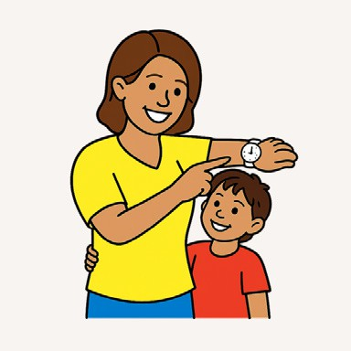
Be early to give yourself lots of time if you fly in *peak travel times*.


Peak travel times are popular times to go away.


For example
  - school holidays

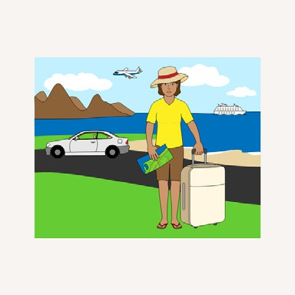
  - long weekends


  - when big sporting events are on.

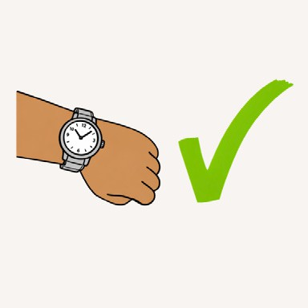
Make sure you arrive at the airport early so you have time to
  - check in

  - drop off your baggage

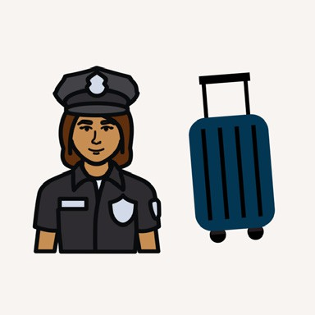
  - go through security checks

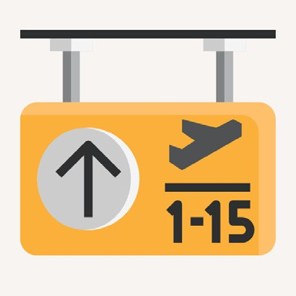
  - get to your gate.

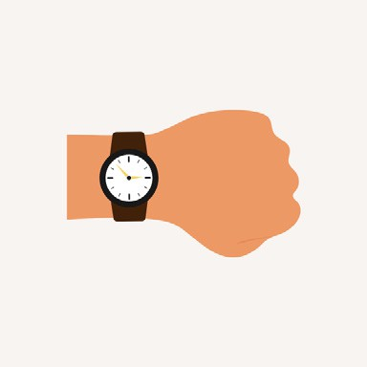
If you travel overseas
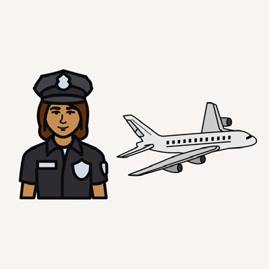
  - you will need extra time

  - there are extra security checks.


Ask your airline if you need to do a *fitness to fly* check.


Fitness to fly means your doctor decides it is safe for you to fly.

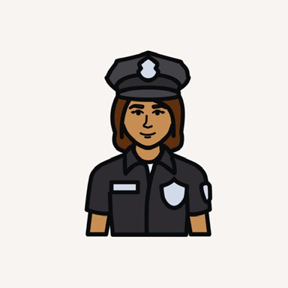
Ask airport security if it is safe to scan your medical devices or equipment.

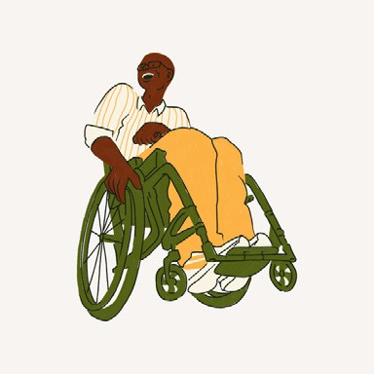
Let the security staff know about your disability access needs and equipment.

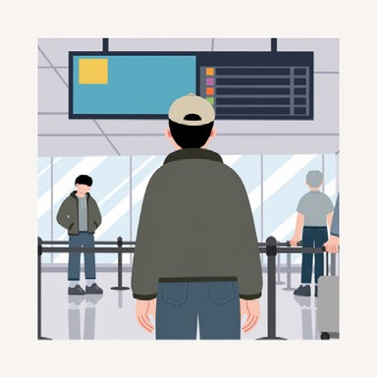
Your gate might change from what you were told. Check the screens so you do not miss your flight.

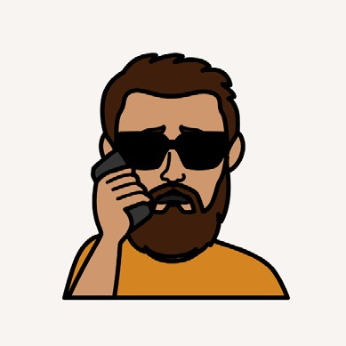
Contact your airline or travel agent straight away if you miss your flight.

On the flight


You must follow cabin crew instructions on
  - safety

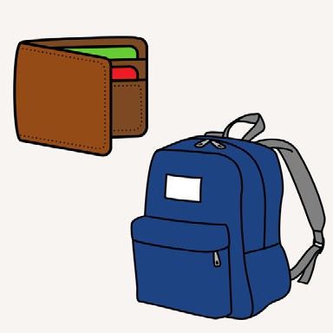
  - where to put your belongings

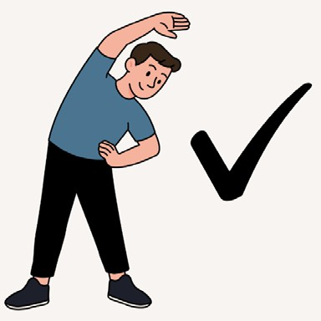
  - when you can move around the plane

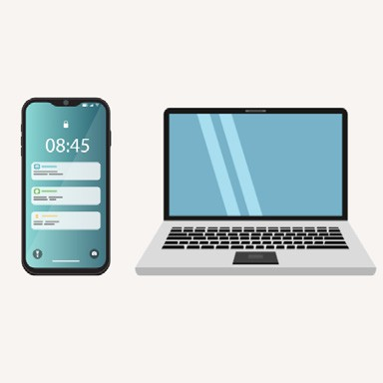
  - when you can use phones or laptops

  - what to do in an emergency.

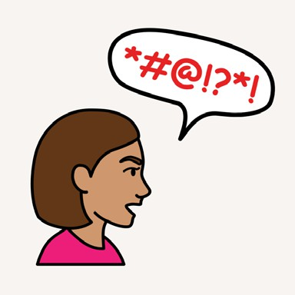
Rude or dangerous behaviour on planes is not allowed.


Being drunk or affected by drugs on planes is not allowed.

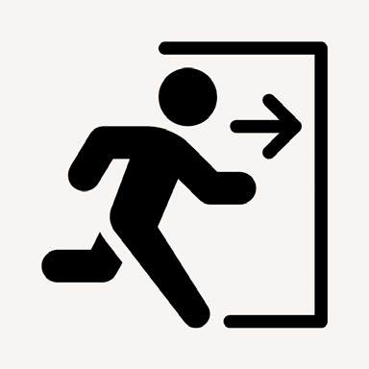
Cabin crew can remove people from the plane if they make others feel unsafe.

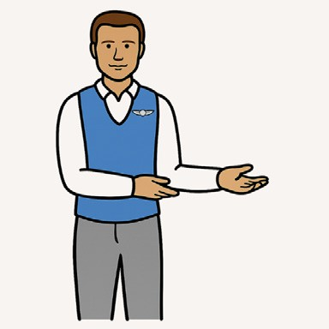
Talk to the cabin crew if you have any worries.

Check you do not leave anything behind when you get off the plane.

Arriving at your destination airport

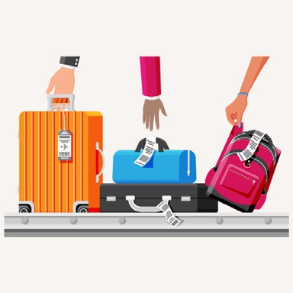
Go to your carousal to collect your bags.

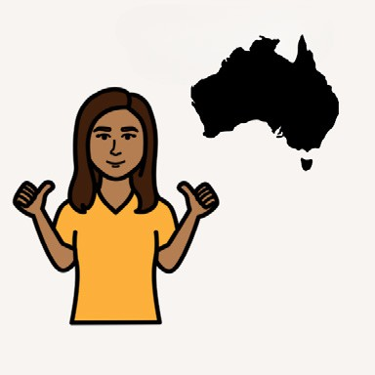
If you come from another country, check
  - things you are allowed to bring in

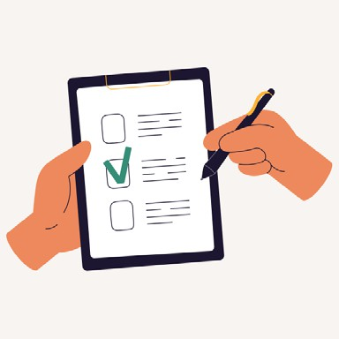
  - forms you need to fill out

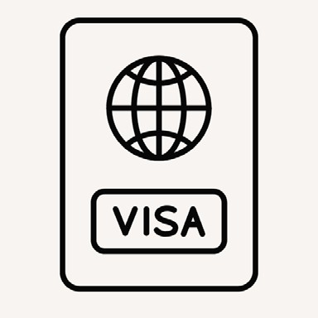
  - what you need to show.
For example, your passport or a *visa*.

A visa is a form you might need if you are not a citizen of the country you visit.

Lost or damaged baggage

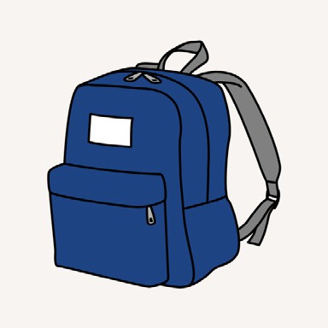
Baggage should not be badly damaged or broken during flights.


Tell the airline straight away, before you leave the airport, if your bag is missing or damaged.

Take photos to help report any damage.

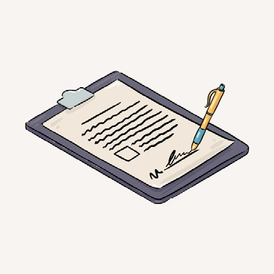
You will need to fill out a form and the airline can help you find your bag.


The airline may pay you for the cost of lost or damaged things.

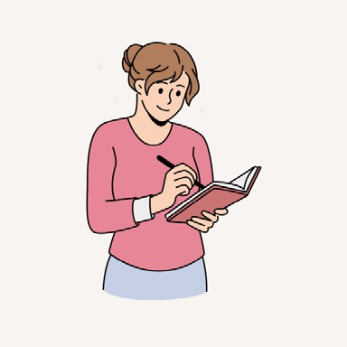
Write down information about
  - items that were lost or damaged

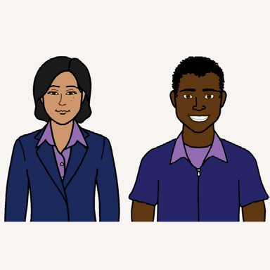
  - who helped you


  - reference numbers given to you

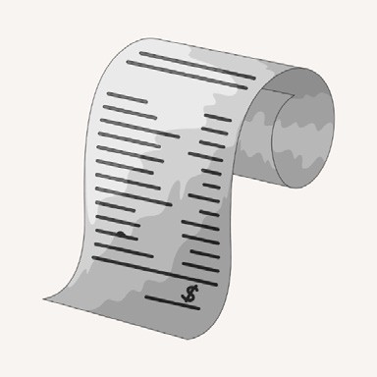
  - receipts if you buy new bags, clothes or items.

Travel insurance might pay for replacement of lost or damaged baggage.

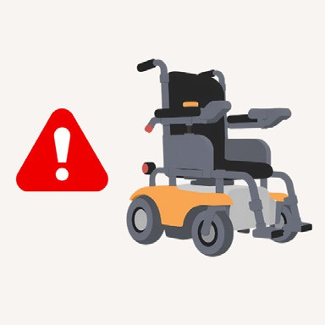
Tell the airline straight away, before you leave the airport, if your wheelchair or other equipment gets damaged.

Making a complaint

If you have a *complaint*, first get help from airline or airport staff.


A complaint means you say you are not happy with a service or product.


You have a right to make a complaint if there is a problem with
  - the airline

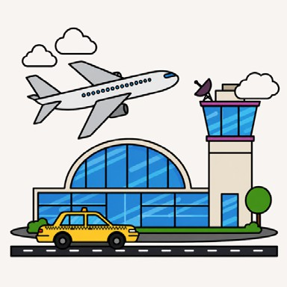
  - the airport


  - your travel agent.

If you make a complaint, make sure you
  - keep travel details and receipts


  - answer messages and questions quickly.


Receipts can support your complaint.


Check your airline’s travel complaint *policies*.

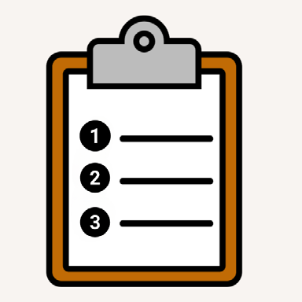
Policies are rules passengers must follow when they use an airline.

Travelling with a disability

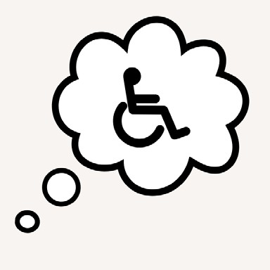
Air travel for people with disability can involve extra planning.

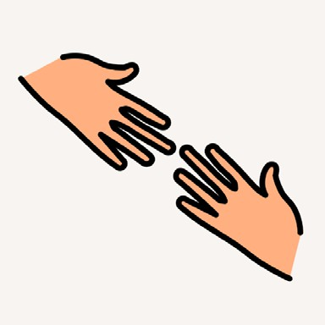
Airlines and airports will offer different levels of support.


Check that supports meet your needs before you book your flight.

Tell your airline about your access needs at least 2 days before you travel.

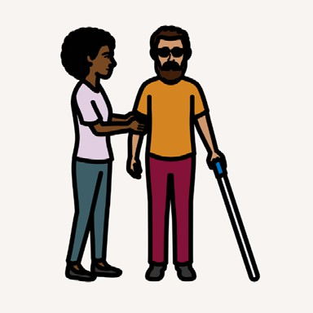
Support might include
  - help to check in or get on the plane


  - seating with extra space

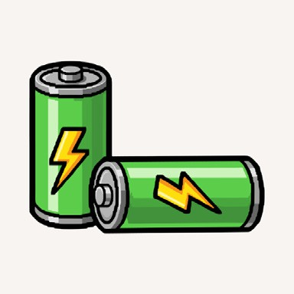
  - batteries for equipment

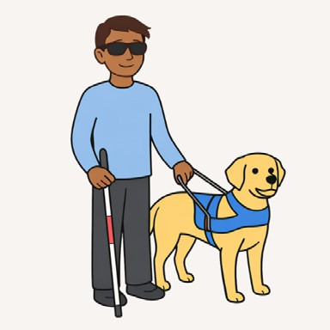
  - an assistance animal.

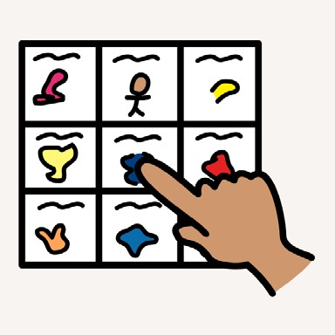
Some airlines and airports can help you plan your trip with pictures and maps.

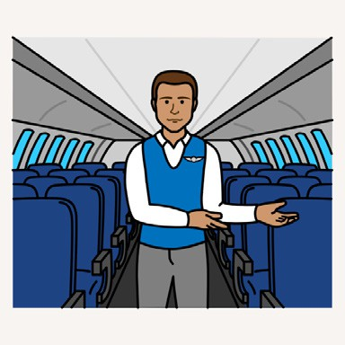
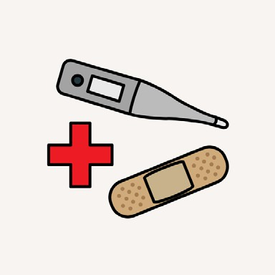
Cabin crew may be able to help with
  - boarding the plane

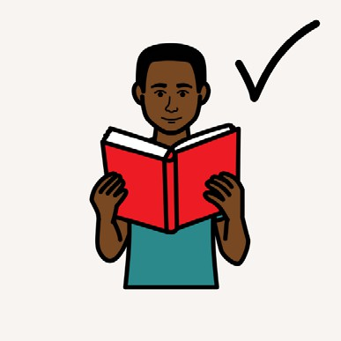
  - understanding safety information

  - opening meals


  - putting bags away.

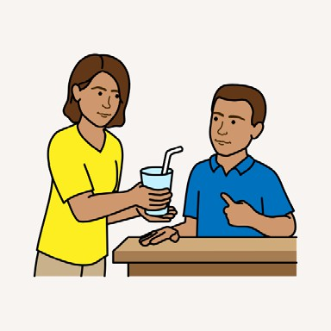
Cabin crew may not be able to help with
  - eating

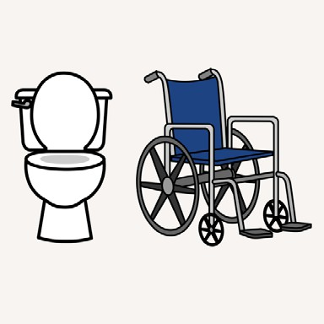
  - using the toilet

  - medical needs.

Learn more

Airport information and rules

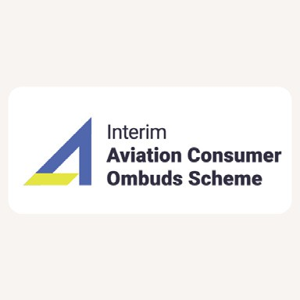
www.infrastructure.gov.au/travel-contacts

Insurance and more travel information

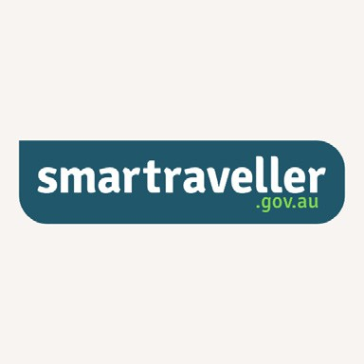
www.smartraveller.gov.au

Travel agencies


www.traveltick.com.au

Packing safely

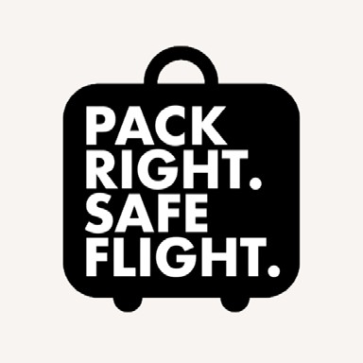
www.casa.gov.au/packright

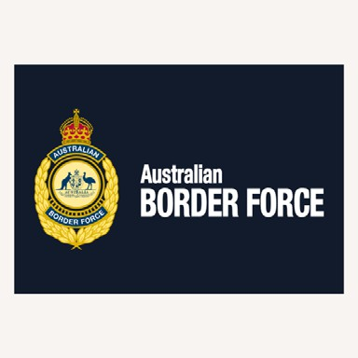
www.abf.gov.au/entering-and-leaving-australia/can-you-bring-it-in/overview

Travelling with a disability


www.rarevoices.org.au/toolkit-page

Customer help and complaints


www.accc.gov.au/by-industry/ travel-and-airports

Travel agent complaints


www.atia.travel/Travellers/ Traveller-Complaints

Qantas, Jetstar and Virgin airlines complaints


ACA can help when you
- tried to make a complaint to the airlines first

- still need more help.

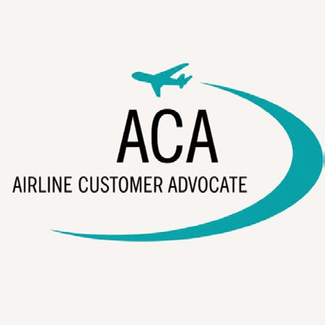
www.airlinecustomeradvocate. com.au/General/Default.aspx

Security screening complaints

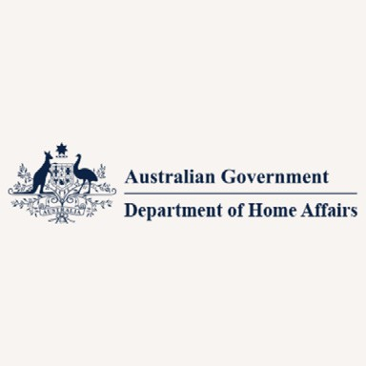
www.homeaffairs.gov.au/help-and-support/departmental-forms/online-forms/ complaints-compliments-and-suggestions

Help with discrimination


www.humanrights.gov.au

Information about Visas

immi.homeaffairs.gov.au/visas/ getting-a-visa/visa-finder

Free services to help you on phone calls

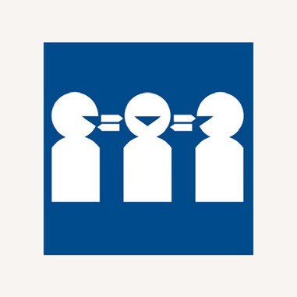
Call 131 450 for the Translating and Interpreting Service if English is not your first language.

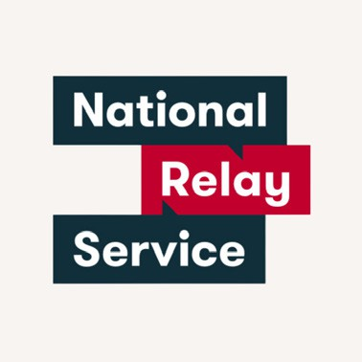
Call 1800 555 660 for the National Relay Service if you have communication support needs.


Call 1800 555 677 if you use a teletypewriter or TTY.





Embrace Access wrote this Easy Read book. This book was co-designed by an advisor with lived experience of disability. You must ask for permission to use the words and images in this book. Picture Communication Symbols
© 1981–2026 by Tobii Dynavox. All Rights Reserved Worldwide. Used with permission. Boardmaker® is a trademark of Tobii Dynavox. Contact the team at Embrace Access to create your own co-designed Easy Read book. W: www.EmbraceAccess.com.au E: info@EmbraceAccess.com.au M: 0433 759 535

