Logo: Australian Government, Department of Infrastructure, Transport, Regional Development and Communications.



www.infrastructure.gov.au
www.communications.gov.au 
www.arts.gov.au


# A Captioning Scheme for Subscription Television

**October 2021**

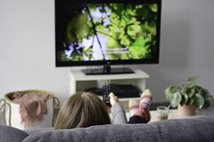

Commonwealth of Australia 2021  
October 2021/ INFRASTRUCTURE

Ownership of intellectual property rights in this publication

Unless otherwise noted, copyright (and any other intellectual property rights, if any) in this publication is owned by the Commonwealth of Australia (referred to below as the Commonwealth).

Disclaimer

The material contained in this publication is made available on the understanding that the Commonwealth is not providing professional advice, and that users exercise their own skill and care with respect to its use, and seek independent advice if necessary.

The Commonwealth makes no representations or warranties as to the contents or accuracy of the information contained in this publication. To the extent permitted by law, the Commonwealth disclaims liability to any person or organisation in respect of anything done, or omitted to be done, in reliance upon information contained in this publication.

Creative Commons licence

With the exception of (a) the Coat of Arms; (b) the Department of Infrastructure, Transport, Regional Development and Communications photos and graphics; copyright in this publication is licensed under a Creative Commons Attribution 4.0 Australia Licence.

Creative Commons Attribution 4.0 Australia Licence is a standard form licence agreement that allows you to copy, communicate and adapt this publication provided that you attribute the work to the Commonwealth and abide by the other licence terms.

Further information on the licence terms is available from <https://creativecommons.org/licenses/by/4.0/>.  
This publication should be attributed in the following way: © Commonwealth of Australia 2020.

Use of the Coat of Arms

The Department of the Prime Minister and Cabinet sets the terms under which the Coat of Arms is used. Please refer to the Commonwealth Coat of Arms—Information and Guidelines publication available at [www.pmc.gov.au](http://www.pmc.gov.au).

Contact us

This publication is available in hard copy or PDF format. All other rights are reserved, including in relation to any Departmental logos or trade marks which may exist. For enquiries regarding the licence and any use of this publication, please contact:

Director—Publishing and Communications  
Communication Branch  
Department of Infrastructure, Transport, Regional Development and Communications  
GPO Box 594  
Canberra ACT 2601  
Australia

Email: [publishing@communications.gov.au](mailto:publishing@communications.gov.au)

Websites: [www.infrastructure.gov.au](http://www.infrastructure.gov.au) | [www.communications.gov.au](http://www.communications.gov.au) | [www.arts.gov.au](http://www.arts.gov.au).

Contents

Introduction 5

What is subscription TV? 5

Captioning rules currently applying to STV licensees 5

The need for a fit for purpose captioning scheme for subscription television 6

Structure of this paper 6

Part 1: Aspects of the current STV captioning arrangements requiring reform 7

Number of STV service categories 7

Ease of Meeting Captioning Targets 8

Annual increases to STV captioning targets 9

Exemptions from STV captioning obligations 10

Exemptions and Target Reduction Orders 11

Nominated Services Exemption 13

Consideration of new objective exemptions 14

Proposed Racing Exemption 14

Proposed Low Audience share exemption 15

Transparency of captioning levels and applied exemptions 16

Part 2: Aspects of the current arrangements which could be retained in a STV captioning scheme 18

New Services Exclusion 18

Sports averaging 18

Captioning of repeat programs 19

Captioning of simultaneously transmitted programs 19

Exclusion of time-shifting and high definition services from annual captioning targets 20

Certain breaches to be disregarded in limited circumstances 21

Part 3: Proposals for a STV captioning scheme 22

1. Number of Categories 22

Issue for comment 22

2. Levels of Captioning (Annual Captioning Targets) 22

Issue for comment 24

3. Freeze or Continued Annual Increases of Captioning Targets 24

Issues for comment 24

4. Exemptions and target reduction orders (unjustifiable hardship) 24

Issues for comment 24

5. Nominated exemptions 25

Issue for comment 25

6. New racing exemption 25

Issue for comment 25

7. New low audience share exemption 25

Issues for comment 25

8. Publication of captioning information 25

Issues for comment 26

9. Retention of certain captioning rules 26

Issue for comment 26

**Tables and figures**

Table 1: Captioning targets for STV categories 2020–21, 2021–22 and 2022–23 7

Table 2: International pass-through channels—examples 8

Figure 1: Compound Annual Growth Rate Forecast for Premium box (STV) services 2016—2025 (AU$millions) 10

Table 3: Availability of exemptions to STV licensees and FTA broadcasters 11

Table 4: Use of Exemption and Target Reduction Orders 2012-13 to 2019–20– FTA broadcasters and STV licensees 12

Figures 2 and 3: Pre and during race images 14

Figures 4 and 5: Foxtel’s Electronic Program Guide—Identification of captioned programs 16

Figure 6: Fetch’s Electronic Program Guide—Identification of captioned programs 17

Figure 7: Example of simultaneously transmitted STV programs 20

Figure 8: Example of time-shifted STV programs 21

Table 5: Proposed reduction in STV categories 22

Table 6: 9 annual captioning targets at 2020–21, 2021–22, 2022–23 levels: 23

Table 7: 5 annual captioning targets at 2020–21, 2021–22, 2022–23 levels: 23

## Introduction

The Australian government is committed to ensuring that all Australians have access to media services, including television services. Captioning, the presentation of the audio component of television programmes, presented as text on the screen, is an important feature that supports access to television for the estimated 1 in 6 Australians who experience some level of hearing loss.[1]

Currently, Part 9D of the Broadcasting Services Act 1992 (the BSA) sets out obligations for free-to-air (FTA) broadcasters and subscription television (STV) licensees to provide captioning services according to particular rules.

## What is subscription TV?

Subscription TV is also known as “Pay TV”. STV licensees provide services that generally consist of a variety of channels and content, including content that is provided by different channel providers for a subscription fee paid periodically. For instance, Foxtel provides content packaged ‘in house’ (e.g. by Foxtel-owned channel providers such Fox Comedy) in addition to programmes supplied by independent channel providers, for example, BBC Worldwide Australia. STV licensees also include resellers who on-sell to viewers programming that is sourced from wholesalers, e.g. Optus resells Fetch TV and Foxtel programming.

The key business groups engaged in the supply of STV services are:

* **Subscription television licensees**: offer subscription television services to viewers, and may provide a range of different channels and genres (e.g. Foxtel and Fetch TV are STV licensees).
* **Independent channel providers**: provide or package content for licensees, often in a specific genre or set of genres. These range from representatives of international media groups (e.g. BBC Worldwide Australia) to small domestic channel groups and community-based organisations (e.g. Aurora).
* **Wholesalers**: sell programming to resellers who on-sell it to viewers (e.g. Foxtel).
* **Resellers**: purchase content from wholesalers to resell to viewers (e.g. Optus).

STV services do not include subscription video on demand (or streaming) services such as Netflix, Stan or Disney Plus.

## Captioning rules currently applying to STV licensees

Division 3 of Part 9D of the BSA sets out rules for captioning by STV licensees, including annual captioning targets, exemptions and target reductions.

STV licensees are subject to captioning targets over a 24 hour period that differ according to 9 categories determined by the dominant genre of the channel.

STV captioning targets progressively increase over time until targets are scheduled to reach 100 per cent of programming by 1 July 2033 for every category of service.

The legislation also sets out grounds for licensees to apply for exemptions and reductions in targets. These grounds include:

* a formula for nominating a percentage of services as exempt where provided before 1 July 2022; and
* where the provision of captioning would impose unjustifiable hardship on the licensee.

## The need for a fit for purpose captioning scheme for subscription television

Between 2015 and 2017 the Department of Communications conducted a public consultation about potential reform of the captioning regulatory framework.[2] In 2016 the Australian Communication and Media Authority (ACMA) also undertook a statutory review of the operation of Part 9D of the BSA.[3] This review also included public consultation. These exercises identified the following priorities for the reform of the STV captioning regime:

* simplification of rules
* more consistent captioning targets for STV licensees
* clearer, prospective information for viewers about what STV services are captioned; and
* simpler, more objective and transparent criteria for exemptions which ensure that captioning resources are directed toward the most popular programs.

The STV sector has faced declining subscriber numbers and declining revenues since the introduction of streaming services to Australia in 2015. In particular, commercial revenues declined substantially in 2020 during COVID-19 restrictions, attributable to closed or less frequented entertainment venues (such as licensed venues showing STV sporting services).

The Broadcasting Legislation Amendment (2021 Measures No. 1) Bill 2021[4] was recently passed by Parliament. The Bill provides for the creation of a STV captioning scheme by legislative instrument made by the Minister for Communications, Urban Infrastructure, Cities and the Arts. Once the Scheme and instrument are established by proclamation, the current rules for STV licensees set out in Division 3 of the BSA will be repealed.

Once the Scheme is in place, compliance with the Scheme will be a licence condition for STV licensees.

## Structure of this paper

Part 1 of this paper discusses aspects of the current STV captioning regime requiring reform.

Part 2 identifies aspects of the current arrangements which could be retained in a STV captioning scheme.

Part 3 details a number of proposals for a STV captioning scheme to deliver captioning more effectively and efficiently while addressing the pressures being experienced by the STV industry. These proposals include a number of issues on which comment is sought.

## Part 1: Aspects of the current STV captioning arrangements requiring reform

### Number of STV service categories

There are currently 9 categories of STV services to which annual captioning targets apply. The targets which apply to these categories are set out at subsection 130ZV(2) of the BSA. The targets for the 2020–21 and 2021–22 financial years are listed in Table 1 below.

Table 1: Captioning targets for STV categories 2020–21, 2021–22 and 2022–23

|  |  |  |  |
| --- | --- | --- | --- |
| Category | 2020–21 captioning target | 2021–22 captioning target | 2022–23 captioning target |
| Category A STV movie service (1st to 6th movie channel) | 100% | 100% | 100% |
| Category B STV movie service (7th movie channel—if nominated by licensee) | 85% | 90% | 95% |
| Category C STV movie service (8th and more movie channels—if nominated by licensee) | 75% | 80% | 85% |
| Category A STV general entertainment service (1st to 18th general entertainment channel) | 85% | 90% | 95% |
| Category B STV general entertainment service (19th to 34th general entertainment channel if nominated by licensee) | 75% | 80% | 85% |
| Category C STV general entertainment service (35th or more general entertainment channel if nominated by licensee) | 55% | 60% | 65% |
| STV news service | 45% | 50% | 55% |
| STV sports service | 45% | 50% | 55% |
| STV music service | 35% | 40% | 45% |

For movie and general entertainment services, licensees can currently nominate which category a particular service fits into, based on how many services the licensee is providing. If licensees choose not to nominate, all services are listed as Category A. Licensees which deliver more services have the advantage of nominating a greater number of services with a lower captioning target. The ability of licensees to nominate the category of movie or general entertainment service can mean that captioning targets for a particular channel aired by a number of licensees may differ depending on who is providing the service.

Feedback and formal submissions from both STV and viewer representatives have noted the complexity in the number of categories and captioning targets and the confusion caused by different targets applying to identical channels delivered by different licensees.

In 2016 ASTRA proposed that a single captioning target be set for general entertainment and movie services[5]. This proposal was generally supported by viewer representative groups noting that reducing the number of categories would:

* simplify the scheme; and
* reduce the instances of the same service having different captioning targets when aired by different STV licensees.

### Ease of Meeting Captioning Targets

The different levels of the captioning targets for STV genres, as set out in **Table 1**, were designed to reflect the relative ease with which particular types of programs can be delivered to Australian viewers of STV with captions. For example, movie and, to a lesser extent, general entertainment services normally have a long lead time between production and going to air, whereas news and sports channels feature many live or near to live events where captioning must be undertaken in a constrained timeframe.

STV licensees offer a number of channels where a single channel is produced overseas for live transmission in a number of countries. Examples of such channels are listed in Table 2 below:

Table 2: International pass-through channels—examples

|  |  |  |
| --- | --- | --- |
| STV Licensees | Channels | Genre |
| Foxtel, Fetch | Al Jazeera English, Bloomberg | News |
| Fetch | Euronews, Channel News Asia | News |
| Foxtel | Russia Today | News |
| Foxtel, Fetch | beIN Sports, Eurosport | Sport |
| Fetch | EGG Channel | Sport |
| Fetch | Travel Channel, Food Network, Fashion TV, Horse and Country, Baby TV | General Entertainment |

These international “pass-through” channels bring special challenges to STV licensees in relation to their captioning. Foxtel has advised that:

Where live news and sports channels are produced solely for markets outside the US and UK, the international version of the channel is commonly distributed without any captions in any market.

[…] there is no opportunity for local insertion (of captions or any other program matter) by those entities that provide those channels. For these international ‘’pass through” channels, Australian STV licensees are no more than transmission platforms received directly from international sources.

Foxtel adds that any insertion of captions into programs on these international pass-through channels must be done locally on a live basis which is an expensive process, significantly adding to the cost of delivering these services in Australia.[6]

The Department notes that many of these international pass through channels have a comparatively low audience share. A proposed exemption for services with a lower audience share is discussed at **Proposed Low Audience share exemption** in this paper.

The Department notes that a separate category for sports services enables the sports averaging rule to apply to this genre category. Sports averaging is discussed in Part 2 of this paper.

The Department also notes that reported captioning levels in 2019–20 for the 12 movie services offered by Foxtel and its resellers ranged from 98.25 to 100 per cent.[7] These levels are well in excess of the current targets set for categories B and C of this genre. This may suggest that targets for this genre are at too low a level.

The wide range of issues affecting different categories of services indicate that there is likely merit in the continued retention of 5 separate STV genre categories (movies, general entertainment, news, sports and music) to which separate captioning targets apply.

### Annual increases to STV captioning targets

Captioning targets for STV licensees increase progressively each financial year by 5 percentage points. All targets are scheduled to have reached 100 per cent of programming by 1 July 2033.

The rules for captioning of STV services were established on the assumption that STV audiences would increase over time. However, STV licensees have found that increased captioning levels have not been matched by increased subscriber numbers.

PWC’s report *The Australian* *Entertainment and Media Outlook 2021-2025[8]* found that with the large number of global and local streaming services now available, consumer behaviour has changed rapidly with movement away from STV (or ‘premium box’) services. PWC reports that in 2020 Foxtel lost approximately 267,000 premium box customers. PWC forecasts that STV services are expected to decline by 7.1 per cent over 2021-25.[9].This trend, along with 3 different potential future scenarios, none of which foresees ongoing growth, is shown in Figure 1 below:

Figure 1: Compound Annual Growth Rate Forecast for Premium box (STV) services 2016—2025 (AU$millions)

(Source: The Australian Entertainment and Media Outlook 2021-2025, PWC)

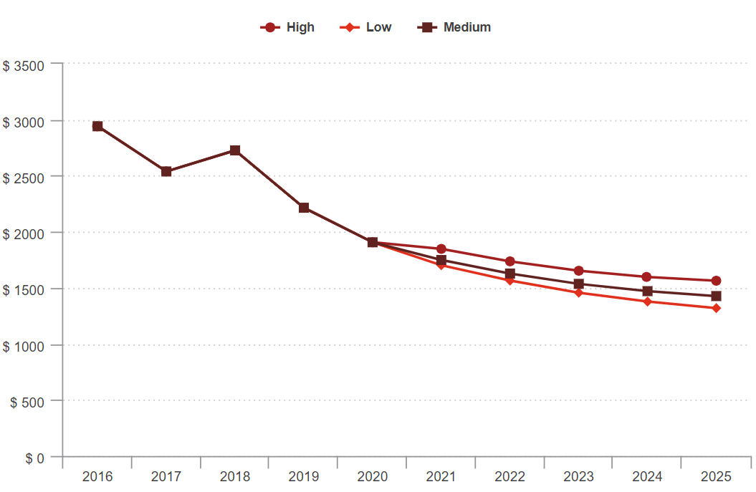

At the same time, advertising revenue is moving away from licensed broadcasters to digital platforms and other online-only media. Data from television broadcaster industry group Think TV indicates that for the 12 months to December 2020, the total TV market (FTA and STV) recorded $3.45 billion in advertising revenue, down by nearly 11 per cent in 2020. This followed a 4.8 per cent decrease in 2019.[10]

STV licensees argue that a continued progressive increase in captioning targets is unsustainable. This viewpoint is reflected in an unsustainable level of claims for exemptions and target reduction orders by STV licensees (see Table 4 below).

Feedback from STV licensees is that the annual increase of STV captioning targets has now reached a “critical level” increasing the urgency of the reform of STV captioning rules.[11]

### Exemptions from STV captioning obligations

A number of exemptions from captioning obligations are available to STV licensees. Table 3 below summarises the exemptions available to STV licensees. Exemptions available to FTA broadcasters are included for comparison.

Table 3: Availability of exemptions to STV licensees and FTA broadcasters

|  |  |  |
| --- | --- | --- |
| Description | Available to FTA broadcasters? | Available to STV broadcasters? |
| Exemption on the basis that providing captions for a particular service would impose unjustifiable hardship to the STV licensee | Y | Y |
| Reduction to the level of the captioning target for a particular service on the basis that meeting the captioning target would impose unjustifiable hardship | Y | Y |
| Exclusion from captioning obligations for 1 to 2 years for new services, where the content predominantly consists of programs not previously transmitted in Australia | N | Y |
| Where the captioning targets are met for a threshold number of services, the ability to nominate additional services of that genre to be exempted from captioning obligations in accordance with a formula set out in the BSA. | N | Y |

Feedback from viewer representatives is that the criteria for the current exemptions available to STV licensees are complex and it is not clear when the exemptions apply to particular services. All exemptions can be claimed retrospectively making it difficult for viewers to know whether an exemption applies to a service at the time it is scheduled for broadcast.

Viewers and STV licensees are supportive of the introduction of new exemptions which apply prospectively and are based on more objective and transparent criteria.

#### Exemptions and Target Reduction Orders

Currently, both FTA and STV licensees can apply for an exemption or reduction, to their captioning targets on the grounds that providing captions on a particular channel in accordance with the target would cause unjustifiable hardship.[12]

An exemption order frees a channel from its annual captioning obligations for a set period of time. A target reduction order provides a channel with a reduced annual captioning target for a set period of time.

Compared to their FTA counterparts, STV licensees rely heavily on exemption orders and target reduction orders to reduce their captioning obligations, as can be seen from Table 4 below:

Table 4: Use of Exemption and Target Reduction Orders 2012-13 to 2019–20– FTA broadcasters and STV licensees

|  |  |  |  |
| --- | --- | --- | --- |
| Service Type | Application Category | Applications Made | Granted |
| Subscription Television Licensee | Exemption Order | 351 | 318 |
| Subscription Television Licensee | Target Reduction Order | 37 | 27 |
| Commercial Television Broadcaster | Exemption Order | 3 | 0 |
| Commercial Television Broadcaster | Target Reduction Order | 12 | 9 |
| National Broadcaster | Exemption Order | 1 | 0 |
| National Broadcaster | Target Reduction Order | 2 | 0 |
|  | **Total** | **406** | **354** |

Orders can be made for exemption or reduction of the captioning target for 1 to 5 financial years. Orders can be retrospective.

The legislative provisions specify that when deciding whether to grant an exemption or target reduction, the ACMA must have regard to:

* the nature of the detriment likely to be suffered by the STV licensee
* the impact on deaf and hearing-impaired viewers
* the number of subscribers to the service concerned (for subscription television only)
* the financial circumstances of the applicant
* the estimated expenditure required if the order is not granted
* the extent to which captioning is provided on services provided by the applicant
* the likely impact of the failure to make the order on the quantity and quality of programs provided by the applicant
* whether the applicant has applied for exemption orders or target reduction orders for any other services; and
* other matters that the ACMA considers to be relevant.

Viewers and their representatives have stated that that draft and final exemption and target reduction orders published by the ACMA do not clearly demonstrate the hardship claimed.[13] In its review, the ACMA noted that it is constrained by the need to balance “confidential stakeholder information with a transparent consultation process.”

Broadcasters (including STV licensees) characterise the application process for these exemptions and target reduction orders as “inflexible, time-consuming and costly”.[14] The application and decision-making process which is subject to stringent timeframes is also a considerable administrative burden for the ACMA.

Reducing the reliance that STV licensees have on these exemptions and target reduction orders on the basis of hardship may be desirable.

#### Nominated Services Exemption

Currently, subscription television licensees that provide a specified minimum of services for some categories (for example, more than 11 STV movie services), may ‘nominate’ additional services within that category by providing written notice to the ACMA before the end of the relevant financial year.

These services are nominated in accordance with a complex formula set out in section 130ZX of the BSA.

The number of services that can be nominated for exemption decreases over time until the exemption ceases to apply on 1 July 2022. When this measure was introduced, it was intended to be a transitional arrangement to ‘assist subscription television licensees to implement captioning on all services’.[15]

In 2019–20 there were 67 services that were nominated for exemption from captioning requirements under section 130ZX of the BSA.[16]

The nominated services exemption, by its nature, favours licensees providing a greater number of services. Smaller providers may have to expend resources captioning programming on a channel that is exempt for a larger provider.[17]

In addition, the operation of this exemption is not transparent to viewers. Exempt services are nominated by licensees during the annual reporting process—that is, after the services have been aired. ASTRA has submitted that this highly complex exemption lacks consumer focus and that the selection process for nominating exempt channels by licensees may appear arbitrary, reducing certainty and transparency of captioning levels for viewers.[18]

Given the complexity, lack of transparency and administrative burden this exemption type presents, it may not be desirable to extend and/or retain it in the long term.[19] However, there may be merit in considering whether this exemption should continue to apply as a transitional measure until such time as STV licensees are able to claim the new objective exemptions proposed in this paper.

#### Consideration of new objective exemptions

During the 2015–17 consultation processes a number of potential new exemptions were proposed for consideration, based on objective criteria.

#### Proposed Racing Exemption

An automatic exemption for racing services where live racing and the replays of live racing represent at least seventy per cent of the channel’s content was proposed by ASTRA in 2016.[20]

In its submission, ASTRA proposed that channels broadcasting thoroughbred, harness and greyhound racing should be exempt. It argued that such an exemption would recognise the unique nature of racing channels, and the difficulties inherent in providing captioning, including:

* racing channels already present large quantities of text—at times, up to 75% of the screen displaying the service is taken up by text information about the race
* captions are usually placed somewhere on the screen that won't interfere with the picture; however, positioning racing captions in a manner that does not obscure either the racing vision or critical racing text displays is problematic
* the readability and accuracy of captioning is likely to be of very poor quality during a race due to racecallers describing races very quickly (often with unstructured syntax and without pauses) making it difficult for stenocaptioners to accurately capture and present what is being said; and
* an average horse race lasts just a couple of minutes and given the delays in live captioning relative to the speed of a race, the information is often out of date by the time it is transmitted, rendering the captioning unhelpful.

Figures 2 and 3: Pre and during race images

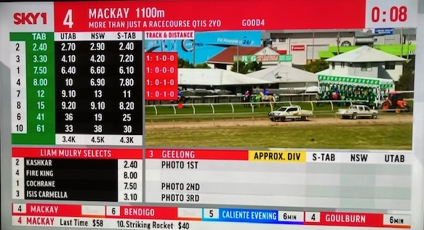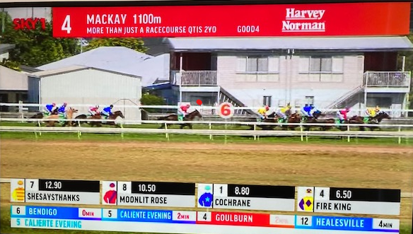

(Source: Sky1 Channel)

Venues where racing is likely to be broadcast, such as TAB and licensed venues, have sole discretion about whether to use captions. Industry has submitted[21] that these venues would be likely to ensure on-screen text and racing vision is fully available to viewers rather than captioning.

The captioning of racing may not enhance the viewing experience for deaf or hearing-impaired viewers in a meaningful way. An automatic exemption for racing channels would streamline the regulatory framework by removing the current burden for industry and the regulator in preparing, lodging and considering exemption orders in respect of racing captioning.

#### Proposed Low Audience share exemption

A low audience share exemption would exempt those channels which attract a very small number of viewers from their captioning obligations; that is, where the average audience share of a channel is below a determined percentage.

This exemption was proposed[22] and received support from all stakeholders during the 2015–17 consultation processes. In summary, views were that an audience share exemption would:

* offer a clear threshold mechanism, based on objective and transparent criteria; and
* focus captioning resources on more popular programming, directing these resources towards services that reach the largest audiences.

An audience share threshold model has been adopted in the United Kingdom where television services are excluded from providing television ‘access services’—which includes captioning if their share of viewing falls below the relevant audience share threshold.[23]

Analysis undertaken by the Department indicates that setting the threshold for low audience share at below 0.1% of total television audience measurement numbers (a combination of both subscription and non-subscription television audience measurement numbers), is likely to exempt channels with very low audience numbers many of which have been subject to exemption orders and target reduction orders on the basis of unjustifiable hardship in the past.

The level of the threshold may need to be adjusted in future in line with market conditions to ensure viewers have access to a reasonable level of captioned programs. This exemption could apply prospectively to channels below the threshold. For instance, where a channel’s average audience share is below the threshold for a calendar year, STV licensees could claim an exemption for the channel for the following financial year or years.

Application could be on the basis of publication or a simple claim process overseen by the ACMA. In either case, transparency of the data demonstrating low audience share is desirable.

A potential source of information on which licensees could base their claims for low audience share is through the data available through OzTAM.[24]

Some OzTAM reports are publicly available on their website. One such report is A2 Consolidated Metropolitan Total TV Share All viewing 5 City Share Report—All Homes. This report, issued weekly, sets out how the total television audience is spread across all FTA and STV channels in the five capital cities (Sydney, Melbourne, Brisbane, Adelaide and Perth) between the hours of 6 am and midnight during a week. Audience share is listed in 0.1 increments. It does not list the audience share of all channels, notably those with a very low audience share, well below 0.1%. Where OzTAM does not collect data for a particular channel, the Department understands that each STV licensee has developed in-house methodologies for measuring audience share.

A comparatively simpler criteria for this proposed exemption, coupled with a streamlined application process may reduce the number of applications for exemption and target reduction orders on the basis of unjustifiable hardship for the STV licensee received by the ACMA[25], reducing the administrative burden on both subscription television licensees and the regulator.

### Transparency of captioning levels and applied exemptions

Representative groups have noted that viewers are unsure about what STV channels and programs are required to be captioned[26], noting the complexity of the captioning targets and the lack of clear, accessible information about what programs are captioned. Deaf Australia has observed that “if deaf and hard of hearing consumers subscribe to subscription television, they do not have advance knowledge of what programs will be accessible. Instead a blanket quota [the captioning target for each genre] is their assurance”.[27]

Information related to captioning levels on subscription television is currently found in a number of different locations.

Foxtel’s website includes a page entitled ‘Closed Captions’.[28] The page shows annual captioning targets and also provides past actual targets. The page also lists channels that are not captioned but does not provide any details of any exemptions or exclusions that apply.

Foxtel’s electronic program guide (EPG)—shows whether individual programs are captioned or not, using the internationally recognisable acronym ‘CC’ in the information provided for each program.

Figures 4 and 5: Foxtel’s Electronic Program Guide—Identification of captioned programs

Foxtel - identification of captioned programs - individual program

Program information for a Foxtel program. At the bottom row of the information about the program the abbreviation CC (Closed Captions) appears. 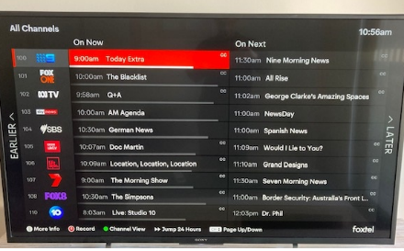

Information on Fetch’s website provides information on how to determine whether a specific program is captioned through a number of methods via the Fetch set-top box interface.[29] No information is provided about targets or the reasons why a program may not be captioned.

The description of individual programs on Fetch’s EPG includes information about the captioning status of that program denoted by the presence or absence of the acronym ‘CC’.

Figure 6: Fetch’s Electronic Program Guide—Identification of captioned programs

Fetch - identification of captioning of individual program

Program information for a Fetch program, 2 Broke Girls. To the right of a description of the episode, the classification of the program and the abbreviation CC (Closed Captions) appears.


The ACMA publishes a list of past and current exemptions and target reduction orders granted on the basis of unjustifiable hardship.[30]

Information about services excluded as ‘new services’ or ‘nominated’ as exempt is not published until annual reports from STV licensees are received and compiled by the ACMA into annual compliance reports. As of 10 June 2021, compliance reports relating for the 2019–20 year and earlier have been published by the ACMA.[31] The ACMA also publishes comprehensive information about targets, exclusions and exemptions.[32]

As part of its 2015-2017 consultation, the Department proposed the introduction of a forward looking ‘captioning plan’ that would specify the amount of captioned content that licensees would provide on their services as well as applicable exemptions.[33]

The provision of consolidated, forward looking information about captioning provided by each STV licensee is supported by a number of stakeholders.

## Part 2: Aspects of the current arrangements which could be retained in a STV captioning scheme

### New Services Exclusion

Subsection 130ZV(6) of the BSA provides that new subscription television services can be excluded from the annual captioning targets for 1 to almost 2 financial years.[34] To qualify as a ‘new’ service, the service must predominantly consist of programs not previously transmitted in Australia.

The ACMA has expressed the view that it is reasonable for a new service ‘which is broadcasting content that has not previously been broadcast in Australia, to be exempt from captioning in its first year of operation’.[35] Whilst the regulator acknowledged concerns expressed by some stakeholders in relation to the blanket exemption, it noted the current approach allowed flexibility for new formats and genres to be trialled on Australian television, whilst not excluding accessibility to these services in the longer term.[36]

In 2019–20, two new channels were excluded from the annual captioning targets—Fox Cricket and MSNBC, a news channel.[37]

The new services exclusion is a simple objective measure that, may support new channels in their first year of broadcasting and provide incentives for the provision of a wider range of accessible STV content in the longer-term.

### Sports averaging

Subsection 130ZV(3) of the BSA allows the annual captioning target for sport services to be aggregated (averaged) across a group of sports channels owned by the same channel provider. One third of a sports channel’s target can be met on another sports channel supplied by the same provider, as long as the average of the captioning levels across all channels in the group meets the annual targets.

The benefits of this provision for viewers include:

* where a sports event held over a number of days is shifted between channels before the completion of an event, captioning can ‘follow’ the event; and
* directing captions towards very popular sports programming—such as AFL and NRL, ensures that captions can reach large audiences.

As sports’ target aggregation was introduced as recently as 2015, there was little feedback from viewer representatives about its operation during the 2015–17 consultations, although one representative group noted to the ACMA review that the rules “are particularly confusing”.[38]

In 2015–17, ASTRA sought flexibility to aggregate a higher percentage of sports services. There has been no renewed request for changes to sports averaging from STV licensees since then.

Sports averaging in its current form appears to offer benefit both STV licensees and viewers.

### Captioning of repeat programs

Section 130ZZ of the BSA provides that that if a STV licensee transmits a program which it has previously transmitted on one of its channels with captions and on each occasion the programs had been supplied by the same channel provider, the licensee is required to caption the repeat of the program.

Restricting the obligation to caption a repeat program to instances where the program was provided by the same channel provider on each occasion, eases the cost and regulatory burden for licensees in meeting their captioning obligations, since there may be difficulties and additional costs associated with captioning where the same program is provided by different channel providers.

At the same time, as the ACMA has pointed out, the requirement benefits viewers for example, through the provision of a program with captions which may be repeated on a channel that has already filled its captioning requirement, or on a channel that is excluded from the captioning obligations under s130ZX of the Act (‘nominated services’).[39]

The captioning of repeat programming sourced from the same channel provider appears to be of benefit to viewers without imposing great additional cost on broadcasters.

### Captioning of simultaneously transmitted programs

Where a STV licensee transmits a program on 2 subscription television services simultaneously, section 130ZZAA of the BSA requires it to caption the second service where the first service is captioned.

For instance Foxtel offers a number of channels in both high definition and standard definition, for example, BBC First and BBC First HD. These STV services may include programs which are broadcast on both channels simultaneously. Where a program is broadcast on one of these channels with captions, its broadcast on the other channel should also include captions.

Figure 7: Example of simultaneously transmitted STV programs

Example of simultaneously transmitted STV programs. Program details of an episode 'The Long Song.  Times listed for the episode show that the episode will be simultaneously shwon on BBC First and BBC First HD.
 

This rule appears to benefit viewers by providing captions on the same program viewed on multiple channels.

### Exclusion of time-shifting and high definition services from annual captioning targets

Subsection 130ZV(5) of the BSA provides for STV services to be excluded from the annual captioning targets STV services where a service:

* transmits the same stream of programs that has previously been transmitted on another STV service provided by the licensee (for example a time-shifting service); or
* simultaneously transmits in high definition format, the same stream of programs that are transmitted in standard definition format on another STV service provided by the licensee.

Similarly, subsection 130ZX(13) excludes time-shifting and high definition services from being nominated for exemption under that section.

Figure 8: Example of time-shifted STV programs

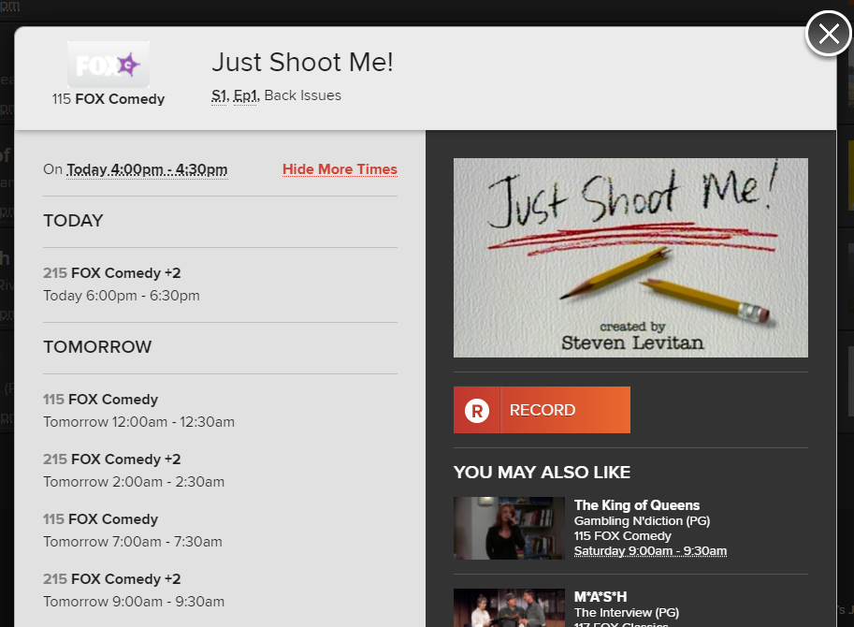

The result is that repeat or simulcast services do not count towards the minimum number of services required to be captioned. While this exclusion adds complexity to the STV captioning rules, it does contribute to the quantity of captioned STV services.

### Certain breaches to be disregarded in limited circumstances

Section 130ZZAB of the BSA sets out certain circumstances where an STV licensee may have breached its captioning obligations but these breaches are to be disregarded.

The circumstances are limited to technical and engineering difficulties that could not have been reasonably foreseen by the licensee.

These exceptions are limited in scope and safeguard licensees against unforeseen major technical issues.

## Part 3: Proposals for a STV captioning scheme

### 1. Number of Categories

The captioning scheme should maintain the STV news, sports and music categories.

To simplify the STV captioning arrangements, the current 6 general entertainment and movie categories could be reduced to 2 single categories.

If the number of categories are reduced, the targets for the proposed single movie and general entertainment categories could be calculated by averaging the existing targets for the current 3 movie and general entertainment categories as set out in Table 5 below. The annual captioning targets for the financial year commencing 1 July 2022 set under the BSA have been used for illustrative purposes:

Table 5: Proposed reduction in STV categories

|  |  |  |
| --- | --- | --- |
| Existing Category | Proposed new Category | Captioning target (from 1 July 2022) |
| Category A STV movie service |  | 100% |
| Category B STV movie service |  | 95% |
| Category C STV movie service |  | 85% |
|  | **STV movie service** | 95% |
| Category A STV general entertainment service |  | 95% |
| Category B STV general entertainment service |  | 85% |
| Category C STV general entertainment service |  | 65% |
|  | **STV general entertainment service** | 80% |
| STV news service |  | 55% |
| STV sports service |  | 55% |
| STV music service |  | 45% |

#### Issue for comment

Should the 5 categories of STV services listed in Table 5 above be adopted in the Scheme? If so, is it appropriate to average the captioning levels for the movie and general entertainment categories?

### 2. Levels of Captioning (Annual Captioning Targets)

To address the difficulties in meeting increasing captioning targets experienced by the STV industry, targets could be reset at 2020–21 levels or remain at 2021–22 levels.

Alternatively, the scheme could commence on 1 July 2022 with annual captioning targets consistent with the current provisions in the BSA mandated for 2022–23.

If the number of STV service categories discussed at Proposal 1 above remained unchanged, the following STV categories and the three options for annual captioning targets set out in Table 6 below could apply from 1 July 2022:

Table 6: 9 annual captioning targets at 2020–21, 2021–22, 2022–23 levels:

|  |  |  |  |
| --- | --- | --- | --- |
| Category | Annual captioning target (2020–21 levels) | Annual captioning target (2021–22 levels) | Annual captioning target (2022–23 levels) |
| 1. Category A STV movie service (1st to 6th movie channel) | 100% | 100% | 100% |
| 1. Category B STV movie service (7th movie channel—if nominated by licensee) | 85% | 90% | 95% |
| 1. Category C STV movie service (8th and more movie channels—if nominated by licensee) | 75% | 80% | 85% |
| 1. Category A STV general entertainment service (1st to 18th general entertainment channel) | 85% | 90% | 95% |
| 1. Category B STV general entertainment service (19th to 34th general entertainment channel if nominated by licensee) | 75% | 80% | 85% |
| 1. Category C STV general entertainment service (35th or more general entertainment channel if nominated by licensee) | 55% | 60% | 65% |
| 1. STV news service | 45% | 50% | 55% |
| 1. STV sports service | 45% | 50% | 55% |
| 1. STV music service | 35% | 40% | 45% |

If the number of STV service categories were reduced as proposed at Proposal 1 above, the following STV categories and the three options for annual captioning targets set out in Table 7 below could apply from 1 July 2022:

Table 7: 5 annual captioning targets at 2020–21, 2021–22, 2022–23 levels:

|  |  |  |  |
| --- | --- | --- | --- |
| Category | Annual captioning target (2020–21 levels) | Annual captioning target (2021–22 levels) | Annual captioning target (2022–23 levels) |
| STV movie service | 85% | 90% | 95% |
| STV general entertainment service | 70% | 75% | 80% |
| STV news service | 45% | 50% | 55% |
| STV sports service | 45% | 50% | 55% |
| STV music service | 35% | 40% | 45% |

#### Issue for comment

What is an adequate level of captioning for STV services to commence on 1 July 2022?

1. Resetting the annual captioning targets at 2020–21 levels?
2. Remaining at the 2021–22 annual captioning targets?
3. Moving to the 2022–23 annual captioning targets?
4. Some other set of targets? Please explain why.

### 3. Freeze or Continued Annual Increases of Captioning Targets

Freezing STV annual captioning targets for a period of time may partially address the issues currently faced by the STV industry. An alternative approach (regardless of the captioning levels selected to commence on 1 July 2022), is that these levels continue to increase by 5 per cent per annum as per the current rules at subsection 130ZV(2) in the BSA as set out at Table 1 of this paper.

#### Issues for comment

1. Is it appropriate that annual STV captioning levels be frozen or should captioning levels continue to increase by 5 per cent per annum as under the existing rules at subsection 130ZV(2) in the BSA?
2. If STV annual captioning levels are frozen, should this freeze be permanent or reviewed after a period of time? If the latter, what should that period of review be?

### 4. Exemptions and target reduction orders (unjustifiable hardship)

The following exemptions currently available to STV licensees could be retained in a STV captioning scheme:

1. Exemption on the basis that providing captions for a particular service would impose unjustifiable hardship to the STV licensee
2. Reduction to the level of the captioning target for a particular service on the basis that meeting the captioning target would impose unjustifiable hardship to the STV licensee

The possible retention of these exemptions should be conditional upon the introduction of additional new exemptions based on objective and transparent criteria (see Proposals 4 and 5).

#### Issues for comment

a. As audience share or the difficulty in captioning racing channels are factors in applications for exemption or target reduction orders based on hardship, is it necessary to retain these exemptions or target reduction orders based on hardship for STV licensees, given the proposed introduction of new exemptions based on objective and transparent criteria (see Proposal 4 and 5)?

b. If these exemptions and target reduction orders are retained, should their:

i. availability be limited to circumstances where other exemptions do not apply?

ii. assessment criteria be amended? If so, how?

### 5. Nominated exemptions

The STV captioning scheme should not retain, in the long term, the ability for STV licensees to nominate additional services of that genre to be exempted from captioning obligations.

#### Issue for comment

Is it appropriate for this exemption to be retained until such time as the proposed new exemptions set out at proposals 4 and 5 can be claimed?

### 6. New racing exemption

The STV captioning scheme should include a new racing channel exemption which would apply prospectively and not require an application. The new exemption would apply to channels where at least 70 per cent of the program content will consist of horse racing, harness racing or greyhound racing.

#### Issue for comment

As the criteria for this new proposed exemption is objective and self-evident, it is proposed that STV licensees do not apply for racing exemptions but should publish the channels to which this exemption applies each financial year. Options for the publication of exemptions are raised for comment at Proposal 6. Is it appropriate that this exemption be “claimed” by publication only?

### 7. New low audience share exemption

The STV captioning scheme should include new a low audience share channel exemption which would apply prospectively and have a streamlined application process. The criteria for this new exemption could be met where for a full calendar year, a service had an audience share below 0.1% of total television audience (both subscription and non-subscription). The exemption could apply for the following 2 financial years.

#### Issues for comment

1. Is there any evidence that a threshold other than less than 0.1% is a more appropriate threshold level for a low audience share exemption? What is the alternative threshold and the evidence of its appropriateness?

Where available, is the OzTAM measurement used in the “A2” report appropriate for determining the low audience share for the purposes of this exemption? Are there are measures that are more appropriate?

1. Is an exemption period of 2 years appropriate for this exemption? If not, what alternative period is more appropriate and why?
2. Should the low audience share exemption be claimed by “publication”, where both the details of the exemption and the data relied upon to demonstrate the low audience share are published?

### 8. Publication of captioning information

The STV captioning scheme should include the requirement that STV licensees publish prospective information about captioned content and applicable exemptions. This information should be published in a manner and in locations which are accessible to both consumers considering a subscription to STV services and to current subscribers.

#### Issues for comment

1. What information should be published?

i. Should the overall, actual percentage of captioning proposed to be delivered by STV licensees for each channel for the current financial year be published?

ii. Should a list of services that are not captioned and the relevant exemption and/or target reduction orders be published?

iii. Should information about whether individual programs are captioned or not be published?

iv. Should a requirement to include information on whether a program is captioned or not be included in the Electronic Program Guides of STV Licensees?

1. When should information be published?

i. For information about the captioning levels and applicable exemptions and target reduction orders at a service (channel) level, should information be published before the start of every financial year (noting that the new, proposed exemptions will apply from the beginning of each financial year)?

1. If retrospective exemptions remain in place or new services become available during the financial year, how should published reports be amended?
2. Where should information be published? Should information about the captioning levels and applicable exemptions and target reduction orders at a service (channel) level be published on:

i. the ACMA website

ii. the website of each STV licensee

iii. both the ACMA website and on the website of each STV licensee?

1. Should information about individual programs be published in the program guides (electronic and otherwise) of STV licensees?

### 9. Retention of certain captioning rules

The following aspects of the current STV captioning arrangements should be maintained in a STV captioning scheme:

1. Exclusion from captioning obligations for 1 to 2 years for new services, where the content predominantly consists of programs not previously transmitted in Australia.
2. The modified formula for subscription sports services.
3. Captioning of repeat programs on subscription television where the program has been supplied by the same channel provider.
4. Captioning of simultaneously transmitted television programs on licensees’ services.
5. Certain breaches to be disregarded in limited circumstances.

#### Issue for comment

Should the modified formula for STV services be modified in any way? If so, why and how?

1. [Disability Statistics · Resources · Australian Network on Disability (and.org.au)](https://www.and.org.au/pages/disability-statistics.html)
2. [Improving captioning regulation | Department of Infrastructure, Transport, Regional Development and Communications](https://www.communications.gov.au/have-your-say/improving-captioning-regulation)
3. ACMA-captioning-report_April2017-pdf.pdf
4. [Broadcasting Legislation Amendment (2021 Measures No. 1) Bill 2021—Parliament of Australia (aph.gov.au)](https://www.aph.gov.au/Parliamentary_Business/Bills_Legislation/Bills_Search_Results/Result?bId=r6699)
5. [Australian Subscription Television and Radio Association (ASTRA).pdf (communications.gov.au)](https://www.communications.gov.au/sites/default/files/submissions/Australian%20Subscription%20Television%20and%20Radio%20Association%20%28ASTRA%29.pdf)
6. [Australian Subscription Television and Radio Association (ASTRA).pdf (communications.gov.au)](https://www.communications.gov.au/sites/default/files/submissions/Australian%20Subscription%20Television%20and%20Radio%20Association%20%28ASTRA%29.pdf), p. 13
7. [Compliance with TV content standards | ACMA](https://www.acma.gov.au/broadcaster-compliance-tv-captioning-obligations)
8. [Outlook | Entertainment & Media | PwC Australia](https://www.pwc.com.au/industry/entertainment-and-media-trends-analysis/outlook.html)
9. Quantified in terms of Compound Annual Growth Rate (CAGR)
10. [TV advertising outperforms market recording growth in first half of FY21—ThinkTV](https://thinktv.com.au/news/tv-advertising-outperforms-market-recording-growth-in-first-half-of-fy21/)
11. [Submissions—Parliament of Australia (aph.gov.au)](https://www.aph.gov.au/Parliamentary_Business/Committees/Senate/Environment_and_Communications/BLAB/Submissions) , Foxtel submission to the Senate Environment and Communications References Committee Inquiry into the Broadcasting Legislation Amendment (2021 Measures No. 1) Bill 2021, p.9
12. The provisions for exemption and target reduction orders relating to unjustifiable hardship are set out in the BSA at sections 130ZUA for FTA broadcasters and 130ZY for STV licensees respectively.
13. ACMA-captioning-report_April2017-pdf.pdf, p. 17
14. ACMA-captioning-report_April2017-pdf.pdf, p. 16
15. [Microsoft Word—368981.docx (aph.gov.au)](https://parlinfo.aph.gov.au/parlInfo/download/legislation/ems/r4836_ems_9f394481-5ca7-447b-839c-7785bc5d4d2c/upload_pdf/368981.pdf;fileType=application%2Fpdf)*Broadcasting Services Amendment (Improved Access to Television Services) Bill 2012;* Explanatory Memorandum p. 28
16. [Compliance with TV content standards | ACMA](https://www.acma.gov.au/broadcaster-compliance-tv-captioning-obligations)
17. ACMA-captioning-report_April2017-pdf.pdf, p 10
18. [Australian Subscription Television and Radio Association (ASTRA).pdf (communications.gov.au)](https://www.communications.gov.au/sites/default/files/submissions/Australian%20Subscription%20Television%20and%20Radio%20Association%20%28ASTRA%29.pdf) , p. 11
19. Section 130ZX only applies to services provided before 1 July 2022.
20. [Australian Subscription Television and Radio Association (ASTRA).pdf (communications.gov.au)](https://www.communications.gov.au/sites/default/files/submissions/Australian%20Subscription%20Television%20and%20Radio%20Association%20%28ASTRA%29.pdf) p.14-16
21. [353 Sky Racing1 | ACMA](https://www.acma.gov.au/publications/2019-11/instruction/353-sky-racing1) Statement of reasons for the decision to make the exemption order STV/EO-00353, ACMA 22 June, 2017
22. [Improving captioning regulation | Department of Infrastructure, Transport, Regional Development and Communications](https://www.communications.gov.au/have-your-say/improving-captioning-regulation). Policy Consultation paper, p. 22-23.
23. [tv-access-services-code.pdf (ofcom.org.uk)](https://www.ofcom.org.uk/__data/assets/pdf_file/0035/179954/tv-access-services-code.pdf), clause 5.4
24. http://www.oztam.com.au
25. Noting that low audience share is often cited as a factor in applications for exemptions and target reduction orders on the basis of unjustifiable hardship.
26. ACMA-captioning-report_April2017-pdf.pdf, p.11
27. [Untitled (communications.gov.au)](https://www.communications.gov.au/sites/default/files/submissions/Deaf%20Australia.pdf) Deaf Australia—Submission to Department of Communications and the Arts, p. 6
28. [Closed captions (foxtel.com.au)](https://www.foxtel.com.au/support/products-and-features/closed-captions.html)
29. [Fetch (fetchtv.com.au)](https://www.fetchtv.com.au/support/fetchtv-closed-captioning)
30. [Final exemption orders and target reduction orders | ACMA](https://www.acma.gov.au/final-exemption-orders-and-target-reduction-orders)
31. [Compliance with TV content standards | ACMA](https://www.acma.gov.au/broadcaster-compliance-tv-captioning-obligations)
32. [Provide captions on subscription TV | ACMA](https://www.acma.gov.au/provide-captions-subscription-tv)
33. [Improving captioning regulation | Department of Infrastructure, Transport, Regional Development and Communications](https://www.communications.gov.au/have-your-say/improving-captioning-regulation). Policy Consultation paper, p. 19-22
34. The length of the exclusion depends on the day of the service’s commencement. For example, if a new service began on 1 January 2020, it would be excluded from the annual captioning targets from 1 January 2020 to 30 June 2021. Depending upon the date of commencement
35. ACMA-captioning-report_April2017-pdf.pdf*,* p.14
36. ACMA-captioning-report_April2017-pdf.pdf*,* p.14
37. [Compliance with TV content standards | ACMA](https://www.acma.gov.au/broadcaster-compliance-tv-captioning-obligations)
38. ACMA-captioning-report_April2017-pdf.pdf , p. 12
39. ACMA-captioning-report_April2017-pdf.pdf , p. 14