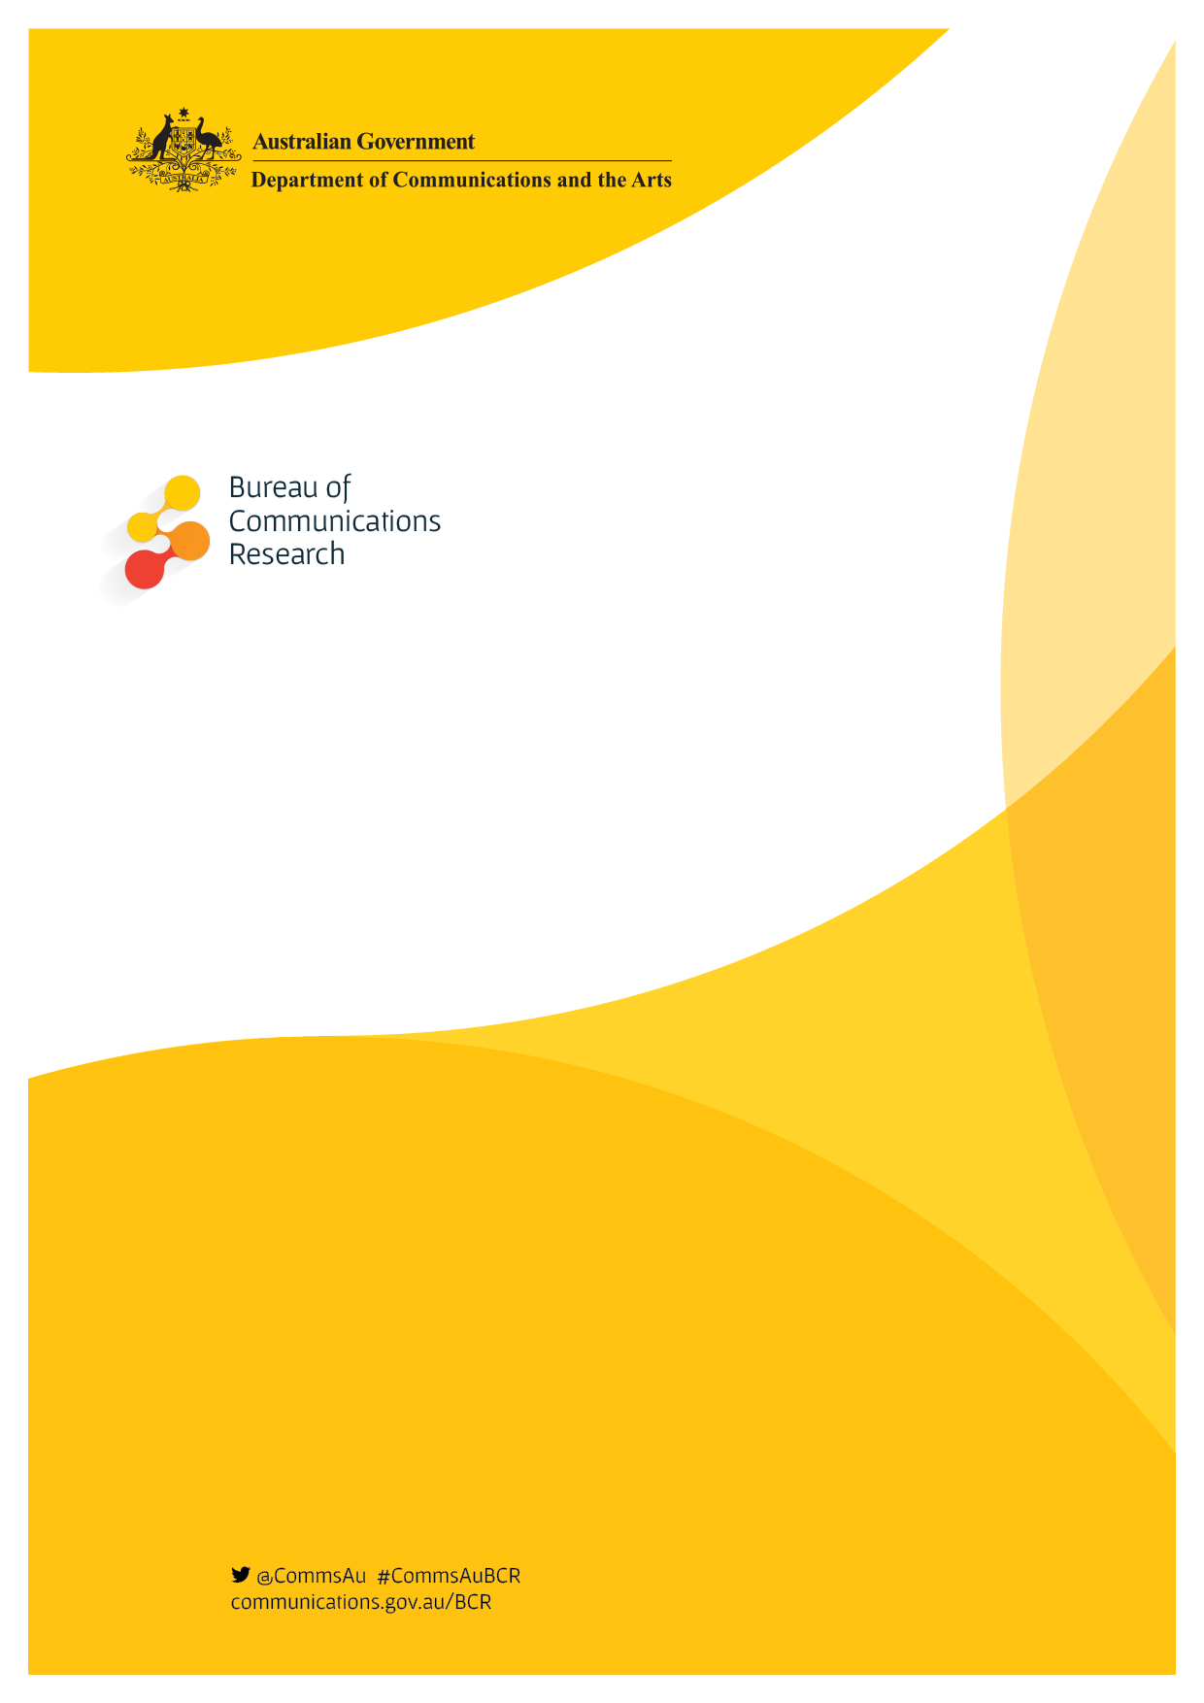

Leading Indicators

*Third release*

November 2015

# Introduction

The Bureau of Communications Research (BCR) supports the development of good public policy and informed policy discussion for digital technologies, communications networks and services. To help achieve these outcomes, the BCR’s leading indicators framework project is generating snapshots around recent data releases to build insights into the communications sector.

In this release we profile how improved access to the internet through Wi-Fi networks is enabling consumers to access information more conveniently; and how fixed line broadband network access is facilitating faster speed and driving the demand for data.

# Mobility is supported by increased access to Wi-Fi

Reliable and convenient access to Wi-Fi is seen as an essential service by consumers, with many preferring Wi-Fi to connect their smartphones and other internet enabled devices.[1]

Telecommunications providers are responding to the potential of Wi-Fi connectivity to transform business models. Globally, there is an increasing number of wireless start-ups who are leveraging Wi-Fi to disrupt traditional approaches to delivering communication services. These operators are transitioning calls, texts and data via Wi-Fi rather than the traditional cellular network.[2]

In August 2015, Optus launched a service that allows voice and text over a Wi-Fi network via an app.[3] This gives suppliers the opportunity to manage demand between their mobile and fixed line networks. It also provides an alternative to popular apps such as Skype, WhatsApp and Viber which provide low cost voice and text over Wi-Fi and mobile networks.[4] Competitors are also exploring opportunities for voice delivered over Wi-Fi networks, including on a ‘native network’ basis without the need for an app.[5]

Forecasts produced by wireless research specialist Maravedis Rethink for Wi-Fi hotspot aggregator iPass show the availability of public Wi-Fi globally is expected to grow 700 per cent in four years, from 48 million in 2014 to more than 340 million by 2018 (see Figure 1). This represents a shift in access to public Wi-Fi from one in every 150 people in 2014, to nearly one in every 20 by 2018.[6]

**Figure 1: Growth in public Wi-Fi deployed worldwide**

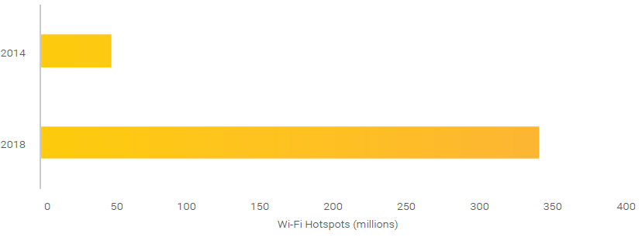

*Source: Derived by the Bureau of Communications Research using data from iPass*

In November 2014, Telstra launched a free public Wi-Fi trial during which half a million gigabytes of data was drawn from 150 hotspots. By May 2015 the trial had grown to 2,600 hotspots across the country signalling strong demand for a service that provides increased accessibility and versatility for consumers (see Figure 2).[7]

**Figure 2: Public Wi-Fi hotspots across Australia deployed by Telstra**

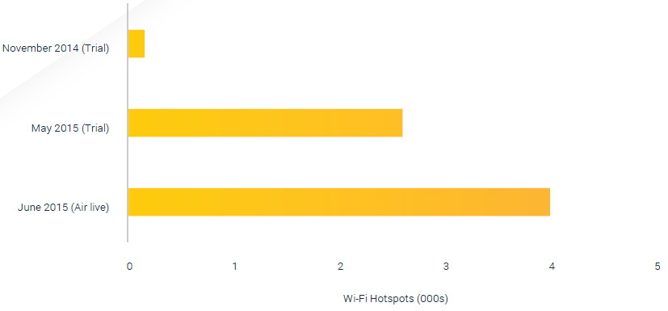

Source: Derived by the Bureau of Communications Research using data from Telstra

Following the success of the trial, on 30 June 2015 Telstra launched its Telstra Air nationwide Wi-Fi network. The program splits a Telstra subscribed private network into two: one for existing subscribers, and the second for Telstra Air subscribers (limited to at a maximum speed of two megabits per second). This has vastly increased the availability of Wi-Fi, adding to existing large scale Wi-Fi networks and hotspots available across Australia. By shifting mobile traffic off mobile networks and on to fixed line ones instead, subscribers can maximise the utility from their fixed line subscription, for example, through their mobile device.

Restructuring how people access the internet is providing new opportunities for how consumers access and download data. An example of this can be seen in the way tourists are consuming data (see Table 1).

In 2014, information accessed by tourists using smartphones increased 40 per cent, year-on-year. In contrast, fixed line access via an internet café or kiosk fell 23 per cent and 19 per cent, respectively.[8] Smartphones offer a platform for tourists to effectively utilise the increased access provided by public Wi-Fi.

For smartphone users: accessing maps has increased 40%, accessing timetables has increased 34%, accessing destination guides has increased 45%, accessing restaurant guides has increased 37%, accessing attraction guides has increased 39%. The total increase has been 40%.

For Internet cafe users: accessing maps reduced 20%, accessing timetables has reduced  23%, accessing destination guides has reduced 6%, accessing restaurant guides has reduced  24%, accessing attraction guides has reduced  24%. The total reduction has been 23%.

For Internet kiok users: accessing maps reduced 16%, accessing timetables has reduced 13%, accessing destination guides has reduced 14%, accessing restaurant guides has reduced  16%, accessing attraction guides has reduced  21%. The total reduction has been 19%.

With the rollout of programs such as Telstra’s Air network, a quasi-fixed mobile convergence (FMC) program which removes differences between fixed and mobile networks, a better experience will be provided to customers by creating seamless services using a combination of fixed broadband and local access wireless technologies to meet their needs in home, offices, and on the go.[9]

# Fixed line access dominates the way we consume data

In this section we assess how application innovation and usage, particularly streaming applications, and faster-speed technology is providing the catalyst for increased demand for more data over fixed line networks: data downloaded increased from 140,000 terabytes for the three months ended June 2010, to 1.35 million terabytes for the three months ended June 2015.

In comparison, the volume of data downloaded via wireless devices was approximately 39,000 terabytes at June 2015. This represents less than three per cent when assessed against fixed line data consumed. [10]

When comparing the volume of data downloaded across fixed line against mobile wireless for the period 2009 to 2015, the proportion of fixed line grew eight percentage points, from 89 per cent to an almost saturated 97 per cent.

Changes in technology and consumer behaviour, as well as lower access prices, are seeing consumers shifting to fixed line services that offer higher speeds and download limits. For instance, increased access to services such as ecommerce, audio streaming and subscription video on demand (SVOD) indicates consumers’ ever-increasing bandwidth appetite. Traffic data from IX Australia demonstrates the demand for SVOD services. Following the launch of Netflix, peering traffic through IX Australia jumped fifty per cent—from 4 gigabytes per second to 8 gigabytes per second.[11]

Progressive access to higher access speeds coupled with an increase in connected devices per capita has led to an increase in broadband subscribers, which has driven stronger growth in data volumes. Based on research by Roy Morgan, it is likely that SVOD will be the overwhelming force driving households’ data consumption. Roy Morgan estimated that 737,000 homes were connected to Netflix with 1.892 million viewers by July 2015[12]. Additionally, market research by Stan shows that demand for its product may rise to four million households within four years. If such growth across SVOD eventuates then exponential growth across fixed line download volumes will be realised.

Using the two factors identified—subscriber density and download volumes—as well as fundamental technology principles such as Moore’s Law, the Bureau of Communications Research expects that by December 2015 data download volumes will increase (from 1.35 million terabytes in June 2015) to approximately 1.6 million. Refer Figure 3.

**Figure 3: Broadband subscribers versus data downloaded volume, 1999 to 2015**

In December 2009 there were 8 Million broadband subscribers. By June 2015 there were 12.67 million broadband subscribers.

In December 2009 the Data downloaded was 0.11 million TBs. By June 2015, the data downloaded had risen to 1.35 million TBs.

BCR forecasts that data downloadsed will reach 1.6 million TBs by December 2015



Source: Derived by the Bureau of Communications Research using data from the ABS Internet Activity Survey (ABS cat no 8153.0);

# What does this all mean?

For the consumer, demand for increased mobility will drive further supply of public Wi-Fi. However, fixed line access will continue to drive increasing data consumption rates.

For the operator, benefits will centre on offloading traffic from their mobile to Wi-Fi networks. As well as reducing costly mobile network investments, these traffic management techniques will help customer retention by improving coverage and overall network performance. When it comes to Telstra’s Air program, the offset will be sacrificing a percentage of its mobile margin in order to differentiate itself from other providers.[13]

# End note

Using the current set of indicators to gauge investment, growth and consumption patterns provides a snapshot of the industry and could foreshadow future trends. However, the communications sector is dynamic and continually evolving. The value of particular indicators needs to be reassessed and the Bureau of Communications Research is seeking new measures to be identified to provide insights into new and emerging areas.

The development of a Leading Indicators framework is an early area of work for the Bureau of Communications Research. The framework will continually evolve through engagement with key stakeholders to determine the most effective and relevant indicators for the communications sector.

1. Cisco, What do consumers want from Wi-Fi? March 2012, pp. 5-6.
2. 2015, ‘Change is in the air’, The Economist, 20 June, pp. 60–62. (No author given).
3. Wilton, P 2015, ‘Optus launces voice, SMS over Wi-Fi’, 12 August, Communications Day
4. Patkar, ‘WhatsApp Voice Call: Everything You Need to Know’, 23 April 215, makeuseof
5. Sadauskas, A, ‘Optus launches voice over wi-fi for Android, iPhones’ 11 August 2015, itnews
6. This forecast is based on assumptions including innovation and uptake of new technology, geographical usage, community versus commercial rates, and expected introduction of Wi-Fi by mode of transport and verticals such as cafés, bars and restaurants. For additional information refer www.rethink-wireless.com
7. Ramli, D 2015, ‘Telstra launches cheaper broadband plans to counter rivals’, 26 June, The Age Business Day
8. Table 1 reflects information accessed and not data downloaded.
9. Fixed mobile convergence refers to services that interact with and use both the fixed line networks and the mobile networks. In this case, FMC is limited to Telstra’s network.
10. Wireless includes satellite, fixed wireless, mobile wireless via a datacard, dongle, USB modem or tablet SIM card and other wireless broadband. This estimate excludes data downloaded via mobile handsets.
11. Grubb, ‘These graphs show the impact Netflix is having on the Australian Market’, 2 April 2015, Sydney Morning Herald
12. ‘Foxtel loses share as Netflix expands pay and subscription TV market’, Roy Morgan Research, August 2015
13. Knight, E 2014, ‘Why Telstra wants to Wi-fi Australia’, The Sydney Morning Herald