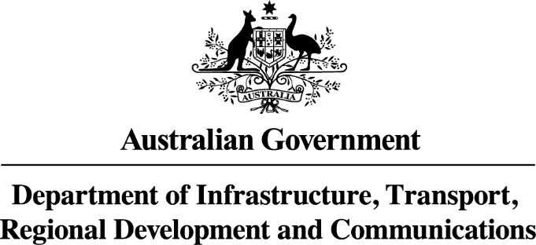

Endorsement of Compliance Certificate
This document authorises the issue of a personal import plate and registration of the endorsed vehicle. The Import Approval and vehicle details must match before an endorsement is given.
Applicant details
Name: ………………………………………………………………………………………………..
Address: ……………………………………………………………………………………………...
Suburb/State: …………………………………………………………………………………………
Postcode: ……………………………………………………………………………………………..
Approval number: ……………………………………………………………………………………
IMPORT APPROVAL ISSUED UNDER REGULATION 11 or 13 - PERSONALLY IMPORTED VEHICLE
ENDORSEMENT OF COMPLIANCE - to be completed by registering authority.
Organisation: ……………………………...………………………………………………...
Address: ………………………………………………………………………..............
………………………………………………………………………..............
Date vehicle inspected ………………………………………………………………………..............
Signature: .....................………………………………………………………………….

Please complete the below vehicle details.
Noting: The vehicle details must correspond with the details on the Import Approval.
Vehicle Details Year: …………………………….……………………………………
Make: …………………………….……………………………………
Model: …………………………….……………………………………
VIN: …………………………….……………………………………
If the vehicle details don’t correspond with the Import Approval Niddrie will not supply a Personal Import Plate and the applicant will need to contact the Department of Infrastructure and Regional Development for any amendments.
Upon approval of the Endorsement of Compliance by the motor vehicle registering authority, the original approval should be kept for registration purposes and a copy sent to Niddrie Nameplates Pty Ltd accompanied with a payment of $102.30 to supply the plate:

Niddrie Nameplates Pty Ltd
PO Box 106
NIDDRIE VIC 3042

Phone: 03 9335 2977
Fax: 03 9335 4357
Email: compliance@niddrienameplates.com.au
Please retain a second copy of the endorsed document to remain with the vehicle.

