# GUIDELINE H

# National Airports Safeguarding Framework

# PROTECTING STRATEGICALLY IMPORTANT HELICOPTER LANDING SITES

|  |  |  |  |
| --- | --- | --- | --- |
| **Revision Date** | **Version Number** | **Changes Made** | **Approved By** |
| May 2018 | 8.1.1 | Document Creation | TIC |
|  |  |  |  |
|  |  |  |  |

**For the purposes of this document, a Helicopter Landing Site (HLS) is an area (not located on an aerodrome) wholly or partly used for the arrival or departure of helicopters.**

## Purpose of guideline

1. This document provides guidance to State/Territory and local government decision makers as well as the owners/operators of identified strategically important HLS (SHLS) to ensure:
   1. the ongoing operation of those SHLS;
   2. the use of those SHLS are not compromised by any proposed development encroaching into flight paths;
   3. new development (and associated activities) do not present a hazard to helicopters arriving or departing from those SHLS; and
   4. any new SHLS are appropriately located.
2. This guideline is also designed to address the following matters:
3. lighting that either distracts or causes interference with night operations;
4. mitigating noise relating to helicopter operations;
5. wildlife/bird strikes;
6. Remotely Piloted Aircraft Systems (RPAS) “drones” operation/strikes; and
7. building induced windshear or air turbulence, where this could affect the normal flight of helicopters operating from these SHLS.

## What is a Strategically Important HLS

1. A SHLS is a site declared by a state or territory to be of critical need to the provision of identified services (see para 6).
2. Not all HLS will require protection from land use or development activity due to the nature or frequency of use of those sites. However, where a HLS is identified as being of strategic importance these sites must be protected from surrounding incompatible uses and encroachment into their flight paths.

## Key Considerations

1. It will be the responsibility of each jurisdiction to consult with the asset owner to identify those HLS that are considered to be of strategic importance or those that are to be protected in the interest of public safety.
2. SHLS to protect should include:
3. a HLS associated with a hospital; or
4. an elevated HLS[1], located within a populated area; or
5. a HLS subject to instrument flight procedures; or
6. any other facility identified as strategic by State/Territory or Commonwealth government/authorities.
7. Where otherwise not required under state/territory provisions, a responsible planning authority or proponent is encouraged to consult with the relevant SHLS asset owner to establish protocols for the referral process within their jurisdiction including:
8. material to be provided as part of the referral;
9. the timeframes in which advice is required to be provided; and
10. the format of any advice provided and the wording of appropriate conditions that can be applied to mitigate any impacts. This should include standard conditions that can be applied in the event that the asset owner is unable to respond within the required assessment timeframes.

## Why it is important

1. The helicopter industry is one of the fastest growing and diverse segments of the aviation industry.
2. The safety, viability and efficient operation of aircraft at a HLS can be compromised by development including permanent buildings and temporary structures (including cranes), gaseous plumes, telecommunication towers, overhead wires and power lines as well as landscape features (such as trees).
3. In recent times, there have been incidents where hospital emergency helipads have been decommissioned due to safety concerns arising from the nearby operation of construction cranes. Elsewhere a fatal accident occurred when a helicopter experienced building induced windshear just after take-off and crashed into a nearby river. Noise generated by helicopters in flight is also a significant issue.
4. Despite the importance of maintaining unimpeded flight paths to strategically important HLS, protective legislation varies across jurisdictions. Many HLS do not require formal land use planning approval and/or are considered ancillary to existing uses. For example, in some jurisdictions where they are provided as part of a hospital, separate approval is not required. Accordingly, there are many HLS with no regulatory oversight.
5. In Australia, HLS are not licensed, certified or regulated in the way that aerodromes are under Part 139 of the Civil Aviation Safety Regulations 1998 (CASR). The *Airports Act 1996* makes no specific reference to the use of HLS. For facilities not located on Commonwealth land there are varying levels of regulation and guidance around safeguarding non-airport HLS across the jurisdictions.
6. Population growth, residential densification, and increasing high-rise development in built up areas will continue to increase pressures on airspace protection for SHLS. Equally, continued growth in aviation industry activity will add to the challenges of effective planning for the interaction of aviation operations with development.
7. If intrusions into the flight paths for a SHLS, and risks associated with the use of those SHLS are not regulated the ongoing helicopter operations at strategically important sites may be compromised. Without protection, development in the vicinity of a SHLS could jeopardise safety and efficiency and potentially result in the decommissioning of the HLS.

## Roles and responsibilities

1. State/Territory and Local Governments are primarily responsible for land use planning on   
   non-Commonwealth land.
2. The International Civil Aviation Organization (ICAO) sets out Standards and Recommended Practices (SARPs) for the safe conduct of civil aviation activities. Australia has undertaken to apply the ICAO SARPs, except where specific differences have been notified to ICAO. The following annexes are applicable to helicopter operations:

Annex 6: Operation of Aircraft – Part III: International Operations – Helicopters  
Annex 14 – Aerodromes – Volume II: Heliports

Guidance on the design of heliports is contained in ICAO’s Heliport Manual (Doc No. 9261)[2]

1. Australia has notified ICAO of a difference in applying the ICAO heliport standard as CASR Part 139 and the Part 139 Manual of Standards currently only applies to HLS located on aerodromes. The proposed incorporation of Annex 14 SARPs into the Australian civil aviation legislation forms part of CASA’s current Regulatory Reform Program.
2. The Civil Aviation Safety Authority (CASA) is responsible for the safety regulation of civil air operations and the safety of air navigation in Australia. This includes helicopters in flight and potential sources of distraction from lighting, which may cause confusion, distraction or glare to pilots in the air.
3. Airservices Australia is Australia’s air navigation service provider responsible for airspace management, aeronautical information, aviation communications, radio navigation aids, and aviation rescue fire fighting services.

## How it should be used

1. The responsible authorities[3] within each jurisdiction should commence consultation with relevant asset owners/operators, aircraft operators (if identified) to identify HLS that should be safeguarded through land use planning controls.
2. When undertaking any strategic review of height limits within land use planning controls, the maximum height limit specified should not extend into any flight path for a SHLS.
3. Once a SHLS is identified, a process is to commence to incorporate its operationally essential flight path/s within the land use planning controls. If a particular flightpath extends over more than one local government boundary, then the requirements will need to be reflected in all relevant land use planning controls. This protection is also to be afforded to the approval of any new SHLS.
4. When a planning permit/approval is required for either a new SHLS (especially where associated with a hospital); a development or a planning scheme amendment that is within the facility’s essential flight paths or zone of influence of an existing SHLS, planning and responsible authorities should consider the application/proposal against this Guideline.
5. If required by the planning scheme, the application/proposal (within the flight path or zone of influence of an existing SHLS) should be referred to the SHLS asset owner/operator and CASA for assessment and advice. Where not required, the advice of the SHLS asset owner/operator should be sought. Figure 1 (page 7) provides guidance on referral requirements for those HLS where a flight path has not been surveyed.
6. In assessing applications/proposals land-use planners should be informed by the advice received from the SHLS asset owner/operator and CASA, including recommendations to specify conditions to mitigate risk or impacts.
7. Some jurisdictions, for example Victoria, already have planning guidelines or polices in place and this document provides guidance for any review of those documents. For those jurisdictions without policies in place, this Guideline (in addition to the associated National Airports Safeguarding Framework) will provide assistance in the development of those policies.
8. Nothing in this guideline overrides the need to refer any development to an airport operator, where it potentially intrudes into the operational airspace of that airport.

# Guidelines for MANAGING INTRUSIONS AND ACTIVITIES IN THE FLIGHT PATHS OF STRATEGICALLY IMPORTANT hls

## SHLS Design Considerations

1. Until such time as new standards are provided by CASA to safeguard HLS, any new SHLS should be constructed in accordance with the CAAP 92-2 (2) *Guidelines for the Establishment and Operation of Onshore Helicopter Landing Sites*.

Exceptions to this are where a suitably qualified and experienced aviation professional has designed and certified the suitability of the SHLS, including a survey of the arrival and departure flight paths and transitional surface, which are to be safeguarded from intrusions.

## Obstacle Limitation Surfaces (OLS)

1. An effective and safe helicopter service to support emergency services relies heavily on both the optimal location of the HLS and a clear flight path free from obstruction.
2. There is currently no formal requirement for a HLS to have a declared Obstacle Limitation Surface (OLS[4]), however a recommended OLS is defined in CAAP 92-2(2). When considering the OLS, it is important to remember that there are three design categories based on the class of performance capability for the helicopter.
3. In the event that a development also encroaches into the OLS for an airport, then the relevant referral and approval processes in association with that airspace is also still required to be undertaken (in addition to the processes identified within this guideline). When considering the need of the OLS protection, the most limiting of these categories relevant to the use of the HLS needs to be used. Further, any object extending above 110m above existing ground level must be assessed by CASA under CASR Part 139 to determine whether it is an obstacle to aircraft operations, including helicopters.

## HLS Flight Path

1. CASA is currently reviewing its standards for HLS to enhance safety and is expected to include the certification of SHLS into the CASRs*.* This will require flight paths of certified HLS to be protected to secure their ongoing operations, for example, where associated with emergency medical services. It is also anticipated that new elevated HLS located within populated areas and HLS subject to instrument flight procedures will require certification by CASA. This Guideline will be updated accordingly when CASA completes this work.
2. Land-use planning authorities and state/territory governments should be aware that all intrusions into the flight path for a SHLS have the potential to create aviation safety risks and to limit the scope of operations possible from the SHLS.
3. The flight paths to a SHLS need to be protected from intrusions (permanent and temporary) and land use planning activities that could interfere with safe operations of the HLS (see paragraph 9).
4. The activity that is proposed to be carried out will generally require approval by state or local government authorities, unless exemptions apply or a planning permit/approval is not required.

All development/activity applications in the vicinity of an identified SHLS should be reviewed to determine if there is any conflict in respect to:

* 1. intrusions into the flight path (buildings, cranes, gaseous plumes);
  2. operational hazards (reflective glare, dust, smoke, electromagnetic interference);
  3. lighting that may cause distraction;
  4. lighting installed to illuminate obstructions that is not visible when using night vision goggles;
  5. wildlife/bird strikes;
  6. drone operations/strikes; and
  7. building induced windshear/turbulence.

1. Where development, including temporary structures ancillary to that development (for example, cranes) has the potential to impact upon the safe operation of SHLS, it is important that the relevant helipad owner is notified and has an opportunity to make a meaningful contribution to the outcome of the development proposal.
2. Where possible the SHLS asset owner should commission a survey of the helicopter flight path by a suitably qualified aviation professional and submit that survey to the relevant planning authority. The relevant planning authority should then safeguard that helicopter flight path through land use planning scheme provisions and assessment considerations.
3. Where the SHLS has not been surveyed to identify the flight path (including transitional surfaces) and/or that survey has not been provided to the relevant planning authority, the area to be identified for determining the trigger for land use planning referrals to the SHLS asset owner should be in accordance with Figure 1 below. No development should be permitted to exceed the height limits within Figure 1 without the prior approval of the SHLS asset owner.

Note: A transitional surface for a HLS is a sloping surface off the side of the flight approach and take off area and the take-off splay. Its purpose is to provide sideways protection for a helicopter when using the flight path and within the flight approach and take off area.

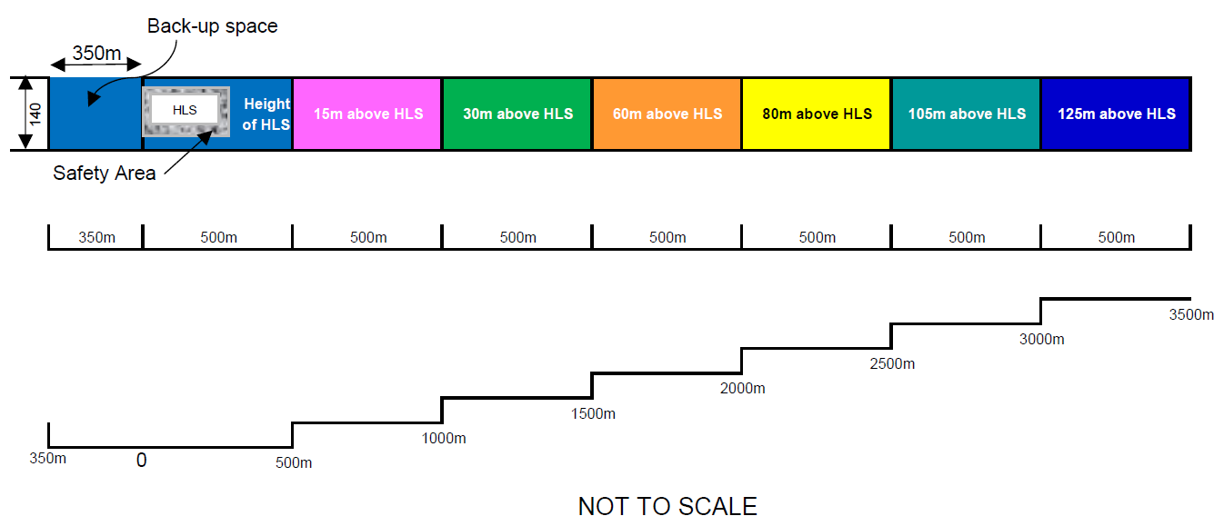**Figure 1 – Referral Trigger for SHLS, where HLS has not been surveyed/survey has not been provided**

**Note:** Any development that exceeds the heights shown in Figure 1, which is consistent with the highest level of HLS classification (Performance Class 1), must be referred to the asset owner and CASA.

**Figure 1** is to be applied to each flight path (approach and departure) to the SHLS. Accordingly, there may be multiple flight paths. The relevant planning authority will have to consult with the SHLS asset owner to obtain confirmation of the location of the flight path(s) associated with the SHLS and the height of the SHLS.

The methodology incorporates:

1. The 3386m length as measured from the safety area boundary for a Performance 1 classification for a HLS and has applied the required 4.5% slope as prescribed in   
   CAAP 92-2(2).
2. A 350m length as measured from the safety area boundary for the back-up surface of a helicopter. (Note: the actual distance required for a back-up surface varies depending upon the helicopter type and is prescribed in the relevant flight manual for each helicopter).
3. The maximum width incorporates the approach and take-off climb surface and the transitional surface for the AW139 helicopter. The width, has been determined using the formula for night time operations within CAAP 92-2(2) which is 10 x the rotor diameter (13.8m for the AW139 helicopter), which equates to 138 metres, and then rounded to the nearest number.

Further background material supporting this methodology is provided at **Appendix A**.

1. Planning authorities should also include the use of the land in considering potential encroachments into the flight path. For example, while a public park might be appropriate within the flight path, uses or activities in that public park may result in encroachments into the flight path. For a public park, this could include circus tents, ferris wheels and the flying of drones.

## Trees

1. Natural features, including trees, can cause obstructions into the flight path of a SHLS. For developments proposed within the flight path to a SHLS, the approved landscape plan should not include tall species that may extend into the flight path on maturity.
2. The relevant planning authority for each jurisdiction may wish to prepare a list of recommended landscape species that are suitable within flight path areas and could condition any approvals (either in the flight path or on the site containing the SHLS) to ensure compliance with that species list (see section on wildlife/bird strike and NASF Guideline C).

## Gaseous Plumes

1. An exhaust plume of significant vertical velocity (i.e. a plume rise) may affect aircraft in various stages of flight. In particular, helicopters can be severely affected by a high temperature plume or the altered air mixture above an exhaust plume.
2. Exhaust plumes can originate from any number of sources. For example: industrial facilities release process emissions through stacks or vents; industrial flares create an instantaneous release of hot gases during the depressurisation of gas systems; cooling towers produce large volumes of buoyant gases that can rise a significant distance into the atmosphere and exhaust gases from power generation facilities can produce plumes of varying velocities.
3. Any development proposal, located within/beneath the flight path/OLS of a SHLS, that has the potential to generate a plume rise should be referred to the asset operator/owner and CASA for advice, and if necessary a plume rise assessment[5].

## Cranes

1. Any development proposal located within/beneath the flight path to a HLS must be required to indicate:
2. whether a crane is to be erected during the construction of that development;
3. the maximum height of the crane;
4. the height and swing radius of the crane with the jib stowed when not in operation; and
5. the period in which the crane is anticipated to remain on site.
6. Regardless of whether the proposed development extends into the flight path, if the crane to be used during construction is anticipated to extend into the flight path, CASA and the SHLS asset owner should be contacted for advice. Advice received during that referral must be taken into consideration in the assessment of the application.
7. Due to the number of incidents with cranes encroaching into flight paths, planning authorities are encouraged, unless an encroachment is approved in association with the application, to place a condition or provide an advisory note (or other applicable mechanism) on relevant approvals within flight paths to a SHLS, prescribing that no crane is permitted to extend into the flight path.

## Lighting

1. Where a SHLS is to be used in association with night time operations, all lighting is to comply with CAAP 92-2 (2) *Guidelines for the Establishment and Operation of Onshore Helicopter Landing Sites,* except where certified by a suitably qualified and experienced aviation professional.
2. Lighting erected onto any obstruction (building, crane, or telecommunication tower for example) within the flight path or above 110 metres in height (whether it is located within a flight path or not), must be able to be detected by Night Vision Goggles (or equivalent). It is understood that lighting that is red in colour and low intensity steady light is preferable. Additionally, any buildings, cranes, etc above 110 metres in height (regardless of their location) should be referred to CASA as part of the assessment process.
3. At night, and in periods of poor visibility during the day pilots rely on the particular pattern of the aeronautical ground lighting to assist in aligning themselves with the correct touchdown point. It is therefore important that lighting in the vicinity of the HLS is not configured or is of such a pattern that pilots could either be distracted or mistake such lighting as being ground lighting from the HLS.
4. Where planning applications involve significant lighting in proximity to a HLS, planning authorities should seek detailed advice on potential impacts from CASA. For developments not requiring planning approval, the proponent should contact CASA for advice on potential impacts on aircraft operations.
5. Coloured lights are likely to cause conflict irrespective of their intensity as coloured lights are used to identify different HLS facilities. Development proposals involving coloured lights (in the vicinity of a SHLS or its flight paths) should be referred to CASA for detailed guidance.
6. CASA has advised that glare from buildings tends to be momentary and, therefore, unlikely to be a source of risk. Further, it is anticipated that when operating helicopters in bright sunlight, pilots would either wear helmets with integrated visors that provide glare protection or sunglasses.
7. Glare from buildings should be assessed in the planning stage of a SHLS as its impact will vary from site to site and can change significantly in transient conditions associated with time of day, sun angle, and time of year and weather conditions.

## Noise

1. Nationally, all helicopters are required to be certified to international noise standards which are implemented through the Air Navigation (Aircraft Noise) Regulations 1984 (the Noise Regulations). These international standards apply to the design of aircraft (including helicopters), and specify the amount of noise that may be emitted by a particular aircraft type/model. The Noise Regulations do not prescribe how an aircraft is to be operated in relation to height or frequency of flights.
2. Australian Standard 2363:1999 *Acoustics – Measurement of noise from helicopter operations[6]* provides methods for the measurement of noise from existing and proposed HLS and helicopter overflights. This standard provides technical guidance for local planners, government agencies and operators in calculating the acoustic environment near existing and proposed HLS or flight paths.
3. The frequency of flight movements and hours of operations are key factors that contribute to the noise impact that a HLS will have on nearby sensitive uses. Where possible, the siting and design of a new SHLS should give consideration to the minimisation or mitigation of noise impacts on neighbouring areas from the operation of aircraft at the SHLS.
4. Noise abatement procedures offer potential reductions in noise impacts on the ground. The implementation of noise optimised procedures has been facilitated via guidance material published by Helicopter Association International (HAI).
5. A Fly Neighbourly Advice (FNA) is a voluntary code of practice that can be established between some aircraft operators and communities or authorities that have an interest in reducing the disturbance caused by aircraft within a particular area. An FNA may recommend limitations on operating heights, the frequency of operations and the areas of operations.
6. A FNA is not enforceable under aviation law and mandatory operating and safety procedures will take precedent. A decision to establish a FNA, is normally taken by a government authority, a business operator or a community group that is materially affected by the operation of aircraft. A FNA should acknowledge the necessity for police, fire, search and rescue and other emergency services and infrastructure monitoring organisations to have access to low level airspace as the need arises.
7. Any noise complaints in association with helicopter operations should be directed to Airservices Australia or the SHLS operator.

## Windshear and Turbulence

1. Air flow disturbances around and over buildings, stands of trees, thermal building effects and other environmental factors can create hazardous turbulence and wind shear in the vicinity of a SHLS thus affecting the safe operation of aircraft into and out of the facility.
2. Any proposed SHLS should take into consideration the impact of building induced windshear and turbulence in determining its suitability.
3. Any new SHLS should be provided with a wind indicator measuring 2.4m in length and visible to the pilot during take-off approach and landing. For complex SHLS sites, more than one indicator should be provided to ensure pilots receive sufficient information on the wind flow over the site.
4. For any SHLS capable for night operations, the wind indicator(s) should be lit. The wind sock should be located outside of the Safety Area and should not penetrate the flight path or the transitional surface.
5. The Bureau of Meteorology is available to provide advice on the appropriate siting of aviation meteorological equipment to support the safe operation of SHLS.
6. For development proposals involving tall structures in immediate proximity to a SHLS (or its flight paths) developers/planning authorities should consult with the asset owner/operator to seek advice on any potential safety impacts.
7. Where turbulence issues are anticipated for a SHLS, these could be communicated by asset owners to pilots through an En Route Supplement Australia (ERSA) notification. This is a document updated by Airservices Australia every 12 weeks to notify pilots of vital information for planning a flight and when in flight.

## Wildlife/Bird Strikes

1. Wildlife/bird strikes are a significant safety risk for pilots as well as an economic risk for operators. Species, numbers, time of day, migratory patterns, flocking patterns, habitat types and breeding activities occurring in the vicinity of HLS contribute to the level of risk.
2. Data supplied by the Australian Transport Safety Bureau indicates that there were 43 recorded wildlife strike incidents for helicopters between 2007 and 2015 (inclusive). 14 of those were in proximity to a hospital HLS.
3. 74% of all strikes and 66% of strikes causing substantial damage occur at (or below) 500 feet.
4. ICAO has developed specific advice on land uses with the potential to become high risk wildlife attractants. These include:
5. Food garbage disposal;
6. Sewage treatment and disposal;
7. Artificial and natural lakes;
8. Abattoirs and freezing works;
9. Fish processing plants;
10. Bird sanctuaries, and
11. Outdoor theatres.
12. SHLS asset owners should work with the relevant planning authority to establish mechanisms that will identify and restrict land uses that would cause hazardous wildlife attraction or activity at or across the HLS and/or its flight paths. HLS asset owners should refer to Guideline C – *Managing the Risk of Wildlife Strikes in the Vicinity of Airports* (Guideline C)*.* Whilst it is acknowledged that Guideline C has been specifically written for airports, its application also has relevance to HLS.
13. Where located within 5.5 kilometres of a SHLS, any proposed uses identified within Attachment 1 of Guideline C should be referred to the asset owner as part of the assessment process. Any comments provided by the asset owner should be taken into consideration in the assessment of that application.
14. When siting and/or assessing a new SHLS consideration should be given to land uses within 5.5 kilometres, to determine the suitability of that site in relation to wildlife/bird strikes.
15. CASA Advisory Circular 139-26(0) provides guidance on wildlife hazard management at aerodromes. At present there is no specific information in this guideline that relates to wildlife strike risk management for HLS.

**Remotely Piloted Aircraft Systems Operation/Strikes**

1. RPAS must not be flown over or above people; including beaches, parks, events, or sport ovals where there is a game in progress.
2. The operation of a RPAS in the vicinity of a SHLS is to be in accordance with CASA Advisory Circular AC 101-10 Remotely Piloted Aircraft Systems – Operation of Excluded RPA (other than model aircraft).

## Background Material

**Victoria**

1. Victoria is the only State at present to have hospital based HLS flight paths protected through land use planning instruments[7].
2. An inner and outer Design and Development Overlay are applied to cater for a graduated plane that reflects the flight path of a helicopter and certain types of development are exempt. This minimises the number of development that may otherwise trigger the overlay and require a planning permit.
3. The ‘Inner Design and Development Overlay’ ensures that any structures, works, or plumes that are of the same height or higher than the HLS and within 240 metres of the HLS or 460 metres along the flight path are referred to the Department of Health and Human Services for assessment of potential impacts on the helicopter flight path.
4. The ‘Outer Design and Development Overlay’ ensures that any structures, or plumes that are more than 10 metres above the HLS and between 460 metres and 1,130 metres from the HLS along the flight path are referred to the Department of Health and Human Services (DHHS) for an assessment of potential impacts on the helicopter flight path.
5. A flight path ‘corridor’ of 150 metres is protected to allow for crosswinds and where appropriate a buffer area of 70 metres either side, which represents the reach of a construction crane. In regional Victoria, the 70 metre buffer is only applied in rural cities, such as Bendigo, where there is a higher future likelihood that developments may use construction cranes that may impact helicopter flight paths.
6. DHHS is a determining referral authority and local councils are required to include its recommendation(s) as conditions on a planning permit. It is working with Albury City Council to protect the Albury Hospital HLS flight paths.
7. Guidance notes and FAQs on HLS flight path protection are available on the DHHS website at:

<http://www.capital.health.vic.gov.au/Asset_property_management_and_operations/Hospital_heliport_flight_path_protection/> .

**UK**

1. Advice from the UK Civil Aviation Authority (CAA) indicates that it has regulatory oversight of licenced/certified aerodromes and heliports and protected safeguarding zones, where a UK license or EASA certificate is held.
2. The one aerodrome dedicated to helicopter operations, over which the CAA do have oversight, has informal safeguarding arrangements in place where there is notification of tall structures in close proximity to the heliport.
3. Due to an accident when a helicopter collided with a crane positioned close to the heliport, the UK Government has agreed to formalise safeguarding arrangements to ensure a more robust notification system is in place. The final shape and design of that zone and protection of the recognised Take off Climb/Approach funnel surfaces (Annex 14 Vol II), within 4.5km radius of the heliport, is currently under review (late 2017).
4. Another licenced heliport (Penzance Heliport) is safeguarded by directing planning authorities to consult with the heliport. This was enacted by lodging a safeguarding map with each planning authority. Whenever a development (triggered by height) was proposed within close proximity to Penzance Heliport, they had an obligation to consult with the heliport owners. The map also included a radius of approximately 3km from the heliport where all applications likely to attract birds required consultation.

**APPENDIX A - HLS FLIGHT PATH METHODOLOGY BACKGROUND**

**Recommended Dimensions and Slopes of Obstacle Limitation Surfaces for Secondary HLS Visual Final Approach and Take-Offs (FATOs)**

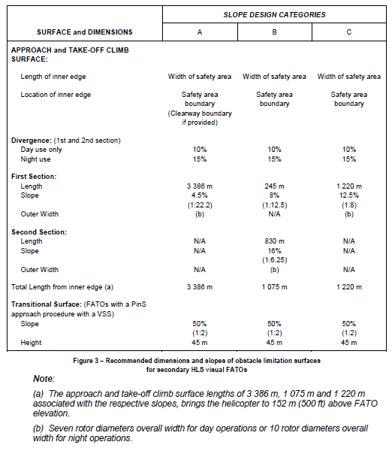

(Source: Civil Aviation Safety Authority (2014), *CAAP 92-2(2) Guidelines for the establishment and operation of onshore Helicopter Landing Sites, page 12.)*

**Approach and Take-off Surfaces – “A” slope profile – 4.5% design**

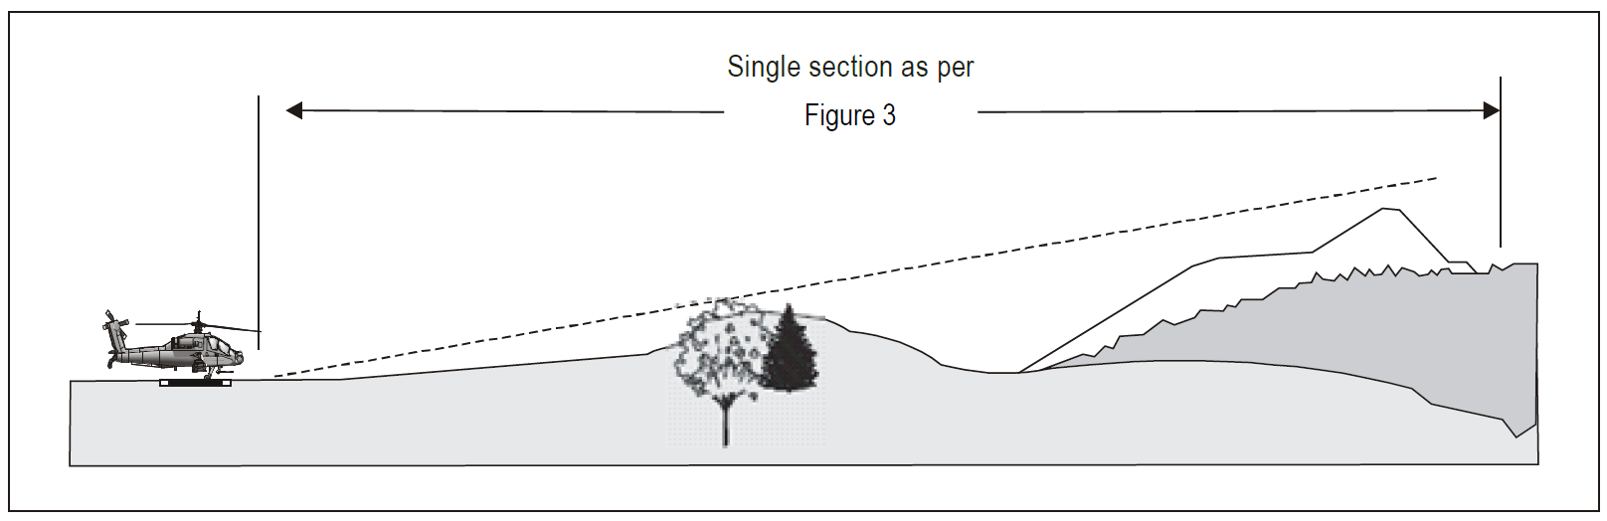

(Source: Civil Aviation Safety Authority (2014), *CAAP 92-2(2) Guidelines for the establishment and operation of onshore Helicopter Landing Sites, page 13.)*

**Transitional Surface for a FATO with a Point-in-Space (PinS) approach procedure with a visual segment surface (VSS)**

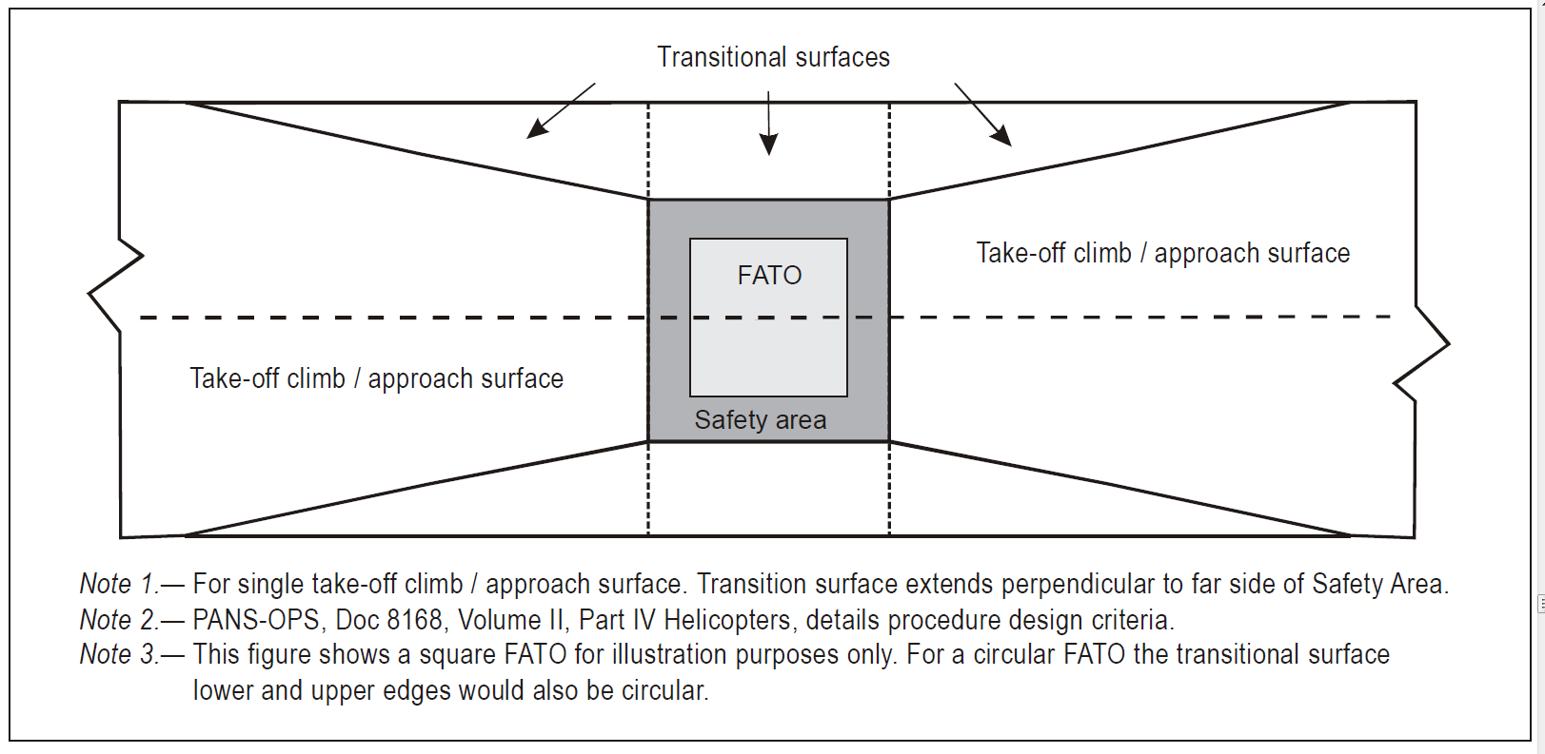

(Source: Civil Aviation Safety Authority (2014), *CAAP 92-2(2) Guidelines for the establishment and operation of onshore Helicopter Landing Sites, page 15.)*

**Back up Profile for the Airbus H135 Helicopter**

**Cat. A Vertical Take-Off and Landing (VTOL) Rearward Flight Path Surface Level Heliport Obstacle Clearance for H135.**

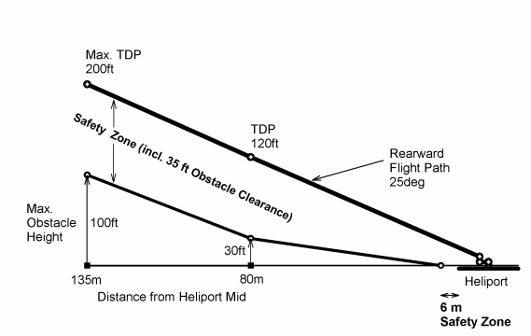

(Source: Eurocopter (now Airbus Helicopters) ‘Figure C23 Rearward Flight Path (VTOL)’, *Flight Manual EC 135 P2+* Rev.10)

*Take-off Departure Profile(TDP)

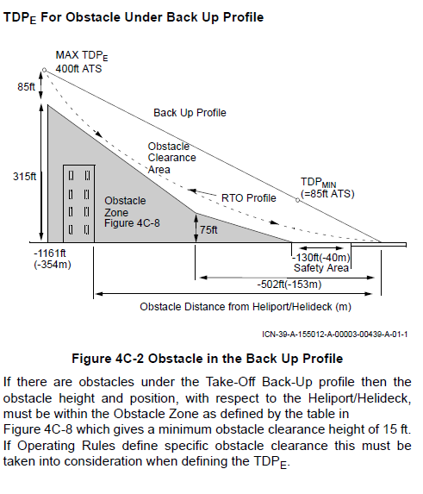**Back Up Profile for Augusta Westland AW 139 Helicopter**

(Source: Augusta Westland ‘TDPE For Obstacle Under Back Up Profile’, *AW139 Rotorcraft Flight Manual*)

*Rejected Take-off (RTO)

1. An elevated HLS is one that is located on a raised structure or building, for example – on top of a car park.
2. December 2017 – This manual has been withdrawn by ICAO. A new version is expected to be released in late 2018.
3. State/Territory or local governments.
4. 'Obstacle Limitation Surfaces (OLS) are a series of surfaces that set the height limits of objects around an aerodrome. Objects that project through the OLS become obstacles.' (CASA 1999)
5. See CASA Advisory Circular 139-5(1) – Plume Rise Assessments
6. Note – this standard is flagged for review by Standards Australia (*November 2017*)
7. Victoria Planning Provision - http://planningschemes.dpcd.vic.gov.au/schemes/vpps/52_15.pdf