


2024-2026 Census Action Plan
The department’s 2025 Census results show strong job satisfaction and performance against the broader APS.
They demonstrate stability, resilience and consistency, with most results remaining steady or improving slightly compared to 2024 – a continuation of steady growth from 2023. We have seen improvements in enabling innovation, wellbeing and support and immediate supervisor leadership. We have also seen a reduction in staff saying they experience workplace stress or burnout.
In acknowledging the department’s continuing positive progress in the 2025 Census, we are mindful of not losing focus on the areas that got us to this point. With this in mind, our departmental Census Action Plan will move from focusing on the one-year census results, to a continuum of focus areas, addressing issues for sustained success in a considered manner.
The success of the action plan is not just in the goals and actions below, but in the energy and willingness with which our staff engage with them. We ask all our staff to take a proactive approach to lead and participate in the actions or utilising developed tools and materials to achieve our goals. It is through our collective accountability, leadership and commitment to progress that we will continue our upward trajectory in future results.
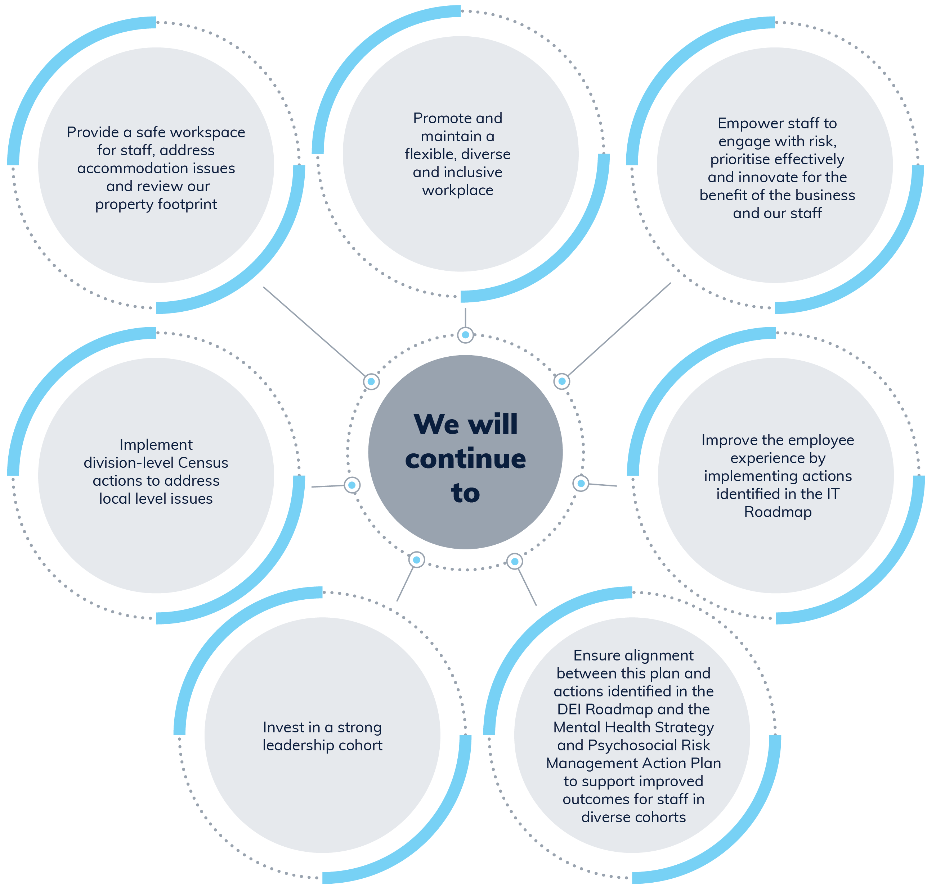

 | 
What you told us | What we are doing
You are experiencing lower levels of bullying, harassment and discrimination; however, you are less likely to report the behaviours when they are experienced for fear of repercussion or inaction. | We want to ensure that our department is a place where staff feel supported, safe, and confident to report instances of unacceptable behaviour. We will:  - continue to promote the zero tolerance of bullying, harassment and discrimination in the department.  - continue to deliver Workplace Respect and Courtesy and Respect@Work training.  - promote incident reporting avenues, including transparency and awareness around what happens after an incident report is submitted and how confidentiality is protected.  - complete work on the Cultural Safety Framework and Anti-Racism Strategy.
You said that you felt greater personal attachment to your group than the department, resulting in the perception of silos across the organisation. | We want to use existing communication channels and events to inform and educate staff across the department about the work of individual groups and business areas by:  - promoting the good work occurring across the department to ensure work is celebrated appropriately.  - enhancing the Secretary's Awards process to provide greater recognition based on demonstrated impacts and contributions to the direction and priorities of the department as led by each group.
While a large portion of staff are happy with the mobility opportunities within the department, you have indicated that you would like to see improved options. | We want to enhance the transparency and option of internal career development opportunities for our people by:  - developing and promoting a departmental Mobility Framework that allows business areas to address capability gaps and enables staff to utilise and enhance their skills and experience.  - promoting the 70:20:10 learning model as detailed in the Learning Strategy 2025-2028, focusing specifically on the 70 and 20 components by offering staff opportunities to learn on the job or learn from their peers either in their current role or by accessing a mobility opportunity.
You feel that departmental leadership could more overtly work as a team and could be better equipped with resources and information to communicate direction and priorities more effectively. | We agree that strong collaboration and information sharing leads to better outcomes, so we will address this by:  - expanding the SES Masterclasses series beyond respect at work to include other areas to uplift SES corporate capability.  - utilising SES All Staff Communications and SES Playbook to enhance communication across Divisions and Branches.  - fully implementing the SES Performance Leadership Framework which places increased emphasis on leaders accountability for behaviours as well as performance; ensuring our leadership model our culture, working as a team and holding each other accountable.
While you believe that it is your responsibility to continually look for new ways to improve the way we work, you feel there is room for improvement for the agency to inspire you to be innovative and to recognise that failure is part of innovation. | Innovation can take many forms, from creative policy reforms to new ways to deliver programs, to small process improvements that delivery increased productivity and efficiency. We understand that innovation and engaging with risk is a culture that needs to be promoted from leadership and fostered across all levels of the department. To improve our innovation culture, we will:  - from the SES Performance Leadership Framework and Secretaries' Charter of Leadership Behaviours, expect our leaders to have an inquiring mind and be willing to innovate and change.  - foster an environment where our staff are encouraged to collaborate, express concern, ask questions and share diverse views in an effort to develop better ways of working.  - highlight areas of innovation and creative response to delivering government priorities to build our collective knowledge of how to find space for new ways to enhance outcomes through our actions to improve communication about what our diverse groups are delivering and focusing on.
Our staff identifying as neurodivergent would benefit from additional support to have a more equitable working experience in the department. | We value diversity and want to enhance this and ensure our staff feel supported by:  - reviewing the department's Reasonable Workplace Adjustments policy and procedures, and anonymous reporting mechanisms to ensure that they are fit for purpose and psychologically safe.  - scoping a project to strengthen inclusive and adaptive leadership capability through a manager focused program that supports inclusive practices.  - piloting a Neurodiversity Coaching Support Program that will support staff identifying as neurodivergent to feel psychologically safe and thrive in the workplace in highly complex cases.  - reviewing and evaluating the pilot program after 6-months in operation to determine success and make recommendations about continuation and ongoing funding.

 |  |  |  | 
2024 target areas | What we want | What we committed to doing | What we have done | What we will do or continue to do
Wellbeing | - To have a work environment where staff are aware of the health and wellbeing support materials available to enhance their safety. | - Run targeted awareness campaigns for topical or high priority issues and staff wellbeing offerings.  - Conduct the People@Work survey, release results and co-design an action plan with staff to enhance psychosocial safety in the workplace. | - Delivered monthly awareness campaigns that highlight important safety and wellbeing initiatives.  - Conducted the People at Work survey and released the results to staff. Staff consultation workshops were then conducted to support the development of the Mental Health Strategy and Psychosocial Risk Management Action Plan. | - Continue to draw attention to important staff safety and wellbeing initiatives monthly.  - Launch the Mental Health Strategy and Psychosocial Risk Management Action Plan.
Performance (Individual and organisational) | - To enhance our individual and collective performance by ensuring common purpose and clarity of expectations for staff.  - Provide guidance and support on how to implement a best-practice change management approach across the department. | - Provide additional guidance on how to create good Thrive agreements, including incorporation of expectations and deliverables.  - Offer additional Thrive Supervisor Essentials and How to Thrive: Performance Exchange training sessions.  - Develop a position description template that articulates role requirements and alignment to objectives for staff and managers.  - Ensure Division level business plans are developed and made available to staff via CONNECT to understand the priorities, key activities and associated risks within their division and how they contribute to the purpose and outcomes of the department.  - Implement a Change Management Framework to provide detailed guidelines and best practices for managing change within the department.  - Foster collaboration and knowledge sharing through the Change Management Community of Practice. | - Refreshed current and developed additional myTHRIVE training to include guidance on setting clear expectations and deliverables in THRIVE agreements.  - In the lead-up to THRIVE performance exchanges, additional training sessions were scheduled for supervisors and staff.  - Position Description Template developed and available for use by staff and managers on CONNECT.  - Divisions across the department have undertaken division-level business planning and have made these available to staff. A new Business Planning Template was developed to articulate how divisions deliver on the departments purpose and outcomes.  - The department determined the use of the APS Change Framework when planning and implementing change was appropriate. Guidelines and templates have been developed to assist with change management, which are available on the Change Management CONNECT page.  - Established a Change Management Community of Practice (CoP). The CoP is open to all staff who are interested in enhancing their change management skills and exploring new change management approaches. | - Continue to ensure additional training sessions are available in the lead up to the THRIVE performance exchanges.  - Implement APS non-SES Performance Framework, including developing a new Thrive agreement template to support changes.  - Encourage development of position descriptions to be attached to THRIVE agreements in line with the Mental Health Strategy and Psychosocial Risk Management Plan to increase staff clarity of role.  - Establish a Change Agent Network to partner with projects to increase the success rate of change by improving communication, fostering employee engagement, and providing business level support and focus on uplifting change management across SES and leadership cohorts .  - Integrate change management into project management where there is a high people impact.
Resourcing and Manager Capability | - Ensure that our managers have the tools and capabilities to effectively perform their role.  - Equip our managers to have discussions, plan and make informed decisions around resourcing and priorities within their areas of responsibility. | - Develop templates to provide business areas with tools and support to undertake workforce planning, knowledge transfer and succession planning at local levels.  - Give managers the tools to review and evaluate position responsibilities and classifications across the department, to ensure that they are consistent with APS Work Level Standards and enable adjustments to be made where necessary.  - Develop a leadership and management capability uplift learning curriculum utilising available resources - people management, priority setting and resilience - with a focus on experience and exposure rather than formal training courses.  - Encourage business areas to regularly review manager capability and work with relevant staff to address any shortcomings through either experiential, exposure or formalised learning opportunities. | - The Workforce Plan, Succession Plan and Position Description templates have been delivered to support business areas with conducting workforce and succession planning.  - A Role Evaluation Tool has been created to assist managers review and evaluate the responsibilities of positions in their business area to assess classifications of new and existing positions.  - The department is developing a leadership and management learning curriculum. The department's new Learning Strategy 2025 - 2028 and Job Family capability resources will assist managers and staff to identify capability gaps and learning opportunities. | - Run awareness campaigns on the workforce planning, succession planning and role evaluation resources.  - Develop a leadership and management learning curriculum.  - Develop and implement a manager guide on probation and performance management processes.  - Communicate the accountabilities that are to be demonstrated, such as APS Values, Employment Principles, Our Stories on Country aspirations and principles, DRIVE (the Secretary's Charter of Leadership Behaviours) and the Charter of Partnerships and Engagement.

