PORTFOLIO ADDITIONAL ESTIMATES STATEMENTS 2022–23

Appropriation Bill (No. 3) 2022–2023  
and  
Appropriation Bill (No. 4) 2022–2023

Infrastructure, transport, regional development, Communications and the arts Portfolio

Explanations of Additional Estimates 2022–23

© Commonwealth of Australia 2021

ISBN 978-1-922521-95-8 (Print)

ISBN 978-1-922521-94-1 (Online)

This publication is available for your use under a [Creative Commons BY Attribution 3.0 Australia](http://creativecommons.org/licenses/by/3.0/au/deed.en) licence, with the exception of the Commonwealth Coat of Arms, the Department of Infrastructure, Transport, Regional Development, Communications and the Arts (the Department) logo, photographs, images, signatures and where otherwise stated. The full licence terms are available from <http://creativecommons.org/licenses/by/3.0/au/legalcode>.

CC by_grey

Use of the Department’s material under a [Creative Commons BY Attribution 3.0 Australia](http://creativecommons.org/licenses/by/3.0/au/deed.en) licence requires you to attribute the work (but not in any way that suggests that the Department endorses you or your use of the work).

**The Australia Government Department of Infrastructure, Transport, Regional Development, Communications and the Arts material used 'as supplied'**

Provided you have not modified or transformed the Department’s material in any way including, for example, by changing the Department’s text; calculating percentage changes; graphing or charting data; or deriving new statistics from published Department statistics – then the Department prefers the following attribution:

*Source: The Australian Government Department of Infrastructure, Transport, Regional Development, Communications and the Arts.*

**Derivative material**

If you have modified or transformed the Department’s material, or derived new material from those of the Department in any way, then the Department prefers the following attribution:

*Based on the Australian Government Department of Infrastructure, Transport, Regional Development, Communications and the Arts data.*

**Use of the Coat of Arms**

The terms under which the Coat of Arms can be used are set out on the Department of the Prime Minister and Cabinet website (see [www.pmc.gov.au/honours-and-symbols/commonwealth-coat-arms](https://www.pmc.gov.au/honours-and-symbols/commonwealth-coat-arms)).

**Other Uses**

Inquiries regarding this licence and any other use of this document are welcome at:

Chief Financial Officer

Department of Infrastructure, Transport, Regional Development, Communications and the Arts.

Telephone: 02 6274 7111

Email: [helpbudgets@infrastructure.gov.au](mailto:helpbudgets@infrastructure.gov.au)

|  |
| --- |
| The Department acknowledges the Traditional Custodians of country throughout Australia and their connections to land, sea and community. We pay our respects to their Elders past and present and extend that respect to all Aboriginal and Torres Strait Islander peoples today. |

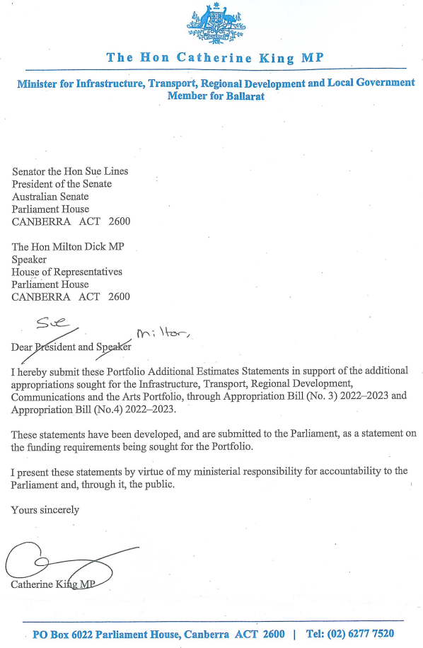

Abbreviations and conventions

The following notations may be used:

NEC/nec not elsewhere classified

‑ nil

.. not zero, but rounded to zero

na not applicable (unless otherwise specified)

nfp not for publication

$m $ million

$b $ billion

Figures in tables and in the text may be rounded. Figures in text are generally rounded to one decimal place, whereas figures in tables are generally rounded to the nearest thousand. Discrepancies in tables between totals and sums of components are due to rounding.

Enquiries

Should you have any enquiries regarding this publication please contact the Chief Financial Officer, Department of Infrastructure, Transport, Regional Development, Communications and the Arts on (02) 6274 7111.

A copy of this document can be located on the Australian Government Budget website at: [www.budget.gov.au](http://www.budget.gov.au/).

User Guide  
to the  
Portfolio Additional Estimates   
Statements

User Guide

The purpose of the 2022–23 Portfolio Additional Estimates Statements (PAES) is to inform Senators, Members of Parliament and the public of the proposed allocation of additional resources to government outcomes by entities within the portfolio.

The PAES facilitate understanding of the proposed appropriations in Appropriation Bill (No. 3) 2022–2023 and Appropriation Bill (No. 4) 2022–2023. In this sense the PAES is declared by the Appropriation Acts to be a ‘relevant document’ to the interpretation of the Acts according to section 15AB of the *Acts Interpretation Act 1901*.

Appropriation Bill (No. 3) 2022–2023, which follows on from *Appropriation Act (No. 1) 2022‑2023* tabled at Budget, will provide additional expenditure authority for the ordinary annual services of government in respect of the 2022–23 financial year.

Appropriation Bill (No. 4) 2022–2023, which follows on from *Appropriation Act (No. 2) 2022‑2023* tabled at Budget, will provide additional expenditure authority in respect of the 2022‑23 financial year for capital works and services, payments to or for the states, territories and local government authorities, and new administered outcomes not authorised in specific legislation.

Contents

[Department of Infrastructure, Transport, Regional Development, Communications and the Arts 15](#_Toc134177320)

[National Transport Commission 25](#_Toc134177321)

[Old Parliament House 31](#_Toc134177322)