guideline b

National Airports Safeguarding Framework

MANAGing THE RISK OF BUILDING GENERATED WINDSHEAR AND TURBULENCE AT AIRPORTS

Revision Date | Version Number | Changes Made | Approved By
Feb 2012 | 2.2.1 | Document Creation | NASAG
Apr 2012 | 2.2.2 | Drafting changes post consultation process | SCOTI
Jul 2012 | 2.2.3 | Version control table added.  Page numbers added. | S. Stone, GM Aviation Environment, DOIT.
Jun 2013 | 2.2.4 | Minor formatting and editing amendments. | S. Stone, GM Aviation Environment, DOIT.
May 2018 | 2.2.5 | Expanded windshear and turbulence criteria, substantial reformatting, following external review. | TIC

Purpose of Guideline
- To provide guidance to Commonwealth, state/territory and local government decision makers and airport operators to manage the risk of building generated windshear (i.e. changes in wind speed and/or direction between two points) and building generated turbulence (i.e. rapid irregular changes in wind speed and/or direction at a fixed point) at airports.

Why it is important
- The Principles for a National Airports Safeguarding Framework acknowledge the importance of airports to national, state/territory and local economies, transport networks and social capital.
- This Guideline is designed to assist land use planners and airport operators in their planning and development processes to reduce the risk of building generated windshear and turbulence near runways at airports.
- The building generated windshear / turbulence issue becomes safety critical when a significant obstacle, such as a building, is located in the path of a crosswind to an operational runway. The wind flow will be diverted around and over the buildings causing the crosswind speed to vary along the runway.
- Australian Transport Safety Bureau (ATSB) data indicates that there have been at least two serious incidents in Australia caused by building induced windshear, which resulted in passenger injuries or damage to the aircraft and triggered safety investigations. In both of these cases the buildings were located on-airport.

How it should be used
- Some states/territories already have planning guidelines or policies in place and this document provides guidance for their review. For those without policies in place, this guideline (in addition to the associated Safeguarding Framework) provides input to new policies.
- This guideline can be applied by airports, planners and regulators when evaluating building proposals on airports, or by planners in consultation with airport operators for proposals in the immediate vicinity of airports.
- While off-airport buildings are an important consideration, buildings would have to be of a significant height to fail the Guideline B criteria. It is not expected that off-airport buildings would create unacceptable risks to aviation as often as on-airport buildings.
- Nevertheless, it is important that local approval authorities/decision makers consider the potential risks of windshear and turbulence when approving off-airport buildings, and seek CASA advice if they are unsure of a building’s acceptability. If hazardous buildings are approved, airport safety and/or capacity may be compromised.
- This guideline is not intended to be applied retrospectively to existing buildings. However:
- if a new building is proposed then the existing surrounding buildings need to be considered in the assessment of the proposed building; and
- if a new runway or a modification to an existing runway is proposed, the existing surrounding buildings that fall within the assessment trigger area for the new or modified runway need to be considered in the assessment of the new or modified runway.

Roles and Responsibilities
- There is a need for a risk-based approach where all the parties listed below recognise the risk of building-induced windshear/turbulence and share the responsibility for risk management.
Australian Government
- On-airport planning at Australia’s leased federal airports and Defence airfields is under Australian Government control and administered under the Airports Act 1996 (the Airports Act) and the Defence Act 1903.
- This responsibility is exercised by the Minister responsible for the Airports Act through the approval of Airport Master Plans (MPs) and Major Development Plans (MDPs). The Department of Infrastructure, Regional Development and Cities provides advice to the Minister to inform the assessment of MPs and MDPs. In forming its advice to the Minister, the Department will also consult with CASA on safety issues.
Civil Aviation Safety Authority (CASA)
- CASA is Australia’s safety regulator for civil air operations and the operation of Australian aircraft overseas.
- For on-airport planning at Australia’s leased federal airports, CASA has a role in providing windshear and turbulence advice to the Minister for all MDPs and any proposed buildings that penetrate the 1:35 surface. In forming their advice, CASA will consider the size, shape and location of a proposed structure and apply this guideline and any other matters it considers relevant.
- CASA does not have regulatory powers to prevent construction based on windshear and/or turbulence risk. If a proposed structure is on a leased federal airport, CASA will provide advice to the Minister on the windshear/turbulence risk to inform the Minister’s consideration and approval of the MDP.
- For structures that are not on leased federal airports, CASA can provide safety advice but the decision to approve or not approve the structure would lie with the local planning/approval authority.
- State/territory/local governments, approval authorities/decision makers, non-federally-leased airports, and proponents of developments, are encouraged to seek CASA safety advice on proposed structures and on the findings of expert’s assessment reports produced under Guideline B.
- CASA may also be able to provide advice on operational mitigation measures that may result in a building being acceptable (i.e. runway closures when wind is coming from a certain direction). Developers and airport operators should work together to develop such measures and CASA would then advise the approval authority/decision maker whether it considers the arrangement to be acceptable.
State/territory and local governments
- State, territory and local governments are primarily responsible for off-airport land use planning in the vicinity of the leased federal airports, as well as on-airport planning and off-airport planning at all other airports.
- For this guideline to be effective, it is important that each jurisdiction considers how best to implement the guideline within their planning schemes so that off-airport development proposals can be assessed in a consistent manner to those on-airport. This is particularly important for the non-federally-leased airports.
- This guideline does not prescribe in detail how state/territory and local governments should implement it into their planning schemes. That is a matter for individual jurisdictions and it is appropriate that jurisdictions have some flexibility in implementation given the variability in planning approaches.
- Jurisdictions could apply this Guideline by overlaying the assessment trigger area and 1:35 surface (described in paragraphs 43-48) in state/territory or local planning documentation.
- For example, the planning documentation could specify that developments within the assessment trigger area, which penetrate the 1:35 surface, need to consider windshear and turbulence risk. In some cases, the proponent of the development may be able to put forward a simple safety case that satisfies the approval authority/decision maker (e.g. easterly winds only occur 10 per cent of the time and the runway is not operational at these times, so a building to the east of the runway is safe). The approval authority/decision maker may seek CASA advice on such safety cases before deciding to approve or not approve the development. In other cases, if the approval authority/decision maker and/or CASA are not satisfied by the safety case, the proponent of the development may wish to engage a suitably qualified wind engineering specialist to assess the proposed structure and advise whether it passes the windshear and turbulence criteria described in paragraphs 49-53. Again, the approval authority/decision maker may seek CASA advice on engineering assessments before deciding to approve or not approve a development.
- Structures that are outside the assessment trigger area and/or do not penetrate the 1:35 surface, do not pose a windshear or turbulence risk and may be approved without further consideration of windshear and/or turbulence.
Airport Operators
- At the leased federal airports, airports are responsible for preparing master plans and major development plans for the Minister’s approval. The safety and amenity related guidelines (including this Guideline B) of the National Airports Safeguarding Framework form part of the Minister’s consideration.
- On-airport planning at non-federally-leased airports is undertaken by the airport operator – either a private owner/operator or, in some cases, the local council which owns and operates the airport. These airports are responsible for complying with relevant state/local planning regimes (including any safeguarding guidelines).
- At non-federally-leased airports this guideline is useful in providing airport operators with some guidance to avoid building structures that may cause building-generated windshear/turbulence near airport runways.
- Building generated windshear and turbulence also affect meteorological equipment at airports and may interfere with the supply of meteorological information in support of aviation operations. Airport operators are responsible for contacting the airport meteorological equipment provider (Bureau of Meteorology) to request advice on the potential impact of proposed developments on meteorological equipment.
Pilots / Airlines
- The operational risk to aviation is ultimately a matter for the pilot/airline. Pilots have the ultimate responsibility for choosing whether to land an aircraft in the prevailing wind conditions.
- Pilots and airlines have a role to inform airports and planners about potential risks and management strategies. Decision makers are encouraged to consult pilot and airline associations during the planning and approval process and seek their advice on risk management strategies and/or safety cases. As the end users of the runway, they should have the opportunity to input into the decision making process.
Qualified Wind Engineers / Other Suitably Qualified Wind Professionals
- When a proposed development penetrates the 1:35 surface, within the assessment trigger area, a qualified wind engineer or other suitably qualified wind professional may be required to assess the proposed structure using wind tunnel testing or computational fluid dynamics (CFD) in order to satisfy the approval authority/decision maker (and CASA if their advice is sought) that the structure is acceptable.
- The purpose of wind tunnel or CFD testing is to assess when and in what circumstances the 6-knot (3.1 m/s), 7-knot (3.6 m/s) and 4-knot (2.1 m/s) windshear and turbulence criteria (outlined in paragraphs 49-53) are expected to be exceeded.
- The assessment report should provide enough information (e.g. whether the criteria will be exceeded, what wind strength and direction would cause each criteria to be exceeded, how often this can be expected to happen) to allow planners to decide whether the proposed structure is acceptable, whether the risks can be mitigated through operational procedures at the airport, or whether the proposed structure should be refused.
- CASA has suggested a preferred format for presenting assessment output data. This specifies that the gust speed required to exceed each criteria should be given at 100m horizontal intervals along the runway centreline and at 5m vertical intervals up to a height of 60m. More information and a suggested table for presenting this data is provided in the Guidance Material at Attachment A.
Australasian Wind Engineering Society (AWES)
- The AWES is a non-profit organisation whose membership comprises the academic and industrial wind engineering communities with the objective of promoting and advancing the practice of wind engineering and industrial aerodynamics.
- The AWES has produced a Quality Assurance Manual (QAM) which provides guidance to practicing professionals on the conduct of wind tunnel testing for buildings and structures. The QAM assists users in specifying wind tunnel tests and ensuring the basic testing requirements are met. Minimum requirements for wind tunnel testing in simulated boundary layers are clearly specified and commentary is provided on the basis of these minimum requirements.
- Wind tunnel tests conducted in accordance with the QAM are generally recognised as industry best practice. However, it is noted that building generated windshear and turbulence are specific cases, requiring specific tests that are not currently covered in the QAM. This Guideline therefore does not mandate the use of the AWES QAM.
- It is not necessary for building proponents, airports or approval authorities/decision makers to consult the QAM for their role in the assessment methodology outlined on page 9.
Bureau of Meteorology (BOM)
- Under the Convention for International Civil Aviation 1947 (the Chicago Convention) BOM is the designated Meteorological Authority for Australia and is required to ensure that aviation weather services are provided in accordance with international standards. BOM provides airport meteorological equipment and aviation weather services at over 250 Australian airports.
- BOM provides historical wind rose data for selected aerodromes on its website, free of charge. Wind roses summarise the occurrence of winds at a location, showing their strength, direction and frequency. The wind roses available on the BOM web site are based on at least 15 years of records, and have been created for the more common 9am and 3pm observation times.
- BOM is also able to provide further comprehensive data sets, at a small cost, through online climate data request forms. This data is more appropriate for conducting wind assessments and should be used where it is available.

Establishing a practicable standard to control the risk of building generated windshear and turbulence at airports near runways
- Australia has international obligations as a contracting state to the Convention on Civil Aviation to regulate aviation safety.
- The Australian Government is committed to developing guidance on the impact of turbulence and windshear generated by buildings in the vicinity of runways. This Guideline was updated in 2017 to reflect advances in the science and understanding of engineering and align guidance material with world’s best practice.
- The science of building generated windshear and turbulence is extremely technical and complex. This Guideline aims to better inform the siting and construction of on-airport buildings, and buildings in the immediate vicinity of airports, to mitigate the risk of building-generated windshear and turbulence without imposing unnecessary resource burdens on affected industries or regulators.
- Noting the complexity of the issues, this Guideline and the guidance material at Attachment A presents a simplified depiction of wind flows behind obstacles such as buildings and contains a synopsis of the technical issues surrounding building-induced wind effects.
- This Guideline and the guidance material at Attachment A set out:
  - empirically determined criteria for windshear and turbulence respectively;
  - generic guidance on mitigating risks from proposed buildings;
  - a methodology for assessment of proposed buildings;
  - options, where required, for subsequent detailed modelling of wind effects; and
  - options to mitigate wind effects of existing buildings, where required.

Key Considerations for Managing the Risk of Building Generated Windshear and Turbulence at Airports
Mitigation of risk by building siting and location
- Research conducted by the Aeronautical Research Laboratory of the Netherlands (NLR) indicates that safety risk is highest below 200ft (61m) above the runway. This research was conducted in response safety incidents at Amsterdam airport caused by building induced wind effects.
- Buildings that could pose a safety risk are those located within a rectangular ‘assessment trigger area’ around the runway ends (see Figure 1, below):
  - 1200m or closer perpendicular from the runway centreline (or extended runway centreline);
  - 900m or closer in front of runway threshold (towards the landside of the airport); and
  - 500m or closer from the runway threshold along the runway.
Figure 1: Assessment trigger area around runways, within which buildings should be assessed

- It is acknowledged that the assessment trigger area is smaller than that adopted by the NLR in the Netherlands. This issue was raised in the 2017 review of Guideline B. While that review was mainly focused on the consideration of turbulence, it has become evident that there is a lack of consensus between wind experts and industry stakeholders over the appropriate size of the assessment trigger area. NASAG has agreed that future work should look at a number of related issues including the appropriate size of the assessment trigger area and how it relates to different sized aerodromes and different aircraft sizes/types. This work will be completed by June 2019, and will include consultation with relevant sectors of the aviation industry.
Mitigation of risk by use of a height limitation surface
- For buildings within the assessment trigger area, the first step is to consider the height of the building to determine its acceptability. The rule adopted in Australia is based on one developed in the Netherlands. This proposes that buildings should not penetrate a 1:35 surface extending perpendicular from the runway centreline (or extended runway centreline within the assessment trigger area). As the 1:35 surface extends from the runway centreline, when considering buildings against the 1:35 surface the building height should be measured above runway level.
- In other words, the distance from the runway centreline to the closest point of the building should be more than 35 times the height (above runway level) of the building. Thus, a building with a height of 10 metres would be acceptable if it is located more than 350 metres perpendicular from the runway centreline (or extended runway centreline) and a building with a height of 20 metres would need to be located more than 700 metres from the runway centreline (or extended runway centreline).
- The 1:35 surface can be applied to rule out buildings that will clearly not pose a risk. This will therefore be the first test that will be applied when approval authorities/decision makers are presented with a building to assess within the trigger area. This approach will enable the vast majority of developments at regional airports to be assessed very quickly. The 1:35 surface is very conservative and any building that does not penetrate the surface is not expected to create unsafe wind effects.
- Plan and elevation views illustrating the concept of the 1:35 surface are provided in Figure 2. The footprint of the 1:35 surface is the same as the assessment trigger area (i.e. 1200m either side of the runway centreline, 500m along the length of the runway and 900m landside of the runway threshold). Figure 2 also illustrates the concept of the ‘extended runway centreline’.

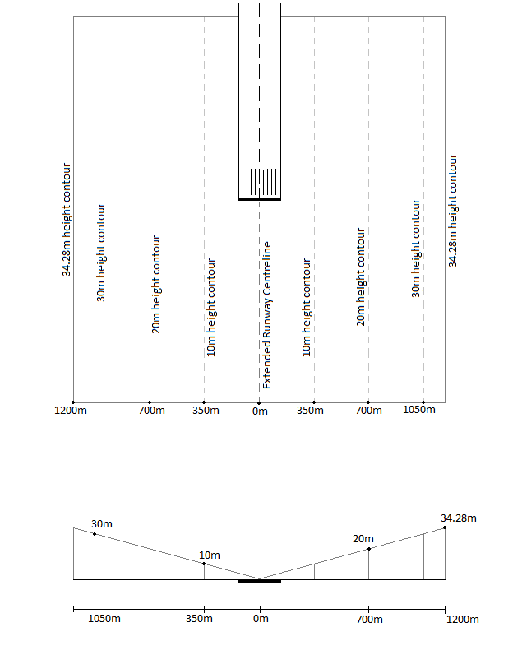
Figure 2: (Top) Plan view of the 1:35 surface within the assessment trigger area. (Bottom) Elevation view of the 1:35 surface, looking down the runway centreline. Illustrative purposes only – not to scale.

Windshear and Turbulence Criteria – Mitigation of risk for buildings that penetrate the 1:35 surface
- For buildings that penetrate the 1:35 surface, an alternative approach is required as the basis of regulatory controls. This approach is:
- The adoption of along-wind and across-wind windshear criteria; and
- The adoption of a turbulence criterion.
- The mean wind speed deficit due to wind disturbing structures is defined as the difference between the mean undisturbed wind field (with no structures present) and the mean disturbed wind field (downwind of the structure).
- The variation in mean wind speed due to wind disturbing structures must remain below:
- 7 knots (3.6 m/s) parallel to the runway centreline (or extended runway centreline) at heights below 61m AGL. Any speed deficit change of 7 knots or greater must take place over a distance of at least 100m. The “7 knot along-wind windshear criterion”.
- 6 knots (3.1 m/s) perpendicular to the runway centreline (or extended runway centreline) at heights below 61m AGL. Any speed deficit change of 6 knots or greater must take place over a distance of at least 100m. The “6 knot across-wind windshear criterion”.
- The standard deviation of wind speed, in the horizontal direction, must remain below 4 knots (2.1 m/s) at heights below 61m AGL. The “4 knot turbulence criterion”.
- These criteria, which will apply in Australia, are based on the research of the NLR and considered by many experts to be world’s best practice.

Assessment Methodology
Using this Guideline
- At airports, a combination of strong winds and large buildings near runways can create runway wind effects that could affect aviation safety.
- This guideline sets out a short summary of steps to follow when assessing this risk from proposed buildings located near the threshold of runways. It should be used in conjunction with the Background and Guidance Material for Planners, Airport Operators and Wind Specialists provided at Attachment A, and with the 2012 report published by SLR Consulting, Guidance Material for Building-Induced Wake Effects at Airports, available on the Department’s website.
- The steps detailed below allow a simple risk based analysis of building induced windshear and turbulence risks in many circumstances. In some circumstances, if a proposed building fails the initial simple checks, a detailed risk assessment and potential mitigation case, taking account of historic wind conditions at the relevant airport, may be sufficient to satisfy the approval authority/decision maker that the building is acceptable. In further cases, physical wind tunnel modelling or computational fluid dynamics modelling may be necessary.
- The below steps are also presented as a decision tree in Figure 3.
Step 1
- Does the entire structure lie outside of the assessment trigger area at each runway end? (See Figure 1) i.e. no part of the structure is within the rectangle:
- 1200m perpendicular from the runway centreline (or extended runway centreline);
- 900 m beyond the runway threshold towards the landside of airport; and
- 500 m from the runway threshold along the runway.
- If the structure is outside the assessment trigger area it is acceptable and no further assessment is required. If any part of the structure is within the assessment trigger area, go to Step 2.
Step 2
- Does the structure sit entirely below the 1:35 surface? i.e. is the horizontal distance, perpendicular from the runway centreline (or extended runway centreline) to the building, more than 35 times the proposed height of the building?
- If yes, the building is acceptable and no further assessment is required. If no, go to Step 3.
Step 3
- If the structure is within the assessment trigger area and penetrates the 1:35 surface then windshear and turbulence effects must be considered and the building proponent must satisfy the approval authority/decision maker that the building will not create an unacceptable risk to aircraft operations.
- It is possible that there will be structures that penetrate the 1:35 surface but do not create an unacceptable risk to aviation safety. The proponent may wish to put forward a risk assessment/safety case/risk mitigation measures for consideration of the approval authority/decision maker. The safety case may consider prevailing wind directions and wind speeds, runway operating modes, shielding provided by surrounding buildings, etc. Tall, slender structures (less than 30m wide) also may not cause significant wake effects and their impact on aircraft operations may be discussed with the airport operator and/or CASA (through the land use planning authority) without requiring professional modelling.
- If the proposed structure is a single, stand-alone building of regular shape (square or rectangular), the proponent may also wish to conduct the simple building-induced wind speed deficit (BWD) assessment using Table 1 on Page 6 of Attachment A.
- This desktop windshear assessment will only test a building for windshear (and not turbulence). It was originally included in Guideline B when the turbulence criterion was not used in Australia. With the inclusion of the turbulence criterion, the desktop test can no longer be used by itself to prove that a structure passes or fails all of the criteria of Guideline B.
- However, the desktop BWD assessment may be used as part of a safety case to show that the building satisfies the windshear criteria. If the BWD assessment shows that the structure meets each of the 6-knot and 7-knot windshear criteria, professional modelling under Step 4 may only be required to test the turbulence criterion.
- The approval authority/decision maker may wish to consult with pilot and/or airline associations and seek advice from CASA when considering the proponent’s safety case and deciding whether the building creates an unacceptable risk to aircraft operations.
- If the approval authority/decision maker is satisfied that the building is acceptable, no further assessment is required. If not, go to step 4.
Step 4
- If the approval authority/decision maker is not satisfied that the proposed building is acceptable based on the proponent’s risk analysis and safety case, the proponent may wish to commission a wind engineer, or other suitably qualified professional, to conduct quantitative modelling. It is important to note that multiple buildings and buildings with complex shapes that penetrate the 1:35 surface must be subject to quantitative modelling.
- The objective of the quantitative modelling should be to provide definitive results on whether the building will meet the 6-knot (3.1 m/s) and 7-knot (3.6 m/s) building-induced windshear criteria and the 4-knot (2.1 m/s) building-induced turbulence criterion.
- The choice between wind tunnel and CFD modelling is a matter for the qualified professional to decide, with input from the building proponent, based on a number of factors including building geometry, surrounding geography and structures, and costs.
- Under some circumstances, the qualified professional conducting the assessment may wish to liaise with CASA and discuss their proposed methodology and proposed presentation of the output, prior to conducting the work. This will help ensure that the assessment and report satisfies CASA’s requirements and is easily interpreted. However, professionals and proponents should note that approaches to CASA for advice outside the land use planning process will be subject to cost recovery arrangements by CASA.
- If the professional assessment indicates that the building passes each of the windshear and turbulence criteria, no further assessment is required and the approval authority/decision maker may approve the proposal (CASA is available to provide advice on expert wind assessments if required). If not, go to step 5.

Step 5
- If the professional assessment above indicates that the building will fail one or more of the windshear or turbulence criteria, the approval authority/decision maker, in discussions with CASA, the airport/building proponent, and airlines/pilots, should consider the likely frequency of occurrence. For example, if historic records indicate that the criteria will be failed only a few times a year and aircraft will be able to use alternative runways, it is possible the airport operator may advise that the building could be accepted and the risks managed through operational procedures. However, the approval authority/decision maker cannot impose operational mitigations without the express consent of the airport operator.
- Discussion and consultation between the proponent of the structure, CASA and the airport users/stakeholders, including airlines’ and pilot’s associations, is required to assess the operational risks and for the approval authority/decision maker to make an informed judgement on whether the proposed structure is acceptable. Structures may be deemed acceptable if appropriate mitigation options are included i.e. runway operating restrictions during strong wind events that may trigger the windshear and turbulence criteria.
- If the risk is determined to be unacceptable, the building proposal should be modified by the proponent or refused by the approval authority/decision maker, to ensure the safety of aviation operations at the airport.
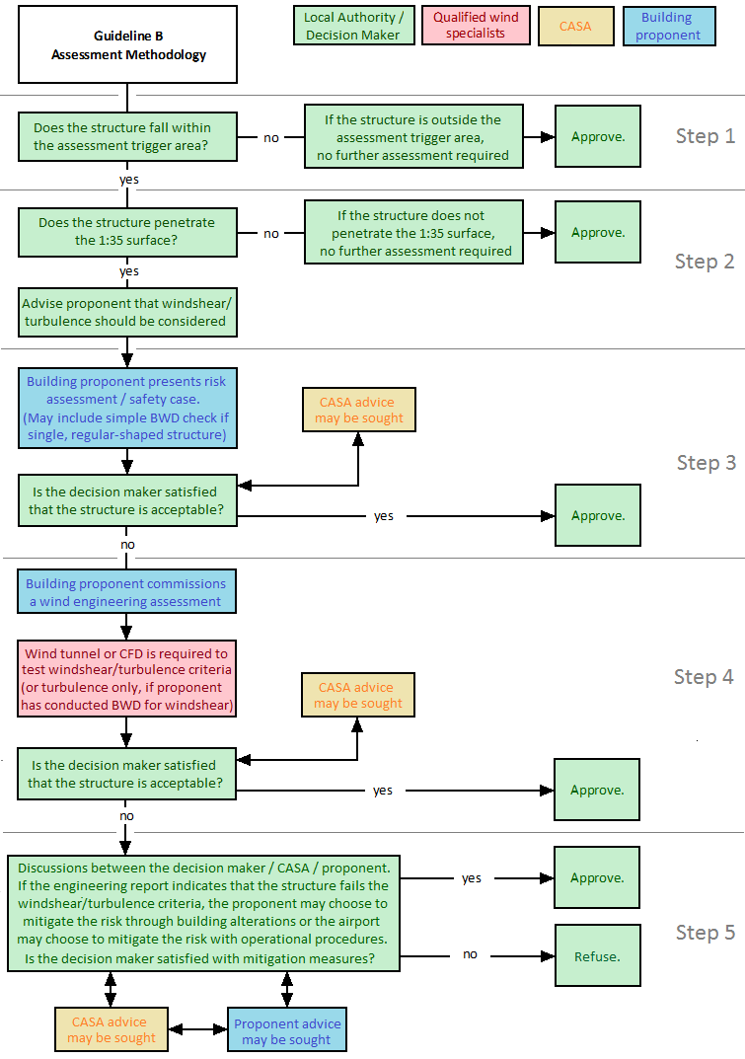
Figure 3: Assessment methodology

guideline b – Attachment A

background and Guidance material For Planners, Airport Operators and wind Specialists to Manage the Risk of Building Generated Windshear and Turbulence at Airports

Revision Date | Version Number | Changes Made | Approved By

Key Considerations for Managing the Risk of Building Generated Windshear and Turbulence at Airports
- At airports, a combination of strong runway cross winds and obstacles to the prevailing wind flow such as large buildings can create:
  - low-level windshear (horizontal and vertical);
  - additional (building-generated) turbulence; and
  - vortices.
- According to the International Civil Aviation Organization (ICAO), windshear is: “A change in wind speed and/or direction in space, including updrafts and downdrafts ... any atmospheric phenomenon or any physical obstacle to the prevailing wind flow that produces a change in wind speed and/or direction, in effect, causes windshear.”
- Turbulence is caused by rapid irregular motion of air. If turbulence is severe and unexpected, sudden changes in the flight path of aircraft may occur and pilots may lose control briefly.
- Building-generated vortices are created when air flows start to spin after strong wind flow encounters a building at particular angles.
- The effect that buildings have on the prevailing wind flow depends on a number of factors, the most important being:
  - the speed of the wind and upstream turbulence;
  - the orientation of wind relative to the building;
  - the scale of the building in relation to the runway dimensions;
  - the location of the building in relation to safety-critical zones such as touch-down zones; and
  - the bulk, form and complexity of the building.

- Although buildings near runways (such as offices, warehouse-type buildings and hangars) are height-restricted to comply with the ‘Obstacle Limitation Surfaces’ (OLS), they can potentially constitute obstacles of significant size relative to the prevailing surface wind flow. The wind flow is diverted around and over the buildings causing the surface wind to vary along the runway in both magnitude and direction.
- Such horizontal windshear, which is usually localized and turbulent, poses risk to light aircraft in particular but has also been a factor in safety incidents involving large jet aircraft.
- Windshear poses the greatest risk on approach, landing and take-off when an aircraft’s speed is low and the pilot’s ability to respond is limited. Flight conditions near the ground are complex, with accurate aircraft control required at a phase when significant changes in wind speed and direction can occur.
- In particular, this applies to large aircraft, and low-wing dual propeller engine aircraft, where the engine housing or propeller may strike the ground in turbulent or windshear conditions.

Buildings near runways: generic guidance to mitigate risk of building-induced wind effects
Existing Regulatory Controls
- The airspace around leased federal airports and Defence airfields is protected from tall buildings based on standards established by ICAO. These standards form the basis of ‘prescribed airspace’ legislation under the Airports Act 1996, which is administered by the Department of Infrastructure and Regional Development (DIRD) and the draft Defence Aviation Area Regulations under the Defence Act 1903 administered by the Department of Defence. Under this legislation, airspace surrounding leased federal airports is regulated to ensure that obstacles to safe air transport are not built.
- Research conducted by the Aeronautical Research Laboratory of the Netherlands (NLR) indicates that the DIRD-administered prescribed airspace legislation protecting the OLS at leased federal airports has the effect of mitigating the risk of building-generated turbulence for aircraft between 200ft and 1,000ft above ground level. However, this legislation does not cover non-federal airports. In addition, airports certified under Part 139 of the Civil Aviation Safety Regulations 1998 are protected from tall buildings as the OLS is protected. However, OLS protection is inadequate to address the risk of building-generated wind effects below 200ft.
Building location with respect to the runway
- The aircraft instability which building-induced windshear and turbulence can cause is significantly reduced once the airplane has touched down or is above 200 feet off the ground after take-off.
- The most critical area (in plan view) for building positioning, with respect to potential (building-related) windshear problems, is close to the touch-down zones of runways (see paragraph 44 of the Guideline for the assessment trigger area, identified as the critical area for Australian airports). Critical areas with respect to potential turbulence problems are more difficult to predict as they depend more heavily on building shape and local surrounds.
- Buildings should preferably not be sited in this assessment trigger area near the touch-down zones of runways. Buildings that are sited in this area should be examined with particular rigour for potential risk. The evidence from aircraft safety incidents for which building-induced windshear and turbulence was a factor shows that buildings in this critical area induced the wind effects of concern.
Building plan form aspect ratio
- The wake behind a building varies significantly with building (plan form) aspect ratio. A building with depth (the dimension in line with the wind) greater than width (dimension perpendicular to the wind), say by a factor of around 2:1, has a considerably smaller wake than a building whose width is equal to or greater than its depth.
- Proponents of buildings should note that that a wide wake is created by buildings with width greater than the depth. Proponents should therefore consider aspect ratio with a view to minimising the size of the wake where possible.
Oblique angle delta vortices
- “Delta” vortices can form over sharp-edged rectangular buildings subject to oblique flow, i.e. oncoming flow at an angle of around 45º to the main façade orientations. These persist in the wind flow for many buildings dimensions downstream.
- Wherever possible, buildings should avoid an orientation which puts it at 45° to the orientation of a nearby runway or where the potential for delta vortex formation is aligned with a prevailing wind direction. Figure 1 depicts the formation of a delta wing vortex.
Complexity of building shape
- Buildings at airports generally have a fairly rectangular form, e.g. terminals, hangars, warehouse type buildings and offices.
- This is not always the case. There can be significant variations in the wake disturbance for complex building shapes compared to simple rectangular forms. Complex building shapes have the potential to create unpredictable wind effects and are harder to analyse for risk. Amsterdam Airport reported a number of aviation safety incidents arising from the unusual extent of wake disturbance created by the Schiphol engine test facility. This facility has a complex shape which causes significant wind effects.
- In the absence of detailed quantitative analysis, it will generally be difficult for even an experienced wind engineer to reliably predict the extent of a building wake and the magnitude of the disturbances contained within the wake, when confronted with complex geometry unless a significant degree of conservatism is employed.
Figure 1: Delta Vortex Formation on Building at Oblique Angle to Wind Flow

Concept of Probability of Occurrence
- Like all aviation safety incidents, building-induced windshear and turbulence events involve a coincidence of factors including the following:
  - There would need to be a building of shape and size able to generate wake disturbances along the measurement plane (i.e. along the runway centreline, 500m runway-side or 900m land-side from the runway threshold).
  - The wind would need to be of a sufficient direction and magnitude to create a wake disturbance large enough to exceed any one of the accepted windshear and/or turbulence criteria.
  - An aircraft would have to be operating in the affected measurement plane.
- The above suggests that the actual risk of a building-induced windshear event involves statistical analysis indicating the likelihood of occurrence of adverse events so that an informed decision can be made as to actual risk involved.

Preliminary assessment of the magnitude of Building-induced Windshear (measured as mean Building-induced Wind speed Deficit (BWD))
- The following desktop assessment method is valid only for windshear (and not turbulence). This desktop windshear test was originally included in Guideline B when the turbulence criterion was not used in Australia. With the inclusion of the turbulence criterion, the desktop test can no longer be used by itself to prove that a structure passes or fails all of the criteria of Guideline B. The justification for leaving this desktop assessment in the updated guideline is: a) if the structure fails the desktop test for windshear then the proponent can be satisfied that further professional analysis by a qualified wind specialist is required for both windshear and turbulence; b) if the structure passes the desktop test for windshear then this may be included as part of a safety case to satisfy the approval authority that the building is acceptable; and c) if the local approval authority requires a professional quantitative assessment, but the structure has already passed the desktop windshear test, only the turbulence criterion needs to be checked by a professional wind specialist.
- This simple desktop assessment may also be useful for smaller aerodromes (who are not required to submit a Major Development Plan to the Minister, or not currently required to meet the Guideline B criteria under their jurisdiction’s planning scheme) to at least go some way toward considering windshear risk without engaging a wind specialist.
- Leased federal and Defence airports, and airports subject to Guideline B through their local planning schemes, may still be required to refer structures that penetrate the 1:35 surface within the assessment trigger area to a wind consultant or other suitably qualified professional to apply quantitative modelling techniques.
- The building-induced wind speed deficit (BWD) is the wind speed difference between the prevailing, undisturbed wind flow at an airport and the disturbed wind flow in the wake of a building.
- Based on a range of empirical studies, it is possible to produce estimates of BWD values as a function of the mean velocity of the approach flow at the roof height (H) of the building of concern, V_{H}.
- For the purposes of a preliminary (i.e. non-quantitative) assessment of an airport building, it is important that these estimates are conservative in nature.
- Accordingly, the preliminary assessment should be based on Table 1.
- The building is assumed to be at typical airport height, e.g. up to 40 m (or even more) in height and rectangular in shape with an aspect ratio such that reattachment does not take place, i.e. the in-line length is less than the building width.
- The values apply to the case of wind flow striking the building perpendicular to the main façade “width” dimension, W, and assume reasonably open flat terrain upstream of the building.
- The magnitude of BWD is given in terms of a percentage of V_{H}. As an example, for a building of width-to-height ratio, W/H = 4, the mean wind speed deficit encountered by an object traversing the building’s wake at a distance of 10 x building height would be equal to 0.22 V_{H} i.e. 22% of V_{H}.
Table 1: BWD values at downstream distances for buildings with W/H ratios between 1 & 8
BWD | W/H Ratios =
BWD | 1 | 2 | 4 | 6 | 8
0.48 VH | 1.7 H | 3.4 H | 6.5 H | 9.5 H | 12.5 H
0.35 VH | 2.2 H | 4.2 H | 8 H | 11.5 H | 15 H
0.22 VH | 3 H | 5.5 H | 10 H | 14 H | 18 H
0.11 VH | 5 H | 9 H | 17 H | 24.5 H | 32 H

- The values provided in the Table 1 would be:
  - greater for wind approaching at an oblique angle; and
  - lower for an upstream terrain of greater roughness.
- Example Calculation
Building Dimensions: Width, W = 120 m; Height, H = 30 m; Length, L = 30 m; W/H = 4
Approach Mean Speed: V_{H} = 10 m/s (36 km/hr, 19.4 kt )
Upstream Terrain: Open, Flat Terrain
Approach Flow: Perpendicular to Width, W, façade of building
Mean velocity deficit, BWD:
= 4.8 m/s 9.5 kt 195 m downstream of the building
= 3.5 m/s 7 kt 240 m downstream of the building
= 2.2 m/s 4.5 kt 300 m downstream of the building
= 1.1 m/s 2 kt 510 m downstream of the building
Size of the wake: = 240 m ( i.e. 2 x Width)

- In the above example, the mean cross wind deficit experience by an aircraft landing on a runway whose centreline is located about 240 m from the nearest face of a building of dimensions 120 m (width), 30 m (length) and 30 m (height) would be of the order of 3.5 m/s (7 kt).
- This wind speed deficit would be sustained over a distance of more than 200 m.
- To obtain a complete understanding of the above example in terms of likelihood of occurrence, it would then be required to use the wind rose for the site to calculate the probability of occurrence of the wind having a magnitude of 10 m/s AND approaching the site from the worst-case wind direction (i.e. firstly over the building and then onto the runway).

Advice for wind consultants and other qualified professionals performing quantitative analysis
Premise
- For buildings within the assessment trigger area - in the first instance, the 1:35 surface is applied. If a building does not penetrate this surface, the building is deemed acceptable. For example, if a 10m tall building is located more than 350m from the runway centreline, it meets the rule and no further assessment is required.
- For buildings within the assessment trigger area that penetrate the 1:35 surface, a wind consultant or other suitably qualified professional may be required to provide guidance on the acceptability or otherwise of the proposed development in relation to the potential wake disturbance caused by the building on nearby runway operations.
- When conducting wind tunnel testing or computational fluid dynamics (CFD) analysis of a proposed structure, the wind consultant or other suitably qualified professional should consider the example quality assurance material provided in CPP review (CPP Project 9315, Technical Review of NASF Guideline B – Table 4, Page 17 and Table 5, Page 20) noting that wind tunnel testing is a more mature science with accepted standards and CFD is a rapidly developing field. The critical issue for both approaches is that assumptions and methods are clearly described to ensure transparency.
- The assessment will be premised on the acceptance criteria, viz. whether the windshear and turbulence criteria will be exceeded or not. If exceeded, an assessment of the expected impact on aircraft operations is required and discussions with the airport are triggered unless the structure is modified to pass the criteria with additional testing.
Key factors to consider
- The key parameters of interest will be:
  - Building Shape (Regular, Non-Regular)
  - Building Dimensions (Width, Depth, Height)
  - Perpendicular Distance of the Building from the runway centreline (or extended runway centreline within the assessment trigger area)
  - Building Position Relative to Touchdown / Take-Off Position
  - Surrounding Terrain (Open, Suburban, Urban Built-Up)
  - Probability of Occurrence and Strength of Winds (particularly from the direction able to cause the cross wind conditions of concern)
Assessment output
- CASA has provided a matrix template (Figure 2) for documenting the wind speed required to exceed the criteria at specified points within the assessment envelope. CASA advises that use of this template would facilitate consistent recording of suitable horizontal and vertical assessment intervals.
- While proponents should conduct modelling along the runway centreline between chainages -900m to +500m, consistent with the assessment trigger area, and up to a height of 60m above ground level, it should be noted that the modelling envelope is applied flexibly. If a proponent demonstrates that wind effects are attenuated beyond a certain point, there is no requirement for additional modelling beyond that point.
- All relevant wind directions should be tested i.e. at every 22.5 degrees (N, NNE, NE, ENE, E, etc) that intersects the building and the runway as shown below in Figure 3. If there are obvious reasons not to test for a particular wind direction (i.e. the direction is shielded by some other structure, or historic wind data indicates minimal winds from that direction) a simple discussion of the reasoning may justify not testing that particular direction.

Gust wind speed required to exceed the windshear/turbulence criteria - as measured at standard anemometer conditions (10m high, in open terrain).
Wind direction – xxx degrees
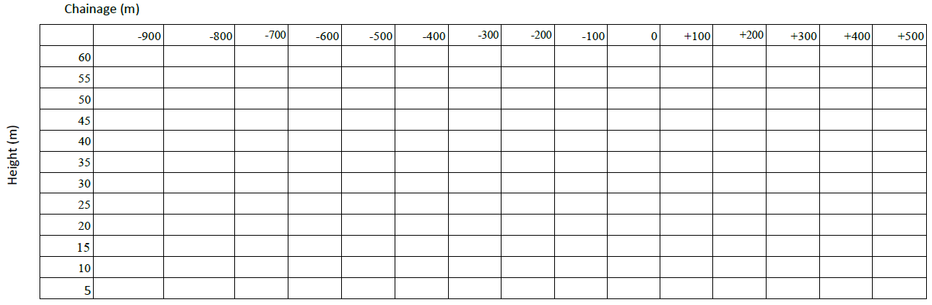

Figure 2: Preferred matrix template for presentation of wind tunnel/CFD output

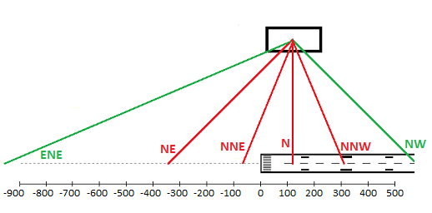
Figure 3: Example of wind directions to be tested – considering the wind directions every 22.5 degrees, four intersect the centreline between -900 and 500 metres (NE, NNE, N, NNW).
(Not to scale, for illustrative purposes)

Exceedance Occurrence
- An example of the exceedance occurrence output of a professional wind assessment (for the 7-knot criterion) is displayed in Figure 4 (Note that this is an example output only and that a full assessment should also provide outputs for the 6-knot and 4-knot criteria). The plot clearly shows that the exceedance of any one of the criteria has a statistical dimension to it. For example, an exceedance might occur once per week (which would be of considerable concern) or it might occur once in every 10 years (which would be of significantly less concern and could likely be managed operationally by the airport).
No of Exceedances of Mean Velocity Deficit per Annum
Figure 4: Sample Output for Building-Generated Windshear Assessment
- In this example, two buildings were examined for the 7-knot windshear criterion only.
- For Building 1, the NLR “7-knot criterion” is never exceeded. The building is therefore acceptable in terms of along-runway windshear, with no consent conditions required to be specified in terms of airport operations etc, e.g. warnings to pilots or restrictions on runway operations under particular cross-wind conditions.
- For Building 2, the NLR “7-knot criterion” is exceeded a number of times per year. The number of exceedances will now play a role in terms of the consent process for the development.
- If the predicted number of annual exceedances is low (e.g. several exceedances per year only), the building may still be approved but with a Building Wake Management Plan required. Such a plan would specify a critical ambient wind condition (e.g. mean winds exceeding “Vcrit” m/sec and blowing from “θcrit” ±22.5º) under which landings or take-offs on a particular runway are disallowed.
- If the predicted number of annual exceedances is significant (e.g. frequent exceedances per year), the building design may require amendment to be approved.
- In the latter case, the regulator may decide that:
  - the building height must be lowered, or
  - the building design must be modified in a manner that will reduce the extent of the wake disturbance behind the building.
- It is also possible that the regulator may conclude that the proposed building is not acceptable at a particular location.
- From the perspective of pilots dealing with cross wind conditions, there is a need for pilots to respond to (rapidly fluctuating) turbulence during cross wind conditions as well as any associated (more sustained) windshear.
- In a full assessment, the above steps should be repeated for the 6-knot windshear criterion and the 4-knot turbulence criterion.

Mitigation options for existing buildings
- In this section, guidance is provided on options to mitigate building generated turbulence and windshear for existing structures where safety risks are identified.
Wake size suppression - Building shape augmentation
- Reference is made once again to one of the key features which influences the wake flow (and hence associated windshear) behaviour surrounding rectangular buildings, namely building plan form aspect ratio, as depicted in Figure 5.
- The wake behind a building whose depth (the dimension in line with the wind) is greater than its width (dimension perpendicular to the wind) by a factor of 2:1 has a considerably smaller wake than a building whose width is equal to or greater than its depth.
Figure 5: Wake Flow Characteristics Influence of Building Plan Form Aspect Ratio
- The implied solution here would be to “create” the conditions where the building appears to have greater depth than is otherwise the case, e.g. to increase the building depth as shown by the orange or pink dotted lines in Figure 5.
- In many instances, the runway (leeward) side of the building would be an area reserved for airport operations and the opposite (windward) side might be needed for building access. Accordingly, the “orange/pink” building augmentation options may not be practical in specific applications.
- It must also be noted that this example only works in very specific cases, in the rare occurrence when the wind strikes the building perpendicularly. At other times augmenting the building shape may increase the strength of corner vortices and/or increase the effective building width for oblique wind directions. However, this is an option that could be explored in some specific cases.
Wake disruption - Surrounding “roughness”
- “Smooth” flow as encountered over flat, open terrain tends to lead to well delineated wake regions. As the oncoming flow becomes more turbulent due to upstream obstacles, so the wake and associated disturbances become less well defined.
- An option for disrupting the wake and therefore the impact of the mean velocity deficit behind an existing building could therefore involve adding roughness elements immediately upstream of the development. Such elements (e.g. trees, other buildings, hoardings such as signage, etc) would however need to be of significant magnitude relative to the building of concern. For example, a row of shrubs, 1 to 2 m in height, located immediately upstream of a building of height 30 m would have negligible impact on the resulting wake behind the building.
Wake disruption - Leading edge roof attachments
- Another option for disrupting the wake is to consider attaching a screen or hoarding to the roof near the leading edge (i.e. the point where the wind first impacts on the building). Both the size of the wake and its accompanying velocity deficits would be potentially lessened with the addition of screens.
- A quantitative investigation would be required to determine the efficacy of any specific recommended wake flow suppression design – screen size, location on roof, angle of orientation, etc.
- The concept is based on sound aerodynamic reasoning and should in practice be feasible to implement as a building “retro-fit” solution, e.g. building signage.
Wake suppression – Wing concept
- At an aircraft hangar which was potentially prone to very high leading edge suction pressures, a leading edge “wing” was attached to the building at roof height to reduce the resulting peak pressure loads on the roof. Apparently, a significant reduction in peak pressure did indeed occur, indicating that the entire wake flow disturbance downstream of the building associated with the changed flow separation conditions would likely have lessened as well.
- The concept idea of such a leading edge wing is shown in Figure 6. The concept is aerodynamically identical to the leading edge devices successfully used in aircraft design which aim to achieve the same lessening of wake disturbance impact and hence drag force.
- The leading edge wing idea is based on sound aerodynamic concepts and would appear to be potentially a cost-effective solution to wake flow mitigation. Aerodynamic modelling would be required to quantify the impacts of such a retro-fit.
- It must be noted that this example only works in very specific cases, in the rare occurrence when the wind strikes the building perpendicularly. At other times the wing may increase the strength of corner vortices. The concept is provided purely as an example to highlight the fact that mitigation options are possible. However, they should be considered individually on a case by case basis depending on the surrounding terrain and prevailing wind conditions.

Aircraft
wing
leading
edge
design
Horizontal “wing” attached to leading edge of roof
Wind flow
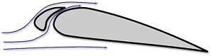

Figure 6: Leading Edge Wing Concept for Vortex Suppression

Wake suppression - Vane concept
- In a wind tunnel model study, prismatic buildings were fitted with vertical blade panels (vanes) at the building corners with a gap between the panel and the building which could vent the flow moving past the building. The purpose of these vanes was to disrupt the separation of wind flow at the building corner associated with high localised (negative) pressure.
- The wind tunnel tests used to carry out this investigation showed substantial reduction in the magnitude of the peak pressures near the corners of these buildings. It is inferred that the wake disturbance behind the buildings would also have decreased.
- A quantitative investigation would be required to determine the efficacy of any specific recommended suppression design – size, gap width, angle of orientation, etc. The concept is based on sound aerodynamic reasoning and should in practice be feasible to implement as a building “retro-fit” solution, once again with possible commercial implications (e.g. vanes used for advertising)
Wake suppression - Flow relief by building openings concept
- The phenomenon of vortex shedding is well understood (as shown in the visualisation diagram on the left side of Figure 7 and its impact on the wind loading of tall buildings and towers is significant – it is not uncommon in tall, lightweight structures for the cross wind loads (perpendicular to the wind) caused by vortex shedding to be greater than the along wind loads (i.e. in line with the wind).
- For this reason, much effort has gone into investigating solutions to minimise cross wind loading. For example, in the case of industrial steel cylinders, helical strakes are a common form of vortex suppression.
- An alternative vortex suppression technique which has been successfully used in the design of several tall buildings (e.g. the Columbia Centre tower shown on the right side of Figure 7) has been to introduce an opening into the building which enables oncoming wind flow to pass directly into the wake behind the building.
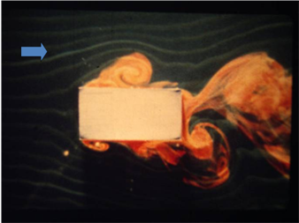
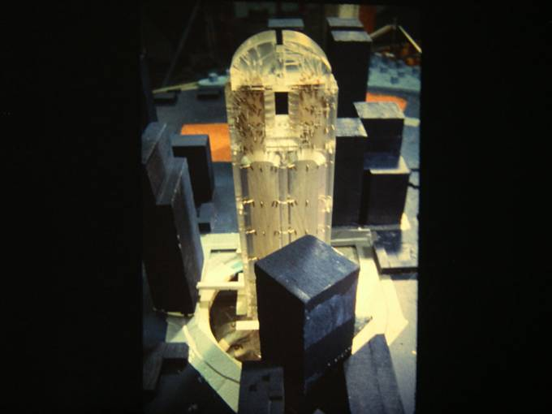

Vortex shedding
Opening near top of Columbia Centre which significantly reduced vortex shedding loading

Figure 7: Vortex Shedding Flow Relief Option

Enable openings within the building to “bleed” airflow into the wake

Windflow

Figure 8: Relief Flow Concept
- As in the case of the leading edge devices, the relief flow concept (Figure 8) has a sound aerodynamic basis and may be feasible, depending upon the usage of the building of concern. The idea may not be suitable for commercial buildings, but may be feasible for hangars where large slot openings could be located on relevant facades.
- Again, a quantitative aerodynamic investigation would be required to determine the efficacy of any specific suppression design.

The extended runway centreline is a hypothetical extension of the runway centreline beyond the runway threshold (as illustrated in Figure 2).

