# Guideline G

**National Airports Safeguarding Framework**

protecting aviation facilities - communication, navigation and surveillance (CNS)

|  |  |  |  |
| --- | --- | --- | --- |
| **Revision Date** | **Version Number** | **Changes Made** | **Approved By** |
| November 2016 | 1.0 | Document creation | TIC |
|  |  |  |  |

## Purpose of guideline

1. To provide land use planning guidance to better protect CNS facilities which support the systems and processes in place by Airservices Australia (Airservices), the Department of Defence (Defence) or other agencies under contract with the Australian Government, to safely manage the flow of aircraft into, out of and across Australian airspace.
2. To provide a consistent approach to land use planning protection of CNS facilities, as applied through State, Territory or Local planning systems.
3. To inform procedures which ensure development and associated activities within Building Restricted Areas (BRA) of CNS facilities do not adversely affect the facility or cause interference for air traffic controllers or aircraft in transit.
4. To provide Commonwealth, State, Territory and Local Government land use planning decision makers with guidance for assessing development proposals in a BRA, and for working with Airservices and Defence in assessing those proposals.
5. To formalise the protection of CNS facilities in land use planning decisions.

## Why it is important

1. CNS facilities are crucial to the safety of aviation. Airservices and Defence rely on them to ensure the safety of civilian and military aircraft operations, maximising aircraft flying safely in our skies.
2. Military and civilian CNS infrastructure and facilities enable:

* pilots to navigate while enroute between airports;
* pilots to utilise navigation aids to conduct instrument approach procedures;
* dialogue between pilots and air traffic control; and
* air traffic control to monitor and confirm an aircraft location.

1. If not properly assessed and managed, inappropriate development located in the BRA of CNS facilities can compromise their effectiveness.
2. The concepts contained in this NASF guideline are consistent with the key elements identified by International Civil Aviation Organization (ICAO) guidance and have been adapted for use in an Australian environment.

## Roles and Responsibilities

**Airservices**

1. As Australia’s civil air navigation services provider, Airservices has responsibility under the *Air Services Act* 1995 (Cth), to ensure safe and efficient air navigation.
2. Airservices and Defence have provided the coordinates for CNS facilities to individual States and Territories with the type and description of the CNS facilities as relevant. Additionally, Airservices and Defence will advise individual States and Territories of any changes to facilities, including the decommissioning of redundant facilities and the installation of new facilities.
3. Airservices will provide assistance to State, Territory and Local Governments with specific Building Restricted Area (BRA) protection requirements for CNS facilities, as required.
4. Airservices can also provide advice to Commonwealth, State, Territory and Local Government land use planning decision makers on development which has the potential to impact on the effectiveness of CNS facilities. This advice includes siting, design, construction and operational constraints associated with development activities.

**Civil Aviation Safety Authority (CASA)**

1. CASA is Australia’s safety regulator for civil air operations and the operation of Australian aircraft overseas and is responsible for enforcing safety requirements under the *Civil Aviation Act* 1988 (Cth) and the *Air Navigation Act* 1920 (Cth). Section 21 of the Civil Aviation Act enables CASA to take enforcement action if it believes on reasonable grounds that an installation is or may be causing active or passive interference with:
2. communications to or from aircraft; or
3. communications to or from centres established for air traffic control; or
4. with navigational aids; or
5. with surveillance systems,

in circumstances that are likely to endanger the safety of aircraft engaged in interstate or international air navigation or air navigation within, to or from a Territory.

**Defence**

1. Defence is responsible for military aviation operations and air traffic control at military airports and airports with a shared military and civil use.
2. Possible infringements of a BRA of most Defence CNS facilities must be assessed by Defence under the Defence (Areas Control) Regulations 1989 (RAAF Base Williamtown and RAAF Base Richmond are notable exceptions; consent authorities are encouraged to liaise with Defence directly in the first instance about BRAs for these airports).

**State, Territory, and Local government**

1. The importance of protecting CNS facilities has been acknowledged by State, Territory and local governments through the National Airports Safeguarding Advisory Group (NASAG) process. Inclusion of appropriate processes into jurisdictions’ planning frameworks is at varying stages.
2. State, Territory and local governments are primarily responsible for land use planning in the vicinity of all airports and can use this guidance to address the protection of CNS facilities in their planning frameworks.

## What is a Building Restricted Area surrounding a CNS facility?

1. The BRA is defined as a space where development has the potential to cause unacceptable interference to CNS facilities. However, the BRA of a CNS facility can extend up to 15 kilometres from a facility in some instances, increasing the potential for new development to adversely impact on its effectiveness.
2. The purpose of BRAs is to trigger an assessment of potential impacts on CNS facilities from proposed developments. They are not intended to prohibit development, except where it would lead to an adverse impact on a CNS facility.
3. The extent of the BRA depends on the type of CNS facility. It is usually divided into zones A, A/B and an Area of Interest, within which different types of development are considered compatible (See Figure 1).

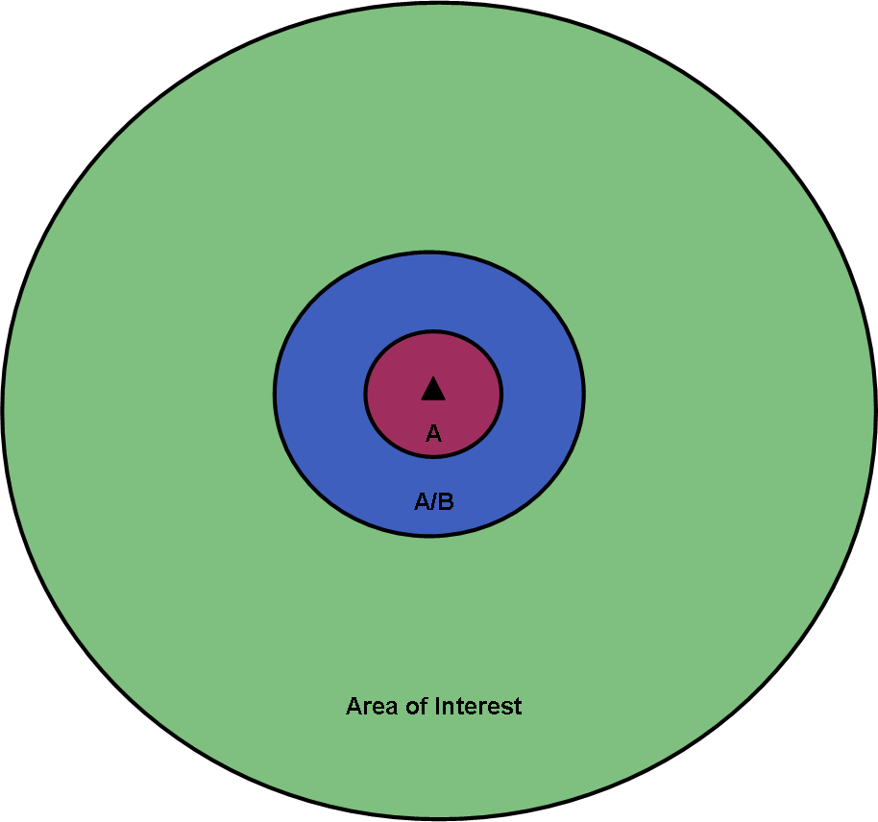

Figure 1: Two dimensional representation three dimensional zones in Building Restricted Areas

1. Generally, a BRA should be kept clear of permanent or temporary:

* obstructions (e.g. buildings, other structures or trees) to the ‘line of sight’ between transmitting and receiving devices;
* objects (e.g. wind turbines) which act as reflectors or deflect signals used by aviation facilities;
* radio frequency interference;
* electromagnetic emissions (e.g. such as those emitted by arc welding associated with steel fabrication); or
* plume rises (as defined in the Airports (Protection of Airspace) Regulations 1996.

1. Attachment 3 provides a more detailed explanation of how zones A, A/B, or an Area of Interest of a BRA are calculated. Further details on individual BRAs is available from Airservices and Defence.
2. Figure 2 details the radius distance of BRAs for each type of CNS facility typically found both on and off-airport land.

|  |  |  |  |
| --- | --- | --- | --- |
| **Facility Type** | **Zone A**  **(metre radius)** | **Zone A/B**  **(metre radius)** | **Area of Interest (metre radius)** |
| High Frequency (HF) | 0 – 100 | 100 – 6000 | 6000 - 10000 |
| Very High Frequency (VHF) | 0 – 100 | 100 – 600 | 100 – 2000 |
| Satellite Ground Station (SGS) | 0 - 30 | 30 - 150 | n/a |
| Non-Directional Beacon (NDB) | 0 – 60 | 60 – 300 | n/a |
| Distance Measuring Equipment (DME) | 0 – 100 | 100 – 1500 | n/a |
| VHF Omni-Directional Range (VOR) | 0 – 100 | 100 – 1500 | n/a |
| Conventional VHF Omni-Directional Range (CVOR) | 0 – 200 | 200 – 1500 | n/a |
| Doppler VHF Omni-Directional Range (DVOR) - Elevated | 0 – 100 | 150 – 1500 | n/a |
| Doppler VHF Omni-Directional Range (DVOR) – Ground Mounted | 0 – 150 | 150 – 1500 | n/a |
| Middle and Outer Marker | 0 – 5 | 5 – 50 | n/a |
| Glide path | n/a | n/a | n/a |
| Localiser | n/a | n/a | n/a |
| Automatic Dependent Surveillance Broadcast (ADS-B) | 0 – 100 | 100 – 1500 | n/a |
| Wide Area Multilateration (WAM) | 0 - 100 | 100 - 1500 | n/a |
| Primary Surveillance Radar (PSR) | 0 – 500 | 500 – 4000 | 4000 – 15000 |
| Secondary Surveillance Radar (SSR) | 0 – 500 | 500 – 4000 | 4000 – 15000 |
| Ground Based Augmentation System (GBAS) - RSMU | 0-155 | 155-3000 | n/a |
| GBAS - VDB | 0-200 | 200-3000 | n/a |
| Link Dishes | 30m |  |  |
| Radar Site Monitor - Type A | 30m | 0 – 500 | n/a |
| Radar Site Monitor – Type B | 70m | 0 – 500 | n/a |

Figure 2: Summary of BRAs for CNS facilities

## Implementing the Building Restricted Area protection framework in planning frameworks

**State and local government plan making**

1. The strategic framework and land use strategies in a local planning instrument should make provision for the safe functioning of CNS facilities.
2. Commonwealth, State, Territory and Local land use planning decision makers can access collated Airservices and Defence CNS location data to enable mapping of CNS sites and their subsequent consideration when development applications are assessed.
3. Where a proposed development or activity is likely to infringe a BRA, details should be referred to Airservices or Defence to allow them to make an assessment. The referral ensures awareness of the proposed obstacle and that mitigation measures are available. Airservices or Defence will also assess the cumulative impact of the proposed development or activity and all other obstacles in a BRA.
4. When allocating land uses in areas where development or activity has the potential to impact on the functioning of CNS facilities, preference should be given to those uses that are unlikely to impact on a facility’s BRA.

**Development assessment**

1. Following referral by a land use planning decision maker or proponent, Airservices or Defence will provide technical advice about the impact of a proposed development on an existing CNS facility and any mitigation measures.
2. Development which may trigger an assessment include:

* Buildings (multistorey offices or residential, private houses, sheds, car parks);
* Hangars and warehouses;
* Infrastructure including bridges and motorway overpasses;
* Power station stacks and plumes;
* Power lines, power poles and light poles;
* Telecommunications towers;
* Commercial signage and advertising billboards;
* Wind turbines and wind monitoring masts;
* Construction equipment such as cranes (eg mobile, tower and luffing) and concrete pumpers.

**The Development Impact Assessment Portal (DIAP)**

1. The DIAP is a geospatial assessment tool currently under development by Airservices and Defence to assist in streamlining the assessment processes. It will assist State, Territory and local land use planning authorities in safeguarding the operations of CNS infrastructure and the national air traffic management system.
2. Initially the DIAP will be trialled in the Queensland planning system. A number of other state/jurisdictions have also indicated their support to utilise the DIAP to support the implementation of Guideline G and for future planning assessments.
3. Once developed and implemented, the DIAP will assist local governments and proponents to easily ascertain if their proposed development/structure is likely to infringe a CNS facility BRA and trigger the requirement for a formal assessment by Airservices or Defence.
4. Governments and/or developers will need to enter site-specific data into the DIAP, i.e. the Lot and RP/address and height of a proposed development/structure. The DIAP will then report upon the site specific constraints (if any) associated with any CNS facility.
5. If there is no infringement into the BRA of a CNS facility, an Impact Assessment Statement confirming no impact will be generated and can be downloaded from the DIAP.
6. If there is an infringement into the BRA, the DIAP will flag the application as requiring specialist analysis and review. At that point, the proponent can opt to proceed for a formal assessment, and will need to electronically submit their application through the DIAP to Airservices or Defence for a technical engineering assessment.

**Attachment 1** shows an indicative process for Airservices consideration of potential BRA impacts.

**Attachment 2** details the different types of CNS facilities.

**Attachment 3** provides cross sections of all CNS facilities and associated BRA’s and assessment tables as guidance for plan making and development assessment.