

# Development of the Universal Service Guarantee

Summary Report

November 2018

Disclaimer

The material in this report is of a general nature and should not be regarded as legal advice or relied on for assistance in any particular circumstance. In any important matter, you should seek appropriate independent professional advice in relation to your own circumstances. The Commonwealth accepts no responsibility or liability for any damage, loss or expense incurred as a result of the reliance on information contained in this report.

This report has been prepared for consultation purposes only and does not indicate the Commonwealth’s commitment to a particular course of action. Additionally, any third party views or recommendations included in this report do not reflect the views of the Commonwealth, or indicate its commitment to a particular course of action.

Copyright

© Commonwealth of Australia 2018

Logo:  Creative Commons. The material in this report is licensed under a Creative Commons Attribution—4.0 International licence, with the exception of:

* the Commonwealth Coat of Arms
* this Department’s logo
* any third party material
* any material protected by a trademark, and
* any images and/or photographs.

More information on this CC BY licence is set out as follows:

* Creative Commons website—[www.creativecommons.org](http://www.creativecommons.org)
* Attribution 4.0 international (CC by 4.0)—[www.creativecommons.org/licenses/by/4.0](http://www.creativecommons.org/licenses/by/4.0).

Enquiries about this licence and any use of this discussion paper can be sent to: [copyright@communications.gov.au](mailto:copyright@communications.gov.au).

Third party copyright

The Department has made all reasonable efforts to clearly identify material where the copyright is owned by a third party. Permission may need to be obtained from third parties to re-use their material.

Attribution

The CC BY licence is a standard form licence agreement that allows you to copy and redistribute the material in any medium or format, as well as remix, transform, and build upon the material, on the condition that you provide a link to the licence, you indicate if changes were made, and you attribute the material as follows:

Licensed from the Commonwealth of Australia under a Creative Commons Attribution 4.0 International licence.

Enquiries about the use of any material in this publication can be sent to: [USO.Taskforce@communications.gov.au](mailto:copyright@communications.gov.au).

Using the Commonwealth Coat of Arms

Guidelines for using the Commonwealth Coat of Arms are available from the Department of Prime Minister and Cabinet website at [www.pmc.gov.au/government/its-honour](https://www.pmc.gov.au/government/its-honour).

Contents

Abbreviations 4

Executive summary 5

1. Introduction 6

2. Background 6

Current USO arrangements 6

Statement of Expectations and Statutory Infrastructure Provider obligations 6

Pressures for change 7

Government announcement 7

Our approach to developing the USG 8

Geographical scope 9

3. Findings 9

Services in operation – fixed 9

Services in operation – payphones 11

Delivery technologies 13

Voice quality and reliability 15

Cost modelling of fixed voice services 16

Potential impact of USO reform on NBN Co 17

Cost modelling of payphone services 18

Comparable developments in other key countries 18

Potential contestability models 19

Potential legislative and regulatory change 20

Likely evolution of the current market place absent further intervention 21

Stakeholder consultation 21

4. Conclusions 23

Voice services 23

Payphones 24

Next steps 24

Appendix 1: Stakeholder consultation 26

## Abbreviations

ACMA Australian Communications and Media Authority  
ADSL Asymmetric Digital Subscriber Line  
ANAO Australian National Audit Office  
ATM Asynchronous Transfer Mode  
CSG Customer Service Guarantee  
CCO Copper Continuity Obligation  
DSL Digital Subscriber Line  
GHz Gigahertz  
GST Goods and Services Tax  
HCRC High Capacity Radio Concentrator  
ICPA Isolated Children’s Parents’ Association  
ITU International Telecommunication Union  
MOS Mean Opinion Score  
NBN National Broadband Network  
Mbps Megabits per second  
NBN Co National Broadband Network Co Limited  
NGWL Next G Wireless Link  
PC Productivity Commission  
PSTN Public-switched telephone network  
RBS Regional Broadband Scheme

RRRCC Regional, Rural and Remote Communications Coalition  
RTR Regional Telecommunications Review  
SIP Statutory Infrastructure Provider  
SMS Short message service  
SoE Statement of Expectations   
TCPSS Act Telecommunications (Consumer Protections and Service Standards) Act 1999  
TIL Telecommunications Industry Levy  
USG Universal Service Guarantee  
USO Universal Service Obligation  
VoIP Voice over Internet Protocol

## Executive summary

In December 2017, the Australian Government announced a program of work to develop a Universal Service Guarantee (USG) that would ensure all Australian premises, irrespective of location, have access to voice and broadband services. Under this model, USG services would generally be delivered on a commercial basis, leveraging the Commonwealth’s investment in the National Broadband Network (NBN) and other commercial networks (like mobile networks). Where this could not be achieved, targeted measures and programs would be developed.

The Department of Communications and the Arts has examined a range of matter relating to the development of the USG, including:

* alternative means of providing reliable voice services to premises outside NBN Co’s fixed line footprint
* the potential impact on NBN Co costs as premises currently served by Telstra under the existing USO migrate to the NBN
* the ongoing role of payphones and other community solutions

The department has also consulted extensively with community and industry stakeholders to ascertain their views and hear their ideas on possible approaches.

Initial high-level cost modelling commissioned by the department indicates that the payments to Telstra for the delivery of the fixed voice services to premises outside the NBN fixed line footprint are reasonably consistent with its costs, given its copper continuity obligation. The modelling also indicates that fixed voice services could be provided at much lower costs by using wireless and satellite technologies. Separate modelling by NBN Co, however, indicates that closure of the Telstra copper network could involve significant additional costs for it, in excess of the current estimated savings.

Moreover, regional consumers outside the NBN fixed line footprint have expressed deep concerns about the possibility of losing access to their existing copper line services, particularly in the absence of multiple proven and reliable alternatives. While some consumers expressed an openness to change, there are clear concerns about the quality, reliability, redundancy and likely cost of alternative solutions, and a general distrust of satellite voice services. These views were reiterated during the 2018 Regional Telecommunications Review (RTR).

It is also clear that any change process would be complex, requiring careful planning and staged implementation, and that new arrangements would need to be negotiated with Telstra.

In this context, we are proposing that the broadband component of the USG be primarily delivered via the NBN, bolstered by the proposed statutory infrastructure provider (SIP) legislation currently before Parliament. The voice component of the USG would be delivered using the existing USO contract with Telstra for the foreseeable future. Given the USO contract has a limited life, a more robust long term USG solution is needed. In the interim, there will also be a sustained focus on continuing improved management of the USO contract.

The current USO also funds the provision of Telstra’s public payphones. The preferred approach here is to maintain the current contract, while working with Telstra and other stakeholders to review the location of payphones to better align them with real need and declining usage. Any change would be subject to further market research, testing of community sentiment and satisfactory negotiation with Telstra on savings. Targeted programs could be developed to assist any vulnerable users of payphone who are adversely affected by any changes.

## 1. Introduction

This document reports on the department’s work in 2018 to develop options for a new telecommunications USG. Noting that most issues are well understood by stakeholders, this report seeks to quickly and clearly summarise what we have found as a result of our work.

Some of the report references more detailed information that was provided to us on a commercial-in-confidence basis. This includes information relating to the number and location of individual USO services, and estimates of the costs of providing services in regional, rural and remote Australia from independent cost modelling processes. As the disclosure of this information could limit future Commonwealth negotiation options, it has not been included in this report.

## 2. Background

### Current USO arrangements

The USO is a legislative safeguard under the Telecommunications (Consumer Protection and Service Standards) Act 1999 (TCPSS Act). It ensures all people in Australia have reasonable access to a standard telephone service (voice services) and payphones, wherever they live or work. Telstra is the designated primary universal service provider in Australia.

The USO is supported by a 20 year contract between the Commonwealth and Telstra; the Telstra USO Performance Agreement (the USO contract). The USO contract extends from 2012 to 2032. Under the USO contract, Telstra is contractually obligated to, amongst other things, supply fixed voice services on reasonable request, and supply, install and maintain payphones. Telstra must also maintain existing copper connections outside the NBN fixed line footprint, except in a limited circumstances. This is known as its copper continuity obligation (CCO).

Under the USO contract, Telstra receives an annual payment of $230 million (GST exclusive) to deliver fixed voice services and $40 million (GST exclusive) to deliver payphone services. In broad terms, the Commonwealth contributes $100 million and industry, including Telstra, pays the remainder via the Telecommunications Industry Levy.

Telstra provides annual performance reports which we use to determine whether Telstra has met its contractual obligations. For USO voice services, Telstra’s performance is mainly assessed against the regulated Customer Service Guarantee (CSG) standard and associated benchmarks. For payphones, we assess whether Telstra has met its regulated USO payphone performance standards and benchmarks, as well as public consultation requirements regarding the installation and removal of payphones.

Approximately 580 of Telstra’s payphones are classed as serving Indigenous communities, including in urban settings. The Department of the Prime Minister and Cabinet also separately funds 245 community phones and 301 community phones with Wi-Fi capability in remote Indigenous communities. These are in smaller communities of less than 50 people, which Telstra has not historically been required to service.

### Statement of Expectations and Statutory Infrastructure Provider obligations

The Statement of Expectations to NBN Co, or SoE, provides guidance to NBN Co on the Government’s expectations for the rollout of the NBN. The SoE ensures that NBN Co’s strategic direction aligns with the Government’s objectives for delivery of the network and specifically requires that all Australian premises have access to very fast broadband at affordable prices.

In addition to the SoE, the Statutory Infrastructure Provider (SIP) legislation, currently before Parliament, will require NBN Co (and other carriers, as appropriate) to provide the necessary infrastructure to ensure all Australian premises are able to access broadband services offering peak wholesale download speeds of at least 25 Megabits per second (Mbps) and upload speeds of at least 5 Mbps. Subject to the Parliament passing this legislation, NBN Co will become the default SIP, with a legal obligation to connect premises and supply wholesale broadband services on reasonable request. Under the SIP regime, broadband services provided on fixed line and fixed wireless networks will also have to support voice services for consumers. The remaining 3% of premises located in areas served by the NBN Sky Muster satellite service require voice solutions over alternative infrastructure because of the technical limitations of these satellites in delivering acceptable voice services.

The Regional Broadband Scheme (RBS) will provide funding support for NBN Co’s SIP obligations by establishing a long term funding mechanism for NBN Co’s fixed wireless and satellite networks. It will level the playing field between NBN Co and its fixed line competitors by requiring all high-speed fixed line carriers, including NBN Co, to contribute to the cost of providing high speed broadband access to regional Australia. The RBS is before the Parliament alongside the SIP legislation as part of the Government’s Telecommunications Reform Package.

### Pressures for change

Since the USO was established, there have been significant changes in technology, the marketplace and customer preferences. There has been increasing use of data and greater use of mobile services, contrasting with falling use of fixed line voice and payphone services. The Government has also made a significant investment in the NBN to improve broadband nationally and the private sector has invested heavily in mobile infrastructure, supplemented by additional investment by government and community organisations to address mobile blackspots.

When the NBN rollout is completed in 2020, all premises will be able to access next-generation broadband services, with the NBN required to support good quality voice services to 97% of premises (those in the NBN fixed line and fixed wireless footprints). More than 99% of Australians currently have access to at least one commercial mobile network, while 96% of Australians have access to three commercial mobile networks. These networks are competing, to varying degrees, with the copper and wireless networks Telstra has historically used to provide voice services under the USO.

The 2015 Regional Telecommunications Review (RTR) called into question the existing USO and recommended a new Consumer Communication Standard for voice and data that would provide technology neutral standards of availability, accessibility, affordability, performance and reliability.

In response to the 2015 RTR, the Government asked the Productivity Commission (PC) to inquire into the future of the USO. The PC concluded that the USO arrangements were ‘anachronistic and costly’ and recommended they be replaced as soon as possible with a new modern approach that covered broadband as well as voice, and leveraged the NBN and other commercial networks, like mobile, to the greatest extent possible.

In 2017, the Australian National Audit Office (ANAO) also conducted a performance audit of the department’s management of the USO contract. It questioned whether the contract met value for money principles and whether we were managing it as effectively as we should be. Neither the PC nor the ANAO, however, were able to model the ongoing cost of delivering the USO or operating Telstra’s copper network.

### Government announcement

In December 2017, in response to the PC’s report, the Government announced it would commence work to develop a new USG policy. The USG would modernise the USO by guaranteeing access to broadband as well as voice services for all Australian premises, while providing ongoing access to community phones or payphones, where appropriate.

The Government indicated that four prerequisites would need to be met before any changes would be made to the existing USO, namely that:

* broadband services would need to be available to 100% of Australian premises, on request, at the completion of the NBN rollout in 2020
* voice services would need to be available to 100% of Australian premises on request
* any proposed new service delivery arrangements would need to be more cost effective than the existing USO contract (including any transitional costs)
* a new consumer safeguards framework would need to be in place, following a review and associated public consultation process

The Government also indicated that the USG would make use of the NBN and other commercial networks, such as mobile networks, in keeping with the Government’s preference for commercial solutions.

Importantly, the Government indicated that the current USO arrangements would remain in place until these prerequisites could be satisfied. That is, the existing USO arrangements, including Telstra’s CCO, would remain the default unless and until a decision was made to change them.

### Our approach to developing the USG

To develop the USG, we undertook a program of work with the following elements:

* confirming the number, location, and delivery technology of USO voice services
* establishing voice quality and reliability benchmarks
* identifying possible alternative voice delivery technologies
* costing alternative approaches to delivering voice services
* costing the potential impact of USG reform on NBN Co
* identifying and costing alternative payphone solutions
* reviewing comparable developments in other key countries
* considering potential contestability models
* considering potential legislative and regulatory changes
* considering the likely evolution of the current marketplace absent further intervention
* consulting with stakeholders, including consumer groups and industry representatives

The discussion of findings in the following section reflects this approach.

In costing the delivery of voice services, we considered three broad options:

1. retaining the current USO contractual arrangements, including the CCO (to set a benchmark)
2. retaining the current USO contractual arrangements, but removing the CCO – i.e. allowing Telstra to use the most cost-effective technology outside NBN fixed line areas – and reducing the number of payphones, and
3. terminating the USO contract and relying on commercial delivery and targeted programs against the background of the proposed SIP legislation.

To assist us in identifying alternative delivery technologies and cost alternative delivery approaches, we contracted Network Strategies, a long-established specialist telecommunications consultancy.

The USG will be complemented by, and coordinated with, a new consumer protection framework that the department is also undertaking. The USG work has also been co-ordinated with the 2018 RTR.

The affordability of services is a key part of any universal service arrangements. The working assumption of the USG is that retail prices in regional Australia should be on par with the prices generally available in the community for comparable services.

### Geographical scope

The USO has always taken a national approach, and the USG would also need to cover all premises in Australia in order to meet the prerequisites set by the Government.

For the most part, broadband and voice services will be provided by NBN Co’s fixed line network, an area in which there is also extensive mobile coverage. The key issue for the department has been the optimal arrangements for the delivery of services outside NBN Co’s fixed line footprint – that is, all areas serviced by NBN Co’s fixed wireless and satellite networks.

In this regard, the PC saw the key issue as how best to provide acceptable voice services to an estimated 90,000 premises in NBN Co’s satellite footprint, that it estimated do not have mobile coverage. This has therefore been one focus of our work.

However, given NBN Co’s concerns about the potential cost impacts on it of USO reform, we also took a broader perspective, looking at the overall delivery of voice services outside NBN Co’s fixed line footprint - that is, all areas serviced by NBN Co’s fixed wireless and satellite networks.

Our aim in doing this was to fully understand the potential cost impact of USO reform, given the Government’s prerequisite for USO reform to be more cost-effective than the existing arrangements.

## 3. Findings

### Services in operation – fixed

The PC acknowledged that it was hindered in its work by a lack of access to detailed data about Telstra’s services in operation under the USO. We negotiated access to such data with Telstra, albeit subject to strict confidentiality rules.

Optus, Vodafone and NBN Co also provided a range of useful data, particularly on network coverage. Other data, especially on service take-up, usage and expenditure, was sourced from Nielsen.

According to NBN Co, there will be 11.6 million serviceable premises in Australia by 2020. Of these, approximately 10.5 million premises will be within its fixed line footprint, 600,000 will be in its fixed wireless footprint and 400,000 will be in its satellite footprint.

Not all premises will take up an NBN service. This is because some premises may be vacant, some occupants may not want a service, will take up a fixed service with another provider, or may prefer to rely exclusively on a mobile service. In its NBN Corporate Plan 2019‒2022, NBN Co estimates that approximately 73‒75% of all premises will take up an NBN service by financial year 2022. However, take-up rates are expected to be lower outside the fixed line footprint, with an estimated 50% of premises in the fixed wireless footprint and 25% of premises in the satellite footprint taking up an NBN service.[1]

Data obtained from Nielsen Consumer and Media View indicates that, in 2017‒18, about 44% of Australians (aged 14+) did not have a fixed home phone. This was consistent across both metropolitan and regional Australia. The data also indicated that 9.5% of all home phone users were considering disconnecting their service within the coming 12 months, which was higher in metro areas (10.5%) compared to regional Australia (7.2%).[2]

By contrast, mobile penetration was high across Australia, with Nielsen Consumer and Media View data indicating that 93.8% of people had mobile phones, with slightly higher rates of ownership in regional Australia (94.3%).

As at September 2018, Telstra provided approximately 4.9 million retail fixed voice services nationally, largely in fulfilment of its USO obligations. Of these, we estimate approximately 600,000 services (12%) were provided to premises located outside the NBN fixed line footprint. In addition, there were approximately 235,000 ADSL broadband services still in operation on Telstra’s copper network outside the NBN fixed line footprint.[3]

Telstra provides the vast majority (96%) of fixed voice services outside the NBN fixed line footprint over its own copper network. A small number of services in rural and remote areas (around 22,000) are provided via alternative network technologies including high-capacity radio concentrator (HCRC), Next G Wireless Link (NGWL) and Telstra satellite. Telstra also has a small number of fibre services (approximately 1,000) in rural areas adjacent to regional centres. Map 1 below shows the distribution of the 600,000 fixed voice services outside the NBN fixed line footprint, according to technology and relative to Telstra 3G mobile coverage.

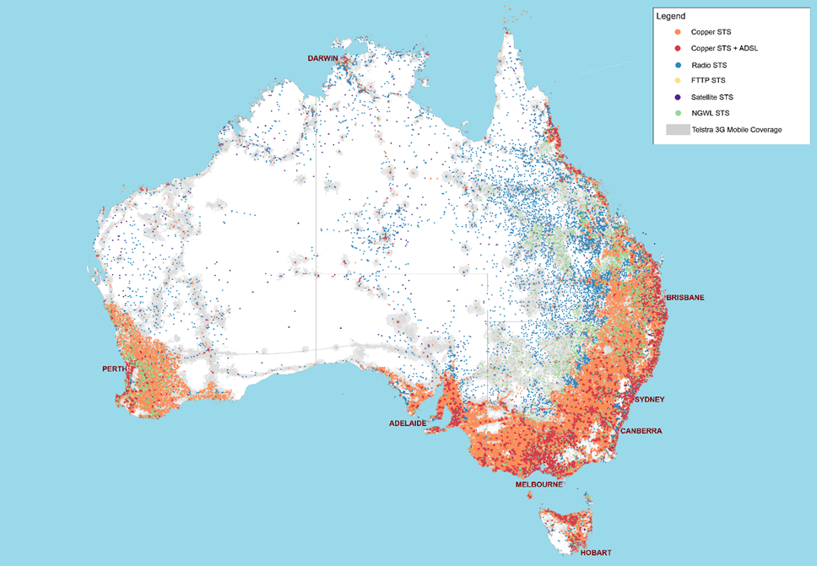*Map 1 – Telstra voice service SIO sites by service technology and Telstra 3G mobile coverage (internal and external antenna coverage), as at September 2018*

Telstra has advised that it has approximately 8,000 special services in operation outside NBN Co’s fixed line footprint. Special services are a set of telecommunication products delivered on Telstra’s copper network, other than the standard landline phone or internet services, generally used by business segments.

### Services in operation – payphones

As at September 2018, there were 15,997 Telstra-operated public payphones. Table 1 below shows the distribution of these payphones by locality and population.

|  |  |  |  |
| --- | --- | --- | --- |
| **Location** | **Number of payphones** | **2016 population[4]** | **Number of people per payphone** |
| Major cities (100,000 or more) | 9,023 | 16,647,383 | 1,845 |
| Large towns (50,000 to 99,999) | 490 | 787,288 | 1,607 |
| Medium towns (10,000 to 49,999) | 1,449 | 1,801,990 | 1,244 |
| Small towns (10,000 to 200) | 2,892 | 2,279,357 | 788 |
| Rural remainder of state or territory | 2,143 | 1,839,515 | 858 |
| **TOTAL** | **15,997** | **23,401,892[5]** | **1,463** |

Table 1 – Distribution of Telstra public payphones

Map 2 below shows the distribution of these payphones and relative to Telstra 3G mobile coverage.

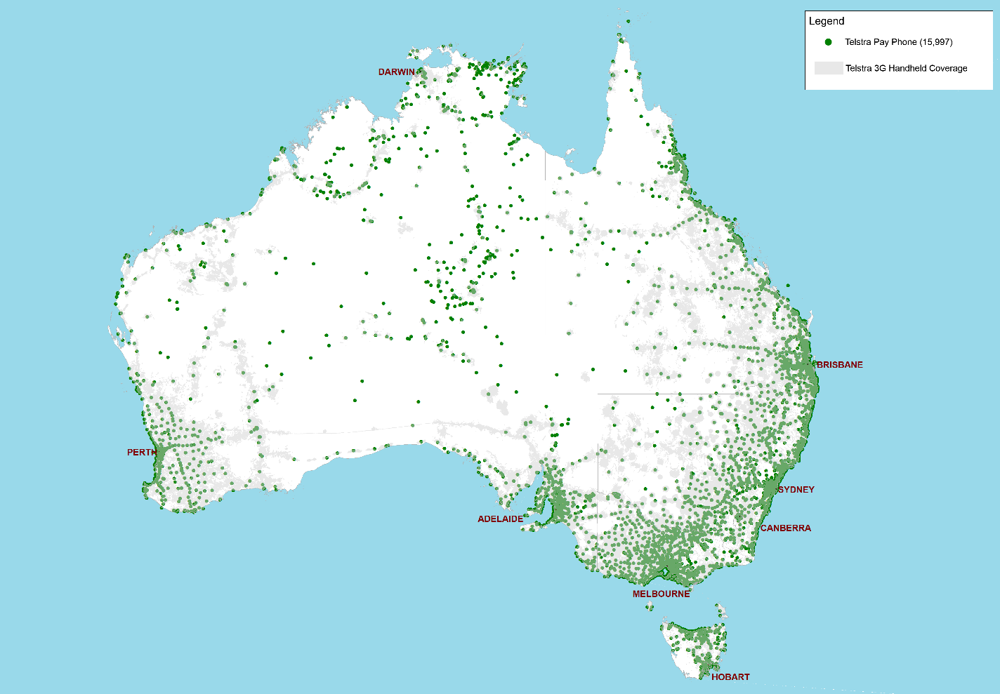*Map 2 – Distribution of Telstra public payphones and Telstra 3G handheld mobile coverage, as at September 2018*

In 2017‒18, Australians made 9.7 million calls from Telstra-operated public payphones, or an average of 27,000 calls a day.[6] This contrasts with a reported 400 million calls and data sessions made daily across the entire Telstra network.[7]

Payphone usage has been steadily declining in Australia, with annual usage falling 18% between 2017 and 2018, and by 76% overall since the USO contract came into force in 2012 (Figure 1). Less than 3% of Australians report using a public payphone in the previous six months at June 2018, unchanged from the previous year.[8]

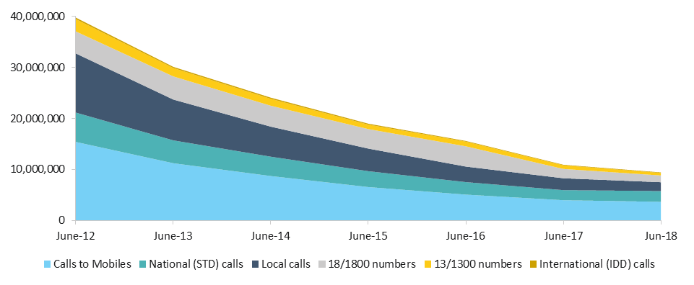Figure 1 – Payphone call volumes, by main call category, June 2012-2018. Excludes Triple Zero calls, SMS and other low volume call types (e.g. 1900 premium services) due to data limitations.

Access to call data for all payphones in Australia in 2017‒18 enabled unprecedented analysis of payphone use. The main reason for using a payphone was to call a mobile phone (39%), followed by calls to national (22%) and local (18%) numbers (Figure 2).

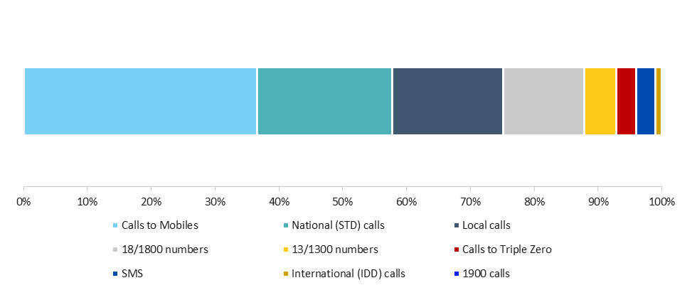*Figure 2. Percentage of payphone call volumes, by call category, year ending 30 June 2018*

Payphones represent a very small percentage of total calls made to emergency services in Australia, making up just 2.3% of Triple Zero call volumes in 2016-17.[9] By contrast, mobiles accounted for 69.7% of Triple Zero calls, with the remaining 28.0% of calls originating from landline telephones.[10]

According to Telstra data, around 200,000 payphone calls were made and connected to the Triple Zero emergency call service in 2017-18. However, only 104,000 of these calls (52%) were considered by the operator to represent genuine emergencies and transferred on to either police, fire or ambulance services.[11]

The payphone usage data is heavily skewed by a small number of very high usage payphones. The most used 500 payphones in Australia, for example, represent just 3% of Telstra’ total fleet but accounted for 17% of all payphone calls in 2017-18. The data also suggests that while these frequently used payphones may breakeven on a standalone basis, the average payphone in Australia is used approximately 11 times per week and is likely loss-making.

### Delivery technologies

We examined both existing and emerging technologies to understand and cost the options available for the delivery of voice services under a new USG. Network Strategies assisted with this work, as did consultations with industry.

#### VoIP

A number of consumer representatives expressed concerns about the delivery of voice services using Voice over Internet Protocol (VoIP). Many perceived VoIP as delivering a lower quality service than what is provided over traditional public-switched telephone networks (PSTN). This is possibly influenced by poor user experiences when using VoIP services over particular network technologies, like satellite, or using unmanaged over-the-top services, like Skype.

Our work indicates that VoIP services can exceed Telstra’s PSTN in terms of voice quality, particularly if the service is offered on a managed basis with appropriate software and dedicated bandwidth, which is typically the case with subscription services offered by internet service providers. Indeed, VoIP has been a standard product widely used with broadband services for many years, and is the means by which telephony is provided over the NBN fixed line and fixed wireless infrastructure.

It is clear, however, that the performance of VoIP services can be affected by the performance of the underlying carriage networks. For example, services can be affected by outages, bandwidth, quality of service settings and latency. Equally, VoIP uses electronic equipment to encode the users’ voice into a format that can be transmitted over the internet and, in doing so, requires access to a reliable power source.

Our view is that VoIP itself, if adequately specified and managed by a service provider (as is generally the case), can provide a satisfactory voice service. There is a broad trend in this direction, with voice increasingly delivered as a VoIP service. While this is a growing trend, there is clearly a need to ensure the underlying delivery platform can support the level of service expected.

#### Alternative platforms

While a number of emerging technologies were identified, the main options for voice delivery remain those that are well known – as are their strengths and weaknesses. These include wired and wireless services, with the latter being either terrestrial or satellite, and either fixed or mobile.

Fixed lines (or landlines) have predominantly been used to deliver USO voice services, including in regional, rural and remote areas. This has historically meant Telstra’s copper network. Premises in the NBN fixed line footprint will eventually be required to migrate off Telstra’s copper network once the NBN rollout is complete. Regional consumers outside the NBN fixed line footprint will not ordinarily be required to migrate off copper. Instead they can choose to maintain their landline telephone service and may also choose to complement this with an NBN fixed wireless or satellite broadband service.

Telstra also uses terrestrial radio systems to deliver a limited number of voice services outside the NBN fixed line footprint. As mentioned earlier, these services are provided using its HCRC and using Next G Wireless Link (NGWL) – a Telstra fixed voice service that utilises Telstra’s 3G network to premises outside Telstra’s copper network.

NBN Co’s fixed wireless network, once fully rolled out, will cover approximately 600,000 premises (around 5%) and broadband services provided over it should be able to support voice, noting that not all of these premises will take up an NBN service.

Approximately 99.4% of Australians have some level of access to mobile services. Approximately 88% of premises outside the NBN fixed line footprint and with a current Telstra fixed line service are estimated to have access to Telstra handheld 3G mobile coverage.

Mobile handsets generally provide an acceptable standard of voice communications. However, the actual quality of the call depends on a large number of variables, including the design and quality of the handset and the connection to the local cell tower. Signal blockers like topography, vegetation and construction materials, also need to be considered. In some cases, performance can be improved at a premises by using an external antenna and/or legal repeater, effectively converting a mobile service to a fixed service, similar to what Telstra does with NGWL.

Satellite is currently used by Telstra to deliver around 1,000 voice services, generally in more remote areas. Telstra’s USO geo-stationary satellite platform has been provisioned for voice services and utilises in-satellite switching so calls can be delivered in a single hop thereby reducing call latency.[12]

NBN Co’s geo-stationary Sky Muster satellites can support voice but have been optimised for data. They operate in the higher Ka band frequencies (17 GHz – 30 GHz), which allow for higher throughput, but are more susceptible to rain-fade. So, while the Sky Muster satellites can support voice calling, and are used for this purpose by some customers, they are not considered suitable as a primary platform for voice services.

Satellite services are generally expensive and are typically only deployed where they are the least cost option (i.e. lower cost than building a terrestrial wired or wireless connection). As noted, services provided by geo-stationary satellites are subject to signal delays (latency), which can be particularly noticeable when a double hop satellite transmission is involved. Depending on the spectrum band employed, they can be subject to rain-fade. As with other wireless services, satellite services generally require a clear line of sight and so topography and vegetation can hinder services. Despite these limitations, satellite can provide an acceptable voice service where another option would otherwise be prohibitively costly.

Latency can be improved by signal processing techniques like in-satellite switching and the use of satellites in medium or low earth orbit (e.g. O3B or Iridium). A number of new low-earth orbit satellite systems are currently under development, such as OneWeb, SpaceX and LeoSat. It is not yet clear, however, whether these will offer acceptable voice services for Australian consumers, or on what timeframe these services will be available.

A range of other new technologies were identified but not considered realistic platforms for the reliable delivery of acceptable voice services at this time, largely because they are at an early stage of development and are currently unproven. Typically involving radio communications, they include high altitude platforms like balloons and drones, peer-to-peer Wi-Fi meshing networks, next-generation wireless systems like CSIRO’s Ngara project or AT&T’s AirGig project, use of TV ‘white space’, and use of emerging Internet of Things (IoT) mobile networks. These technologies are progressing quickly, and the department will continue to monitor developments over the coming years.

In the case of payphones, the most noteworthy trend has been their apparent displacement by mass take-up of mobile phones. Indeed, apart from the potential shift of Telstra’s existing payphone fleet from copper onto alternative telecommunications networks (e.g. the NBN or 4G mobile networks), we did not identify any alternative payphone technologies that were under development. Instead, the main payphone developments relate to the evolution of the cabinets themselves. There is a growing tendency amongst payphone providers to integrate payphone equipment with new digital advertising billboards, kiosks with mobile charging stations and/or public Wi-Fi hotspots, a trend evident in the USA, UK and Australia. These can provide carriers with new revenue streams by leveraging off the location of existing payphone services.

### Voice quality and reliability

Voice quality and network reliability are key aspects of ensuring voice services under a USG can meet the needs of consumers. They are also important in the selection of delivery solutions and the costing of those solutions.

The International Telecommunications Union’s (ITU) standardised benchmark for measuring the quality of voice services, known as the Transmission Rating Factor or R-Value, is seen as providing an appropriate yardstick. The R‑Value provides a guide for user satisfaction, with 50-70 considered low satisfaction, 70-80 medium satisfaction, 80‑90 highly satisfied and 90+ being very satisfied. The R-Value can also be calibrated against a Mean Opinion Score (MOS), which uses a 1 to 5 rating scale and is used in the industry.

In considering a suitable R-Value, we looked at consumer telecommunications usage trends and compared call quality between technologies.

Historically, public-switched telephone networks, like Telstra’s copper network, have provided an   
R-Value of around 80 in good conditions, with higher scores being achievable in some scenarios. VoIP services are also able to achieve these high levels, depending on the software and underlying delivery platforms.

As noted above, Australians are increasingly choosing mobile over fixed services, meaning carriers have a strong commercial incentive to ensure their services consistently provide good voice quality. Independent real-world testing of mobile voice calls in Australia have shown mobile services to have a MOS range of 3.4 to 3.8, which aligns with an R-Value of 65 to 75.[13] These results are supported by data separately provided by mobile carriers.

The growing use of mobile services suggests that consumers are generally satisfied with the quality of calls being carried over a mobile voice service, noting it does offer the additional benefit of mobility. As such we consider an acceptable benchmark for an average voice service would be an R-Value of 65 or higher, noting that some variability between individual calls is inevitable.

Notwithstanding such a benchmark, we would expect consumer demand and established design principles will lead to much higher performance levels generally being available. It has been reported that, in some instances, mobile calls can achieve R-Values of 80+ (exceeding PSTN call quality) – for example, when using 4G calling (VoLTE). The performance of mobile services could be enhanced if they were used to provide services on a fixed basis, for example, with the use of an external antenna and, if needed, a legal repeater.[14]

For the purposes of cost modelling, our consultant, Network Strategies, assumed that 95% of calls would have an R-Value of 75 or more and 100% would have an R-Value of 50 or more. This low score is necessary to allow for the inevitable incidence of some double-hop calls using satellite.

In terms of network reliability, as measured by the proportion of time a network is operational and available for use, the clear preference would be for this to be as high as possible. However, experience is that 100% availability is not realistic, and a degree of flexibility is required. In the year to June 2018, according to its National Reliability Framework reporting, Telstra’s fixed voice network averaged 99.68% availability nationally. This equates to around 28 hours of downtime per annum. By comparison, in the six months to September 2017, the NBN fixed wireless network averaged a higher 99.927%, while the NBN satellite network averaged 99.712%.[15] A mid-point of 99.85% is seen as a reasonable reliability benchmark for the USG, noting that there is scope for higher performance.

In all instances it is worth noting that, if performance benchmarks are found to be inadequate, higher benchmarks can be set but will come at a cost, whether it is done through contract or regulation.

### Cost modelling of fixed voice services

A key aspect of the USG work was to determine whether voice services could be provided more cost effectively than under the current USO arrangements. Greater cost-effectiveness is one of the prerequisites set by the Government for the new USG. Moreover, many parties have questioned the current level of funding payable to Telstra for the USO, including the PC and the ANAO.

We contracted Network Strategies to help develop delivery scenarios and model their costs. Network Strategies was asked to cost three broad scenarios:

1. continued delivery by Telstra under the current arrangements, including continuation of the CCO (to set a cost benchmark)
2. continued delivery by Telstra but with maximum technical flexibility, and
3. delivery in a contestable environment, in which the most efficient provider services uses the most efficient technology, with services being provided commercially or with Government support where needed.

Given that the Government needs to ensure that voice services can be provided to all premises outside NBN Co’s fixed line footprint, the costing looked at service delivery over this larger area, as well as specifically the NBN satellite-only footprint. Costs were estimated from 2020 to 2032, the end-date of the current agreement with Telstra. Due to timing constraints, Network Strategies had to make extensive use of public data sources.

Costing telecommunications service delivery is a complex task, open to a range of approaches, and to dispute and criticism accordingly. Networks Strategies adopted a discounted cash flow analysis. The treatment of network replacement costs acted as a key cost driver. There are alternative approaches. Network Strategies costings should, therefore, be seen as initial and high level. Notwithstanding there may be scope for refinement, we consider the cost estimates to be robust, both in terms of the ranking of scenarios, and the general orders of magnitude.

In broad terms, Network Strategies concluded that the delivery of voice services using wireless (mobile and fixed) and satellite technologies would be more cost-effective than the current arrangements. While the costings are high level, potential savings in the hundreds of millions of dollars over the period from 2020 to 2032 were identified. These costs have not been detailed in this report as they could affect future negotiations. This result aligns with the PC’s tentative conclusion – and the widely held perception – that utilising extensive mobile and national satellite coverage is a more efficient means of providing voice services. The current copper network was the most expensive of the scenarios considered and costed. However, this cost estimate was broadly consistent with current payments to Telstra, noting that Telstra is contracted to maintain the copper network outside the NBN fixed line footprint to 2032. This means that the amount paid annually to Telstra is not necessarily unreasonable because Telstra is obliged under the USO contract to maintain copper services, even though they may be more expensive.

### Potential impact of USO reform on NBN Co

Another key task for the department was to investigate NBN Co concerns, put to the PC, that there could be significant cost impacts for NBN Co from USO reform. For a USG to be more cost-effective than the existing arrangements, as required by the Government, savings from reform would need to outweigh any additional cost impacts.

Achieving maximum savings from the use of wireless and satellite technologies to deliver voice services outside the NBN fixed line footprint assumes Telstra’s copper infrastructure would be decommissioned.

As noted above, however, as well as providing voice services, the Telstra network outside the NBN fixed line footprint also supports around 235,000 ADSL broadband services. NBN Co has advised that it designed its fixed wireless and satellite networks on the assumption these Telstra services would be maintained. As such, if Telstra was able to decommission its copper network, NBN Co would need to invest in additional capacity in order to service these additional broadband customers.

Costings provided by NBN Co indicate that the additional investment needed to serve these ADSL customers would exceed the current estimated potential savings from using wireless and satellite technologies to deliver voice services outside the NBN fixed line footprint. NBN Co has also emphasised that its wireless network has long term spectrum requirements, which also involves a significant cost. This costing information was not available to the PC.

### Cost modelling of payphone services

As indicated above, payphone use has been decreasing steadily since the USO contract commenced, and this is a continuing trend. The main alternative to payphones is the growing use of mobile phones in the community. On this basis, current levels of payphone provisioning and the associated cost appear difficult to justify.

Accordingly, Network Strategies modelled a number of scenarios in which payphone numbers were reduced according to a range of assumptions, including mobile coverage and take-up. Because Telstra has a large stock of deployed payphones, and the evidence suggests little if any interest from anyone new entering the payphone market in a significant way, the costings assumed Telstra would continue to operate payphones. Again, Network Strategies used a discounted cash flow approach, with the results strongly influenced by asset replacement assumptions. Likewise, the costings were undertaken for the period from 2020 to 2032, the end date of the current USO contract with Telstra.

The status quo was costed to establish a costing benchmark. The other scenarios examined included reducing multiple payphones at the same site or in close proximity and allowing the removal of payphones except where there was no mobile coverage, in smaller regional centres, in areas of socio-economic disadvantage, and combinations of these. The costing model allows a wide range of other scenarios to be costed in the future, if required.

Network Strategies’ costings indicate what Telstra receives in USO payphones is not unreasonable in light of the cost to Telstra of operating its current fleet of payphones. Reductions in the number of payphones could lead to commensurate reductions in cost, however significant reductions in payphone numbers could be required to realise savings against the current payments made to Telstra.

Again, we consider these costings are initial and may be subject to further refinement. Even if the costings are robust in suggesting that payments to Telstra are reasonable given Telstra’s costs, there is still an issue as to whether those costs (and payments) are reasonable for the community given the ever decreasing use of payphones. This gives rises to the question: are the costs to Telstra and the community of providing payphones worthwhile given the low use of payphones in the community generally?

### Comparable developments in other key countries

To inform our work, we looked at policy arrangements for universal voice, payphone and broadband delivery in a number of developed economies including the USA, Canada, New Zealand and the UK. We also looked at countries with more distinctive approaches, particularly in relation to payphones. Network Strategies also assisted with this work.

As a developed country with a relatively large proportion of people living in urban areas, and an important, but relatively small, regional population spread over a vast area, there are few countries which offer a close comparator for Australia. Noting there are significant differences, Canada is perhaps the most comparable. While we recognise the difficulties in generalising across a large number of different countries, there are a number of clear trends, which are arguably increasingly global.

Across all of the reviewed countries, access to voice communications at places of residence and business is still generally accepted to be important. Most developed countries continue to regulate for the provision of fixed voice services to such places. Equally, however, there is a clear trend to mobile communications around the world, with mobile services now far exceeding fixed services. In this context, improved access to mobile services, including in areas beyond commercial coverage is a common theme, with programs for example in Canada and the UK (as in Australia) to advance this objective.

Conversely, with the growth in mobile services, there are clear drop-offs in the use of payphones, leading to significant reductions in payphones in most jurisdictions and the relaxation or removal of obligations to have payphones in many jurisdictions. Some countries, albeit it with very high mobile coverage and take-up, like France and Norway, have removed public payphones from their USOs.[16]

As in Australia, the increasing use of online services around the world has seen a strong focus on new arrangements to provide for universal access to broadband services, albeit at varying levels of commitment and service standards. Often these arrangements take the form of policy commitments, with an emphasis on commercial delivery, but legislative requirements are also being used. For example, legislated or regulated broadband obligations have been implemented in Canada, the United Kingdom and Singapore, just as Australia has proposed its SIP obligations.[17]

### Potential contestability models

In its December 2017 announcement, the Government indicated that the new USG would leverage the NBN and other commercial networks to the greatest extent, and use targeted programs where necessary. How this model would work will depend on the decision the Government takes on implementing the USG and the role of the copper network. However, we have given some consideration as to how this market might work if the CCO was removed.

If the CCO was removed, consumers would generally select service providers on a commercial basis according to their availability and ability to meet their needs. In the NBN fixed wireless footprint, consumers could take an NBN broadband service which would also support voice. Additionally or alternatively, they could take a mobile service for voice as many are now choosing to do. If consumers want the comfort or familiarity that a fixed connection provides, they may choose a fixed wireless service connected to a traditional handset rather than simply relying on a mobile phone. Where a consumer had to migrate from an existing copper service or faced additional costs with a new connection, for example installing an external antenna or legal repeater, additional support may be needed.

Where terrestrial wireless (mobile or fixed) coverage was not available, consumers would need to choose from available satellite services for broadband and voice services, notwithstanding the technical limitations of these services.

Service qualification could work in the following way. If a consumer wanted a fixed wireless connection, they could request it. A desk-top qualification check could be undertaken to confirm if it is an option for that premises. If so, the equipment could be dispatched for self-installation. If professional installation was required, for example, because an external antenna was required, that would be scheduled. If none of these options were workable, the premises would need to be referred to a satellite specialist.

If there was to be a transition, copper or other existing services would need to remain in place until the new service was connected and working, potentially over an extended transition period.

Where providing a service to a remote consumer meant that the consumer would face what was more than the generally available price, for example, because additional equipment was required, or satellite usage costs were high, those prices would need to be subsidised so they were in line with prices generally available across Australia.

We envisage service providers would meet installation costs in the first instance, and could be entitled to subsidies as a result. The subsidies could be reflective of the difference between the cost of supply and the generally available price payable by consumers. We envisage subsidies would be capped to reflect reasonable costs of supply and to prevent gold-plating at the taxpayers’ expense. We would expect subsidies would be aggregated and invoiced to the Commonwealth periodically. There would be appropriate fraud prevention mechanisms. In the first instance, we expect funding would be on a similar basis to current USO funding arrangements.

Another approach would be to tender for the supply of services on a per-area and/or per-technology basis, for example, for the supply of services in a particular region or the supply of satellite services nationally. This might be done to provide economies of scale for suppliers, clarity for consumers and to reduce administrative costs. For example, offering and managing a contract for an extended service area may involve less administrative costs than operating a per-service scheme. Generally we see this option as less attractive as it would reduce consumers’ choice and dynamic competition. However, we also recognise it may be necessary to ensure services are available in an area and it may be more efficient to administer than a per-service scheme.

These models would need to be developed further in the event the Government decides to move in this direction.

### Potential legislative and regulatory change

As part of our work, we also gave consideration to possible legislative and regulatory changes to implement a new USG. Again, the exact form of such measures would depend on the Government’s ultimate decision and so this work has been limited in nature. As has been noted above, any changes to the existing arrangement will need to be considered in the context of the current USO contract with Telstra. If there was a move away from the current USO, termination on a valid basis or significant amendment of the USO contract with Telstra would be required.

The broadband component of the USG would be implemented through the enactment of the SIP legislation currently in the Parliament.

Legislative reform may also be needed in relation to voice and payphone services. The general approach would be to remove most of the detailed legislation concerning these services where possible and replace it with legislation requiring the Commonwealth to ensure there was access to services of a specified nature, or to ensure there were measures in place to do this. If such services were available, the requirement on the Commonwealth would be taken to have been fulfilled.

In the case of payphones, their provision is governed by extensive regulation made by the Minister for Communications and the ACMA. In the absence of other changes, this regulation would need to be amended. The nature of the changes would depend on the exact changes to payphone requirements.

Current funding arrangements could continue in place for the time being to support such arrangements.

### Likely evolution of the current market place absent further intervention

To help understand the best way forward with the USG, we also considered how the market may evolve in the absence of further intervention. The costing work has been an important part of this consideration, as costs are clearly a key driver for Telstra and the wider industry.

Telstra has indicated publicly that it is open to renegotiation of the USO contract but equally that it accepts it has a contract which it will fulfil in the absence of change.

However, we see the marketplace continuing to evolve, often outside the control of Telstra, with this inevitably putting pressure on Telstra and its delivery of services over the copper network.

Mobile services are popular in rural and remote areas and have high levels of take-up. As indicated above, there is also a growing number of premises, including in regional, rural and remote areas, relying solely on mobile for voice. Both these trends are set to continue and may accelerate as mobile carriers like Optus and Vodafone increase their regional footprints and the level of competition. Equally, as the NBN becomes fully established in regional areas, it will likely also attract customers from the Telstra network. In these instances, consumers may increasingly ask why they need to pay for multiple fixed services, along with their mobiles. Most likely they will forego a standalone voice connection and rely on mobile and/or VoIP. This will put ongoing pressure on Telstra in continuing to operate the network.

Similar issues will arise in relation to payphones, noting the significant cost and low returns and continuing falling usage.

In this context, we see ongoing pressure for USO reform from both Telstra and the wider industry, noting a further review is scheduled under the USO contract in 2021. The contract is also set to end in 2032. At this stage it is not clear that Telstra would want to enter into a contract with a CCO beyond 2032.

### Stakeholder consultation

We placed a heavy emphasis on seeking the views of stakeholders in the USG development process. That said, given the comprehensive consultations undertaken during the PC inquiry process, the department did not undertake a formal written consultation process. Instead, we met with key industry participants, consumer groups and Government organisations. This approach was welcomed by stakeholders. Stakeholders were also able to provide their views directly to the department to our email address as published on our website.

A full list of the stakeholders approached is provided at Appendix 1.

#### Regional and consumers groups

We met regularly with members of the Regional, Rural and Remote Communications Coalition (RRRCC) and participated in a number of regional forums including the Broadband for the Bush Forum in Darwin, the annual conference of Isolated Children’s Parents’ Association Queensland in Winton and the National Isolated Children’s Parents’ Association conference in Canberra. Bilateral meetings were also held with organisations representing Indigenous, homeless and disadvantaged Australians. Views expressed through the 2018 RTR, including its public consultation process, were also taken into account.

Regional, rural and remote stakeholders emphasised their need for reliable, high-quality, affordable voice and broadband services. This included the need for robust voice quality and reliability standards. Most saw Telstra’s copper network as a trustworthy and proven network, and were concerned with the prospect of Telstra shutting down its copper services. Some also expressed concern about Telstra’s HCRC system reaching the end of its serviceable life. The ICPA also emphasised the importance of these services to distance education.

Regional stakeholders indicated an openness to alternative technologies, such as wireless delivery mechanisms which had proven track records. Of the technologies canvassed, there was some support for terrestrial mobile and wireless solutions, but also concerns about satellite services due to latency and rain-fade issues.

A common view among regional, rural and remote stakeholders was the importance of resilience and redundancy in telecommunications, particularly given concerns about the relative isolation of many rural and remote properties and that a telephone service is very much a lifeline. In this context, concerns were raised about network outages and extended delays in service restoration.

Stakeholders expressed concerns about telecommunications solutions that were not network-powered like the traditional copper service and relied on power supplied at the premises, noting many rural and remote properties may only run generators for part of the day. In the absence of network powering, they emphasised the importance of back-up power options being available, or at least the ability to connect back-up power to telecommunications devices. A recurrent theme was also the need for two or more telecommunications platforms to be available (for example, copper and mobile, or wireless and satellite) to maximise service continuity, particularly in times of emergency.

There was little unprompted comment from stakeholders about payphones, although some noted that they continue to play an important role in some communities, particularly where there is no mobile coverage, and for some types of users. This is particularly true of remote Indigenous communities.

The views put to us in the context of the USG were generally reflected in the submissions to the 2018 RTR and the RTR’s report.

#### Industry

In addition to sourcing key data for analysis, we also sought the views of industry players on the development of the USG. This included Telstra, Optus, Vodafone, TPG and NBN Co, as key providers of fixed and/or mobile infrastructure. We also met with the Communications Alliance, the Commpete alliance of providers, satellite providers and attended the 2018 Australasia Satellite Forum. In consulting with industry, we were particularly interested in quality of service levels, new delivery technologies, costs, new products suitable for regional areas and contestability models.

Industry, in general, was supportive of the idea of USO reform. Providers saw scope for more efficient delivery of voice services, particularly using wireless and satellite technologies. They saw the establishment of a USG as an opportunity to significantly reduce their contributions to the Telecommunications Industry Levy and redirect existing funding to improve their regional networks and expand their regional customer bases.

Consultation with industry did not identify any alternative technologies, beyond mobile and satellite, that could be used to deliver services at present. However, proposed new low earth orbit satellite systems were seen as promising. While noting that there are a number of emerging technologies and business models for regional telecommunications, we concluded these are largely untested and unlikely to be ready for mass-market deployment until the early-to-mid 2020s. However, it will be essential to keep a watching brief in this area.

The general preference in industry was for voice services to be provided on a commercial basis over the NBN or other commercial networks, particularly mobile and wireless, to the greatest extent possible. That is, where services of the requisite quality were being offered at a generally affordable price and taken up by consumers, there should be no need for further intervention, including subsidisation.

There were varying views, however, on how any new mechanism to subsidise the delivery of voice services, where required, should work if the current USO were reformed. Three broad ideas were put forward. The first involved per-service subsidies where this would be needed to keep services affordable. In this instance, providers would seek subsidies for each consumer for whom they provided support. The second idea involved a per-area model, whereby the supply of service in a particular under-serviced area would be tendered out. The third option was a ‘play or pay’ model which envisaged operators being able to provide infrastructure and services in an underserved areas in lieu of payments to the Telecommunications Industry Levy.

## 4. Conclusions

### Voice services

High-level costings by our consultant, Network Strategies, indicated that a combination of wireless (mobile/fixed) and satellite technologies could be significantly more cost-effective in delivering voice services, while noting quality of service on satellite could be lower. The modelling also indicated that ongoing delivery of services under the USO contract is the most costly option, but that USO funding provided to Telstra is broadly in line with its costs.

For savings to be maximised, however, the Telstra CCO would need to be removed from the USO contract. This would mean around 235,000 ADSL broadband customers on the Telstra copper network would need to migrate to alternative platforms, most likely either NBN Co’s fixed wireless or satellite networks. NBN Co has advised us that servicing these additional premises would require it to undertake significant further investment in its network, particularly in its fixed wireless footprint, and create longer term spectrum pressure. These estimated costs would outweigh any estimated savings or efficiency gains from reform.

At the same time, however, there are community concerns about the quality of the copper and HCRC networks, and these networks will be under ongoing pressure from wireless technologies. Ultimately the USO contract with Telstra will end in 2032 and a new delivery solution will be required beyond that date.

We also perceive that regional, rural and remotes consumers’ top priorities are to have good quality, affordable voice and broadband services which are highly reliable, including in terms of power supply and alternative back-up platforms in an emergency. If services can meet these requirements, we perceive that the delivery technology itself is likely to be a secondary consideration. To the extent that mobile networks could deliver such outcomes, regional consumers may benefit in that they could have reliable fixed wireless services and greater mobile access. This suggests a key issue is to demonstrate mobile networks can in fact deliver acceptable fixed solutions.

At this stage, we consider that, for the immediate future, the broadband component of the USG is best delivered via the NBN, supplemented by other SIPs, while the voice component is best delivered under the existing USO contract, pending further work on a more robust longer term USG strategy. This would see voice services continuing to be delivered over the Telstra platforms currently in use in NBN Co’s fixed wireless and satellite footprints, principally Telstra’s copper network, but also its HCRC, NGWL and other existing networks. This is because of the likely significant cost impact of changes to the USO contract and the concerns in regional, rural and remote communities about significant change in the absence of proven alternatives. If change were to take place, there are clear logistical challenges that would need to be addressed and satisfactory contractual changes would need to be negotiated with Telstra.

In the interim, improved management of the USO contract would continue in line with the department’s clear commitment on this front.

Given the USO contract has a defined end date, a long term USG solution will ultimately be needed. We therefore propose that further work be undertaken, in consultation with all stakeholders, to develop a robust plan for addressing the identified issues.

Until such time as an acceptable plan is developed, the voice component of the USG should be delivered under the existing arrangements.

### Payphones

The vast majority of people living in Australia now have access to mobile phones and most payphones are located in areas which now have mobile coverage. Given this, there may be some scope to relax the rules around the provision of payphones to allow Telstra to remove payphones. This could include options such as:

* reducing multiple payphones at the same site or in close proximity
* retaining payphones in locations of greatest utility, like
  + areas outside mobile coverage
  + Indigenous communities
  + in areas of demonstrated high usage
  + in more isolated communities
  + areas of greatest socio-economic disadvantage

As a range of options are available, the final approach in this area should be subject to further market research, testing of community views and satisfactory negotiations in relation to savings. This work could also assist with the development of targeted programs, if required, to help any vulnerable groups who may be unduly affected by a reduction in payphones. For example, it may be such groups would be helped by providing easier access to low cost mobile phones and services, including Wi-Fi, something which could also offer them greater freedom and flexibility.

### Next steps

While our conclusion is the USG is best delivered for now by relying primarily on the NBN (for broadband) and the existing USO contract (for voice services and payphones), we consider a better long term USG delivery model can be put in place over time and will ultimately be required.

We therefore propose a range of further work including:

* detailed market research on both regional communications and payphones
* more refined cost modelling
* a trial to test and demonstrate the quality of alternative voice solutions to consumers
* further engagement with Telstra, NBN Co and other industry players on practical solutions
* a communications and support program for regional consumers
* the development of contestable delivery models
* the development of contractual and associated regulatory changes, particularly for payphones

As part of this work, we propose to explore with Telstra what benefits could be realised if it had greater technological flexibility under the USO contract, subject to consumers’ interests being effectively protected, flow-on cost impacts being contained, and satisfactory negotiations on the treatment of any savings. For example, if greater use of wireless benefitted consumers because it provided a better service and greater mobility and was acceptable to them, it is not clear why it should not be facilitated if it can be done without increasing costs. We envisage this work will reinforce the long term, sustainable delivery of baseline telecommunications in regional Australia.

We emphasise, however, that our strong view is that the current voice arrangements should remain in place and be effectively administered unless and until robust acceptable proven alternatives are identified and able to be implemented. In all instances, we would only see change taking place after careful planning and close consultation with stakeholders. Any change process would need to be staged and take place over an extended period, most likely years. We would also expect existing services to remain in place until new services were provided and were proven to work over a sensible transition period.

## Appendix 1: Stakeholder consultation

A series of government consultation processes have been undertaken regarding USO reform over the past years, engaging with a number of key stakeholders. These have canvased a wide range of views on potential options for reform, including those explored in this report. We would again like to thank stakeholders for their time and considered contributions to these past processes and our work.

**Regional and consumer groups**

* Regional, Rural and Remote Communications Coalition (RRRCC):
  + Australian Communications Consumer Action Network (ACCAN)
  + AgForce Queensland
  + Australian Forest Products Association
  + Better Internet for Rural, Regional and Remote Australia (BIRRR)
  + Broadband for the Bush Alliance Network (BB4A)
  + Cotton Australia
  + Country Women’s Association – National, NSW and South Australia
  + GrainGrowers
  + Isolated Children's Parents’ Association (ICPA) – Federal
  + National Farmers’ Federation (NFF)
  + National Rural Health Alliance
  + National Rural Women’s Coalition
  + Northern Territory Cattleman’s Association
  + NSW Farmers
  + The Pastoralists’ Association of West Darling
  + Rice Growers Association of Australia
  + Queensland Farmers’ Federation
  + South Australia Country Women’s Association
  + Victorian Farmers Federation
  + WAFarmers
* Isolated Children's Parents’ Association (ICPA) – QLD
* First Nations Media Australia (formerly Indigenous Remote Communication Association)
* St Vincent de Paul/Amelie House
* Telecommunications Industry Ombudsman (TIO)

**Industry**

* Activ8me
* Communications Alliance
* Commpete (formerly Competitive Carriers' Coalition)
  + Amaysim
  + Macquarie Telecom
  + MyRepublic
  + MyNetFone
  + Southern Phone
  + TasmaNet
* IPSTAR Australia
* NBN Co
* OneWeb
* Optus
* Pivotel
* Telstra
* TPG
* Vocus
* Vodafone Australia

**Government**

* Australian Communications and Media Authority (ACMA)
* Australian Competition and Consumer Commission (ACCC)
* Australian Local Government Association (ALGA)
* Data61/CSIRO
* Department of Agriculture and Water Resources
* Department of Finance
* Department of Home Affairs
* Department of Human Services
* Department of Industry, Innovation and Science
* Department of Infrastructure, Regional Development and Cities
* Department of Social Services
* Department of the Prime Minister and Cabinet (including Indigenous Affairs and Office for Women)
* Department of the Treasury
* State and Territory representatives (through the NBN Liaison Group)

1. NBN Co Corporate Plan 2019-2022
2. Department of Communications and the Arts findings based in part on data provided by Nielsen through its Consumer & Media View for the Telecommunications category for the 4 years trend starting April 2014 and ending May 2018, for Total Australia 14+/mobile phone users/home phone users/home internet users, according to the Nielsen standard product hierarchy. Copyright © 2018, The Nielsen Company.
3. These are not USO services, however the services are delivered over Telstra’s copper network.
4. ABS, Table 2, 2071.0 Census of Population and Housing: Reflecting Australia - Stories from the Census, 2016 - Small Towns.
5. Includes 48,000 persons with no usual address.
6. Data provided to the department by Telstra.
7. *Telstra Strategy Update*, 20 June 2018 – Transcript, p. 22.
8. ACMA-commissioned consumer research, yet to be published.
9. ACMA, Communications Report 2016-17, p. 95.
10. Ibid, p. 94-95.
11. Based on 2017-18 payphone call data provided by Telstra. According to Telstra’s ‘Enhanced 000 Policy for V3 - Emergency Call Person Support’, when there is doubt as to whether a call is a genuine emergency or not, the agent is to connect the call to the relevant police service. According to the Department of Communication’s 2015 review into the Triple Zero service, between 4% and 21% of calls transferred to state or territory police service were eventually considered to be a non-emergency, hoax or nuisance call.
12. By contrast, a double hop call requires the call to be transmitted to a satellite, returned to an earth station for routing, then back to a satellite before finally being connected to the other caller. This increases latency and affects quality.
13. See, for example, 2017 P3 connect Mobile Benchmark in Australia.
14. External antennas can be installed on the outside of premises to maximise mobile signal strength and overcome signal obstructions. For premises on the outer limits of the mobile coverage maps, an external antenna can improve performance. Legal repeaters, or smart antennas, are devices that extend indoor mobile coverage by relaying mobile signals from one area to another.
15. Senate Standing Committee on Environment and Communications, Answers to Senate Estimates Questions on Notice, 3 November 2017, NBN Co Limited, Question No. 200.
16. BEREC updated survey on the implementation and application of the universal service provisions – a synthesis of the results, BoR (17)41, 24 February 2017.
17. See, for example, Canada’s universal service criteria that Canadian residential and business fixed internet access service subscribers should be able to access speeds of at least 50 Mbps download and 10 Mbps upload; Telecom Regulatory Policy CRTC 2016-496, 21 December 2016.