# Consumer survey on online copyright infringement 2018

## Slide 1

Logo: Australian Government, Department of Communications and the Arts.
Logo: Indigenous Professional Services

Title page: Consumer Survey on Online Copyright Infringement 2018. Prepared by Indigenous Professional Services for the Department of Communications and the Arts.

Copyright
© Commonwealth of Australia 2018
 
The material in this paper is licensed under a Creative Commons Attribution—4.0 International licence, with the exception of:
the Commonwealth Coat of Arms, this Department of Communications and the Art’s logo, any third party material, any material protected by a trademark, any images and/or photographs.


## Slide 2

The survey - this report presents the main findings for the fourth consumer survey of online copyright infringement amongst Australians aged 12+ conducted in 2018.
The survey period was during March 2018 asking respondents about their online activity in the past three months. A total of 2,453 people participated, guided by gender, age and state quotas.

## Slide 3

Survey objectives: To understand the prevalence of online copyright infringement in Australia across four content types: music, video games, movies and TV programs. To understand what attitudes drive online copyright infringement behaviours. To determine the role pricing plays in lawful and unlawful access of online content. To understand how online user behaviour and attitude has changed since the survey first began in 2015 and the emerging trends over the past four years.


## Slide 4

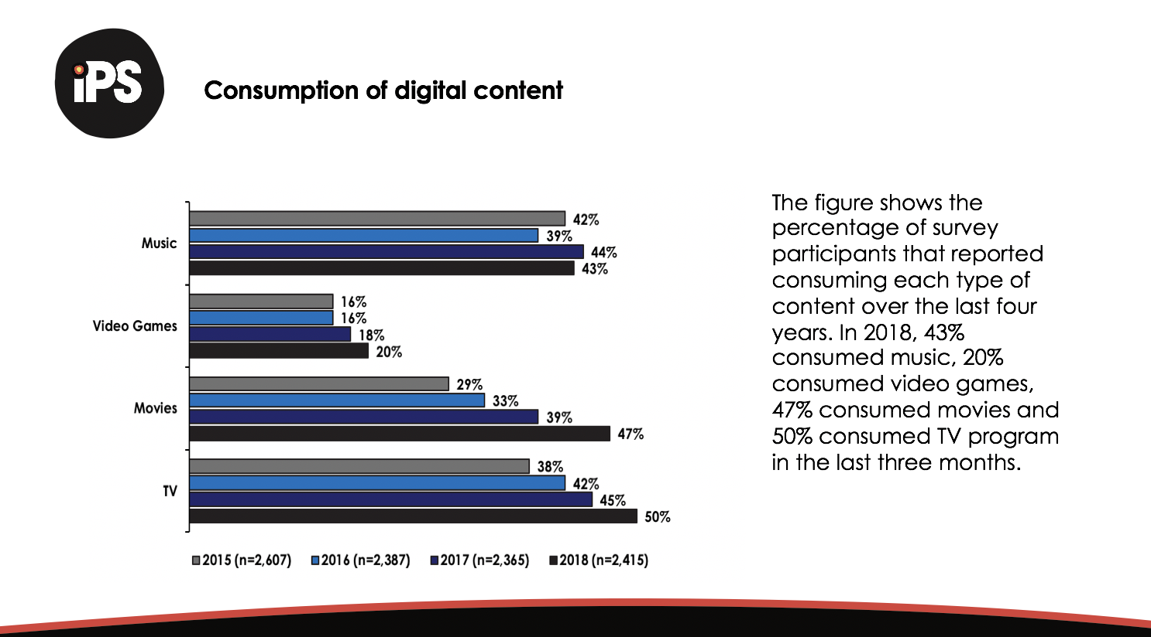

## Slide 5

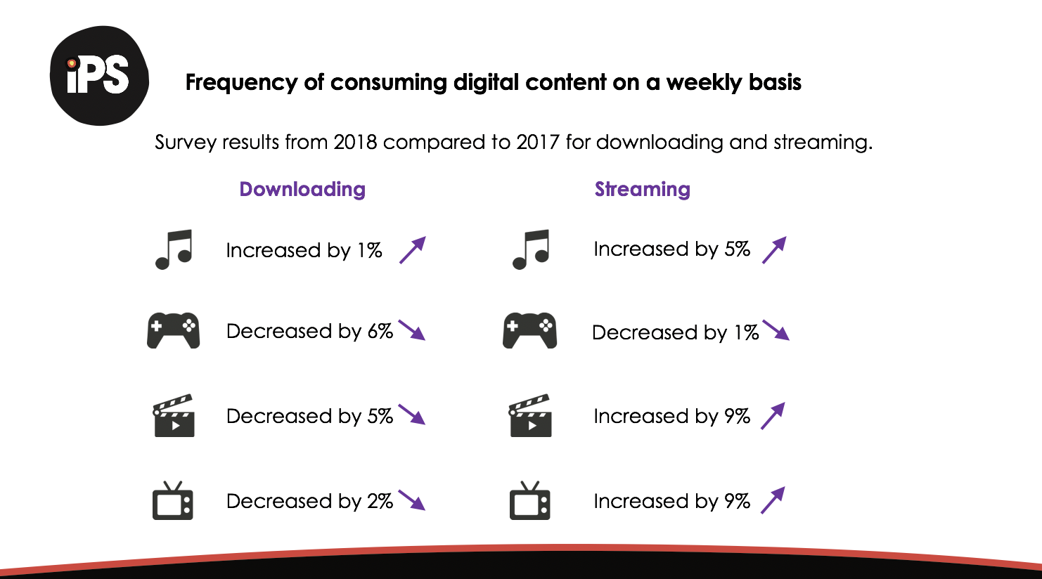

## Slide 6

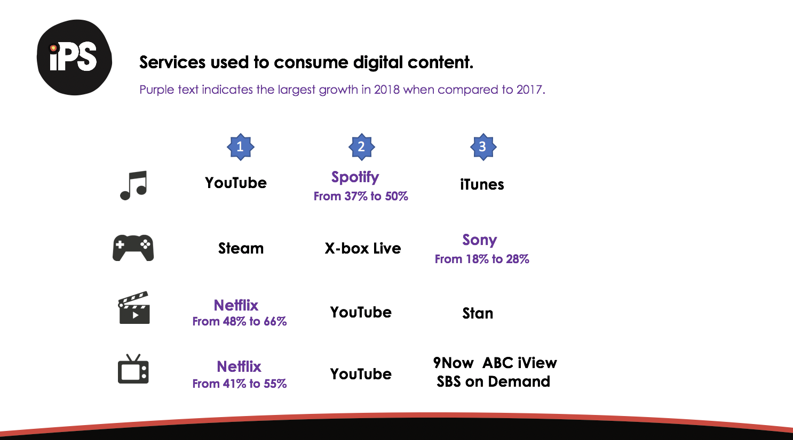

## Slide 7

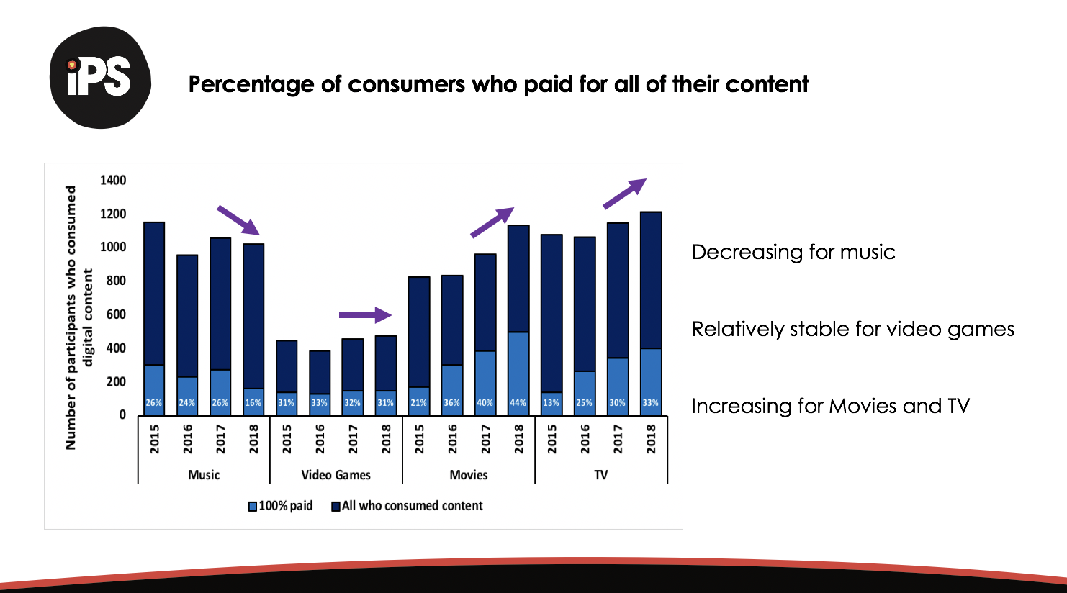

## Slide 8

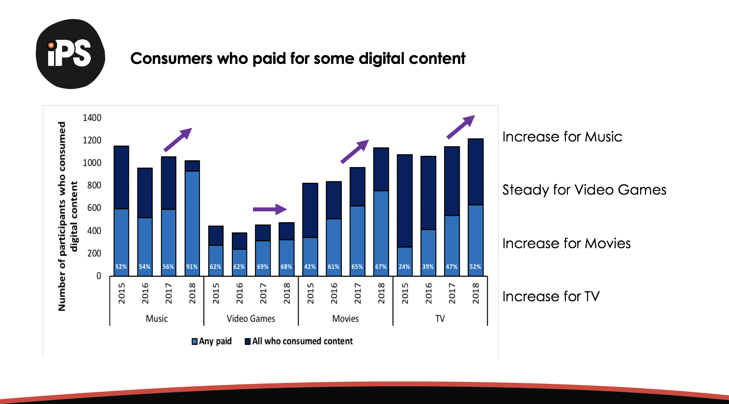

## Slide 9

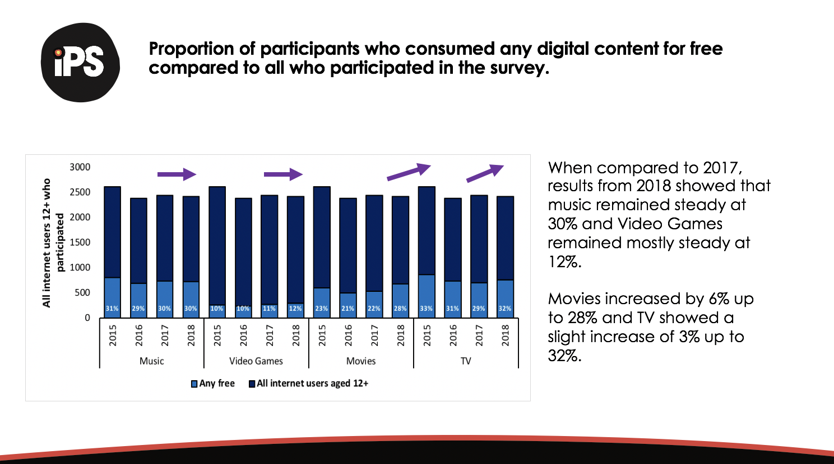

## Slide 10

Proportion of digital content consumed lawfully, unlawfully or a mix of both lawfully and unlawfully across all who consumed digital content. For 2018 music where n=1022 100% unlawful was 128, mix was 204 and 100% lawful was 690. Video games where n=476 100% unlawful was 47, mix was 103 and 100% lawful was 326. Movies where n=1134 100% unlawful was 202, mix was 38 and 100% lawful was 894. TV where n=1214 100% unlawful was 124, mix was 105 and 100% lawful was 985. Any of the four where n=1735 100% unlawful was 177, mix was 388 and 100% lawful was 1170.
Collectively, across all four content types, 100% lawful consumption is increasing.

## Slide 11

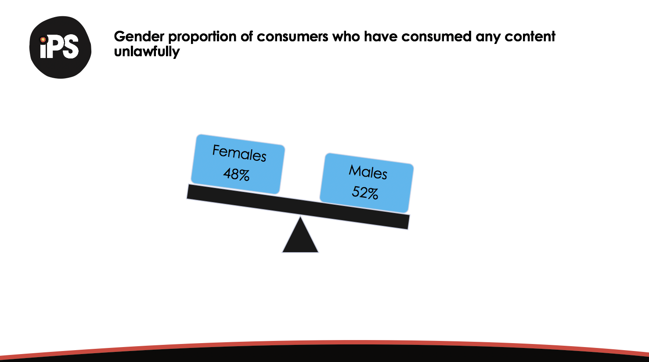

## Slide 12

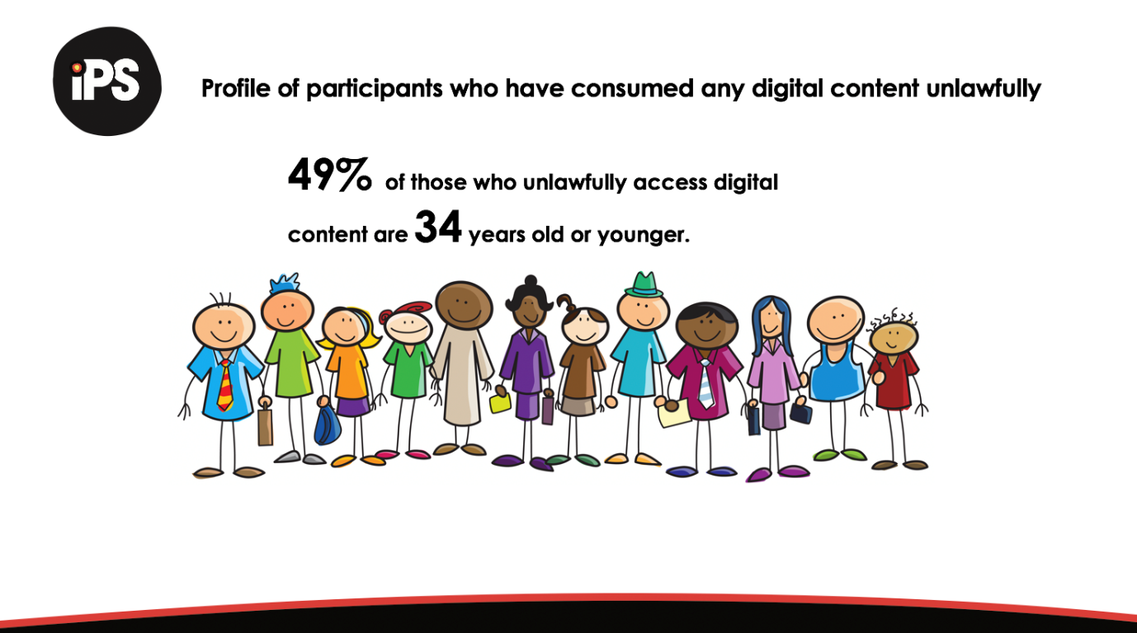

## Slide 13

Volume of consumption of digital files in millions (m). 
Paid files, comparing 2017 results to 2018
Music 717m up to 720m songs
Video games 24m down to 22m games
Movies 61m up to 95m movies
TV 176m up to 209m shows
Free files, comparing 2017 results to 2018
Music 644m up to 996m songs
Video games 27m down to 22m games
Movies 79m down to 74m movies
TV 152m up to 171m shows

## Slide 14

Volumes of files consumed lawfully and unlawfully in millions (m).
Lawful files, comparing 2017 results to 2018
Music1177m up to 1423m songs
Video games 45m down to 33m games
Movies 87m, down to 86m movies
TV 276m down to 258m shows
Unlawful files, comparing 2017 results to 2018
Music 184m up to 292m songs
Video games 7m up to 11m games
Movies 53m up to 83m movies
TV 53m up to 122m shows.

## Slide 15

Consumer spend
Total spend, comparing 2017 results to 2018
Music $96.80 down to $88.34
Movies $65.60 down to $64.09
TV $24.00 up to $28.00
Video games $35.40 down to $31.65
Digital Purchases, comparing 2017 results to 2018
Music $8.10 down to $6.60
Movies $3.60 up to $4.00
TV $4.50 up to $6.30
Video games $8.80 up to $10.31
Subscriptions, comparing 2017 results to 2018
Music $15.90 down to $11.17
Movies $8.30 up to $10.88
TV $8.60 up to $11.00.

## Slide 16

Likelihood of consumers spending a certain dollar value for music and movies.
Music - respondent prepared to pay 69cents, down from 78% in 2017 to 76% in 2018. 
Music - respondent prepared to pay  $1.69, up from 56% in 2017 to 58% 2018.
Movies - respondent prepared to pay $5, was 68% in 2017 and 71% 2018.
Movies - respondent prepared to pay $25, was 13% in 2017 and fell to 9% in 2018.

## Slide 17

Reasons why consumers use paid services:
1. 49% it's easier and 49% it's quicker
2. 36% they are better quality
3. 34% I don't want to use sites providing unlawful content.

## Slide 18

Reasons why participants consume digital content unlawfully.
1. 44% it's free
2. 38% it's easy
3. 31% it's quick

## Slide 19

What would make infringers stop?
26% said if unlawful services were cheaper, 23% said if it was clearer what is lawful and what isn't lawful, 6% said nothing would make me stop.

## Slide 20

How would participants react if they encountered a blocked site?
57% said they would simply give up
34% said they would seek alternative lawful access
7% said they would bypass the blocked site

## Slide 21

At least 50% of respondents were aware of each of these lawful or licensed online services:
YouTube
Netflix
Foxtel
Spotify
Stan
iTunes

## Slide 22

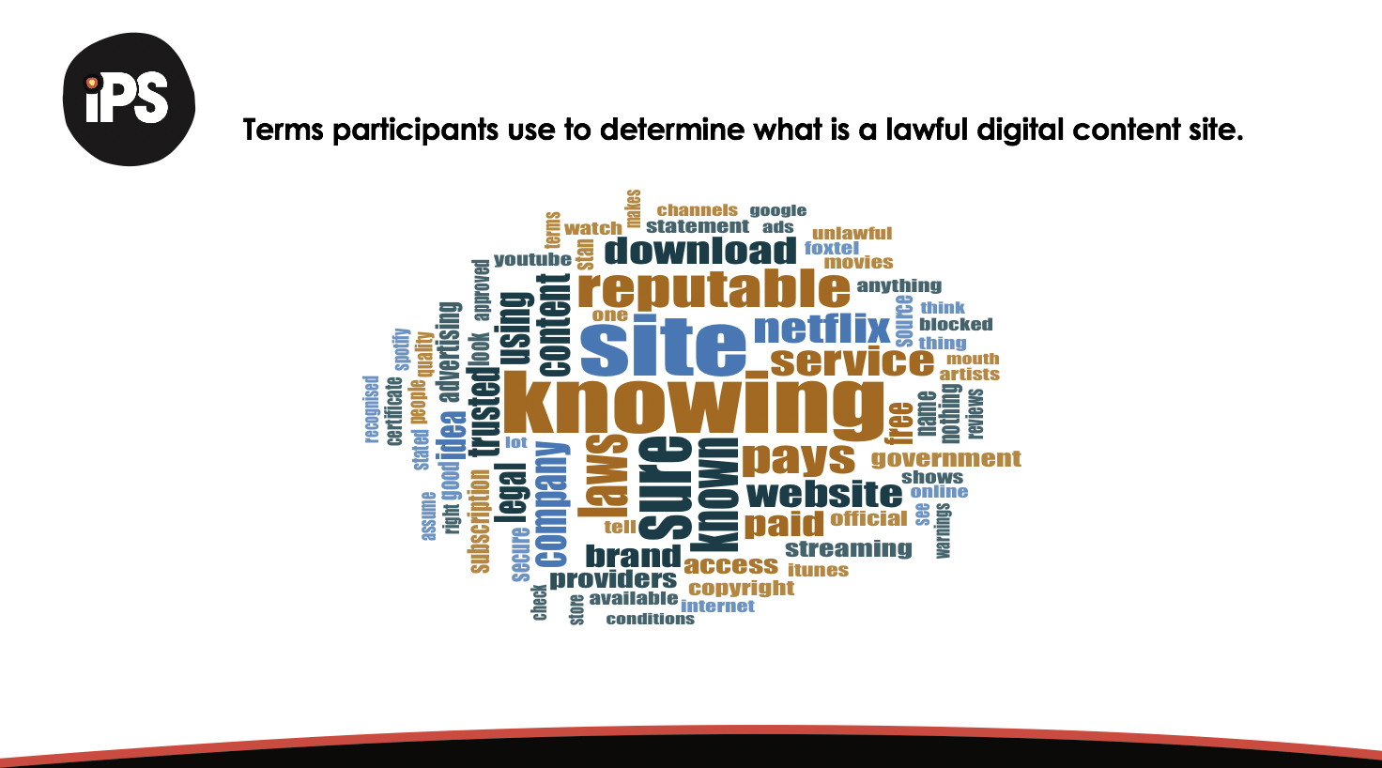

## Slide 23

End screen - Thank You

© Commonwealth of Australia 2018

Indigenous Professional Services - www.indigenousprofessionals.com.au
