Logo: Australian Government, Department of Communications and the Arts.

Consumer Survey on Online Copyright Infringement 2018May 2018 Created by Indigenous Professional Services and prepared by Dr Katie Roe.

# Consumer survey on online copyright infringement 2018

**Indigenous Professional Services**

Prepared by Dr Katie Roe

June 2018

**Disclaimer and Copyright Attribution**

**Disclaimer**

The Commonwealth accepts no responsibility or liability for any damage, loss or expense incurred as a result of relying on information in this report. This report has been prepared for general information purposes only and does not indicate the Commonwealth’s commitment to a particular course of action. Additionally, any third party views or recommendations included in this report do not reflect the views of the Commonwealth, or indicate its commitment to a particular course of action.

**Copyright**

© Commonwealth of Australia 2018

Creative Commons Logo

The material in this paper is licensed under a Creative Commons Attribution—4.0 International licence, with the exception of:

* the Commonwealth Coat of Arms
* this Department of Communications and the Art’s logo
* any third party material
* any material protected by a trademark
* any images and/or photographs.

For more information on this licence, see the [Creative Commons website](http://www.creativecommons.org) or the [licence webpage](http://www.creativecommons.org/licenses/by/4.0).

**Third party copyright**

The Department of Communications and the Arts has made all reasonable efforts to clearly identify material where the copyright is owned by a third party. You may need to obtain permission from third parties to re-use their material.

**Attribution**

The CC BY licence is a standard form licence agreement that allows you to copy and redistribute the material in any medium or format, as well as remix, transform and build on the material, on the condition that you provide a link to the licence, you indicate if changes were made, and you attribute the material as follows:

Licensed from the Commonwealth of Australia under a Creative Commons Attribution 4.0 International licence.

**Enquiries**

Please email [copyright@communications.gov.au](mailto:copyright@communications.gov.au) with enquiries about this licence and any use of this report or material in this report.

**Using the Commonwealth Coat of Arms**

The [Department of the Prime Minister and Cabinet website](http://www.pmc.gov.au/government/commonwealth-coat-arms) hosts guidelines for using the Commonwealth Coat of Arms.

Contents

1. Executive summary 1

1.1. Consumption of digital content 1

1.2. Services used to consume digital content 3

1.3. Payment for digital content 3

1.4. Levels of copyright infringement 4

1.5. Consumption volumes 4

1.6. Consumer spend 6

1.7. Price sensitivity 6

1.8. Reasons for using paid services and for infringing 7

1.9. What would make infringers stop? 8

1.10. Levels of consumer awareness of lawful services and confidence about what is and is not lawful online 8

2. Research overview 9

2.1. Background 9

2.1.1. The first consumer survey (2015) 9

2.1.2. The second consumer survey (2016) 9

2.1.3. The third consumer survey (2017) 10

2.1.4. The fourth consumer survey (2018) 10

2.2. Key objectives 10

2.3. Methodology overview 12

2.4. Notes for this report 12

2.4.1. Content type and activities assessed 12

2.4.2. Payment and lawfulness 13

2.4.3. Key metrics 14

2.4.4. Significant differences by year and by subgroup 15

2.5. Changes to the 2018 survey instrument compared to 2017 15

3. Digital content consumption 17

3.1. Digital behaviour among internet users aged 12+ across all content types 17

3.1.1. Connection used to consume digital content 23

3.1.2. Frequency of consuming digital content 23

3.1.3. Frequency of downloading digital content 23

3.1.4. Frequency of streaming digital content 24

3.1.5. Frequency of sharing digital content 24

3.1.6. Median volumes of files consumed 25

3.1.7. Services used to consume digital content 26

3.2. Payment groups 31

3.3. Existing ownership, and free access to digital content before purchasing 37

3.3.1. Physical ownership of digital content 37

3.3.2. Was content purchased after consuming it for free? 39

4. Levels of copyright infringement 41

4.1. Lawfulness groups 41

4.1.1. Consumption of unlawful content types amongst consumers 43

4.1.2. Median items consumed unlawfully by lawfulness groups 44

4.1.3. Consumption of free content lawfully/unlawfully 45

4.1.4. Consumption of paid content lawfully/unlawfully 46

4.1.5. Sites used for consuming or sharing content by infringers/non–infringers 46

4.2. Content consumption volumes 47

4.2.1. Volume of content by content type 47

4.2.2. Volume of content consumed—paid versus free 48

5. Consumer spend 51

5.1. Quarterly consumer spend among 12+ year olds 51

5.2. Average consumer quarterly spend among lawfulness groups 56

5.3. Quarterly total spend estimates 58

5.4. Price sensitivity 62

6. Attitudes towards digital activities and copyright infringement 63

6.1. Motivations for general online activities 63

6.2. Attitudes towards online content 67

6.2.1. Attitudes towards price and payment of online content 67

6.2.2. Morality of accessing and sharing content without permission 69

6.2.3. Efficacy of accessing online content 70

6.3. Motivations for lawful and unlawful behaviour 71

6.4. Awareness of licensed online sites or services 83

6.5. Confidence in knowing what is and is not lawful online 85

6.6. Attitudes and behaviour towards blocked sites 87

7. Appendix 89

7.1. Key considerations for methodological design 89

7.1.1. Key considerations 89

7.1.2. Justification for approach taken 90

7.1.3. Online interviewing 90

7.1.4. CATI interviewing 91

7.2. Methodological approach in detail 91

7.2.1. Questionnaire design 91

7.2.2. Recruitment and fieldwork 92

7.2.3. Timing 93

7.2.4. Sampling 93

7.2.5. Sample selection 94

7.2.6. Weighting and grossing 94

Tables / images / charts contents

Figure 1—Percentage of participants that reported consuming each type of content over the last four years. 2

Figure 2—Frequency of consuming digital content on a weekly basis in 2018 compared to 2017 for downloading or streaming. 2

Figure 3—Top three services used to consume digital content in 2018 for each content type. 3

Figure 4—Profile of participants who have consumed any digital content unlawfully 4

Figure 5—Consumption volumes of digital files, paid and free, in millions (m) for 2018 compared to 2017. 5

Figure 6—Consumption volume of digital files, lawful and unlawful, in millions (m) for 2018 compared to 2017. 5

Figure 7—Consumer spend. 6

Figure 8—Reasons why consumers use paid services. 7

Figure 9—Reasons why participants consume digital content unlawfully. 7

Figure 10—What would make infringers stop? 8

Figure 11—Research objectives and metrics 11

Figure 12—Definition of content types 13

Figure 13—Assessing levels of online infringement 14

Figure 14—Assessing consumer spend on categories and price sensitivity 15

Figure 15—Subgroups of interest 15

Figure 16—Digital behaviour in the last three months amongst internet users aged 12+ for all content that has been downloaded, streamed or shared. 17

Figure 17—Music: digital behaviour in the last three months among internet users aged 12+ 18

Figure 18—Video games: digital behaviour in the last three months among internet users aged 12+ 19

Figure 19—Movies: digital behaviour in the last three months among internet users aged 12+ 20

Figure 20—TV: digital behaviour in the last three months among internet users aged 12+ 21

Figure 21—e–Books: digital behaviour in the last three months among internet users aged 12+ 22

Figure 22—PC software: digital behaviour in the last three months among internet users aged 12+ 22

Figure 23—Proportion of consumers downloading digital content on a weekly basis 23

Figure 24—Proportion of consumers streaming or accessing digital content on a weekly basis 24

Figure 25—Proportion of consumers sharing digital content on a weekly basis 24

Figure 26—Median number of files downloaded 25

Figure 27—Median number of files streamed or accessed 25

Figure 28—Median number of files shared 26

Figure 29—Services used to consume music 27

Figure 30—Services used to consume video games 28

Figure 31—Services used to consume movies 29

Figure 32—Services used to consume TV 30

Figure 33—Proportion of digital consumers who consumed only paid content (no free content) 31

Figure 34—Proportion of all internet users 12+ who consumed only paid content (no free content) 32

Figure 35—Proportion of digital consumers who consumed both paid for and free content 32

Figure 36—Proportion of all internet users 12+ who consumed both paid for and free content 33

Figure 37—Proportion of digital consumers who did not pay for digital content (100% free) 33

Figure 38—Proportion of all internet users 12+ who did not pay for digital content (100% free) 34

Figure 39—Proportion of digital consumers who paid something to consume digital content 34

Figure 40—Proportion of all internet users 12+ who paid something to consume digital content 35

Figure 41—Proportion of digital consumers who consumed any digital content for free 35

Figure 42—Proportion of all internet users 12+ who consumed any digital content for free 36

Figure 43—Participants who consumed digital content and the proportion of content they own in physical format. 37

Figure 44—Participants who consumed digital content and owned part of that content in physical format 38

Figure 45—Participants who consumed digital content and did not own any in physical format 38

Figure 46—The mean number of items owned by participants in physical format 39

Figure 47—Paid for all (100%) content previously consumed for free 39

Figure 48—Any paid for content previously consumed for free 40

Figure 49—Did not pay anything for content (0%) previously consumed for free 40

Figure 50—Proportion of digital content consumed lawfully, unlawfully or a mix of both lawfully and unlawfully across all who consumed digital content 41

Figure 51—Proportion of digital content consumed lawfully, unlawfully or a mix of both lawfully and unlawfully or did not consume (other) across all internet users 12+ 42

Figure 52—Gender of content consumers and infringers 43

Figure 53—Age of content consumers and infringers 43

Figure 54—Median content consumed unlawfully 44

Figure 55—Lawfully and unlawfully consumed free digital content 45

Figure 56—Lawfully and unlawfully paid digital content 46

Figure 57—Volume of content consumed to the nearest million (across Australian population aged 12+) 47

Figure 58—Percentage of content consumed (physical and digital) 48

Figure 59—Volume of paid and free digital content consumed to the nearest million (across Australian population aged 12+) 48

Figure 60—Proportion, expressed as a percentage, of paid and free digital content consumed (across Australian population aged 12+) 49

Figure 61—Volume of lawful and unlawful music content consumed to the nearest million (across the Australian population aged 12+) 50

Figure 62—Volume of lawful and unlawful video game, movie and TV program content consumed to the nearest million (across the Australian population aged 12+) 50

Figure 63—Proportion of lawful and unlawful content consumed (across the Australian population aged 12+) 51

Figure 64—Music spend 52

Figure 65—Proportion of participants that spent anything on music 52

Figure 66—Video games spend 53

Figure 67—Proportion of participants that spent anything on video games 53

Figure 68—Movie spend 54

Figure 69—Proportion of participants that spent anything on movies 54

Figure 70—TV program spend 55

Figure 71—Proportion of participants that spent anything on TV programs 55

Figure 72—Average consumer quarterly spend among those that are 100% lawful 56

Figure 73—Average quarterly spend among those that are a mix of lawful and unlawful consumers 56

Figure 74—Average consumer quarterly spend among those that are 100% unlawful 57

Figure 75—Quarterly total spend on music across the Australian population aged 12+, to the nearest million 58

Figure 76—Proportion spent on each music component 58

Figure 77—Quarterly total spend on video games across the Australian population aged 12+, to the nearest million 59

Figure 78—Proportion spent on each video game component 59

Figure 79—Quarterly total spend on movies across the Australian population aged 12+, to the nearest million 60

Figure 80—Proportion spent on each movie component 60

Figure 81—Quarterly total spend on TV programs across the Australian population aged 12+, to the nearest million 61

Figure 82—Proportion spent on each TV program component 61

Figure 83—Likelihood of digital music consumers spending a given value 62

Figure 84—Likelihood of digital movie consumers spending a given value 62

Figure 85—Participant motivations for taking part in online activities (downloading, streaming or accessing and sharing content) rather than buying a physical version. 63

Figure 86—Participant reasons for not downloading or sharing content online 65

Figure 87—Motivations for sharing content online. 66

Figure 88—Content that you download or access online should be cheaper than the equivalent purchased in physical format 67

Figure 89—If you had paid for a digital file you should then be able to share it with others 68

Figure 90—I think you should be able to download or access the content you want for free from the Internet. 68

Figure 91—The price that you pay to download or access content is generally about right 69

Figure 92—It is wrong to access content online without the creator’s or artist’s permission 69

Figure 93—The rules governing what you can and can’t do with content you purchase should be the same for both physical and online formats. 70

Figure 94—It is easy to find content on the Internet for free that would usually be paid for 70

Figure 95—I find it difficult to find lawful content online 71

Figure 96—The reason I paid is ‘It’s easier or more convenient’ (1) 72

Figure 97—The reason I paid is ‘it’s quicker’ (2) 72

Figure 98—The reason I paid is ‘they are better quality’ (3) 73

Figure 99—The reason I paid is ‘I don’t want to use sites providing unlawful content’ (4) 73

Figure 100—The reason I paid is ‘I fear they may have viruses/malware/spyware’ (5) 74

Figure 101—The reason I paid is ‘I want to support creators/industry’ (6) 74

Figure 102—The reason I paid is ‘I think it’s morally wrong to use sites providing unlawful content’ (7) 75

Figure 103—The reason I paid is ‘I can afford to pay’ (8) 75

Figure 104—The reason I paid is ‘I don’t think it’s right to get them for free’ (9) 76

Figure 105—The reason I paid is ‘I prefer to pay’ (10) 76

Figure 106—The reason I paid is ‘I fear I might be caught’ (11) 77

Figure 107—The reason I paid is ‘I’m unaware of the free services available’ (12) 77

Figure 108—The reason I paid is ‘I don’t know how to use the free services’ (13) 78

Figure 109—Motivations for unlawful consumption of content: top six responses 2018 78

Figure 110—Motivations for unlawful consumption of content: ‘It’s free’ 79

Figure 111—Motivations for unlawful consumption of content: ‘It’s easy / convenient’ 79

Figure 112—Motivations for unlawful consumption of content: ‘It’s quick’ 80

Figure 113—Motivations for unlawful consumption of content: ‘I didn’t realise it was unlawful’ 80

Figure 114—Motivations for unlawful consumption of content: ‘I can’t afford to pay’ 81

Figure 115—Motivations for unlawful consumption of content: ‘It means I can try something before I buy it’ 81

Figure 116—Top six responses 2018 (Any unlawful) 82

Figure 117—Top five responses 2018 (All unlawful) 83

Figure 118—Proportion of internet users aged 12+ aware of lawful / licensed online services 84

Figure 119—Confidence in knowing what is and what is not lawful online 85

Figure 120—Age demographics of participants not confident in knowing what is and what is not lawful online. 86

Figure 121—Word Cloud 86

Figure 122—What participants would do if they encountered a blocked site 87

Figure 123—Actions participants would take to bypass a blocked site 88

Figure 124—Actions taken by participants that encountered a blocked site. 89

Figure 125—Brand list 2018 91

Figure 126—Recruitment, field dates and participant numbers 92

Figure 127—Sampling frame for 2018 research 93

Figure 128—Unweighted and weighted achieved sample 95

## Executive summary

The report presents the main findings for the fourth consumer survey of online copyright infringement amongst Australians aged 12+, conducted in March 2018. A total of 2,453 individuals participated in the 2018 survey. Respondents either completed the survey online or via a Computer Assisted Telephone Interview (CATI) and the survey asked respondents to consider their online activity in the past three months. Responses from 2018 have been compared to responses from the previous years’ surveys to demonstrate trends and build an understanding of digital consumption within Australia. Quotas were set for gender, age and geography, as per previous surveys, to ensure a representative sample of Australian people was achieved. Please note that the sample of digital video game consumers is comparatively small, at 20% of the survey sample, due to the survey sample size and quotas. As such, small changes noted within the study may in fact be greater within the general Australian population.

There were four key objectives for the research. Firstly, to understand the prevalence of online copyright infringement in Australia across four content types: music, video games, movies and TV programs. Second, to understand what attitudes drive online copyright infringement behaviours. Third, to determine the role pricing plays in lawful and unlawful access of online content and finally, to understand how online user behaviour and attitude has changed since the survey first began in 2015 and the emerging trends over the past four years.

### Consumption of digital content

Since the study first began in 2015, digital consumption through downloading, streaming or sharing across the six categories of music, video games, movies, TV programs, e–Books and PC software has been increasing from 65% in 2015 to 66% in 2016 and 69% in 2017. The greatest increase occurred in the past 12 months from 69% in 2017 up to 78% in 2018, a significant increase of 9%.

Participants were asked about their consumption of digital content within the last three months. Within the categories, the consumption of digital music, video games and e–Books remained relatively steady compared to 2017. The consumption of TV programs increased by 5% from 45% in 2017 up to 50% in 2018. Digital movie consumption increased 8% from 39% in 2017 up to 47% in 2018 and consumption of digital PC software increased 9% from 23% in 2017 up to 32% in 2018.

The way digital content within the four core categories of music, video games, music and TV programs is consumed, differs slightly across the categories. The following figure shows the percentage of survey participants that reported consuming each type of content over the last four years.

Figure 1—Percentage of participants that reported consuming each type of content over the last four years.

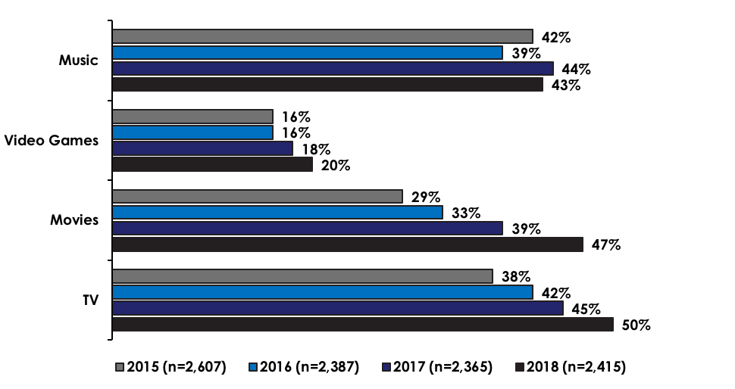

The majority of participants (72%) utilised a fixed line to consume digital content, a decrease from 82% in 2017. Connection to mobile networks remained steady at 40%. A slight decrease was noted in the use of public Wi–Fi from 13% in 2017 down to 12% in 2018. Consumers were asked about their connection to fixed wireless and satellite for the first time in 2018 and it was found that 18% reported using a fixed wireless connection and 2% a satellite connection.

The reported frequency of downloading digital content on a weekly basis has changed slightly across the four content types since 2017. The following figure demonstrates those changes.

Figure 2—Frequency of consuming digital content on a weekly basis in 2018 compared to 2017 for downloading or streaming.

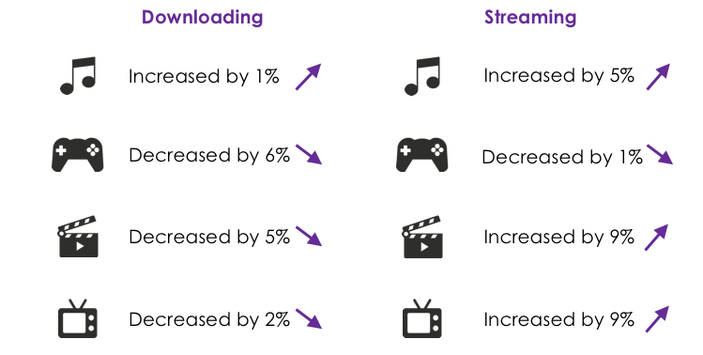

The sharing of digital content on a weekly basis was found to have changed only slightly when compared to 2017 with a 1% increase in movies from 45% to 46% and the other three content types experiencing a decline. The sharing of music dropped 5% in 2018 down to 57%, video games dropped 6% down to 57% and the sharing of TV programs dropped 5% down to 47%. The decline was also reflected in the median number of files shared with music experiencing a drop from 10 in 2017 down to 5 in 2018. Video games dropped from 3 to 2, movies and TV programs both stayed level at 2.

### Services used to consume digital content

YouTube remains the most frequently selected service used to consume or share music since the survey began. The use of Spotify continues to increase significantly each year, since 2015 where it was selected by 19% to 50% in 2018. iTunes is the third most selected service and Facebook, in fourth position, is still used by 37% of participants.

The following figure shows the most frequently used services used to consume digital content. The purple text indicates the largest growth in 2018 when compared to 2017.

Figure 3—Top three services used to consume digital content in 2018 for each content type.

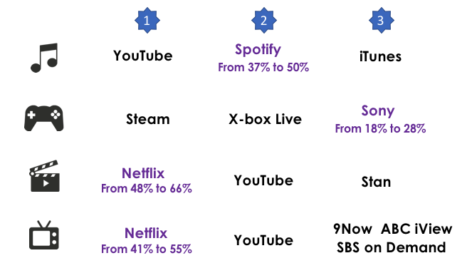

The use of legal streaming services by consumers is increasing across the years and these provide digital consumers with a legal, affordable (or free) option.

### Payment for digital content

When considering the data as a whole, the increasing trend continues for consumers to pay for some of their digital content while the consumption of 100% free content continues to decline. This trend is probably driven by paid streaming services such as Netflix and Stan which have been shown to experience dramatic popularity over the past few years and negates the need for consumers to source the content using other means.

Consistent with findings from 2017, those aged 55 and over were significantly less likely to consume 100% paid content and significantly more likely to have consumed TV for free. This continued for digital movie consumption where those aged over 55 years were less likely to have consumed any paid movies compared to other age groups.

Ownership of a physical version prior to consuming the same digital content has increased significantly in the past 12 months across all content types. Music was 8% in 2017 and increased to 17% in 2018, which could be attributed to the increasing popularity of vinyl records. One hundred percent physical video game ownership was 15% in 2017 and increased to 58% in 2018. This means that 58% of respondents had consumed a digital version of all the video games they already owned in physical version (100%). This could be attributed to more video games that were previously only available in physical version, now being available digitally and participants consuming the digital version. The increase in both movie, from 3% in 2017 up to 27% in 2018, and TV programs from 4% in 2017 up to 13% in 2018 could be attributed to the popularity of Netflix and Stan where consumers may have already owned a physical version and were now able to download, stream or access a digital version of the physical version they already owned. This does not necessarily mean that consumers are purchasing higher volumes of physical versions of video games, movies or TV programs it suggests that they may be consuming digital versions of the physical versions they already owned.

### Levels of copyright infringement

When viewed independently, three of the four content types experienced a slight drop in unlawful consumption, with the exception of video games which experienced a slight increase. Consumers who mixed lawful and unlawful consumption remained steady within music but experienced an increase within video games, a continuing trend over the last three years. Both movies and TV programs saw a drop of consumption by participants that consumed lawful and unlawful content (mix) and an increase in participants that consumed all their content lawfully (100% lawful consumption).

When looking collectively at all four content types, there is a greater proportion of consumers that are 100% lawful in 2018 compared to previous years. This finding is consistent with the view that legal streaming services are increasingly being used by digital content consumers and having a positive impact on the reduction of, or need for, unlawful consumption.

Participants that consumed all their content unlawfully (100% unlawful) or consumers who consumed some content lawfully and some unlawfully (mix) are collectively represented within the ‘any unlawful’ category. The median number of files downloaded or streamed by participants that consumed ‘100% unlawfully’ across the four content types, has remained steady over the last two years at 9. There was a significant drop observed within music (from 16 files to 5) in the median content consumed ‘100% unlawfully’ and also ‘any unlawful’ from 18 files in 2017 to 5 in 2018. The median for ‘any unlawful’ remained the same (4 files) within video games but there was a drop from 2 files in 2017 to 1 in 2018 of the ‘100% unlawful’. Movies remained steady for ‘any unlawful’ at 5 files but there was a drop in ‘100% unlawful’ from 5 files in 2017 down to only 1 in 2018. TV programs also saw a drop in ‘100% unlawful’ from 4 files to 3 but the ‘any unlawful’ remained steady at 5 files.

Figure 4—Profile of participants who have consumed any digital content unlawfully

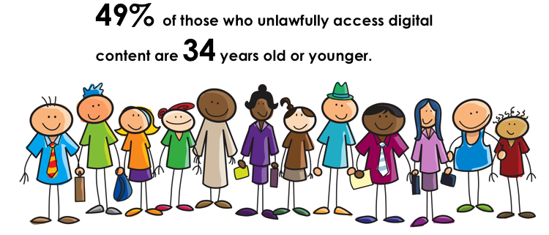

Consumption of unlawful content is slightly higher in males (52%) than females (48%). While 49% of those who unlawfully access digital content are 34 years old or younger, the highest proportion of infringers within any age group was found to be those aged 45 to 54 years of age at 20%. It would be interesting to explore this in more depth next year to ascertain why and see if there is a link between knowledge of streaming services, understanding of how to access them or some other reason for the infringing behaviour.

### Consumption volumes

Consistent with previous years, there has been an increase in consumption volumes of digital content across music, movies and TV programs. Video games experienced a drop in digital consumption volume.

The following figure shows the consumption volumes of digital files in millions (m) for 2018 compared to 2017 across the four core content types.

Figure 5—Consumption volumes of digital files, paid and free, in millions (m) for 2018 compared to 2017.

Figure 5 shows the consumption volume of digital files, paid and free, in millions for 2018 compared to 2017. When extrapolating the survey results across the entire Australian population aged 12+, the incidence of consumers paying for digital content has increased in volume for music, movies and TV programs but declined for video games in 2018, when compared to 2017. The consumption volume of free music has increased significantly from 2017 at 644 million (m) up to 996m in 2018. An increase in consumption volume of free TV programs was also observed from 152m in 2017 up to 171m in 2018 and could be attributed to the numerous free TV program services now available enabling consumers to ‘catch up’ on programs they have missed without the need to source the programs via other unlawful online services.
The consumption volume of free video games has dropped from 27m in 2017 down to 22m in 2018 and warrants further exploration within next year’s survey to see if online subscriptions are the cause and to measure their overall impact. The consumption volume of free movies has also dropped from 79m in 2017 down to 74m in 2018 suggesting subscription services such as Netflix are having an impact.


The increase in consumption volume of free TV programs could be attributed to the numerous free TV program services now available enabling consumers to ‘catch up’ on programs they have missed without the need to source the programs via other unlawful online services.

The consumption volume of free video games has dropped and warrants further exploration within next year’s survey to see if online subscriptions are the cause and to measure their overall impact. The consumption volume of free movies has also dropped suggesting subscription services such as Netflix are having an impact.

The following figure shows the volume of files consumed lawfully and unlawfully in millions (m) and compares the results from 2018 to 2017.

Figure 6—Consumption volume of digital files, lawful and unlawful, in millions (m) for 2018 compared to 2017.

Figure 6 shows the consumption volume of digital files, lawful and unlawful, in millions for 2018 compared to 2017. The incidence of lawful consumption versus unlawful consumption of music showed some interesting results for 2018. The volume of lawful files consumed increased from 1,177m in 2017 up to 1,423m in 2018, but the incidence of unlawful consumption of music also increased. A significant rise was seen from 184m in 2017 up to 292m.
The volume of lawfully consumed video games has shown a decline for the first time since the study began in 2015. It was noted that 45m digital files were consumed lawfully in 2017 and this dropped to 33m in 2018 which also saw an increase in unlawful consumption at 11m, up from 7m in 2017. The volume of lawful consumption of movies remained relatively unchanged at 87m in 2017 compared to 86m in 2018 however there was a significant difference in the volume of unlawfully consumed movies from 53m in 2017 up to 83m in 2018.
The trend identified within movies was also found within the volume of unlawfully consumed TV programs where 53m were noted in 2017 and 122m in 2018, a significant increase. The volume consumption of lawful TV programs dropped from 276m in 2017 to 258m in 2018. 

These finding warrants further exploration and consideration should be given to digital consumers sharing streaming services, such as Netflix, when someone else is paying for the service but not living within the same household. This is not currently captured with the survey questions.

### Consumer spend

Consumer spend was captured within the survey and the following figure shows total spend for each content type, the consumer spend on digital purchases and also on subscriptions. Figures for 2018 have been compared to 2017.

Figure 7—Consumer spend.

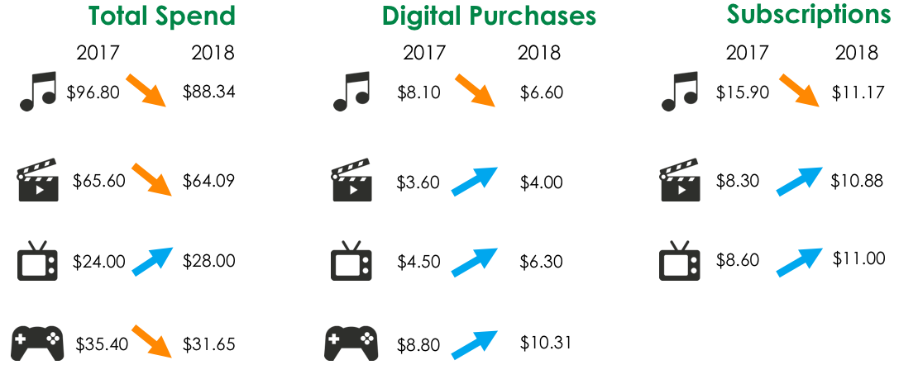

The average consumer quarterly spend among those that are 100% lawful has declined across all four content types, a trend across the last three years for video games and movies and the last two years for music and TV programs. This could be related to a number of different reasons, for instance the pricing of subscriptions may have come down or participants are consuming digital content rather than purchasing a more expensive physical version. Further investigation into this trend is warranted for next year’s survey. The average consumer quarterly spend within those that are a mix of unlawful and lawful has increased over all four content types for the last four years. The increase from 2017 to 2018 is significant for music, movies and TV programs.

The average consumer quarterly spend within those that are 100% unlawful varies across the four content types. An increase in average spend can be observed within music from $84.10 in 2017 to $104.20 in 2018 and also within TV programs from $13.00 in 2017 up to $26.20 in 2018, a significant change. The average spend for video games jumped significantly from $14.70 in 2017 up to $101.60 in 2018. The average spend on movies has dropped significantly from $64.90 in 2017 down to $34.00 in 2018.

There was a greater difference within the average spend on TV programs with 100% lawful at $38.31 and 100% unlawful at $26.20. The greatest and most significant difference can be observed within the average spend on movies where 100% lawful was $81.66 and 100% unlawful was $34.00.

### Price sensitivity

Consumer sensitivity to a single digital music track price has remained relatively steady over the past four years and for 2018. Approximately three quarters (76%) indicated they would pay 69 cents for a single music track, a 2% drop from 2017 (78%) and 74% indicated they would pay 99 cents, an increase of 3% from 2017 (71%). Just over half of digital music consumers (58%) indicated that they would pay up to $1.19 for a single music track, a slight increase from 56% in 2017.

The majority of digital movie consumers indicated that they would be prepared to pay $5 for a single movie download at 71%, an increase of 3% from 68% in 2017. The proportion of digital movie consumers prepared to pay $5 increased from 68% in 2017 to 71% in 2018. Less respondents were prepared to pay $15 or more when compared to 2017.

### Reasons for using paid services and for infringing

The following figures show reasons why consumers use paid services and why some participants choose to consume digital content unlawfully.

Figure 8—Reasons why consumers use paid services.

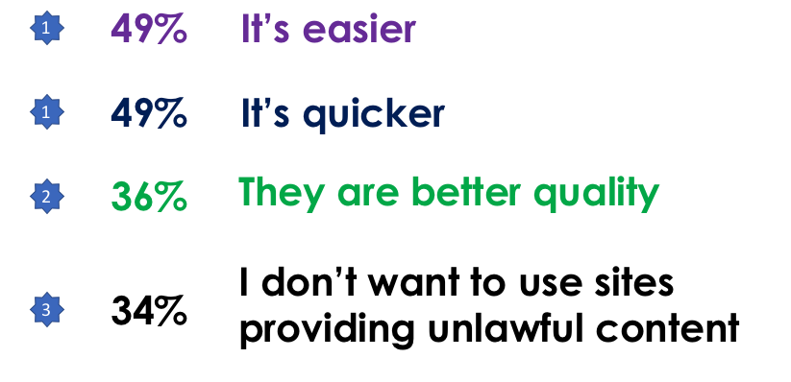

Other results of note included participants selecting to ‘support creators / industry’ dropped from 36% in 2017 down to 29% in 2018. Fear of viruses dropped slightly from 33% in 2017 down to 31% in 2018.

Figure 9—Reasons why participants consume digital content unlawfully.

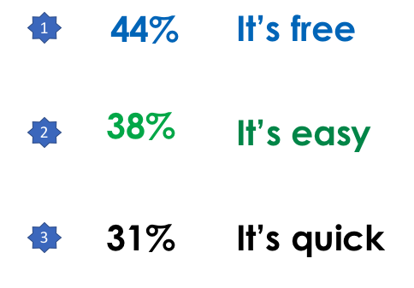

Infringers were less likely to select ‘I don’t think it’s right to get them for free’ (8%), ‘I don’t know how to use the free services’ (6%) or ‘I am unaware of the free services available’ (5%).

In 2017 it was noted that nearly a quarter of those that were 100% unlawful infringers did not realise they were consuming content unlawfully and in 2018, this dropped to 19%.

### What would make infringers stop?

Participants that consumed any unlawful content were asked what would make them stop infringing. The following figure shows the top two responses and the proportion of participants that said nothing would make them stop.

Figure 10—What would make infringers stop?

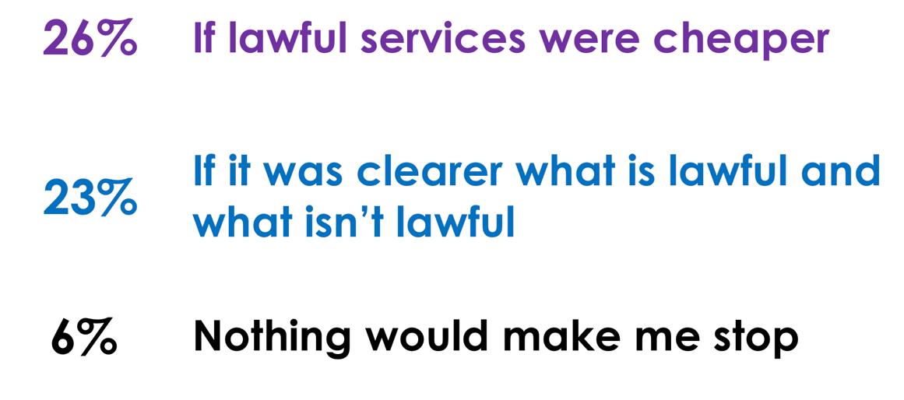

It is interesting to look at the impact of blocking unlawful sites and consumers’ attitudes and actions when encountering a blocked site. When asked what they would do if they encountered a blocked site the majority of respondents (57%) said they would ‘give up’ or ‘seek alternative lawful access’ (34%) but 7% of respondents said they would try to bypass the blocked website. When those that had encountered a blocked website were asked what actions they took, 46% said that they gave up, 19% sought alternative but lawful access and 15% sought free but unlawful access. Less than 1% managed to bypass the blocked website and to achieve this, participants used VPN (30%) or proxy websites (21%). To a lesser degree respondents also used Google Translate (15%) or changed the network proxy in browsers (11%).

### Levels of consumer awareness of lawful services and confidence about what is and is not lawful online

Consumers showed a high level of awareness of lawful or licensed online services with Netflix, YouTube, Foxtel, Stan, iTunes and Spotify all identified by more than 50% of participants. Their confidence in knowing what is and what isn’t lawful online has risen slightly from a combined score of 63% in 2017 up to 66% in 2018. While the majority of participants have been confident over the last four years, confidence is increasing and those indicating that they are not at all confident has decreased by 3% in the last year. It is important to note that 34% are indicating that they are not confident with knowing what is and what is not lawful online. This further emphasises that education is required and potentially an alternative approach to providing consumers with a way to check whether online sites or digital content is lawful or not.

Participants indicated that a number of elements helped them gauge what they perceived as being lawful in terms of online services. Key words frequently used by participants included ‘reputable’, ‘known’, ‘trusted’, ‘secure’, ‘quality’ and ‘recognised’.

## Research overview

### Background

#### The first consumer survey (2015)

Due to a lack of authoritative local data on online copyright infringement, in 2015 the Department of Communications and the Arts commissioned a study to provide baseline data on the prevalence of online copyright infringement in Australia. Creative industries had argued that the move from physical to digital media consumption had increased the risk of copyright infringement, which in turn diminished the economic contribution of these industries. Copyright infringement directly results in a loss of income for businesses in copyright industries. Indirectly, copyright infringement can decrease the incentive to create new content, as creators may be unable to sustain themselves from their incomes. Kantar Public was commissioned to conduct the first consumer survey in March/April 2015, which was intentionally modelled on surveys undertaken in the UK by Kantar Media, enabling direct comparison between Australia’s first survey and the UK’s fifth–wave survey. The first consumer survey provided a holistic view of online copyright infringement in Australia by measuring levels of use (lawful versus unlawful) and levels of access (streaming, downloading and sharing) of four core content types (music, movies, TV programs and video games).

The findings from the research were published in July 2015 and provided a foundation to assess the effectiveness of measures to address online copyright infringement.

The first consumer survey revealed that 26% of internet users had consumed at least one item of online content unlawfully. Additionally, the main reasons consumers provided for infringing included the cost, convenience and speed of accessing unlawful material.

The results also highlighted a lack of awareness of what content is lawful and what is unlawful, with four in ten consumers (43%) not confident in their knowledge regarding what is and is not lawful online.

#### The second consumer survey (2016)

This second survey was commissioned to measure and understand any changes in online content consumption, access and infringement since the first survey in 2015.

The fieldwork for the first survey coincided with the launch of Netflix Australia on 24 March 2015, meaning that it was unable to measure the uptake and impact of Netflix and the other newly‑launched streaming services Stan and Presto to any great extent. The second survey was designed to take the introduction of these services into account.

The results of the 2016 online copyright infringement survey showed an overall decrease in the level of infringement (since 2015) largely due to the increase in the availability of lawful online streaming.

* In 2016, 23% of Australian internet users were accessing unlawful online content, down from 26% in 2015.
* The results indicated pricing and availability of online copyright content, such as streaming services, led to a reduction in infringement.

The *Copyright Amendment (Online Infringement) Act 2015 (Cth.*) (the Act) came into effect in June 2015, after the first survey was conducted. This Act amended the *Copyright Act 1968 (Cth)* to enable rights holders to apply for a Federal Court order requiring an internet service provider (ISP) to block foreign websites that infringe copyright, or facilitate infringement. The second survey was unable to evaluate the effect of the amendments as no orders had been made at that time to block foreign websites.

#### The third consumer survey (2017)

The third consumer survey was commissioned in 2017 to continue to measure and understand any changes in online content consumption, access and infringement since the first survey in 2015, and compared to the results of the second survey in 2016. The third consumer survey was the first survey to measure the impact of website blocking measures on reducing and deterring access to infringing material.

December 2016 saw the first two site blocking cases in the Federal Court decided under the website blocking powers in the Copyright Act. The third consumer survey was designed to understand levels of awareness of these injunctions and what impact these had on infringing behaviour.

The Productivity Commission (PC) reviewed Australia’s Intellectual Property arrangements and the Government released a report detailing the PC’s findings and several recommendations on 20 December 2016. The focus of the PC’s report in terms of the copyright recommendations was that Australia’s copyright arrangements are too heavily skewed in favour of copyright owners. The PC also concluded that the most effective approach to addressing online copyright infringement was through ‘timely and competitively–priced access to copyright–protected works’ (finding 19.1).

The third consumer survey had a continued focus on how market forces are driving consumer behaviour and the effect Government intervention generally has, in order to assist the Government with finding the appropriate balance in terms of copyright protection/enforcement.

The extent that content delivery influences user behaviour, and specifically whether greater consumer access to streaming services continues to reduce rates of infringement, was a key area of interest in the third consumer survey.

#### The fourth consumer survey (2018)

The fourth consumer survey was commissioned in 2018 to continue to measure and understand any changes in online content consumption, access and infringement since the first survey in 2015, and compared to the results of the second (2016) and third (2017) surveys.

The focus of the 2018 survey remained generally unchanged from 2017 with continued attention on the four content types of music, video games, movies and TV programs. The opportunity to understand the broader effect of website blocking and consumer responses to encountering a blocked website were of particular interest.

The increasing availability of lawful digital content via subscription and its impact on consumer behaviour was an interesting aspect of the study.

### Key objectives

The fundamental objectives for this research were to understand the frequency of online copyright infringement among consumers in Australia and how this has changed over the years since the benchmark collected in 2015.

To guide the research, three key questions were developed to provide the overall aims of the research; these focused on current activity and attitudes towards copyright infringement and the role price plays:

1. What is the current level of online copyright infringement among Australian consumers?
2. What are the attitudes that drive online copyright infringement behaviours?
3. What role does pricing play in lawful and unlawful access to online content?

In order to answer these questions, they need to be deconstructed in a way that facilitates the identification of comprehensive insights. The table below illustrates our approach and shows how the survey metrics relate to each objective.

Figure 11—Research objectives and metrics

| Overall Aim | Research Objective | Metrics |
| --- | --- | --- |
| What is the current level of online copyright infringement among Australian consumers? | What is the level of access (streaming, downloading and sharing) of the four core content types among Australian consumers?  What level of use/access for the four core content types is lawful (and what proportion is unlawful)?  How does level of use differ by demographic factors?  How has consumption changed since 2015? | Whether accessed/downloaded/ shared files (past three months) by content type  Frequency per content type  Volume per content type  Proportion of type paid for and free  Proportion of files believed to have been lawfully accessed (from which a figure for unlawful files can be derived) |
| What are the attitudes that drive online copyright infringement behaviours? | What is the level of consumer awareness and knowledge around online copyright infringement?  What are consumer attitudes towards online copyright infringement?  What drives online copyright infringement among consumers?  What would stop consumers from undertaking copyright infringement behaviours?  What is the level of awareness and use of lawful streaming, downloading, and sharing services?  What are the key reasons driving use/non–use of lawful services?  How do knowledge, awareness, and attitudes differ by demographic factors?  How have knowledge and attitudes changed since 2015, and what role have policy measures played? | General attitudes  Key drivers of behaviour  Why people do / don’t infringe  What would make them stop  Awareness / use of lawful services  Reasons why consumers do / don’t use lawful services  Understanding of what is lawful |
| What role does pricing play in lawful and unlawful access to online content? | What is the current level of spend across each of the four core content types?  How does unlawful file sharing impact on purchases across each of the four core content types?  What is the willingness to pay and optimum pricing levels for different content types?  What is the role of demographic factors in willingness to pay?  How have spend levels and willingness to pay changed since 2015, and what role have policy measures played? | Current spend on relevant material  Willingness to pay model |

### Methodology overview

The 2015, and subsequent surveys, were designed to closely replicate the methodology for the UK study so that results between the two jurisdictions could be compared. A key objective of the 2018 consumer survey was to be able to compare results to that of previous years (2015, 2016 and 2017) in order to understand to what extent consumption and attitudes have changed in Australia. In order to enable such a comparison, it was imperative that the survey approach used in 2015, 2016 and 2017 be replicated as closely as possible, including:

* use of the same data collection methodologies;
* conducting fieldwork at a similar time of year;
* asking the same questions using the same questionnaire structure;
* defining target sample, quotas and weighting in the same way to achieve an equivalent representative sample; and
* use of the same data analysis processes.

As in previous years, the approach for the 2018 Australian study comprised a mixed methodology of online interviewing and computer assisted telephone interviewing (CATI). Online interviewing was used to reach respondents who use the Internet at least once a day or more frequently and CATI interviewing was used to reach respondents who use the Internet less often. A total of 2453 interviews were undertaken between 1st March and 21st March 2017 with the target audience for this study being all people aged 12+ in Australia. Of this total, 2,053 interviews were achieved online, 1,892 from people aged 16+ and 161 from people aged 12–15 years old. The remaining 400 interviews were achieved by CATI from people aged 16+. The average length of the interviews was 16 minutes for online and 21 minutes by CATI.

Greater detail of the study methodology can be found in the Appendix.

### Notes for this report

#### Content type and activities assessed

This study sought to provide detailed measurements for four core content types of interest:



It also provided top level measurements for a further two content types, but did not provide detailed measurements for these content types due to restrictions on survey length and these being the two least commonly used of the six types:



The survey asked respondents to think about activities they had undertaken in the past three months, which broadly corresponds to the first quarter (January–March) of 2018.

The questions were primarily focused around three online activities, explained to each respondent as follows:

**Streamed or Accessed**—By this we mean that you viewed, listened or played content directly through the Internet without downloading a copy. For example, watching TV programmes on Netflix or listening to music through services such as Spotify.

**Downloaded**—By this we mean that you transferred a copy of the file to your device. For example, downloading a music track to your computer through iTunes or Amazon.

**Shared**—By this we mean that you made the file publicly available, or sent or uploaded it online for someone else to download or stream/access. For example, sharing files on your computer through an online service. This does not include sharing links online.

These categories all relate to what is termed ‘digital’ content/files. However, certain metrics in this report also incorporate consumer spend attributable to ‘physical’ formats, such as CDs, DVDs, games and cartridges, to help locate the consumption of digital content in its wider context. This report also frequently refers to consumed digital content, by which is meant content that is either streamed or accessed online or is downloaded from the Internet. For most of the content types there are several elements that have the potential to cause confusion and thereby distort the figures if misinterpreted by the respondent. For example, there is a fine line between music tracks and music videos, and there is a distinct difference (in terms of number of digital files) between singles and albums. Similarly, for computer software and video games people may consider updates and patches as products in themselves. Therefore the questionnaire attempted to be as clear to respondents as possible in terms of what they should include in each definition. In addition, music videos and short video clips were asked about separately to aid with the distinctions. The definitions were as follows:

Figure 12—Definition of content types

| Content Type | Definitions for respondent |
| --- | --- |
| Music | Music tracks or albums (excluding online radio stations) and monthly subscriptions |
| Video games | Video games (excluding patches and upgrades) |
| Movies | Movies (full length) |
| TV programs | TV programs |
| e–Books | e–Books |
| Computer software | Computer software (excluding mobile phone apps, and patches / upgrades to software already owned. |

#### Payment and lawfulness

Respondents who had consumed (i.e. streamed or accessed or downloaded) digital content were asked in the survey how much of what they had consumed was paid for and how much was lawful, and from this it is possible to calculate how much was free and how much was unlawful respectively. Payment and lawfulness were explained to respondents as follows:

**Payment**—how many items of digital content did you or someone in your household personally pay for, either as a one off or as part of a subscription.

**Lawfulness**—how many do you think were downloaded or streamed lawfully. Four categories have been used to determine lawfulness.

1. One hundred percent lawful which is where all the digital content consumed is done so lawfully.
2. Mix of lawful and unlawful where the digital content consumed is done both lawfully and also unlawfully by the same respondent.
3. One hundred percent unlawful is where all the digital content consumed is done so unlawfully.
4. Any unlawful represents the respondents that are either within the mix of lawful and unlawful category or the 100% unlawful category (ii and iii combined).
5. As highlighted by the previous surveys, there is a large proportion of the Australian public who are not confident they know what is lawful and what is unlawful in terms of downloading, streaming, accessing and sharing content through the Internet (see Chapter 5). Therefore, in addition to some people being reluctant to admit to engaging in unlawful activities, some people may not be aware that what they are doing is necessarily unlawful, and hence the level of unlawful activity may be under–reported.

#### Key metrics

With respect to assessing levels of copyright infringement for each content category, the approach is consistent throughout the survey, filtering down from general online behaviour towards the potentially sensitive topic of infringement. Within each category, key metrics are reported at two levels:

**Respondent level**—For example, the total number and proportion of the Australian population who undertook an activity such as downloading music; and

**Volume level**—For example, the number of music tracks downloaded in the past three months, or the number of music tracks lawfully obtained.

The key metrics throughout this report are summarised in the following table:

Figure 13—Assessing levels of online infringement

| Topic | Respondent level | Volume level |
| --- | --- | --- |
| General behaviour | 1. Done in the past three months  2. Frequency  3. Median volumes (past three months) among those who have done activity |  |
| Payment | Proportion of the population who fit into the following derived groups in terms of volume of content consumed in the past three months:  1. 100% paid  2. Mix of paid and free  3. 100% free  4. Any free (combination of 2 + 3)  5. 100% already owned in physical format  6. Any already owned in physical format  7. None already owned in physical format  8. 100% previously downloaded for free (% of paid acquisitions across formats)  9. Any previously downloaded for free  10. None previously downloaded for free  As well as the proportions of those who have done the activity in the past three months, metrics 1 to 4 are also reported among the total 12+ internet population, and include median volumes. Metrics 5 to 10 include mean volumes. | Paid and free proportions of total volume (incorporating physical format where relevant) |
| Lawfulness | Proportion of the population who fit into the following derived groups in terms of volume of content consumed in the past three months:  1. 100% lawful  2. Mix of lawful and unlawful  3. 100% unlawful  4. Any unlawful (combination of 2 + 3)  As well as the proportions of those who have done the activity in the past three months, the above metrics 1 to 4 are also reported among the total 12+ internet population and include median volumes. | Lawful and unlawful proportions of total volume (incorporating physical format where relevant) |

Figure 14—Assessing consumer spend on categories and price sensitivity

| Topic | Respondent level | Volume level |
| --- | --- | --- |
| Spend | Proportion of population who have spent anything (and average spend in the past three months) on digital subscriptions, individual digital downloads, physical formats and other related areas such as gigs or cinema. | Total volumes and proportions of overall spend |
| Price sensitivity | Willingness to pay (music and movies only)  For consuming individual files via a download service  For a subscription service (monthly charge) |  |

#### Significant differences by year and by subgroup

For each category the report details the main findings from 2018 and compares them with the results from 2015, 2016 and 2017.

The report also details significant differences of interest (at the 95% confidence level) among the following groups:

Figure 15—Subgroups of interest

| Category | Subgroups |
| --- | --- |
| Gender | Male, Female |
| Age | 12–15, 16–25, 25–34, 35–44, 45–54, 55+ |

### Changes to the 2018 survey instrument compared to 2017

1. Question S4: Are you (male / female).

Option of ‘other’ added.

1. Question 1: Do you have any of the following?

Option of ‘Internet at home through a set top box or dongle e.g. Apple TV, Google Chromecast’ added.

Question 2: Do you personally use any of the following devices?

Option of ‘An internet connected set top box or dongle e.g. Apple TV, Google Chromecast’ added.

1. Question 5: Through which of the following ways, if any, do you receive television in your household? Please think about all the TV sets in your household?

Option of ‘Presto’ deleted—‘Subscription internet–based TV streaming services through Netflix, Foxtel Now, Quickflix, Stan, etc.’

1. Question 11: For these activities (SHOW ACTIVITIES SELECTED AT Q7 AND Q10), which of the following connections do you regularly use to download or access content?

Options of ‘Fixed wireless’ and ‘Satellite’ added.

1. Question 15: And approximately how much do you personally spend each month on music subscription services such as Spotify or Apple Music (do not include music videos accessed through a TV service subscription or through free online sites such as YouTube).

Options of ‘Pandora’ and ‘Rdio’ deleted.

Option of ‘Apple Music’ added.

1. Question 31: Approximately how much have you personally spent on the following in the past three months? Please include money spent on gifts for other people (where you didn't expect them to pay you back).

Option of ‘Video games downloaded or accessed online e.g. through services such as Steam, Xbox Live or PlayStation Plus’ added.

1. Question 32: Deleted from survey.
2. Question 44: Options reworded.

d. Movies bought/rented and streamed/accessed or downloaded individually using an internet connection.

e. Online Movie and TV programme subscription services e.g. Netflix or Stan.

f. Movies purchased individually through your Pay TV service via Pay–per–view e.g. Foxtel or Fetch TV.

1. Question 59: Option reworded.

d. Online movie and TV programme subscription services e.g. Netflix or Stan

1. Question 66: Reworded, ‘tape’ deleted.

How many TV programmes do you think you have personally bought or rented on disc in the past three months?

1. Question 71: Reworded.

Other than the services previously stated, what other online services are you aware of to download, stream or share content?

1. Question 73: Reworded

You indicated that you downloaded or streamed content in the past three months. Generally, what would you say are your personal reasons for downloading or streaming these types of files rather than buying a physical version such as a CD, DVD, Blu–ray, paper (books), etc.?

1. Insert new question ‘Q85’ (between Q74 and Q81)

Instructions: Ask all with access to internet [those that did not select code 98 or 99 in Q1 and excluding Q74=16]

Have you encountered a blocked site in the past three months?

Yes / No / Don’t know

1. Question 81: New instructions and question reworded.

Instructions: Ask all who haven’t downloaded or streamed in the past three months because the site has been blocked CODE 16 at Q74 and those that have encountered a blocked site in the past three months CODE 1 Q85.

You indicated that you have encountered a blocked site in the past three months. Which of the following best describes what you did in this instance?

Response options stay the same.

1. Question 83: New instructions.

Ask all with access to internet (those that did not select code 98 or 99 in Q1).

Reminder of the question to stay the same.

1. Question 78: Option reworded.

If my Internet Service Provider sent me a letter informing me my account had been used to download or stream files unlawfully.

## Digital content consumption

### Digital behaviour among internet users aged 12+ across all content types

The consumption of each content type of digital content across internet using respondents is shown in the following Figure. The ‘any of the 6 categories’ represents the aggregate scores of content consumers. It is important to note that each respondent is only counted once when they consume content, for example if someone downloaded and streamed both music and movies, they would only be counted once within the overall population.

Figure 16—Digital behaviour in the last three months amongst internet users aged 12+ for all content that has been downloaded, streamed or shared.

Figure 16: Digital behaviour in the last three months amongst internet users aged 12+ for all content that has been downloaded, streamed or shared. Results are shown fr the years 2015 to 2018. Music has changed from 42% to 39% to 44% to 43%. Video games has changed from 16% to 16% to 18% to 20%. Movies has changed from 29% to 33% to 39% to 47%. TV programs has changed from 38% to 42% to 45% to 50%. e-Books has changed from 15% to 14% to 16% to 15%. PC software has changed from 23% to 21% to 23% to 32%. Consumption across any of the 6 categories has changed from 65% to 66% to 69% to 78%.


Source: Q7 Have you streamed or accessed any of the following through the Internet in the past three months? Q10 Have you downloaded any of the following through the Internet in the past three months? Q13 Have you shared any of the following through the Internet in the past three months?

The consumption of digital content by internet users has increased by 9% in 2018, to a total of 78%, when compared to 2017, at 69%. Over the course of the research which began in 2015, there has been a steady increase from 65%, however the increase reported this year is significantly higher than previous years.

Consumption of PC software, movies and TV programs have experienced the greatest increase. PC software was most significant with a rise from 23% in 2017, to 32% in 2018, movies increased from 39% in 2017, to 47% in 2018, and TV programs increased from 45% in 2017, to 50% in 2018.

The consumption of music and e–Books has remained relatively steady and consumption of video games has experienced a slight increase of 2% from 18% in 2017 to 20% in 2018.

There was little difference within the genders in relation to the consumption of music, movies or TV programs. There were notable differences, however, in consumption across the genders in relation to video games with males significantly more likely to stream (73%) than females (27%). This trend was also found within streaming computer software with males at 60% and females at only 40%. Females were more likely to download e–Books at 55% than males at 45%.

Streaming digital content in the last three months was an activity most popular across the age groups of 16–24 at 90% and 25–34 at 89%. This was followed by 12 to 15 year olds at 82% and 35 to 44 year olds at 76%. Of those aged 45 to 54, 52% streamed digital content and of the respondents aged 55 years and older, 5% streamed.

With an understanding of digital consumption overall, the following Figures highlight consumption of each content type and provides a breakdown of the proportion of consumers who download, stream or access, share or a combination of these.

Figure 17—Music: digital behaviour in the last three months among internet users aged 12+

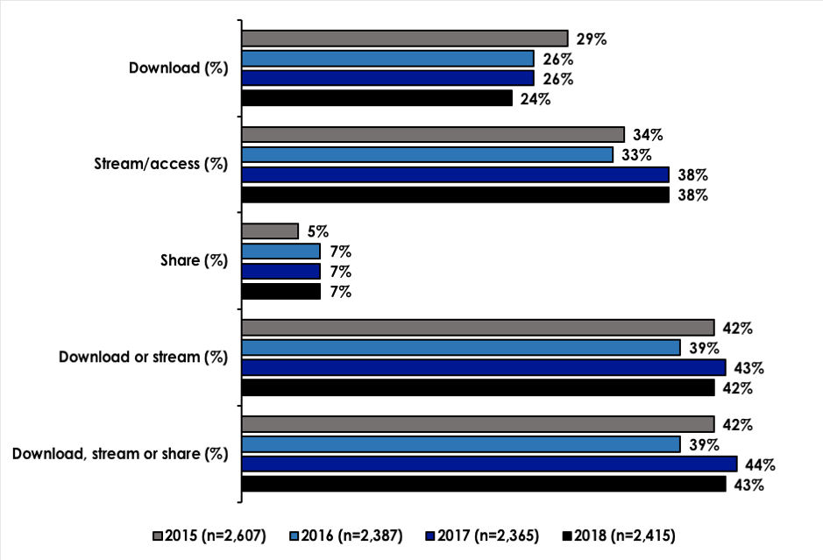

Source: Q7 Have you streamed or accessed any of the following through the Internet in the past three months? Q10 Have you downloaded any of the following through the Internet in the past three months? Q13 Have you shared any of the following through the Internet in the past three months?

There has been a slight drop in the downloading of music from 26% in 2017, to 24% in 2018. Streaming or accessing music remains unchanged at 38% and sharing of music also remains unchanged at 7%.

When looking collectively at downloading and streaming or accessing music, there is only a 1% difference between 2017 at 43% and 2018 at 42%. This trend continues when looking at all digital activity for music, downloading, streaming or accessing and sharing with only a 1% drop from 44% in 2017 to 43% in 2018.

Overall, the proportion of internet users who stream or access music (38%) is significantly higher than those who download music (24%). Sharing music has remained steady at 7% for the past three years.

Figure 18—Video games: digital behaviour in the last three months among internet users aged 12+

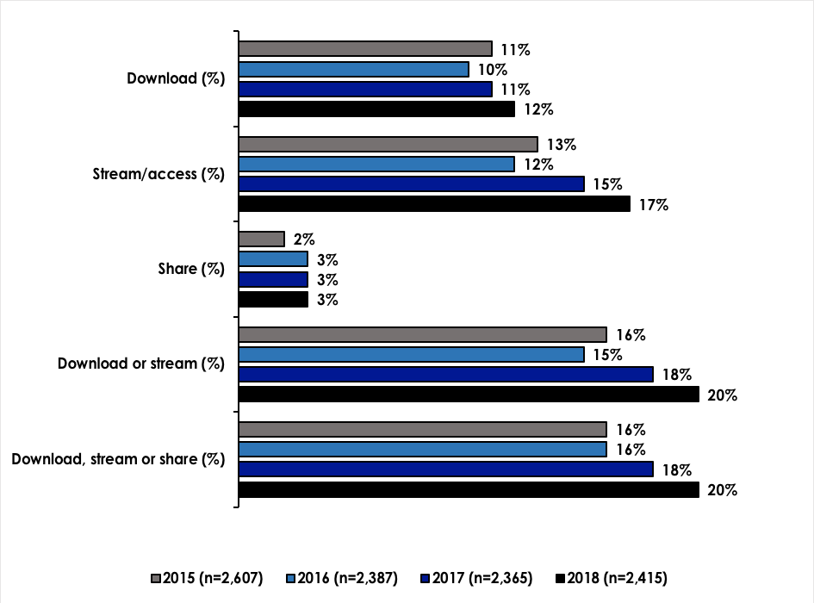

Source: Q7 Have you streamed or accessed any of the following through the Internet in the past three months? Q10 Have you downloaded any of the following through the Internet in the past three months? Q13 Have you shared any of the following through the Internet in the past three months?

The digital consumption of video games has seen a steady increase over the past four years. Downloading has increased slightly from 11% in 2017 to 12% in 2018. Streaming or accessing has increased slightly more by 2% from 15% in 2017 to 17% in 2018. Sharing has remained steady at 3%.

When looking collectively at downloading and streaming or accessing, there is only a slight increase of 2% from 18% in 2017 to 20% in 2018. This trend continues when looking at all digital consumption of video games, downloading, streaming or accessing and sharing with a 2% increase from 18% in 2017 to 20% in 2018.

Overall, the proportion of internet users who stream video games (17%) remains higher than those who download (12%). Across the four years, downloading has remained relatively steady with a variation of only 1–2%. Streaming or accessing video games has experienced steady growth from 13% in 2015 to 17% in 2018. Sharing has remained steady at 3% for the past three years.

Figure 19—Movies: digital behaviour in the last three months among internet users aged 12+

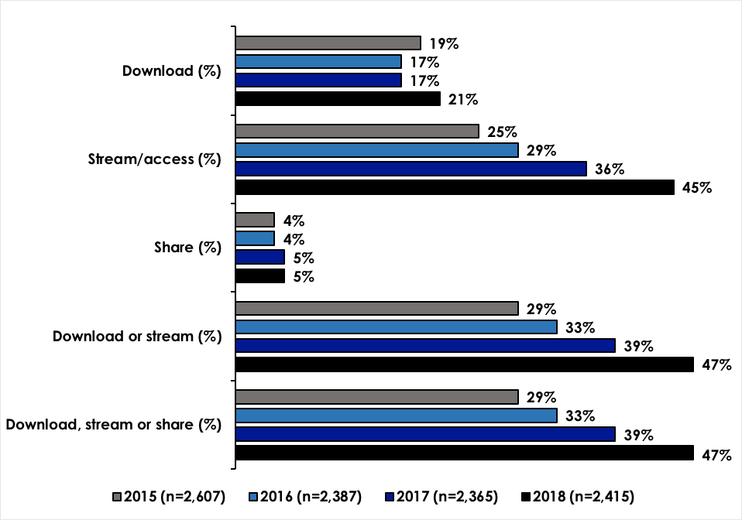

Source: Q7 Have you streamed or accessed any of the following through the Internet in the past three months? Q10 Have you downloaded any of the following through the Internet in the past three months? Q13 Have you shared any of the following through the Internet in the past three months?

The digital consumption of movies has seen a significant increase over the past four years. Streaming or accessing digital movies has increased significantly from 25% in 2015 to 45% in 2018. Downloading digital movies has also experienced a jump in activity from 17% in 2017 to 21% in 2018. Sharing, however, has remained unchanged from 2017 to 2018 at 5%.

When looking collectively at downloading and streaming or accessing, there is a significant increase across all four years, with the highest increase between 2017 at 39% to 2018 at 47%. This trend continues when looking at all digital consumption of movies, downloading, streaming or accessing and sharing with an 8% increase from 39% in 2017 to 47% in 2018.

Figure 20—TV: digital behaviour in the last three months among internet users aged 12+

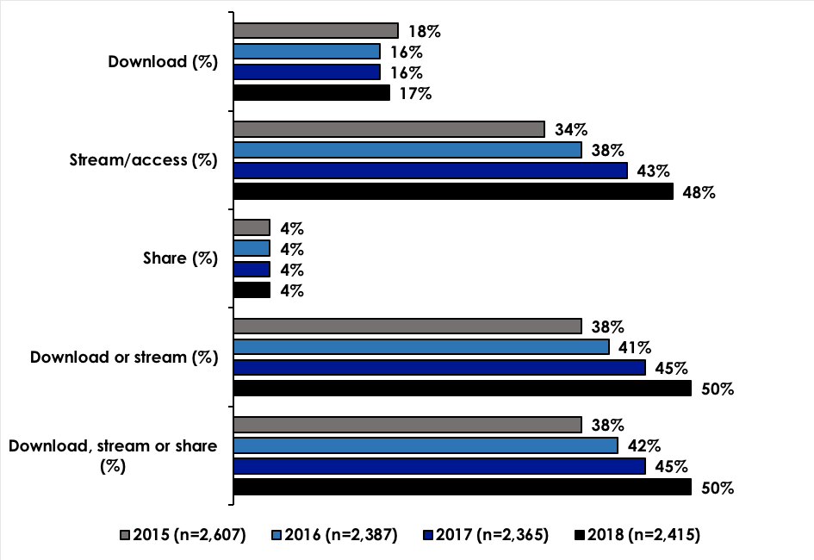

Source: Q7 Have you streamed or accessed any of the following through the Internet in the past three months? Q10 Have you downloaded any of the following through the Internet in the past three months? Q13 Have you shared any of the following through the Internet in the past three months?

The digital consumption of TV programs has seen a significant increase over the past four years. Streaming or accessing TV programs has increased most significantly from 34% in 2015 to 48% in 2018. Downloading TV programs has remained relatively steady at 17% in 2018, compared to 16% for both 2016 and 2017. Sharing, however, has remained unchanged from 2015 through to 2018 at 4%.

When looking collectively at downloading and streaming or accessing, there is a steady increase across all four years, with 38% in 2015 through to 50% in 2018. This trend continues when looking at all digital consumption of TV programs, downloading, streaming or accessing and sharing.

Figure 21—e–Books: digital behaviour in the last three months among internet users aged 12+

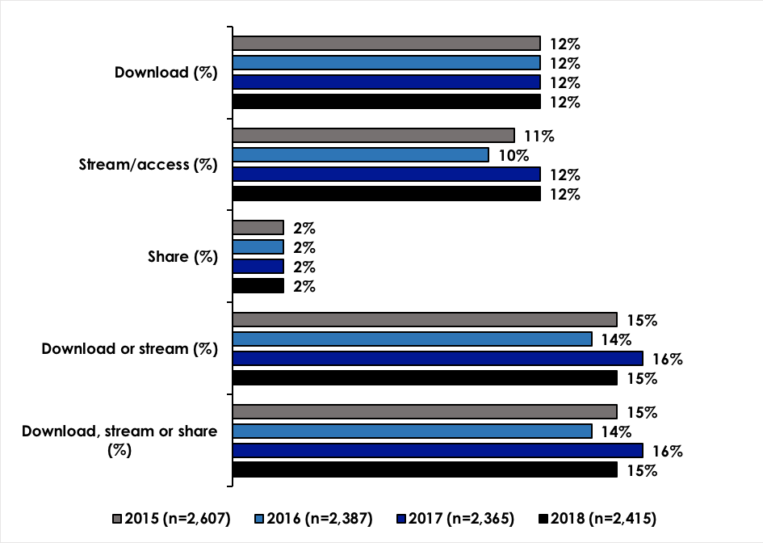

Source: Q7 Have you streamed or accessed any of the following through the Internet in the past three months? Q10 Have you downloaded any of the following through the Internet in the past three months? Q13 Have you shared any of the following through the Internet in the past three months?

The consumption of e–Books, has remained very steady throughout the four years of data collection. The proportion of content consumers who download e–Books remains unchanged at 12%, those streaming or accessing also remains steady at 12% and sharing unchanged at 2%.

Figure 22—PC software: digital behaviour in the last three months among internet users aged 12+

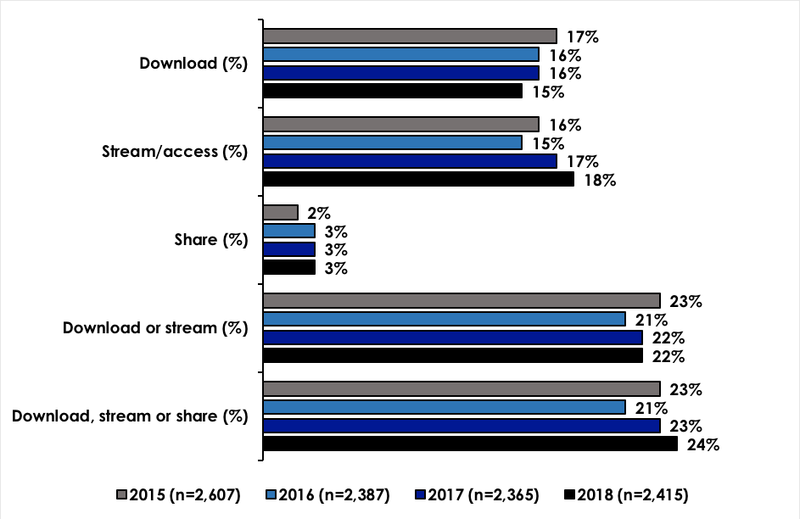

Source: Q7 Have you streamed or accessed any of the following through the Internet in the past three months? Q10 Have you downloaded any of the following through the Internet in the past three months? Q13 Have you shared any of the following through the Internet in the past three months?

The digital consumption of PC software has also remained relatively consistent over the past four years. Downloading has experienced a drop from 17% in 2015 to 15% in 2018. Streaming or accessing has experience a slight increase from 16% in 2015 to 18% in 2018. Sharing has remained consistent for the past three years at 3%.

Looking across PC software consumption, there is only a 1% increase from 23% in 2017 to 24% in 2018.

#### Connection used to consume digital content

Consumers have a number of different options providing access to digital content. Fixed line, mobile network and public Wi–Fi have been considered in previous surveys and in 2018 the options of fixed wireless and satellite have been added.

Participants who had consumed (streamed or accessed or downloaded) any content in the past three months were found to have utilised the following digital connections:

* Fixed line was utilised by 72% of participants. This is a drop in previous years where 2017 noted 82%, 2016 83% and 2015 77%. This result could be linked to the increased use of NBN and/or an understanding of terminology. Consideration to the wording of the question is warranted for any following studies.
* Connection to mobile networks has remained steady at 40% in 2018 when compared to 2017 (40%).
* A slight decrease has been noted in the use of public Wi–Fi from 13% in 2017 to 12% in 2018.
* Consumers were asked about their connection to fixed wireless for the first time in 2018 and it was found that 18% reported using a fixed wireless connection.
* Consumers were also asked about connection to digital content via satellite for the first time in 2018, it was found that 2% reported using a satellite connection.

#### Frequency of consuming digital content

Digital content consumers who downloaded, streamed or accessed, or shared any of the four core content types (music, video games, movies and TV) were asked how frequently they engaged in digital consumption for each content type.

#### Frequency of downloading digital content

The following Figure shows the number of participants who downloaded each type of digital content and the percentage of participants who downloaded at least once a week.

Figure 23—Proportion of consumers downloading digital content on a weekly basis

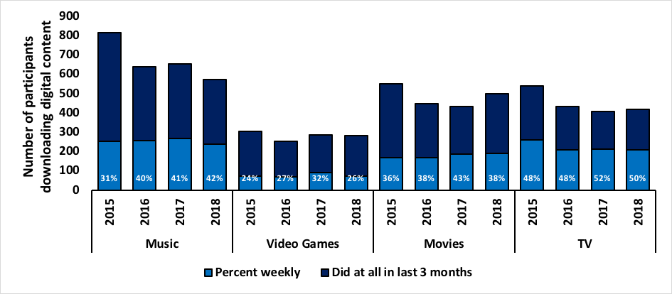

Source: Q10 Have you downloaded any of the following through the Internet in the past three months? Q16 Q33, Q45 and Q60 Generally, how often do you download (music tracks or albums/Video games/Movies/TV programs) through the Internet? Respondents were provided with the options of ‘most days’, ‘2–3 times a week’, ‘about once a week’, ‘every 2–3 weeks’, ‘about once a month’, ‘less often’ and ‘don’t know’. The Figure represents respondents that selected ‘most days’, ‘2–3 times a week’, ‘about once a week’.

Changes can be observed in consumer behaviour in relation to downloading digital content on a weekly basis. Consumers downloading music has remained relatively unchanged from 41% in 2017 to 42% in 2018, however there has been a drop in downloading of video games on a weekly basis from 32% in 2017 to 26% in 2018. This trend continues with weekly downloading of movies from 43% in 2017 to 38% in 2018. The downloading of TV programs on a weekly basis has experienced a 2% decline from 52% in 2017 and 50% in 2018.

#### Frequency of streaming digital content

Figure 24—Proportion of consumers streaming or accessing digital content on a weekly basis

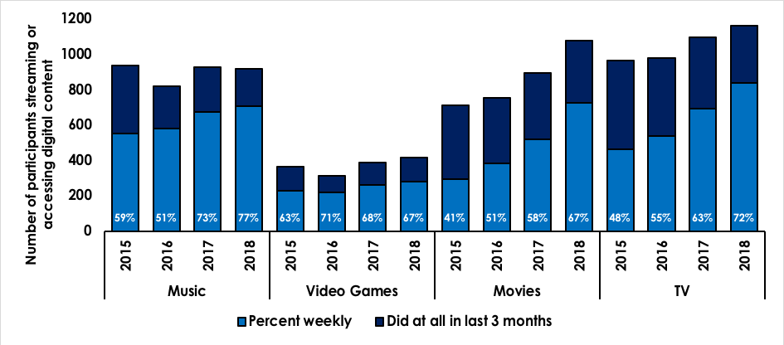

Source: Q7 Have you streamed or accessed any of the following through the Internet in the past three months? Q17 Q34, Q46 and Q61 Generally, how often do you stream or access (Q17 music tracks or albums Q34 Video games Q46 Movies Q61 TV programs) without downloading through the Internet? Respondents were provided with the options of ‘most days’, ‘2–3 times a week’, ‘about once a week’, ‘every 2–3 weeks’, ‘about once a month’, ‘less often’ and ‘don’t know’. The Figure represents respondents that selected ‘most days’, ‘2–3 times a week’, ‘about once a week’.

An increase in streaming of digital content can be observed across three of the four core content types. The most significant increase can be seen with streaming of TV programs where growth has been observed across the last four years from 48% in 2015 up to 72% in 2018. Movies has also experienced a steady increase in streaming from 41% in 2015 up to 67% in 2018. Music streaming has increased from 73% in 2017 to 77% in 2018. The streaming of video games, however, is steady with a slight decrease of 1% from 68% in 2017 to 67% in 2018.

#### Frequency of sharing digital content

Figure 25—Proportion of consumers sharing digital content on a weekly basis

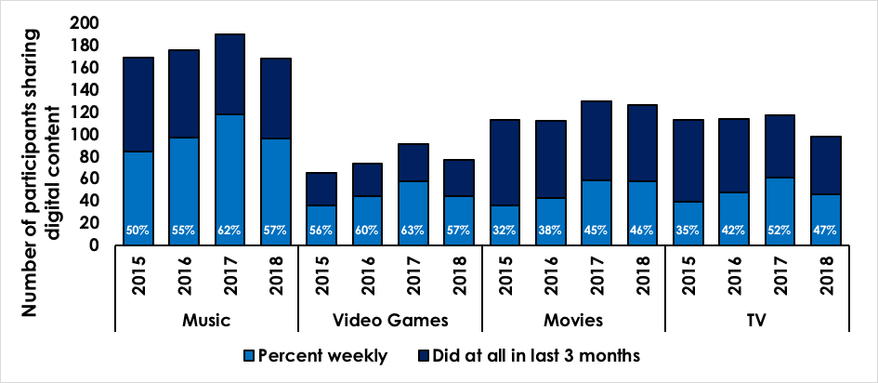

Source: Q13 Have you shared any of the following through the Internet in the past three months? Q18 Q35 Q47 Q62 Generally, how often do you share (Q18 music tracks or albums Q35 Video games Q47 Movies Q62 TV programs) through the Internet? Respondents were provided with the options of ‘most days’, ‘2–3 times a week’, ‘about once a week’, ‘every 2–3 weeks’, ‘about once a month’, ‘less often’ and ‘don’t know’. The Figure represents respondents that selected ‘most days’, ‘2–3 times a week’, ‘about once a week’.

The sharing of music has seen a significant drop of 5% from 62% in 2017 down to 57% in 2018. The sharing of video games also experienced a significant drop of 6% from 63% in 2017 down to 57% in 2018. The sharing movies experienced an increase of 1% from 45% in 2017 up to 46% in 2018. Sharing TV programs experienced a significant 5% drop from 52% in 2017 down to 47% in 2018.

#### Median volumes of files consumed

The following Figures show the median volumes of files downloaded, streamed or accessed or shared in the past three months for each of the four core content types. The median has been used in place of mean in previous years’ surveys due to the individual respondents consuming or sharing very large numbers of files, which caused a distortion on the figures and it was determined that the median value provided a more accurate indication.

Figure 26—Median number of files downloaded

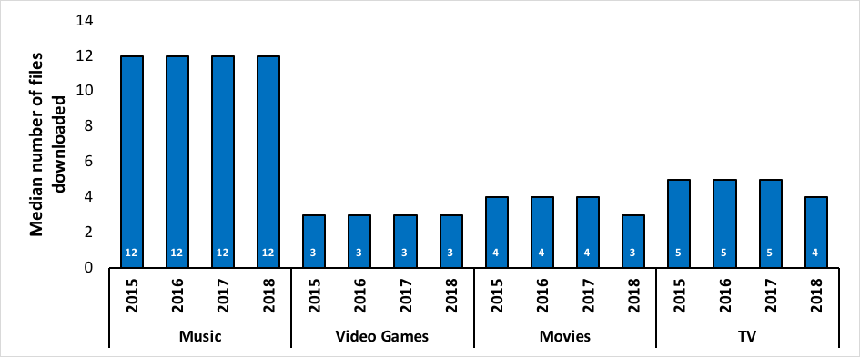

Source: How many (Q19 music tracks or albums Q36 Video games Q48 Movies Q63 TV programs) have you downloaded online in the past three months?

The Figure shows that the median number of music files (12) and video games (3) that have been downloaded has remained unchanged for the past four years. There is a slight decrease in the median downloaded files for movies, from 4 in 2017 to 3 in 2018 and also for TV programs, 5 in 2017 and 4 in 2018.

Figure 27—Median number of files streamed or accessed

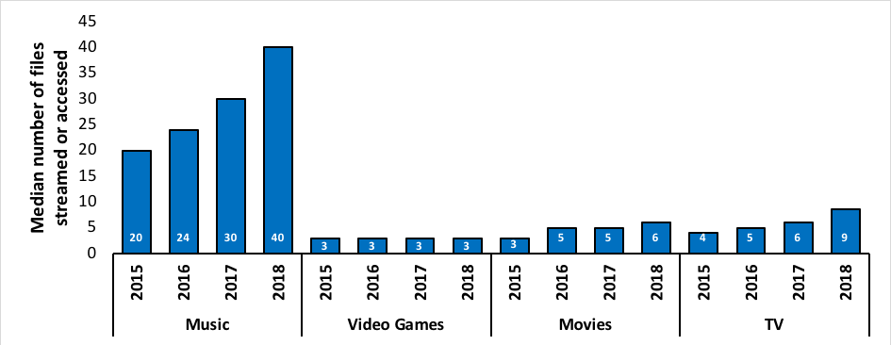

Source: How many (Q20 music tracks Q37 Video games Q49 Movies Q64 TV programs) have you streamed or accessed online in the past three months?

The median number of music files streamed or accessed has increased significantly from 30 in 2017 up to 40 in 2018. An increase was also observed with TV programs, from 6 in 2017 up to 9 in 2018, and movies from 5 in 2017 up to 6 in 2018. The median number of video game files streamed or accessed has remained steady at 3 for the past four years.

Figure 28—Median number of files shared

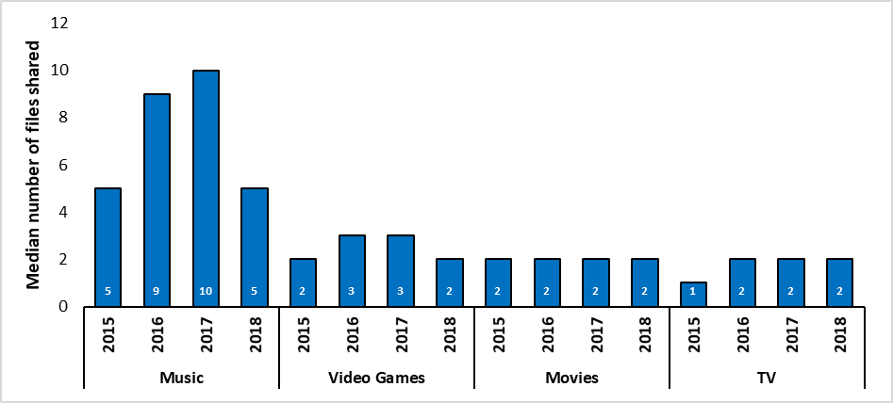

Source: How many (Q22 music tracks or albums Q38 Video games Q50 Movies Q65 TV programs) have you shared online in the past three months?

The median number of files shared across the four core content types varies. There has been a significant drop in music from 10 in 2017 down to 5 in 2018. A drop was also observed in the median number of video game files shared from 3 in 2017 down to 2 in 2018. The median number of files shared across movies and TV programs remained consistent between 2017 and 2018 at 2 for each.

#### Services used to consume digital content

The following Figures show the incidence of the top services used in the past three months to consume or share each of the four core types of content.

Figure 29—Services used to consume music

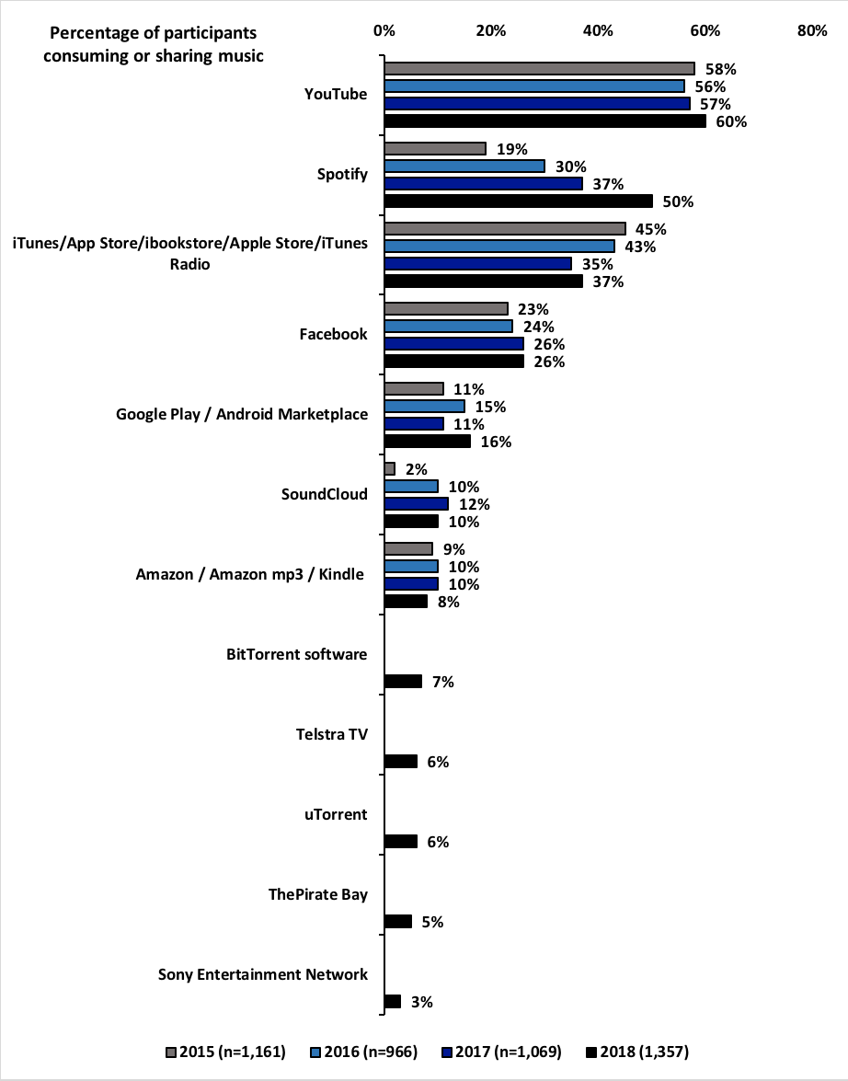

Source Q24 Which sites or services have you used in the past three months to download, stream or access, or share music tracks or albums through the Internet? Respondents were provided with an extensive list of sites and services (appendix).

In 2018, digital content consumers used an average of three services to consume or share music with the most popular being YouTube (60%) then Spotify (50%) and iTunes (37%). Facebook held firm with 26%, the same as 2017. Google Play experienced a significant increase from 11% in 2017 up to 16% in 2018.

In comparison to 2017, YouTube experienced a slight increase from 57% to 60% and iTunes from 35% up to 37%. Spotify experienced a significant increase from 37% in 2017 up to 50% in 2018.

The popularity of YouTube has remained consistent over the past four years, however, Spotify is increasing significantly in popularity each year. The age group of 16–24 is more likely to use Spotify (28%) than YouTube (22%). Within the age group of 25–34 both Spotify and YouTube are just as popular with 25% and 26% respectively. iTunes remains more popular with those aged 35‑44 (23%) and also those aged 45–54 (12%). There was no difference between genders as was reported in 2017, which is potentially related to the increasing popularity of Spotify across the responding population.

Figure 30—Services used to consume video games

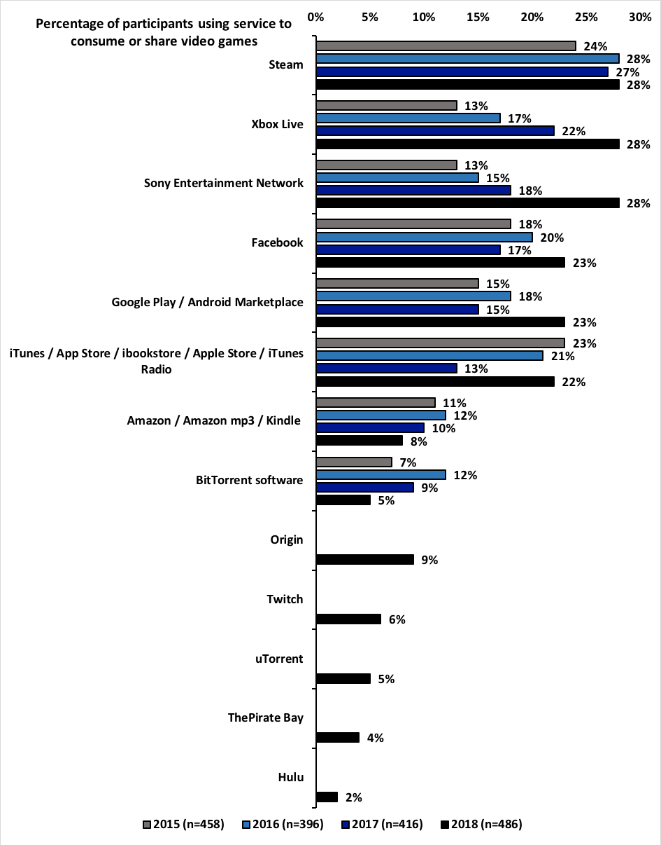

Source Q40 Which sites or services have you used in the past three months to download, stream or access, or share video games through the Internet? Respondents were provided with an extensive list of sites and services (appendix).

In 2018, digital consumers of video games used an average of four services to consumer or share. Steam, Xbox Live and Sony Entertainment Network were the most popular services and equal in use at 28% each. While Steam has maintained similar use in 2018 (28%) since last year at 27% both Xbox Live and Sony have experienced a significant growth in popularity. Xbox Live has grown over the past four years from 13% in 2015 up to 28% in 2018. Sony has experienced its greatest growth between 2017 at 18% up to 28% in 2018.

Facebook was also a popular service with 23% and Google Play also represented 23%. iTunes was only behind by 1% at 22%.

Within the age groups, Steam is most popular with those aged 16–24 (34%) and 25–34 (31%). Xbox Live is most popular with 12–15 year olds (20%), 16–24 year olds (34%) and 25–34 year olds (31%). Facebook is most popular with those aged 16–24 (26%) and 25–34 (26%) in relation to consuming or sharing video games. Facebook is also the most popular service for those aged 45 and over (10%).

Figure 31—Services used to consume movies

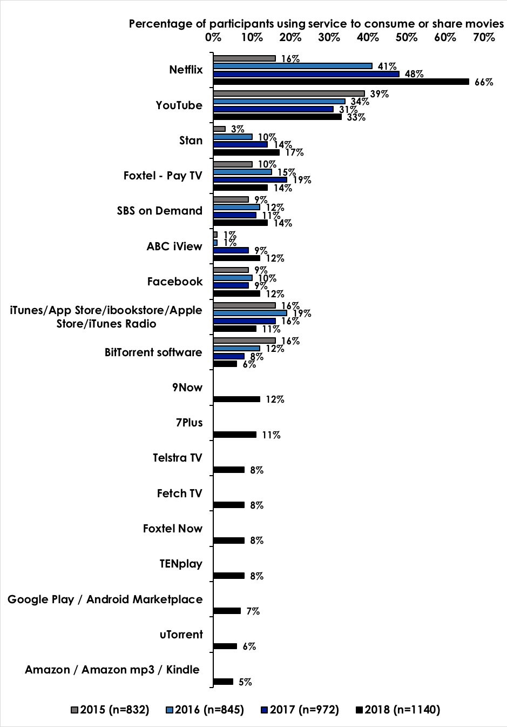

Source Q52 Which sites or services have you used in the past three months to download, stream or access, or share movies (full length) through the Internet? Respondents were provided with an extensive list of sites and services (appendix).

The availability of Netflix continues its popularity in 2018 with another significant leap in use as a source for consuming movies. From 16% in 2015 up to 66% in 2018, Netflix is clearly the most popular service providing movies in Australia. The next most popular is YouTube with 33%, which remains largely unchanged from last year (31%). Stan has experienced slight growth from 14% in 2017 to 17% in 2018. Foxtel Pay TV has declined in popularity from 19% in 2017 down to 14% in 2018.

Within the age groups, Netflix is most popular within 16–24 (22%), 25–34 (23%) and 35–44 (22%). YouTube is the most popular service for those aged 12–16 (10%) and also those aged 45–54 (14%). Foxtel Pay TV is still popular across most age groups 16–24 (18%), 25–35 (22%), 35–44 (18%), 45–54 (12%) and also 55+ (15). This service has been around for a while and these results are not surprising, especially Foxtel Pay TV’s popularity with older age groups. There was no significant difference between genders.

Figure 32—Services used to consume TV

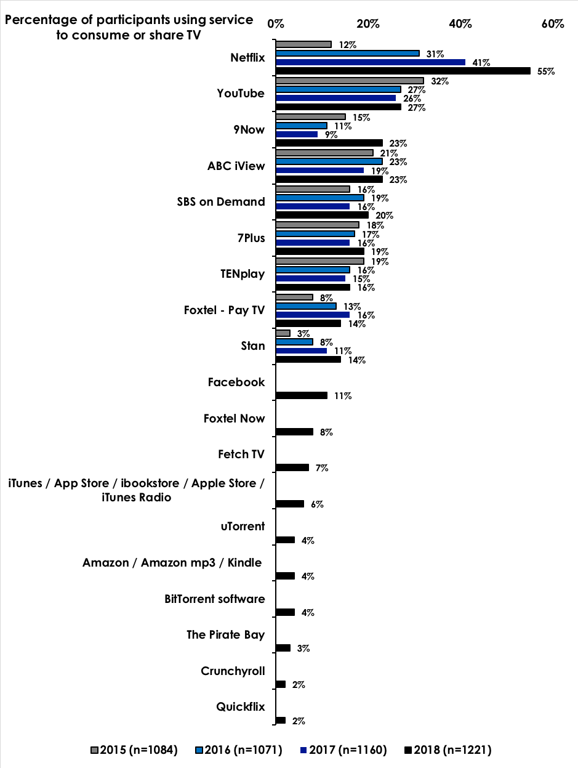

Source Q67 Which sites or services have you used in the past three months to download, stream or access, or share TV programs through the Internet? Respondents were provided with an extensive list of sites and services (appendix) Note: A number of other sites or services were provided as an ‘other’ response. Band camp received 4 mentions, Apple Music 3, Deezer and IHeartRadio were each mentioned twice and other sites or services were only noted once each.

In a similar trend to the consumption of movies, the use of Netflix to consume and share TV programs has grown exponentially, from 12% in 2015 up to 55% in 2018. YouTube retains second position with 27% which is similar to last year’s result of 26%.

The popularity of Netflix among age groups is very similar to that for movies. There is a slight difference in gender with more females (53%) using Netflix to consume TV programs, than males (47%).

The various TV network offerings have either experienced stability in their popularity or growth. 9Now has experienced significant growth from 9% in 2017 to 23% in 2018.

### Payment groups

Digital consumers were categorised into payment groups according to the proportion of digital content they have paid for, either personally of by someone in their household. The following Figures show the incidences for each payment group in terms of the content accessed in the past three months, across two different bases:

* Base 1—all who downloaded or streamed/accessed each content type in the past three months
* Base 2—all internet users aged 12+

Figure 33—Proportion of digital consumers who consumed only paid content (no free content)

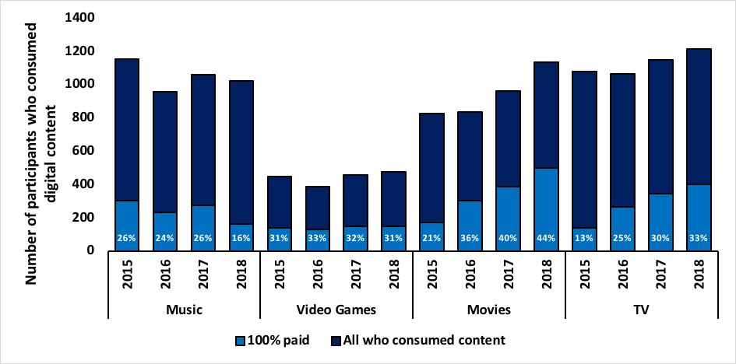

Source: multiple sources including M1, M2, M3, M4, V1, V2, V3, V4, F1, F2, F3, F4, T1, T2, T3 and T4.

The Figure shows that the proportion of digital consumers who paid 100% to consume digital music dropped significantly from 26% in 2017 down to 16% in 2018. The proportion of people who pay 100% to consume video games remained mostly steady at 31% for 2018 compared to 32% for 2017, a consistent tend over the past four years. For both movies and TV programs, there was consistency in the trend across the past four years with an increase in the proportion of consumers who paid 100%. For movies that was from 40% in 2017, up to 44% for 2018 and for TV programs it was 30% last year to 33% for 2018.

Figure 34—Proportion of all internet users 12+ who consumed only paid content (no free content)

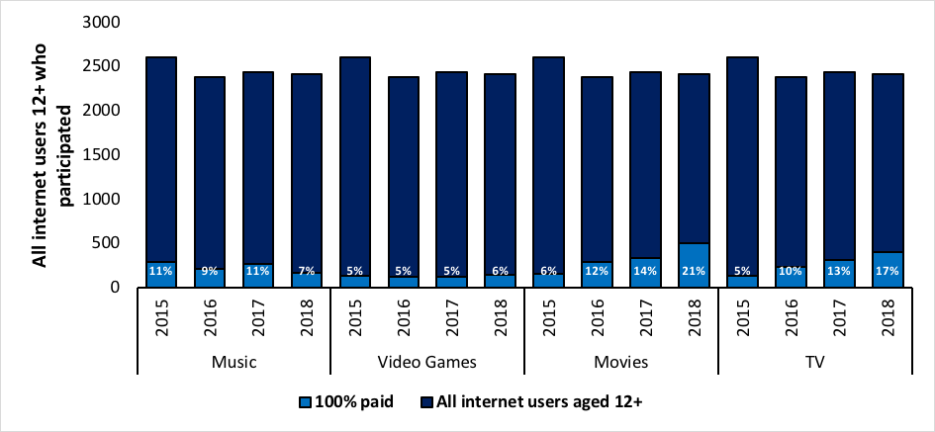

Source: multiple sources including M1, M2, M3, M4, V1, V2, V3, V4, F1, F2, F3, F4, T1, T2, T3 T4, Q7 Have you streamed or accessed any of the following through the Internet in the past three months? Q10 Have you downloaded any of the following through the Internet in the past three months? Q13 Have you shared any of the following through the Internet in the past three months?

In addition to looking at digital content consumers, the results were applied to all internet users aged 12+ who participated in the research for 2018. Movies has the highest proportion of consumers who paid 100% at 21% followed by TV at 17%, music had 7% and video games 6%.

Figure 35—Proportion of digital consumers who consumed both paid for and free content

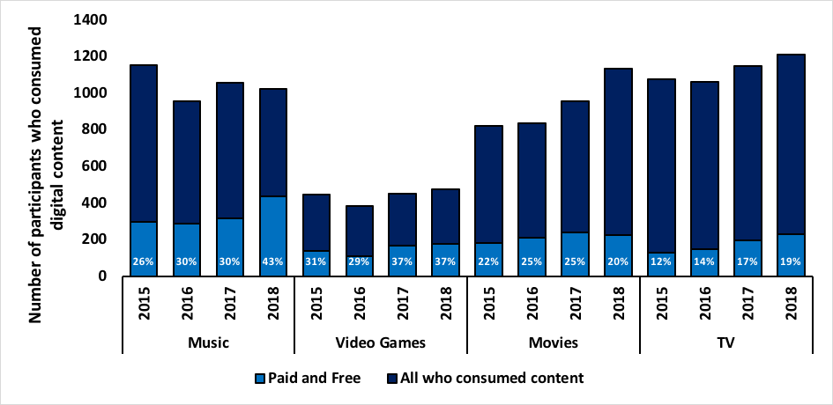

Source: multiple sources including M1, M2, M3, M4, V1, V2, V3, V4, F1, F2, F3, F4, T1, T2, T3 and T4.

It is interesting to compare the consumption of digital content across the four content types in relation to consumers that paid for some content and got some for free. There is a significant proportion of music consumers in this category with 43% which also represents the greatest difference from the 2017 results where only 30% were noted. In comparison, the consumers of video games (37%), movies (20%) and TV programs (19%) were all steady with results from previous years despite an increase in consumption noted in 2018.

Figure 36—Proportion of all internet users 12+ who consumed both paid for and free content

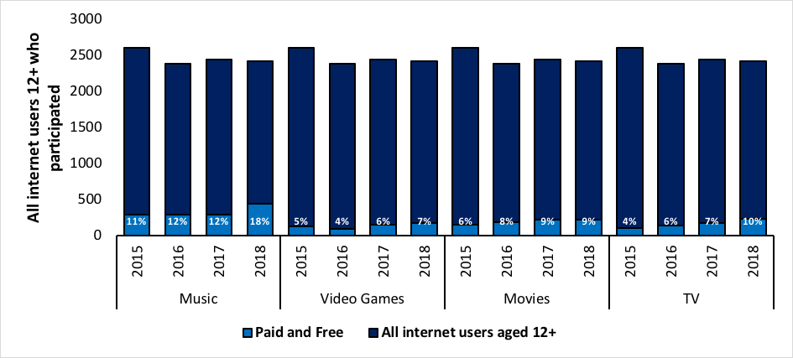

Source: multiple sources including M1, M2, M3, M4, V1, V2, V3, V4, F1, F2, F3, F4, T1, T2, T3 T4, Q7 Have you streamed or accessed any of the following through the Internet in the past three months? Q10 Have you downloaded any of the following through the Internet in the past three months? Q13 Have you shared any of the following through the Internet in the past three months?

When applying the results to all internet users aged 12+ who participated in 2018, those consuming music both paid and for free account for nearly a fifth of consumers (18%) compared to only 12% in 2017. Video game consumers gained 1% increasing from 6% in 2017 up to 7% in 2018. Paid and free consumers of movies stayed steady at 9% and there was an increase from 7% to 10% in TV program consumption.

Figure 37—Proportion of digital consumers who did not pay for digital content (100% free)

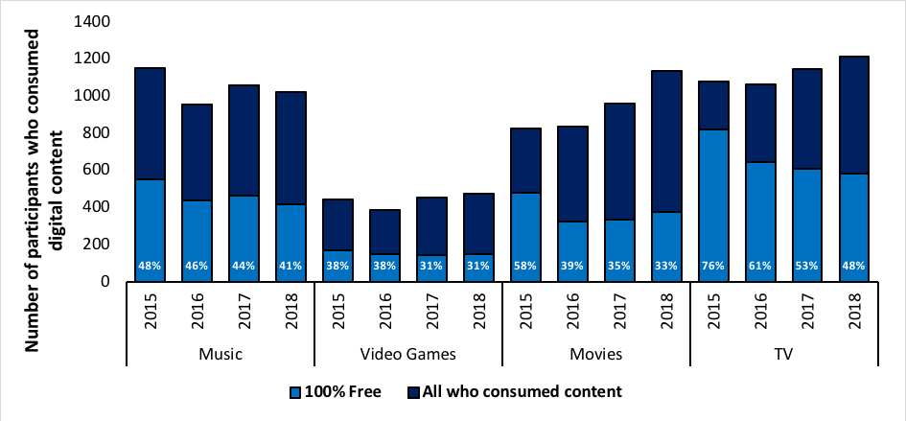

Source: multiple sources including M1, M2, M3, M4, V1, V2, V3, V4, F1, F2, F3, F4, T1, T2, T3 and T4.

The proportion of digital content consumers who did not pay for digital content (consumed 100% for free) has either remained steady across consumers or declined. Participants who consumed music for free decreased from 44% in 2017 down to 41% in 2018. Video games remained steady at 31% and movies experienced a slight drop from 35% in 2017 down to 33% in 2018. Participants who consumed TV programs for free decreased significantly from 53% in 2017 down to 48% in 2018.

Figure 38—Proportion of all internet users 12+ who did not pay for digital content (100% free)

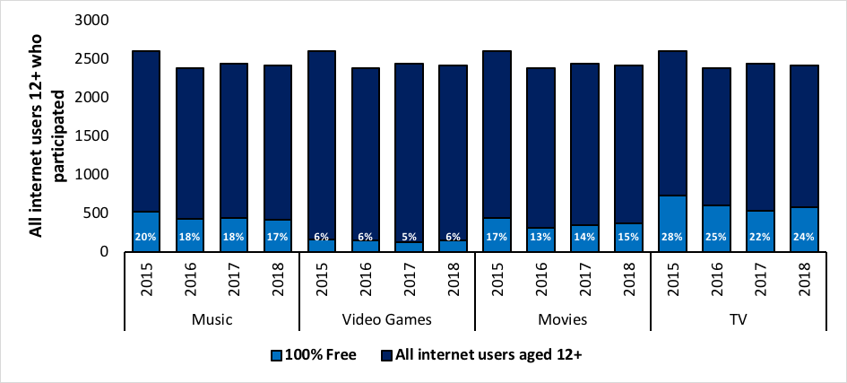

Source: multiple sources including M1, M2, M3, M4, V1, V2, V3, V4, F1, F2, F3, F4, T1, T2, T3 T4, Q7 Have you streamed or accessed any of the following through the Internet in the past three months? Q10 Have you downloaded any of the following through the Internet in the past three months? Q13 Have you shared any of the following through the Internet in the past three months?

When applying the results across all internet users aged 12+ who participated no significant changes were noted. Music was 18% in 2017 and dropped 1% down to 17% in 2018. Video games saw an increase of note of 1% from 5% in 2017 to 6% in 2018. Movies also saw a 1% increase from 14% in 2017 up to 15% in 2018. The most significant increase was noted with TV programs where previous years had noted a steady decline, 2018 recorded a 2% increase from 22% in 2017 up to 24% in 2018.

Figure 39—Proportion of digital consumers who paid something to consume digital content

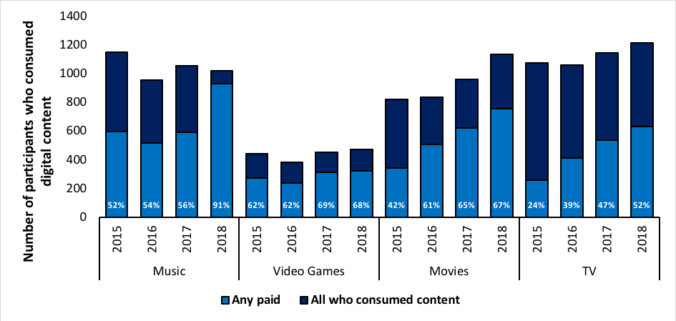

Source: multiple sources including M1, M2, M3, M4, V1, V2, V3, V4, F1, F2, F3, F4, T1, T2, T3 and T4.

Investigating the proportion of digital consumers who paid something to consume digital content has given some interesting results. Ninety–one percent of music consumers claim to have paid something for their music content, a significant increase from 2017 (56%). There was a decline of 1% for video games from 69% in 2017 down to 68% in 2018. Increases were noted across both movies, from 65% in 2017 to 67% in 2018, and TV programs from 47% in 2017 to 52% in 2018.

When comparing the trends over the past four years it is evident that digital content consumers are increasingly paying for some of their content.

Figure 40—Proportion of all internet users 12+ who paid something to consume digital content

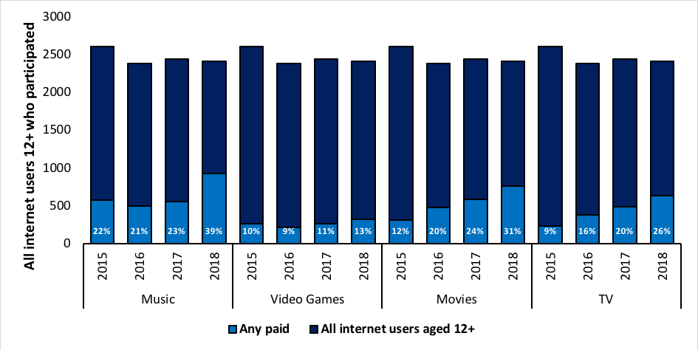

Source: multiple sources including M1, M2, M3, M4, V1, V2, V3, V4, F1, F2, F3, F4, T1, T2, T3 T4, Q7 Have you streamed or accessed any of the following through the Internet in the past three months? Q10 Have you downloaded any of the following through the Internet in the past three months? Q13 Have you shared any of the following through the Internet in the past three months?

Applying the results to all internet users aged 12+ who participated, the trend for increased payment becomes further evident. While the increase in music is clearly significant at 39% compared to 2017 at 23%, an increase is seen across all content types. Video games saw a 2% increase from 11% in 2017 up to 13% in 2018. The increase for movies was significant at 31% for 2018, compared to 24% in 2017. The proportion was also significant for TV program consumers from 20% in 2017 up to 26% in 2018.

Figure 41—Proportion of digital consumers who consumed any digital content for free

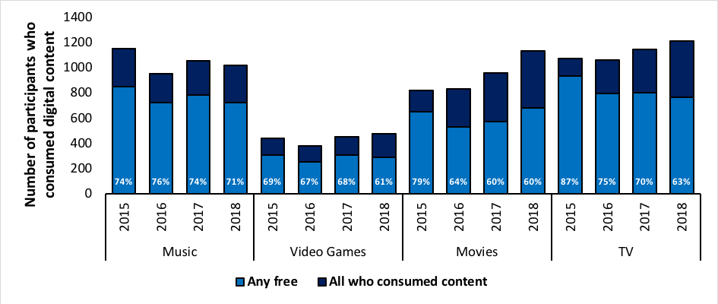

Source: multiple sources including M1, M2, M3, M4, V1, V2, V3, V4, F1, F2, F3, F4, T1, T2, T3 and T4.

Investigating the proportion of digital consumers who consumed any digital content for free provides an insight into consumer behaviour across the population. There is a decline across music from 74% down to 71%, video games from 68% down to 61% and TV programs from 70% down to 63% comparing 2017 to 2018 results. Movies stayed steady at 60% across the two years.

Figure 42—Proportion of all internet users 12+ who consumed any digital content for free

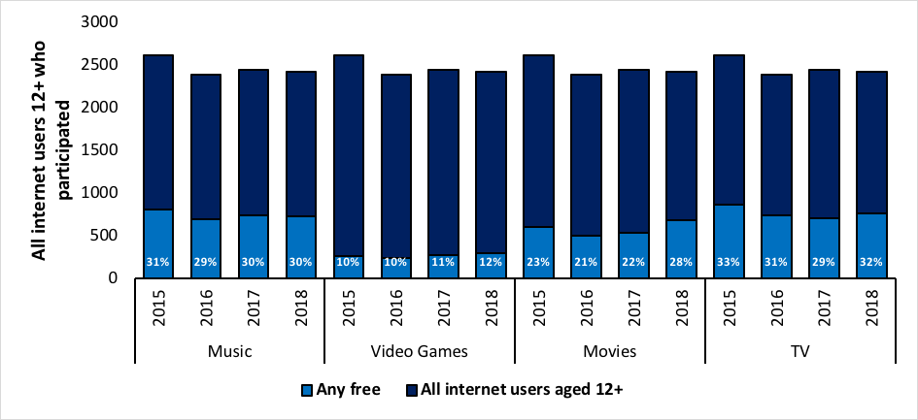

Source: multiple sources including M1, M2, M3, M4, V1, V2, V3, V4, F1, F2, F3, F4, T1, T2, T3 T4, Q7 Have you streamed or accessed any of the following through the Internet in the past three months? Q10 Have you downloaded any of the following through the Internet in the past three months? Q13 Have you shared any of the following through the Internet in the past three months?

Applying the data across all internet users aged 12+ shows that music is steady at 30% and video games experienced a slight rise from 11% in 2017 up to 12% in 2018. Both movies and TV programs experienced an increase. The increase for movies was significant from 22% in 2017 up to 28% in 2018. The increase for TV programs was 29% up to 32%.

When considering the data as a whole, the increasing trend continues for consumers to pay for some of their digital content while the consumption of 100% free content continues to decline. This trend is probably driven by paid streaming services such Netflix and Stan which have been shown to experience dramatic popularity over the past few years and negates the need for consumers to source the content using other means.

Consistent with findings from 2017, those aged 55 and over were significantly less likely to consume 100% paid content and significantly more likely to have consumed TV for free. This continued for digital movie consumption where those aged over 55 years were less likely to have consumed any paid movies compared to other age groups.

### Existing ownership, and free access to digital content before purchasing

Participants who consumed digital content were asked if they owned a physical version of the content. The following Figures show whether participants had content only in physical format, content in digital and physical format and digital content only where none was owned in physical format.

#### Physical ownership of digital content

Figure 43—Participants who consumed digital content and the proportion of content they own in physical format.

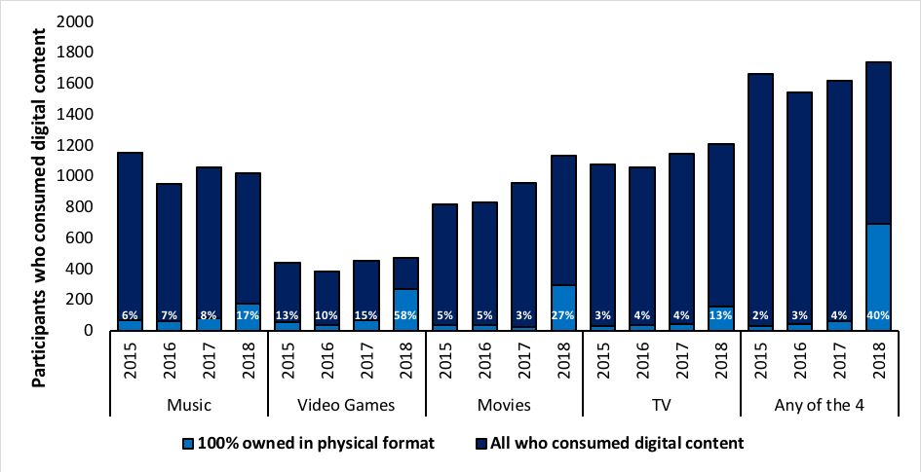

Source: multiple sources including Q21, Q25B, M1, M2, M3, M4, Q39, Q41B, V1, V2, V3, V4, Q51, Q53B, F1, F2, F3, F4, Q66, Q68B, T1, T2, T3 and T4.

Ownership of a physical version prior to consuming the same digital content has increased significantly in the past 12 months across all content types. In 2017 participants reported that of the digital music they consumed, they owned 8% in physical format; this increased to 17% in 2018, which could be attributed to the increasing popularity of vinyl records. One hundred percent physical video game ownership was 15% in 2017 and increased to 58% in 2018. This means that 58% of respondents had consumed a digital version of all the video games they already owned in physical version (100%). This could be attributed to more video games that were previously only available in physical version, now being available digitally and participants consuming the digital version.

The increase in both movie, from 3% in 2017 up to 27% in 2018, and TV programs from 4% in 2017 up to 13% in 2018 could be attributed to the popularity of Netflix and Stan where consumers may have already owned a physical version and were now able to download, stream or access a digital version of the physical version they already owned. This does not necessarily mean that consumers are purchasing higher volumes of physical versions of video games, movies or TV programs it suggests that they may be consuming digital versions of the physical versions they already owned.

Figure 44—Participants who consumed digital content and owned part of that content in physical format

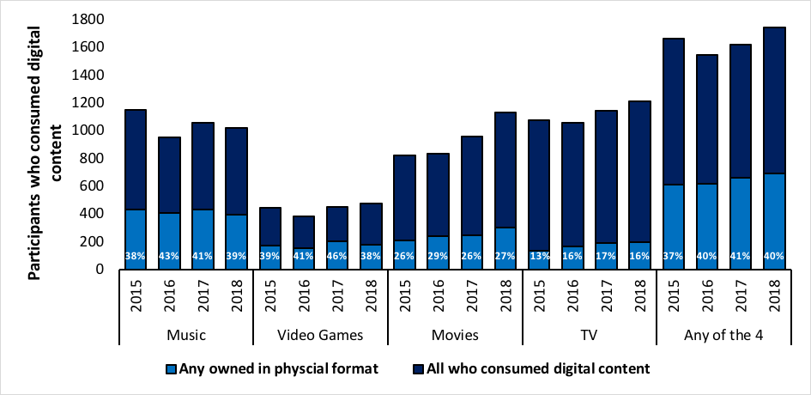

Source: multiple sources including Source: multiple sources including Q21, Q25B, M1, M2, M3, M4, Q39, Q41B, V1, V2, V3, V4, Q51, Q53B, F1, F2, F3, F4, Q66, Q68B, T1, T2, T3 and T4.

Digital consumers who owned some of the digital content in physical form has remained relatively steady across the content types, with the exception of video games which experienced a significant drop from 46% in 2017, down to 38% in 2018. Music dropped 3% from 41% in 2017 down to 39% in 2018. Movies increased from 26% in 2017 to 27% in 2018 and TV programs decreased by 1% down to 16% in 2018.

Looking at all four content types, the last three years have remained relatively steady despite the increase in participants who consumed digital data.

Figure 45—Participants who consumed digital content and did not own any in physical format

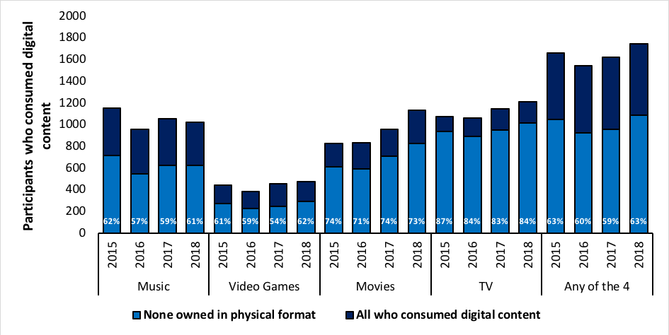

Source: multiple sources including Source: multiple sources including Q21, Q25B, M1, M2, M3, M4, Q39, Q41B, V1, V2, V3, V4, Q51, Q53B, F1, F2, F3, F4, Q66, Q68B, T1, T2, T3 and T4.

Across the four content types, the consumption of digital data without owning any in physical format has increased from 59% in 2017 up to 63% in 2018. Within the content types, video games experienced the greatest difference from 54% in 2017 up to 62% in 2018 with music, movies and TV programs only experiencing a difference of 1–2%.

Figure 46—The mean number of items owned by participants in physical format

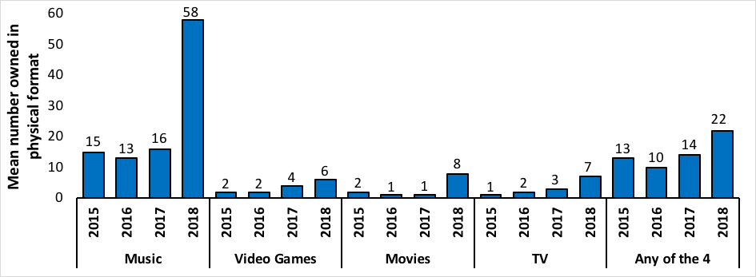

Source: multiple sources including Source: multiple sources including Q21, Q25B, M1, M2, M3, M4, Q39, Q41B, V1, V2, V3, V4, Q51, Q53B, F1, F2, F3, F4, Q66, Q68B, T1, T2, T3 and T4.

It is interesting to note the dramatic change in 2018 compared to previous years. This is potentially due to the number of digital content items being used for the calculation in alignment with the question format. This is particularly relevant for music tracks versus albums. The data shows that the average number of music owned in physical format is 58 in 2018 compared to 16 in 2017 and could again be attributed to the increasing popularity of owning vinyl records. The average number of physical video games increased from 4 in 2017 to 6 in 2018 and aligns with the trend over the past four years. There is a significant rise in physical movie ownership from 1 in 2017 up to 8 in 2018 and TV programs saw a rise from 3 in 2017 up to 7 in 2018.

When looking at physical ownership across the four content types, there is a rising trend over the last three years. This can be explained by participants owning a physical version and then consuming a digital version as it became more readily available on services such as Netflix and Stan for example.

#### Was content purchased after consuming it for free?

The following Figures show whether people who paid for content (in either digital or physical format) in the past three months had previously consumed that same content online for free.

Figure 47—Paid for all (100%) content previously consumed for free

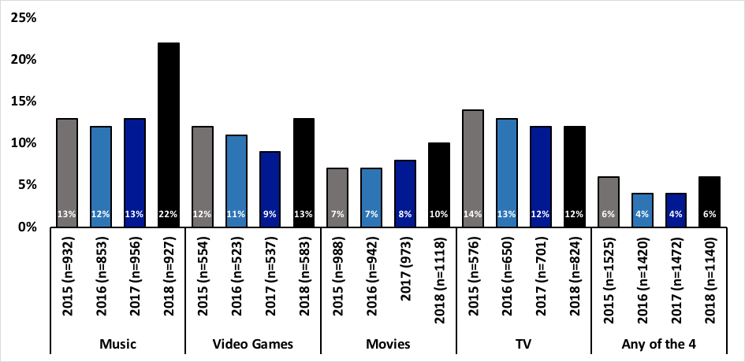

Source: Q26 Q42 Q54 and Q69 You indicated that you have paid for (x) music tracks / video games / movies / TV programs (digital or physical) in the past three months. How many of these had you previously downloaded, streamed or accessed online for free?

There is an increase in the incidence of consumers who consume digital content for free and then purchase the same content either digitally or physically. The greatest and most significant increase is observed within music content where 2017 noted 13% and 2018 increased to 22%. Video games also saw an increase between the two years from 9% in 2017 up to 13% in 2018. There was a slight increase within movies of 2% and TV programs remained steady at 12%.

Across the four content types there was an increase from 4% in 2017 up to 6% in 2018 indicating an increase in consumers purchasing content that was previously consumed for free.

Figure 48—Any paid for content previously consumed for free

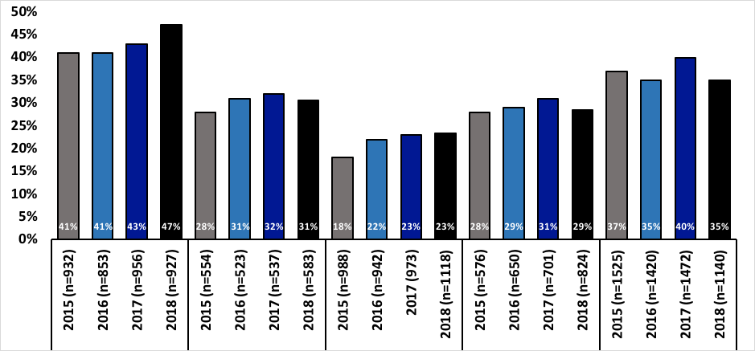

Source: Q26 Q42 Q54 and Q69 You indicated that you have paid for (x) music tracks / video games / movies / TV programs (digital or physical) in the past three months. How many of these had you previously downloaded, streamed or accessed online for free?

The trend within music continues towards purchases of content previously consumed for free with an increase from 43% in 2017 up to 47% in 2018. The purchase of video games after free consumption saw a slight decrease last year from 32% down to 31% in 2018. Movies remained steady at 23% and there was a slight decrease also noted within TV programs from 31% in 2017 down to 29% in 2018.

Across the four content types there is a downward shift from 40 % in 2017 to 35% in 2018. The mean number of files previously consumed for free increased from 6 in 2017 to 8 in 2018.

Figure 49—Did not pay anything for content (0%) previously consumed for free

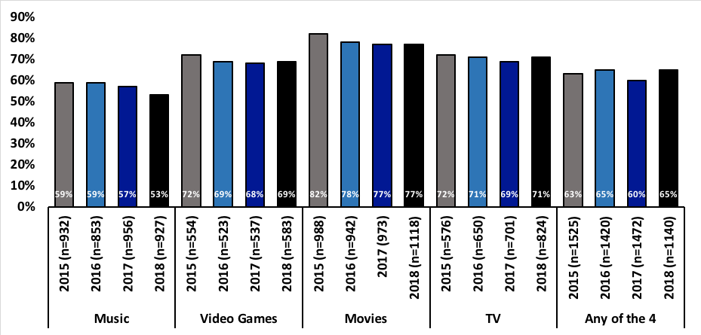

Source: Q26 Q42 Q54 and Q69 You indicated that you have paid for (x) music tracks / video games / movies / TV programs (digital or physical) in the past three months. How many of these had you previously downloaded, streamed or accessed online for free?

Across the four content types, the consumption of free content without ever purchasing a digital or physical version remains high and experienced an increase from 60% in 2017 up to 65% in 2018. A slight drop of 4% is seen within music, a 1% rise in video games and a 2% rise in TV programs. Movies remains steady at 77%.

In a continuing trend, for all four content types, males were more likely than females to have purchased any paid for content after already consuming it for free as were younger consumers than older consumers.

## Levels of copyright infringement

### Lawfulness groups

Lawfulness groups have been created by assessing the proportion of online content they each consume lawfully.

Digital consumers were asked how many of the free pieces of digital content they consumed were consumed lawfully. For music and movies, respondents were also asked how many of the individual items they consumed were done so lawfully. Given this information, it is possible to measure the lawfulness of all music and movie digital content and lawfully accessed paid for digital content. To measure the lawfulness of video games and TV programs, it has been assumed that all paid for content was lawful and, by default, any free content was unlawful. These measure are shown in the following Figure. The proportion of 100% unlawful is shown in red, 100% lawful is green and the mix of lawful and unlawful consumption is black (and includes the 100% unlawful proportion).

Figure 50—Proportion of digital content consumed lawfully, unlawfully or a mix of both lawfully and unlawfully across all who consumed digital content

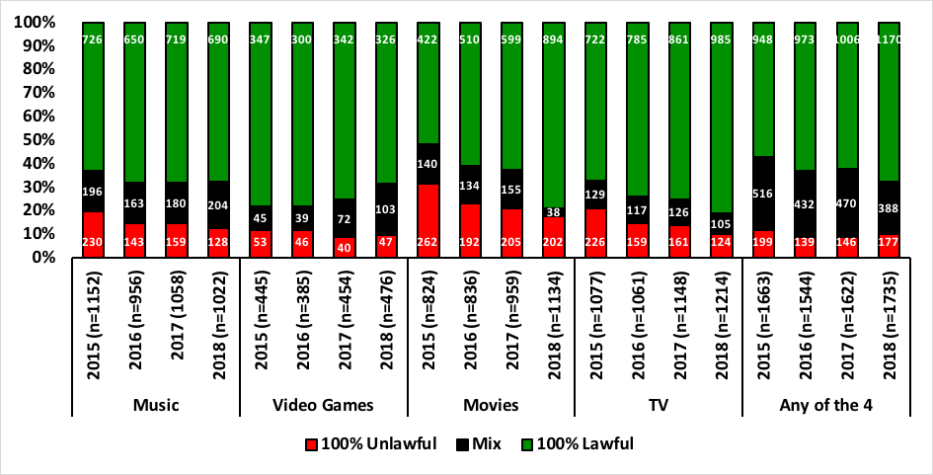

Source: Q25(A) Q41(A) 53(A) 68(A) How many did you or someone in your household pay for. Q27 Q55 You indicated that you have paid for (x) downloaded, streamed or accessed (music tracks / movies) in the past three months. How many of these do you think were done so lawfully? Q28 Q43 Q56 Q70 You indicated that you have downloaded, streamed or accessed (music tracks/video games /movies/TV programs) for free in the past three months. How many of these do you think were done so lawfully?

Across the four core content types (any of the four), the proportion of unlawful digital content consumption remained steady at about 10% and there was a slight drop in a mix lawful and unlawful consumption from 31% in 2015 down to 22% in 2018, which equated to an increase in 100% lawful consumption.

When viewed independently, three of the four content types experienced a slight drop in unlawful consumption, with the exception of video games which saw a slight increase. Consumers who mixed lawful and unlawful remained steady within music but experienced an increase within video games, a continuing trend over the last three years. Both movies and TV programs saw a drop of lawful and unlawful mix and therefore an increase in 100% lawful.

Figure 51—Proportion of digital content consumed lawfully, unlawfully or a mix of both lawfully and unlawfully or did not consume (other) across all internet users 12+

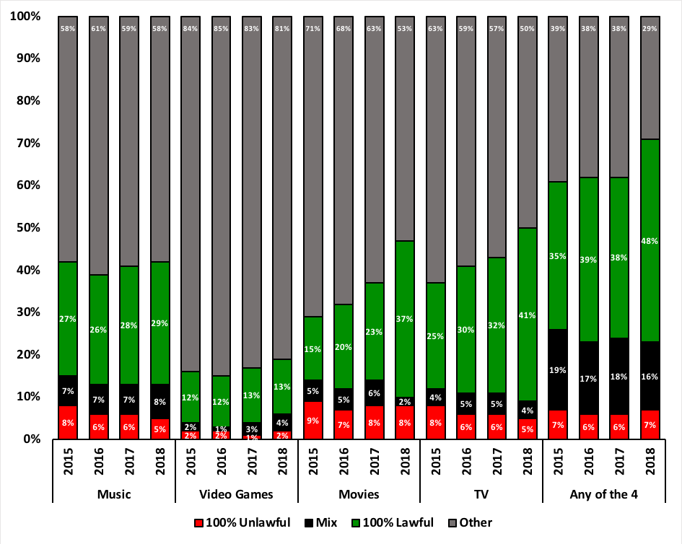

Source: Q25(A) Q41(A) 53(A) 68(A) How many did you or someone in your household pay for. Q27 Q55 You indicated that you have paid for (x) downloaded, streamed or accessed (music tracks / movies) in the past three months. How many of these do you think were done so lawfully? Q28 Q43 Q56 Q70 You indicated that you have downloaded, streamed or accessed (music tracks/video games /movies/TV programs) for free in the past three months. How many of these do you think were done so lawfully? Note: ‘other’ represents respondent population aged 12+ that used the Internet but did not consume digital content within music, video games, movies or TV programs.

The Figure shows that the lawful consumption of music has remained relatively constant over the last four years. Video games have experienced an increase in mixed consumption and both movies and TV programs have experienced a drop in mixed and unlawful consumption and a rise in lawful consumption.

Across the four content types, there is a greater proportion of consumers that are 100% lawful in 2018 compared to previous years.

#### Consumption of unlawful content types amongst consumers

The following Figures show the demographic profile of all content consumers and infringers across the four core content types.

Figure 52—Gender of content consumers and infringers

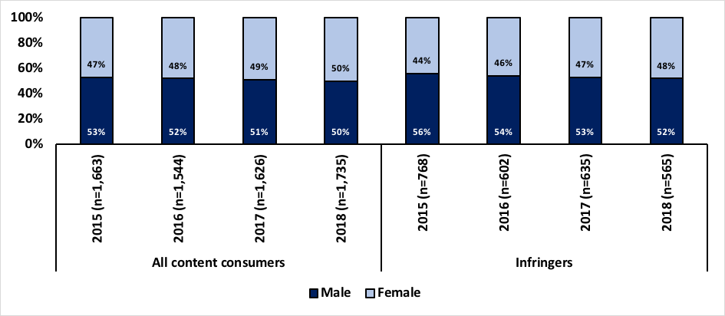

Source S4 Are you (male / female / other)? Q25(A) Q41(A) 53(A) 68(A) How many did you or someone in your household pay for. Q27 Q55 You indicated that you have paid for (x) downloaded, streamed or accessed (music tracks / movies) in the past three months. How many of these do you think were done so lawfully? Q28 Q43 Q56 Q70 You indicated that you have downloaded, streamed or accessed (music tracks/video games /movies/TV programs) for free in the past three months. How many of these do you think were done so lawfully?

Across the four years, infringers are more likely to be male than females. There was a slight decrease for of 1% from 53% in 2017 down to 52% in 2018 of male infringers and subsequently a rise in female infringers from 47% in 2017 up to 48% in 2018.

Figure 53—Age of content consumers and infringers

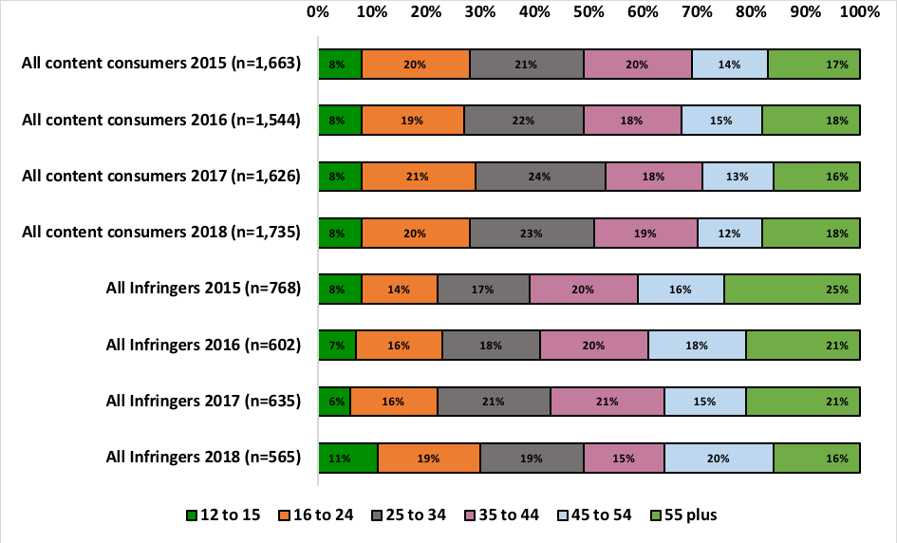

Source: S1 How old are you? Q25(A) Q41(A) 53(A) 68(A) How many did you or someone in your household pay for. Q27 Q55 You indicated that you have paid for (x) downloaded, streamed or accessed (music tracks / movies) in the past three months. How many of these do you think were done so lawfully? Q28 Q43 Q56 Q70 You indicated that you have downloaded, streamed or accessed (music tracks/video games /movies/TV programs) for free in the past three months. How many of these do you think were done so lawfully?

Infringers are more likely to be young in age and represent 49% of all infringers. Those aged 12‑15 represent 11% of infringers, 16–24 19% and 25–34 19%. The highest proportion within an age group was found within those aged 45‑54 years of age at 20%. Those aged 55 years plus accounted for 16% of infringers.

#### Median items consumed unlawfully by lawfulness groups

The following Figure shows the median number of items downloaded or streamed unlawfully.

Figure 54—Median content consumed unlawfully

Figure 54. Median items of content consumed unlawfully. Results are shown for the years 2015 to 2018. For music, the median number of items consumed by those who consumed only unlawful content changed from 20, to 20, to 16, to 5. For video games, the median number of items consumed by those who consumed only unlawful content changed from 2, to 3, to 2, to 1. For movies, the median number of items consumed by those who consumed only unlawful content changed from 5, to 5, to 5, to 1. For TV programs, the median number of items consumed by those who consumed only unlawful content changed from 7, to 5, to 4, to 3. For any of the four content categories, the median number of items consumed by those who consumed only unlawful content changed from 13, to 15, to 9, to 9. 
For music, the median number of items consumed by those who consumed any unlawful content changed from 20, to 20, to 18, to 5. For video games, the median number of items consumed by those who consumed any unlawful content changed from 2, to 3, to 4, to 4. For movies, the median number of items consumed by those who consumed any unlawful content remained unchanged from 2015 at 5 items. For TV programs, the median number of items consumed by those who consumed any unlawful content changed from 7, to 7, to 5, to 5. For any of the four content categories, the median number of items consumed by those who consumed any unlawful content changed from 16, to 16, to 13, to 11.
More detail in report.

Source: Q25(A) Q41(A) 53(A) 68(A) How many did you or someone in your household pay for. Q27 Q55 You indicated that you have paid for (x) downloaded, streamed or accessed (music tracks / movies) in the past three months. How many of these do you think were done so lawfully? Q28 Q43 Q56 Q70 You indicated that you have downloaded, streamed or accessed (music tracks/video games /movies/TV programs) for free in the past three months. How many of these do you think were done so lawfully? M4, V4, F4 and T4.

The median number of files downloaded or streamed 100% unlawfully across the four content types has remained steady over the last two years at 9. There is a decrease in the median content consumed by any unlawful from 13 in 2017 to 11 in 2018.

There was a significant drop observed within music (from 16 to 5) in the median content consumed 100% unlawfully and also any unlawful from 18 in 2017 to 5 in 2018. The median for any unlawful remained the same (4) within video games but there was a drop from 2 in 2017 to 1 in 2018 of the 100% unlawful. Movies remained steady for any unlawful at 5 but there was a drop in 100% unlawful from 5 in 2017 down to only 1 in 2018. TV programs also saw a drop in 100% unlawful from 4 to 3 but the any unlawful remained steady at 5.

#### Consumption of free content lawfully/unlawfully

The consumption of free digital content can be either lawfully consumed or unlawfully consumed. The following Figure shows the lawfulness of the digital content consumed for free by respondents who consumed free content.

Figure 55—Lawfully and unlawfully consumed free digital content

Figure 55. Lawfully and unlawfully consumed free digital content. For 2018 music where n=727 100% unlawful was 17%, mix was 16% and 100% lawful was 67%. Video games where n=291 100% unlawful was 16%, mix was 9% and 100% lawful was 75%. Movies where n=678 100% unlawful was 28%, mix was 11% and 100% lawful was 61%. TV where n=766 100% unlawful was 20%, mix was 10% and 100% lawful was 71%. Any of the four where n=1,339 100% unlawful was 14%, mix was 25% and 100% lawful was 61%. Across the four content types there is an increase in 100% lawful consumption of free content and a reduction in the 100% unlawful and mix of lawful and unlawful in 2018, when compared to 2017.
Music saw a drop in unlawful consumption of free content from 21% in 2017 down to 17% in 2018 which corresponded to an increase in 100% lawful consumption. Video games saw a drop in 100% unlawful consumption from 21% in 2017 down to 16% in 2018, movies saw a drop from 36% in 2017 down to 28% and TV programs saw a drop from 24% down to 20%.
Movies (39%) are still the most likely to be consumed unlawfully, followed by music (33%) and then TV programs (30%). More detail in report.

Source: Q25(A) Q41(A) 53(A) 68(A) How many did you or someone in your household pay for. Q27 Q55 You indicated that you have paid for (x) downloaded, streamed or accessed (music tracks / movies) in the past three months. How many of these do you think were done so lawfully? Q28 Q43 Q56 Q70 You indicated that you have downloaded, streamed or accessed (music tracks/video games /movies/TV programs) for free in the past three months. How many of these do you think were done so lawfully? M4, V4, F4 and T4.

Across the four content types there is an increase in 100% lawful consumption of free content and a reduction in the 100% unlawful and mix of lawful and unlawful in 2018, when compared to 2017.

Music saw a drop in unlawful consumption of free content from 21% in 2017 down to 17% in 2018 which corresponded to an increase in 100% lawful consumption. Video games saw a drop in 100% unlawful consumption from 21% in 2017 down to 16% in 2018, movies saw a drop from 36% in 2017 down to 28% and TV programs saw a drop from 24% down to 20%.

Movies (39%) are still the most likely to be consumed unlawfully, followed by music (33%) and then TV programs (30%).

#### Consumption of paid content lawfully/unlawfully

The next Figure shows the lawfulness of paid content for music and movies. The survey did not include questions about paid digital content for video games or TV programs.

Figure 56—Lawfully and unlawfully paid digital content

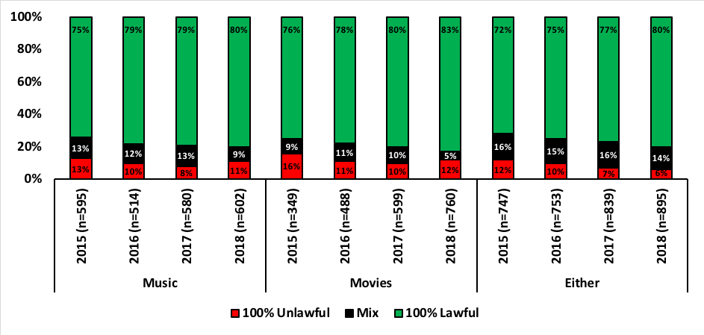

Source: Q25(A) Q53(A) How many did you or someone in your household pay for? Q27 Q55 You indicated that you paid for (x) downloaded, streamed or accessed (music tracks / movies) in the past three months. How many of these did you think were done so lawfully?

The consumption of lawful paid content continues to rise within music and movies across the years. 2018 saw an increase of 1% within music and 3% within movies when compared to 2017. While there was an increase in the 100% unlawful consumption within both movies and music, when combined with a mix of lawful and unlawful, there was still a decrease in unlawful activity.

#### Sites used for consuming or sharing content by infringers/non–infringers

The sites used to consume digital content by infringers and non–infringers were compared to determine if there was a difference between the sites used by lawful consumers (non–infringers) and unlawful consumers (infringers). It was found that the top ten sites were the same across all content consumers, any unlawful (infringers) and 100% lawful (non–infringers). The top six sites were:

* Netflix
* YouTube
* Spotify
* iTunes / App Store / iBookstore / Apple Store / iTunes Radio
* Facebook
* Google Play.

### Content consumption volumes

The metrics outlined so far have represented results at an individual respondent level. The following Figure outlines total consumption volume estimates for each of the content types in the past three months. Figures are rounded to the nearest million in each case, and based on mean consumption across all adults 12+. It has also been assumed that all physical items are paid for and lawful.

#### Volume of content by content type

Figure 57—Volume of content consumed to the nearest million (across Australian population aged 12+)

Figure 57. Volume of content consumed to the nearest million (across Australian population aged 12+) Note the Figure uses an exponential scale and values with columns are to the nearest million. For 2018 music physical was 276 and digital was 1,715. Video games physical was 22 and digital was 44. Movies physical was 38 and digital was 169. TV physical was 22 and digital was 380. 
There has been an increase in volume of content consumed across music, movies and TV programs for both physical and digital content. Video games stayed steady for physical content consumption but experienced a drop in digital volume.
Physical volume of music increased from 238 million (m) in 2017 to 276m for 2018 and for digital volume from 1,360m to 1,715m.
Physical volume of video games has remained steady at 22m for the last three years with a decline in digital volume observed from 51m in 2017 down to 44m in 2018. Movies experienced a growth in consumption volume in both digital, from 141m to 169m, and also physical from 19m in 2017 to 38m in 2018. TV programs saw a rise in volume of physical consumption from 7m to 22m and digital volume from 329m in 2017 to 380m in 2018.
More detail in report.

Source: QM1, V1, F1 and T1 Digital total. Q23, Q39, Q51 and Q66 How many (music tracks/video games/movies/TV programs) do you think you have personally bought or rented in the past three months? Note: The Figure is using a logarithmic scale due to the high volume for music. Note the Figure uses an exponential scale and values with columns are to the nearest million.

There has been an increase in volume of content consumed across music, movies and TV programs for both physical and digital content. Video games stayed steady for physical content consumption but experienced a drop in digital volume.

Physical volume of music increased from 238 million (m) in 2017 to 276m for 2018 and for digital volume from 1,360m to 1,715m.

Physical volume of video games has remained steady at 22m for the last three years with a decline in digital volume observed from 51m in 2017 down to 44m in 2018.

Movies experienced a growth in consumption volume in both digital, from 141m to 169m, and also physical from 19m in 2017 to 38m in 2018.

TV programs saw a rise in volume of physical consumption from 7m to 22m and digital volume from 329m in 2017 to 380m in 2018.

The following Figure shows the proportion of physical volume compared to digital volume.

Figure 58—Percentage of content consumed (physical and digital)

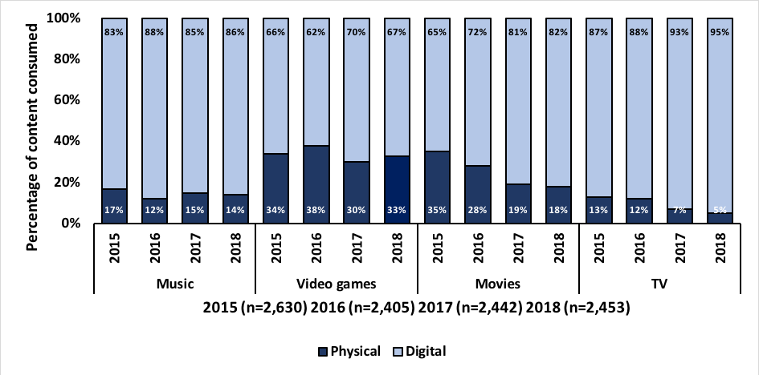

Source: QM1, V1, F1 and T1 Digital total. Q23, Q39, Q51 and Q66 How many (music tracks/video games/movies/TV programs) do you think you have personally bought or rented in the past three months?

It is evident that the volume of digital content is greater in all instances across the four content types. Digital consumption has increased by 1% for music, decreased by 3% for video games, increased by 1% for movies and increased by 2% for TV programs.

#### Volume of content consumed—paid versus free

The proportion of paid versus free and lawful versus unlawful digital content consumption is shown in the Figures below.

Figure 59—Volume of paid and free digital content consumed to the nearest million (across Australian population aged 12+)

Figure 59. Volume of paid and free digital content consumed to the nearest million (across Australian population aged 12+) . For 2018 music paid was 720 free was 996, video games paid was 22 and free was 22, movies was 95 paid and 74 free and TV paid was 209 and free was 171. The volume of paid digital music has increased from 717m in 2017 to 720m in 2018 and the consumption of free digital music has experienced a significant increase from 644m in 2017 up to 996m in 2018. The volume of video games consumed for both paid and free has declined since 2017 from 24m paid down to 22m paid and 27m free down to 22m free. The volume of paid movies consumed has increased significantly over the last four years and most notably from 61m in 2017 up to 95m in 2018. The volume of free movies consumed has declined for the last three years and is currently estimated to be 74m. The trend identified within movies for volume paid is also found within the volume of TV programs consumed. In 2017 the paid volume reported was 176m and in 2018 it was 209m. The volume of free TV programs consumed has increased from 152m in 2017 up to 171m in 2018.
More detail in report.

Source: QM1, V1, F1 and T1 Digital total. Q25A Q41A Q53A and Q68A How many did you or someone in your household pay for? Note: The Figure uses an exponential scale and values with columns are to the nearest million.

The volume of paid digital music has increased from 717m in 2017 to 720m in 2018 and the consumption of free digital music has experienced a significant increase from 644m in 2017 up to 996m in 2018.

The volume of video games consumed for both paid and free has declined since 2017 from 24m paid down to 22m paid and 27m free down to 22m free.

The volume of paid movies consumed has increased significantly over the last four years and most notably from 61m in 2017 up to 95m in 2018. The volume of free movies consumed has declined for the last three years and is currently estimated to be 74m.

The trend identified within movies for volume paid is also found within the volume of TV programs consumed. In 2017 the paid volume reported was 176m and in 2018 it was 209m. The volume of free TV programs consumed has increased from 152m in 2017 up to 171m in 2018.

Figure 60—Proportion, expressed as a percentage, of paid and free digital content consumed (across Australian population aged 12+)

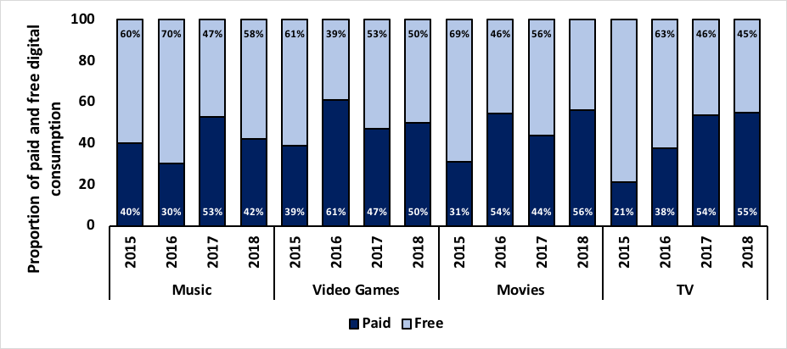

Source: QM1, V1, F1 and T1 Digital total. Q25A Q41A Q53A and Q68A How many did you or someone in your household pay for? Values in columns are percentages.

When comparing the paid volume consumed with free consumption there are different trends within each content type. Music has seen a significant decline in the proportion of paid, from 53% in 1027 down to 42% in 2018, and therefore an increase in the proportion of free digital consumption.

Paid video game consumption has increased from 47% in 2017 up to 50% in 2018. The proportion of paid movies has increased from 44% in 2017 up to 56% in 2018. The proportion of paid TV program consumption has also increased but only by 1% from 54% in 2017 to 55% in 2018.

Now that we have an understanding of the volume of free and paid content, it becomes important to look at the volume of lawful and unlawful consumption. The following Figures show the volume of lawful and unlawful consumption across the four content types and then the proportion of lawful and unlawful consumption for each content type.

Figure 61—Volume of lawful and unlawful music content consumed to the nearest million (across the Australian population aged 12+)

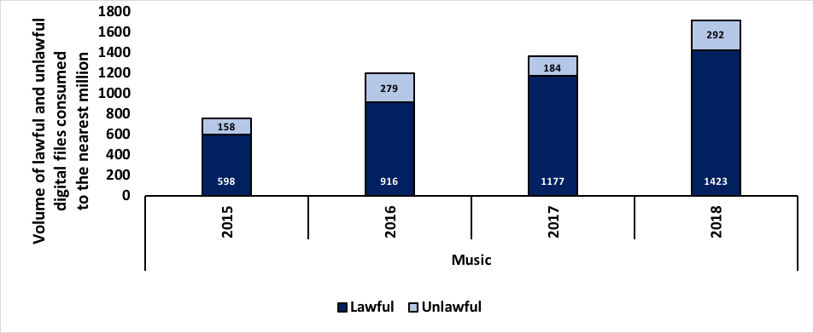

Source: Q25(A) Q41(A) 53(A) 68(A) How many did you or someone in your household pay for. Q27 Q55 You indicated that you have paid for (x) downloaded, streamed or accessed (music tracks / movies) in the past three months. How many of these do you think were done so lawfully? Q28 Q43 Q56 Q70 You indicated that you have downloaded, streamed or accessed (music tracks/video games /movies/TV programs) for free in the past three months. How many of these do you think were done so lawfully? M4, V4, F4 and T4. Note: music has been shown separately due to the higher volume.

The volume of music consumption has significantly increased over the last four years and each year since 2015, the volume consumed lawfully has increased from 598m in 2015 up to 1,423m in 2018. The consumption of unlawful digital music files has also experienced an increase since 2015 from 158m up to 292m in 2018. It should be noted that 2017 experienced a drop in unlawful consumption from 279m in 2016, down to 184m in 2017.

Figure 62—Volume of lawful and unlawful video game, movie and TV program content consumed to the nearest million (across the Australian population aged 12+)

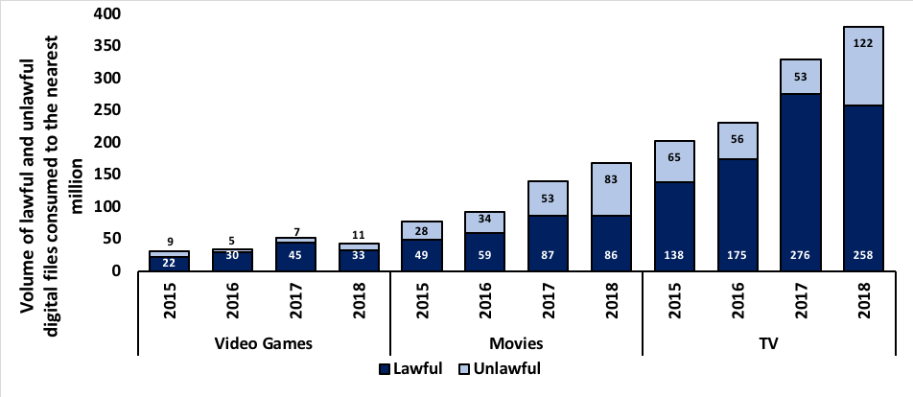

Source: Q25(A) Q41(A) 53(A) 68(A) How many did you or someone in your household pay for. Q27 Q55 You indicated that you have paid for (x) downloaded, streamed or accessed (music tracks / movies) in the past three months. How many of these do you think were done so lawfully? Q28 Q43 Q56 Q70 You indicated that you have downloaded, streamed or accessed (music tracks/video games /movies/TV programs) for free in the past three months. How many of these do you think were done so lawfully? M4, V4, F4 and T4. Note: music has been shown separately due to the higher volume.

The volume of lawfully consumed video games has shown a decline for the first time the study began in 2015. It was noted that 45m digital files were consumed lawfully in 2017 and this dropped to 33m in 2018 which also saw an increase in unlawful consumption at 11m, up from 7m in 2017.

The volume of lawful consumption of movies remained relatively unchanged at 87m in 2017 to 86m in 2018 however there was a significant difference in the volume of unlawfully consumed movies from 53m in 2017 up to 83m in 2018.

The trend identified within movies was also found within the volume of unlawfully consumed TV programs where 53m were noted in 2017 and 122m in 2018, a significant increase. The consumption volume of lawful TV programs dropped from 276m in 2017 to 258m in 2018.

Figure 63—Proportion of lawful and unlawful content consumed (across the Australian population aged 12+)

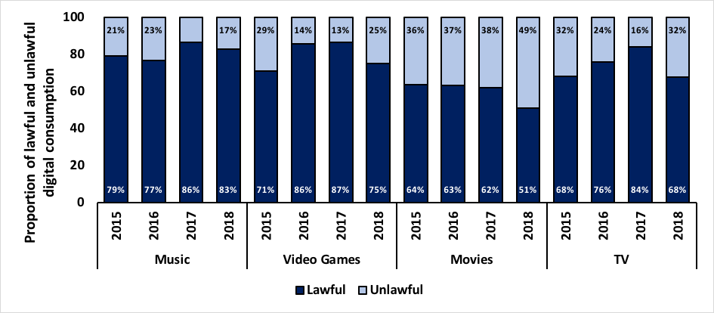

Source: Q25(A) Q41(A) 53(A) 68(A) How many did you or someone in your household pay for. Q27 Q55 You indicated that you have paid for (x) downloaded, streamed or accessed (music tracks / movies) in the past three months. How many of these do you think were done so lawfully? Q28 Q43 Q56 Q70 You indicated that you have downloaded, streamed or accessed (music tracks/video games /movies/TV programs) for free in the past three months. How many of these do you think were done so lawfully? M4, V4, F4 and T4.

When the proportion of lawful and unlawful digital consumption is applied across the Australian population, it can be seen that the proportion of unlawful consumption has increased across all four content types from 2017 to 2018. A decrease in unlawful consumption of music, video games and TV programs had been observed between 2016 and 2017. Unlawful consumption of movies was relatively stable at 37% in 2016 to 38% in 2017.

## Consumer spend

This section outlines the main findings for consumer spend across the four content types.

### Quarterly consumer spend among 12+ year olds

The following Figures show the respondents’ average spend within the four content types in the past three months. Also shown within the Figures is the proportion of respondents who claim to have spent money on these items. Both values are averages across the respondent population (not just content consumers) to align with previous years’ analysis.

The ‘other’ category for each Figure incorporates merchandise (for all content types) and content type specific measures. For example within the Figure showing consumer spend within music, the ‘other’ category includes music concerts or gigs. The content type specifics for ‘other’ are detailed below each content type Figure.

Figure 64—Music spend

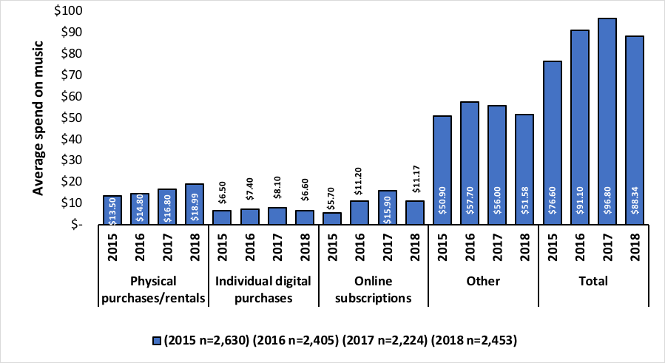

Source: Q14(A, B, C and D) Approximately how much have you personally spent on the following in the past three months? Please indicate money spent on gifts for other people (where you didn’t expect them to pay you back). Other category represents (A) Live music concerts or gigs and (B) Music merchandise.

The total spend on music has declined slightly from $96.80 in 2017 down to $88.34 in 2018. This is a result of a decline in individual digital purchases which dropped from an average spend of $8.10 in 2017 down to $6.60 in 2018, and with online subscriptions which dropped from $15.90 in 2017 down to $11.17 in 2018. The ‘other’ category which represents live music concerts or gigs and merchandise also experienced a drop from $56.00 in 2017 to $51.58 in 2018. The only type that experienced growth was physical purchases and rentals which rose from $16.80 in 2017 to $18.99 in 2018.

Figure 65—Proportion of participants that spent anything on music

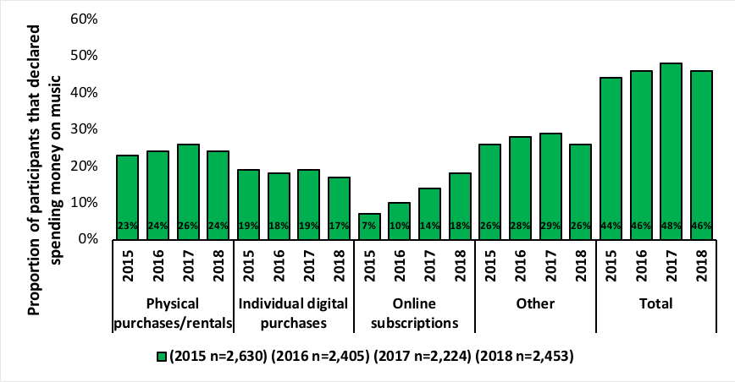

Source: Q14(A, B, C and D) Approximately how much have you personally spent on the following in the past three months? Please indicate money spent on gifts for other people (where you didn’t expect them to pay you back). Other category represents (A) Live music concerts or gigs and (B) Music merchandise.

The proportion of participants that spent anything on music has remained relatively steady for the last four years and currently sits at 46%.

Figure 66—Video games spend

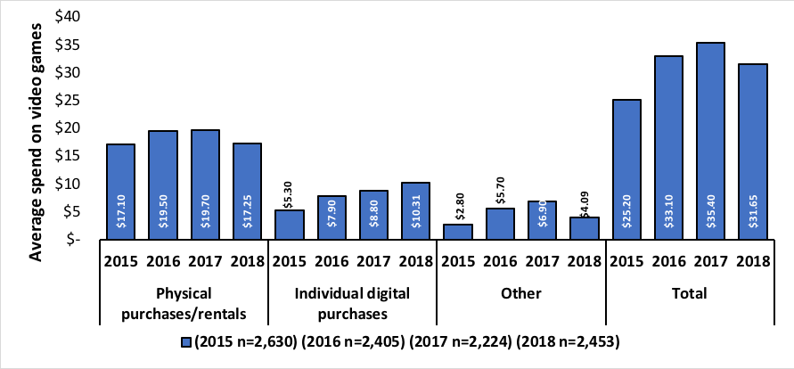

Source: Q31 (A, B and C) Approximately how much have you personally spent on the following in the past three months? Please indicate money spent on gifts for other people (where you didn’t expect them to pay you back). Other category represents (B) Video game merchandise.

Spending in video games has seen a slight decline in physical purchases and rentals down from $19.70 in 2017 to $17.25 in 2018. This was also the case for video game merchandise (other) which saw a drop from $6.90 in 2017 to $4.09 in 2018. The average spend on individual digital purchases, however saw a rise from $8.80 in 2017 to $10.31 in 2018.

The total spend declined overall from $35.40 in 2017 down to $31.65 in 2018.

Figure 67—Proportion of participants that spent anything on video games

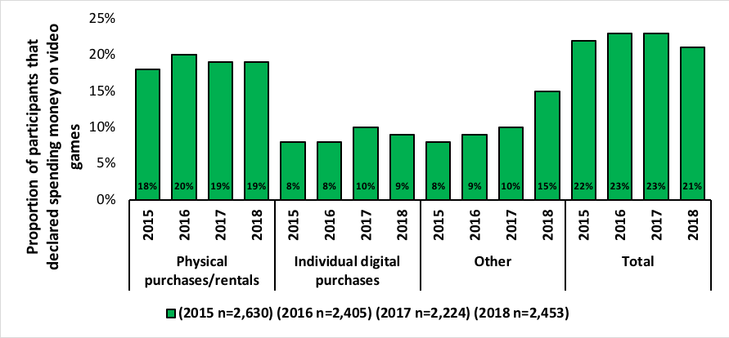

Source: Q31 (A, B and C) Approximately how much have you personally spent on the following in the past three months? Please indicate money spent on gifts for other people (where you didn’t expect them to pay you back). Other category represents (B) Video game merchandise.

The proportion of participants that spend anything on video games has remained relatively steady over the last four years and currently sits at 21%.

Figure 68—Movie spend

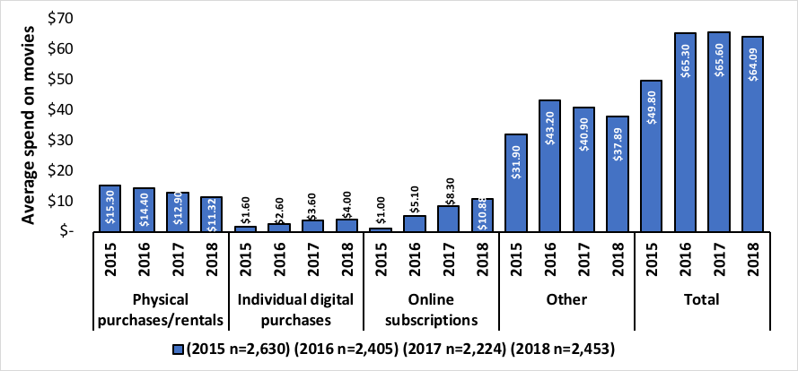

Source: Q44 (A, B, C, D, E and F) Approximately how much have you personally spent on the following in the past three months? Please indicate money spent on gifts for other people (where you didn’t expect them to pay you back). Other category represents (A) Movies watched at the cinema (c) Movie merchandise and (F) Movies purchased individually through Pay TV.

The average spend on movie physical purchases and rentals has continued to decline over the last four years from $15.30 in 2015 to $11.32 in 2018. This downward trend is also found within the ‘other’ category covering cinema movies, merchandise and PayTV where an average of $40.90 was spent in 2017 and this dropped to $37.89 in 2018.

The average spend on movie individual digital purchases and subscriptions have both risen steadily over the last four years. Individual digital purchases has risen from $1.60 in 2015 to $4.00 in 2018. Subscriptions has risen from $1.00 in 2015 to an average spend of $10.88 in 2018.

Across the total spend for movies there has been some stability in the last three years and the average is currently $64.09.

Figure 69—Proportion of participants that spent anything on movies

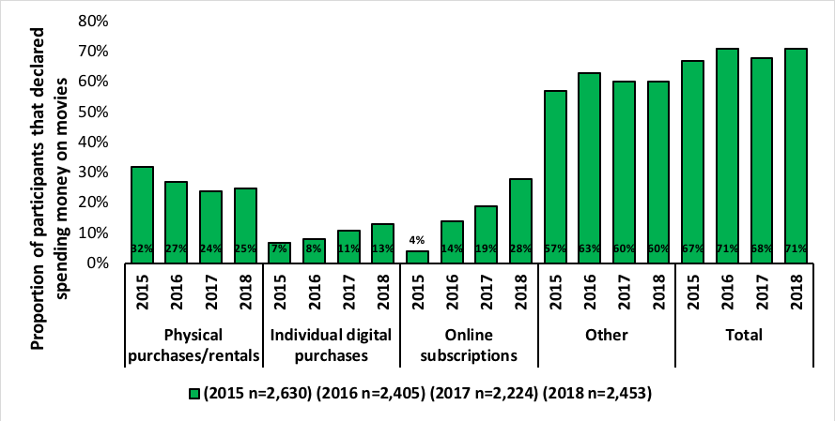

Source: Q44 (A, B, C, D, E and F) Approximately how much have you personally spent on the following in the past three months? Please indicate money spent on gifts for other people (where you didn’t expect them to pay you back). Other category represents (A) Movies watched at the cinema (c) Movie merchandise and (F) Movies purchased individually through Pay TV.

The proportion of participants that spend anything on movies has remained relatively steady over the last four years and currently sits at 71%.

Figure 70—TV program spend

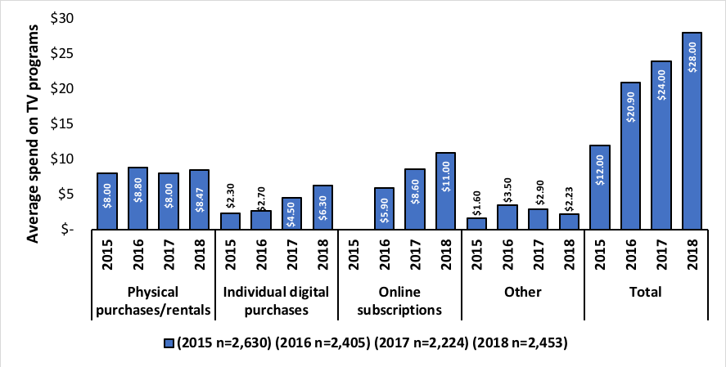

Source: Q59 (A, B, C and D) Approximately how much have you personally spent on the following in the past three months? Please indicate money spent on gifts for other people (where you didn’t expect them to pay you back). Other category represents (B) TV program merchandise.

The total spend on TV programs has increased over the last four years from $12.00 in 2015 up to $28.00 in 2018. While physical purchases or rentals has remained relatively steady, individual digital purchases and online subscriptions has increased. The average spent on individual digital purchases was $4.50 in 2017 and $6.30 in 2018. For online subscriptions it was $8.60 in 2017 and $11.00 in 2018.

The average spend for TV merchandise (other) has seen a steady decline over the last three years and is currently at $2.23.

Figure 71—Proportion of participants that spent anything on TV programs

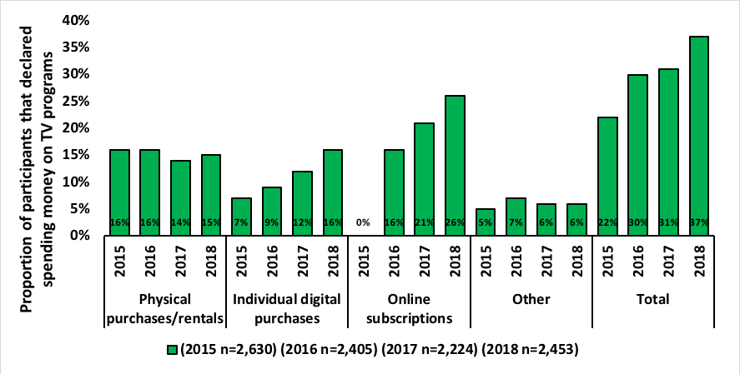

Source: Q59 (A, B, C and D) Approximately how much have you personally spent on the following in the past three months? Please indicate money spent on gifts for other people (where you didn’t expect them to pay you back). Other category represents (B) TV program merchandise.

The proportion of participants that spend anything on TV programs has increased steadily over the last four years and currently sits at 37%.

### Average consumer quarterly spend among lawfulness groups

The following Figures show the average total spend for each of the four core content types among the lawfulness groups.

Figure 72—Average consumer quarterly spend among those that are 100% lawful

Figure 72. Average consumer quarterly spend among those that are 100% lawful. 
For 2015 music was $125.20, video games was $110.10, movies was $66.20 and TV was $22.10. 
For 2016 music was $147.80, video games was $145.20, movies was $105.80 and TV was $40.00 
For 2017 music was $154.80, video games was $136.90, movies was $96.90 and TV was $44.90 
For 2018 music was $111.76, video games was $109.97, movies was $81.66 and TV was $38.31. 
More detail in report.


Source: Q14 Q31 Q44 Q59Approximately how much have you personally spent on the following in the past three months? Please indicate money spent on gifts for other people (where you didn’t expect them to pay you back). Q15 And approximately how much do you personally spend each month on music subscriptions services? Q27 Q55 You indicated that you have paid for (x) downloaded, streamed or accessed (music tracks / movies) in the past three months. How many of these do you think were done so lawfully? Q28 Q43 Q56 Q70 You indicated that you have downloaded, streamed or accessed (music tracks/video games /movies/TV programs) for free in the past three months. How many of these do you think were done so lawfully? M4, V4, F4 and T4.

The average consumer quarterly spend among those that are 100% lawful has declined across all four content types. This is a trend across the last three years for video games and movies and the last two years for music and TV programs.

Figure 73—Average quarterly spend among those that are a mix of lawful and unlawful consumers

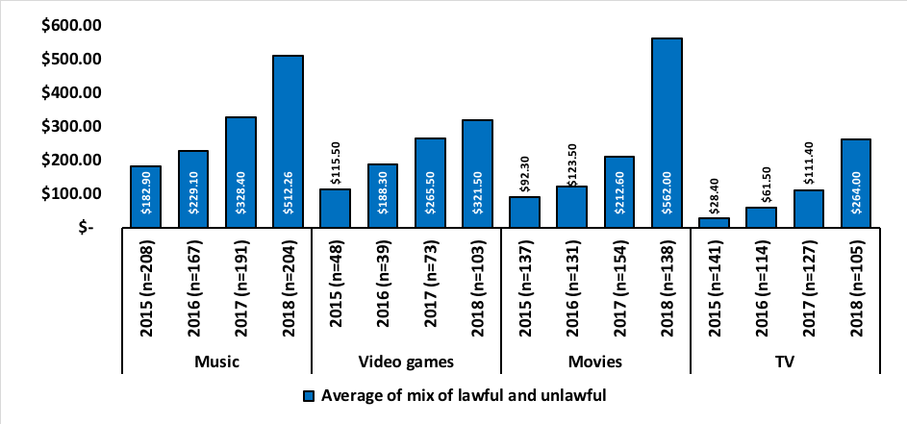

Source: Q14 Q31 Q44 Q59Approximately how much have you personally spent on the following in the past three months? Please indicate money spent on gifts for other people (where you didn’t expect them to pay you back). Q15 And approximately how much do you personally spend each month on music subscriptions services? Q27 Q55 You indicated that you have paid for (x) downloaded, streamed or accessed (music tracks / movies) in the past three months. How many of these do you think were done so lawfully? Q28 Q43 Q56 Q70 You indicated that you have downloaded, streamed or accessed (music tracks/video games /movies/TV programs) for free in the past three months. How many of these do you think were done so lawfully? M4, V4, F4 and T4.

The average consumer quarterly spend within those that are a mix of unlawful and lawful has increased over all four content types for the last four years. The increase from 2017 to 2018 is significant for music, movies and TV programs.

Figure 74—Average consumer quarterly spend among those that are 100% unlawful

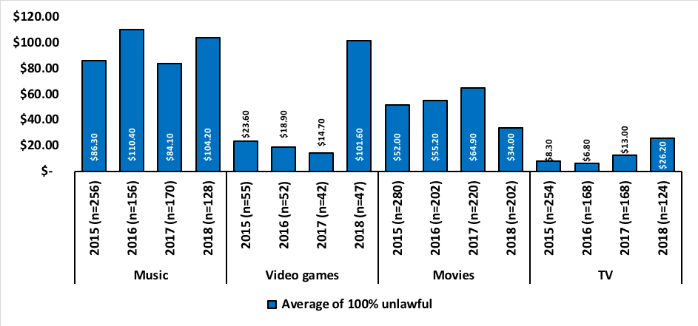

Source: Q14 Q31 Q44 Q59Approximately how much have you personally spent on the following in the past three months? Please indicate money spent on gifts for other people (where you didn’t expect them to pay you back). Q15 And approximately how much do you personally spend each month on music subscriptions services? Q27 Q55 You indicated that you have paid for (x) downloaded, streamed or accessed (music tracks / movies) in the past three months. How many of these do you think were done so lawfully? Q28 Q43 Q56 Q70 You indicated that you have downloaded, streamed or accessed (music tracks/video games /movies/TV programs) for free in the past three months. How many of these do you think were done so lawfully? M4, V4, F4 and T4.

The average consumer quarterly spend within those that are 100% unlawful varies across the four content types. An increase in average spend can be observed within music from $84.10 in 2017 to $104.20 in 2018 and also within TV programs from $13.00 in 2017 up to $26.20 in 2018, a significant change. The average spend for video games jumped significantly from $14.70 in 2017 up to $101.60 in 2018. The average spend on movies has dropped significantly from $64.90 in 2017 down to $34.00 in 2018.

When looking at the 100% lawful and 100% unlawful groups together the average quarterly consumer spend on music for 2018 is reasonably similar with 100% lawful at $111.76 and 100% unlawful $104.20. This is also the case for video games where an average of $109.97 was spent by 100% lawful and $101.60 for 100% unlawful.

There was a greater difference with the average spend on TV programs with 100% lawful at $38.31 and 100 unlawful at $26.20. The greatest and most significant difference can be observed with the average spend on movies where 100% lawful was $81.66 and 100% unlawful was $34.00.

### Quarterly total spend estimates

This section outlines the total spend estimates for each content type in the past three months, based on mean spend and applied to the Australian population 12+. The figures are rounded to the nearest million in each case.

Figure 75—Quarterly total spend on music across the Australian population aged 12+, to the nearest million

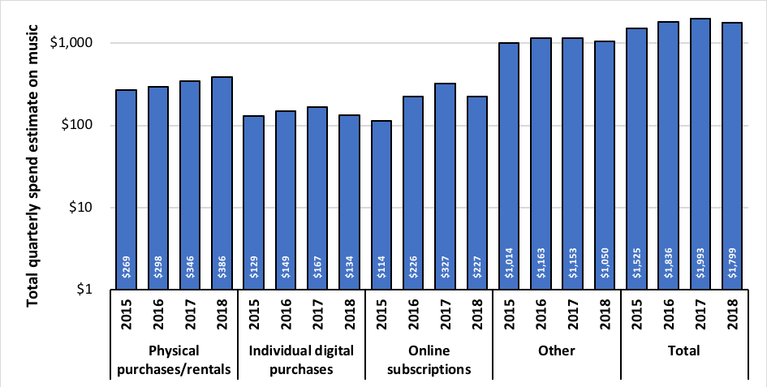

Source: Q14 how much have you personally spent on the following in the past three months? Please indicate money spent on gifts for other people (where you didn’t expect them to pay you back). Q15 And approximately how much do you personally spend each month on music subscriptions services? Q27 You indicated that you have paid for (x) downloaded, streamed or accessed music tracks in the past three months. How many of these do you think were done so lawfully? Q28 You indicated that you have downloaded, streamed or accessed music tracks for free in the past three months. How many of these do you think were done so lawfully? M4. Note the Figure uses an exponential scale and values with columns are to the nearest million.

The total quarterly spend estimates on music are $1,799m, a slight decrease from 2017 which was reported as $1,933m. While physical purchases and rentals continue on an upward trend across the last four years, individual digital purchases, online subscriptions and ‘other’ all experienced a decrease.

Figure 76—Proportion spent on each music component

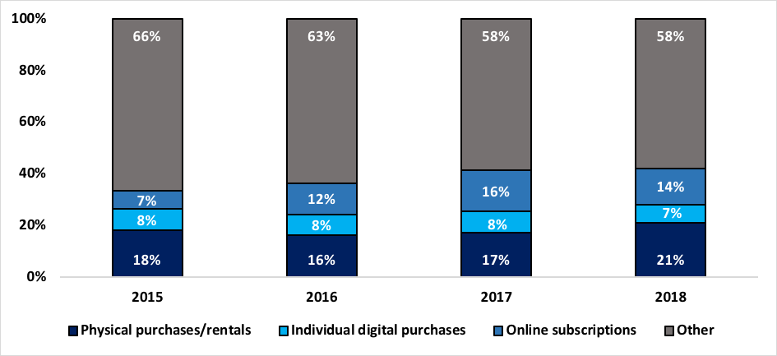

Source: Q14 how much have you personally spent on the following in the past three months? Please indicate money spent on gifts for other people (where you didn’t expect them to pay you back). Q15 And approximately how much do you personally spend each month on music subscriptions services? Q27 You indicated that you have paid for (x) downloaded, streamed or accessed music tracks in the past three months. How many of these do you think were done so lawfully? Q28 You indicated that you have downloaded, streamed or accessed music tracks for free in the past three months. How many of these do you think were done so lawfully? M4.

The proportion spent on physical music continues to rise and is currently 21%. There was a reduction in individual digital purchases from 8% in 2017 down to 7% in 2018.

Figure 77—Quarterly total spend on video games across the Australian population aged 12+, to the nearest million

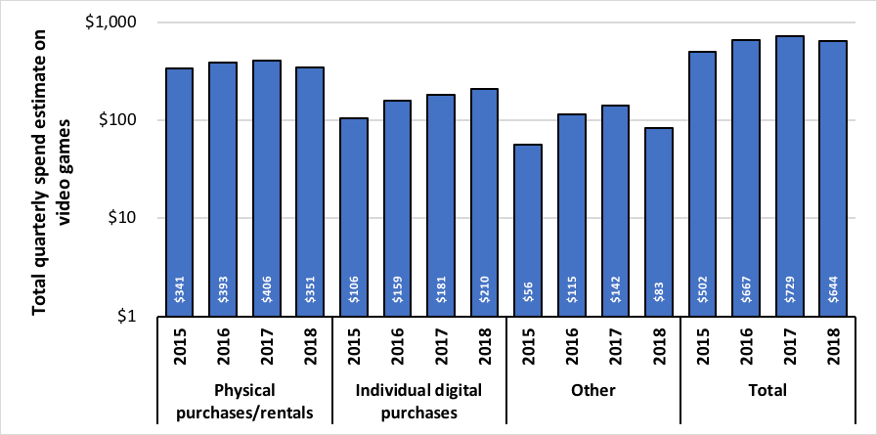

Source: Q31 Approximately how much have you personally spent on the following in the past three months? Please indicate money spent on gifts for other people (where you didn’t expect them to pay you back). Q43 You indicated that you have downloaded, streamed or accessed video for free in the past three months. How many of these do you think were done so lawfully? V4. Note the Figure uses an exponential scale and values with columns are to the nearest million.

The total quarterly spend estimates on video games has declined from $729m in 2017 down to $644m in 2018. While individual digital purchases increased from $181m in 2017 up to $210m in 2018, physical purchases and rentals experienced a drop from $406m in 2017 to $351m and ‘other’ experienced a decrease from $142m in 2017 to $83m in 2018, both significant drops.

Figure 78—Proportion spent on each video game component

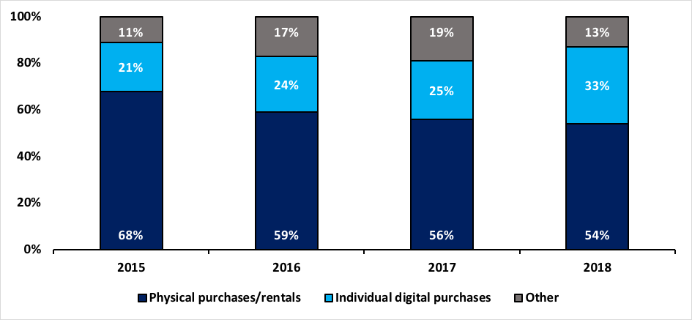

Source: Q31 Approximately how much have you personally spent on the following in the past three months? Please indicate money spent on gifts for other people (where you didn’t expect them to pay you back). Q43 You indicated that you have downloaded, streamed or accessed video for free in the past three months. How many of these do you think were done so lawfully? V4.

The proportion spent on physical purchases and rentals has declined steadily over the last four years and is currently at 54%. There is an increase in the proportion spent on individual digital purchases which currently represents 33% of the overall spend on video games.

Figure 79—Quarterly total spend on movies across the Australian population aged 12+, to the nearest million

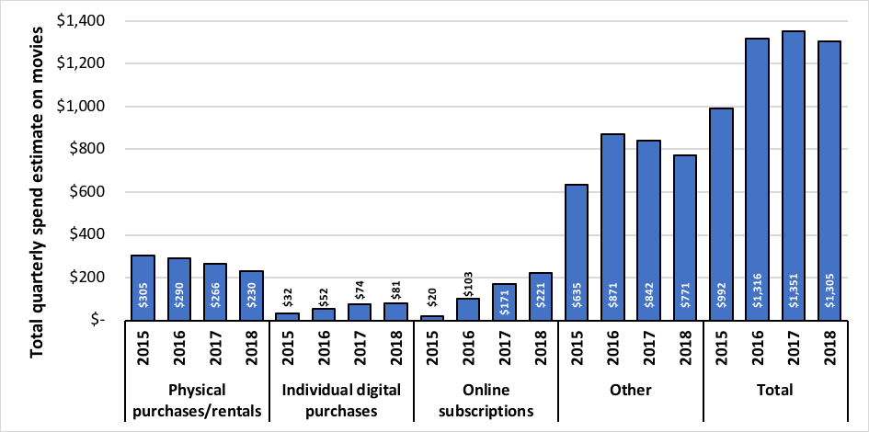

Source: Q44 Approximately how much have you personally spent on the following in the past three months? Please indicate money spent on gifts for other people (where you didn’t expect them to pay you back). Q55 You indicated that you have paid for (x) downloaded, streamed or accessed movies in the past three months. How many of these do you think were done so lawfully? Q56 You indicated that you have downloaded, streamed or accessed movies for free in the past three months. How many of these do you think were done so lawfully? F4.

The total quarterly spend estimate on physical purchases and rentals, and ‘other’ have declined steadily over the last three years. The spend on individual digital purchases has increased from $74m in 2017 to $81m in 2018. Online subscriptions have seen a significant increase from $171m in 2017 up to $221m in 2018.

Overall, the total quarterly spend on movies has decreased from $1,351m in 2017 down to $1,305m in 2018.

Figure 80—Proportion spent on each movie component

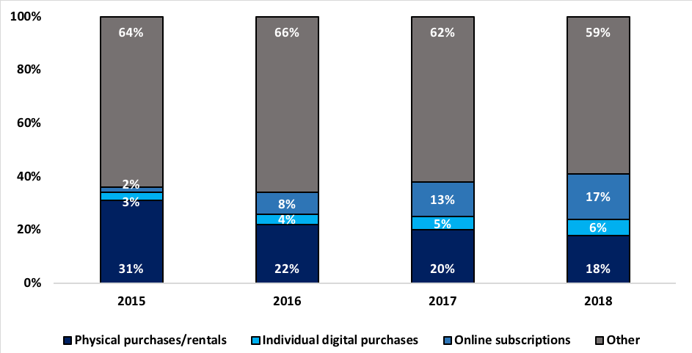

Source: Q44Approximately how much have you personally spent on the following in the past three months? Please indicate money spent on gifts for other people (where you didn’t expect them to pay you back). Q55 You indicated that you have paid for (x) downloaded, streamed or accessed movies in the past three months. How many of these do you think were done so lawfully? Q56 You indicated that you have downloaded, streamed or accessed movies for free in the past three months. How many of these do you think were done so lawfully? F4.

The proportion of total quarterly spend on physical purchases or rentals of movies has declined over the last four years and is currently 18%. Online subscriptions have seen a significant increase from 2% in 2015 up to 17% in 2018.

Figure 81—Quarterly total spend on TV programs across the Australian population aged 12+, to the nearest million

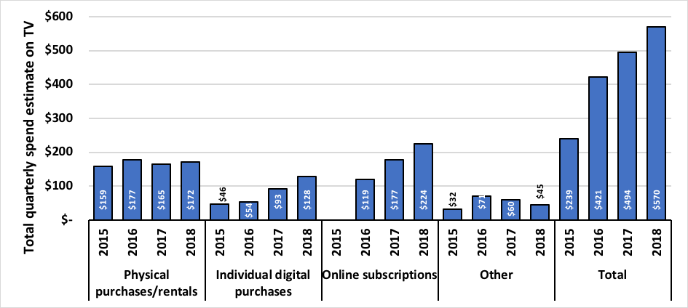

Source: Q59Approximately how much have you personally spent on the following in the past three months? Please indicate money spent on gifts for other people (where you didn’t expect them to pay you back? Q70 You indicated that you have downloaded, streamed or accessed TV programs for free in the past three months. How many of these do you think were done so lawfully? T4.

The quarterly spend on TV programs has experienced significant growth over the last four years and is currently at $570m. There is an increase in physical purchases from $165m in 2017 to $172m in 2018 and a significant increase with individual digital purchases from $93m in 2017 up to $128m in 2018. The decline experience with ‘other’ in 2017 continues into 2018 and is now at $45m.

Figure 82—Proportion spent on each TV program component

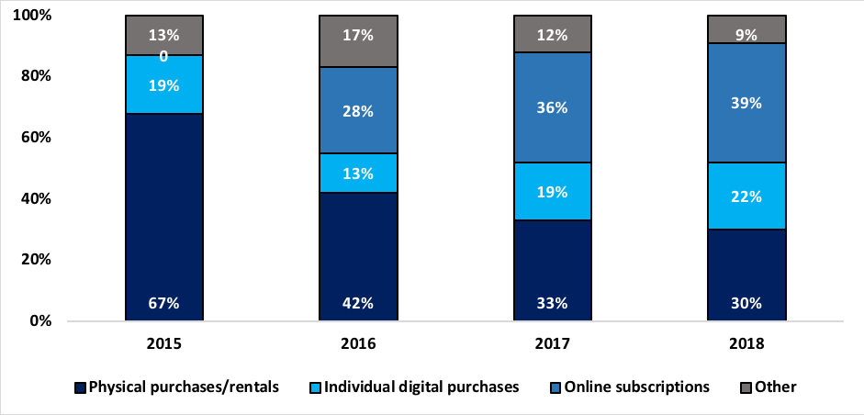

Source: Q59Approximately how much have you personally spent on the following in the past three months? Please indicate money spent on gifts for other people (where you didn’t expect them to pay you back? Q70 You indicated that you have downloaded, streamed or accessed TV programs for free in the past three months. How many of these do you think were done so lawfully? T4.

The proportion spent on TV program content shows the decline of physical purchases over the last four years from 67% down to 30%, and also the increase in online subscriptions from 0% up to 39%.

### Price sensitivity

Participants who had consumed digital music or digital movies in the past three months were asked how likely they were to pay a particular value. Participating consumers were given a monetary value and asked how likely they were to pay that value. The following Figures show the proportion of content consumers that were ‘likely’ or ‘very likely’ (scores combined) to pay the given amount.

Figure 83—Likelihood of digital music consumers spending a given value

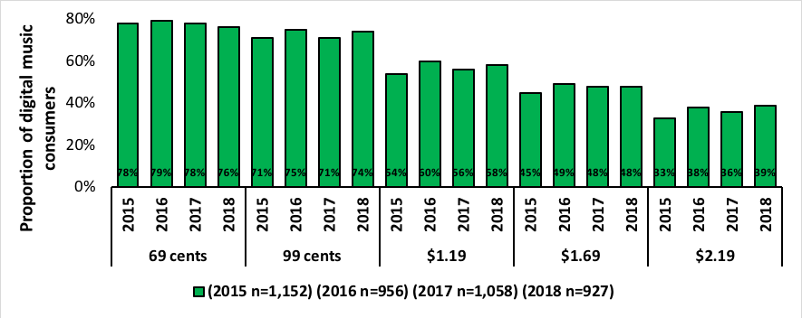

Source: Q29 Assuming you saw a single music track on an online service that you wanted to own. The track would be high quality, and you knew it was a reputable and reliable service. How likely would you be to download if it was the following price? Respondents were provided with four response options ‘very likely’, ‘likely’, ‘unlikely’ and ‘very unlikely’. The Figure represent respondents’ combined scores of ‘very likely’ and ‘likely.

Approximately three quarters (76%) indicated they would pay 69 cents for a single music track, a 2% drop from 2017 (78%) and 74% indicated they would pay 99 cents, an increase of 3% from 2017 (71%).

A significant proportion of digital music consumers (58%) indicated they were very likely or likely to pay $1.19 for a single music track. This is a slight increase from 2017 (56%). Just under half the respondents (48%) indicated they would pay $1.69, a finding consistent with 2017. The proportion of respondents prepared to pay $2.19 increased slightly from 36% in 2017 to 39% in 2018.

Figure 84—Likelihood of digital movie consumers spending a given value

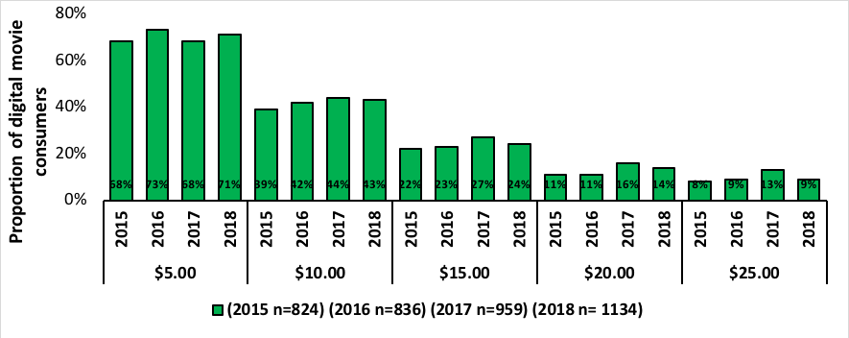

Source: Q57 Assuming you saw a newly released movie on an online service that you wanted to own. The movie would be high quality, and you knew it was a reputable and reliable service. How likely would you be to download if it was the following price? Respondents were provided with four response options ‘very likely’, ‘likely’, ‘unlikely’ and ‘very unlikely’. The Figure represent respondents’ combined scores of ‘very likely’ and ‘likely.

The proportion of digital movie consumers prepared to pay $15 or more has decreased since 2017. For those likely or very likely to pay $15 the proportion dropped from 27% in 2017 down to 24% in 2018. For $20 it dropped from 16% in 2017 down to 14% in 2018 and for $25 it dropped significantly from 13% in 2017 down to 9% in 2018.

The proportion of digital movie consumers prepared to pay $5 increased from 68% in 2017 to 71% in 2018.

## Attitudes towards digital activities and copyright infringement

### Motivations for general online activities

The survey measured consumer attitudes to explore participant motivations for taking part in the activities covered in the survey including downloading, streaming or accessing, and sharing content. The following Figures show participants’ ranked responses. The complete survey question has been included under each Figure.

Figure 85—Participant motivations for taking part in online activities (downloading, streaming or accessing and sharing content) rather than buying a physical version.

Figure 85. Participant motivations for taking part in online activities (downloading, streaming, or accessing and sharing content) rather than buying a physical version. Results are shown for the years 2015 to 2018. 
The proportion of participants who downloaded, streamed or accessed an online version of content instead of purchasing a physical version, because it was easier/it was more convenient was 71% in 2015, 68% in 2016, 66% in 2017 and 68% in 2018. The proportion of participants who chose online over physical because it was quicker was 57% in 2015, 51% in 2016, 57% in 2017 and 50% in 2018. The proportion of participants who chose online over physical because it was cheaper was 50% in 2015, 48% in 2016, 51% in 2017 and 44% in 2018. The proportion of participants who chose online over physical because it was allowed access on devices the participant already had was 43% in 2015, 37% in 2016, 38% in 2017 and 36% in 2018. The proportion of participants who chose online over physical to catch up on missed TV was 3% in 2015, 39% in 2016, 39% in 2017 and 34% in 2018. The proportion of participants who chose online over physical because it was free was 44% in 2015, 36% in 2016, 36% in 2017 and 28% in 2018. The proportion of participants who chose online over physical because it saved on physical space was 1% in 2015, 22% in 2016, 23% in 2017 and 20% in 2018. The proportion of participants who chose online over physical because it provided a more up-to-date version was 29% in 2015, 21% in 2016, 22% in 2017 and 20% in 2018. The proportion of participants who chose online over physical because the quality isn’t noticeably different was 27% in 2015, 20% in 2016, 20% in 2017 and 15% in 2018. The proportion of participants who chose online over physical because the content was not yet available in physical form in Australia was 1% in 2015, 19% in 2016, 22% in 2017 and 14% in 2018. The proportion of participants who chose online over physical because it allowed them to try before they bought was 57% in 2015, 51% in 2016, 57% in 2017 and 50% in 2018. The proportion of participants who chose online over physical because it was what everyone does was 18% in 2015, 16% in 2016, 17% in 2017 and 11% in 2018. The proportion of participants who chose online over physical because they were unable to play a physical version (eg. no CD player) was 0% in 2015, 8% in 2016, 10% in 2017 and 6% in 2018.
More detail in report.

Source: Q73 You indicated that you downloaded or streamed content in the past three months. Generally, what would you say are your personal reasons for downloading or streaming these types of files rather than buying a physical version such as a CD, DVD, Blu–ray, paper (books), etc.? Respondents were provided with 15 response options and ‘other’. They could select as many or as few as they chose. The data represents their collective responses.

The highest response selected, representing 68% of respondents, was ‘it’s easier / more convenient’, a result consistent with the last four years. Younger consumers were more likely to select this option, than those aged up to 44 years.

The second highest response, ‘it’s quicker’, was also consistent with previous years but dropped from 57% in 2017 down to 50% in 2018. This response was relatively even across all age groups.

Cost was the third most popular reason but experienced a significant drop from 51% in 2017 down to 44% in 2018. Cost, as a reason, was selected by most age groups but a slightly higher proportion of younger people, aged less than 35.

The proportion of respondents selecting ‘not available in Australia yet’ dropped significantly from 22% in 2017 down to 14% in 2018 and was more likely to be selected by those aged 16–24 or 25–34.

Across all of the reasons, the proportion of respondents has declined compared to 2017. The only reason that increased, from all those offered to participants, was ‘it’s easier / more convenient’.

Of the 53 ‘other’ responses provided by respondents ‘I only want to watch it once’ was noted by four participants. All other responses were only noted once each.

Participants with internet access who had not downloaded any of the four core content types in the last three months were asked why. They were given a number of response options and could select as many or as few as they chose. The following Figure shows their response.

Figure 86—Participant reasons for not downloading or sharing content online

Figure 86. Participant reasons for not downloading or sharing content online. Results are shown for the years 2015 to 2018. 
The proportion of participants who didn’t download or share content online because they weren’t interested was 55% in 2015, 55% in 2016, 56% in 2017 and 44% in 2018. The proportion of participants who didn’t download or share because they were unsure how to was 28% in 2015, 34% in 2016, 34% in 2017 and 23% in 2018. The proportion of participants who didn’t download or share online because they were too busy, or had no time, was 25% in 2015, 26% in 2016, 1% in 2017 and 19% in 2018. The proportion of participants who didn’t download or share online because they were wary of viruses or malware was 25% in 2015, 26% in 2016, 30% in 2017 and 18% in 2018. The proportion of participants who didn’t download or share online because they prefer to have a physical copy was 29% in 2015, 30% in 2016, 29% in 2017 and 17% in 2018. The proportion of participants who didn’t download or share online because they feared the online content was unlawful was 20% in 2015, 18% in 2016, 22% in 2017 and 15% in 2018. The proportion of participants who didn’t download or share online because they preferred to stream/access (without downloading) was 19% in 2015, 20% in 2016, 16% in 2017 and 14% in 2018. The proportion of participants who didn’t download or share online because it was too expensive was 12% in 2015, 15% in 2016, 18% in 2017 and 13% in 2018. The proportion of participants who didn’t download or share online because it was easier to purchase physical copies was 18% in 2015, 17% in 2016, 16% in 2017 and 11% in 2018. The proportion of participants who didn’t download or share online because they were unaware of the download services available was 21% in 2015, 22% in 2016, 17% in 2017 and 11% in 2018. The proportion of participants who didn’t download or share online because physical versions are more flexible was 14% in 2015, 16% in 2016, 17% in 2017 and 9% in 2018. The proportion of participants who didn’t download or share online because they did not have a large enough download data limit was 1% in 2015, 1% in 2016, 11% in 2017 and 6% in 2018. The proportion of participants who didn’t download or share online because the quality is not as good was 8% in 2015, 7% in 2016, 8% in 2017 and 5% in 2018. The proportion of participants who didn’t download or share online because they did not own a device capable of downloading was 8% in 2015, 12% in 2016, 11% in 2017 and 5% in 2018. The proportion of participants who didn’t download or share online because they didn’t have a debit/credit card was 5% in 2015, 7% in 2016, 7% in 2017 and 4% in 2018. The proportion of participants who didn’t download or share online because the site had been blocked was 0% in 2015, 0% in 2016, 3% in 2017 and 2% in 2018.
More detail in report.

Source: Q74 What are the reasons you haven’t downloaded or streamed any files in the past three months? You may give as many or as few answers as you feel apply. Respondents were provided with 16 response options and ‘other’. Note: figures for 2015, 2016 and 2017 are reported as being for ‘Downloaded’ only.

The reasons selected by respondents explaining why they haven’t downloaded or streamed any files in the last three months have only changed slightly since 2017. The top reason selected by participants was ‘I’m not interested’ and while it has experienced a drop from 56% in 2017 down to 44% in 2018, it still remains the top reason selected by participants.

The reason ‘not sure how to do it’ also experienced a drop from 34% in 2017 down to 23% in 2018, but retains the second position. This decreasing trend is consistent with the exception of ‘they are too expensive’ which was overtaken by ‘I prefer to stream / access without downloading’ in 2018.

Last year (2017), nearly one third (29%) selected that they prefer to have a physical version. This dropped significantly down to 17% in 2018.

Respondents selecting ‘I fear they may have viruses, malware or spyware’ was a reason more popular with older respondents, 55+, than young respondents. This was also the case for those selecting ‘I fear that they may not be lawful’.

The reason ‘the site has been blocked’ was only selected by 2% in 2018 and most of those were young respondents aged between 16 and 34.

Of the 36 ‘other’ responses provide by respondents’ factors including cost (2 responses) and slow internet (3 responses) were the most frequent.

Figure 87—Motivations for sharing content online.

Figure 87. Motivations for sharing content online. Results are shown for the years 2015 to 2018. 
The proportion of participants who shared content online because their family couldn’t access the files themselves was 34% in 2015, 40% in 2016, 35% in 2017 and 34% in 2018. The proportion of participants who shared content online because they felt they should be able to share their content with whomever they chose was 29% in 2015, 30% in 2016, 23% in 2017 and 31% in 2018. The proportion of participants who shared content online because it was easy to do was 44% in 2015, 37% in 2016, 35% in 2017 and 26% in 2018. The proportion of participants who shared content online because it was only fair was 36% in 2015, 29% in 2016, 28% in 2017 and 24% in 2018. The proportion of participants who shared content online because it was what everyone else does was 29% in 2015, 28% in 2016, 32% in 2017 and 21% in 2018. The proportion of participants who shared content online because, unless they shared the content, they couldn’t download other files themselves, was 12% in 2015, 10% in 2016, 5% in 2017 and 10% in 2018. More detail in report.

Source: Q76 you indicated that you have shared content in the past three months. What were your personal reasons for doing this? You may give as many or as few answers as you feel apply. Respondents were provided with 7 response options and ‘other’.

The most common response (34%) was ‘my friends and family can’t access files themselves’, a result consistent with 2017. This response was more likely to be selected by males (56%) than females (44%)

In 2017, the second most popular response, and equal to the highest response for 2017, was ‘it’s easy to do’ (35%); this experienced a significant drop in 2018 down to 26%. Also a more popular response for males than females. For 2018, the second most popular response was ‘I should be able to share my content with whomever I choose’ at 31%.

‘It’s only fair’ was selected by 24% and ‘It’s what everyone does’ was selected by 21%, a significant drop from 32% in 2017.

Of the 16 ‘other’ responses provided by the respondents the most common theme was sharing content with friends or family for amusement (4 responses).

### Attitudes towards online content

Respondents who consumed any of the four core content types (music, video games, movies and TV programs) were asked to what extent they agreed or disagreed to a series of statements relating to their consumption of digital data. They were provided with five response options:

1. Strongly agree
2. Slightly agree
3. Neither agree nor disagree
4. Slightly disagree
5. Strongly disagree.

The following Figures outline participant responses to each statement. To be consistent with previous years’ research, results for strongly agree and slightly agree have been combined and results for strongly disagree and slightly disagree have also been combined and the results for ‘neither agree nor disagree’ have not been included in the analysis. Each years’ results have been divided into three separate categories: all aged 12+ with internet access, any unlawful infringers; 100% lawful non–infringers.

#### Attitudes towards price and payment of online content

Figure 88—Content that you download or access online should be cheaper than the equivalent purchased in physical format

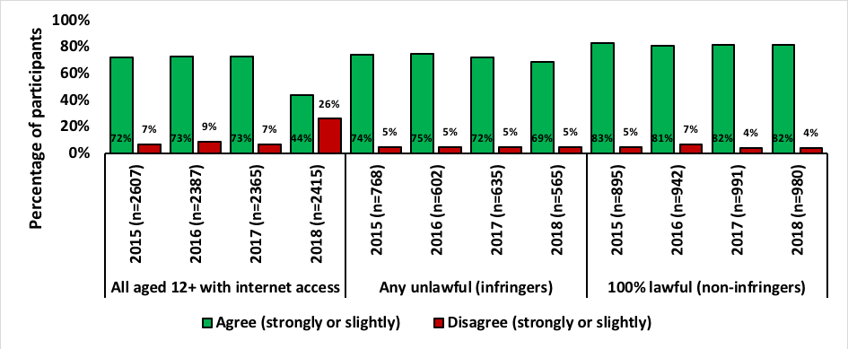

Source: Q72 To what extent do you agree or disagree with the statement ‘Content that you download or access online should be cheaper than the equivalent purchased in a physical format (e.g. a CD, DVD, Blu‑ray or VHS)’?

There is a significant decrease in the percentage of participants, all aged 12+ with internet access, that agreed with the statement in 2018 (44%) compared to 2017 (73%). This shift was not seen within the infringers or non–infringers categories which remained relatively similar to 2017 and previous years, although a slight drop from 72% down to 69% was noted in the infringers’ category. There was also a strong increase in participants aged 12+ with internet access that disagreed with the statement, from 7% in 2017 up to a significant 26% in 2018.

Figure 89—If you had paid for a digital file you should then be able to share it with others

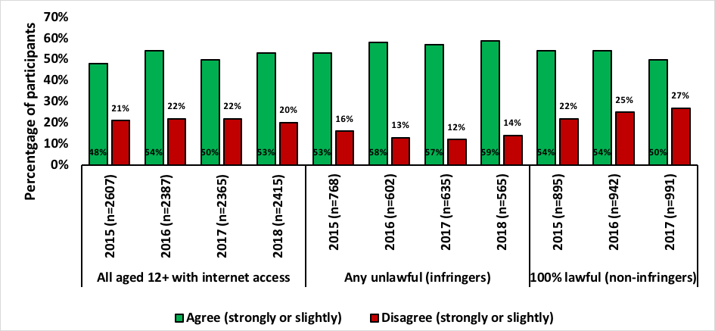

Source: Q72 To what extent do you agree or disagree with the statement ‘If you had paid for a digital file you should then be able to share it with others’?

More participants with internet access agreed with this statement (53%) when compared to 2017 (50%). This was also seen within the infringers’ category with a 2% increase from 57% in 2017 up to 59% in 2018. Non–infringers, however, dropped from 54% in 2017 down to 50% in 2018.

Figure 90—I think you should be able to download or access the content you want for free from the Internet.

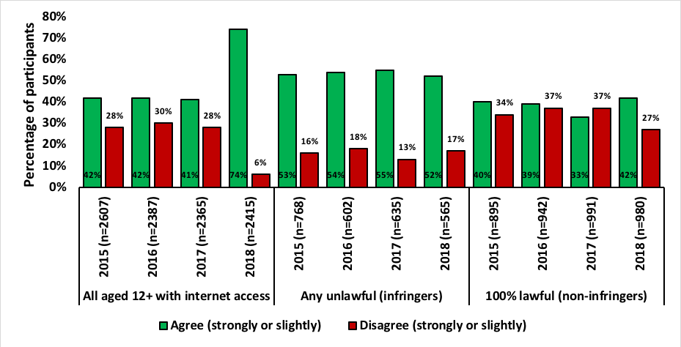

Source: Q72 To what extent do you agree or disagree with the statement ‘I think that you should be able to download or access the content you want for free from the Internet’?

The attitude shift in this statement was most notable among all aged 12+ with internet access where those who agreed jumped from 41% in 2017 up to 74% in 2018. Younger respondents were more likely to agree than older respondents, although most age groups agreed with the statement.

The attitude shift is also reflected in the proportion that disagreed with the statement, dropping significantly from 28% in 2017 down to 6% in 2018.

The proportion of infringers dropped slightly from 55% in 2017 down to 52% in 2018. There was a significant increase in non–infringers from 33% in 2017 up to 42% in 2018.

Figure 91—The price that you pay to download or access content is generally about right

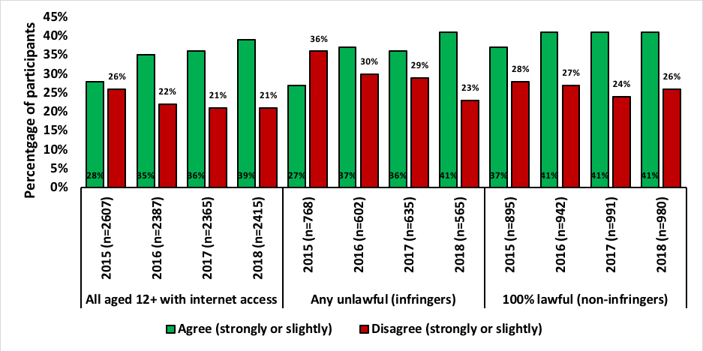

Source: Q72 To what extent do you agree or disagree with the statement ‘The price that you pay to download or access content online is generally about right’?

The proportion of participants that agree with this statement continues to rise within the category of all aged 12+ with internet access from 36% in 2017 up to 39% in 2018. There was also an increase in the proportion of infringers who agree with the statement (41%) when compared to 2017 (36%). Agreement within the non–infringers has stayed steady for the last three years at 41%.

The proportion of infringers that disagree with this statement has significantly declined from 29% in 2017 down to 23% in 2018.

#### Morality of accessing and sharing content without permission

Figure 92—It is wrong to access content online without the creator’s or artist’s permission

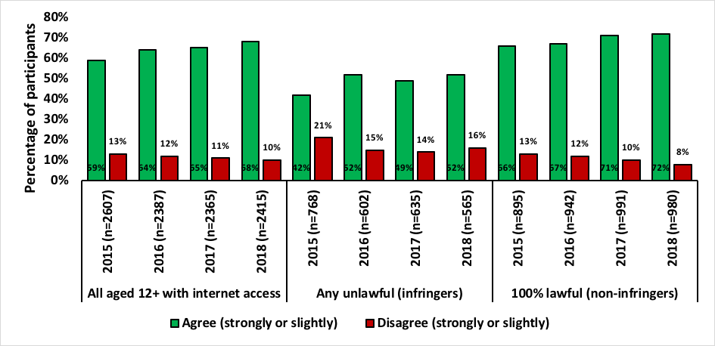

Source: Q72 To what extent do you agree or disagree with the statement ‘It is wrong to access content online without the creators / artists permission’?

The levels of morality continue to rise across all categories. In 2017, 49% of infringers agreed it was wrong to access content online without permission and in 2018 this has risen to 52%. Non‑infringers also experienced a greater proportion of agreement from 71% in 2017 up to 72% in 2018.

Figure 93—The rules governing what you can and can’t do with content you purchase should be the same for both physical and online formats.

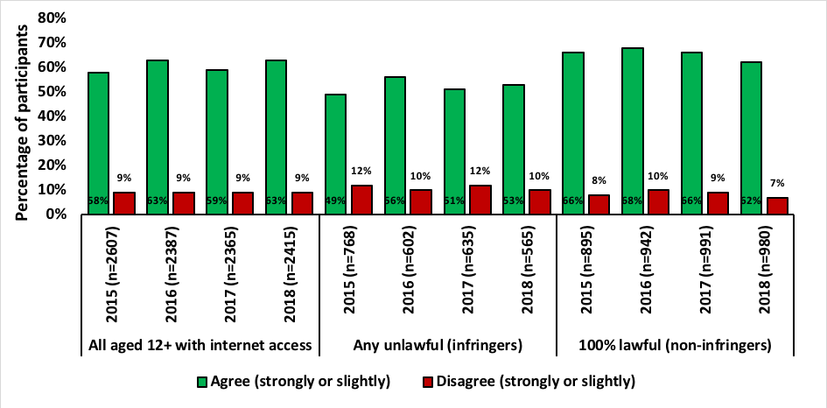

Source: Q72 To what extent do you agree or disagree with the statement ‘The rules governing what you can and can’t do with content you purchase should be the same for both physical (e.g. a CD, DVD, Blu–ray, or VHS) and online formats’?

The downward turn in agreement to this statement noted in 2017 has not been continued into 2018 with exception of the non–infringers category where the decline continued from 66% in 2017 down to 62% in 2018.

#### Efficacy of accessing online content

Figure 94—It is easy to find content on the Internet for free that would usually be paid for

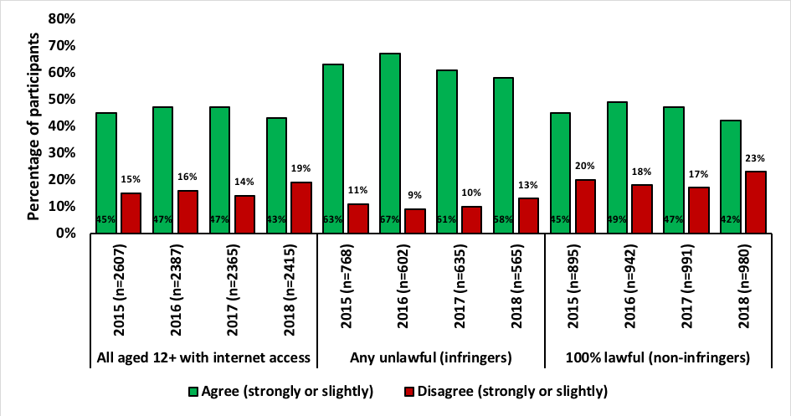

Source: Q72 To what extent do you agree or disagree with the statement ‘It is easy to find content on the Internet for free that would usually be paid for’?

Across all categories less participants agree with this statement when compared to previous years. Additionally, those that disagree with the statement has increased across all categories.

Figure 95—I find it difficult to find lawful content online

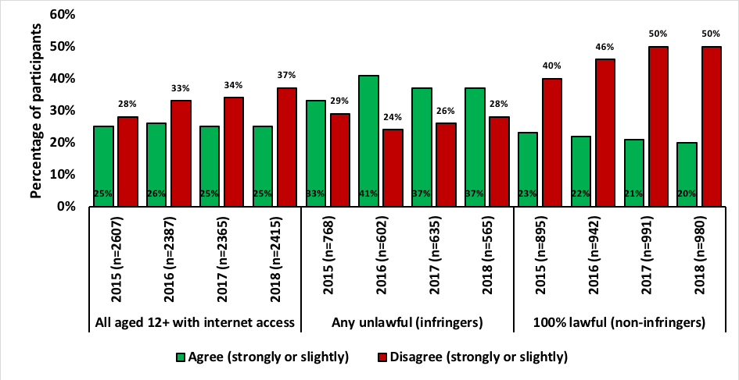

Source: Q72 To what extent do you agree or disagree with the statement ‘I find it difficult to find lawful content online’?

More participants disagree with this statement and within the categories of all aged 12+ with internet access and infringers there is an increase in disagreement compared to 2017. The proportion of non–infringers that disagree remains constant at 50%. Only a quarter agree with this statement within the category of all aged 12+ with internet access. This increases to just over a third (37%) within the infringers’ category.

### Motivations for lawful and unlawful behaviour

To assess participants’ primary motivations for lawful and unlawful behaviour, further questions were asked to uncover factors that might encourage those who currently infringe to stop.

Respondents who paid for any content were asked what their personal reasons were for doing this, rather than using free services. It is important to consider that in asking about the use of paid services over free services, there is not necessarily an implication that the latter is unlawful. There are a number of popular, free services such as YouTube, ABC iView and Facebook that enable consumption and sharing of content.

The following Figures show the main reasons given for paying for online content, they are presented in order of statement selection (highest to lowest, numbered to show ranking) for 2018. Each Figure shows the total percentage of participants who have selected the statement for any paid content (black), infringers (any unlawful—red) and lawful (non–infringers—green). Additionally, data from each year has been included for comparison.

Figure 96—The reason I paid is ‘It’s easier or more convenient’ (1)

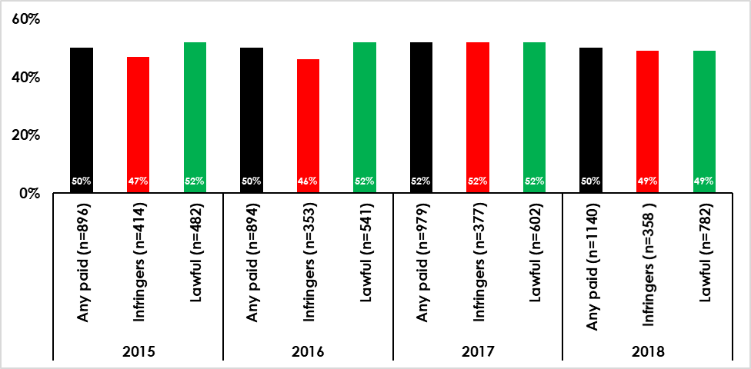

Source: Q75 you indicated that you have paid to download or stream or access content in the past three months. What are your personal reasons for doing this rather than using services where you could have got them for free? Respondents were provided with 13 responses and ‘other’, and they could select as many or as few as they felt applied.

The number one reason selected by participants as their reason for paying for content rather than accessing it for free was ‘it’s easier / convenient’ which was selected by 50% of any paid, 49% of infringers and 49% of lawful consumers. These results are similar to 2017, however there is a slight decline in proportion across the three categories.

Figure 97—The reason I paid is ‘it’s quicker’ (2)

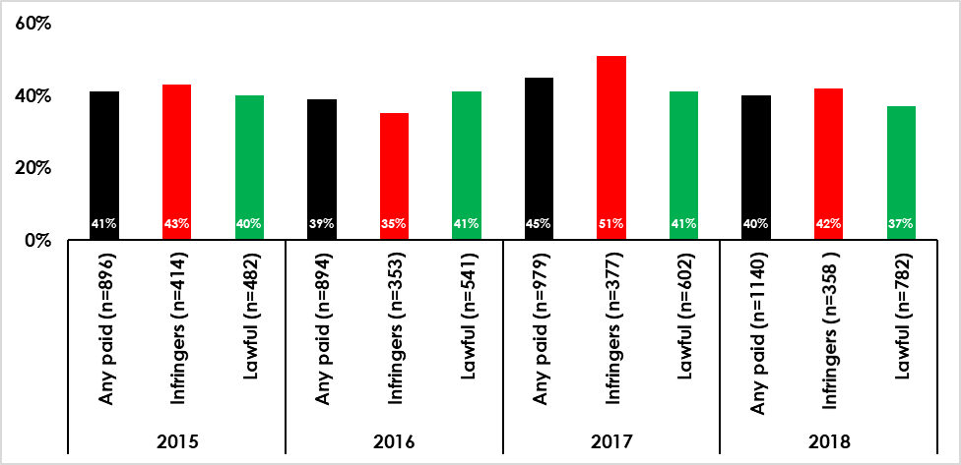

Source: Q75 you indicated that you have paid to download or stream or access content in the past three months. What are your personal reasons for doing this rather than using services where you could have got them for free? Respondents were provided with 13 responses and ‘other’, and they could select as many or as few as they felt applied.

The second most selected reason given for paying was ‘it’s quicker’. There was a decline in all categories compared to 2017. Any paid was 45% in 2017 and dropped to 40% in 2018 for infringers it dropped significantly from 51% in 2017 down to 42% in 2018. Within the lawful category the proportion dropped from 41% down to 37%.

Figure 98—The reason I paid is ‘they are better quality’ (3)

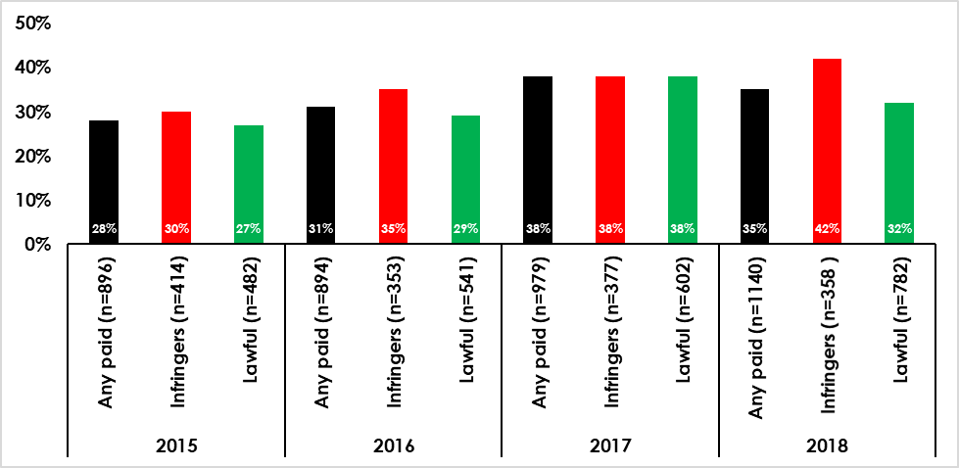

Source: Q75 you indicated that you have paid to download or stream or access content in the past three months. What are your personal reasons for doing this rather than using services where you could have got them for free? Respondents were provided with 13 responses and ‘other’, and they could select as many or as few as they felt applied.

The reason ‘they are better quality’ increased within infringers from 2017 at 38% to 42% in 2018. A drop was observed in both the any paid and lawful categories of 3% and 6% respectively.

Figure 99—The reason I paid is ‘I don’t want to use sites providing unlawful content’ (4)

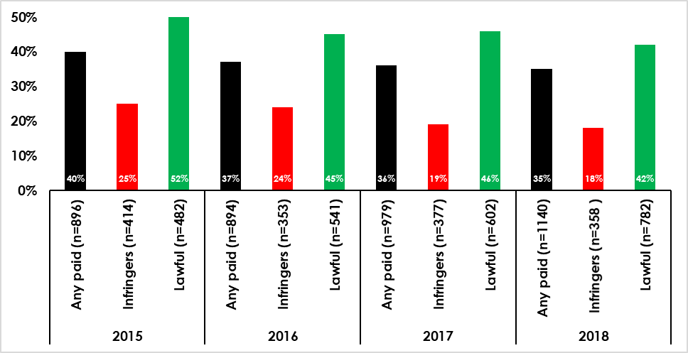

Source: Q75 you indicated that you have paid to download or stream or access content in the past three months. What are your personal reasons for doing this rather than using services where you could have got them for free? Respondents were provided with 13 responses and ‘other’, and they could select as many or as few as they felt applied.

This response was selected by 42% lawful and 35% any paid but the declining trend continues for infringers as being a reason for paying for digital content and is currently at 18%.

Figure 100—The reason I paid is ‘I fear they may have viruses/malware/spyware’ (5)

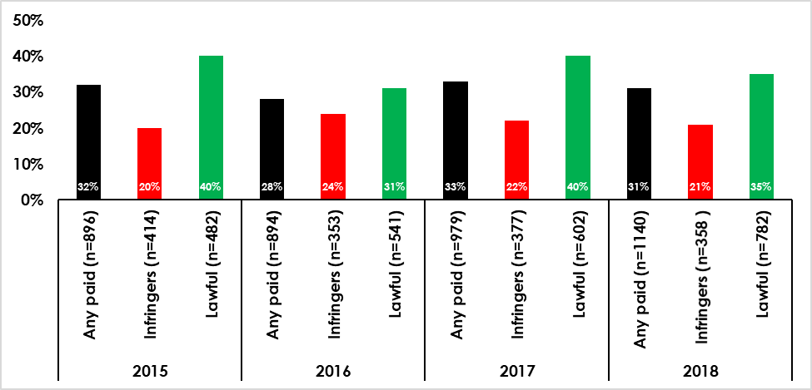

Source: Q75 you indicated that you have paid to download or stream or access content in the past three months. What are your personal reasons for doing this rather than using services where you could have got them for free? Respondents were provided with 13 responses and ‘other’, and they could select as many or as few as they felt applied.

Just over a third of lawful respondents (35%) fear viruses, malware and spyware and choose to pay for digital content with the perception that it will avoid this issue. This reason was selected by 31% of participants within the any paid category.

Figure 101—The reason I paid is ‘I want to support creators/industry’ (6)

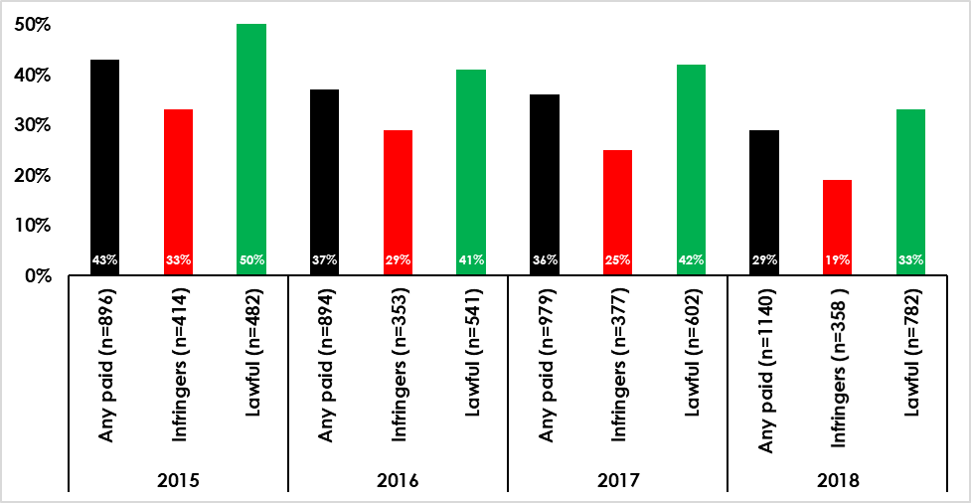

Source: Q75 you indicated that you have paid to download or stream or access content in the past three months. What are your personal reasons for doing this rather than using services where you could have got them for free? Respondents were provided with 13 responses and ‘other’, and they could select as many or as few as they felt applied.

The reason of supporting creators and industry has decreased across all categories. In 2017 any paid was 36% and dropped to 29%, infringers was 25% and dropped to 19% and lawful was 42% and experienced a significant drop to 33%.

Figure 102—The reason I paid is ‘I think it’s morally wrong to use sites providing unlawful content’ (7)

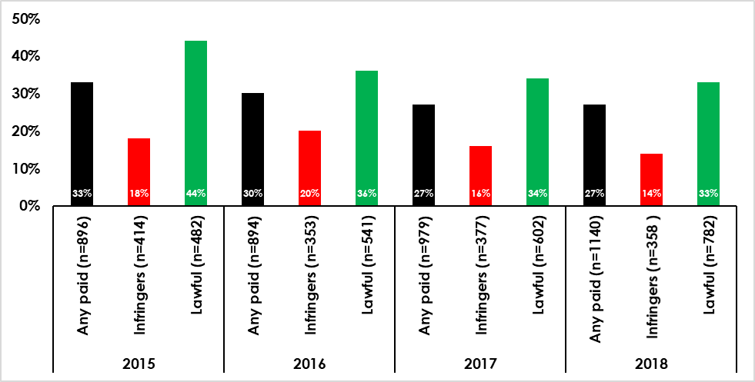

Source: Q75 you indicated that you have paid to download or stream or access content in the past three months. What are your personal reasons for doing this rather than using services where you could have got them for free? Respondents were provided with 13 responses and ‘other’, and they could select as many or as few as they felt applied.

Morality as a reason for paying for content was selected by 33% of respondents within the lawful category and 27% within the any paid category, with the figures relatively stable compared to 2017.

Figure 103—The reason I paid is ‘I can afford to pay’ (8)

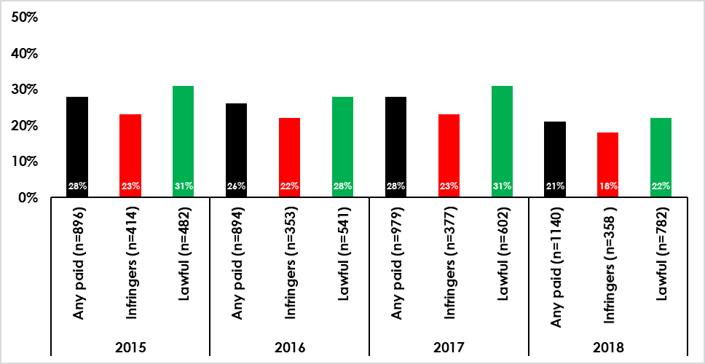

Source: Q75 you indicated that you have paid to download or stream or access content in the past three months. What are your personal reasons for doing this rather than using services where you could have got them for free? Respondents were provided with 13 responses and ‘other’, and they could select as many or as few as they felt applied.

Being able to afford to pay for digital content was chosen by about a fifth of respondents within each category but all categories decreased from 2017.

Figure 104—The reason I paid is ‘I don’t think it’s right to get them for free’ (9)

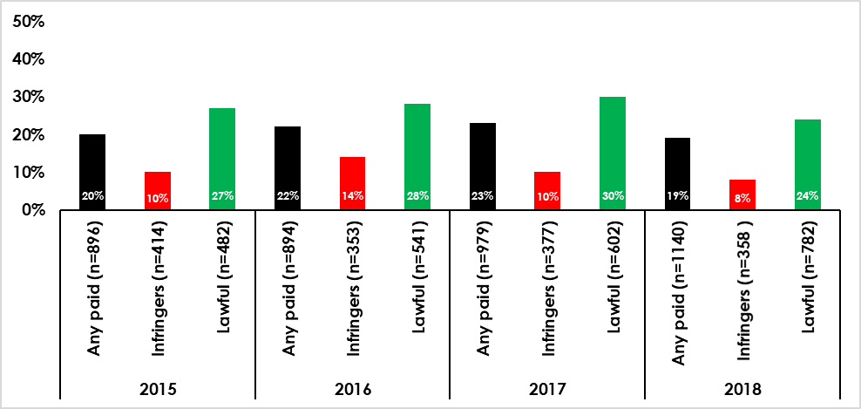

Source: Q75 you indicated that you have paid to download or stream or access content in the past three months. What are your personal reasons for doing this rather than using services where you could have got them for free? Respondents were provided with 13 responses and ‘other’, and they could select as many or as few as they felt applied.

This reason was selected by 8% of infringers, 19% of the any paid category and 24% of the lawful category.

Figure 105—The reason I paid is ‘I prefer to pay’ (10)

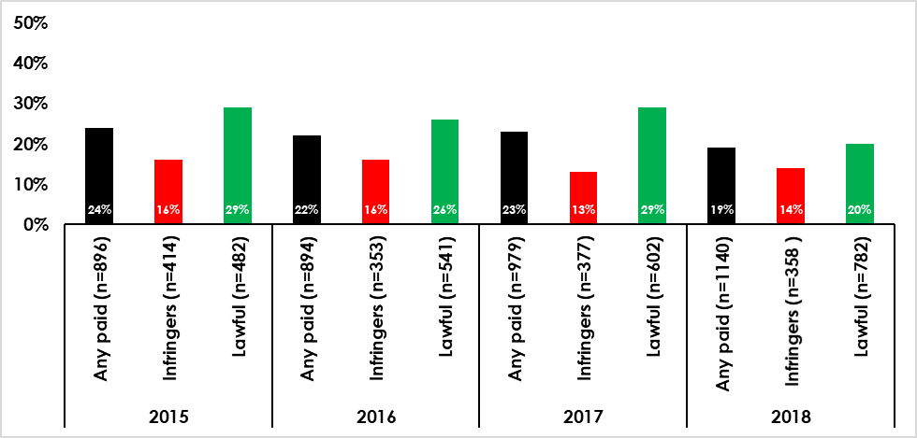

Source: Q75 you indicated that you have paid to download or stream or access content in the past three months. What are your personal reasons for doing this rather than using services where you could have got them for free? Respondents were provided with 13 responses and ‘other’, and they could select as many or as few as they felt applied.

There was a slight increase (1%) within the infringers category stating ‘I prefer to pay’ as a reason for paying for content comparing 2017 and 2018. Also of note, a decrease from 29% in 2017 down to 20% in 2018 was found within the lawful category.

Figure 106—The reason I paid is ‘I fear I might be caught’ (11)

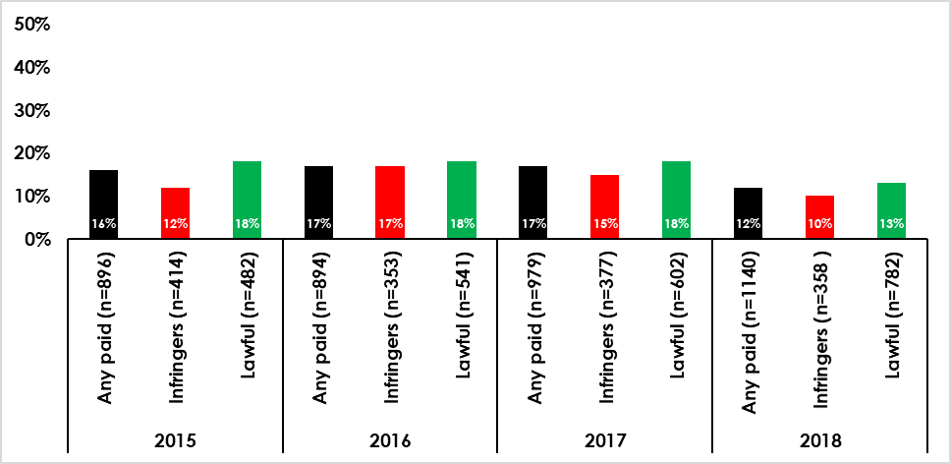

Source: Q75 you indicated that you have paid to download or stream or access content in the past three months. What are your personal reasons for doing this rather than using services where you could have got them for free? Respondents were provided with 13 responses and ‘other’, and they could select as many or as few as they felt applied.

The fear of getting caught was chosen by 10% of infringers, 12% of any paid and 13% within the lawful category.

Figure 107—The reason I paid is ‘I’m unaware of the free services available’ (12)

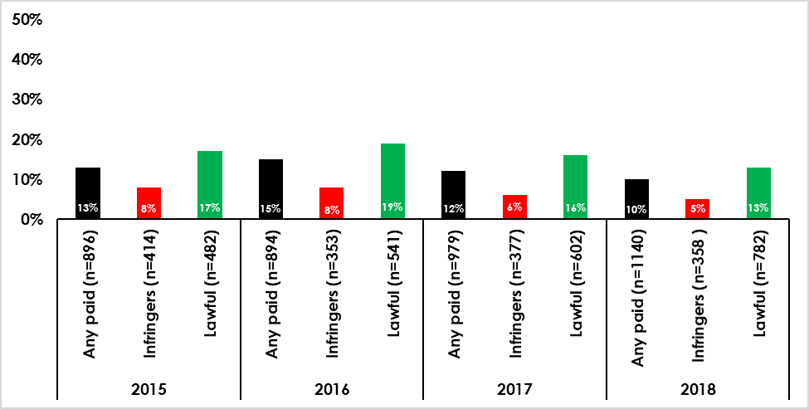

Source: Q75 you indicated that you have paid to download or stream or access content in the past three months. What are your personal reasons for doing this rather than using services where you could have got them for free? Respondents were provided with 13 responses and ‘other’, and they could select as many or as few as they felt applied.

Being unaware of free services was selected by any paid and lawful categories at a rate of 10% and 13% respectively. Only 5% of infringers chose this as a reason for paying for content.

Figure 108—The reason I paid is ‘I don’t know how to use the free services’ (13)

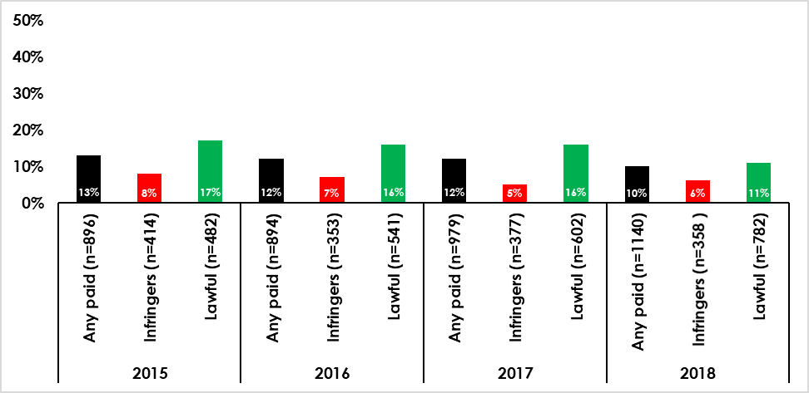

Source: Q75 you indicated that you have paid to download or stream or access content in the past three months. What are your personal reasons for doing this rather than using services where you could have got them for free? Respondents were provided with 13 responses and ‘other’, and they could select as many or as few as they felt applied.

The reason of not knowing how to use free services provided a similar result to not knowing about free services with 10% any paid, 11% lawful and 6% infringers selecting this reason.

Respondents who indicated that they had infringed (any unlawful) were asked what their personal reasons were for consuming content unlawfully. The main reasons given for unlawful consumption of content online among the lawfulness groups were as follows. The first figure shows the top six responses. The ‘any unlawful’ proportion gives the total of both ‘mix lawful and unlawful’ and ‘all unlawful’.

Figure 109—Motivations for unlawful consumption of content: top six responses 2018

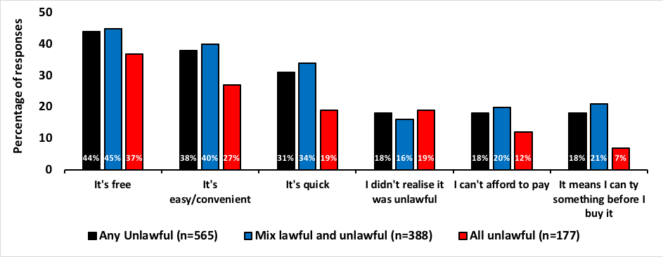

Source: Q77 You indicated that you have downloaded or streamed or accessed content in the past months which you think may have been done unlawfully. What are your personal reasons for doing this? Respondents were provided with 20 response options and ‘other’. They could select as many or as few as they chose. Note: ‘Any unlawful’ represents the sum of ‘mix lawful and unlawful’ and ‘all unlawful’.

The top response given as a motivation for unlawful consumption of content was ‘it’s free’, selected by 44% of any unlawful, 45% of mix and 37% of all unlawful consumers. ‘It’s easy/convenient’ was also popular with 38% of any unlawful, 40% of mix and 27% of all unlawful. ‘It’s quick’ was popular with any unlawful (31%) and mix (34%) but not so popular with all unlawful (19%).

Figure 110—Motivations for unlawful consumption of content: ‘It’s free’

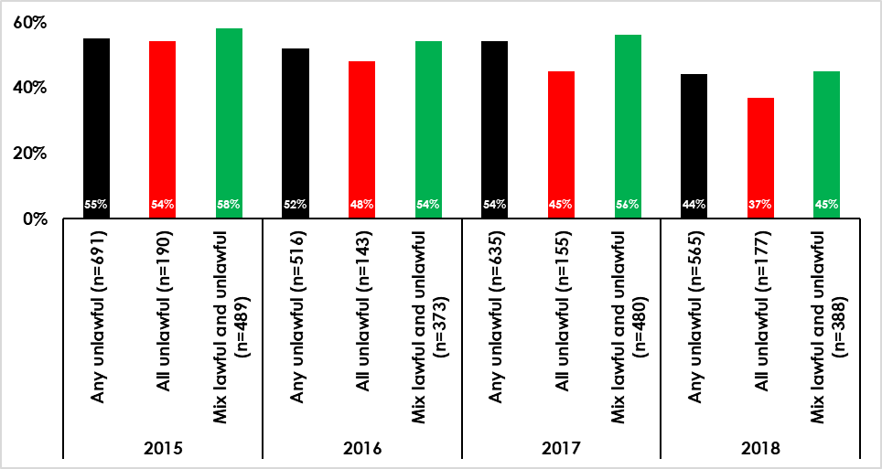

Source: Q77 You indicated that you have downloaded or streamed or accessed content in the past months which you think may have been done unlawfully. What are your personal reasons for doing this? Respondents were provided with 20 response options and ‘other’. They could select as many or as few as they chose.

The reason ‘it’s free’ has declined in popularity across all categories from 2017 to 2018. Within the any unlawful it dropped from 54% down to 44%, in all unlawful from 45% to 37% and mix from 56% down to 45%, a significant drop.

Figure 111—Motivations for unlawful consumption of content: ‘It’s easy / convenient’

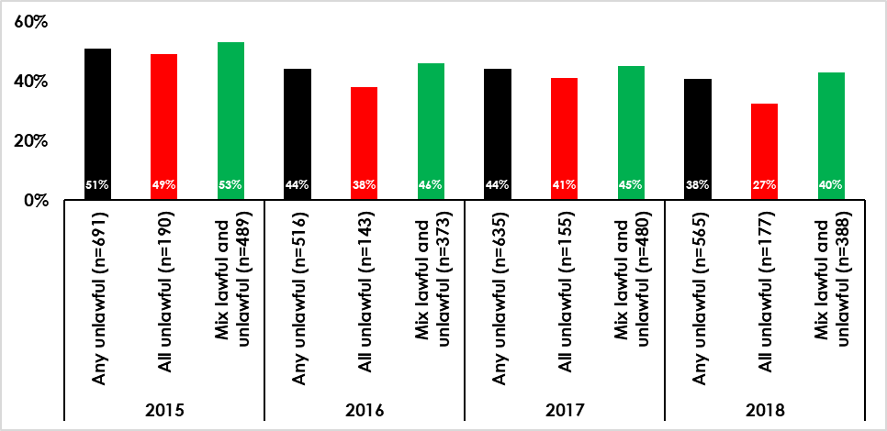

Source: Q77 You indicated that you have downloaded or streamed or accessed content in the past months which you think may have been done unlawfully. What are your personal reasons for doing this? Respondents were provided with 20 response options and ‘other’. They could select as many or as few as they chose.

Being easy or convenient was selected by more than a third of any unlawful (38%) and mix (40%) but only 27% of all unlawful which also saw a significant drop from 41% in 2017.

Figure 112—Motivations for unlawful consumption of content: ‘It’s quick’

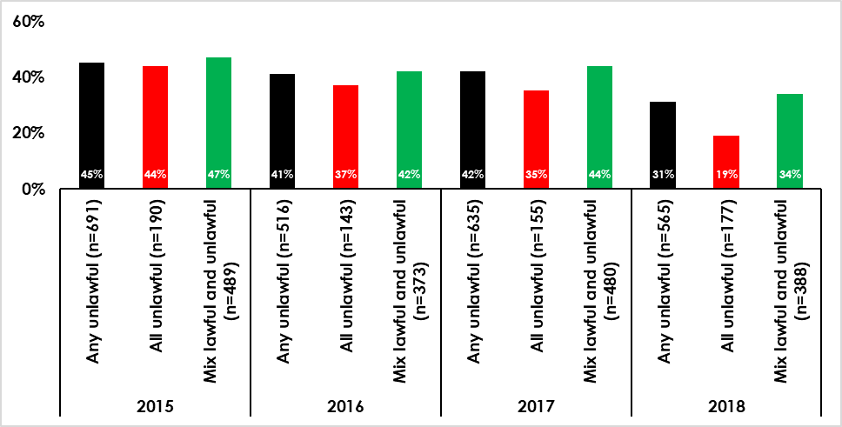

Source: Q77 You indicated that you have downloaded or streamed or accessed content in the past months which you think may have been done unlawfully. What are your personal reasons for doing this? Respondents were provided with 20 response options and ‘other’. They could select as many or as few as they chose.

Speed as a reason for consuming content unlawfully has also declined significantly in popularity across all categories.

Figure 113—Motivations for unlawful consumption of content: ‘I didn’t realise it was unlawful’

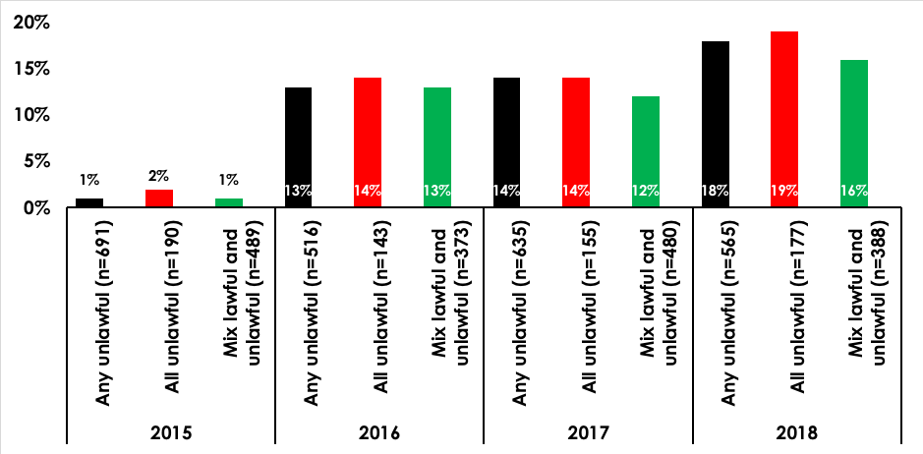

Source: Q77 You indicated that you have downloaded or streamed or accessed content in the past months which you think may have been done unlawfully. What are your personal reasons for doing this? Respondents were provided with 20 response options and ‘other’. They could select as many or as few as they chose.

Not knowing that an activity was unlawful was selected by about a fifth of respondents across all categories and was an increase compared to 2017. This could indicate that consumers are having difficulty determining what is and isn’t lawful activity.

Figure 114—Motivations for unlawful consumption of content: ‘I can’t afford to pay’

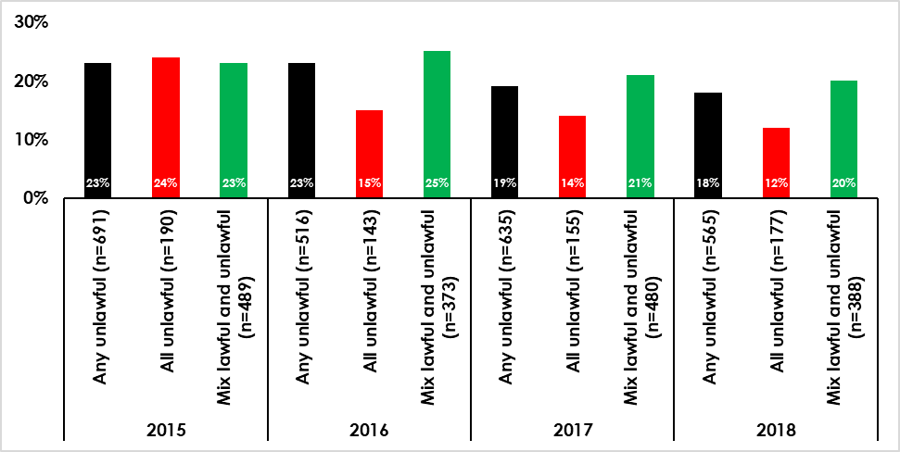

Source: Q77 You indicated that you have downloaded or streamed or accessed content in the past months which you think may have been done unlawfully. What are your personal reasons for doing this? Respondents were provided with 20 response options and ‘other’. They could select as many or as few as they chose.

Concern over cost as a reason for unlawful consumption was given by 20% of mix category and 18% within the any unlawful. Only 12% of all unlawful used ‘I can’t afford to pay’ as their reason for consuming unlawful content. Figures are relatively similar to those within 2017.

Figure 115—Motivations for unlawful consumption of content: ‘It means I can try something before I buy it’

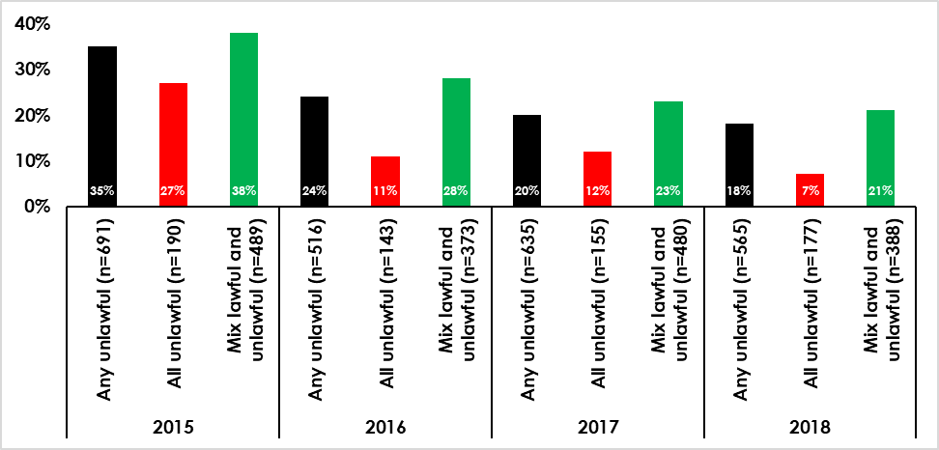

Source: Q77 You indicated that you have downloaded or streamed or accessed content in the past months which you think may have been done unlawfully. What are your personal reasons for doing this? Respondents were provided with 20 response options and ‘other’. They could select as many or as few as they chose.

Trying something before purchasing it was used as a reason by 18% of any unlawful and 21% of mix but only 7% of all unlawful.

Infringers were asked a series of statements to determine what, if anything, would make them stop downloading or streaming files unlawfully. The following Figures show the top answers for all who consumed content unlawfully and those that consumed 100% unlawful content (all unlawful).

Figure 116—Top six responses 2018 (Any unlawful)

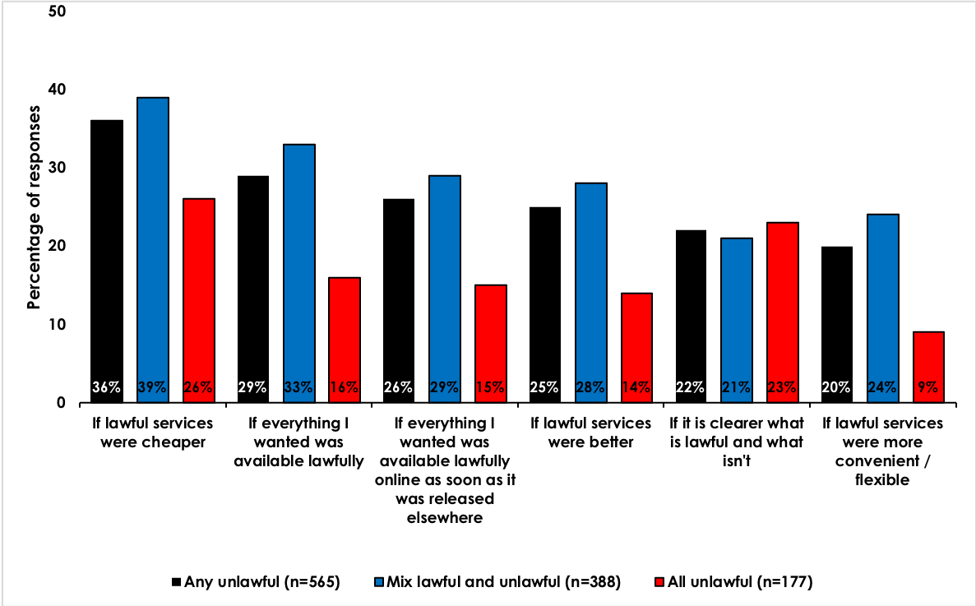

Source: Q78 Which, if any, of the following do you think would make you stop downloading or streaming files unlawfully? Respondents were provided with 15 response options and ‘other’. They could select as many or as few as they chose.

Participants who consume any unlawful digital content were most likely to stop infringing ‘if lawful services were cheaper’ (36%) or ‘if everything they wanted was available lawfully’ (29%). This result was similar within the all unlawful group with 26% selecting ‘if lawful services were cheaper’ however, the second most selected response within the unlawful group was ‘if it is clearer what is lawful and what isn’t’. This suggests that infringing participants may not consume unlawful content if they were aware of it being unlawful, however this should be further tested.

The respondents that represented the ‘mix lawful and unlawful’ generally followed the same trend as the any unlawful category and were most likely to stop infringing ‘if lawful services were cheaper’ (39%), ‘if everything I wanted was available lawfully’ (33%), ‘if everything I wanted was available lawfully online as soon as it was released elsewhere’ (29%) and ‘if lawful services were better’ (28%). There was a slightly higher proportion who chose the ‘if lawful services were more convenient/flexible’ (24%) compared to the any unlawful proportion of 20%.

Within the all unlawful group, the top five responses are shown in the Figure below.

Figure 117—Top five responses 2018 (All unlawful)

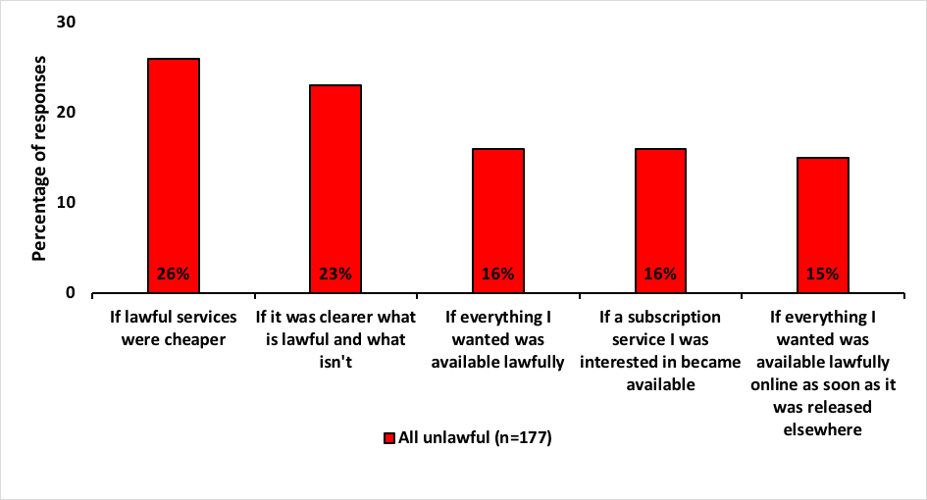

Source: Q78 Which, if any, of the following do you think would make you stop downloading or streaming files unlawfully? Respondents were provided with 15 response options and ‘other’. They could select as many or as few as they chose.

About a quarter of the all unlawful group (26%) selected ‘if lawful services were cheaper’ as a reason they would stop infringing. There was no difference in gender, and younger people were more likely to select this option. This was also the case for the second most popular reason of ‘if it was clearer what is lawful and what isn’t’ which was selected by 23%. Also of note is the increase in participants selecting ‘nothing would make me stop’ from 4% in 2015, 2016 and 2017 up to 6% in 2018.

### Awareness of licensed online sites or services

The following Figure shows awareness of sites or services offering licensed / lawful access to any of the four core content types covered in the survey. The Figure includes respondents who also indicated that they had used any of these services in the past three months. The 13 most frequently identified sites or services are shown.

Figure 118—Proportion of internet users aged 12+ aware of lawful / licensed online services

Figure 118. Proportion of internet users aged 12+ aware of lawful / licensed online services. Results are shown for the years 2015 to 2018. 
The proportion of users who were aware of Netflix was 51% in 2015, 73% in 2016, 73% in 2017 and 78% in 2018. The proportion of users who were aware of YouTube was 79% in 2015, 83% in 2016, 78% in 2017 and 73% in 2018. The proportion of users who were aware of Foxtel was 74% in 2015, 74% in 2016, 73% in 2017 and 71% in 2018. The proportion of users who were aware of Stan was 30% in 2015, 49% in 2016, 53% in 2017 and 61% in 2018. The proportion of users who were aware of iTunes/Apple Store was 70% in 2015, 72% in 2016, 65% in 2017 and 57% in 2018. The proportion of users who were aware of Spotify was 38% in 2015, 48% in 2016, 50% in 2017 and 56% in 2018. The proportion of users who were aware of SBS On Demand was 36% in 2015, 44% in 2016, 48% in 2017 and 49% in 2018. The proportion of users who were aware of Fetch TV was 39% in 2015, 43% in 2016, 42% in 2017 and 49% in 2018. The proportion of users who were aware of 7Plus was 48% in 2018 (not applicable in earlier years). The proportion of users who were aware of Telstra TV was 47% in 2018 (not applicable in earlier years). The proportion of users who were aware of TENplay was 45% in 2018 (not applicable in earlier years).  The proportion of users who were aware of Google Play was 40% in 2018 (not applicable in earlier years). The proportion of users who were aware of Amazon/Kindle was 54% in 2015, 50% in 2016, 44% in 2017 and 36% in 2018. More detail in report.

Source: Multiple sources including Q71 Other than the services previously stated, what other online services are you aware of to download, stream or share content? Also, brand list incidence from Q24, Q40, Q52 and Q67. Note: 7Plus, Telstra TV, TENplay and Google Play were included for the first time in 2018.

Consumer awareness of sites or services offering licensed or lawful access to any of the four core content types is relatively high across the top three Netflix (78%), YouTube (73%) and Foxtel (71%).

Stan has experienced an increase in awareness from 53% in 2017 up to 61% in 2018. This is also the case for Spotify, increasing from 50% in 2017 to 56% in 2018. There was a reduction in awareness of iTunes from 65% in 2017 down to 57% in 2018 and also for Amazon from 44% in 2017 down to 36% in 2018.

7Plus, Telstra TV, TENplay and Google Play were all measured for the first time in 2018 and approximately half of the participants were aware of them.

### Confidence in knowing what is and is not lawful online

One of the challenges for internet users is knowing when a site or service is lawful or licensed. Participants were asked to rate their confidence level in regards to knowing what is lawful and what isn’t in terms of downloading, streaming or accessing or sharing content through the Internet.

The following Figure shows participant confidence levels and how they have changed since 2015.

Figure 119—Confidence in knowing what is and what is not lawful online

Figure 119. Confidence in knowing what is and what is not lawful online. Results are shown for the years 2015 to 2018.
The proportion of participants who indicated they were very confident in knowing what is and what is not lawful online was 20% in 2015, 21% in 2016, 23% in 2017 and 27% in 2018. The proportion of participants who indicated they were slightly confident in knowing what is and what is not lawful online was 37% in 2015, 37% in 2016, 40% in 2017 and 39% in 2018. The proportion of participants who indicated they were not particularly confident in knowing what is and what is not lawful online was 25% in 2015, 25% in 2016, 21% in 2017 and 21% in 2018. The proportion of participants who indicated they were not at all confident in knowing what is and what is not lawful online was 18% in 2015, 17% in 2016, 16% in 2017 and 13% in 2018.
More detail in report.

Source: Q79 How confident are you that you know what is lawful and what isn’t in terms of downloading, streaming or accessing, and sharing content through the Internet. Respondents selected one of four options: ‘very confident’, ‘slightly confident’, ‘not particularly confident’ and ‘not at all confident’. n=2415.

In 2018, confidence levels have risen slightly from a combined score of 63% in 2017 up to 66% in 2018. While the greater proportion of participants have been confident over the last four years, confidence is increasing and those indicating that they are not at all confident has decreased by 3% in the last year. It is important to note that 34% are indicating that they are not confident with knowing what is and what is not lawful online.

The following Figure shows those participant that indicated they were not confident of knowing what is and what is not lawful online and their age category.

Figure 120—Age demographics of participants not confident in knowing what is and what is not lawful online.

Figure 120. Age demographics of participants not confident in knowing what is and what is not lawful online. The graph shows respondents who selected ‘not particularly confident’ or ‘not at all confident’.
The proportion of participants who were not confident that fell into the 12-15 year age group was 34% in 2015, 35% in 2016, 27% in 2017 and 28% in 2018. The proportion of participants who were not confident that fell into the 16-24 year age group was 30% in 2015, 32% in 2016, 25% in 2017 and 23% in 2018. The proportion of participants who were not confident that fell into the 25-34 year age group was 34% in 2015, 32% in 2016, 29% in 2017 and 21% in 2018. The proportion of participants who were not confident that fell into the 35-44 year age group was 35% in 2015, 40% in 2016, 30% in 2017 and 30% in 2018. The proportion of participants who were not confident that fell into the 45-54 year age group was 49% in 2015, 42% in 2016, 41% in 2017 and 42% in 2018. The proportion of participants who were not confident that fell into the 55 years and older age group was 59% in 2015, 54% in 2016, 53% in 2017 and 57% in 2018.
More detail in report

Source: S1 How old are you? Q79 How confident are you that you know what is lawful and what isn’t in terms of downloading, streaming or accessing, and sharing content through the Internet. Respondents who selected ‘not particularly confident’ or ‘not at all confident’. n=825.

The Figure shows that, generally, the older the participant the less confident they are. This trend can be seen across the four years however, in 2018 there is a decrease in the 16–24 and 25–34 age group and an increase in the 45–54 and 55+ age group.

Figure 121—Word Cloud

Figure 121. Word Cloud. Most common words given in open ended answer about what the participant perceived as being lawful in terms of an online service include: reputable, service, knowing, sure, legal, quality, certificate, reviews, warnings, blocked, secure. More detail in report.

Respondents were asked an open ended question in order to gauge what they perceived as being lawful in terms of online services. The word cloud highlights the most popular responses.

The top responses spontaneously mentioned by 28% of all those with internet access followed the trend from previous years to be the importance of being:

* reputable
* known
* trusted
* secure
* quality
* lawful
* legitimate
* recognised
* Australian.

Examples include:

“Large legitimate companies.”

“Recommended by Government.”

“Government approved.”

“Great quality.”

“Well advertised.”

The second most common response as an indication of lawfulness was ‘paying’ for the service / subscription / item spontaneously mentioned by 12% of respondents, a slight increase from 2017 which reported 11%.

Examples include:

“If I pay, I assume it’s lawful.”

“If it’s a well–known site and you pay for it.”

“Paying for the service, knowing the brand e.g. Stan, Netflix”

The third most common response was ‘well known’, ‘brand’ or ‘popular’ with 11% spontaneously mentioning these indicators.

Examples include:

“I only use reputable or known companies.”

“I think that seeing advertising on TV or hearing about that particular brand would make me sure that it is legitimate.”

“A well–known brand e.g. Netflix, Foxtel, 9now”

### Attitudes and behaviour towards blocked sites

Respondents were asked questions relating to encountering blocked sites within the past three months. All participants were asked if they had encountered a blocked site within the past three months. Of all participants with internet access (n=2415) 12% of internet users reported encountering a blocked site, 78% had not and 10% did not know. Participants were then asked what they would do if they encountered a site that had been blocked and offered five options and ‘other’. The following Figure shows participants’ responses.

Figure 122—What participants would do if they encountered a blocked site

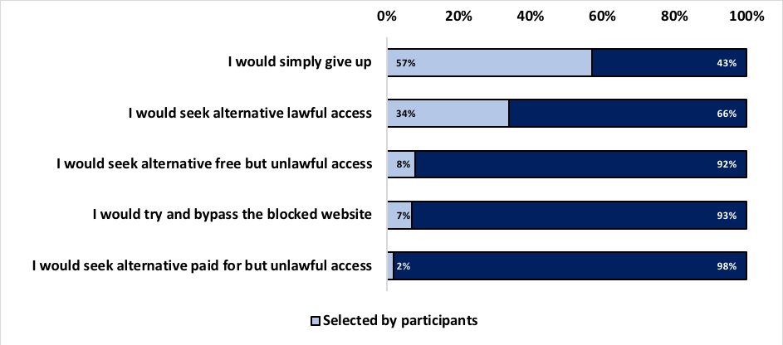

Source: Q83 What would you do if you encountered a site which has been blocked? Respondents were provided with five options and ‘other’. n=2415.

The majority of participants indicated that they ‘would simply give up’ if they encountered a blocked site (57%). The next most selected response was that they ‘would seek alternative lawful access’ at 34%.

Of the ‘other’ responses the majority claimed that they ‘did not know’ (n=38) and the next most common response was that they would seek assistance (n=18).

Participants that indicated they would try to bypass the blocked site (7%, n=158) were asked how they would go about bypassing. The following Figure shows participants responses.

Figure 123—Actions participants would take to bypass a blocked site

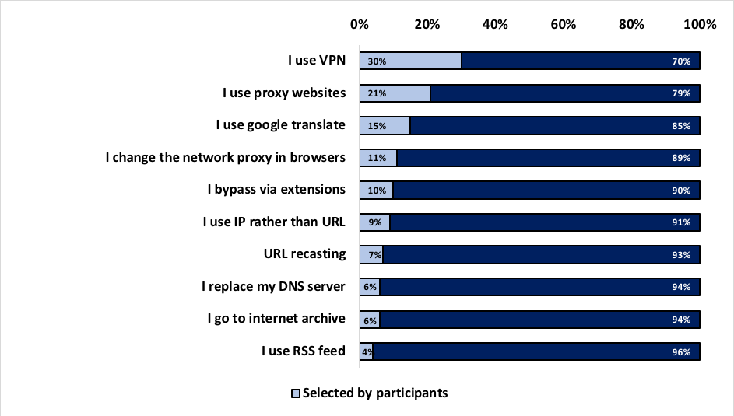

Source: Q84 Please indicate how you went about bypassing the blocked website. Respondents were provided with 10 options and ‘other’. n=158.

Using a VPN was the highest response with 30%, followed by using proxy websites at 21%. Google translate was the third highest response at 15%. Males were more likely to attempt to bypass a blocked website using proxy websites and VPN than females. Bypassing via extensions was utilised by both males and females equally.

Of the 35 ‘other’ responses, most said that they would continue searching until they found what they were looking for (n=9). The next most frequent was ‘I don’t know’ (n=7) followed by a number of respondents who chose not to share their methods (n=4).

Participants that reported encountering blocked sites (n=302), were asked what they did during that encounter and what action, if any, they took to bypass the blocked website. Respondents were provide with five responses and ‘other’. The following Figures summarise participants’ responses.

Figure 124—Actions taken by participants that encountered a blocked site.

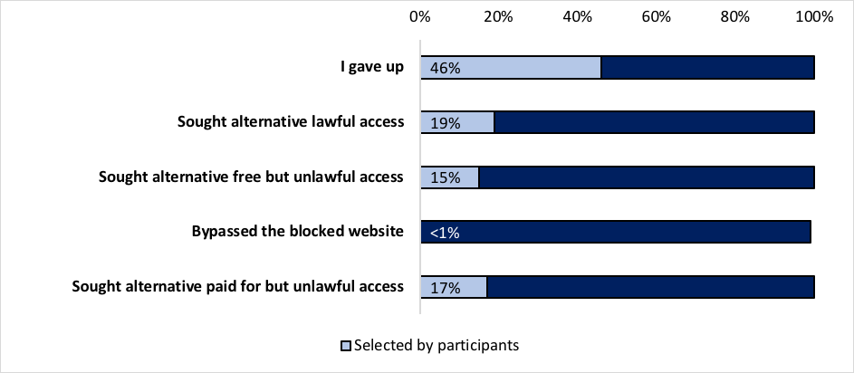

Source: Q81 You indicated that you have encountered a blocked site in the past three months. Which of the following best describes what you did in this instance? Respondents were provided with 5 options and ‘other’. n=302.

The majority of respondents said that they ‘gave up’ (46%). The next most popular response was that they ‘sought alternative lawful access (19%) and 15% indicated that they ‘sought alternative free but lawful access’.

Of the seven ‘other’ responses, using VPN was the most frequent (n=3) along with leaving the site (n=3).

Less than one percent that encountered a blocked website tried to bypass the block, a drop from 3% reported in 2017.

## Appendix

### Key considerations for methodological design

#### Key considerations

The methodology for the 2018 consumer survey replicated that employed in 2015 and subsequent years, 2016 and 2017. This was a critical consideration given the longitudinal approach to the study and helped to ensure that the data collected was building on the knowledge of previous surveys. This approach enabled direct comparison of consumer consumption and attitude changes over the course of the surveys.

There were three considerations highlighted in the UK methodological study that shaped the original methodology developed for the 2015 study. These are detailed below.

1. **Researching unlawful behaviour and obtaining honest responses**

Measuring online copyright infringement is a challenge as the fundamental drawback with any questionnaire–centric approach is that we are reliant on self–reported measures of behaviour. Many people will be reluctant to admit to engaging in such activities, and will no doubt be wary of the consequences if they do. Furthermore, some people may be unaware that what they are doing is unlawful.

The only way to obtain truly accurate behavioural data is via monitoring online activities. However, the cost of doing this would be prohibitive, and there would be obvious representativeness issues (e.g. it is highly unlikely that anyone actively partaking in unlawful file–sharing would agree to have their online activities monitored).

As such the approach used for the survey was designed to overcome these cost and representation issues, minimise suspicion, and convey a level of trust that reassured respondents that there would be no repercussions from any response.

1. **Representativeness**

Estimates of copyright infringement behaviour vary substantially in Australia, by industry group. It is likely that these differences can be somewhat attributed to differences in methodology between each estimate. Therefore, it was essential to ensure this research collects sufficiently robust and representative data, in order to allow it to become an authoritative source for ongoing monitoring of online copyright infringement behaviours.

1. **Consumer understanding**

Any research that covers a technical subject matter among a wide range of ages will need to consider this in the questionnaire design and data collection stages of the research. It was essential that the survey was administered in a way that would ensure all respondents could understand what was being asked of them.

#### Justification for approach taken

As a result of these three considerations, as well as a need to ensure consistency between the Australian and UK studies, a quantitative methodology was utilized. To capture participants of all ages, two different approaches were employed, online interviewing and computer assisted telephone interviewing (CATI).

#### Online interviewing

An online interviewing approach was selected as the primary data collection method in order to ensure consistency with the UK survey. Online interviewing ensures a representative sample by allowing for a larger sample size because it is more cost effective. It also provides a higher incidence of high–frequency internet users, key to quantification for any questions on unlawful online behaviour, and hence providing a more robust sample to allow profiling of the data. This sample can be down–weighted in order to provide the true proportion among all adults.

Online interviewing also assists with obtaining honest responses: The UK methodological reports found that online interviewing was more likely to generate honesty because it is entirely self‑ completed (i.e. removing the interviewer conditioning effects).

Finally, online interviewing was thought to assist with respondents’ understanding of the research by allowing:

* larger pieces of information to be presented for review to gauge responses, which can be difficult to comprehend when read over the telephone
* the ability to run longer surveys
* more ‘considered’ responses because people participate at a time of self–selected convenience (rather than ‘on the spot’ following a telephone contact).

However despite these benefits of online interviewing, it cannot be considered representative in isolation as it:

* significantly reduces coverage of 65+ year olds
* significantly reduces coverage of low–frequency internet users (i.e. people who use the Internet less than once a day).

As such, CATI interviewing was employed to overcome these issues.

#### CATI interviewing

CATI interviewing was selected in order to overcome the representativeness issues of online interviewing. The CATI interviewing component of this research was particularly targeted towards over 65 year olds and those who use the Internet less than once a day (it is important to note that there is considerable overlap between these two groups). The approach differs from the UK study which used face to face interviewing to target over 65 year olds and those who use the Internet less than once per day. Replication of the face to face component of the UK study in Australia was not undertaken due to the cost and logistical implications this would involve. For example, ensuring a nationally representative sample for face to face interviews in Australia would involve flying teams of researchers to metropolitan, regional, and remote locations throughout Australia, which has large cost implications. It would also require significant time investment and logistical planning which was not feasible in this instance. CATI was considered a more time and cost effective option and is in line with standard practice in Australia.

### Methodological approach in detail

#### Questionnaire design

The 2017 questionnaires were used as the basis for the 2018 online and CATI surveys, incorporating any agreed changes while ensuring the two versions maintained the same content as each other, and did not exceed 20 minutes in length. The questionnaire changes made for the 2018 survey are outlined in section 2.5 of this report.

The 2018 questionnaire followed the same order as in 2015/2016/2017 with the following sections:

* screener questions—age, gender, location, internet access and usage
* online streaming, downloading and sharing of different content types:
* music
* video games
* movies
* TV programs
* consumer attitudes to streaming, downloading, and sharing content online.

Figure 125—Brand list 2018

| Code | Website/service | Music | Video games | Movies | TV progs | Attutides |
| --- | --- | --- | --- | --- | --- | --- |
| 22 | 9Now | N |  | Y | Y | Y |
| 23 | Amazon / Amazon mp3 / Kindle | Y | Y | Y | Y | Y |
| 24 | Bandit.fm | Y |  |  |  | Y |
| 25 | Telstra TV | Y |  | Y |  | Y |
| 26 | BitTorrent software | Y | Y | Y | Y |  |
| 27 | Dendy Direct |  |  | Y | Y | Y |
| 28 | Facebook | Y | Y | Y | Y |  |
| 29 | Fetch TV |  |  | Y | Y | Y |
| 30 | Foxtel—Pay TV |  |  | Y | Y | Y |
| 31 | Foxtel Now |  |  | Y | Y | Y |
| 32 | Google Play / Android Marketplace | Y | Y | Y |  | Y |
| 33 | iTunes / App Store / ibookstore / Apple Store / iTunes Radio | Y | Y | Y | Y | Y |
| 34 | ITV Hub |  |  |  | Y | Y |
| 35 | ABC iView |  |  | Y | Y | Y |
| 36 | Netflix |  |  | Y | Y | Y |
| 37 | Mix Radio | Y |  |  |  | Y |
| 38 | ThePirate Bay | Y | Y | Y | Y |  |
| 39 | 7Plus |  |  | Y | Y | Y |
| 40 | Quickflix |  |  | Y | Y | Y |
| 41 | SBS on Demand |  |  | Y | Y | Y |
| 42 | Sony Entertainment Network—Music Unlimited / Video Unlimited / Playstation Network | Y | Y | Y |  | Y |
| 43 | SoundCloud | Y |  |  |  | Y |
| 44 | Spotify | Y |  |  |  | Y |
| 45 | Stan |  |  | Y | Y | Y |
| 46 | Steam |  | Y |  |  | Y |
| 47 | TENplay |  |  | Y | Y | Y |
| 48 | uTorrent | Y | Y | Y | Y |  |
| 49 | Xbox Live |  | Y |  |  | Y |
| 50 | YouTube | Y |  | Y | Y | Y |
| 52 | Freegal | Y |  |  |  | Y |
| 53 | Origin |  | Y |  |  | Y |
| 54 | DivxCrawler |  |  | Y |  | Y |
| 55 | Hayu |  |  |  | Y | Y |
| 56 | Crunchyroll |  |  | Y | Y | Y |
| 57 | Hulu |  | Y | Y | Y | Y |
| 58 | Funimation |  |  | Y | Y | Y |
| 59 | Daisuki |  |  | Y | Y | Y |
| 60 | DocPlay |  |  | Y | Y | Y |
| 61 | Twitch |  | Y |  |  | Y |
| 62 | KodiTV |  |  | Y | Y | Y |
| 63 | EVPad |  |  | Y | Y | Y |
| 64 | WatchESPN |  |  |  |  | Y |
| 65 | BossCast |  |  |  |  | Y |
| 66 | StreamSports |  |  |  |  | Y |
| 67 | LiveTV |  |  |  |  | Y |
| 68 | stream2watch |  |  |  |  | Y |
| 69 | FirstRowSports |  |  |  |  | Y |
| 70 | Streamwoop |  |  |  |  | Y |
| 71 | VIPbox |  |  |  |  | Y |
| 72 | cbssports |  |  |  |  | Y |
| 73 | bleacherreport |  |  |  |  | Y |
| 74 | foxsports |  |  |  |  | Y |

#### Recruitment and fieldwork

Figure 126—Recruitment, field dates and participant numbers

|  |  | 2015 |  |  | 2016 |  |  | 2017 |  |  | 2018 |  |
| --- | --- | --- | --- | --- | --- | --- | --- | --- | --- | --- | --- | --- |
| Fieldwork dates | 25 March | to | 13 April | 4 March | to | 21 March | 2 March | to | 20 March | 1 March | to | 21 March |
| Data collection instrument | Online | CATI | Total | Online | CATI | Total | Online | CATI | Total | Online | CATI | Total |
| Total aged 12+ | n=2,227 | n=403 | n–2,630 | n=2,005 | n=400 | n=2,405 | n=2,042 | n=400 | n=2,442 | n=2,053 | n=400 | n=2,453 |
| 12–15 year olds | n=145 | – | n=145 | n=177 | – | n=177 | n=147 | – | n=147 | n=161 | – | n=161 |
| Aged 16+ | n=2,082 | n=403 | n=2,485 | n=1,828 | n=400 | n=2,228 | n=1,895 | n=400 | n=2,295 | n=1,892 | n=400 | n=2,292 |
| Interview length | 22 mins | 24 mins | – | 14 mins | 20 mins | – | 15 mins | 19 mins | – | 16 mins | 21 mins | – |

A total of n=2,453 interviews were undertaken in 2018 with the target audience for this study, all people aged 12+ in Australia. This compared with n=2,442 in 2017, n=2,405 in 2016 and n=2,630 interviews in 2015.

Online interviewing took place using an online panel. IPS subcontracted sourcing of the online respondents for the 2018 project.

A total of n=2,053 12+ interviews were achieved online in 2018 (compared with n=2,042 in 2017, n=2,005 in 2016 and n=2,227 in 2015), with n=1,892 from people aged 16+ and n=161 from people aged 12–15 years old. The average length of the interview was 16 minutes. All online respondents were incentivised through an online points reward system, which is the standard incentive provided by the online panel provider for interviews of 20 minutes. Recruitment of 12‑15 year olds was handled differently to adult (16+) respondents as they need to be recruited via their parents (who are asked for consent). Among this age group, we used an online–only approach as internet penetration and frequency of use is very high.

CATI interviewing was subcontracted to a full service resource supplier to the market research industry, as done in previous years. IPS provided a full briefing to interviewers on the project requirements prior to fieldwork commencement. A total of n=400 interviews were achieved through this approach. The survey was an average of 21 minutes long. A $10 Coles–Myer gift card was provided to each respondent in line with the AMSRS guidelines that state CATI interviews over 20 minutes require an incentive.

#### Timing

To be consistent with previous years, both the online and CATI surveys were run concurrently in the field to avoid bias in the data caused by any changes in the market, particularly given the rapid pace of change and high–profile cases related to copyright infringement in the media.

Both the online and CATI surveys were piloted over the first 24 hours of interviewing to check the survey length, screening criteria, and questionnaire routing were all working as anticipated. In 2018 the pilot surveys ran on the 1st March 2018. Data from the pilot was included in the final survey data as the questionnaires did not need to be amended following the pilots. Online fieldwork then took place between 2nd and 9th March 2018 and CATI fieldwork took place between 2nd and 20th March 2018.

The 2018 surveys were run at the same time of year as the 2015, 2016 and 2017 studies, allowing the findings from all the studies to be directly comparable.

#### Sampling

An essential aspect of this research was to undertake rigorous sample stratification to ensure that the data was a nationally representative sample of the target audience—all people aged 12+ in Australia. Although some elements of the survey cover those without internet access, so as to provide a nationally representative frame, the core focus of the study (and thus the majority of questions) was the Australian online population aged 12+.

The following table illustrates the sampling frame used for this research (please note that target samples have remained the same for each year of sampling).

Figure 127—Sampling frame for 2018 research

| Age group | % of population who access the Internet | % of internet users using daily | % of population using internet daily | % of 12+ Australia population | Total target sample | Online target sample | CATI sample |
| --- | --- | --- | --- | --- | --- | --- | --- |
| 12–15 | 97% | 82% | 94% | 6% | 145 | 145 | 0 |
| 16–24 | 98% | 81% | 94% | 14% | 345 | 305 | 40 |
| 25–34 | 96% | 82% | 94% | 17% | 380 | 340 | 40 |
| 35–44 | 94% | 81% | 90% | 16% | 410 | 370 | 40 |
| 45–54 | 87% | 75% | 80% | 15% | 380 | 340 | 40 |
| 55–64 | 81% | 71% | 78% | 14% | 340 | 270 | 70 |
| 65+ | 51% | 56% | 70% | 18% | 400 | 230 | 170 |

Within the target sample for each age group, it was ensured that a reasonable balance of males and females was achieved. Separate targets were set for each state or territory in line with their proportion of the total Australian population.

#### Sample selection

The way in which the sample was selected varied across data collection methods:

**Online interviews (16+)**: The sample was initially selected using age, gender and location information held by the online panel provider. The panelists were invited via email to take part in the survey, and demographic quota targets (gender, age, and location) were set to ensure that the end sample profile was representative of the Australian internet population. Respondents were screened out if they claimed to use the Internet less than once a day.

**Online interviews (12–15 year olds)**: Invitations to complete the questionnaire were emailed out to a separate sample of online panelists who had previously agreed to participate in market research, and had children in the relevant age group. They were invited to pass the completion of the survey on to their child, having provided consent for them to participate. The survey was closed when the required sample profile was achieved.

**CATI interviews (16+)**: CATI interviews were undertaken by targeting households with a higher likelihood of containing an infrequent internet user. All interviews were conducted via the CATI field team and in accordance with strict quality control procedures. Quotas (by gender, age, and location) were set during interviewing to ensure representativeness of the data. Respondents were screened out if they claimed to use the Internet at least once a day, thereby ensuring that all CATI interviews were with people who used the Internet infrequently or not at all. Both landline and mobile phones were used in the method to maximise response rates and the representativeness of the sample.

#### Weighting and grossing

In order to accurately measure levels of online copyright infringement in Australia, it was important that the achieved sample was representative of the Australian population. Careful sampling and monitoring of quotas was used to ensure that the achieved sample approximated the Australian population in terms of gender, age and state/territory. The data was weighted on these characteristics to ABS statistics using figures from the most recent estimated resident population release (in the case of 2018, the 30 June 2016 figures) to ensure an exact match.

In addition, in order to collect sufficient data on online activities, the achieved sample was designed to over–represent those who used the Internet frequently (at least daily) and under‑represent those who used the Internet infrequently (less than daily). The final data was then weighted to correct for this over–representation, to ensure it was representative of the Australian population. Due to the fact that frequency of internet usage is known to be correlated with age, the data was weighted by internet usage within age in addition to gender and state/territory. Official statistics on internet usage within age were sourced from a combination of 2014–15 ABS statistics on household use of information technology (for levels of internet access) and the Australian Communications and Media Authority (ACMA) 2012–13 report (for frequency of internet usage). 12–15 year olds were not weighted by internet usage since all 12–15 year olds who took part in the survey used the Internet at least daily.

Data was weighted using a Random Iterative Method (rim) technique with targets defined for gender (two categories), internet usage (eight categories) and age (seven categories). The three non–interlocking dimensions are individually put through an iterative sequence of weighting adjustments. The sequence adjusts for each dimension in turn and then repeats itself as many times as is required in order to obtain a convergence, in which the sum of the weighted dimensions matches the target population estimates, or is as close as it is possible to achieve.

The rim weighting efficiency gives an indication of how well balanced the sample is. If the data for many respondents needs to be heavily weighted up or down, the efficiency percentage will be low. In 2018 the weighting efficiency was 78.2% (maximum weight 3.18; minimum weight 0.30), which is a respectable proportion (and similar to the 2015 and 2016 efficiency), given the deliberate decision to over–represent those who used the Internet frequently in the survey design.

The target weights for gender, internet usage within age and state/territory are shown in the following table.

Figure 128—Unweighted and weighted achieved sample

| Variable | Year | Unweighted (n) | Unweighted (%) | Weighted (n) | Weighted (%) |
| --- | --- | --- | --- | --- | --- |
| **Gender** |  |  |  |  |  |
| Male | 2018 | 1,195 | 49 | 1,219 | 50 |
| Male | 2017 | 1,156 | 47 | 1,209 | 50 |
| Male | 2016 | 1,143 | 48 | 1,190 | 50 |
| Male | 2015 | 1,318 | 50 | 1,323 | 50 |
| Female | 2018 | 1,257 | 51 | 1,232 | 50 |
| Female | 2017 | 1,286 | 53 | 1,233 | 50 |
| Female | 2016 | 1,262 | 52 | 1,215 | 50 |
| Female | 2015 | 1,312 | 50 | 1,307 | 50 |
| Other | 2018 | 1 | >1 |  |  |
| **Internet usage with age** |  |  |  |  |  |
| 12–15 | 2018 | 161 | 7 | 148 | 6 |
| 12–15 | 2017 | 175 | 7 | 147 | 6 |
| 12–15 | 2016 | 177 | 7 | 144 | 6 |
| 12–15 | 2015 | 145 | 6 | 158 | 6 |
| 16–24 daily use | 2018 | 321 | 13 | 268 | 11 |
| 16–24 daily use | 2017 | 327 | 13 | 269 | 11 |
| 16–24 daily use | 2016 | 326 | 14 | 265 | 11 |
| 16–24 daily use | 2015 | 340 | 13 | 289 | 11 |
| 16–24 non–daily use | 2018 | 36 | 1 | 74 | 3 |
| 16–24 non–daily use | 2017 | 29 | 1 | 73 | 3 |
| 16–24 non–daily use | 2016 | 31 | 1 | 72 | 3 |
| 16–24 non–daily use | 2015 | 30 | 1 | 79 | 3 |
| 25–34 daily use | 2018 | 329 | 13 | 314 | 13 |
| 25–34 daily use | 2017 | 350 | 14 | 317 | 13 |
| 25–34 daily use | 2016 | 328 | 14 | 313 | 13 |
| 25–34 daily use | 2015 | 489 | 19 | 342 | 13 |
| 25–34 non–daily use | 2018 | 40 | 2 | 97 | 4 |
| 25–34 non–daily use | 2017 | 40 | 2 | 98 | 4 |
| 25–34 non–daily use | 2016 | 34 | 1 | 96 | 4 |
| 25–34 non–daily use | 2015 | 30 | 1 | 79 | 3 |
| 35–44 daily use | 2018 | 368 | 15 | 295 | 12 |
| 35–44 daily use | 2017 | 326 | 13 | 293 | 12 |
| 35–44 daily use | 2016 | 327 | 14 | 289 | 12 |
| 35–44 daily use | 2015 | 520 | 20 | 342 | 13 |
| 35–44 non–daily use | 2018 | 39 | 2 | 102 | 4 |
| 35–44 non–daily use | 2017 | 30 | 1 | 98 | 4 |
| 35–44 non–daily use | 2016 | 29 | 1 | 96 | 4 |
| 35–44 non–daily use | 2015 | 41 | 2 | 105 | 4 |
| 45–54 daily use | 2018 | 342 | 14 | 244 | 10 |
| 45–54 daily use | 2017 | 338 | 14 | 244 | 10 |
| 45–54 daily use | 2016 | 322 | 13 | 241 | 10 |
| 45–54 daily use | 2015 | 293 | 11 | 289 | 11 |
| 45–54 non–daily use | 2018 | 43 | 2 | 110 | 5 |
| 45–54 non–daily use | 2017 | 46 | 2 | 122 | 5 |
| 45–54 non–daily use | 2016 | 32 | 1 | 120 | 5 |
| 45–54 non–daily use | 2015 | 40 | 2 | 131 | 5 |
| 55–64 daily use | 2018 | 289 | 12 | 192 | 8 |
| 55–64 daily use | 2017 | 288 | 12 | 196 | 8 |
| 55–64 daily use | 2016 | 285 | 12 | 192 | 8 |
| 55–64 daily use | 2015 | 239 | 9 | 210 | 8 |
| 55–64 non–daily use | 2018 | 63 | 3 | 159 | 6 |
| 55–64 non–daily use | 2017 | 85 | 3 | 146 | 6 |
| 55–64 non–daily use | 2016 | 96 | 4 | 144 | 6 |
| 55–64 non–daily use | 2015 | 82 | 3 | 158 | 6 |
| 65+ daily use | 2018 | 243 | 10 | 124 | 5 |
| 65+ daily use | 2017 | 238 | 10 | 122 | 5 |
| 65+ daily use | 2016 | 240 | 10 | 120 | 5 |
| 65+ daily use | 2015 | 201 | 8 | 105 | 4 |
| 65+ non–daily use | 2018 | 141 | 6 | 356 | 13 |
| 65+ non–daily use | 2017 | 170 | 7 | 318 | 13 |
| 65+ non–daily use | 2016 | 178 | 7 | 313 | 13 |
| 65+ non–daily use | 2015 | 180 | 7 | 342 | 13 |
| **State/territory** |  |  |  |  |  |
| NSW | 2018 | 770 | 31 | 776 | 32 |
| NSW | 2017 | 712 | 29 | 785 | 32 |
| NSW | 2016 | 758 | 32 | 773 | 32 |
| NSW | 2015 | 882 | 34 | 842 | 32 |
| VIC | 2018 | 623 | 25 | 612 | 25 |
| VIC | 2017 | 609 | 25 | 614 | 25 |
| VIC | 2016 | 592 | 25 | 604 | 25 |
| VIC | 2015 | 648 | 25 | 653 | 25 |
| QLD | 2018 | 486 | 20 | 495 | 20 |
| QLD | 2017 | 526 | 22 | 486 | 20 |
| QLD | 2016 | 494 | 21 | 479 | 20 |
| QLD | 2015 | 516 | 20 | 529 | 20 |
| SA | 2018 | 170 | 7 | 171 | 7 |
| SA | 2017 | 195 | 8 | 176 | 7 |
| SA | 2016 | 169 | 7 | 173 | 7 |
| SA | 2015 | 182 | 7 | 190 | 7 |
| WA | 2018 | 274 | 11 | 262 | 11 |
| WA | 2017 | 279 | 11 | 264 | 11 |
| WA | 2016 | 263 | 11 | 260 | 11 |
| WA | 2015 | 267 | 10 | 287 | 11 |
| ACT | 2018 | 49 | 2 | 39 | 2 |
| ACT | 2017 | 51 | 2 | 39 | 2 |
| ACT | 2016 | 48 | 2 | 39 | 2 |
| ACT | 2015 | 57 | 2 | 43 | 2 |
| TAS | 2018 | 53 | 2 | 54 | 2 |
| TAS | 2017 | 51 | 2 | 54 | 2 |
| TAS | 2016 | 57 | 2 | 53 | 2 |
| TAS | 2015 | 54 | 2 | 58 | 2 |
| NT | 2018 | 28 | 1 | 24 | 1 |
| NT | 2017 | 19 | 1 | 24 | 1 |
| NT | 2016 | 24 | 1 | 24 | 1 |
| NT | 2015 | 24 | 1 | 27 | 1 |

This report includes some figures grossing up levels of online activity to the Australian population level. ABS data from April 2018 was used for calculations, at which point in time the Australian population age 12+ was estimated to be 20,372,261.