

Introducing the single licensing system, disqualified persons and spectrum authorisations

Introduction
The centrepiece of the Bill is the introduction of a single licensing system. This will provide for a more administratively streamlined approach for users in regards to licensing, planning, allocation and renewal, and give users greater certainty of process. Spectrum authorisations will regulate the use of spectrum without a licence.

Issue
The existing licensing system consisting of class, apparatus and spectrum licences is rigid and overly prescriptive. Removing the current hard barriers that exist between licence types, and the rigid manner in which licenses are designed within the framework, will enable the licensing system to better respond to new technologies and service innovations.

Detail
The key aim of the reformed licensing framework is to provide the ACMA with the ability to adapt licence issue and design to enable new technologies, and to simplify processes and improve timeliness for users. Under the new framework, key characteristics of a licence will be specified on the licence itself, providing greater clarity for the user.

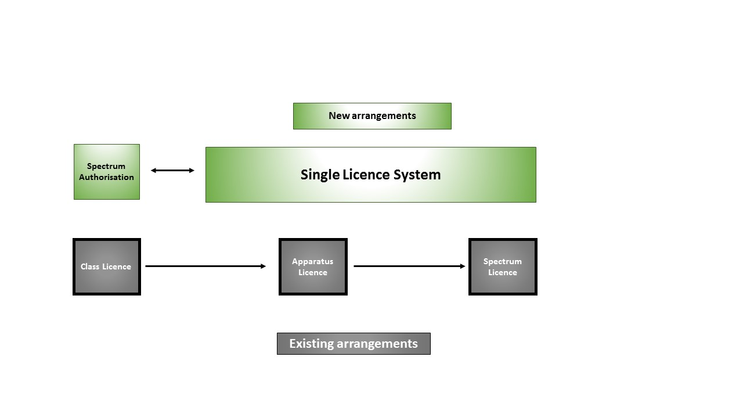The proposed new legislation moves away from the unnecessary regulatory red tape and administration required under the current Radiocommunications Act 1992.
The single licensing system will provide licensees with transparency, clarity and certainty of process around the rights and obligations embedded in their licences. Additional conditions may appear on the licence, such as technical parameters. The use of designated statements will also appear on the licence in order to limit or restrict the ability for the licence to be traded, suspended or cancelled.

The Bill will provide a legislative framework to construct the licensing system. It will prescribe a set of key conditions to be included in a licence. These include:
- geographic area (part/s) (frequency bandwidth)
- device registration
- prohibition on disqualified persons
- any end of term arrangements
- duration (maximum of 20 years), and
- the payment of applicable charges.

The ACMA may include other conditions in a licence.

Disqualified persons
The Bill will give the ACMA the increased ability to delegate spectrum management functions, such as the issue of licences, to accredited persons or bodies. Ready access to information is paramount to allow for informed decisions regarding licence issue.

The ACMA will reserve the ability to cancel licenses in only the most serious of continued breaches. If an individual or executive officer of a body corporate has their licence cancelled due to a breach of their licence conditions, the ACMA may determine that person is disqualified from being issued a new licence for a specified period of time (a maximum of two years).

The name of the person, duration of the disqualification and details of the offence caused will be published on the ACMA website on a disqualified persons register for public viewing.

Spectrum authorisations
Spectrum authorisations will have a fundamentally different purpose to licences, with authorisations not including most of the key conditions of a licence. Similarly to class licences under the 1992 Act, spectrum authorisations will not have to be applied for and no fees will be payable. The core feature of authorisations will be that they are intended to allow radiocommunications devices to be operated in certain parts of the spectrum on a shared basis, subject to common conditions. Conditions may also be imposed that ensure that devices must not be operated to cause interference to licenced radiocommunications services, and no protections from interference are provided to spectrum authorised users. That is, it will operate on a ‘no protection/no interference’ basis.

Devices will still be required to meet criteria (mainly technical) to be authorised for use. However, in most cases this will be transparent to end users, who are able to use their device and not have to consider if they need to apply for a licence. More information about equipment regulation can be found on the Introducing equipment rules factsheet.

Comparison between spectrum authorisations and licences

 |  | Spectrum authorisations | Licences (receivers & transmitters)
What rights do users have? | Possession of a device | ☑ | ☑
 | Use of a device | ☑ | ☑
 | Tradable |  | ☑
 | Interference protection |  | ☑
 | Civil proceedings |  | ☑
What predictability do users have? | Regulatory undertakings |  | ☑
 | Right to review decisions |  | ☑
 | End of term processes |  | ☑
What obligations do users have? | Payment required |  | ☑
 | Taxable |  | ☑
 | Requirement to register device |  | ☑
 | Device certification |  | ☑
 | Maximum duration |  | ☑
 | Designated statements |  | ☑
 | Conditions imposed by the ACMA | ☑ | ☑

