NBN non-commercial services funding options

**Final Consultation Paper**

*October 2015*

**Disclaimer**

The material in this discussion paper is of a general nature and should not be regarded as legal advice or relied on for assistance in any particular circumstance or emergency situation. In any important matter, you should seek appropriate independent professional advice in relation to your own circumstances.

The Commonwealth accepts no responsibility or liability for any damage, loss or expense incurred as a result of the reliance on information contained in this discussion paper.

This discussion paper has been prepared for consultation purposes only and does not indicate the Commonwealth’s commitment to a particular course of action. Additionally, any third party views or recommendations included in this discussion paper do not reflect the views of the Commonwealth, or indicate its commitment to a particular course of action.

**Copyright**

© Commonwealth of Australia 2015

Creative Commons Attribution 3.0 logo

The material in this discussion paper is licensed under a Creative Commons Attribution—3.0 Australia license, with the exception of:

* the Commonwealth Coat of Arms
* this Department’s logo
* any third party material
* any material protected by a trademark
* any images and/or photographs.

More information on this CC BY license is set out at [creative commons](http://creativecommons.org/licenses/by/3.0/au/). Enquiries about this licence and any use of this discussion paper can be sent to: National Security and International Branch, Department of Communications and the Arts, GPO Box 2154, Canberra, ACT, 2601.

**Attribution**

Use of all or part of this discussion paper must include the following attribution:

© Commonwealth of Australia 2015

**Using the Commonwealth Coat of Arms**

The terms of use for the Coat of Arms are available from [It’s an Honour](http://www.itsanhonour.gov.au/).

**Contents**

Useful terms and abbreviations 5

Executive summary 7

Chapter 1: Introduction 12

1.1 Background 12

1.2 Purpose of the Final Consultation Paper 12

Chapter 2: Defining non-commercial services 13

2.1 Treatment of non-commercial fixed line NBN services 14

Chapter 3: Drivers of non-commercial service losses in the fixed wireless and satellite networks 15

3.1 Government requirements 15

3.2 Fixed wireless operational and commercial assessment 16

3.3 Satellite operational and commercial assessment 20

3.4 Capacity considerations 23

3.5 Future technology considerations 24

3.6 BCR assessment of technology developments 27

Chapter 4: Quantifying non-commercial service losses 28

4.1 Use of NBN Co cost and revenue data 28

4.2 Adopting an appropriate cost measurement framework 28

4.3 Network assessment at a granular level 33

4.4 Period for loss assessment 34

Chapter 5: Model approach and outcomes 37

5.1 Financial analysis methodology 37

5.2 Discount rate 38

5.3 Long-term forecasts 39

5.4 Model outcomes 41

Chapter 6: A principles-based approach to designing funding arrangements 44

6.1 Transparency 45

6.2 Contestability 46

6.3 Competitive neutrality 46

6.4 Sustainability 47

6.5 Economic efficiency 48

6.6 Equity 49

Chapter 7: NBN non-commercial service funding options 50

7.1 Assessment of eligibility approaches 50

7.2 Implementing an NBN equivalent approach 61

7.3 Financial outcomes 64

7.4 Cost and price implications of an NBN equivalent funding arrangement 65

Chapter 8: Administration arrangements 67

8.1 Roles and responsibilities 67

8.2 Timeframe for introducing funding arrangements 69

8.3 Regulatory and policy review points 70

8.4 Achieving transparency 71

8.5 Contestability for non-commercial funding arrangements 72

Chapter 9: Intersection with other regulatory issues 75

9.1 Telecommunications Industry Levy and the Universal Service Obligation 75

9.2 Leveraging Telecommunications Industry Levy operational arrangements 77

9.3 Special Access Undertaking 78

9.4 Telecommunications regulatory and structural reform 79

Chapter 10: How to comment 80

10.1 Publication 80

10.2 Confidentiality 80

10.3 Privacy 80

Attachment A: Terms of Reference 82

# Useful terms and abbreviations

| **Term** | **Definition** |
| --- | --- |
| **ACCC** | Australian Competition and Consumer Commission |
| **Access network** | The network or technology used to deliver broadband to end users |
| **ACMA** | Australian Communications and Media Authority |
| **ADSL** | Asymmetric digital subscriber line |
| **ARPU** | Average revenue per user |
| **BBM** | Building block model |
| **BCR** | Bureau of Communications Research |
| **Capex** | Capital expenditure |
| **Carrier Licence Condition** | Refers to the *Carrier Licence Conditions (Networks supplying Superfast Carriage Services to Residential Customers) Declaration 2014* |
| **CoAG** | Coalition of Australian Governments |
| **CSO** | Community service obligation |
| **CIR** | Committed information rate |
| **DCF** | Discounted cash flow |
| **ERR** | Eligible revenue returns |
| **FDC** | Fully distributed cost |
| **FTTB** | Fibre to the building/basement |
| **FTTN** | Fibre to the node |
| **FTTP** | Fibre to the premise |
| **FY** | Financial year |
| **GBE** | Government business enterprise |
| **Gbps** | Gigabits per second |
| **GPRS** | General packet radio service |
| **GSMA** | GSM Association |
| **HSPA** | High-speed packet access |
| **HFC** | Hybrid fibre coaxial |
| **ICRA** | Initial cost recovery account |
| **ICT** | Information communication technology |
| **IOP** | NBN Co Integrated Operating Plan (as at 27 March 2015) |
| **IOT** | Internet of things |
| **IRR** | Internal rate of return |
| **ISP** | Internet Service Provider |
| **ISS** | NBN Co interim satellite service |
| **LEO** | Low earth orbit |
| **LTE** | Long-term evolution |
| **LTE-A** | Long-term evolution advanced |
| **LTSS** | NBN Co long-term satellite service |
| **M2M** | Machine-to-machine |
| **Mbps** | Megabits per second |
| **MIMO** | Multi-input-multi-output |
| **MTM** | NBN Co multi-technology mix, including the HFC, FTTP and FTTN fixed line networks |
| **NBN** | National Broadband Network |
| **NBN Co** | NBN Co Limited ACN 136 533 741 |
| **NPV** | Net present value |
| **NRS** | National Relay Service |
| **NSS** | NBN Co satellite support scheme |
| **Opex** | Operational expenditure |
| **OSS/BSS** | Operational and business support systems |
| **Policy Paper** | Refers to the *Telecommunications Regulatory and Structural Reform* policy paper released by the Australian Government in December 2014 |
| **POTS** | Plain old telephone service |
| **RAB** | Regulatory asset base |
| **RSP** | Retail service provider. A provider of retail broadband services to end users |
| **RTIRC** | Regional Telecommunications Independent Review Committee |
| **TDD** | Time division duplex |
| **TIL** | Telecommunications Industry Levy (Australia), imposed under the *Telecommunications (Industry Levy) Act 2012* |
| **SAC** | Stand alone cost |
| **SAU** | Special access undertaking |
| **SIO** | Services in operation |
| **USO** | Universal service obligation |
| **Vertigan Review** | Collectively the *Statutory Review under Section 152EOA* of the *Consumer and Competition Act 2010* (July 2014), *NBN Cost‐Benefit Analysis* (August 2014) and *NBN Market and Regulatory Report* (October 2014) |
| **VDSL** | Very-high bit-rate digital subscriber line |
| **VSAT** | Very-small-aperture terminal |
| **WACC** | Weighted average cost of capital |
| **WSA** | Wireless service area |

# Executive summary

The Australian Government has asked the Bureau of Communications Research (BCR) to consider economically sound ways to fund the rollout of the National Broadband Network (NBN) to regional Australia. In addressing these requirements, the BCR has assessed the non-commercial losses expected from building and operating satellite and fixed wireless services and considered options for funding these losses via industry contributions. This Final Consultation Paper is the second in a two-part consultation process and sets out the BCR’s preliminary findings ahead of providing a final report to Government later this year. The BCR is seeking further input from interested parties by   
3 November 2015, to assist in the finalisation of this report.

#### Costings and presentation of other financial information

The losses and funding amounts in this paper are estimates based on the BCR’s financial modelling. This modelling has used NBN Co Limited (NBN Co)[1] Corporate Plan 2016 data to 30 June 2018 and where available, NBN Co financial estimates to 2022. The BCR is responsible for the cost outputs and projections.

The BCR also acknowledges that the paper includes long-term assumptions that could be impacted by future developments which would result in different estimates. These estimates are subject to change, and do not represent budget costings, Government’s views or indicate a commitment to a particular course of action.

#### Drivers of NBN non-commercial service losses

An important starting point for this study is defining NBN non-commercial services. The relevant benchmark for determining the commerciality of a network is the extent to which its operator is able to recover its costs over time (including an appropriate cost of capital) through revenues. Where revenues fall short of costs, a network is non-commercial and the services offered by that network are non-commercial services. NBN Co’s fixed wireless and satellite services meet this definition.

The fixed wireless and satellite NBN networks are non-commercial largely as a result of the high cost needed to achieve successive government requirements for high-speed broadband to be delivered across Australia. Meeting the required coverage and performance standards requires significant capital investment. Revenue opportunities are limited given the small number of customers served, current pricing arrangements and infrastructure competition.

NBN Co is working to optimise the services which can be provided over fixed wireless and satellite. This is particularly important to ensure that satellite capacity is used in areas of greatest need. Optimisation may include the possibility of investing in more satellite capacity or shifting the coverage of some premises from the satellite to the fixed wireless network to preserve satellite capacity. Capacity management requirements may increase non-commercial service losses beyond current projections.

In the future, emerging technologies may change the competitive landscape and present new opportunities for broadband service delivery. Ongoing demand for capacity and the changing technology landscape support an ongoing requirement to periodically reassess non-commercial services losses and funding arrangement settings.

#### Quantifying losses

The BCR has modelled non-commercial services using a discounted cash flow (DCF) approach. Losses have been modelled at an aggregate network level, using a forecast period to FY2040 which aligns with the Special Access Undertaking (SAU) and provides a sufficient timeframe to smooth losses. The BCR estimates that the net present value (NPV) loss for fixed wireless and satellite services to FY2040 is approximately $9 billion using a post-tax nominal discount rate of 6.46 per cent. In FY2015 real terms, this loss represents a per-month subsidy of approximately $120 for each satellite premise activated and $100 for each fixed wireless premise activated.

Financial outcomes are sensitive to changes in expenditure assumptions. A 10 per cent increase in capital expenditure would increase non-commercial service losses by an estimated $560 million. Financial outcomes are less sensitive to revenue assumptions.

The BCR notes that its estimate of losses is based on avoidable costs, in other words, those costs which would have otherwise been avoided had the fixed wireless or satellite service not been provided. This approach is consistent with Government requirements for Government Business Enterprises, regulatory economics practice and reflects the approach largely favoured by industry. However, it differs from NBN Co’s accounting treatment and views expressed in its submission to the Initial Consultation Paper.

#### Determining eligibility

Submissions received following the initial consultation round were divided on whether eligibility should be limited to NBN equivalent industry participants (i.e. high-speed fixed line network operators) or should include a broader range of industry participants, including mobile network operators.

While both an NBN equivalent and broader industry funding approach achieve level playing field contestability objectives, the BCR considers an NBN equivalent funding arrangement best achieves Government requirements on the basis of economic efficiency. An NBN equivalent funding approach treats close substitutes equally, resulting in all high-speed fixed line networks facing the same per service funding contribution as NBN Co. Mobile broadband services would not be included in these arrangements, as they are not considered to be close substitutes to fixed line services.

An NBN equivalent approach also maintains important existing commercial incentives for NBN Co to control costs, determine appropriate service standards and innovate. This would occur as NBN Co would continue to recover the bulk of fixed wireless and satellite losses from its own fixed line customer base, where it faces long-term and declining price caps. This minimises the impact on the broader telecommunications industry and is a proportionate response to a modest level of expected competitive entry and cross-subsidy leakage.

Under an NBN equivalent approach, the BCR considers that eligibility should be tightly focused on NBN Co and industry participants that resemble NBN Co, namely operators of high-speed fixed line broadband access networks that deliver download speeds of at least 25 Megabits per second (Mbps). The BCR considers the following fixed line networks should be exempt from the proposed funding arrangements:

* **Networks transitioning to NBN Co under the Definitive Agreements -** Telstra and Optus should be exempted from the funding arrangement for their networks transitioning to NBN Co so as to avoid creating a significant compliance burden to collect revenue over a short, interim period.
* **High-speed fixed line services in the NBN fixed wireless and satellite footprint -** These services should be exempted to maintain existing incentives for NBN Co and other network investors to choose the lowest cost technology in rolling out networks in these areas.

Further, the BCR considers that an eligibility threshold based on revenues or services-in-operation (SIOs) could be considered to ensure that the administrative costs of compliance and collection are not disproportionate to the amount collected.

#### Calculating contributions

The BCR considers that an NBN equivalent approach should be calculated according to the number of high-speed fixed line SIOs. The BCR has calculated that each high speed fixed line SIO would contribute around $6 per-month in FY2015 real terms. This is equivalent to around $6.75 per month nominal in FY2018 (the first full financial year for which new funding arrangements could be calculated), and $8 per month nominal by FY2022 when the NBN is expected to be completed and in a steady-state of operations.

Under this method, the total annual contribution across industry increases as the rollout of the NBN and other fixed line networks progress. This would see NBN Co continue to make the largest contribution towards fixed wireless and satellite losses, as it has the largest number of SIOs (expected to be about 94 per cent of the overall market by FY2022). The BCR estimates this will generate annual industry contributions (outside of NBN Co) of around $50 million in FY2015 real value by FY2022. Relative to the annual costs of deploying non-commercial services, this represents a modest contribution with infrastructure competitors expected to make up only six per cent of the high-speed fixed line market by this time.

The following table provides estimated financial outcomes under an NBN equivalent funding arrangement.

**Table 1: Financial outcomes under an NBN equivalent (high-speed fixed line networks) funding base**

|  | **FY2018** | **FY2022** |
| --- | --- | --- |
| NBN equivalent fixed line SIOs (cumulative) | 400,000 (~10% market share) | 550,000 (~6%) |
| NBN Co fixed line SIOs (cumulative) | 4 million (~90%) | 8 million (~94%) |
| Total fixed line SIOs (including NBN services) | 4.5 million | 8.5 million |
| Per-fixed line contribution monthly amount (nominal value of $6 FY2015 real value) | $6.75 | $8.00 |
| Per-fixed line contribution annual amount (nominal value) | $80 | $95 |
| Non-NBN annual contribution | $30 million | $50 million |
| NBN Co annual contribution | $320 million | $760 million |
| Approximate total annual collection | $350 million | $810 million |

*Note: Figures are rounded. NBN equivalent SIOs are based on BCR estimates of the number of premises ready for service and assumed take-up rates. NBN Co SIOs are based on NBN Co’s Corporate Plan 2016. The nominal per-SIO contribution collected each year is calculated by removing discounting from FY2015 present value. Estimates of the number of SIOs included in this report are based on total high-speed fixed line SIOs. The estimates presented are preliminary and do not represent budget costings. The final figures may vary as details are finalised.*

While favouring a funding arrangement limited to NBN equivalent services, financial outcomes under a broader industry based approach (which is similar to the existing Telecommunications Industry Levy (TIL) arrangement) are provided to inform discussions. Table 2 below highlights that the key difference between the two funding options considered by the BCR is the share of fixed wireless and satellite losses borne by NBN Co. Under the preferred NBN equivalent option, NBN Co funds 94 per cent of non-commercial services losses when it reaches a steady-state of operations. Whereas under a broader industry funding base, the BCR estimates that NBN Co funds only 13 per cent of losses by FY2022, largely as a result of including mobile networks in the funding base.

**Table 2: Financial outcomes under a broader industry funding base like the Telecommunications Industry Levy (TIL)**

|  | **FY2018** | **FY2022** |
| --- | --- | --- |
| Non-NBN percentage of total contribution | 95% | 87% |
| NBN Co percentage of total contribution | 5% | 13% |
| Non-NBN Co annual contribution | $330 million | $700 million |
| NBN Co annual contribution | $20 million | $110 million |
| Approximate total annual collection | $350 million | $810 million |

*Note: Figures are rounded. The BCR has calculated industry contributions under a broader industry funding base by overall share of telecommunications revenue, using the same mechanisms as the Telecommunications Industry Levy (TIL). The BCR has estimated NBN Co’s contribution based on the 2013-14 TIL share, Telstra and Optus’ FY2014 wholesale revenues, and BCR estimations. Total approximate annual collection is held constant between the funding options for comparison purposes. The estimates presented are preliminary and do not represent budget costings. The final contributions and collections may vary as details are finalised.*

#### Impact on costs and pricing

Under an NBN equivalent funding arrangement, the BCR anticipates NBN Co’s pricing would either remain unchanged or fall slightly, reflecting the modest contribution from non-NBN fixed line network operators. The application of a monthly per-SIO contribution makes transparent the cross-subsidy that NBN Co fixed line customers provide towards NBN non-commercial services. In today’s dollars, a $6 monthly per-SIO contribution would constitute around 15 per cent of NBN Co’s fixed line wholesale average revenue per user (ARPU). The BCR expects that competition will result in any reductions in NBN Co’s wholesale prices flowing through to consumers, although this could occur in many different forms.

Costs for networks serving the remaining six to 10 per cent of the fixed line market would increase, ensuring these networks share the burden of non-commercial services losses. Market forces may result in increased costs being fully absorbed by network operators, or passed on in part or full. If fully passed on this would lead to an increase of around 22 per cent in non-NBN wholesale prices. However, competitive pressure make it more likely that higher costs for non-NBN networks would be reflected in lower margins or reduced product offerings rather than flowing through to retail prices commensurately.

#### Administering non-commercial service funding arrangements

Administration of the NBN non-commercial services funding arrangements could be handled in a number of ways, with calculation of the funding amount determined by the Australian Competition and Consumer Commission (ACCC), the Department of Communications and the Arts or the Australian Communications and Media Authority (ACMA). Collection of the funds is recommended to be undertaken by the ACMA.

#### Achieving transparency

The BCR considers that appropriate transparency of funding arrangements would be achieved through publishing the process for determining the overall NBN non-commercial service loss, the estimated magnitude of the loss over the relevant time horizon and the contribution paid by each eligible participant (while preserving commercial-in-confidence information requirements). In addition, NBN Co should account for cash outflows and inflows relating to the NBN non-commercial services funding arrangement as part of its accounting separation requirements. This would reflect a transfer of funds from the fixed line networks to the fixed wireless and satellite networks.

#### Regulatory and policy review points

The BCR considers that the funding requirement should be re-calculated every five years, as part of ongoing regulatory review points. Adjustment in collections at each review period should be allowed for using a process of ‘overs-and-unders’, consistent with the approach taken in other regulated industries. These regulatory review points would provide a mechanism to adjust forecasts to reflect latest financial estimates as the NBN rollout progresses. In addition, the BCR recommends periodic policy reviews, to be conducted by the Department of Communications and the Arts on behalf of the Minister for Communications. These reviews should be conducted every five to 10 year to reflect technological or market developments (such as the introduction of 5G mobile technology), policy developments or ahead of significant investment decisions (for example, ahead of NBN Co commissioning replacement satellites).

# Chapter 1: Introduction

## 1.1 Background

The Bureau of Communications Research (BCR) is an independent economic and statistical research unit within the Department of Communications and the Arts. The Australian Government has asked the BCR to consider economically sound ways to fund the rollout of the NBN to regional Australia. In addressing these requirements, the BCR has been asked to assess the non-commercial losses expected from building and operating satellite and fixed wireless services and consider options for funding these losses via industry contributions. Terms of Reference are provided at Attachment A.

This Final Consultation Paper is the second in a two-part consultation, setting out the BCR’s findings and draft recommendations in response to initial industry submissions.[2]

**Figure 1: Consultation process**

On 8 May 2015, the BCR released its Initial Consultation Paper. Submissions were received from:

* Australian Communications Consumer Action Network (ACCAN)
* Australian Competition and Consumer Commission (ACCC)
* Competitive Carriers’ Coalition (CCC)
* DigEcon Research
* Great Northern Telecommunications
* Ian Martin Advisory Pty Ltd (Ian Martin)
* iiNet Limited (iiNet)
* John de Ridder Consulting Pty Ltd (John de Ridder)
* Macquarie Telecom Group Limited (Macquarie Telecom)
* NBN Co Limited (NBN Co)
* Singtel Optus Pty Ltd (Optus) – initial and supplementary submissions
* Telstra Corporation Limited (Telstra)
* Vodafone Hutchison Australia Limited (Vodafone)

## 1.2 Purpose of the Final Consultation Paper

This consultation paper is the final opportunity for the BCR to consult ahead of providing a final report to Government. It addresses issues raised in submissions received on the Initial Consultation Paper and introduces additional information relevant for NBN non-commercial services funding arrangements, including further examination of non-commercial service drivers, quantification of any losses, funding options and implementation arrangements. Additionally, this paper provides clear guidance to interested stakeholders on the BCR’s preliminary findings which, subject to consideration of responses from interested parties, the BCR intends to include in the final report to Government.

The BCR is seeking input from the telecommunications industry and other interested stakeholders on the findings and recommendations in the Final Consultation Paper. Further information on the consultation process, including instructions on how to make a submission, is provided at Chapter 10: How to comment.

# Chapter 2: Defining non-commercial services

* The BCR considers that fixed wireless and satellite networks are non-commercial as they do not generate sufficient revenues to cover costs. A cost assessment shows the fixed wireless and satellite networks are subsidy recipients.
* The BCR notes that while some areas of the NBN fixed line networks may also be loss-making, at an aggregate level the networks are projected to be commercial. Accordingly, loss-making fixed line areas are not considered. Further, identification and quantification of loss-making areas in the fixed line is problematic given the early stages of the multi-technology mix (MTM) rollout, and is not the cross-subsidy issue the Government has instructed the BCR to address.

An important starting point for this study is defining NBN non-commercial services. The relevant benchmark for determining the commerciality of a network is the extent to which its operator is able to recover its costs over time (including an appropriate cost of capital) through revenues. Where revenues fall short of costs, a network is inherently non-commercial, and the services offered by that network would be defined as non-commercial services.

The NBN Co submission noted:

*…as noted by the BCR and the Vertigan Review, revenues from the provision of NBN fixed wireless and satellite services will not recover this significant upfront investment (or ongoing operational costs (OPEX) associated with providing these services) over the life of these assets – for this reason the NBN fixed wireless and satellite services have been deemed to be non-commercial services.*[3]

The BCR notes that academic literature proposes a formal test for assessing whether a cross-subsidy between profitable and non-profitable business activities exists,[4] providing further guidance on how to assess commerciality within a multi-product firm. This involves a stand alone test for whether a service is a source of cross-subsidy, and an incremental (or avoidable) cost test for whether a service is the recipient of a cross-subsidy. If the stand alone test demonstrates a service is not the source of a cross-subsidy, and the incremental cost test indicates the service receives a cross-subsidy, the service is considered to be unambiguously non-commercial. The Australian Competition and Consumer Commission (ACCC) applies this approach in testing for cross-subsidies in Australia Post.[5]

**Stand alone test**, which tests if a service is a source of subsidies:

* The lower bound of the stand alone cost test is the service’s fully distributed cost (FDC). Where the service’s revenue exceeds FDC (i.e. the sum of the service’s direct, attributable and unattributable costs), it may be a source of subsidy.
* The upper bound of the stand alone cost test is the sum of the service’s direct and attributable costs, and the total of all of a firm’s unattributable costs. Where the service’s revenue is above this upper bound, it is a definite source of subsidy.

**Incremental cost test**, which tests if a service is a recipient of subsidies:

* Where revenue is less than direct costs, the service is a recipient of a subsidy. This is the lower bound of the incremental cost test.
* Where revenue is sufficient to cover the direct costs, but less than the sum of direct and attributable costs, the service group may be the recipient of a subsidy. This is the upper bound of the incremental cost test.

The BCR’s modelling confirms that the fixed wireless and satellite networks would be subsidy recipients under the incremental cost test as revenues fall short of direct costs.

## 2.1 Treatment of non-commercial fixed line NBN services

NBN Co’s submission to the Initial Consultation Paper raised concerns that the BCR has limited its discussion of commerciality to the fixed wireless and satellite networks, calling instead for a more widely-focused view of cross-subsidisation across its service offerings. NBN Co noted that cross-subsidies are likely to be inherent within the fixed line footprint due to geographic pockets of non-commerciality.[6] In other words, commercial fixed line operations will cross-subsidise both loss-making fixed line and non-fixed line services.

The BCR recognises that there will be different costs for providing services within the fixed line footprint, and that some fixed line services may be non-commercial. Nevertheless, the issue the Government has instructed the BCR to address is the cross-subsidisation of NBN fixed wireless and satellite networks by the fixed line networks, as reflected in the Terms of Reference.

Further, from a practical perspective, it is currently not possible to accurately calculate fixed line costs, and in particular costs at a granular geographic level, given the MTM fixed line networks have yet to deploy at scale. The fibre-to-the-node (FTTN) rollout is at the trial stage and the hybrid fibre-coaxial (HFC) deployment is yet to begin. This contrasts with progress on the fixed wireless network (close to 50 per cent deployed) and the long-term satellite service (LTSS) network (first satellite launched and services to commence in FY2016). In short, the extent of non-commercial services in the fixed line networks is uncertain.

Accordingly the BCR has not considered commerciality in the fixed line footprint as part of this study.

# Chapter 3: Drivers of non-commercial service losses in the fixed wireless and satellite networks

* The fixed wireless and satellite NBN networks are non-commercial largely as a result of the high cost needed to achieve successive government requirements for the delivery of high-speed broadband outside of the fixed line footprint. The fixed wireless and satellite programs are capital intensive and do not generate significant revenues.
* NBN Co is working to optimise the services which can be provided over the fixed wireless and satellite networks. This is particularly important to ensure that that satellite capacity is used in areas of greatest need. Optimisation may include the possibility of shifting the coverage of some premises from the satellite to the fixed wireless network to preserve satellite capacity. Capacity management requirements may increase non-commercial service losses beyond current projections.

## 3.1 Government requirements

NBN Co has made its technology decisions in response to the requirements of successive governments to provide high-speed broadband to all Australian premises.

The initial Statement of Expectations provided to NBN Co in December 2010 required that all premises outside of the fixed line footprint would be:

*…served by a combination of next-generation fixed wireless and satellite technologies providing peak speeds of at least 12 megabits per second.*[7]

This Statement of Expectation was informed by the KPMG and McKinsey Implementation Study which noted the high costs associated with delivery of high-speed broadband to premises outside of the fixed line footprint, and which identified fixed wireless and satellite technologies as the most cost effective for serving the last seven to 10 per cent of Australian premises.[8]

As outlined in Figure 2 below, NBN Co implemented a network design to meet these requirements. An independent assessment of the fixed wireless and satellite network design conducted as part of NBN Co’s Special Access Undertaking (SAU) process found the NBN network design to be efficient and prudent in meeting these requirements.[9]

**Figure 2: Fixed wireless and satellite network design**

| **Fixed wireless network design**  The NBN fixed wireless network is designed based on fourth-generation time-division duplex (TDD) long-term evolution (LTE) technology. While this is the same technology used for 4G mobile broadband, the NBN fixed wireless platform has been configured to deliver peak broadband speeds that support government expectations. This is achieved using a line of sight between the base station and an outdoor antenna at the end user premises. Further, unlike mobile networks, NBN Co has designed each fixed wireless facility to serve a set number of premises. This supports greater consistency in the speed and quality of service that can be delivered to each home and business receiving the fixed wireless service.[10] NBN Co’s spectrum acquisitions support the delivery of high-speed broadband services via the fixed wireless network.  **Satellite network design**  NBN Co is launching two Ka band satellites configured for the delivery of high-speed broadband services. Each satellite will support 75 small and 26 large spot beams. This provides a predicted aggregate system capacity across the two satellites of 135 gigabits per second (Gbps), comprising 107 Gbps for downloads and 28 Gbps system capacity for uploads. NBN Co has commissioned 10 ground stations and entered into agreements for satellite launch and the provision of end user equipment and telemetry, tracking and control services. |
| --- |

On 6 February 2013, NBN Co announced a new 25 Mbps speed tier for its fixed wireless and long-term satellite services,[11] and in April 2014 the Government released a revised Statement of Expectations which required that NBN network design be guided by the Government’s policy objective of providing data download rates of at least 25 Mbps to all premises.[12]

In May 2014, NBN Co released the Fixed Wireless and Satellite Review which provided guidance on how these networks could operate under the revised Statement of Expectations.[13] This review assessed different options by which the fixed wireless and satellite networks could be deployed, including an assessment of partnering or divestment opportunities. It concluded that a deployment model where NBN Co is responsible for building and operating the networks was appropriate.[14]

## 3.2 Fixed wireless operational and commercial assessment

As of 1 October 2015, NBN Co had completed more than 1,200 fixed wireless base stations, covering 294,000 serviceable premises in regional Australia. Of these, 68,000 premises had signed up to receive an NBN fixed wireless service.[15] By the end of FY2018, the fixed wireless tower build will be largely completed, with a projected 535,000 premises ready for service and a projected 220,000 activations.[16]

Fixed wireless operations are underpinned by commercial agreements confirming price and non-price terms. In 2011, Ericsson Australia was awarded a 10-year contract to design, build and manage the fixed wireless network deployment,[17] providing cost certainty over the rollout period. The fixed wireless network is characterised by high capital expenditure (capex) during the initial build phase, with operating expenditure (opex) becoming an increasing proportion of expenditure over time.

**Figure 3: Fixed wireless capex and opex from FY2011 to FY2018, includes common costs**

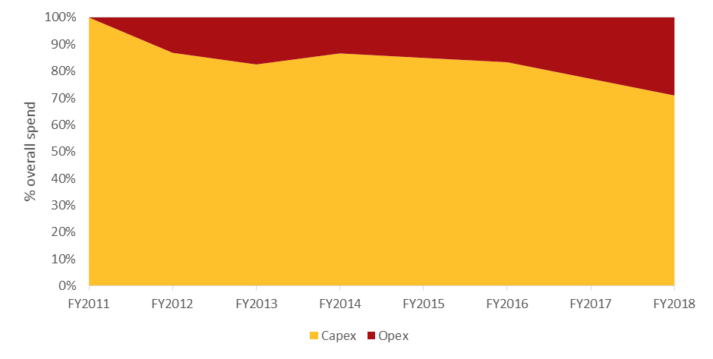

As shown in Figure 4, capital expenditure to FY2018 is largely driven by constructions costs.

**Figure 4: Fixed wireless capex breakdown, percentage of overall spend from FY2011 to FY2018, based on nominal dollars**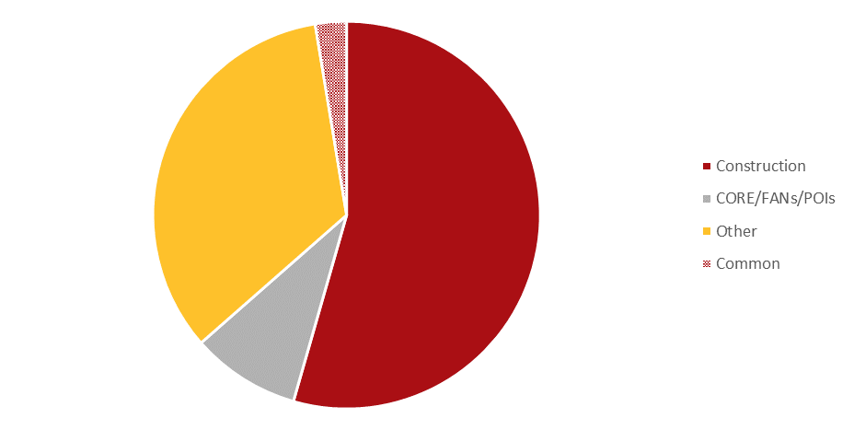

*Note: Other costs includes activations, base station design and acquisition, spectrum, fibre spurs, capitalised labour and all remaining fixed wireless capex costs.*

As shown in Table 3 below, fixed wireless assets carry a useful life of between five to 16 years.

**Table 3: Useful life of fixed wireless assets, source: NBN Co**

| **Description** | **Useful life (years)** |
| --- | --- |
| Customer premises equipment | 5 |
| Spectrum licenses | 15 |
| Base station – civil construction works | 16 |
| Base station – network and coverage upgrades | 15 |
| Core network | 7 |

Following the completion of the capital-intensive fixed wireless build phase, operating costs contribute an increasing proportion of overall expenses, driven largely by site rental costs.

**Figure 5: Fixed wireless opex breakdown, percentage of overall spend from FY2015 to FY2018, based on nominal dollars**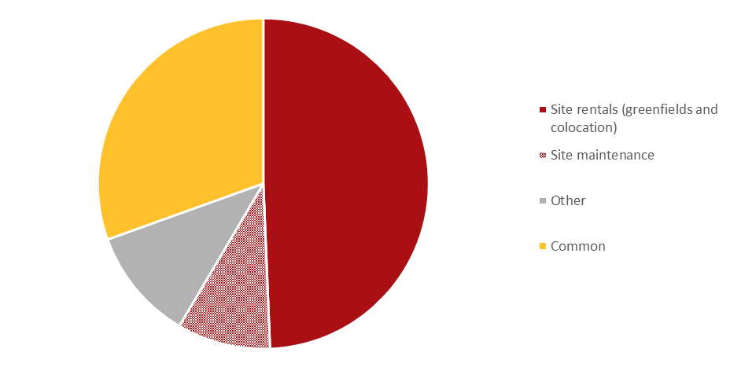

*Note: Other includes power, managed services backhaul, spectrum and microwave licences.*

The NBN fixed wireless network currently offers 12 Mbps download and 1 Mbps upload and 25 download and 5 Mbps upload services, with consistent pricing to equivalent fixed line services. In April 2015, NBN Co announced it would trial a fixed wireless 25-50 Mbps download and 10-20 Mbps upload service.[18] From FY2015 to FY2018, fixed wireless revenues are expected to account for around five per cent of overall NBN Co telecommunications revenue.

In some regional areas, the NBN fixed wireless network competes with other broadband networks, including ADSL/ADSL2+. ADSL2+ in particular offers a comparable service to NBN fixed wireless as it provides comparable headline speeds and data download limits (although the headline ADSL2+ speed is dependent on the length of the copper from the exchange to the premises, with speeds falling over longer lengths). Many Internet Service Providers (ISPs) offer equivalent pricing and data allowances between the NBN and ADSL products, including in regional or rural areas.

**Table 4: NBN fixed wireless and ADSL2+ retail prices, source: ISP websites accessed in August 2015. Excludes installation fees, telephony, user equipment, bundles or discount offers. Based on 24-month contracts; fixed wireless plans offering 25/5 Mbps; nationwide ADSL2+ plans.**

|  | **Technology** | **Plan name** | **Plan cost  ($/month)** | **Download capacity  (GB/month)** |
| --- | --- | --- | --- | --- |
| **Telstra** | Fixed wireless | Basics Plan | $75 | 100 GB |
| ADSL2+ | Basics Plan | $75 | 100 GB |
| **Optus** | Fixed wireless | 200GB Broadband with ‘Fast’ Speed Pack | $85 | 200 GB |
| ADSL2+ | 200GB Broadband | $80 | 200 GB |
| **iiNet** | Fixed wireless | NBN Wireless 2 | $64.90 | 50 GB |
| ADSL2+ (Off-Net) | ADSL2+ Home-1 | $39.95 | 50 GB |
| **Internode** | Fixed wireless | NBN Wireless Silver | $54.95 | 30 GB |
| ADSL2+ (Off-Net) | Each Reach | $59.95 | 30 GB |

Notably, unlike the fixed line footprint, there is no migration event that requires a customer to transfer to the NBN fixed wireless network. Fixed wireless pricing is based on the same regulated price caps as equivalent fixed line services. This places a ceiling on the amount NBN Co can charge and the extent to which it can cost recover.

The presence of ongoing infrastructure-based competition and the associated lack of specific migration incentives suggest there are limits on customer take-up of NBN fixed wireless and satellite services and subsequent revenues. Pricing arrangements further constrain revenue opportunities.

## 3.3 Satellite operational and commercial assessment

Ahead of the launch of the Long Term Satellite Service (LTSS), NBN Co deployed the Interim Satellite Service (ISS) in 2011 using leased capacity from IPSTAR and Optus to support around 44,000 services. In June 2013, the ISS reached capacity and NBN Co stopped offering further services.[19] In July 2014, NBN Co announced the NBN Co Satellite Support Scheme (NSS) offering services for up to 9,000 additional premises. This service is delivered by IPSTAR and participating ISPs as opposed to NBN Co.[20]

The LTSS will be delivered by two Ka band multi-spot beam satellites designed for the delivery of high-capacity broadband. The first satellite, Sky Muster, launched on 1 October 2015 with the second satellite to launch approximately six months later. Combined, both satellites are expected to serve a coverage footprint of approximately 412,000 premises that are outside the NBN fixed wireless or fixed line footprint.[21] Services are expected to commence in FY2016.[22]

Satellite operations are underpinned by commercial agreements. In July 2014, NBN Co announced that Ericsson would manage ground station operations and handle the migration of interim satellite users to the LTSS. This complements the telemetry, tracking and control (satellite flight functions) contracted to Optus.[23]

As at 1 October 2015, NBN Co had a total of 37,000 active satellite connections.[24] Following the launch of the LTSS, this number is anticipated to grow to approximately 135,000 connections by FY2018.[25] The satellite program is characterised by high capital costs leading up to the launch of the satellites.

**Figure 6: Satellite capex and opex from FY2011 to FY2018, includes common costs**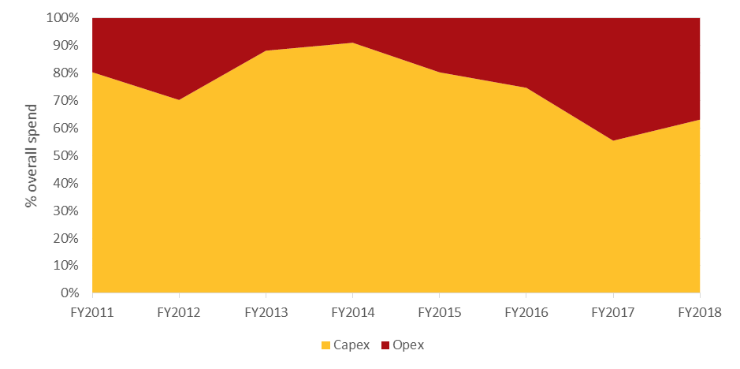

Capital expenditure is largely associated with spacecraft, launch and ground station costs. Following the launch of the satellites in FY2016, capital expenditure is largely driven by customer connection and ground station costs.

**Figure 7: Satellite capex breakdown, percentage of overall spend from FY2011 to FY2018, based on nominal dollars**

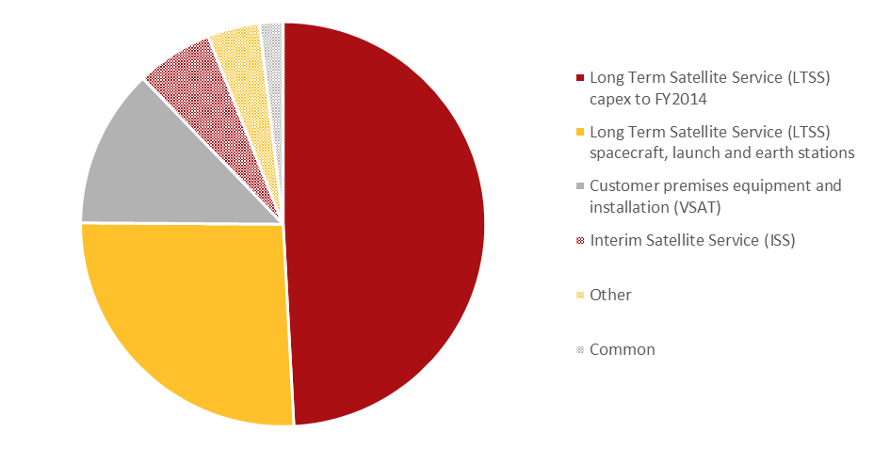

As shown in Table 5 below, satellite assets carry a useful life of between seven and 15 years.

**Table 5: Satellite asset useful life, source: NBN Co**

| **Description** | **Useful life (years)** |
| --- | --- |
| Customer premises equipment and installation (VSAT) | 7 |
| Infrastructure | 15 |

Ongoing operating expenditure is largely driven by outsourced contracts providing support and assurance services.

**Figure 8: Satellite opex breakdown, percentage of overall spend from FY2015 to FY2018, based on nominal dollars**

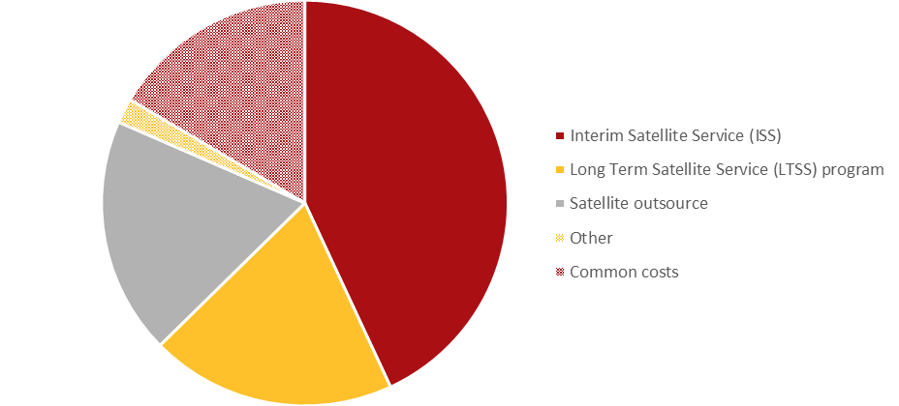   
*Note: ISS includes managed services, transponder services and other costs. LTSS includes apparatus licences, ground stations, supplier support services and other costs.*

From FY2015 to FY2018, satellite revenues are expected to account for around 2.5 per cent of overall NBN Co telecommunications revenue. While the BCR understands that NBN Co is considering additional services that could be offered over the satellite network, it is currently unclear the extent to which new services might increase revenues.

## 3.4 Capacity considerations

For both the fixed wireless and satellite networks, there is a relationship between speeds, data usage and network investment. The greater the speeds provided over the network, the greater the data usage. Increasing network data traffic is a key driver of network upgrades, especially to support peak period requirements.

Capacity is an important consideration for the satellite program. The LTSS has finite capacity and there are limited options available once capacity constraints are reached.

Importantly, while recent trends suggest increasing demand for data usage, capacity constraints are unlikely in the short term, given the significant increase in capacity offered by the LTSS compared to current service offerings. Capacity constraints are more likely a longer term consideration and given that the LTSS is offered on a spot-beam basis, capacity shortfalls will likely be limited to beams serving large population centres.[26]

The Fixed Wireless and Satellite Review identified a number of measures to conserve capacity, including developing a standard product based on pre-determined Committed Information Rate (CIR), implementing Service Level Agreements that define customer experience and putting in place tools to monitor and control usage.[27] Consideration could also be given to ensuring the availability of capacity for services with high social value, such as those delivered to schools and hospitals.

Ultimately, such capacity management techniques optimise the services which can be provided over fixed wireless and satellite. This is particularly important in the satellite footprint, to ensure that capacity is preserved over the asset life of the satellites.

In the event that satellite capacity constraints are reached, NBN Co could implement further controls to manage peak network usage, invest in more satellite capacity or could limit satellite take-up and instead extend fixed wireless infrastructure. As identified in the Fixed Wireless and Satellite Review, a number of options exist to upgrade capacity on the fixed wireless network, including site sector splitting, adding new base stations or deploying new technologies such as carrier aggregation.[28] Network upgrades have cost and revenue implications.

These issues highlight the sensitivity of non-commercial service losses to capacity constraints. For example, a greater-than-expected shifting of end users from the satellite to the fixed wireless network will increase the extent of non-commercial service losses and industry funding contributions.

New technologies may emerge that increase capacity on the fixed wireless and satellite networks or support options for alternative delivery of high speed broadband services.

## 3.5 Future technology considerations

* 5G and the evolution of high-capacity satellites indicate significant improvements will be available for the fixed wireless and satellite networks.
* Emerging technologies may change the competitive landscape and present new and potentially alternate opportunities for broadband service delivery.

Over the next 10 to 20 years, the BCR expects there will be new technologies that can enable greater performance across both the fixed wireless and satellite networks.

### 3.5.1 5G technology

Historically, new generations of mobile technology have come to market roughly once per decade (see Figure 9 below). Despite the fact that 4G standards are still being developed, work is already being carried out to scope the initial standards for 5G technologies.

**Figure 9: Timeline for cellular technology introductions, source: Analysys Mason, 2015**

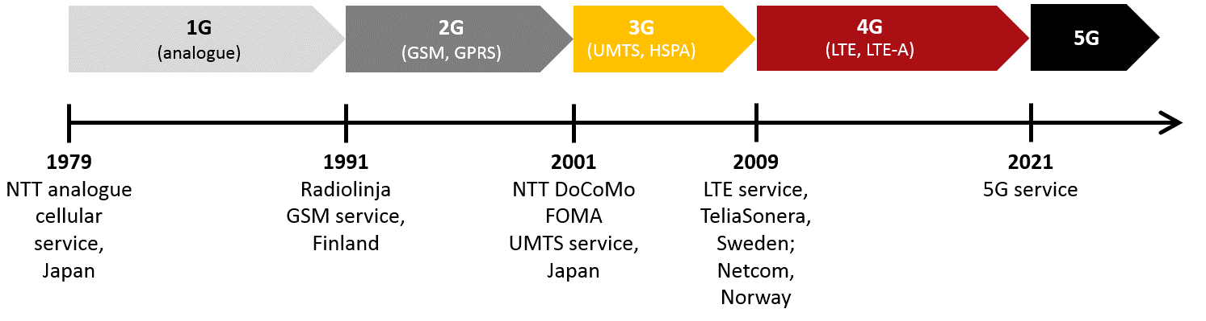

*Note: 2G technology: Global System for Mobile Communications (GSM), General packet radio service (GPRS); 3G technology: Universal Mobile Telecommunications System (UMTS);* *High Speed Packet Access (HPSA); 4G technology: Long-Term Evolution (LTE); Long-Term Evolution Advanced (LTE-A).*

Agreement has yet to be reached on what 5G technology should be aiming to deliver, and whether it should be an evolution of 4G standards or a complete break with the past. Different groups of potential users want 5G to deliver ultra-fast connectivity in urban areas with much higher device density than current networks, pervasive coverage to support low power machine-to-machine (M2M) and internet of things (IoT) applications, and high-reliability services to support the needs of critical communications users (for example, emergency services).

In a recent paper, the industry trade association GSMA sets out two views of 5G and lists eight requirements (seeFigure 10), noting that it may be impossible to satisfy all of these requirements simultaneously and that only the first two represent true technical requirements (the rest being either economic objectives or aspirations applicable to all network technologies).[29]

**Figure 10: Perspectives on 5G and potential requirements, source: Analysys Mason, adapted from GSMA, 2014**

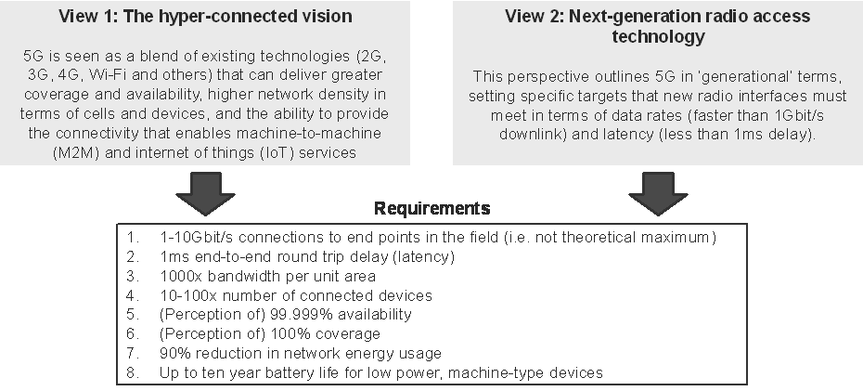

Technical proposals for 5G are expected to be considered from late 2017, with final specifications likely to be agreed in 2020. Some countries are hoping to begin 5G deployments immediately after this. The complexity of the task suggests it is possible that deployment will be delayed.

Given that the spectral efficiency of 4G networks is already quite close to theoretical limits, the BCR does not expect that a transition to 5G technology will, in itself, lead to a step-change performance improvement for the NBN fixed wireless network. The upcoming 2015 World Radio Conferences will consider whether additional spectrum bands below 6GHz might be used for 5G services. The subsequent 2019 World Radio Conference will consider whether additional bands above 6GHz should be used for 5G services.

The BCR considers that the coverage range of bands above 6GHz is likely to be too short to enable significant improvements in NBN Co’s fixed wireless service, but if NBN Co could secure additional spectrum below 6GHz then improvements to the performance of the fixed wireless network would be expected, enabling greater speeds and data capacity. NBN Co’s long-term financial planning allows for further investment in the fixed wireless network, which could support an increase in the required service standards over time. Less certain is whether the introduction of 5G technology by mobile operators may see an increase in the level of substitution from the fixed wireless and satellite networks to mobile. 5G mobile networks may emerge as a viable alternative for the delivery of high-speed broadband outside of the NBN fixed line footprint.

### 3.5.2 Evolution of high-throughput satellites

Research and development activities are taking place to increase the total throughput currently available through high-throughput Kaband satellites. The principal areas of activity are:

* **Use of larger antennas to create a larger number of smaller spot beams on each satellite** –It is expected that it should be possible to build Ka band satellites with 200-300 spot beams by 2020. This would improve frequency re-use and increase capacity.
* **Use of high frequencies for feeder links to and from satellite gateways** – At present the feeder links for most Ka band high-throughput satellites also operate in the Ka band. This reduces the amount of spectrum that is available to support end users and also places some limitations on where the gateways can be sited. Future satellites may be able to use spectrum in the Q/V bands (around 40-50 GHz) or free-space optical links to overcome these limitations.

In addition to these technical developments it may be possible to make more Ka band spectrum available for use by the LTSS in the future.

Taken together, the BCR recognises that by the time NBN Co’s first two satellites need to be replaced (expected around 2031) it may be possible for NBN Co to deploy Ka band high-throughput satellites with greater capacity compared to current technology.

### 3.5.3 Potential for low-earth orbit broadband satellites

In the past 12 months, a number of new proposals have been announced to deliver global broadband connectivity using large constellations of satellites in low-earth orbit (LEO). Table 6 below provides information about three such proposals.

**Table 6: Overview of selected LEO broadband satellite projects, source: Analysys Mason, 2015**

|  | **OneWeb** | **SpaceX** | **LeoSat** |
| --- | --- | --- | --- |
| **Champion** | Greg Wyler, ex-CEO of O3b Networks (pioneer of MEO satcomms) | Elon Musk, founder of SpaceX | Vern Fotheringham, ex-CEO of Kymeta (solid-state satellite antenna company) |
| **Partners and backers** | Virgin Galactic, Qualcomm. Airbus, Bharti Enterprises, Coca Cola, Intelsat, Totalplay Telecommunications | Google | None announced |
| **Number of satellites** | 650 | 4,000 | 80–140 |
| **Proposed operating band** | Ku band | Ku or Ka band | Ka band |
| **Satellite manufacturer** | Airbus | SpaceX (in new factory) | Not yet announced |
| **Other details** | Aiming to procure satellites for US$400,000 each; mass-market fixed terminals for US$250. Press reports indicate system cost of US$2-6 billion. Also planning specialised terminals for aeronautical and first responder markets | Appears to be aiming at mass market. Press reports indicate system cost of US$10 billion–US$15 billion | Aiming at high end users, ‘top 3000 rather than other 3 billion’. Will use high-speed inter-satellite links to provide fixed point-to-point connections at up to 1.2Gbps. System cost stated to be US$2.5 billion–US$3 billion |

LEO satellites are typically much smaller than geostationary satellites (including those currently used to deliver NBN services). They are also mass-manufactured and launched in much lower orbits and so cost less. The systems described above could potentially deliver much more capacity over Australia than the two LTSS satellites. However, while the user antenna for a geostationary satellite can be a simple fixed dish, the antenna for a LEO satellite needs to be able to track a satellite across the sky and quickly pick up the next satellite when the first dips below the horizon. Bi-directional antennas capable of doing this currently cost tens of thousands of dollars. Although companies are developing low-cost solid-state alternatives, it is uncertain whether price points in the low hundreds of dollars are achievable. There will also be challenges in coordinating the use of Ku and Ka band spectrum by both geostationary and LEO satellites.

Nevertheless, OneWeb, SpaceX and LeoSat are led by successful space industry entrepreneurs and OneWeb and SpaceX have announced some well-financed backers (including Airbus, Virgin Galactic, Intelsat and Qualcomm in the case of OneWeb, Google in the case of SpaceX). If these projects eventuate it is possible that the LEO systems could build their own gateways and sell directly to NBN Co’s downstream service providers. Alternatively, NBN Co could be their partner of choice based on its existing infrastructure and downstream distribution network in Australia.[30] NBN Co will launch its first two satellites well before any future LEO system becomes available. LEO systems could emerge as a possible, cheaper alternative for providing a satellite service compared to NBN Co replacing the first two satellites when they reach end-of-life around 2031.

## 3.6 BCR assessment of technology developments

While it is impossible to predict the exact implications that new technologies will have, these developments suggest that the delivery model for non-commercial services will need to evolve over time. Consideration is required regarding how funding arrangements can be adjusted over time to accommodate changing circumstances. For example, new technologies may present opportunities to increase services standards and revenues across the fixed wireless and satellite networks or for more efficient delivery of non-commercial services.

Further, long-term modelling will need to consider potential outcomes arising from technology change, including to reflect costs associated with network upgrades, availability of higher throughput services and changes in customer take-up profiles.

# Chapter 4: Quantifying non-commercial service losses

The Initial Consultation Paper identified a number of cost measurement issues:

* use of NBN Co cost and revenue data
* adopting an appropriate cost measurement framework
* network assessment at a granular level
* forecast period for assessment.

Following careful consideration of the submissions, the BCR’s position on each issue is discussed below.

## 4.1 Use of NBN Co cost and revenue data

As discussed in the Initial Consultation Paper, the BCR has quantified non-commercial service losses using NBN Co historical cost and revenue data and the latest company corporate plan projections as the best available estimates. The BCR has used this data as the basis for longer term modelling that disaggregates fixed wireless and satellite financial outcomes.

While the submissions were supportive of the BCR using NBN Co data for this purpose, Telstra, Optus and NBN Co all noted the inherent uncertainty in long-term projections, and the need to ensure projections in the model are replaced with actual cost and revenue data in a timely manner.[31]

## **4.2 Adopting an appropriate cost measurement framework**

* The BCR considers that an avoidable (or incremental) cost approach is appropriate for measuring NBN non-commercial service losses.
* Avoidable costs are measured as directly attributable costs and a share of common costs that would be avoided if the fixed wireless and satellite networks were not rolled out.

In order to quantify the costs of the construction, maintenance and operation of the fixed wireless and satellite networks, the BCR must determine the most appropriate cost measurement approach. The Initial Consultation Paper outlined three commonly used approaches in regulatory contexts, as shown in Table 7.

**Table 7: Cost measurement approaches**

| **Cost Measurement** | **Description** |
| --- | --- |
| **Avoidable (or Incremental) Cost** | All costs (including capital costs) which would have otherwise been ‘avoided’ had the product or service not been provided.[32] |
| **Fully Distributed Cost (FDC)** | The total costs of an enterprise allocated to all the different activities it undertakes, including those not directly attributable to particular activities.[33] |
| **Stand Alone Cost (SAC)** | The costs associated with the provision of a product or service in isolation.[34] |

The BCR recognises that cost measurement is contentious for the purpose of quantifying NBN non-commercial service losses. The cost measurement approach effects the quantum of losses to be funded by industry contributions as a result of the extent to which common costs are allocated between the fixed line and non-fixed line businesses.[35]

Figure 11 below illustrates how different cost measurement approaches consider common cost allocations.

**Figure 11: Cost methodologies and associated cost types, source: conceptual approach based on International Telecommunications Union, Telecommunications Regulation Handbook, 2000  
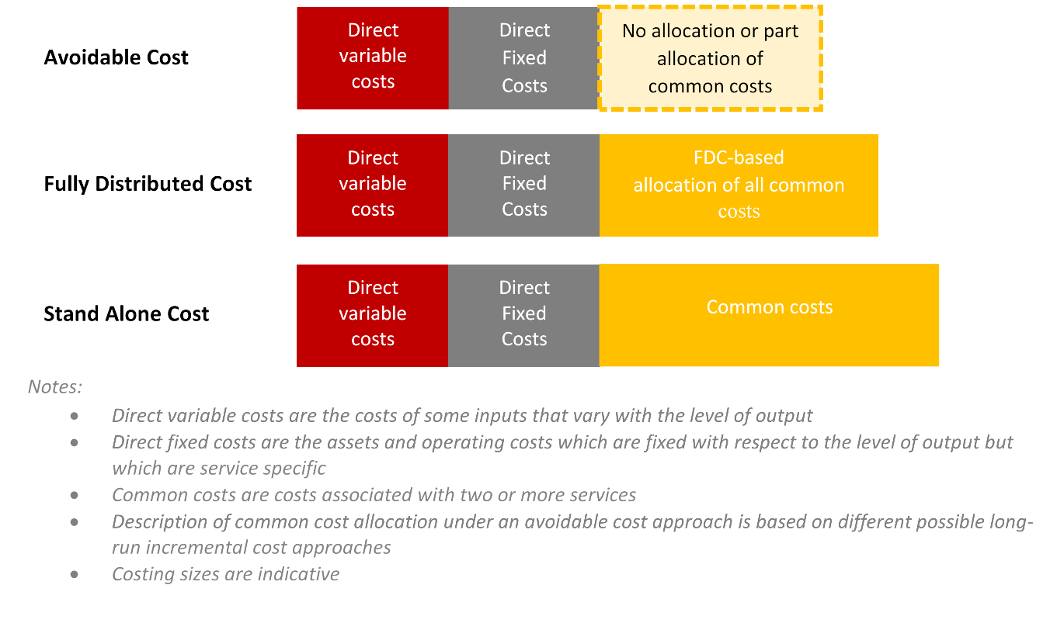**

In the Initial Consultation Paper, the BCR proposed costing on a ‘commercially focused’ basis, with a full distribution of common or indirect costs.[36] Eight of the 14 submissions received expressed concern about the use of this methodology, arguing that a fully distributed accounting approach is not reflective of the actual cost to deliver the service,[37] would increase the impact of an industry-based funding arrangement on commercial customers[38] and could provide NBN Co with a net competitive advantage over any new entrants in the fixed line market.[39]the BCR has further considered cost measurement approaches both in the context of government requirements and from the perspective of funding arrangement outcomes.

In terms of government requirements, the BCR notes that cost measurement is a consideration in the context of costing Community Service Obligations (CSO). In 1994, the Steering Committee on National Performance Monitoring of Government Trading Enterprises proposed the following, now widely adopted, definition of a CSO:

*A Community Service Obligation arises when a government specifically requires a public enterprise to carry out activities relating to outputs or inputs which it would not elect to do on a commercial basis, and which the Government does not require other businesses in the public or private sectors to generally undertake, or which it would only do commercially at higher prices.[40]*

The BCR considers that the delivery of fixed wireless and satellite services on a non-commercial basis is consistent with this definition.

When considering funding arrangements, government guidelines favour an avoidable cost approach to valuing CSOs, as it provides the best approximation of the additional costs associated with delivering a specific service. By comparison, a FDC approach and a stand-alone cost approach result in over-estimation of the extent of cost increases caused by the supply of a non-commercial services.[41] The preference for an avoidable cost approach for determining CSOs is reiterated in the Government’s Competitive Neutrality guidelines.[42]

The main advantage of an avoidable cost approach it supports economic efficiency and competitive neutrality, by providing an appropriate way of costing shared resources so that prices of commercial services can be set to reflect full cost attribution. As Vodafone noted in its submission:

*Using a fully allocated or stand alone cost standard for uncommercial areas would mean that in the commercial areas:*

* *NBN Co could sustainably recover the incremental costs of serving customers plus the remainder of common costs (e.g. corporate overheads) that are not recovered in non-commercial areas*
* *Other suppliers would need to recover their own incremental costs, plus pay a contribution to the common costs of NBN Co in serving non-commercial areas – costs which these other suppliers would also incur in serving commercial areas.*

*It can be readily shown that this can lead to situations where end users choose services from NBN Co even where it is the less efficient provider. Using [FDC] to calculate costs therefore undermines the notion of contestability.[43]*

The BCR notes concerns from a number of stakeholder submissions that using the FDC approach may lead to overestimation of the loss, and that the avoidable approach can minimise any overestimation. This is consistent with the Australian Government’s Competitive Neutrality Guidelines, which note that a FDC approach can inappropriately inflate common cost allocation.[44]

In its submission NBN Co advocated a FDC measurement approach and raised a number of concerns with the adoption of an avoidable cost approach:

*Funding options which do not take into account common costs associated with the supply of NBN fixed wireless and satellite services will not provide a sustainable source of funding into the future, but will instead entrench the existing cross-subsidy from the fixed-line platform to the fixed wireless and satellite platforms in NBN’s business case. An incremental cost approach will mean that the prices for NBN’s fixed line services will need to be higher which will in turn make market entry into high-value low-cost-to-serve areas more attractive to network operators seeking to cherry-pick. Cherry-picking will not only be detrimental to NBN’s business base (i.e. it will lessen NBN’s ability to fund the full share of the common costs) but it will also encourage socially wasteful duplication of fixed network costs. Given the natural monopoly characteristics inherent in fixed telecommunications infrastructure, any duplication of fixed network costs will raise the overall cost of delivering broadband services thereby reducing overall industry profits. Consequently, over time an incremental cost approach will mean that the burden of funding the provision of non-commercial fixed wireless and satellite services will represent an increasing share of industry profits – such an outcome is unsustainable and will not maximise overall social welfare.*[45]

NBN Co has also raised with the BCR that implementing an avoidable cost approach would impose significant administrative burden on the company.

Ultimately, funding arrangements need to ensure that where NBN Co faces direct competition, it occurs on a level playing field where competitors equally share the burden of funding non-commercial services and where the most efficient network operator gains market share. The BCR considers that funding arrangements should not unnecessarily restrict market entry or competitive activity. This would more likely arise where competitors are required to make contributions towards costs NBN Co would incur anyway in providing fixed line services.

However, sustainability is also an important consideration. Where NBN Co loses market share to competitors that are facing the same cost burden for funding non-commercial services, this would suggest the presence of a more efficient competitor, but only if the correct cost burden is being recognised. A cost measurement approach that does not reflect the additional costs NBN incurs to provide fixed wireless and satellite services overly favours NBN Co’s competitors. To the extent that material levels of competition arise, this could diminish NBN Co’s ability to sustainably fund non-commercial services.

The BCR considers there is merit in NBN Co’s arguments that the full exclusion of common costs from the non-commercial services cost base will place upwards pressure on its pricing in the fixed line footprint (though within price cap constraints). Where funding from NBN non-commercial services contributions does not recognise and contribute to the recovery of avoidable common costs, NBN Co will need to recover these costs from other business activities, namely fixed line operations. Where NBN Co faces fixed line competition, non-commercial service funding arrangements should not constrain NBN Co’s ability to compete and reduce prices.

This suggests trade-offs need to be assessed between a cost measurement approach that potentially over-allocates common costs, thereby inflating contribution requirements from competitors in the fixed line footprint and stifling competition, and a cost measurement approach that potentially under-allocates common costs to the detriment of a level playing field. The BCR considers that an avoidable cost approach best strikes this balance, and meets government guidelines for costing CSOs.

Under the BCR’s proposed avoidable cost approach, indirect and common costs that NBN Co incurs in order to provide fixed wireless and satellite services are included in the estimate of losses to be recovered by the funding arrangement. While this requires some judgment, the BCR considers this approach best addresses the key issue of whether NBN Co could reasonably expect to avoid a particular cost if the activity did not take place.[46] The BCR further understands that Australia Post allows for an allocation of some common costs as part of its CSO costing model, suggesting precedence for this approach.[47]

The BCR’s process for identifying NBN Co’s avoidable fixed wireless and satellite costs is below.

**Figure 12: BCR steps to identify avoidable costs**

The BCR has adopted the following approach to identifying the avoidable costs of the satellite and fixed wireless services:

1. Categorise all NBN Co costs into:
   1. costs that are directly attributable to the provision of satellite and fixed wireless services (e.g. satellite costs, fixed wireless tower costs, etc.)
   2. costs that are directly attributable to the provision of fixed line services (e.g. cost of pit and pipe), or
   3. common and indirect costs from assets and activities shared by fixed wireless, satellite and fixed line services (e.g. transit and labour costs).
2. Identify whether the common and indirect costs (under 1c) are:
   1. unavoidable, as they do not vary irrespective of the deployment of the satellite and fixed wireless networks
   2. partly avoidable, because they would be less if the satellite and fixed wireless networks were not deployed.
3. For those common and indirect costs that are partly avoidable, the BCR has allocated costs between the fixed line, fixed wireless and satellite networks based on the percentage of SIOs in a given financial year.

This approach results in around 1.2 per cent of all indirect or common costs being allocated to the fixed wireless and satellite networks from FY2011-FY2022.[48] By comparison, the fixed wireless and satellite networks are expected to account for around eight per cent of all premises covered by the NBN. The sensitivity of the BCR’s estimate of fixed wireless and satellite losses to the allocation of common costs is explored in Chapter 5.4.

The BCR acknowledges NBN Co’s concerns about the administrative burden of implementing an avoidable cost approach, recognising that this would require allocating costs and assembling accounts solely for this purpose. The BCR considers that the Government agency calculating the funding contribution will need to give further consideration to the practical issues of how the avoidable cost approach is implemented in an objective, transparent and minimally-burdensome manner, in consultation with NBN Co and the ACCC.

The BCR notes that a number of factors make the implementation of an avoidable cost approach less burdensome in the case of NBN Co, than for other GBEs. For example, the fixed wireless and satellite networks are separate from the fixed line networks, making it easier to isolate most avoidable costs. The estimate of losses also applies to all fixed wireless and satellite customers and services, rather than only a subset. This contrasts with other GBEs such as Australia Post, where a common network serves CSO and non-CSO customers, and CSO and non-CSO products, making it more difficult to identify the avoidable costs of delivering the CSO.

## 4.3 Network assessment at a granular level

* The BCR considers that the commerciality of fixed wireless and satellite networks should be considered at an aggregate level, rather than at a granular ‘network cluster’ level.

The Initial Consultation Paper sought views on whether it was appropriate to assess commerciality of fixed wireless and satellite services at a granular network level. In particular, the BCR was concerned that within the fixed wireless network there might be some areas that are commercial or become commercial over time. By assessing commerciality at a granular level (for example, at the Wireless Service Area (WSA)level),[49] this would provide a better understanding of the economic cost of providing non-commercial services.

A granular analysis could be helpful if there were significant areas of commerciality in the fixed wireless footprint, such that an aggregate analysis materially underestimated losses in the loss-making segments of the fixed wireless business. This is demonstrated in Table 8 and the subsequent discussion.

**Table 8: Hypothetical example of granular network assessment in the fixed wireless footprint**

| **Wireless Service Area** | **Indicative operating profit/(loss) $ (million)** |
| --- | --- |
| WSA#1 | (10) |
| WSA#2 | (5) |
| WSA#3 | (5) |
| WSA#4 | 2 |
| WSA#5 | 3 |

At an aggregate level, the hypothetical example above shows that a wireless network comprising these WSAs results in a total loss of $15 million. Alternatively, a granular level assessment would indicate that if a provider was not required to serve non-commercial areas, the delivery of fixed wireless services would result in a profit of $5 million dollars. Further, excluding the commercial areas indicates that the true cost for delivering non-commercial services is $20 million.

A granular analysis could also be useful if the funding scheme was to be contestable and different subsidies were payable for serving different areas, reflecting differences in the costs of service provision. However, both these scenarios are currently considered to be unlikely.

NBN Co raised concerns that considering costs at a granular level would not provide meaningful data regarding fixed wireless and satellite commerciality:

*An analysis based on network clusters is likely to require arbitrary assumptions and allocations that would distort the identification of non-commercial services. The interwoven nature of fixed wireless and satellite services outside of the fixed line footprint means that both of these networks should be identified as non-commercial for the purpose of establishing the funding arrangements.[50]*

The BCR agrees that an assessment that introduces significant modelling uncertainty will not support useful outcomes. This is consistent with Ian Martin’s submission:

*Modelling inherently involves a trade‐off between capturing as much useful information and analysis as possible to guide decision making without adding so much complexity as to make the analysis impractical. As well the commerciality model shouldn't itself be a substitute for management decisions. But it does need to be sufficiently close to inform the commerciality assessment and given the nature of NBN FW&S resource decision‐making that is unlikely to be achieved by simply considering network clusters.[51]*

For the purpose of assessing NBN non-commercial services, the BCR will not consider commerciality at a granular level and agrees with NBN Co’s assessment that both fixed wireless and satellite should be identified as non-commercial for the purpose of funding arrangements.

## 4.4 Period for loss assessment

* The BCR considers it appropriate to quantify NBN non-commercial service losses to FY2040. This provides a sufficient timeframe to average the losses incurred during the initial build phase while allowing for consideration of reasonable operating and replacement capital costs.
* The BCR considers that asset life does not provide a definitive timeframe for considering non-commercial service losses given the different useful life of assets in the fixed wireless and satellite networks.
* The BCR agrees with industry submissions that it is not appropriate to include a terminal value in calculating losses.

As discussed in the Initial Consultation Paper, the BCR’s preliminary view was to model non-commercial losses to FY2040, as contemplated under the SAU. While some submissions supported this approach[52] a number of respondents suggested that the BCR should instead adopt useful asset life as the more appropriate timeframe for measuring losses.[53] Vodafone for example said:

*Surprisingly, the BCR does not raise the possibility of aligning the modelling with the expected asset lives. In principle, this approach seems better than aligning with the SAU timing as the relevant non-commercial assets will have expired asset lives (with the useful life of satellites between 15 to 18 years and the fixed wireless network possibly having a similar life). The advantage of this approach is while we have very little idea of what replacement assets will cost in 15 years, there is far more certainty about what costs have already been incurred.[54]*

In considering a useful asset life approach, the BCR notes that the satellite asset life of 15 years potentially provides a point for financial analysis. Given the satellite service commencement date of FY2016, this would see forecasts extending to around FY2030 (noting that capital expenses relating to new satellite deployment typically occurs two to three years before its launch, reflecting progressive commissioning and build payment milestones). Satellite ground stations also typically have a 15-year life cycle. This differs to the asset life for the fixed wireless network as show in Table 9.

**Table 9: Useful life of fixed wireless assets, source: NBN Co**

| **Description** | **Useful life (years)** |
| --- | --- |
| Customer premises equipment | 5 |
| Base station – civil construction works and network upgrades | 15-16 |
| Core network | 7 |

Noting that the fixed wireless network rollout began in 2011 and is expected to be largely complete by FY2018, modelling will need to account for replacement costs associated with initial infrastructure deployments and assume investment in replacement assets. In practice, the rolling deployment of the fixed wireless network suggests there is no clear ‘cut-off’ point which aligns with expected asset lives across both the fixed wireless and satellite networks.

Beyond asset lifecycle, the BCR recognises that there are varying levels of confidence over a forecast period to FY2040. As illustrated in Figure 13, actual data is available from FY2011 to FY2015 and NBN Co projections that separate fixed wireless and satellite costs and revenues from those for the fixed line platform are available over the build phase and initial operating phase to FY2022. From FY2023 onwards, fixed wireless and satellite costs and revenues are based on BCR modelling (informed by detailed discussions with NBN Co). This consideration argues in favour of using a relatively short timeframe.

**Figure 13: Information over different projection periods**

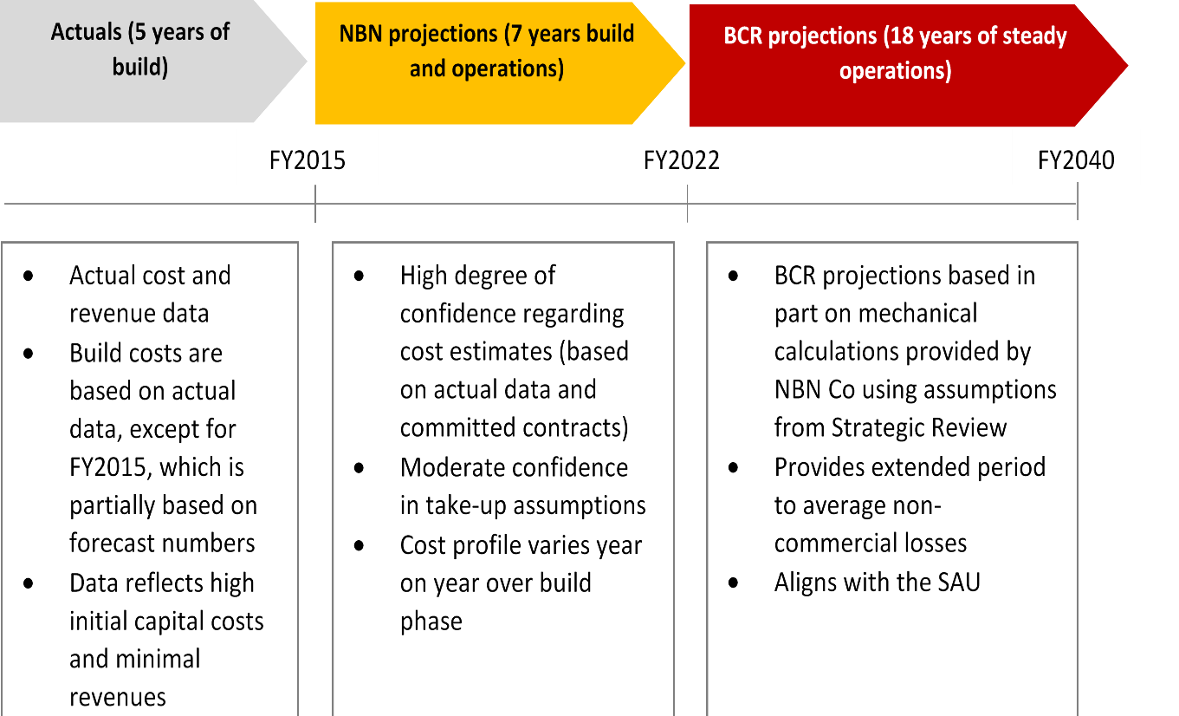

Conversely, an advantage of forecasting over longer periods is this provides a greater period to average non-commercial losses.

On balance, FY2040 is considered to provide a sufficient timeframe to smooth the losses incurred during the initial build phase while allowing for consideration of reasonable replacement capital costs. This approach also provides consistency between non-commercial service calculations and the long-term NBN Co business case which is used for the purpose of the SAU. A forecast period to FY2040 also provides a sufficient estimate of long-term steady state operations. Further, increased uncertainty from using this longer timeframe can be ameliorated by the proposed regulatory review approach proposed in Chapter 8.3.

Including a post-FY2040 terminal value would project losses into perpetuity. The BCR notes that submissions raised concerns that a terminal value would be highly speculative and would inappropriately bring forward the implied estimate of all future losses for payment in the present. The BCR concurs with this assessment and has not included a terminal value as part of its financial modelling.

Importantly, quantified losses will include actual costs incurred from the commencement of the fixed wireless and satellite service in FY2011 to FY2015. This includes costs associated with the ISS and the subsequent NSS.

# Chapter 5: Model approach and outcomes

Beyond the cost measurement issues discussed earlier in the document, the following concepts have been considered in modelling NBN non-commercial service losses:

* financial analysis methodology
* discount rate
* long-term forecasts

## 5.1 Financial analysis methodology

* The BCR has modelled NBN non-commercial service losses using a discounted cash flow methodology rather than the building block model which is often favoured by regulators.
* This approach can be transitioned to a building block model in the future without material shifts in the estimate of the FY2011 to FY2040 loss pool if desirable for regulatory purposes.

As part of the Initial Consultation Paper, the BCR sought views on the appropriateness of using a discounted cash flow (DCF) analysis compared to a building block model (BBM), which is often favoured by regulators. Typically, a DCF analysis involves estimating the future cash inflows and outflows, and applying an appropriate discount rate to those future cash flows.[55] It is commonly used to value firms and projects, an exercise closely aligned with the loss identification required by the Terms of Reference.

A BBM is commonly used for estimating optimal annual efficient cost recovery revenue for regulated industries. The ACCC describes that to implement a BBM, an initial Regulatory Asset Base (RAB) value is established and then ‘locked in’ and rolled forward year-by-year by actual changes in the value of the asset base as determined by annual capex and depreciation. The BBM accounts explicitly for each cost category or ‘building block’ faced by the regulated business, including opex, return on capital (which reflects a cost of capital and depreciation) and tax liabilities. Each of the building blocks is added together to determine the business’s optimal revenue requirement.[56]

While the majority of submissions supported the use of a DCF approach, Optus and John de Ridder argued that a BBM should be used for quantifying non-commercial services.[57] The ACCC noted that while a DCF analysis is appropriate to quantify losses expected between now and 2040, a BBM is:

*…well suited to periodic updating of forecast information and updating for actual information. Although the building block approach is more typically used for setting regulated prices, the ACCC considers that it could potentially be adopted in a funding model for NBN non-commercial services.[58]*

Optus raised concerns that there should be consistency between non-commercial service funding arrangements and the SAU particularly to ensure that:

*…any change to the approach of cross subsidies must be reflected in changes to the SAU modelling – and hence may change the price regulation of NBN Co.[59]*

The BCR considers that a DCF analysis is a suitable model for quantifying non-commercial services losses. This approach directly and transparently aligns with financial projections and can readily accommodate future updates as new forecasts are estimated. In response to the concerns raised in the submissions, the BCR considers:

* **A DCF approach can readily and transparently accommodate periodic updating of forecast information and revision of past forecasts in light of actual information** – The model contemplated by the BCR adds actual and forecast data to quantify an overall loss amount. The BCR considers that this approach could be conducted periodically to provide revised loss estimates. A DCF approach aligns with NBN Co Corporate Plan forecasts and can directly and transparently accommodate revised figures to calculate losses. The BCR notes that a BBM can also readily accommodate periodic updating of information.
* **A DCF approach supports consistent outcomes to a BBM** – The BBM aims to ensure that a firm earns a revenue stream with an equal present value to its expenditure stream. Put another way, the BBM ensures that over the life of the project, the net present value (NPV) is equal to zero (allowing only for the minimum required return on capital invested). With consistent cost forecasts and key parameter assumptions, the present value of costs (and hence losses) over time calculated using the BBM approach will in general equate to the outcomes from a DCF approach. Given the two costing approaches rely on the same cost inputs, the BCR considers that a DCF approach does not preclude the future use of a BBM and the funding arrangement calculation could be transitioned to a BBM if required without material change in the estimated losses.
* **A DCF approach aligns with the operation of the SAU** – The BCR considers that any extra cash inflows provided to NBN Co as a result of the NBN non-commercial services funding arrangement would offset any initial unrecovered costs that would otherwise accumulate into the SAU Initial Cost Recovery Account (ICRA). In effect, the DCF is used for calculation purposes while the mechanics of the SAU will support regulated price outcomes.

## 5.2 Discount rate

The discount rate is an adjustment for the lower value of a payment (received or incurred) in the future relative to a payment now – as a payment received now could earn a return by investing it elsewhere. It reflects risk and uncertainty which increases over the timeline of the project. Applying a discount rate means that the later a payment, the less weight is placed on it.

Discounting is a step in arriving at the expected value of a project or firm, which may ultimately be profit-making or loss-making. Where a project is profit-making at the beginning and loss-making at the end, discounting will place more weight on the profits because they arise earlier. Similarly, where a project is loss-making at the beginning and profit-making at the end, discounting will place more weight on the losses because they arise earlier.

In the context of non-commercial services, which are characterised by negative cashflows throughout the life of the project, the discount rate decreases net present value (NPV) losses. In other words, the greater the discount rate, the smaller the overall loss.

The BCR considers that the most appropriate discount rate for quantifying non-commercial losses is the WACC calculated by the method approved by the ACCC for NBN Co’s SAU – the risk free rate (10-year Commonwealth Government Bond spot rate) plus 350 basis points. This would achieve regulatory alignment between price and revenue regulation on NBN Co and any NBN non-commercial service funding arrangement.

The WACC contemplated in the SAU is consistent with the Government’s competitive neutrality guidelines for determining a target rate of return. A risk-based approach allows for the application of a benchmark base cost of capital such as the Commonwealth long-term bond rate and the addition of a risk premium.[60]

For the purposes of the current exercise, BCR has used this approach to calculating the WACC value, and has used a discount rate of 6.46 per cent to give indicative NPV loss estimates.[61]

## 5.3 Long-term forecasts

* The BCR has taken NBN Co actual data to FY2015 and estimates to FY2022 as the basis to develop longer term financial projections from FY2023 to FY2040. Assumptions regarding long-term trends are included for transparency purposes.
* Loss estimates are subject to change based on a range of factors.

The model is based on actual cost and revenue data to FY2015. NBN Co has provided projections for the fixed wireless and satellite networks to FY2022. This reflects the NBN Co submission:

*…the BCR will need to develop its own projections of revenues and costs arising from the provision of NBN Co fixed wireless and satellite service for the period beyond 2022.[62]*

To this end, the BCR model uses NBN projections to FY2022 as an anchor to calibrate the modelling approach and assumptions for driving revenues and costs from FY2023 onwards. This approach best reflects a steady state or continuation of past trends, rather than any step changes in operational, cost or revenue assumptions. Reflecting this approach, the BCR model assumes the following for FY2023 and beyond:

* **Premises ready for service growth** – Assumes growth in the fixed wireless footprint of 1.3 per cent in line with new premises growth in outer metro and regional Australia. No growth is assumed in the satellite footprint as the satellite program is assumed to be fully subscribed from FY2023 onwards.
* **Take-up** – As a base case, the BCR takes NBN’s residential take-up growth rate to FY2022 and applies this to new premises beyond FY2023. In the fixed wireless footprint, take-up grows from 51 per cent in FY2023 to 56 per cent by FY2040. In the satellite footprint, take-up is assumed to peak at around 69 per cent.
* **Inflation** – The BCR assumes inflation of 2.5 per cent. This rate has been selected to maintain the real value of nominal capex and opex over time.
* **Revenue growth** –Driven mostly by premises activated growth, which is a product of take-up and premises ready-for-service growth. Consistent with the SAU, prices for the 12/1 and 25/5 Mbps services are assumed to grow slightly in nominal terms but fall in real terms. The model assumes that NBN Co does not discount prices in the fixed wireless and satellite business below the SAU price caps. The model reflects all NBN Co revenue from the fixed wireless and satellite networks, as proposed in submissions from ACCAN and Telstra.
* **Capex** – Mix of fixed costs that remain stable (e.g. launched satellite) and variable costs that increase in proportion to premises growth and recur at the end of useful asset lives. Assumes two replacement high-capacity satellites are deployed in FY2031.
* **Opex** – Mix of fixed costs that do not grow (e.g. satellite telemetry, tracking, and command costs) and variable costs that increase in line with premises activations.
* **Working capital** –Working capital is allocated to each network by their share of operating income (revenue minus opex).
* **Contingency** –10 per centof capex from FY2023 onwards, consistent with NBN Co’s assumption for steady state operations in FY2022.
* **Common/indirect cost allocation** – Avoidable costsgrow from FY2023 consistent with the avoidable cost framework discussed in Chapter 4.2. Under this approach, only directly attributable and avoidable indirect and common costs are considered.
* **Capacity constraints** – Committed information rates are applied to the fixed wireless and satellite networks based on NBN Co estimates. Under this approach, capacity constraints are not reached.
* **Competition** – The competitive environment from FY2023 to FY2040 is consistent with FY2022. This assumes no new investment in competing copper-based infrastructure and mobile substitution rates remain within NBN Co long-term business case estimates.
* **Technology upgrades** – Upgrades from 4G to 5G are included in capacity upgrade projections and do not incur a step-change in investment.

The BCR’s estimates of losses are indicative only, as it is likely that over the period to 2040 there will be step changes in products and technology that will vary outcomes. For example, the following scenarios could lead to the BCR’s model over-estimating the net losses:

* As NBN Co gains experience it discovers lower cost ways of operating.
* New sources of revenue increase fixed wireless and satellite revenue, reducing losses.
* Further deployment of demand management tools such as peak hour pricing or slower speeds in the peak hour, could reduce the need for capacity augmentation.

Conversely, the following factors could be expected to lead to the model under-estimating the net losses:

* Customers demand greater monthly downloads than expected, requiring additional upgrades to fixed wireless and satellite capacity and increasing costs and losses.
* If the Government requires NBN Co to provide a significantly higher level of service, then this may require additional investment.

The BCR considers that re-forecasting should be conducted to allow for changing conditions. This is discussed in the implementation arrangements section (see Chapter 8).

## 5.4 Model outcomes

The NPV loss to FY2040 is estimated at $9 billion based on a discount rate of 6.46 per cent. This loss represents a per-month subsidy as follows:

**Table 10: Subsidy to each fixed wireless and satellite premises activated**

| **FY2015 real value** | **Fixed Wireless (estimate)** | **Satellite (estimate)** |
| --- | --- | --- |
| Subsidy per premises, per month | $100 | $120 |

*Note: The estimates presented are preliminary and do not represent budget costings. The final contributions and collections may vary as details are finalised.*

Figure 14 illustrates the profile of losses over time.

Figure : Cumulative NPV loss, by final year of funding period

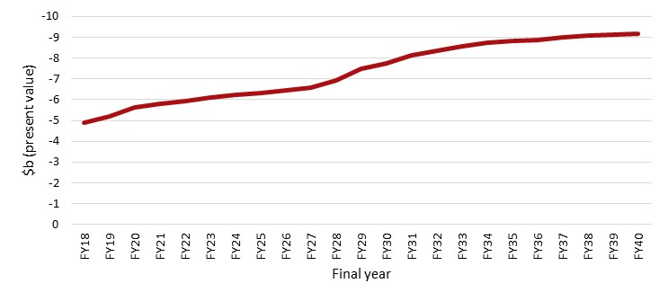

The fixed wireless and satellite (inclusive of the ISS) are estimated to contribute 55 per cent and 45 per cent losses respectively.

**Figure 15: NPV loss, breakdown by network**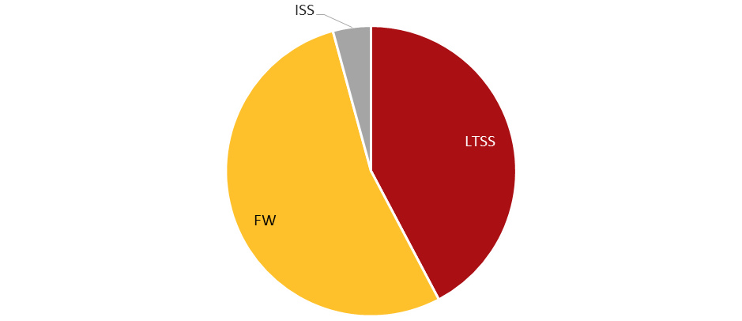

For both the fixed wireless and satellite networks, capex is the most significant driver of non-commercial service losses.

**Figure 16: NPV loss, breakdown by financial item**

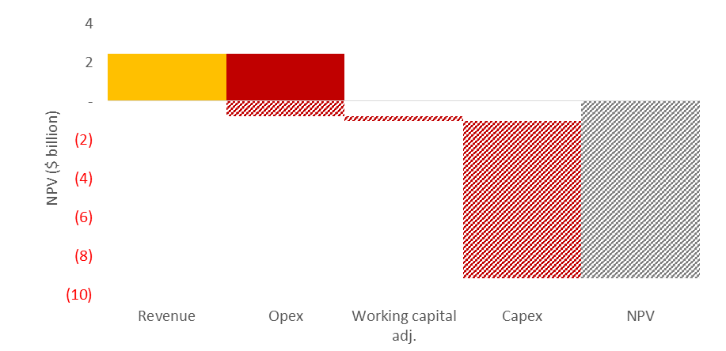

As a result, the loss is sensitive to changes in capex, followed by opex, common costs and revenue. These sensitivities show the effect of changing only one factor at a time. It does not reflect any changes to other factors that may result. For example, the capex sensitivity does not reflect the higher opex that could be associated with a larger capital asset base.

**Figure 17: Figure NPV loss, sensitivity by financial item**

| **Opex sensitivity**  Figure is a bar graphs showing sensitivity of financial loss estimates by opex. | **Capex sensitivity**  **Figure is a bar graphs showing sensitivity of financial loss estimates by capex.** |
| --- | --- |
| **Common cost sensitivity**  **Figure is a bar graphs showing sensitivity of financial loss estimates by common cost.** | **AVC average revenue per user sensitivity**  Figure is a bar graphs showing sensitivity of financial loss estimates by AVC revenue per user. |

*Note: Higher AVC average revenue per user sensitivity not modelled due to price cap constraints.*

Because the loss is calculated in NPV terms, the loss is also sensitive to the discount rate chosen.

**Figure 18: NPV loss, sensitivity by discount rate**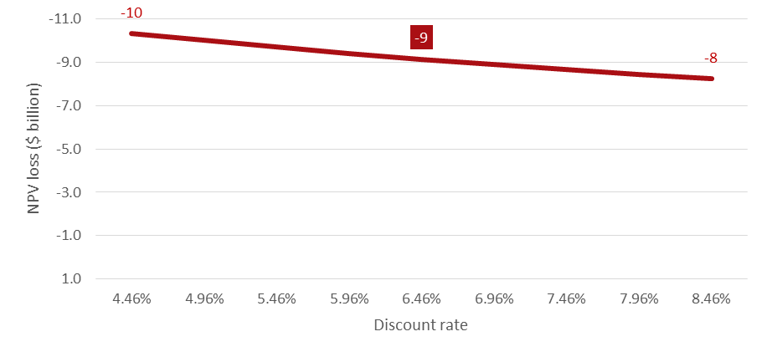

These sensitivities highlight the need to conduct periodic reforecast of non-commercial service losses, particularly to reflect updated cost estimates.

# Chapter 6: A principles-based approach to designing funding arrangements

* The BCR has considered funding arrangements against the principles of transparency, contestability, sustainability, economic efficiency and equity.
* Following consideration of industry submissions, the BCR has included competitive neutrality as a principle.
* The principles are identified to provide a framework for developing and assessing non-commercial service funding arrangements and show where trade-offs occur.

The Initial Consultation Paper proposed a number of overarching principles to help guide the development of appropriate funding arrangements. While the submissions largely supported the proposed principles, a number of respondents highlighted that competitive neutrality should be included as a core principle.[63]

Ian Martin noted:

*The Government's telecommunications policy paper says that the purpose of this assessment and consideration of funding options is to ensure competitive neutrality. However, neither of the terms 'competitive neutrality' nor 'net competitive advantage' are mentioned in the BCR's consultation paper. They are central to the purpose of the costing exercise and the most appropriate point of reference when considering the range of issues raised in the consultation paper.[64]*

The BCR agrees that funding arrangements should be assessed against competitive neutrality requirements as described in government policy. This is discussed in Chapter 6.3 below.

Further, a number of respondents suggested that ‘simplicity’ should be an additional principle.[65] The BCR considers simplicity to be a core element of achieving sustainable funding arrangements, and it has therefore not been included as its own principle. Similarly, the BCR considers ACCAN’s suggestion of ‘bypassability’ also relates to the existing principle of sustainability.[66]

A number of submissions recommended that particular principles be prioritised. For example, NBN Co suggested that transparency and sustainability are the key principles that should guide consideration of alternative funding models.[67] The BCR considers that the principles provide a framework for designing and assessing non-commercial services and that all principles should be considered equally. However, the BCR recognises that it may not be possible to meet the requirements of all principles at all times. A principles-based framework should therefore identify where trade-offs occur.

Table 11 below describes NBN non-commercial services funding principles.

**Table 11: Principles for designing funding arrangements**

| Principle | Description |
| --- | --- |
| Transparency | * The design, implementation and costs of a non-commercial obligation should facilitate scrutiny and evaluation. * Transparency allows the Government to monitor performance of funding arrangement outcomes, and cost information supports decisions to improve arrangements as appropriate. |
| Contestability | * The funding arrangements should minimise barriers to entry or other impediments in both commercial and non-commercial sectors. * The design of non-commercial service funding arrangements should not advantage any market participants. |
| Competitive neutrality | * The funding arrangements should not provide government-owned entities any advantages (or disadvantages) over private sector participants. This includes rate of return requirements, tax neutrality, debt neutrality and regulatory neutrality. |
| Sustainability | * The mechanism used to fund the provision of the non‑commercial service should be viable for the anticipated period the non‑commercial obligation will be in effect. * The mechanism should be secure and reasonable in the face of changing social, political, technological and economic circumstances to fund fixed wireless and satellite losses over the longer term. * The mechanism should provide certainty to industry stakeholders of any obligations. * The design of the non-commercial funding arrangement should not conflict with or undermine other regulatory objectives. * The funding schemes should be simple. The more complex the scheme is to administer, monitor and implement, the less likely it is that its objective will be achieved and the more costly it will be to administer. |
| Economic efficiency | * Non-commercial funding models should be assessed by whether they support or constrain productive, allocative or dynamic efficiency. Allocative efficiency includes consideration of the distortionary impact of taxes and levies on demand for goods and services. |
| Equity | * Non-commercial service obligations should consider how any funding arrangement will fall across society. Equitable outcomes for beneficiaries and funders of non-commercial services should also be considered. |

## 6.1 Transparency

A lack of transparency makes it difficult to determine the actual cost and benefits of providing non‑commercial services, and the performance of the non-commercial service provider. It makes it difficult to determine if the non-commercial service arrangements continue to meet the Government’s policy, social or technological objectives. Transparency allows the provider’s performance to be monitored and improved as appropriate, based on established and agreed metrics. This enables the non-commercial services arrangement’s administration and performance to be regularly assessed objectively, and areas of improvement identified and addressed.

A transparent funding arrangement makes clear to industry participants, government and the public: the full cost of non-commercial services now and in the future; the level of funding required now and in the future; how contributions are spent; who contributes to funding and why; and how the contribution of the industry participants is determined. The information used to determine the non-commercial service arrangements – including cost, eligibility and contributions – should be made freely available for public scrutiny. Governments should make better choices when the costs are transparent to all.[68] In the BCR’s consultation process, industry stakeholders recognised the importance of this principle and supported the move to a more transparent funding arrangement.

The non-commercial services funding arrangement should make transparent:

* the losses associated with the deployment, maintenance and operation of NBN non‑commercial services and how these losses have been calculated
* the eligibility criteria to determine participation, the amount that each participant is required to contribute and the process for calculating funding contributions.

The BCR notes that submissions largely did not see benefit in the development of transparency arrangements that reflect how government equity and third party debt contribute towards non-commercial services. The NBN Co submission said:

*NBN does not consider it appropriate for equity and debt to be allocated amongst network platforms. It is expected that such allocations would not be economically meaningful as NBN operates as a single corporate entity and equity and debt holder’s interests will be in NBN as a whole (i.e. not in a separate business unit or network platforms).[69]*

The BCR agrees that developing measures which attribute debt and equity to non-commercial services will not improve transparency outcomes.

## 6.2 Contestability

Competition is an important economic force that improves the welfare and living standards of Australians as it drives economic efficiencies through better productivity, lower costs and prices, new products and innovation. A funding mechanism for a ubiquitous nation-wide service should minimise distortions to competition in relevant markets by removing any barriers to contestability.

The Government’s obligation to deliver high-speed broadband to all parts of Australia represents a cost burden on NBN Co which other industry participants are not required to meet and puts NBN Co at a commercial disadvantage in fixed line areas relative to competing infrastructure providers.

An industry-based funding arrangement that levels the playing field in areas that can be commercially serviced would be more likely to promote economic efficiency. Eligible participants assume a proportional share of non-commercial costs and new providers are not deterred to enter the market. In the BCR’s consultation process, most stakeholders emphasised the requirement that any funding arrangement support contestability in low cost areas and not present any onerous barriers to enter and perform in those markets.

Funding arrangements should also be designed to support contestability of non-commercial services, so that consumers in these areas can also benefit from competition.

## 6.3 Competitive neutrality

A number of submissions identified the significance of the Government’s competitive neutrality policy.[70] Competitive neutrality requires that government-owned entities should not be provided any advantages (or disadvantages) over their private sector competitors simply by virtue of public sector ownership. The BCR recognises that a competitively neutral funding arrangement is one of the objectives of this exercise.

In 1995, in response to the Hilmer Report, the Coalition of Australian Governments (CoAG) entered into a competitive neutrality agreement, aiming to eliminate resource allocation distortions by ensuring no government businesses enjoyed a net competitive advantage in the marketplace.[71]

In June 1996, the Commonwealth released a competitive neutrality policy statement.[72] A number of competitive neutrality elements discussed in this statement relate to GBEs, including NBN Co, and are therefore relevant for NBN non-commercial service funding arrangements. These include:

* **Rate of return requirements** – GBEs are specifically required to achieve, over time, as a minimum benchmark, economic rates of return on assets for their commercial operations equivalent to the long-term bond rate plus an appropriate margin for risk.[73] The rate of return for GBEs is settled by the Finance Minister and responsible portfolio Minister.
* **Debt neutrality** – Debt neutrality will be achieved by subjecting identified organisations to similar borrowing costs to those faced by private sector businesses.
* **Regulatory neutrality** – Regulatory neutrality will be achieved by subjecting, where appropriate, all identified organisations to the same regulatory environment as private sector businesses.

Issues around corporatisation and tax neutrality are not considered directly relevant to NBN non-commercial service funding arrangements.

Further, the policy statement says that competitive neutrality does not require governments to remove CSOs from their government business. Where CSOs exist, competitive neutrality and other competition policy reforms may limit the ability for these CSOs to be financed through cross subsides within the business.[74] Transparent, non-discriminatory funding of CSOs through budget funding or specific charges is thereby encouraged.[75] For the purpose of NBN non-commercial services, consideration is given to the CoAG Competition Principles Agreement and the Commonwealth competitive neutrality policy statement.

## 6.4 Sustainability

A sustainable funding arrangement consists of a number of key attributes:

* **Certainty** – Funds will be available in the face of changing social, political, technological and economic circumstances to sustainably fund fixed wireless and satellite losses over the longer term. Industry contributors would further benefit from a certain and sustainable arrangement by being able to incorporate any contributions and associated administration costs into their forecasts.
* **Minimal complexity** – The more complex the scheme is to administer, monitor and implement, the less likely is that its objective will be achieved and the more costly it will be to administer. The administration time and costs incurred by industry contributors to comply with the new funding arrangement must be considered along with their other regulatory obligations. NBN Co supported this view in their submission by saying that ‘funding options should not impose undue administrative burden on parties or duplicate existing arrangements’.[76] John de Ridder also supported the view by saying the funding arrangement should be kept simple.[77]
* **Consistency with overall regulatory framework** – The industry-based funding arrangement might be only one component of regulation that affects participants within an industry. If so, the potential for conflict between the objectives or design of the funding arrangement and other regulations needs to be explored.

## 6.5 Economic efficiency

The design of a non-commercial funding arrangement should minimise the extent to which it diverts resources away from more highly valued uses. It should also encourage cost-based service provision and provide incentives for investment and innovation.

The economic welfare of society is typically maximised when the following three components of economic efficiency are achieved:

* **Productive efficiency** – A funding mechanism does not distort a provider’s incentives to adopt the best mix of technologies and exploit economies of scale, thus delivering services at the lowest possible cost. It is important that the funding mechanism does not lead the service provider to be more concerned about devoting resources to protect their subsidy rather than investing in more economical and innovative delivery solutions.
* **Allocative efficiency** – Economic resources can move freely towards their most highly valued uses. That is, as far as possible the design of the non-commercial service arrangement minimises the additional costs imposed on society due to the diversion of resources away from their more highly valued uses.[78] If resources are diverted into activities that are less highly valued from a national perspective, then the community will be worse off.[79]
* **Dynamic Efficiency** – A funding arrangement does not deter a provider from investing in and innovating their service delivery approach. A funding arrangement may create dynamic inefficiencies if it undermines incentives to innovate to contain costs over time, or to provide new services. Flexibility also supports dynamic efficiency. If the delivery mechanism for funding non-commercial services is locked in it could create market distortions if changing technologies and consumer preference generate potentially cheaper ways of achieving the objective of the non-commercial service arrangement. ACCAN, in its submission to the BCR’s consultation process, said that funding arrangements:

*…should be sufficiently flexible so that they can be updated over time. An issue with the Universal Services Obligation has been that it is fixed on the one service, even though consumers’ needs and requirements have changed over time.*[80]

## 6.6 Equity

Equity is the concept of fairness and can be applied to the end users of a service. There are two criteria that are often employed when assessing the fairness of a policy:

* **Horizontal equity** – A fairness concept that compares individuals facing similar circumstances. The idea behind the concept is that different individuals who face similar circumstances should be treated similarly.[81]
* **Vertical equity** – A fairness concept that compares individuals who have different levels of income or wealth. The idea behind the concept is that more wealthy individuals should receive less of the net benefits from a policy than those who are not as wealthy.[82]

Consumers should not be disproportionately affected as a result of the introduction of NBN non-commercial service arrangements. The BCR notes the Government’s policy in response to the Vertigan Review seeks to ensure that the introduction of non-commercial funding arrangements does not increase total NBN end user costs compared to current forecasts.[83]

A number of submissions to the BCR’s consultation process said that equity should be a key consideration in developing a funding arrangement. ACCAN, for example, argued that equity is:

*a priority principle…the BCR needs to consider the end users’ services to ensure that there are equitable outcomes.*[84]

Further, temporal equity is an additional consideration, whereby funding arrangements should not unfairly treat industry participants or consumers at different points in time. For example, eligible industry participants that make funding contributions at the commencement of the scheme should not make disproportionally higher or lower contributions compared to participants that enter later.

# **Chapter 7: NBN non-commercial service funding options**

This section considers options for industry funding of NBN non-commercial service losses. NBN Co is considered to be an eligible industry participant under all scenarios.

The BCR considers that funding options should be constructed based on decisions around eligibility and calculation mechanisms. Implementation issues, including transparency mechanisms, are discussed in later sections.

## 7.1 Assessment of eligibility approaches

* Submissions are divided on whether eligibility should be limited to NBN Co and NBN equivalent industry participants or should include a broader range of participants, including mobile network operators.
* While both an NBN equivalent and broader industry funding approach achieve level playing field contestability objectives, a funding arrangement limited to NBN Co and NBN equivalent industry participants maintains important existing commercial incentives for NBN Co to control costs, determine appropriate service standards and innovate.
* The BCR considers that limiting eligibility to NBN equivalent services is the most economically efficient way of achieving competitively neutral funding of fixed wireless and satellite losses, while freeing up infrastructure competition.

### 7.1.1 Industry views on eligibility

A material issue raised through submissions is whether an industry funding arrangement should only apply to the operators of high-speed broadband fixed line access networks (i.e. an NBN equivalent funding approach), or whether it should be spread more broadly to include the whole telecommunications industry (i.e. a broader industry funding approach).

The BCR’s Initial Consultation Paper took the view that funding arrangements should only apply to operators of high-speed broadband fixed line access networks serving residential and small business customers.[85] This view was shared by Optus and Telstra, which argued that funding arrangements should be confined to fixed line networks. Optus, in its supplementary submission, said:

*Optus reiterates that the policy intent of the explicit subsidy arrangement is to ensure that every superfast access fixed line in metro areas contributes to the rural cross-subsidy; to ensure parity across NBN Co and non-NBN Co fixed networks. Even if it was within the scope of this Inquiry to consider including mobile networks, there is no legitimate policy reason to do so.[86]*

However iiNet, NBN Co, Vodafone and ACCAN disagreed with this position, calling for funding arrangements to apply to a broader industry base. NBN Co called for a ‘revenue-based levy’,[87] iiNet argued that ‘the BCR should consider going beyond the USO approach’,[88] Vodafone proposed that losses should be funded from spectrum licence fees,[89] and ACCAN noted that funding services through general taxation would be more equitable.[90]

NBN Co listed the benefits of a broader industry-based funding approach as:

*First, a revenue-based levy will, in contrast to alternative mechanisms (such as a network-based levy), ensure that the funding arrangements do not fall disproportionally on network owners and therefore do not unduly affect entry decisions….  
   
Second, as the effect of sourcing funds from particular operators or end-users is to raise the price of the services that are consumed, broadening the basis will minimise the effect of those higher prices on consumption choices….   
  
Third, funding options that are restricted to services above 25 Mbps are likely to create competitive distortions by creating a wedge between prices above and below this threshold.*[91]

iiNet submitted that a broader funding base was within the scope of this review:

*The fact that the Terms of Reference refer only to 'industry contributions' clearly allows (and iiNet would say requires) the BCR to consider the merits of models that source contributions from the industry more broadly.*[92]

The BCR considers that funding non-commercial services losses from spectrum licence fees or general taxation is outside the Terms of Reference. While industry pays spectrum licence fees, hypothecation of these fees would have a market and budgetary impact, and in the BCR’s view not meet the Terms of Reference of ‘direct funding arrangements based on industry contributions’.

Accordingly the BCR’s analysis focuses on two options: funding arrangement only applying to the operators of high-speed broadband fixed line access networks, and funding arrangements applying more broadly across the telecommunications industry. While a broader base could be defined in a number of ways, for the purpose of its analysis the BCR has focused on the funding base captured by the TIL (see Chapter 9.1 for background).

### 7.1.2 Performance of the options against the funding principles

The BCR has assessed the different funding approaches against the principles of designing funding arrangements discussed in the previous chapter.

#### **Competitive neutrality and contestability**

Under the status quo, the revenue NBN Co must recover from fixed line customers is inflated by the fixed wireless and satellite cross subsidy, reflecting the current approach of using the government-owned entity NBN Co to meet a social objective – comparable services at comparable prices in urban, regional and remote areas. However, privately-owned fixed line competitors are at present not subject to this impost resulting in an uneven playing field.

Compared to the status quo, an NBN equivalent funding arrangement removes the distortion between NBN Co and its fixed line competitors by ensuring they also bear a share of the cost of subsidising non-commercial service losses. It also enables a small reduction in the revenue NBN Co must raise from fixed line customers. The BCR estimates that under this approach, NBN Co goes from funding 100 per cent of fixed wireless and satellite losses, to about 94 per cent by FY2022, with competitors paying the balance, based on their market share.

Under a broader industry funding arrangement, the cost of funding fixed wireless and satellite losses is spread across a much broader base. As a result, the contribution of NBN Co and its fixed line competitors is equal, but substantially lower.

Figure 19 and Figure 20 are illustrative examples highlighting that both funding arrangements address the uneven burden on NBN Co of funding fixed wireless and satellite losses, and provide for transparent, non-discriminatory funding of the Government’s social objective through a specific charge. In this regard, both options perform equally on the criteria of contestability by ensuring level playing field outcomes.

**Figure 19: Impact of proposed funding arrangements on level playing field contestability: illustrative example**

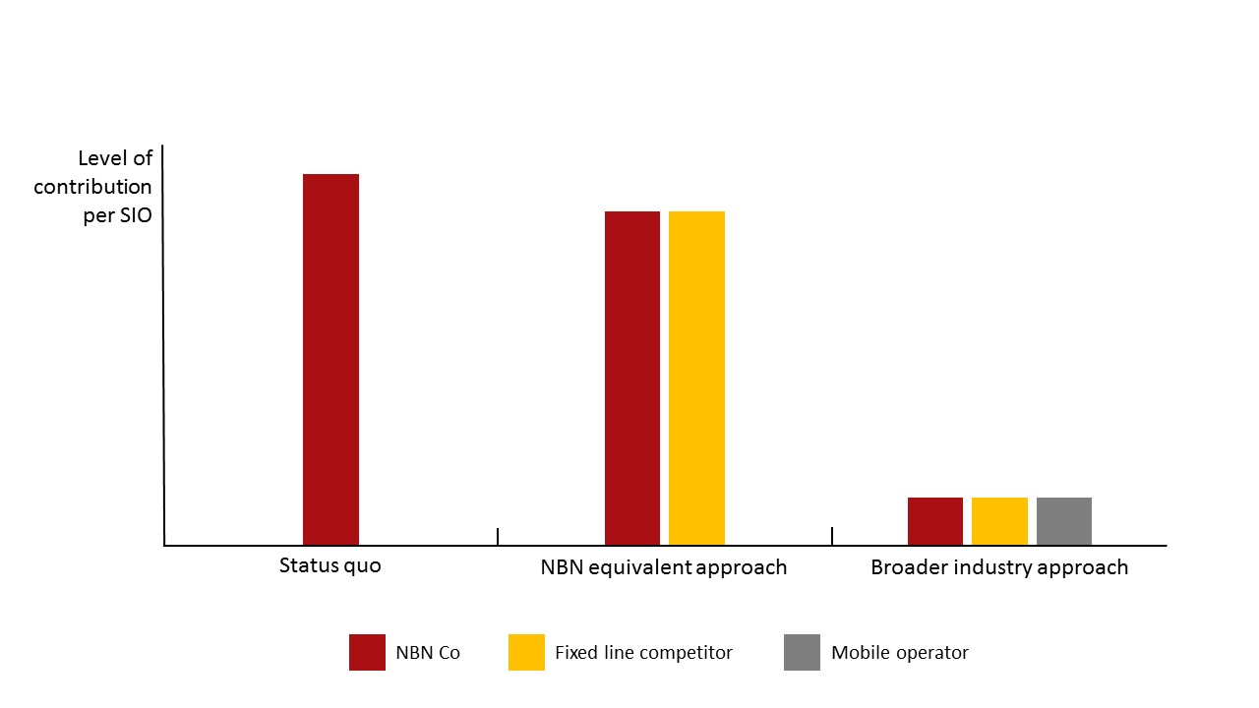

**Figure 20: Comparison of options on basis of level playing field contestability: illustrative worked example**

Both an NBN equivalent and a broad-based funding approach support competitive neutrality, as both would ensure consistent payments towards non-commercial services by NBN Co and non-NBN network operators. This is illustrated in the following hypothetical example:

|  |  |  |
| --- | --- | --- |
| A. Assumed annual collection amount | $100 million |  |
| B. NBN Co fixed line SIOs | 1,000,000 |  |
| C. Non-NBN Co fixed line SIOs (i.e. NBN equivalent) | 100,000 |  |
| D. Broader industry base SIOs (excluding NBN SIOs) | 5,000,000 |  |

|  | **NBN equivalent** | **Broader industry** |
| --- | --- | --- |
| E. NBN Co share of contribution (based on SIOs) | 91%  **[B/(B+C)]** | 17%  **[B/(B+C+D]** |
| F. Non-NBN Co share of contribution (based on SIOs) | 9%  **[C/(B+C)]** | 83% **[(C+D)/(B+C+D)]** |
| G. NBN Co contribution | $91 million **[A*E]** | $16 million **[A*E]** |
| H. Non-NBN Co contribution | $9 million **[A*F]** | $84 million **[A*F]** |
| I. NBN Co contribution per SIO, per month | $7.60  **[G/B/12]** | $1.40  **[G/B/12]** |
| J. Non-NBN Co contribution per SIO, per month | $7.60 **[H/C/12]** | $1.40 **[H/(C+D)/12]** |
| K. NBN Co reduction in contribution per SIO, per month | $0.76 **[H/B/12]** | $7.00 **[H/B/12]** |

Note: This is a hypothetical worked example, with figures for illustrative purposes only. See Tables 13 and 14 below for BCR estimates of NBN Co and non-NBN Co share of contributions under NBN-equivalent and broader industry base funding options. Figures have been rounded.

Both approaches would ensure equivalent contributions by NBN Co or private competitors towards non-commercial services allowing all industry participants to compete equally. In this regard~~s~~, both funding approaches support the overarching competitive neutrality requirements that government entities such as NBN Co should not be advantaged (or disadvantaged) over private sector competitors by virtue of public sector ownership (and in this case, as a result of NBN Co’s obligation to ensure all Australians have access to very fast broadband at affordable prices).

Further, the specific competitive neutrality requirements discussed in Chapter 6.3 are unaffected:

* **Rate of return** – as discussed in Chapter 5.2, the quantum of NBN non-commercial service losses have been calculated using the long term bond rate plus a risk premium of 350 basis points. This approach is consistent with Competitive Neutrality guidelines[93] and aligns with the rate of return used in SAU and which the ACCC considers as appropriate to allow NBN Co to make a commercial return on investment;
* **Debt neutrality** – under either approach, where NBN Co seeks to access third party debt to fund non-commercial services this would occur at market rates; and
* **Regulatory neutrality** – under either funding approach, NBN Co would be subject to the same regulatory environment as private sector businesses, including liability for making contributions to fund fixed wireless and satellite losses.

#### Economic efficiency

The BCR considers that an NBN equivalent funding arrangement performs better on the criteria of economic efficiency because it maintains incentives for cost control and market responsiveness for NBN Co.

Limiting eligibility to NBN equivalent services means that NBN Co remains strongly accountable for fixed wireless and satellite losses, as it must fund nearly all of these losses from its own fixed line customers. If it is not able to do this, it suffers a low rate of return for which it is accountable to its shareholder Ministers, or must make the case to its shareholder Ministers and the ACCC for changed regulatory or service settings. This provides strong incentives for the NBN Co Board to minimise fixed wireless and satellite losses.

By contrast, under a broader industry base, the BCR estimates that NBN Co bears about 13 per cent of fixed wireless and satellite losses by FY2022 (see Table 15 below), with the broader telecommunications industry bearing the balance. In the BCR’s view, this materially reduces NBN Co’s accountability and incentives to control costs. While the NBN Co Board would make the decisions about fixed wireless and satellite costs, prices and product offerings, losses resulting from those decisions would be borne by the broader telecommunications industry. Despite funding most of the loss, the industry would have limited ability to influence it, other than through representations to the shareholder ministers or the regulator. While a process that involves the setting and resetting the non-commercial services cost pool would consider whether NBN Co’s costs were productively efficient, the BCR considers this would be less effective than market constraints and long-term price caps, and accountability to shareholder Ministers.[94]

Any reduction in accountability would be potentially concerning given the magnitude of the decisions that could face the NBN Co Board in the future. For example, if the percentage of households in regional areas that took up the fixed wireless service materially exceeded forecast take-up rates, or if downloads per regional customer were greater than forecast, then the fixed wireless and satellite networks could face capacity constraints. This could necessitate difficult choices between costly capacity augmentation, degrading services or changing product offerings in regional areas to meet demand, or seeking regulatory approval for higher prices. An NBN equivalent funding option would help ensure that NBN Co continues takes a strongly disciplined approach to additional investment (including full consideration of innovative low-cost solutions) as it bears the consequences of these decisions, rather than the bulk of the additional burden falling on the broader telecommunications industry.

In short, the BCR considers that productive and dynamic efficiency would be higher under an NBN equivalent funding arrangement, as NBN Co has stronger incentives to minimise losses and embrace innovations that reduce future investment requirements and better meets customer needs.

The BCR considers that an NBN equivalent funding arrangement is also likely to perform better on the criteria of allocative efficiency. The BCR considers the gains in allocative efficiency of maintaining market disciplines on NBN Co are likely to outweigh the loss of allocative efficiency of using a narrower base to fund non-commercial services.

Under an NBN equivalent funding arrangement, NBN Co has strong incentives to minimise losses, and so tailor its product offerings and prices to best reflect consumers’ preferences and willingness to pay, achieving allocative efficiency. However, under a broader industry-based funding arrangement, the BCR estimates that NBN Co bears only about 13 per cent of non-commercial services losses by FY2022, which the BCR considers would reduce NBN Co’s incentives to minimise the divergence between the value to customers (captured by price) and the cost of production.

Against this, a broader industry-based funding arrangement would spread costs more broadly, including to mobiles, and thereby lead to a smaller loss of allocative efficiency from funding non-commercial services. Economic theory shows that collecting a given amount of tax revenue from a broad base is less distortionary than collecting the same amount of revenue from a narrow base.[95]

Further, the greater the price responsiveness of demand, the greater the dead-weight loss in economic efficiency from differential taxation, which implies that close substitutes should be taxed equally.[96] In this context, the BCR notes that a funding arrangement limited to NBN equivalent services treats close substitutes equally. High-speed fixed line networks would face the same funding contribution as NBN Co.

Extending the funding base to include mobiles would improve the funding aspect of allocative efficiency simply because the costs are spread more broadly, but the BCR considers these would be moderate as mobile services are only partial substitutes for fixed line services at this time. While 21 per cent (3.9 million) of adult Australians elect for mobile-only services for internet usage,[97] only five per cent of data downloaded in the three months ending 30 June 2015 was over mobile handsets, with 92 per cent of data still downloaded over fixed line networks.[98] The BCR notes that this may change in the future with the introduction of 5G technology, or if mobile network operators leverage their mobile networks to deliver fixed wireless services within the NBN fixed line footprint. This could be considered in any future reviews of the funding arrangement (see Chapter 8.3).

Finally, the BCR notes that the purpose of the funding arrangement is to provide a competitively neutral way of funding fixed wireless and satellite services, given the Government’s December 2014 decision to liberalise infrastructure-based competition. A funding arrangement limited to NBN equivalent services achieves this objective, while minimising broader impacts on cost disciplines, NBN regulatory settings, and the telecommunications industry. By contrast, a broad-based funding approach would substantially alter the governance and funding of NBN Co, impacting on regulatory settings and increase imposts on the broader telecommunications industry. Given the modest expected level of fixed line entry, a funding approach that has these much wider impacts appears to be a disproportionate response to a modest level of cross-subsidy ‘leakage’.

For these reasons, the BCR considers that limiting eligibility to NBN equivalent services is on balance the most economically efficient way of providing competitively neutral funding of fixed wireless and satellite losses, in the context of freeing up infrastructure competition.

#### Transparency, sustainability and equity

As discussed above, the BCR considers that the choice between the funding options turns on their differential impact on economic efficiency. The two options have a similar impact on competitive neutrality. On the remaining criteria of transparency, sustainability and equity, the two options are broadly comparable.

In terms of transparency, under both options the aggregate annual subsidy for fixed wireless and satellite services and the subsidy paid by NBN Co and the total subsidy paid by other networks would be transparent.

From a sustainability perspective, an NBN equivalent funding arrangement faces risks to sustainability and equity in the longer term as it is based on a single technology, and over the long-term a higher percentage of consumers may choose alternative technologies such as mobile. This risk can be reviewed through a periodic policy review process.

In considering equity, given the widespread use of telecommunications services, both funding arrangements would fall broadly across society. Under an NBN equivalent funding arrangement, the 21 per cent of households that do not have a fixed line service would not contribute to the funding of non-commercial services. However, as a disproportionate share of these households are low income,[99] there would be some vertical equity benefits of this uneven funding incidence. The following figure shows the percentage of households in 2012‐13 with a mobile-only broadband connection by income bracket.

**Figure 21: Mobile substitution by income bracket** 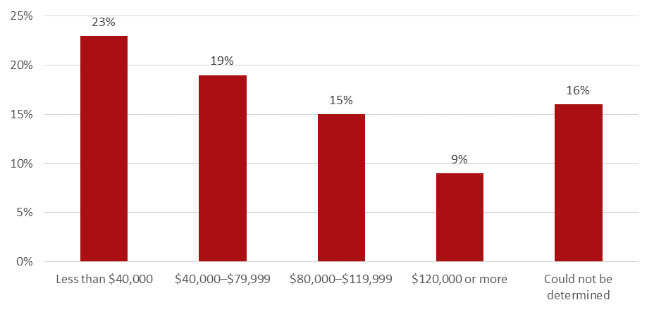

### 7.1.3 Eligibility Criteria

* Under an NBN equivalent approach, eligibility applies to industry participants that resemble NBN Co. For the purpose of regulatory alignment, the *Telecommunications Act 1997* definition of a superfast carriage service is suitable for defining NBN equivalent services.
* Under this approach, eligibility is based on network operators of high-speed fixed line broadband access networks that deliver download speeds of at least 25 Mbps to residential and small business customers.
* The BCR considers that networks serving government and medium and large businesses should not be required to contribute to the funding of fixed wireless and satellite losses.
* The BCR considers that Telstra and Optus should be exempted from the funding arrangement for their copper access and HFC networks that are being transferred to NBN Co under the Definitive Agreements. However, networks established prior to 2011 and networks declared adequately served should be included in the funding base.

Under an NBN equivalent approach, the BCR considers that eligibility should be tightly focused on NBN Co and industry participants that resemble NBN Co, namely operators of high-speed fixed line broadband access networks that deliver download speeds of at least 25 Mbps to residential and small business customers. This definition is consistent with the definition of a superfast carriage service under Parts 7 and 8 of the *Telecommunications Act 1997* (the Act). These funding arrangements would apply to all networks with lines serving small business and residential customers, with contributions reflecting the number of eligible services in operation.

Networks serving medium sized business, large business and government customers

Beyond high speed networks serving residential and small business customers, consideration could be given to expanding the eligibility criteria to contemplate networks offering high speed fixed line services to medium sized business, enterprise and government customers in order to promote competitive neutrality outcomes.

The following table describes the Australian Bureau of Statistics definition of different business segments by number of employees:

**Table 12: Definition of Australian businesses by employee size, source: ABS**

|  | **Non-employing business** | **Micro business** | **Other small business** | **Medium business** | **Large business** |
| --- | --- | --- | --- | --- | --- |
| **Number of employees** | 0 | 1-4 | 5-19 | 20-199 | 200+ |

The BCR notes that the Government’s Statement of Expectations requires NBN Co to serve all Australian premises.[100] The Government’s requirements do not delineate between residential and business segments, suggesting NBN Co is required to serve all markets equally. NBN Co’s Corporate Plan 2016 indicates NBN Co is developing products and services aimed at all business segments, with medium business and enterprise products scheduled for release over the Corporate Plan period to FY2017.[101]

Under these circumstances, it seems reasonable that NBN Co should contest these markets on a level playing field, suggesting grounds for introducing funding arrangements that ensure equal contributions towards NBN non-commercial services. Beyond this, extending the funding base to government and business customers would allow the funding rate to be lower, reducing the economic losses from inflating prices above costs. This would support allocative efficiency outcomes.

However, requirements under Part 7 and 8 of the Act indicate that Governments have been concerned about a lack of infrastructure competition in markets serving residential and small business customers (and so implemented open access and structural separation), but not the government and medium and large business markets. As noted by the Vertigan Review:

*On the basis that high-speed networks servicing business customers are not subject to special regulation under Parts 7 or 8, the panel has not concerned itself with these networks. Telecommunications service providers have generally been responsive to the needs of larger business customers and can have every incentive to remain so. Consistent with this observation, no special intervention in support of those customers should be considered.[102]*

Vertigan noted that the Explanatory Memorandum for Parts 7 and 8 indicated that the objective of these provisions was to support NBN Co’s ability to cross-subsidise services in regional, rural and remote areas.[103]

Other arguments for excluding networks serving government and larger business customers include:

* **Regulatory certainty** – Setting a principle that contributions are payable by competitors in whichever markets NBN Co contests, would create regulatory uncertainty, as NBN Co’s business strategy evolves;
* **Administrative complexity** – There would be increased complexity in determining the number of government, medium business and enterprise SIOs;
* **Regulatory consistency** – It would reduce regulatory complexity if eligibility was aligned with the Part 8 provisions and the Carrier Licence Condition, both of which exclude SIOs serving medium and large businesses and government customers (see Chapter 9.4); and
* **Minimise business input taxation** – Including medium and large businesses raises business input taxation concerns.

Further, while potentially high value, medium and large businesses are expected to contribute a relatively small number of fixed line connections compared to residential and small business customers.

On balance, the BCR considers the latter arguments are more persuasive, and so favours excluding networks serving government and medium and large business customers. The BCR also considers that the SIOs of these customers should be excluded from the calculation of the funding rate and eligible networks’ liability, to ensure a level playing field. The BCR calls for stakeholder feedback on the eligibility of networks providing high-speed broadband services to medium and large businesses and to Government.

#### **Specific exemptions**

The BCR considers the following fixed line networks should be exempt from contributing towards the funding of non-commercial service losses:

* **Networks that are being transferred to NBN Co under the Definitive Agreements** – The BCR considers that Telstra and Optus should be exempted from the funding arrangement for their copper access and HFC networks that are being transferred to NBN Co under the Definitive Agreements. Once customers have transferred to NBN Co’s network, they should be included in the funding base, with contributions paid by NBN Co. The rationale for exempting Telstra and Optus for these networks is that otherwise they would need to revise their pricing plans for the short period before transition, creating a significant compliance burden for revenues provided over a short, interim period.
* **High-speed fixed line services in the NBN fixed wireless and satellite footprint** – The BCR considers that these services should be exempted so that NBN Co and other network investors’ choice of technology in rolling out networks is not influenced by the funding arrangement. Therefore exemption from the funding arrangement would reflect the expected area of the fixed wireless and satellite footprint, fixed at a point in time.

Part 8 of the Actand the *Carrier Licence Conditions (Networks supplying Superfast Carriage Services to Residential Customers) Declaration 2014* both exempt from the structural and functional separation requirements high-speed networks that came into existence prior to January 2011, and the Government’s Policy Paper indicates that this will remain the case after Part 8 is amended.[104] As to whether pre 2011 networks should be subject to the funding arrangement, Telstra noted:

*… there are a number of established high speed networks within Australia which existed at the time the NBN business case was developed. Some of these networks were assumed to co-exist with the NBN or to be candidates for acquisition by NBN Co. They were not seen as competitors to NBN and were not a threat to NBN’s funding of non-commercial services. On this basis these networks — which include corporate fibre networks — should not be captured by the proposed funding arrangement.*

*Telstra suggest that the BCR should nominate a cut-off date for excluding networks contemplated by the original NBN business case from eligibility for the proposed new funding arrangement. As a date of 1 January 2011 has been recently used in similar contexts (i.e. the Carrier Licence Conditions (Networks supplying Superfast Carriage Services to Residential Customers) Declaration 2014), such a date could be applied in the interests of consistency.[105]*

Against this, the arguments for requiring pre-2011 networks to contribute to the funding arrangement include:

* **Allocative efficiency** – The more services subject to the funding arrangement, the lower the funding rate can be. Broadening the funding base to the greatest extent possible within an NBN equivalent definition reduces taxation distortions and profitability impacts on eligible networks[106] and may make it easier for eligible networks to pass the cost on to retailers;
* **Weaker case for grandfathering** – The exemptions in the Act relate to a much more onerous regulatory provision - the requirement to structurally separate - than the funding arrangement. As such, there is a weaker case for grandfathering networks.
* **Equity** – All small business and residential premises in the fixed line footprint contribute to the cross subsidy of residents in the fixed wireless footprint; and
* **Contestability** – Where there is potential network competition, the inclusion of pre-2011 networks would ensure that all networks faced the same costs for funding non-commercial services, rather than pre-2011 networks being favoured over new entrants.

Similar arguments also apply to the issue of whether networks declared adequately served should be required to contribute to the funding of non-commercial services. [107] On balance, the BCR considers that networks established prior to 2011 and networks declared adequately served should be required to contribute to the funding of non-commercial services. In particular, allocative efficiency gains in broadening the funding base are considered compelling.

Finally, the BCR considers there is a case for exemption on the basis of a carrier’s total number of local access lines or revenue from these lines. A threshold could be considered to ensure that the administrative costs of compliance and collection are not disproportionate to the amount collected.

### 7.1.4 Market size

Under an NBN equivalent eligibility approach, the following table provides BCR estimates regarding network operators may meet the eligibility criteria. Importantly, these estimates are based on public data and the BCR recognises this may not reflect actual market conditions.

**Table 13: Potentially eligible networks under an NBN equivalent funding arrangement, source: network operator data, various public sources and media articles, BCR estimates**

| **Network operator** | **Network technology** | **Premises RFS FY2015** | **Notes** |
| --- | --- | --- | --- |
| NBN Co | FTTP | 897,000[108] | This figure comprises of premises declared ready for service in existing (brownfields) and new developments (greenfields). |
| Telstra | FTTP | 118,000[109] | Velocity and South Brisbane networks. Telstra’s Velocity (Fibre Access Broadband) service is available in 130 sites.[110] |
| OptiComm | FTTP | 147,000[111] | OptiComm is the largest non-Telstra/NBN Co greenfield provider, operating in around 100 sites. |
| Other greenfield operators | FTTP | 50,000[112] | Includes OPENetworks, Pivit and other private FTTP greenfield networks operators. |
| iiNet | VDSL2+ | 65,000[113] | The former TransACT network services the Canberra region and is the largest VDSL2+ network in Australia. |
| iiNet | HFC | 80,000[114] | The former TransACT network services the regional Victorian centres of Ballarat, Geelong and Mildura. |
| TPG | FTTB | 3,200[115] | The network currently passes 352 multi-dwelling units (MDUs) in metropolitan centres,[116] with TPG announcing plans to connect a total of 500,000 premises to this network.[117] |

Taking the premises ready for service estimates described in the above table and applying BCR projected take-up rates, the BCR estimates around 550,000 active SIOs on NBN equivalent networks by FY2022 (by which time the NBN is expected be in a steady state of operations), compared to approximately eight million NBN SIOs.[118]

## 7.2 Implementing an NBN equivalent approach

### 7.2.1 Calculating contributions

* The BCR recommends a per-SIO calculation as it provides certainty to industry regarding collection requirements. Further, compared to other potential approaches, a per-SIO calculation minimises the risk of volatility in industry contributions while the NBN is being rolled out.

The BCR considers a suitable approach for calculating annual collection amounts is a monthly per SIO contribution calculation based on long-term forecasts that average contribution requirements across the build phase and steady state.

Further, the BCR considers that industry-funded arrangements should aim to draw contributions when and where there is the greatest ability to pay. In real terms, a fixed monthly per-service contribution helps achieve this. If there are more services in the market in the year, more contributions will be drawn that year. If Firm A has more SIOs in the market than Firm B, Firm A will make a proportionally greater contribution. This approach allows service providers to invest with certainty and reduces the possibility of unintended consequences or volatility resulting from changes in the NBN rollout profile.

Under a per-SIO approach, actual losses from FY2011 to 2015 are added to the forecast fixed wireless and satellite NPV loss from FY2016 to FY2040 to calculate an overall loss. This is then divided by the average number of fixed line SIOs serving residential and small business customers from the period FY2018 to FY2040 and the number of months in the funding arrangement period.

The BCR has estimated the number of residential and small business fixed line SIOs from the period FY2018 to FY2040 by adding NBN’s projections for fixed line activations to FY2022 with BCR projections from FY2023 to FY2040 and BCR estimates of current and future fixed line SIOs held by other providers. This results in an annual average of around 9.4 million fixed line SIOs.

**Figure 22: NBN Co vs other network operator share of eligible SIOs, FY2018 to FY2040, BCR estimates**

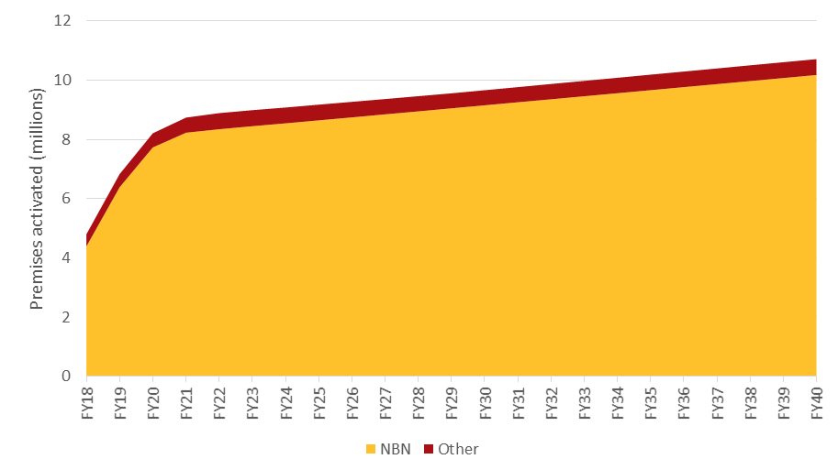

The BCR considers funding arrangements should be calculated based on eligible SIOs, not just SIOs based on a particular speed-tier threshold, so as not to distort customers’ broadband package selection.

The BCR considers that the monthly per SIO contribution should be fixed to be constant over time in real terms (that is, increase only with inflation in nominal terms). This provides temporal equity as it ensures consistent contributions for eligible participants and avoids penalising or rewarding competitive entry decisions. It also provides pricing certainty across the market. Eligible industry participants will know each year the exact contribution required for each service in operation.

It should be noted that this approach does not seek to align funding contribution to the actual profile of non-commercial service losses. Such an approach would be sensitive to expenditure fluctuations across the build phase and the timing of replacement capex investment decisions.

The BCR recognises that this approach differs from domestic and international funding schemes, which typically determine funding contributions based on market share percentages. The BCR notes these programs typically involve steady-state market operations. Ultimately, the BCR considers that until the build phase of the NBN is complete it is appropriate to consider a tailored approach to calculating NBN non-commercial service contributions.

In December 2014, the Government announced that it will amend Part 8 of the Act to require new networks targeting residential customers and offering high-speed broadband to be structurally separated as a default, and provide for the ACCC to authorise functional separation arrangements in certain circumstances. To maintain regulatory alignment, the BCR considers that any change to the scope of Part 8 should trigger a review of the funding calculation approach. This could include for example a review of the eligibility of small business SIOs.

### 7.2.2 Monthly per SIO contribution amount

The BCR estimates the monthly contribution amount per residential and small business fixed line SIO in FY2015 real value is around $6, equivalent to approximately $6.75 nominal in FY2018 and approximately $8 nominal in FY2022.

A per SIO calculation method is sensitive to the time period over which losses are estimated and recovered. A longer period for estimating and recovering losses means a greater number of average SIOs to smooth the losses. A shorter forecast period reduces the total losses to be recovered, but it also reduces the number of average SIOs and increases the monthly cost per SIO.

**Figure 23: Monthly per SIO funding required for different final years for funding arrangement, in FY2015 real value**

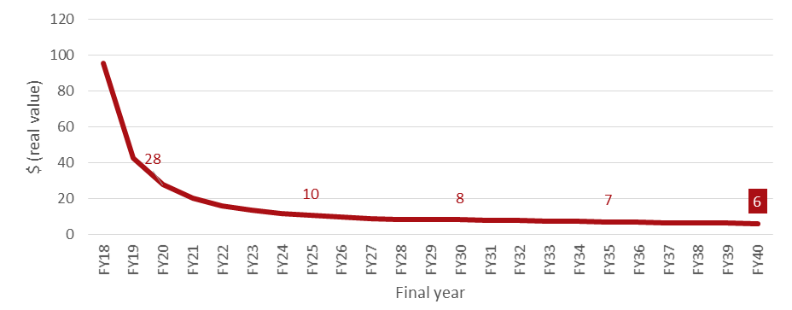

The outcomes highlighted in Figure 23 above reflect that upfront build costs are high, while the initial number of SIOs is small and builds relatively slowly over time.

## 7.3 Financial outcomes

While favouring a funding arrangement limited to NBN equivalent services, the BCR has presented funding options based on both an NBN equivalent and broader industry approach to inform discussions and support government decision making.

Table 14 below summarises financial outcomes under an NBN equivalent funding approach.

**Table 14: Financial outcomes under an NBN equivalent funding arrangement**

|  | **FY2018** | **FY2022** |
| --- | --- | --- |
| NBN equivalent fixed line SIOs (cumulative) | 400,000 (~10% market share) | 550,000 (~6%) |
| NBN Co fixed line SIOs (cumulative) | 4 million (~90%) | 8 million (~94%) |
| Total fixed line SIOs (including NBN Co services) | 4.5 million | 8.5 million |
| Per-fixed line contribution monthly amount (nominal value of $6 FY2015 real value) | $6.75 | $8.00 |
| Per-fixed line contribution annual amount (nominal value) | $80 | $95 |
| Non-NBN annual contribution | $30 million | $50 million |
| NBN Co annual contribution | $320 million | $760 million |
| Approximate total annual collection | $350 million | $810 million |

*Note: Figures are rounded. NBN equivalent SIOs are based on BCR estimates of the number of premises ready for service and assumed take-up rates. NBN Co SIOs are based on NBN Co’s Corporate Plan 2016. The nominal per-SIO contribution collected each year is calculated by removing discounting from FY2015 present value. Estimates of the number of SIOs included in this report are based on total high-speed fixed line SIOs. The estimates presented are preliminary and do not represent budget costings. The final figures may vary as details are finalised.*

As highlighted in the below table, the key difference between the two funding options is the share of fixed wireless and satellite losses borne by NBN Co. Under the preferred NBN equivalent option, NBN Co funds 94 per cent of non-commercial services losses by the time it reaches a steady-state of operations. Under a broader industry based option, NBN Co funds only 13 per cent of losses largely as a result of including mobile networks in the funding base.

**Table 15: Financial outcomes under a broader industry funding base like the Telecommunications Industry Levy**

|  | **FY2018** | **FY2022** |
| --- | --- | --- |
| Non-NBN percentage of total contribution | 95% | 87% |
| NBN Co percentage of total contribution | 5% | 13% |
| Non-NBN Co annual contribution | $330 million | $700 million |
| NBN Co annual contribution | $20 million | $110 million |
| Approximate total annual collection | $350 million | $810 million |

*Note: Figures are rounded. The BCR has calculated industry contributions under a broader industry funding base by overall share of telecommunications revenue, using the same mechanisms as the Telecommunications Industry Levy (TIL). The BCR has estimated NBN Co’s contribution based on the 2013-14 TIL share, Telstra and Optus’ FY2014 wholesale revenues, and BCR estimations. Total approximate annual collection is held constant between the funding options for comparison purposes. The estimates presented are preliminary and do not represent budget costings. The final contributions and collections may vary as details are finalised.*

## 7.4 Cost and price implications of an NBN equivalent funding arrangement

* Under the preferred NBN equivalent funding arrangement, wholesale prices are expected to stay the same or fall slightly for the 90 to 94 per cent of high-speed fixed line services provided by NBN Co. The BCR expects competition will ensure that any reductions in NBN Co’s wholesale prices will flow through to consumers, although this could be in many different ways.
* Costs for networks serving the remaining six to 10 per cent of the market will increase, ensuring these networks share non-commercial services losses. This will lead to either no change in wholesale prices, or a maximum potential increase of around 22 per cent, if the approximately $6 FY2015 real monthly per-SIO contribution is passed through to current wholesale prices.
* Uniform national pricing by retailers, and the fact that other networks only serve six to 10 per cent of the market, make it more likely that higher costs for non-NBN networks will be reflected in lower network or retail margins or reduced product offerings in certain locations, rather than flowing through to retail prices commensurately.

The Terms of Reference ask the BCR to report on adjustments to NBN Co’s pricing to reflect the removal of the internal cross subsidy for non-commercial NBN services.

By the time the NBN roll-out is complete, the BCR estimates that NBN Co is likely to account for 94 per cent of high speed fixed line services in operation. The BCR expects that under an NBN equivalent funding arrangement, NBN Co pricing will either remain unchanged or fall slightly. A monthly per SIO contribution makes transparent the cross-subsidy that NBN Co fixed line customers provide towards NBN non-commercial services. In today’s dollars, a $6 monthly per SIO contribution would constitute around 15 per cent of NBN Co’s fixed line wholesale monthly average revenue per user (ARPU).[119]

The BCR estimates that NBN Co would receive an additional $50 million in FY2015 real terms in FY2022, which could be used to reduce wholesale pricing, achieve higher margins, or a mix of both. This will be a commercial decision for NBN Co, influenced by network competition, regulatory constraints and shareholder views. Current SAU arrangements are likely to require this additional revenue to be reflected in lower prices once NBN Co has paid off the costs of building the network (see Chapter 9.3), which is many years away. The BCR expects that retail competition and competition in the housing market should ensure that any reductions in wholesale prices flow through to consumers, for example in small reductions in national retail prices or wider product offerings in certain locations. In the New Development market this could translate to lower land prices depending on how developers pass through any cost reductions.

For the remaining six to 10 per cent of the high-speed fixed line market not served by NBN Co, the new funding arrangement will increase costs, ensuring these networks are contributing to non-commercial services losses. The extent to which these costs are passed through in higher wholesale or retail prices will depend on any competition between NBN Co and other network operators (noting that NBN Co’s costs have not increased and it is subject to declining price caps); and commercial arrangements between network operators, developers and retailers. The BCR notes that major retail service providers offer uniform national prices, which are influenced by NBN Co’s network charges (given its large market share). Non-NBN network’s charges have relatively little influence. This makes it likely that higher costs for non-NBN networks will be reflected in lower network or retail margins or reduced product offerings in certain locations, rather than flowing through to retail prices commensurately.

**Figure 24: Potential pass through of NBN non-commercial service funding**

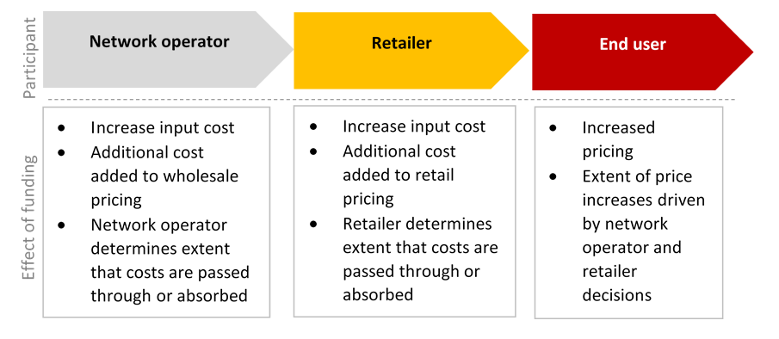

Table 16 below provides indicative wholesale prices for areas served by non-NBN networks, based on a $6 monthly per SIO contribution (in today’s dollars). In these areas there may be no change in prices, or if there was full pass through of a $6 monthly per SIO contribution, the BCR estimates a maximum potential increase of around 22 per cent to existing wholesale prices. As noted above, uniform national pricing by retailers, and the fact that other networks serve a small segment of the market, make it unlikely that such a maximum increase in wholesale prices would be reflected in retail prices commensurately.

**Table 16: Indicative wholesale price**

|  | **Current estimated wholesale price (per month)** | **Updated wholesale price  (per month)** |
| --- | --- | --- |
| **Greenfield operators** | $37[120] | $37-$43 (up to 16 per cent increase) |
| **TPG FTTB** | $27[121] | $27-$33 (up to 22 per cent increase) |

*Note: The estimates presented are preliminary and do not represent budget costings.*

Existing legislation requires that all high-speed fixed line network operators servicing residential and small business premises are required to do so on a wholesale only, open access basis.[122] Future NBN market reforms will require vertical separation for new high-speed fixed line broadband networks.[123] This removes the requirement to consider funding arrangements specifically for vertically integrated networks.

# Chapter 8: Administration arrangements

This section considers the key activities that would be required to establish and operate the funding arrangement, make funding arrangements transparent. Consideration has also been given to the contestability of funding arrangements.

## 8.1 Roles and responsibilities

* The periodic re-forecasting of NBN non-commercial service losses and recalculation of the funding amount required could either be the responsibility of the ACCC, the ACMA or the Department of Communications and the Arts (on behalf of the Minister for Communications).
* The BCR considers that the ACMA is best placed to collect NBN non-commercial services funding.

The administration of the non-commercial services funding arrangements would involve two distinct roles. The first would be to determine the required funding amount in light of revenue and costs incurred and updated forecasts for fixed wireless and satellite services. The second, ongoing role would be to collect the funding contributions from eligible participants.

**Table 17: Summary of the key responsibilities**

| **Determination of funding amount** | **Collection of industry contributions** |
| --- | --- |
| * Determine the total per SIO amount required to fund NBN non-commercial services, based on an assessment of NBN Co costs and revenues for fixed wireless and satellite services * Conduct periodic reviews of the funding arrangement * Publish updated forecasts | * Collect and assess company information and ensure all eligible network operators submit returns * Calculate eligible individual participant contributions and invoice network operators for payments * Publish industry contributions * Administer disbursement of funding * Undertake periodic reviews of auditing and collection processes |

### 8.1.1 Determination of funding amount

The BCR considers a number of government agencies - the ACCC, the Department of Communications and the Arts (on behalf of the Minister) or the ACMA ­could perform the role of determining the annual target amount required to fund NBN non-commercial services.

**ACCC**

The ACCC is an independent Commonwealth statutory authority the role of which is to enforce the *Competition and Consumer Act 2010* and a range of additional legislation, promote competition and fair trading, and regulate national infrastructure for the benefit of all Australians. The ACCC has a number of responsibilities in the regulation of the NBN through Part XIC of the *Competition and Consumer Act 2010*. These responsibilities include a key role in determining the terms and conditions of access to services provided over the NBN, including through SAUs and access determinations.

The BCR notes that the ACCC is currently assessing NBN Co’s cost and revenue projections under the SAU, including conducting prudency and efficiency assessments of expenditure. Administering the calculation of the non-commercial service funding arrangement aligns with these activities.

**Department of Communications and the Arts**

An alternative option would be for the Department of Communications and the Arts (on behalf of the Minister) to take on calculation responsibilities. This would complement its current role in recommending to the Minister for Communications the overall TIL amount to recover Universal Service Obligation (USO) and other public interest communication service costs. This approach would minimise the number of institutions involved in administering the funding arrangements.

**ACMA**

A third option is for the ACMA to take on this role. This would ensure there was a single regulator responsible for the calculation and collection of funding for non-commercial services. The ACMA may require additional resources with specific skill sets to perform this new role.

Table 18 examines the strengths and limitations of these different options.

**Table 18: Key considerations for determining which entity should determine the annual target funding amount**

| **ACCC** | **Department of Communications and the Arts** | **ACMA** |
| --- | --- | --- |
| * Experience in assessing financial forecasts * Industry contribution calculations relevant to SAU * Impartial and at arms-length from NBN Co * Includes a further institution to calculate industry funding compared to current arrangements | * Alignment with current TIL calculation role * Minimises administrative overheads * Supports future ‘harmonisation’ of industry contribution calculation functions * Risk of non-alignment with the SAU | * Ensures a single regulator is responsible for all aspects of the funding arrangement * Impartial and at arms-length from NBN Co * ACMA may need to engage additional expertise in financial forecasting and scrutiny of NBN Co accounts |

As NBN Co is the provider of non-commercial services, the BCR considers that financial forecasts should be prepared by NBN Co or based on NBN Co input data. The responsible entity would provide guidance to NBN Co regarding the appropriate financial model and costing approach, and would assess financial projections to ensure they meet prudency and efficiency requirements. Consistent with existing regulatory processes such as the fixed line access determination, the BCR expects that industry would be consulted in determining a funding arrangement target amount and the corresponding financial inputs.

### 8.1.2 Collection of industry contributions

The ACMA administers the collection of the TIL to fund the USO, the National Relay Service, emergency call service and other public interest telecommunication services provided by Telstra and other contractors. Telecommunication carriers with eligible revenue in excess of $25 million (known as ‘participating persons’) are required to lodge eligible revenue returns. The ACMA collects and audits these returns for accuracy and compliance. The ACMA then determines each participating person’s funding arrangements amount, issues an invoice and collects the payment.

Aligning administrative activities for NBN non-commercial services would see the ACMA undertake a similar role in the NBN non‑commercial services arrangement. However the information collected from carriers would be different (e.g. SIOs instead of revenue), reflecting the different calculation method for the non-commercial services funding arrangement. This role would complement the ACMA’s current TIL responsibility and should not be a major impost on the ACMA’s resources as the number of eligible carriers is expected to be small.

Under this approach, the ACMA would administer two arrangements:

* the new proposed arrangement on high-speed fixed line networks to fund NBN Co non-commercial services losses; and
* the existing TIL, on all telecommunications carriers with eligible revenue exceeding $25 million, used to fund public interest telecommunications services.

The role of the ACMA in the new funding arrangement would also need to have regard for and be integrated with any changes in the ACMA’s role coming out of the current review of the ACMA, commissioned by the Minister for Communications.[124]

Alternatively the Australian Taxation Office could be responsible for the collection of industry contributions.

## 8.2 Timeframe for introducing funding arrangements

The BCR has assumed that funding arrangements would be introduced in 2017 as part of the broader NBN-related telecommunication market reforms. Importantly, the BCR recognises that any new industry-based funding arrangement creates uncertainty. This could be ameliorated in any implementation by providing reasonable notice and appropriate transition arrangements for any necessary changes to contractual, commercial or regulatory arrangements.

The BCR notes that the overall contribution made by non-NBN networks is small, reflecting modest forecast levels of entry in the high-speed wholesale broadband market. Optus has proposed not introducing funding arrangements until there is further proof of competitive entry which materially affects NBN Co’s ability to fund the deployment of the fixed wireless and satellite networks:

*There is a risk that a considerable amount of work and cost is devoted to developing an industry-wide levy mechanism to recoup a negligible amount of cross-subsidy leakage. To limit the red-tape costs on industry Optus recommends that whilst it would be useful to identify the losses associated with non-commercial services the implementation of an industry funding mechanism should only proceed once a threshold level of competing services has been triggered.*[125]

Deferring the introduction of the funding arrangements may be appropriate if costs, includes setup and Commonwealth administrative costs and compliance costs for networks exceeded benefits. These issues would be assessed through the undertaking of a regulation impact statement.

## 8.3 Regulatory and policy review points

* The BCR recommends that regulatory reviews (i.e. funding resets) be conducted every five years in order to re-forecast NBN non-commercial service losses and recalculate the funding amount required.
* The regulator should be authorised to conduct a review outside of the set review points if there is cause to do so including by request of the Minister for Communications.
* The Minister for Communications could commission a review of the policy settings for funding non-commercial services losses, as circumstances required.

NBN Co financial projections will change over time as the company gains more cost and revenue insights and moves from the build phase to a steady state of operations. The BCR considers that as part of the NBN regulatory framework, review points should be added to re-forecast financial losses, consistent with other regulated industries. In Australia, the time between regulatory reviews is typically three to five years. In the United States, cost of service regulation is reviewed on average every two years. In the United Kingdom, price cap regulation has a cycle of four to five years.[126]

Review points need to strike the right balance between providing certainty for industry participants regarding the costs associated with non-commercial services and adjusting for latest estimates.

The BCR recommends five-year review periods. Over the five-year review period, the per-SIO contribution amount contemplated should be steady in real terms (only increase in nominal terms). At each review point, any adjustments between periods should be dealt with through a process of ‘overs-and-unders’. Where revised forecasts show an over-recovery in the previous period, this is returned through a deduction over the subsequent period. Conversely, an under recovery would see an upwards adjustment over the subsequent period.

The BCR further recommends that the Government agency responsible for the funding calculations be authorised on a case-by-case basis, including at the request of the Minister for Communications to conduct a review outside of the set review points if there is cause to do so. The decision to perform any additional reviews would need to be considered alongside administration costs for the Government agency conducting the calculations, NBN Co and industry stakeholders.

Periodic policy reviews would support the sustainability of the NBN non-commercial services funding arrangement by allowing adjustments to be made in line with market, technology or other changes. This would allow an assessment of the policy ahead of major asset replacement decisions, such as the purchase of additional satellites. Policy reviews could also consider the merits of an alternative operator providing non-commercial services and the need for any revisions to the eligible funding base. The BCR considers these reviews could be conducted at the request of the Minister for Communications every five to 10 years, or as circumstances require.

## 8.4 Achieving transparency

* The BCR considers that quantifying and publishing the losses made by NBN non-commercial services is the first step in achieving transparency. Transparency of future funding arrangements will be achieved by publishing the process for calculating funding contributions, and the per-SIO amount collected.
* The BCR considers that NBN Co’s payments should be net of funding provided by other eligible parties. NBN Co payments should not require an actual transfer of funds but its contribution should be reported for transparency purposes.

Further to quantifying the extent of NBN non-commercial service losses, transparency of funding arrangements will be achieved through publishing the process for determining the overall NBN non-commercial service loss, the amount collected by NBN Co and non-NBN network operators on a per-SIO basis.[127]

In addition, NBN Co should account for cash outflows and inflows relating to the NBN non-commercial services funding arrangements as part of its accounting separation obligations. This would reflect a transfer of funds from the fixed line networks to the non-fixed line networks.

### 8.4.1 Operational arrangements for industry contributions

Consideration is required regarding the receipt and disbursement of industry contributions. Care must be taken to avoid unnecessary transaction costs. This is particularly relevant under an NBN equivalent funding arrangement where NBN Co largely continues to fund non-commercial services. Introducing a requirement in which NBN Co transfers significant funds and then receives these same funds back is not efficient, particularly where NBN Co may need to borrow to cover a short-term funding shortfall.

The BCR considers that while NBN Co should not make actual payments out only to receive them back, there should still be a clear record of transaction showing NBN Co’s contribution towards non-commercial services (e.g. a notional invoice) for transparency.

At a high level, and subject to legal requirements, the key steps in the payment process would be:

1. The responsible entity issues notices and invoices to all eligible providers of high-speed broadband networks (including NBN Co), identifying the contribution amount owing. Where NBN Co is the largest provider of fixed wireless and satellite services, it will be a beneficiary, rather than a provider, of funding contributions.
2. Providers’ contribution amounts are collected by the responsible entity.
3. Payments are provided to NBN Co for the provision of non-commercial services
4. Reporting is published annually with the contribution amount made by all eligible participants, including NBN Co.

The netting off of NBN Co contributions could be calculated using a debit/credit system or a set-off provision (similar to TIL arrangements).

The BCR’s Initial Consultation Paper raised the question of whether the cost of funding non-commercial services should be reflected in end user invoicing to enhance transparency. Parties making submissions did not support this proposal. Telstra said it would create unnecessary red tape,[128] and ACCAN was concerned it would lead to confusion among customers.[129] As such, the BCR does not support a requirement on network operators and retailers to separately identify the funding arrangement contributions on customer bills.

## 8.5 Contestability for non-commercial funding arrangements

* To prevent instability and uncertainty during the scale up of the rollout, the BCR considers it premature to contest the provision of fixed wireless and satellite services at this point in time.
* Upon completion of the fixed wireless and satellite networks, Government could periodically test the market for contestability.

Contestability considerations to this point in the paper have been in regard to high-speed network operators in fixed line areas. However, contestability is also a relevant consideration for the delivery of services in the fixed wireless and satellite footprints.

Ultimately, contestability encourages innovation, promotes economic efficiencies and minimises distortions in the market. The submissions broadly supported the inclusion of contestability as one of the core principles of this funding exercise. The majority of submissions, however, were not supportive of the extension of this principle to the actual provision of non-commercial satellite and fixed line services.

Under the Statement of Expectations, NBN Co has an obligation to deliver high-speed broadband to all Australian premises irrespective of the commerciality of these services. In its submission, NBN Co noted how the natural monopoly characteristics of its non-commercial networks mean that it would be highly inefficient to encourage network duplication.[130] Similarly, Telstra and Optus both expressed views that competition in fixed wireless and satellite is unlikely and undesirable. Optus said it would be unrealistic to expect there to be interest from an alternative operator to provide non-commercial services given the very large costs that will be sunk to provide the NBN fixed wireless and satellite services.[131] Telstra argued a redirection of non-commercial subsidies to new entrants has the potential to ‘muddy the water around the NBN construct itself’.[132]

The BCR agrees that it is premature to contest the provision of the non-commercial NBN fixed wireless and satellite services at this point in time. At present, NBN Co is scaling up the deployment of regional and rural infrastructure, with the launch of both long-term satellites scheduled for completion by next year and the fixed wireless deployment expected to be largely complete by FY2018. Given NBN Co has already sunk significant costs to deliver these services, the BCR believes there is no value in encouraging a new entrant in non-commercial services unless its costs are demonstrably lower than NBN Co’s future costs.[133]

The proposed funding arrangements are expected to be implemented during 2017, by which time more than 200,000 households are expected to have obtained an NBN fixed wireless or satellite service. Based on discussions with industry on the required levels of investment, and noting previous attempts by government to contest non-commercial telecommunication services,[134] the BCR believes that competition for non-commercial service subsidy funding is unlikely in the short to medium term. Contesting these services when there is no other contestant would be a disruptive regulatory process, delaying the rollout, leading to additional administrative costs and creating regulatory and economic uncertainty.

Recognising ACCAN’s concerns about the difficulty in transitioning established funding arrangements away from the incumbent,[135] a future policy review could assess potential contestability.

There may also be times outside of these formal policy review points where it would be sensible to re-assess the market for contestability. Ideally, contestability should incentivise a new entrant when it knows its costs are low and the assets of the existing provider are close to their economic life. Replacement decisions, such as the purchase of additional satellites or the introduction of 5G, could trigger a review into the state of the market and an assessment of contestability arrangements.

Market signals could also provide guidance as to when it may be appropriate to consider contesting the funding arrangements. A firm investing significantly in emerging complementary or competing broadband technologies in regional or rural areas, could be grounds for government initiating a tender process to test the market. The BCR appreciates, however, that Government will not know, at any point in time, whether there are technologies or firms that are more efficient than the incumbent.

Alternatively, Government could accept unsolicited proposals from providers seeking to contest services. State governments have had success adopting this practice, particularly in the transport sector.[136]

Beyond contestability of non-commercial service funding, the BCR notes the findings of the NBN Co Fixed Wireless and Satellite Review which recommended that NBN Co remain open to partnership opportunities for satellites and continue tendering for fixed wireless services under competitive conditions. These approaches support ongoing efficiencies in delivering non-commercial services.[137]

# Chapter 9: Intersection with other regulatory issues

The introduction of an NBN non-commercial service funding arrangement will intersect with a number of current regulatory mechanisms in the telecommunications sector. This section explores the synergies the new funding arrangement may have on the USO, TIL and the SAU and future opportunities for reform presented by the NBN rollout across regional and rural Australia.

## 9.1 Telecommunications Industry Levy and the Universal Service Obligation

* The BCR considers that the proposed NBN non-commercial services funding arrangements can operate in parallel to existing TIL arrangements (which are used to fund the USO and other public interest telecommunication services).
* Industry submissions advocate for USO reform as a result of the NBN rollout. While recognising the benefits of harmonising telecommunications funding arrangements, the BCR sees this as a broader policy issue beyond the Terms of Reference and intended scope of this study.

On 1 July 2012, as part of a package of legislation to achieve continuity of key telecommunications safeguards in the transition to the NBN, the previous USO and the National Relay Service (NRS) levies were replaced with a single levy, the TIL. The TIL together with government funding covers the costs of the implementation and administration of service contracts and grants to deliver:

* reasonably accessible standard telephone services and payphone services to all Australians on an equitable basis, regardless of where they live or carry on business (the USO);
* a national telephone service to enable people with a hearing or speech impediment to make and receive telephone calls (the NRS);
* delivery of emergency call services; and
* delivery of other public policy telecommunications outcomes.[138]

The BCR considers that the proposed NBN non-commercial service funding arrangements and the TIL can operate in parallel. In other words, the introduction of a new funding scheme would not preclude current operations. As discussed in Chapter 9.2, the BCR considers there is operational alignment between the new and existing scheme which should be explored to minimise administrative burden and operational complexity.

A number of industry stakeholders believe the USO should be revisited in light of the NBN. Macquarie Telecom argued that:

*The USO is rendered obsolete by the advent of the NBN…the USO should be abolished as the NBN becomes available in more regional areas.*[139]

ACCAN suggested that:

*USO arrangements could be amended to include the provision of broadband services in non-commercial areas … this would align the USO policy with the NBN policy.*[140]

However, Telstra and Optus are opposed to merging the two arrangements, with Telstra arguing:

*The USO is a retail service provision obligation designed to provide a safety net for customers at a retail level, not a wholesale infrastructure obligation.*[141]

The USO has been an important safeguard in ensuring people across Australia have access to reliable telephony services. The importance of adequate voice services to regional and rural Australia has been highlighted by the Regional Telecommunications Independent Review Committee (RTIRC), established under Part 9B of the *Telecommunications (Consumer Protection and Service Standards) Act 1999*. The reviews are conducted every three years into telecommunications services in regional, rural and remote parts of Australia. These reviews have assessed the adequacy of safeguards, including the USO, in these areas. The BCR notes that a RTIRC review is in progress at the time of releasing this consultation paper.[142]

As the NBN network rollout extends, broadband-enabled options will become available to more regional and rural Australians. Fixed wireless and satellite platforms will serve approximately eight per cent of Australian residential and business end-users which are located in regional and remote locations.[143] Once the NBN deployment has reached maturity, and consumer usage habits of all technologies are better understood, a key consideration for Government may be whether USO services could comprehensively be delivered via alternative technologies, including over the NBN fixed wireless network. An exception, given inherent latency characteristics,[144] is likely to be those premises where NBN uses satellite technology for broadband delivery. It is likely that consumer safeguards may be required to ensure the availability of USO voice services in the NBN satellite footprint. It should be noted, however, that Telstra is currently delivering USO services using a number of technology platforms including satellite. As discussed in Figure 25, there are a number of international examples of USO arrangements transitioning to next generation networks, including through the use of wireless technologies.

**Figure 25: International examples of USO changes**

| New Zealand, Ireland and Spain are delivering universal services in rural areas using wireless technologies. In Norway, the USO provider Telenor will turn off its plain old telephone service (POTS) in 2019/20 and is in the process of upgrading, replacing and removing its copper infrastructure. The company is rolling out an IP-based converged network through its fixed network and deploying FTTH and VDSL2. The company plans to fulfil its USO obligation by providing VoIP and SIM-based fixed phones.  Telenor has said it is turning off its old telephone service because:   * a large number of subscribers are cancelling fixed telephony * the cost of supporting fixed telephony is high * there is a lack of qualified engineers to support the copper infrastructure * there is a shortage of vendors supporting the infrastructure.[145] |
| --- |

A future review of the USO and associated funding arrangements goes beyond the scope of the Terms of Reference. However, in light of stakeholder submissions, the BCR has chosen to make some general commentary on this matter, noting that decisions concerning the necessity and timing of a future USO review is a broader issue for Government.

The BCR considers that any future review of the USO, if agreed by Government, should consider the possibility of a shared funding mechanism that reflects the convergence of voice and broadband services and lessens the compliance burden on industry.

## 9.2 Leveraging Telecommunications Industry Levy operational arrangements

The BCR examined the merits of using a single operational process to collect industry information to determine eligibility for both the TIL and the NBN non‑commercial services funding arrangement. In line with the Government’s deregulation commitment, a funding arrangement that uses the same or a similar collection mechanism would lessen the administrative and compliance burden on industry. Table 19 below shows the eligibility and calculation elements of the BCR’s preferred NBN non‑commercial service funding option (per SIO contribution) and the TIL.

**Table 19: Collection of preferred funding arrangement for NBN non-commercial services and the TIL**

|  | **NBN equivalent** | **TIL** |
| --- | --- | --- |
| **Contributors** | Operators of high speed fixed line broadband networks serving residential or small business premises | Telecommunications Carriers (with scope to include Carriage Service Providers if required in future) |
| **Eligibility** | Eligible SIO | Carrier Eligible Revenue  (> $25 million p.a.) |
| **Contribution calculation** | Total number of residential and small business fixed line SIOs | Eligible Revenue share |
| **Amount to be funded** | Average forecasted losses | Actual costs of relevant contracts, grants and administrative costs, less $100 million p.a. Government contribution |
| **Administrator** | ACMA | ACMA |

The NBN equivalent funding arrangement would be payable by operators of high-speed fixed line broadband networks serving residential or small business premises based on their number of residential and small business SIOs. The entity responsible for collecting the NBN non-commercial funding arrangement would need to implement a reporting mechanism in order to collect this information from eligible participants. An option for the ACMA (as the proposed collection entity) could be to revise its current Eligible Revenue Reporting (ERR) forms to identify eligible high-speed broadband operators and the number of applicable SIOs. The ACMA could then apply the amount per-SIO to calculate the contribution amount for each eligible provider. This type of process would limit the administration burden on both the ACMA and industry. Figure 26 below examines how existing TIL processes could be leveraged to support the proposed NBN non-commercial services funding arrangements.

**Figure 26: Comparison of current and proposed ACMA responsibilities**

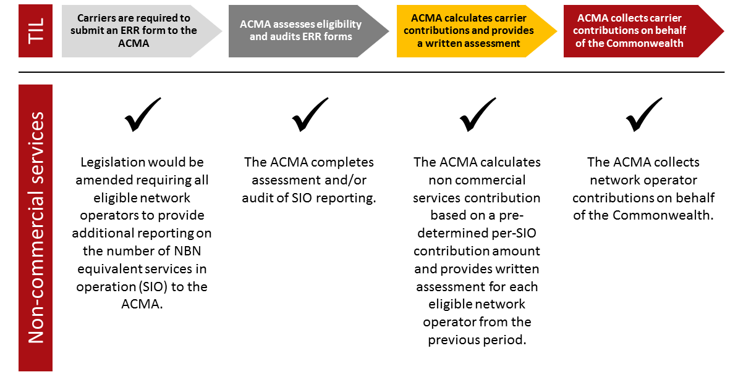

## 

## 9.3 Special Access Undertaking

* The BCR considers that the SAU should be updated to recognise NBN non-commercial funding contributions.

On 13 December 2013, the ACCC accepted an SAU from NBN Co. The SAU specifies price and non-price terms and conditions relating to access to NBN fibre, fixed wireless, satellite networks and other related services.

The SAU features revenue cap and prudency measures to provide NBN Co with the opportunity to recover its prudent and efficient cost over the term of the SAU. The ‘revenue requirement’ amount represents: the revenue that NBN Co must earn in that year to recover its operating costs; the costs of financing previous capital investments; a return on previous investments through regulatory depreciation and an allowance for taxation costs. The revenue requirement can be viewed as the annualised costs of providing services.

In its submission, NBN Co argued that it has strong incentives built into the SAU to ensure it operates efficiently. These included:

*…provisions for the ACCC to assess expenditures against the prudency criteria set out in the SAU. Also, the constraints on NBN prices not to increase by more than CPI less 1.5 per cent each year means that NBN has an incentive to both minimise costs and maximise the take-up of services.*[146]

### 9.3.1 Changes to the SAU as a result of non-commercial service funding arrangements

In its submission to the BCR’s consultation process, the ACCC anticipated that NBN Co would need to consider the details of an alternative funding model before it could advise on the extent to which the SAU would need to be varied, if at all. The ACCC does not have the powers under Part XIC of the *Competition and Consumer Act 2010* to require NBN Co to vary an existing SAU, or to otherwise initiate changes to an existing SAU.[147] NBN Co supported this view, noting:

*…it is premature to be discussing any modifications that NBN may need to make to the SAU. NBN considers the BCR should proceed on the basis that NBN will seek appropriate amendments to the SAU to accommodate the final arrangements for the funding of NBN fixed wireless and satellite services.*[148]

As part of its NBN reform agenda announced in December 2014, the Government also requested that NBN Co transition to a price cap model to enable NBN Co to reduce wholesale pricing in response to more competitive arrangements. Under the NBN equivalent funding option recommended by the BCR, contributions from eligible industry participants make up the portion of cross-subsidy amount that NBN Co would have received if there was no competition in commercial areas. Beyond this, it is expected that NBN Co will reduce prices below its price caps as required to meet competition. The ACCC and NBN Co will need to advise industry on any implementation arrangements and consider any necessary changes to the SAU flowing from the BCR’s proposed funding arrangements and the Government’s policy that NBN Co transition to price caps.

## 9.4 Telecommunications regulatory and structural reform

The funding of NBN non-commercial services is part of the broader Telecommunications Regulatory and Structural Reform policy, announced by the Government in December 2014 in response to the recommendations of the Vertigan Review. This reform agenda outlined a number of new Government commitments, including to legislate broadband infrastructure provider of last resort (IPOLR) obligations, and to amend the existing level playing field provisions for superfast fixed line networks under Part 8 of the Act.

The BCR recognises the importance of regulatory symmetry, and has addressed the need for consistency with the overall regulatory framework under the principle of sustainability (see Chapter 6.4). The proposed non-commercial services funding arrangement broadly aligns with existing regulatory instruments and frameworks. However these funding arrangements, and in particular the eligibility criteria, may need to be reviewed upon the introduction of new legislation that amends or alters the overarching telecommunications regulatory framework.

# Chapter 10: How to comment

The BCR invites written submissions from the public, industry and other interested stakeholders by 3 November 2015. Please provide your name, organisation (if relevant) and contact details with your submission.

Your submission can be lodged in the following ways:

| **Email: (preferred)** | [BCR@communications.gov.au](mailto:BCR@communications.gov.au) |
| --- | --- |
| **Post:** | Richard Bullock Director, Market Analysis Bureau of Communications Research Department of Communications and the Arts  GPO Box 2154 CANBERRA ACT 2601 |

The BCR welcomes enquiries about issues raised in the paper to Richard Bullock, Director Market Analysis, Bureau of Communications Research by email to [BCR@communications.gov.au](mailto:BCR@communications.gov.au) or by telephone on (02) 6271 7035.

The BCR is bound by the Department of Communications and the Arts’ (the Department’s) publications, confidentiality and privacy provisions.

## 10.1 Publication

Respondents should be aware that submissions may be made publicly available, including on the Department’s website ([www.communications.gov.au](http://www.communications.gov.au)) unless the submitting party indicates they do not want this. The Department reserves the right not to publish any submission, or part of submission, which is in the view of the Department contains potentially defamatory material, or where it considers it appropriate to do so for confidentiality reasons.

## 10.2 Confidentiality

All submissions will be treated as non-confidential information unless the respondent specifically requests that the submission, or part of a submission, is kept confidential. Alternatively, respondents may choose to provide an additional version of that submission for public release.

Even when the Department agrees to keep a submission or part of it confidential, the obligation of confidence will not be breached where the Department discloses the information to a House or Committee of Parliament, relevant Ministers, Commonwealth entities (where this meets the Commonwealth’s legitimate interests), within the Department and to its advisors, or where authorised or required by law. The Department cannot guarantee the confidentiality of information released through these or other legal means. The Department will treat any personal information provided in accordance with the Department’s Australian Privacy Principles Privacy Policy (see [www.communications.gov.au/privacy](http://www.communications.gov.au/privacy)). Note that submissions will generally be subject to the *Freedom of Information Act 1982*.

## 10.3 Privacy

The Department has obligations under the *Privacy Act 1988*, which establishes certain principles with respect to the collection, use, and disclosure of information about individuals. In particular, the Privacy Act contains the Australian Privacy Principles which govern how the Department collects, uses, discloses and stores personal and sensitive information, and how individuals can access and correct records containing their personal or sensitive information.

If you include any personal information and/or sensitive information in your submission, this information will be collected by the Department. By providing the Department with your personal information and/or sensitive information in your submission (or, if relevant, in your communication enclosing the submission), you consent to the Department collecting, using and disclosing that information in accordance with this notice.

As part of considering your submission, the Department may use your personal and/or sensitive information for considering the issues raised in this paper and developing policies and programs in relation to the subject of this paper. Further, the Department may also disclose your personal information to its Minister or other government agencies and by placing the public version of your submission (including personal information included in the submission and information needed to identify who made the submission, such as your name) on the Department's website, which means it may be viewed by people in Australia or overseas.

Respondents should clearly indicate in their submission if they do not want to have their name or other information included in any submissions or summary of submissions that the Department may publish.

If you do not consent to the Department's collection, use and disclosure of your personal information, please do not provide it. If you have already provided your information to the Department, please notify [BCR@communications.gov.au](mailto:BCR.consultation@communications.gov.au) immediately.

For further information, including how to access or correct personal information, or to make a complaint, please see the Department's Australian Privacy Principles Privacy Policy (see [www.communications.gov.au/privacy](http://www.communications.gov.au/privacy)).

# Attachment A: Terms of Reference

The Bureau of Communications Research (BCR) within the Department of Communications will investigate and provide a report to the Minister for Communications and the Minister for Finance by 30 September 2015 on options for the efficient and transparent funding of non‑commercial services in the National Broadband Network (NBN).

The BCR will provide advice on options to replace the current arrangement, where NBN Co funds non-commercial services through an internal cross-subsidy, with direct funding arrangements based on industry contributions.

The BCR will provide recommendations on the total amount and possible structure of industry contribution arrangements. In developing this advice the BCR will:

1. Identify and quantify the level of loss incurred by fixed wireless and satellite NBN services, including:
   1. accounting for losses incurred across the NBN fixed wireless and satellite networks
   2. including the reasonable share of costs associated with commons such as NBN’s Operations Support Systems/Business Support Systems (OSS/BSS), transit network and corporate functions
   3. accounting for NBN Co having increased flexibility over time to adjust pricing in non‑commercial areas subject to price cap arrangements
2. Consider options for structuring the funding arrangements, including:
   1. options for the efficient and transparent collection of industry contributions
   2. eligibility requirements of contributors (based on revenue, services in operation or other criteria)
   3. whether funding should be based on actual losses or losses forecast over a future period with options for the funding arrangements to allow for changes to forecasts over time
   4. adjustments to NBN Co pricing to reflect the removal of the internal cross-subsidy for non‑commercial NBN services
3. Consult with industry on the amount and possible structure of contribution arrangements.
4. Consider the interaction of proposed funding arrangements with relevant NBN-related regulatory instruments and other telecommunications levy schemes, including:
   1. Consideration should be given to, but not limited to, how the funding arrangements will interact with the NBN Co Special Access Undertaking and the TIL.
5. Identify any financial risks to the Commonwealth posed by alternate funding and financing mechanisms.
6. Provide advice on competition issues arising from implementation of the proposed funding arrangements, including:
   1. Consideration should be given to long-term implications including potential contestability of funding arrangements.

The BCR should take into account evidence from previous reports and inquiries from overseas and in Australia, including information from the Independent Cost-Benefit Analysis of Broadband and Review of Regulation, the Fixed Wireless and Satellite Review, NBN Co Strategic Review and NBN Co’s Corporate Plan process. The BCR should also consider other issues that may be relevant to this task and provide recommendations.

The BCR will also develop a publically releasable version of its final report.

1. In April 2015, NBN Co announced a re-brand from NBN Co to nbn. This consultation paper uses the term ‘NBN Co’ for the purpose of company description. ‘NBN’ is used to describe networks and services.
2. Industry submissions are published on the Departments’ [Have Your Say](https://www.communications.gov.au/have-your-say/nbn-non-commercial-services-funding-options) website.
3. NBN Co submission, pp. 5-6.
4. GR Faulhaber, ‘Cross-subsidization: pricing in public enterprises’, American Economic Review, 65(5), December 1975, pp. 966–77.
5. ACCC, [Tests for assessing cross-subsidy](https://www.accc.gov.au/system/files/Tests%20for%20assessing%20cross-subsidy_0_0.pdf), June 2014, p 2.
6. NBN Co submission, p. 5.
7. Australian Government, [Statement of Expectations](http://www.nbnco.com.au/content/dam/nbnco/documents/statement-of-expectations.pdf), December 2010.
8. McKinsey-KPMG, Implementation Study for the National Broadband Network, March 2010.
9. Analysys Mason, [Review of the efficiency and prudency of NBN Co’s fibre, wireless and satellite network design,](http://www.google.com/url?q=http://www.nbnco.com.au/content/dam/nbnco/documents/analysys-mason-report.pdf&sa=U&ei=k5OMVaPkM8zq8AXrn4LwDQ&ved=0CBYQFjAA&usg=AFQjCNHXKak35V0TfyDJXlQgzynraDRdAA) 26 September 2012, p. 152.
10. NBN Co, [Fact Sheet: Fixed Wireless](http://www.nbnco.com.au/content/dam/nbnco/documents/fixed-wireless-factsheet.pdf), accessed 26 June 2015.
11. NBN Co, [Media Release - Faster internet for the bush](http://www.nbnco.com.au/content/dam/nbnco/media-releases/2013/internet-speed-doubles-fixed-wireless.pdf), 6 February 2013.
12. Australian Government, [Statement of Expectations](http://www.nbnco.com.au/content/dam/nbnco2/documents/soe-shareholder-minister-letter.pdf), April 2014.
13. NBN Co, [Fixed Wireless and Satellite Review](http://www.nbnco.com.au/content/dam/nbnco/documents/nbnco-fixed-wireless-and-satellite-review-07052014.pdf), May 2015. See for example, p.70.
14. Ibid.
15. NBN Co, [Rollout information - Weekly Summary](http://www.nbnco.com.au/content/dam/nbnco2/documents/nbnco-rollout-metrics-01102015.pdf), 1 October 2015.
16. NBN Co, [Corporate Plan 2016](http://www.nbnco.com.au/content/dam/nbnco2/documents/nbn-corporate-plan-2016.pdf), pp. 60, 63.
17. NBN Co, [Media Release - NBN Co selects fixed wireless network partner for mid-2012 service start](http://www.nbnco.com.au/corporate-information/media-centre/media-releases/nbnco-selects-fixed-wireless-network-partner-for-mid-2012-service-start.html), 1 June 2011.
18. NBN Co, [Media Release – NBN Co pilot to boost broadband speeds for the bush](http://www.nbnco.com.au/corporate-information/media-centre/media-releases/nbn-co-pilot-to-boost-broadband-speeds-for-the-bush.html), 20 April 2015.
19. NBN Co, [Fixed Wireless and Satellite Review](http://www.nbnco.com.au/content/dam/nbnco/documents/nbnco-fixed-wireless-and-satellite-review-07052014.pdf), May 2014, p. 26.
20. NBN Co, [Media Release – NBN Co prioritises bringing broadband to the bush](http://www.nbnco.com.au/corporate-information/media-centre/media-releases/nbn-co-prioritises-bringing-broadband-to-the-bush.html), 22 July 2014.
21. NBN Co, [Corporate Plan 2016](http://www.nbnco.com.au/content/dam/nbnco2/documents/nbn-corporate-plan-2016.pdf), p. 60.
22. The Hon Malcolm Turnbull MP*,* [Media Release - NBN satellite launch to revolutionise broadband for regional and remote Australia](http://www.minister.communications.gov.au/malcolm_turnbull/news/nbn_satellite_launch_to_revolutionise_broadband_for_regional_and_remote_australia#.Vc0ezY2KCP4), 13 August 2015.
23. NBN Co, [Media Release - Ericsson to deliver fixed wireless and satellite ground services](http://www.nbnco.com.au/corporate-information/media-centre/media-releases/ericsson-to-deliver-fixed-wireless-and-satellite-ground-services.html), 30 July 2014.
24. NBN Co, [Rollout information - Weekly Summary](http://www.nbnco.com.au/content/dam/nbnco2/documents/nbnco-rollout-metrics-01102015.pdf), 1 October 2015.
25. NBN Co, [Corporate Plan 2016](http://www.nbnco.com.au/content/dam/nbnco2/documents/nbn-corporate-plan-2016.pdf), p. 63.
26. NBN Co, [Fixed Wireless and Satellite Review](http://www.nbnco.com.au/content/dam/nbnco/documents/nbnco-fixed-wireless-and-satellite-review-07052014.pdf), May 2014, p. 86-87.
27. Ibid p. 43, 67.
28. Ibid, p. 64.
29. GSMA, [Understanding 5G: Perspectives on future technological advancements in mobile](https://gsmaintelligence.com/research/?file=141208-5g.pdf&download), December 2014.
30. Financial Review, [Richard Branson to pitch NBN satellite alternative](http://www.afr.com/business/telecommunications/richard-branson-to-pitch-nbn-satellite-alternative-20150909-gjiksy), 9 September 2015.
31. See, Telstra submission, p. 9; Optus submission, p.8; NBN Co submission, p. 13.
32. Steering Committee on National Performance Monitoring of Government Trading Enterprises (SCNPMGTE), [Community Service Obligations: Some Definitional, Costing and Funding Issues](http://www.pc.gov.au/research/completed/community-service-obligations), (Industry Commission: Canberra, 1994), p. 17.
33. Ibid, p. 15.
34. Ibid, p. 19.
35. See, for example, Bureau of Transport and Communications Economics (BTCE), The cost of Telecom's community service obligations: summary, 1989.
36. Common costs are those costs borne by a multiproduct firm that cannot causally be attributed to variations in the output of any single product or subset.
37. See, for example, ACCAN submission, p. 6.
38. See, for example, Telstra submission, p. 4.
39. See, for example, Vodafone submission, p. 9; iiNet submission, p. 3.
40. Steering Committee on National Performance Monitoring of Government Trading Enterprises (SCNPMGTE), [Community Service Obligations: Some Definitional, Costing and Funding Issues](http://www.pc.gov.au/research/completed/community-service-obligations)*,* (Industry Commission: Canberra, 1994).
41. Ibid, p. 20.
42. Australian Government, [Australian Government Competitive Neutrality Guidelines for Managers](http://www.finance.gov.au/sites/default/files/AGCN_guide_v4.pdf), February 2004, p. 41
43. Vodafone submission, p. 7.
44. Australian Government, [Australian Government Competitive Neutrality Guidelines for Managers](http://www.finance.gov.au/sites/default/files/AGCN_guide_v4.pdf), February 2004, p. 37.
45. NBN Co submission, p. 6.
46. This approach is consistent with costing examples considered by the Commonwealth Competitive Neutrality Complaints Office. See [Cost Allocation and Pricing](http://www.pc.gov.au/research/completed/cost-allocation-pricing/costallo.pdf), CCNCO Research Paper, October 1998, p.39.
47. BCR discussions with Australia Post’s Finance, Data and Operations area, 2015.
48. As discussed in Chapter 5: Model approach and outcomes, an allocation has been calculated to FY2022 to support financial projections from FY2023 and beyond.
49. A WSA comprises up to 192 base stations which connects to a single Fibre Access Node. See, Analysys Mason, [Review of the efficiency and prudency of NBN Co’s fibre, wireless and satellite network design,](http://www.google.com/url?q=http://www.nbnco.com.au/content/dam/nbnco/documents/analysys-mason-report.pdf&sa=U&ei=k5OMVaPkM8zq8AXrn4LwDQ&ved=0CBYQFjAA&usg=AFQjCNHXKak35V0TfyDJXlQgzynraDRdAA) 26 September 2012, p. 82.
50. NBN Co submission, p. 7.
51. Ian Martin submission, p. 5.
52. See, for example, NBN Co submission, p. 7.
53. See, for example, ACCAN submission, p. 2; Ian Martin submission, p. 5.
54. Vodafone submission, p. 10.
55. Queensland Treasury and Trade, [Non-current asset policies for the Queensland Public Sector, NCAP-3 – Valuation of Assets](https://www.treasury.qld.gov.au/publications-resources/non-current-asset-policies/ncap-3-valuation-of-assets.pdf), December 2014 p. 9.
56. ACCC, [Public inquiry to make final access determinations for the declared fixed line services](http://www.accc.gov.au/system/files/Discussion%20paper%20-%20FADs%20for%20fixed%20line%20services%20-%20public%20version.pdf), Discussion Paper, April 2011 (public version), p. 2.
57. See, John de Ridder submission, p. 6; Optus submission, pp. 7-8.
58. ACCC submission, p. 4.
59. Optus submission, p. 8.
60. Australian Government, [Australian Government Competitive Neutrality Guidelines for Managers](http://www.finance.gov.au/sites/default/files/AGCN_guide_v4.pdf), February 2004 p.32.
61. Based on 10 year Australian bond yield as at 16 July 2015. See [Bloomberg business](http://www.bloomberg.com/markets/rates-bonds/government-bonds/australia)*.* Inflation assumed at 2.50 per cent as per PPB Advisory estimates from June 2015.
62. NBN Co submission, p. 13.
63. See, for example, Ian Martin submission, p. 6; NBN Co submission, p. 8.
64. Ian Martin submission, p. 3.
65. See, for example, John de Ridder submission, p. 6; NBN Co submission, p. 8.
66. ACCAN submission, p. 3.
67. NBN Co submission, p. 8.
68. D Luck, ‘Future Funding of the Telecommunications Universal Service Obligations in Australia’, Telecommunications Journal of Australia, 57(2/3), 2007.
69. NBN Co submission, p. 8.
70. See, for example, NBN Co submission; Ian Martin submission.
71. Clause 3.1, Coalition of Australian Governments (CoAG), [Competition Principles Agreement – 11 April 1995 (As amended to 13 April 2007)](https://www.coag.gov.au/node/52), 1995.
72. Australian Government, [Commonwealth competitive neutrality policy statement](http://archive.treasury.gov.au/documents/275/PDF/cnps.pdf), June 1996.
73. Australian Government, [Australian Government Competitive Neutrality Guidelines for Managers – Financial Management Guidance No. 9](http://www.finance.gov.au/sites/default/files/AGCN_guide_v4.pdf), February 2004, p. 30.
74.
75.
76. NBN Co submission, p. 8.
77. John de Ridder submission, p. 6.
78. These additional costs are sometimes known as excess burdens or deadweight losses.
79. O Gabbitas and D Eldridge, [Directions for State Tax Reform](http://www.pc.gov.au/research/completed/state-tax-reform/statetax.pdf), Productivity Commission Staff Research Paper, May 1998, p. 19.
80. ACCAN submission, p. 4.
81. O Gabbitas and D Eldridge, [Directions for State Tax Reform](http://www.pc.gov.au/research/completed/state-tax-reform/statetax.pdf), Productivity Commission Staff Research Paper, May 1998, p. xxii.
82. Ibid p. xxii.
83. Australian Government, [Telecommunications Regulatory and Structural Reform](https://www.communications.gov.au/sites/g/files/net301/f/Telecommunications_Regulatory_and_Structural_Reform_Paper_-_11_December_....pdf), December 2014, p. 6.
84. ACCAN submission, p. 6.
85. BCR Initial Consultation paper, p. 25.
86. Optus supplementary submission, p. 6.
87. NBN Co submission, pp. 16-17.
88. iiNet submission, p. 7.
89. Vodafone submission, p. 17.
90. ACCAN submission, p. 4.
91. NBN Co submission, pp. 16-17.
92. iiNet submission, p. 6.
93. Australian Government, [Australian Government Competitive Neutrality Guidelines for Managers](http://www.finance.gov.au/sites/default/files/AGCN_guide_v4.pdf), February 2004 p.32.
94. Price caps are discussed in M Crew and P Kleindorfer, [Regulatory Economics: Recent Trends in Theory and Practice](https://www.accc.gov.au/system/files/Keynote%20address_%20Paul%20Kleindorfer%20(Paper)%20-%20Regulatory%20Economics_%20Recent%20Trends%20in%20Theory%20and%20Practice.pdf), background paper to the ACCC Conference – ‘Evaluating the Effectiveness of Regulation’, July 29-30, 2004.
95. K Henry, [Australia’s Future Tax System Review: Part Two, detailed analysis](http://taxreview.treasury.gov.au/content/downloads/final_report_part_2/AFTS_Final_Report_Part_2_Vol_1_Consolidated.pdf), December 2009, pp. 285-291.
96. J Hausman, [Efficiency Effects on the U.S. Economy from Wireless Taxation](http://economics.mit.edu/files/1029), National Tax Journal, Vol LIII 3(2), pp. 733-742.
97. ACMA, [Australians get mobile](http://www.acma.gov.au/theACMA/engage-blogs/engage-blogs/Research-snapshots/Australians-get-mobile), research snapshots, 9 June 2015.
98. ABS, [8153.0 Internet Activity](http://www.abs.gov.au/ausstats/abs@.nsf/mf/8153.0/), Australia, June 2015. See volume of data downloaded. Fixed line includes DSL, cable, fibre and other fixed line broadband. Wireless includes satellite, fixed wireless, mobile wireless via a data card, dongle, USB modem or tablet SIM card and other wireless broadband. The volume of data downloaded via mobile handsets is separately recorded by the ABS, and these figures have been included in order to capture all data downloaded in Australia.
99. ABS, [Household use of information technology, 2012-2013](http://www.abs.gov.au/ausstats/abs@.nsf/Lookup/8146.0Chapter12012-13) (data on mobile substitution by income bracket is available on request).
100. Australian Government, [Statement of Expectations](http://www.nbnco.com.au/content/dam/nbnco2/documents/soe-shareholder-minister-letter.pdf), 8 April 2015
101. NBN Co, Corporate Plan 2016, p. 43.
102. Vertigan Review, National Broadband Network – Market and Regulatory Report, p 74.
103. Ibid, p 76.
104. Policy Paper, p. 10, response to recommendations no. 4.
105. Telstra submission, p. 5.
106. K Henry, [Australia’s Future Tax System Review: Part Two, detailed analysis](http://taxreview.treasury.gov.au/content/downloads/final_report_part_2/AFTS_Final_Report_Part_2_Vol_1_Consolidated.pdf), December 2009, pp. 285-291.
107. Department of Communications, [No double up – the adequately served policy](https://www.communications.gov.au/what-we-do/internet/national-broadband-network), accessed 11 September 2015.
108. NBN Co, [Corporate Plan 2016](http://www.nbnco.com.au/corporate-information/about-nbn-co/corporate-plan/corporate-plan.html), p.60.
109. <http://www.buddeblog.com.au/frompaulsdesk/telstra/>; <http://exchange.telstra.com.au/2013/01/24/south-brisbane-exchange-migrations-completed/>.
110. <http://telstrawholesale.com.au/download/document/fab-site.xls>.
111. <http://www.opticomm.net.au/index.php/communities/ourcommunities?resetfilters=0>
112. BCR estimate, based on projected size of greenfield market. See, Paul Budde, Australia – Broadband – FttH Greenfield Market, December 2014.
113. <http://forums.whirlpool.net.au/forum-replies.cfm?t=2158435&#r9>
114. BCR estimate, based on the number of total active services in 2011, <http://www.itnews.com.au/news/transact-cable-in-for-the-long-stretch-259772>.
115. Based on the current number of MDUs passed by TPG divided by the average number of premises per MDU. See <http://www.zdnet.com/article/nbn-co-waiting-on-apartment-cable-contracts/> for estimated number of premises per MDU.
116. <http://www.zdnet.com/article/tpgs-nbn-rival-reaches-352-buildings/>
117. <http://www.computerworld.com.au/article/555701/tpg-revenue-soars-isp-releases-fttb-plan-details/>
118. NBN Co, [Corporate Plan 2016](http://www.nbnco.com.au/corporate-information/about-nbn-co/corporate-plan/corporate-plan.html), p.12.
119. NBN Co FY2015 ARPU is $40 per month. See, NBN Co [Corporate Plan 2016](http://www.nbnco.com.au/corporate-information/about-nbn-co/corporate-plan/corporate-plan.html), p.64
120. Greenfield operator data based on Greenfield Fibre Operators of Australia estimates of an average monthly $15 AVC and $22 port cost in metropolitan areas. See, Joint Parliamentary Committee on the National Broadband Network, [Answers to questions on notice by OPENetworks, Service Elements and Pivit who are members of the Greenfield Fibre Operators of Australia (GFOA)](http://www.google.com/url?q=http://www.aph.gov.au/parliamentary_business/committees/house_of_representatives_committees%3Furl%3Djcnbn/./bill/subs/sub1.1.pdf&sa=U&ved=0CBQQFjAAahUKEwjE1bqy3NfHAhUJn5QKHWnwAF8&usg=AFQjCNGSn6DAzQ2R5_W91ZYYIry4Dtt3Vw), 2011.
121. TPG wholesale price based on Layer 2 25/5 Mbps FTTB wholesale product. See, ITNews, [TPG opens Layer 2 FTTB product for wholesale](http://www.itnews.com.au/News/408415,tpg-opens-layer-2-fttb-product-for-wholesale.aspx), August 2015. Does not include backhaul or point of interconnection charges.
122. s143, *Telecommunications Act 1997.*
123. Australian Government, [Telecommunications Regulatory and Structural Reform](https://www.communications.gov.au/sites/g/files/net301/f/Telecommunications_Regulatory_and_Structural_Reform_Paper_-_11_December_....pdf), December 2014, p. 7.
124. Minister for Communications, the Hon Malcolm Turnbull MP, [Media release: A future-focused regulator for the communications market](http://www.minister.communications.gov.au/malcolm_turnbull/news/a_future-focused_regulator_for_the_communications_market#.VfDatI2KDVg), 12 June 2015.
125. Optus submission, p. 5.
126. See, for example, MIT Energy Initiative, [The Future of the Electric Grid](https://mitei.mit.edu/publications/reports-studies/future-electric-grid), 5 December 2011, p. 186; Regulatory Assistance Project (RAP), [Electricity Regulation in the US: A Guide](http://www.google.com/url?q=http://www.raponline.org/docs/RAP_Lazar_ElectricityRegulationInTheUS_Guide_2011_03.pdf&sa=U&ved=0CBYQFjAAahUKEwi3_O_prbHHAhXEKKYKHfMpAao&usg=AFQjCNEr5gXkZPspneQ0YJDxwqKSTnuzHA), March 2011, pp. 36-37.
127. Non-NBN collection amounts should be published on an aggregate basis to prevent identification of commercial in confidence information, such as number of active services in operation.
128. Telstra submission, p. 11.
129. ACCAN submission, p. 8.
130. NBN Co submission, p. 10.
131. Optus submission, p. 7.
132. Telstra submission, p. 8.
133. Sunk costs act as a barrier to a perfectly contestable market, restricting costless entry and exit. Failure to recognise the sunk cost character of network investment results in incorrect decisions and decreased economic efficiency. See, for discussion, J Hausman, ‘The Effect of Sunk Costs in Telecommunications Regulation’, The New Investment Theory of Real Options and its Implication for Telecommunications Economics, Springer US, 1999, pp. 191-204.
134. In 2001, the Australian Government ran two pilots to test the contestability of the USO. These pilots ran for three years and yet resulted in no alternative providers, despite significant encouragement from Government. Assessing why the contestability arrangements failed, economists focused on the significant commercial risks faced by alternative providers and the competitive advantage held by Telstra, leading to the conclusion there was no incentive for other carriers to enter the market. See, for discussion, J Bahtsevanoglou, ‘The Pitfalls of Auctioning Universal Service – the Australian experience’, Info, 12(2), 2010, pp. 55-79.
135. ACCAN submission, p. 8.
136. The Victorian Government, for example, recently accepted an unsolicited proposal from a private firm (Transurban) to widen the CityLink-Tullamarine Freeway.
137. NBN Co, [Fixed Wireless and Satellite Review](http://www.google.com/url?q=http://www.nbnco.com.au/content/dam/nbnco/documents/nbnco-fixed-wireless-and-satellite-review-07052014.pdf&sa=U&ved=0CBYQFjAAahUKEwitvY-UsrHHAhUFkZQKHdRLBxQ&usg=AFQjCNHRcWsfRueo5pPHmtUa-NuPrQKaCA), May 2014, pp. 107-109.
138. See, for discussion, ACMA, [Telecoms funding arrangements](http://www.acma.gov.au/Industry/Telco/Carriers-and-service-providers/Universal-service-obligation/telecommunications-funding-arrangements), accessed 30 July 2015.
139. Macquarie Telecom submission, p. 3.
140. ACCAN submission, p. 9.
141. Telstra submission, p. 11.
142. See [www.rtirc.gov.au](http://www.rtirc.gov.au).
143. NBN Co submission, p. 5.
144. Satellite latency is the time delay that occurs when data or voice communications are transmitted via satellite.
145. Analysys Mason, 2015.
146. NBN Co submission, p. 9.
147. ACCC submission, p. 2.
148. NBN Co submission, p. 20.