Logo: Australian Government, Departmetnt of Communications.
Twitter: @CommsAu.
Web: www.communications.gov.au

Broadband Availability and Quality: *Summary Report*

23 December 2013

# Summary Report

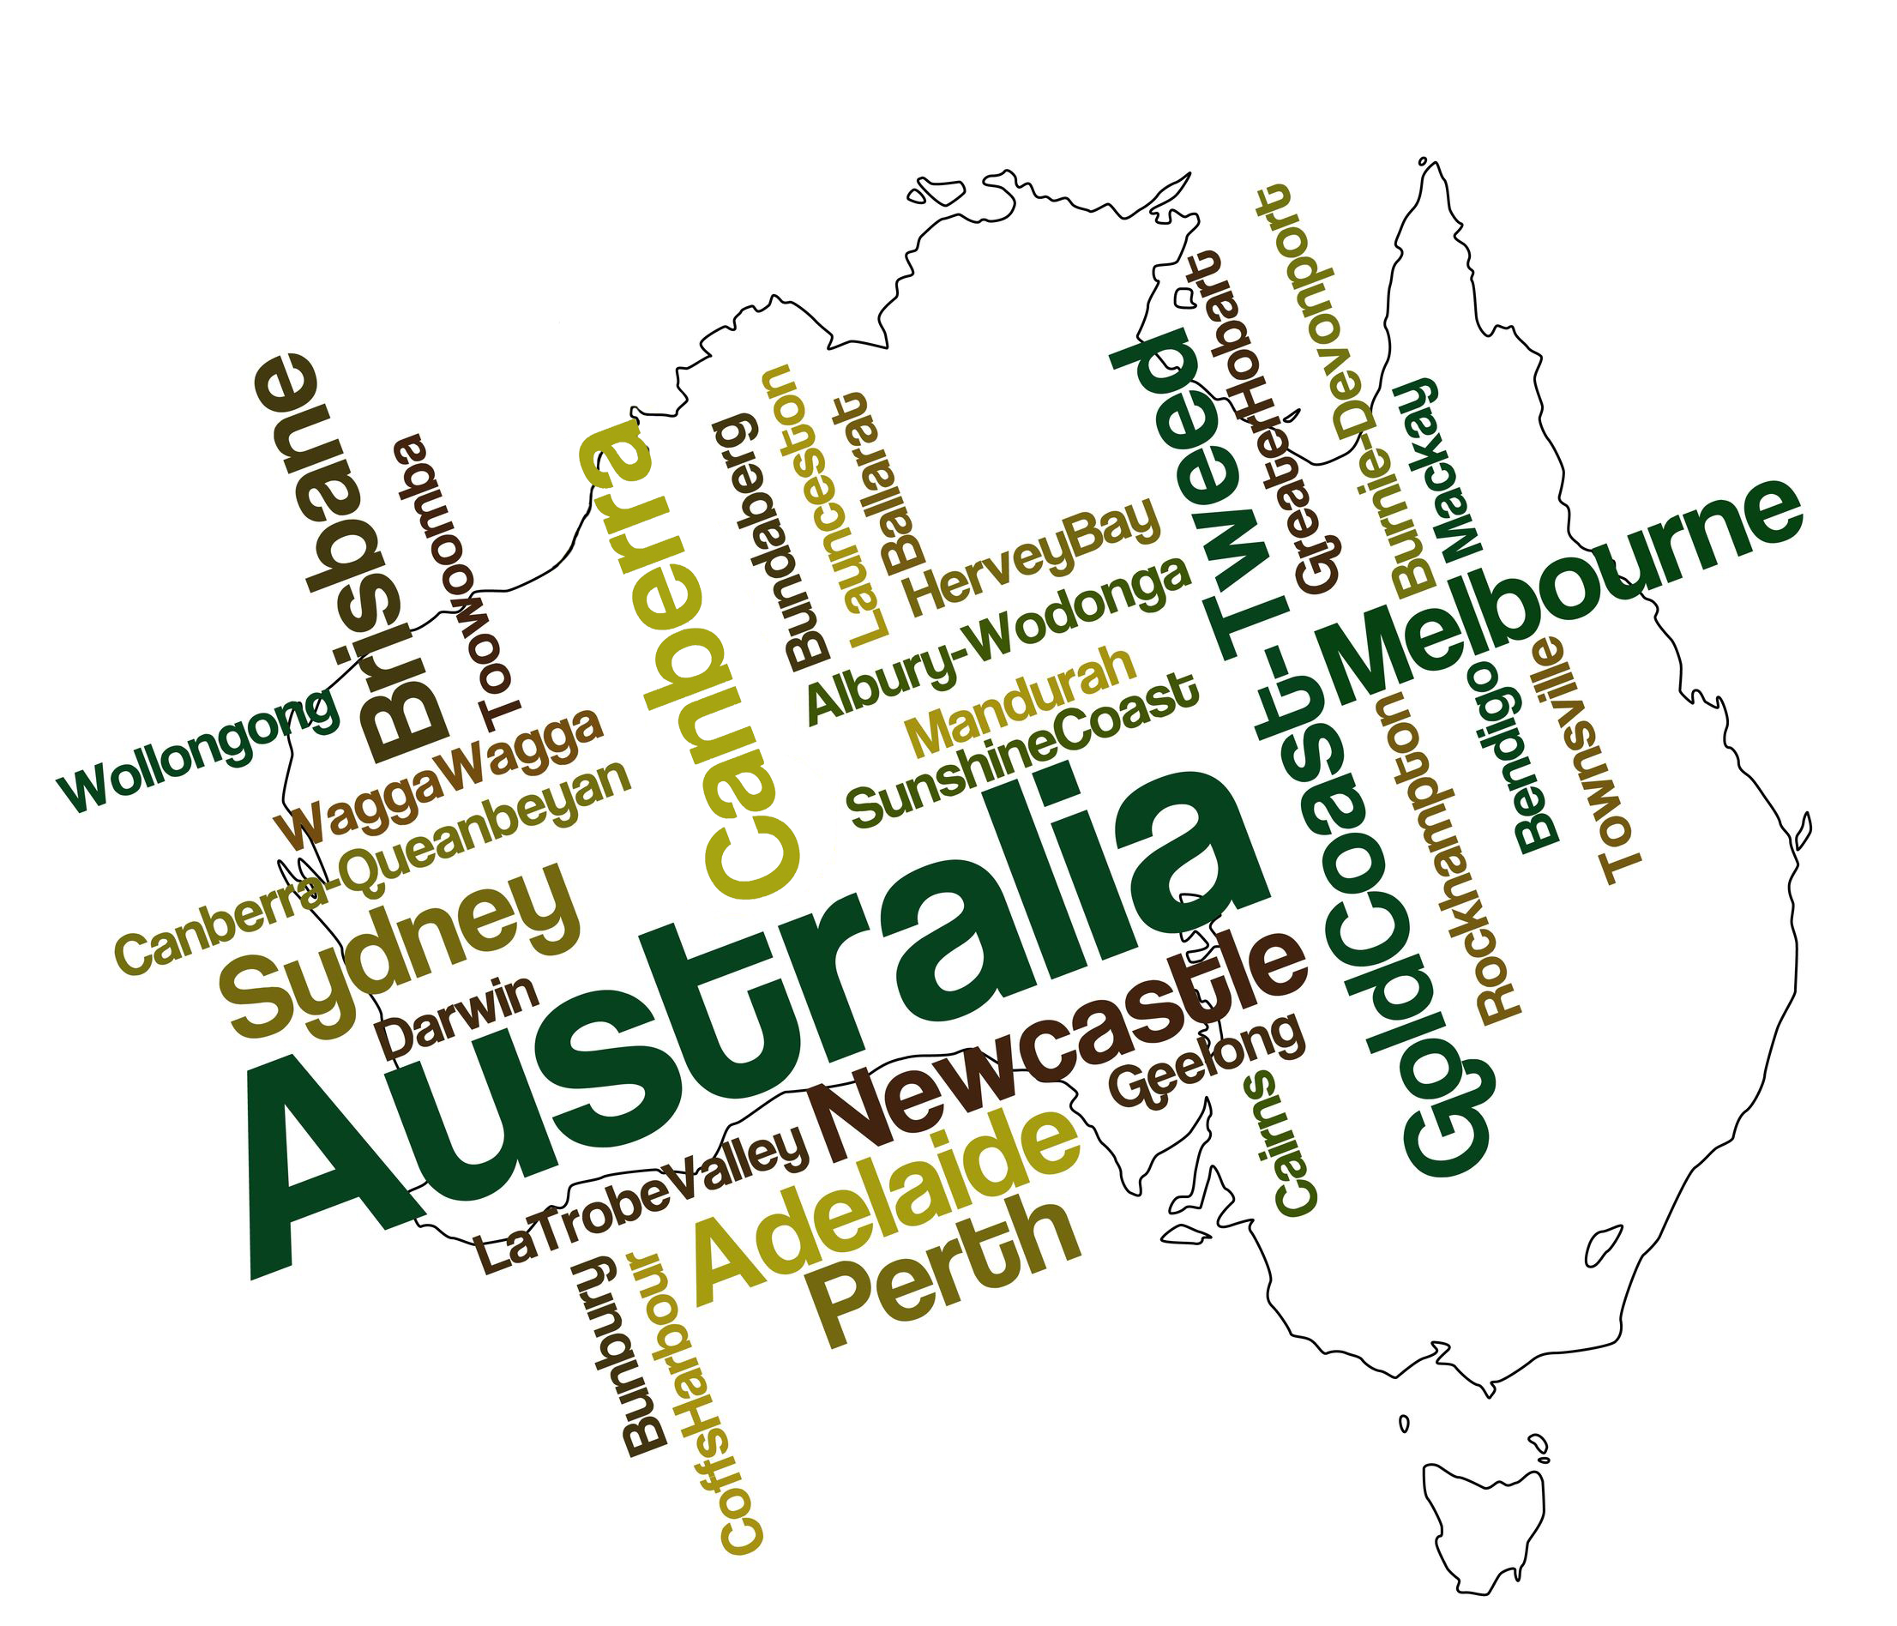

The Australian Government has asked NBN Co, the company building the National Broadband Network (NBN), to prioritise the many Australians without adequate fixed line broadband in the rollout. To assist with the prioritisation of under-served areas, the Government asked the Department of Communications to undertake an analysis of broadband quality and availability in all areas of Australia. This Summary Report is the first release of material from that analysis.

Broadband services are delivered using a range of technologies to homes and businesses across the country. The infrastructure most often used to provide broadband includes digital subscriber line (xDSL) technology over the copper access network, the 3G and 4G mobile networks, hybrid fibre coaxial (HFC) networks originally rolled out for subscription television, fibre-to-the-node (FTTN) networks and fibre-to-the-premises (FTTP) networks. In addition to these terrestrial networks, all Australian premises are covered by satellite broadband networks.

The findings presented in this document are based on a detailed spatial analysis of the coverage of broadband customer access networks, along with estimates of their likely performance given known constraints. This analysis uses the available information to measure broadband availability in terms of the infrastructure currently in place. It uses the possible speeds achievable over that infrastructure to measure quality. This methodology was determined after reference to international examples.

Overall the analysis found that there are areas of inadequate access to infrastructure across the country – approximately 1.4 million premises (13 per cent) are in areas where fewer than 40 per cent of premises can access a fixed broadband service. The premises in this category are typically located in regional or remote areas of Australia, or in small pockets of poor service in metropolitan and outer metropolitan areas.

NBN Co’s recommended deployment scenario for the NBN is set out in the Strategic Review undertaken by the company between October and December 2013. The Strategic Review ‘multi-technology mix’ scenario (scenario 6) included estimated costs to allow for areas with poor current broadband service to be prioritised. NBN Co will prioritise the areas of greatest need wherever this is logistically and commercially feasible.

The key preliminary findings of this analysis of Australian broadband availability and quality are:

Availability**[1]**

* Approximately 9.9 million premises (91 per cent) have access to fixed line broadband services delivered via xDSL technology.
* Approximately 3.1 million premises (28 per cent) have access to a high speed broadband platform (defined as including fibre-to-the-premises, fibre-to-the-node, hybrid fibre coaxial networks and fixed wireless networks).
* Approximately 8.8 million premises (81 per cent) have access to 3G mobile broadband services and about 6.4 million premises (59 per cent) have access to 4G services.
* All Australian premises are covered by satellite broadband, although there is a ceiling to the capacity of these services and therefore not all premises can access a service.

## Quality

* Approximately 3.1 million premises (28 per cent) have access to peak download speeds of between 25 megabits per second (Mbps) and 110 Mbps.
* Approximately 7.1 million premises (65 per cent) are in areas that have access to peak median download speeds of less than 24 megabits per second over the copper network.
* About 0.7 million (6 per cent) premises are unable to get access to a fixed broadband service.
* Of premises with access to xDSL broadband services over copper, about 3.7 million are located in areas with an estimated peak median download speed of less than 9 Mbps, and 920,000 in areas with an estimated peak median download speed of less than 4.8 Mbps.

In summary (Figure 1), whilst there is a section of the Australian community who have severely limited access to broadband services, the more significant national issue is the quality of broadband services.

Graph:
Overall fixed broadband availability and quality.
Y axis: percentage of premises.
X axis: availability and quality - A, B, C, D and E.

A (highest) over 80 percent availability and just over zero in quality.

B over zero percent availability and over 30 percent in qualiaty.

C over zero percent availability and a little higher with just over zero percent in qualiaty.

D over around ten percent availability and around 15 percent in qualiaty.

E (lowest) just over zero percent availability and over 45 percent in qualiaty.


Figure 1. Percentage of Australian premises in each fixed broadband availability and fixed broadband quality band

### xDSL Quality

The findings of this, and many other studies, note that the most common form of fixed broadband subscription is provided by xDSL technologies, which reflects the widespread availability of this access technology. Figure 2 provides information on the approximate percentage of premises with access to xDSL that are likely to receive particular xDSL median peak download speeds.

Graph:

Distribution of median modelled xDSL download speed.

Y axis: percentage of premiums.
X axis: median modelled xDSL peak download speed.

3mbps: around 2.5 percent.
6mbps: around 8 percent.
9mbps: around 23 percent.
12mbps: around 10.5 percent.
15mbps: around 12 percent.
18mbps: 10 percent.
21mbps: around 16.5 percent.
over 21mbps: around 16.5 percent.


Figure 2. Percentage of premises in each band of modelled median peak download speeds

Broadband services are generally more available, and of higher quality, in metropolitan areas than in regional and remote areas. Although premises within regional and remote areas that are located close to local telephone exchanges do have access to higher quality xDSL services, premises further away from the exchange or on the outskirts of towns generally do not. The analysis has also identified many small urban areas where there is limited availability of fixed broadband services and a large number of premises that can access a basic service only at download speeds that are less than 9 Mbps.

It is important to note that broadband availability and quality is affected by multiple factors. Key elements are considered in this analysis, but a range of other factors may impact individual circumstances. In many locations there will be premises whose individual circumstances vary from the high or low rating for broadband availability and quality that their local area receives in this analysis.

### Data Inputs

This analysis makes use of the following data inputs:

* Current network coverage data from all major telecommunications carriers, and a number of smaller players with customer access networks,
* Data from the Telstra Wholesale website,
* Empirical xDSL usage observations comprising 20,000 real world measures of xDSL download sync speeds, associated cable loss, and the location and number of small, medium and large pair gains, and
* Locations and numbers of premises based on the Geocoded National Address File (G‑NAF).

All data sources are the most current available, dating from July 2013 to October 2013, with the exception of Telstra’s spatial representation of its mobile coverage (current as at January 2013). It is important to note that telecommunications carriers continually invest in infrastructure and broadband availability, and quality is therefore dynamic[2]. This analysis represents a snapshot of broadband as at December 2013.

## Next Steps

This Summary Report is the first release of material from the broadband availability and quality analysis and provides a national snapshot. The Department is refining the granular detail of the analysis, and compiling maps which will be published along with the methodology used. There will be an opportunity to provide feedback on the methodology and the preliminary results.

Further information on this analysis will become available in early 2014 via a website that will allow end users to obtain the results for their local community and provide feedback on their individual experience.

If you have any questions about this material please email [mybroadband@communications.gov.au](mailto:mybroadband@communications.gov.au).

1. The total of this section exceeds 100 per cent because the majority of premises have access to multiple broadband technologies.
2. Investment in the mobile market is resulting in expanding coverage, particularly in 4G coverage. Telstra announced on 18 December 2013 its 4G network coverage had expanded to reach 85 per cent of the Australian population. Optus has dual 4G networks and aims to expand its 4G coverage to over 70 per cent of the population in metropolitan areas by April 2014.