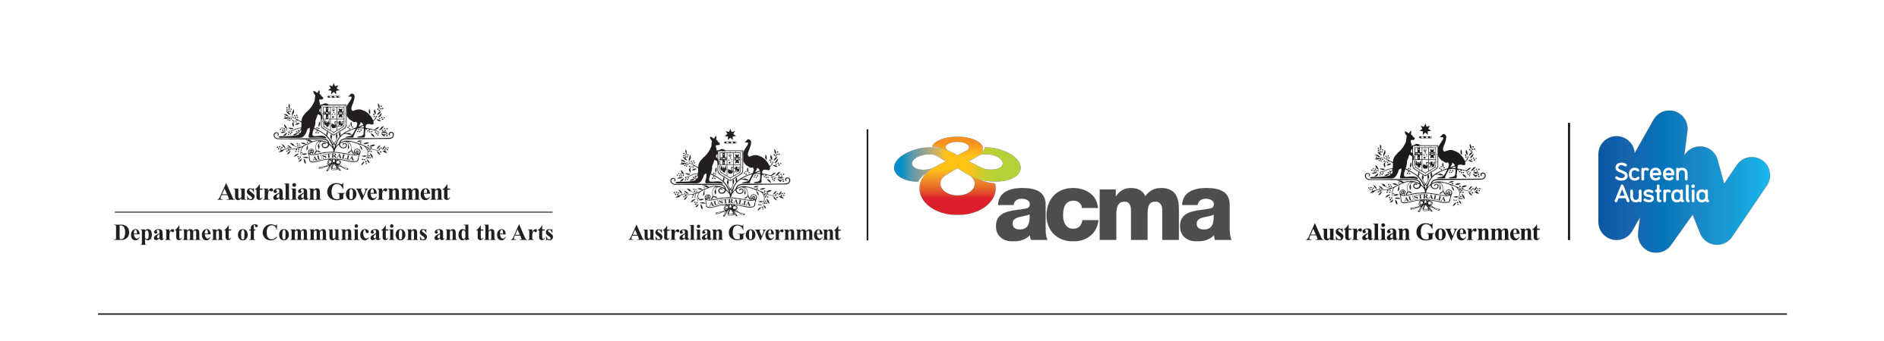

# Australian and Children’s Screen Content Review

## Terms of Reference

### Context

In a globally connected, on-demand world, Australian stories need to be told and heard by Australians, in particular our children, and across the world. A viable domestic screen production sector is essential if audiences are to have access to quality Australian content. Given the small size of the Australian market for screen content, and the sheer quantities of screen content production in larger English-language markets such as the United States and the United Kingdom, it is unlikely that Australia would produce the quantity, quality and variety of Australian content required to achieve cultural benefits without Government support. Similarly the Australian Screen Production Incentive was designed to suit pre-2007 industry models.

Changes in audience consumption habits, the introduction of new distribution platforms and increasing competitive pressure on Australian content producers and distributors mean that the existing models of regulation and support for Australian and children’s content need to be revisited.

### Scope

The Review’s objective is to provide policy options to Government on the most efficient and effective support mechanisms to ensure the ongoing availability of Australian screen content to domestic and international audiences regardless of platform. Specifically, mechanisms to foster and support Australian drama, documentary and children’s content and the Australian Screen Production Incentive will be reviewed.

The Review will consider:

* the economic and social value of Australian screen content to the Australian community;
* the current and likely future market for Australian screen content production and distribution;
* whether the Australian Government’s current policy settings:
  + are relevant to current industry practice;
  + appropriately target content that requires intervention;
  + ensure an approach that works across a diversity of platforms;
  + promote a sustainable production and distribution sector; and
  + are able to support Australian content on any platform into the future.

The regulations on local content for regional television and regional radio are out of scope of the review.

### How you can get involved

People with an interest in the creation, distribution and consumption of Australian content are encouraged to contribute to the review. Consultations will commence from June 2017.

Information on the review is available on the Department of Communications and the Arts website at [www.communications.gov.au/contentreview](http://www.communications.gov.au/contentreview)

You can contact the Review Taskforce to share your views and ask questions related to the review by emailing [contentreview@communications.gov.au](mailto:contentreview@communications.gov.au)