

# Australian Government held spectrum report

April 2019

Disclaimer

The material in this report is of a general nature and should not be regarded as legal advice or relied on for assistance in any particular circumstance or emergency situation. In any important matter, you should seek appropriate independent professional advice in relation to your own circumstances. The Commonwealth accepts no responsibility or liability for any damage, loss or expense incurred as a result of the reliance on information contained in this report.

This report has been prepared for consultation purposes only and does not indicate the Commonwealth’s commitment to a particular course of action. Additionally, any third party views or recommendations included in this report do not reflect the views of the Commonwealth, or indicate its commitment to a particular course of action.

Copyright

© Commonwealth of Australia 2019

Logo:  Creative Commons.  The material in this report is licensed under a Creative Commons Attribution—4.0 International licence, with the exception of:

* the Commonwealth Coat of Arms
* this Department’s logo
* any third party material
* any material protected by a trademark, and
* any images and/or photographs.

More information on this CC BY licence is set out as follows:

* Creative Commons website—[www.creativecommons.org](http://www.creativecommons.org)
* Attribution 4.0 international (CC by 4.0)—[www.creativecommons.org/licenses/by/4.0](http://www.creativecommons.org/licenses/by/4.0).

Enquiries about this licence and any use of this discussion paper can be sent to: [copyright@communications.gov.au](mailto:copyright@communications.gov.au).

Third party copyright

The Department has made all reasonable efforts to clearly identify material where the copyright is owned by a third party. Permission may need to be obtained from third parties to re-use their material.

Attribution

The CC BY licence is a standard form licence agreement that allows you to copy and redistribute the material in any medium or format, as well as remix, transform, and build upon the material, on the condition that you provide a link to the licence, you indicate if changes were made, and you attribute the material as follows:

Licensed from the Commonwealth of Australia under a Creative Commons Attribution 4.0 International licence.

Enquiries about the use of any material in this publication can be sent to: [copyright@communications.gov.au](mailto:copyright@communications.gov.au).

Using the Commonwealth Coat of Arms

Guidelines for using the Commonwealth Coat of Arms are available from the Department of Prime Minister and Cabinet website at [www.pmc.gov.au/government/its-honour](https://www.pmc.gov.au/government/its-honour).

Contents

Glossary 4

Background 6

Accessing spectrum 7

Scope of report 7

Out of scope 8

Methodology 8

Summary 10

Australian Government use 13

Very low frequency and low frequency bands 13

3 – 300 kHz 13

Medium frequency 14

300 – 526.5 kHz 14

1605.5kHz – 3 MHz 14

High frequency 15

3 – 30 MHz 15

Very high frequency 16

30 – 87.5 MHz 16

87.5 – 108 MHz 17

108 – 137 MHz 18

137 – 174 MHz 18

174 – 230 MHz 19

230 – 399.9 MHz 20

Ultra high frequency 21

399.9 – 520 MHz 21

520 – 694 MHz 22

694 – 960 MHz 23

960 – 1215 MHz 23

1215 – 1710 MHz 24

1710 – 2700 MHz 25

2700 MHz – 3.6 GHz 25

Super high frequency 26

3.6 – 4.2 GHz 26

4.2 – 5.925 GHz 27

5.925 – 6.7 GHz 28

6.7 – 10.7 GHz 28

10.7 – 11.7 GHz 29

11.7 – 31 GHz 30

Extremely high frequency 31

31 – 300 GHz 31

Attachments 32

A. Government Spectrum Steering Committee members 32

B. Departments and agencies consulted 33

C. Frequency band aggregation for reporting purposes 34

D. Frequency assignments by band and by agency 35

E. Australian Defence Radiofrequency Spectrum 37

## Glossary

| **Term** | **Definitions** |
| --- | --- |
| **apparatus licence[1]** | Apparatus licences permit holders to access particular frequencies of the electromagnetic spectrum in specified areas for an approved purpose. Each licence comes with conditions based on its use, such as power density, field strengths, applicable standards or other output characteristics that enable users to communicate effectively with minimum interference. Apparatus licences are usually purchased for a fixed fee for a maximum of 5 years, with no legal right to trade or transfer the licence. Licences can only be transferred to other operators with prior approval of the Australian Communications and Media Authority (ACMA).[2] |
| **apparatus licence fee** | There are two types of fees applicable to apparatus licences:   1. Administrative charges to recover the direct costs of spectrum management. 2. Annual licence taxes to recover the indirect costs of spectrum management. These taxes are calculated based on spectrum location, geographical location, amount of spectrum occupied and coverage area.[3] |
| **Australian Government** | This paper includes holdings for federal government departments and agencies listed under each Australian portfolio, referred to collectively as ‘Australian Government’. |
| **class licence** | Under a class licence, all users operate in the same spectrum segment on a shared basis and are subject to the same licence conditions. Class licences are not issued to individuals, rather automatically authorise anyone to use complying devices on a no interference/no protection basis.[4] The Australian Government operates services using class licences, for example the Aircraft and Aeronautical Mobile Stations Class Licence authorises the operation of a range of aeronautical radiocommunications and radionavigation equipment fixed to, or carried on-board all aircraft. Emergency services and the Australian Maritime and Safety Authority utilise class licences to operate emergency position-indicating radio beacons, which provide a critical safety-of-life and search and rescue function. This service is protected from harmful interference from other users in the same band. |
| **criticality** | For the purpose of this report, agencies reported on criticality of use under a range of categories outlined in Table 1 below, ranging from having Safety Implications for Australians, being Critical to agency objectives, to holding an Administrative or Functional support use. These categories do not represent a hierarchy of use, rather provide further description of why agencies require spectrum in these bands. |
| **frequency assignment** | Frequency assignment is the identification of suitable radiofrequencies for use in accordance with the ACMA legal and policy requirements.[5] Frequency assignments have been selected as a proxy for usage by frequency band to demonstrate the differences in scope across licences. This recognises that frequency assignments (transmitters and/or receivers) within a single licence can re-use the same frequencies, and could have a wide varying amount of equipment use. |
| **geographic use** | For the purpose of this report, geographic use has been defined under three major categories; Site-based, Area-wide, Australia-wide. These general descriptors have been used as a method to describe breadth of use, noting that area and site sizes can vary, and Australia-wide does not imply exclusive use. In some instances ‘Australia-Wide’ will be confined to Australian waters, and/or may also be shared with other users. |
| **sharing** | Spectrum sharing may be understood as usage of the same spectrum resource by more than one user, and/or service, and/or more than one application in a way that interference is managed.[6] |
| **spectrum licence** | Spectrum licences permit holders to access spectrum within a defined spectrum space (geographic area and frequency band) provided they comply with licence conditions and the technical framework for that frequency band. Spectrum licences expire after a maximum of 15 years, with the right to trade in whole or part at any time during the licence period.[7] |
| **third-party authorisation** | Third-party authorisation is a private agreement that allows a spectrum or apparatus licensee to authorise another person or organisation to operate a radiocommunications device.[8] Third-party users are subject to the same licence conditions as the licensee. |

## Background

The 2018 Commonwealth Held Spectrum Review contains three recommendations for improving the governance, transparency and use of Australian Government holdings.[9]

1. **A strong governance framework**  
   Establish an advisory committee comprising relevant Commonwealth government agencies to:

* provide advice to the Minister for Communications on spectrum policy issues
* identify and implement whole-of-government efficiencies to enhance Commonwealth spectrum management.

1. **Improving transparency**  
   Publish a consolidated report every two years that outlines the value and use of Government spectrum holdings. Source and reflect information from relevant portfolio agencies, including:

* the value (price paid) and number of licences held
* utilisations-over-time and purposes of the spectrum used
* future spectrum requirements, including the timing of new spectrum allocations.

1. **Retaining benefits through sharing and trading of spectrum**  
   Explore implementing a whole-of-government approach to sharing and trading Government held spectrum. Examine foreign government approaches, emerging technologies and processes to determine if opportunities exist for the Australian Government to engage in spectrum sharing and trading.

In making these recommendations, the Review noted that implementation would be staged, with each recommendation building on the preceding one.

In line with the first recommendation, the Government Spectrum Steering Committee (the Committee) has been established[10], and met for the first time in April 2018 to develop a work plan and guide the development of the biennial report (recommendation 2). The Committee is supported by a Technical Working Group (the Working Group) who meet quarterly. The agencies represented on the Working Group are the same as those on the Committee.

More than 30 Australian Government departments and agencies were consulted in the development of this report. In preparing this report, the Committee has focused on establishing a data collection and reporting methodology that can be used for future reports, thereby enabling analysis over time.

This reporting process assists agencies and departments to identify opportunities to review their holdings and identify potential opportunities to improve the efficiency in the management and use of their individual holdings. Over time and with advances in technology, this may enable Australian Government users to identify opportunities to exchange or share spectrum (recommendation three).

## Accessing spectrum

The Australian Government uses spectrum to provide services that benefit society beyond commercial return. Australian Government departments and agencies obtain licences through the same mechanisms as other spectrum users in Australia.

Australian Government held spectrum, as with all users, is determined by allocations in the ACMA’s Australian Radiofrequency Spectrum Plan (ARSP), recognising that all licences are held in accordance with internationally agreed spectrum harmonisation.[11] Spectrum harmonisation refers to the uniform allocation of radio frequency bands across a specified region or globally. The International Radio Regulations contain provisions for harmonised frequency use as stipulated in Articles, Appendices, Resolutions and Recommendations.

As a legal instrument, the ARSP divides Australian spectrum into bands and provides information on each band’s use and purpose. It also reflects Australia’s obligations as a member of the International Telecommunication Union (ITU), and the international frequency allocations agreed to for the three world regions under the Radio Regulations international treaty, reviewed and revised at the World Radiocommunication Conference (WRC) every three to four years. Australia also aligns its spectrum management activities with other international standards bodies, such as the International Civil Aviation Organisation (ICAO), the International Maritime Organisation and the World Meteorological Organization (WMO).

Radiofrequency spectrum licences are the ‘holdings’ that allow people to access spectrum. The *Radiocommunications Act 1992* (the Act) defines ‘apparatus licences’ and ‘spectrum licences’ as the two types of licences that can be purchased from the ACMA. This licensing system applies to government, corporate entities, not-for-profit organisations or individuals. With the exception of the Department of Defence which holds one spectrum licence in the Super High Frequency band, all other Australian Government departments and agencies use apparatus licences to operate their services.

Australian Government spectrum users pay fees in accordance with the same pricing framework as other spectrum users. That framework sets fees for apparatus licences based on the ACMA’s licence tax formula. Information about apparatus licence fees and allocations are publically available through the ACMA’s licence fee schedule.[12] [13]

This is in line with the recommendations from the Spectrum Pricing Review, notably “to ensure efficient use of spectrum, the Government and the ACMA should endeavour to charge users of similar spectrum at the same rate”. The Pricing Review noted that bespoke pricing arrangements will sometimes be necessary, and where this occurs the reasons for this decision will be published.

## Scope of report

This report includes information on the radiofrequency spectrum licences held by Australian Government departments and agencies. For the purpose of this report, these departments and agencies are collectively referred to as ‘Australian Government’ holders of spectrum.

32 Australian Government departments and agencies across seven different portfolios hold spectrum and/or apparatus licences and are included in this report.[14]

Information on Australian Government held licences is publically available through the ACMA’s Register of Radiocommunications Licences (RRL).[15] Licence types reflected in this report are all ‘assigned’ to a frequency range. Agencies also reported an additional 11 unassigned licences, primarily maritime coast/maritime ship non assigned licences.[16] The assigned licence option is provided for use cases that require individual frequency assignments. Non assigned licences are provided for use cases that require a number of standard frequencies.

### Out of scope

This report only includes publicly available licence data and does not include information that could compromise national security or defence. It also excludes local, state and territory governments, national broadcasters and Government Business Enterprises (e.g. NBN Co Limited and Australia Post).

While local, state and territory government holdings are not included in the report, inter-governmental coordination does take place in specific bands (e.g. Harmonised Government Spectrum (HGS) use in the 400 MHz band).

Some Australian Government entities access spectrum through class licences.[17] Class licences allow spectrum users to share a limited set of frequencies for a common purpose through standardised equipment. Because class licences are not issued to individual users nor require payment of licence fees, their use is not registered in the RRL and they are not captured in the licence data.

The Australian Government, from time to time, obtains temporary licences to support events which cause a surge of spectrum demand at particular locations. This report includes those licences that were still valid or issued at the time of data capture.

Some Australian Government entities access services that utilise spectrum, such as satellite services, from commercial operators. This report does not include spectrum accessed through commercial arrangements.

### Methodology

To capture the scale and diversity of Australian Government spectrum use, this is an aggregated report (by frequency ranges outlined in Attachment C) using frequency assignments to demonstrate the scope of Australian Government spectrum use per licence held. As a static, point-in-time report, the analysis cannot capture the complexities of real time spectrum use. For example, systems that operate across multiple bands, or differences based on power usage are not captured in this report.

The steps taken to develop this report were:

1. **Extraction of licence and frequency data**

This data was extracted from the ACMA’s publically available online database of licensed radiocommunications services in Australia. The RRL is prepared by the ACMA in accordance with Part 3.5 of the *Radiocommunications Act 1992*. The information from the RRL for this report was accessed in September 2018. As licences are obtained and renewed individually throughout the year, the figures in this report are subject to change.

1. **Verification of data – agencies with small spectrum holdings**

Departments and agencies with relatively few licences (i.e. less than 10, or 2 per site location), were provided with the information extracted from the RRL, and asked to verify its accuracy and confirm an assessment of licence use. The assessments were based on each entity’s number of licences and related facilities, as well as licence and assigned frequency type. For example, the Federal Court of Australia holds 20 licences that covers 38 assigned frequencies. These frequencies are used to transmit and receive information across different court and registry locations in each state and territory. The licence and frequency types in this instance are used for operating land mobile, internal paging and ambulatory systems.[18] These systems are used between the 30 – 87.5 MHz and 399.9 – 520 MHz frequency ranges, and support general building and security operations.

1. **Verification of data – agencies with large holdings**

All major Australian Government spectrum holders were asked to verify the data and also provide additional qualitative information on their spectrum use (see Table 1).

1. **Aggregation and analysis of data**

The data was then aggregated qualitatively and quantitatively in line with the band summaries in section 6 of the report.

Table 1 – Reporting categories

| Category | Description |
| --- | --- |
| Australian Government users | All Australian Government agencies with frequency assignments in the band. |
| Frequency assignments | Count of all assignments (including frequencies assigned for transmitters and receivers) registered to licences held by the Australian Government.[19] |
| AG occupancy | Percentage of Australian Government frequency assignments compared to all other users in the frequency range. |
| Licence type | Types of licences registered to Australian Government users in the frequency range. |
| Purpose | Description of spectrum use. |
| Functionality**[20]** | Categories[21]:   * safety implications * critical to agency objectives/ capability * very important, or important to agency objectives/ capability * administrative/ functional support * other. |
| Geographic use**[22]** | Categories:   * site based * area-wide * Australia wide[23]. |
| Additional notes on use | Additional notes on use (for example sharing or third party arrangements, future spectrum requirements, etcetera). |

## Summary

Australian Government spectrum use facilitates a wide range of services supporting the Australian community. These range from air and maritime safety, meteorological climate and weather monitoring, national security and border protection, humanitarian response and disaster recovery, science and research, through to day to day security and operations for our national cultural institutions. The data demonstrates that this use supports ongoing requirements for Australian Government departments and agencies.

Most Australian Government frequency assignments are found within the 3 – 30 MHz frequency range, which is 23% of total number of assignments in this band. The majority of these being held by the Department of Defence, in line with ARSP allocations. The next highest frequency assignments within a band is the 399.9 – 520 MHz range, which is less than 1% of the total number of assignments in 399.9 – 520 MHz. The third highest Australian Government frequency assignments is within the 108 – 174 MHz, which amounts to 39% of the total number of assignments.

Figure 1 below shows the percentage of Australian Government holdings in each band. The blue bar shows the percentage of Australian Government use and the grey bar represents non Australian Government use. The overall percentage of Australian Government frequency assignments across all bands is 1.4 percent.

Figure 1 Percentage of Australian Government spectrum holdings by band

This graph shows the percentage of Australian Government holdings in each frequency band compared to other spectrum holders. The 
960 to 1215 MHz band, the 230 to 399.9 MHz band, the 300 to 526.5kHz band and the 3 to 
300 kHz band have the highest percentage of Australian Government holdings compared to other spectrum holders. 

Figure 2 below identifies the major Australian Government spectrum users, with the three largest licence holders being the Department of Defence with 7,793 assignments[24], Airservices Australia with 2,603, and the Bureau of Meteorology with 1,310. A full list of agency assignments is provided at Attachment D.

Figure 2 Total assignments by agency

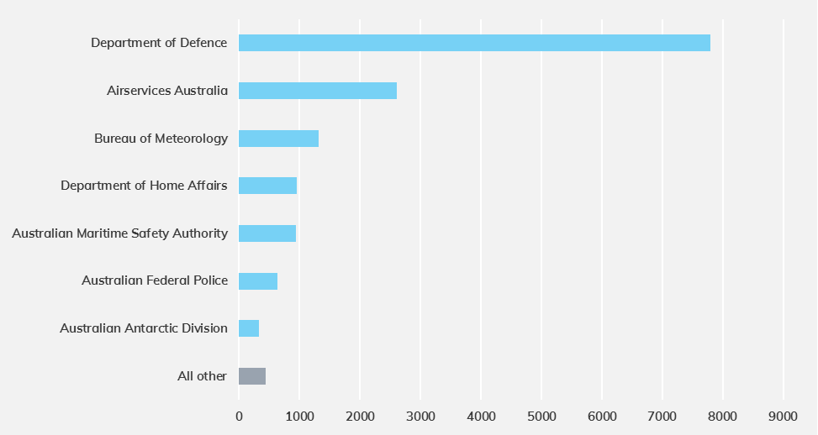

As technology changes so will demand for spectrum. Major Australian Government holders, such as Defence, are planning in the future to look towards these new technologies to consider efficiencies in spectrum management, including demand based spectrum management and sharing.

Through the reporting process agencies have identified a range of future spectrum use needs, and in some instances identified where licences are no longer required. The process has identified where agencies will have continued, or growing need, for further spectrum use. It has also identified where future technologies will mean spectrum use is likely to change in the ten year outlook. For example, new satellite technologies could in future be used to support aviation communication, which raises the possibility that licences will no longer be required for certain technologies as agencies needs change and equipment lifecycles evolve.

The reporting process has enabled agencies to undertake a thorough stocktake of existing holdings, which will inform both the agencies’ individual future use and their engagement in the future aims of the Government Spectrum Steering Committee. This includes policy advice on whole-of-government efficient spectrum management, including opportunities in future for sharing and trading mechanisms.

The advice of the Government Spectrum Steering Committee will be informed by this reporting process. A stock-take of spectrum use every two years will assist in future coordination and effective management of this important resource for all Australians.

## Australian Government use

The section below provides a summary of Australian Government use against aggregated frequency bands, defined by major Australian Government use within the ARSP allocations. These summaries also include relevant references to forward planning within the ACMA’s current Five Year Spectrum Outlook, and aggregated data collated from the ARSP and respective agencies.

### Very low frequency and low frequency bands

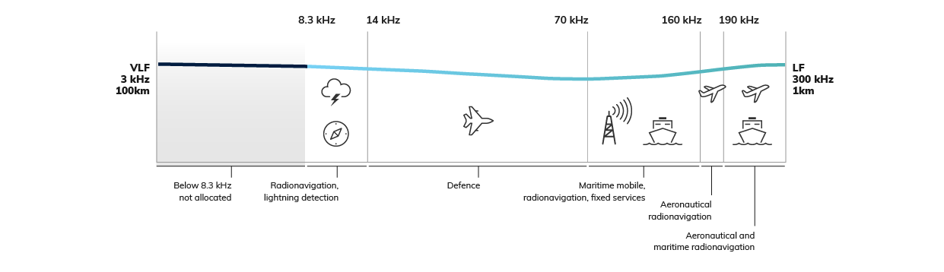

#### 3 – 300 kHz

The ARSP primarily allocates the VLF and LF spectrum bands to radiodetermination (operating stations that determine the position, velocity or other characteristic of an object, or other related information e.g. radio beacons or RADAR). The Department of Defence and Airservices Australia have the highest number of Australian Government frequency assignments within this band.

Australian Government uses for these bands include (but are not limited to):

* Radionavigation Satellite Systems (RNSS)
* Differential Global Positioning System (DGPS)
* non-directional beacon aviation navigation aids
* submarine communications.

Geographically, the vast majority of Australian Government use within these bands is area-wide. The remaining uses are limited to a small number of site-based operations. All assignments within these bands are reported as being critical to agency objectives or capability, with the majority of uses having safety implications.

Most Australian Government uses within these bands require continual access to spectrum. However, Airservices Australia is planning a review of its backup navigation network, which may have implications for band usage.

| Government users | Frequency assignments | Licence types | Government use |
| --- | --- | --- | --- |
| Airservices Australia, Australian Maritime Safety Authority, Department of Defence | 57 frequency assignments across 3 agencies | Aeronautical, Defence, Radiodetermination | 78% of overall assignments |

### Medium frequency

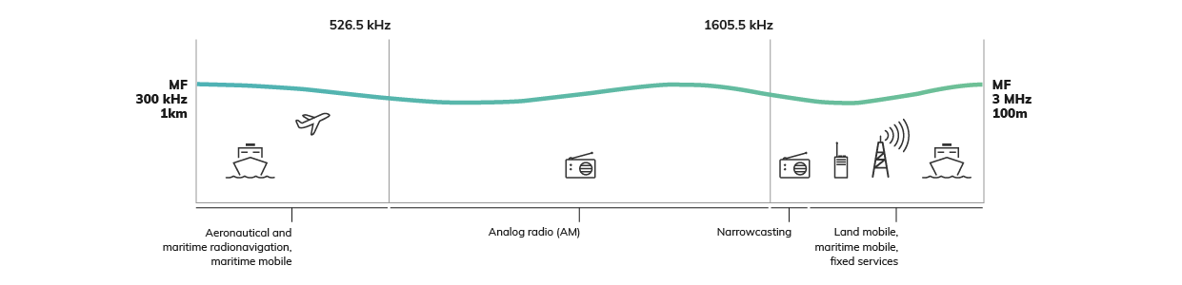

#### 300 – 526.5 kHz

The ARSP allocates this section of spectrum to aeronautical and maritime radionavigation and maritime mobile communications. The Department of Defence, Airservices Australia and the Australian Maritime Safety Authority have the highest number of Australian Government frequency assignments within this band.

Australian Government uses for this band include (but are not limited to):

* non-directional beacon aviation navigation aids
* DGPS.

Geographically, the majority of Australian Government use within the band is Area-wide. The remaining uses are limited to a small number of site-based operations. All assignments within this band were reported as having safety implications.

The majority of Australian Government uses within this band require continual access to spectrum.

| Government users | Frequency assignments | Licence types | Government use |
| --- | --- | --- | --- |
| Airservices Australia, Australian Maritime Safety Authority, Department of Defence | 98 frequency assignments across 3 agencies | Aeronautical, Radiodetermination | 83% of overall assignments |

#### 1605.5kHz – 3 MHz

The ARSP allocates this section of spectrum to narrowcasting, land mobile, maritime mobile and fixed services. The Department of Defence has the highest number of Australian Government frequency assignments within this band.

Australian Government uses for this band include (but are not limited to):

* Australian Defence Force communications from air, ground and maritime platforms
* communication across Antarctic stations
* marine weather forecast services
* maritime mobile use
* measuring ionospheric conditions.

Geographically, the vast majority of Australian Government use within this band is site-based. The remaining are area or Australia-wide. Most assignments within this band were reported as being critical to agency objectives or capabilities, with nearly a third having safety implications. Use within this band also includes third party authorisation for testing new equipment.

Spectrum access requirements within this band are expected to vary, with some increasing in line with capability developments and the expected modernisation of some networks changing access requirements in the future.

| Government users | Frequency assignments | Licence types | Government use |
| --- | --- | --- | --- |
| Australian Antarctic Division, Bureau of Meteorology, Defence | 454 frequency assignments across 3 agencies | Aeronautical, Fixed, Fixed Receive, Land Mobile, Maritime Coast, Major Coast Receive, Maritime Ship, Radiodetermination | 10% of overall assignments |

### High frequency

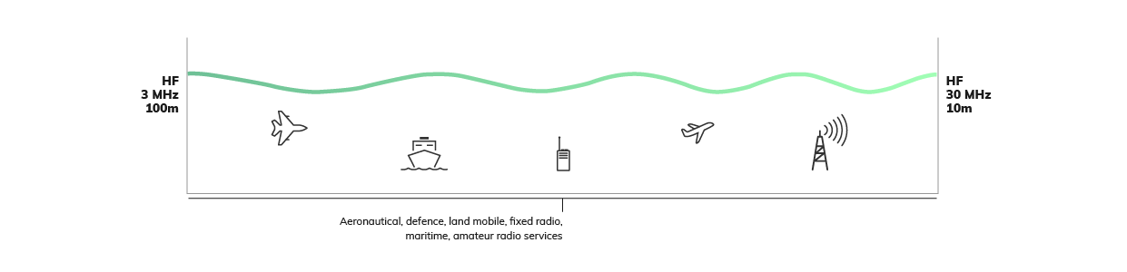

#### 3 – 30 MHz

The ARSP allocates this section of spectrum to land mobile, maritime, aeronautical, fixed and amateur radio services, and a significant portion is footnoted for Defence use. The Department of Defence, Airservices Australia, Australian Maritime and Safety Authority and the Australian Antarctic Division have the highest number of Australian Government frequency assignments within this band.

Australian Government uses for this band include (but are not limited to):

* Australian Defence Force communications from air, ground and maritime platforms
* aviation communications for air traffic control
* communication between Antarctic stations
* marine weather forecast services
* maritime communications and search and rescue (as part of the Global Maritime Distress Safety System (GMDSS)
* multinational training and Indo-Pacific outreach
* measurement of ionospheric conditions
* radar facilities.

Geographically, most Australian Government assignments within this band are area-wide or site-based. All assignments were reported as being critical or very important to agency objectives or capabilities, with some having safety implications.

Spectrum access requirements within this band may change as satellite communications are implemented as the global standard for aviation. However, there are emerging technology standards, which demand higher bandwidths to support streaming video and images in High Frequency (HF) band. The Department of Defence is encouraging defence users of the spectrum to explore demand-based access practices to address congestion.

| Government users | Frequency assignments | Licence types | Government use |
| --- | --- | --- | --- |
| Airservices Australia, Australian Antarctic Division, Australian Federal Police, Australian Maritime Safety Authority, Bureau of Meteorology, Department of Defence, Department of Home Affairs | 5,012 frequency assignments across 6 agencies | Aeronautical, Defence, Fixed, Fixed Receive, Land Mobile, Major Coast Receive, Maritime Coast, Maritime Ship, Radiodetermination, Scientific | 23% of overall assignments |

### Very high frequency

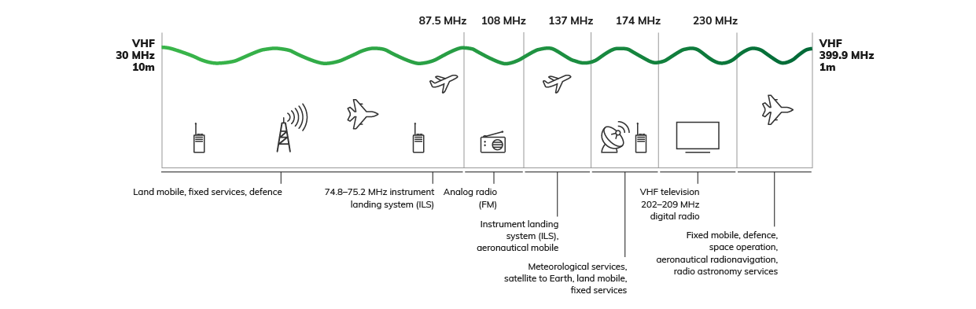

#### 30 – 87.5 MHz

The ARSP allocates this section of spectrum to land mobile, fixed services, Defence, and aeronautical radionavigation (instrument landing system marker beacons). The Department of Defence has the highest number of Australian Government frequency assignments within this band.

Australian Government uses for this band include (but are not limited to):

* aircraft landing navigation
* aviation Instrument Landing Systems
* field work communications
* operational deployment
* scientific equipment
* support to Humanitarian Assistance and Disaster Recovery
* tactical voice communication systems from ground-to-air and air-to-ground
* ground-to-ground wide area tactical voice communications
* testing radiation hazard levels
* vertical wind profilers.

Geographically, the vast majority of all Australian Government assignments are site-based. Most assignments were reported as critical to achieving agency objectives or capabilities.

Spectrum access requirements within this band are expected to vary, with a number reporting an ongoing need while noting some technologies may require a review of spectrum access needs in the future.

| Government users | Frequency assignments | Licence types | Government use |
| --- | --- | --- | --- |
| Airservices Australia, Australian Antarctic Division, Bureau of Meteorology, Commonwealth Scientific and Industrial Research Organisation (CSIRO), Department of Defence | 1,077 across 5 agencies | Aeronautical, Defence, Fixed, Land Mobile, Radiodetermination, Scientific | 9% of overall assignments |

#### 87.5 – 108 MHz

The ARSP allocates this section of spectrum to analogue radio broadcast (FM) use. The departments of Infrastructure, Regional Development and Cities, and Agriculture and Water Resources have the highest number of Australian Government frequency assignments.

Australian Government uses for this band include (but are not limited to):

* compact, transportable radio stations (Radio In a Box) usable for information dissemination during humanitarian assistance and disaster recovery
* providing local community information for Narrabri on FM
* radio broadcast licences to provide remote community self-help sites with ABC and commercial radio content.

Geographically, Australian Government use within this band varies between being site and area-wide. Assignments within this band were reported to support a wide range of uses of high importance to agency objectives, including safety implications and administrative use.

Australian Government use of this band is expected to remain consistent, with a potential need for increased spectrum for deploying compact radio stations.

| Government users | Frequency assignments | Licence types | Government use |
| --- | --- | --- | --- |
| CSIRO, Department of Agriculture and Water Resources, Department of Defence, Department of Infrastructure, Regional Development and Cities, Director of National Parks | 24 frequency assignments across 5 agencies | Broadcasting | 0.5% of overall assignments |

#### 108 – 137 MHz

The ARSP allocates this section of spectrum to aeronautical radionavigation (instrument landing system) and aeronautical mobile use. The operation of radiocommunication services in this band is subject to ICAO Standards and Recommended Practices. Airservices Australia and the Department of Defence have the highest number of Australian Government frequency assignments within this band.

Australian Government uses for this band include (but are not limited to):

* air-to-ground & air-to-air communications (VHF voice & data)
* aviation navigation systems
* VHF communications for the Aviation Rescue and Fire-Fighting Service
* RAAF aircraft coordination and communication
* Australian Defence Force tactical radio systems predominantly for voice communications.

Geographically, the majority of Australian Government assignments are Area-wide. The vast majority of assignments were reported as being critical or very important to agencies objectives and having safety implications.

Spectrum access sharing arrangements exists in this band between Airservices Australia and the Department of Defence. Additional class licence (Aircraft and Aeronautical Mobile Stations class licence) use in this band supports air traffic control communications and emergency communications.

| Government users | Frequency assignments | Licence types | Government use |
| --- | --- | --- | --- |
| Airservices Australia, Australian Antarctic Division, Australian Federal Police, Bureau of Meteorology, Department of Defence, Department of Infrastructure, Regional Development and Cities, Director of National Parks | 1,581 frequency assignments across 7 agencies | Aeronautical | 35% of overall assignments |

#### 137 – 174 MHz

The ARSP allocates this section of spectrum to meteorological, satellite to earth, land mobile and fixed services. The Australian Maritime Safety Authority and Bureau of Meteorology have the highest number of Australian Government frequency assignments within this band.

Australian Government uses for this band include (but are not limited to):

* Antarctic station to shipping vessel communications
* Australian Defence Force operational deployment
* VHF maritime communications for the Aviation Rescue and Fire-Fighting Service
* building security and operations
* flood warning networks
* high-profile bilateral initiatives
* humanitarian assistance and disaster recovery
* marine weather forecasts
* maritime communications and search and rescue (as part of the GMDSS)
* tactical voice communications.

Geographically, over a third of all Australian Government assignments are Australia-wide for national maritime communication purposes. The remaining are mainly site based. All assignments were reported as critical to agency objectives, with most having safety implications. The Department of Defence is encouraging defence users of the spectrum to explore dynamic access practices for specific aeronautical uses.

Most Australian Government use within this band will require continual access to this frequency range. The 2019 WRC will consider use within this band.

| Government users | Frequency assignments | Licence types | Government use |
| --- | --- | --- | --- |
| Airservices Australia, Australian Antarctic Division, Australian Federal Police, Australian Maritime Safety Authority, Bureau of Meteorology, CSIRO, Department of Agriculture and Water Resources, Department of Defence, Department of Home Affairs, Department of Infrastructure, Regional Development and Cities, Director of National Parks, Indigenous Land Corporation | 1,631 frequency assignments across 12 agencies | Aeronautical, Aircraft, Fixed, Fixed Receive, Land Mobile, Maritime Coast, Radio-determination | 4% of overall assignments |

#### 174 – 230 MHz

The ARSP allocates this section of spectrum to VHF digital television and radio. The only Australian Government user in this band is the Department of Infrastructure, Regional Development and Cities for remote broadcasting purposes.

Geographically, these Australian Government assignments are area-wide. These assignments are critical to agency objectives and have safety implications.

Australian Government access to spectrum for this use is expected to continue. The daily transmission of digital television and radio services to remote communities provides free to air television content and emergency warning notifications in remote communities including the Cocos (Keeling) Islands and Christmas Island.

| Government users | Frequency assignments | Licence types | Government use |
| --- | --- | --- | --- |
| Department of Infrastructure, Regional Development and Cities | 10 frequency assignments | Broadcasting | 3% of overall assignments |

#### 230 – 399.9 MHz

The ARSP commits this section of spectrum to aeronautical radionavigation, fixed mobile, space operation and radio astronomy services. This is an internationally harmonised spectrum segment for government use. Although the Department of Home Affairs holds the most frequency assignments, including through third party arrangements with the Department of Defence, the Department of Defence has access to the entire frequency range (less the 328.6 – 335.4 MHz segment) through allocations via ARSP footnotes. Defence provides third party authorisation to other federal agencies and for temporary events on case-by-case basis.

Australian Government uses for this band include (but are not limited to):

* aircraft landing navigation
* Ultra High Frequency (UHF) air-to-ground and air-to-air communications
* emergency frequency operations
* radar
* military operational and training deployment support for voice and wideband data communications
* instrument Landing Systems (glideslope component)
* border protection
* UHF satellite communication.

Geographically, most Australian Government assignments are site-based. The majority of assignments are critical to agency objectives. While most Australian Government users are expected to require continual access within this band, some capability developments may result in increased spectrum demand. For example, the transfer from traditional voice communications to high quality video and file transfer will likely result in increased demand for spectrum.

| Government users | Frequency assignments | Licence types | Government use |
| --- | --- | --- | --- |
| Airservices Australia, Department of Defence, Department of Home Affairs | 177 frequency assignments across three agencies | Aeronautical, Defence, Land Mobile, Radiodetermination | 90% of overall assignments |

### Ultra high frequency

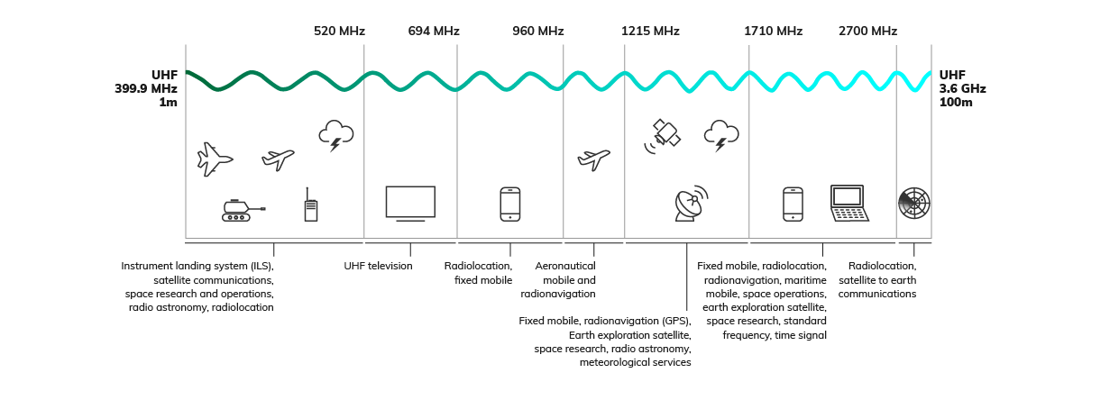

#### 399.9 – 520 MHz

The ARSP allocates this section of spectrum to include satellite communications, space research and operations, mobile, fixed, aeronautical mobile and radionavigation, radio astronomy, and radiolocation uses. The Australian Federal Police, Bureau of Meteorology and departments of Defence and Home Affairs have the highest number of Australian Government frequency assignments within this band.

Australian Government uses for this band include (but are not limited to):

* air traffic data transmissions across the Airservices network
* UHF communications for the Aviation Rescue and Fire-Fighting Service
* emergency frequency operations
* RNSS
* land mobile use to support site operations and building security services.

Geographically, most Australian Government assignments are site based. The remaining are Australia-wide. The majority of assignments are critical to agency objectives, with many having safety implications. The Department of Defence provides third party authorisation in this band for radio use at special events.

This frequency range also includes the 400 MHz of HGS. HGS is primarily used for land mobile services but is also shared with some fixed (point-to-point and point-to-multipoint), radiolocation and amateur use. The HGS comprises several segments in 403 – 470 MHz, which are identified for exclusive use by the state and territory governments under this approach, enabling interoperability for land mobile services used for national security, law enforcement and emergency services.

| Government users | Frequency assignments | Licence types | Government use |
| --- | --- | --- | --- |
| Australian Criminal Intelligence Commission, Australian Federal Police, Airservices Australia, Australian Nuclear Science and Technology Organisation, Australian Securities and Investment Commission, Australian Sports Commission, Australian War Memorial, Bureau of Meteorology, CSIRO, Department of industry, Innovation and Science, Department of Defence, Department of Health, Department of Home Affairs, Department of Infrastructure, Regional Development and Cities, Department of Parliamentary Services, Treasury, National Parks, Federal Court of Australia, Geoscience Australia, National Gallery of Australia, National Library of Australia, National Museum of Australia, National Portrait Gallery of Australia, Office of the Official Secretary to the Governor-General | 1,276 frequency assignments across 27 agencies | Aeronautical, Defence, Earth, Fixed, Fixed Receive, Land Mobile, Radiodetermination | 1% of overall assignments |

#### 520 – 694 MHz

The ARSP allocates this section of the spectrum to UHF television. The Department of Infrastructure, Regional Development and Cities has the highest number of Australian Government frequency assignments within this band.

Australian Government uses for this band include (but are not limited to):

* DTV rebroadcasting to remote communities
* re-transmitting signals to remote defence base locations.

Geographically, the majority of Australian Government assignments are area-wide. The remaining are site-based. Assignments were reported as having safety implications, as well as being supportive of administrative functions.

Australian Government use within this band is expected to continue. The ACMA’s 2018–22 Five-Year Spectrum Outlook (FYSO) notes ongoing monitoring of this band.

| Government users | Frequency assignments | Licence types | Government use |
| --- | --- | --- | --- |
| Department of Defence, Department of Infrastructure, Regional Development and Cities | 24 frequency assignments across 2 agencies | Broadcasting | 1% of overall assignments |

#### 694 – 960 MHz

The ARSP allocates this section of the spectrum to fixed mobile and radiolocation. The Department of Defence and the Australian Federal Police have the highest number of Australian Government frequency assignments within this band.

Australian Government uses for this band include (but are not limited to):

* Antarctic stations
* air traffic data transmissions across the Airservices network
* mobile radar systems
* operational functions on offshore islands
* radio Acoustic Sounding Systems
* range safety networks ad Defence training areas.

Geographically, the majority of Australian Government assignments in this band are site-based. All assignments were reported as critical to agency objectives, with many having safety implications.

Australian Government use within this band will require continual access to this frequency range, with a large portion of uses’ requirements expected to grow. Within this band the ACMA is implementing outcomes of the review of the 803 – 960 MHz band.

| Government users | Frequency assignments | Licence types | Government use |
| --- | --- | --- | --- |
| Airservices Australia, Australian Antarctic Division, Australian Federal Police, Bureau of Meteorology, CSIRO, Department of Defence, Department of Home Affairs | 864 across 7 agencies | Defence, Fixed, Land Mobile, Radiodetermination | Less than 1% of overall assignments |

#### 960 – 1215 MHz

The ARSP allocates this section of spectrum to aeronautical mobile and radionavigation. Airservices Australia has the highest number of Australian Government frequency assignments within this band.

Australian Government uses in this band include (but are not limited to):

* aeronautical air-to-ground communications
* military tactical data link networks
* aeronautical radio navigation
* aeronautical surveillance
* surveillance radars.

Geographically, most Australian Government assignments are Australia-wide. The majority of assignments were reported as critical to agency objectives and having safety implications. Shared access occurs in this band between the Department of Defence and Airservices Australia.

Australian Government use within this band is expected to continue, with some potential for increased spectrum requirements as new international partnerships are formed.

| Government users | Frequency assignments | Licence types | Government use |
| --- | --- | --- | --- |
| Airservices Australia, Department of Defence | 651 frequency assignments across two agencies | Defence, Fixed Receive, Radiodetermination | 98% of overall assignments |

#### 1215 – 1710 MHz

The ARSP allocates this section of spectrum to earth exploration-satellite, radiolocation, radionavigation, space research, meteorological aids, and fixed mobile. The Bureau of Meteorology has the highest number of Australian Government frequency assignments within this band.

Australian Government uses for this band include (but are not limited to):

* unmanned Aerial Systems command and control
* RNSS
* air traffic data transmissions across the Airservices network
* aviation satellite communications
* meteorological satellite earth station receivers
* radioastronomy observations
* surveillance radars
* telemetry systems
* transportable radar systems
* wind profilers.

Geographically, most Australian Government assignments use is site-based or area-wide. The vast majority of assignments were reported as being critical to agency objectives.

Australian Government use within this band is expected to remain mostly consistent, with some increase in requirements due to capability advancements. The ACMA’s FYSO recognises the need to review planning arrangements for parts of the 1500 and 1600 MHz spectrum range to identify uses that will maximise overall public benefit.

| Government users | Frequency assignments | Licence types | Government use |
| --- | --- | --- | --- |
| Airservices Australia, Australian Maritime Safety Authority, Bureau of Meteorology, CSIRO, Department of Defence, Geoscience Australia | 161 frequency assignments across 6 agencies | Aircraft, Aeronautical, Defence, Earth Receive, Fixed, Fixed Receive, Radiodetermination | 2% of overall assignments |

#### 1710 – 2700 MHz

The ARSP allocates this section of spectrum fixed mobile, radiolocation, radionavigation, maritime mobile, space operations, earth exploration satellite, space research, standard frequency and time signal. The CSIRO and Department of Defence have the highest number of Australian Government frequency assignments within this band.

Australian Government uses in this band include (but are not limited to):

* Australian Defence Force operational deployments
* defence telemetry systems
* doppler orbitography and radiopositioning
* Earth observation/ remote sensing satellite services
* meteorological satellite communications
* radioastronomy observations
* spacecraft tracking and communications.

Geographically, most Australian Government assignments are site-based. Nearly all assignments are critical to agency objectives or capabilities. Australian Government use within this band is expected to remain mostly consistent, with some increase in requirements due to capability advancements.

In 2016, the ACMA released arrangements for use of the 1800 MHz band in remote areas for fixed and mobile wireless broadband services, the current FYSO notes that demand for spectrum in the 1800 MHz band in remote areas is better understood, the ACMA will review the existing arrangements. The ACMA’s FYSO also outlines plans to continue to monitor and, where appropriate, engage with stakeholders on the development of international issues related to the frequency bands 1980 – 2010 MHz and 2170 – 2200 MHz.

| Government users | Frequency assignments | Licence types | Government use |
| --- | --- | --- | --- |
| Australian Maritime Safety Authority, Bureau of Meteorology, CSIRO, Department of Defence, Geoscience Australia | 41 frequency assignments across 5 agencies | Aeronautical, Earth, Earth Receive, Fixed | Less than 1% of overall assignments |

#### 2700 MHz – 3.6 GHz

The ARSP allocates this section of spectrum to aeronautical radionavigation, radiolocation and satellite to earth communications, and wireless broadband. The Department of Defence has the highest number of Australian Government frequency assignments within this band.

Australian Government uses in this band include (but are not limited to):

* air traffic control primary surveillance radar
* maritime radars
* ship navigation in Australian waters
* multinational training and Indo-Pacific outreach
* communications and surveillance in support of Humanitarian Assistance and Disaster Recovery
* weather radars.

Geographically, the majority of Australian Government assignments are site-based. All assignments were reported as critical to agency objectives, with the majority having safety implications. Shared access occurs within part of this band between the Department of Defence, Bureau of Meteorology and Airservices Australia. Australian Government use within this band is expected to continue.

The 3.3 GHz band is allocated to radiolocation services worldwide on a primary basis. In Australia, the radiolocation services in this band are mostly used for air traffic control, defence and national security purposes. The ACMA’s FYSO notes it will continue to monitor international developments on mobile broadband use in this band, including the potential for economies of scale for equipment.

Noting incumbent use in this band, the ACMA believes this band may be a candidate for dynamic spectrum-access (DSA) type arrangements, to promote sharing and increase utility. The ACMA plans to engage relevant stakeholders to gain a better understanding of existing use patterns in the band.

| Government users | Frequency assignments | Licence types | Government use |
| --- | --- | --- | --- |
| Airservices Australia, Australian Maritime Safety Authority, Bureau of Meteorology, Department of Defence | 281 frequency assignments across 4 agencies | Defence, Radiodetermination | 2% of overall assignments |

### Super high frequency

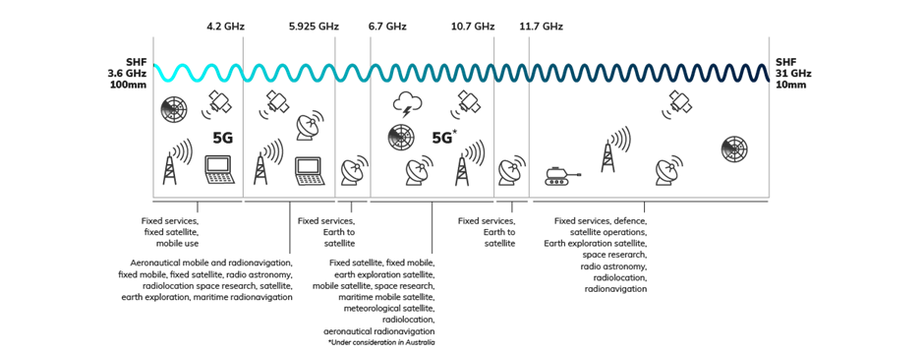

#### 3.6 – 4.2 GHz

The ARSP allocates this section of spectrum to fixed services, fixed-satellite, and mobile use. The Department of Defence and the Department of Home Affairs have the highest number of Australian Government frequency assignments within this band.

Australian Government uses for this band include (but are not limited to):

* defence space communications
* meteorological satellite services
* Australian Defence Force unit deployments
* humanitarian assistance and disaster recovery support.

Geographically, all Australian Government assignments are site-based. All assignments were reported as critical to agency objectives or capability. Australian Government use within this band will require continual access to this frequency range.

This section of the SHF band includes 3.8 GHz, which has received much attention in relation to 5G. In Australia, the 3.8 GHz frequency range is currently allocated on a co-primary basis for fixed/fixed-satellite (space-to-earth) and mobile services.

| Government users | Frequency assignments | Licence types | Government use |
| --- | --- | --- | --- |
| Bureau of Meteorology, Department of Defence, Department of Home Affairs, Geoscience Australia | 18 frequency assignments across 4 agencies | Earth Receive, Radiodetermination | 1% of overall assignments |

#### 4.2 – 5.925 GHz

The ARSP allocates this section of spectrum to Aeronautical Mobile and Radionavigation, fixed mobile, fixed-satellite, radioastronomy, radiolocation space research, earth-exploration satellite, and maritime radionavigation. The Bureau of Meteorology holds the majority of Australian Government frequency assignments within this band.

Australian Government uses in this band include (but are not limited to):

* airborne radio altimeter
* airborne weather radar for aircraft
* defence space communications
* tactical high capacity point-to-point links
* radioastronomy observations
* ship-based
* weather radar
* space surveillance radar
* data and telemetry for Unmanned Aerial Systems.

Geographically, the majority of assignments are site based, with four Australia-wide assignments supporting aircraft and ship operations. Major uses were reported as being critical to agency objectives or capability, with a large number reporting safety implications. All Australian Government use within this band will require continual access to this frequency range, with future capabilities potentially requiring additional bandwidth.

The ACMA’s FYSO notes that the 4.8 GHz section of this section of spectrum (4800 – 4940 MHz) is primarily designated for defence and national security purposes, but recognises the increasing interest for mobile broadband services. The ACMA will continue to monitor international developments, with a view this band may be a candidate for DSA type arrangements, to promote sharing and increase utility.

This section of the SHF band also includes class licence arrangements in the 4.9 GHz band (4940 – 4990 MHz) for public protection and disaster relief. This enhances public safety agency operations and provides flexibility in deploying emergency responses and disaster recovery activities.[25] The class licence is to both commonwealth and state public safety agencies, although current use is understood to be primarily by state agencies. This forms part of the ACMA’s strategic approach to meet the spectrum requirements of Australian public safety agencies.[26]

| Government users | Frequency assignments | Licence types | Government use |
| --- | --- | --- | --- |
| Airservices Australia, Bureau of Meteorology, CSIRO, Department of Defence | 124 assignments across 4 agencies | Defence, Earth Receive, Radiodetermination | 10% of overall assignments |

#### 5.925 – 6.7 GHz

The ARSP allocates this section of spectrum to fixed services and earth to satellite communications. The Department of Home Affairs, Bureau of Meteorology and the Department of Defence have the highest number of Australian Government frequency assignments within this band.

Australian Government uses in this band include (but are not limited to):

* data transmission
* defence communication
* point-to-point communication links
* satellite communications
* primary surveillance radar.

Geographically, the majority of assignments are site-based and were reported as critical to agency objectives or capability. Most Australian Government use within this band will require continual access to this frequency range.

| Government users | Frequency assignments | Licence types | Government use |
| --- | --- | --- | --- |
| Australian Antarctic Division, Bureau of Meteorology, Department of Defence, Department of Home Affairs, Geoscience Australia | 29 assignments across 5 agencies | Earth, Fixed, Radiodetermination | Less than 1% of overall assignments |

#### 6.7 – 10.7 GHz

The ARSP allocates this section of spectrum to fixed-satellite, fixed-mobile, space research, earth exploration satellite, mobile satellite, maritime mobile-satellite, meteorological satellite, radiolocation and aeronautical radionavigation. The Department of Defence, Airservices Australia and the Australian Maritime Safety Authority have the highest number of Australian Government frequency assignments within this band.

Australian Government uses in this band include (but are not limited to):

* air traffic data transmissions across the Airservices network
* airborne doppler and weather radar for aircraft
* CCTV functions
* defence communications
* humanitarian assistance and disaster relief support
* RACONS for ship navigation
* radioastronomy observations and spacecraft tracking
* airport surface movement radars
* satellite communications
* Earth observation/remote sensing satellite services.

Geographically, most Australian Government assignments are site-based, with one Australia-wide assignment used for air services. The majority of assignments were reported as critical to agencies objectives or capability, with a large number having safety implications. The remaining were reported as being very important to agency objectives and administrative/functional support.

Most Australian Government use within this band will require continual access to this frequency range.

| Government users | Frequency assignments | Licence types | Government use |
| --- | --- | --- | --- |
| Airservices Australia, Australian Federal Police, Australian Institute of Marine Science, Australian Maritime Safety Authority, Australian Nuclear Science and Technology Organisation, Bureau of Meteorology, CSIRO, Department of Defence, Department of Home Affairs,  Department of Parliamentary Services, Geoscience Australia | 588 assignments across 11 agencies | Aircraft, Defence Receive, Earth, Earth Receive, Fixed, Radiodetermination | 2% of overall assignments |

#### 10.7 – 11.7 GHz

The ARSP allocates this section of the spectrum to fixed services and earth to satellite communications. The Department of Home Affairs holds the majority of Australian Government frequency assignments.

Australian Government uses in this band include (but are not limited to):

* CCTV functions
* data transmissions
* point-to-point communications.

Geographically, all Australian Government assignments are site-based, and were reported as critical to achieving agency objectives and having safety implications. Australian Government use within this band will require continual access to this frequency range.

| Government users | Frequency assignments | Licence types | Government use |
| --- | --- | --- | --- |
| Bureau of Meteorology, CSIRO, the Department of Home Affairs | 36 assigned frequencies across 3 agencies | Fixed | Less than 1% of overall assignments |

#### 11.7 – 31 GHz

The ARSP allocates this section of spectrum to fixed services, defence, satellite operations, Earth exploration, space research, radio astronomy, radiolocation and radionavigation. The Department of Defence, Airservices Australia and the Bureau of Meteorology have the highest number of Australian Government frequency assignments within this band.

Australian Government uses in this band include (but are not limited to):

* airborne doppler radar for aircraft
* CCTV functions
* humanitarian assistance and disaster relief support
* radioastronomy observations
* Military satellite communications
* spacecraft tracking and communications
* time-critical voice/data supporting air traffic services transmissions.

Geographically, the majority of Australian Government assignments are site-based, and were reported as critical to agencies objectives or capabilities. The majority of Australian Government use within this band will require continual access to this frequency range.

The Department of Defence holds Australia Wide spectrum licences in this band. The frequency bands 20.2 – 21.2 GHz and 30 – 31 GHz are globally harmonised for military.

The ACMA is in consultations on the suitability of the 28 GHz band for a broad range of users and service types and will soon be finalising planning arrangements for wireless broadband in the 26 GHz band.

| Government users | Frequency assignments | Licence types | Government use |
| --- | --- | --- | --- |
| Airservices Australia, Bureau of Meteorology, CSIRO, Department of Defence, Department of Home Affairs | 341 across 5 agencies | Aeronautical, Defence, Earth Receive, Fixed, Radiodetermination, Spectrum | 1% of assignments across the band |

### Extremely high frequency

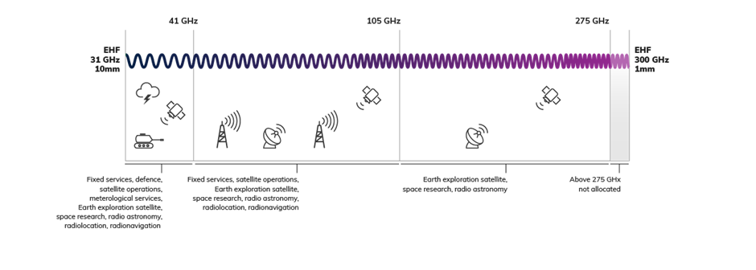

#### 31 – 300 GHz

The ARSP allocates this section of spectrum to include fixed services, satellite operations, radiolocation, radio astronomy and earth exploration satellite. The main use in this section of spectrum is point‑to‑point fixed services and radiodetermination. The Australian Federal Police and Department of Home Affairs have the highest number of Australian Government frequency assignments within this band.

Australian Government uses in this band include (but are not limited to):

* CCTV functions
* cloud radars
* humanitarian assistance and disaster recovery support
* short range radars
* radioastronomy observations
* spacecraft tracking and communications.

Geographically, most Australian Government assignments are site-based. All assignments were reported as critical or important to agency objectives. Use within this band also includes third party authorisation for testing new systems.

Components of this band are under consideration by the WRC for future development of International Mobile Telecommunications and 5G. The ACMA’s FYSO also notes that 40/50 GHz range in this band is attracting interest for terrestrial broadband use as part of millimetre wave 5G and increasing interest for satellite communications.[27]

| Government users | Frequency assignments | Licence types | Government use |
| --- | --- | --- | --- |
| Australian Federal Police, Bureau of Meteorology, CSIRO, Department of Defence, Department of Home Affairs | 118 frequency assignments | Defence, Earth, Earth Receive, Fixed, Radiodetermination | 2% of overall assignments |

## Attachments

### Government Spectrum Steering Committee members

This Report was produced under the direction of the Committee. The Committee is chaired by the Department of Communications and the Arts and its members consist of senior representatives from the Australian Government departments and agencies who are major users of spectrum. The ACMA provides technical advice to the Committee.

Member

Department of Communications and the Arts (Chair)

ACMA (Technical Advisor)

Australian Federal Police

Bureau of Meteorology

CSIRO

Department of Defence

Department of Home Affairs

Department of Industry, Innovation and Science

Department of Infrastructure, Regional Development and Cities

Geoscience Australia

### Departments and agencies consulted

| Portfolio | Department / agency |
| --- | --- |
| Agriculture and Water Resources | * Department of Agriculture and Water Resources |
| Australian Government Parliament | * Department of Parliamentary Services |
| Communications and the Arts | * National Film and Sound Archive of Australia * National Gallery of Australia * National Library of Australia * National Museum of Australia * National Portrait Gallery of Australia |
| Courts | * Federal Court of Australia * High Court of Australia |
| Environment and Energy | * Department of Environment and Energy * Australian Antarctic Division * Bureau of Meteorology * Director of National Parks |
| Health | * Department of Health * Australian Sports Commission |
| Home Affairs | * Department of Home Affairs * Australian Criminal Intelligence Commission * Australian Federal Police |
| Infrastructure, Regional Development and Cities | * Department of Infrastructure, Regional Development and Cities * Airservices Australia * Australian Maritime Safety Authority |
| Jobs and Innovation | * Department of Industry, Innovation and Science * Australian Institute of Marine Science * Australian Nuclear Science and Technology Organisation * CSIRO * Geoscience Australia |
| Prime Minister and Cabinet | * Indigenous Land Corporation * Office of the Official Secretary to the Governor-General |
| Treasury | * The Treasury * Australian Securities & Investment Commission |

### Frequency band aggregation for reporting purposes

| **VLF/LF** | **MF** | **HF** | **VHF** | **UHF** | **SHF** | **EHF** |
| --- | --- | --- | --- | --- | --- | --- |
| 3 – 300  kHz | 300 – 526.5  kHz | 3 – 30  MHz | 30 – 87.5 MHz | 399.9 – 520 MHz | 3.6 – 4.2 GHz | 31 – 300 GHz |
|  | 526.5 – 1605.5  kHz[28] |  | 87.5 – 108 MHz | 520 – 694 MHz | 4.2 – 5.925 GHz |  |
|  | 1605.5 – 3000  kHz |  | 108 – 137 MHz | 694 – 960 MHz | 5.925 – 6.7 GHz |  |
|  |  |  | 137 – 174 MHz | 960 – 1215 MHz | 6.7 – 10.7 GHz |  |
|  |  |  | 174 – 230 MHz | 1215 – 1710 MHz | 10.7 – 11.7 GHz |  |
|  |  |  | 230 – 399.9 MHz | 1710 – 2700 MHz | 11.7 – 31 GHz |  |
|  |  |  |  | 2700 MHz – 3.6 GHz |  |  |

### Frequency assignments by band and by agency

**By band**

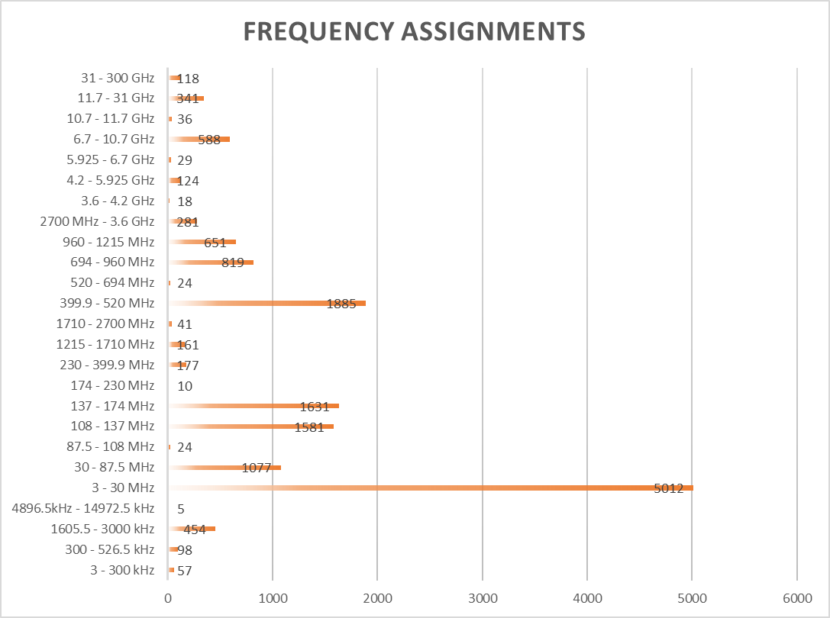

**By agency**

| **Agency** | Assignments |
| --- | --- |
| Department of Defence | 7793 |
| Airservices Australia | 2603 |
| Bureau of Meteorology | 1310 |
| Department of Home Affairs | 961 |
| Australian Maritime Safety Authority | 945 |
| Australian Federal Police | 636 |
| Australian Antarctic Division | 324 |
| Director of National Parks | 97 |
| CSIRO | 70 |
| Department of Infrastructure and Regional Development | 50 |
| Federal Court of Australia | 38 |
| Geoscience Australia | 26 |
| Department of Parliamentary Services | 25 |
| Indigenous Land Corporation | 24 |
| Department of Agriculture and Water Resources | 23 |
| Australian War Memorial | 20 |
| Australian Institute of Marine Science | 16 |
| Australian Nuclear Science and Technology Organisation | 10 |
| Department of Industry, Innovation and Science | 8 |
| Australian Sports Commission | 6 |
| Department of Health | 6 |
| National Gallery of Australia | 4 |
| National Museum of Australia | 4 |
| Office of The Official Secretary To The Governor-General | 2 |
| National Film and Sound Archive of Australia | 2 |
| National Library of Australia | 2 |
| Department of The Treasury | 2 |
| National Portrait Gallery of Australia | 2 |
| High Court of Australia | 2 |
| Australian Criminal Intelligence Commission | 2 |
| Australian Securities Investments Commission | 2 |

### Australian Defence Radiofrequency Spectrum

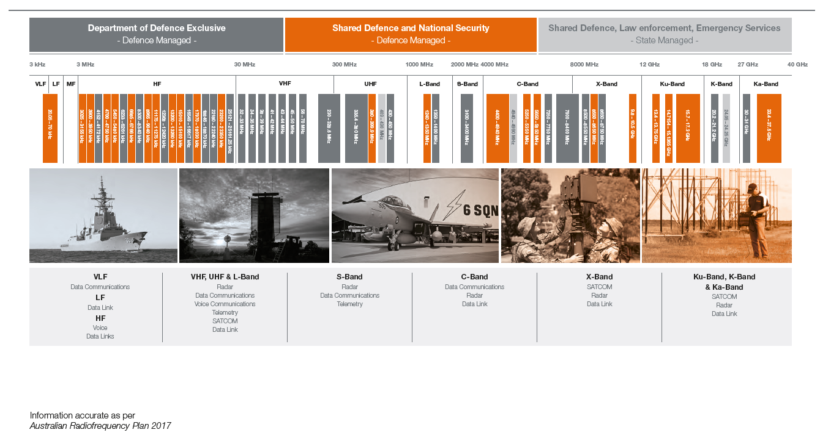

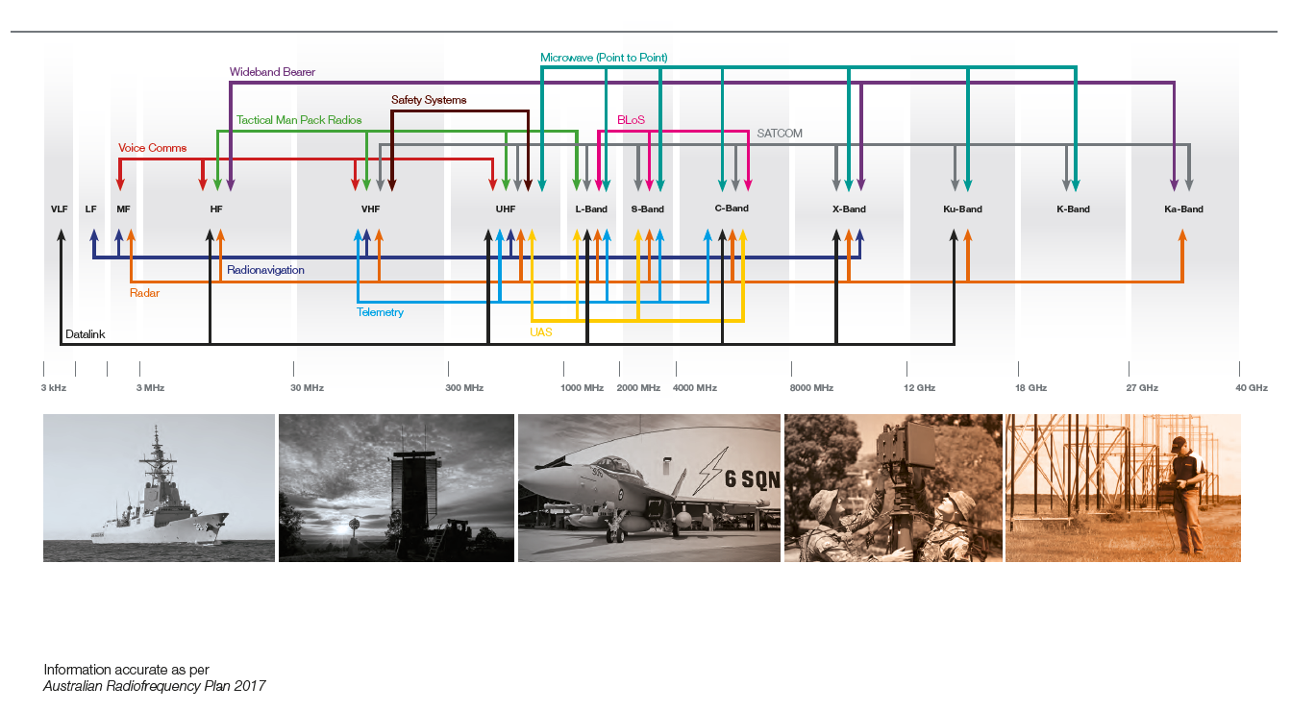

1. Per consultation on new spectrum legislation a proposal is being put forward to simplify spectrum licencing arrangements. [www.communications.gov.au/have-your-say/consultation-new-spectrum-legislation](http://ims.dept.gov.au/tccache59/5775959/www.communications.gov.au/have-your-say/consultation-new-spectrum-legislation)
2. [www.acma.gov.au/Industry/Spectrum/Radiocomms-licensing/Spectrum-licences/spectrum_20](http://ims.dept.gov.au/tccache59/5775959/www.acma.gov.au/Industry/Spectrum/Radiocomms-licensing/Spectrum-licences/spectrum_20)
3. [www.acma.gov.au/theACMA/About/Making-payments/Apparatus-licence-fees/apparatus-licence-fees-acma](http://ims.dept.gov.au/tccache59/5775959/www.acma.gov.au/theACMA/About/Making-payments/Apparatus-licence-fees/apparatus-licence-fees-acma)
4. [www.acma.gov.au/Industry/Spectrum/Radiocomms-licensing/Spectrum-licences/spectrum_20](http://ims.dept.gov.au/tccache59/5775959/www.acma.gov.au/Industry/Spectrum/Radiocomms-licensing/Spectrum-licences/spectrum_20)
5. https://www.acma.gov.au/theACMA/frequency-assignment-and-coordination
6. ITU, *Regulatory tools to support enhanced shared use of the spectrum,* 2017
7. [www.acma.gov.au/Industry/Spectrum/Radiocomms-licensing/Spectrum-licences/spectrum_20](http://ims.dept.gov.au/tccache59/5775959/www.acma.gov.au/Industry/Spectrum/Radiocomms-licensing/Spectrum-licences/spectrum_20)
8. https://www.acma.gov.au/Industry/Spectrum/Radiocomms-licensing/Apparatus-licences/third-party-authorisation-apparatus-licences-acma
9. [www.communications.gov.au/documents/commonwealth-held-spectrum-review](https://www.communications.gov.au/documents/commonwealth-held-spectrum-review)
10. Attachment A lists the members of the Government Spectrum Steering Committee (GSSC)
11. [www.acma.gov.au/theacma/australian-radiofrequency-spectrum-plan-spectrum-planning-acma](http://ims.dept.gov.au/tccache59/5775959/www.acma.gov.au/theacma/australian-radiofrequency-spectrum-plan-spectrum-planning-acma)
12. [www.acma.gov.au/theACMA/About/Making-payments/Apparatus-licence-fees/apparatus-licence-fees-acma](http://www.acma.gov.au/theACMA/About/Making-payments/Apparatus-licence-fees/apparatus-licence-fees-acma)
13. Some licences, such as marine, may not be bound by the geographic limitations of the administered pricing formula.
14. A list of the portfolios, departments and agencies included is available at Attachment B**.**
15. <https://web.acma.gov.au/rrl/register_search.main_page>
16. https://www.acma.gov.au/theACMA/maritime-coast-licences-guidelines#non_assigned
17. [www.acma.gov.au/theACMA/class-licensing](https://www.acma.gov.au/theACMA/class-licensing)
18. [www.acma.gov.au/theACMA/land-mobile-licences-guidelines#as](https://www.acma.gov.au/theACMA/land-mobile-licences-guidelines%23as)
19. The majority of licences held have two frequency assignments, transmitter and receiver, however depending on the licence it can range up to more than 100, demonstrating the variance in licences held.
20. Only agencies providing additional qualitative information were required to provide information on criticality or geographic use.
21. These categories do not represent a hierarchy of importance, noting the different use and purposes different agencies require spectrum for.
22. Only agencies providing additional qualitative information were required to provide information on criticality or geographic use.
23. In some instances Australia-wide may represent a frequency band that is shared with another agency or multiple users, for example where the band is only used for Australian waters and not in-land use.
24. As Australia’s major spectrum holder, further detail on Department of Defence holdings and management can be found at Attachment E.
25. www.acma.gov.au/Industry/Spectrum/Spectrum-projects/5-Year-Spectrum-Outlook/five-year-spectrum-outlook
26. www.acma.gov.au/theACMA/spectrum-for-public-safety-radiocommunications
27. https://www.acma.gov.au/Industry/Spectrum/Spectrum-projects/5-Year-Spectrum-Outlook/five-year-spectrum-outlook
28. There were no Australian Government reported licences in this bandwidth within the scope of this report.