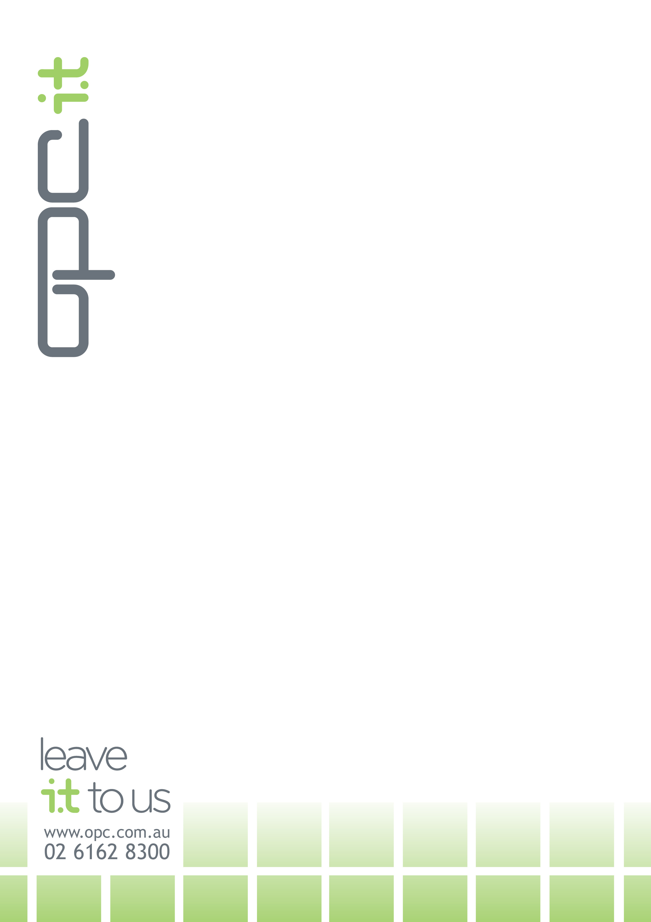Statement of Accessibility Conformance

Department of Communications and the Arts website

Site/s: www.arts.gov.au

Date: 27/07/2018

Tester: Glen Wallis, OPC IT Pty Limited

Technologies: **HTML, JavaScript**

Conformance Level: **Level AA**

**The Department of Communications website has received independent accessibility conformance testing on all pages.**

**The website has received a conformance level of Level AA as per the Web Content Accessibility Guidelines 2.0 (**<http://www.w3.org/TR/WCAG20/>**) \***

signature

_________________________________

Glen Wallis

Senior Accessibility Consultant

OPC IT Pty Limited

**\*Web Content Accessibility Guidelines (WCAG) 2.0 covers a wide range of recommendations for making Web content more accessible. Following these guidelines will make content accessible to a wider range of people with disabilities, including blindness and low vision, deafness and hearing loss, learning disabilities, cognitive limitations, limited movement, speech disabilities, photosensitivity and combinations of these. Following these guidelines will also often make your Web content more usable to users in general.**