Review of the National Triple Zero (000) Operator
Discussion Paper
July 2014
Disclaimer
The material in this discussion paper is of a general nature and should not be regarded as legal advice or relied on for assistance in any particular circumstance or emergency situation. In any important matter, you should seek appropriate independent professional advice in relation to your own circumstances.
The Commonwealth accepts no responsibility or liability for any damage, loss or expense incurred as a result of the reliance on information contained in this discussion paper.
This discussion paper has been prepared for consultation purposes only and does not indicate the Commonwealth’s commitment to a particular course of action. Additionally, any third party views or recommendations included in this discussion paper do not reflect the views of the Commonwealth, or indicate its commitment to a particular course of action.
Copyright
© Commonwealth of Australia 2014
The material in this discussion paper is licensed under a Creative Commons Attribution—3.0 Australia license, with the exception of:
- the Commonwealth Coat of Arms;
- this Department’s logo;
- any third party material;
- any material protected by a trademark; and
- any images and/or photographs.
More information on this CC BY license is set out at www.creativecommons.org/licenses/by/3.0/au/ Enquiries about this license and any use of this discussion paper can be sent to: National Security and International Branch, Department of Communications, GPO Box 2154, Canberra, ACT, 2601.
Attribution
Use of all or part of this discussion paper must include the following attribution:
© Commonwealth of Australia 2014
Using the Commonwealth Coat of Arms
The terms of use for the Coat of Arms are available from the It’s an Honour website
(see www.itsanhonour.gov.au and click ‘Commonwealth Coat of Arms’).

Contents
1. The review 4
1.1. Introduction 4
1.2. Terms of reference 5
1.3. How you can contribute 6
1.4. Enquiries 6
2. The Triple Zero service 7
3. The Triple Zero service of the future 8
3.1. Community expectations 8
3.2. Challenges 10
3.3. Opportunities 12
4. Determining how we get there 16
4.1. The role of the national operator 16
4.2. The role of telecommunications providers 17
4.3. The role of innovators 22
4.4. Cooperation and decision-making 23
5. List of all questions 25
A. Appendices 27

The review

Introduction
On 8 July 2014, the Minister for Communications, the Hon Malcolm Turnbull MP, announced that the Department of Communications will undertake a review of the national Triple Zero (000) operator.
The review will consider how the national Triple Zero operator should adapt to the changing communications environment so that it can continue to support a world class Triple Zero emergency call service into the future.

Key points
- Established in 1961, Australia’s Triple Zero emergency call service has become highly trusted by the community and currently answers about 9 million calls each year.
- Although improvements have been made to the service, it remains a ‘voice-only’ service, reflecting the period it which it was established.
- However, the communications environment has changed dramatically since then, presenting exciting opportunities for the service (such as new ways of requesting emergency assistance) as well as challenges (such as locating calls from mobiles phones and internet devices).
- The Triple Zero service needs to keep up with this changing communications environment or it runs the risk of not meeting community expectations.
- The national Triple Zero operator plays an important part in delivering the service by answering calls to Triple Zero from anywhere in Australia and transferring them to the relevant state or territory emergency service organisation.
- In 2012, the Australian Government and Telstra agreed that Telstra would continue as the national Triple Zero operator for up to 20 years, subject to a competitive tender to be issued by 23 June 2016.
- The tender provides a valuable and timely opportunity to reconsider the arrangements for the national operator.

Purpose of this discussion paper
The Department has released this discussion paper as part of the review’s public consultation process.
- Part 2 provides a summary of the Triple Zero service and the role of the national operator.
- Part 3 discusses the future of the service – including community expectations, challenges and opportunities.
- Part 4 discusses the arrangements necessary to support the service in the future – including the role of the national operator, telecommunications providers and innovators, as well as cooperation and decision-making arrangements.
Parts 3 and 4 include questions on which the Department is seeking comments. All of the questions are repeated in Part 5.
Part 3 has been informed by research the Department commissioned in 2012 to explore community expectations of the Triple Zero service. A summary of this is provided in Appendix A.1.

Terms of reference
- The Department of Communications shall review and make recommendations on the future of the national Triple Zero (000) operator (also referred to as the ‘Emergency Call Person’) with particular reference to the following:
- The role and objectives of the national operator.
- The national operator’s existing business processes and architecture.
- The existing funding and delivery model for the emergency call service.
- The financial and regulatory responsibilities of emergency service organisations, the telecommunications industry and other stakeholders.
- The changing telecommunications environment, including alternative ways to request emergency assistance and improvements to mobile phone location information.
- The needs and expectations of the community in relation to the national operator.
- The operational requirements of emergency service organisations in relation to the national operator.
- Funding and delivery models to drive the efficiency, effectiveness and adaptability of the emergency call service, with reference to overseas examples.
- Limitations of the existing national operator model and ways in which they can be addressed.
- How free and open access to an authoritative geocoding capability would enhance the delivery of Triple Zero (000) services.
- In conducting the review, the Department shall have regard to the following:
- The tender of the national Triple Zero (000) operator by the Telecommunications Universal Service Management Agency, required to be issued by 23 June 2016 under the Commonwealth’s contract with Telstra concerning the delivery of certain public interest services.
- The review of the Telecommunications Universal Service Management Agency Act 2012 and related legislation, required by 1 January 2018 under section 123 of the Telecommunications Universal Service Management Agency Act 2012.
- Work being led by the New South Wales Police Force to develop an Emergency Communications Services (Triple Zero) Policy, Framework and Standards to Address Current and Future Community Expectations.
- The Department shall consult consumers, state and territory emergency service organisations, the national Triple Zero (000) operator, the telecommunications industry and other relevant government and non-government parties.
- The Department shall report to the Minister for Communications by March 2015.
Certain aspects of the Triple Zero service are beyond the scope of the review, including state and territory responsibility for the dispatch of emergency assistance by emergency service organisations.
The National Relay Service, the 106 teletypewriter emergency number, the emergency alert system, and other non-Triple Zero emergency arrangements are also beyond the scope of the review.

How you can contribute
The Department encourages individuals and organisations to contribute to the review by completing a quick online survey or making a written submission.
The online survey (which is more suitable for individuals and small organisations) is available at www.communications.gov.au/triplezeroreview.
Written submissions can be made by:
- filling out the online form at www.communications.gov.au/triplezeroreview
- emailing a document to triplezeroreview@communications.gov.au
- posting a document to:
Triple Zero Review
Department of Communications
GPO Box 2154
CANBERRA ACT 2601
The Department seeks submissions that address the questions in this discussion paper or the terms of reference more generally.
If you are making a submission, please refer to Appendix A.2 for important information about publication, confidentiality and privacy.
The online survey and written submissions close at 5 pm Eastern Standard Time on
Friday, 22 August 2014.
The Department is intending to meet with selected groups and individuals to further explore any issues raised in the survey and the written submissions.

Enquiries
For further information about the review, please email triplezeroreview@communications.gov.au or write to:
Triple Zero Review
Department of Communications
GPO Box 2154
CANBERRA ACT 2601

The Triple Zero service
Australia’s Triple Zero service was established in 1961 and provides a single national number for requesting emergency assistance from police, fire or ambulance services in life-threatening or time-critical situations. You can call Triple Zero (000), free of charge, from any fixed or mobile phone (where there is coverage), certain VoIP services and most satellite phones in Australia.
While the service appears as a single service from a caller’s perspective, it in fact has two parts: the national Triple Zero operator; and emergency service organisation call centres. The national Triple Zero operator (which is currently Telstra) answers the call and transfers it to the appropriate emergency service organisation call centre (police, fire or ambulance). The emergency service organisation call centre then dispatches the emergency response (see Figure 1 below).
Figure 1 Triple Zero call process
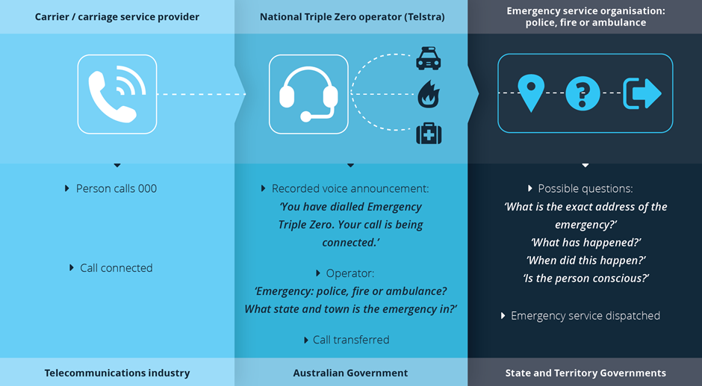
The Triple Zero service is provided cooperatively by the Australian Government and the state and territory governments, with the Australian Government responsible for the national operator, and the state and territory governments responsible for the emergency service organisation call centres. The service is supported by telecommunications infrastructure provided by telecommunications carriers.
Triple Zero is the primary emergency service number in Australia. There are also two secondary emergency service numbers: 112 – the international standard emergency number that can be called from a mobile phone; and 106 – that can be called from a teletypewriter (TTY) through the National Relay Service.

The Triple Zero service of the future

Community expectations
While the relevant legislation and regulations (see Part 4.2) set out a number of well-defined expectations and requirements for the Triple Zero service, there are also a number of unstated expectations that are widely accepted. At the highest level it is understood that the community expects to be able to contact Triple Zero:
- anytime
- anywhere
- easily
- quickly
- free of charge
Table 1 below expands upon this list to outline how these expectations are reflected in the current arrangements. The Department is seeking your views on whether these are your expectations of the Triple Zero service, what other expectations you have of the service and if your expectations are currently being met. This will help inform the future direction of the service.
Table 1 Expectations of Triple Zero and how they are reflected in the current arrangements
Expectation | How the expectation is reflected in the current arrangements
1. That Triple Zero can be contacted anytime. | - The national Triple Zero operator and emergency service organisations operate call centres 24 hours a day, every day of the year.  - The national operator and emergency service organisations have redundancy arrangements in place.  - Government works with the private sector to improve the resilience of telecommunications networks.
2. That Triple Zero can be contacted anywhere. | - Telecommunications providers are required by legislation to provide users of landlines, mobile phones, certain VoIP services and handheld satellite phones with access to Triple Zero.  - Mobile phones roam to other networks to allow a Triple Zero call when the home network is out of range.
3. That Triple Zero can be contacted easily. | - Triple Zero is contactable with a voice call.  - The number is easy to remember and simple to dial.  - The service is accessed in the same way in any part of the country.  - Mobile phone users can call the service without a SIM card or active account.  - The National Relay Service provides an equivalent service for people who are deaf, or have a hearing or speech impairment, and who cannot make a voice call.
4. That Triple Zero can be contacted quickly. | - The service is contactable with a voice call.  - The number is quick to dial.  - Telecommunications providers are required to give Triple Zero calls the ‘highest priority’ over their networks and calls are to be transferred with the minimum delay.  - The national Triple Zero operator is required to answer calls within certain timeframes (85 per cent of calls within five seconds and 95 per cent within 10 seconds).  - Telecommunications providers are required to provide the national operator and emergency service organisations with certain information about callers (e.g. phone number, state/territory that the call was made from, service address (if the call is from a landline), and billing address and approximate location (if the call is from a mobile phone).
5. That Triple Zero can be contacted free of charge. | - Telecommunications providers are required by legislation to provide free access to the Triple Zero service for users of landlines, mobile phones, certain VoIP services and handheld satellite phones.  - Mobile phone users can call the service without any credit.
Question 1: Community expectations
It is commonly accepted that community expects the Triple Zero service to be contactable anytime, anywhere, easily, quickly and free of charge.
Are these your expectations of the Triple Zero service now and into the future? Are your expectations currently being met? Why or why not?

Challenges

Locating callers using mobile phones
Mobile phones have become the predominant way to access the Triple Zero service, with 67 per cent of calls to Triple Zero made from mobile phones in 2012-13. However, unlike landlines, the exact location of a mobile caller is not able to be provided automatically to the Triple Zero operator. The limited location information that is provided is derived from the mobile phone network, not a phone’s GPS functions, as technical limitations prevent GPS information from being provided automatically to Triple Zero. Emergency service organisations report that it takes longer to respond to mobile calls as they need to ask questions to determine the caller’s exact location.
Emergency service organisations can ask mobile carriers to interrogate their networks for more precise location information if needed. While mobile carriers are required to process these requests ‘without delay’, they can take around 10 minutes to complete. Work is underway to provide this network information automatically with each call, but the accuracy will still be limited by the capabilities of the mobile network.
An official smartphone app, Emergency+, has been developed to assist callers with GPS-enabled phones to provide location information. The app provides the user with his or her street address and GPS coordinates, which he or she can read out to the Triple Zero operator. Mobile carriers and emergency service organisations are discussing how GPS information from mobile phones could be further used to enhance Triple Zero.
Australia’s approach to mobile location is comparable to – and in some cases more advanced than – other countries, with many emergency call systems only receiving simple mobile tower information. Some countries are attempting to move to more advanced systems – such as the United States that has developed a phased approach to achieve more accurate location information. However, these initiatives have faced significant practical challenges.

Voice over Internet Protocol (VoIP)
The increasing use of over-the-top VoIP services (such as Skype) is also causing challenges for the Triple Zero service. These services can be technically difficult to locate and do not need accurate location or subscriber information to operate. There may also be issues with the quality and prioritisation of calls from over-the-top VoIP services, which is not desirable in emergency situations.
There are measures in place to deal with Triple Zero calls from VoIP services – such as consumer protection requirements and a requirement to flag VoIP services in the Triple Zero system. However, technical and other issues remain, with Europe, and countries such as the United States, also grappling with these challenges.

Handling extreme call volumes
Large scale disasters, which result in extreme call volumes, can severely affect the capacity of the Triple Zero service. This is compounded by people calling Triple Zero during disasters who:
- hang up and call again when calls are not answered immediately (which results in the caller falling to the back of the queue)
- are simply seeking information, or
- are seeking assistance from other services, such as the State Emergency Service
Some of this may reflect the fact that Triple Zero is well regarded and the first number that many people turn to in a crisis. It may also reflect the fact that people are not aware of, or have difficulty getting through to, other information sources.
Governments, the national Triple Zero operator and emergency service organisations have worked cooperatively on measures to handle extreme call volumes. These include call overflow and redirection arrangements, recorded voice announcements, and awareness-raising activities. While recognising that extreme events will occur that can strain any system, further awareness-raising activities, improved information, and technical measures will continue to be an important part of the response.

Non-emergency calls
In 2012-13, 8.9 million calls were made to Triple Zero. Of these, 65 per cent (5.7 million) were passed on to an emergency service organisation by the national operator. The remaining 35 per cent (3.1 million) were non-emergency calls. Even with this level of filtering, emergency service organisations report that a significant number of the 5.7 million calls that are transferred by the national operator are non-emergency calls. The primary types of non-emergency calls are:
- malicious calls
- calls from people asking for assistance or information for situations that are not life-threatening or emergencies
- simple misdialled calls
Such calls place a significant load on the service, can result in the unnecessary dispatch of emergency vehicles and, in the case of malicious calls, can cause distress for operators and place responders at risk.
A number of measures are used to reduce non-emergency calls. These include: awareness-raising activities; a recorded voice announcement that is played when the call is first connected (giving callers the opportunity to hang up if they have misdialled); and a warning and account suspension process. Despite the success of these measures, non-emergency calls continue to be a challenge for Triple Zero. New and sustained approaches to awareness-raising, supported by possible further technical measures, are required.
Question 2: Challenges facing the Triple Zero service
Ongoing changes in the communications landscape, and certain expectations in the community regarding the nature of the service, present challenges for the Triple Zero service. These challenges include locating callers, the quality and prioritisation of VoIP calls, extreme call volumes during disasters and non-emergency calls.
What are your views on these challenges and what further steps could be taken to address them? What other challenges need to be considered?

Opportunities

Other ways of requesting emergency assistance
The ‘voice only’ nature of the Triple Zero service reflects the period in which the service was established. Voice calls have proven to be a quick, reliable and trusted way of requesting emergency assistance and are likely to remain the predominant way of requesting emergency assistance in the foreseeable future.
However, people now communicate in a range of other ways, including by SMS, email, instant messaging, video calls and social media, and there have been reports of people trying to use social media and other communication methods to request emergency assistance. It is also foreseeable that in the future medical devices, such as pacemakers or health monitors, may be able to automatically request emergency assistance on behalf of the user.
These alternative contact methods offer the potential to enhance the Triple Zero service. However, each has its advantages and disadvantages and there are practical issues that would need to be addressed should any of them be incorporated into the service. For example:
- SMS could be used when it is not possible or desirable for the person to speak (such as during a burglary), but it is likely to take longer and there may be no guarantee that the message will be delivered.
- Video calls could be used for communicating with sign language, but sufficient bandwidth would be needed for quality video.
- Automated devices could send information about a person to emergency services without any interaction from the user, but may result in a high rate of false alerts and not allow a two-way conversation.
- Social media could be used to reach a wide audience immediately (including family and friends), but carries the risk of misinformation being disseminated.
A detailed listing of the advantages and disadvantages of potential alternative contact methods is provided in Table 2 in Appendix A.3.
Other countries are also exploring these issues. For instance, initiatives are underway in the United States to transition to ‘Next Generation 911’ – an Internet Protocol (IP)-based system that will allow that country’s emergency call system to accommodate photos, videos and text messages, in addition to voice calls. In addition, ‘text-to-911’ is currently available on a limited basis in the United States, with the aim of it being widely available in the future. In Europe, similar work is underway as part of ‘Next Generation 112’ and the European Commission is seeking to rollout ‘eCall’ – a device installed in cars that automatically calls the nearest emergency centre if a car is in a crash.
Australia’s National Relay Service provides people who are deaf, or have a hearing or speech impairment, with additional ways of requesting emergency assistance. These include teletypewriters (TTYs), internet relay, SMS relay and video relay. Apart from the 106 TTY number, these are not dedicated emergency call services, however, emergency calls are given priority by the National Relay Service. There are a range of services available overseas that allow people who are deaf, or have a hearing or speech impairment, to contact emergency services, many of which require users to register before they can use them. In Australia, registration is not required for the majority of services operated by the National Relay Service.
Question 3: Other ways of requesting emergency assistance
The only way of contacting Triple Zero is with a voice call and this is likely to remain the primary way of requesting emergency assistance. However, people use a range of other ways to communicate, including SMS, email, instant messaging, video calls and social media.
In addition to voice calls, is it desirable to have other ways of requesting emergency assistance? If so, what ways and what challenges do you foresee?

Improving information
Timely and accurate information is essential to the Triple Zero service, with the most essential information being the type of emergency and its location.
Changes in technology offer opportunities to improve the information available to the Triple Zero service, as well as to people requesting emergency assistance. For instance:
- The GPS capabilities of a smartphone could assist in more accurately locating a person requesting emergency assistance.
- Video and pictures from a camera phone could provide police and fire fighters with additional information about the scene of an emergency prior to their arrival.
- Information about a person’s pre-existing medical condition could be provided automatically to the ambulance service during an emergency.
- A smartphone could potentially show the estimated time of arrival of assistance.
- Tools are available that monitor social media for certain phrases relating to an emergency or potential emergency.
- Apps and websites could allow members of the community to provide eyewitness accounts of events.
Many of these technologies are also alternative contact methods (discussed above).
A key question is how we take advantage of these opportunities while addressing the challenges that many of the technologies may pose, including privacy. A related question is what information is essential for emergency assistance, and what information is desirable.

Geocoded address information
It is essential for the Triple Zero service to have access to up-to-date and accurate address information and, in particular, accurate geocoded address datasets.
Address datasets on the national scale contain well over 12 million address records and are managed by a variety of organisations (e.g. government mapping agencies and land registries, the Australian Electoral Commission and Australia Post). With constant changes and updates as a result of new construction, planning, subdivision and more accurate mapping techniques, the scale and effort to keep up-to-date information in a consolidated national dataset is significant.
Geocoded address information provides the means to verify the existence and accuracy of an address. Authoritative geocoded datasets, like the Geographic National Address File (G-NAF) produced by PSMA Australia, provide essential address information. However, this information could be improved to provide better services for end users.
Open and free access to address datasets, including geocoded datasets, has the potential to improve national address information by enhancing feedback mechanisms. Increased access to address datasets would provide greater opportunity for users of the data to notify data custodians of errors or discrepancies.
As regular users of address information, there is also potential for emergency service organisations to make a significant contribution to improving the accuracy of geocoded address data (e.g. from street to parcel level) by providing machine-to-machine volunteered geographic information (VGI). This could then, in turn, improve the quality of address data available to the Triple Zero service.
Question 4: Improving information
It is important that emergency service organisations, as well as callers, have the information they need in an emergency. Changes in technology offer opportunities to improve the information available, however, these changes also present some challenges.
What information is essential to emergency service organisations and callers in an emergency and what information is desirable?

Determining how we get there

The role of the national operator
The aim of this review is to ensure that the arrangements for the national Triple Zero operator continue to support a world-class Triple Zero service into the future. While taking a long-term view of the future direction of the service, a particular focus will be on any changes that need to be made to the national operator arrangements over the next five to 10 years.
The national operator plays an important part in delivering the Triple Zero service by promptly answering calls and transferring them (along with certain information) to the relevant emergency service organisation. The operator provides a common experience for callers across Australia when the call is first answered and a single system for telecommunications providers and emergency service organisations to connect to. The operator also assists emergency service organisations in meeting surges in calls during extreme events.
However, having a national operator necessarily involves the double-handling of calls, and the national operator can become congested if emergency service organisations reach capacity. Further, having a common system nationwide may restrict the ability of emergency service organisations to make changes to their systems.
In the lead up to the tender of the national operator in 2016, the Government needs to consider a range of issues. These include:
- whether the current model remains appropriate for the Triple Zero service of the future
- how the underlying expectations for the service translate into specifications for a competitive tender process
- whether new ways of requesting emergency assistance should go through the national operator or directly to emergency service organisations
- whether the current funding model provides the appropriate cost drivers and incentives
- the practicalities of any proposed changes to the national operator arrangements
- what transitional arrangements would be needed to ensure continuity in service should changes be made to the model
Several different models exist for the delivery of emergency call services. For example, the United States uses a localised structure where telecommunications providers route 911 calls direct to one of approximately 6,000 ‘Public Safety Answering Points’ operated by local counties and other institutions. Some answering points dispatch the emergency service themselves while others transfer the call to the appropriate emergency service organisation.
Question 5: The role of the national Triple Zero operator
A tender for the national Triple Zero operator is required to be issued by June 2016. The aim of this review is to ensure that the arrangements for the national Triple Zero operator continue to support a world class Triple Zero service into the future.
What criteria should be used to determine the functions of the national operator?

The role of telecommunications providers
Telecommunications providers (carriers and carriage service providers) are integral to the delivery of the Triple Zero service. They provide services and infrastructure necessary to connect callers with emergency service organisations.
Below is an outline of the main regulatory requirements for telecommunications providers in relation to Triple Zero, the contractual and funding arrangements for the national operator, and the related review of the Integrated Public Number Database. A diagram of the overall regulatory framework for Triple Zero is provided at Figure 2 on page 19.
Carriers and carriage service providers will continue to be integral to the delivery of Triple Zero in the future and in maintaining community safeguards. However, in line with the Government’s commitment to reduce the regulatory burden on business, it is important to consider whether:
- the regulatory framework for Triple Zero remains appropriate given changes in technology and the telecommunications industry
- the framework needs to be changed to support the Triple Zero service of the future
- the regulatory burden is appropriately set at the minimum level necessary to achieve an effective Triple Zero service
Work to reduce regulatory burden in this area has already commenced, with the Australian Communications and Media Authority (ACMA) proposing to remove duplication in reporting requirements for carriage service providers under the ACMA’s Telecommunications (Emergency Call Service) Determination 2009.

Main regulatory requirements
The main regulatory requirements in relation to Triple Zero are specified in the ACMA’s Telecommunications (Emergency Call Service) Determination 2009. The determination requires carriers and carriage service providers to:
- provide users of standard telephone services with access to the emergency call service free of charge, with special arrangements for VoIP and satellite phones
- carry emergency calls in a way that would give consumers the appearance of a single national emergency call system
- carry emergency calls to the relevant termination point
- transfer Triple Zero and 112 emergency calls to the national operator ‘with the highest priority’
- provide other carriage service providers with access to their services, networks and facilities to enable them to comply with the determination
- minimise non-emergency calls to Triple Zero and 112 (only applies to carriers)
- provide certain information to the Integrated Public Number Database (this is discussed further below)
- provide automatic information about the phone number and the caller’s location, with further information available upon request by an emergency service organisation
- provide information to the ACMA
- keep certain records
The determination prohibits carriage service providers from charging emergency service organisations for connecting and transferring emergency calls, and providing information in relation to such calls. However, the determination allows carriage service providers to charge for a higher level of service upon agreement with the emergency service organisation. The determination also prohibits carriage service providers from charging a national operator for emergency call services, but allows them to charge a national operator for non-emergency calls made by an operator.

Contractual and funding arrangements for the national operator
The Telecommunications Universal Service Management Agency (TUSMA) manages a contract with Telstra, on behalf of the Australian Government, to supply the national Triple Zero operator service. Under the contract, Telstra is obliged to supply the service in accordance with applicable regulatory requirements for up to 20 years, subject to a tender to be issued by 23 June 2016. The outcomes of this review will inform this tender process.
Under the arrangements, Telstra is entitled to an annual reimbursement by TUSMA equal to the net operating costs of providing the service during each financial year, capped at $22 million (including GST). In 2012-13, this amounted to $17.6 million (including GST). These costs are met by Australian Government funding and an industry levy paid by telecommunications carriers with eligible revenue of $25 million or more. As approximately 66 per cent of TUSMA’s total costs in the relevant year are met by the levy, it can be notionally said that approximately $11.6 million of the cost of the national operator is met by the levy.

Integrated Public Number Database
The Telecommunications Act 1997 and Telecommunications (Emergency Call Service) Determination 2009 require carriers and carriage service providers to provide certain information about their phone services and subscribers to the Integrated Public Number Database.
As part of a separate review into the database, the Department is considering whether the database is fulfilling its objectives, whether the objectives are still relevant, and whether any reforms are required to improve outcomes for the database’s users and the community. One matter being considered is the functionality of the database and how it should innovate and keep pace with technological and market changes (such as whether and how it could deliver dynamic location information to its users).
Question 6: The role of telecommunications providers
Telecommunications providers have regulatory obligations in relation to Triple Zero, recognising their importance in the delivery of the service. However, it is important to consider whether the regulatory framework remains appropriate given changes in technology and the telecommunications industry, the likely direction of the Triple Zero service, and the Government’s commitment to reduce the regulatory burden on industry.
Is the current regulatory and funding framework for the Triple Zero service appropriate now and for the future? If not, what changes should be made and why?
The Department welcomes information from the telecommunications industry, when responding to this question, on how much it costs industry to meet the existing regulatory requirements in relation to the Triple Zero service.

Figure 2 Regulatory framework for Triple Zero
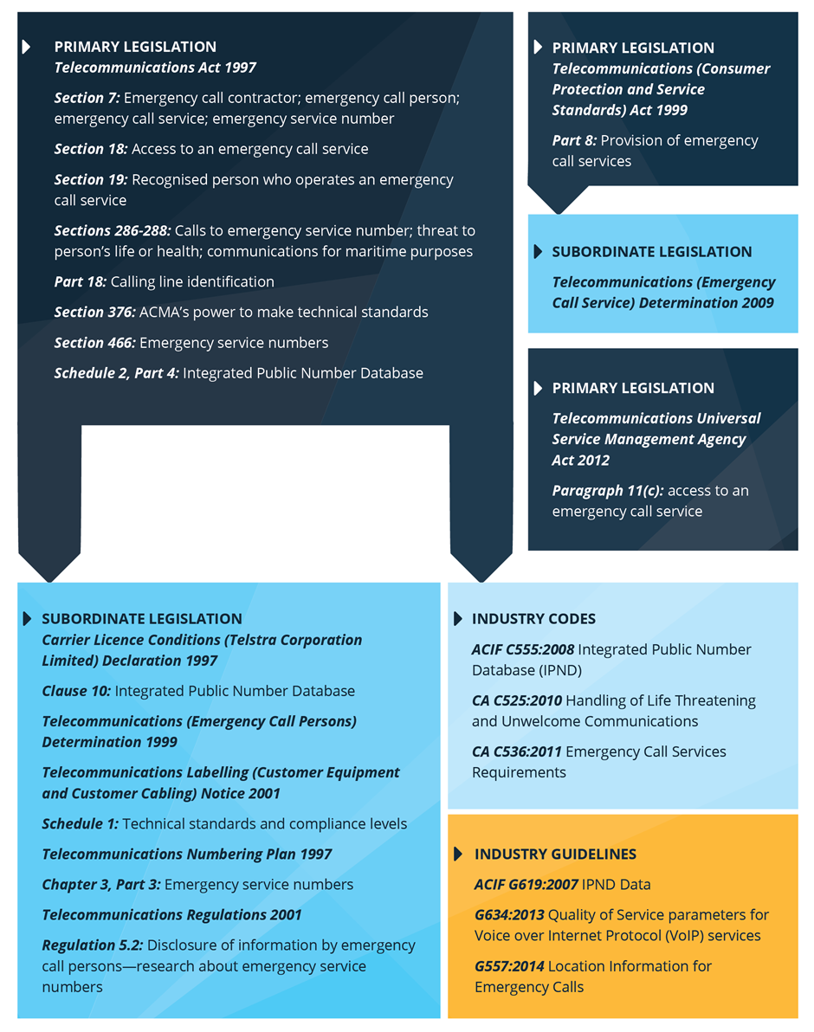

The role of innovators
Innovative ideas to improve emergency assistance may come from a range parties that have not traditionally been involved in the delivery of the Triple Zero service. These include app developers, device and car manufacturers, research organisations, community service providers and individuals. Indeed, a variety of emergency-related products are already on the market, while developers and others are seeking to fill a perceived gap in the market with other products.
There are a number of factors that currently limit the ability of Triple Zero from accommodating third party solutions, including:
- the voice nature of the service and the inability of emergency service organisations’ existing Triple Zero call service systems to accept additional types of data (such as text messages, images and live location information)
- concerns around maintaining the reliability and integrity of the service
- decision-making processes (this is discussed in Part 4.4)
There are also concerns with products being offered that cannot do what they claim. If the market was to be opened up, consumers would need ways to easily evaluate the suitability of any new innovative service for their needs.
The Triple Zero Awareness Working Group has published advice for people considering using emergency-related apps. However, there are no comprehensive guidelines in Australia for developers of emergency-related apps, such as those published by the National Emergency Number Association in the United States.
In considering the future of the Triple Zero service, it is important that we consider how innovators can contribute to the service and how the service can work more closely with innovators.
Question 7: The role of innovators
Innovative ideas to improve emergency assistance may come from a range of parties such as app developers, device and car manufacturers, research organisations, community service providers and individuals.
What sorts of innovations would most improve the Triple Zero service? How can innovation and third party innovators be supported while ensuring the reliability and integrity of service?

Cooperation and decision-making
There is no single body responsible for the whole Triple Zero emergency call service (i.e. from the call through to the dispatched service). Management of the service is based on a cooperative model involving states and territories, the Australian Government and the telecommunications industry. This model reflects Australia’s federal system of government and respective constitutional roles and responsibilities.
The Department is seeking views on whether any changes need to be made to the cooperation and decision-making arrangements amongst these parties to allow the Triple Zero service to better adapt – and respond to – issues in the future.

Australian Government responsibilities
Under the existing model, the Australian Government is responsible for the regulation of the telecommunications industry and the operation of the national Triple Zero operator. This includes the provision of customer access to Triple Zero and the handling of emergency calls by carriers, carriage service providers and the national Triple Zero operator. The following Australian Government departments and agencies have responsibilities and interests in relation to Triple Zero:
- Department of Communications – which provides policy advice to the Minister for Communications in relation to the Australian Government’s regulatory framework for Triple Zero.
- Australian Communications and Media Authority (ACMA) – which regulates and monitors the provision of Triple Zero by the national Triple Zero operator and the telecommunications industry. The ACMA maintains the Emergency Call Service Advisory Committee to assist the ACMA in performing this role.
- Telecommunications Universal Service Management Agency (TUSMA) – which is responsible for entering into, and managing, contracts or grants to ensure the ongoing delivery of the national Triple Zero operator functions.
- Attorney-General’s portfolio – which supports states and territories in developing their capacity for dealing with emergencies and disasters, and provides physical assistance to states or territories upon request when they cannot reasonably cope during an emergency.

State and territory responsibilities and coordination
The states and territories have primary responsibility for life and property in Australia and are responsible for Triple Zero call handling and dispatch arrangements within their respective jurisdictions. Within the states and territories, these responsibilities are typically shared between several ministers and multiple agencies, including:
- policy departments (such as health and justice)
- emergency communications agencies (such as Victoria’s Emergency Services Telecommunications Authority)
- emergency service organisations (police, ambulance, metropolitan fire and country fire services)
The Council of Australian Governments (COAG) Law, Crime and Community Safety Council is the ministerial council assisting COAG to build the resilience of the Australian community to deal with disasters. The Australia-New Zealand Emergency Management Committee is the senior officials committee that advises the council.
There are also two ongoing operational working groups that support coordination across jurisdictions:
- The National Emergency Communications Working Group Australia-New Zealand – which consists of representatives of emergency service organisations, carriers and other organisations who are responsible for the planning, development, operation and use of Triple Zero.
- The Triple Zero Awareness Working Group – which develops and administers programs and activities to enhance community awareness of Triple Zero.
Question 8: Cooperation and decision-making
There are a range of parties with interests and responsibilities in relation to Triple Zero. It is important that there are effective cooperation and decision-making arrangements in place amongst these parties so that the service can continue to adapt and respond to issues as they arise in the future.
What things do the current cooperation and decision-making arrangements for Triple Zero do well? What things do they not do well? What changes are needed so the service can better adapt and respond to issues in the future?

List of all questions
The Triple Zero service of the future
- Question 1: Community expectations
Question 2: Challenges facing the Triple Zero serviceQuestion 3: Other ways of requesting emergency assistanceQuestion 4: Improving information
Determining how we get there
- Question 5: The role of the national Triple Zero operatorQuestion 6: The role of telecommunications providersQuestion 7: The role of innovators
- Question 8: Cooperation and decision-making

- Appendices
  - Summary of consumer research
In 2012, the then Department of Broadband, Communications and the Digital Economy commissioned research to explore community views in Australia in relation to Triple Zero. The research was both quantitative and qualitative and explored the public’s use, perception and expectations of the service. A summary of the key findings is included below.
    - Perceptions of the service
The qualitative research found that perceptions of the service were generally positive. All participants who had personal experience in calling Triple Zero reported that their call was answered promptly and Triple Zero operators received high praise from participants.
    - Awareness of call diversion process
The quantitative research found that 79 per cent of respondents were aware that their call would be answered by a national operator before being transferred to their local emergency service organisation; 19 per cent were unaware; and three per cent were unsure.
    - Wait times
Respondents expected very short wait times when calling Triple Zero; nearly half expected to be connected immediately and 36 per cent expected to wait no longer than one minute (see Figure 3 below).
Figure 3 Expected wait times when calling Triple Zero (per cent of respondents)
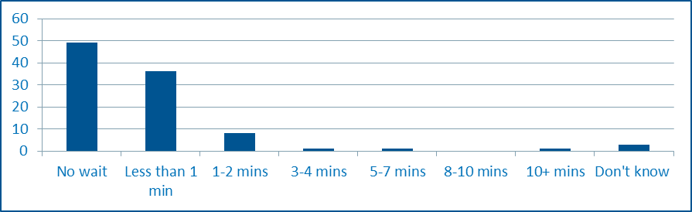
Source: Triple Zero Research, Department of Broadband, Communications and the Digital Economy, 2012
    - Human interaction
Ninety-three per cent of respondents indicated that they expect to speak to a human operator when calling Triple Zero, with only six per cent not having this expectation. This expectation is also reflected in the attitudes toward an interactive voice recognition system, with 69 per cent strongly against, and 11 per cent slightly against, such a system.
    - Ways of contacting Triple Zero
60 per cent of respondents indicated that they were most likely to use a landline to call Triple Zero and 31 per cent indicated that they would use a mobile phone. The remaining nine per cent were unable to choose between a landline and mobile without knowing the exact situation (see Figure 4 below). The figure below also indicates the perception of being able to use other contact methods.
Figure 4 Prompted and unprompted methods of contact (per cent of respondents)
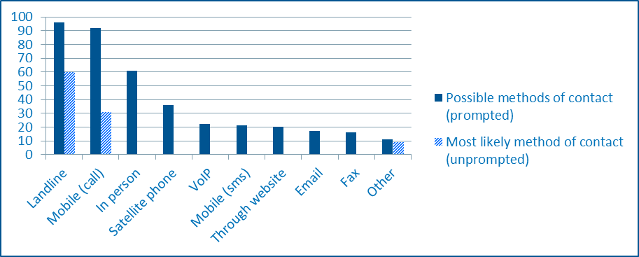
Source: Triple Zero Research, Department of Broadband, Communications and the Digital Economy, 2012
When prompted with potential future methods of contacting Triple Zero, sending an SMS appealed to 60 per cent of respondents, with slightly less finding appeal in a smartphone app (57 per cent) and the Triple Zero website (56 per cent). Seventeen per cent of respondents found no appeal in any of the suggested alternative methods (see Figure 5 below).
Figure 5 Appeal of potential future methods of contact (per cent of respondents)
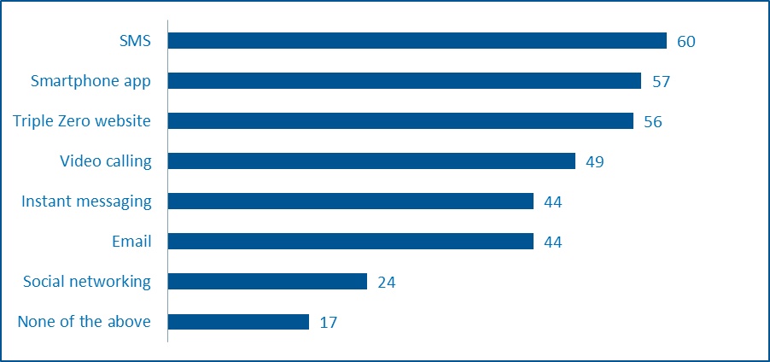
Source: Triple Zero Research, Department of Broadband, Communications and the Digital Economy, 2012
The participants of the qualitative research were not calling for changes to be made to the current system, although they were open to the idea of new contact methods when that idea was raised with them, as long as the current method was maintained. Participants felt that it was probably inevitable that such changes would be made, however, they required convincing of the benefits of each potential method over the current system.
The participants of the qualitative research considered video calling and a smartphone app to be most suitable for future consideration.
    - Information about users
Respondents were asked how willing they would be to have certain personal information available to the Triple Zero operator when making an emergency call. Almost all respondents (93 per cent) were willing for the operator to have information on their current location, while fewer were willing for the operator to have access to their contact information (81 per cent) and their name (72 per cent). Just over half of the respondents were willing to release their medical information (55 per cent) and age (54 per cent) (see Figure 6 below).
Figure 6 Willingness to have personal details available to the operator (per cent of respondents)
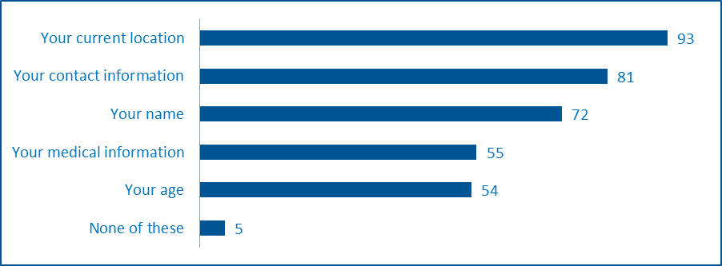
Source: Triple Zero Research, Department of Broadband, Communications and the Digital Economy, 2012
For those who indicated that a smartphone app should be developed to contact Triple Zero, the willingness to provide personal information was higher overall (see Figure 7 below).
Figure 7 Willingness to provide personal details for a smartphone app (per cent of respondents)
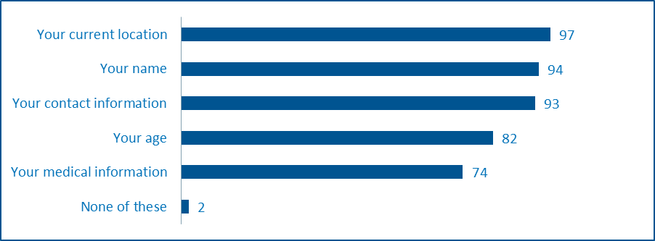
Source: Triple Zero Research, Department of Broadband, Communications and the Digital Economy, 2012

  - Publication, confidentiality and privacy of submissions
    - Publication
Submissions will be made publicly available, including on the Department’s website. The Department reserves the right not to publish any submission, or any part of a submission, which in its view, breaches applicable laws, promotes a product or a service, contains offensive language, may offend or vilify sections of the community, or does not substantively comment on matters within the scope of review. Publication of a submission is not an indication that the Department endorses the content of that submission. In making a submission, you provide the Commonwealth with a permanent, irrevocable, royalty-free licence to use, reproduce, adapt, and communicate your submission both online and in any other related documents (for example, in a future discussion paper or report).
    - Confidentiality
Submissions will be treated as non-confidential unless the respondent specifically requests otherwise and the Department agrees. Given the nature of the consultation process, it is unlikely that the Department will agree to keep a submission or part of it confidential. Even where the Department agrees to keep a submission or part of it confidential, the obligation of confidence will not be breached where the Department discloses the information to a House or Committee of Parliament, relevant Ministers, Commonwealth entities (where this meets the Commonwealth’s legitimate interests), within the Department and to its advisors, or where authorised or required by law. The Department will strive to consult submitters of confidential information before that information is provided to another body or agency. The Department cannot guarantee the confidentiality of information released through these or other legal means. The Department will treat any personal information provided in accordance with its Australian Privacy Principles Privacy Policy (see www.communications.gov.au/privacy).
    - Privacy
The Department is committed to protecting your privacy. The Department has obligations under the Privacy Act 1988 (the Privacy Act). In particular, the Privacy Act contains the Australian Privacy Principles which govern how the Department collects, uses, discloses and stores personal and sensitive information, and how individuals can access and correct records containing their personal or sensitive information.
You may make a submission to the Department anonymously or by using a pseudonym. If you include any personal information and/or sensitive information in your submission or (if relevant) the online form, this information will be collected by the Department. By providing the Department with your personal information and/or sensitive information, you consent to the Department collecting, using and disclosing that information in accordance with this notice.
As part of considering your submission, the Department may use your personal and/or sensitive information for the purpose of developing policies and programmes in relation to the subject of this discussion paper. Further, the Department may also disclose your personal information to its Minister, its Parliamentary Secretary other government agencies and by placing your submission on the Department’s website (which means it may be viewed by individuals in Australia or overseas).

If you do not consent to the Department's collection, use and disclosure of your personal information, please do not provide your personal information to the Department. If you have already provided your information to the Department, please notify the Department immediately (see contact details on page 6).
For further information (including in relation to how to access or correct personal information or make a complaint), please see the Department’s Australian Privacy Principles Privacy Policy here: www.communications.gov.au/privacy.

  - Comparison of alternative contact methods
Table 2 Key advantages and disadvantages of alternative contact methods
Method | Advantages | Disadvantages
SMS/MMS | - Can be used when it is not possible or desirable to speak  - Can include photos and videos | - May not be delivered immediately or at all  - No delivery or read confirmation  - Unlike voice, difficult to provide detailed interactive instructions to assist the caller  - Takes time to type text  - May need multiple messages  - May result in hoax requests
Email | - Can be used when it is not possible or desirable to speak  - Can be sent from a computer or mobile phone  - Can include confirmation that the message has been read  - Can include attachments | - May not be delivered immediately or at all  - Takes time to type text  - May need multiple messages  - May result in hoax requests
Smartphone app (including instant messaging, voice, video, maps and other advanced features) | - Can be used when it is not possible or desirable to speak  - Can include confirmation that the request has been delivered and read  - Can include photos and videos  - Can elicit specific information  - Can send pre-stored information (e.g. medical history)  - Can provide location information  - Can include other information to assist the user | - May not be delivered immediately or at all  - Takes time to type text  - May need a follow-up conversation  - May result in hoax requests  - Requires a data connection
Instant messaging | - Can be used when it is not possible or desirable to speak  - Can include confirmation that it has been delivered and read  - Can include photos and videos  - Can provide near real-time communication | - May not be delivered immediately or at all  - Takes time to type text  - May need multiple messages  - May expose call-takers to distressing images  - May result in hoax requests  - Requires a data connection
Website form | - Can be used when it is not possible or desirable to speak  - Can be used on a computer or mobile device  - Can elicit specific information | - May be time-consuming to complete  - May need a follow-up conversation  - Form/website may be difficult to locate in emergency  - May result in hoax requests
Social media | - Can be used when it is not possible or desirable to speak  - Can be used on a computer or mobile phone  - Can include photos and videos  - Can tell if it has been successfully posted  - Can link to the person’s contact details and relatives and friends  - Location details may alert community members to the incident (advantage and disadvantage) | - Needs to be specifically monitored  - May be public – personal information will be displayed  - Takes time to type text  - May need multiple messages  - Location details may alert community members to the incident (advantage and disadvantage)  - May expose call-takers to distressing images  - May result in hoax requests  - Misinformation could potentially be disseminated to a wide audience immediately
Video calls | - Provides emergency services with live video of the scene to assist in the response or gathering of evidence  - Can include a voice conversation  - Could be used for sign language | - May expose call-takers to distressing images  - Need sufficient bandwidth for quality videos  - May not be suitable for all emergency services
Automated devices | - Requires minimal or no user interaction (useful if the user is incapacitated or cannot speak)  - May be linked to a third party call centre that can determine an alternative response  - Can send pre-stored information (e.g. medical history)  - Can send telemetry (e.g. information about a car after a car accident has occurred) | - Some may be unregistered or without a third party call centre making it difficult for emergency services to respond  - May be a high rate of false alerts  - May not be possible to have a two-way conversation

See the Telecommunications (Emergency Call Service) Determination 2009.
Telecommunications (Emergency Call Service) Determination 2009, section 32.
Australian Communications and Media Authority, Communications report 2012-13, p.50, viewed April 2014, <http://www.acma.gov.au/theACMA/Library/Corporate-library/Corporate-publications/communications-report-2012-13>.
See: Australian Communications and Media Authority, Enhanced mobile location information for the Emergency Call Service, ACMA consultation on a proposal to amend the Telecommunications (Emergency Call Service) Determination 2009, May 2010, p.4, viewed April 2014, <http://www.acma.gov.au/Industry/Telco/Carriers-and-service-providers/Emergency-call-service/public-consultation-paper-12-2010-emergency-call-service-i-acma>.
Telecommunications (Emergency Call Service) Determination 2009, section 52A.
See: Attorney-General’s Department, Triple Zero – Emergency+ Smartphone App, viewed April 2014, <http://www.triplezero.gov.au/Pages/EmergencySmartphoneApp.aspx>.
See, for example: European Commission, Communications Committee, COCOM 13-04 REV1, Working Document, Implementation of the European emergency number 112 – Results of the sixth data-gathering round, 18 March 2013, viewed April 2014, <http://ec.europa.eu/index_en.htm>.
Federal Communications Commission, 911 Wireless Services, viewed April 2014, <http://www.fcc.gov/guides/wireless-911-services>.
See: Telecommunications (Emergency Call Service) Determination 2009, section 14.
Australian Communications and Media Authority, Communications report 2012-13, p.50, viewed April 2014, <http://www.acma.gov.au/theACMA/Library/Corporate-library/Corporate-publications/communications-report-2012-13>. It is important to note that the national Triple Zero operator does not explicitly triage calls – i.e. it does not attempt to assess whether the call is genuine. However, the operator will only transfer a call if the caller is asking for assistance from the police, fire or ambulance service.
Under this measure, access to Triple Zero is not barred to ensure that all genuine calls get through.
CNET, Trapped in a drain… try Facebook for help?, 10 September 2009, viewed April 2014, <http://news.cnet.com/8301-17939_109-10347498-2.html>.
911.gov, Next Generation 911 (NG911), viewed April 2014, <http://www.911.gov/911-issues/standards.html>.
Federal Communications Commission, What you need to know about Text-to-911, viewed April 2014, <http://www.fcc.gov/text-to-911>.
European Emergency Number Association (EENA), EENA Next Generation 112 Committee, viewed April 2014, <http://www.eena.org/view/en/Committees/NG112.html>.
European Commission, Digital Agenda for Europe: A Europe 2010 Initiative, eCall: Time saved = lives saved, viewed April 2014, <http://ec.europa.eu/digital-agenda/ecall-time-saved-lives-saved>.
Further information about the National Relay Service is available at <http://relayservice.gov.au/>.
National Emergency Number Association, 9-1-1 Statistics, p.6, viewed May 2014, <http://www.nena.org/?page=911Statistics>.
See: Australian Communications and Media Authority, Reducing telecoms reporting requirements, Issue for comment 14/2014, viewed May 2014, <http://www.acma.gov.au/theACMA/Consultations/Consultations/Current/reducing-telecoms-reporting-requirements>.
Telecommunications (Emergency Call Service) Determination 2009, section 54.
Telecommunications (Emergency Call Service) Determination 2009, section 55.
TUSMA enters into contracts with, and make grants to, deliver public interest telecommunications services on behalf of the Australian Government in accordance with the Telecommunications Universal Service Management Agency Act 2012. In the 2014-15 Budget, the Government announced that it will transfer the functions of TUSMA to the Department of Communications (see: Commonwealth of Australia, Budget 2014-15, Agency Resourcing, Budget Paper No. 4, 2014-15, p.134, viewed May 2014, <http://www.budget.gov.au/2014-15/content/bp4/download/BP4_consolidated_file.pdf>). It is expected that legislation to give effect to this change will be introduced into Parliament later in 2014 and that the Government will implement transitional measures in relation to TUSMA’s governance for the financial year 2014-15.
Telecommunications Universal Service Management Agency, Register of Public Interest Telecommunications Contracts, 1. TUSMA Agreement: Telstra, viewed May 2014, <http://www.tusma.gov.au/about_us/governance_and_accountability/register_of_public_interest_telecommunications_contracts>.
Telecommunications Universal Service Management Agency, Annual Report 2012–13, p.19, viewed May 2014, <http://www.tusma.gov.au/__data/assets/pdf_file/0004/43159/TUSMA_Annual_Report_2012-13_full_report.pdf>.
Telecommunications (Participating Persons) Determination 2013 (No. 2).
The Integrated Public Number Database records all Australian telephone numbers and associated subscriber information and is used for a range of purposes such as Triple Zero, the investigation of serious crime, dissemination of telephone-based emergency warnings and the production of public number directories.
Further information about the review of the Integrated Public Number database is available on the Department of Communications’ website <http://www.communications.gov.au/telephone_services/integrated_public_number_database_ipnd>.
Attorney-General’s Department, Triple Zero – Emergency+ Smartphone App, viewed April 2014, <http://www.triplezero.gov.au/Pages/EmergencySmartphoneApp.aspx>.
National Emergency Number Association, Public Safety Considerations for Smartphone App Developers, viewed April 2014. <http://www.nena.org/?page=SmartphoneApps>.
See ‘Contractual and funding arrangements for the national operator’ on page 17.

