Migration Assurance Policy Statement

Draft for consultation

July 2015

Summary

The national broadband network is an Australia wide project to upgrade the existing fixed line phone and internet network. NBN Co Limited (nbn), a wholly Commonwealth-owned company, is responsible for rolling out the national broadband network on a wholesale-only, open access basis. nbn’s wholesale products are the building blocks upon which retail service providers (RSPs) then develop their national broadband network retail products to offer to residential and business customers.

As nbn rolls out the fixed line network on a region by region basis, there is an 18 month period (migration window) from the date a region is declared ‘ready for service’ by nbn, until the Disconnection Date. During the migration window all voice, broadband and over-the-top legacy services within nbn’s fixed line footprint, must be migrated off legacy network services and onto services provided over the national broadband network, if customers want to maintain their fixed line services. At the end of the migration window (after the Disconnection Date), Telstra is required to disconnect all services on its legacy networks, subject to limited exceptions[1].

The Australian Government recognises that a great deal of hard work has been done by industry to improve this migration process for end users and commends industry on its co-operation and commitment to the process. However, to date, there have been significant challenges experienced in migrating end user services to services over the national broadband network ahead of the Disconnection Date.

The migration assurance policy (MAP) statement establishes assurance principles which set out in broad terms the Government's expectations for reformed migration arrangements. The statement is accompanied by a MAP framework that is designed to promote active involvement from industry to implement an effective end-to-end migration process that:

* supports service continuity for end users as the network is rolled out
* drives early migration by end users ahead of the mandatory disconnection of services on Telstra’s fixed networks; and
* ensures that end users, particularly those who are vulnerable, are given the opportunity to make a smooth transition to services over the national broadband network, with minimal risk of unexpected or inappropriate interruption to their services.

The MAP framework has been developed by the Government in collaboration with nbn and Telstra.   
The intention is for the MAP framework to be industry owned and implemented, and the Government is asking industry to actively work with it to refine and improve the framework and ultimately put it into practice. To this end we are releasing the MAP statement and the accompanying framework for industry consultation.

It is important to note that the MAP framework only applies to the fixed line footprint as premises within the nbn fixed wireless and satellite footprints do not need to migrate off existing legacy networks.

The MAP statement and framework will be updated as required, including for nbn’s multi-technology mix model, which includes fibre to the node/basement (FTTN/B) and hybrid fibre-coaxial (HFC) solutions.

# Migration Assurance

A successful end-to-end migration process is underpinned by two critical components:

1. **A clear allocation of roles and responsibilities.** All parties involved in the migration process must be clear about their roles and responsibilities and play their part. Ongoing co-operation, commitment and resources are required from all key stakeholders. The MAP framework outlines the high level roles of key players in the migration process and encourages participation by those stakeholders in a way that facilitates a successful migration of existing services to services over the national broadband network.
2. **Information sharing and data stability**. To support the migration and disconnection process, transparent arrangements relating to information flows, and access to reliable and consistent data need to be available and supported by key stakeholders. The MAP framework outlines the key requirements each player has in supporting this component.

Once these two fundamentals are in place, experience to date and feedback from stakeholders has shown that certain elements are required to support the migration process:

1. Serviceability
2. Product availability
3. End user awareness and management
4. Installation and activation capacity

These elements are the four pillars supporting successful migration. The following diagram illustrates this approach.

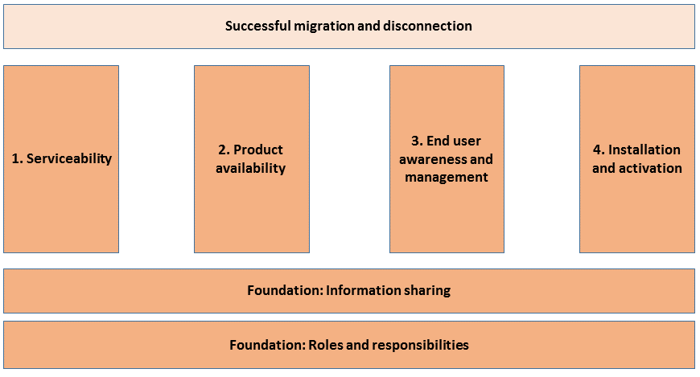

The first pillar is serviceability. Serviceability represents the requirement for there to be a service over the national broadband network which an end user can migrate to. High levels of serviceability are critical to the early migration of end users. In the context of the framework, serviceability also relates to aspects of the migration process such as the declaration of an area being ‘ready for service’, and the service class level applied to a premises.

The second pillar represents product availability. In many cases, new products or processes need to be developed, tested and put in place in order for telecommunications services to be delivered over the fixed line national broadband network. This includes the migration of critical over‑the‑top legacy services such as fire and medical alarms, lift phones, and payment services such as EFTPOS and ATMs. Corporate customers may also require more complex product solutions.

The third pillar is end user awareness and management. End users impacted by the national broadband network rollout need consistent, accurate and timely messages from all parties regarding the need to migrate in order to make informed choices. Aspects of end user awareness addressed in the MAP framework include the management of vulnerable end users and safety critical services, end user redress, and nbn, RSP and application service provider communication responsibilities.

The fourth pillar in the framework relates to the installation and activation of services over the national broadband network. Once an end user places an order with their chosen RSP, it needs to be installed and activated in a timely manner. This pillar covers areas including the role of the cabling industry, disconnections in error, and measures to improve service continuity.

# Migration Assurance Principles

The responsibilities and actions set out in the accompanying MAP framework are guided by broad migration assurance principles which aim to promote a smooth and timely migration off legacy network sevices and onto national broadband network services. These principles are:

* Migration should be an end user focussed and industry-led activity in which interdependencies between the different activities and parties are closely managed. This will:
  + minimise adverse impacts on end users
  + prioritise continuity of service
  + provide for the appropriate treatment of vulnerable people in the community.
* Migration processes should be managed in a predictable and straightforward manner so reasonable certainty is provided to all stakeholders, particularly end users.
* Migration arrangements should be proportionate and reflect an appropriate balance of cost and risk in a manner which does not distort or unreasonably constrain business as usual activities for stakeholders.
* Provision of migration information should be timely, accurate and consistent. The flow of information between all parties should be, to the extent possible, all inclusive and allow for transparency of any identified migration issues.
* Migration should be encouraged early in the 18 month migration window, and well ahead of the Disconnection Date, to ensure service continuity for end users. This is a shared responsibility – end users should be proactive about migrating to the national broadband network before the Disconnection Date.
* Migration processes are to be developed to manage the transition of all required services (e.g. legacy over-the-top services, special services, non-premises). These processes and solutions should provide a framework that allows for the management of unforeseen changes or challenges and allow for industry and end user driven solutions where possible. Corporate customers with more complex requirements may require extra lead-time to migrate.
* Products should be available to RSPs well before the migration window commences so they can develop their own retail national broadband network based products and services. nbn will make available the product technical specifications (including limitations) well before the migration window commences.
* RSPs should develop national broadband network retail products and services as soon as practicable so that end users can migrate off the copper network once an area is declared ready for service. If an RSP does not intend to provide services over the national broadband network, this should be communicated to their end users in a timely manner so that an informed decision can be made with regard to alternative providers and/or products and services.
* Migration arrangements should be consistent with the broader regulatory framework and policy objectives of the Government, which includes Telstra’s mandatory disconnection obligations.

1. Special services (mostly business data products) and non-premises.