

Research on youth exposure to, and management of, cyberbullying incidents in Australia

Part B:
Cyberbullying incidents involving Australian minors, the nature of the incidents and how they are currently being dealt with

Prepared for:
Australian Government Department of Communications
June 2014

Matthew Keeley, Ilan Katz, Shona Bates, Melissa Wong
SPRC Report Series 09/12
Research on youth exposure to, and management of,
cyberbullying incidents in Australia
Eight reports were produced in this series of publications; these are listed below.
Synthesis report
Part A: Literature review on the estimated prevalence of cyberbullying involving Australian minors
Part B: Cyberbullying incidents involving Australian minors, the nature of the incidents and how they are currently being dealt with
Part C: An evidence-based assessment of deterrents to youth cyberbullying
Appendix A: Literature review – International responses to youth cyberbullying and current Australian legal context
Appendix B: Findings of research with adult stakeholders
Appendix C: Findings of research with youth
Appendix D: Supplementary data and analysis

© Australian Government 2014

ISSN: 1446-4179
ISBN: 978-1-925218-01-5 (online)
SPRC Report 10/2014

The Social Policy Research Centre is based in the Faculty of Arts and Social Sciences at UNSW Australia. This report is an output of the Youth exposure to and management of cyberbullying incidents in Australia project, funded by the Australian Government Department of Communications.

Suggested citation
Keeley, M., Katz, I., Bates, S., & Wong, M. (2014). Research on youth exposure to, and management of, cyberbullying incidents in Australia: Part B ‒ Cyberbullying incidents involving Australian minors, the nature of the incidents and how they are currently being dealt with (SPRC Report 10/2014). Sydney: Social Policy Research Centre, UNSW Australia.


This research has been prepared for the Department of Communications.
Disclaimer
The material in this research paper is of a general nature and should not be regarded as legal advice or relied on for assistance in any particular circumstance. In any important matter, you should seek appropriate independent professional advice in relation to your own circumstances.
The Commonwealth accepts no responsibility or liability for any damage, loss or expense incurred as a result of the reliance on information contained in this research paper.
This research paper has been prepared for research purposes only and does not indicate the Commonwealth’s commitment to a particular course of action. Additionally, any third party views or recommendations included in this discussion paper do not reflect the views of the Commonwealth, or indicate its commitment to a particular course of action.
Copyright
© Commonwealth of Australia 2014

All material presented in this publication is protected by copyright.
With the exception of the Commonwealth Coat of Arms (for terms of use, refer to the Commonwealth Coat of Arms webpage), the Department of Communications logo, images, photographs and any material protected by trademark, all material included in this publication is licensed under a Creative Commons Attribution 3.0 Australia Licence (http://creativecommons.org/licenses/by/3.0/au/).
The CC BY 3.0 AU Licence is a standard form licence agreement that allows you to copy, distribute, transmit and adapt material in this publication provided that you attribute the work. Further details of the relevant licence conditions are available on the Creative Commons website (accessible using the links provided) as is the full legal code for the CC BY 3.0 AU Licence (http://creativecommons.org/licenses/by/3.0/au/legalcode).
The form of attribution for any permitted use of any materials from this publication (and any material sourced from it) is:
Source: Licensed from the Commonwealth of Australia under a Creative Commons Attribution 3.0 Australia Licence. The Commonwealth of Australia does not necessarily endorse the content of this publication.
Other use
The use of any material from this publication in a way not permitted or otherwise allowed under the Copyright Act 1968, may be an infringement of copyright. Where you wish to use the material in a way that is not permitted, you must lodge a request for further authorisation with the Department.
Contact details
This report can be viewed online at www.communications.gov.au/publications. For more information about the Department and to view other publications visit www.communications.gov.au
If you would like additional information on the report, please contact:
Manager, Cyber Safety Programs
Department of Communications
GPO Box 2154
Canberra ACT 2601, Australia
Phone: 1800 254 649 (free call) or 02 6271 1000 (international +61 2 6271 1000)
Email: enquiries@communications.gov.au

Research Team
Contact for follow up shona.bates@unsw.edu.au or ilan.katz@unsw.edu.au
Social Policy Research Centre
Professor Ilan Katz (Chief Investigator), Matthew Keeley (Co Investigator), Shona Bates, Melissa Wong
University of South Australia
Barbara Spears, Carmel Taddeo, Tony Daly
University of Western Sydney
Teresa Swirski, Philippa Collin
National Children’s and Youth Law Centre
Marianne Dakhoul, Kelly Tallon, Ahram Choi
Young and Well Cooperative Research Centre
The Young and Well CRC, through Dr Michelle Blanchard, provided in kind support to this research by helping the research team engage with young people and those who care for them in the project, as well as providing access to its participant organisations through a workshop held ahead of the CRC's Connect 2014 Conference and through the promotion of surveys.
Acknowledgements
The research team would like to thank the people who generously shared their time with us, both through interviews and by completing the online survey. This research particularly relied on the generous time and contributions of stakeholders that provide support to victims and cyberbullies. We would also like to thank Julie Hodgkinson and the team at the Department of Communications for their support, direction and contribution to this research.
Contents
Executive Summary 1
1. Introduction 4
1.1 Part B research: Purpose and scope 4
2. Methods 6
2.1 Review of School Principals Survey data 6
2.2 Stakeholder survey 7
2.3 Stakeholder interviews 9
2.4 Police interviews and police data 9
2.5 Case study: NCYLC 10
2.6 Ethics 10
2.7 Limitations of this research 10
3. Reported incidence of cyberbullying 12
3.1 How many incidents are being reported? 12
3.2 Are incidents increasing or decreasing? 16
3.3 Who is reporting incidents? 18
3.4 Summary 19
4. Nature of cyberbullying incidents 20
4.1 Profile of victims 20
4.2 Profile of cyberbullies 22
4.3 Type of cyberbullying behaviours reported 24
5. How cyberbullying is being dealt with 27
5.1 By schools 27
5.2 By stakeholders 28
5.3 By police 36
5.4 How practice can be improved 42
6. Key findings 54
7. Conclusion 56
Appendix A School principals survey: Executive summary 59
Appendix B Stakeholder survey 62
Appendix C Stakeholder interview topic guide 69
Appendix D Case Study: NCYLC 71
Tables
Table 1: Representation of school levels in School Principals Survey 6
Table 2: Stakeholder survey participants by type of organisation 8
Table 3: Stakeholder survey participants by State/Territory 8
Table 4: Mean number of reports of cyberbullying by school level 13
Table 5: Who refers cyberbullying incidents to organisations 18
Table 6: Estimated age range of cyberbullying victims 21
Table 7: Age range of cyberbullies 22
Table 8: Number and types of cyberbullying incidents reported by organisations 24
Table 9: How schools deal with cyberbullying behaviours (% schools) 27
Table 10: Profile of victims and cyberbullies 75

Figures
Figure 1: Who contacts NCYLC in connection with cyberbullying 73
Figure 2: Non-sexual cyberbullying cases 75
Figure 3: Sexual cyberbullying cases 75
Figure 4: Incidents of cyberbullying by location 77
Figure 5: Cyberbullying behaviours in cases reported to NCYLC 78
Figure 6: Cyberbullying behaviours –victims and perpetrators (%) 79
Figure 7: Statutory references in National & State/Territory legislation 80
Figure 8: Factors likely to increase the risk to the victim 80
Figure 9: Harms identified by victims, by age 82
Figure 10: How NCYLC is responding to cyberbullying 85
Figure 11: Identity of online platforms and applications 86

Abbreviations
ADC Anti-Discrimination Commissioner
AFP Australian Federal Police
AVO Apprehended Violence Order
GLBTI Gay, lesbian, bisexual, transgender and intersex
NCYLC National Children’s and Youth Law Centre
SPRC Social Policy Research Centre
Glossary
For the purpose of this report and research:
Cyberbully The person (perpetrator) conducting the cyberbullying
Victim The victim of the cyberbullying activity
Cyberbullying Any communication using a digital device or medium (e.g. smartphones and social media sites), with the intent to coerce, intimidate, harass or cause substantial emotional distress to a person. This may include posting embarrassing or harmful photos, videos, or rumours relating to an individual and can include using social media features to actively promote and spread the harmful content.
Prevalence The number of people in a given population who are subject to a certain condition in a particular timescale.
Incidence The number of new occurrences of a condition, in a particular population over a specific time period.
Reported incidence The number of victims of cyberbullying reported in a specific timescale for a particular population, e.g. the number of victims in incidents reported to schools in 2013. Reported incidence can also refer to the number of incidents themselves, irrespective of the number of victims involved in those incidents.

Executive Summary
This is the second report of a three-part series researching the youth exposure to, and management of, cyberbullying incidents in Australia, commissioned by the Australian Government as represented by the Department of Communications.
The objective of this part of the research was to ascertain the estimated prevalence of cyberbullying incidents involving Australian minors that are reported to police, community legal advice bodies and other related organisations, the nature of these incidents disaggregated by broad socio economic categories and categories of cyberbullying behaviours, and how such incidents are currently being dealt with.
This research draws from a wide range of data sources: an online survey of stakeholders, qualitative interviews, a case study, a review of other research commissioned by the Department, and a review of how police respond to and record such incidents. The research provides a clear picture of the way cyberbullying is reported, dealt with and recorded by the relevant authorities, and a view about the strengths and weaknesses of the current system.

Cases of cyberbullying reported
A large proportion of cases of cyberbullying are reported to schools. It is not possible to accurately identify the percentage of incidents which are reported to schools: the best estimate is that about half of incidents involving secondary school students are reported to schools. The incidence of reporting in primary schools was much lower than secondary schools, with only a tenth of the rate of reporting.
Young people in their early teens (13-15 years old) are most likely to be reported as victims of cyberbullying. It also appears that by the age of 15 or 16 years old, young people are more aware of their online behaviour and also more aware of protective behaviours. Thus the incidence of reports of cyberbullying reduces in the late teens along with the reduction of cyberbullying incidences.
The majority of victims of cyberbullying reported to organisations are female, but there are mixed findings in relation to the gender of cyberbullies, with some organisations reporting mainly male bullies and some reporting equal proportions of male and female cyberbullies.
The research found an apparent discrepancy between the number of cases which schools report to police and the number of cyberbullying cases recorded by the police. This appears to be a consequence of the way police categorise reports, with cyberbullying currently not being identified in either the allegation or the Modus Operandi, and of the way police generally respond to reports by providing assistance or other informal diversionary options.
Legal advice bodies and other agencies tend to deal with complex cases. They receive referrals from a wide range of sources including victims and their families, as well as other organisations including police and schools.
Different organisations tend to respond to different types of cyberbullying reports. Schools tend to receive more complaints about text messages, emails etc., whereas other organisations tend to receive complaints involving social media. Incidents involving social media appear to account for the majority of incidents overall.
More females than males were reported to schools as being cyberbullies, but males appeared to be involved in the more significant incidents. The peak age of cyberbullies was 10-15 years old, with a large drop off of students reported as being cyberbullies who were older than 15 years old.
Most stakeholder groups indicated that reports of cyberbullying are increasing, with some organisations seeing sharp increases in reports in the recent past. However, the actual rate of increase is not possible to quantify. There are a number of possible reasons for this increase, but the most likely explanation is the increasing access by children and young people to the internet and smartphones, and their increasing propensity to use online methods to communicate.

How cyberbullying is dealt with
Schools tend to deal with cyberbullying by mediating between the victim and bully, involving parents, and punishing bullies. Most schools have a cyberbullying policy or code of practice and include education about cyberbullying as part of the curriculum. When they do refer externally, schools tend to refer to the police.
The legal aid centres, ombudsmen and other service providers tend to take a restorative justice approach, providing support to both victims and bullies. This is especially salient given that many children are both victims and bullies. Agencies also provide advice and information to victims about their legal rights and the processes for protecting themselves, e.g. asking social network sites to take down offensive material.
Police only take formal action under youth offender legislation in the more serious cases; police will almost always use diversionary approaches such as warning the bully or, in very serious cases, using diversionary approaches such as juvenile justice conferences. In serious cases police may encourage victims to take out an Apprehended Violence Order (AVO) or request a social media provider to take down an offensive website. Very few cases result in the police commencing criminal proceedings.
Many organisations have been ill equipped to address the rise in cyberbullying. Agencies have been resourced mainly to address face–to-face legal and social issues; organisations are having to change their working practices and staff profile in order to be able to better understand and intervene in the cyber environment.
The most important barrier encountered by police and other agencies in dealing with cyberbullying is the lack of accountability of social media and other service providers, who are reluctant to take down offensive material and are often slow to respond to such requests, even from police. The global nature of the cyber environment makes it very difficult for police or other authorities to take action on behalf of victims, for example, where the social media provider is located overseas.
There was not a consensus view from stakeholders as to whether and how the existing laws should be changed. However, many participants welcomed the idea of a more simplified legal framework.
These findings should not be considered in insolation and should be read in conjunction with Part A and Part C of this research.

Introduction
The Australian Government Department of Communications commissioned the Social Policy Research Centre (SPRC) at UNSW Australia (UNSW), the University of South Australia, the University of Western Sydney, and the Young and Well Cooperative Research Centre, to research youth exposure to, and management of, cyberbullying incidents in Australia.
Cyberbullying has become a significant issue for young people as they interact increasingly through social media; yet for many stakeholders the legal status of cyberbullying is unclear. There is also little empirical, longitudinal evidence to inform policy makers in this area. This research aims to fill an urgent gap by summarising and appraising the current empirical evidence and by adding to it through analysis of new primary and secondary datasets, as well as through consultations with key informants.
The research aims to provide the Australian Government with evidence relating to the desirability of whether to create a new, separate cyberbullying offence and in its consideration of a new civil enforcement regime. The research involves three parts:
Part A: The estimated prevalence of cyberbullying incidents involving Australian minors, based on a review of existing published research including how such incidents are currently being dealt with.
Part B: The estimated prevalence of cyberbullying incidents involving Australian minors that are reported to police, community legal advice bodies and other related organisations, the nature of these incidents, and how such incidents are currently being dealt with.
Part C: An evidence-based assessment to determine, if a new, simplified cyberbullying offence or a new civil enforcement regime (CER) were introduced, how such an offence or regime could be implemented, in conjunction with the existing criminal offences, to have the greatest material deterrent effect.
This report presents the findings from Part B of the research.

Part B research: Purpose and scope
The purpose of this part of the research is to investigate:
- The reported incidence of cases that are:
  - dealt with by schools
  - reported to community legal advice bodies and other organisations.
- The nature of those incidents
- How such incidents are currently being dealt with.
The remainder of the report is structured as follows:
- Chapter 2 provides a description of the methodologies used in this part, as well as limitations of this research
- Chapter 3 describes the reported incidence of cases dealt with by schools, elevated to third party organisations, and those dealt with by the police, and whether incidents are increasing
- Chapter 4 describes the nature of the incidents, including who is reporting the incidents, the profile of the victim and cyberbully, and the type of behaviours being reported
- Chapter 5 summarises how incidents are being dealt with, recorded, and the effectiveness of responses, and
- Key findings and conclusions are presented in Chapters 6 and 7.

Methods
A multi-method approach was used to provide a comprehensive picture of the reported incidence, nature and management of cyberbullying incidents in Australia. This part of the research focuses on the point at which an incident is referred or addressed by an organisation or agency providing support and advice to a victim or cyberbully. The research incorporates:
- A review of other survey data, in particular the survey ‘Estimates of cyber-bullying incidents dealt with by Australian schools’ (School Principals Survey) commissioned by the Department of Communications
- A stakeholder survey of organisations providing support and advice
- Stakeholder interviews
- Interviews with police officers and data custodians
- A case study of one stakeholder organisation (the National Children’s and Youth Law Centre).
The data was analysed to understand the reported incidence of cyberbullying at schools, the nature of incidents, and how incidents were being dealt with.

Review of School Principals Survey data
The Department of Communications commissioned IRIS Research to conduct an online survey of a representative sample of Australian school principals . The survey (February–March 2014) received 384 responses from principals or their nominated delegates across Australia (see Appendix A). As indicated in Table 1, the sample was broadly representative of the proportions of different school levels in the population.
Table 1: Representation of school levels in School Principals Survey
School Level | Sample | % of total | Population* | % of total
Primary | 261 | 68.0 | 6256 | 69.8
Secondary | 57 | 14.8 | 1385 | 15.5
Combined primary/secondary | 66 | 17.2 | 1321 | 14.7
Total | 384 |  | 8962
Source: IRIS Research (2014) using ABS 4221.0 Schools Australia 2013. *Excludes special schools

The survey covered the following topics:
- School characteristics (level of school, educational sector, number of students)
- Number and type of cyberbullying incidents reported to schools in the 2013 calendar year
- How schools generally handle reports of cyberbullying incidents
- Case studies outlining the age and gender of cyberbullying victims (and where possible offenders) and the social media I social network(s) for each cyberbullying behaviour reported.

- Data from this component is referenced ‘school survey data’.

Stakeholder survey
An online survey was developed to gain an understanding of the reported incidence of cyberbullying referrals to the organisation, the nature of incidents, how they are being dealt with, and whether there is an increase/decrease in cyberbullying (see Appendix B). The survey was sent to a broad range of stakeholder groups (517 organisations), from legal services to victim support services, from anti-discrimination agencies to education departments. The survey was open from 20 March to 7 April 2014.
Recognising that many stakeholders do not collect or record the specific data that was being sought, the survey provided the option to offer an estimate of the types of incidents being reported, as well as actual figures if they were available. Only six organisations were able to provide actual data as opposed to estimates.
A total of 105 stakeholders responded (20 per cent). Forty-one responses were complete and 64 were partial responses that were still used for analysis.
Table 2 and Table 3 provide a breakdown of participants in the survey by type of organisation and by State/Territory respectively.
Table 2: Stakeholder survey participants by type of organisation
Organisation | Number | %
Community Legal Advice Body ª | 23 | 21.9
Legal Aid Commission | 5 | 4.8
Aboriginal and Torres Strait Islander Legal Service | 4 | 3.8
Sexual Assault Service | 5 | 4.8
Victims of Crime Agency | 14 | 13.3
Children's Court or Local Court | 1 | 1.0
Education Department | 1 | 1.0
School | 2 | 1.9
Catholic Education Office | 1 | 1.0
Regulatory Authority | 6 | 5.7
Human Rights, Anti-Discrimination or Children's Commissions | 5 | 4.8
Mental Health or Suicide Prevention Service | 4 | 3.8
Counselling Service | 4 | 3.8
Community Support Organisations ^{b} | 26 | 24.8
Research | 4 | 3.8
Total | 105 | 100.0^{c}
Source: Survey – Section 1, Question 1
ª This group included one private organisation
^{b} This group consists of a broad range of organisations involved in child protection, family planning, children’s rights organisations, peak bodies, adolescent drug and alcohol treatment services, etc.
^{c} Numbers may not add up to exactly 100 per cent due to rounding
Table 3: Stakeholder survey participants by State/Territory
State/Territory | Number | %
ACT | 0 | 0.0
NSW | 35 | 33.3
NT | 2 | 1.9
QLD | 18 | 17.1
SA | 6 | 5.7
TAS | 11 | 10.5
VIC | 29 | 27.6
WA | 4 | 3.8
Total | 105 | 100.0ª
Source: Survey – Section 1, Question 2
ª Numbers may not add up to exactly 100 per cent due to rounding
As the number of survey respondents is small, within and between group comparisons should be made with caution.
- Data from this component is referenced ‘stakeholder survey’.

Stakeholder interviews
Nine people from eight stakeholder organisations were interviewed (by telephone) in April 2014 to gain further insights into the management of cyberbullying dealt with by their organisation. The topic guide for the interviews is included in Appendix C. The participants were also asked whether and why they felt cyberbullying was increasing, decreasing or remaining stable in terms of their work. The organisations provide a range of services to support victims and/or cyberbullies and also offer education services to specific groups and the broader community.
Stakeholders were selected to represent the breadth of the groups identified in Section 2.2 above. All participants had a long history with their organisation. Each organisation had a specific role, whether that was supporting victims, providing services to cyberbullies, or both, and developing policy and education material. Some were state-based organisations, others provided a national service. Some organisations provided online support or telephone support, some provided support in person, and some provided both.
- Data from this component is referenced ‘stakeholder interview’.
In addition to interviews, a workshop was conducted with Anti-Discrimination Commissioners (ADCs) at a meeting in Adelaide on the 17 April 2014. The ADCs recognise that cyberbullying may be a vehicle for, or component of, harassment and vilification. The workshop was facilitated with the ADCs to provide an insight into how existing laws are or can be used in the area of cyberbullying, what works and what doesn’t work, and what could help. The ADCs are responsible for promoting pro-social behaviours. Their experience in this area is helpful to this research to understand, based on evidence, how to best engage with youth and promote pro-social policy, and thus prevent anti-social behaviours.
- Data from this component is referenced ‘ADC’.

Police interviews and police data
This component focused on:
- How incidents are being managed in each jurisdiction (based on a review by each jurisdiction).
- How police community liaison officers deal the reported incidents (based on interviews with police).
- How police agencies record data on cyber-bullying incidents (based on interviews and any data provided).
Interviews were conducted with senior police officers in different jurisdictions to understand how reports of cyberbullying incidents are dealt with and how data is captured. Contacts were provided by the Department of Communication. The researchers asked a range of questions, listed in Appendix C, relating to the number and type of incidents reported to the police, how they are managed and the outcomes that are achieved, what barriers exist to addressing cyberbullying, and their views on the proposed potential law and other reforms. Participants were also asked how cyberbullying data was recorded, how police records could better reflect how cyberbullying is dealt with, and the outcome of police interventions in cyberbullying allegations.
- Data from this component is referenced ‘police interview’.
In addition, the Department of Communications, through the National Cybercrime Working Group and the Attorney-General’s Department, sought advice from all Australian police forces on the prevalence of cyber-bullying reports and how these reports are ultimately dealt with. The request also included any anecdotal evidence. This data was reviewed to understand how incidents were reported and managed.
- Data from this component is referenced ‘police data’.

Case study: NCYLC
The case load of the National Children’s and Youth Law Centre, an organisation providing legal advice to young people, was examined in greater detail to understand the incidence of cyberbullying cases being reported to one organisation, the nature of the incidents, and how they are being dealt with. The full case study is presented in Appendix D. For the period 1 April 2013 to 31 March 2014, 76 cases related to various accounts of cyberbullying (7 per cent of all cases managed).
- Data from this component is referenced ‘case study’.

Ethics
Ethics approval was obtained from the UNSW Human Research Ethics Advisory Panel I (Social/Health Research) on 24 February 2014 (Ref 9_14_006) and was ratified by the University of South Australia on 25 February 2014 (Ref 32652) and the University of Western Sydney on 11 March (Ref H10562).
All participants (interviews and surveys) provided consent to participating in this research. All police data is confidential and therefore not reproduced in this report. All data in this report is de-identified.

Limitations of this research
The definition of cyberbullying, presented in the glossary, was used to ensure consistency between the different surveys being conducted. This definition had already been used in a previously commissioned survey by the Department of Communications and it was used here to ensure compatibility between datasets. However, in the process of conducting this research it has become apparent that there is no agreed definition of cyberbullying.
While the terms of reference for this research require the team to estimate the prevalence of cyberbullying incidents that are reported, prevalence refers to the number of people in a given population who are subject to a certain condition in a particular timescale, irrespective of when or whether this is reported to relevant authorities. The prevalence of cyberbullying in Australia is addressed in the report on Part A of this research. This part of the research investigates the reported incidence in terms of the number of victims of cyberbullying reported in a specific timescale for a specific population, e.g. the number of incidents reported to schools in 2013.
This research was conducted with the following limitations:
- Stakeholders did not collect data on the reported incidence of cyberbullying within the cases/incidents they managed. Most provided estimates which could be relatively accurate assessments or broad guesses.
- All data-sets provided by third-parties was done so on a confidential basis and cannot therefore be reproduced in this report.
- The research was conducted over a short time period (February-April 2014). The Department of Communications went to every effort to go through formal channels to secure data and contacts from police forces during this time. A number of police forces were unable to participate in interviews or in the provision of data. The main reason given was that they did not believe their recording systems could provide information on the level of reporting of cyberbullying or how it is dealt with by their force.
- Time constraints; for many organisations it was very challenging to collate information which is not recorded as a specific category within the timescales of this research. Furthermore, survey instruments and interview topic guides could not be piloted or refined.
- Note that State elections in South Australia and Tasmania were occurring during the survey period which may have impacted on survey participation.

Reported incidence of cyberbullying
As indicated in the Part A report, cyberbullying incidents are most likely to be reported in the first instance to friends or families. Most reports to formal authorities are made to schools, as young people are in contact with school personnel far more than any other authorities. Schools in turn may either deal with the report themselves or may refer out to other agencies including the police, local NGOs and legal aid centres. This section reports on how different organisations deal with incidents of reported cyberbullying and the outcomes of those reports.

How many incidents are being reported?

To schools
The schools survey found that in 72 per cent of schools an incident of cyberbullying was reported to the school in the calendar year 2013, with an average of 8.7 reports for all schools surveyed.
When taking account the size of the schools it was found that Australian students had a 2.1 per cent (1 in 50) chance of being involved in an in-scope cyberbullying incident to their school. However, as shown in Table 4, the rate of reporting was much higher for secondary schools than for primary schools, with secondary school students having a 9.1 per cent chance of being involved in a report (nearly 1 in 10), whereas primary school children only had a 1.2 per cent chance (just over 1 in 100).
When compared to the estimated prevalence of cyberbullying victimisation in the population (discussed in the Part A Report), these findings indicate that around half to one-third of cyberbullying incidents of secondary school students are reported to the school. These estimates must be interpreted with caution as the questions, definitions, and populations were different across the different surveys.

Table 4: Mean number of reports of cyberbullying by school level
 | Secondary Schools |  | Primary Schools
 | Per school | Per student  (%) | Per school | Per student  (%)
At least one behaviour | 22.8 | 9.1 | 3.2 | 1.2
Cyberbullying behaviour where the offender is anonymous (including websites or social networks that allow anonymous posting and emails and/or other messaging from an unknown person) | 3.8 | 1.5 | 0.5 | 0.1
Creating hate websites and/or social media pages | 0.6 | 0.1 | 0.0 | 0.0
Blackmail using emails, SMS/instant messaging and/or social networking sites | 0.8 | 0.2 | 0.0 | 0.0
Students receiving threatening, abusive and/or bullying emails, social networking messages, telephone calls and/or SMS/instant messages | 6.8 | 2.7 | 1.0 | 0.4
Creating fake internet andIor social networking accounts | 0.7 | 0.2 | 0.1 | 0.0
Private andI or personal information being posted on blogs or social networking websites | 1.5 | 0.4 | 0.2 | 0.1
Coercive Sexting (sending of revealing images or video) resulting from coercion, intimidation, blackmail or sharing revealing images and video without authorisation of the victim | 1.3 | 0.4 | 0.0 | 0.0
Posting inappropriate images or video and/or inappropriate image tagging (including false tagging) | 1.2 | 0.3 | 0.1 | 0.0
Posting, forwarding and/or sharing or inappropriate and/or harmful content | 2.2 | 0.6 | 0.2 | 0.1
Being purposeful exclusive or encouraging exclusion of others using the internet or mobile phones | 1.5 | 0.5 | 0.3 | 0.1
Other | 0.0 | 0.0 | 0.0 | 0.0
Source: IRIS Research, (2014).
Note: % reported using a 5% trimmed mean. Per student %=number of reports in a school/number of students in the school.

When comparing reports for different types of cyberbullying behaviour, it should be noted that some forms of cyberbullying are likely to involve greater numbers of students than others (e.g. offensive websites may involve more victims than abusive emails).

Reports to stakeholder organisations
Stakeholders reported dealing with between 1 and 750 cyberbullying incidents for the 2013 period (average 121), reflecting the different type and size of the stakeholder organisations, and whether they were reporting as an individual or on behalf of the organisation as a whole (stakeholder survey).
Data was not captured on cyberbullying specifically; however, most stakeholders interviewed provided an indication of the proportion of incidents involving some form of cyberbullying based on their experience. The reported incidence identified by interview participants may be low, due to organisational remit, and also due to underreporting. As one participant said:
We know that young people feel great reluctance to come forward and to speak about their experience of being bullied because they blame themselves and by speaking about it they re-enact the trauma, they re-enact their sense of humiliation and shame that they feel because they have been targeted in this way. (stakeholder interview)
Interview participants who dealt directly with cyberbullying identified an incidence of reported cyberbullying as being between 1–25 per cent of their case load. Whilst cyberbullying was often not the main reason for a young person to make initial contact with an organisation, it was often raised during discussion as a part of a bigger problem. For example, one participant commented:
…it's growing all the time. I think the primary reason people come to us is because they have been assaulted in the real world. But then it's amazing how many people … suddenly start to talk about that they have had trouble online as well. …I would say that maybe 25 per cent of the people that we're seeing [of all ages] have some form of cyber issue going on in the background, but it would not be their primary reason to come to us … I think with young people it would be much higher. Like if we just took them out as a subgroup, then they would probably be running more like 50 to 70 per cent would have some cyber issues going on, whether they have had a sexting incident, whether they have been bullied, whether they are victims of sextortion … and particularly with people with cognitive impairment, we have quite a number of those clients as well. That group would be overrepresented as well. (stakeholder interview)
Organisations interviewed varied significantly in size. One participant reported an incidence of 6–7 per cent of contacts relating to bullying, cyberbullying, and harassment and assault (cyberbullying could not be disaggregated); out of a total of 300,000 contacts (stakeholder interview).
ADCs generally had little exposure to children as complainants in their own right and virtually none with children complaining of cyberbullying:
Very low numbers. Statistically I don't think I would be able to demonstrate the level of complaint. Particularly for minors. (ADC)
Because I think the children don't automatically come to us, it would only be if their parents complained on their behalf. (ADC)
Paradoxically, each ADC spoke about the significant concerns expressed by adults and children in the community about cyber racism and cyberbullying affecting youth:
But if I am in the country…I say to them, “…why don't you tell me what you think is the major issue”. And over and over and over again I get the same answer. It's got to be bullying of children in schools, typically through cyber or social media. (ADC)
I talk to many [children] and they also provided information in surveys - bullying, including a cyber element, was one of the utmost issues for them in terms of breaches of their rights, breaches of their privacy. (ADC)

To police
No police jurisdiction records data relating to cyberbullying as a specific offence. However, the majority of officers interviewed noted an increase in reports based on anecdotal evidence:
I think you will find across every jurisdiction, and probably worldwide, that it is a growth industry. It is definitely increasing. (Police interview)
I would imagine that we would get one to two calls a day about that sort of behaviour…We do have some community based police, like police in schools...Those people may become more involved. (Police interview)
We don't have any figures at all...because it's not something that's an offence, we don't make a record of it...But certainly anecdotally...there's definitely a sense that they're getting these calls regularly and several years ago we did not. (Police interview)
Of the police agencies who provided confidential data for the purposes of this research, each jurisdiction used its own method for estimating the number and type of reports, and the estimates vary widely, given the population of the different states and territories. Nevertheless, all reported incidents were very low, even in populous states.
Police estimated the number of cyberbullying reports in various ways, for example by examining allegations relating to victims under 18 years old or for words such as ‘school’, ‘online’, ‘texting’, ‘Facebook’, etc. All of these methods only give broad approximations of the incidence of reporting of cyberbullying to the police, and the various methods used by different police forces provided very different incidence rates.
Even accounting for the differences in the methods for identifying reported incidents across jurisdictions, this may appear to be a surprising finding. Many schools, if not most, report cases of cyberbullying to police, albeit only the more serious incidents, and police receive high numbers of reports. Even the most conservative estimate of such reports would indicate that there are likely to be many hundreds of reports to police from schools each year in the most populous states. Furthermore, police do not only receive reports from schools; many victims and their families report directly to police. Legal aid centres also report to police from time to time. One contributing explanation for this finding, supported by the police interviews conducted, is that police are dealing with matters reported to them informally through means such as assistance or an informal warning. The case study (Appendix D) suggests that whilst sometimes repeated reports are made to police, they are not always recorded.
Discussions with police participants indicated that current categories of recording reports to police do not include bullying as a category. Cyber offences are also not recorded separately although the fact that a report involves the internet or mobile phone may be recorded as the Modus Operandi of the offence. Most cyberbullying offences are recorded as intimidation or telecommunications offences. However, some offences which would be included in the definition of cyberbullying – for example blackmail or coercive sexting – would be recorded under separate offences and therefore would be unlikely to be included in any police estimates of cyberbullying.
Thus it appears that the vast majority of cases of cyberbullying reported to the police are either not recorded or recorded in a way that prevents them from later being identified or categorised as cyberbullying.
In order to better capture cyberbullying in police records, three changes would have to be implemented:
- Police forces around the country would have to agree a definition and description of cyberbullying and a way of recording it.
- The new category would have to be included in police databases.
- Police officers or others who record reports would have to be educated in the use of the new category and encouraged to use it.
Of these, the last is the most challenging, and it may take several years before these reports are accurately categorised and recorded consistently across the country.

Are incidents increasing or decreasing?
Stakeholders completing the survey were asked how they thought the number of cyberbullying incidents was changing over time. Ten per cent thought the number was remaining stable, whilst 54.2 per cent noted an increase and 12.5 per cent noted a sharp increase in the number of incidents (22.9 per cent couldn’t say). This at least in part may reflect a growth in access to technology, a growth in the number of platforms where cyberbullying can occur, and a greater awareness of reporting options due to the greater prominence of cyberbullying prevention and education efforts in recent years. This finding is also consistent with the findings in the Part A Report which seem to indicate that the prevalence of cyberbullying is increasing.
It appears that current methods of deterrence and prevention are not effective in reducing the overall prevalence of cyberbullying. As indicated in the Part C Report, it does appear that bullying is reducing as a result of prevention efforts in schools, but cyberbullying seems to be on the increase.
Some participants commented that, whilst they were unsure of the number of incidents involving cyberbullying, they could only see it increasing in the future.
Definitely rising. We're saying a lot more matters coming in. For example, in the area of AVOs, we are seeing people bringing in the printouts from what's been happening on Facebook or they've been saving their text messages and bringing them to police and that's being used as evidence to ground an application for an AVO. We see stuff that's been happening on Facebook in police briefs of evidence. I think people are becoming more aware of the fact that they can actually take action against this. (stakeholder interview)
We know that it is growing in terms of numbers of calls coming through to the help line but I can't give you exact figures…We're talking of a crime that was barely recognised probably five years ago … Brodie's law [in Victoria], will have triggered perhaps some spikes when there is publicity around that and also when there is media exposure to the issue. (stakeholder interview)
Others commented that they believed the number of incidents were currently stable, after a sharp increase over the previous years due to the increase in technology. One stakeholder commented that it also depended on the stakeholders understanding of cyberbullying and investigating whether it is a component of another problem.
I think it's a bit tricky to say it's directly related to more people using the internet because our intake figures and the stories I hear are directly proportionate to the workers’ understanding it is an issue and asking about it. (stakeholder interview)
Participants noted that bullying is an ongoing problem, and the growth of technology provides another way for it to be delivered:
The more kids have had access to iPads, iPhones, the other items that they keep attached to them surgically by the looks of things, it has become more prevalent for us. But if you went back 15 years ago, no, we got very little cyberbullying. We got bullying and in some ways, similar bullying, it's just taken on another way of being delivered. (stakeholder interview)
It is an estimation, but something like between 20 to 40 per cent of young people I think would be having difficulty with bullying of some sort. Often from my experience it's not limited to only cyberbullying; if they're experiencing cyberbullying they'll possibly be experiencing bullying in other forms as well. … In terms of the data from young people, it's less than one per cent who indicate that's why they're contacting us [total of 1,200 contacts per month for the organisation]. (stakeholder interview)

Who is reporting incidents?
A wide range of people reported incidents of cyberbullying, including victims, their parents and schools, other concerned people, youth agencies, cyberbullies, and the police. Stakeholders were asked who referred cyberbullying incidents to the organisation – the results are presented in Table 5 (stakeholder survey). The results show that most incidents are being referred by the cyberbullying victims themselves, followed by parents or other family members. Interestingly, 10 participants identified that incidents were being brought to them by the police – a similar proportion to matters referred by schools.
Table 5: Who refers cyberbullying incidents to organisations
 | N | %
Schools | 9 | 23.1
Parents or other family member | 25 | 64.1
Cyberbullying victim | 30 | 76.9
The cyberbully | 9 | 23.1
Cyberbullying bystander or witness | 7 | 17.9
Lawyers | 2 | 5.1
Sexual Assault Service or Victims of Crime Agency | 3 | 7.7
Police | 10 | 25.6
Education Department | 3 | 7.7
Catholic Education Office | 1 | 2.6
Regulatory Authority | 1 | 2.6
Human Rights, Anti-Discrimination or Children's Commissions | 0 | 0.0
Mental Health, Suicide Prevention or Counselling Service | 3 | 7.7
Community Support Organisations | 6 | 15.4
Other | 4 | 10.3
Total number of responses | 113
Notes: Total number of survey responses n=113; participants who responded to this question (n=39) – could select all that apply
Source: Survey – Section 2, Question 15 and 16

Whilst most stakeholders interviewed identified internal recording systems for the contacts that were made, and complaints that were managed, most recording was made using familiar identifiers such as the type of offence (telecommunications offence, bullying, stalking), concern raised, or other attributes. Most participants were looking to include cyberbullying as a new category to identify and record in order to track the extent of the issue in the future. One said:
We are starting to capture that data now. We have had to introduce the form of cyberbullying within the bullying sort of catch-all that was already there. So we are collecting data on that now. (stakeholder interview)

Summary
Reports of cyberbullying are relatively common in secondary schools across Australia; with the best estimate being that nearly one in ten secondary school students was involved in a cyberbullying report in 2013 and a much lower proportion of students in primary schools. The vast majority of schools have a policy for dealing with cyberbullying and many have introduced cyberbullying education programs and other activities aimed at preventing cyberbullying. Cyberbullying is generally dealt with by discussions with the bully and the victim, involving parents and using formal punishment.
When schools refer reports to external agencies they tend to report incidents to the police rather than community organisations or legal advice centres.
Overall it is estimated that around one-third to a half of cyberbullying incidents that involve secondary school students are reported to schools.
Stakeholder organisations receive reports from a wide range of sources including victims and their families, schools, police and other organisations.
Police similarly receive reports from schools as well as from victims themselves. However, the number of reports recorded by police is very low compared to the estimated number of incidents which are reportedly referred to police. Police do not specifically record cyberbullying incidents.
Most stakeholders believed that cyberbullying is increasing, and it has become a significant part of the caseload for many organisations; however, there is no definitive evidence of the rate of increase. Similarly stakeholders perceived that the nature of cyberbullying is changing as internet use is expanded to younger children, technology changes, and different social media platforms become more fashionable.

Nature of cyberbullying incidents
The nature of cyberbullying incidents reported varied depending on who they were reported to. For example, cyberbullying incidents reported to a sexual assault service were sexual in nature. This section discusses the profile of victims and cyberbullying and the types of cyberbullying behaviours reported.

Profile of victims

Age and sex
The literature review in Part A found that victims were more likely to be female and that the peak age range for cyberbullying victims was 10–15 years old. This finding is substantiated by the School Principals survey which, when schools provided details of some of the more serious incidents reported to their schools, the majority of victims reported (80.1 per cent) were between 10–15 years old.
Stakeholders also indicated that cyberbullying victims were more likely to be female than male, with nearly three-quarters of victims (71.9 per cent) being female compared to 23.1 per cent male (stakeholder survey). The low estimates for male cyberbullying victims may also reflect the fact that boys are generally less likely to report. The proportions in the School Principals Survey (for the most harmful or distressing types of reports they receive) were 74.7 per cent female and 25.3 per cent male.
Participants in the stakeholder survey were able to be more specific about the age range of victims and identified that victims were more likely to be in the 14–15 year age group than any other and that 82.6 per cent of victims were reported to be between 14–17 years old (see Table 6). This is an older cohort than is reported in the prevalence studies in the Part A Report, and may indicate that older victims are more likely to report to an agency, or that older victims are involved in more serious cases. This may also reflect the sample of the stakeholder survey, which was not a random sample of agencies dealing with cyberbullying.
Table 6: Estimated age range of cyberbullying victims
 | Average %
Under 10 | 1.2
10–13 | 16.1
14–15 | 45.1
16–17 | 37.5
Total | 100.0
Notes: Total number of participants who responded to question (n=14)
Source: Survey – Section 3, Question 20

Risk factors
Stakeholders provided comments, based on their experience of working with victims of cyberbullying, on whether they believed there were any specific personal, social or economic risk factors which predispose individuals to be victims of cyberbullying. Many participants thought that cyberbullying impacts on young people of all demographics. Others suggested that certain groups appeared overrepresented, including Indigenous youth, school age girls, and people from a low socio-economic background. Others described characteristics of people they often saw as victims of cyberbullying, including people with low self-esteem, low literacy, family issues, weight related concerns, sexual identity (e.g. GLBTI), break-up of relationships (family, friends, intimate), mental health, isolation or otherwise vulnerable. These risk factors also relate to traditional bullying, and respondents were not asked to distinguish any risk factors that were unique to cyberbullying victims.
One stakeholder commented on the abuse of alcohol being the immediate cause. Others said:
Where sexual assault occurs between two young people there is a higher level of cyberbullying that occurs between the accused and the victim. 70 per cent of our clients are victims of sexual assault. They come from vastly different socio-economic and educational backgrounds. (stakeholder interview)
They think it’s cool to post themselves as rock star models and pose freely. Remote rural children have access to the net and can be left unsupervised. Teenage girls who are vulnerable. (stakeholder interview)
There were comments also about the lack of supervision of children using the internet, the difficulty in supervising online relationships, and the availability and accessibility of technology as a facilitator of this behaviour. As one participant said:
Making the victim available, but also [providing] an audience to witness the victimisation. (stakeholder survey)

Profile of cyberbullies

Age and sex
The literature review presented in the Part A Report highlighted that cyberbullies were equally likely to be male or female and most likely to be in the 13–15 year age range.
The School Principals Survey, however, found that for the most serious or most harmful cyberbullying incidents schools received reports for, in the majority of reports, the cyberbullies were female; however, males were more likely to be cyberbullies in cases where the bullying behaviour was coercive sexting, and sending threatening, abusive or bullying communications (including emails, social networking messages, telephone calls and/or SMS/instant messages). Cyberbullies were also a similar age group to victims, with the majority being aged 10–15 years old and a significant drop off after this age.
Stakeholders identified that slightly more males than females were cyberbullies (53.7 per cent compared to 46.4 per cent) and cyberbullies were more likely to be in the 16–17 year age group than any other (stakeholder survey). Of particular interest, stakeholders identified that cyberbullies tended to be older than the victims (see Table 7).
Table 7: Age range of cyberbullies
 | Average %
Under 10 | 0.4
10–13 | 7.9
14–15 | 20.8
16–17 | 40.6
Over 18 | 30.3
Total | 100ª
Notes: Total number of participants who responded to question (n=12)
ª Numbers may not add up to exactly 100 per cent due to rounding
Source: Survey – Section 3, Question 21

Risk factors
Stakeholders provided comments on whether they believed there were any specific personal, social or economic risk factors which predispose individuals to being a cyberbully. As with victims, some participants reported that there appeared to be no specific risk or other socio-economic factors which predisposed people to become a cyberbully. Others suggested that certain groups appeared overrepresented, including people from a low socio-economic background or people with particular characteristics such as people with low self-esteem, trauma, jealousy, belief of superiority, and family issues.
Stakeholders made a number of observations:
A young person might be bullied, they might bully others, they may be a bystander to bullying. We are talking about a complex web of peer relationships here and a young person could be any one of those three at any time. (Stakeholder interview)
Our data – and it seems to be consistent with research data – shows that 10 to 14 age group is a peak time for this behaviour to emerge. Some research has put that down to that is the transition years from primary to secondary school. We are dealing with very immature children… I think we need to take that into account when we are planning our responses. (Stakeholder interview)
Some stakeholders were particularly concerned about vulnerable groups, such as people with cognitive impairments, who may form relationships online which may then lead to inappropriate activity and victimisation:
What we're finding is that they will do things like say, ‘Oh but I've got a boyfriend online’, whom they've never met face-to-face and that they are sending photographs that they shouldn't be. (Stakeholder interview)
In terms of cyberbullies, many stakeholders commented about youth not understanding boundaries and how to behave online. They also commented about the lack of monitoring of online activities, which are sometimes discovered only after a face to face incident is reported. One participant said:
These are kids who nobody has monitored their access to the internet. So they've been free - and they are often exhibiting some fairly disturbed behaviour - to do what they want; no-one has noticed that they have been accessing pornography, that they have been bullying other people, that they have been abusive to other people. Often their offending has been online. … we've found that in fact they have been doing a large number of things online that they had not been dealt with about and they've actually moved to it being face-to-face or a contact offence. (Stakeholder interview)
Only one comment was made about the gender of cyberbullies. According to one stakeholder, in Victoria, 120 young people were currently subject to Therapeutic Treatment Orders in relation to cyberbullying, of which only five were girls (Stakeholder interview).

Type of cyberbullying behaviours reported
Some types of cyberbullying were much more likely to be reported in schools than others. In both primary and secondary schools, the highest rate of the most serious reports in 2013 was for students receiving threatening, abusive and/or bullying emails, social networking messages, telephone calls and/or SMS/instant messages, with secondary school students having a 2.7 per cent and primary school students a 0.4 per cent chance of being involved in reporting this sort of cyberbullying.
Table 8 shows the different types of incidents reported to stakeholders, identifying threatening, abusive or intimidating activity as the most often reported form of cyberbullying (80.5 per cent of organisations); followed by posting, forwarding or sharing of inappropriate or harmful content (56.1 per cent); and sexting resulting from coercion, intimidation, blackmail, or sharing images or video without authorisation (53.7 per cent). The nature of incidents is likely to be more severe by the fact that a third party has been approached for advice or to resolve the incident.
Table 8: Number and types of cyberbullying incidents reported by organisations
 | Number of organisations reporting by type only¹  (n=41) | % of responses | Number of organisations providing specific data  (n=22)²
Hate pages - creating hate websites and/or social media pages | 13 | 31.7 | 6
Blackmail - using emails, SMS, instant messaging or social networking sites | 17 | 41.5 | 5
Threatening, abusive or intimidating posts, emails, social networking messages, telephone calls, SMS or instant messages | 33 | 80.5 | 17
Creating fake internet or social networking accounts | 9 | 22.0 | 3
Sexting (sending revealing images or video) resulting from coercion, intimidation, blackmail or sharing revealing images or video without authorisation of the victim | 22 | 53.7 | 13
Posting, forwarding or sharing of inappropriate or harmful content | 23 | 56.1 | 11
Private or personal information being posted on blogs or social networking websites | 17 | 41.5 | 10
Being purposefully exclusive or encouraging exclusion | 13 | 31.7 | 4
Refusal to delete or take down cyberbullying material | 8 | 19.5 | 3
Other | 3 | 7.3 | 1

Stakeholders selecting ‘other’ identified other cyberbullying behaviours including exploitation of young and otherwise vulnerable individuals, organised gossip pages on Facebook, and online harassment.
One stakeholder alluded to the ‘grooming and cyber sexual assault of young people’:
We are a sexual assault support service so the young people who access us come here as a result of a sexual assault. As part of their recovery from the trauma it is often identified that once the sexual assault is known that it has been placed on Facebook. The other issue for us is the grooming and cyber sexual assault of young people. With easy access to pornography we now have a generation of young people who may have 'abnormal' views on how relationships should be, including sexual relationships. This area is a growing concern for us for both young women and men. (stakeholder survey)
Other stakeholders commented about the nature of incidents and the impact they had on young people. For example:
There's some evidence to suggest that cyberbullying can have even a more powerful impact on the young person than bullying itself…because the humiliation and shame involved in it reaches a wider audience, the impact on a young person can be more profound. (stakeholder interview)
The penetrating nature of cyberbullying, where it is happening in your home when you're meant to be safe and it is happening throughout the night. (stakeholder interview)
The type of cyberbullying behaviours reported varied significantly. As one participant commented, it doesn’t matter what the type or scale of the cyberbullying is; it depends on the victim and their circumstances as to how it affects them:
…even name calling can really put a young person at risk. It depends what else is happening for that young person, how isolated they are, what their mental health systems are. (stakeholder interview)
Cyberbullying varies significantly in type, from general bullying to sexual harassment to vilification. Stakeholders reported that the majority of cyberbullying cases coming to their attention were identified whilst addressing another issue, including assault and depression. One stakeholder commented:
[The majority of cyberbullying incidents we deal with] would be sexting related. … Let's say I had five phone calls about something to do with a cyber issue, three of those would be to do with sexting. … The other sorts of common calls I would have would be things like an underage person who has had a paedophile take photographs of them and they're concerned about the photographs being on the internet and they're concerned about other people finding those photographs on the internet. (stakeholder interview)
Not all cyberbullying is clear cut in that party A cyberbullies party B. An example was provided where one person had logged into another person’s Facebook account and made remarks against others under their identity. The owner of the Facebook account is now being vilified but is in fact an innocent party. The cyberbully then sought help to try to rectify the situation on seeing the damage caused.
In terms of incidents reported to the police, officers commented that the majority of cyberbullying reported was low-level name calling and nasty comments; conduct that fell short of being criminal:
In virtually all occasions, the conduct people are complaining about is effectively name calling online or people saying unpleasant things. That doesn't reach the threshold of being criminal. (Police interview)
What we find is a lot of our cyberbullying involves very flippant comments that might be made on Facebook or something like that. (Police interview)

How cyberbullying is being dealt with
As expected, cyberbullying is dealt with differently depending on a number of factors, including the type of incident, the age of the cyberbully and victim, and the impact the incident has had. Schools, stakeholders providing advice, and the police, may respond differently due to the nature of the incident and also their internal capacity to manage the incident. Responses often involved a combination of measures and varied in their success.

By schools
The survey of schools results indicated that schools addressed cyberbullying in a number of different ways. Overall, the main approaches involved a combination of:
- contacting/involving parents
- general discussion/counselling with one or all involved parties
- general warnings/class discussion
- formal punishment according to school policy, and
- referral to police.
Most forms of cyberbullying were first dealt with informally by the school, with parents involved in more serious cases. Sanctions such as suspension and expulsion were used for particularly serious incidents. Most incidents were dealt with by school staff members. When incidents were referred to outside agencies, reports to the police appeared to be the most common option, with just under one-third of reports involving referral to the police as part of the process, as indicated in Table 9. Referral to external mediation or legal aid services occurred in less than one per cent of cases.
Table 9: How schools deal with cyberbullying behaviours (% schools)
Type of behaviour | Parents contacted | Discussion/ counselling | Formal punishment | Refer to mediation service | Refer to community legal centre | Refer to legal aid service | Refer to police | Other
Average % | 78.2 | 74.5 | 49.5 | 7.1 | 0.9 | 0.2 | 30.8 | 3.9
Source: Authors calculation from IRIS Research (2014)
Note: Schools may have dealt with an incident or incidents using a number of means and could select more than one response.

The types of behaviour which schools were asked about included:
- Anonymous offender (n=139)
- Hate websites/ social media pages (n=57)
- Blackmail (n=46)
- Threatening, abusive or bullying emails (n=211)
- Fake accounts (n=68)
- Private information posted on blogs (n=92)
- Coercive sexting (n=87)
- Posting inappropriate images or video (n=79)
- Posting, sharing harmful content (n=102)
- Excluding others using the internet (n=109)
The behaviours where schools were most likely to refer to the police as part of their approach to responding to an incident involved: reports of coercive sexting (sexting resulting from coercion, intimidation, blackmail or sharing revealing images and video without authorisation of victim); creating hate websites and or social media pages; and cyberbullying behaviour where the offender is anonymous. A small percentage of schools stated that they generally referred the cyberbullying report directly to police as the sole approach in dealing with the reported behaviour. The data do not allow for a determination of whether police actually became involved in the handling of the incident.
Schools also stated a range of ‘other’ methods for dealing with various cyberbullying behaviours including introducing or revisiting cyberbullying education programs, contacting the Child Wellbeing Unit (in NSW), or inviting the police youth liaison officer to discuss cyberbullying with students.
Overall 83.5 per cent of schools that participated in the survey indicated their school had a system, process and/or policy for how cyberbullying reports are managed.
Secondary government (97.5 per cent) and secondary non-government (100 per cent),and non-government primary schools (92.9 per cent) were more likely to have a system in place compared to government primary schools (79.1 per cent).

By stakeholders
The response to cyberbullying may vary depending on the role of the stakeholder organisation. Not all provided direct services. As one stakeholder said:
Our organisation is not a direct service provider – as such we would refer all incidents to an organisation we know are equipped to deal with any issue raised. (stakeholder survey)
Stakeholders identified counselling and support as the best means of responding to the cyberbullying incident. Some took a less formal approach. As one participant said:
Reporting to the school or parents seems to be the first logical and effective step with the young people I have worked with. The school is very effective because many of the issues arise within the school and are then transferred onto social media and the cyberspace. The school can help determine whether the issue needs to be taken further with the assistance of the police. (stakeholder survey)
Two participants reported removing the offending materials and the involvement of police:
Removal of the offending materials; police cautioning the perpetrator (a necessary element to prove ‘stalking offence’). (stakeholder survey)
Making sure the harmful posts are taken down. In the case of a bully receiving a formal caution, that makes them appreciate the severity of their actions, but not leave them with a criminal record. (stakeholder survey)
One participant commented that anti-discrimination agencies may be well placed to perform a restorative justice role:
Cyberbullying is behaviour that is akin to many other breaches of anti-discrimination laws and may be most appropriately dealt with by conciliation which can have an educative as well as a restorative justice role. Anti-Discrimination agencies may be well placed to assist in providing these services to young people. (stakeholder survey)
Stakeholders surveyed provided a diverse range and number of services to young people affected by cyberbullying, including direct services (32.7 per cent), advocacy for the person affected (44.2 per cent), information (28.8 per cent), education (14.4 per cent), policy reform (23.1 per cent), and research (23.1 per cent). Survey participants were asked to identify the most common way in which cyberbullying incidents were managed across a range of categories.
Stakeholders surveyed were most likely to provide or refer victims and cyberbullies to counselling, mental health, or suicide prevention services (63.4 per cent). Incidents were more likely to be referred to the police (31.7 per cent), state/territory or AFP, than reported to schools (19.5 per cent) or parents (19.5 per cent). This may reflect the severity of incidents that require a third-party stakeholder to become involved.
Some organisations supported both the victim and the cyberbully, whereas others focused on the victim only. Some organisations also supported parents of victims and cyberbullies.
[We provide] parents advice…how to deal with the situation if their child is the person doing the cyberbullying. (stakeholder interview)

Cyberbullying policies
Only one of the eight stakeholders interviewed had a policy specific to cyberbullying incidents.
There are protocols …So for instance, which ones we would report to the police, which ones we would deal with internally, what sort of referral options there are for people. (stakeholder interview)
They outlined a typical response to a sexting incident as:
We would need to ascertain whether there needs to be police involvement. …. We would also need to look at the safety of the young person. … We look at the parental situation because some of the ethnic groups we deal with, the young women in particular are just actually not safe in the home with those sorts of incidents. … We would then have to look at how do we then help that person be resilient to the situation at hand and also working with the parents. (stakeholder interview)
One participant identified the need to develop a specific process for managing a cyberbullying incident:
We would have to have a totally different … it would have to be a much quicker process than what we currently handle. I think young people would need to have access to an advocate I suspect. … to make sure that they have a fair hearing…. I think they're in some ways they're both vulnerable. They're still growing and maturing and developing frameworks. [Cyberbullies]… need help to work through some of those things. Often the victims are more likely to be more vulnerable. If it's exposed that you are a perpetrator, I think you're also at risk of doing something really silly, and that could include taking your own life or being even perhaps more violent in a physical sense. (stakeholder interview)
Other organisations applied their general policies in this area of work. Where an organisation also provided education initiatives in cyberbullying and online behaviours, more specific policies had been developed in order to implement the program including the legal implications of cyberbullying. Participants identified engagement and early intervention through education as a critical component of minimising cyberbullying:
We have a policy of engaging in early intervention and one of the ways we do that is through education. It does appear at least from our practice that the more information young people have the easier it is for them to make decisions to keep themselves safe and out of trouble. (stakeholder interview)
One ADC implemented a process called narrative mediation to address a number of bullying complaints made by children against other children on the ground of race. This was in response to recognition that the existing mediation or conciliation mechanisms of the various commissions may not be suitable to children, do not deal with the relational aspects of bullying, and can be particularly problematic to implement in relation to cyberbullying, discrimination or harassment:
We've had in the last 12 months four complaints of race related bullying in schools and we took an entirely different approach than we would normally take to deal with those. We have just recently got a couple more. And we won't apply our normal complaint process because it just doesn't work, in our view. So a whole different way of doing it. (ADC)
In terms of the conciliation model, what we can do about it is always the problem. Who posts the material, can you get them to a conciliation? Can you get the material taken down? Our general comment is we don't think so – it’s one thing that we're not very effective at resolving. (ADC)

Supporting the victim
All participants identified the need for an individual assessment and response to support a victim, to resolve their concerns and to increase their safety. Not all stakeholders had the capacity to support the victim within an organisation and had therefore established referral pathways to other organisations; a range of specialist services were required to support a victim and were not often provided within one organisation. For example, victims could benefit from counselling services (e.g. Kids Helpline, Lifeline, BeyondBlue, headspace), sexual assault services, legal advice services, victims assistance (Victims Assistance and Counselling Program), and the police. Services varied between jurisdictions – many national providers are active in this area and therefore had to know what was available to victims in different states and territories. One participant recognised how difficult it is for the victim, compared to the cyberbully:
For a victim it's kind of, it's more of a thing because there's no actual court matters for them except as a witness, then they've sort of got to unfortunately got to do a bit more work for themselves to realise, ‘I can get legal advice and this is where I can go’…. There is a very clear process where somebody's been charged, but I agree it's not such a clear process for the victims. I think there are resources out there. It's just our job to make sure that young people know what those resources are and how they can access them. (stakeholder interview)
Following an individual needs assessment, victims are often offered counselling to reduce the trauma and to develop safety plans. Some stakeholders worked with victims to resolve the situation themselves. For serious incidents, stakeholders explained how to engage the police without necessarily going to court – for example, through a youth justice conference or facilitated meeting to resolve an issue, to establishing an intervention order.
Many participants provided general technical advice about how to block people, get material taken down, and how to stop being contacted. Victims were encouraged to talk to someone, not retaliate, to block the cyberbully, report any abuse, and collect evidence. For example:
If there's offensive material on the internet we will talk about the ways in which they can contact the social media provider to get that material down. (stakeholder interview)

Supporting the cyberbully
Some organisations provided legal support and education programs specifically targeted to the cyberbully, rather than the victim. Many stakeholders provide support to both. For some, this is determined by their remit or terms of reference. For others, this may just be a perception of who they provide advice to but in actual fact they can and do support both parties.
For cyberbullies, stakeholders provide advice on how to rectify the situation. Stakeholders may be contacted by a cyberbully wanting to understand the implications of their actions, wanting to rectify their actions, or seeking legal advice when the matter is being dealt with by the police. Youth law advocates encourage wherever possible that young people are diverted away from the criminal justice system and often provide advice to young people before the police decide whether to charge them (stakeholder interview). Under current Commonwealth law, a common charge for cyberbullying is the use of a carriage service to menace, harass or offend. The law includes referral options – assuming the cyberbully has not used up their referral options already through other offending, they may then be diverted away from the criminal justice system.
In Victoria, if the offence is of a sexual nature, one response may be education through a Therapeutic Treatment Order.

Cooperating with other services
Stakeholders identified a network of support available to victims and cyberbullies; each incident is individual and requires a specific response. During the interviews, stakeholders discussed working with or referring people to a number of other services including:
- Family or support person (trusted adult) to keep the victim (or cyberbully) emotionally and physically safe
- School
- GP (if any associated health issues)
- headspace
- Legal aid, legal advice centres
- Counselling services
- Police
- Community based services
- Websites.
A number of participants highlighted the need for stakeholder organisations to work together, learn from each other, and develop tools to best support and advise both victims and cyberbullies.

Most effective response
Participants were asked what they considered to be the most effective response to cyberbullying. This depended on the nature of the incident, the role of the stakeholder organisation, and the individual case. All highlighted the need to provide ongoing support:
Ongoing support for the young person until either the behaviour is resolved and/or the emotional impact and other impacts from that are lessened are very important. (stakeholder interview)
We want to make sure we're supporting young people through that process, not just scaring them, and also that they have some element of control about who we tell and how we help them because someone that's been bullied might feel completely out of control. I think it's important that what the young person wants is taken into account. (stakeholder interview)
To minimise the impact of cyberbullying, early intervention was identified as critical:
Obviously, the earlier the intervention, the better the outcomes for victims, offenders - everyone. (stakeholder interview)
In relation to young people who are attending the same school, or in the same neighbourhood or community cohort, we often find that addressing those issues by having a discussion about them or making an apology often resolves the matters more favourably. (stakeholder interview)
Resolution of incidents has often been successful using different methods:
I have seen some of those matters to be quite effectively resolved …by people within their school communities [and] by community agencies.…It may depend upon the type of bullying, the persistency of it, the relationship between the parties and the severity of it obviously. (stakeholder interview)
Where there is a significant impact, an intervention order was seen as effective:
The intervention order will cover electronic harassment as well. Therefore if the person continues to [cyberbully], they will then be in breach of the intervention order, which then means that the criminal system can come into effect.(stakeholder interview)
A number of stakeholders highlighted education and therapeutic treatment addressing an incident and reducing the likelihood of repeat offences. This also had the benefit of not attracting a criminal record which could have long-term consequences for the young person concerned.
The [Victorian] legislation says if you willingly engage in treatment, then you're dealt with under the Therapeutic Treatment Order legislation …. They don't have a criminal record. (stakeholder interview)

Least effective response
Stakeholders were asked about the least effective types of response; some considered involving the police as the least effective response:
Those matters which are resolved simply by involving the police in relation to other young people often don't [work] - we don't get a very satisfactory outcome either, not necessarily for the victim but certainly from the offender's point of view…they don't have an opportunity to meet with the victim to talk about reparation of their harm and sometimes can feel quite unhappy that they've been severely punished for what they might have thought was a mistake. (stakeholder interview)
Some of the experience legislatively is a bit of a nightmare because you can actually be charged with producing and distributing child pornography when in fact what you have been doing is sending something that you accessed about someone around. (stakeholder interview)
Interviewees indicated that if a particular response did not work they would not implement it or would stop doing it. They were very anxious about young people receiving a criminal record or being placed on Sex Offender Registers.
Survey participants were also asked to comment on what responses appeared to be least effective. They include:
- Telling children that they should not go on the internet
- Contacting parents who were disinterested
- Contacting social media provider in relation to anonymous postings
- Heavy-handed police responses/AVOs.
One participant commented:
Going straight to the police or taking other serious action can sometimes be detrimental to both the victim and the perpetrator as it does not resolve the tension in the relationship. Schools and other community networks are more likely to be able to identify the issue in more depth before further action is taken. Also, reporting to the social media provider does not seem to be particularly effective for similar reasons and they are also hard to maintain or even establish any contact with. (stakeholder survey)
Other participants commented on the absence of legislation for promoting a more effective response:
Reporting and involving social media providers and the state / territory police, due to the absence of legislation that promotes a more effective response. (stakeholder survey)
Supporting to apply for an intervention order. Victims may have to resort to civil remedies under harassment / stalking laws (i.e. personal safety intervention orders) where they are generally not eligible for legal aid assistance. (stakeholder survey)
One participant commented on the need for victim assistance programs to better address the needs of cyberbullying victims:
In a purely clinical sense, victims of cyberbullying can suffer similar mental injury as victims of violent crime. Most victim assistance programs were designed pre-Internet and rest on a social work paradigm that perhaps does not match the needs of victims of cyber-bullies. Further, victim assistance is often constrained by geo-politico borders (usually defined by the place the offence happened), yet cyberbullying is not constrained by such borders. (stakeholder survey)
Stakeholders were also asked if legal action was taken, how effective the laws were in dealing with the situation (stakeholder survey). Some did not know the outcome of most cases referred, ‘but clients express frustration at early stages in the case with limitations of what can be done legally’. Participants provided a number of comments:
The child protection laws need to be enhanced to cover cyberbullying and sexual assault activities. Work is being done in Queensland to address some of these issues. (stakeholder survey)
We have had some reports of schools and/or police not addressing cyberbullying under existing policies and laws, but we think connecting the young person with an adult advocate helps ensure that appropriate action is taken. (stakeholder survey)
Shortcomings in the law exist locally, nationally and internationally. For instance, one case … the victim lived overseas and the perpetrator [was] in another Australian State. Jurisdictional priorities, especially for the police, also negatively impacted on the victim practically and emotionally / psychologically. Victims' rights (such as their fundamental right to security of the person and right to privacy) should know no borders. (stakeholder survey)
[The laws are] probably not that powerful as they are not that well understood or sufficiently tested. (stakeholder survey)
From our recent observations, police often refuse to take action because they cannot fit the behaviour within a threat to harm/kill using a carriage service (the existing offence) or forcing the victims to resort to civil remedies under harassment / stalking laws (i.e. personal safety intervention orders) where they are generally not eligible for legal aid assistance. (stakeholder survey)
Referrals to the police are reasonably effective because this results in the parents taking the matter seriously and actually deciding they need to intervene in terms of the offender…for the victim’s parents this is often the first time they become aware there is a problem. (stakeholder survey)

By police
All police officers interviewed alluded to the role of police discretion in examining all of the surrounding circumstances to determine their approach, including if a school is endeavouring to resolve the issue internally:
You have to look at all the circumstances, the seriousness of the allegations, the harm to the victim, the previous manner in which the suspect has been treated. All of those things come into consideration. And what treatment options are, what is going to satisfy the mind of the victim, what's best for the ongoing relationship with the family. (Police interview)
Sometimes we'll get a report where the school has dealt with it and they're just letting us know. Sometimes the school will be letting us know going, ‘Will this fall into criminality?' So basically we're really looking at anything from putting people before the courts, referring them to a counselling agent, speaking to parents or nothing. Because there is no cyberbullying specific offence, it may well be a case where somebody is just not being nice. It is one of those grey areas. (Police interview)
All officers referred to the practice of low-level policing strategies that can include engaging with parents and schools and the provision of advice:
Yes, there is definitely a link between schools and policing. Most of the time… schools tend to be the people sorting these out. I think that is appropriate anyway. (Police interview)
We'll give advice to parents and schools and really bullying incidents, especially involving young children, should in the first instance be resolved by parents. If it happens in a school setting maybe it should be resolved by the school and the school should become involved. (Police interview)
It is very much assessing what has happened in terms of what the child is saying. What they try to do is get all parties together, not so much in the same way, but they talk to the kids both on if we call it the victim and the perpetrator side about the dangers of cyberbullying, the effects it has on the children's mental stability, their families, their friend networks, their social aspects at school and they try to resolve it at that level within the school or within whatever social atmosphere that that has arisen. A lot of the time it is resolved there. (Police interview)
One officer in particular indicated a commitment to resolving cyberbullying problems while remaining aware of any self-harm being experienced by the victim and ensuring that support services are in place and the threat removed:
Depending on the severity of the situation and in the interest of the parties involved - because so many times the victim just wants it to stop and an assurance that that is not going to happen in the future, and that can be resolved sometimes. If that resolution fails and they go to the next step…and always the worst case scenario is that you have a self-harm incident. It is about monitoring the situation and dealing with it the best way you can to ensure that doesn't happen, get the appropriate support processes in place, remove the threat. If that comes to at the end of the day you have to take an arrest situation to remove that threat, get court orders about injunctions on internet access, use and that sort of thing, so be it. (Police interview)
All officers commented on youth offender legislation and the diversionary opportunities it provides. They all saw youth offender options as available depending on the circumstances of the case:
The juvenile justice, there have always been parameters that that is a more serious step and whatever action was taken would have to be justified and warranted. Criminal proceedings - we don't want to be charging children. (Police interview)
So we would provide a range of things like just talking to them to cautioning to a formal written caution, which is part of our youth diversion sort of system. (Police interview)
Some officers could offer no example of a serious cyberbullying incident leading to significant police involvement, such as a prosecution:
I don't have personal knowledge…of an incident involving young people that has really justified police involvement. (Police interview)
Off the top of my head I don't have specific knowledge of an incident occurring between youths. What we do find is most of the youth on youth cyberbullying or cybercrime is very much at the lower end. So they may have taken a selfie - an explicit selfie. They might be in a relationship and forward it on or something like that and we've gone and told them, ‘We know that you are learning about life and that sort of thing but it is just wrong. It is child abuse material,' issue a verbal caution, that type of thing. What we do find more prevalent at the moment is older males, so ranging between the ages of 20 and 30 who are preying on schoolgirls ranging between the ages of 12 and 16 via Facebook. They're coaxing or grooming young girls into sexual relationships with money, with a whole heap of things. (Police interview)
One officer commented that both his state/territory laws and the Commonwealth laws were not practical in the context of youth cyberbullying. This officer was of the strong view that the cyberbullying conduct that he was aware of was not illegal:
I suppose the main offence in our [state or territory] legislation that would apply to some of this behaviour is stalking. In this jurisdiction stalking is an indictment offence... So to justify charging somebody with a crime of stalking it really has to be something that justifies a Supreme Court trial...It is not intended to be trivial conduct. (Police interview)
Some police tended to be wary of using Commonwealth law to deal with cyberbullying:
There is certainly in the Commonwealth Criminal Code the offence of using a telecommunications carrier to harass or cause offence… Even though [state or territory] police can enforce Commonwealth law, [state or territory] police... have our own laws to enforce. The Commonwealth Government has its own police force. Primarily, they're responsible for the enforcement of Commonwealth law. We effectively enforce Commonwealth law when there's some interest in us doing it, but we don't do it as a matter of course. (Police interview)
All officers commented on the existence of a range of offences that covered criminal cyberbullying behaviours. Officers did not volunteer a range of cyber behaviours that they had encountered that would ‘fit’ those offences, other than the name calling etc. mentioned above. However, when prompted on the issue of non-consensual sexting, officers immediately recognised the potential for criminality:
If [non-consensual sexting] involves minors, yes, because if the photo or image is explicit, then it's the production of child abuse material… It would depend on the type of image, it would depend on how the victim feels about it and whether the victim wants to make a formal complaint about it. I can say that we don't have too much of that reported to us formally in terms of, ‘Yes, please, investigate this fully’,...I dare say it is happening quite a bit…It would be - as a youth, distribution of child abuse material, it would be highly unlikely that we would go to youth diversion for something like that. (Police interview)
One officer held a strong view that the cyberbullying encountered by his force was not criminal. He alluded to some occasional dissatisfaction with the police’s role:
I suppose what we do do is provide information. For some people that's effective. Some people unfortunately are unwilling to follow advice… but because they want someone else to fix the problem, they won't do that themselves; they'll want the police to organise to have any sort of offensive content taken down. It is certainly not our role to do that. (Police interview)
The same officer also offered the interesting insight that there was little opportunity for general deterrence through policing cyberbullying in his jurisdiction:
I suppose the criminal law is all about penalties; it's all about offenders being caught, being penalised for their bad behaviour and that penalty acting as a specific deterrent to them doing it in the …. We don't penalise children. So the ability of police to use law enforcement as a way to prevent future offending when we're talking about children is not very easy. The whole youth diversion process tends to be very focused on some sort of specific deterrence. There is very little general deterrence in youth justice because there is no consequence or significant consequence a lot of times for children going through that. (Police interview)

Young people, police and youth offender options
Details of the statutory provisions relating to young offenders and diversionary options in each jurisdiction are provided in the Part C Report. The police, in each state and territory, are empowered by legislation and common law to respond in a range of ways which carry differing levels of formality and consequences (Weatherburn et al., 2012). Police have similar powers in all Australian jurisdictions.

Police discretion
Police can respond to a young person’s cyberbullying in a number of ways, depending on a police officer’s judgement about which is the right response to use in the circumstances. In exercising this discretion, police officers take into account a host of factors including severity of the conduct, contextual factors, the previous record of the young person, and how co-operative she or he has been. The broad options open to police officers under state or territory youth offender legislation or the common law tend to be: to assist parties involved, to give an informal warning, to issue a formal caution, to use a form of youth justice conferencing, and finally – as a last resort – to initiate criminal proceedings (Weatherburn et al., 2012; Cunneen, 2008).
While the common law plays more of a role in some states than others, generally speaking youth offender legislation in each state and territory provides the legal framework for these police responses to young people suspected of committing a criminal offence, and an officer in exercising his or her discretion will likely have regard, indeed is required to have regard, to the application of these diversionary options in preference to commencing criminal proceedings (Weatherburn et al., 2012; Cunneen, 2008).

Assistance
The least formal response to a young offender’s behaviour is to simply mediate between the people involved. This involves the police officer resolving the issue by talking to the young person and helping them to understand that what they did was against the law. This is often accompanied by the police officer settling the matter with any aggrieved people by trying to undo or mitigate any damage caused. Assistance may include advice to the young people, information provision, referral to organisations and school crime prevention activities (Cunneen, 2008: p. 193). This response does not go on a young person’s criminal record and is unlikely to be logged administratively.

Informal warning
The police can choose to give an informal warning to a young person who commits a minor offence. These warnings are usually given on the spot and do not require a young person to admit to the offence. These warnings do not get put on a young person’s criminal record, but may be recorded for the police’s own records. Parents or guardians may be contacted (Weatherburn et al., 2012; Cunneen, 2008).

Formal caution
A formal caution is like a warning except that it is more serious and is officially recorded. It is generally administered at a police station and authorised by senior police personnel. It does not appear on the young person’s criminal record, but does appear on separate records which specialised children’s courts may access in order to determine sentences. To receive a caution, a young person has to admit having committed the offence. Since young people often don’t understand the legal consequences of admitting certain things, states and territories often require cautions and accompanying admissions to be made while an adult is present and can assist the young person. Such cautions are usually given as an alternative to criminal prosecution, with the intention of impressing upon the young person the severity of their behaviour. The caution is often accompanied by the police officer explaining why what the young person did was wrong (Weatherburn et al., 2012; Cunneen, 2008; Sanders, 2010).

Youth justice conferencing
Youth justice conferencing is a process that attempts to help a young person understand the impacts of what they have done. It involves a meeting of the young offender, their victim, support people, and other relevant people involved with the young person. Everyone may talk about the crime and its impacts and what the offender can do to repair the harm. This is done in a non-adversarial environment, and is often mediated or facilitated by a neutral third party. In some states the police have the discretion to refer a young person to youth conferencing, whereas in other states youth conferencing can only happen if ordered by a court. In all states conferencing is available only where the young person admits to the offence. Like a formal caution, the admission cannot be used to prosecute the young person and will not result in a criminal record. However, it can still be taken into account by a specialised children’s court in future proceedings (Weatherburn et al., 2012; Cunneen, 2008; Sanders, 2010).

Criminal proceedings
As a matter of last resort, the police may treat a young person’s breach of the law in much the same way as an adult’s. Charging and prosecuting a minor is generally reserved for the most serious offences or where the young person has shown an unwillingness to engage in alternative processes like youth justice conferencing. If criminal proceedings are commenced, then, depending on the state, locality within a state or territory, or nature of the offence, the young person may appear before a specialised children's court or a normal court. Other circumstances in which police may initiate criminal proceedings include if the young offender legislation does not apply to the specific offence; if the young person chooses to go to court instead of taking up the offer of a caution or conference; and if for some reason completing a caution or conference proved impractical (Weatherburn et al., 2012; Cunneen, 2008; Sanders, 2010).

How incidents are recorded by police
Police confirmed that the majority of incidents, deemed not to be criminal, are not recorded in any way. Those that are sufficiently serious to be deemed criminal are recorded under traditional offence categories. In some jurisdictions attempts have been made to add a ‘cyber’ category to pre-existing data fields but implementation is patchy. Some officers hold out hope that the ACORN project (Australian Cybercrime Online Reporting Network), scheduled to commence in late 2014, will generate better data on cyberbullying, including those reported and those subsequently treated as criminal:
There's a field where we currently record the class of premise where an offence has occurred. So if it has occurred at a restaurant or a licensed premises or it has occurred in a public street, we had a field added to that - sorry, an item added to that field I should say of online. So that when people are reporting any offence, or police officers when they are entering any offence, can indicate that the offence has happened entirely online. … it is hard to get that message through and it takes some time. If somebody's bullied online but they are receiving whatever the threatening material is at home, that premises field might be filled out as premises rather than online. So we are working to try to collect that data but at this stage I would not say that our level of accuracy would be great. (Police interview)
A lot of the incidents that the [youth liaison officer] are very much reported through the school system, they're reported verbally and because they're such low level incidents, the [youth liaison officers] could only give us an approximate figure of how much they would deal with year to date. (Police interview)

Summary
Generally police officers find cyber offences challenging to investigate because they are difficult to prove. Police generally try to avoid investigating low level matters where the offender is a juvenile because they are reluctant to criminalise juveniles unless they have committed a relatively serious offence. Most police forces have a clear policy of using diversionary methods in preference to criminal proceedings. In this respect Australian police have a similar response to police from other countries (e.g. Broll & Huey, 2014). Police prefer these matters to be dealt with by schools or other agencies, but find that many agencies believe that police involvement will provide a deterrent effect. In most cases reported to police, their first response is to resolve the issue by talking to the alleged offender and/or his/her parents or advising the victim to take corrective action such as requesting a post be taken down. In a few cases other action is taken including issuing of an AVO or similar. Police may also use diversionary mechanisms such as youth justice conferences. Virtually no cases are prosecuted under criminal legislation. In this respect cyberbullying may be no different from any other crime involving juveniles.
Police participants in this project were not enthusiastic about any change to the criminal law, believing the current legal framework is adequate for addressing cyberbullying. They were especially sceptical of the value of a Commonwealth criminal offence. However, the exceptions to this were their views about internet service providers and social media sites. Police believe that these sites should be required to take down offensive pages or should at least safeguard material on their sites more carefully and provide better warnings about the consequences of using offensive or intimidating language.
Police recording of cyber offences is patchy and inconsistent, but there were mixed views about whether cyberbullying should be recorded as a specific category. In general this was thought to be a good idea but not a high priority, and should not be done without a clear implementation and education plan for police forces.

How practice can be improved
Stakeholders and police officers were asked what barriers their organisations faced in dealing with cyberbullying and how they could be overcome.

Clear responsibility and resourcing
Stakeholders were asked who they thought were ultimately responsible for issues concerning the broader responsibilities of cyberbullying. Many commented on the lack of clarity in this area, for example:
The ACMA has a role, the Department of Communications has a role, Australian Federal Police has a role, so it's not always clear to people where they should go. (stakeholder interview)
I think the proposed introduction of an e-safety commissioner… would be a good start in terms of providing a space, both a policy and a practice space, where law makers and where counsellors and where children and young people and families can talk about how to resolve this issue more effectively and more quickly, and have a space and have a body that will advocate and be in a position to develop some national approaches. (stakeholder interview)
There was also concern raised about resourcing and the need to rely upon networks of support services to work in partnership to deliver the best outcomes:
I don't think a statutory authority could ever be resourced enough to monitor every instance of cyberbullying across Australia. There's just too many. I think it is more about the building up of local networks of support, awareness, building up awareness amongst parents, teachers, children about where they can go to seek help, what options for redress of the issue they have, having policies in place at school, having educative programs to develop the quality of peer relationships amongst children at school…. I don't think a statutory agency can do all that alone; it's got to be a partnership across community. (stakeholder interview)
With so many organisations having a role in supporting a small number of people affected by cyberbullying, there was a call for clear direction and approach to tackling the issue:
One organisation on its own is not going to solve the problem of bullying or cyberbullying. There are so many programs out there that - it's not that I think programs have different messages but I think sometimes if it can be dissipated so it has less effect overall. (stakeholder interview)
It's a whole of government and a whole of community issue. ... It is just about generating some more coordinated responses across government as a starting point and that will hopefully lead to some greater clarity around pathways for victims. (stakeholder interview)

Guidance
Many stakeholders believed that the overall multi agency approach should be underpinned by clear guidance:
One of the other barriers to seeking resolution to these issues is, to be honest, I think we can do more to support police in the field from a what is the best practice for resolving cyberbullying incidents? I don't know. I couldn't tell you what best practice is. I can give you a whole range of options but is there a suite of options and steps, some sort of process rigour that has a better chance of yielding a positive outcome for all parties concerned… Hopefully some research down the track will give us the guidance that we need to be more effective. (Police interview)
Such a best practice guide might assist to overcome what one police officer suggested was the occasionally dismissive police officer:
I think some [police] are really dismissive of the complaints because they assume that it's not going to be criminal. Irrespective of whether it is criminal or not, we should probably take the time to listen to what the complaint is, at least provide some advice and make an assessment because in some instances the behaviour could reach that threshold where it justifies some sort of criminal sanction and should be investigated. (Police interview)

Capacity building of staff and organisations
Many participants recognised the need for their staff to remain up to date on the latest trends in technology and how it is used in order to provide the best advice to remedy a situation.
There are cultural barriers in terms of understanding the technology. [Parents and workers] may not be as familiar with the technology itself. (stakeholder interview)
Workers aren't informed enough. We have a fairly large staff so of course we can't be sure that all the workers have the same level of understanding about online material. (stakeholder interview)
Others advocated the need to embrace the new technology:
I think that these new media things - they're not really that new anymore, but we need to embrace and educate rather than condemn [them]. (stakeholder interview)
Within an organisation, technological issues also prohibited staff from being able to access to internet sites and applications making it very difficult to provide support. As one participant said:
A lot of the social networks are barred across the whole network and you have to get special permission to be allowed to access them. So if someone - if a young person says to their counsellor, ‘On my Facebook page they went and said all these things’, the counsellor actually can't go and look at it because they would have to get special permission to be allowed to use Facebook. (stakeholder interview)

Support for schools
The role of schools in addressing cyberbullying was raised by some participants:
[Need] consistent frameworks across education facilities for dealing with this issue now. … We need some, again, some body to work with schools across Australia to develop effective responses. That involves I think both legislation, policy, training of educators in terms of this issue and the impact of this issue and heightened awareness amongst children and young people that there is help available if they do speak out about this experience. (stakeholder interview)
Children are in schools. …That's where they're going to experience bullying and cyberbullying. That is where their support is best placed to deal with this issue. …One of the impacts of bullying and cyberbullying is that young people will withdraw from school or, if they attend, will not engage in education activities. Teachers have to work with young people to overcome this issue if they're going to achieve their educational aims with their students. I think schools need a lot of assistance and help to do that. Again, it needs to have a national approach in relation to that issue. (stakeholder interview)
ADCs were of the view that the leadership of school principals is critical to the success of anti-cyberbullying campaigns:
I think one of the things would be principals around Australia need to understand their leadership role and they might need to be pointed out perhaps their vicarious liability in failing. Or have in their contracts or something. Because I think the leadership issue is essential to the way bullying is dealt with from school to school. (ADC)
…in all of the research around domestic and family violence, teaching children respectful relationships in schools is the starting point. And then the leadership. And so bullying as part of that respectful relationship training that happens in schools has got to be the future. So it's more holistic. It's part of the way that we actually just treat each other as human beings. (ADC)
Other stakeholders highlighted the need to encourage young people to address the problem. For example:
You might ask the question about how can young people be an irresistible force to ensure cyberbullying doesn't exist in Australia? ... It is getting people to take ownership of the issue and be accountable for having action and change. (stakeholder interview)
So I think actually using children to actually teach other children and seeing themselves and the consequences and the solutions by children and by children who are from the communities which the campaigns are going into. So children from traditional communities and children from urban communities. (ADC)

Education and awareness
Many advocated for the use of education as a first resort, backed up by a civil enforcement regime.
I think there are better ways to deal with [young people], which is usually education. So I think you could ask that they attend certain programs … but I wouldn't support jailing them or juvenile justicing them or something. It sits on their record forever. It sets them up in some ways to not have a successful life. (stakeholder interview)
The enactment of a civil enforcement regime, which I personally [think] is a good initiative because at the end of the day if education has failed to end the problem and it's continuing, given the impacts of cyberbullying, I think it is quite reasonable to have a backup, last resort system where people can go and call parties together and seek some action to end it in a more public setting. (stakeholder interview)
… I don't think that victims or offenders are particularly well served by a greater criminalisation in this area. [Should tailor] the ones that we have to deal better with these particular kinds of incidents… geared towards deferral, education, restorative justice practices instead of criminalisation, long-term criminal record implications and in more extreme cases, sex offender registry. (stakeholder interview)
Education about the legal consequences of cyberbullying could help young people understand the long-term consequences of their actions:
Longer-term consequences of some of these charges…anything to do with the child pornography pictures, there is a very real risk if these things go to court and young people are found guilty of very long-term consequences like the sex offenders register. (stakeholder interview)
Participants identified a number of different issues concerning awareness, including awareness of what is happening online (general online activity and cyberbullying), awareness of the resources available, the power of education, and the need to create new social norms for online behaviour.
Young people spend a lot of time online. Awareness of what is happening online is hard for parents, teachers and counsellors to understand without themselves being familiar with latest trends and technology.
I think the whole uptake of the harm of online deviant behaviour is a very challenging field for a lot of places. A lot of workers are used to dealing with real world things. So they don’t even understand the technology and how someone can be upset about words on a screen. They also don't tend to grasp how much young people…actually live online and the impact it has on them. (stakeholder interview)
We really have to deal with this because it's a huge change. I don't think any of us saw it coming. No-one thought if you gave young people iPads, iPhones that they would either send people pictures of themselves in compromising positions or, for that matter, would use them to systematically bully someone. …. So it's like we're always on the back foot trying to catch up …. The kids are way ahead of us. (stakeholder interview)
Some people underestimate the seriousness of online behaviours:
I think this is from a societal point of view - of the parents of perhaps the significance for perpetrators, often how serious it is and how the matter needs to be resolved. Sometimes that can be a barrier that people do underplay the significance of what is happening. (stakeholder interview)
Despite the amount of online activity, many young people were unaware of the resources available to support them in relation to cyberbullying. Their parents or teachers may also be unaware of the resources available:
One of the problems, particularly children between 14 and probably 18, I think wouldn't know where to complain to. (stakeholder interview)
Often kids know what the steps are to deal with cyberbullying but their parents may not…parents just want that practical, step by step advice on how they can help a situation. That is often quite direct stuff like how to report, who to reach out to and what other technical steps they can take. (stakeholder interview)
Telling kids to report cyberbullying is well and good…but then it's a matter of helping them to identify who to report it to and who will be helpful in the situation. We know that often kids don't report cyberbullying because they think that the situation will be made worse or they think the reporting won't help in anyway… helping kids find something specific that's going to work for them in a particular case. (stakeholder interview)
Stakeholders commented on people not knowing how to behave in online environments and their organisations were active in an educational role to complement their direct support to victims of cyberbullying and cyberbullies. For example:
One of our programs is an online interactive program that deals with cyberbullying and it puts kids in the situation of seeing a friend being cyberbullied. Through a kind of guided role play, we get to think about how they would intervene in the situation to make it better for the victim. (stakeholder interview)
Education plays a critical role in teaching young people how to behave in an online environment. Based upon a discussion with a group of young people, one participant noted:
People say, ‘It's just jokes, can't take a joke’. I think there's definitely room for lots of conversations about appropriate communication and healthy communication online, because it is a very different social environment in some ways. … just talking a bit more about the differences between communicating face-to-face and communicating online, which I think is happening a bit. But there is definitely a lot more room for those kinds of discussions with young people and actually with adults. With everyone using technology more to communicate, it is a different world and we do need to think a bit more carefully about it. (stakeholder interview)
[Need to educate young people] about the choices they are making online now in their lives because people will make different decisions in the future. (Stakeholder)
One stakeholder encouraged everyone to get online to build social norms:
I would encourage everybody to get online. We need more voices on there. ... We need not just young people on there, we need old people on there, we need parents on there, we need single people - we need everybody on there to be able to then help to bring about more social norms on there. (stakeholder interview)
Another said:
We're conscious that there is that generational gap and young people need to bring their own perspectives to bear on this. We are catching up with a cultural change that is continually confounding people…. It also poses so many challenges for people in terms of understanding what behaviour is acceptable and what is not. (stakeholder interview)

Working with technology providers
Many participants highlighted the quick remedy of a cyberbullying incident to be the best outcome for all parties. This often involves taking down offensive material as soon as possible which often involves engaging with technology providers. Most participants raised the need to involve providers more proactively to get a better result:
We have to get down that material as quickly as we can and have some protocols in place with Google in relation to those social media sites. We are seeking to develop some protocols with Facebook as we speak. (stakeholder interview)
There is a role to play for people who are providing online environments to have clear policies about how to deal with cyberbullying. (stakeholder interview)
I think one of the barriers is having some consistent national approach to deleterious material on the web site, having national policies and procedures in place, where possible, with social media providers to manage hate pages and to manage humiliating material when it is posted on the web site in acts of bullying. (stakeholder interview)
In terms of advising the young person to report the cyberbully to social network sites, one participant said:
It depends on what they want to do. If there's going to be legal action involved, then the information we have from the police is not to block because it's about evidence gathering. (stakeholder interview)
ADCs expressed the main frustration with their dealings with social network sites as:
…even when I've used a notice to produce, which I can issue, to Facebook – got absolutely nowhere. We had a complaint where the respondent was saying, “Yes, that's my Facebook profile but I didn't post that stuff”. And so we asked Facebook to identify whether the respondent had complained about somebody having hacked their account or there was any evidence to support that assertion and they didn't – they wouldn't play at all with us…The onus is on the complainant to prove. They are up against it when you have corporations like Facebook that are hard enough to find let alone get evidence from when they have it in their control, and they're the only entity that controls that evidence. I think that's a real problem with any law in this area at the moment. (ADC)
Other stakeholders had similar frustrations. For example, where a stakeholder had reported or facilitated the report of cyberbullying to a social media service, more than half were dissatisfied with the response (n=14). One participant was told that ‘the content would remain up because it did not violate the community standards’. Another was told that ‘the onus was on the victim to block the bully rather than the social media to block the bully’.
The majority of stakeholders surveyed (85.4 per cent) believed that social media sites should be required to follow any cyberbullying laws, although some questioned the practicality of this approach and suggested it would be difficult to enforce. A lower proportion believed this requirement should also be applied to other sites that have chat room functions, such as gaming sites (71.4 per cent) (stakeholder survey).
Police officers interviewed were unanimous that international jurisdictional boundaries posed a barrier to conducting investigations involving offensive material hosted by a technology provider:
In terms of Facebook, particularly because that tends to be the main medium, they're a company that are based in another country. We don't have any authority over Facebook; they're outside our jurisdiction to start with. (Police interview)
At the moment the international restrictions on that does cause us a lot of problems. Unless we get the user names and passwords and full access to perpetrator's Facebook accounts, it then becomes very difficult to investigate those. (Police interview)
Many commented on the role of technology providers:
I think the take down notice stuff sounded really good and I think that also means that [technology providers] are actually taking responsibility for what's actually happening on their web sites as well. (stakeholder interview)

Understanding the law
The current legal framework for dealing with cyberbullying was unclear to most stakeholders, particularly to national organisations providing advice or counselling to youth. There is both national and state/territory law that may be applied. Participants commented:
There are laws in place - that obviously deal with the issue of cyberbullying. However, they're kind of disparate and they're not always clear to interpret. (stakeholder interview)
All of the legislation around sexting in each state and territory is different and our clinicians … are not across all of the different legislation and legal issues. (stakeholder interview)
On a practical level it would be great if they were the same across states, partly also I think for people to be quite familiar with and for us to have a national approach. (stakeholder interview)
Some of the existing legal provisions and their application were of concern to the stakeholders. For example:
Sometimes because of the serious ramifications of admitting to offences, young people often aren't prepared to resolve them and - they're not even advised to necessarily make admissions in relation to those matters and perhaps be able to informally be able to resolve them without going down a process of the criminal justice system. (stakeholder interview)
A lot of young people who come to us indicate that they have tried to resolve those issues or would like to say be able to resolve those issues at school. …The school is often very unwilling to engage in any sort of resolution of those matters because they're concerned about possible legal implications. So if they think, ‘Having this option might constitute a criminal offence’, they've got obligations to then involve the police, which therefore discourages young people from using those mechanisms to resolve matters. (stakeholder interview)
There were different feelings about the use of law and criminal sanctions in the area of cyberbullying, but some recognised there was a need for law to end particular behaviour. For example:
I am quite concerned as an individual in terms of proliferation of predatory behaviour on to internet of young people and I think we need to take a very strong stand and use the law to end that behaviour and punish those who are committing that. [Consensual sexting] should not be a criminal act. Young people unfortunately do risk take and they will experiment. It is often part of a young person's development of their sexual identity and so on that this behaviour is engaged in. To criminalise that behaviour and restrict future opportunities for young people in my mind who foolishly do that behaviour I don't think is appropriate. I think an educative response is what is needed there. But again, if down the track if that ex-partner then uses that material to coerce their former partner or to blackmail or to attempt to use that to sexually abuse them in some way, then I think the law should be rigorously applied on that act. (stakeholder interview)
On the subject of introducing a fine, one participant said:
I would not be in favour of a fine concept for young people… I don't think is that good for kids since they don't always have their own money. (stakeholder interview)
In relation to trolling, one participant said:
[For] adults as well as young people, …setting an example to young people saying, ‘If you're being mean to someone online, we're going to find you and we're going to hold you accountable’. …. Young people are going to be … saying, ‘But there you see I can do it and there's no repercussions for me’. ... They're saying really, really horrible things, telling people, ‘I hope you get raped and die. I'm going to come and blow up your house’, and this sort of stuff. And nothing is happening about it. (stakeholder interview)

Changing the law?
Stakeholders were asked to consider what is an appropriate range of penalties for young people (under 18) who cyberbully others – this links to the Part C Report. The response considered most appropriate was parental and school discipline (97.2 per cent), followed by restricting access to devices/websites (94.4 per cent), and informal and formal police caution (90.9 per cent). Other measures such as legal notices requiring removal of material, restorative justice, and Youth Justice Conference and outcome plan were also favoured (all at 88.9 per cent). However, sentencing with criminal record, sex-offender registration, other sentencing and detention options were not thought as appropriate (33.3, 17.2, 35.7 and 39.3 per cent respectively).
In respect of non-criminal responses or penalties, participants clearly favoured strategies that could be employed by schools, parents and external dispute resolution agencies (discipline, reduced access and mediation) in addition to the more formal response of a legal notice requiring removal of cyberbullying material or ceasing cyberbullying behaviours. Support for infringement notices (fines) or civil law actions were more equivocal.
In respect of criminal responses or penalties, participants clearly favoured those that could be implemented by police without creating or adding to a perpetrator’s criminal record rather than those imposed by a court of law. The court imposed responses or penalties that received the greatest level of support were those that ensured the perpetrator did not end up with a criminal record or were those responses specifically applicable to minors and less serious offences (presumably under state or territory youth offender legislation).
Stakeholders commented that detention should be used as a last resort, avoiding the criminal justice system wherever possible:
[It should be used] only for extremely serious cases of cyberbullying. We have elected to not accept ‘other sentencing options applicable to serious (indictable) offences’ because young people should be dealt with in the Children’s Court, including the sentencing options applicable in the Young Offenders Act. (stakeholder interview)
Stakeholders suggested that education and conflict resolution are better alternatives than criminal sanctions, but that the appropriate response depends on the seriousness of the conduct. One stakeholder commented on the nature of adolescent development:
I think there needs to be better consideration of adolescent development, including cognitive and brain development. There seems to be a mismatch between understanding impulsive behaviour in this context and the responses that are often prescribed. We all did stupid things as teenagers – there needs to be a way of not excusing and stopping cyberbullying but within a context where the offending young person is not unduly punished. (stakeholder interview)
Another said:
..systems of restorative justice seek to represent victims’ interests as a priority. Further, the process should emphasise the need for acceptance by the offender of his or her responsibility for the offence and the acknowledgement of the adverse consequences of the offence for the victim in the form of a sincere apology. Some bullying victims have been fearful of participating in a restorative process. One victim queried the imbalance of power and looked on the offer (of restorative justice) as a way for the 'school' to avoid making hard decisions such as reporting the offending to police and being publicly exposed as a place in which bullying happened. (stakeholder)
Another stakeholder spoke about education of the cyberbully:
Rather than fining or charging young people for cyberbullying, we propose a more effective alternative, namely completion of a cyberbullying diversion program. The program would have an educative element (possibly an online course which they have to complete) which aims to educate young people about: the effect of cyberbullying on others (including potential mental health repercussions like depression, anxiety and suicidal ideation); and their responsibilities when using social media networks (including spreading rumours, using derogatory terms, posting embarrassing or digitally altered photographs of others or making threats against someone’s safety). (stakeholder interview)
One participant commented that victims of bullying, cyberbullying or assault were often predisposed to go on to commit similar offences:
Young people tend to learn through observation and often put into practice what they have learnt from their parents, relatives, etc. (stakeholder survey)
Another participant elsewhere pointed to the need to treat cyberbullies who are children differently to those who are adults and alluded to the state of an adolescent’s brain development:
We support, in principle, the creation of new offences to deal with online issues. However, these laws should deal with young people (under 18 years old) separately from adults. There must be a balancing between the rights and interests of young people as offenders and the victims. The laws must give discretion to courts to allow for sentencing options to be proportionate to the harm caused to the victim and remorse of the perpetrator. This is especially given that young people often lack the faculty to be able to understand the consequences and impacts that their actions will have into the future. (stakeholder survey)
A majority of officers were opposed to the creation of a new offence of cyberbullying, with only one supporting:
No [law reform], not at this time. I think we need to do exactly what you are doing now. We need to have some research done into this. I certainly don't support the introduction of legislation of cyberbullying as an offence specifically to either garner statistics or to treat it as a new crime type because for everything that is done in terms of what constitutes cyberbullying, there are offence measures in place already...Just because you don't have an offence of cyberbullying doesn't mean it doesn't get investigated, because it will if it's serious. It will if there's an intervention process that's going to work, it will still be addressed. (Police interview)
Because stalking is a serious indictable crime, it's not something that we apply to cases unless they're particularly serious. So what was suggested was that effectively a parallel summary offence be created to cater for less serious offending. We could then use that to deal with youth who bully one another. My personal position is that's a bad idea because in a lot of instances what we're talking about with young children especially bullying one another is not something that should be dealt by the criminal justice system... We should be looking at education as a means of resolving it, not coming down with the heavy hand of criminal justice approach where we're trying to punish people. (Police interview)
I don't think there needs to be the creation of cyber offences directly. We already have threats and we already have extortion and stalking. The only thing in [state/territory] it would be useful to do would be to extend our stalking legislation to specifically cover the distribution of things where people have a reasonable expectation of privacy, the classic example being [non-consensual sexting]. (Police interview)
One officer commented that industry needed to get more behind cybersafety efforts:
…industry has a role to come forward and actually play a greater role in protecting our kids and our communities. The industries goes in there and it puts out these platforms knowing with full expectation what happens online yet it could do more to invest in the safety of our community in those environments and do more. It could easily have word filters come up and if someone is quite obscene online…Industry makes a lot of money out of this technology, yet it gives very little back in providing protection and some sort of education and development of the appropriate conduct that we want to see. (Police interview)

Key findings
Overall the findings of this part of the research indicate that a large proportion of cases of cyberbullying are reported to schools. Depending on the data source, the estimate is around 50 per cent of incidents, based on the estimate of around 20 per cent of young people being involved in cyberbullying, and just under 10 per cent of secondary students being involved in a report in any one year. However, these are very rough estimates. In particular, the estimates of reporting are derived from the number of reports, rather than the number of children involved, and thus reports with more than one child involved and repeated reports for a particular child are not accounted for. Estimates of the prevalence of cyberbullying also vary considerably as reported in the Part A Report.
Notwithstanding the resources and programs targeting cyberbullying prevention, the prevalence of cyberbullying appears to be increasing.
With regards to age, the early teens (13–15 year old) is the age group most likely to be cyberbullied. The incidence of reporting in primary schools was much lower than secondary schools, with only a tenth of the rate of reporting. It also appears that by age 15 or 16 young people are more aware of their online behaviour and also more aware of protective behaviours; hence the incidence of cyberbullying reduces in the late teens.
The majority of victims of cyberbullying reported to organisations are female, but there are mixed findings in relation to the gender of cyberbullies, with some organisations reporting mainly male bullies and some reporting equal proportions of male and female cyberbullies.
The type of cyberbullying reported depended on the organisation involved. Schools tended to receive more complaints about text messages, emails etc., whereas other organisations tended to receive complaints involving social media. The findings presented in the Part A Report indicate that the most common platform for cyberbullying is social media.
Schools tend to deal with cyberbullying by mediating between victim and bully, involving parents and punishing bullies. Most schools have a cyberbullying policy or code of practice and most include education about cyberbullying as part of the curriculum. When they do refer externally, schools tend to refer to the police.
The police, however, tend not to investigate cyberbullying reports unless it involves a serious offence. The most common response from police is for the incident to be dealt with using non punitive approaches such as providing assistance, warning the bully, or at most encouraging the victim to take out an intervention order. Police are reluctant to get involved in discussions with social media providers, but when they do so they have not had great success in forcing providers to take down offensive material or providing evidence of an offence.
Legal aid centres, ombudsmen and other service providers often deal with serious cases. These organisations also tend to take a restorative justice approach, providing support to both victims and bullies. This is especially salient given the fact that many young people are both victims and bullies. Agencies also provide advice and information to victims about their legal rights and the processes for protecting themselves, e.g. requesting social network sites to take down offensive material, intervention orders etc.
There is no way to track the outcomes of cyberbullying offences, to reporting, to action by authorities. Thus it is not known, for example, what proportion of reports to schools are resolved, what action is taken by police or other agencies who receive reports from schools, and the outcomes of those reports for young people.
Although the incidence of cyberbullying does appear to be increasing, it is not clear whether there is any trend in the nature of cyberbullying, including the types of media being used for cyberbullying, nor whether the response to cyberbullying by different agencies is changing.

Conclusion
Although the evidence for this report draws from a wide range of different data sources (IRIS survey of school principals, the survey of key stakeholder agencies, interviews with stakeholder agencies and police officers, case study, and data provided by police forces), it provides a relatively clear picture of the way cyberbullying is reported, dealt with and recorded by the relevant authorities, and about the strengths and weaknesses of the current system.
The evidence indicates that a high proportion of cyberbullying incidents are reported, mainly to schools. Most schools have policies and programs in place to deal with cyberbullying. However, the effectiveness of the response is not possible to gauge. Given that the incidence of cyberbullying reports seems to be rising, it is possible that the response is not as effective as it could be. There is little evidence of the effectiveness of the response to cyberbullying. However, schools and other agencies seem to be ‘catching up’ to some extent, and many organisations are now employing staff who are more familiar with social media and internet activity, and also about how young people’s behaviour is changing.
Generally there was a view that there has been a marked increase in reports of cyberbullying incidents but there is no common view as to whether there is an increase in prevalence or whether this is because more incidents are now being reported or identified as agencies become more familiar with the online environment.
Agencies provide a range of services to victims, bullies and others involved, yet there was a view that many young people are not aware of the supports available to them nor of the legal implications of cyberbullying.
Stakeholders conceded that it had taken some time for responses to cyberbullying to emerge, due to the rapidly changing nature of technology and their lack of preparation. Although there is now more awareness and expertise, agencies still struggle to keep ahead with the change in technology and also changing behaviour of young people.
There is little hard evidence of the effectiveness of any particular response, and the rapidly changing nature of cyberbullying creates significant challenges in developing an evidence-based response. Nevertheless, there was a call for better guidance on current best practice in this area.
The recording of responses to cyberbullying is neither consistent nor adequate and it is not possible, using administrative data, to establish the outcome of reports of cyberbullying.
With regard to the legal situation there was not a consensus that current criminal laws should be simplified or amended, but many stakeholders believed that there should be more power to require social media websites to respond to requests to take down material. Others perceived that the law may sometimes act as a barrier to effective responses. This may be because stakeholders are not sufficiently aware of the law and how to advise regarding it, or because some cyberbullying victims might themselves be vulnerable under the criminal law – either because at one time they might also have been a perpetrator, or because earlier in the process of victimisation they may have created an image that would contravene child abuse material laws.
In general there is a preference for non-criminal responses over criminal responses except in cases of very serious cyberbullying. Sexually charged cyberbullying was frequently recognised as being more suitable for appropriate criminal justice intervention.
There are five main gaps in the current response:
- Lack of awareness amongst young people of the resources available for advice and counselling around cyberbullying (including when associated with other bullying behaviours or sexual harassment).
- An effective mechanism for rapid take down of material on social networking sites where this material is used for the purposes of cyberbullying.
- An agreed multi-agency response where each agency is aware of their role and the role of other organisations, and there is a protocol for referring and addressing cyberbullying (including when associated with other bullying behaviours or sexual harassment).
- Improvements in recording incidents, how they are responded to and the outcomes of the response.
- Better training for police on the investigative mechanisms available to obtain evidence expeditiously that would either serve to prove or disprove a cyberbullying related offence.
- Ongoing research into and evaluation of the effectiveness of responses.
Overall participants from all sectors advocated and implemented approaches other than criminal proceedings in the vast majority of cases. There was a strong belief that criminal proceedings leading to a criminal record or detention are not appropriate responses to cyberbullying and are counter-productive other than in the most extreme cases. Generally it was felt that the particular approach taken should place the needs and wishes of the victim as the priority, and that no specific formula for intervention was appropriate for the whole range of cyberbullying incidents.

References
Broll, R. & Huey, L. (2014). Just being mean to somebody isn't a police matter: Police perspectives on policing cyberbullying. Journal of School Violence, doi: 10.1080/15388220.2013.879367
Cunneen, C. (2008). Young people and juvenile justice. In: Monaghan G, Young L (eds). Children and the Law in Australia. Chatswood: LexisNexis.
IRIS Research. (2014). Estimates of cyberbullying incidents dealt with by Australian schools: Draft Report (Unpublished report for the Department of Communications). Wollongong: IRIS Research.
Sanders, J. (2010). Youth Justice: Your guide to cops and court in NSW. 4th ed. Leichardt: The Federation press
Weatherburn, D., McGrath, A. & Bartels, L. (2012). Three dogmas of juvenile Justice. UNSW Law Journal, 35, 779.

School principals survey: Executive summary
The Department of Communications commissioned IRIS Research to conduct research to estimate the prevalence of cyber-bullying reported in Australian schools and identify methods used by schools to deal with the cyber-bullying behaviours.
A survey was conducted online in February and March 2014. In total, 384 responses were received from principals, or their nominated delegate, from Australian primary and secondary schools.
The sample of schools participating in the survey matched the characteristics of the school population in regards to geographic spread, secondary and primary, and government and non-government schools. However, there are a number of limitations that users of this information should consider. These limitations are documented in Section 3 of the report.

Cyber-bullying incidents reported to schools
Schools were asked to provide the number of reports they had received in the 2013 calendar year for a range of cyber-bullying behaviors. For the purposes of the survey, cyber-bullying was defined as any communication using a digital device or medium (e.g. smart phones and social media sites), with the intent to coerce, intimidate, harass or cause substantial emotional distress to a person - this may include posting embarrassing or harmful photographs, videos, or rumours relating to an individual, and can include using social media features to actively promote and spread the harmful content.
The number of reports stated by schools varied considerably. Nine schools in the final sample indicated in an excess of 100 reports, with two secondary schools confirming reports of 621 and 900 respectively. Consequently, to provide a more robust statistic for the average number of reports, a 5% trimmed mean has been used throughout this report. The mean measures account for all schools, including those schools which indicated zero reports of the specific behaviours. A comparison of trimmed and actual means for numbers of reports is provided in Appendix 1.
Seventy-two percent of schools indicated that at least one incident of cyberbullying was reported to their school in the 2013 calendar year. Based on the data provided, schools received on average 8.7 reports (5% trimmed) of cyber-bullying incidents in 2013.
The number of reports made to schools was highest for the behaviours of: students receiving threatening, abusive and/or bullying emails, social networking messages, telephone call and/or SMS/instant messages (2.4 per school); and cyber-bullying behaviour where the offender is anonymous (including websites or social networks that allow anonymous posting and emails and/or other messages from an unknown person) (1.3 per school).
When adjusting for the number of students in each school, a 5% trimmed mean of 2.1 cyber-bullying reports per 100 students was determined.
The volume of reporting was higher for the range of cyber-bullying behaviours at secondary schools compared to primary schools. A 5% trimmed mean of 9.1 reports per 100 students was recorded for secondary schools, compared to a 5% trimmed mean of 1.2 reports per 100 students for primary schools.

Schools handling of reported cyber-bullying behaviours
Schools that indicated they had at least one report of a cyber-bullying behaviour were asked how they dealt with the type of reports in general. Schools were provided with a range of possible direct actions and also provided with the opportunity to provide a reason if no action was generally taken.
The majority of schools indicated they undertook a direct response to the range of cyber-bullying behaviours that was reported. Schools largely used multiple methods to deal with the reports with the most popular combination being: providing a general warning, class discussion, contacting parents, discussion with one or both parties, following formal school policy and referring to police. Despite schools noting that referral to outside agencies was part of a combined response for reports, the use of external agencies as the only measure to deal with cyber-bullying reports was very low.
The survey found that for the range of cyber-bullying behaviours reported, a proportion of schools indicated they took no action. The behaviour where the highest incidence of no action was taken by the schools receiving at least one report were for: creating hate websites and/or social media pages (10.5%). The main reason why no action was taken given was that the schools indicated the behaviour didn’t occur during school hours.

Case examples of cyber-bullying reports
Schools that indicated a cyber-bullying incident had been reported to them in 2013 were asked to provide examples for each behavior including the age and gender of the main victim and offender (where known), and the social media platform(s) used. The provision of case examples was optional for the school.
The summary of case examples showed that victims across the range of cyber-bullying behaviours were more likely to be female with the main victim and offender attending the same school. The percentages for females ranged from 60% for the behaviour of creating fake internet and/or social networking accounts, to 89.3% for being purposefully exclusive or encouraging exclusion using the internet or mobile phones of others.
The age of victims provided in the case examples indicates that children aged 10 are involved in cyber-bullying incidents reported to schools.
For known offenders, female students were generally more likely to be the offender than male students. However there were exceptions for the behaviours of sexting (resulting from coercion, intimidation, blackmail or sharing revealing images and video without authorisation of victim); and posting, forwarding or sharing harmful content. For these behaviours, males were more likely to be the offender than females.
Of the cases described, Facebook and to a much lesser extent Instagram, were identified as the main networks being used for cyber-bullying behaviours reported to schools.

Cyber-Bullying school policies
83.5% of schools indicated their school had a system, process and/or policy for how cyber-bullying reports are managed. Secondary government schools (97.5%), secondary non-government schools (100%), and primary non-government schools (92.9%) were more likely to have a system in place compared to government primary schools (79.1%).
Schools without a system for managing cyber-bullying behavior were more likely to take no action when an incident was reported. This trend was evident across all types of cyber-bullying behavior included in the survey.
When asked to describe the system, process and/or policy for how cyber-bullying reports are managed, schools referred to student behavioural plans, signed student agreements for IT and internet usage, thorough investigations of reports and usage of education preventative measures.

Stakeholder survey
Researchers from the UNSW Social Policy Research Centre, the University of Western Sydney and the University of South Australia are working together to explore youth exposure to, and management of, cyberbullying incidents in Australia. This research will help provide an evidence base for the Australian Commonwealth Government to enhance Online Safety for youth (under 18).

As part of this research, we invite you to participate in a survey to help us understand the prevalence of cyberbullying incidents that are reported to organisations, the nature of these incidents, and how these incidents are currently being dealt with.

This survey is concerned with cyberbullying of and by Australian minors (persons under 18 at the time of the cyberbullying). In this survey, when the term “cyberbullying incident” is used, it ONLY refers to a cyberbullying incident or incidents in which:

- An Australian young person (under 18) is the victim of cyberbullying; and/or
- An Australian young person (under 18) is the cyberbully.

Your responses will remain confidential and you will not be identified in the analysis. Your participation is voluntary and you have the right to withdraw at any stage. If you have any questions about this study, please contact Shona Bates from the UNSW Social Policy Research Centre on (02) 9385 4058 (email: shona.bates@unsw.edu.au).

This project has been approved by the UNSW Human Research Ethics Approval panel (HREA Ref 9-14-004). If you have any ethical concerns about the project or questions about your rights as a participant please contact the Ethics Secretariat at UNSW, Tel: +61 2 9385 4234; Email ethics.sec@unsw.edu.au.

The survey is relatively short BUT it is detailed. Importantly, it is Australia’s first research on wider organisational responses to different types of cyberbullying incidents. Your participation is greatly appreciated.

The survey should take approximately 25 minutes to complete and can be saved at any time – you can return later to complete it using the link provided in the invitation email.

Section 1: Questions about your work and your organisation
To ensure that we have a representative sample of organisations across Australia, we would like to collect some data about you and your organisation.

Q1. Which of the following best describes your organisation? Please select ONE.
- Community Legal Advice Body
- Legal Aid Commission
- Aboriginal and Torres Strait Islander Legal Service
- Sexual Assault Service
- Victims of Crime Agency
- Children’s Court/Local Court
- Police (school/youth liaison officer)
- Police (all other)
- Education Department
- School
- Catholic Education Office
- Regulatory Authority
- Human Rights/Anti-Discrimination/Children’s Commissions
- Mental Health/Suicide Prevention Service
- Counselling Service
- Community Support Organisations
- Other (specify)………………………………………………….

Q2 In which State/Territory are you based? ……………………………………

Q3 Which of the following best describes your work relating to young people (under 18) affected by a cyberbullying incident(s)? Please select no more than FOUR.
- Direct service to young person/people affected by an incident, e.g. teacher, police, counsellor
- Advocate for young person/people affected by an incident, e.g. lawyer, youth advocate
- Information provider, e.g. cybersafety website
- Cybersafety education provider
- Policy/law reform
- Research
- Management (Please specify)
- Other (Please specify)

Q4 If your work has included directly responding to cyberbullying incidents, do you work mostly with victims, the cyberbullies, both victims and cyberbullies fairly equally or others? Please select ONE.
- I do not directly respond to incidents
- I work mostly with victims
- I work mostly with cyberbullies
- I work fairly equally with both victims and cyberbullies
- I work mostly with others (Please specify)…………………………………….

Section 2: Questions about the number and kinds of cyberbullying incidents reported to you or your organisation in 2013
(Please ignore Sections 2 and 3 if you/your organisation received no reports of cyberbullying incidents in 2013).

For the purposes of this survey, cyberbullying refers to any communication using a digital device or medium (e.g. smartphones and social media sites), with the intent to coerce, intimidate, harass or cause substantial emotional distress to a person. This may include posting embarrassing or harmful photos, videos, or rumours relating to an individual and can include using social media features to actively promote and spread the harmful content.

Q5 Is the data you will be recording in the survey on the number and kinds of cyberbullying incidents actual or estimated?
1. Actual
2. Estimated

Q6 Does the data you will be recording in the survey on the number and kinds of cyberbullying incidents relate to your own work experience or the organisation’s as a whole?
1. Own work
2. Organisation

Q7 Approximately what percentage of incidents, you or your organisation deal with, involve:
- Bullying with no cyber element
- Bullying including an element of cyberbullying
- Cyberbullying alone

Q8 In 2013, if known or you can estimate, how many cyberbullying incidents did you/your organisation deal with?.........................

Q9 In 2013, please indicate which of the following TYPES of cyberbullying incidents were reported to you/ your organisation. If an incident can be included in more than one of the behaviours listed, please include the incident under the type of behaviour which caused the most harm or distress to the victim.

Types of cyberbullying incidents | Select all that apply
Hate pages: Creating hate websites and/or social media pages
Blackmail: using emails, SMS/instant messaging and/or social networking sites
Threatening, abusive or intimidating posts, emails, social networking messages, telephone calls and/or SMS/instant messages
Creating fake internet and/or social networking accounts
Sexting (sending of revealing images or video) resulting from coercion, intimidation, blackmail or sharing revealing images or video without authorisation of the victim
Posting inappropriate images or video and/or inappropriate image tagging (including false tagging)
Posting, forwarding and/or sharing of inappropriate and/or harmful content
Private and/or personal information being posted on blogs or social networking websites
Being purposefully exclusive or encouraging exclusion
Refusal to delete/take down cyberbullying material
Other (please specify)

Q10 In 2013, please indicate, if you have the data (actual or estimated), the number of each type of cyberbullying incident that were reported to you/ your organisation. If an incident can be included in more than one of the behaviours listed, please include the incident under the type of behaviour which caused the most harm or distress to the victim.

Types of cyberbullying incidents | Number of incidents reported
Hate pages: Creating hate websites and/or social media pages
Blackmail: using emails, SMS/instant messaging and/or social networking sites
Threatening, abusive or intimidating posts, emails, social networking messages, telephone calls and/or SMS/instant messages
Creating fake internet and/or social networking accounts
Sexting (sending of revealing images or video) resulting from coercion, intimidation, blackmail or sharing revealing images or video without authorisation of the victim
Posting inappropriate images or video and/or inappropriate image tagging (including false tagging)
Posting, forwarding and/or sharing of inappropriate and/or harmful content
Private and/or personal information being posted on blogs or social networking websites
Being purposefully exclusive or encouraging exclusion
Refusal to delete/take down cyberbullying material
Other (please specify)

Q11 If you report “other” types of cyberbullying incidents (in the previous question), and have data, please specify the types of incidents and data here.
Q12 If any of those cyberbullying incidents occurred outside the State or Territory where you are based, please indicate the number in each State or Territory.
Q13 If known or you can estimate, please indicate the number and/or percentage of those cyberbullying incidents in which the cyberbully was anonymous.
- Known/ estimated (Please specify)……Number………………%……………..

Q14 If known or you can estimate, please indicate the number and/or percentage of those cyberbullying incidents in which the cyberbully’s behaviour was part of a broader range of incidents targeting the victim.
- Known/ estimated (Please specify)……Number……………%………………..

Q15 In 2013 did any of the following report/refer a cyberbullying incident to you/your organisation?
- Schools
- Parents or other family member
- Cyberbullying victim
- Cyberbully
- Cyberbullying bystander/witness
- Lawyers
- Sexual Assault Service/Victims of Crime Agency
- Police
- Education Department
- Catholic Education Office
- Regulatory Authority
- Human Rights/Anti-Discrimination/Children’s Commissions
- Mental Health/Suicide Prevention/ Counselling Service
- Community Support Organisations
- Other (specify)………………………………………………….

Q16 What were the three types of organisation or individual that made the most referrals (in order of referrals made where 1 is most)

Q17 Do you think the number of cyberbullying incidents by or of an Australian young person (under 18) reported to you/your organisation is increasing or decreasing?
- Decreasing sharply
- Decreasing
- Stable
- Increasing
- Increasing sharply
- Can’t say

Section 3: Characteristics/Demographics of victim, cyberbully and reporter/referrer
(Please ignore Section 3 if you/your organisation received no reports of cyberbullying incidents in 2013).

Q18. If known or you can estimate, in 2013, what proportion of the victims were male or female?
- Male (Please specify %)….
- Female (Please specify %)….

Q19 If known or you can estimate, in 2013, what proportion of the cyberbullies were male or female?
- Male (Please specify %)…..
- Female (Please specify %)….

Q20 If known or you can estimate, in 2013 what proportion of the victims were:
- Under 10 (Please specify %)….
- 10-13 (Please specify %)….
- 14-15 (Please specify %)….
- 16-17 (Please specify %)….
- Don’t know/ cannot estimate

Q21 If known or you can estimate, in the second half of 2013 what proportion of the cyberbullies were:
- Under 10 (Please specify %)….
- 10-13 (Please specify %)….
- 14-15 (Please specify %)….
- 16-17 (Please specify %)….
- Over 18 (Please specify %)….
- Don’t know/ cannot estimate

Q22 In your experience, are there specific risk or socio-economic factors which predispose individuals for cyberbullying victimisation?

Q23 In your experience, are there specific risk or socio-economic factors which predispose individuals to cyberbully?

Section 4: Questions about your/ your organisation’s response to cyberbullying incidents

Q24. Please select which of the following best describes how you/ your organisation most commonly respond to reports of cyberbullying by or of an Australian young person (under 18)? You may select no more than TEN.
No Action
- No action
- Take no action because others are taking appropriate action
- Take no action after complaint withdrawn
Contact
- Parents contacted
- School(s) contacted
Deliver services or refer to services
- Refer to or provide counselling, mental health or suicide prevention service(s)
- Refer to or provide Sexual Assault Service/Victims of Crime Agency
- Refer to or provide external mediation service
- Refer to or provide Community Legal Centre/ Aboriginal and Torres Strait Islander Legal Service
- Refer to/provide Legal Aid service
Discipline
- School discipline
- Informal police warning
Report to or support report to
- School
- Social Media Provider
- ACMA (Australian Communications and Media Authority
- Australian Federal Police
- State/Territory Police
Support
- Ongoing support for victim
- Support victim to make cyberbully stop
- Support victim to cause take down/deletion/blocking of cyberbullying material
- Ongoing support for cyberbully
Formal responses
- Formal police caution
- Mediate between young persons affected (includes Youth Justice Conference)
- Issue take-down/delete notice
- AVO (Personal Violence or Intervention Order) or other civil law response
Miscellaneous
24. Other (Please specify)…………………………………………………

Q25 Which of your/your organisations responses appear to be most effective, and why?

Q26 Which of your/your organisations responses appear to be least effective, and why? (optional)

Q 27 If your organisation took action or referred to another organisation to take action which involved the application of existing civil or criminal laws, how effective do you think the laws were in dealing with the situation? Please comment

Q28 Which of the following do you consider to be appropriately within the range of penalties for young people (under 18) who cyberbully others?

 | Yes | No, never
Non-criminal responses/penalties
- Parental, school discipline
- Restricted/supervised access to: mobile/digital devices, social media websites
- Legal Notice requiring removal of cyberbullying material and/or ceasing behavior
- Infringement Notice (fine) for failure to comply with Legal Notice
- Restorative justice (negotiation & mediation)
- Civil law action (e.g. warning, law suit, compensation, Apprehended Violence Order )
Criminal responses/penalties
- Police imposed (no criminal record)
- Police informal warning/formal caution
- Justice Conference and outcome plan
Court imposed
- options without criminal record
- options with criminal record
- offender registration (sexting-type offence)
- State/Territory sentencing options specifically applicable to minors and less serious offences
- sentencing options applicable to serious (indictable) offences
- detention as a last resort

Other

If “Other” Please comment.

Section 5: Questions about Social Media’s response to cyberbullying reports
Q29 Do you think that social media websites (e.g. YouTube, or Snapchat) should be required to follow any Australian cyberbullying laws?
- Yes
- No
- Don’t know
Q30 Please comment.

Q31 Do you think that this should also apply to other sites that have chat functions, including gaming sites (e.g. World of Warcraft or Minecraft)?
- Yes
- No
- Don’t know
Q32 Please comment.

Q33 If in 2013 you reported or facilitated the report of an incident or incidents of cyberbullying to a social media website or websites, overall how satisfied were you with the social media website(s) response(s)?
- Not applicable
- Very satisfied
- Satisfied
- Not satisfied
- Very dissatisfied
Q34 Please comment.

Section 6: Miscellaneous
Q35 (optional) If there is anything that you would like to add on the topic of cyberbullying, please comment here
Q36 (optional) If you would like the researchers to provide feedback/an update on the progress of the research, please leave your email address here
Survey complete. Thank you for participating in this important research.

Stakeholder interview topic guide
Under Part B, we are to interview and consult with people working in organisations that others go to for help with cyberbullying incidents, specifically cyberbullying incidents involving Australian minors (“a cyberbullying incident”). This will include police officers and police data custodians. A separate set of questions is listed for police data custodians.
The researchers will ask:

Background/demographics
- Role in the organisation
- How long they have been in the organisation
- About the organisation – location, size and role
- Does the organisation have a policy or protocol for dealing with cyberbullying?
- How much of the organisation’s work (in their estimation) is linked to cyberbullying?

Responding to cyberbullying
- What they do in response to different types of cyberbullying incident(s);
- What they do with or for the person being cyberbullied (“the victim”);
- What they do with or for the person doing the cyberbullying (“the perpetrator”);
- How they respond to a cyberbullying incident in cooperation with other services;
- What they do that is most effective in overcoming the incident;
- What they do that is least effective in overcoming the incident;
- Are these reports stable in number, decreasing or increasing in number;
- Factors that increase risk of being a victim of cyberbullying;
- Factors that increase risk of being a perpetrator;
- What are the barriers for the organisation in dealing more effectively with reports of cyberbullying?
  - Legal issues
  - Technological issues
  - Organisational issues
  - Lack of awareness
  - Others
- How they or their organisation goes about collecting client feedback in these matters;
- How they or their organisation goes about recording and reporting on cyberbullying incidents;
- Who they understand may have overriding responsibility for ensuring that a cyberbullying incident is resolved, that the victim and perpetrator have had the opportunity to access necessary supports and that the matter is finalised?

Questions for Police data custodians
- How they or their organisation goes about recording and reporting on cyberbullying incidents;
- How would they suggest their datasets could be used to establish a baseline for the incidence of reported cyberbullying
- How could their data be used to examine the response to allegations of cyberbullying?
- What processes would have to be followed to access the dataset?
- Do they support additions or amendments to the Australian and New Zealand Standard Offence Classification to better capture cybercrimes such as cyberbullying and sexting?

NB: Certain questions (above) will be avoided where the respondent has already answered the question via the Part B survey.

Case Study: NCYLC

Introduction
The National Children’s and Youth Law Centre at the UNSW (NCYLC or the Centre) is a non-government organisation with a vision of justice and equality for all children and young people in Australia. The Centre provides direct legal help to children, young people and their advocates.

Methodology
Survey Monkey (online survey software) was used to facilitate analysis and presentation of data. The data for this case study was collected in a three-stage process of (1) defining the search parameters, (2) identifying cases, and (3) entering case details into the online survey database. Upon completion, 76 individual cyberbullying cases were identified.

Stage 1: Identify and define search parameters
The researchers looked at all cases received by the Centre in a 12 month period (1 April 2013 to 31 March 2014), which reported an incident of cyberbullying and involved a victim or perpetrator who was under 18 years old at the time of the cyberbullying incident.
Cyberbullying is defined in Section 1. Sexual forms of cyberbullying included cyberbullying that involves the sending of revealing images or video resulting from coercion, intimidation or blackmail. It also includes the sharing of the images or video without the consent of the victim. While sexual forms of cyberbullying is a gendered issue that fits within the broader cultural context of sexual violence against women, it has been included in this cyberbullying framework because it is commonly associated with other cyberbullying behaviours and is able to be captured under some of the same legal provisions as non-sexual cyberbullying. We acknowledge that there are limitations in using the cyberbullying framework for these types of behaviours, particularly as regards the identification, acknowledgment and analysis of the inherent gender issues.
For the purposes of this case study, all references to ‘sexting’ are made within the context of cyberbullying; i.e. they are coercive and/or intimidating. This does not include the consensual exchange of images or videos where there is no element of bullying present.

Stage 2: Identify relevant cases
Researchers examined internal databases, the Lawmail system and the Lawmail register, to identify cases that met the search parameters. Information contained in the databases is based only on what a client relates to the Centre in their own words.
“Lawmail” is the brand-name given to the Centre’s national legal advice service, almost exclusively provided via email.
On receipt of a Lawmail, the Centre classifies it based upon its urgency and the content of the Lawmail. For example, a Lawmail asking about employment conditions might be classified as ‘standard – employment – work conditions’. An initial search of these classifications was made using the terms: ‘cyberbullying’, ‘sexting’ ‘harassment’, ‘social media’, ‘stalking’, ‘threats’, ‘safety’, ‘filming’, ‘consent’, ‘grooming’, ‘defamation’, ‘identity theft’ and ‘self-incrimination’. The first two search terms yielded the greatest results with ‘cyberbullying’ capturing all classifications of ‘cyber’ and ‘bullying’. The research team also undertook a search of the ‘query text’. The ‘query text’ is what the client writes to us when they contact the Centre. The search terms used in this instance were: ‘Facebook’, ‘Snapchat’, ‘screenshot’, ‘screenshotted’, ‘nudes’, ‘bully’, ‘video’, ‘photos’, ‘Skype’, ‘account’. This search of the query text only yielded one relevant case, as other cases had already been identified through the classification search.
Lawmails were then excluded from this sample for various reasons, including:
- There was no cyber element. The situation arose where we could not determine with certainty whether or not the bullying incident occurred via the ‘cyber’ medium.
- Either the victim or perpetrator’s age was unknown. As a prerequisite of sending a Lawmail, the client’s date of birth should be entered. However, on some occasions individuals leave this blank or it is incomplete.
Some Lawmails that were included but are on edge of the search parameters include:
- Recklessness (rather than intent to harm) in sending photos.
- Taking screenshots of nude photos where the researchers deemed this action of screen-shotting to be bullying because it is a breach of trust; an intentional act by the individual.
- Both parties engaged in some level of cyberbullying where there was no clear victim or perpetrator as both were engaged in online harassment

Stage 3: Data entry and analysis
The research team developed a short survey to capture details from cases identified for further analysis. The survey was made up of five parts:
- Identifying features of the victim/s and perpetrator/s
- Initial risk factors identified by the Centre
- The cyberbullying behaviour
- Risk factors, socio-economic indicators and harm identified by the victim
- Responses to the cyberbullying incident
The questions ranged from requiring very simple answers (most often) to needing some basic legal or other judgement (rarely). In order to maintain this quality assurance, one researcher was nominated to oversee all data entry and to look over all the responses entered. This ensured consistency, coherency and accuracy between the data entries.

Reported incidence of cyberbullying in NCYLC caseload
The Centre received 1052 Lawmails in the period from 1 April 2013 to 31 March 2014, of which 76 related to various accounts of cyberbullying or 7 per cent of all Lawmails received.

Nature of incidents reported to NCYLC

Who is reporting incidents
The NCYLC provides support and advice for victims, cyberbullies and third parties. Half of the cyberbullying cases were raised directly by a victim under 18 years old looking for a solution to their problem (see Figure 1). In total, 97 per cent of cyberbullying cases were raised with the Centre either by a young person involved in a cyberbullying incident or by a family member.
Figure 1: Who contacts NCYLC in connection with cyberbullying
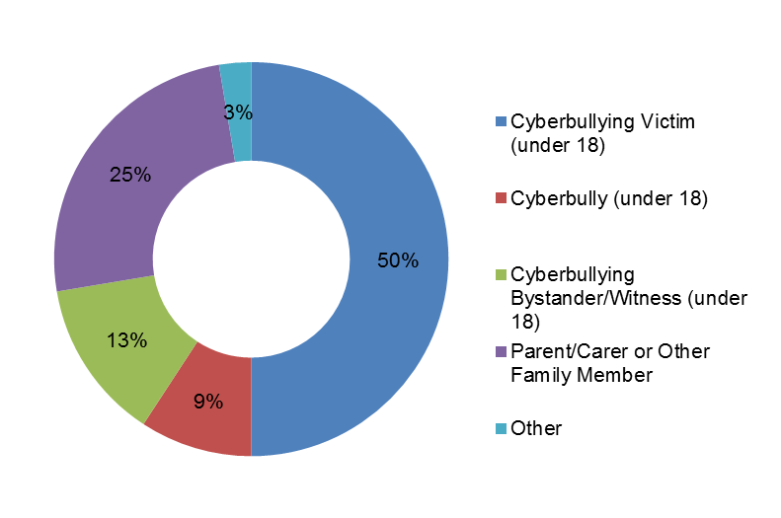
In 13 per cent of cases, the Centre was contacted by a cyberbullying witness or bystander, either connected to the victim by friendship (directly or indirectly) or did not know the victim at all but were plainly concerned about the welfare of the victim. The types of behaviours they identified included death threats, encouraging the victim to commit suicide, abusive messages/fake pages on social media, and forwarding of nude photos of the victim.
A quarter of cases came from a concerned parent/carer or other adult family member. In 2 of these 17 cases, the Centre acted on behalf of the perpetrator. In approximately 89 per cent of these cases, the adult had already approached the school or police with details of the behaviour. The cyberbullying had been ongoing and they had taken some level of action to try and stop it. Most adults were seeking more answers, while others were disatissfied with the solutions communicated by the school or police.
Most parents were already aware of the child’s predicament. However, when young people are in a sexual form of cyberbullying such as non-consensual sexting, the young people may be more reluctant to disclose what is happening to an adult. Seventy per cent of victims who indicated that they wanted to keep what was happening to them a secret from their parents/family were involved in sexually charged cyberbullying.
In 9 per cent of cases, the Centre was contacted by the cyberbully. Some were worried over their situation and were seeking advice about legal ramifications, whereas others contacted the Centre recognising that their actions were foolish and needed assistance in dealing with the school’s response.
No cases were raised directly from schools, counsellors, youth workers/advocates, police or social networking sites, although it is possible that individuals within this group may refer children or parents to Lawmail.

Profile of victims and cyberbullies

Gender
Table 10 reveals that 73.7 per cent of victims are female, 21.0 per cent are male and 5.3 per cent did not state their gender. This finding is consistent with the research literature cited in the Part A Report, although the extent of the differential in the Centre’s data is greater than in the literature. This could reflect a reporting bias against boys who are known to not seek help or use services until reaching a crisis point. Fifty per cent of cyberbullies were male, 30.3 per cent were female and 19.8 per cent did not state their gender.
Table 10: Profile of victims and cyberbullies
 | Sex % |  |  | V→Pª | Age groups (%)
 | Female | Male | Not stated |  | <10 | 10–13 | 14–15 | 16–17 | >18 | Not stated
Victim | 73.7 | 21.0 | 5.3 | 10.5 | 3.9 | 19.7 | 26.3 | 30.3 | – | 19.7
Cyberbully | 30.3 | 50.0 | 19.8 |  | 1.3 | 5.3 | 10.5 | 7.9 | 11.8 | 63.2
ª Victim indicated he/she was at one time a perpetrator

To investigate this distinction between genders further, we have divided the cases into ‘non-sexual’ and ‘sexual’ cyberbullying: 50 cases were non-sexual, and 26 were sexual, a ratio of approximately 2:1 (see Figure 2 where n=50 and Figure 3 where n=26).
Figure 2: Non-sexual cyberbullying cases | Figure 3: Sexual cyberbullying cases
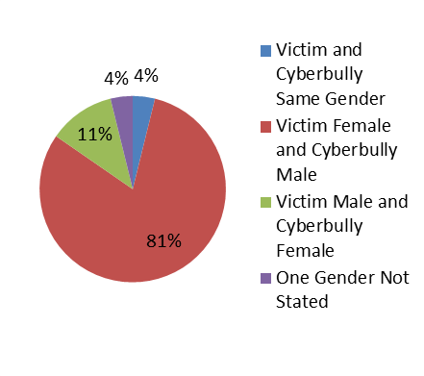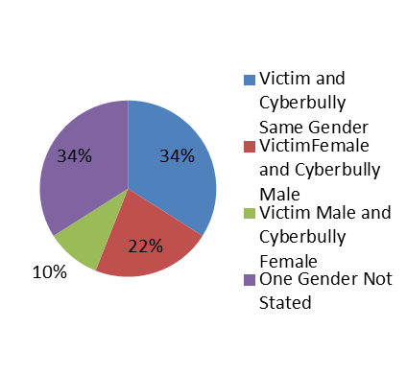
The following observations are of note:
- In 34 per cent of the non-sexual cases, the victim and perpetrator were of the same gender. In 71 per cent of these both the victim and perpetrator were female.
- In 32 per cent of the non-sexual cases, the victim and perpetrator were a different gender. Of the 22 per cent of cases identifying a female victim and male perpetrator, 3 out of 11 female victims were also perpetrators at one stage.
- In 81 per cent of the sexual cases, the victim is female and the perpetrator is male. In 9.5 per cent of these, the female victim was at one time a perpetrator.
- In 11 per cent of the sexual cases, the victim is male and the perpetrator is female. In 33 per cent of these, the male victim was once a perpetrator.
- In 4 per cent of the sexual cases, both victim and perpetrator were of the same gender and were both female.
The data highlights the difference between sexual and non-sexual cases, with less of a gender imbalance between victims and perpetrators in the non-sexual form though females are still more commonly victims than males. The gendered nature of cyberbullying victimisation is even more evident in the sexual cyberbullying cases.

Age
Half of all victims were aged 15 and under, while only 30 per cent were 16–17 years old. The average age of the victim was 14 years old. The average age of the cyberbully was not able to be discerned because in 63 per cent of cases the perpetrator’s age was not stated.
Where the age of the perpetrator has been stated, the following observations can be made:
- Victims 10–13 years old: In the 20 per cent of cases where the age of the cyberbully was known, the majority of cyberbullies fell within the same age group.
- Victims 14-15 years old: In the 35 per cent of cases where the age of the cyberbully was known, almost three-quarters of cyberbullies fell within the same age group.
- Victims 16-17 years old: In the 35 per cent of cases where the age of the cyberbully was known, two-thirds of cyberbullies were over 18 years old.

More than one victim or cyberbully
In some situations there was more than one victim or cyberbully; 39 per cent of cases indicated that there was more than one cyberbully. Although the type of situations where this occurs varies, the most common was that the main cyberbully solicits others to continue to cyberbully the victim. Other situations include posts on an online platform, encouraging many people both known and unknown to the victim to cyberbully.
The majority of cases (74 per cent) indicated that there was only one victim, but there were some situations where two or more people were the victims of cyberbullying (26 per cent). The most common situation is where the perpetrator targets the victim’s close family members, friends or partners (e.g. girlfriends or boyfriends). The second most common situation relates to sexual cyberbullying, where the victim (female) indicates that the perpetrator (male) has ‘done this to other girls’. For example, the cyberbully harasses many girls for inappropriate pictures.
NCYLC provides a national service. As the service uses the internet to communicate with its clients (Lawmail), this provides people the opportunity to seek help irrespective of their locality. Figure 4 below pinpoints where the cyberbullying incidents reported to the Centre are occurring.
The state with the most reported incidents is New South Wales (29 cases), followed by Queensland (20) and Victoria (11).
Figure 4: Incidents of cyberbullying by location
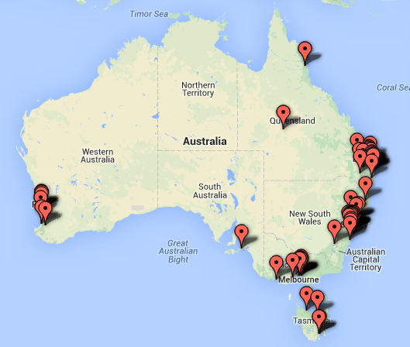:
11
3
29
7
5
1
0
20

Types of cyberbullying behaviours reported
Figure 5 reveals the types of cyberbullying behaviours in the 76 cases reviewed. The most commonly reported behaviours are threatening, abusive or intimidating use of the internet or mobile technologies and online harassment. They are often exhibited together in the same cyberbullying incident.
Figure 5: Cyberbullying behaviours in cases reported to NCYLC
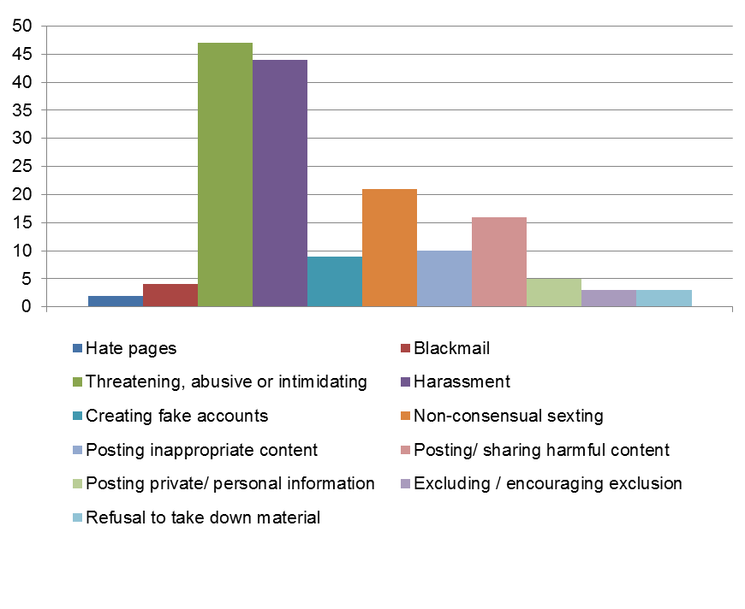
Note: n=76

A significant trend in Figure 5 is the high level of online harassment and threatening, abusive or intimidating behaviours. In the cases reviewed, most online harassment was accompanied by other forms of cyberbullying such as intimidating the victim or non-consensual sexting. The threats that were communicated include threats to life, threats to do physical harm, and threats to reveal personal information, images or videos. There was also a range of abusive and intimidating behaviours targeting the victim’s appearance, encouraging suicide, or making insulting/offensive comments.
Figure 6 also provides a breakdown of the types of cyberbullying behaviours based on the ages of the victims and the perpetrators, as well as the frequency and distribution of these behaviours among victims and perpetrators.
Figure 6: Cyberbullying behaviours –victims and perpetrators (%)
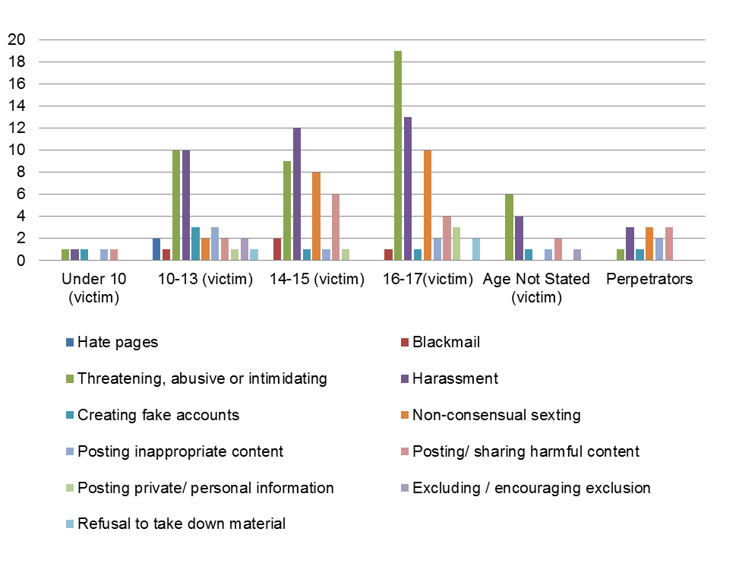
In the under 10 age group, all cases involved non-sexual incidences of cyberbullying. This same trend can be seen in the 10–13 age group, with most incidences of cyberbullying being of a non-sexual nature (two were of a sexual nature). However, the spread of behaviours is far greater than any other age group. A spike in sexual cases occurs in the 14-15 age group where non-consensual sexting behaviours are high. This behaviour is also linked with the posting and forwarding of inappropriate content. Sexually charged cyberbullying also sees a rise in the 16–17 age group. A significant number of incidents (83 per cent) in the 16-17 age group exhibit some level of threatening, abusive or intimidating behaviour. Most of these incidents also indicated non-consensual sexting as an associated behaviour. In these cases, threats were made to the victim in order to control them and ensure that the victim would bend to the will of the perpetrator. The case study provided below is an example of this behaviour.
It is evident that cyberbullying incorporates many forms of behaviours, with most incidents falling within more than one of these behaviours. They range from less serious cases such as continued name calling to serious crimes such as solicitation of a child for child pornography or abuse material.
The word cloud in Figure 7 highlights the main statutory references the Centre has researched in its advices to clients.
Figure 7: Statutory references in National & State/Territory legislation
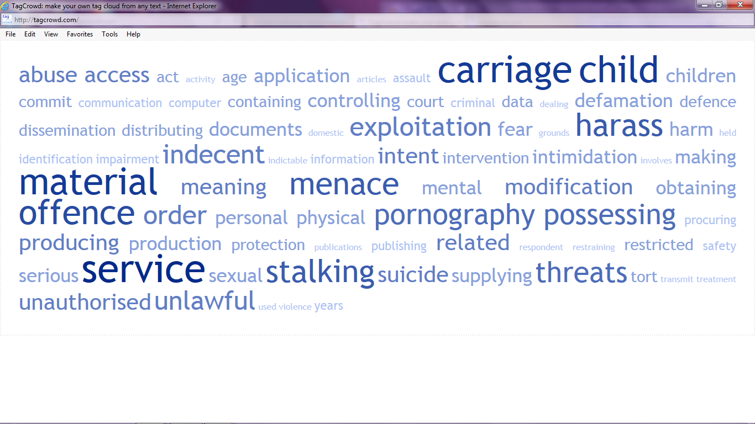

Factors increasing the risk to the victim
Three factors were identified by the Centre as increasing the risk to the victim: whether the cyberbullying was part of a broader range of incidents targeting the victim; whether the cyberbully was anonymous; and whether the victim expressed concern about confidentiality, i.e. was reluctant to inform a trusted adult (other than the Centre). See Figure 8 below.
Figure 8: Factors likely to increase the risk to the victim
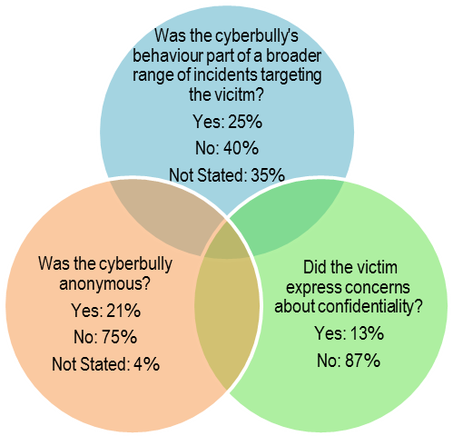
These three factors viewed alone or in combination, contribute to an increased risk of serious harm to the victim (in the opinion of the Centre).

Factor 1 – Broader Range of Incidents Targeting the Victim
These cyberbullying incidents are categorised by a constant and pervasive pattern of bullying. Some examples of this include:
- Continued abuse over phone and message after ceasing communication with perpetrator on social media
- Continued abuse for many months and years. In these situations, the victim may feel trapped or threatened before they are able to seek redress
- Targeting friends, family or current partners of the victim
- Physical bullying including assault, stalking, showing up at victim’s place of work/school
- School yard bullying.

Factors 2 and 3 – Cyberbully anonymity and confidentiality
A perpetrator was deemed anonymous if they were unknown to the victim in the ‘real world’. This means that the perpetrator was operating under the name ‘anonymous’ online, they were operating under a pseudonym, or they were operating under a name or image that could not be confirmed. There were 16 cases in total which indicated that the cyberbully was anonymous. Of these, 10 indicated that the cyberbully was operating under the name ‘anonymous’ or they did not otherwise identify who it was. However, there are six cases where a young person has been communicating with a pseudonym. These cyberbullying incidents were of a sexual nature, and in all but one, the victims were female. The behaviours communicated to the Centre are all serious crimes. They include blackmail, procuring/grooming a child, coercing the child to perform sexual acts or positions, and threatening the child with the publication of these materials. Two of these victims were 13, one was 15, one was 16, and two were 17 years old.
In four of these cases, the victim expressed concerns around the confidentiality of their cases. In one case the victim had informed her mother after already revealing nude images to the cyberbully. These victims expressed feelings of shame and embarrassment, fearing their parents’ reactions, and in one case the victim stated she did not want to tell the cyberbully she was seeking help because he had threatened her with releasing the indecent material of her on Facebook.
These comments provide a snapshot into the magnitude of the issue and the extent of the manipulation and grooming undertaken by the cyberbully. The case study in below presents an example of this type of incident. The ‘cyberbullying’ label seems inadequate to describe such incidents.
Of the other cases indicating confidentiality concerns, victims have varying motivations for expressing this discomfort. These concerns included: not wanting to worry their parents, not wanting others at school to find out, wanting to keep their issues a ‘secret’, or fear that telling an adult the situation might make the situation worse.

Harms identified by victim
Victims of cyberbullying are experiencing a broad spectrum of harm. The harms in Figure 9 (n=76) were expressly communicated by the clients of the Centre in the cases reviewed. Victims often remain silent in communicating their harm, as identified by the incidence of ‘not stated’; it is important to acknowledge the potential for hidden harms in these cases.
Figure 9: Harms identified by victims, by age
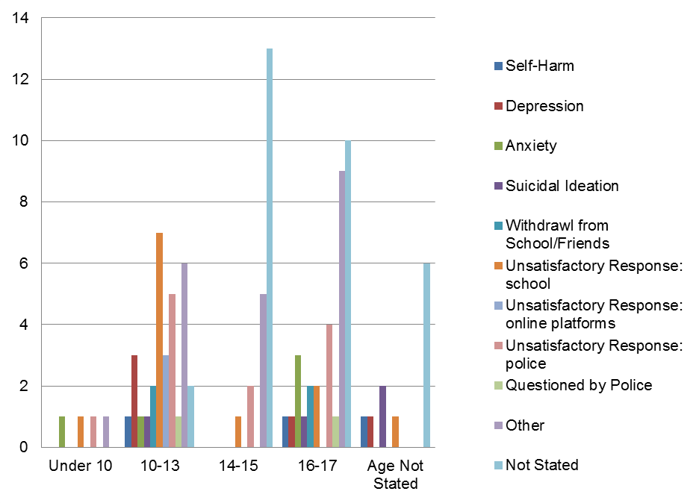
Children under 10 are experiencing anxiety, and in one case, the victim identified she was ‘frightened for [their] life’. Victims in the 10–13 age group reported a broader range of harms including self-harm, depression, and even suicidal ideation.
Harms to victims in the 14–15 age group were mainly categorised as ‘other’ and included: feelings of insecurity and low self-esteem, self-deprecating behaviours, emotional breakdowns, and physical effects such as feeling sick and fainting.
Victims in the 16–17 age group identified a broad range of harms, and once again, most of these fell within the ‘other’ category. These include: feelings of embarrassment or shame, refusal/reluctance to engage in society because of fear, post-traumatic stress disorder, fear for safety, inability to continue with school, forced to leave school and leave town, with one victim stating that they had to leave their job as a result.

Unsatisfactory response at school
In some cases, victims identified that they received an unsatisfactory response from their school. The way a school responds to cyberbullying incidents is important because in 35 per cent of the cases reviewed, both the perpetrator and victim were known to attend the same school, while 45 per cent of cases were silent on the issue.
The following are the examples of when victims have indicated an ‘unsatisfactory response’ from the school:
- In 5 out of 12 cases, the school did address the cyberbullying, either by suspension, formal warnings, counselling sessions, or inviting a police officer to talk about bullying. However, this did not stop the perpetrator.
- The fact that the school has no control over certain activities was also highlighted. In one case, the school could not do anything because it was the last day of term, and in another, the school expressed they couldn’t act because the victim no longer attended the school. Also, the school did not act in one case because the cyberbully said someone else had used their phone to send the abusive message.
- In other cases, the parent or victim felt like the school was not acknowledging or appreciating the harm to the victim, and in two cases the victims moved schools because of this.

Unsatisfactory response by police
The cases reviewed indicated two problems with the police response: either the police are restricted by the facts of the case and are limited in what they can do, or the police reportedly have not responded at all. Nine cases were identified (of 12) where the police said they were restricted in their actions. The following are some fact scenarios in words mirroring the victim’s:
- Police were not able to address the issue because the cyberbully was 12 years old.
- Police attempted to sort the issue out but the cyberbullying continued.
- There isn’t a lot the police can do unless the situation escalates, e.g. until the perpetrator makes a physical threat. Six cases identified this issue.
- The police could not do anything because the behaviour was on Facebook and the cyberbully needed to repeat actions multiple times before any action could be taken.
The response of the police varied, from ignoring the requests, not recording repeated reports, to responding to and resolving the incident.

How incidents are being dealt with by NCYLC
Figure 10 provides an overview of the different types of responses provided by NCYLC in response to cyberbullying. These range from good practice advice (e.g. advising the client to block, ignore, copy bullying content, delete incriminating content, and tell a trusted adult) to advising on personal violence or intervention orders. Other responses include refer, report, support, and provide formal responses such as the take down/cease and desist notice. The data shows that the Centre’s preferred responses include advice and engaging the roles of counselling services, schools, parents, social media and police in responding to cyberbullying.

Figure 10: How NCYLC is responding to cyberbullying
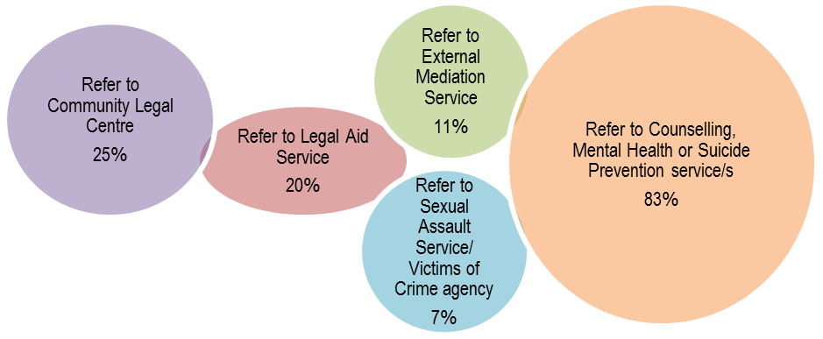
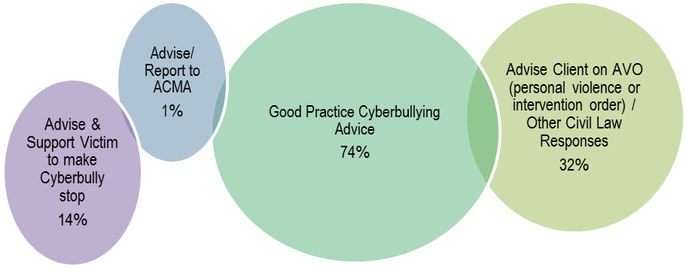
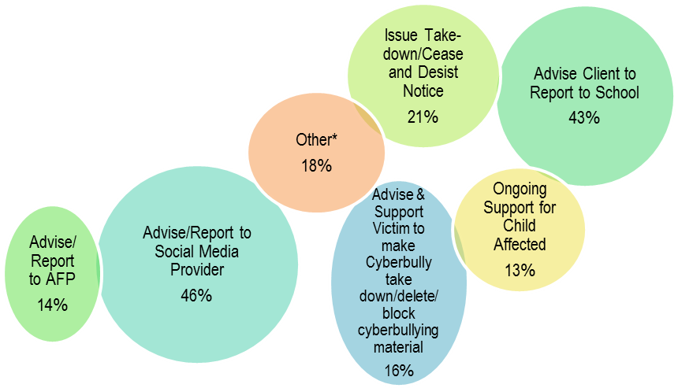
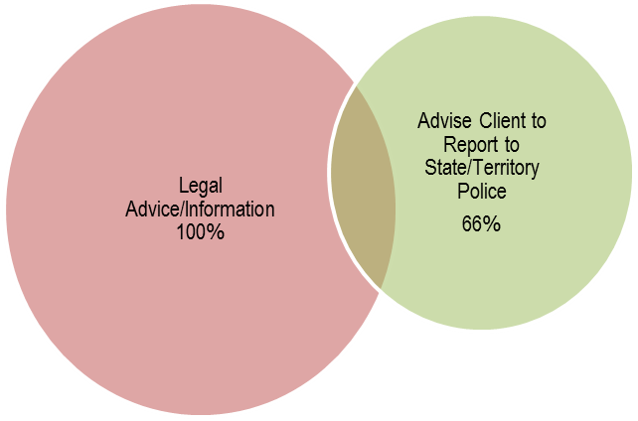
*Other: Includes advising client to report to Catholic Education Office, Sydney Anglican Schools, Christian Schools Australia, State/Territory Education Department, Ombudsman, and Phone Company.

Reporting cyberbullying to online platform or application
Most of the cases identified either an online platform or application as the platform through which the cyberbullying occured. In some cases, the vicitm was cyberbullyied across multiple platforms. The identity of these platforms, as identified in the cases reviewed, is extracted in Figure 11.
Figure 11: Identity of online platforms and applications
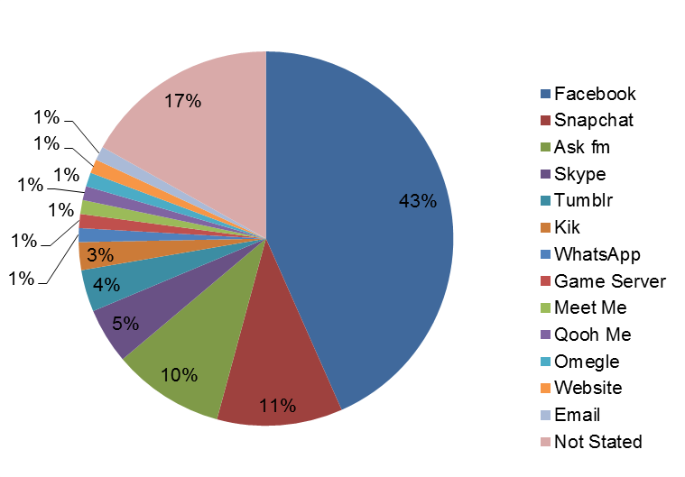

Note: n=76

Facebook
There were six incidents where either the victim or the Centre reported the cyberbullying to Facebook. A range of responses were communicated to the Centre from the victims. These ranged from receiving no response, to receiving a response but no action was taken, to having the issue resolved to the satisfaction of the client. In one case a page was removed because it showed pictures of male genitalia and contained sexual threats. Another page directed at abusing the victim was removed only after repeated complaints by users.
In one example, the Centre was approached by a client whose child was the victim of a Facebook hate page. The mother reported the page to Facebook by their online reporting mechanism. Facebook responded to the mother but did not remove the page. The Centre reported the page to Facebook twice using the same means as the mother, but received the same result. It was only when the Centre contacted a representative from Facebook Australia in person that the page was taken down.

Google
In this case, offensive images in the style of ‘posters’ were made about a victim using a particular website. When the victim’s name was googled, the posters were a prominent search result. The Centre reported the matter to Google via their online contents complaint form. Google responded stating they had no control over the hosting company and therefore didn’t remove the URL from search results. After contacting the web master, the pages were deleted.

Other online platforms
In the case of Instagram, the client did not specify whether any reporting action was taken. However, in regards to Ask fm, qooh.me and a game server, the clients reported that no action had been taken by the online platform.

Composite case studies and NCYLC response
Three composite case studies have been prepared in order to provide a clearer understanding of the types of cyberbullying incidents being dealt with by NCYLC. Note that these are composite case studies and contain de-identified scenarios from a broad range of incidents dealt with recently by the Centre. Fictional names have been used in each case study.

Most common cyberbullying scenario
My name’s Larissa and I am 14 years old. I have been having some trouble with this girl Georgia. She goes to my school and I thought we were friends until she started saying hurtful and mean things about me.
It started on Monday when I was on Facebook, Georgia inboxed me and said ‘you’re an attention seeker that needs to stay out of my relationship with Robbie’.
I replied saying ‘I don’t know what you’re talking about. Me and Robbie are only friends. I wouldn’t do that to you cause you’re my friend’.
The conversation went back and forward for a couple messages, her pretty much saying that I was trying to break them up. I know for a fact that I haven’t done anything like that. I think people have told her things which made her go off at me.
When I got to school on Tuesday I find out that Georgia has started spreading rumours about me, telling people at school that I’m a slut and I shouldn’t be trusted. I tried to talk to Georgia at school but she turned away from me and won’t listen.
That night I went on Facebook to find many hurtful and abusive messages in my inbox and on my wall, all from Georgia and her friends. They are calling me a ‘slut’, ‘ugly’, ‘low life piece of shit’ or telling me to ‘do the world a favour and kill yourself’. I had enough, so I inboxed Georgia telling her to stop and leave me alone because I hadn’t done anything. She replies ‘do you think I will give up? Sorry but I won’t’.
I want this all to stop. What can I do? There’s not much more I can handle.

Centre response
The Centre provided Larissa with both practical and legal advice. The practical measures included telling a trusted adult about the situation, keeping a record of the messages she received, deleting/blocking Georgia and her friends from her Facebook account, and not replying to any bullying messages. The Centre advised Larissa to report this behaviour to Facebook (noting that the Centre could do this on her behalf) as well as to her school, which may be able to facilitate reconciliation between the two students.
The Centre also provided Larissa with legal advice about certain laws that had been broken and offered Larissa the option of drafting a Notice to Georgia which outlines the laws that Georgia may have broken and tells Georgia to stop this behaviour. The Centre also advised Larissa to notify the police if she felt threatened, and if Georgia’s behaviour continued and made Larissa feel scared. To help support Larissa during this time and help her cope, the Centre also provided Larissa with contact details for the Kids Helpline.

Most serious victim scenario (non-sexual)
I’m 17 years old and for the last few months I have been constantly bullied by multiple students at school. Jessica has bullied me through Facebook, posting status updates and sending me abusing messages. She would call me ugly, tell me she hates me, I don’t deserve to live, and I should exterminate myself before she does. She also posted a photo of me compared to a pig. People at school started calling me pig and making oinking noises when I walked past. The stupid nicknames seem like nothing but actually hurt me a lot. I felt horrible about myself and my self-esteem lowered by every single insult.
Eric repeatedly called and harassed me over the phone. He would call me at all times of the day on a private number and leave nasty messages, calling me names and threatening to ‘punch my face in’. I got a new number but he found it out. I was worried every time my phone would ring.
The school hasn’t done anything to stop this. When I told them about what’s been happening at school they suspended some of the students, but the day they come back the bullying starts again. I have also been to the police about the Facebook stuff and they tried to sort it out but they said they can’t do anything.
Over the past week a Facebook page has been made with my photo on it. Most of the people on this page are writing hate messages about me, making comments about how I look and calling me names. I have already left the school, but the bullying keeps following me.
I know that something needs to be done but I don’t know what. Most days I come home, lock myself up in my room and self-harm for hours on end.

Centre Response
In this case, the Centre identified many risk-factors to the victim, including a persistent pattern of victimisation which subsequently affected his day-to-day life, incidents of self-harm, and a reported inability of the school or police to adequately resolve the issue. Due to these identified harms, the Centre sent a preliminary email to the victim with contact numbers for Lifeline, Kids Helpline and 000.
Following this, the Centre issued advice to the victim outlining both practical and legal measures that could be implemented to address the cyberbullying. Some practical measures were: tell a trusted adult, delete/block these people from Facebook, and keep screen shots and records of any messages or telephone calls received. The Centre also advised him to report this behaviour to the phone company and to Facebook (with an option of the Centre contacting either on his behalf), as well as making a formal written complaint to the school and the Department of Education if the school was unsafe or unwilling to keep him safe.
The Centre provided legal advice on the types of laws that had been broken and recommended he take all evidence of messages, conversations and telephone calls to the police station so that the police would be able to engage with the situation. Other legal measures advised were to seek a protection order against certain individuals, seek victim’s compensation and services to pay for counselling and other services in aid of recovery and, as a last resort, to sue the school and other people involved.
The victim told the Centre that he had reported the hate page to Facebook, but Facebook had not removed the page. The Centre, on behalf of the victim, reported this hate page through Facebook’s online reporting system. The Centre received the same result as the victim. However, once a representative from Facebook Australia was contacted directly, they removed the hate page.

Most serious victim scenario (sexual)
About two months ago I met this boy on a site called Omegle. We started talking and he told me he was 16 years old. We became Facebook friends and chatted a bit on there. Then he asked me to go on Skype so I did, I couldn’t see his face but he asked me to take my top off. I didn’t want to do this but he kept flirting with me and persisting, so I gave in and flashed him.
I knew it was a mistake as soon as I did it. He told me he took a screenshot of my naked chest. I was really upset he did this. Then he started asking me to do more stuff and show more of my body. I told him I didn’t want to do anything else because I was uncomfortable. But then he started threatening me to send the photo to all my Facebook friends if I didn’t do what he was saying. I was embarrassed and afraid so I just did as he said.
Now he keeps messaging me every night and making me do stuff on Skype or he says he will publish everything he made me do the first time. Once it’s over I cry myself to sleep purely because I know this is wrong and that I never wanted to do it.
He won’t stop. I don’t want to keep playing his game, but I don’t want to tell anyone because I am so ashamed and embarrassed. I am on the border of depression and hate coming home to this. I don’t know his real name. I don’t know what to do.

Centre Response
The seriousness of this situation is compounded by the fact that the victim feels isolated and is afraid to tell her parents about what is happening. The Centre recommended that the victim speak to a trusted adult, someone like a parent, teacher or relative who can help her report this to the police and provide her with ongoing support. If she felt uncomfortable with this, the Centre also provided her with a warm referral to a local counselling/sexual assault service where she would be able to talk to someone in confidence and obtain help in dealing with the trauma. This service had connections to the police, so they were able to assist in this way as well. The Centre also provided her with the details for Kids Helpline and 1800RESPECT.
The Centre provided the victim with legal advice about certain laws that have been broken and provided her with the option of sending the perpetrator a ‘Notice of Criminal Behaviour’. This notice would outline the laws that had been broken and ask the other person to stop and delete the content. The Centre recommended she talk with the counsellor about sending this Notice to the perpetrator.
The Centre provided the victim with practical advice such as not to respond to his messages, unfriend/block and to keep any evidence of conversations they had to take to the police. The Centre also reassured her that it would be there for her if she needed help in the future.
The Centre advised her about reporting the incident to the police and gave the victim a warm referral to her local police station and provided a contact for a police officer that deals with these matters. The Centre also recommended that she attend the station with an adult for support. This station would be able to report to the Australian Federal Police (AFP), but the Centre also provided her with a link where she can report this behaviour directly to the AFP.

Are incidents increasing?
The Centre has seen a significant increase in the number of cyberbullying incidents being reported, from one per cent of Lawmails in 2010 (6 of 787 Lawmails received in the period) to 7 per cent for the 12 month period from 1 April 2013 to 31 March 2014 (76 of 1052 Lawmails received). This amounts to a seven fold increase in three years.

Summary of findings
In 63 per cent of the cases, cyberbullying victims and bystanders contacted the Centre. From this it is clear that young people are searching for responses in which they themselves have agency.
The Centre for the most part deals with serious or very serious matters which could potentially invoke criminal law responses in virtually every case. The Centre has very few cases of ‘name calling’.
Young people involved in sexual forms of cyberbullying are likely to be more reluctant to disclose what is happening to an adult. The majority (70 per cent) of victims of sexual forms of cyberbullying wanted to keep what was happening to them a secret from their parents and family.
The experience of the Centre is that cyberbullying is a gendered form of behaviour with victims being predominantly female (73.7 per cent) and cyberbullies slightly more often being male (50 per cent) compared to 30.3 per cent female, with 19.8 per cent of the cyberbullies’ gender being unknown.
The gendered nature of cyberbullying victimisation is particularly evident in the subset of cases classified as sexual forms of cyberbullying. In 81 per cent of sexual cyberbullying cases, the victim was female and the perpetrator male.
A significant proportion of the reported cyberbullying cases were sexual cyberbullying cases. The ratio of non-sexual cyberbullying cases to sexual cyberbullying is approximately 2:1.
The distinction between sexual and non-sexual cyberbullying markedly increases in the 14-15 year age group in which a spike in sexual matters occurs. The prevalence of those matters continues to rise in the 16-17 year age group. Given that the majority (81 per cent) of victims in sexual cyberbullying cases are female and the perpetrators male, the rise in the sexual victimisation of girls by boys through the use of technologies may suggest the emergence of a new concerning phenomenon of technology driven gendered violence emerging within the teenage demographic. However, it is also important to note that 21 per cent of cyberbullies were anonymous and may not be young people at all.
Threatening, abusive or intimidating behaviour is the most common cyberbullying behaviour, closely followed by harassment. Both behaviour types featured predominately across all the age groups.
The average age of a cyberbullying victim is 14 years. Half of all cyberbullying victims were under the age of 15.
Legal advice or information was provided in all of the Centre’s responses to cyberbullying. In 83 per cent of cases, the client was referred to counselling, mental health or suicide prevention services. The third most popular response was to provide practical advice on next steps, which was provided in 74 per cent of the cases.
There are concerns about the variability and effectiveness of many responses but the Centre continues to see importance in advice and assistance to any young person involved in a cyberbullying incident and in the roles of parents and trusted adults, schools, social media, police and a range of other agencies to which the Centre refers its clients.

Social Policy Research Centre
Level 2, John Goodsell Building
Faculty of Arts and Social Sciences
UNSW Australia
UNSW Sydney 2052 Australia
t +61(2) 9385 7800
f +61(2) 9385 7838
e sprc@unsw.edu.au
w www.sprc.unsw.edu.au

The University of New South Wales
CRICOS Provider Code 00098G
ABN 57 195 873 179

A victim can be involved in a number of incidents in a particular period of time, and similarly one incident can involve several victims.
Although this survey formed part of this project, it was conducted separately and is reported separately. This report only includes limited information about the methodology and findings of the survey.
This is calculated using a 5 per cent trimmed mean; the top and bottom 2.5 per cent of schools were not included in the analysis in order to exclude outliers.
These estimates are based on the number of reported incidents in 2013 divided by the number of students in a school. They therefore assume that each reported incident involves one student. This does not take into account that students may be involved in several reports and that reports may involve several students. Thus this figure should be seen as a rough estimate only.
This does not add up to 100 per cent as the questions were asked separately also these percentages are indicative as they involve a combination of estimates and recorded data.
In the School Principals Survey, however, the age group the schools receive the most serious reports of cyberbullying are from10-13 year olds (54.7 per cent), whereas 25.4 per cent of reports involved 14-15 year old victims.
NB the literature on the demographic profile of victims of cyberbullying has reported mixed findings with regard to the socio economic status of victims, with some research indicating that cyberbullying is equally prevalent across all social classes. See Part A Report.
Provisions within the Victorian Children, Youth and Families Act 2005 (CYFA) that relate to children in need of therapeutic treatment provide an alternative pathway into treatment when the child does not voluntarily seek help, without the need to rely on a criminal prosecution.
The number of schools that dealt with the issue is provided in brackets.

