# Independent cost-benefit analysis of broadband and review of regulation

Volume II - The costs and benefits of   
high-speed broadband

August 2014

This page is left blank intentionally.

Contents

Overview of volume II 5

Why cost-benefit analysis? 5

Key elements of the analysis 5

The scenarios examined 6

Key findings 7

Fixed wireless and satellite 8

Sensitivity analysis 9

Growth in demand and upgrade potential for the multi-technology mix 10

Understanding the components of the analysis 13

1. Introduction 18

1.1 This report in the context of the panel's terms of reference 18

1.2 What is cost-benefit analysis? 19

1.3 Why undertake a CBA? 21

1.4 Inputs into the cost-benefit analysis 21

1.5 The structure of this report 22

2. Understanding the need for high-speed broadband 23

2.1 How much speed is needed, in a technical sense? 23

2.2 The Communications Chambers report 24

2.3 Communications Chambers model results 25

3. Overview of CBA methodology 29

3.1 Background 29

3.2 Estimating willingness to pay (WTP) 30

3.3 Analysis of costs 31

3.4 General CBA parameters 31

4. The scenarios evaluated 34

4.1 Speeds available under each technology 37

4.2 No further rollout of high-speed broadband or new infrastructure 38

4.3 Unsubsidised rollout of high-speed broadband 38

4.4 Multi-technology mix scenario 39

4.5 Fibre to the premises scenario 40

4.6 Variation of scenarios 40

5. Costs of each scenario 41

5.1 Approach 43

5.2 Cost differences across technologies 43

5.3 Total costs 44

5.4 The timing of costs 46

6. Benefits of each scenario 48

6.1 Willingness to pay for higher speeds 49

6.2 Business willingness to pay 65

6.3 Valuing public and external benefits 66

6.4 Residual value 68

6.5 Disruption costs 68

6.6 Deadweight loss of taxation 69

6.7 Benefits over time 69

7. Net benefits of alternative options for delivering high-speed broadband 71

7.1 Net benefits of fixed wireless and satellite 71

7.2 Sensitivity analysis 72

7.3 Net benefits under alternative growth in WTP 73

7.4 Specific sensitivity analysis 76

Appendix A - Government involvement in high-speed broadband deployment 80

The limited rationale for government involvement 80

The recent history of government involvement 82

Appendix B - Internet in Australia 84

Internet access connections 84

Internet use 89

Expected future 93

Take-up of NBN 93

Appendix C - Technologies for high-speed broadband 95

Network technology summary 95

Appendix D - Previous analysis of the costs and benefits of high-speed broadband 99

Willingness to pay for speeds 99

Other approaches to assessing the benefits of broadband 101

Summary of previous choice modelling studies 102

Appendix E - Activities with benefits outside of private benefits 104

Types of benefits 104

Appendix F - Review of cost estimates made by NBN Co 120

Overview 120

NBN Co modelling framework 121

High-level comparative review of Corporate Model Outputs 123

Bottom-up review of models 129

Converting financial costs into economic costs 132

Appendix G - International broadband strategies 134

International Broadband Strategies 134

Commercial deployment of high-speed broadband 134

Appendix H - Choice modelling analysis 145

Objectives 145

Sample Methodology 145

Survey structure 147

Model Results 155

Outputs of the choice modelling 160

Appendix I - Sensitivity analysis input probabilities 166

References 166

Glossary of terms 172

## Overview of volume II

Volume I of the report of the Independent Cost-Benefit Analysis and Review of Regulation highlighted the scope for changes to the current arrangements to enhance the efficiency with which Australia's telecommunications infrastructure is built, managed and used. The very substantial sums of taxpayers' funds that are being committed to broadband infrastructure make those changes all the more important.

Underscoring that assessment is the panel's analysis of the costs and benefits of increased access to very high-speed broadband, which shows that while there are net benefits to that increased access, they will only be realised by efficient investment, operation and pricing. This volume of the panel's report sets out those findings, which are closely bound up with its policy recommendations in Volume I.

The panel was required to carry out its analysis of cost and benefits by its terms of reference, which specified that it consider the economic and social value of increased broadband speeds. To respond to this part of the terms of reference, research to measure and compare the costs and benefits of alternative options for delivering higher broadband speeds to Australian households and businesses has been undertaken. This has included original research.

### Why cost-benefit analysis?

The results in this report have been prepared using the economic discipline of cost-benefit analysis (CBA). CBA differs from financial analysis in that it is concerned with net economic benefits to the entire community.

Because meeting the national broadband network (NBN) objective under current policy settings involves substantial government expenditure, it is important to understand the magnitude of the benefits that arise from this use of taxpayer funds.

As the rollout of the NBN involves choices about technologies, it is also important to understand the relative merits of different technological choices, particularly given the expectation of steadily growing demand for broadband speed.

CBA is a tool designed to place the benefits and costs of the different NBN choices on a common basis so that they can be compared and understood. CBA is widely used to assist policy makers in making decisions on alternative policy and technical options that affect the community. CBA allows policy makers to consider trade-offs and decide whether the community as a whole is better or worse off under these alternative policy and technical scenarios.

CBA is a powerful tool that can assist in guarding against poor decisions. An important aspect of CBA is that it can highlight the sensitivity of the outcomes to changes in the key parameters affecting costs and benefits. That makes it especially useful in dealing with inevitable uncertainty, as it clarifies the extent of the risks and helps structure options for managing them. A more complete discussion of the nature of the CBA and its implications can be found in Chapter 5, Volume 1 of the panel's report.

### Key elements of the analysis

The analysis in this report focuses on the incremental benefits and costs that arise from providing additional bandwidth (speed) to households and those businesses to be served by the NBN. Each of the investment scenarios considered involves an increment to current speed.

Each of the scenarios considered in the analysis begins from the current point in time. The analysis is not attempting to recreate what a CBA would have looked like at the time the original decision was made to rollout the NBN and establish NBN Co.

The value to households and businesses arises from the increased possibilities that these changes in speed allow. This includes greater benefits from existing uses of the internet, benefits from new uses only made possible through increased speed, time savings, reductions in transactions costs and productivity increases.

The analysis in this report has a particular focus on estimating the household willingness to pay (WTP) for high-speed broadband. This is a measure of the consumer benefits of the additional speed that the NBN offers and encompasses each of the types of gain noted above.

Where appropriate, WTP for high-speed broadband is also extended to those business customers that are to be serviced by the NBN.

In addition, the analysis also considers the likely *public* benefits that arise in addition to the *private* household and business benefits. These could include changes in the quality or cost of services such as health and education and lower transport congestion.

The total benefits are then compared to the costs of different high-speed broadband alternatives calculated using detailed information provided by NBN Co, and appropriately modified by the panel to reflect its use in CBA.

### The scenarios examined

CBA involves the comparison of different options. The scenarios chosen for this CBA are designed to consider the question of which method of rolling out high-speed broadband has the greatest net benefits but also to allow a calculation of the general net benefits of high-speed broadband itself. This CBA is conducted around four main scenarios.

* *No further rollout scenario* — this scenario assumes there is no further investment in high-speed broadband infrastructure beyond the investments already made and no change in speeds from those available today. This is a purely illustrative scenario (it is clearly not realistic) used to estimate the benefits of high-speed broadband.
* *Unsubsidised rollout scenario* — this scenario models the rollout of high-speed broadband using hybrid-fibre coaxial (HFC) and fibre to the node (FTTN) technologies to areas where it can be undertaken without the need for any government subsidy. It provides a reference case against which to compare other scenarios.
* *Multi-technology mix scenario (MTM scenario)* — this scenario assumes a combination of fibre to the premises (FTTP), FTTN, HFC and fixed wireless and satellite solutions (as set out in the NBN Co *Strategic Review).*
* *Fibre to the premises scenario (FTTP scenario)* — this scenario assumes delivery of FTTP to all premises in the fixed line footprint, complemented in high cost areas by fixed wireless and satellite solutions (as set out in the 'radically redesigned' option of the NBN Co *Strategic Review).*

These scenarios differ in the upload and download speeds made available, in the timing of delivery and in their coverage. In particular, the following features should be noted.

* The *FTTP scenario* and the *MTM scenario* provide higher speeds Australia-wide.
* The *unsubsidised rollout scenario* provides higher speeds to the majority of the fixed line area (up to 93 per cent of premises) but not to areas covered by the other investment scenarios through fixed wireless and satellite services.
* The *FTTP scenario* provides the highest speeds but is more costly and takes materially longer to deploy. The *FTTP scenario* takes longer to deploy than the *MTM scenario* because it involves replacing the HFC assets (which are used in the *MTM scenario)* and copper connections to premises (which are used in FTTN delivery in the *MTM scenario)* and placing entirely new connections in almost all premises. Given the greater tasks involved, accelerating the deployment of FTTP to match that in the MTM would likely entail substantial cost increases.

Appropriate comparison of each of these scenarios allows the panel to respond to its terms of reference.

### Key findings

Table 1 summarises the net economic benefits of each scenario using a base set of assumptions. These assumptions are varied in the sensitivity analysis considered further below. Table 1 expresses the results relative to the *unsubsidised rollout scenario.*

Table 1 shows the following results from the CBA.

* Continued investment through an *unsubsidised rollout* of high-speed broadband has a net benefit of $24 billion (when compared with the reference case *no further rollout scenario).* This can be seen in Table 1 as avoiding a $24 billion net cost under the *no further rollout scenario.*
* The *MTM scenario* has a net cost of $6 billion relative to the *unsubsidised rollout scenario.* This largely reflects the net costs of delivering higher speeds to rural and remote areas via fixed wireless and satellite.
* The *FTTP scenario* has a net cost of $22 billion relative to the *unsubsidised rollout scenario.* This is because it is more costly and slower to deliver, which delays the realisation of benefits. This means that its costs are higher and its benefits lower than the *unsubsidised rollout scenario.* The net costs of this scenario also include the net costs of delivering higher speeds to rural and remote areas via fixed wireless and satellite.

Table 1: Net benefits of each scenario relative to the reference case

| Cost/Net benefits | No further rollout $b, present value | Unsubsidised rollout $b, present value | MTM scenario $b, present value | FTTP scenario $b, present value |
| --- | --- | --- | --- | --- |
| Cost relative to reference case | -17.7 | 0 | 7.2 | 17.6 |
| Benefits relative to reference case | -41.7 | 0 | 1.0 | -4.7 |
| **Net benefits** | **-24.0** | **0** | **-6.1** | **-22.2** |
| **Net benefit per Australian household ($)** | -2,430 | 0 | -620 | -2,220 |

*Note:* These results use a discrete choice survey to estimate benefits.

*Source:* The CIE.

An alternative way of understanding these results is to consider how each scenario compares with the *no further rollout scenario* and with each other. This alternative comparison in presented in Chart 2, where the same information in Table 1 is re-expressed.

Chart 2 clearly indicates that different methods of investing in high-speed broadband can generate different net benefits, and some ways of investing can cause net benefits to decline compared with levels that could otherwise be achieved.

The *unsubsidised rollout scenario* using HFC and FTTN in the fixed line area (up to 93 per cent of premises) provides the greatest net benefits.

* The *MTM scenario* extends high-speed broadband to all premises through investment into higher cost areas serviced by fixed wireless and satellite. It also includes around 15 per cent of premises serviced by FTTP. This reduces net benefits by $6.1 billion or $600 per Australian household (compared with the *unsubsidised rollout scenario).*
* The *FTTP scenario* provides higher speeds within the fixed line area at higher cost and with a slower rollout. This reduces net benefits by a further $16.1 billion or $1,600 per Australian household. The FTTP scenario only makes the community $2 billion better off, in net terms, than under the *no further rollout scenario.*

Chart 2: The net benefits of each scenario (present value)

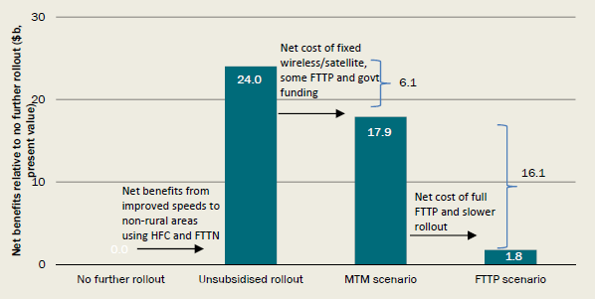

*Data source:* The CIE.

### Fixed wireless and satellite

The lower net benefits from the *MTM scenario* relative to the *unsubsidised rollout scenario* are primarily a result of the delivery of fixed wireless and satellite networks. Table 3 indicates the reasons for this by showing the costs and benefits of the fixed wireless and satellite component separately.

The reduction in net benefits of $6.1 billion in this scenario is primarily the result of net costs of providing fixed wireless and satellite services of $4.2 billion (see next paragraph). The remaining $1.9 billion of net costs results from continuing the rollout of FTTP while transitioning to FTTN and HFC (which the *unsubsidised rollout scenario* does not assume occurs) and additional deadweight loss from the greater taxation funding required for the *MTM scenario.*

Providing fixed wireless and satellite services costs nearly $5 billion but the benefits are only just above 10 per cent of that. The result is a substantial net cost to the community. The net social cost is equivalent to almost $7,000 per additional premises connected through the provision of fixed wireless and satellite services.

This net cost is incurred because (i) the WTP for higher speeds is less than the costs of delivering higher speeds in these footprints and (ii) the substantial government contribution must be funded from taxes, which impose a deadweight economic loss (DWL).

This outcome represents the net cost of providing access to high-speed broadband to rural and remote regions of Australia.

Table 3: Net benefits of fixed wireless and satellite

| Costs and benefits | Present value $b |
| --- | --- |
| **Costs** | **4.8** |
| **Total benefits, made up of:** | **0.6** |
| Willingness to pay | 1.2 |
| Public benefits | 0.1 |
| DWL of taxation | -1.1 |
| Disruption costs | -0.1 |
| Residual value | 0.6 |
| **Net benefits** | **-4.2** |
| **Net benefit per additional customer connected by 2040 ($)** | **-6,890** |

*Source:* The CIE.

### Sensitivity analysis

The key findings set out in Table 1 and Chart 2 depend on a wide variety of assumptions. To get a sense of how robust these results are, and in particular the comparison between the *MTM scenario* and the *FTTP scenario,* the CBA includes systematic sensitivity analysis of the key assumptions, as well as sensitivity analysis of each assumption in turn.

The results of the systematic sensitivity analysis are summarised in Chart 4, which shows the probability distribution of the difference in net benefits between the *MTM scenario* and the *FTTP scenario.*

* This probability distribution is derived by systematically varying each of the assumptions underlying the analysis and then recording the results for each individual 'simulation'. By conducting a large number of simulations with the CBA model, it is possible to get a sense of outcomes for a very wide range of assumptions.
* Chart 4 indicates that in almost all cases (98 per cent) the *MTM scenario* outperforms (that is, has greater net benefits than) the *FTTP scenario.*
* The *FTTP scenario* only outperforms the *MTM scenario* in cases where the following tend to occur together; FTTP costs are low, the discount rate is low, FTTN under-delivers on expected speeds, there is very rapid growth in the demand for high speeds and no upgrades are allowed in the *MTM scenario.*

Chart 4: Probability distribution of net benefits of the *MTM scenario* relative to the *FTTP scenario*

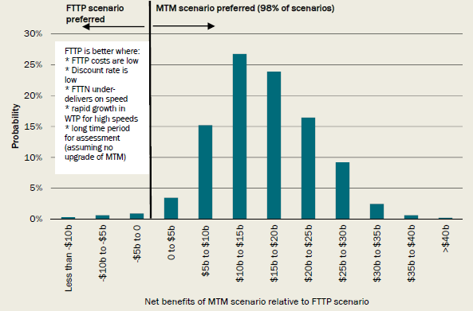

*Data source:* The CIE.

### Growth in demand and upgrade potential for the multi-technology mix

One of the key uncertainties in the CBA is the extent of future growth in the demand for high-speed broadband. This uncertainty is particularly important when comparing the *FTTP scenario* (which has very high-speed capabilities) with the *MTM scenario,* which does not have the same speed capability, but has the potential to be upgraded at a later date.

To test the importance of growth in the demand for speed (measured as growth in the WTP for speed), Chart 5 shows the effects of extending the analysis to allow for a very wide range in WTP growth. Chart 5 shows the net benefits of the *MTM scenario* over the *FTTP scenario* for a range of WTP growth assumptions. Results are presented for two cases: first, assuming no subsequent upgrades to HFC and FTTN in the *MTM scenario* (which is the assumption in the base *MTM scenario* and shown by the black line) and second, assuming that these technologies are upgraded to FTTP (at additional cost) as demand increases (the red line).

The upgrade calculation conservatively assumes that 20 per cent of the cost of FTTP can be avoided in an upgrade from FTTN to FTTP because of the investment already made in FTTN.

The results summarised in Chart 5 have a number of key implications.

* First, even without allowing for upgrades, the *MTM scenario* continues to dominate the *FTTP scenario* for most growth rates in WTP. The *FTTP scenario* only dominates at the point of growth in WTP of around 250 per cent over 10 years (or 13 per cent per year for each of those 10 years). Essentially, this result suggests that the *FTTP scenario* will dominate the *MTM scenario* if the growth rate in WTP for speeds offered by FTTP and not by FTTN is greater than 13 per cent per year. This is considered unlikely for the reasons set out in Box 6.
* Second, allowing for upgrades to technologies used in the *MTM scenario* means that this scenario dominates the *FTTP scenario* under any possible growth in WTP. This result arises because:
* under any WTP growth it is better to first roll out the *MTM scenario* as this delivers improved speeds quickly and gives higher immediate benefits. The higher costs of delivering FTTP can be delayed until there is sufficient demand (that is, until WTP is sufficiently high); and
* with very high growth in WTP, the net benefits of the *MTM scenario* actually increase relative to the *FTTP scenario.* This is because the slow delivery of the *FTTP scenario* means that, given high growth in demand, many potential benefits are missed in the medium term. The *MTM scenario* with an upgrade allows these more immediate benefits to be realised.

One way of summarising this is to note that the *MTM scenario* has significantly greater option value than the *FTTP scenario.* The *MTM scenario* leaves open more options for the future because it avoids high up-front costs while still allowing the capture of benefits if, and when, they emerge. It is, in that sense, far more 'future proof' in economic terms: should future demand grow more slowly than expected, it avoids the high sunk costs of having deployed FTTP. On the other hand, should future demand grow more rapidly than expected, the rapid deployment of the *MTM scenario* allows more of that growth to be secured early on, with the scope to then upgrade to ensure the network can support very high speeds once demand reaches those levels. Because the base *MTM scenario* does not assume any upgrade path, it does not include this option value and so understates the gap in net benefits between the MTM and FTTP scenarios.

Chart 5: Net benefits of *MTM scenario over FTTP scenario* with and without upgrade

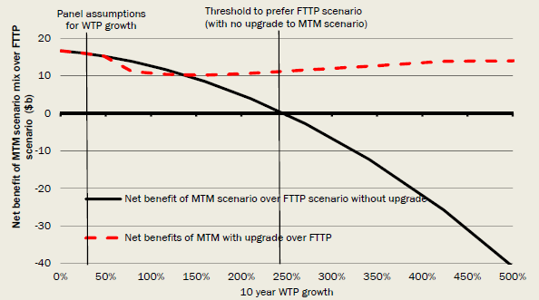

*Data source:* The CIE.

**Box 6: Technical modelling to understand growth in demand for speed**

How fast will WTP for speed grow? More importantly, how fast will WTP grow for the high speeds that are serviced by FTTP and not by FTTN?

An important input to the CBA has been the development of a detailed bottom-up model of the technical demand for bandwidth (that is, speed). This model (explained in detail in Chapter 2) is a fully Australian version of a modelling framework originally developed in the United Kingdom. It uses information on the bandwidth requirements of individual applications, aggregated to the household level, to provide detailed profiles of the demand for bandwidth.

One important outcome of this model is the observation that bandwidth demand is not the same as traffic. Overall traffic can grow very rapidly, but this is not the same as the growth in bandwidth demand. Consider, for example, the simple case of a household that increases time spent watching streamed high definition video. If peak bandwidth demand for that household was determined by the initial video viewing, then increasing the amount of time spent watching video would increase traffic without increasing bandwidth demand. This is important to keep in mind as it is a common, but incorrect, intuition that bandwidth demand will grow proportionally to total traffic.

The potential future growth in WTP for bandwidth clearly needs to be considered in this context. While traffic is likely to grow rapidly (more than 13 per cent a year, for example) it does not follow that bandwidth demand will grow at this rate. Indeed, analysis with the technical demand model indicates that while the WTP for speed may grow rapidly at low speeds (less than 40 megabits per second (Mbps) download, or less than 8 Mbps upload), for most people it is not expected to grow at all for higher speeds (greater than 50 Mbps download or greater than 9 Mbps upload). Thus, the outcome in Chart 5 where (without upgrades) the *FTTP scenario* dominates the *MTM scenario* at WTP of growth of greater than 250 per cent over 10 years (13 per cent a year) is unlikely to emerge given analysis from the technical demand model.

### Understanding the components of the analysis

The results summarised above are based on detailed analysis involving a number of components. These are each summarised in the discussion below.

#### *The benefits of higher broadband speeds*

The research underlying the CBA model uses three distinct methods to estimate the value of higher upload and download broadband speeds for users (that is, the WTP for higher speed).

* First, estimates based around a specially commissioned discrete choice modelling study. This directly measures, using statistical and survey techniques, what households are willing to pay for higher speeds. These estimates are used as the default method for measuring benefits in this CBA.
* Second, estimates based around 'technical' demand for bandwidth derived from a specifically commissioned bottom-up model of the demand for bandwidth in Australia. This measures how users' experience is impacted at different broadband speeds and seeks to place a value on this.
* Third, estimates based around observed uptake of NBN speed plans to date.

Using different methods allows for greater confidence in the findings, particularly given that there is little existing research on the value of broadband speed.

The three methods give similar conclusions about the relative benefits arising from each scenario, although with differences in the absolute level of benefit of investing in high-speed broadband.

* There are substantial benefits from increasing broadband speeds in Australia from their current levels. These are estimated (for the *unsubsidised rollout scenario)* at over $40 billion over the period from 2015 to 2040 under the first two methods discussed above. The estimate of benefits is lower, at around $15 billion, when using actual take up data from NBN Co to date as a basis for estimating benefits. This is because the uptake of NBN Co speed plans has mainly been in more modest speed ranges for the customers connected to date to FTTP.
* There is a declining value to additional broadband speeds under all methods. That is, an increase in download speeds from 5 Mbps to 10 Mbps is worth more to consumers than an increase from 50 Mbps to 55 Mbps. Using the discrete choice modelling survey, the value of an extra Mbps download speed is $1.50/month at very low speeds (1-5Mbps) and decreases to 70 cents at 50 Mbps and then to 0 at 90 Mbps.
* Users of broadband would prefer an increase to their current speeds quickly, rather than to wait longer to gain a higher level of speed. This means consumers place a greater value on the early deployment of high speeds rather than on the slower deployment of very high speeds using FTTP.
* The majority of the benefits from higher speed broadband accrue to private uses within the households and businesses served by faster broadband. Public, or external, benefits — that is benefits accruing outside individual households or businesses such as in health and education — are a very small proportion of the total benefits available. This reflects patterns of internet usage as well as the fact that, as currently understood, most public good uses require relatively low bandwidth.

#### *The costs of delivering higher speeds*

Each of the scenarios clearly involves additional costs. The starting point for the analysis of the costs of each option was a series of cost models provided by NBN Co. These cost models were developed for the NBN Co *Strategic Review.* As part of the CBA:

* the cost models were independently reviewed; and
* financial costs to NBN Co were converted to economic costs by:
* removing financial costs to NBN Co that represent transfers to another organisation for use of existing assets or for disconnection of customers from existing networks, such as some payments to Telstra and Optus;
* estimating costs incurred and avoided outside of NBN Co under each option, such as maintenance costs for the existing copper network and costs to provide ADSL services;
* converting nominal costs into real costs to remove the effect of inflation; and
* discounting costs over time to give a present value of future costs.

Because the CBA uses economic costs that are discounted to a present value, the costs in this CBA cannot simply be compared to previous public cost estimates for the construction and operation of the NBN, which typically sum nominal amounts over periods of time.

The technologies for providing high-speed broadband have very different rollout costs (Chart 7). FTTP capital expenditure costs are around four times higher than FTTN and HFC because less use is made of existing infrastructure.

Chart 7: Average capital costs per premises passed for each technology (index numbers of present value)

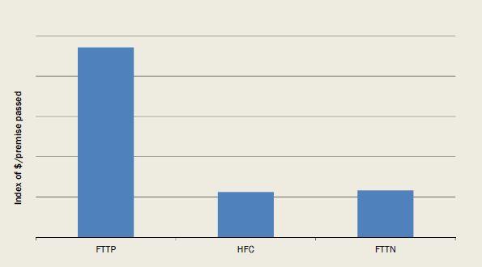

*Data source:* The CIE.

Table 8 summarises (in present value terms) the cost components for each of the scenarios.

* The fixed line footprint costs and the fixed wireless/satellite costs are the costs specific to each technology — these are the main costs that differ across investment scenarios, as each technology has different total costs.
* General incremental economic or resource costs are costs that are similar across scenarios, such as transit network costs and overheads for NBN Co.
* Beyond the economic costs that are directly included in the CBA, there are substantial financial costs to NBN Co for payments to others, such as Telstra and Optus, for use of existing assets. These costs are not shown in Table 8 because they are regarded as commercial-in-confidence by NBN Co. To put these costs in perspective, Telstra summarises its Definitive Agreement with NBN Co as leading to a post-tax net present value of $11 billion[1] and Optus estimates that its Definitive Agreement is worth $800 million on a net present value basis[2] (noting that they have been calculated using different discount rates to that used in this CBA). For example, even though the numbers are not directly comparable, in the *unsubsidised rollout,* the financial costs from these Definitive Agreements are equivalent to around two thirds of the total resource cost relative to *no further rollout,* as NBN Co would continue to pay contract payments for the use of existing assets and for customer transition.
* While transfers (including financing costs, such as those payments made under the Definitive Agreements), are not included in the CBA directly they do affect the loss made on the project over the scenario period. As that loss is financed through taxes, the economic costs these taxes impose are taken into account in the CBA.

Table 8: Costs for each scenario - panel assumptions

| Costs | No further rollout $b, present value | Unsubsidised rollout $b, present value | MTM scenario $b, present value | FTTP scenario $b, present value |
| --- | --- | --- | --- | --- |
| **Fixed line footprint costs** Capital rollout costs | — | 5.4 | 8.4 | 19.8 |
| **Fixed line footprint costs** Post-build capex | — | 1.6 | 1.7 | 1.1 |
| **Fixed line footprint costs** Opex | — | 1.9 | 1.9 | 1.4 |
| **Fixed wireless/satellite footprint costs** Capex | — | 0 | 3.7 | 3.7 |
| **Fixed wireless/satellite footprint costs** Opex | — | 0 | 1.1 | 1.1 |
| **General resource costs incurred by NBN Co** Capex | — | 4.6 | 4.8 | 4.5 |
| **General resource costs incurred by NBN Co** Opex | — | 8.3 | 8.9 | 8.8 |
| Other financial (non-resource) costs for NBN Co | — | — | — | — |
| Total financial costs for NBN Coa | — | — | — | — |
| **Other resource costs outside of NBN Co** Resource costs outside of NBN Co | — | 0 | 0 | 0 |
| **Other resource costs outside of NBN Co** Resource costs avoided outside NBN Co | — | -4.2 | -5.6 | -5.2 |
| Total resource costs relative to *no further rollout* b | 0 | 17.6 | 24.9 | 35.3 |
| Total cost relative to *unsubsidised rollout* | -17.6 | 0 | 7.2 | 17.6 |
| Cost of *FTTP scenario* relative to *MTM scenario* | — | — | — | 10.4 |

a. Total financial costs for NBN Co are the sum of fixed line footprint costs, fixed wireless/satellite footprint costs, general resource costs and other financial (non-resource) costs for NBN Co.

b. Resource costs relative to *no further rollout* are the sum of fixed line footprint costs, fixed wireless/satellite footprint costs, general resource costs and costs incurred and avoided outside of NBN Co.

*Note:* The costs for the *unsubsidised rollout scenario* are shown using the choice modelling benefit results.

*Source:* The CIE.

In the course of its review, and drawing on discussions with NBN Co and its consultants, the panel updated some of the assumptions underlying the NBN Co models. The changes in assumptions made by the panel are set out in detail in the body of the report. Table 9 indicates the net effect (in terms of the present value of resource costs) of these changes. Were the unadjusted costs obtained from NBN Co used in this CBA the conclusions of the analysis would not be different.

Table 9: Economic (resource) costs for each scenario

| Costs | No further rollout $b, present value | Unsubsidised rollout $b, present value | MTM scenario $b, present value | FTTP scenario $b, present value |
| --- | --- | --- | --- | --- |
| Initial estimates using NBN Co assumptions | 0 | 17.4 | 23.9 | 30.6 |
| Updated panel estimates | 0 | 17.6 | 24.9 | 35.3 |
| Difference (per cent) | na | 1.5 | 4.2 | 15.2 |

*Note:* The costs for the *unsubsidised rollout scenario* are shown using the choice modelling benefit results. For clarity, NBN Co did not estimate an *unsubsidised rollout scenario* in its *Strategy Review,* this is a panel estimate based on NBN Co cost assumptions.

*Source:* The CIE.

## 1. Introduction

### 1.1 This report in the context of the panel's terms of reference

This report presents the results from the panel's research to address the first item of its terms of reference:

1. *What is the direct and indirect value, in economic and social terms, of increased broadband speeds, and to what extent should broadband be supported by the government?*

*a) This should consider the economic and social benefits of bringing forward improvements in broadband speed and the respective benefits of alternative/potential technologies.*

*b) It should also consider the extent to which market pricing mechanisms can capture the value of benefits (including benefits to Australian governments).*

This report addresses this set of requirements by undertaking a comprehensive CBA of high-speed broadband options. CBA requires the comparison of well specified scenarios, which can be evaluated against a 'baseline' (often a 'do nothing' scenario) or against each other.

For the purposes of this analysis, four scenarios were developed (summarised in Table 1.1 and set out in detail in Chapter 4).

Table 1.1: CBA scenarios considered in this report

| Scenario | Comment |
| --- | --- |
| No further rollout of high-speed broadband or new infrastructure. | This is clearly not a 'realistic' scenario, but is used as a point of comparison to allow the calculation of the overall value of high-speed broadband. |
| Unsubsidised rollout of high-speed broadband to premises where this can be done without a government subsidy. | This scenario leads to rollout of high-speed broadband to up to 93 per cent of premises. No coverage is provided to 7 per cent of premises - these premises are serviced by fixed wireless and satellite in the *MTM scenario* and the *FTTP scenario.*  This scenario is used as a reference case against which other scenarios are compared. |
| Multi-technology mix (MTM scenario): the rollout of high-speed broadband through the use of multiple technologies and rollout of fixed wireless and satellite to remaining premises | This scenario allows the examination of an alternative set of technological choices.  This scenario has Australia-wide rollout of high-speed broadband. |
| Fibre to the premises (FTTP scenario): continued rollout of FTTP under the radical redesign set out in the NBN Co *Strategic Review* and rollout of fixed wireless and satellite to remaining premises | This scenario allows the examination of one particular technological choice.  This scenario has Australia-wide rollout of high-speed broadband. |

*Source:* Expert panel.

The appropriate comparison of costs and benefits under each of these scenarios allows the panel to draw conclusions around the items in its terms of reference. In particular, the analysis of these scenarios will help inform the Government on:

* the likely net economic returns from government investment in the NBN;
* the different returns that are likely to arise from alternative technological choices, including the returns from provision of services in higher cost areas serviced by fixed wireless and satellite;
* the identification of risks and opportunities associated with alternative technological choices; and
* the preferred technological choices, given the value and costs from different increments to broadband speed possible under alternative technologies.

The panel has taken a 'conventional' (within the discipline of economic analysis) approach to the CBA analysis of the NBN. Care has been taken to satisfy the requirements for a sound CBA. As will be set out in the course of this report, research commissioned and undertaken by the panel provides a substantive new input into the understanding of the economics of high-speed broadband in Australia.

### 1.2 What is cost-benefit analysis?

CBA is a tool designed to place the benefits and costs of particular actions or proposals on a common basis so that they can be compared and understood. It provides a basis on which the Government can assess the net public benefits of decisions around high-speed broadband and can consider the merits of alternative approaches to the development of high-speed broadband.

CBA provides a technique that allows a systematic treatment of trade-offs arising from government decisions and the changes they entail. It allows for quantification and valuation of the full range of potential impacts that might arise from changes in broadband availability and/or pricing. It involves aggregation of these impacts across the various types of costs and benefits and through time into a single metric *- the expected present value of net benefits* from a change relative to a reference or base case.

A CBA framework is widely used as a tool to assist policy makers in making decisions on alternative options (for example, policy options or technology options) that impact on the community. It is commonly used by policy makers in situations where proposed actions have differential impacts throughout the community. As a result, policy makers are required to consider trade-offs and decide whether the community as a whole is better or worse off under alternative scenarios. CBA is a powerful tool that can assist in guarding against poor decisions.

A CBA framework is focused on the social welfare of the community. The policy option that delivers the highest *net social welfare* is considered to be the best for society.

CBA is designed to take account of the full range of potential benefits and costs of particular actions. In this sense, it is holistic and designed to include, for example, the environmental, health and economic impacts of particular actions. A CBA places each of these impacts on a common basis so that they can be compared and understood.

A CBA framework also considers the timing of each of the impacts. Under a CBA approach, future impacts are 'converted' into today's terms so that they can be meaningfully compared. A CBA, for example, will enable an evaluation of policies that deliver different streams of benefits and costs over time.

A CBA is used to assess whether one option is preferred to another option in the sense that it will lead to better outcomes for the community. CBA is a practical tool for policy makers that are seeking to compare different specified options and choose the best among them.

In a standard CBA, net benefits are summed across all individuals in the community. Typically, issues of overall net gains (in dollar terms) are separated from issues of the distribution of those net gains. This is particularly important as in many cases there is insufficient information to make distributional judgements, whereas there is sufficient information to make assessments of overall net benefits.

Because a CBA evaluates net benefits on the basis of assumptions about each of the costs and benefits, it can help in understanding the uncertainties inherent in a particular project. Specifically, by varying those assumptions, it is possible to test whether the outcomes, including the ranking of alternatives, are more or less sensitive to the assumptions on which the analysis is based. That helps highlight the risks the project involves, and can inform the management of those risks.

The key steps underlying a CBA are presented in Box 1.2.

**Box 1.2: Key steps in a CBA**

* **Articulating the decision** that the CBA is seeking to evaluate. For example, in relation to high-speed broadband, the decision relates to both the particular technologies used to deliver high-speed broadband as well as to the decision to devote taxpayer funds to the project. The way in which the CBA is framed and the information requirements will differ depending on the decision being evaluated.
* **Establishing the reference case** (or 'base case') against which to assess the potential socioeconomic and environmental impacts of changes. In the case of high-speed broadband with substantive government involvement, a natural reference case is the level of broadband that would be delivered in the absence of any subsidy from government.
* **Quantifying the changes** from the base case resulting from the possible scenarios being considered. This will focus on the incremental changes to economic welfare resulting from the decision. The changes may be known with certainty or could also be defined in probabilistic terms. The quantification should focus on key changes that will be utilised in the valuation stage. For example, for this report the focus is on the change in the download and upload speeds arising from different broadband scenarios.
* **Placing values on the changes** and aggregating these values in a consistent manner to assess the outcomes.
* **Generating the net present value (NPV)** of the future net benefits stream, using an appropriate discount rate, and deciding on the **Decision Rule** on which to assess the different options.
* **Undertaking sensitivity analysis** on a key range of variables, given the uncertainties related to specific benefits and costs, especially WTP.
* **Deciding on which option is better for society.** In practice, additional information, aside from the CBA results, may also be utilised when deciding on the preferred option.

### 1.3 Why undertake a CBA?

If the development of high-speed broadband were a strictly private undertaking, funded through the private sector and without government funding or other involvement, then a CBA of the type presented here would not be necessary. Rather, investors would proceed if the expected revenues exceeded the expected costs, which is often a sufficient, but not necessary, condition for a project to be socially worthwhile.

However, for a range of largely historical reasons, the Government is closely involved in broadband development in Australia, and a substantial amount of public money has been committed to broadband provision. The limited rationale for government involvement in delivery of high-speed broadband, combined with the actual history of extensive involvement, strengthens the urgency of CBA to understand the underlying economics of the public resources devoted to the NBN.

### 1.4 Inputs into the cost-benefit analysis

The CBA presented in this report has been developed through the combination of a number of commissioned research items and through professional assistance.

* Dr Alex Robson from Griffith University was commissioned to prepare an *Analytical Framework* for considering the costs and benefits of high-speed broadband. This report was released separately in May 2014 and is available on the Department of Communications' website[3].
* Communications Chambers was commissioned to provide a detailed bottom-up analysis of the technical bandwidth demand for Australian households. Communications Chambers' report is available as a separate document. Particular features of this report are summarised in Chapter 2 and are used to formulate one set of estimates of the WTP for high-speed broadband as set out in Chapter 6.
* The Institute for Choice at the University of South Australia was commissioned to conduct a detailed choice modelling study to understand people's preferences for broadband plans and how much they are willing to pay for higher speeds. The findings of this report are used to provide the main set of estimates of the WTP for high-speed broadband as set out in Chapter 6. The details of the Institute for Choice analysis are at Appendix H to this report.
* NBN Co provided cost models and related data underlying their *Strategic Review.* With some modification (detailed throughout this report) these cost models formed the basis of the cost analysis presented in this report. NBN Co also provided information on uptake of alternative NBN plans offered.
* Link Economics was commissioned to review the costs estimates contained within the NBN Co models. This included advice on converting financial costs into economic costs as well as a set of modifications to the original NBN Co models (reflecting the different purposes of financial planning versus economic analysis).
* An international expert group reviewed the methodology used in the cost-benefit appraisal and its implementation. The group consisted of Professor Nicolas Curien (Conservatoire National des Arts et Metiers, Paris), a former member of the French telecommunications regulatory commission, and an expert in the economics of telecommunications; Professor Kenneth Flamm (Lyndon B Johnson School of Public Affairs, University of Texas, Austin), an expert in the economics of innovation and of technological change; Professor Cliff Winston (Brookings Institution, Washington), who has a distinguished background in applied cost-benefit appraisal and regulatory economics; and Professor Jonathan Pincus (University of Adelaide), a former Economic Adviser to the Productivity Commission who has made important contributions to public economics, economic history (including that of Australian telecommunications) and the theory of taxation. Although the responsibility for the panel's work is its own, this expert group made a substantial contribution to the CBA.
* The Centre for International Economics (CIE) used these various inputs to construct a detailed CBA model that has formed the basis for the panel's analytical work.
* The CIE and the Department of Communications have assisted in drafting the report for the CBA.

### 1.5 The structure of this report

This report is set out as follows.

* Chapter 2 details the need for high-speed broadband and particularly the analysis undertaken by Communication Chambers as to how bandwidth affects the activities that households are expected to undertake.
* Chapter 3 sets out an overview of the CBA methodology.
* Chapter 4 discusses the scenarios evaluated and the key areas of difference between scenarios.
* Chapter 5 sets out the financial and economic costs of each scenario. The details of these costs are set out in Appendix F.
* Chapter 6 details the estimation of benefits of high-speed broadband.
* Chapter 7 sets out the net benefits of alternative options for delivering high-speed broadband and how this varies with alternative assumptions.

There are a number of appendices that provide further information relevant to this study, including background information on Australian internet speeds, international broadband developments, areas of external and public benefit from high-speed broadband and past studies considering the benefits of higher broadband speeds.

## 2. Understanding the need for high-speed broadband

Understanding why households and business need high-speed broadband and the nature of the benefits that this would bring are important steps in the CBA. While there have been many claims about the broadband speeds that will be required into the future and about the broad qualitative benefits of high-speed broadband, the panel has sought to provide a solid quantitative basis to speed requirements and benefits. Inevitably, any quantification is uncertain and, in the following analysis, this uncertainty is rendered explicit and then taken into account.

High-speed broadband is expected to:

* increase benefits from existing uses of the internet (including allowing some consumers to access existing products they were previously unable to access);
* generate benefits from the ability to use new services available over the internet (including products not yet developed, or that will be provided in Australia as a consequence of high-speed broadband);
* lead to a range of time savings (including savings in travel times);
* reduce a range of transaction costs; and
* lead to a range of other productivity improvements.

In principle these are all separate effects, but because in many cases they will accrue directly to individuals or firms they will be captured in estimates of consumers' WTP for faster broadband. Put another way, these benefits can be captured through appropriate estimates of the demand for high-speed broadband. Estimates of benefits are explained in more detail in Chapters 3 and 6.

This chapter focuses on the speed and bandwidth that could be required to generate these benefits. Understanding the potential applications that consumers and businesses can access at various internet speeds forms an important base for calculating benefits.

### 2.1 How much speed is needed, in a technical sense?

The 'technical' demand for bandwidth is the actual bandwidth requirement within a household to do what it would like to do. The willingness of a household to pay for higher speeds is clearly related to the level of this technical demand. Technical demand will depend on a variety of factors including:

* the types of applications household members want to use on the internet;
* the bandwidth requirements of those applications;
* the structure of the household (numbers of adults and children); and
* the likely extent of simultaneous use, which depends on the potential overlap between applications and between members of the household.

A large household with members that all wish to use multiple applications at the same time will have much higher bandwidth demand than a single person household using one application at a time.

### 2.2 The Communications Chambers report

As detailed further below, the panel has taken a number of approaches to estimating the WTP for high-speed broadband. One of the key studies the panel commissioned examined the 'technical' demand for broadband speed.

The panel commissioned Communications Chambers to provide a detailed bottom-up model of household demand for bandwidth — a model that could track the speeds necessary to allow households to undertake the internet activities that they expect to undertake. Communications Chambers' work provides a full Australian implementation of work previously undertaken for the United Kingdom. The full Communications Chambers Australian report is available as a separate document and the panel highly commends the report to readers.

As part of its analysis, Communications Chambers consulted a number of Australian internet service providers, both to test the modelling methodology and to obtain (confidential) data necessary to implement the model. The completed model findings were then further tested with internet service providers who provided feedback and comments.

#### What is needed in a bandwidth demand model?

Systematically modelling bandwidth demand for Australian households implies particular basic requirements for the model, as follows.

* A rigorous approach to determining the speeds required by individual applications, in particular by investigating the speeds recommended by the leading providers of the service in question.
* Accounting for changes in the required speeds over time. In many cases, requirements will rise — for instance, consumer expectations of acceptable download times will likely shorten. However, requirements may also fall. In particular, constantly improving video compression means that (for a given video definition) required bandwidth will decline.
* Reflecting variation in demand across households, particularly that driven by household size. Approximately 58 per cent of Australian households contain only one or two people. The average usage and bandwidth requirements of such households will, all other things being equal, be lower than that of larger households.
* Building a quantified view of the probability and likely duration of 'app stacks'. Much discussion of future bandwidth needs has been anecdotal, such as "imagine a household doing X, Y and Z simultaneously". While any such 'app stack' is conceivable, that does not necessarily mean it is likely or will happen regularly.
* Providing a picture of the duration of the highest levels of demand in a household. This allows the calculation of the costs of demand not being met through available bandwidth.

#### The modelling approach

To meet these requirements, the Communications Chambers model takes a bottom-up approach. It begins with a set of 13 different categories of applications that cover the vast majority of ways in which the domestic internet is used. Some, such as web use, are broad, covering everything from Facebook through to particular varieties of cloud services such as salesforce.com.

Based on the best available data, the model incorporates assumptions about both the bandwidth needs and the volume of usage of each of these applications. Note that the model does not necessarily base these on today's current usage. In some cases, current usage is constrained by current bandwidth, rather than reflecting what might be reasonably expected absent this constraint. To take one example, while downloading a console game might typically require a user to wait overnight or longer, the model sets expectations to 60 minutes, with this figure decreasing over time.

However, in making such assumptions, the Communications Chambers model takes a middle line between today's expectations and a 'perfect world'. In a perfect world, everyone would be able to download everything in seconds. However, this would imply that everyone 'needs' gigabit speeds today. This is not particularly meaningful, and as a practical matter, other elements of the chain from the content provider's server to the consumer's device might not be able to provide gigabit speeds, even if the access network could.

The model combines usage profiles of the various applications into usage profiles of individuals. In doing so, it takes a probabilistic approach to combining apps. For example, if app A is being used for 50 per cent of the time and app B is used for 40 per cent, then the two would be used simultaneously for 20 per cent of the time.

The model then combines these individual profiles into household profiles (again taking a probabilistic approach), depending on household composition. This is based on 16 household types (for example, single adult, two adults, and two adults one child) and on the type of primary TV set (such as whether it is standard, high or ultra-high definition — for example, ultra-high definition "4K" TVs have the potential to be an important contributor to bandwidth demand). The model also disaggregates households out into high, medium[4] and low categories based on their propensity to use the internet. In combination, these splits build to a total of 192 household types.

These household profiles are then combined into a picture of the national mix of demand. While these profiles (and the underlying usage assumptions) cover the vast majority of cases, they will not address *all* possibilities - for instance, people working at home on professional animation or analysing astronomical data sets might need to up- or download very large files. These extreme high users are not covered in the model.

The outputs of the model focus on the 'busy hours'. Bandwidth demand is driven by peaks, not the average speed required, and the model focuses on the busiest four hours per day (in many households this is likely to be 7-11pm or later). The model assumes that 50 per cent of usage occurs in these four hours - put another way, this assumption means that the rate of usage in this period is five times the rate of usage in the rest of the day, and thus tall 'app stacks' are much more likely.

### 2.3 Communications Chambers model results

#### Usage profile for sample households

Chart 2.1 shows the usage profile generated by the model for three different sample households (out of the 192 covered by the model). Chart 2.1 traces the number of minutes of use (during the busy hours of a month) that particular download speeds are demanded. There is a total of 7,200 minutes in busy hours in a month (4 hours per day for 30 days = 7,200 minutes). The busiest minutes are towards the left side of the horizontal axis.

Chart 2.1: 2023 usage profiles for three sample household types

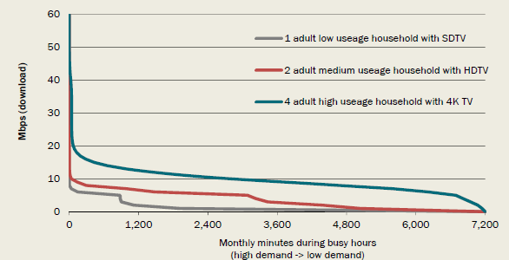

*Data source:* Communications Chambers bandwidth demand model.

For the single person low usage household with SD television, the connection is in fact idle for much of the time (where the grey curve hits the horizontal axis), but has several hours at 5 Mbps and short periods in the range of 8-10 Mbps. Conversely, the four adult household has appreciable usage almost constantly during the busy hours, at times of 20 Mbps or even higher. The peak demand for the four adult house is around 70 Mbps, although this is only required for 0.1 minutes a month.

#### Monthly bandwidth demand

The 192 household profiles are combined together to calculate the profile of monthly household demand for all households (as illustrated in Chart 2.1). The default setting in the model is to do this on a '4 minutes excluded monthly' basis. This means the bandwidth necessary to serve all but the four busiest minutes in the month (or one minute per week for each household) — that is, the four minutes at the extreme left of Chart 2.1. Communications Chambers argues that this metric is useful and sensible as a technical performance standard. Under this measure, consumers experience one minute per week of degraded performance, such as a video stream with briefly lower resolution.

Importantly, this assumption can easily be varied in the Communications Chambers model (its report also contains considerable sensitivity analysis). More importantly, however, in converting this technical demand to WTP (as set out in detail in Chapter 6), the 4 minutes excluded adjustment is not used, rather the CBA model attaches a cost to all minutes of usage not covered by available bandwidth.

Chart 2.2 shows the resulting distribution of (download) bandwidth demand for 2013, 2018 and 2023. This chart shows, for three different years, the proportion of households (on the vertical axis) that require particular download speeds (on the horizontal axis). The highest demand households are towards the bottom of the vertical axis.

In 2023, the median household (the 50 per cent proportion of households, as indicated by the line from the vertical axis across to the 2023 profile) requires bandwidth of 15 Mbps. The top 5 per cent of households have demand of 43 Mbps or more. The top 1 per cent of households have demand of 45 Mbps or more. The top 0.01 per cent of households have demand of 48 Mbps.

Chart 2.2: Technical household demand for speed

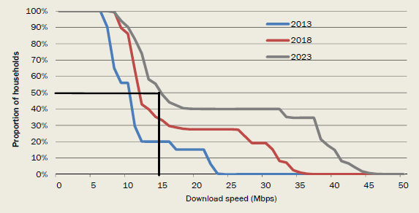

*Note: these results are presented on a '4 minute excluded' basis: that is the bandwidth required to service all but the 4 busiest minutes in the month. The Communications Chambers report provides significant sensitivity analysis around this assumption.*

*Data source:* Communications Chambers bandwidth demand model.

The figures for median demand should be interpreted with some care; network capacity should not be based on this metric as by definition, such a network would (to some extent) disappoint 50 per cent of households.

The figures of 15 Mbps and 43 Mbps for median and top 5 per cent of demand may seem low, particularly by comparison to the results of some other research in this area. However, the most common type of household comprises just two people. Even if those two are each watching their own HDTV stream, each surfing the web and each having a video call all simultaneously, then (in part thanks to the impact of improving video compression) the total bandwidth (in 2023) for this somewhat extreme use case for that household is just over 14 Mbps.

In summary, the key factors that drive the 'technical' demand for bandwidth in the Communications Chambers model include:

* bottom-up accounting of demand looking at 13 categories of application used by individuals in 192 different household types;
* carefully accounting for the probability of different 'stacks' (that is, simultaneous use) of applications within a household;
* reference to actual bandwidth requirements of individual applications (as specified by the application designers) as well as explicitly accounting for developments over time (including continuing advances in compression technology); and
* a detailed analysis of actual household demographics (for example, the most common household comprises two people, in contrast to the assumed large households in some analyses).

#### Bandwidth demand versus traffic

It is a common forecasting methodology to essentially assume that bandwidth demand will move proportionally with traffic[5].

In contrast, the methodology adopted by Communications Chambers effectively involves adding up the explicit bandwidth demand of a range of different applications used by a variety of household types. Bandwidth demand is explicitly directly modelled, and traffic demand (that is, the volume of traffic over a connection) emerges *as a consequence* of growing bandwidth demand and duration of use. Under this methodology, bandwidth demand and traffic demand are not proportional. Indeed, traffic demand can (and does) increase much faster than bandwidth demand. Aside from the recent Australian data which illustrates this, this can also be seen by considering the simple case of a household that increases time spent watching streamed HD Video. If peak bandwidth demand for the household was determined by the initial video viewing, then increasing the amount of time spent watching video would increase traffic without increasing bandwidth demand.

#### Caveats

Like all future looking analysis, the Communications Chambers model is subject to uncertainty. To address this Communications Chambers undertakes considerable sensitivity analysis in its report. However, the panel considers that these findings provide crucial background for understanding bandwidth demand in Australia. As subsequent analysis in this report will demonstrate, alternative methods of understanding demand align very closely with the Communication Chambers analysis.

## 3. Overview of CBA methodology

### 3.1 Background

The analysis presented in this report uses the broad discipline of cost-benefit analysis to consider and compare the costs and benefits of alternative scenarios for delivering high-speed broadband. Reflecting this, the differences between scenarios are modelled in terms of incremental changes in upload and download speeds.

This chapter provides an overview of the methodology used in this CBA and an explanation and quantification of the key parameters included in the calculations.

As noted in the introduction, CBA involves a number of components. For this analysis, the particular areas of focus are:

* defining the scenarios to be examined. As set out in detail in Chapter 4, these scenarios include a reference case that is used as the basis for determining the incremental costs and benefits of the other options;
* converting the financial costs identified by NBN Co in their *Strategic Review* into economic costs relevant for the CBA — this allows the measurement of the underlying resource costs from adopting alternative high-speed broadband scenarios;
* identifying consumer WTP for increases in broadband speed as the core measure of economic benefits; and
* business benefits as well as 'external' benefits (or public good benefits) have been related to consumer WTP.

The benefits and costs considered are set out in Table 3.1.

Table 3.1: Costs and benefits included

| Costs | Benefits and disbenefits |
| --- | --- |
| Capital costs of new infrastructure  Operating costs of high-speed broadband  Costs avoided as a result of high-speed broadband rollout, such as costs for provision of existing broadband services | Private WTP for higher speeds (for business and residential users)  Third party benefits from higher speed and other attributes including government impacts and externalities  Costs incurred by others as a result of high-speed broadband (including disruption costs)  The cost arising from taxation to fund the government contribution to high-speed broadband delivery (deadweight loss of taxation)  Residual value of assets at the end of evaluation period |

*Source:* The CIE.

This study does not consider changes in the amount of data downloaded, latency or jitter.

* Increases in the amount of data downloaded will have costs for retail service providers directly (which are then passed through to customers) and benefits to customers. To evaluate this change would require estimating the costs of allowing greater downloads, not just across the access network, and the benefits that customers obtain from greater downloads. By not including either of these costs and benefits the analysis assumes cost-reflective pricing of data downloads through data limits. (The same approach is applied to other services offered over the internet for a charge, such as video-on-demand.)
* There are other customer experience changes that are less important than speeds and that are not quantified in this CBA. These include:
* variability of speeds — this will reflect factors related to the internet service provider, and capacity of infrastructure;
* latency — the time taken for data to travel to a third party server and back — for example from a household to Amazon and back. This will reflect the location of servers and infrastructure outside of the access network, most obviously for sites that require international connections;
* packet loss — the proportion of data that is lost in transmission; and
* jitter — the variability of latency.

There are likely to be some differences between these factors for each scenario, with FTTP likely to lead to lower latency for the access network. These differences are expected to be of an order of magnitude smaller than the value of changes in speed and are hence not quantified.

### 3.2 Estimating willingness to pay (WTP)

A considerable focus of the research for this analysis has been on identifying and measuring consumer WTP for higher speed broadband. WTP captures the value of higher speed broadband to users.

The analysis has developed three distinct (and independent) methods for measuring WTP. Using different methods allows for greater confidence in the findings, particularly given that there is little existing research on the value of broadband speed.

* The Institute of Choice was commissioned to undertake a detailed choice modelling study of the demand for broadband focussing on all the elements of the consumer's decision when making broadband choices. This well framed study allows specific identification of the 'demand for speed' (and hence the increase in consumer welfare as speed increases), while at the same time controlling for the various other factors that determine consumer demand. The value of WTP calculated from this modelling is used as the default method for measuring benefits in this CBA (with the two methods below effectively used to test sensitivities). Details of this study are set out in Appendix H, while key findings for WTP are set out in Chapter 6.
* Secondly, a detailed study of technical bandwidth demand, using a bottom-up simulation model, was developed by Communication Chambers, as discussed in Chapter 2. The findings of this analysis are discussed in more detail in Chapter 6 and the detailed findings are available in a separate report.
* Third, the panel undertook a detailed analysis of NBN take-up data to date. The observed choices of consumers in actually taking up NBN packages can be used to infer WTP for speed. These findings are also detailed in Chapter 6.

These methods generate estimates for WTP for higher speed broadband now. Growth rates need to be applied to the estimates from these methods to estimate WTP into the future.

### 3.3 Analysis of costs

The underlying basis of the cost analysis in the report are the models prepared by NBN Co as part of their *Strategic Review* and provided to the panel.

The NBN Co models were independently reviewed and adjusted as set out in Chapter 5 and Appendix F.

### 3.4 General CBA parameters

There are a number of general CBA parameters that frame the analysis. These include the time period over which analysis is conducted, the value applied to assets at the end of this period, the discount rate (which determines how future costs and benefits are weighted relative to more immediate costs and benefits) and the deadweight loss of taxation. These factors are discussed below in turn.

#### Time period

This study evaluates scenarios over the period 2015 to 2040. This is consistent with the time period used in the NBN Co *Strategic Review.* This allows for 16 years after the rollout to the last fixed line premises under the slowest rollout scenario.

* cost incurred to date are not included as part of the CBA; and
* costs that are unavoidable as a result of past decisions (for example the creation of NBN Co), but have not yet been incurred, have been included.

The time period adopted reflects the risks inherent in investment in telecommunications infrastructure, as opposed to other infrastructure. For some infrastructure projects, such as road investments, longer periods are often used — such as 30 years. Results for a longer time period are also tested.

#### Residual value

There are two approaches available for estimating the residual value of the assets at the end of the evaluation period. The first approach is cost based — it considers the depreciated value of assets at the end of the CBA period. The second approach is benefit based — it considers the future value of benefits extending beyond the evaluation period.

A cost-based approach has been employed. This approach avoids the difficulties involved in estimating WTP beyond the terminal date. It typically gives a lower residual value.

#### Discount rate

The discount rate determines the weight placed on future benefits and costs relative to more immediate benefits and costs.

The present value of costs and benefits is calculated using a high-speed broadband specific discount rate, based on calculating the pre-tax real weighted average cost of capital.[6] There are a number of sources for discount rates for high-speed broadband specific infrastructure, as set out in Table 3.2. The lowest of these is from the Optus 2007 proposal at 6.6 per cent — the debt margin cited in this proposal is lower than other estimates, as there has been a widening in debt margins since the time of Optus' submission. The Telstra 2006 proposal was substantially higher in its estimated cost of capital (and higher than the estimate below for this CBA).

The investment specific discount rate used in this CBA is 8.3 per cent (real pre-tax). This is slightly above the implied (real pre-tax) weighted average cost of capital allowed by the ACCC in NBN Co's Special Access Undertaking.[7]

Results for the CBA are also shown using the generic real discount rates recommended by Infrastructure Australia, of 4 per cent, 7 per cent and 10 per cent.

Table 3.2: Weighted average cost of capital estimates

| capital estimates | Panel estimate Per cent | Optus proposal 2007 Per cent | NBN Co advice 2011 Per cent | NBN Co Special Access Undertaking 2013 Per cent |
| --- | --- | --- | --- | --- |
| Nominal risk-free rate | 5.0 | 5.0 | 5.0 | — |
| Real risk free rate | 2.3 | 2.3 | 2.3 | 2.3 |
| Inflation | 2.7 | 2.7 | 2.7 | — |
| Market risk premium (MRP) | 6.0 | 6.0 | 7.0 | — |
| Debt margin | 3.1 | 1.2 | 2.87 | — |
| Debt to total asset | 50.0 | 60.0 | 40.0 | — |
| Gamma | 0.25 | 0.25 | 0.25 | — |
| Tax rate | 30.0 | 30.0 | 30.0 | — |
| Equity beta | 1.0 | 1.0 | 0.7 | — |
| Cost of equity (nominal post-tax) | 11.0 | 11.0 | 9.9 | — |
| Cost of Debt (nominal pre-tax) | 8.1 | 6.2 | 7.9 | — |
| Real pre-tax WACC | 8.3 | 6.6 | 8.0 | na |
| Real post-tax WACC | 6.7 | 5.4 | 6.3 | 5.8 |

*Note:* Optus proposal debt margin is from FANOC (2007); panel debt margin estimate from IPART (2014); Formulas for real pre-tax and post-tax WACC as used by the Independent Pricing and Regulatory Tribunal of NSW; Risk-free rates (real and nominal) use 10 year government bonds. This analysis uses an average over the past 10 years, given that recent low risk-free rates have probably been associated with a higher MRP.

*Sources:* FANOC 2007; Value Adviser Associates 2011; IPART 2014; ACCC 2013.

#### Deadweight loss of taxation

The deadweight loss (DWL) of taxation captures the costs of raising government revenue to fund high-speed broadband infrastructure. That is, tax levels will be higher than would otherwise be the case in order to fund any net government contribution to the delivery of high-speed broadband. Taxes impose economic costs because they induce individuals to behave differently and make decisions they would not have made in the absence of the tax. Taxes encourage individuals to consume a mix of goods that is less desirable from the standpoint of their subjective preferences. The result is what economists call a social cost or 'excess burden'. The excess burden from a tax is the difference between the cost to taxpayers from having a tax imposed and the amount of tax collected. The more the tax changes behaviour, the greater the excess burden.

The losses associated with these excess burdens should be included where there is a substantial net government contribution, as is the case for some of the high-speed broadband scenarios that this CBA evaluates. These costs of taxation are typically reported as the dollar social cost per dollar of revenue raised from taxation.

Estimates of these costs for the main Australian Government taxes are set out in Table 3.3. The marginal excess burden is the burden of slightly changing the tax to raise additional revenue. The average excess burden measures the impact of moving from no tax to the tax at its current level.

The cost and benefit numbers reported in this study use a moderate deadweight loss of taxation of 24 cents per dollar, reflecting funding the government contribution through higher labour income taxes than would otherwise be the case. In sensitivity testing, sensitivities are tested for DWL of taxation ranging from 10 cents per dollar to 70 cents per dollar.

Table 3.3: Estimates of the deadweight loss of Australian Government taxes

| Australian Government tax | Marginal excess burden $/dollar of revenue raised | Average excess burden $/dollar of revenue raised |
| --- | --- | --- |
| GST | 0.08 | 0.06 |
| Labour income tax | 0.24 | 0.16 |
| Corporate income tax | 0.40 | 0.23 |
| **Specific sector taxes** Conveyancing stamp duties | 0.34 | 0.31 |
| **Specific sector taxes** Motor vehicle registration | 0.37 | 0.32 |
| **Specific sector taxes** Motor vehicle stamp duties | 0.38 | 0.38 |
| **Specific sector taxes** Insurance taxes | 0.67 | 0.47 |
| **Specific sector taxes** Crude oil excise | 0.70 | 0.50 |

*Source:* KPMG Econtech 2010, CGE analysis of the current Australian tax system, prepared for Department of Treasury, 26 March.

## 4. The scenarios evaluated

All CBA involves the comparison of different scenarios — CBA assesses the incremental net benefits of decisions, relative to a well-specified baseline or reference scenario. It is widely used to assist policy makers in making decisions on alternative policy and technical options that affect the community. CBA allows policy makers to consider trade-offs and decide whether the community as a whole is better or worse off under alternative policy and technical scenarios.

This CBA is a tool designed to place the benefits and costs of the different choices for rolling out the NBN on a common basis so that they can be compared and understood. An important part of the process is identifying the policy options that will be considered and any reference scenarios that they will be compared against.

This CBA considers four scenarios that differ in terms of the coverage of premises that they provide and the technology used to deliver higher speeds. These scenarios are designed to consider the question of which method of rolling out high-speed broadband has the greatest net benefit but also to allow a calculation of the general net benefits of high-speed broadband itself. These scenarios are summarised in Table 4.1 and their characteristics are described in more detail in the rest of the chapter.

Table 4.1: CBA scenarios considered in this report

| Scenario | Comment |
| --- | --- |
| **No further rollout** of high-speed broadband or new infrastructure. | This is clearly not a 'realistic' scenario, but is used as a point of comparison to allow the calculation of the overall value of high-speed broadband. |
| **Unsubsidised rollout** of high-speed broadband to premises where this can be done without a government subsidy. | This scenario leads to rollout of high-speed broadband to up to 93 per cent of premises. No coverage is provided to 7 per cent of premises - these premises are serviced by fixed wireless and satellite in the *MTM scenario* and the *FTTP scenario.*  This scenario is used as a reference case against which other scenarios are compared. |
| Multi-technology mix (**MTM scenario**): the rollout of high-speed broadband through the use of multiple technologies and rollout of fixed wireless and satellite to remaining premises. | This scenario allows the examination of an alternative set of technological choices.  This scenario has Australia-wide rollout of high-speed broadband. |
| Fibre to the premises (**FTTP scenario**): continued rollout of FTTP under the radical redesign set out in the NBN Co *Strategic Review* and rollout of fixed wireless and satellite to remaining premises. | This scenario allows the examination of one particular technological choice.  This scenario has Australia-wide rollout of high-speed broadband. |

*Source:* Expert panel.

The key differences in investment scenarios (that is, all scenarios except for *no further rollout)* are:

* *unsubsidised rollout* delivers improved high-speed broadband to most Australian premises, while the *MTM scenario* and *FTTP scenario* deliver higher speeds to all premises. The main difference is that *unsubsidised rollout* would not provide coverage to the areas covered by fixed wireless and satellite in other investment scenarios (Table 4.2);
* *unsubsidised rollout* and the *MTM scenario* provide a similar technology mix in the fixed line area, except that the *MTM scenario* allows for rollout of FTTP to about 1.5 million premises, while *unsubsidised rollout* discontinues the delivery of any further FTTP; and
* the *FTTP scenario* delivers higher download and upload speeds than the *MTM scenario* but takes a longer time to rollout (Charts 4.3, 4.4 and 4.5).

Table 4.2: Scenarios - premises coverage and technologies used

| Scenarios | No further rollout | Unsubsidised rollout | MTM scenario | FTTP scenario |
| --- | --- | --- | --- | --- |
| Per cent of premises with fixed line coverage for high-speed broadband | 26 | 47-93 | 93 | 93 |
| Per cent of premises with non-fixed line coverage for high-speed broadband | <1 | <1 | 7 | 7 |
| Technology mix for additional investment FTTP | na | No | Yes | Yes |
| Technology mix for additional investment HFC | na | Yes | Yes | No |
| Technology mix for additional investment FTTN/FTTdp | na | Yes | Yes | No |
| Technology mix for additional investment Fixed wireless/satellite | na | No | Yes | Yes |
| Rollout finalised | — | <2021 | 2020 | 2024 |

*Source:* The CIE.

Chart 4.3: Timing of rollout of each scenario

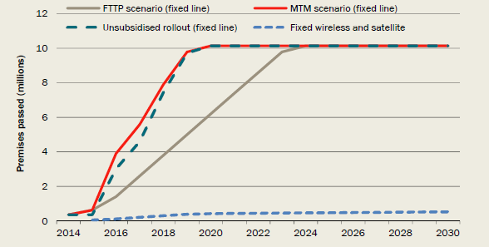

*Note:* The chart shows the *unsubsidised rollout* for the main assumptions used. The level of rollout for this scenario can change under alternative methods of estimating WTP and costs. Fixed wireless and satellite is premises connected rather than passed. *Data source:* NBN Co; The CIE.

Chart 4.4: Share of existing premises achieving different available *download* speeds (Mbps)

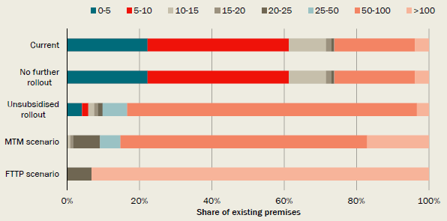

*Note:* The chart shows the *unsubsidised rollout* for the main assumptions used. *Data source:* The CIE.

Chart 4.5: Share of existing premises achieving different *upload* speeds (Mbps)

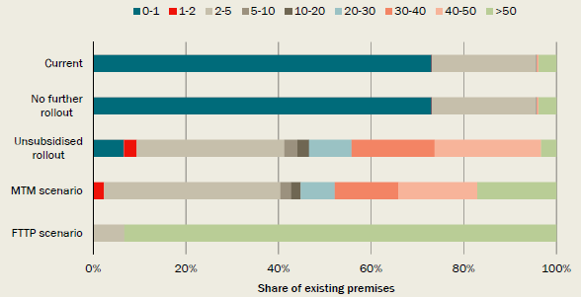

*Note:* The chart shows the *unsubsidised rollout* for the main assumptions used. *Data source:* The CIE.

The details of each scenario are discussed below.

### 4.1 Speeds available under each technology

The speeds available under each technology and the share of premises that are estimated to be covered by FTTN speeds are set out in Table 4.6 and Charts 4.7 and 4.8. These speed assumptions are held constant over the period to 2040.[8] Note that the panel had access to FTTN download and upload speeds by distance from the premises to the node, but these data are not included here for commercial-in-confidence reasons.

Table 4.6: Download and upload speeds assumed

| Technology | Down (Mbps) | Up (Mbps) |
| --- | --- | --- |
| HFC | 50-100 | 5-10 |
| FTTP | >100 | >50 |
| FTTN | Mainly 50-100, some 25-50 and lower. | Mainly 20-50, some lower. |
| Fixed wireless | 20-25 | 2-5 |
| Dial-up | 0-5 | 0-1 |
| ADSL | Varies as per set out in Appendix B | Varies as per set out in Appendix B |

Note: HFC speeds increase from those currently available because of the investments made in HFC networks under the unsubsidised rollout and MTM scenario.

Source: The CIE.

Chart 4.7: FTTN download speeds (Mbps)

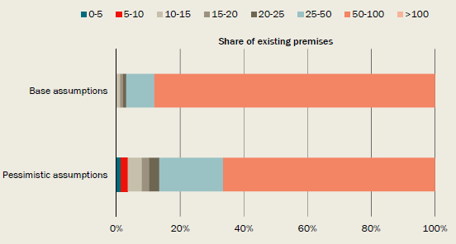

*Data source:* The CIE based on consultation with technology providers.

Chart 4.8: FTTN upload speeds (Mbps)

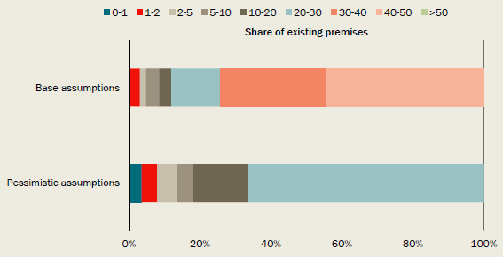

*Data source:* The CIE based on consultation with technology providers.

### 4.2 No further rollout of high-speed broadband or new infrastructure

*No further rollout* allows for no additional investment in infrastructure beyond the investments already made and no change in speeds from those available today. This scenario assumes that all existing broadband networks remain in place, including the Optus and Telstra HFC networks and NBN Co's investments already made in FTTP and fixed wireless continuing to provide high-speed broadband, and ADSL provided over Telstra's copper network continuing to provide the majority of fixed line services.

This scenario is not a realistic scenario: in practice there would continue to be incremental investments that would improve speeds. It is intended only to allow the calculation of the benefits of high-speed broadband, as part of the panel's terms of reference.

### 4.3 Unsubsidised rollout of high-speed broadband

*Unsubsidised rollout* allows for high-speed broadband to be rolled out to premises where this could be done without a government subsidy.

* This scenario is the reference case against which the costs and benefits of the other high-speed broadband scenarios are compared.

This scenario assumes that for future incremental rollout of high-speed broadband:

* NBN Co or a similar monopoly continues to be the company that rolls out high-speed broadband;
* rollout decisions (that is, whether to rollout) are made on an exchange service area (ESA) basis and within each ESA, a decision is made separately for areas where HFC is available and where it is not available. This leads to decisions being made separately for 5,300 areas;
* the prices that NBN Co can charge are not restricted to the prices that it is currently allowed to charge under its Special Access Undertaking. Instead, it is assumed that NBN Co would be able to set prices to enable it to obtain revenue up to 70 per cent of the incremental WTP in each area;[9]
* rollout decisions are made solely on the basis of cost and the 70 per cent of WTP assumption, rather than incorporating information relevant for demand (such as incomes) in each area. This has been done because there is no disaggregated demand data on which to devise a better decision-making rule; and
* the rate of return sought is equal to the NBN specific cost of capital. The rate of return is estimated over a period of 25 years, which matches the period from 2015 to 2040 used in the CBA.

*Unsubsidised rollout* is assumed to use HFC within the current HFC footprint and FTTN outside of the current HFC footprint. Because FTTP deployment is more costly than other technologies it is not continued (but existing FTTP continues to be used). As there is a delay before alternative technology deployment commences, this scenario is rolled out more slowly than the *MTM scenario,* in which FTTP rollout continues during the transition period.

*Unsubsidised rollout* assumes that copper and the HFC networks are not maintained as competitor networks for high-speed broadband. It further assumes that the Optus HFC network is closed down.

It is assumed that fixed wireless and satellite, as currently specified by NBN Co, would not be rolled out in this scenario. This reflects the fact that WTP for these services and, hence, potential revenue is well below the costs.[10] Note there may be options to deliver an improvement in broadband speeds to areas outside of the fixed line footprint without a government subsidy. This might be possible if the standard of services to be delivered, such as the reliability of fixed wireless, were specified differently. This has not been investigated in detail.

The coverage of premises under this scenario varies from 50 per cent of premises to 93 per cent of premises (the entire fixed line footprint), depending on the cost and benefit assumptions. The average across a range of sensitivities is 85 per cent. That is, a commercial rollout would most likely occur to much of the fixed line area.

### 4.4 Multi-technology mix scenario

The *MTM scenario* allows for the rollout of high-speed broadband through the use of multiple technologies. The following assumptions are made:

* HFC is used in areas within the existing HFC footprint;
* FTTP continues to increase to 1.5 million premises, including in the interim while other technology options are implemented;
* FTTN covers the remaining part (and majority) of the fixed line footprint;[11] and
* fixed wireless and satellite cover the non-fixed line footprint.

This scenario is assumed to be able to be rolled out according to the NBN Co *Strategic Review's* timing assumptions.

This scenario assumes a single high-speed broadband network in each area. Overlapping networks, where they exist, are assumed to be shut down.[12]

### 4.5 Fibre to the premises scenario

The *FTTP scenario* allows for the rollout of FTTP to all premises in the fixed line footprint, under the radical redesign set out in the NBN Co *Strategic Review.* It also allows for the rollout of fixed wireless and satellite outside of the fixed line footprint.

The timing of the rollout is assumed to follow that modelled in NBN Co's *Strategic Review.*

The *FTTP scenario* assumes that copper and the HFC networks are not maintained as competitor networks for high-speed broadband. It further assumes that the Optus HFC network is closed down.

### 4.6 Variation of scenarios

The CBA tests a number of variations to these scenarios.

* The timing of the rollout of scenarios is varied so that the *MTM scenario* and *FTTP scenario* have the same rollout speed. This seeks to isolate the extent to which the costs and benefits differ because of the speeds delivered or the ability to deliver speeds more rapidly or more slowly.
* FTTP is removed from the *MTM scenario.*

## 5. Costs of each scenario

One side of the cost-benefit calculation is identifying and valuing the costs of building and operating the network(s) that will deliver higher speed broadband to the Australian community.

Costs in a CBA are measured as economic costs (or underlying resource costs) rather than financial costs. As this analysis begins with financial costs, they have been adjusted by excluding costs that are transfers between organisations (such as for the use of existing assets or for the disconnection of customers from existing networks) and accounting for costs avoided because the NBN is being constructed (such as maintenance on now obsolete networks).

Costs are shown in present value terms, with costs incurred in the future discounted back to a present day equivalent.

For both of these reasons, the costs in this CBA cannot simply be compared to previous public cost estimates for the construction and operation of the NBN.

This chapter details the cost estimates for each scenario, including information on how they were constructed.

The three scenarios that roll out higher speed broadband have different costs for those rollouts (the *no further rollout* scenario obviously has no additional costs).

* *Unsubsidised rollout* provides for a moderate cost upgrade to existing speeds, over a relatively short time period through the use of existing infrastructure where possible.
* The *MTM scenario* incurs an incremental cost above this because it rolls out FTTP to around 1.5 million premises at a higher cost and delivers fixed wireless and satellite services, at an additional cost.
* The *FTTP scenario* incurs an incremental cost above this again, as FTTP involves replacing copper connections to each premises with fibre. However, the costs occur over a longer period. This means that once the discount rate is applied, the cost differences are reduced.

A summary of the economic costs of each scenario under the panel's preferred assumptions and NBN Co's *Strategic Review* assumptions are set out in Table 5.1. The *FTTP scenario* has costs that are about $10 billion higher in present value terms than the *MTM scenario* under the panel's cost assumptions.

Table 5.1: Costs for each scenario

| Cost | No further rollout $b, present value | Unsubsidised rollout $b, present value | MTM scenario $b, present value | FTTP scenario $b, present value |
| --- | --- | --- | --- | --- |
| Panel assumptions | 0 | 17.6 | 24.9 | 35.3 |
| NBN Co assumptions | 0 | 17.4 | 23.9 | 30.6 |

*Note:* The costs for *unsubsidised rollout* are shown using the preferred benefit assumptions. For clarity, NBN Co did not estimate an *unsubsidised rollout scenario* in its *Strategy Review,* this is a panel estimate based on NBN Co cost assumptions.

*Source:* The CIE.

Using NBN Co assumptions from the *Strategic Review,* the cost difference between the *FTTP scenario* and the *MTM scenario* is $6.8 billion (in present value terms). The panel has made two adjustments to these assumptions that widen the cost difference between these scenarios to $10.4 billion (in present value terms, Chart 5.2). These are discussed briefly below and set out in detail in Appendix F.

1. The NBN Co *Strategic Review* made assumptions about how costs may decline over time because of productivity improvements. In the panel's view these adopted an optimistic view of FTTP productivity improvements and a pessimistic view of FTTN productivity improvements over time. The panel has reviewed and amended these assumptions so that productivity improvements in all technologies are lower and so that FTTP delivery costs decline from an initial level that matches the costs anticipated in NBN Co's Corporate Plan.
2. The NBN Co *Strategic Review* had low costs for remedying faults in the FTTP network, which differed from the costs for remedying faults for other technologies. The panel has made an adjustment to better align these assumptions. A minor adjustment has also been made to reduce electricity costs for FTTN to a level below the general consumer retail price.

The panel's estimates of the difference between the costs for the *FTTP scenario* and the *MTM scenario* are likely to be conservative or understate the difference in costs for other reasons. In Chart 5.2, some other plausible adjustments are shown, as well as changes that show the underlying cost differences between technologies on a like-for-like comparison, such as aligning rollout timing. These are used as sensitivities to the analysis. These adjustments are:

* reducing indirect costs and project management costs to reflect the scope for cost savings in the *MTM scenario;*
* removing FTTP from the *MTM scenario;*
* speeding up the rollout of the FTTP to match the rollout timing of the *MTM scenario;* and
* increasing FTTP capital costs to those of the Corporate Plan (that is, allowing for no productivity improvements in FTTP delivery costs).

The cost differences between the *MTM scenario* and *FTTP scenario* in Table 5.1 are smaller than the cost differences between technologies (that is, between FTTN/HFC and FTTP) because the *MTM scenario* includes some FTTP. In addition, the rollout for the *MTM scenario* occurs more rapidly and hence has a higher cost once discount rates are applied.

Chart 5.2: The cost difference between the *FTTP scenario* and the *MTM scenario*

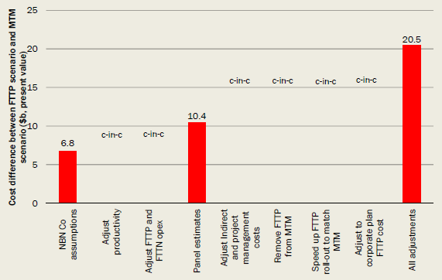

*Data* *source:* The CIE.

### 5.1 Approach

The cost of each scenario has been estimated using cost data provided by NBN Co. This cost data has been:

* independently reviewed, with a number of changes made, as set out in Appendix F;
* adjusted to remove transfers or costs that would occur in the absence of a high-speed broadband rollout;
* used to construct an additional scenario for *unsubsidised rollout;* and
* adjusted to remove costs avoided by others. In particular, the analysis takes account of the costs of maintaining the copper network and ADSL services in the absence of new investment for delivering high-speed broadband.

The costs have not been adjusted to include any costs outside of NBN Co, such as those borne by retailers. In practice, retailers may also incur some costs — these are not considered to differ significantly between the scenarios.

Note that there are also some costs to households and to society from the deadweight loss of taxation. These are treated as disbenefits and assessed in Chapter 6.

Appendix F contains details of the approach used to develop estimates of costs.

### 5.2 Cost differences across technologies

The technologies used in each scenario have different rollout costs.

* FTTP is 2.5 times as expensive to rollout on a lifecycle basis as FTTN and 3 times as expensive as HFC (Table 5.3). Table 5.3 shows index numbers that give a guide to relative costs of different stages of the rollouts as the dollar per premises figures cannot be shown for commercial-in-confidence reasons.
* The direct rollout costs for FTTP would cost around $ per month per premises, compared to less than $ per month per premises for either HFC or FTTN.[13]

These figures are per premises passed. Not all premises take up services, so the cost per premises activated is higher.

Table 5.3: Relative average rollout and operating costs for each technology (index numbers)

| Technology | Capex cost – build cost/premises | Capex cost – post build cost/premises/year | Opex cost cost/premises/year | Total cost cost present value/premises | Equivalent cost per month cost/month/ premises |
| --- | --- | --- | --- | --- | --- |
| **FTTP** NBN Co | 246 | 3 | 1 | 260 | 3 |
| **FTTP** Panel | 245 | 3 | 2 | 271 | 3 |
| **HFC** NBN Co | 59 | 3 | 1 | 86 | 1 |
| **HFC** Panel | 59 | 3 | 1 | 86 | 1 |
| **FTTN** NBN Co | 61 | 2 | 4 | 104 | 1 |
| **FTTN** Panel | 61 | 2 | 4 | 100 | 1 |

*Note:* This table provides index numbers to show the relatively costs of the various stages of rolling-out various technologies - the figures are not dollars. The total cost of FTTN using the panel's assumptions has been set at 100, with all other figures set relative to that number. This approach was taken as the dollar figures are commercial-in-confidence to NBN Co.

The total costs were calculates as a present value cost over 30 years using the NBN specific discount rate. The post build costs apply after 1 year for HFC, after 5 years for FTTN and after 8 years for FTTP. The costs are economic costs — that is, are adjusted to remove any transfers, including pole leases.

*Source:* NBN Co; The CIE analysis.

Fixed wireless and satellite costs are significantly higher than the costs for fixed line technologies. The costs for the rollout in the non-fixed line footprint are estimated at $ per premises taking up a service per month. This is not directly comparable to the figures above as these costs include some of the transit costs that are separately accounted for in the fixed line network and the cost is per premises taking service. Nevertheless, this does indicate the significant cost penalty involved in providing fixed wireless and satellite services.

### 5.3 Total costs

The total cost of each scenario is higher than the rollout and operating costs. Other economic costs that would be incurred include costs related to the transit network and overheads for NBN Co. There are also substantial financial costs to NBN Co that are not economic costs, either because they would have occurred in the baseline or because they are transfers to other businesses. These include payments made to Telstra and Optus, which either replace payments these companies would anticipate from customers should high-speed broadband not be rolled out or are a transfer to these companies.[14]

The costs for each of the scenarios over the evaluation period and discounted to the present are set out in Table 5.4. The costs for the *FTTP scenario* are highest, costing $10 billion more in economic terms (discounted) than the *MTM scenario* and $18 billion more than the *unsubsidised rollout.*

Table 5.4 also shows the substantial financial costs to NBN Co that are not economic costs, either because they would have occurred in the baseline or because they are transfers to other businesses. This includes payments to Telstra to lease existing assets and payments for customer disconnections to Telstra and Optus.

Table 5.4: Costs for each scenario - panel assumptions

| Costs | No further rollout $b, present value | Unsubsidised rollout $b, present value | MTM scenario $b, present value | FTTP scenario $b, present value |
| --- | --- | --- | --- | --- |
| **Fixed line footprint costs** Capital rollout costs | — | 5.4 | 8.4 | 19.8 |
| **Fixed line footprint costs** Post-build capex | — | 1.6 | 1.7 | 1.1 |
| **Fixed line footprint costs** Opex | — | 1.9 | 1.9 | 1.4 |
| **Fixed wireless/satellite footprint costs** Capex | — | 0 | 3.7 | 3.7 |
| **Fixed wireless/satellite footprint costs** Opex | — | 0 | 1.1 | 1.1 |
| **General resource costs incurred by NBN Co** Capex | — | 4.6 | 4.8 | 4.5 |
| **General resource costs incurred by NBN Co** Opex | — | 8.3 | 8.9 | 8.8 |
| Other financial (non-resource) costs for NBN Co | — | — | — | — |
| Total financial costs for NBN Co a | — | — | — | — |
| **Other resource costs outside of NBN Co** Resource costs outside of NBN Co | — | 0 | 0 | 0 |
| **Other resource costs outside of NBN Co** Resource costs avoided outside NBN Co | — | -4.2 | -5.6 | -5.2 |
| Total resource costs relative to no investment b | 0 | 17.6 | 24.9 | 35.3 |
| Total cost relative to the unsubsidised rollout | -17.6 | 0 | 7.2 | 17.6 |
| Cost of FTTP scenario relative to MTM scenario | — | — | — | 10.4 |

a Total financial costs for NBN Co are the sum of fixed line footprint costs, fixed wireless/satellite footprint costs, general resource costs and other financial (non-resource) costs for NBN Co.

b Resource costs relative to no investment are the sum of fixed line footprint costs, fixed wireless/satellite footprint costs, general resource costs and costs incurred and avoided outside of NBN Co.

*Note:* The costs for *unsubsidised rollout* are shown using the main benefit assumptions.

*Source:* The CIE.

The same cost table is presented for comparison for NBN Co assumptions.

Table 5.5: Costs for each scenario - NBN Co assumptions

| Costs | No further rollout $b, present value | Unsubsidised rollout $b, present value | MTM scenario $b, present value | FTTP scenario $b, present value |
| --- | --- | --- | --- | --- |
| **Fixed line footprint costs** Capital rollout costs | — | 5.1 | 7.5 | 16.0 |
| **Fixed line footprint costs** Post-build capex | — | 1.6 | 1.7 | 1.1 |
| **Fixed line footprint costs** Opex | — | 2.0 | 1.7 | 0.5 |
| **Fixed wireless/satellite footprint costs** Capex | — | 0 | 3.7 | 3.7 |
| **Fixed wireless/satellite footprint costs** Opex | — | 0 | 1.1 | 1.1 |
| **General resource costs incurred by NBN Co** Capex | — | 4.6 | 4.8 | 4.5 |
| **General resource costs incurred by NBN Co** Opex | — | 8.3 | 8.9 | 8.8 |
| Other financial (non-resource) costs for NBN Co | — | — | — | — |
| Total financial costs for NBN Co a | — | — | — | — |
| **Other resource costs outside of NBN Co** Resource costs outside of NBN Co | — | 0 | 0 | 0 |
| **Other resource costs outside of NBN Co** Resource costs avoided outside NBN Co | — | -4.2 | -5.6 | -5.2 |
| Total resource costs relative to no investment b | 0 | 17.4 | 23.9 | 30.6 |
| Total cost relative to the unsubsidised rollout | -17.4 | 0 | 6.5 | 13.2 |
| Cost of FTTP scenario relative to MTM scenario | — | — | — | 6.8 |

a Total financial costs for NBN Co are the sum of fixed line footprint costs, fixed wireless/satellite footprint costs, general resource costs and other financial (non-resource) costs for NBN Co.

b Resource costs relative to no investment are the sum of fixed line footprint costs, fixed wireless/satellite footprint costs, general resource costs and costs incurred and avoided outside of NBN Co.

*Note:* The costs for *unsubsidised rollout* are shown using the main benefit assumptions.

*Source:* The CIE.

### 5.4 The timing of costs

The timing of the total costs incurred is set out in Chart 5.6. The *FTTP scenario* has a continuation of costs over a longer period. Once fully rolled out, its costs are lower than the *MTM scenario.*

Chart 5.6: Timing of resource costs

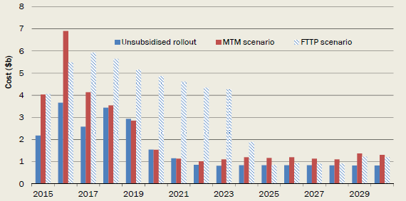

*Note:* The costs for *unsubsidised rollout* are shown using the WTP method.

*Data source:* The CIE.

## 6. Benefits of each scenario

Considerable focus of the research for this CBA has been on identifying and measuring the benefits of higher speed broadband. As noted in Chapter 2, while there have been many claims about the broad qualitative benefits of high-speed broadband, the panel has sought to provide a solid quantitative basis to these benefits.

A major aspect of this part of the CBA has been estimating WTP by households for faster broadband, which has included commissioned studies as inputs. Efforts have also been made to identify other benefits, such as WTP by businesses that will connect to the NBN and public and external benefits.

The calculation of benefits also includes by convention some disbenefits (effectively costs), in this case disruption costs and deadweight loss of taxation.

Like costs, the benefits from higher speed broadband will occur over time. Therefore it is important to consider how benefits could evolve and grow over time, and the influences on that evolution.

This chapter presents the estimates of the value of higher speed broadband under the four scenarios and details how those benefits were calculated.

The scenarios for delivering higher speed broadband have different benefits because of the speeds delivered once fully rolled out and the time taken to roll out. Of these two effects, the second is quantitatively the more important. This means that, for example, the *MTM scenario* has both **lower costs** and **higher benefits** than the *FTTP scenario.*

The scenarios also differ in their coverage of premises. The benefits of coverage throughout Australia are only marginally higher than the benefits of mainly covering the fixed line area. This is because the change in speeds is smaller outside the fixed line area and the number of premises served is small.

A summary of the benefits for each scenario is set out in Table 6.1. The majority of benefits are from household and business WTP for higher speeds in the fixed line area.

Table 6.1: Estimates of benefits using base assumptions

| Benefit | No further rollout $b, present value | Unsubsidised rollout $b, present value | MTM scenario $b, present value | FTTP scenario $b, present value |
| --- | --- | --- | --- | --- |
| Household WTP - fixed line area | — | 33.1 | 34.5 | 32.4 |
| Business WTP - fixed line area | — | 6.4 | 6.6 | 6.2 |
| WTP - non-fixed line area | — | 0 | 1.2 | 1.2 |
| Public benefits and externalities | — | 2.1 | 2.2 | 2.1 |
| DWL of taxation | — | 0 | -2.4 | -6.6 |
| Disruption costs | — | -1.4 | -1.6 | -1.7 |
| Residual value | — | 1.5 | 2.2 | 3.5 |
| Total benefits | 0 | 41.7 | 42.7 | 37.0 |
| Benefits relative to reference case | -41.7 | 0 | 1.0 | -4.7 |

*Source:* The CIE.

The timing of WTP benefits under each scenario and the base assumptions are set out in Chart 6.2. The *FTTP scenario* has the highest benefits once it is fully rolled out, but takes a longer time to rollout. The *MTM scenario* has slightly higher benefits in the fixed line area than the *unsubsidised rollout* because of those premises served by FTTP.

Chart 6.2: Timing of direct benefits to households and businesses for each scenario

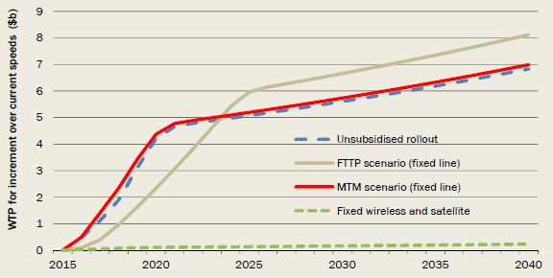

*Data source:* The CIE.

The benefits under alternative methods of estimating WTP relative to an *unsubsidised rollout* are shown in Table 6.3. Note that the coverage of the *unsubsidised rollout* varies across these methods, so these cannot be compared to the costs in Chapter 5. For example, the *unsubsidised rollout* would provide coverage to 59 per cent of premises under the 'uptake' method. This means the costs are also substantially lower.

These benefits reflect per household benefits of $40 to $50 per month for the first two methods and about half this using the uptake method.

Table 6.3: Benefits - alternative estimation methods

| Benefit | No further rollout $b, present value | Unsubsidised rollout $b, present value | Unsubsidised rollout Coverage (%) | MTM scenario $b, present value | FTTP scenario $b, present value |
| --- | --- | --- | --- | --- | --- |
| Choice modelling (base assumption) | -41.7 | 0 | 93% | -4.7 | 1.0 |
| Technical bandwidth demand | -47.5 | 0 | 93% | -6.2 | 6.2 |
| Uptake data | -15.1 | 0 | 59% | 4.3 | 7.9 |

*Source:* The CIE.

The sections below detail the approach to estimating benefits.

### 6.1 Willingness to pay for higher speeds

In this CBA, WTP seeks to measure the value that households or businesses place on additional internet speeds to those currently available.

There are a number of widely used methodologies that can be used to estimate this WTP. Previous literature seeking to identify this WTP has used a variety of techniques, including:

* choice modelling surveys — this technique asks households (or businesses) to choose amongst alternative possible internet plans and then uses this to identify the value that people place on particular attributes; and
* analysis of market data — this technique uses observed behaviour (price and uptake) to infer the value that consumers place on particular internet options.

In addition, assessing WTP by measuring and valuing the time saved by households and businesses from improved infrastructure has been a common feature of CBA.

Given that there is little existing research on the value of broadband speed, the panel adopted as comprehensive an approach as possible to estimating WTP, including using multiple estimation methodologies.

#### General approach

The approach used in this study to estimate and apply WTP has the following steps.

* First estimating the average WTP per household to move from existing speeds to speeds available under each scenario.
* This is undertaken using three separate methodologies, to give as robust a view as possible on WTP. These methodologies use choice modelling analysis undertaken by the Institute for Choice, a model of technical demand for bandwidth developed by Communication Chambers and existing data on take-up of NBN plans.
* For each scenario, measuring the change from currently available speeds (see Appendix B) to future available speeds under the particular scenario. Many households will not choose the maximum speeds available either within the current market or under alternative scenarios, because of the higher prices of higher speed packages.
* Applying a rate of change to the average WTP figures through time. This is applied as a per cent change in average WTP per year and the implications of alternative assumptions are carefully considered.
* The average WTP per household is applied to the number of households that have taken up high-speed broadband services at each point in time
* An estimate is made of average business WTP relative to household WTP. This is applied to the number of businesses expected to take-up high-speed broadband services at each point in time.

The sections below set out the approaches and findings for the three methods of estimating household WTP in greater detail.

#### Choice modelling

The Institute for Choice was commissioned to undertake a choice modelling survey of Australian households. Appendix H sets out the details of this study. Choice modelling is a statistical approach that seeks to understand people's choices between possible plans that have different levels of speed and other characteristics. By doing this, the value that households place on the key attributes that are changed by high-speed broadband (upload and download speeds) can be measured. The experiment allows for a broader range of packages and speeds to be considered by consumers than occurs in any actual market, thereby eliciting greater information on preferences than can be observed in uptake rates alone.

The value of WTP calculated from this modelling is used as the base assumption for measuring benefits in this CBA.

The results of a choice experiment can be used in many ways. For the purposes of this CBA, the key impact of concern is how consumers value additional upload and download speed.

Consumers were divided into two groups in the survey. One group was shown minimal information about what speeds meant in practice — such as download times for television shows. This is the 'uninformed consumers' group. A second group was shown information about activities that could be undertaken at different speeds, such as video conferencing and 4K television (see Chart H.1). This is the 'informed consumer' group.

Within each group, people can fall into several classes that respond differently to the characteristics of broadband packages, depending on their age and income for example. Taking a weighted average across these classes, the marginal willingness to pay (MWTP) for download and upload speeds are shown in Charts 6.4 and 6.5.[15] This measures the amount that households would be willing to pay for an extra 1 Mbps of speed. This amount varies with the level of speed.

Importantly, and echoing the results of Communication Chambers' bandwidth demand study, there is a declining value on both upload and download speed. This means, for example that an extra Mbps at 5 Mbps is worth more than it is at 50 Mbps.

Also importantly, those that were informed about how speeds impacted on activities showed a higher valuation in total but a steeper decline in the value of additional speed than those who were not. This is also shown in Chart 6.15, in a steeper demand curve for those people that were informed. A better understanding of the speeds required for particular applications increases the MWTP for extra speed at low speeds, but with a sharper decline in MWTP as the speed increases.

Chart 6.4: Marginal willingness to pay for *download* speed

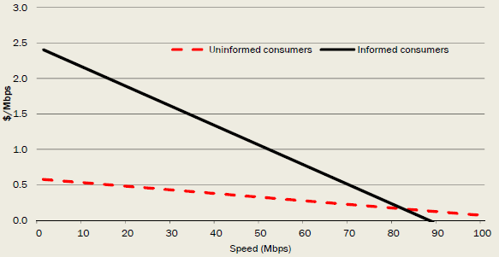

*Note:* The MWTP curves are a weighted average across the two classes estimated by the Institute for Choice and for a price of $75 per month.

*Data source:* Institute for Choice; The CIE calculations.

Chart 6.5: Marginal willingness to pay for *upload* speed

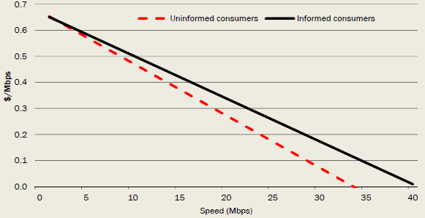

*Note:* The MWTP curves are a weighted average across the two classes estimated by the Institute for Choice and for a price of $75 per month.

*Data source:* Institute for Choice; The CIE calculations.

These relationships can be used to show the value of giving consumers additional speed, while keeping everything else in a household's internet plan unchanged (for example, download limits and bundling with voice products). Table 6.6 sets out an example of how this calculation is undertaken using two illustrative examples.

First, the change in speed experienced by the particular household is estimated. This will depend on the particular scenario under examination. In Table 6.6, illustrative household 1 goes from 10 Mbps to 40 Mbps for download, and from 2 Mbps to 5 Mbps for upload. For household 2, the increment is larger.[16]

A value is then applied to the change in speeds based on the WTP to move between different levels of speed.[17]

Table 6.6: An example of how MWTP is applied — choice modelling approach

| Speed | Illustrative example household 1 | Illustrative example household 2 |
| --- | --- | --- |
| **Current speed** Download | 10 Mbps | 5 Mbps |
| **Current speed** Upload | 2 Mbps | 1 Mbps |
| **Future speed** Download | 40 Mbps | 60 Mbps |
| **Future speed** Upload | 5 Mbps | 10 Mbps |
| **WTP to go from current to future speed ($/month)** Download | $33.2 | $54.1 |
| **WTP to go from current to future speed ($/month)** Upload | $1.8 | $5.2 |
| **Total WTP ($/month)** | **$35.0** | **$59.3** |

*Source:* The CIE.

Table 6.7 applies this calculation to the changes in speed for all households under each of the three scenarios (all compared with the *no further rollout scenario).* The average gain per household within the rollout footprint for the scenario is $41 for the *unsubsidised rollout* and the *MTM scenario.* It is higher at $46 per household per month for the *FTTP scenario,* because of the higher speeds achieved under this scenario.

These figures are the gain from moving households immediately to the higher speeds. Each scenario has different paths of upgrading speeds and the value of upgrading changes through time, which has to be accounted for, as discussed later in this chapter.

Table 6.7: Current average benefits to households that use the internet — MWTP calculated from choice modelling results

| Speed | Benefit relative to no further rollout — download $/household in rollout/month | Benefit relative to no further rollout — upload $/household in rollout/month | Share of premises rolled out to Per cent |
| --- | --- | --- | --- |
| **Fixed line footprint** Unsubsidised rollout scenario | 40.4 | 6.1 | 89.4 |
| **Fixed line footprint** MTM scenario | 40.5 | 6.1 | 95.6 |
| **Fixed line footprint** FTTP scenario | 45.8 | 9.7 | 95.6 |
| **Non-fixed line footprint** Unsubsidised rollout scenario | na | na | 0 |
| **Non-fixed line footprint** MTM scenario | 23.0 | 0.6 | 91.0 |
| **Non-fixed line footprint** FTTP scenario | 23.0 | 0.6 | 91.0 |

*Note:* The shares of rollout are less than 100 per cent because some premises have already received FTTP and fixed wireless/satellite.

*Source:* The CIE.

The value from speed upgrades set out above reflects the change in the available speed. Because the NBN is priced, some people will not take-up the maximum available speed — nor have households all currently taken up the maximum speeds available to them. This means that the estimated gains are marginally overstated, as those who value speed the most will continue to take-up those speeds despite the higher prices.

The gains set out above are for internet using households (mobile and fixed line), as these households constituted the sample used in the choice survey. According to the most recent ABS survey, 83 per cent of households use the internet (ABS 2014). The estimates above are therefore reduced by 17 per cent to account for households which take-up a connection to a high-speed broadband network for the use of voice (or other non-internet) services.

#### Time savings based on technical bandwidth demand

The bandwidth demand information generated using the Communications Chambers model (discussed in Chapter 2) can be used to infer the potential time cost to a household as a result of having bandwidth less than that required for the household to do the things it wants to on the internet.

This can be measured from the Communications Chambers model as the number of 'degraded minutes' (per month) that a household is likely to experience. Degraded minutes are the minutes within a month where the household demand is not satisfied by the household's current bandwidth. By definition, during this time some part of internet access must be 'degraded'. This could come about in a number of ways, through lower video resolution (for those minutes) or through longer download times (or longer page load times in the case of web browsing). It is possible that the household will not notice this effect, although for the purposes here it is assumed that all degraded minutes have some cost to the household.

The patterns of degraded minutes in 2023 for three percentiles are illustrated in Chart 6.8.

Chart 6.8: Degraded minutes (2023)

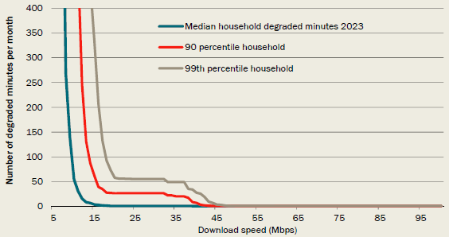

*Data source:* Communications Chambers bandwidth demand model.

Chart 6.8 shows that:

* for the median household (the teal colour line) achieving 10 Mbps means that this household will experience 'degradation' for around 55 minutes a month; and
* looking at the most demanding households (the 99th percentile) achieving 20 Mbps will see degraded performance for around 60 minutes a month.

The shape of the curve illustrated in Chart 6.8 has a number of interesting implications.

* The slope of the curve (basically vertical up to 10 Mbps for the median, or to 20 Mbps or so for the more demanding households) fits with a general intuition that 'we need broadband': indeed households do, if broadband is defined as faster speeds than are currently available to most Australian households and if 'degraded' minutes are to fall to a lower level.
* But the slope also shows that the incremental gain from say 25 Mbps to 50 Mbps is a lot smaller than the gain up to 15 Mbps or 20 Mbps. This may be one way of 'reconciling' the different views about requirements for speed; it is a matter of being very clear what is meant by high-speed broadband.

As one way of using the degraded minutes metric to value increments in speed, the CBA model assumes that each of these degraded minutes represents actual time lost to the household. Valuing this time lost at a proportion of the wage rate provides an indication of the value of increments in speed.[18]

The results of doing this are shown in Charts 6.9 and 6.10 for downloads and uploads respectively. At low speeds, such as 5 Mbps, speed currently (2013) has a significant impact on households. At about 10 Mbps, averaged across households, this speed would lead to only around $2.70 per month in cost from degradation of quality. By 2018, this is estimated to increase to $16 per month per household and by 2023 to $42 per month per household (given the demand forecasts derived from the Communications Chambers bandwidth demand model). That is, there is rapid growth in the impact on households at speeds from 5 to around 35 Mbps. At higher speeds (>45 Mbps), most households face no cost from degradation of quality of service now or by 2023.

The same pattern holds with upload speeds. Upload speeds of about 4 Mbps lead to almost no cost on households even by 2023.

Chart 6.9: Cost of degraded download minutes (log scale)

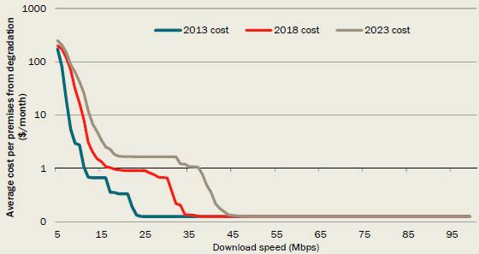

*Note:* This is based on a time cost of $15 per hour. In converting technical demand to WTP (as set out in detail in Chapter 6), the 4 minutes excluded adjustment is not used. Rather the CBA model attaches a cost to all minutes of usage not covered by available bandwidth.

*Data source: Communications Chambers; The CIE.*

Chart 6.10: Cost of degraded upload minutes (log scale)

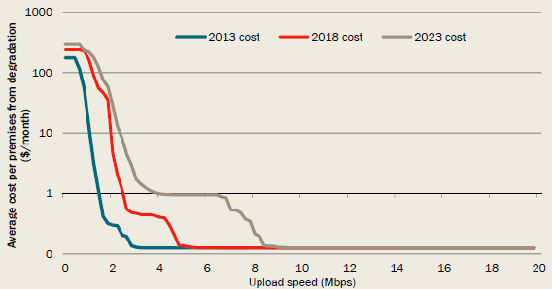

*Note:* This is based on a time cost of $15 per hour. In converting technical demand to WTP (as set out in detail in Chapter 6), the 4 minutes excluded adjustment is not used. Rather the CBA model attaches a cost to all minutes of usage not covered by available bandwidth.

*Data source:* Communications Chambers; The CIE.

The decline in the value of additional speed is more rapid than the results from the choice modelling study. This is not surprising, as the technical bandwidth demand approach applies an equal cost to each minute of degraded time. In practice, households that face a large amount of degraded time would likely respond by changing their behaviour to minimise the costs of degradation of service quality, such as by not watching videos over the internet.

The benefits per household per month of each of the scenarios can be estimated by combining the costs of degraded quality of service with the speeds under each of the scenarios considered. The average benefit per household for each of the scenarios is shown in Table 6.11. Each of the scenarios generates similar benefits, as there is little benefit in speeds above the levels delivered by FTTN and HFC. There is a slight difference for the *unsubsidised rollout scenario,* as a small set of people with very high fixed line costs would not be rolled out to — these premises also currently have low speeds.[19]

The fixed wireless/satellite benefits are the largest, because customers in these areas currently have the lowest speeds and the value of speed is much higher at lower initial speeds. Note that there is no differentiation of households across different regions, so this may overstate benefits in the non-fixed line area if demand for services in these areas is lower than in the fixed line footprint.

Table 6.11: Current average benefits — bandwidth demand approach

| Speed | Benefit relative to no further rollout — download $/household in rollout/month | Benefit relative to no further rollout — upload $/household in rollout/month | Share of premises rolled out to Per cent |
| --- | --- | --- | --- |
| **Fixed line footprint** Unsubsidised rollout scenario | 43.61 | 9.49 | 95.6 |
| **Fixed line footprint** MTM scenario | 43.71 | 9.50 | 95.6 |
| **Fixed line footprint** FTTP scenario | 43.72 | 9.51 | 95.6 |
| **Non-fixed line footprint** Unsubsidised rollout scenario | na | na | 0 |
| **Non-fixed line footprint** MTM scenario | 117.88 | 12.94 | 91.0 |
| **Non-fixed line footprint** FTTP scenario | 117.88 | 12.94 | 91.0 |

*Note:* The shares of rollout are less than 100 per cent because some premises have already received FTTP and fixed wireless/satellite. The calculations are based on 2013 estimates of the costs of degraded quality of service. We apply an escalation of these costs over time as set out in later sections.

*Source:* The CIE.

The gains set out above are for internet using households. A share of premises that connect to a high-speed broadband service will not be internet users, and will only use the network for voice (or other non-internet) services.[20] According to the most recent ABS survey, 83 per cent of households use the internet (ABS 2014). The estimated average WTP per household in Table 6.11 are therefore scaled down accordingly.

#### Uptake of high-speed broadband

Actual data on take-up and prices of the NBN to date can be used to estimate the gains that consumers are implicitly allowing for in making their choices. In doing this, the take-up data may suffer from issues of selection bias as those with the highest value from additional speed have taken up the NBN early, while those who place little or no value on higher speeds are yet to take-up NBN plans.

The Australian take-up rates of the highest speeds are substantially higher than those in other countries where high-speeds have been available for longer, suggesting such selection effects (Table 6.12). Information provided by Cartesian (a communications consulting company) indicates that price premiums for a plan with 100 Mbps download speed range from $4.61 to $16.60 per month, above the next highest speed plan (10 to 70 Mbps). At this price difference, the take up of the 100 Mbps download speed is close to 10 per cent for most countries except Sweden, where it is above 25 per cent. In comparison, 23 per cent of NBN fixed line plans taken up have been for the 100 Mbps download speed, with a retail price premium for this towards the upper end of pricing premiums in other countries.

Table 6.12: Price premiums and uptake for 100 Mbps plans

| Country | 100 Mbps pricing premium $/month (US PPP) $A | 100 Mbps uptake in the market Per cent |
| --- | --- | --- |
| Sweden | $4.61 (10 to 100) | >25 (2013) |
| The Netherlands | $9.71 (50 to 100) | 7 (2013) |
| Lithuania | $5.33 (10 to 100) | 10 (2012) |
| Belgium | $16.60 (70 to 100) | 13 (2013) |
| Portugal | $6.00 (30 to 100) | 11 (2013) |
| **NBN Co to date** | **$9.60 (50 to 100)** | **23 (2014)** |

Source: Cartesian 2014, Ultra-fast broadband study: Investigating demand and benefits, prepared for Corning, May; NBN Co.

Uptake information can be used to provide a lower bound estimate of the amount consumers are willing to pay for higher speeds — this is observed in how much more they actually do pay for higher speeds. In order to estimate the total consumer gain for higher speeds, this uptake information needs to be combined with information about the slope of the demand curve for speed — uptake information alone is not sufficient for this calculation.

#### Lower bound estimate of gains from higher speeds

The average retail prices for each speed tier plan offered by NBN Co are shown in Table 6.13. These have been calculated through:

* analysing the prices of 232 plans offered by retailers on NBN Co infrastructure against the attributes in that plan (the provider, download/upload speeds, data limits and inclusion of voice services);
* applying the provider-specific estimate to the take up of NBN Co plans across providers to date; and
* specifying a data limit of 100 GB/month and no inclusion of voice services.

The price premiums for higher speed plans are also shown in Table 6.13 relative to the basic NBN Co plan. These measure the additional price for higher upload and download speeds with other factors held constant.[21]

Any customer who chooses a higher speed plan must value this at least as highly as the additional price they have to pay. For example, to choose a 100/40 plan over a 12/1 plan, a consumer must perceive a value for the additional speed of at least $26 per month.

Table 6.13: Price premiums for higher speed plans

| Plan | Retail price $/month | Share of fixed line NBN customers per cent | Price premium over basic NBN plan $/month |
| --- | --- | --- | --- |
| 12/1 | 65.7 | 42 | 0.0 |
| 25/5 | 74.1 | 29 | 8.4 |
| 25/10 | 75.1 | 1 | 9.4 |
| 50/20 | 82.1 | 5 | 16.4 |
| 100/40 | 91.7 | 23 | 26.0 |

*Note:* The retail price excludes bundles that have voice inclusions and is for 100 GB/month download limit.

*Source:* The CIE based on NBN Co data.

The average price premium across customers is the sum of the price premium for each speed tier multiplied by the share of customers taking up that speed tier. This measures the value of speeds above 12/1 relative to a speed of 12/1. The result of this calculation is $9.3 per customer — that is, customers taking up the NBN to date have at least been willing to pay an average premium of $9.3 per customer for plans above the most basic NBN plan.[22] This is a lower bound because customers may have been willing to pay more than they actually paid, and because it measures the premium relative to NBN Co's most basic plan, which is likely on average to be an improvement on existing speeds.

#### Total estimate of gains from higher speeds

In order to get an estimate of the total surplus created by higher speeds it is necessary to understand:

* how much consumers gain from moving from their existing internet speeds to the lowest NBN Co bundle; and
* how much more consumers would pay beyond what they have paid to obtain services.

On the first point, it is not possible to use market data to understand the gains from moving from existing available speeds to the NBN speeds because contractual arrangements force customers off existing networks. The delivery of NBN services at 12/1 would be an improvement for many Australian households, where ADSL average speeds (or dial-up) provides speeds lower than this. For other households, this would represent a decline in speeds relative to those currently available on HFC and ADSL in some areas.

The analysis here assumes that the surplus that goes to a consumer for the 12/1 plan is about the same as the value for those taking up a 25/5 plan relative to a 12/1 plan.[23]

Consumers that take up a particular speed tier may be willing to pay an amount greater than the amount that they are actually required to pay. For example if 20 per cent of people have paid an additional $10 to obtain a 100/40 (download/upload) service over a 50/20 service, then they have at least been willing to pay this $10. The total gain is equal to the $10 plus any additional amount they would have paid. This additional amount is called 'the consumer surplus'.

The consumer surplus can be calculated through combining the information on price and quantity with information on how responsive take-up is to price. If take-up is highly responsive to price, then this indicates that few people value the service well above the price that they paid. If take up is not responsive, then this indicates that more people value the service well above price. The responsiveness of take-up to price is called the elasticity of demand.

The total surplus is estimated by combining the price premium and the consumer surplus as shown in Chart 6.14.

The price premium paid is shown as the rectangle A, with the vertical axis representing the price premium over the next highest plan. This matches the calculations in Table 6.13.

The triangle B represents the consumer surplus — shown for a 'low' elasticity in the chart. This triangle becomes smaller if the demand curve is flatter (that is, more elastic) or larger if the demand curve is steeper (that is, less elastic).

Chart 6.14: Measuring average WTP using demand curves

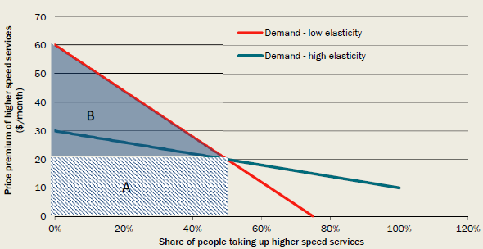

*Note:* Diagram shows demand curves as linear for presentation purposes. Demand curves estimated are constant elasticity of substitution.

*Data source:* The CIE.

The estimated consumer surplus is sensitive to the assumptions made about the responsiveness of people to higher prices and the shape of the demand curve (linear or not).

There are a number of measures of how responsive consumers are to prices.

* The previous literature on the value of high-speed broadband has sought to estimate elasticities in some cases. For example, Dutz et al (2009) found that elasticities from dial-up to broadband were about -0.69 in 2008 — that is, a 10 per cent rise in the price of broadband would lead to a 6.9 per cent decline in the number of people choosing broadband versus dial-up internet. At higher speeds, Dutz et al (2009) found much higher elasticities — generally larger than -4. This makes sense, as another high-speed plan (such as 50/20) is a closer substitute to a very high-speed plan (100/40) than is dial up internet. The latter estimates are most relevant for this study, as few people are moving from dial-up to broadband
* The choice modelling conducted for this study provides an understanding of the responsiveness of consumers to higher prices. The results of this are shown in Chart 6.15, for the 100/40 plan with other plans held constant. The implied elasticity of demand varies in the range of -2 to -3. Note that the choice modelling study informed one group about what can be undertaken at different speeds but did not inform the second group. The group that was informed are more likely to choose cheaper lower speed packages as the price of the top plan (100 Mbps down/40 up) increases.

Chart 6.15: Demand curves for 100/40 plan (derived from choice modelling)

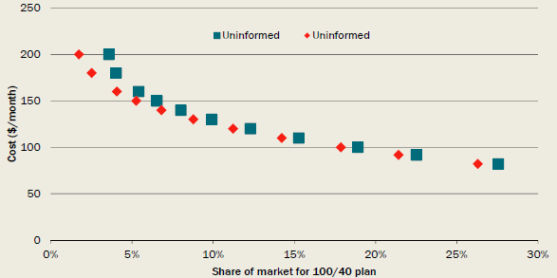

*Note:* This keeps the prices of other NBN plans constant.

*Data source:* Institute for Choice; The CIE analysis.

To estimate the consumer surplus and total surplus from higher speeds (that is, A + B in Chart 6.14), we use an elasticity at the lower end of available evidence of -2 and also show results for -3. We use a constant elasticity of substitution form, as this more closely aligns with the way that previous estimates and estimates from the Institute for Choice study are constructed. These assumptions err towards showing a higher benefit from additional speed.

The implied surplus created from the different plans is set out in Table 6.16. A household taking up the 100/40 plan is estimated to have an average benefit of $59.10 per month relative to average current speeds. A household taking up the 50/20 plan is estimated to have an average benefit of $39.40 per month.

The weighted total benefit per household moving to the NBN is $26.30 per month.

Table 6.16: Benefits from higher speed plans

| Plan | Retail price $/month | Share of fixed line NBN customers Per cent | Price premium over basic NBN plan $/month | Price premium over current speed plan $/month | Implied total surplus per uptake relative to current for those taking up $/household on plan |
| --- | --- | --- | --- | --- | --- |
| 12/1 | 65.7 | 42% | 0.0 | 0.0 | 8.1 |
| 25/5 | 74.1 | 29% | 8.4 | 8.4 | 24.6 |
| 25/10 | 75.1 | 1% | 9.4 | 9.4 | 24.9 |
| 50/20 | 82.1 | 5% | 16.4 | 16.4 | 39.4 |
| 100/40 | 91.7 | 23°% | 26.0 | 26.0 | 59.1 |

*Source:* The CIE.

Applying these implied values to each scenario is not straightforward, as the scenarios have premises on a range of different speeds. The analysis makes the simplifying assumptions that:

* the *FTTP scenario* gives access to all plans in the fixed footprint;
* the *MTM scenario* gives access to all plans except the 100/40 plan in the fixed footprint; and
* fixed wireless and satellite gives access to the 12/1 and 25/5 plans.

This is likely to understate the benefits of the *MTM scenario,* given that around 17 per cent of households will receive FTTP in this scenario.

Under these assumptions, the benefits of each scenario, at current WTP and with immediate access to new speeds, are shown in Table 6.17. The benefits per household are around $18 to $22 depending on the elasticity assumed, for the *unsubsidised rollout* and the *MTM scenario.* The benefits are around $22 to $26 per household for the *FTTP scenario.*

Table 6.17: Benefits of each scenario using current take-up method

| Weighted average | Elasticity of -2 Fixed line $/household taking up NBN | Elasticity of -2 Fixed wireless & satellite $/household taking up NBN | Elasticity of -3 Fixed line $/household taking up NBN | Elasticity of -3 Fixed wireless & satellite $/household taking up NBN |
| --- | --- | --- | --- | --- |
| Unsubsidised rollout | 21.8 | 0 | 18.6 | 0 |
| MTM scenario | 21.8 | 16.7 | 18.6 | 14.7 |
| FTTP scenario | 26.3 | 16.7 | 22.0 | 14.7 |

*Source:* The CIE.

#### Changes to WTP through time

There is substantial uncertainty around the future path of demand for additional speed. This uncertainty reflects:

* uncertainty around future demand for current applications;
* uncertainty around the set of applications that will be available and that households and businesses would like to use; and
* technological changes to the efficiency with which information can be transported — such as coding[24].

These are in addition to changes in the ability to use particular infrastructure to deliver higher speeds in the future.

The Communications Chambers' work makes a strong case that there will be substantial growth in demand for speed, but that this will be focused at moderately high-speed levels. The estimated changes in the 'degraded minute' cost at particular upload and download speed levels are calculated in Charts 6.18 and 6.19. At moderate speeds, the average rates of growth in the time cost of degraded minutes (interpreted as WTP as outlined above) are in excess of 20 per cent per year. However, at higher speeds, these growth rates are zero.

Chart 6.18: Annualised change in the cost of degradation from download speeds

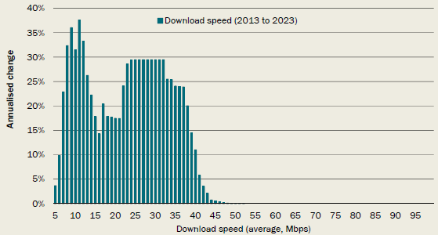

*Data source:* Communications Chambers; The CIE.

Chart 6.19: Annualised change in the cost of degradation from upload speeds

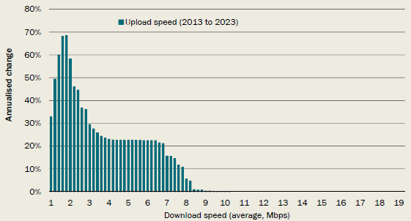

*Data source:* Communications Chambers; The CIE.

Previous work such as Dutz et al (2009) has also shown growth in the WTP for broadband through time.

For the purposes of this CBA, a key issue is the change in the WTP at speeds in excess of the *MTM scenario.* The sensitivity analysis presented below varies demand for speeds (including the highest speeds) from remaining the same over a 10 year period to more than tripling over this period.

In presenting main results, the CBA results presented here use a 2 per cent per year growth in WTP. This level of WTP growth represents growth that is slightly higher than historical and expected real income growth per capita. Given that the efficiency of coding of information for key high-bandwidth applications is anticipated to increase by 9 per cent per year, this implies a demand for higher speed activities increasing by 11 per cent per year. Given the technical bandwidth demand results, this may overstate the additional benefits from the higher speeds delivered by FTTP relative to other technologies, as a Communications Chambers' study found limited expected growth in demand for download speeds above 50 Mbps and upload speeds above 10 Mbps.

### 6.2 Business willingness to pay

Businesses can derive benefits from the use of high-speed broadband. Businesses can use the internet for video conferencing, VoIP, data storage and backup, cloud computing, collaborative working, e-learning, electronic delivery of services, ordering of products, communication, providing customer service and delivering new products among other uses. These activities can help to lower costs and/or increase revenues and generally increase profitability.

The extent that businesses are willing to pay for high-speed broadband services will depend on the benefits they expect to realise. Surveys and studies in the literature show the extent of expected benefits from internet and broadband services is affected by the industry, structure and size of the business (see ANU 2004, Lea and Kempson 2012, Commerce Commission New Zealand 2012, APS Group Scotland 2011, Castalia 2008). Those businesses in the services sector (particularly digital media services, communications and property services) are more likely to value internet services, as are large businesses, or those with high turnover. Some studies showed that businesses in rural or provincial centres were likely to value internet less than those in urban areas - however this result was not consistent across the studies (see ANU 2004, Commerce Commission New Zealand 2012, APS Group Scotland 2011).

There is very little information available on demand for high-speed broadband by Australian businesses. Surveys have been conducted by Australian Industry Group (AIG) (2013) and the ACMA (2014) which show that the vast majority of businesses are connected to the internet using a broadband connection (around 97 per cent) and most of these use a DSL connection, with around 1.7 per cent connected using fibre. These results depend heavily on the size of the business, with 25 per cent of large businesses using a fibre internet connection. Most survey respondents in both surveys were satisfied with their current internet connection. The AIG survey found that 16 per cent of businesses did not expect to be able to do anything with the NBN that they could not already do.

Businesses' benefits from high-speed broadband are likely to move in line with consumers' WTP for high-speed broadband. As broadband services improve in terms of speed and reliability, the WTP by households and businesses are both expected to increase. Additionally, with greater demand and uptake of internet services by households, businesses have greater opportunities to engage with consumers in the digital world and would therefore see greater value in being connected themselves. As is the case for households, relevant information on businesses' WTP for high-speed broadband in Australia is limited. Because of the lack of available information and the expected link between household and business WTP, we look at benchmarking business WTP against household WTP data.

A study by Leicestershire County Council (Lea and Kempson 2012) used a consistent approach to gauge both household and business WTP for improved internet connections. They found that the WTP of an individual business was approximately 167 per cent of the WTP of an individual household. In Australia, a study conducted on broadband adoption on the Yorke Peninsula (Molloy et al. 2008) found that the point at which businesses determined broadband to be too expensive is 145 per cent of the price at which households concluded broadband was too expensive.

Alcatel Lucent (2012b), in estimating the benefits of high-speed broadband for New Zealand, found that around 71 per cent of the total benefits would accrue to businesses. This leads to a much higher rate of business to household benefits (around 245 per cent). It is worth noting, however, that Alcatel Lucent did not use a WTP approach to estimate benefits but rather determined the expected time, travel and cost savings that would be realised from e-health and e-education and expected cost savings combined with improved services and revenues to businesses and the dairy sector. The household WTP for the private benefits of broadband internet associated with entertainment and other private activities was not captured.

These figures are likely to overestimate the benefits of the NBN to businesses. In many cases businesses have the capacity to relocate to areas where there is high-speed broadband already available if it is critical for their business. Ergas and Robson (2009) suggest that there is little unmet demand for high-speed broadband by businesses, given that fibre networks cover capital city central business districts and that business parks, large organisations, hospitals and government offices located outside these areas often have direct fibre connections. Benefits will be realised through the rollout of the NBN for companies who either cannot relocate to central areas to access high-speed broadband, or don't value the high-speed broadband enough to justify such a move.

Based on the results of those studies, business WTP for each connection has been valued at 150 per cent relative to each household connection (that is, a 50 per cent premium). To allow for uncertainties, a range of 100 per cent to 200 per cent has been tested in sensitivity analysis.

### 6.3 Valuing public and external benefits

A comprehensive list of potential benefits from high-speed broadband is provided in Appendix E. This list is aimed at identifying public and external benefits but includes private benefits that are commonly included in the literature and public discussions about the advantages of high-speed broadband.

While there are many broad discussions on the nature of the potential benefits of a high-speed broadband network in the literature, there is very limited information available that places values on these public or external benefits. For example, a recent Australian report[25] estimated the private benefits to Australian households from high-speed broadband. The report also described additional social benefits (social inclusion, equity, health care) and environmental impacts, but does not attempt to quantify these non-private benefits.

A report for the European Space Agency (PricewaterhouseCoopers 2004) included a comprehensive assessment of the benefits of provision of broadband connectivity across Europe. The report was focused on broadband of lower speeds than is the focus of this report, however, it is useful because it is one of very few reports that provides quantitative estimates of the full range of benefits, and categorises the benefits in a useful way. Of interest from this report is the allocation of total benefits across these categories (rather than the estimated value of the benefits).

The benefits were grouped into those that are:

* direct benefits to the consumer;
* benefits to providers of services - primarily realised by governments; and
* indirect benefits arising to other people.

The public sector benefits considered included:

* online delivery of government services (such as social benefit payments, tax returns and vehicle licensing);
* e-learning (that is the use of ICT in teaching and web based higher education); and
* e-health (including tele-consultations, specialist referrals and treatment of diabetes, dermatology and pulmonary conditions).

External benefits considered include the benefits from reduced pollution, benefits to rural populations and benefits of improved educational levels.

The results of the analysis showed that direct private benefits accounted for 94 per cent of the total benefits. The benefits to the public sector and the externalities accounted for 5 and 1 per cent respectively.

This result is further supported by analysis commissioned by Corning (Cartesian 2014) in which the socio-economic benefits of ultra-fast broadband were estimated and grouped into six categories: e-work, e-health, e-learning, e-commerce, consumer video use and cloud computing. Most the benefits included in the analysis were private in nature, except for the e-health and e-learning elements. Together, these areas were estimated to account for 4.8 per cent of total benefits.

Data collated by Sandvine (2014) further verifies the finding that most household internet use is for private, entertainment purposes. In 2014 real-time entertainment accounted for 47 per cent of internet traffic in the Asia Pacific region while for the US the figure was 59 per cent. Other major traffic categories include file sharing, web browsing, social networking and communications, much of which is also likely to be for private benefits rather than facilitating the delivery of public services. In the US, peak period downloads were dominated by one entertainment provider, Netflix (34.2 per cent of downstream traffic).

The report by Communications Chambers also considers the breakdown of demand into uses with private and public benefits. The analysis concluded that the key drivers of bandwidth requirements are applications with primarily private benefits.

The types of benefits that are highlighted in Table E.1 in Appendix E as ones that warrant consideration in the CBA are mostly associated with the government provision of health and education services. These benefits align closely with the public and external benefits included in the PWC and Corning analyses.

The above evidence suggests that non-private benefits from high-speed broadband, particularly extremely high-speed broadband, are likely to be limited. We allow for these by applying a premium of 5 per cent on top of private WTP (both household and business).

This approach takes the view that private WTP reflects the set of applications available at particular speeds. If there are few private applications at particular speeds then there are also likely to be few applications with public benefits.

It also takes the view implicitly that ubiquity does not bring additional public benefits. For example, it may be argued that if rollout covers 100 per cent of households then the government may be able to shift delivery of services to a more efficient method. In our view this is unlikely to occur in practice. Government service delivery is generally well behind the frontier of what is possible and even with ubiquitous access governments would be likely to ensure they can deliver services to people who do not use the internet.

### 6.4 Residual value

There is a residual value of the assets created by each high-speed broadband scenario. This value could reflect any benefits accruing outside of the evaluation period or could reflect a cost-based estimate of the asset value, such as depreciated capital costs. As discussed earlier, a cost-based estimate is used.

The economic lives and hence depreciation rates for the equipment used in the rollout of high-speed broadband differs across asset types. Under NBN Co modelling, the assets would be fully depreciated by.

A depreciation rate of 2.5 per cent is applied to all capital expenditure (capex), implying an economic life of 40 years on average for new assets. This means that capex in 2015 is depreciated by more than half by 2040. Once discounting is applied, residual values are a small part of overall benefits.

### 6.5 Disruption costs

There have been and are likely to be further disruption costs to households and businesses from the rollout of high-speed broadband. These costs can include:

* time and search costs for customers as they move to new service offerings and provide access to contractors to connect new services; and
* financial costs borne by customers or retailers in the rollout — for example, customers are responsible for equipment such as modems and routers and any rewiring of the home or business considered necessary. NBN Co estimates average costs for customer equipment would be $80-110 per premises (NBN Co 2013, p82).

These types of costs may differ across technologies. For example, there have been issues in the rollout of FTTP around network termination devices being located in different areas to existing wiring of telecommunications services around a house.

The Institute for Choice survey also gives an interesting insight into the customer inertia to moving away from their current plan. The choice modelling results suggest that households would consider themselves to be around $16 per month worse off by moving away from their current plan to an alternative plan with the same characteristics. This may be because they understand what they get with their current plan. The cost implied from forcing people to change is hence very large.

While there is considerable uncertainty about the overall magnitude of disruption costs it is relatively clear that these would be high for FTTP and new HFC connections and lower for FTTN and existing HFC connections. We apply a cost of 2 hours of average wages for any connection requiring a home visit, a $150 cost if a lead-in requires trenching to a premises and a base cost of $200 per premises to reflect upgrading of customer premises equipment costs and customer inertia. The resulting disruption costs are set out in Table 6.20.

Table 6.20: Disruption costs by technology

| Technology | Disruption cost per premises $/premises/once-off | Relative to FTTP Per cent |
| --- | --- | --- |
| FTTP | 329 | 0.0 |
| FTTN | 200 | -39.2 |
| HFC | 278 | -15.6 |
| Fixed wireless/satellite | 272 | -17.3 |

*Source:* NBN Co, Institute for Choice, Department of Communications, CIE estimates.

### 6.6 Deadweight loss of taxation

A further disbenefit from some scenarios for rolling out high-speed broadband is the requirement for government funding and the distortions from taxation to provide this funding. As discussed in Chapter 3, a deadweight loss of taxation of 24 cents per dollar of revenue required is used. The cost of taxation is measured by taking the difference between the present value of the revenue earned from users and the financial costs of NBN Co. Note that:

* financial costs are higher than economic costs; and
* revenue is estimated on the basis of NBN Co forecasts of revenue per user, which in turn reflects the prices allowed in NBN Co's Special Access Undertaking.

There is no deadweight loss of taxation from an *unsubsidised rollout* scenario as no tax funding is required. This is because prices can be set to ensure costs are fully recovered.

### 6.7 Benefits over time

The benefits for investment scenarios accrue over time as a stream of benefits from improvements in download and upload speeds. The timing over which benefits accrue relate to the rollout of high-speed broadband and the uptake of high-speed broadband by residential and business customers. The uptake of customers is slower than the rollout to premises and not all premises passed take up services. The take up assumptions are the same as those used for the NBN Co *Strategic Review.*

We take a generic approach and allow for the same average benefit per household and business customer from the time they are an active customer on the NBN. For example, if the average benefit per customer is $20 and increases by 2 per cent per year, then customers that are connected in 2015 are assumed to receive a benefit of $20*1.02 in 2015, and thereafter increasing by 2 per cent each year.

The nature of the rollout could impact on the timing of benefits for different residential and business customers, as different customers place different values on any improvements in speeds. This is not accounted for in the analysis.

The rollout of the *FTTP scenario* is slower than the other investment scenarios. This means that the benefits from improving speeds take longer to eventuate. Because future benefits have a lower value than current benefits (they are discounted), this reduces the value of the benefits from the *FTTP scenario,* as well as reducing its costs.

## 7. Net benefits of alternative options for delivering high-speed broadband

This chapter provides the overall results of the CBA, showing the net benefits of the various scenarios for delivering high-speed broadband. These results depend on a wide variety of assumptions as set out in previous chapters so there is also extensive sensitivity analysis to get a sense of how robust the results are to changes in those assumptions.

The best way to compare alternative scenarios is the net present value of their benefits less the net present value of their costs. The results using preferred assumptions are shown in Table 7.1.

* An *unsubsidised rollout* of high-speed broadband has net benefits relative to *no further rollout* of $24 billion. This shows the value of high-speed broadband.
* The *MTM scenario* has a net cost relative to an *unsubsidised rollout* of $6 billion. This reflects:
* the substantial net cost of fixed wireless and satellite rollout; and o the higher cost of continuing with FTTP for 1.5 million premises.
* The *FTTP scenario* has net costs of $22 billion compared to the *unsubsidised rollout.* This reflects:
* the high cost of providing FTTP;
* the slower rollout and hence slower delivery of benefits (as well as costs); and o the substantial net cost of fixed wireless and satellite rollout.
* The *MTM scenario* has net benefits relative to the *FTTP scenario* of $16 billion. This is comprised of lower costs (around $10 billion) and higher benefits (around $6 billion). The benefits are higher because this scenario delivers higher speeds to consumers earlier.

Table 7.1: Net benefits of each scenario relative to the reference case

| Benefits | No further rollout $b, present value | Unsubsidised rollout $b, present value | MTM scenario $b, present value | FTTP scenario $b, present value |
| --- | --- | --- | --- | --- |
| Cost relative to reference case | -17.7 | 0 | 7.2 | 17.6 |
| Benefits relative to reference case | -41.7 | 0 | 1.0 | -4.7 |
| **Net benefits** | **-24.0** | **0** | **-6.1** | **-22.2** |
| **Net benefit per Australian household ($)** | -2,430 | 0 | -620 | -2,220 |

*Note:* These results use a discrete choice survey to estimate benefits.

*Source:* The CIE.

### 7.1 Net benefits of fixed wireless and satellite

Deployment of fixed wireless and satellite services is a significant difference between an *unsubsidised rollout* and the *MTM scenario.* This has a net cost of $4.2 billion (Table 7.2). The benefits of this delivery are low because the substantial government contribution leads to a large deadweight loss of taxation that roughly offsets the WTP for higher speeds

Table 7.2: Net benefits of fixed wireless and satellite

| Costs and benefits | Discounted value ($b) |
| --- | --- |
| **Costs** Capital | 3.7 |
| **Costs** Opex | 1.1 |
| **Total costs** | **4.8** |
| **Benefits** WTP | 1.2 |
| **Benefits** Public benefits | 0.1 |
| **Benefits** DWL of taxation | -1.1 |
| **Benefits** Disruption costs | -0.1 |
| **Benefits** Residual value | 0.6 |
| **Total benefits** | **0.6** |
| **Net benefits** | **-4.2** |
| **Net benefit per additional customer connected by 2040 ($)** | **-6,890** |

*Source:* The CIE.

### 7.2 Sensitivity analysis

There is substantial uncertainty around a number of assumptions made in this CBA. This uncertainty has been tested in a number of ways.

1. Simulations using probability distributions across assumptions have been conducted particularly to analyse the performance of the *MTM scenario* relative to the *FTTP scenario.* In 98 per cent of simulations, the *MTM scenario* outperforms the *FTTP scenario* (Chart 7.3). For the *FTTP scenario* to be preferred tends to require a combination of the following: FTTN speeds to be lower than anticipated, FTTP to cost less than anticipated, a long time period for evaluation, higher growth in WTP for speed and a low discount rate. The construction of probability distributions is set out in Appendix I.
2. The sensitivity of results to alternative growth rates in the WTP for speeds has also been tested, particularly the difference between the net benefits of the *MTM scenario* and the *FTTP scenario.* This has also incorporated 'real option' considerations because, for example, upgrades to FTTN can be made at a later date depending on how demand for speed changes, but in contrast FTTP investments close off the real option. Taking account of the scope for upgrading shows that the *MTM scenario* is preferred at any level of WTP growth. Counter-intuitively, it is more preferred at very high growth than at high growth because it gives consumers the benefits of greater speeds more quickly. That is, at very high growth rates, it is preferred to deliver an initial increment in speed rapidly and then to upgrade again rather than wait a longer period to get to a higher speed level. This is similar to the result in Ergas and Robson, 2009.
3. Changes to specific assumptions have been made, such as the techniques to estimate benefits or the basis of cost assumptions. Altering these assumptions does not generally change the ranking of investment scenarios with the *unsubsidised rollout* being preferred, then the *MTM scenario* and then the *FTTP scenario*.

Chart 7.3: Probability distribution of net benefits of the *MTM scenario* relative to the *FTTP scenario*

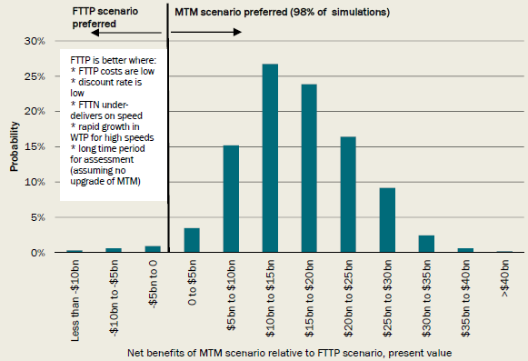

*Data source:* The CIE.

### 7.3 Net benefits under alternative growth in WTP

There is substantial uncertainty about future demand for speed and future technological changes to accommodate applications. This is particularly relevant in comparing the *FTTP scenario* to the *MTM scenario,* which puts in place a less expensive technology solution (more rapidly rolled out) that does not have the same speed capabilities.

Chart 7.4 shows the net benefits of the *MTM scenario* relative to the *FTTP scenario,* with different growth rates in WTP. For the *FTTP scenario* to be preferred to the *MTM scenario* would require WTP of speeds greater than 50 Mbps to grow by more than 250 per cent over 10 years (or more than 13 per cent per year) and continue to increase at the same rate thereafter. This is very unlikely given the findings of Communications Chambers, which found that growth in demand for additional speeds would be very low at these speed levels.

Chart 7.4: Net benefits of *MTM scenario* relative to the *FTTP scenario* at different growth rates in WTP

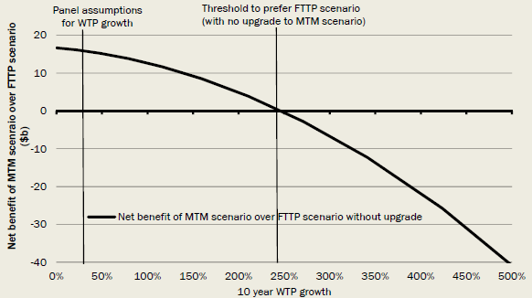

*Data source:* The CIE.

This substantially overstates the performance of the *FTTP scenario,* as the investment scenarios have very different characteristics in terms of their option value.

* The *FTTP scenario* has very little option value, because a high level of costs are incurred up-front, therefore leaving minimal options to scale back costs should bandwidth demand have been overestimated.
* The *MTM scenario* has substantial option value, because it has lower sunk costs than FTTP at the outset (and more rapid deployment) but provides the flexibility to upgrade should demand growth prove extremely rapid.

What this means in practice is that should WTP growth prove to be low, the losses from choosing FTTP now are locked in. However, the scope for sequential upgrading means implementing the *MTM scenario* does not result in losses even if demand growth greatly exceeds expectations.

We have approximately mapped out the timing at which the additional WTP for higher speeds would cover the capital costs of upgrading to FTTP. This assumes that when upgrading from FTTN to FTTP in the future, 20 per cent of the costs of upgrading from current technology to FTTP can be avoided because of the investment made in FTTN (that is, the future upgrade cost to FTTP is 80 per cent of the original upgrade cost because some FTTN investment can be re-used). In the case of upgrading from HFC to FTTP in the future, it is assumed that no costs of upgrading from current technology to FTTP can be avoided (that is, the future upgrade cost to FTTP is the same as the original upgrade cost).

The timing of upgrade is linked to each potential increase in WTP over 10 years, as shown in Chart 7.5. Very rapid WTP growth would lead to upgrades being economic in 2025.

Chart 7.5: Timing of upgrade to FTTP

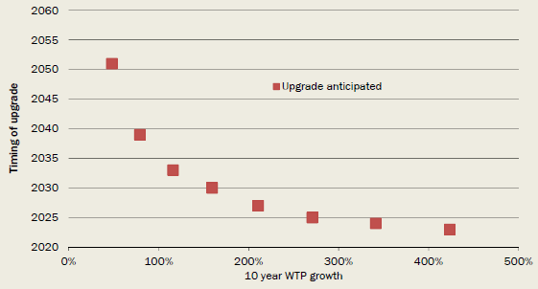

*Data source:* The CIE.

The comparison of the two scenarios once we allow for upgrade to occur is shown in Chart 7.6.

* Under any WTP growth it is preferable to rollout the *MTM scenario* as this delivers increased speeds to households and businesses quickly and therefore gives higher immediate benefits. Costs for delivering FTTP can then be delayed until there is sufficient demand.
* At very rapid WTP growth, the net benefits of rolling out the *MTM scenario* first and then upgrading actually increase. This is because the slow delivery of the *FTTP scenario* leads to more benefits being forgone in the short term: the more rapid the WTP growth, the greater the loss.

Chart 7.6: Net benefits of *MTM scenario* over *FTTP scenario* with and without upgrade

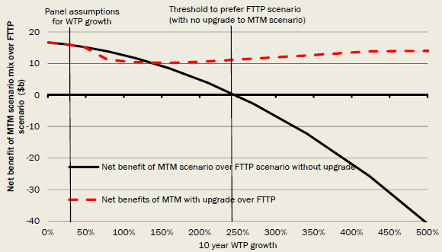

*Data source:* The CIE.

Overall the *MTM scenario* has significantly greater option value than the *FTTP scenario.* The *MTM scenario* leaves more options for the future open because it avoids high up-front costs while still allowing the capture of benefits if, and when, they emerge. It is, in that sense, far more 'future proof' in economic terms: should future demand grow more slowly than expected, it avoids the high sunk costs of having deployed FTTP. On the other hand, should future demand grow more rapidly than expected, the rapid deployment of the *MTM scenario* allows more of that growth to be secured early on, with scope to then upgrade to ensure the network can support very high speeds once demand reaches those levels.

### 7.4 Specific sensitivity analysis

#### Methods of estimating benefits

The method of estimating WTP can make a substantial difference to the benefits of higher speeds. For example, if the take-up approach is used then the *no further rollout scenario* becomes preferred to the *MTM scenario.* This is because the take-up of the higher speed plans for customers offered FTTP to date has been relatively low, and the evidence used for this method suggests that many of those who have taken up the higher speed plans would not do so if price premiums for those plans were greater than current premiums. There is substantial uncertainty about this method however, because the rollout has not targeted areas with higher demand and there is no way to measure the benefit obtained by those moving to the lowest NBN Co plan, as households are forced to move to the NBN.

The relative ranking of the *MTM scenario* and *FTTP scenario* is unaffected by the method for estimating benefits.

Table 7.7: Net benefits using variations to WTP estimation approaches

| Benefits | No further rollout $b, present value | Unsubsidised rollout $b, present value | MTM scenario $b, present value | FTTP scenario $b, present value |
| --- | --- | --- | --- | --- |
| Base assumptions | -24.0 | 0 | -6.1 | -22.2 |
| Technical bandwidth demand | -29.8 | 0 | -1.0 | -23.8 |
| Take up and elasticity | -4.0 | 0 | -5.7 | -19.8 |

*Source:* The CIE.

#### Discount rates

The net benefits using alternative discount rates are shown Table 7.8. The ranking of the scenarios stays the same in most cases, with the *unsubsidised rollout scenario* being preferred, then the *MTM scenario,* then the *FTTP scenario* and then the *no further rollout scenario.* The exception is that with a high discount rate *no further rollout* is preferred to the *FTTP scenario.* In other words, if the discount rate is sufficiently high, the losses from FTTP deployment are so large that it is better to freeze broadband availability at current (clearly inadequate) levels.

The discount rate impacts on both the incremental costs and benefits of each scenario relative to the reference case. Because the *FTTP scenario* has costs spread over a longer period and higher eventual benefits this has the following implications.

* At low discount rates, both the delayed incremental costs and the delayed incremental benefits of the *FTTP scenario* are given more weight in the present value of net benefits. This leads to the *FTTP scenario* having a smaller net cost relative to the reference case than under the NBN specific discount rate of 8.3 per cent, because the increase in discounted benefits outweighs the increase in discounted costs.
* At a high discount rate, the *FTTP scenario* also has a smaller net cost relative to the reference case than under the NBN specific discount rate of 8.3 per cent. In this case the reasons are different. A higher discount rate reduces the discounted incremental costs and benefits relative to the reference case. The reduction in the magnitude of both benefits and costs has the impact of narrowing the gap to the reference case.

For the *MTM scenario* the impact of the discount rate largely reflects the fixed wireless/satellite changes, as the timing of the rollout in fixed line areas in this scenario is similar to the *unsubsidised rollout.* As the discount rate increases, the expenditure on fixed wireless and satellite has a greater net cost.

Table 7.8: Net benefits using different discount rates

| Benefits | No further rollout $b, present value | Unsubsidised rollout $b, present value | MTM scenario $b, present value | FTTP scenario $b, present value |
| --- | --- | --- | --- | --- |
| 4 per cent | -51.2 | 0 | -3.2 | -19.4 |
| 7 per cent | -30.1 | 0 | -5.5 | -22.0 |
| 8.3 per cent (base assumption) | -24.0 | 0 | -6.1 | -22.2 |
| 10 per cent | -17.9 | 0 | -6.7 | -22.1 |

*Source:* The CIE.

#### Variations to scenarios

A number of variations in rollout speed and inclusion of FTTP in the *MTM scenario* have been considered. These changes do not change the ranking of scenarios.

* Removing FTTP from the *MTM scenario* increases the net benefits of this scenario. The CBA does not take account of the fact that the FTTP in the *MTM scenario* is partly targeted at areas with higher WTP. Therefore it may be the case that the *MTM scenario* underestimated benefits in base assumptions and overstates the relative gain in benefits in going from MTM to FTTP.
* The speed of deployment is an important factor for benefits. If technologies could be rolled out equally rapidly without any change in costs, then the gap in benefits between the *FTTP scenario* and the *MTM scenario* narrows, although the *MTM scenario* remains preferred by a substantial margin. However, it is implausible that the *FTTP scenario* could be rolled out as rapidly as the *MTM scenario,* given that it involves replacing the HFC assets (which are used in the *MTM scenario)* and copper connections to premises (which are used in FTTN delivery in the *MTM scenario* ) and placing entirely new connections in almost all premises.

Table 7.9: Net benefits using variations to scenarios

| Benefits | No further rollout $b, present value | Unsubsidised rollout $b, present value | MTM scenario $b, present value | FTTP scenario $b, present value |
| --- | --- | --- | --- | --- |
| Base assumptions | -24.0 | 0 | -6.1 | -22.2 |
| FTTP removed from MTM scenario | -24.0 | 0 | -4.7 | -22.2 |
| FTTP scenario sped-up to match MTM scenario | -24.0 | 0 | -6.1 | -20.3 |
| MTM scenario slowed down to match FTTP scenario | -24.0 | 0 | -12.4 | -22.2 |

*Source:* The CIE.

#### Alternative cost estimates

The sensitivity of results to the use of NBN Co cost assumptions or increased FTTP capital costs (aligned to what has occurred to date) and lower *MTM scenario* overheads has been tested. This does not change the ranking of investment scenarios.

Table 7.10: Net benefits using alternative cost estimates

| Benefits | No further rollout $b, present value | Unsubsidised rollout $b, present value | MTM scenario $b, present value | FTTP scenario $b, present value |
| --- | --- | --- | --- | --- |
| Base assumptions | -24.0 | 0 | -6.1 | -22.2 |
| NBN Co costs | -24.3 | 0 | -5.2 | -17.1 |
| Increased FTTP capex and reduced MTM overheads | -24.0 | 0 | -6.4 | -26.3 |

*Source:* The CIE.

#### Other sensitivities

If FTTN fails to deliver anticipated speeds then this narrows the gap between the *FTTP scenario* and other investment scenarios but does not reverse the rankings.

A longer time period by itself does not make substantial differences to the analysis.

Table 7.11: Net benefits using alternative cost estimates

| Benefits | No further rollout $b, present value | Unsubsidised rollout $b, present value | MTM scenario $b, present value | FTTP scenario $b, present value |
| --- | --- | --- | --- | --- |
| Base assumptions | -24.0 | 0 | -6.1 | -22.2 |
| Pessimistic FTTN speeds | -17.3 | 0 | -4.9 | -15.5 |
| Evaluation period from 2015 to 2054 | -30.4 | 0 | -5.8 | -21.7 |

*Source:* The CIE.

## Appendix A - Government involvement in high-speed broadband deployment

### The limited rationale for government involvement

The Federal Government has taken on the responsibility to deliver the NBN. This extent of government involvement is extremely unusual internationally, as governments in the advanced economies now generally rely on the private sector to take the lead in upgrading the telecommunications network.

Of course, government involvement in infrastructure delivery may be warranted where there are 'market failures' that prevent the optimal outcome from being achieved through private investment. Three features of telecommunications infrastructure might, but do not necessarily, warrant government involvement in delivering high-speed broadband:

* the natural monopoly characteristics of some telecommunications infrastructure;
* social equity or equality concerns; and
* externalities from the use of high-speed broadband.

None of these reasons necessitate government delivery of services as under the current NBN Co model.

* These potential market failures in delivery of high-speed broadband can be addressed through means other than government ownership and delivery of services.
* Inefficiencies in construction and operation, and a lack of incentives for those inefficiencies to be redressed, are often quoted as reasons why governments should not deliver public infrastructure (Productivity Commission 2014).

#### Natural monopoly

A natural monopoly forms because any given level of output is most cheaply produced by a single firm (rather than two or more firms). This is usually the case where there are very high fixed costs but low marginal costs. These conditions can arise in the case of telecommunications customer access networks, where there are significant costs associated with network establishment but low marginal costs once the network is in place. Left unregulated, natural monopolies can lead to excessive prices.

Natural monopoly concerns are typically addressed through requiring third party access and regulation of prices or revenue. Infrastructure areas that are currently price regulated in Australia include the copper access network (regulated by the ACCC), electricity and gas distribution networks (regulated by the Australian Energy Regulator) and water infrastructure (regulated by state-based regulators).

Natural monopoly concerns do not justify government delivery of infrastructure.

#### Social equity

Equitable access has long been one of the main reasons why governments, rather than the private sector, provide infrastructure. Markets may not provide equitable access to a basic quality of service (for example, water, sewerage, roads, rail and telecommunications) to groups that are less able to pay or are more costly to supply (such as rural communities). As such, governments have often taken a lead role in particular sectors to ensure basic services are provided (Productivity Commission 2014).

Unsubsidised broadband networks are unlikely to be made available to all Australian households. Without government intervention, households in rural and remote areas in particular may not be provided access to high-speed broadband, because the cost of delivering the services to less densely populated areas exceeds the expected revenues from providing the service; or the level of service provided may differ to that provided in metropolitan areas.

Universal service, that is, the principle that all citizens should be provided reasonable and affordable access to certain services, in the past has been applied to voice telephony services. There is an increasing trend to include high-speed internet services in the application of universal service. In the United States, the Telecommunications Act of 1996 was expanded to include reasonable and affordable access to high-speed internet for all consumers (FCC 2014). Twenty other countries have made broadband or internet access a right (a basic legal right, a citizen's right or constitutional right), including Finland, France, Spain and Switzerland (Broadband Commission for Digital Development 2013).

The NBN policy objective includes ensuring "all Australians have access to very fast broadband as soon as possible, at affordable prices" (Turnbull and Cormann 2014). Currently in Australia the universal service obligations require standard telephone services be reasonably accessible to all Australians regardless of where they live or carry on business.

Achieving universal access to broadband in Australia will need some government involvement. Again, this does not necessarily require government delivery of services. For example, the government, via an industry levy, has provided a subsidy for Telstra to provide services in high cost areas, rather than seeking to deliver these services itself.

A key driver of the costs of meeting universal access requirements is the minimum level of services. For example, a higher minimum level of service (such as speed or reliability) will lead to a higher subsidy for higher cost delivery areas than would otherwise be the case.

#### Externalities

The realisation of positive externalities is often cited as a justification for government investment and involvement in providing high-speed broadband to communities. The types of externalities that may arise through access to and use of high-speed broadband are summarised in Chapter 6 and Appendix E of this report. The externalities are generally associated with improving the outcomes, or lowering the cost, of education and health services.

The existence of externalities may indicate that the level of investment in high-speed broadband is inefficiently low because the benefits of these externalities are not reflected in market-based decisions. Subsidies directed to the provision of broadband services can assist in correcting for this market failure, but this should only be done where justified. The analysis in this report suggest that the benefits of these externalities are likely to be significantly lower than the private benefits that individuals are expected to gain from using high-speed broadband, indicating the extent of any market failure as a result of externalities is not likely to be great.

### The recent history of government involvement

In its submission to the House Standing Committee on Infrastructure and Communications in 2011, the then Department of Broadband Communications and the Digital Economy (2011) described the potential benefits of a high-speed broadband network in Australia.

Implementation of the NBN in 2009 sought to realise these benefits by "providing all Australians with access to world class high-speed broadband" (DBCDE 2011). The NBN will create opportunities for business, governments and consumers to use the NBN to:

* expand business opportunities;
* improve and extend the reach of service delivery;
* help address significant public policy challenges; and
* get easier and more convenient access to a greater range of services.

Australia's geography means that investment in telecommunications infrastructure outside the major metropolitan centres has lagged that of the cities. Under the belief that the market would not make the necessary investment that would provide a ubiquitous high-speed and high capacity broadband platform throughout the country and therefore serve as a stimulus for investment and innovation in services and applications, the government established NBN Co to invest in this infrastructure.

Prior to the establishment of NBN Co, Telstra was virtually a monopoly provider of fixed line infrastructure (with limited competition from Optus and Transact in selected regions). The retail sector was dominated by four companies (Telstra, Optus, iiNet and TPG Telecom). In its 2008-09 telecommunications report the ACCC suggested that the market was reaching a natural limit with commercial and technological elements restricting competition in regional areas (NBN Co 2013).

In April 2009, the then Government announced the creation of a wholesale-only, open access communications network aimed at delivering high-speed broadband and telephony services to the nation. The Government formed NBN Co to carry out the project, referred to as the NBN.

The products quoted as provided under the NBN are described as a combined package of peak information rates (PIRs) for downloads and uploads.[26] The entry-level service is 12 Mbps/1 Mbps (download/upload). Retail service providers (RSPs) sell products to household and business customers that are underpinned by the NBN products. The RSP may choose to offer products that, in addition to the PIRs, specify download limits and prices and may be bundled with other services (such as IPTV or VOIP services). NBN Co currently plans to offer services at a uniform national wholesale price, on the basis that this will give every community in regional Australia the opportunity to get fairer access to affordable high-speed broadband.

NBN Co began building the broadband infrastructure, using a FTTP model, with trials in 2009 and then first release sites in 2010 and 2011. Rollout to regional and rural areas using fixed wireless technology started in 2011 and interim satellite services were provided to other remote customers in July 2011.

NBN Co releases weekly summaries of network rollout, which set out the progress of establishing the network including the number of premises passed, serviceable[27] and activated. This is summarised in Table A.1 below.

Table A.1: NBN deployment progress, 30 June 2014

| NBN deployment progress | Premises passed | Premises serviceable | Premises activated Number of premises |
| --- | --- | --- | --- |
| Brownfields | 381,146 | 281,294 | 105,211 |
| Greenfields | 111,116 | 111,116 | 45,916 |
| Fixed wireless | 112,208 | 112,208 | 16,553 |
| Satellite | 48,000 | 48,000 | 42,948 |
| **Total** | **652,470** | **552,618** | **210,628** |

*Note:* Activated refers to premises connected and subscribing to a service over the NBN; premises passed are those where there is a lead passed the property, serviceable premises are those where there is a lead into the property and would be able to be connected.

*Source:* NBN Co 2014.

## Appendix B - Internet in Australia

### Internet access connections

The internet is now a part of everyday life for a majority of Australians. In 2013 around 80 per cent of Australian adults lived in homes with internet access, 74 per cent lived in homes with broadband services, 62 per cent used the internet via a mobile handset and 64 per cent have a smart phone (ACMA 2013).

Australians access the internet through fixed line services - delivered through ADSL, fibre, cable, satellite, fixed wireless and dialup - and through mobile services to mobile phone handsets, tablets, dongles, USB modems and data cards. In terms of the number of connections, internet through mobile handsets are the most prominent with 19.64 million subscriptions in June 2013 compared with 6.21 million fixed line connections and 6.15 million mobile broadband subscriptions (see Chart B.1). In the year from June 2012 to June 2013 the share of connections that are fixed wireless, fibre and ADSL have increased and the proportion of internet connections using dialup has fallen.

However, in terms of data downloads, fixed line services are much more prominent. The average data downloaded on a fixed line is 25 times greater than that downloaded to a wireless device (fixed wireless, satellite, dongles, data cards and tablet sim cards - see Chart B.2) and 108 times greater than that downloaded to mobile phone handsets (ACMA 2013).

Chart B.1: Internet subscribers by technology type, Australia, June 2013

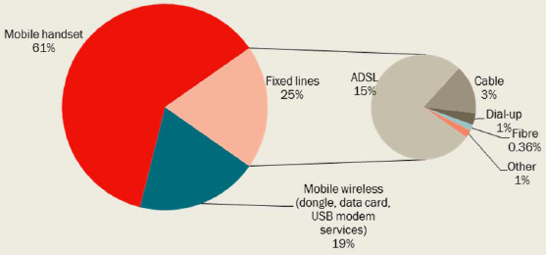

*Data source:* ACMA 2013.

Chart B.2: Volume of data downloaded by connection type, Australia

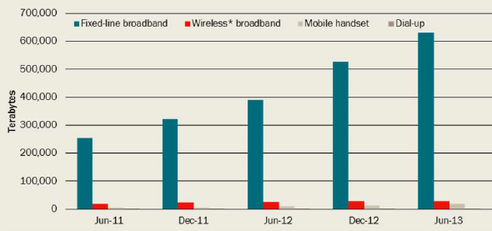

*Note: Wireless broadband includes dongle, USB modems, data cards and satellite and excludes downloads via mobile phone handsets.*

*Data source:* ACMA 2013.

The choice consumers make between alternative technologies and service providers may depend on service requirements (such as speed, reliability and 'always on' characteristics), price, and/or other services provided in conjunction with the internet service. An ACMA commissioned survey found that when choosing internet service providers, Australian consumers place the highest importance on reliability (Chart B.3). This may not, however, indicate that speed or other service characteristics are unimportant if they are common across service providers.

Chart B.3: Most important factor in selecting an ISP, Australia, May 2013

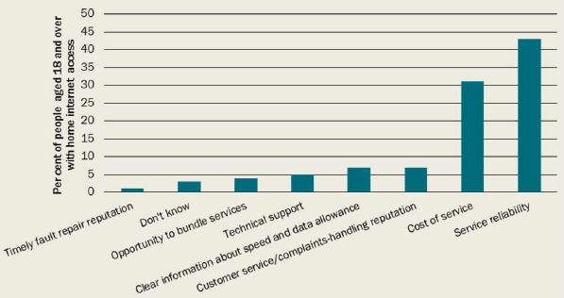

*Data source:* ACMA 2013.

Since September 2006, there has been a general increasing trend in the use of higher speed fixed line internet services in Australia (Chart B.4). In September 2006, over 80 per cent of connections had an advertised speed of 1.5 Mbps or less. By June 2013 just 5 per cent of connections had an advertised speed of 1.5 Mbps and over 60 per cent had advertised speeds of 8 Mbps or more.

Chart B.4: Proportion of subscriptions in different internet speed brackets, Australia

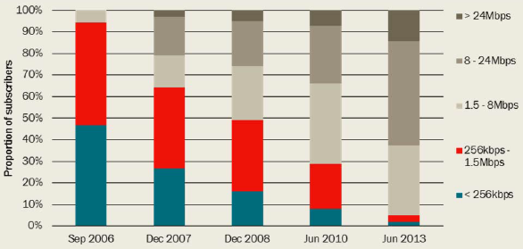

*Data source:* ABS 2013.

The Department of Communications has recently released detailed information on the type of internet service available in different areas of Australia. The MyBroadband website ([www.communications.gov.au/mybroadband](http://www.communications.gov.au/mybroadband)) offers detailed information on the type of internet infrastructure available in different areas of Australia and includes a speed test to capture real world user experience of download and upload speeds. Using this information and having regard to the Ookla Net Index and the Akamai State of the Internet report, the estimated average download speeds and upload speeds currently available in Australia are set out in Charts B.5 and B.6. These estimates reflect average *available* download and upload speeds. In particular, premises that could immediately access the HFC network are allocated the available speeds of HFC, even if they are not currently using HFC for their broadband.

It is important to note that internet speeds are affected by a broad range of factors as set out in Box B.7 and there are limited detailed data sources to indicate average download speeds.

Chart B.5: Average Australian download speeds 2014

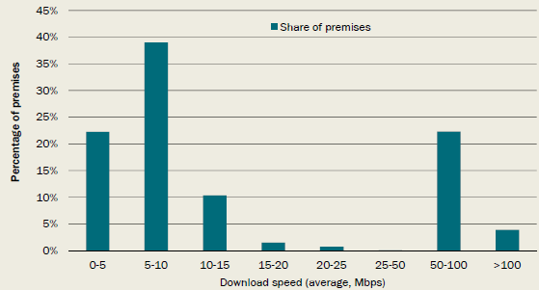

Note: This chart illustrates the estimated distribution of broadband download speeds by attributing an average download speed to each Australian premises based on the highest performing fixed technology platform available at each premises.

Data source: MyBroadband datacube Version 3 and speed test results (as at 29 April 2014); Ookla Net Index; Akamai State of the Internet Report 1st Quarter 2014; The CIE.

Chart B.6: Average Australian upload speeds 2014

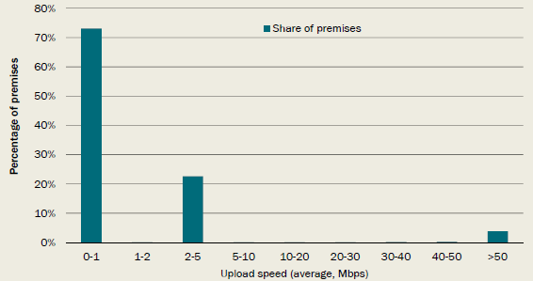

Note: This chart illustrates the estimated distribution of broadband upload speeds by attributing an average upload speed to each Australian premises based on the highest performing fixed technology platform available at each premises.

Data source: MyBroadband datacube Version 3 and ADSL speed test results (as at 29 April 2014); Ookla Net Index; Akamai State of the Internet Report 1st Quarter 2014; The CIE.

ACMA has previously collated data on the satisfaction with speed across Australian households. For fixed line services, 11 per cent of people surveyed reported being dissatisfied with their speed and a further 6 per cent were very dissatisfied. In comparison, 22 per cent were very satisfied and 36 per cent were satisfied.[28] NBN Co has also found that 83 per cent of households surveyed are satisfied with their current speed.[29]

**Box B.7: Understanding broadband speeds**

The most common metric for the quality of broadband internet services is speed, however, there are differences in the way speed can be defined and measured.

**Capacity** is the total traffic carrying capability of a link in a network. Where links in a network path have differing capacities the end-to-end capacity of a path is the minimum link capacity along the path. Capacity is measured by the amount of traffic the link can carry over a particular time interval - for example megabits per second (Mbps).

**Available bandwidth** is how much capacity is unused in a link or path. As with capacity, the available bandwidth of a path is the minimum available bandwidth of a set of links. If the total capacity of a link is 100 Mbps and peak usage was 45 Mbps then the available bandwidth would be 55 Mbps.

**Bulk transfer capacity** (BTC) is a measure of the amount of data that can be transferred along a network path with a congestion aware transport protocol (for example TCP). It refers to the speed at which a steady flow of data can be maintained. It is affected by the number of competing flows, settings of network protocols and end-system properties. Overhead data (metadata and headers) are not included in the data measured and therefore BTC may be lower than other speed measures.

Speed measurements can be used to compare delivered speeds with speeds advertised by ISPs, and to assess the quality of a broadband network. However, there are many factors that affect speeds delivered to the end-user. Understanding these factors and the differences in methodologies for measuring speeds is important to making valid inferences from measurement data.

A number of organisations measure and publish data on the speed of broadband connections[30]. The speed measured is closest to the bulk transfer capacity described above. Despite these tests using the same definition of speed, the results of these tests vary significantly. Differences can be explained by differences in testing methodologies including:

* the distance to the testing server (latency);
* the number of TCP connections used to run the test; and
* filtering of sample measurements.
* Other factors that affect speeds experienced by the end-user include:
* end-user's network configuration (eg home wifi capacity);
* congestion on the home network or local network;
* operating system and computer hardware of the user;
* server performance; and
* TCP tuning and path performance.

Source: Bauer et al. 2010.

Connection speeds in Australia have been increasing according to a number of different measures. According to Akamai, connection speeds have increased from 2 Mbps in 2007 to almost 6 Mbps in 2013. According to Ookla speed test data, download speeds have increased from below 5 Mbps in 2008 to 14 Mbps in 2014 (Chart B.8). At the same time, average upload speeds have increased from 0.5 Mbps to almost 3 Mbps.

Chart B.8: Australian speed trends from Ookla

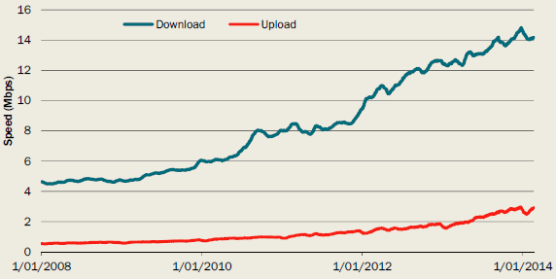

*Data source:* Ookla test data.

#### Australian speeds in comparison to international speeds

Data published by Akamai (2014) shows that average global connection speeds increased by 29 per cent over a year to reach 3.6 Mbps in September 2013. Average speeds vary from country to country.

* South Korea had an average connection speed of 22.1 Mbps.
* US had an average speed of 9.8 Mbps.
* The lowest average connection speeds reported were in Libya (0.6 Mbps) and Cameroon (0.8 Mbps).
* Average connection speeds in Australia were 5.5Mbps in the same period (an increase of 28 per cent compared with the previous year).

### Internet use

Around 78 per cent of internet subscriptions are by households and the remaining are connections subscribed by business and government. The proportion of connections attributed to business and government has increased over the past 7 years.

#### Use of internet by businesses

A survey of medium and large businesses conducted by Alcatel-Lucent (2012a) found that the majority of businesses believed that digital participation has been positive for their productivity, efficiency, profitability and growth. Participation in the digital economy has been through providing fast access to information, remote working and better communications. The vast majority of businesses use email and broadband internet access, and the majority also make use of online file sharing, intranet and mobile internet. Expectations were that businesses would engage more in online communications in the future and that improvements in national broadband infrastructure would increase activity in the digital economy.

#### Household internet use

Desktop PCs and laptops are the most common devices used for accessing the internet, however, portable devices such as phones and tablets are becoming increasingly popular (Chart B.9). A majority of people (62 per cent) are accessing the internet through three or more devices, and the use of multiple devices appears to be correlated with age, with younger users tending to use more devices to access the internet (Chart B.10).

Chart B.9: Devices used to access the internet from home, Australia

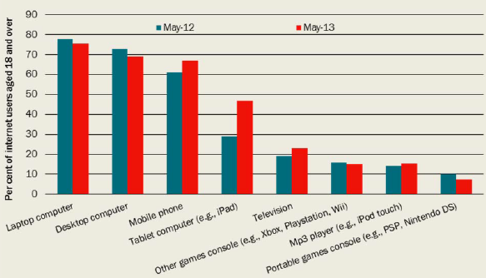

*Data source:* ACMA 2013.

Chart B. 10: Number of devices used to access the internet, Australia, six months to May 2013 (by age of users)

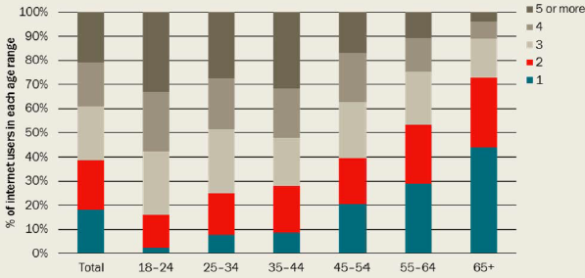

*Data source:* ACMA 2013.

Demand for internet services is derived from the demand for applications that make use of the internet. Streamed entertainment material is becoming increasingly popular in Australia as well as globally. Chart B.11 shows how the number of people accessing various types of streamed entertainment has changed since 2009. There is a clear increasing trend in the number of people accessing video and music content online. Video content generally requires higher speeds, or bandwidth, than other online content.

Chart B.11: Digital media activities undertaken by online Australians during June

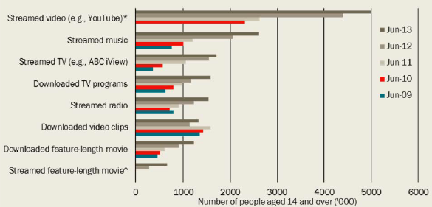

*Data source:* ACMA 2013.

Figure B.12 provides some examples of the bandwidth required for various online services, with 4K TV having the greatest requirements. These requirements are expected to fall sharply as coding technology allows more information to be transmitted over a given amount of bandwidth.

Figure B.12: Current bandwidth requirements for various internet services

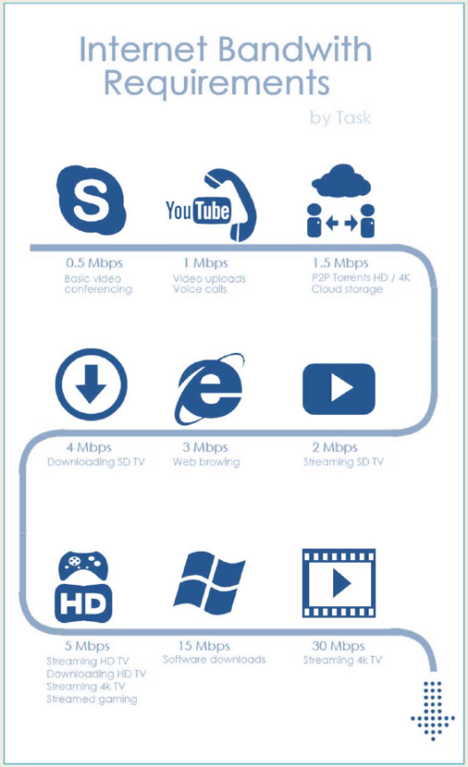

### Expected future

The number of people accessing internet services and associated applications is expected to continue to increase over time. The Cisco VNI Service Adoption Forecast (Cisco 2013) estimates that by 2017 online video will be the most highly adopted service, growing from 1.1 billion users to 2 billion worldwide by 2017. Digital TV use is forecast to increase by 8.2 per cent a year to 2017 to 1.4 billion households, and videos on demand services will grow by 9.4 per cent a year to 256 million subscribers worldwide by 2017.

Enabling the increase in demand for internet services is the increased penetration of internet enabled devices. Cisco (2013) forecasts that the average number of devices per household will increase from 4.65 globally in 2012 to 7.09 in 2017. Alcatel-Lucent Bell Labs (2013) predicts internet traffic demand will increase in the US by 370 per cent between 2012 and 2017. This increase in traffic is expected to be driven by IP video and data-centre/cloud traffic.

The development of high bandwidth rich applications are expected to follow when high-speed broadband reaches an adequate level of penetration to sustain a business case for that application (DBCDE 2011).

### Take-up of NBN

Initial choices made by consumers (and their retailers) suggest moderate demand for higher speed packages. This reflects a relatively small number of customers (less than 100,000) that had taken up NBN plans as at December 2013, which was the data used in the CBA calculations (noting that it was the share of users on each plan that was used not the aggregate number of customers). It also does not take account of selection bias issues — for example, it would be expected that households and businesses with a preference for higher speeds would take up the NBN where available first and other households would move to the NBN when alternative services would not be available. To date, around one fifth of customers have chosen the highest speed package of 100 Mbps down and 40 Mbps up. The majority of customers are connected to either 12/1 or 25/5 plans. Note that the decisions of the retailers have driven significant changes in uptake across speed plans. Telstra initially migrated customers automatically to the 100/40 plan and now migrates customers automatically to the 25/5 plan.

NBN Co has also provided information on customers that have changed their package from the initial package they were on with the NBN from May 2013 to May 2014. Over this period, around 5 per cent of premises increased the speed of their NBN Co plan and 2 per cent reduced the speed of their NBN Co plan.

Chart B.13: Take-up of NBN Co speed bands

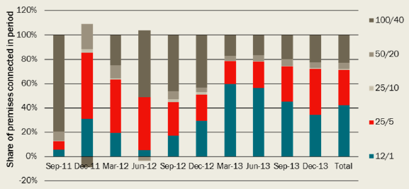

*Note:* In December 2011 some of the premises that had previously taken up 100/40 switched plans, leading to a negative overall uptake for 100/40 for that month.

*Data source:* The CIE calculations based on data provided by NBN Co.

The take-up of the NBN to date reflects the prices being charged in the market, which are a combination of NBN Co wholesale prices and additional retailer prices. Using details on the plans available and the take-up of plans across the different retailers, the average retail prices for a 100 GB/month data limit are shown in Table B.14.

Table B.14: Take-up and pricing of the NBN

| Speed band | Take-up of fibre connected premises (to December 2013) | NBN Co wholesale price (excluding CVC) $/month | Average retail price - no voice service $/month | Average retail price - voice service includeda $/month |
| --- | --- | --- | --- | --- |
| 12/1 | 42.3% | 24.0 | 65.7 | 75.5 |
| 25/5 | 29.2% | 27.0 | 74.1 | 83.9 |
| 25/10 | 0.8% | 30.0 | 75.1 | 84.9 |
| 50/20 | 5.0% | 34.0 | 82.1 | 91.9 |
| 100/40 | 22.8% | 38.0 | 91.7 | 101.5 |

a. The bundle includes a voice service. There are different levels of voice service included, such as free local calls, national calls or mobile calls. This is the cost across plans with different levels of voice services included.

*Note:* Average retail prices reported for a 100GB/month limit. This is based on a weighted average across retailers' plans reflecting a hedonic regression of plans against characteristics and a retailer specific premium. The retailer specific premium is then aggregated according to take-up of NBN plans to date across retailers.

*Source:* NBN Co provided data; The CIE analysis.

## Appendix C - Technologies for high-speed broadband

### Network technology summary

Broadband can be delivered to households and businesses through various different technologies. Table C.1 provides a brief summary of the primary technology options and some of the advantages and disadvantages associated with each.

Table C.1: Broadband technology options

| Broadband Technology | Description | Factors impacting end-user experience |
| --- | --- | --- |
| ADSL (Asymmetric Digital Subscriber Line) | A technology designed to give basic broadband performance over copper telephone lines, allowing more data to be sent than with dial-up internet. Download data speeds for ADSL are up to 8 Mbps downstream. | * Limitations of the selected technology associated with its technical standard (8 Mbps for ADSL) * Service plan * Copper line length * Signal interference * Quality of the copper line * ISP's network and backhaul provisioning * Home wiring * End-user equipment & software |
| ADSL2+ | An enhancement to ADSL that uses a wider frequency range to achieve substantially faster speeds, but only over relatively short distances. ADSL2+ speeds reach up to 24 Mbps downstream and up to 1.4 Mbps upstream. | * Limitations of the selected technology associated with its technical standard (24 Mbps for ADSL2+) * Service plan * Copper line length * Signal interference * Quality of the copper line * ISP's network and backhaul provisioning * Home wiring * End-user equipment & software |
| FTTN - (fibre to the node) | FTTN describes the installation of optical fibre from a point of interconnect (or exchange) to a distribution point (a node or street cabinet) in a neighbourhood that serves a few hundred customers within a radius of about 1 km. The connections from the node to the customer premises use one of the xDSL standards. The only Australian FTTN network delivered at scale is in the ACT. This network offers downstream speeds of up to 60 Mbps. | * Limitations of the selected technology associated with its technical standard (VDSL or VDSL2) * Service plan * Copper line length * Signal interference * Quality of the copper line * ISP's network and backhaul provisioning * Home wiring * End-user equipment & software |
| FTTP - (fibre to the premises) | FTTP describes the installation of optical fibre from a point of interconnect all the way to a premises (residential or business). A common FTTP technology that is employed in residential scenarios is GPON - gigabit passive optical network (selected by NBN Co). GPON delivers 2.5 Gbps downstream and 1.2 Gbps upstream shared between a maximum of 32 premises in the NBN FTTP deployment. | * Limitations of the selected technology associated with its technical standard (GPON, 10GPON) * Service plan * Contention (the number of premises served by an optical node) * ISP's network and backhaul provisioning * End-user equipment & software |
| HFC - (Hybrid Fibre Coaxial Cable) | HFC is a network utilising both optical fibre and coaxial cable for the delivery of Pay TV, internet and voice services. Speeds of up to 100 Mbps downstream and 2 Mbps upstream are possible on the Australian HFC networks but speeds can vary depending on usage on the network. | * Limitations of the selected technology associated with its technical standard (DOCSIS 2.0 or 3.0) * Service plan * Contention (the number of premises served by an optical node) * ISP's network and backhaul provisioning * End-user equipment & software |
| Fixed Wireless | Broadband services similar to mobile broadband however using fixed receiving equipment, for example antennas mounted on roofs. Fixed wireless is a shared medium however generally provides a more consistent and reliable service (compared to mobile) due to reception advantages and controlled subscriber numbers. | * Limitations of the selected technology associated with its technical standard (WiMAX, Wi-Fi, WCDMA, LTE) * Contention (the number of premises served by a sector or base station) * Service plan * Backhaul capacity at cell site * End-user equipment & software |
| Satellite | Broadband services delivered using a geostationary satellite and dishes installed at customer premises. Satellite is a shared medium and also introduces significant latency (delay) which can impact some applications. Satellite is an expensive technology which is generally used in areas where other technologies are not available. | * Limitations of the customer premises equipment and available satellite bandwidth * Service plan * Contention (the number of premises served by a spot beam) * Rain-induced service degradation (rain-fade) * Latency |
| Mobile broadband | Broadband services delivered by mobile networks, such as '3G' or '4G' networks, offering mobility and flexibility for users of handheld and laptop devices. Mobile networks are shared networks such that when multiple users are accessing the network at the same time the speed performance will reduce. | * Limitations of the selected technology associated with its technical standard (GSM, WCDMA, LTE) * Service plan * Cell site congestion/usage * Backhaul capacity at cell site * Interference * End-user equipment & software * Signal coverage (in-building, topography) |

*Source:* based on [ISPreview.co.uk](http://ISPreview.co.uk).

The rollout plans for the NBN are focused on a combination of FTTP, FTTN, HFC, fixed wireless and satellite. Each of these technologies has the capacity to deliver faster speeds than ADSL and ADSL 2+ (which are currently the most common types of connections). However, each of these five delivery modes has different attributes which make them more suitable for different applications. Table C.2 shows current performance of each technology, it upgradability and some trade-offs with its deployment. For example, a key trade-off is between high initial deployment costs and low ongoing maintenance costs associated with FTTP compared with lower initial costs but higher ongoing costs associated with FTTN.

Table C.2: NBN technologies

| Technology | Current Performance | Upgradability | Comments |
| --- | --- | --- | --- |
| FTTP | NBN Co offers up to 100 Mbps services using GPON with a split ratio of 32:1 | Substantial potential by changing electronics at either end. NBN Co could deliver 2.5Gbps services to selected customers today. | High initial deployment costs but low ongoing maintenance costs and low costs to continually upgrade the network over the next 30-50 years. |
| FTTN | ~50 Mbps (for premises 500m from the node and using vectoring) | Without modifying the FTTN network layout, can get up to ~100 Mbps for premises within 100m from the node. | There are limited opportunities to upgrade FTTN that do not involve installing significant additional fibre infrastructure (see Chart C3).  Higher operational cost than FTTP over medium to long term. |
| HFC | 100 Mbps a | Can be upgraded to speeds of 1 Gbps+ via node splitting (reducing the number of users who share capacity) and upgrading the network and customer premises equipment to newer HFC standards. Trade-off for higher broadband speeds may mean fewer TV channels can be delivered. | A shared medium technology with all users on a particular cable sharing the available bandwidth. For example, if 50 people are sharing a 100 Mbps connection then each will receive around 2 Mbps. |
| Fixed wireless | 25 Mbps | Technologies are constantly improving; speeds of up to 1Gbps theoretically possible with the optimal set up. | Is a shared medium technology with all users on a particular wireless segment sharing the available bandwidth. If congestion is a problem then additional spectrum is required or the installation of additional towers. Available spectrum is limited. |
| Satellite | 25 Mbps | Nil, upgrading capability will involve launching additional satellites. | A last choice technology but has an important role to play in rural and remote Australia where no other options are available. |

a. This speed reflects average conditions and assumes the maximum available plan.

*Source:* Analysys Mason and Tech4i2 2013.

#### Upgrading technologies

One consideration in investing in network infrastructure is how suitable the infrastructure is going to be in the future. As noted in Table C.2, some of the relevant technologies have the capacity to be upgraded to cope with greater demand for bandwidth.

There are a number of potential technologies that may be able to improve the speeds obtainable on FTTN networks. These technologies increase speeds to different extents depending on the distance of the premises from the fibre node. Vectoring and pair bonding are technologies that are currently available, although not widely used as yet. Phantom Mode DSL and G.fast are expected to be available in up to 5 years' time. Rollout of these technologies may be limited by quality and availability of copper lines. Some upgrades are only possible for premises close to the node; others require new infrastructure investment or are only viable if there is existing spare capacity in the network.

As an example of how technologies have developed recently, Chart C.3 (from Alcatel-Lucent) shows the speeds possible under alternative technology options before 2012 and in 2014. It shows that just 2 years ago VDSL technology was not capable of speeds over 100 Mbps but now with G.fast technologies VDSL is expected to be able to deliver speeds equivalent to FTTP networks.

Chart C.3: Broadband technology options pre 2012 and 2014

**PRE-2012**

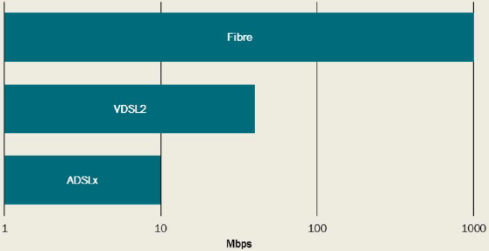

**2014**

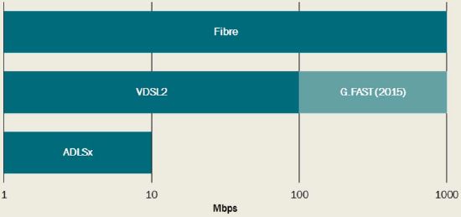

*Data source:* Alcatel-Lucent 2014.

## Appendix D - Previous analysis of the costs and benefits of high-speed broadband

There have been a number of past studies in Australia and overseas on the costs and benefits of the internet, or changes to the internet. Past studies have varied in terms of their approach, objectives, comprehensiveness of analysis, and the technology and region being analysed. Most of the studies reviewed and summarised here focused on the benefits of high-speed internet.

We categorise studies into those that consider WTP for higher internet speeds and alternative approaches.

### Willingness to pay for speeds

WTP seeks to measure the value that households or businesses place on additional internet speeds to those currently available. The methods that have been used in the literature to seek to identify this value include:

* choice modelling — this technique asks households (or businesses) to choose amongst alternative possible internet plans and then uses this to identify the value that people place on particular attributes; and
* analysis of market data — this technique uses observed behaviour (price and uptake) to infer the value that consumers place on particular internet options.

Two studies, Dutz et al. (2009) and Rosston et al. (2010), are comparable to the current study, although with some limitations. These are explained more fully below. A further set of studies set out in Attachment F are not considered to have substantial relevance for this study.

#### *Dutz et al*

The study by Dutz et al (2009) used both market econometrics and a simplistic stated preference (survey) approach to estimate the WTP for internet and broadband at a range of speeds. Some of the stated preference results from this study are relevant for analysis of the impact of high-speed broadband in the CBA being undertaken here. The Dutz et al study found that the average increase in WTP from shifting from current (in 2009) broadband internet access to internet with speeds of 50 Mbps of US$31.40 per month. Adjusting this figure for exchange rates and inflation would yield a value of around A$33.30 per month.

Note that the incremental value of shifting from 5 Mbps to 50 Mbps was much lower and is also relevant for our study. This found a WTP of US$7.20 (A$7.60) for an increase in speeds from 5 Mbps to 50 Mbps. There are no figures in this study that reflect the difference between WTP for 50 Mbps and 100 Mbps download speeds.

Note that these values are per household choosing broadband (excluding those choosing no internet or dialup).

While a generally thorough study, there are, however, several limitations to the study when trying to apply it to Australia today.

* The sample period is 2005 to 2008, a period of slow transformation from dial-up to broadband in the US. In the latest year of the study, only 69 per cent of the sample, had a broadband connection, 11 per cent had dial-up and 20 per cent still had no internet connection. This is in contrast to the current situation in Australia.
* The data for the statistical analysis contained no explicit speed information, only a proxy provided by the alternative technologies. There is no information about the speeds of the alternative broadband technologies.
* The household uses for the internet reported do not cover any uses that require high bandwidth. They mostly involved web-browsing. There was no reported use of video. This may reflect a difference in cable television availability in the US.
* There is no wireless broadband option (again in sharp contrast to Australian usage).

The stated preference instrument used by Dutz et al was very simple and did not allow a precise link between WTP and speed.

#### *Rosston et al*

Rosston et al 2010 looked at the value of speed, reliability and cost as well as some additional services (ability to connect wirelessly away from the home, download high definition movies, prioritise some downloads, interact with health specialists and place free video calls). The study found that speed and reliability were important characteristics and consumers were willing to pay an additional $20 per month for reliable service and $45 per month for an improvement from 'slow' to 'fast' speeds.

Rosston et al used choice experiments to estimate household preferences. In their report, speed was characterised as:

* slow — similar to dialup, downloads and uploads are slow;
* fast — high-speed connection with downloads and uploads much faster than dialup; good for music, photo sharing and watching some videos; and
* very fast — high-end internet, 'blazing fast' downloads and uploads; great for gaming, HD movies and instant transfer of large files.

Unfortunately, the study did not use precise definitions of speed. It is also important to note that the study was determined by the Office of Management and Budget (OMB) in the US 'not to meet the standards of OMB's survey guidance and should not be used to infer accurate nationally representative estimates'.

For comparison with the relevant question of shifting from currently available average internet speeds in Australia to NBN internet, we would be looking at a shift primarily from fast to very fast, although in some cases from slow to very fast. The study results show a representative, internet-using household is willing to pay:

* US$45 (A$48) per month for an improvement in speed from slow to fast;
* US$48 (A$51) per month for an improvement from slow to very fast, or approximately 1.21 per cent of the average monthly wage; and
* US$3 ($A3.2) per month for an improvement from fast to very fast.

Note that these estimates are per internet using household.

These results suggest a declining value for additional speed.

### Other approaches to assessing the benefits of broadband

Deloitte Access Economics (2013) adopted an illustrative approach to approximating the value of high-speed internet for Australians. They selected 10 different 'typical' people or households and estimated the potential benefits high-speed broadband may provide each of these households. These estimates included the value of time saved by reduced travel to work, shops, and accessing services, reduced transport costs and improved health and education outcomes. It also took into account the expected costs associated with the use of broadband and realising the various benefits described. The analysis also included government cost savings that could be realised by increased online service delivery.

Alcatel-Lucent's Bell Labs estimated the benefits from high-speed broadband in New Zealand. They used two approaches - an assessment of the impact on GDP from investment in the infrastructure, and the consumer surplus from the applications that can be realised through the use of the network. The contribution of infrastructure investment to GDP was estimated to be $5.5 billion (New Zealand dollars at 2010 prices) over 20 years (with 85 per cent of the benefits to be realised in the first 6 years). The increase in consumer surplus from the rollout of the network was estimated to be $32.8 billion over 20 years (Alcatel-Lucent 2012b). This consumer surplus is a combination of lower costs, reduced time and reduced travel expenses associated with health and education, savings in businesses associated with telecommunications and infrastructure, increased revenues and services through new and improved products and improvements in dairy farm productivity.

The Government of South Australia commissioned a study into the benefits from broadband adoption on the Yorke Peninsula, SA (Molloy et al. 2008). They used a telephone survey of business and residential premises and ultimately estimated the total annual benefits from broadband adoption in the Peninsula, realised on the Peninsula and in South Australia. The present value of 5 years of benefits was calculated to be $21.4m (of which $15m is to businesses and $6.4m to residential households). These estimates include both direct benefits (consumer surplus, network effects and producer surplus) and indirect (income effects and multiplier effects) benefits.

In 2004 PricewaterhouseCoopers, with Ovum and Frontier Economics, conducted a CBA on broadband connectivity in Europe for the European Space Agency and the European Commission (PricewaterhouseCoopers 2004). They sought to identify the costs and benefits associated with the expected increase in broadband connectivity across Europe. They used two assumptions around the expected rate of take-up of services. They considered a range of technology options for each region which included combinations of ADSL, fibre, HFC, wireless and satellite. There was no target speed, rather the study sought to identify the services that were likely to be provided by commercial operators between 2004 and 2013, and these ranged from 512 kbps to over 10 Mbps. The benefits estimated included direct benefits to consumers, network externalities and other external effects. Direct benefits were estimated based on the price paid for internet subscriptions (an underestimate of the private benefits). Benefits to suppliers of public services (for example health and education) and external benefits (such as the reduction in external costs associated with transport - infrastructure, congestion, accidents and pollution) were estimated based on case studies. The results estimated net benefits of 141 Euros per subscriber in 2013 and a benefit cost ratio of 1.55 over the period from 2004 to 2013. The ratio for just the rural areas was lower than the total, at 1.13.

Analysys Mason and Tech4i2 (2013) completed a study for the European Commission DG Communications Networks, Content and Technology that took a comprehensive look at the current take-up of high-speed broadband in Europe, the expected rollout and take-up to 2020, and the value of benefits of high-speed broadband. They used two approaches for estimating the benefits - input-output analysis and consumer surplus estimation (regression analysis was ruled out due to a lack of historical data). Consumer surplus was estimated based on the expected decline in prices and the consumer surplus that results. The estimate of consumer surplus was significantly less than the total value of investment in the infrastructure required, although it is noted that the consumer surplus estimate is a lower bound. Using the input-output approach, a scenario without government intervention estimated the benefit cost ratio for high-speed broadband to be 2.37 (or 2.72 with major government investment).

### Summary of previous choice modelling studies

Hayes (2011) provides a comprehensive summary of choice modelling papers relevant to broadband internet. His summary is reproduced in Table D.1. Most of these studies are dated, and do not apply directly to Australia. He also provides a summary of other contingent valuation papers relevant to broadband internet. This summary is reproduced in Table D.2.

Table D.1: Selected choice modelling papers

| Source | Product(s) | Country | Timeframe | Features or characteristics |
| --- | --- | --- | --- | --- |
| Rosston, Savage & Waldman - 2010 | Broadband internet | USA | 2009 | Online survey respondents were asked several times to choose between hypothetical bundles of broadband access, emphasising different elements such as speed, reliability, portability, cost. |
| Savage & Waldman - 2005 | Broadband internet | USA | 2002 | Survey respondents were asked questions on availability of internet access options and choice questions on broadband. |
| Savage & Waldman - 2004 | Internet access | USA | 2003 | Survey respondents given choice experiments with attributes of internet access including speed and being always on. |
| Greenstein & McDevitt - 2010 | Broadband over dialup | USA | NA | Uses adoption information together with Savage and Waldman - 2004 |
| Ida & Horiguchi, - 2008 | Public services over FTTH | Japan | 2006 | Focused on WTP for public services provided by FTTH in rural areas. |
| Ida & Sato - 2006 | Broadband services including ADSL, Cable and FTTH | Japan | 2003 | Survey respondents were asked to state their choice of service, choosing among ADSL, Cable and FTTH. |
| Kim - 2005 | Mobile telecommunications | Korea | 2002 | Survey respondents, who already subscribed to an International Mobile Technology (IMT-2000) service, were asked to choose between hypothetical bundles of service with different qualities (global roaming, video telephony, etc) |
| Madden & Simpson -1997 | Broadband internet | Australia | 1995 | Survey respondents were asked to choose between several services, and asked to choose from different broadband subscription bundles. |
| Ido & Kuroda - 2009 | Mobile telephone services | Japan | 2004 | Revealed preference with respect to 2G versus 3G, elasticities for email, web and movies on the phone. |
| Ida & Kuroda - 2006 | Dialup, ISDN, ADSL, CaTV and FTTH | Japan | 2003 | Revealed preference. Survey respondents, who all had access to all five internet alternatives, were asked what type of internet they had chosen as well as demographic details. |
| Ida & Sakahira - 2008 | FTTH | Japan | 2005 | Revealed preference, exploring determinants of staying and switching between broadband technologies in Japan. |
| Cardona, Schwarz, Yurtoglu & Zulehner - 2009 | DSL, cable mobile and broadband | Austria | 2006 | Revealed preference. Demand estimation for market definition purposes. choosing among ADSL, Cable and FTTH. |

*Source:* Hayes 2011.

Table D.2: Selected contingent valuation studies

| Source | Product(s) | Country | Timeframe | Features or characteristics |
| --- | --- | --- | --- | --- |
| Yoo & Moon - 2006 | Portable/wireless internet | Korea | 2003 | Respondents stated their choices in hypothetical markets for different service qualities at certain prices with their present service as an "outside option" |
| Rappoport, Alleman & Taylor - 2004 | Wireless access to the internet | USA | 2003 | Survey respondents were asked about their WTP per month for wireless internet access. |
| Byun, Bae & Kim - 2006 | Digital multimedia broadcasting | Korea | 2003 | Survey respondents were asked whether they would be willing to pay several different sums for monthly access to DMB, using the Double-Bounded Dichotomous Choice method. |
| Rappoport, Taylor & Alleman - 2006 | VoIP | USA | 2004 | Survey respondents were asked for their maximum WTP per month for the ability to make local and long distance calls via the internet if they had internet, or if not, their maximum WTP for the service if internet connection cost them $20. |
| Yoo - 2002 | Cable television | Korea | 1998 | Survey respondents were asked their WTP for cable television in Double Bounded Dichotomous Choice format. |

*Source:* Hayes 2011.

## Appendix E - Activities with benefits outside of private benefits

### Types of benefits

The following table is a substantial list of direct benefits that could result from the rollout of high-speed internet, recognising that new applications providing benefits will always be arising. The table has separate sections based on whether the benefits are private or public.

The first section lists benefits that predominantly are private in nature. They arise from activities by private individuals or businesses. As a result of these activities there may be some externalities - that is some indirect impact on others in the community or the society at large. These potential externalities are listed in the final column of the table. These are mostly in relation to health, education, environment and general societal wellbeing outcomes -traditional areas of government action.

The second section lists direct public benefits. These are applications related to the delivery of public services such as health and education. These applications may enable the provision of new services or improve existing services through reduced costs or better outcomes. Applications that result in new or better services also contribute to positive externalities associated with improved health, education and societal wellbeing.

Positive externalities that may be realised through the use of broadband applications include:

* improved education: improvements in education lead to increased productivity, only part of this is captured privately through higher wages;
* general environmental benefits;
* health benefits;
* public safety;
* reduced pollution;
* reduced traffic and associated costs: costs include those associated with infrastructure, congestion, accidents, noise and air pollution; and
* social inclusion benefits.

While this list is long, most of those benefits listed do no warrant separate consideration in this CBA. To warrant consideration as an additional benefit, the benefit should:

* *be for household or small business use.* This CBA is only concerned with the rollout of high-speed internet services to households and businesses using the NBN;
* *not already be incorporated into private WTP.* Private benefits are already captured in the WTP estimate and therefore should not be double counted; and
* *differ between the scenarios being considered in the CBA.* Where the benefit is expected to be realised under all scenarios there is no insight to be made by analysing the benefit.

The benefits that are relevant for further consideration (that is, they meet the above criteria) are highlighted in the table. Note that all those highlighted are only relevant for comparing the *no further rollout* or *unsubsidised rollout* scenarios with the *MTM scenario* and *FTTP scenario* (and not between the *MTM scenario* and *FTTP scenario).* Most of the benefits that would be realised under the latter two scenarios would be in rural or regional areas where current internet speeds are very low.

Table E.1: Direct benefits from high-speed internet

**PRIVATE BENEFITS**

| Area of benefit | Application | Description of application and potential socio­economic impact | Nature of network use | Required bandwidth (Mbps) | Would needs be met under rollout scenarios:  1. No rollout  2. Unsubsidised rollout  3. Multi-technology  4. FTTP | Connection required at household (H), business (B) and/or government (G) premises | Externalities |
| --- | --- | --- | --- | --- | --- | --- | --- |
| Commerce/economy | SmartAgriFood - EU initiative to increase efficiency of farming | Efficient farming meets consumers' demands better: available at the right place in the right time, at reasonable cost, with less impact on the environment | Data transfer - for precision farming, product storage and conservation, low bandwidth requirements | 1 | 1. partly  2. partly  3. fully  4. fully | B | — |
| Commerce/economy | Cloud computing (business) | Resulting increase in IT efficiencies creates opportunity to create a new generation of products and services | Symmetric data services - using online applications, real time backup; Require 2 Mbps+, maximum 10ms latency | 2 | 1. partly  2. partly  3. fully  4. fully | B | — |
| Commerce/economy | Send complex information electronically | Reduced costs, increases organisational efficiency | Web browsing, social media, video streaming and uploads, document downloads and uploads | 3 | 1. partly  2. partly  3. fully  4. fully | B | — |
| Commerce/economy | General increased access to information | General productivity improvements from increased access to information, more efficient markets, accelerates spread of ideas and innovation | Web browsing, social media, video streaming, document downloads | 3 | 1. partly  2. partly  3. fully  4. fully | B | — |
| Commerce/economy | Online banking -business | Aids SMEs in dealing with suppliers and reduces costs | Web browsing | 3 | 1. partly  2. partly  3. fully  4. fully | B | — |
| Commerce/economy | Online banking -households | Addresses financial exclusion for rural communities | Web browsing | 3 | 1. partly  2. partly  3. fully  4. fully | H | — |
| Commerce/economy | Open Food Network | An e-commerce system that will reduce cost of food businesses, improve market access for farmers, increase supply of fresh produce to consumers | Web browsing, file uploads and downloads | 3 | 1. partly  2. partly  3. fully  4. fully | B | — |
| Crime and public safety | CCTV - remote storage of video data | Reduces crime and community safety by acting as a deterrent to burglaries on business | Symmetric use of multiple video streaming, video generally not HD | 2 | 1. partly  2. partly  3. fully  4. fully | B, G | Improves public safety |
| Crime and public safety | Disaster response -receive information and communication | Warning systems and communication with and between affected people | Web browsing and social media | 3 | 1. partly  2. partly  3. fully  4. fully | H, G | Improves public safety |
| Culture | Collaborative musicianship | Allows for remote musical collaboration | Real time high fidelity services; requires 120 Mbps up and down, and latency of less than 25ms | 120 | 1. no  2. no  3. no  4. no | H, G | — |
| Education and skills | Online courses (further education from home) | Provides education with flexibility and affordability which helps for those that also need to work | Web browsing, video streaming | 5 | 1. partly  2. partly  3. fully  4. fully | H | Benefits of improved education |
| Education and skills | Remote musical tuition | Provides access to expert tuition through video conferencing services | Video conferencing | 12 | 1. partly  2. partly  3. fully  4. fully | H | — |
| Employment | Homeshoring - mainly call centre employees working from home | Potentially leads to increased employment in home territory as businesses move to homeshoring instead of overseas outsourcing; cost savings for businesses | Web-based networks to connect employees at home to business servers | 5 | 1. partly  2. partly  3. fully  4. fully | H, B | Reduced traffic and associated costs |
| Employment | Telework | Geographically dispersed workforce -more jobs for rural and regional communities, and people with disabilities, increased productivity and work-life balance | Video conferencing, VPNs, and VoIP services | 12 | 1. partly  2. partly  3. fully  4. fully | H, B | Reduced traffic and associated costs |
| Employment | 1080p telepresence | Creates a similar feeling to a face to face meeting - has cost and environmental benefits due to reduced travel as well as potential business advantages | High-definition video conferencing, symmetric; requires 24 Mbps+ and maximum 50ms latency | 24 | 1. partly  2. partly  3. fully  4. fully | H, B | Reduced traffic and associated costs |
| Environment | Instant Mobility - EU initiative to provide real-time travel information in urban areas | Environmental and time-saving impacts -provides information to individuals about urban travel and generate most efficient travel route/method | Asymmetric data transfer | 1 | 1. fully  2. fully  3. fully  4. fully | H | Reduced traffic and associated costs |
| Environment | Smart grids/intelligent buildings | Connecting buildings to the grid so that energy consumption can be automatically managed. The US Department of Energy estimates that robust use of the smart grid could equate to eliminating fuel and greenhouse gas emissions from 53 million cars | Symmetric data transfer services (between building and grid/utility provider); low bandwidth requirements but reliable and widespread network access | 1 | 1. partly  2. partly  3. fully  4. fully | H, B | Reduced pollution |
| Equality and inclusion | New services for digitally excluded -possibly delivered by mobile | New services could provide access to job opportunities, training, government and local authority services to more people | Low quality IPTV, video conferencing - likely to be small devices eg tablets | 5 | 1. partly  2. partly  3. fully  4. fully | H | Social inclusion benefits |
| Equality and inclusion | Talking books | Increased access to talking books for people with print impairments | Streaming or download of talking book files | 12 | 1. partly  2. partly  3. fully  4. fully | H | Social inclusion benefits |
| Equality and inclusion | Access to Electronic Media for the Hearing and Vision Impaired (eg DTV4ALL in EU) | Applications to aid people with vision and hearing impairments -eg signing, subtitling, audio descriptions, clean audio | IPTV (combined with terrestrial services) | 24 | 1. partly  2. partly  3. fully  4. fully | H | Social inclusion benefits |
| Equality and inclusion | TV-based videophone | Make video calls accessible to those that are not computer literate (eg elderly) -social inclusion and health care benefits | Video services via broadband delivered to the TV | 24 | 1. partly  2. partly  3. fully  4. fully | H | Social inclusion benefits |
| Equality and inclusion | Video Relay Services | Allows sign language users to make and receive phone calls with voice telephone users through use of a VRS centre and an interpreter | Video conferencing | 24 | 1. partly  2. partly  3. fully  4. fully | H | Social inclusion benefits |
| Equality and inclusion | Video Remote Sign Interpreting | Allows sign language users to communicate with hearing people through use of an interpreter connected via video conferencing | Video conferencing | 24 | 1. partly  2. partly  3. fully  4. fully | H | Social inclusion benefits |
| Equality and inclusion | Service centre for deaf-blind people | People who are deaf-blind are able to ask the service centre for help with tasks at home - using a combination of speech, video and text | Combination of text, video and audio communication | 24 | 1. partly  2. partly  3. fully  4. fully | H | Social inclusion benefits |
| Equality and inclusion | Communication for people with intellectual impairments | People with intellectual impairments may find ordinary telephones difficult to use and understand, video allows them to see the person they are speaking to | Video conferencing | 24 | 1. partly  2. partly  3. fully  4. fully | H | Social inclusion benefits |
| Equality and inclusion | Education in sign language | Distance education in sign language | Video conferencing, downloading video files | 24 | 1. partly  2. partly  3. fully  4. fully | H, G | Social inclusion benefits |
| Health and care | Online health education | Ability to access this information will allow individuals to manage their health more effectively and save money on healthcare; likely to lead to reduction in sick days | Asymmetric, streaming video | 3 | 1. partly  2. partly  3. fully  4. fully | H | Health benefits |
| Well being | High-definition video VoIP services | Improves quality of life by keeping friends/family connected, saves individuals money as these services are generally free | Video conferencing, 1.5 Mbps+ (Skype), | 1.5 | 1. partly  2. partly  3. fully  4. fully | H | — |
| Well being | Cloud computing (residential) | Improves quality of life by saving consumers time providing easy access to media content | Likely to be mainly asymmetric services such as video/music streaming, although some symmetric services such as data back-up; Require 2 Mbps+, low latency | 2 | 1. partly  2. partly  3. fully  4. fully | H | — |
| Well being | Social inclusion | Marginalised people are able to have a voice and engage in community through blogs and social media | Blogging and social media | 3 | 1. partly  2. partly  3. fully  4. fully | H | Social inclusion benefits |

**PUBLIC BENEFITS**

| Area of benefit | Application | Description of application and potential socio­economic impact | Nature of network use | Required bandwidth (Mbps) | Would needs be met under rollout scenarios:  1. No rollout  2. Unsubsidised rollout  3. Multi-technology  4. FTTP | Connection required at household (H), business (B) and/or government (G) premises | Externalities |
| --- | --- | --- | --- | --- | --- | --- | --- |
| Crime and public safety | Safe City - EU initiative using M2M communication to create intelligent infrastructure | More effective crime and incident management creates a safer urban environment | Asymmetric data (eg from intelligent traffic lights), multiple uplink video from CCTV; low bandwidth requirements | 1 | 1. partly  2. partly  3. fully  4. fully | G | Public safety |
| Crime and public safety | Remote video witness statements | Witnesses can choose to appear on video from a location closer to their home or because they prefer not to face the accused in person | Video conferencing | 5 | 1. partly  2. partly  3. fully  4. fully | G | — |
| Crime and public safety | Disaster response - to co-ordinate response efforts, disseminate safety information, and provide outlets for citizens to report problems and needs | Benefits from greater connectivity, eg between health centres and utility providers; greater resilience to threats such as infectious outbreaks, bioterrorism and attacks to the energy grid. Also improves emergency services response | Web-based networks, streaming video, real­time mapping, etc. | 5 (dedicated private network) | 1. partly  2. partly  3. fully  4. fully | G | Public safety |
| Culture | WADEYE IPTV | To archive and serve cultural video content to remote indigenous populations, enabling content to be accessed by future generations | IPTV and remote storage | 12 | 1. partly  2. partly  3. fully  4. fully | H, G | — |
| Education and skills | Access to education resources | Greater access to information (outside the classroom), improves the quality of offline education | Download e-books, tests and videos | 5 | 1. partly  2. partly  3. fully  4. fully | H, G | Benefits of improved education |
| Education and skills | Online learning and education resources in class | Deployment of innovative services, applications and content enhances education and professional skills development, increases business productivity and spurs economic growth | Teaching resources including high-quality video, primarily asymmetric streaming/one-to-many | 5 | 1. partly  2. partly  3. fully  4. fully | G | Benefits of improved education |
| Education and skills | Teacher professional development | Teachers outside metropolitan areas unable to access professional learning can receive development opportunities through virtual training. New teachers in remote areas improves educational outcomes | Video conferencing and online interactive activities | 5 | 1. partly  2. partly  3. fully  4. fully | H, G | Benefits of improved education |
| Education and skills | Fieldlabs - using new technology to increase research and development | Transfer of knowledge between corporations and universities to increase R&D activity and productivity | Videoconferencing, symmetric data sharing | 12 | 1. partly  2. partly  3. fully  4. fully | G | — |
| Education and skills | Virtual reality experiences | Interactive lesson plans and simulated experiences | Symmetric data for high quality VR video | 218 | 1. no  2. no  3. no  4. no | G | Benefits of improved education |
| Education and skills | Interactive virtual reality experiences | Immersive and interactive VR for educational purposes | Symmetric data for high quality VR video | 960 | 1. no  2. no  3. no  4. no | G | Benefits of improved education |
| Education and skills | School for the air | Satellite broadband used to deliver services to remote students, and those with disabilities who might otherwise find access to education difficult | Speeds of at least 2 Mbps needed to fully harness e-learning benefits; high-definition streaming video, high-definition videoconferencing to give sense of presence | 2-24 | 1. partly  2. partly  3. fully  4. fully | H | Benefits of improved education |
| Environment | Increase awareness of environmental issues | Increased awareness of environmental issues leads to positive environmental outcomes | Social media, web browsing, video streaming | 3 | 1. partly  2. partly  3. fully  4. fully | H | Environmental benefits |
| Equality and inclusion | Caring for the elderly - remote monitoring so that the elderly are able to stay in their own homes for longer | Will save individuals and authorities money in terms of carers and will improve quality of life for the elderly and their families | Symmetric data services; low bandwidths | 3 - must be reliable connection | 1. partly  2. partly  3. fully  4. fully | H, G | Social inclusion benefits |
| Governance | Participatory sensing | Management and monitoring of noise pollution by local government in urban areas - reduces government costs | Low bandwidth data transfer from remote noise sensors | 1 | 1. fully  2. fully  3. fully  4. fully | G | — |
| Governance | Online government services | Includes electronic tax returns, procurement, trade and customs processes | Web browsing and applications | 3 | 1. partly  2. partly  3. fully  4. fully | H, G | Reduced traffic and associated costs |
| Health and care | SIMPill | Device on medication packets detects when opened and reports when medications are not taken to improve treatment | Simple messaging services | 1 | 1. partly  2. partly  3. fully  4. fully | H, G | Health benefits |
| Health and care | Telehealth -monitoring | Monitoring and reporting of health data and measurements | Data transfer, not in real time | 1 | 1. partly  2. partly  3. fully  4. fully | H, G | Health benefits |
| Health and care | Emergency alarms for disabled | Alert systems that can be activated by disabled people to call for help, allowing them to be more independent | Low bandwidth connection for sending alert messages | 1 | 1. partly  2. partly  3. fully  4. fully | H, G | Health benefits |
| Health and care | Electronic health records - records distribution | Cost reductions from more automated clinical systems | Symmetric data -most research implies this is low bandwidth such as insurance records | 2 | 1. partly  2. partly  3. fully  4. fully | G | — |
| Health and care | SeeCare IPTV | Improve health literacy of the population with positive health outcomes | Use of television to reach people without computer skills | 2 | 1. partly  2. partly  3. fully  4. fully | H | Health benefits |
| Health and care | Health information | Patients and health workers can access information online. Improvements in health outcomes where patients take preventative measures and improve treatment behaviours | Web browsing | 3 | 1. partly  2. partly  3. fully  4. fully | H, G | Health benefits |
| Health and care | Aged care services | Services for older people that enable reduced social isolation, in home health care, telehealth, passive health monitoring, falls detection | Web browsing, video conferencing, remote sensing | 5 | 1. partly  2. partly  3. fully  4. fully | H, G | Health benefits |
| Health and care | Viewing of medical imaging | Ability for specialists to examine medical imaging conducted at remote local hospitals | File transfers | 5 | 1. partly  2. partly  3. fully  4. fully | G | Health benefits |
| Health and care | Communication and information sharing | Electronic information flows between care providers to improve planning, coordination and decision making | Emails and document storage and sharing | 5 | 1. partly  2. partly  3. fully  4. fully | G | Health benefits |
| Health and care | Training and support | Training for health professionals, especially in remote areas | Video conferencing and online interactive activities | 5 | 1. partly  2. partly  3. fully  4. fully | G | Health benefits |
| Health and care | Remote key-hole surgery | Surgery performed remotely - removes the need for patients to travel to large cities to see surgeons, requires equipment in remote locations | Secure reliable network with low latency, surgical apparatus controlled remotely | 10 | 1. partly  2. partly  3. fully  4. fully | G | Health benefits |
| Health and care | Teledentistry | Provides access to specialist health services - connects specialists with regional clinicians | Video conferencing | 24 | 1. partly  2. partly  3. fully  4. fully | G | Health benefits |
| Health and care | Telerehabilitation | Enable sufferers of Chronic Obstructive Pulmonary Disease (COPD) to undertake remote respiratory rehabilitation in their own homes | Integrating videoconferencing and a wireless smart app for pulse oximetry | 24 | 1. partly  2. partly  3. fully  4. fully | H, G | Health benefits |
| Health and care | Telestroke | Connect regional hospitals to specialists, qualified stroke neurologists to prescribe drugs to treat stroke | Video conferencing | 24 | 1. partly  2. partly  3. fully  4. fully | G | Health benefits |
| Health and care | Telehealth -consultations | Remote consultations and examination of patients, reducing time and cost of travel | Requires stable, high quality connection with symmetrical bandwidth for video conferencing | 10+ | 1. partly  2. partly  3. fully  4. fully | H, G | Health benefits |
| Well being | Hear Me Out | Online activities to promote social inclusion and participation for hearing impaired young people | Video conferencing and interactive online activities | 24 | 1. partly  2. partly  3. fully  4. fully | H, G | Social inclusion benefits |

*Source:* The CIE based on: PricewaterhouseCoopers 2004; Hayes 2011; Slater et al. 2010; Analysys Mason and Tech4i2, 2013; Institute for a Broadband Enabled Economy 2014; Deloitte 2014; Access Economics 2009.

## Appendix F - Review of cost estimates made by NBN Co

### Overview

During the course of NBN Co's *Strategic Review,* NBN Co and its consultants produced a number of financial models to estimate network deployment and maintenance costs using different technology options. The panel has drawn on those models to estimate costs that are relevant for use in the CBA.

The panel notes that the purpose of the CBA differs from that of the *Strategic Review,* which has implications for the methodology used to estimate costs. While the *Strategic Review* cost modelling examined the financial costs to NBN Co of deploying, operating and maintaining the NBN, the CBA considers the economic costs associated with those activities. As is discussed in more detail below, the economic costs are the underlying resource costs associated with the NBN.

In order to determine relevant costs for use in the CBA the panel has conducted a review of NBN Co's cost estimates, which has involved:

* conducting a high-level comparative review of the output of the cost models against relevant benchmarks;
* conducting a detailed review of calculations contained within the cost models to understand the key cost drivers, make any appropriate adjustments to assumptions or calculations, and identify parameters for sensitivity analysis; and
* converting the financial costs produced by the NBN Co models into economic costs.

Aside from the adjustments required to estimate economic costs, rather than financial costs, the panel has considered it appropriate to make a number of refinements to the model. The panel notes that the *Strategic Review* modelling assessed the issue of whether a Multi-Technology Mix (MTM) network would be less costly than continuing with an FTTP-only fixed network. That modelling showed that even when a reasonably conservative approach was taken[31], the MTM network scenario was less costly than the *FTTP scenario*.

The cost modelling refinements that the panel has considered it appropriate to adopt relate primarily to:

* **Productivity factors:** the *Strategic Review* assumed very substantial productivity gains during the NBN construction phase for all technologies. These were particularly high for FTTP, incorporating large productivity gains that were in addition to the efficiencies achievable from the Radically Redesigned FTTP network. The panel considered that the productivity gains for all technologies were very ambitious and as a result, conducted an analysis using an alternative set of productivity factors that are more consistent with international estimates of nation-wide network deployment.
* **Indirect operating costs:** corporate overhead assumptions in the *Strategic Review* model were largely set at the levels previously adopted in the Corporate Plan and were modelled based on an *FTTP scenario.* The bulk of the detailed modelling in the *Strategic Review* focussed on the technology models that estimate the network costs, rather than on scrutinising corporate overhead costs. This likely reflects that a key focus of the *Strategic Review* was on the difference in deployment costs between an FTTP-only network and an MTM network. While the matter of whether indirect costs vary between the technology scenarios may not have been crucial to the assessment of the matters at issue in the *Strategic Review,* the panel considers that it is potentially material to the CBA and so has further examined these costs. The panel has concluded that it is appropriate to conduct a sensitivity in which indirect costs vary between technology scenarios according to the level of accumulated capex.
* **Project management and design costs:** project management costs in the *Strategic Review* model were also held constant for the FTTP and MTM scenarios. Although the *MTM scenario* would involve some additional complexity in managing the deployment of multiple technologies, the total amount of network construction under the MTM is substantially less than in the *FTTP scenario.* The panel has concluded that it is appropriate to conduct a sensitivity in which project management and design costs would be reduced for the *MTM scenario.* This has been done by assuming the costs vary in proportion to the level of accumulated capex.
* **Opex assumptions (power and truckroll):** power costs in the FTTN technology model were set at the standard rate as advertised on an energy supplier's website. The panel considered it likely that an entity the size of NBN Co would receive a volume discount off standard rates and has adjusted this cost accordingly. With regard to truckroll costs (that is, the cost of technician visits to address network faults), the panel considered that the assumption of technician hours for each truckroll for the FTTP network (as compared with hours for FTTN technician callouts) was understated and revised this upwards.
* **Other minor audit matters:** in our review of the *Strategic Review* models we identified some corrections to be made to formulas. We note that these changes had a relatively minor impact on the results of the model.

In what follows we first briefly describe the modelling framework used by NBN Co[32]. We then discuss the findings of our high-level comparative review of the model results, the detailed review of the model calculations and identify the adjustments and sensitivity analyses that we consider appropriate.

### NBN Co modelling framework

A number of technology-specific models were prepared for NBN Co by its consultants for FTTP, FTTN, HFC and Fixed Wireless/Satellite (FWS) services as part of the *Strategic Review.* Results from these models feed into NBN Co's Corporate Model, which combines technology-specific costs with costs that are common to all technologies, such as transit costs, systems costs, and other general overhead costs. A copy of each of the technology models and the Corporate Model were provided on a confidential basis.

The technology models were constructed by NBN Co's external consultants (BCG) with input from NBN Co. The models contain detailed bottom-up assessments of the capex required for network deployment, ongoing operating expenditure (opex), and the ongoing Capex of replacements and capacity upgrades. Costs are estimated using individual equipment costs, estimates of the quantity of equipment required and hours of labour necessary for network deployment.

For FTTP and FTTN, the technology models cover the network from the customer premises up to, but not including, the Fibre Access Node (FAN) - see Chart F.1 below for a diagram demonstrating the components modelled for FTTP. Costs are modelled for individual Distribution Areas (DAs) based on information regarding the number of premises[33] and network distances for each DA.[34]

Chart F.1: FTTP costs modelled in the *Strategic Review*

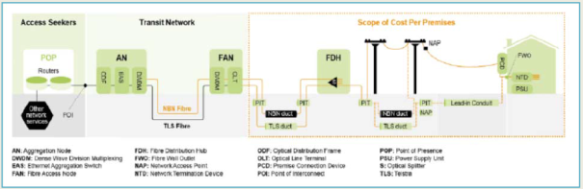

The FTTP model assumes that some of the network is aerial using existing poles, some uses Telstra's existing underground network and that the remainder requires construction of completely new network infrastructure. The specific assumptions used in the FTTP model regarding the use of Telstra's existing underground lead-in conduits and ducts and use of aerial network are contained below in Table F.2.

Table F.2: FTTP model assumptions on aerial, existing underground and new underground network

| Network | Lead-ins Per cent | Local network Per cent | Distribution network Per cent | Shared network Per cent |
| --- | --- | --- | --- | --- |
| Share of aerial network | **—** | **—** | **—** | **—** |
| Share of existing underground network | **—** | **—** | **—** | **—** |
| Share of new underground network | **—** | **—** | **—** | **—** |

*Source:* Link Economics, based on NBN Co cost models.

For the HFC technology model, the costs included are from the Cable Modem Termination System (CMTS), including CMTS costs, to the customer drop. Key costs modelled relate to:

* filling in the HFC coverage footprint;
* lead-ins for premises that do not yet have one;
* CPE (customer premises equipment) upgrades for existing HFC subscribers;
* providing battery backups; and
* ongoing capacity expansion as usage increases.

The Corporate Model includes a number of technology mix options that were evaluated in the *Strategic Review.* The two technology scenarios that we have relied on for the CBA analysis are: (1) The Radically Redesigned *FTTP scenario* (referred to from here on as the *FTTP Scenario);* and (2) The Optimised Multi-Technology Mix scenario which includes a mix of FTTP, FTTN and HFC within the primary fixed line footprint (referred to from here on as the *MTM scenario).*

In both the *FTTP scenario* and the *MTM scenario,* the 7 per cent of customers outside the primary fixed line footprint are served using fixed wireless services, satellite services or, for a small proportion of customers, FTTN. The FWS model includes the costs of providing services to approximately customers outside the primary fixed line network, but provides coverage to a total of customers.

Due to the nature of FWS services, the FWS model includes both the customer connection and transit costs. Fixed wireless services are provided using 2,300Hz spectrum and require a line-of-sight between the BTS and the subscriber. Approximately 2,500 fixed wireless sites plus additional repeater towers are assumed to be deployed by the end of 2019. Backhaul costs in the fixed wireless component of the FWS model include microwave costs, fibre spurs and the FAN.

In the satellite component of the FWS model, we utilised cost results from the scenario in which two satellites are deployed (rather than three), and a satellite throughput of 200kbps.

### High-level comparative review of Corporate Model Outputs

The Corporate Model (unadjusted) produces total nominal opex of $ for the *FTTP scenario* and $ for the *MTM scenario* for the period 2015 to 2040. Nominal capex for the same period is $ and $, respectively for the *FTTP and MTM scenarios.*

With regard to opex, as can be seen from Table F.3, a significant proportion, around per cent, is accounted for by payments to Telstra and Optus. Those payments cover the use of assets (for example, dark fibre for the transit network, and the lease of ducts in the local network) as well as disconnection payments to parties when customers are migrated to the NBN (for example, the PSAA payments to Telstra). As is discussed in more detail below, the bulk of these payments would be excluded from the CBA as they are transfers rather than resource cost incurred as a result of deploying the NBN. However, these costs are relevant to determining the amount of government funding required which is utilised in the CBA to calculate the deadweight loss of taxation. One observation that can be made is that these costs remain roughly constant between the FTTP and the MTM scenarios. This reflects the financial commitments included in the contracts.

The Corporate Model (unadjusted) produces total nominal opex of $ for the *FTTP scenario* and $ for the *MTM scenario* for the period 2015 to 2040. Nominal capex for the same period is $ and $, respectively for the *FTTP and MTM scenarios.*

Table F.3: NBN Co forecast Operating Expenditure (total nominal cost 2015-2040)

| Costs | FTTP scenario $m | FTTP scenario % | MTM scenario $m | MTM scenario % |
| --- | --- | --- | --- | --- |
| Rollout opex | — | — | — | — |
| HFC Payments - Optus | — | — | — | — |
| PSAA Payments - Telstra | — | — | — | — |
| Fixed wireless and satellite opex | — | — | — | — |
| Reimbursement of RSP ATAs | — | — | — | — |
| Duct lease costs | — | — | — | — |
| Transit network opex | — | — | — | — |
| Outsourced O&M opex | — | — | — | — |
| OSS/BSS increment to Corporate Plan | — | — | — | — |
| Indirect opex | — | — | — | — |
| Network operations | — | — | — | — |
| Contingency opex | — | — | — | — |
| **Total opex** | — | **100.0** | — | **100** |

*Source:* Link Economics based on data provided by NBN Co.

Aside from the cost items that are largely transfers, indirect opex is the single largest cost item accounting for per cent of total opex. The bulk of the indirect opex is accounted for by salaries and wages (per cent of indirect opex). Other significant components of indirect opex include IT and telecommunications costs which account for per cent and Facilities, Office, Security and Fleet costs which account for per cent indirect opex.

Technology specific opex for the fixed network technologies account for per cent of total opex for the *FTTP scenario* and around per cent for the *MTM scenario,* while fixed wireless and satellite opex is approximately per cent of opex.

Fixed network capex (total nominal over the period 2015 to 2040) is $ billion for the *FTTP scenario* and $ billion for the *MTM scenario.*[35]Capex for areas outside of the fixed network footprint totals $ billion, however as this includes backhaul it is not comparable with the fixed network costs.

Table F.4: NBN Co forecast Capital Expenditure (total nominal cost 2015-2040)

| Costs | FTTP scenario $m | FTTP scenario Per cent | MTM scenario $m | MTM scenario Per cent |
| --- | --- | --- | --- | --- |
| Construction capex | — | — | — | — |
| Replacement capex | — | — | — | — |
| Contingency capex | — | — | — | — |
| Transit network capex | — | — | — | — |
| Lead-in-Conduit shortfall capex | — | — | — | — |
| Common capex | — | — | — | — |
| Project management and design | — | — | — | — |
| Reserves and other capex | — | — | — | — |
| Fixed wireless and satellite capex | — | — | — | — |
| OSS/BSS increment to Corporate Plan | — | — | — | — |
| Greenfields capex | — | — | — | — |
| **Total capex** | — | **100.0** | — | **100.0** |

*Source:* Link Economics, based on NBN Co cost models.

#### International comparisons

The NBN Co FTTP bottom-up technology model estimates an average construction capex cost of $ per premises passed (see Table F.5).[36] The NBN Co Corporate model assumes that labour productivity gains. Given that the average labour inflation rate is approximately 3.5 per cent

Table F.5: NBN Co FTTP cost estimate

| Cost | Capex cost – build $/premises passed | Annual post-build capex cost $/premises | Annual opex cost $/premises |
| --- | --- | --- | --- |
| Average | — | — | — |
| Median | — | — | — |

*Source:* Link Economics, based on NBN Co cost models.

Chart F.6: NBN Co estimates of FTTP build costs per premises passed (real 2014 dollars)

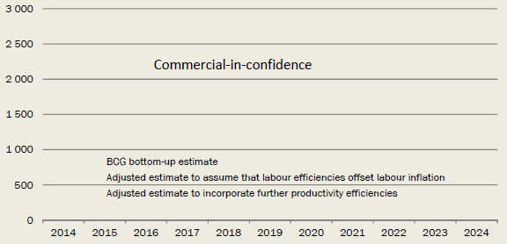

*Source:* Link Economics, based on NBN Co cost models.

The *Strategic Review* briefly discusses international benchmarks and NBN Co's finding that "the cost of rolling out a new FTTP network in countries most comparable to Australia ranges from $1,100 - 1,300 per premises."[37] Those international benchmarks are the basis of the productivity adjustments applied by NBN Co.

A difficulty with international comparisons of costs is that FTTP deployments in other countries have been primarily on a commercial basis. That is, network deployment has been confined to areas that are commercially viable. As a result, international benchmarks of FTTP deployment costs would generally be lower than the costs of wide scale deployment. This is clear from a study commissioned by the European Commission (prepared Analysys Mason and Tech4i2 2013) which modelled the costs of commercial and full coverage. As can be seen from Chart F.7, average build costs of full coverage networks are substantially higher than average build costs of commercial deployment. This is particularly the case for countries that have low population densities, more akin to Australia, such as the Nordic countries where full coverage costs are at least three times the costs of commercial deployment.

Chart F.7: European Commission FTTP costs per premises for commercial deployment and full coverage - Western Europe

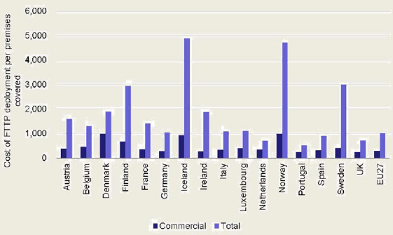

*Source:* European Commission (2013), The Socio-Economic Impact of Bandwidth, p. 213.

Comparison of the NBN Co FTTP cost estimates shows that the bottom-up cost estimate of A$ is.

Another international benchmark relating to a wide scale deployment of FTTP is that of New Zealand. In FY2013 Chorus, New Zealand's largest network provider of FTTP services, incurred a cost per premises passed (CPPP) of NZ$3,048 (A$2,824) for new builds, with a blended cost of NZ$2,935 (A$2,720) when existing Broadband Over Fibre premises and new subdivisions are taken into account. In addition, the customer connection costs experienced by Chorus have been NZ$1,700 (A$1,575) for standard connections. This implies a total cost of around $A4,295 at present. Over the longer term, Chorus is aiming to reduce connection costs to NZ$900-NZ$1,100 (A$835 - A$1,020) per premises (in real dollars).[38] Chorus' long-term target for the CPPP appears to be around A$1,390, with forecast cost reductions primarily attributed to having deployed network in the higher cost areas in the earlier years of the build as a result of commitments to deploy to priority premises zones.[39] Even with these longer term cost reductions, Chorus' total cost per customer connected is around A$2,320. Costs can be expected to vary across countries for a range of reasons, including for example, due to differences in the extent to which the existing duct network and lead in conduits can be used. However, it

With regard to FTTN, NBN Co's bottom-up technology model estimates a build cost of $ per premises (see Table F.8).

Table F.8: NBN Co FTTN cost estimate

| Cost | Capex cost – build $/premises passed | Annual post-build capex cost $/premises | Annual opex cost $/premises |
| --- | --- | --- | --- |
| Average | — | — | — |
| Median | — | — | — |

*Source:* Link Economics, based on NBN Co cost models.

Application of the NBN Co's FTTN productivity factors results in the FTTN build cost in real 2014 terms ranging from around $ per premises in the first year of deployment (2016) to $ per premises in the final year of deployment (2020), with a weighted average over time of $.

Chart F.9: NBN Co estimates of FTTN build costs per premises passed (real 2014 dollars)

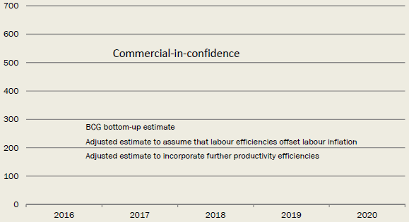

*Source:* Link Economics, based on NBN Co cost models.

Comparing these costs with those from the analysis commissioned by the European Commission shows that the NBN Co estimate of € After application of the productivity efficiencies, the NBN Co 2020 estimate of €

Chart F.10: European Commission FTTN costs per premises for commercial deployment and full coverage - Western Europe

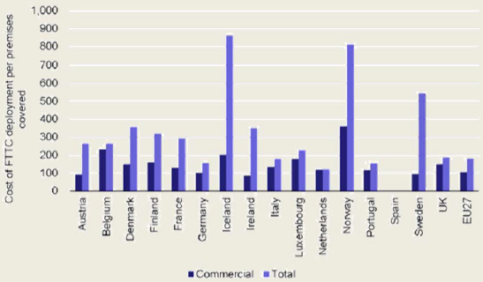

*Source:* European Commission (2013).

### Bottom-up review of models

Our review of the NBN Co models focussed primarily on:

1. reviewing the overall methodology;
2. gaining a detailed understanding of the way in which the model works so as to ensure that we are able to correctly extract the relevant information;
3. identifying critical assumptions that are have a significant degree of uncertainty and have potential to materially impact the quantum of costs; and
4. auditing the calculations to identify any inadvertent errors.

We note the technical assumptions made in the technology models were the subject of detailed review and scrutiny by NBN Co's external consultants using NBN Co's own cost information and international benchmarking. As a result we have largely adopted those assumptions in our cost modelling.

In what follows we discuss the key findings of our review and implications for adjustments to the model.

#### Productivity assumptions - FTTP

As discussed above, the NBN Co Corporate Model assumes

Chart F.11: NBN Co and revised FTTP productivity factors

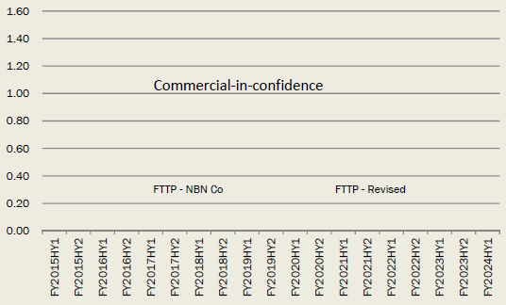

#### Productivity - HFC and FTTN

For FTTN and HFC we adopt productivity factors that are similar to the NBN Co estimates

Chart F.12: NBN Co and revised FTTP productivity factors

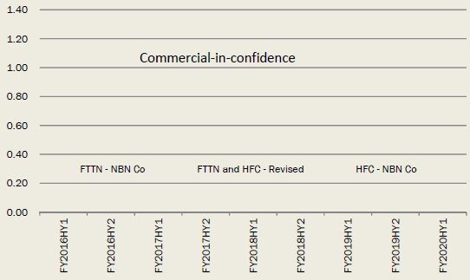

#### Indirect costs and project management costs

As highlighted above in the discussion of NBN Co's opex forecasts, the Indirect Opex included in the NBN Co cost model is

It is common in telecommunications cost modelling for Indirect Opex costs to be directly related to the level of capex and direct opex. This is implemented through the use of an overhead mark-up. While there is some variation within international cost models of the percentage mark-up used to estimate overhead costs, the approach of applying a mark-up is common reflecting a general consensus that there is a relationship between the overall size of the investment and operations, and the level of overheads.[40]

In light of the above discussion, the panel considers it appropriate to carry out a sensitivity analysis on

#### Financial commitments under existing contracts

There are a number of minimum purchase arrangements in the agreements with Telstra including for ducts and lead-in conduits. The minimum financial commitments have been incorporated into the NBN Co corporate cost model.

The bulk of the cost of the financial commitments is not an economic cost (as it is instead a transfer) and so is primarily relevant for the calculation of funding rather than for the estimation of the cost base to be included in the CBA.

#### Replacement capex

Each of the technology models for FTTN, FTTP and HFC calculate a

As a result, we have adjusted the replacement capex estimates to reflect the time profile of asset lifetimes.

#### Opex - power costs

A power cost of c/kWh was used in the FTTN model. This is sourced to the Origin Energy website and appears to be a standard rate. A large customer such as NBN Co would typically be offered some form of volume discount. In the absence of information as to what discount NBN is provided with, the panel has assume a discount of per cent which is likely on the conservative side (that is, a higher discount may well be achieved by such a large customer).

#### Opex - truckroll

The FTTP model assumes that when a fault occurs and a technician is sent to restore the fault that only hours of technician time is required. In comparison, the FTTN model utilises the assumption that hours of technician time is required for each FTTN fault that requires a "truckroll" (that is, a technician visit).

#### Inclusion of GST

#### Opex materials costs

### Converting financial costs into economic costs

#### Approach

Financial costs are different to economic costs. Economic costs measure the incremental resource costs associated with a new activity. In contrast, financial costs are the costs incurred by NBN Co (in this case). To adjust financial cost information provided by NBN Co to economic costs we have done the following.

* Removed transfers from NBN Co to other organisations under each scenario. Transfers include, for example, payments to Telstra for the use of existing assets.
* Added costs incurred outside of NBN Co under each scenario.
* Removed costs avoided because of NBN Co's existence under each scenario. For example, a FTTP network would avoid maintenance costs associated with the copper network.

#### Transfers

Costs to NBN Co that are transfers to other parties for the use of existing infrastructure are not included in the assessment of costs for the CBA.[41] The transfers we have identified in our review of the NBN Co models and removed from the cost assessment are as follows:

* the majority of HFC payments to Optus;
* the majority of PSAA (per subscriber address amount) payments to Telstra;
* the majority of duct lease costs;
* spectrum used in the provision of fixed wireless services;
* co-location leases for the provision of fixed wireless services;
* ground leases in the FWS model;
* approximately half of transit opex costs, which cover a range of services including Dark Fibre, Rack Spaces, Reservation Fees and Managed Backhaul Services;
* pole rental charges;
* LIC (Lead-In Conduit) Charges - a once-off charge per LIC is applied in the FTTP Technology Model; and
* LIC Shortfall Payment - this payment reflects contractual commitments to purchase a minimum number of LICs.

While there may be some other transfers in addition to those listed above we expect these to be relatively small, such that they would not have a material effect on the model results.

Some of these items identified above are not pure transfers because a degree of maintenance and/or investment would be required in order to provide the service. In respect of duct leases, we have estimated the cost of ongoing maintenance by using the opex/capex ratio adopted by the ACCC in its LRIC Core and Access Model.[42] Using that ratio allows us to derive that 99.8% of the duct lease costs would be capex, and we assume that the entirety of that capex is a transfer.

For transit payments, we refer to information published by Telstra in its explanation memorandum[43] ("the Telstra EM") to determine that a reasonable assumption of the percentage transfer is 75 per cent. With regard to PSAA payments, we relied on the information disclosed in the Telstra EM regarding customer migration costs to determine that a reasonable assumption of the percentage transfer is 95 per cent. The same percentage transfer was applied to the Optus HFC payments.

The FTTN model does not include any additional payments to Telstra with regard to the use of sub-loops (that is, the copper loop between the customer premises and the node) that would be required to provide FTTN services. We allow for an additional cost to maintain parts of the copper network used for FTTN compared to areas where HFC or FTTP is used. This is reflected as a smaller avoided cost from reduced copper costs for the *MTM scenario.*

#### Avoided costs

As a result of the migration of customers to the NBN, the costs of maintaining parts of the existing customer access network will be avoided. To calculate the avoided costs of maintaining the copper network we used information contained in the ACCC TSLRIC model for fixed services. We identified for each asset related to the access network whether it would be avoided under each of the FTTP and MTM scenarios. We then summed the network opex and associated business overheads for each avoided asset to estimate the total avoided costs associated with the copper network and applied these reductions over time. It is assumed that (where relevant) the costs of copper are avoided 2 years after a premises is passed. This may be an underestimate in some cases if copper services are continued because, for example, special services cannot be provide over another technology platform.

Under the NBN, broadband service providers will avoid the costs of using their own DSL equipment. We have calculated the avoided cost per line as the difference between the regulated prices for wholesale ADSL and for Unbundled Local Loop. This gives an estimate of $7.64 per subscriber per month, which equates to $3.69 per premises passed per month. This avoided cost is allocated over time as premises are passed by the NBN.

## Appendix G - International broadband strategies

### International Broadband Strategies

The importance of broadband internet in economic and social development has been recognised by many countries. A report by the Broadband Commission for Digital Development (2013) found that in mid-2013 134 different countries had some form of broadband plan in place - ranging from aspirational targets to detailed plans for the rollout of network infrastructure.

Particulars of nine selected government policies (plus Australia), along with details of the network deployment and regulatory environment, are summarised in the tables below. Of these summarised plans, most aim to provide at least basic broadband speeds to most (90-100 per cent) households by 2020. Most of the plans also target speeds of 100 Mbps for at least some of the network. With the exception of Singapore, all the summarised plans propose a combination of public and private funds to achieve the network rollout and most do not specify a technology. The mechanism of providing the public funding include low cost loans, tax subsidies, direct subsidies and regulated wholesale access to existing infrastructure.

Two clear examples of alternative approaches to regulating the broadband sector are that of the US and Europe. After an initial period of requiring incumbent network providers to share their networks through local loop unbundling and wholesale access, the US regulators switched to a regulatory regime that encouraged facilities-based competition (rather than service-based competition). European governments, however, continue to favour the service-based competition approach. Yoo (2014) sought to use empirical data from the US and Europe to assess which regulatory approach was more successful at increasing adoption and deployment of broadband technologies. He found that, compared to Europe, a greater percentage of US households had access to high-speed broadband services (where high speed was defined as speeds of at least 25 Mbps). This result held for both urban and rural areas. The level of investment in building and upgrading networks was also higher in the US and US broadband was found to be more expensive (although US users also consumed significantly more bandwidth than European users). He concludes that the US has fared better than Europe in extending broadband access and that the US regulatory approach contributed to this result. Yoo noted that cable networks were initially deployed to provide multichannel video services and therefore broadband coverage may be a path dependent outcome of different forces rather than a product of the regulatory approaches. He argues, however, that service-based competition also has a statistically significant negative impact on broadband coverage provided through VDSL and FTTP (excluding cable services).

A review of international broadband plans by the Berkman Center for Internet and Society at Harvard University (2010) concluded that many broadband policy targets adopted dual targets, with universal access to first generation broadband technologies and increase availability of next generation technologies to a significant portion of the population.

### Commercial deployment of high-speed broadband

In addition to government plans to encourage and invest in high-speed broadband, there are a number of examples of private companies investing in high-speed broadband networks in selected metro areas. This investment suggests that companies expect there to be reasonable demand for high-speed broadband that would enable them to make a return on their initial investment in the network. It also shows that the level of coverage provided under commercial deployment would not be uniform. In less dense geographic areas, services would be delivered in a different way and to a different standard of service.

Some examples of commercial network deployments include:

* a 1 Gbps FTTP network in two cities in the US launched by Google;
* a 300 Mbps FTTP network in Austin, Texas by AT&T;
* a FTTP network with minimum speeds of 100 Mbps in France by Numericable;
* a 100 Mbps FTTP network in Italy by FastWeb;
* plans to build a 1 Gbps network in 3 cities in the UK by Sky and TalkTalk;
* plans to build a 1 Gbps network in Spain by Vodafone and Orange; and
* a 200 Mbps FTTP network in Brazil by Telefonica and Vivo.

In markets where there is high-speed broadband available (either fully commercial or government supported) at a reasonable price, adoption of high-speed services has been in the range of 7 to 25 per cent of total broadband subscribers. In Sweden a 100 Mbps service is available at a price 12 per cent higher than a 10 Mbps service and uptake of the high-speed service among broadband subscribers is greater than 25 per cent. In the Netherlands a 100 Mbps services is available at a 21 per cent premium (compared to a 50 Mbps service) and has uptake of 7 per cent.

Table G.1: International broadband strategies - government policy and funding

| Country | Fixed-line Broadband Subscriptions | Fixed-line Broadband Subscription s - % of Households | Broadband Plan | Broadband Plan Launch Year | Target Coverage/Speed | Target Technology | Public/Private | Funding Model |
| --- | --- | --- | --- | --- | --- | --- | --- | --- |
| United Kingdom | 22.1 million | 84% | Britain's Superfast Broadband Future - Broadband Delivery Program | 2010 | 2015 - 2 Mbps+ to 100%; 24 Mbps+ to 90%  2017 - >24 Mbps to 95% | Technology neutral | Government: £1.1 billion Private: BT Openreach £2.5 billion | Gap funded investment model: 1/3 Government, 1/3 municipal level or European Union, 1/3 private. Public Private Partnerships at municipal level. Regional development incentives. |
| Germany | 28 million | 70% | Federal Government's Broadband Strategy ICT Strategy of the German Federal Government: Digital Germany 2015 | 2009/10 | 2010 - 1 Mbps+ to 100%  2014 - 50 Mbps+ to 75%  2020 - 50 Mbps to 100%; 100 Mbps to 50% | Technology neutral | Government: €4.5 billion Private: Deutsche Telekom €6 billion by 2020 | Market driven approach using digital dividend (spectrum auction) and self-incentivised partnerships. Public Private Partnerships at municipal level. High-tech start-up fund to provide technologically orientated companies with start-up capital (involves investors in Public Private Partnership). European Investment Bank provides loans (long-term repayment periods and low interest rates) of up to 50% of broadband project size. |
| New Zealand | 1.3 million | 77% | Ultra Fast Broadband (UFB) Rural Broadband Initiative (RBI) | 2010 | 2015 - 5 Mbps to 86% of rural households; FTTP to schools, hospitals and 90% of businesses  2020 - >100 Mbps to over 75% | FTTN + FTTP; fibre and wireless to rural areas | Government: NZ$1.7 billion Private: Partner companies contribute in support funds and assets | Gap funded investment model: 1/2 NZ Government, 1/2 private. Government entity (Crown Fibre Holdings (CFH)) provides funds to local fibre companies (Public Private Partnership). Intention to privatize CFH. |
| Singapore | 2 million | 100% | Next Generation Nationwide Broadband Network (NGNBN) | 2006 | 2010 - 100 Mbps to 1Gbps to 60% of residential and non-residential buildings  2012 - 100 Mbps to 1Gbps to 95% homes and offices  2013 - universal service obligation (100% coverage) | FTTP | Government: S$1 billion | Public Private Partnerships at national level. Government funded with intention of privatising. |
| France | 24 million | 89% | National Ultra-Fast Broadband Program | 2013 | 2017 - 50% of population with access to superfast broadband  2022 - 100% of population with access to high-speed broadband | Technology neutral | Government + municipality: €6 billion Private + municipality: €6 billion Private: €6 billion | Municipality expenses will be funded by tax-free, regulated deposits through the state bank. Private funding in densely populated areas (1/3); private and municipality funding in moderately densely populated areas (1/3); government and municipality funding in rural areas (1/3). |
| Finland | 1.6 million | 66% | National Plan of Action for Improving the Infrastructure of the Information Society and Broadband 2015 Project | 2008 | 2010 - 1 Mbps+ to 100%  2015 - 100 Mbps to 99% of premises within 2km of an optical fibre or cable network | Technology neutral | Government: €66 million EU: €25 million Municipalities: €41 million Private: 34% of costs by operator | Public Private Partnerships between EU, government, municipality and network operators. Municipalities apply for grants, regulator evaluates plans, government adopts the plans for state subsidies. |
| South Korea | 18 million | 99% | Broadband Convergence Network (BCN)  Ultra Broadband Convergence Network (UBCN) | BCN - 2003  UBCN - 2007 | 2010 - BCN - 50-100 Mbps to 10 million fixed line households and 10 million wireless subscribers  2013 -UBCN - 100 Mbps to 14 million fixed line households + 200,000 1 Gbps lines 2020 - commercial services upgraded to 10 Gbps | BCN: Fixed  Line FTTx and 4G wireless  UBCN: Fibre and 4G/LTE | BCN (to 2005): government seed funding of US$806 million Private: US$32 billion  UBCN:  Proposed total investment of US$24.6 billion (government funds of US$1.19 billion) from 2009­2013 | Low-rate government backed loans to FTTx operators with speeds >50Mbps in rural areas. Government matched investment in areas with <50 households. |
| Sweden | 3.1 million | 87% | Broadband Strategy for Sweden | 2009 | 2015 - 100 Mbps to 40% households and businesses  2020 - 100 Mbps to 90% households and businesses | Technology neutral | Government: SEK250 million (from 2010­2012) | Government funded Rural Development Program. |
| United States | 91 million | 72% | National Broadband Plan Connect America Fund (Rural) | 2010/11 | 2015 - 100 million homes have access to 50 Mbps/20 Mbps  2020 - 100 million homes have access to 100 Mbps/50 Mbps Rural - 18 million people to have 4 Mbps/1 Mbps | Technology neutral | Government: Connect America Fund -US$45 billion over 10 years | Regional development incentives. Connect America Fund - Public Private Partnership. Government funds come from a surcharge on consumer and business monthly phone bill. Companies must bid to win grants from the fund and also contribute their own funding. |
| Australia | 5.8 million | 67% | National Broadband Network | 2009 | 2015 - up to 25 Mbps to 7% of premises  2021 - up to 1 Gbps to 93% of premises | FTTP (93%)  Fixed Wireless/ Satellite (7%) | Government: A$30.4 billion + private debt | Government funding via government entity (NBN Co) with intention of privatising. |
| Australia (Coalition) | 5.8 million | 67% | National Broadband Network | 2013 | 2016 - 25 Mbps+ to 100%  2019 - 50 Mbps+ to 90% of fixed line footprint | Technology neutral (substantial use of FTTN) | Government: A$29.5 billion cap | Government funding via government entity (NBN Co) with intention of privatising. |

*Source:* Supplied by NBN Co.

Table G.2: International broadband strategies - network deployment

| Country | Fixed Broadband Lines by Technology DSL | Fixed Broadband Lines by Technology HFC | Fibre Architecture Deployed FTTx | FTTx Homes Passed % | FTTx Subscriptions as % of Fixed Broadband Subscriptions | Average Advertised Download Speed; Max Connection Speed | Upgrade Paths |
| --- | --- | --- | --- | --- | --- | --- | --- |
| United Kingdom | 80% | 15% | 25% FTTP 75% FTTN | 1% | 7% | Avg: 49 Mbps Max: 102 Mbps | FTTP on demand; 1 Gbps product being tested over FTTP. Testing vectoring technology. |
| Germany | 81% | 17% | 37% FTTP 63% FTTN | 3% | 1% | Avg: 25 Mbps Max: 102 Mbps | FTTP on demand; VDSL2 vectoring technology to double data rates; integrating fixed and mobile networks based on Internet Protocol. |
| New Zealand | 89% | 7% | FTTN (mainly) + FTTP | 14% | 1% | Avg: 31 Mbps Max: 102 Mbps | — |
| Singapore | 28% | 42% | 100% FTTP | 99% | 28% | n/a | Focus on developing next-gen fibre-based applications and demand for networked content and services. Expanding high-speed 4G mobile network (150Mbps nationwide). |
| France | 89% | 7% | FTTP (mainly) + VDSL2 | 24% | 2% | Avg: 52 Mbps Max: 102 Mbps | Cable upgrade to DOCSIS 3.0. Copper upgrade to support VDSL2. |
| Finland | 64% | 33% | FTTP (mainly) | n/a | 2% | Avg: 53 Mbps Max: 350 Mbps | — |
| South Korea | 12% | 27% | 40% FTTP 60% FTTN | 94% | 63% | Avg: 68 Mbps Max: 100 Mbps | Advancing 4G network, incorporating mobile WiMAX and LTE technologies. Cable upgrade to DOCSIS 3.0. |
| Sweden | 45% | 19% | 44% FTTx (FTTP + FTTN) | n/a | 32% | Avg: 136 Mbps Max: 1 Gbps | TeliaSonera: Upgraded copper to VDSL2 or FTTP. Rural areas: government assisted fibre network to within a few kms, with users to pay for final fibre connection. Com Hem: cable Euro DOCSIS 3.0 upgrade. |
| United States | 30% | 55% | 66% FTTP 34% FTTN | 17% | 8% | Avg: 45 Mbps Max: 300 Mbps | AT&T: copper to FTTN (U-verse). Verizon: copper to FTTH. Century Link: FTTH trial. Comcast: upgraded to DOCSIS 3.0. Time Warner Cable: upgraded to DOCSIS 3.0. |
| Australia | 82% | 15% | 100% FTTP | 5% | 2% | Avg: 36 Mbps Max: 102 Mbps | FTTP designs upgradeable to >1 Gbps (PON) and >10 Gbps (PtP). |
| Australia (Coalition) | 82% | 15% | FTTN (mainly) + FTTP | 5% | 2% | Avg: 36 Mbps Max: 102 Mbps | All FTTN designs upgradeable; FTTP on demand; co-funded FTTP deployment. |

*Source:* Supplied by NBN Co.

Table G.3: International broadband strategies - regulatory environment and market structure

| Country | Competition a | Functional/Structural Separation | Access Regulation | Regulated Infrastructure | Incumbent Operator/s | Ownership  (fibre/copper networks) | Retail Fixed Broadband Market Share (main providers) |
| --- | --- | --- | --- | --- | --- | --- | --- |
| United Kingdom | Facilities and service based competition | Functional separation of retail and infrastructure arms of incumbent operator. | Copper: Regulated prices for local loop unbundling and wholesale line rental services.  Fibre: Incumbent operator (BT Openreach) sets rates (w/regulatory oversight) for fibre infrastructure on equivalent basis. | Copper Fibre | BT Openreach; Kingston Communications (Hull area) | Copper/Fibre – BT Openreach  Cable - Virgin Media | BT (30%)  Virgin Media (21%)  Sky (19%)  Cable/Telco Duopoly |
| Germany | Facilities (mainly) and service based competition | No current functional/structural separation requirements for copper/fibre infrastructure operators. | Copper: Regulated prices of carriers with substantial market power (SMP) through unbundling of incumbent's local loops and third-party access prices to networks.  Fibre: Access prices for access providers with SMP are required to be submitted to the Regulator for approval. | Copper Fibre | Deutsche Telekom (15% owned by German Government) | Copper/Fibre -Deutsche Telekom Cable - Kabel Deutschland | Deutsche Telekom (44.6%)  Kabel  Deutschland (11.2%) |
| New Zealand | Facilities and service based competition | Deployed wholesale only fibre network operators. Structural separation of retail and infrastructure arms of incumbent operator. | Copper: Regulator determines prices for supply of designated services. Specified services are limited to non-price terms and conditions.  Fibre: Rates to access fibre network are set by government entity (Crown Fibre) and contractually agreed with local fibre companies. | Copper Fibre | Chorus and others | Copper - Chorus and others  UFB Fibre - Chorus and other fibre companies ie Enable Networks, WEL Networks, Northpower  RBI Wireless -Chorus, Vodafone | Telecom NZ (49%)  TelstraClear (16%)  Vodafone (13%) |
| Singapore | Service and content based competition | Deployed a structurally separated, wholesale network operator. Structural separation between passive and active infrastructure providers. Functional separation between active infrastructure providers and retail service providers. | Copper/Fibre: Carriers with SMP are required to submit proposed retail and wholesale access prices to the Regulator for approval. | Copper Fibre | SingTel | Copper - SingTel  Fibre - Opennet (passive infrastructure), Nucleus Connect (active infrastructure) | SingTel (41.5%)  tarhub (33.4%) |
| France | Facilities based competition | No current functional/structural separation requirements for copper/fibre infrastructure operators. | Copper: Regulator can rule on reciprocal pricing terms applied to traffic routing between an operator and an enterprise providing online communications service to the public. Fibre: not yet defined. | Copper | France Telecom (now Orange) (part owned by Government) | Copper/Fibre -Orange | Orange (41%) |
| Finland | Facilities and service based competition | No current functional/structural separation requirements for copper/fibre infrastructure operators. | Copper: Carriers with SMP are required to submit proposed retail and wholesale access prices to the Regulator for approval.  Fibre: State aid recipients required to provide access to active and passive network with non-discriminatory and reasonable terms for 10 years after last payment of aid. | Copper Fibre | TeliaSonera | Copper/Fibre -TeliaSonera | Elisa Corporation (34%)  TeliaSonera (29%)  Finnet Group (14%)  DNA (13%) |
| South Korea | Facilities, service and content based competition | No current functional/structural separation requirements for copper/fibre infrastructure operators. | Copper/Fibre: Carriers with SMP are required to submit proposed retail and wholesale access prices to the Regulator for approval. For cases where the revised rates lower prices, only notification to the Regulator is required. | Copper Fibre | Korea Telecom | Copper/Fibre - KT  Cable - SK Broadband | KT (43.4%)  SK Broadband (15.9%)  LG Uplus (15.5%);  SK Telecom (8.2%) |
| Sweden | Facilities and content based competition | Vertical functional separation. | Copper/Fibre: Regulator has specified TeliaSonera must supply wholesale bitstream access; access to copper (LLU) and fibre (dark fibre) using cost-based (LRIC) pricing on an equivalent, non-discriminatory basis. | Copper Fibre | TeliaSonera (37.3% owned by the Government) | Copper/Fibre - TeliaSonera  Fibre - Tele2 , Stokab  Cable - Com Hem Municipalities own some local fibre networks | TeliaSonera (38.5%)  Tele2 (7.6%)  Telenor Sweden (17.8%)  Com Hem (17.7%) |
| United States | Facilities based competition | No current functional/structural separation requirements for copper/fibre infrastructure operators. | Copper: Federal agency (regulates interstate and international telecoms) has established national pricing principles. State agencies (regulate intra-state telecoms) can regulate rates and services for incumbent local exchange carriers that have not elected to use incentive regulation. | Copper | AT&T, Verizon, CenturyLink | Copper/Fibre - AT&T Fibre - Verizon Cable - Comcast; Time Warner Cable; Cox | Comcast (22%)  AT&T (18%)  Time Warner Cable (13%)  Verizon (10%)  Cable/Telco Duopoly |
| Australia | Service and content based competition | Deploying a structurally separated wholesale network operator. | Copper - Regulated prices for local loop unbundling and other regulated services.  Fibre - Regulator authorises pricing framework. Uniform national wholesale pricing requirement, non-discriminatory access. | Copper Fibre | Telstra | Copper/Cable -Telstra Cable - Optus  Fibre - NBN Co | Telstra (45.9%)  Optus (17.4%)  iiNet (14.4%) |
| Australia (Coalition) | Facilities, service and content based competition | Deploying a structurally separated wholesale network operator. | Copper - Regulated prices for local loop unbundling and other regulated services.  Fibre - Regulator authorises pricing framework. Uniform national wholesale price caps, non-discriminatory access. | Copper Fibre | Telstra | Copper/Cable -Telstra Cable - Optus  Fibre - NBN Co | — |

a Facilities based competition: service providers deliver broadband access over different infrastructure; Service based competition - service providers deliver broadband access over the same infrastructure; Content based competition - operators provide different content (for example exclusive TV programs).

*Note:* SMP: Significant Market Power.

*Source:* Supplied by NBN Co.

## Appendix H - Choice modelling analysis

This appendix reports on the details of the choice modelling analysis undertaken by the Institute for Choice (I4C). This appendix was prepared by I4C with the assistance of the CIE.

The main alternative to stated preference (SP) techniques (such as choice modelling) is revealed preference. Revealed preference (RP) uses actual uptake decisions to measure the value consumers place on alternative options. As RP data is by definition data collected on choices made in real markets, it is limited to collecting data only on currently existing alternatives within those markets. In the case of high-speed broadband in Australia, there is limited revealed preference data from which to draw. Further, the panel considered that revealed preference data could not provide information on the difference between what households are willing to pay for higher speeds and what they actually pay, as this is not observable.

Reflecting these reasons, the panel determined that Discrete Choice modelling represents an important approach to quantify the benefits of increases in internet speeds.

* Discrete Choice modelling based on Discrete Choice Experiments (DCEs) requires decision makers to select their preferred option from a set of competing alternatives (which collectively form choice tasks).
* Respondents are shown multiple choice tasks, over which the features of the alternatives are systematically varied, allowing for a determination of how each of the features impacts upon the preferences of a sampled population.
* DCEs were first developed in the 1930s (Thurstone 1931) allowing for comparisons of two alternatives, and later extended to multinomial choices in the 1980s (Louviere and Hensher 1982 and Louviere and Woodworth 1983).
* DCEs are now used by many fields to understand and model the trade-offs and preferences revealed by the choices that people make.
* They are widely used for modelling and forecasting the demand for new products/services and/or changes to existing products/services.

The panel commissioned I4C to undertake the study. I4C are world experts in studying human decision-making and choice behaviour.

### Objectives

The key objective of the choice modelling project is to understand the preferences and likely demand for high-speed broadband in Australia and thereby to inform estimates of the WTP for alternative broadband speeds.

### Sample Methodology

* A quantitative online survey (25-30 minutes) was conducted with internet users Australia wide.
* Respondents were randomly split into two groups:

2 uninformed: respondents who were not shown any additional information

3 informed: respondents who were shown information from Communication Chambers on the current technical bandwidth required for different types of internet activities. The image that was shown to respondents in the survey is displayed in Chart H.1.

* Data was collected in April/May 2014 from a sample of 3,312 people.
* The sample was stratified by state, location and information group (uninformed and informed). Table H.2 shows the final numbers achieved by quota segment.

Chart H.1: Internet bandwidth requirements by activity

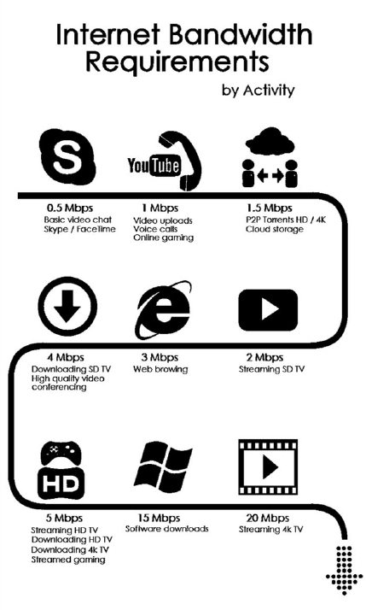

Table H.2: Survey sample

| State | Uninformed Metro | Uninformed Rural | Informed Metro | Informed Rural | Total |
| --- | --- | --- | --- | --- | --- |
| NSW | 169 | 159 | 142 | 141 | 611 |
| VIC | 160 | 126 | 160 | 141 | 587 |
| QLD | 185 | 148 | 154 | 140 | 627 |
| SA | 172 | 81 | 177 | 86 | 516 |
| WA | 166 | 79 | 157 | 72 | 474 |
| ACT | 88 | 9 | 76 | 5 | 178 |
| TAS | 73 | 67 | 37 | 70 | 247 |
| NT | 25 | 22 | 11 | 14 | 72 |
| **Total** | **1,038** | **691** | **914** | **669** | **3,312** |

The majority of the sample was sourced from three online panel providers as shown here.

* NineRewards (n=1734)
* Pureprofile (n=614)
* I-View (n=493)

Online panels are a cost effective and efficient way to recruit respondents for online projects.

Additional recruitment (telephone recruitment to online completion) was undertaken to compare and contrast the quality and representativeness of the online panel data.

* I-View (n=471)

### Survey structure

#### Current internet plan and usage

* Approximately 10 minutes to complete.
* Contained background questions to establish the respondent's current internet plan and usage behaviour (defined the status quo alternative for the choice modelling task).
* In this section respondents were asked if they knew their current download/upload speed. If they were not sure they were directed to an online speed test for confirmation.

#### Information on Speed

* It was clear that it would be difficult for respondents to understand speeds without examples (for example, how do they interpret how these speeds will impact their lives?).
* This section contained examples used to visually display the time it would take to do various familiar tasks on the internet under different speed conditions. Examples are shown in Charts H.3 and H.4.
* Approximately 2-3 minutes to view.

Chart H.3: Example 1 of speed information shown to respondents

Please press the simulate button to begin.

This is just an example, you do not need to watch the entire simulation. You can end the simulation at any time using the 'End simulation' button.

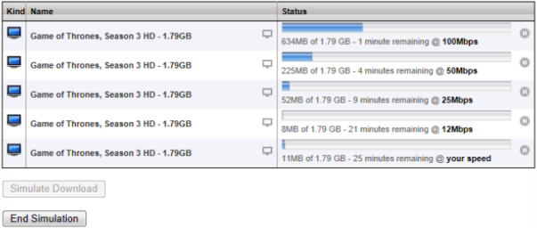

Chart H.4: Example 2 of speed information shown to respondents

Please press the simulate button to begin.

This is just an example, you do not need to watch the entire simulation. You can end the simulation at any time using the 'End simulation' button.

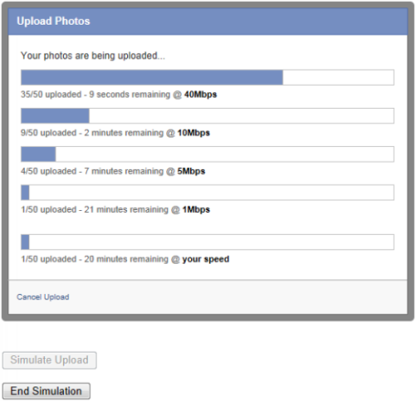

#### Choice Task

The choice tasks were presented in the following way.

* The fixed broadband market — a set of four possible options including the current plan of the respondent (the status quo) and three alternative fixed broadband options. If the status quo option was chosen then the respondent was asked to choose again between the three alternative options.
* The fixed and mobile broadband market — a set of six possible options including the current plan of the respondent (the status quo), three alternative fixed broadband options and two mobile broadband options. If the status quo option was chosen then the respondent was asked to choose again between the five alternative options.

#### Fixed broadband market

The initial task contained a status quo (current broadband plan) and three hypothetical alternative broadband choices (scenarios) (example Chart H.5).

* The task was designed to show comparison bundle plans in a similar way to how they are presented in the market (for example, through internet sites, brochures, etc.).
* Approximately 5-6 minutes to complete.
* Each participant completed 4 scenarios.

Chart H.5: Example of choice task

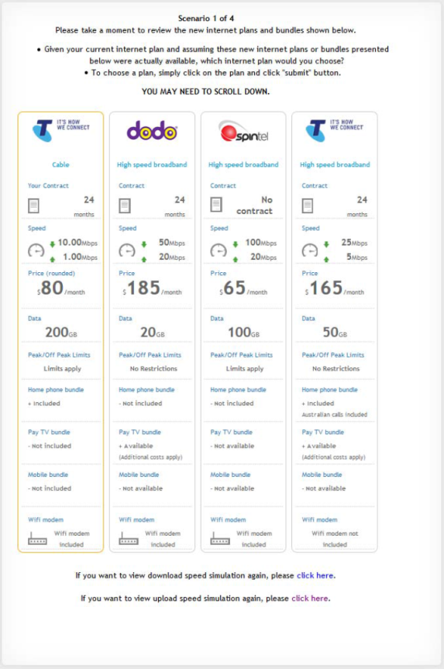

#### Fixed and mobile broadband market

Respondents were asked to complete a second task which included mobile broadband options.

* The task was designed to show comparison bundle plans in a similar way to how they are presented in the market (for example, through internet sites, brochures, etc.).
* Approximately 5-6 minutes to complete.
* Each participant completed 4 scenarios. Results for this model are not shown in this report.
* Each scenario contained a status quo (current broadband plan), three hypothetical fixed broadband plans, plus a mobile dongle and mobile smartphone plan (see Chart H.6).

Chart H.6: Example including mobile options

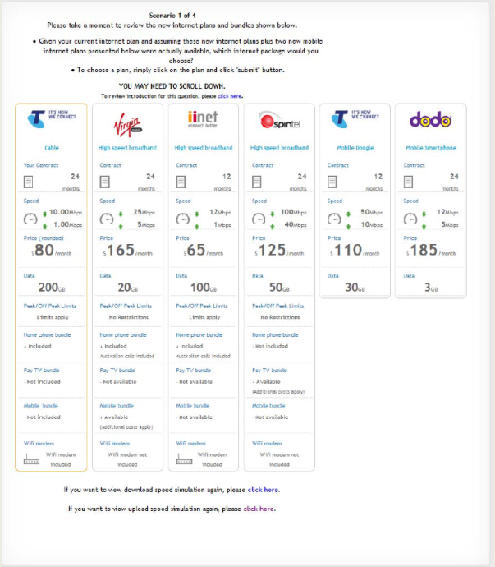

#### Design

Focus groups were conducted to inform the appropriate features to include in the DCE.

The combinations of levels of each feature in the DCE were designed using the latest experimental techniques developed by Rose and Bliemer (2009) and implemented in NGene, the software developed by Rose, Bliemer, Collins and Hensher.

A D-efficient design was used to structure the choice experiment.

#### Model Background

Choice experiments are based on Random Utility Theory (RUT). RUT is derived from the work of Thurstone (1927) and states that decision makers compare the alternative goods and services within a market, whether real or hypothetical, and selects the bundle of attributes or goods that yield the maximum utility (that is, the respondent is a utility maximiser).

RUT assumes the existence of an error term resulting from the analyst being unable to observe the true choice processes of the individual respondents being modelled and hence they apply (poor) approximations of these processes (see McFadden 1974 and Manksi 1977). From a psychological perspective, the error term may also represent errors on behalf of decision makers.

RUT proposes that overall utility *Unsj* can be written as the sum of the observable component[44], *Vnsj*, expressed as a function of the attributes presented and a random or unexplained component, *εnsj* as shown in the following equation

*Unsj =Vnsj + εnsj*

where:

*Unsj* is the overall utility of alternative *j* by respondent *n* in choice situation *s,*

*Vnsj* is the observed or explained component of utility (for alternative *j* by respondent *n* in choice set *s),*

*εnsj* are randomly distributed error terms which vary over the population of respondents.

* The systematic component of utility is typically assumed to be a linear relationship of observed feature levels, *x,* of each alternative *j* and their corresponding weights (parameters), *β*, such that



where *βk* represents the marginal utility or parameter weight associated with feature *k*.

The random error terms, *εnsj* are unobserved by the analyst, and therefore assumptions are made about the form of these terms associated with each alternative, *j.*

The most common assumption is that they are independently and identically distributed (IID) extreme value type 1 (EV1). This assumption is used extensively in discrete choice modelling and leads to the formulation of all logit models (McFadden 1974).

The simplest discrete choice model is called the Multinomial Logit model (MNL). Assumptions of the MNL model:

* errors are IID;
* independence of observed choices (that is, all observations are treated as independent even if they are from the same respondent); and
* homogeneity of preferences (that is, all respondents have the same preferences or parameter weights).

#### Modelling approach for this study

More advanced discrete choice models allow for the relaxation of one or more of the assumptions underlying the MNL model. In this study, we made use of a latent class model (LCM) to analyse the data.

The LCM allows for preference heterogeneity (that is, different respondents can have different marginal utility or parameter weights for each of the features), which is handled via discrete distributions. These discrete distributions are referred to as 'classes'.

* According to the model, each individual resides up to a probability in each 'latent' class, c.
* In estimating the model, there exist a fixed number of classes, C, where the number of classes is defined a priori by the analyst.
* Estimates consist of the class specific parameters and for each respondent, a set of probabilities defined over the classes.
* Within each class, the parameters and choice probabilities are assumed to be generated by Multinomial Logit (MNL) models.

The LCM relaxes some or all of the assumptions of the MNL model

* IID - relaxed via different classes.
* Independence of observed choices - through the classification of pseudo-individuals in estimation of the panel effects to allow for differences within individuals.
* Homogeneity of preferences - through the different parameter weights by class.

### Model Results

A latent class model with two classes was estimated. Various data transformations were tested for best data fit (including log and square transformations).

* For price and speed features the inclusion of the square seemed to fit the data best (that is, quadratic, linear plus the square).
* For data plan, the log transformation fit the data best.

Previous literature has shown respondents tend to evaluate the status quo option differently to the hypothetical alternatives (for example, see Hess and Rose 2009 for a review of the literature).

* For example, they may choose the status quo disproportionately to the other alternatives. This can be addressed using alternative specific constants for the status quo which capture unobserved effects.
* Preferences for the status quo attributes may also be different.
* Levels for the status quo are not controlled by a design and are different to level range for the other alternatives.
* Combining the parameters in the presence of differences would lead to aggregation bias.
* Therefore separate parameters were estimated for the status quo and new plans (NBN) alternatives.

Model estimation was conducted at the brand level, although brand predictions/shares are not shown in the final results. The constants in the model included:

* Brand effect: The effect the brand has on choice across all alternatives (status quo and new).
* Status-quo effect: The effect the respondents' current brand has on their choice of the status-quo alternative.
* Loyalty effect: The effect the respondents' current brand has on their choice of the new alternatives.

In the choice set, if the respondent chose the status quo they were asked a follow up question which forced them to choose from the hypothetical alternatives.

The results for the forced choice model (where respondents are forced to choose a non-status quo alternative) are not presented in this report but were not markedly different to the results in the current model for the new alternatives (which includes the status quo).

The model results for the uniformed and informed market are shown in Tables H.7 and H.8. The model fit results illustrate that both models provide a superior fit to a constant only model.

#### Uninformed Model Results

Table H.7: Uninformed model results

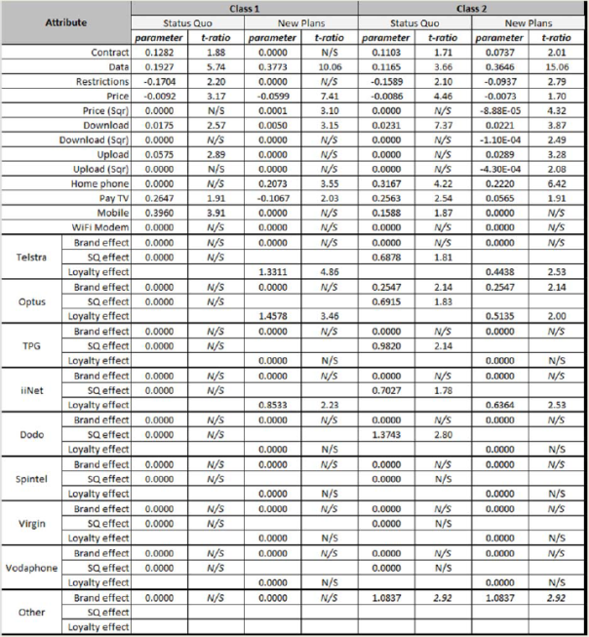

*Model Fit*

* Log likelihood (c): -8,367
* Log likelihood (P): -6,018
* Rho squared: 0.28
* Number of respondents: 1,729
* Number of choice observations: 6,916

#### Informed Model Results

Table H.8: Informed model results

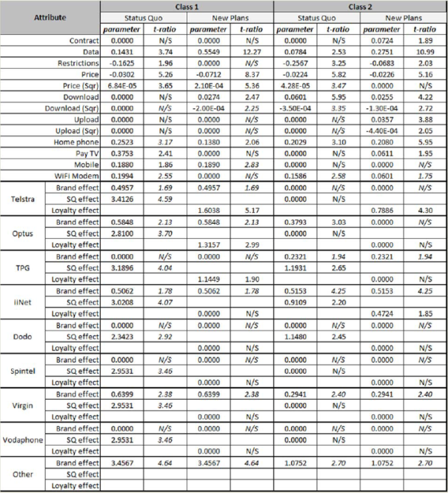

*Model Fit*

* Log likelihood (c): -5,314.
* Log likelihood (P): -7,453
* Rho squared: 0.29
* Number of respondents: 1,583
* Number of choice observations: 6,332

#### Latent class assignment

Using the latent class model, socio-demographics can be added to test whether they influence the class assignment model. The following socio-demographics were tested:

* age;
* gender;
* household income;
* state;
* location (metro/rural); and
* current bundle plan.

In the uninformed model Class 1 were more likely to be (compared to class 2):

* on bundle plans;
* middle aged; and
* lower household incomes.

In the informed model Class 1 were more likely to be (compared to class 2):

* older.

#### Attribute importance

In choice models, the parameters cannot be directly compared because the variables they are related to are presented on different scales, meaning the parameters also reflect different scales (for example, the range of the price attribute is different to the binary pay TV attribute).

The importance of the attributes can be assessed through comparing two identical plans, changing one attribute at a time and recording the change in market share. Table H.9 presents the change in market share after changing the levels for each attribute (extremes of the design).

* In both models and across both classes the most important attributes were:
* price;
* data; and
* download speed.
* Upload speed was only important to one class in each model.
* There were some further differences between the classes on less important attributes such as contract, data restrictions, pay TV and mobiles.

Table H.9: Attribute importance

**Uninformed Attribute Importance**

| Attribute | Initial attribute value | Final attribute value | Total Change in market share Per cent | Class 1 Change in market share Per cent | Class 2 Change in market share Per cent |
| --- | --- | --- | --- | --- | --- |
| Contract | Contract | No contract | 2 | 0 | 4 |
| Download speed (mbps) | 12 | 100 | 15 | 11 | 20 |
| Upload speed (mbps) | 1 | 40 | 5 | 0 | 11 |
| Data plan (GB) | 20 | 1000 | 31 | 31 | 31 |
| Data restrictions | Restrictions | No restrictions | 2 | 0 | 5 |
| Monthly price | $45 | $185 | 48 | 48 | 48 |
| Home phone | Not included | Included | 11 | 10 | 11 |
| Pay TV | Not available | Available | 2 | -5 | 3 |
| Mobile | Not available | Available | 0 | 0 | 0 |
| WiFi modem | Not included | Included | 0 | 0 | 0 |

**Informed Attribute Importance**

| Attribute | Initial attribute value | Final attribute value | Total Change in market share Per cent | Class 1 Change in market share Per cent | Class 2 Change in market share Per cent |
| --- | --- | --- | --- | --- | --- |
| Contract | Contract | No contract | 2 | 0 | 4 |
| Download speed | 12 | 100 | 16 | 11 | 22 |
| Upload speed | 1 | 40 | 8 | 0 | 17 |
| Data plan | 20 | 1000 | 32 | 40 | 25 |
| Data restrictions | Restrictions | No restrictions | 2 | 0 | 3 |
| Monthly price | $45 | $185 | 44 | 46 | 46 |
| Home phone | Not included | Included | 9 | 7 | 10 |
| Pay TV | Not available | Available | 1 | 0 | 3 |
| Mobile | Not available | Available | 5 | 9 | 0 |
| WiFi modem | Not included | Included | 1 | 0 | 3 |

### Outputs of the choice modelling

The outputs of the choice modelling used in the CBA are the responsiveness of demand to higher prices (used in the take-up method) and the MWTP for speed (used in the discrete choice method).

* Predicted market uptake (demand) is calculated using the model probabilities and changing the prices of alternative speed offers.
* MWTP measures the amount that the monthly price could be changed by that would leave a consumer indifferent between two plans with different attributes. For example, a consumer might be indifferent between a plan with a price of $50 per month and a download speed of 10 Mbps and a price of $60 per month and a download speed of 20 Mbps. The marginal WTP for the additional 10 Mbps in this case would be $10 per month.
* MWTP can differ depending on the initial level of the attributes of a person's plan. For example a respondent may have a MWTP of $1 per Mbps of additional download speed at a download speed of 10 Mbps but a MWTP of $0.5 per Mbps of additional download speed at a download speed of 20 Mbps.
* MWTP is calculated as the ratio of the change in marginal utility of attribute *k* to the change in marginal utility for a cost attribute.
* MWTP describes how much the cost would be required to change given a change in a feature, such that the change in total utility will be zero. It therefore calculated using the derivatives of price and the feature of interest.
* In this study the MWTP is calculated using ratio of the price and speed coefficients (holding everything else constant) and is a measure of the WTP for an additional unit of speed (Mbps).

If price and the feature enter into utility in a linear fashion, then

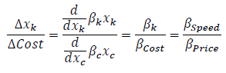

Given the non-linear transformations of the data however, the MWTP is not the ratio of the two parameters. In this instance,

Formula for quadratic (Price/price squared and Speed/Speed squared)



**Box H.10: Example of calculating MWTP**

The MWTP for a respondent with a 5 Mbps download speed, who pays $50 per month would be (assuming the quadratic formula above):

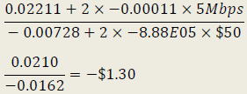

This means the respondent is willing to pay $1.30 for an additional unit of speed (Mbps)

The MWTP outputs are shown in Chapter 6.

The choice modelling can also be used to calculate consumer surplus. Consumer surplus is the monetary representation of the outcome in utility from a choice situation.

* Different scenarios can be evaluated by comparing a change in consumer surplus. The formula for consumer surplus is displayed in the equation below (Train, 2009).
* The change in consumer surplus is often referred to in the literature as Total WTP (TWTP). In this study consumer surplus is calculated as the change between the current market (status quo) and the availability of new high-speed broadband market.
* Consumer surplus is calculated for every participant using the latent class parameters, class probabilities and the data (X's) for the status quo and the new NBN plans.

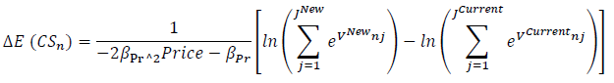

The *—2βPrice Price — βPr* is the derivative of utility with respect to the price attribute taken at the average price level.

To compare the consumer surplus care has to be taken because the consumer surplus reflects the number of options offered. The market offers hundreds of different offers, while a limited number can be practically considered within the choice framework. The main implication of this is that the consumer surplus measure should be compared with the same number of options under different attributes for the options.

In this study the focus has been on the MWTP for additional upload and download speeds.

* The MWTP and the consumer surplus are related but are not necessarily the same. The change in the consumer surplus from an incremental change in download speed is equal to the MWTP for the incremental change in download speed, in the case that the number of plans available remains unchanged and the price is not changed.[45]
* Also note that consumer surplus does not capture the total welfare impacts of changes to the broadband plans available when prices are changed — the total (private) welfare impacts are the sum of the gains to consumers and the gains to producers. The gains to producers, termed 'producer surplus' are captured through higher prices for higher speed plans.
* The MWTP does conceptually capture the entire gain to welfare — it does not specify how this is distributed between consumers and producers. Potentially it overstates gains to the extent that prices lead to households choosing lower speeds than available. The impacts of this are moderated because the consumers with the highest value for speed will tend to choose higher speed plans.

#### Revealed preference and stated preference

It is possible to combine SP techniques (such as choice modelling) with RP data (such as NBN Co uptake to date). For this study we have chosen not to do this and to separately consider the benefits using take-up data as a different methodology. This decision reflects the limited take-up data available and the forced choice encapsulated in NBN Co take-up data, which means it cannot provide information on the value from moving to the lowest NBN Co plan. RP data in the NBN context also suffers from issues including:

* limitation on the alternatives offered, in terms of the prices, download/upload speeds; and
* limited variability in attributes and correlation of attributes - for example, revealed preference data from the NBN Co uptake to date would not be able to differentiate the value for upload and download speeds separately, as they are combined in packages.

There are also disadvantages of stated preference techniques. These are set out below.

#### Hypothetical scenarios

SP may suffer from 'hypothetical bias', a condition whereby respondents answering SP survey tasks respond in a manner other than how they would if faced with similar choices in real markets (see for example, Fifer et al. 2014). Given the lack of an alternative methodology to collect preference data in many research contexts, in particular for markets where the object of study interest currently does not exist, a number of attempts over past decades have been made to improve the external validity of SP experiment outcomes. For example, researchers have explored a number of innovations, introducing methods such as information acceleration (for example, Urban et al. 1996, 1997) where researchers create a choice environment that mimics better the context in which future consumption will be made, the combining of SP data with revealed preference data (for example, Hensher et al. 1994; Kroes and Sheldon 1998; Wardman 1998) which is designed to augment the hypothetical SP data with real world data, and attempts to make the choice questions more realistic (for example, Collins et al. 2013) with the aim to make them mirror as closely as possible similar real market places.

Let us begin by restating that SP data represents choices "made" or stated given hypothetical situations. We noted earlier that this may lead to situations in which personal constraints are not considered as constraints at the time of choice. This will particularly be the case if the SP task is not taken seriously by subjects *("Sure, I'll take two Ferraris").* The task of the analyst is therefore to make the hypothetical scenarios as realistic as possible.

The hypothetical nature of SP data also offers the analyst a significant benefit over RP data. We noted in the previous section that RP data is constrained in terms of being able to collect information solely on currently existing alternatives. As such, the alternatives, the attributes and the attribute levels are fixed in terms of what is currently on offer. Since predicting outside of the ranges of data provides notoriously unreliable estimates from most statistical models, what we require is an approach that will either allow for accurate model predictions outside of the existing data range or alternatively an approach that allows for the collection of data outside of these ranges which may be used with conventional modelling techniques for predictive purposes.

Chart H.11 illustrates clearly the discussion above. RP data represents information up to the extent of the technological frontier as it currently exists. SP data allows us to explore issues outside of the technological frontier.

Chart H.11: The technological frontier and the roles of RP and SP data

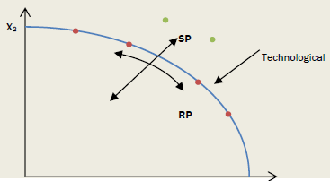

*Data source:* Figure 2.1 from Louviere, Hensher and Swait (2000, 23).

##### Mapping to Utility

With SP experiments, the analyst must specify the attributes and attribute levels in advance. This allows the analyst to manipulate the relationship between attributes and investigate specific hypotheses about the functional form that utility should take (for example, linear additive (X1 + X2) or interactive (X1X2)). Continuing from the previous section, there now exists the ability to map utility functions from previously non-existing alternatives and test the functional form of these.

##### Multiple observations

With SP data, respondents are usually shown multiple choice sets, each of which has different attribute levels (and possibly even different alternatives present depending on the design). Thus for each respondent, we gain multiple observations over the number of choice sets completed. RP data however, usually provides the analyst with information about the single choice that was made. We say usually, as this depends on the data collection methodology employed by the analyst. This will be the case if RP data is collected using a cross-sectional survey. Given more observations, SP data will typically produce more statistically robust estimates than models estimated on RP data.

#### Mitigation of hypothetical bias in stated preference experiments

A number of researchers such as Rose and Hensher (2006), Lanscar and Louviere (2008) and Hess and Rose (2009) argue that one such factor is the degree of realism imposed in SP surveys. Rose and Hensher (2006) suggest that the realism of SP experiments is bolstered by the respondents being asked to make a choice between a finite set of alternatives, as they would in the market. Moderating the realism is the extent to which the alternatives, attributes, and attribute levels align with the respondent's experiences, or generally appear credible. In the current study, we set up the survey in such a way to maximise the realism for each individual respondent in a number of ways.

##### Use of reference alternatives and pivot designs

For behavioural reasons, the literature has moved towards the use of SP experiments that are pivoted around the experiences of sampled respondents (see for example, Hensher 2004, 2007; Rose et al. 2008). The use of a respondent's experience, embodied in a reference alternative, to derive the attribute levels of the experiment has come about in recognition of a number of supporting theories in behavioural and cognitive psychology, and economics, such as prospect theory, case-based decision theory and minimum-regret theory (see Starmer 2000; Hensher 2004).

Reference alternatives in SP experiments act to frame the decision context of the choice task within some existing memory schema of the individual respondents and hence make preference-revelation more meaningful at the level of the individual. Theoretically, the role of reference alternatives in SP tasks is well supported within the literature. For example, prospect theory (Kahneman and Tversky 1979), which argues that individuals use decision heuristics when making choices, promotes the idea that the very specific context in which a decision is made by each individual is an important determinant of the selection of choice-heuristic, supporting the use of reference alternatives in SP tasks. Framing effects, of which reference dependence is a popular interpretation, provides context support in trading off the desire to make a good choice against the cognitive effort involved in processing the additional information provided in a SP task (Hensher 2006). Case-based decision theory (Gilboa et al. 2002) promotes the role of accumulated experience represented by a reference alternative. Starmer (2000, p 353) in particular argues strongly for the use of reference alternatives (for example, an internet plan in decision theory:

*While some economists might be tempted to think that questions about how reference points [alternatives] are determined sound more like psychological than economic issues, recent research is showing that understanding the role of reference points [alternatives] may be an important step in explaining real economic behaviour in the field.*

##### The use of realistic choice tasks

A number of researchers have examined how more realistic presentation of SP experiments can produce more robust results (for example, Rose and Hensher 2006, Collins et al. 2013). Given the increase in the number of market choices being made online, it is possible that SP experiments that are made to look and react in a fashion similar to real market RP contexts may improve the results of SP studies. In particular, there exist a number of websites that allow for comparisons between alternative internet providers, including providers of NBN services, which upon examination closely mimic highly structured interfaces typically used in SP decision contexts. As such, SP experiments conducted on contexts that lend themselves to internet choice environments tend to benefit from more realistic presentation settings when they are made to look more like their real life online interface counterparts (Collins et al. 2013). In particular, making SP choice tasks more similar in look and feel, with larger numbers of alternatives (not less), and providing various navigation mechanisms including search tools that allows the amount of information to be controlled by the user may led to significant improvements in SP model results. In the current experiment, we made the choice tasks look similar to an existing online internet provider comparison website.

##### Cheap talk

Cheap talk refers to a text script which is shown to respondents prior to completing an experiment. The script emphasises the importance of the respondent's answers, despite the hypothetical nature of the design. Various script lengths have been tested in the literature, ranging from short scripts (a few sentences to one paragraph) to long scripts (five paragraphs or more). There is still much conjecture about which script length is the more appropriate, but for most studies, scripts are designed to suit the intended audience and proposed survey methodology.

## Appendix I - Sensitivity analysis input probabilities

The probabilities used in conducting simulations for the detailed sensitivity are set out in the table below. The output distribution was formed by conducting 1000 simulations using these input probability distributions.

Table I.1: Probability assumptions

| Parameter | Probabilities applied |
| --- | --- |
| Method of estimating benefits | 50% for choice modelling, 25% for take-up method and 25% for technical bandwidth demand method |
| Discount rate | 25% for each of 4%, 7%, 8.3% and 10% |
| DWL of taxation | 25% for each of 8 cents in the dollar, 24 cents, 40 cents and 70 cents |
| Business WTP as a proportion of household | Uniform distribution from 100% to 200% |
| Change in WTP per year | Log normal distribution with a mean of 2% and range from simulations of 0.1% to 33.1% |
| Timing of roll-out | 50% NBN Co, 25% delay MTM to match FTTP and 25% delay FTTP to match MTM |
| Inclusion of FTTP in the multi-technology mix scenario | — |
| Productivity assumptions | 40% NBN Co, 50% panel preferred assumptions and 10% FTTP costs from the revised outlook from the NBN Co Strategic Review |
| FTTP and FTTN opex assumptions | 50% NBN Co, 50% panel preferred assumptions |
| Overheads and project management costs | 50% NBN Co, 50% lower costs for MTM in line with amount of cumulative capex |
| Evaluation period | 2034 + lognormal distribution with mean of 6 years and range from 2035 to 2062 |
| Speeds for FTTN | 50% base assumption, 25% pessimistic and 25% for 50-100 down/10-20 up (UK speeds) |

*Source:* The CIE.

### References

ABS (Australian Bureau of Statistics) 2013, *Internet Activity, Australia, June 2013,* Cat. no. 8153, ABS, Canberra.

ABS 2014, *Household Use of Information Technology, 2012/13,* Cat. No. 8146.0, ABS, Canberra.

ACCC 2013, *NBN Co Special Access Undertaking 2013,* 13 December.

Access Economics 2009, *Impacts of a national high-speed broadband network,* A report by Access Economics Pty Ltd for Telstra Corporation Limited.

ACMA (Australian Communications and Media Authority) 2013, *Communications report 2012-13,* ACMA, Canberra.

ACMA 2014, *Australian SMEs in the digital economy,* Communications report 2012-13 series, Report 1, Canberra.

Akamai 2014, *The State of the Internet 3rd Quarter,* 2013, vol. 6, no. 3, Cambridge.

Alcatel-Lucent 2014, *Ultra-broadband, faster closer first,* Presentation to panel of Experts (cost-benefit analysis of broadband & review NBN regulation), 25 February 2014.

Alcatel-Lucent 2012a, *Smart Digital Connected,* 2012 Research Report, Alcatel-Lucent, Paris.

Alcatel-Lucent 2012b, *Building the Benefits of Broadband,* Alcatel-Lucent, Wellington.

Alcatel-Lucent Bell Labs 2013, *Metro Network Traffic Growth Study: an architecture impact study,* Strategic White Paper, Alcatel-Lucent, Paris.

AMP Capital 2012, *The Capital Efficiency of Australian Electricity Distributors - Results of a Benchmarking Study,* Submission to the Productivity Commission.

Analysys Mason and Tech4i2 2013, *The socio-economic impact of bandwidth,* Study for the European Commission DG Communications Networks, Content and Technology.

APS Group Scotland 2011, *Research on Broadband and Business in Scotland: A report to the Scottish Government,* Edinburgh, March.

Australian Industry Group 2013, *The business end of broadband: what business users want from high speed broadband,* Australian Industry Group, North Sydney, October.

Australian National University 2004, *Australian broadband telecommunications research project: Business Broadband Adoption Report,* Supplied to the Department of Communication, Information Technology & the Arts, June.

Bauer, S., Clark, D. and Lehr, W. 2010, *Understanding Broadband Speed Measurements,* TPRC 2010 Conference, 15 August 2010. Available at SSRN: <http://ssrn.com/abstract=1988332>

Berkman Center for Internet and Society at Harvard University 2010, *Next Generation Connectivity: a review of broadband internet transitions and policy from around the world,* Harvard University, Cambridge.

Bourreau, M., Lupi, P. and Manenti, F.M. 2013, 'Old technology upgrades, innovation and competition in vertically differentiated markets', Available at SSRN: <http://ssrn.com/abstract=2217525> or <http://dx.doi.org/10.2139/ssrn.2217525>

Broadband Commission for Digital Development 2013, *Planning for Progress Why National Broadband Plans Matter,* ITU, ITU/UNESCO and Cisco, Geneva.

Cartesian 2014, *Ultra-Fast Broadband Study: Investigating Demand and Benefits,* Material prepared for Corning.

Castalia 2008, *Getting the Most from High Speed Broadband in New Zealand: Investing in Productivity Growth,* Report to Telecom, TelstraClear, & Vodafone, December.

Cisco 2013, *Cisco VNI Service Adoption Forecast,* San Jose, <http://www.cisco.com/c/en/us/solutions/collateral/service-provider/vni-service-adoption-forecast/Cisco_VNI_SA_Forecast_WP.html>, Accessed 25 March 2014.

Collins, A.T., Rose, J.M. and Hess, S. (2013) Choice Modeling with Search and Sort Data from Interactive Choice Experiment, Transportation Research Part E, 56(1), 36-45.

Contreras, J.E.M., Rickman, N. and Trillas, F. 2008, 'Regulation by duopoly under political constraints', University of Surrey. Available at: <https://www.google.com/url?sa=t&rct=j&q=&esrc=s&source=web&cd=1&ved=0CCAQFjAA&url=https%3A%2F%2F_editorialexpress.com%2Fcgi-bin%2Fconference%2Fdownload.cgi%3Fdb_name%3DIIOC2009%26paper_id%3D634&ei=Z0SyU77XE4jtkgW6sICABA&usg=AFQiCNESGZ0peSlIBIbyLnztM8g2QMfXEQ&sig2=doeGSiQjGfpl_lS3vl63Mg&bvm=bv.69837884,d.dGI&cad=rja>

Commerce Commission New Zealand 2012, *High speed broadband services demand side study,* project no. 13.07/12813, June.

Commonwealth of Australia, Handbook of Cost Benefit Analysis, January 2006

DBCDE (Department of Broadband, Communications and the Digital Economy) 2011, *The role and potential of the national broadband network,* Submission to the House Standing Committee on Infrastructure and Communications, DBCDE, Canberra.

Deloitte 2014, *Value of connectivity Economic and social benefits of expanding internet access,* Report for Facebook Inc.

Deloitte Access Economics 2013, *Benefits of High-Speed Broadband for Australian Households,* Report by Deloitte Access Economics for the Commonwealth of Australia as represented by the Department of Broadband, Communications and the Digital Economy.

Dutz, M., Orszag, J. and Willig, R. 2009, *The substantial consumer benefits of broadband connectivity for US households,* Commissioned by the Internet Innovation Alliance.

Ergas, H. and Robson, A. 2009, *The social losses from inefficient infrastructure projects: recent Australian experience,* <http://papers.ssrn.com/sol3/papers.cfmPabstract_id=1465226>

European Commission 2013, Basic Joint Venture Model, <https://ec.europa.eu/digital-agenda/en/news/basic-joint-venture-model>, accessed 11 June 2014.

FANOC 2007, *Special Access Undertaking to the ACCC,* 30 May.

FCC 2014, *Universal Service,* Federal Communications Commission, <http://www.fcc.gov/encyclopedia/universal-service>

Fifer, S. Rose, J.M. and Greaves, S. (2014) Hypothetical bias in Stated Choice Experiments: Is it a problem? And if so, how do we deal with it? Transportation Research Part A, 61, 164-177.

Gilboa, I., Schmeidler, D., Wakker, P. (2002) Utility in case-based decision theory, Journal of Economic Theory, 105, 483-502.

Harrison 2010, *Valuing the future: the social discount rate in cost-benefit analysis,* Productivity Commission visiting research paper, p XIII.

Hayes, R. 2011, *Valuing Broadband Benefits: A selective report on issues and options,* Melbourne Business School The University of Melbourne, February, available online at: [http://papers.ssrn.com/sol3/papers.cfmPabstract id=1856378](http://papers.ssrn.com/sol3/papers.cfmPabstract%20id=1856378).

Hensher D.A. (1994) Stated Preference Analysis of Travel Choices: The State of Practice, Transportation, 21, 107-133.

Hensher, D.A. (2004) Identifying the influence of stated choice design dimensionality on willingness to pay for travel time savings, Journal of Transport Economics and Policy, 38(3), 425-446.

Hensher, D.A. (2006) How do respondents process stated choice experiments? - Attribute consideration under varying information load, Journal of Applied Econometrics, 21, 861-878

Hensher, D.A. (2007) Joint estimation of process and outcome in choice experiments and implications for willingness to pay, Institute of Transport and Logistics Studies, University of Sydney, May.

Hess, S. and Rose, J.M. (2009) Should reference alternatives in pivot design SC surveys be treated differently?, Environmental and Resource Economics, 42(3), 297-317.

Institute for a Broadband Enabled Economy 2014, *NBN Review,* Presentation to the Expert Panel.

IPART 2014, *New approach to estimating the cost of debt,* February.

[ISPreview.co.uk](http://ISPreview.co.uk), n.d., *Broadband ISP Technology,* available at: [www.ispreview.co.uk/broadband.shtml](http://www.ispreview.co.uk/broadband.shtml)

Jeffcoat, C., Davis, A.F. and Hu, W. 2012, 'Willingness to pay for broadband access by Kentucky farmers', *Journal of Agricultural and Applied Economics,* vol. 44, issue 3, pp. 323-334.

Kahneman, D., Tversky, A. (1979) Prospect theory: an analysis of decisions under risk, Econometrica, 47 (2), 263-91.

KPMG Econtech 2010, *CGE analysis of the current Australian tax system,* prepared for Department of Treasury, 26 March.

Kroes E.P. and Sheldon R.J. (1988) An Introduction, Journal of Transport Economics and Policy, 12 (1), 11-25.

Lanscar, E. and Louviere, J.J. (2008) Conducting discrete choice experiments to inform healthcare decision making: A user's guide, Pharmacoeconomics, 26, 661-667.

Lea, A. and Kempson, M. 2012, *Broadband Leicestershire: Analysis of household and business survey responses,* Leicestershire County Council, July.

Louviere, J.J., Hensher, D.A. and Swait, J.D. (2000) Stated Choice Methods: Analysis and Application, Cambridge University Press, Cambridge.

Louviere, J., Hensher, D.A. (1982) On the design and analysis of simulated choice or allocation experiments in travel choice modelling. Transportation Research Record, 890, 11-17.

Louviere, J., Woodworth, G. (1983) Design and analysis of simulated consumer choice or allocation experiments: an approach based on aggregate data. Journal of Marketing Research, 20, 350-367.

Madden, G.G. and Simpson, M. 1997, *Residential broadband subscription demand: an econometric analysis of Australian choice experiment data,* MPRA Pater No. 11936, Curtin University of Technology, available online at: <http://mpra.ub.uni-muenchen.de/11936/>

Manski, C. (1977) The Structure of Random Utility Models, Theory and Decision, 8, 229-254.

McFadden, Dan (1974) Conditional Logit Analysis of Qualitative Choice Behaviour. In Zarembka, P. (ed.), Frontiers of Econometrics, Academic Press, New York, 105-142.

Molloy, S., Burgan, B. and Rao, S. 2008, *Creating new markets: broadband adoption and economic benefits on the Yorke Peninsula,* A report prepared for the Information Economy Directorate, Department of Further Education, Employment, Science and Technology, Government of South Australia by Systems Knowledge Concepts Pty Ltd, July.

NBN Co 2014, *National Broadband Network - Rollout Information the week ending 16 March 2014,* Sydney, <http://www.nbnco.com.au/about-us/weekly-progress-report.html>, accessed 25 March 2014.

NBN Co 2013, *Strategic Review Report,* NBN Co, Sydney, December 2013.

Optus 2012, Submission in response to the ACCC's Draft Determination on the Application for Authorisation of the HFC Subscriber Agreement between NBN Co Limited and SingTel Optus Pty Ltd and other Optus entities, June

Plum 2011, *Copper pricing and the fibre transition - escaping a cul-de-sac,* A report for ETNO, London, December.

PricewaterhouseCoopers 2004, *Technical assistance in bridging the "digital divide": A cost-benefit analysis for broadband connectivity in Europe,* report for the European Space Agency, <http://telecom.esa.int/telecom/www/object/index.cfm?fobjectid=14864>.

Productivity Commission 2013, *Electricity Network Regulatory Frameworks,* Report No. 62, Canberra.

Productivity Commission 2014, *Public Infrastructure,* Draft Inquiry Report, Canberra

Pullar-Strecker, T. 2014, 'Chorus pledges to increase broadband speeds', *Stuff.co.nz,* <http://www.stuff.co.nz/technology/60061683/chorus-pledges-to-increase-broadband-speeds>, accessed 11 June 2014.

Quiggin, J. 1998, 'The Premature Burial of Natural Monopoly: Telecommunications reform in Australia', *Agenda,* Vol.5, No. 4, pp 427-440.

Rosston, G., Savage, S.J. and Waldman, D.M. 2010, *Household demand for broadband internet service,* Final report to the Braodband.gov Task Force, Federal Communications Commission.

Sandvine 2014, *Global internet phenomena report 1H 2014,* Sandvine, Ontario.

Slater, J., Lindstrom, J. and Astbrink, G. 2010, *Broadband Solutions for Consumers with Disabilities,* Australian Communications Consumer Action Network (ACCAN), Ultimo.

Telstra 2011, Explanatory Memorandum for the Resolution Under Item 2 at the Annual General Meeting on 18 October 2011: Telstra's Participation in the rollout of the National Broadband Network, September.

Turnbull, M and Cormann, M. 2014, *Statement of Expectations,* Minister for Communications, 8 April 2014.

Value Adviser Associates 2011, *Report on WACC component of NBN Co's Special Access Undertaking,* December.

van der Vorst, Brennenraedts, Kerkhof and Brekkers 2014, *Fast Forward: How the speed of the internet will develop between now and 2020.* Report commissioned by NLKabel and Cable Europe. Available at [http://cable-europe.eu.apache11.hostbasket.com/content/uploads/2014/06/140624 Dialogic- Fast-Forward-How-the-speed-of-the-internet-will-develop-between-now-and-2020 FINAL.pdf](http://cable-europe.eu.apache11.hostbasket.com/content/uploads/2014/06/140624%20Dialogic-%20Fast-Forward-How-the-speed-of-the-internet-will-develop-between-now-and-2020%20FINAL.pdf).

Yoo, C.S. 2014, US vs European broadband deployment: what do the data say?, University of Pennsylvania Law School and Centre for Technology, Innovation and Competition, <https://www.law.upenn.edu/live/files/3352-us-vs-european-broadband-deployment>

Rose, J.M. and Bliemer, M.C.J. (2009) Constructing Efficient Stated Choice Experimental Designs, Transport Reviews, 29(5), 587-617.

Rose, J.M., Bliemer, M.C.J., Hensher, D.A. and Collins, A.T. (2008) Designing Efficient Stated Choice Experiments Involving Respondent Based Reference Alternatives, Transportation Research Part B, 42(4), 395-406.

Rose, J.M. and Bliemer, M.C.J. (2009) Constructing Efficient Stated Choice Experimental Designs, Transport Reviews, 29(5), 587-617.

Rose, J.M. and Hensher, D.A. (2006) Accounting for individual specific non-availability of alternatives in respondent's choice sets in the construction of stated choice experiments, Stopher, P.R. and Stecher, C. (eds.) Survey Methods, Elsevier Science, Oxford.

Starmer, C. (2000) Developments in non-expected utility theory: the hunt for a descriptive theory of choice under risk, Journal of Economic Literature, XXXVIII, 332-382.

Thurstone, L. (1931) The indifference function, Journal of Social Psychology, 2(2), 139-167.

Thurstone, L. (1927) A law of comparative judgment, Psychological Review, 34, 278-286.

Train, K. (2009) Discrete Choice Methods with Simulation 2nd Ed. Cambridge University Press, Cambridge.

Urban, G.L., Weinberg, B.D. and Hauser, J.R. (1996) Premarket forecasting of really new products, Journal of Marketing, 60(1), 47-60.

Urban, G.L., Hauser, J.R., Qualls, W.J., Weinberg, B.D., Bohlman, J.D. and Chicos, R.A. (1997) Information acceleration: validation and lessons from the field, Journal of Marketing Research, 34(2), 143-153.

Wardman, M. (1998) The Value of Travel Time: A Review of British Evidence, Journal of Transport Economics and Policy, 32(3), 285-315.

## Glossary of terms

| Glossary | Definition |
| --- | --- |
| 4K TV | Display devices or content with a horizontal resolution of the order of 4000 pixels. It has twice the horizontal and vertical resolution of High Definition TV, with four times as many pixels. |
| ADSL | Asymmetric Digital Subscriber Line - delivers basic broadband services over copper telephone lines |
| ADSL2+ | An enhancement to ADSL that uses a wider frequency range to achieve substantially faster speeds |
| Cable | Term used to describe HFC cable - delivers Pay TV, internet and voice services through optical fibre and coaxial cable |
| Committed information rate | The speed an end-user is guaranteed to be provided with. |
| CPE | Customer Premises Equipment |
| Dial up | Internet services delivered using telephone lines, requires no new infrastructure beyond the telephone network. |
| DOCSIS2.0 or 3.0 | Data Over Cable Service Interface Specification - an international telecommunications standard that permits the addition of high-speed data transfer to an existing cable TV (CATV) system |
| Fibre | Delivers high-speed broadband services through optical fibre |
| Fixed line subscriptions | Internet service subscriptions with services delivered to a fixed address through various technology options. |
| Fixed wireless | Broadband services similar to mobile broadband however using fixed receiving equipment e.g. antennas mounted on roofs. |
| FTTdp | Fibre-to-the-distribution point |
| FTTP | Fibre-to-the-Premises |
| FTTN | Fibre-to-the-Node |
| Gbps | Gigabits per second |
| GPON | Gigabit Passive Optical Networking |
| HFC | Hybrid fibre-coaxial - a technology that delivers broadband using a combination of optical fibre and coaxial cable. |
| IPTV | Internet Protocol TV - television services delivered using the internet network |
| ISP | Internet Service Provider |
| Latency | The time it takes for data to get from one point to another |
| Mobile services | Internet service subscriptions with services delivered to mobile devices (such as mobile phone handsets, tables, dongles, USB modems and data cards). |
| Mbps | Megabits per second |
| NBN | National Broadband Network |
| NBN Co | A Government Business Enterprise, tasked with providing Australians with access to the most appropriate high-speed broadband technology. |
| Peak connection speed or peak information rate (PIR) | The maximum connection speed an end-user may achieve |
| RSP | Retail Service Provider |
| Satellite | Broadband services delivered using a geostationary satellite and dishes installed at customer premises. |
| TCP | Transmission Control Protocol - a popular transport protocol used to decrease congestion, reduce packet loss and provide end-to-end reliability in connections. |
| VDSL | Very-high-bit-rate digital subscriber line - a digital subscriber line technology providing data transmission faster than ADSL over copper wires |
| VDSL2 | An enhancement to VDSL that uses a wider frequency range to achieve faster speeds |
| VoIP | Voice over IP - delivery of voice communications over the internet network |
| WTP | Willingness to Pay |
| DSL | A group of technologies that use telephone lines to deliver broadband services |

1. Telstra summary of definitive agreement. <https://www.telstra.com.au/abouttelstra/download/document/2011-definitive-agreements-telstra-nbnco.pdf>
2. Optus media release, Optus reaches landmark agreement with NBN Co on HFC network, 23 June 2011 <https://www.optus.com.au/aboutoptus/About+Optus/Media+Centre/Media+Releases/2011/Optus+reaches+landmark+agreement+with+NBN+Co+on+HFC+network>
3. <http://www.communications.gov.au/broadband/national_broadband_network/cost-benefit_analysis_and_review_of_regulation>
4. The medium category is then further split into those who do and do not participate in large software downloads and video uploads.
5. For example, a recent European study (van der Vorst et al, 2014) projected download demand of 165 Mbps in 2020. The methodology for this study essentially assumes that bandwidth demand will be proportional to traffic.
6. The analysis uses the pre-tax weighted average cost of capital as recommended by Harrison (2010).
7. Note that the NBN Co SAU is focused on NBN as an entity, for which the costs and revenues of the increment of speed are only a part. For example, NBN Co receives revenues from provision of telephony and broadband services, rather than only the incremental revenue from speeds above existing speeds. It would be expected that the increment would have a higher cost of capital than the entity as a whole.
8. This is likely to be a conservative assumption as the achievable speeds are likely to increase over time for all technology options, often with minimal cost.
9. A perfectly price discriminating monopolist would be able to extract up to 100 per cent. In practice, less than the full amount would be able to be extracted. Under the methods used to estimate the surplus from changes in speeds in Chapter 6, a basic level of price discrimination, such as is in NBN Co's current pricing structure, would capture 50 per cent to 70 per cent of total surplus.
10. There are some methods for estimating WTP that would make the fixed wireless and satellite rollout being undertaken by NBN Co a commercial proposition. However, across most methods this is generally not the case.
11. In some cases fibre to the distribution point (FTTdp) is used instead of FTTN.
12. That is, any parts of the Optus or Telstra HFC networks that overlap are not maintained as competitor networks for high-speed broadband and the copper network is not maintained as a competitor network for broadband in the HFC areas or in FTTP areas.
13. This is across all premises passed. A significant number of premises passed would not take-up a service so the costs per premises taking up the service would be higher.
14. Transfers to overseas owners of Telstra and Optus are treated as a resource cost.
15. The shape of these curves can change depending on the estimation. For example, the use of a log curve shows a steeper relationship than the use of squared terms shown in these charts. The relationships shown are those that provided the best fit to the data.
16. Note that in the CBA model, each household within an exchange service area is effectively considered to be identical so the speed change for each household is not identified, just the speed changes across all households in an exchange service area. This has no impact on the results. For example, the calculations result in the same estimate if household A goes from a speed of 5 to 10 and household B goes from a speed of 2 to 20, compared to household A going from 5 to 20 and B from 2 to 10.
17. This is essentially the area under the curves in Charts 6.4 and 6.5.
18. The analysis applies a value of $15 per hour. This is similar to the values used for time taken in transport evaluations.
19. Note that the rollout decision reflects the average revenue available rather than allowing for an *unsubsidised rollout* to charge differently in different areas.
20. This is because alternative services are assumed to be made unavailable.
21. An example is Telstra offering to boost speeds from 25/5 to 100/40 for an additional $20 per month.
22. It is assumed that this is per household as services targeted at businesses customers were not available within the period covered by the take up data.
23. Analysis of pricing plans for the NBN against non-NBN plans shows that the 12/1 plan is priced very similarly to current ADSL plans.
24. Communications Chambers assumes an annual improvement in video compression of 9 per cent for SD, HD and 4K TV.
25. See Deloitte Access Economics (2013).
26. The peak information rate is the theoretical maximum speed an end user may achieve. The peak information rate differs from the committed information rate which is a guaranteed amount of bandwidth made available to an end user.
27. Serviceable premises differ from premises passed only in brownfield sites where fibre passes the premises but the premises is not yet connected to the network with a lead into the property.
28. ACMA Research, unpublished 2013.
29. NBN Co 2014, unpublished research.
30. For example: [Speedtest.net](http://Speedtest.net); Akamai; ComScore; M-Labs; Google's Youtube service.
31. In particular, a cautious approach seems to have been taken in respect of FTTN so as to err on the side of overstating costs, whereas a more optimistic approach was taken for the FTTP modelling in terms of achieving efficiencies.
32. For further detail see NBN Co (2013).
33. The information used splits out the number of premises by the amount that are single‐dwelling units versus multiple‐dwelling units.
34. In particular, the distances between the pillar and premises, and between the pillars and the FAN.
35. This includes construction capex, replacement capex, transit network capex and greenfields network deployment costs.
36. The FTTP build costs relate to the access network only and do not include payments for use of ducts, but do include payments for lead‐in conduits.
37. *Strategic Review*, p.13.
38. Chorus Half Year Result, FY14 For six months ending 31 December 2013, p. 21. Available at: <http://www.chorus.co.nz/file/42884/Investor‐Presentation.pdf>
39. Chorus (21 May 2014), Institutional Investor Presentation. Available at: <https://www.nzx.com/files/attachments/194167.pdf>
40. For example, the ACCC calculated overheads through a mark‐up in its Total Service Long Run Incremental Cost (TSLRIC) model that was used to set prices for fixed network access services. The TSLRIC model estimated overheads using both a mark‐up on capex and a markup on opex, of 1.97 per cent and 59.77 per cent, respectively. In the US the BCPM model used in the context of Universal Service Modelling, business overheads are derived by applying a mark‐up of 10.4 per cent for common costs in the base case scenario. (DOCKET NO. UT‐980311(a) for Universal Service Tenth Supplemental Order, Order Establishing Costs. Before the Washington Utilities and Transportation Commission In the Matter of Determining Costs, Order Establishing Costs, para. 263). Cost modelling consultants WIK have found in their benchmarking analysis, that it is common to use an overhead mark‐up of around 10 per cent on total capex and opex. (WiK‐Consult (March 2013), Estimating the Cost of GEA), p.28.
41. However, it is noted that transfers are relevant to the calculation of the total amount of government funding which is used separately in the CBA model.
42. *Core and Access Model* prepared by Analysys Mason for the ACCC in 2008.
43. Telstra Corporation Limited, For the Resolution Under Item 2 at the Annual General Meeting on 18 October 2011: Explanatory Memorandum Telstra’s Participation in the Rollout of the National Broadband Network. Available at: <http://www.telstra.com.au/abouttelstra/download/document/Explanatory‐Memorandum.pdf>
44. Otherwise referred to as the systematic component.
45. This can be seen by taking the derivative of the expected consumer surplus with respect to an attribute, such as the download speed. (Note this is also on the basis that the marginal utility of income reflects the derivative of utility with respect to all price terms – squared as well.)